Project 2: Podman-Based Containerization Report

# 1. Introduction

This report documents the steps involved in containerizing a simple Flask application using Podman, a daemonless container engine. The objective was to build and run the app inside a Podman container, exploring the tool's installation, configuration, build process, and execution. The report also includes screenshots, common errors encountered, and troubleshooting insights.

# 2. Environment Setup and Podman Installation

Podman Desktop was downloaded and installed from the official website. During the setup process, Podman prompted to install Podman CLI and initialize a default virtual machine for running containers. Installation included configuration of the Podman machine and verifying version installation.

Verification via CLI:

podman --version

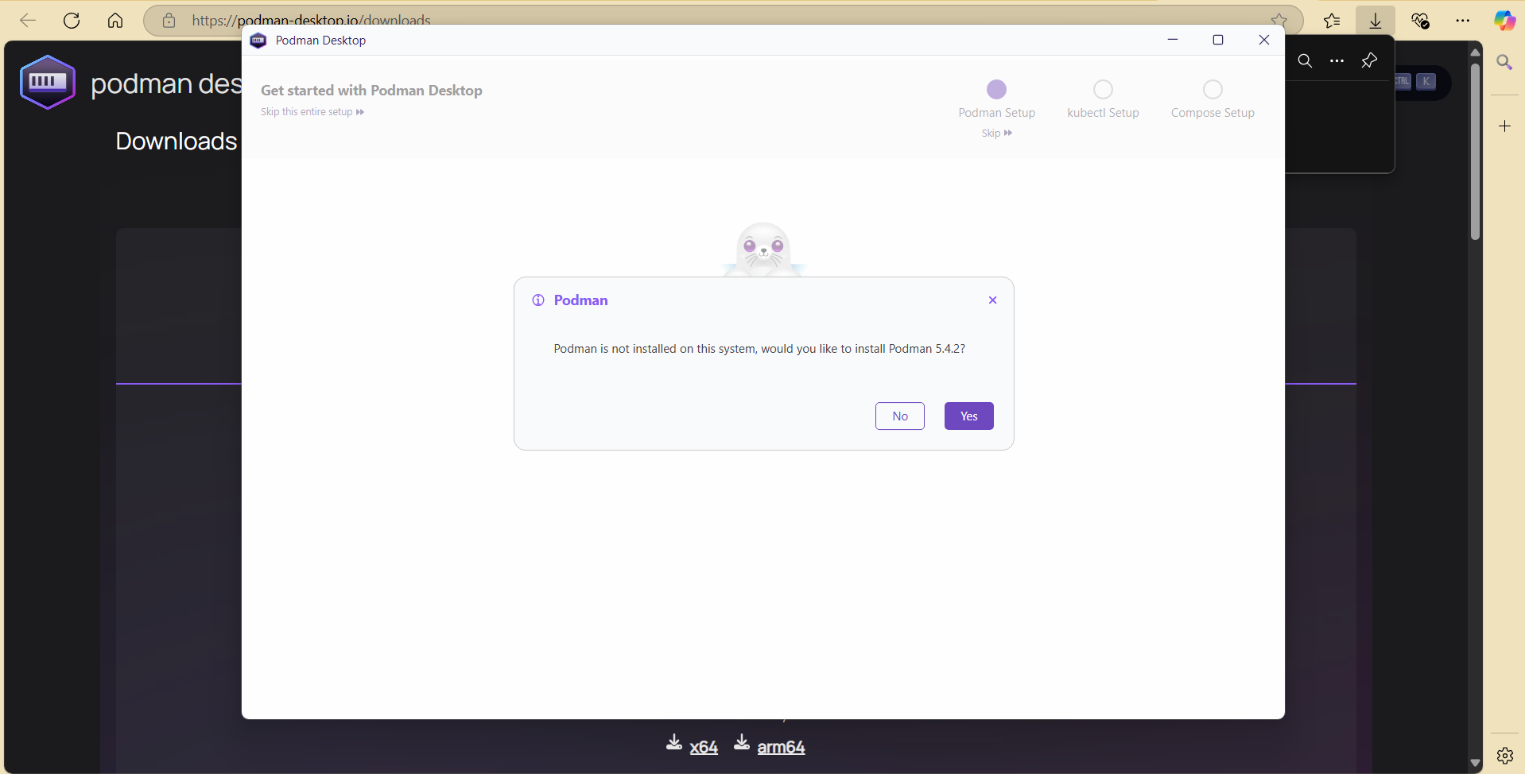

# 3. Common Errors and Troubleshooting

Initial attempt to use the Podman CLI resulted in an error:

podman: The term 'podman' is not recognized...

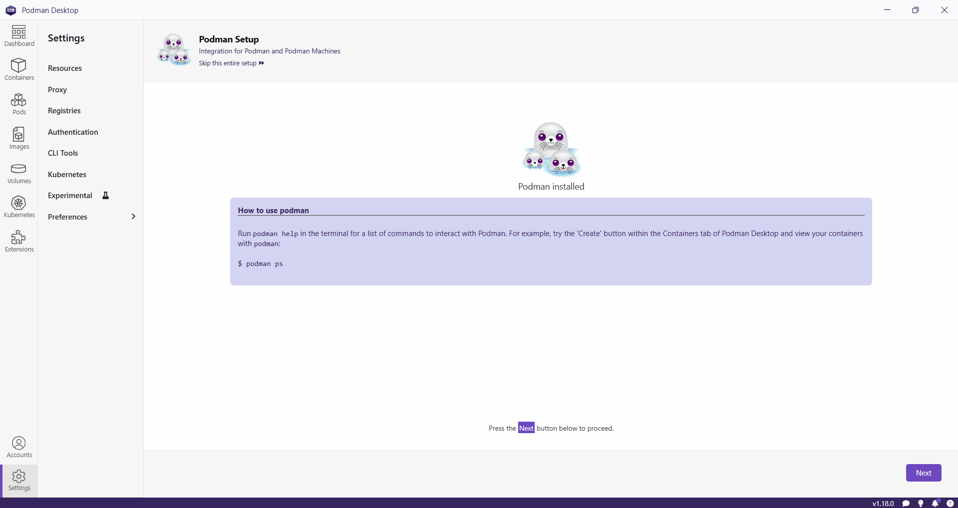

This was due to the system not recognizing the CLI path. A system restart resolved this by refreshing the environment variables and path configuration.

Another error was due to a missing Dockerfile in the Podman project directory. The issue was resolved by copying the working Dockerfile from the Docker-based project.

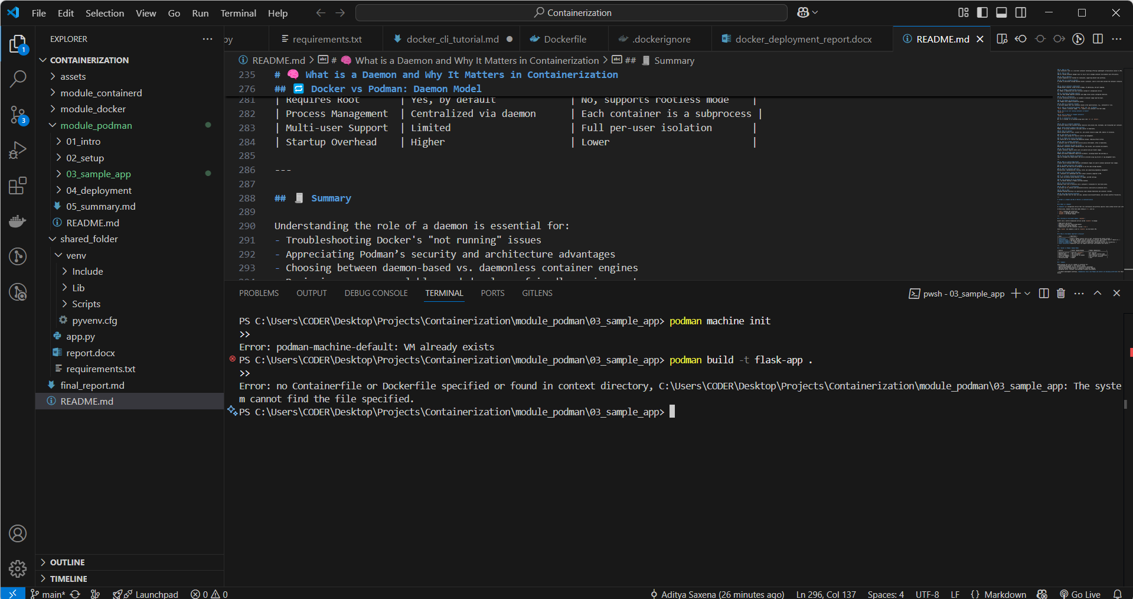

An additional problem involved the Podman machine not being active. The following commands helped resolve the issue:

podman machine init

podman machine start

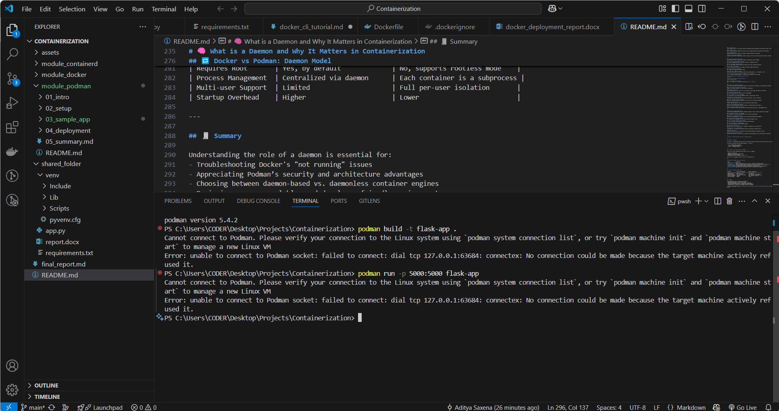

# 4. Building the Podman Container Image

Successfully built using the command:

podman build -t flask-app .

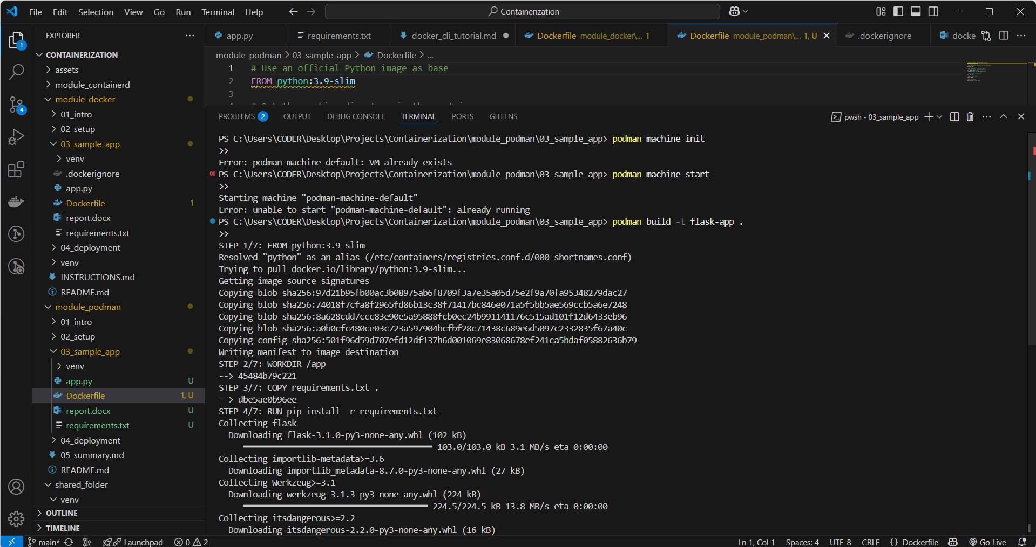

# 5. Running the Flask App in Podman

Command used:

podman run -p 5000:5000 flask-app

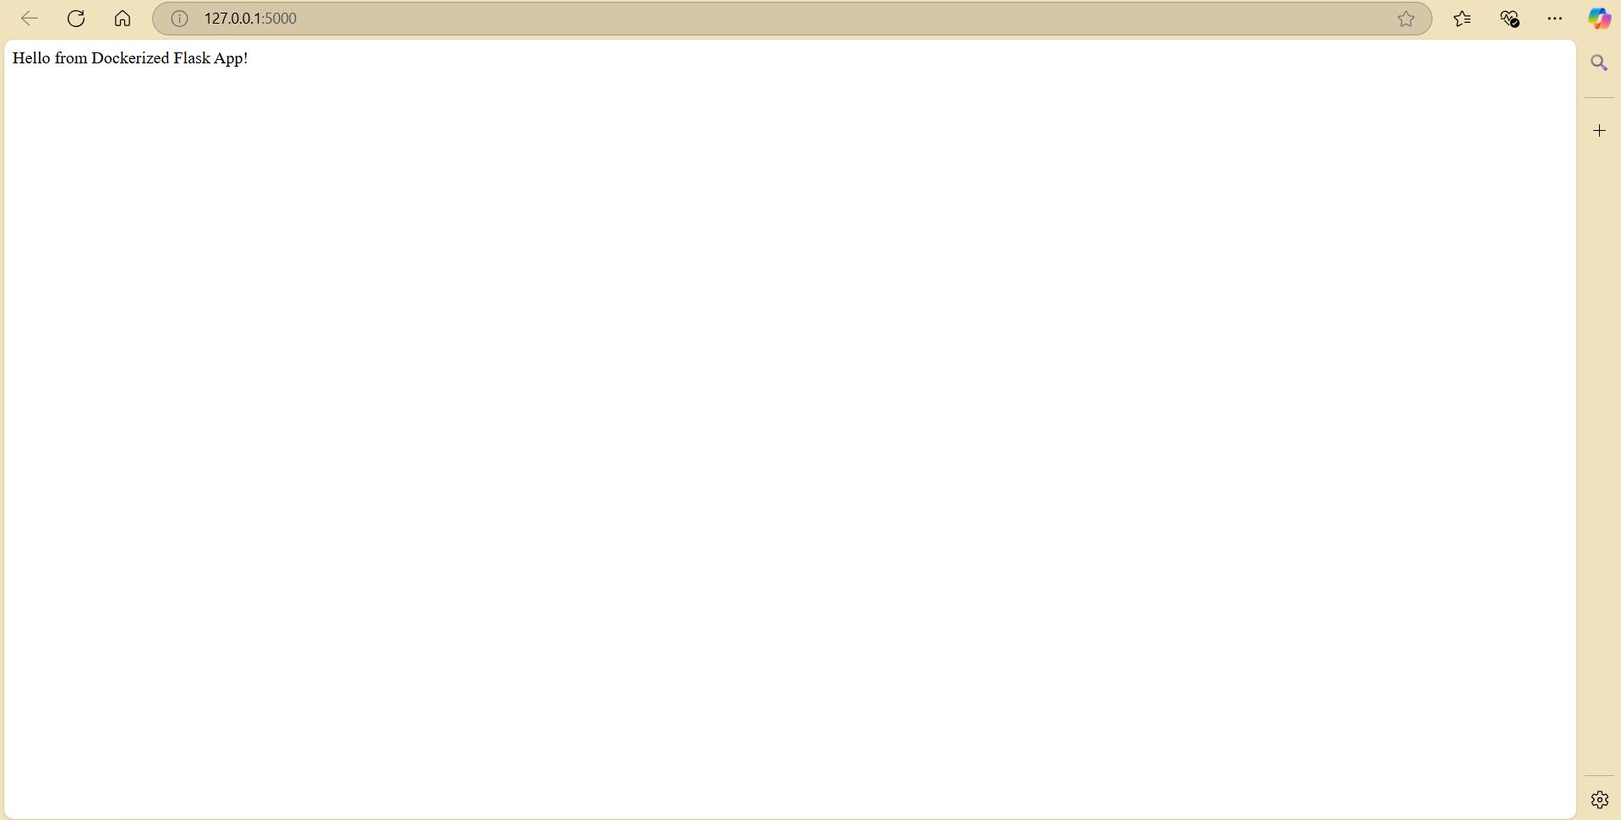

Browser Output:

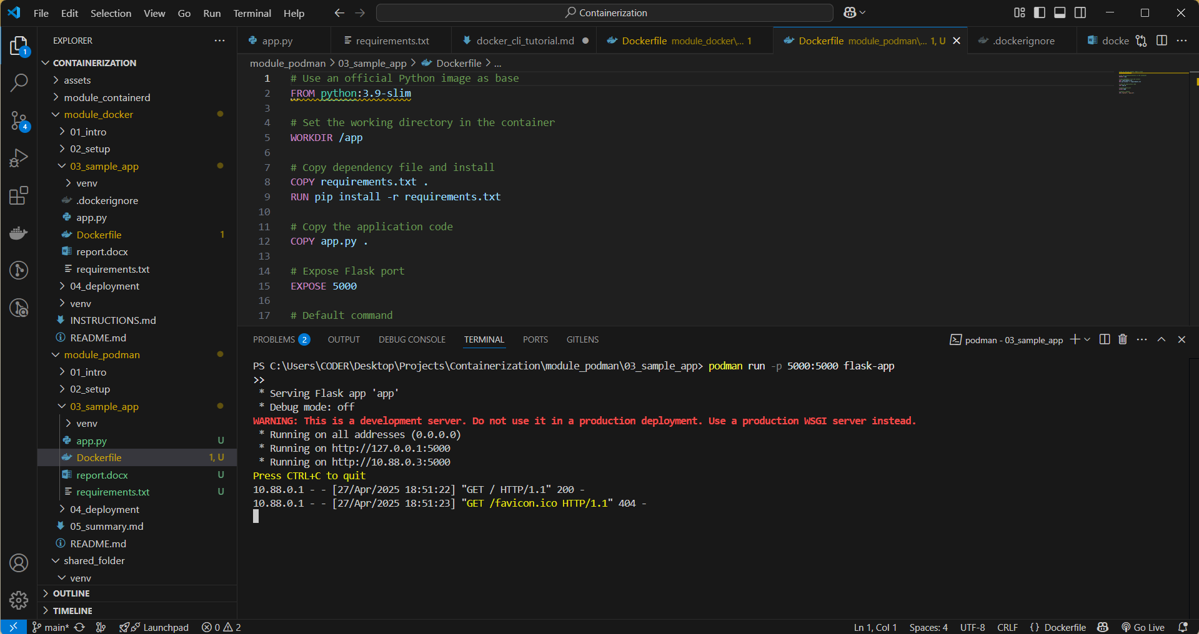

# 6. Conclusion

This project successfully demonstrates how to use Podman to build and run containerized applications. The learning experience highlighted the importance of configuring environment variables, resolving runtime errors with the Podman machine, and ensuring correct file placement for Dockerfile-based builds.