# Flask App Setup and Testing in Shared Folder

## Step 1: Creating and Activating a Virtual Environment

We used Python's built-in `venv` module to create a virtual environment. This environment isolates dependencies to avoid conflicts with global Python packages.  
  
Commands used:

python -m venv venv

.\venv\Scripts\Activate.ps1

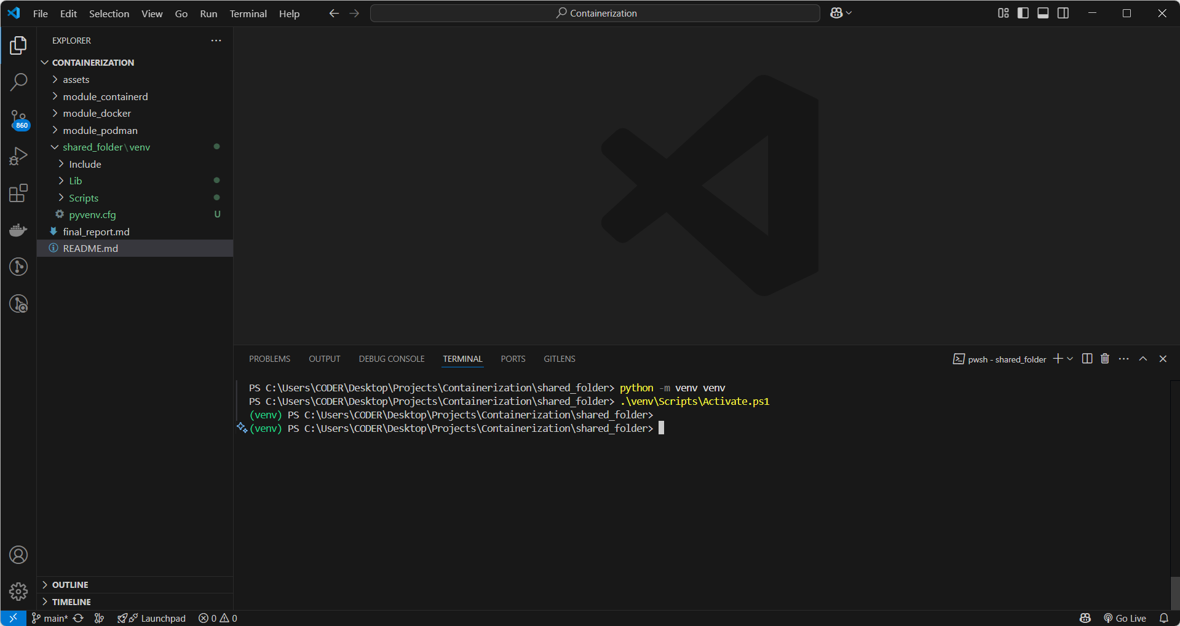

## Step 2: Installing Flask Using requirements.txt

We created a `requirements.txt` file containing the Flask package and installed it with pip.  
  
Command used:

pip install -r requirements.txt

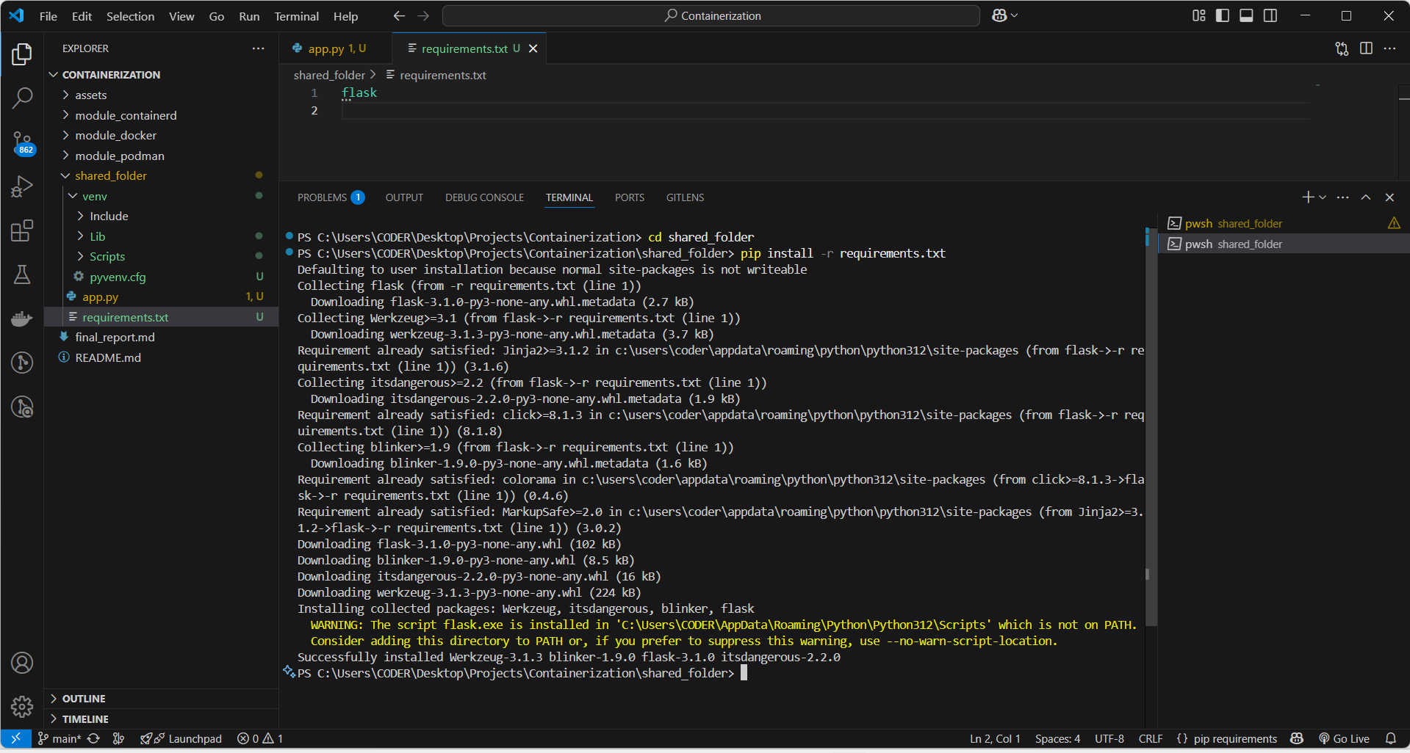

## Step 3: Running the Flask App

After installation, we ran the Flask app using Python. The output shows the development server started successfully and is listening on port 5000.

python app.py

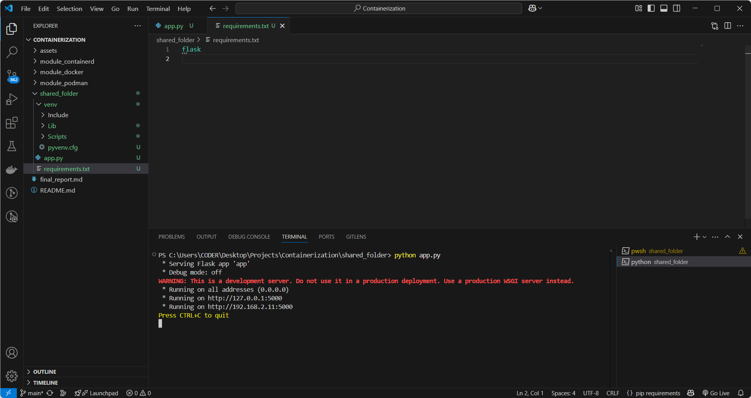

## Step 4: Verifying the App in Browser

We opened a web browser and visited http://127.0.0.1:5000 to verify that the app displays 'Hello from Dockerized Flask App!'.

