SAP Integration Lab Assignment Report

# Introduction

This report documents the steps and findings from an in-class assignment designed to explore SAP integration concepts using the SAP Business Accelerator Hub. The activity involved hands-on interaction with the Sales Order (A2X) OData API, exploring the IDoc structure, and designing a basic integration flow architecture.

# Task 1: OData API Simulation

The student navigated to SAP Business Accelerator Hub and searched for 'Sales Order (A2X)' API. After registration and activation of a sandbox environment, the student ran a GET request for Sales Orders.

The following screenshots capture the key steps of the process:

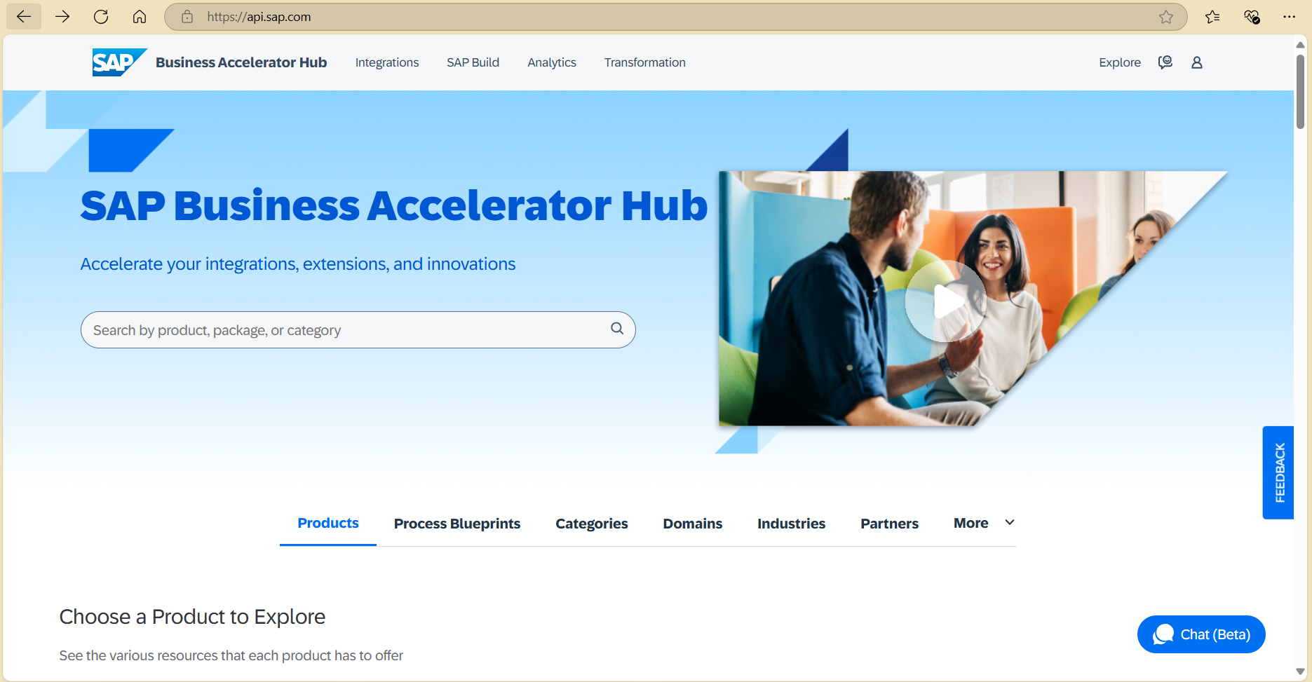

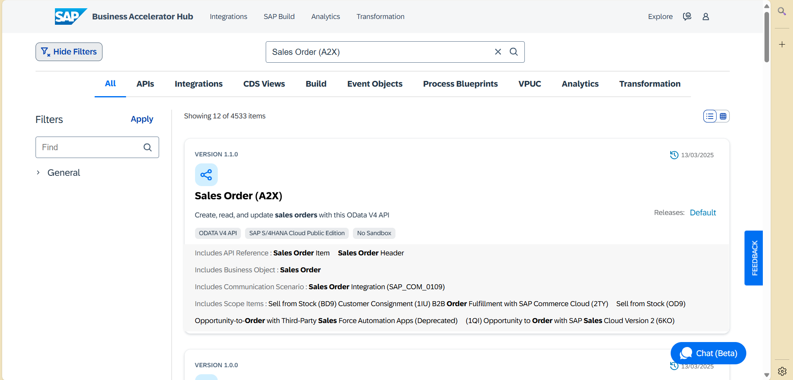

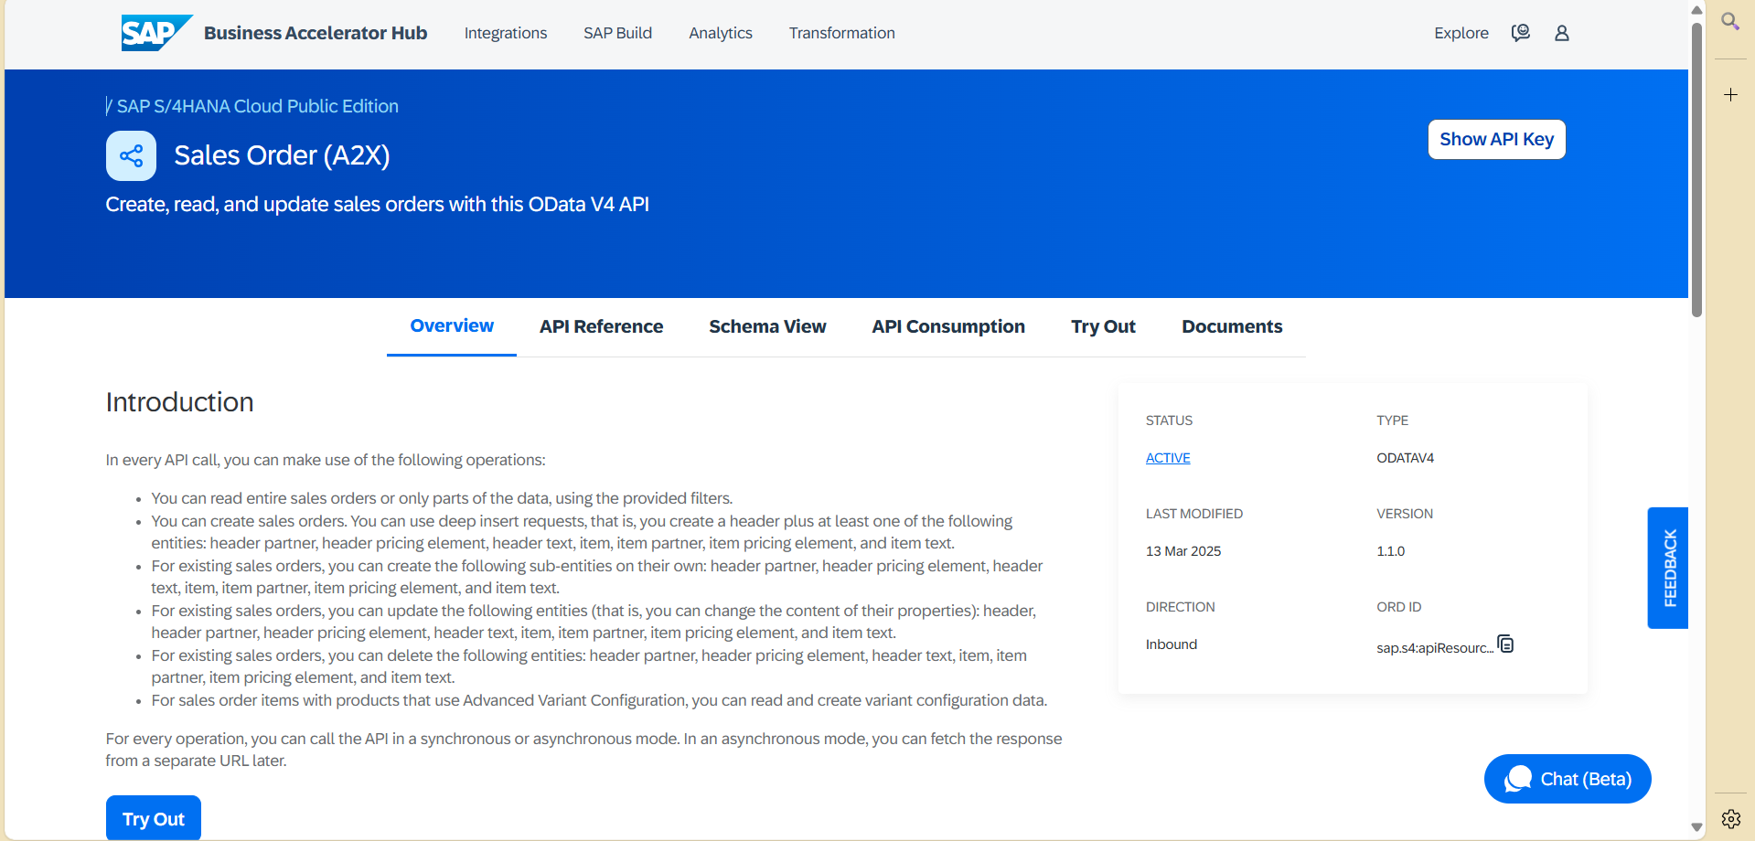

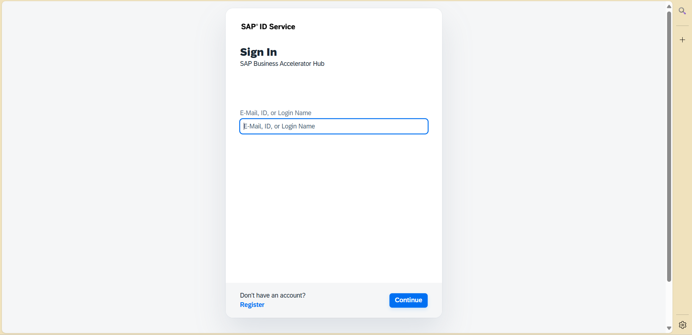

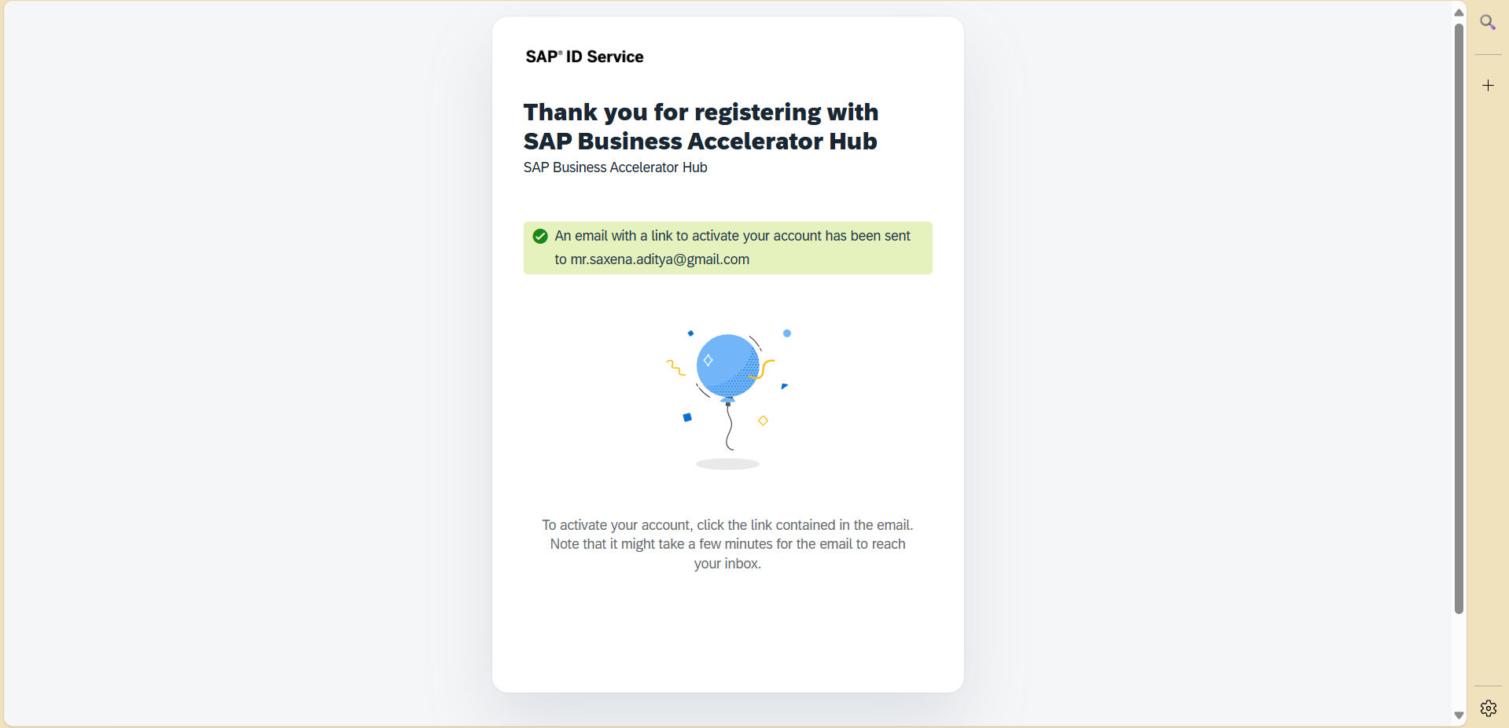

📝 Questions & Answers

• What are the key fields returned?

SalesOrder, SalesOrderType, SoldToParty, SalesOrganization, CreationDate

• What HTTP status code indicates a successful call?

200 OK

• How could you use this data in an external logistics app?

This data could trigger shipment workflows, confirm order dispatch to warehouses, or notify customer service about order progress.

# Task 2: IDoc Structure Exploration

The ORDERS05 IDoc structure was explored using SAP Help Portal. Key segments identified:

• E1EDK01 – Document Header  
• E1EDP01 – Item Level

Mapping to ANSI X12 850 standard:

• E1EDK01 → BEG, N1  
• E1EDP01 → PO1

# Task 3: Integration Flow Design

A basic 3-tier architecture was proposed using Draw.io (not included in this document).

Suggested Flow:

Web App → API Gateway → SAP S/4HANA → Message Broker (Kafka/RabbitMQ)

# System Interaction: API Try Out & Response

