JASP

Ruth V. Walker

Julie Madden

The University of Tennessee at Chattanooga

**Abstract**

Jeffreys' Amazing Statistics Program (JASP) was originally developed to make Bayesian statistics more accessible, provide a free alternative to SPSS, and to create software with a user-friendly interface (EFPSA, 2015). Although JASP is typically discussed as statistical software for teaching undergraduate statistics courses in psychology, we hope to convince you of JASP’s utility for advanced statistical analyses – particularly Bayesian analyses. This chapter provides an overview of JASP features and available analyses, comparing it to similar statistical programs like Jamovi, IBM SPSS, and R with R console. We highlight its strengths in real-time analysis, data visualization, and open science integration, making it a valuable tool for both educational and professional use. Additionally, we include step-by-step walk-through examples of both frequentist and Bayesian factorial ANOVA and multiple regression, illustrating the capabilities of the software. Furthermore, valuable tips and resources are provided to enhance your experience and effectiveness in using JASP for complex statistical analyses.

**Introduction**

When our department was considering changes to the statistical software we incorporate into our undergraduate courses, we explored a variety of different statistical programs, including SPSS, JASP, Jamovi, and R. We ultimately choose Jeffreys' Amazing Statistics Program (JASP) for three main reasons: it was free for students, featured a user-friendly graphical interface, and faculty familiar with other statistical programs could begin using it without training. Our hope as instructors was that it would allow us the opportunity to focus more on conceptual understanding of when to use a particular statistical test, how to check assumptions, how to interpret the results, and how to write up the results in APA format. However, it quickly became our preferred software for our own analyses due to the advanced options it provides compared to the programs we previously deferred to (i.e., SPSS, R). If you already have experience using statistical software with a graphic user interface (GUI), the training curve needed to successfully navigate and analyze data with JASP is essentially flat. With large buttons labeled “Descriptives,” “T-Tests,” “ANOVA,” “Mixed Models,” “Regression,” “Frequencies,” and “Reliability,” conducting familiar analyses is intuitive. In fact, when demonstrating the Bayesian options to graduate students who recently learned how to run analyses in R, they were shocked at the ease with which the same analyses could be completed. Overall, JASP has given us as instructors and researchers the ability to focus more on interpretation and write-up, rather than feeling tied down with the minutia of coding and programming.

Developed by Jonathon Love and the JASP team, JASP was originally developed to make Bayesian statistics more accessible, provide a free alternative to SPSS, and to create software with a user-friendly interface (EFPSA, 2015). Initial funding was sourced from a European Research Council grant E.J. Wagenmakers received to develop a software package that included Bayesian methods. The goal was to provide a tool that combines both basic and advanced statistical techniques without the learning curve associated with alternative open-source options such as R programming language to facilitate collaboration and accessibility (Love et al., 2019). JASP integrates specialized features like Bayesian statistics alongside frequentist statistics, making it versatile for conducting analyses and promoting statistical understanding across different fields. Today, JASP continues to grow with regular updates based on extensive feedback from the JASP user community (e.g., GitHub, social media, forums) and can be expanded with modular extensions to add additional analyses and features.

JASP offers a variety of specialty features, making it useful for both learning and professional use. It includes real-time analysis, updating your results instantly as you change parameters (Wagenmakers et al., 2023). This is great for seeing the effects of changes right away. You can also annotate your analyses directly within the software, making it easy to collaborate and keep track of your steps and thoughts. JASP also offers many data visualization options, like histograms, bar charts, box plots, and scatter plots, helping you see patterns and share your findings clearly (JASP, 2024). We enjoy using the raincloud plots (frequentist) and posterior distribution plots (Bayesian) to help visualize group distributions between conducting mean difference tests. There are also chart customization options (e.g., color, transparency, labels, titles, axis scale) to adjust as needed. Figure 1 illustrates descriptive statistics with annotations added and edits to both the analysis title and y-axis of the boxplot for an Open Science Framework data set (de Lima, 2019).

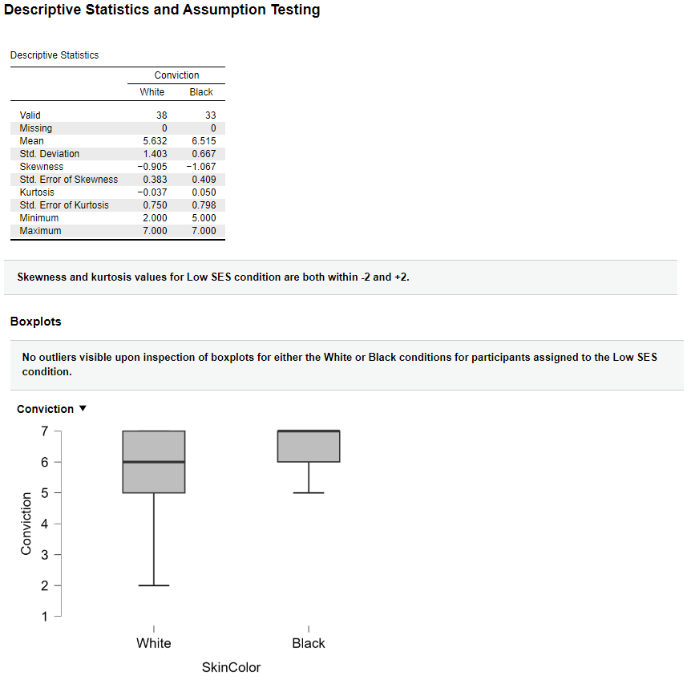

Figure 1 Illustration of JASP annotation and editing functions with descriptive statistics output.

One popular past criticism of JASP was the inability to manipulate data within the software; however, recent updates allow for increased data management. The software has a spreadsheet-like view for data editing, as well as the ability to synchronize changes if a file being edited in Excel, for example, is opened in JASP. Other features facilitate collaboration between researchers using different software programs. For example, JASP can open files saved as Comma-Separated Values (CSV) files (.csv), text files (.txt, .tsv), Excel files (.xls, .xlsx), SPSS files (.sav, .por), Stata files (.dta), SAS files (.sas7bdat, .sas7bcat, .xpt), and OpenDocument Format (.ods; JASP, 2024a). Results and charts can be exported in various formats as well (e.g., PDF, HTML, PowerPoint, and image files) to simplify collaboration. This philosophy of ensuring data is accessible is further exemplified by the ability to link analyses to Open Science Framework (OSF).

For educators and those interested in either brushing up on their statistical skills or learning new ones, JASP includes helpful resources like tutorials, templates, and example files to guide beginners (i.e., Learn Stats, Learn Bayes). Further, the JASP Voluntary Product Accessibility Template (2023) notes several accessibility features. These include the ability to resize text, zoom, and use keyboard navigation to help users interact with the software. However, there are still areas in the software that cannot be fully navigated using the keyboard alone, leading to potential "traps" where users can get stuck in certain parts (e.g., text boxes). Additionally, JASP does not currently support screen readers, which are essential tools for visually impaired users. Thus, although JASP has some accessibility features, it may still present difficulties for users who are blind or have severe motor impairments. JASP also added automatic software updates to ensure users have access to the latest features. Please see Table 1 for a listing of popular features and analyses available with JASP.

**Table 1**

**Overview of JASP Features and Analyses**

|  |  |  |  |
| --- | --- | --- | --- |
| **Category** | **Feature/Functionality** | **Description** | **Analyses** |
| **General Features** | Real-Time Analysis | Results update immediately as parameters are adjusted, providing instant feedback. |  |
|  | User-Friendly Interface | Intuitive design that simplifies navigation and analysis execution. |  |
|  | Data Editing | Allows direct editing and management of data within JASP. |  |
|  | Integration with Open Science Framework (OSF) | Facilitates open science practices by linking analyses directly to OSF. |  |
|  | Output Export Options | Export results and visualizations in various formats (PDF, HTML, image files). |  |
| **Descriptive Statistics** | Descriptive Statistics | Provides measures of central tendency and variability. | Mean, Median, Standard Deviation |
| **Frequentist Statistics** | *t*-Tests | Compares means between groups. | Independent samples, Paired samples, one-sample |
|  | ANOVA | Analyzes differences among group means. | One-way ANOVA, Repeated measures ANOVA, Factorial ANOVA, ANCOVA, MANOVA |
|  | Regression Analysis | Examines relationships between variables. | Linear regression, Multiple regression |
| **Bayesian Methods** | Bayesian t-Tests | Bayesian approach to comparing group means. | Independent samples, Paired samples, one-sample |
|  | Bayesian ANOVA | Bayesian approach to analyzing group mean differences. | One-way ANOVA, Repeated measures ANOVA, Factorial ANOVA, ANCOVA |
|  | Bayesian Regression | Bayesian approach to examining variable relationships. | Correlation, Linear regression, Logistic regression |
| **Reliability Analysis** | Reliability Analysis | Assesses the consistency of a set of measurements or instruments. | Cronbach's alpha |
| **Data Visualization** | Graphical Displays | Creates various types of graphs for data exploration and presentation. | Histograms, Bar charts, Box plots, Scatter plots |
| **Structural Equation Modeling (SEM)** | Examines complex relationships among variables using latent constructs. | SEM models |  |
| **Teaching Tools** | Learn Bayes  Learn Stats | Modules designed to teach Bayesian and frequentist statistics interactively. | Bayesian concepts tutorials, Normal distribution, Central limit theorem |
| **Customization and Extensibility** | Modular Extensions | Extend functionalities by adding specific modules tailored to research needs. | Additional statistical tests, Custom analyses (e.g., mediation and moderation, multilevel modeling, meta-analysis, network analysis, latent class analysis, item response theory, survival analysis) |
| **Accessibility** | Partial Keyboard Navigation  Resize Text | Partially supports navigating through the software using only the keyboard. |  |

**Comparison to Other Statistical Program**

JASP, Jamovi, and R with RStudio are all free, open-source options that provide user-friendly interfaces and are designed to be more accessible compared to IBM SPSS. Compared to JASP, Jamovi, stands out for its accessibility and data management options. For instance, Jamovi provides cloud plans for users to access the software through a web browser. They offer a free guest plan with limited availability and session restrictions, as well as paid plans that offer priority access and more robust features.

Based on the provided Voluntary Product Accessibility Templates for Jamovi (2024) and IBM SPSS (2024), they both have broader support for accessibility compared to JASP, especially for users with visual impairments, providing better support for screen readers and keyboard navigation. Additionally, both programs have enhanced data management and editing capabilities. Personally, we clean and organize our data in either Excel (using synchronization with JASP) or in IBM SPSS. However, SPSS is cost prohibitive for many researchers without financial licensing support, has less frequent updates, a slightly less intuitive GUI, may require more complex navigation or syntax use for advanced analyses, and has very limited Bayesian analysis options.

R with RStudio offers extensive flexibility and customization, supporting a wide range of analyses through various packages. It has a user-friendly GUI and RStudio Cloud, which provides free and paid plans for cloud-based use. RStudio also has extensive data manipulation packages (dplyr, tidyr) that also make it a stronger option for data editing. However, it requires learning to code, which can be a steep learning curve for beginners.

In summary, Jamovi and JASP are excellent free, user-friendly alternatives to IBM SPSS, with Jamovi excelling in data management and accessibility. However, JASP is catching up in data management capabilities and exceeds Jamovi in both Bayesian methods and open science integration. R with RStudio is ideal for those seeking extensive customization and willing to invest time in learning to code, offering the most flexibility among these options.

***Integration with R Console***

Although JASP operates with a simplified graphical user interface, it uses R packages behind the scenes to conduct analyses. This allows a wider range of complex statistical computations without burdening users with engaging in R code. JASP offers the option to write and execute R scripts directly within the software, providing flexibility to combine JASP's ease of use with the customizability and power of R programming (van Doorn, 2023). Although JASP is written in C++ and QLM, the analyses themselves are written in R and use many packages from CRAN (Wagenmakers et al., 2023). As researchers that have used a variety of statistical software, we like to compare JASP and R using the following analogy. A truck and a C class RV may have the same engine, but one is vastly more enjoyable to be stuck in for an afternoon. Since the release of JASP 0.17, it is possible to generate R code within the JASP environment.

The ability to generate R code in JASP has several benefits for instructors as well as students. First, the generated R code can be shared, allowing for transparency of settings used in the analysis process. This allows instructors to see where errors may have occurred, and it is great for transparency within research and replication efforts (e.g., Open Science Framework). Secondly, changes to the code immediately make changes to the GUI, and vice versa. Often, students report difficulty when going from a point-and-click interface to a syntax interface (e.g., R). This feature allows the learner to see how changes to the code modify changes to the selected interface options, or how the selection of a post-hoc test option in the GUI changes the syntax. This should flatten the steep learning curve for students as they transition to a primarily syntax method of data analysis. A third consideration is the beautiful tables, charts, and plots that JASP can create with ease. You can use your R syntax, and then quickly swap to the GUI to create APA formatted data components that can be incorporated directly into your manuscript. Currently, the JASP generated R code can be used in R Console, but not in R Studio.

***Frequentist Factorial ANOVA***

For our walk-through example, we will be using data from a study conducted by de Lima and colleagues (2019) examining how social class indicators affect judgments of Black and White people accused of a crime. In Study 1, de Lima and colleagues (2019) hypothesized that study manipulations that signaled a lower social class (i.e., driving a Fiat Uno 45) versus the control condition (i.e., vehicle), would increase participant agreement with the conviction of Black targets but not White ones. The study included 160 Portuguese undergraduate students randomly assigned to one of four conditions in a 2 (skin color: Black or White) x 2 (socioeconomic class: lower or control) factorial design. Students were asked to read a vignette about a suspect who attempted to bribe a police officer and were then asked to indicate their level of agreement with convicting the suspect. Skin color was manipulated through a photo of the suspect, which showed either a black or white individual. For more information about the study methods and design, please refer to the original article (de Lima et al., 2019) and Open Science Framework registration (de Lima, 2019).

For the purposes of this tutorial, we will be analyzing data from the first study. Students rated their agreement with the suspect’s conviction, the dependent variable, on a scale from 1 (*strongly disagree*) to 7 (*strongly agree*). Both study factors, class and skin color, are dichotomous.

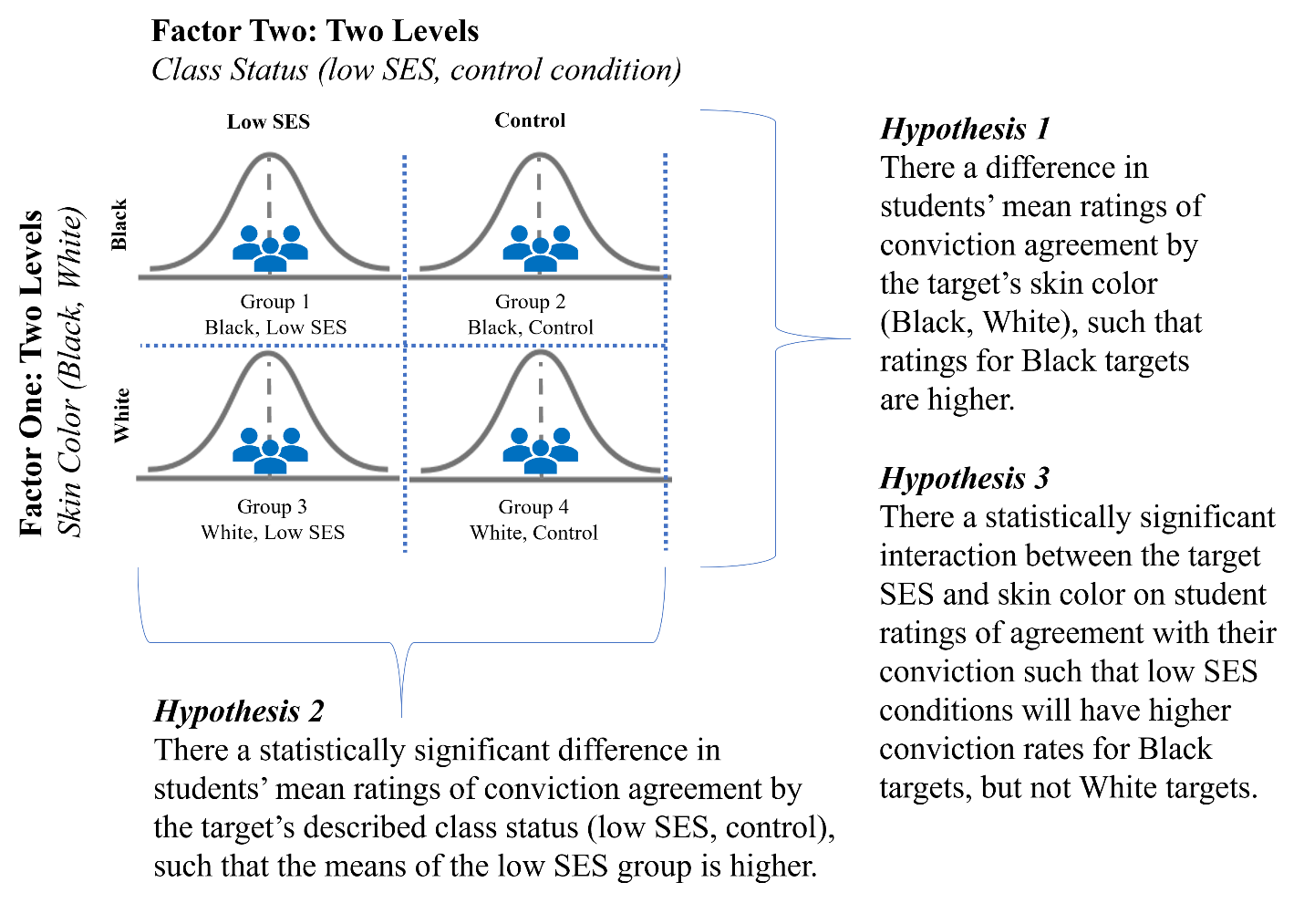

Figure 2 de Lima et al (2019) study one design and hypotheses.

To conduct a 2x2 factorial ANOVA in JASP, you first want to open JASP and load your dataset by clicking on the three horizontal lines in the top, lefthand corner of the JASP screen. From there, you can navigate to “Open,” “Computer,” and “Browse” to locate the appropriate file. Next, label the levels of your factors to make it easier to interpret results. To do so, double click on the variable names (SkinColor and SocialClass). From there, you can change the labels for each variable value.

* + Skin Color: White = 1; Black/Negro = 2
  + Social Class: Control = 1; Low SES = 2

Prior to conducting a factorial ANOVA, check to ensure the data meet the assumptions required to be appropriate for this analysis. Namely, you want to ensure the dependent variable is normally distributed (e.g., skewness and kurtosis statistics between -2 and +2, distribution plots), homogeneity of variances (e.g., Levene’s test > .05), and no outliers. For additional information about how to conduct assumption testing for a factorial ANOVA in JASP, please see Walker and colleagues (2021) step-by-step instructions.

To proceed with the primary analyses, click on the “ANOVA” menu, select "ANOVA" under the Classical menu, and input your variables. “Conviction” will be moved to the “Dependent Variable” box. “SkinColor” and “SocialClass” will be moved to the “Fixed Factors” box. Additionally, you will click on the following options:

* Under “Display” click the boxes for “Descriptive statistics” and “Estimates of effect size.” JASP has the option of reporting eta-squared, partial eta-squared, and omega-squared effect sizes. Although de Lima and colleagues (2019) reported partial eta-squared in their publication, we will report omega-squared as past statisticians have noted it provides a more accurate estimate of the population effect size by adjusting for sample size and reducing overestimation bias (Field, 2013; Lakens, 2013).
* Under “Assumption Checks” we will check the box next to “Homogeneity tests.” This will provide us with a test for the equality of variances, an assumption that is checked during your primary analyses.

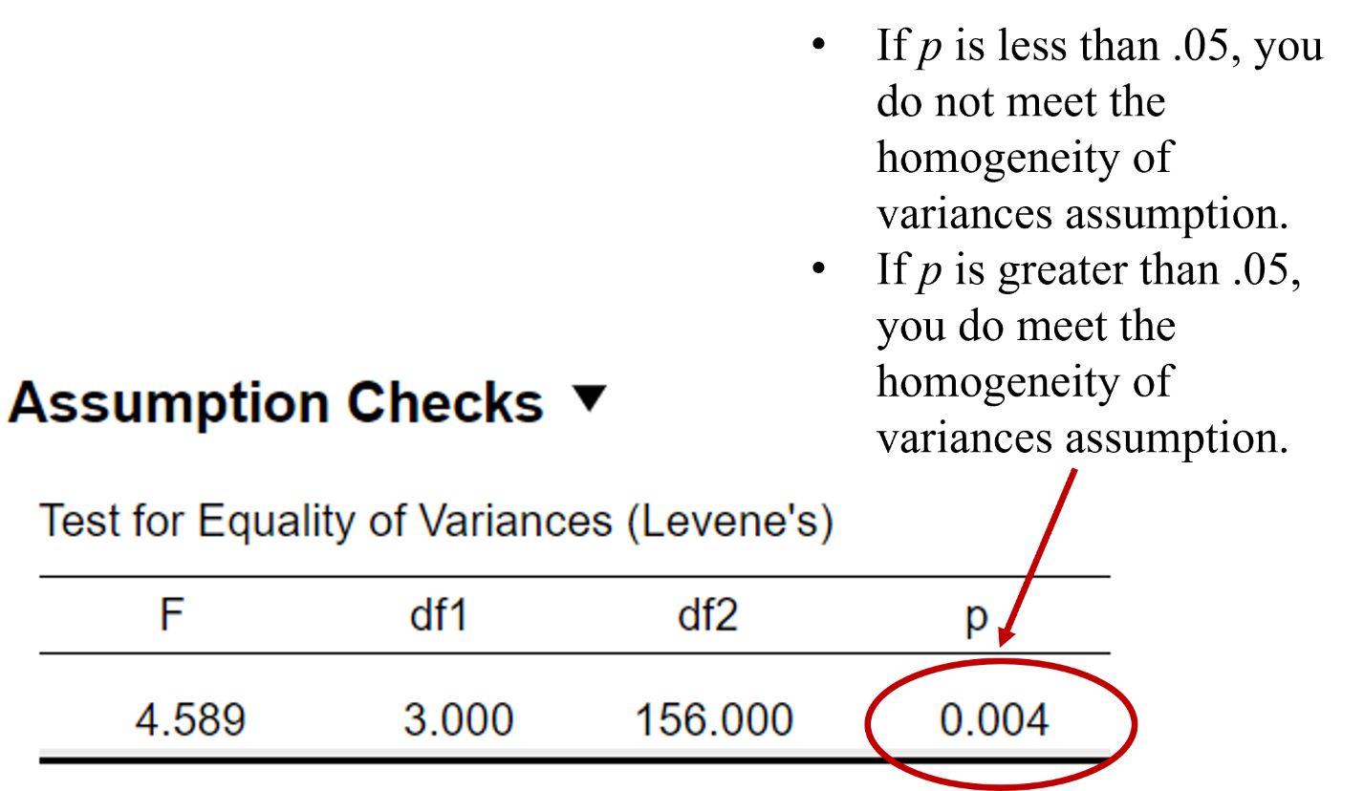

Figure 3 Levene's test of equality of variances.

Unfortunately, the Levene’s test for equality of variances was significant, meaning we do not meet this assumption (*p* < .05). Arguably, the two-way ANOVA is robust against this violation when there is roughly equal number of participants in each group (Maxwell & Delaney, 2004). For this example, the sample sizes for each condition are 54, 33, 35, and 38; thus, it may be a subjective decision whether we meet the necessary conditions (i.e., balanced group sizes) to consider the analyses robust to continue.

**To interpret the results of the omnibus ANOVA test, we will first look at the *p* values and effect sizes for both factors and the interaction. Figure 3 includes the results table with output we will be focusing on for the purpose of this example. For the main effect of factor one (skin color), factor two (social class), and interaction, if *p* is less than our alpha level of .05, we will reject the null hypothesis.**

* **Hypothesis One: There is no significant statistical difference between the group means of our first factor, skin color (*p* = .23). Because our *p* value is greater than our alpha level of .05, and the omega-squared effect size is .00, we fail to reject our first null hypothesis. We do not have a main effect of skin color on students’ levels of agreement with target conviction.**
* **Hypothesis Two: There is no significant statistical difference between the group means of our second factor, social class (*p* = .84). Because our *p* value is greater than our alpha level of .05, and the omega-squared effect size is .00, we fail to reject our second null hypothesis. We do not have a main effect of social class on students’ levels of agreement with target conviction.**
* **Hypothesis Three: There is a significant interaction between skin color and social class (*p* < .001). Because our p value is less than our alpha level of .05, and our omega-squared effect size is medium (**ω2= .07), **we reject our third null hypothesis. We do have a significant interaction between skin color and social class on student levels of agreement with target conviction.**

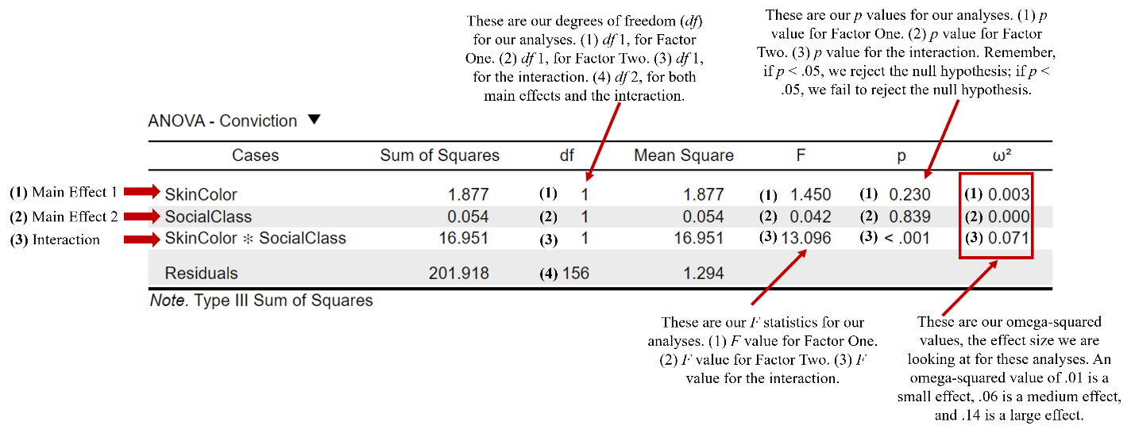

Figure 4 2x2 Factorial ANOVA Omnibus Test Results.

**A significant interaction means we will need to proceed with post-hoc tests to understand and interpret the results. To address this, we will take two steps: (1) plot the means of each cell in our interaction to visualize the data, and (2) perform post-hoc tests known as simple main effects. To ask JASP to generate an interaction graph, in the same ANOVA analysis window, click on “Descriptive Plots.”**

* **Move Skin Color to the “Separate Lines” box. This will graph our first factor, skin color, as two separate lines on the graph.**
* **Move Social Class to the “Horizontal Axis” box. This will place our second factor, social class, on the x-axis of the graph.**
* **Click “Display error bars.”**

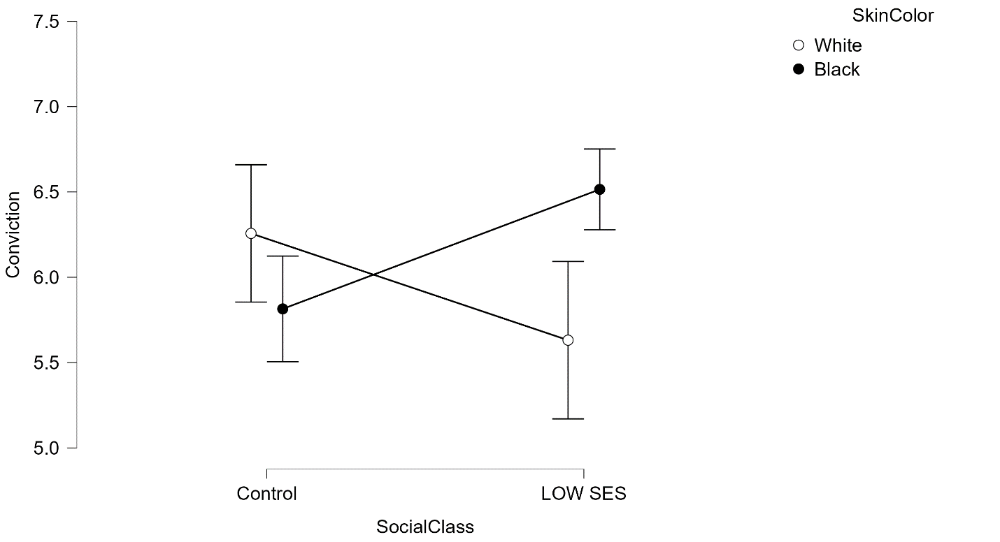

Figure 5 Interaction Plot: Social Class and Skin Color with Means and 95% Confidence Intervals.

The descriptives plot with the means and confidence intervals of the error can help you visualize the interaction. In this example, the overlap between the means and confidence intervals for the level of student agreement with conviction in the control condition appears to be similar for both the White and Black conditions. However, the lack of overlap of the error bars in the low socioeconomic status condition between the White and Black conditions indicate that the mean levels of conviction agreement are going to be significantly different. To determine if this is accurate, we must conduct simple main effects. However, let’s look at the raincloud plots as well. To create raincloud plots in JASP, you will click on the “Raincloud Plots” menu **in the same ANOVA analysis window. From there, you can choose which factor you would like on the horizontal axis and separate plots, as well as whether you would like a horizontal versus vertical display.** For this walk-through, I placed social class on the horizontal axis, skin color in separate plots, and chose horizontal display. Looking at the raincloud plots in Figures 6 and 7, the distribution of conviction agreement for the low SES White target and the Black target in the control condition appear very similar, as do the distributions for the White control group and the low SES Black group.

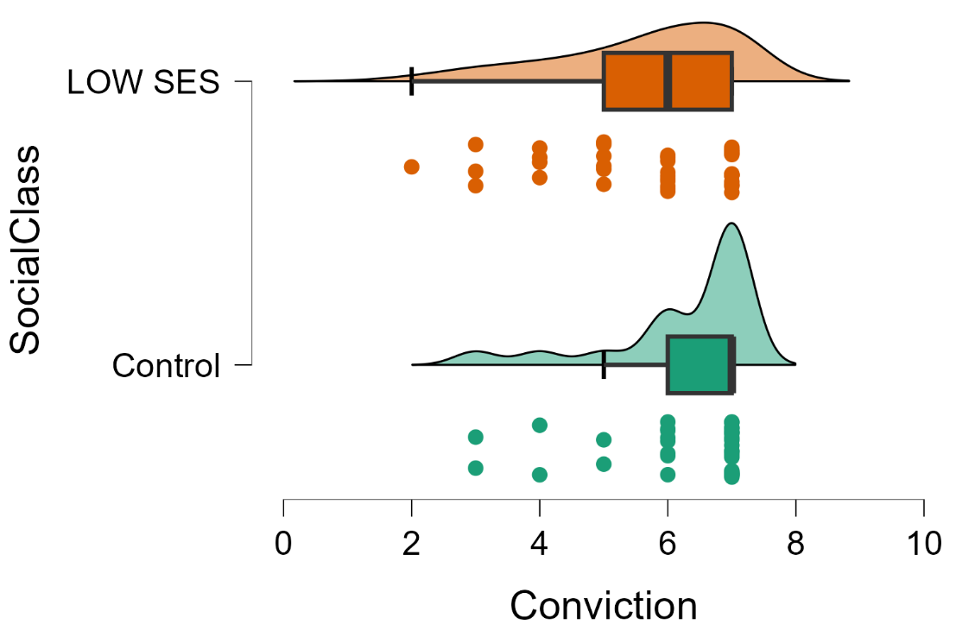

Figure 6 Raincloud plot displaying the conviction agreement distribution for the Low SES and control conditions for White targets.

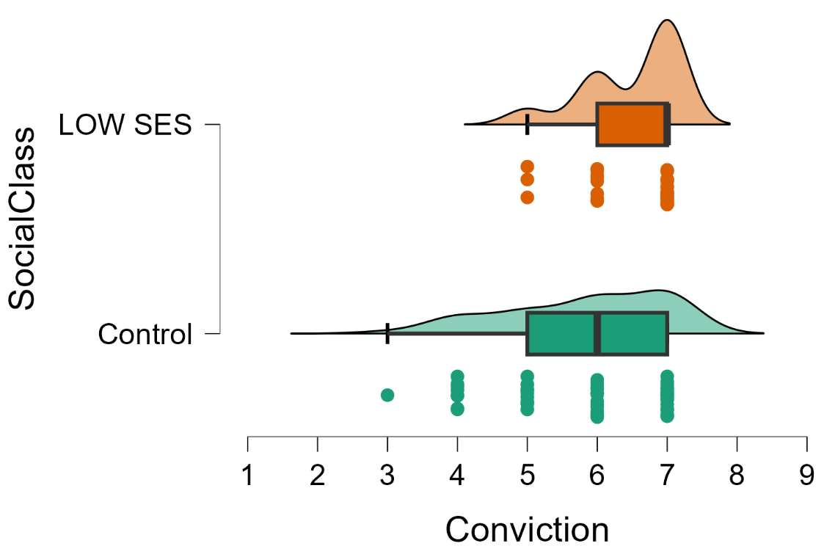

Figure 7 Raincloud plot displaying the conviction agreement distribution for the Low SES and control conditions for Black targets.

In de Lima and colleagues’ (2019) published paper, they conducted pairwise comparisons to probe the interaction instead of simple main effects. This may be because they used SPSS to run their analyses (based on the .sav files they have uploaded on Open Science Framework). Although SPSS can run simple main effects using syntax, it does not currently have the capacity to run them using the point-and-click interface. However, a simple main effect is a more commonly used and recommended method for probing an interaction by examining the impact of one factor at a specific level of another factor (Abelson & Prentice, 1997; Field, 2013). Thus, we will deviate from de Lima and colleagues (2019) to conduct simple main effects in JASP. For our example, a simple main effect would analyze the effect of skin color at each level of social class. For example, the first simple main effect would assess whether there are differences in the mean level of conviction agreement between the White and Black targets for each social class condition. Similarly, a second simple main effect would evaluate whether there are differences in the mean level of conviction agreement between the control and low SES conditions for both skin color conditions. To run this in JASP, **in the same ANOVA analysis window, click on “Simple Main Effects.”**

* **Move Skin Color to the “Simple Effect Factor” box.**
* **Move Social Class to the “Moderator Factor 1” box.**

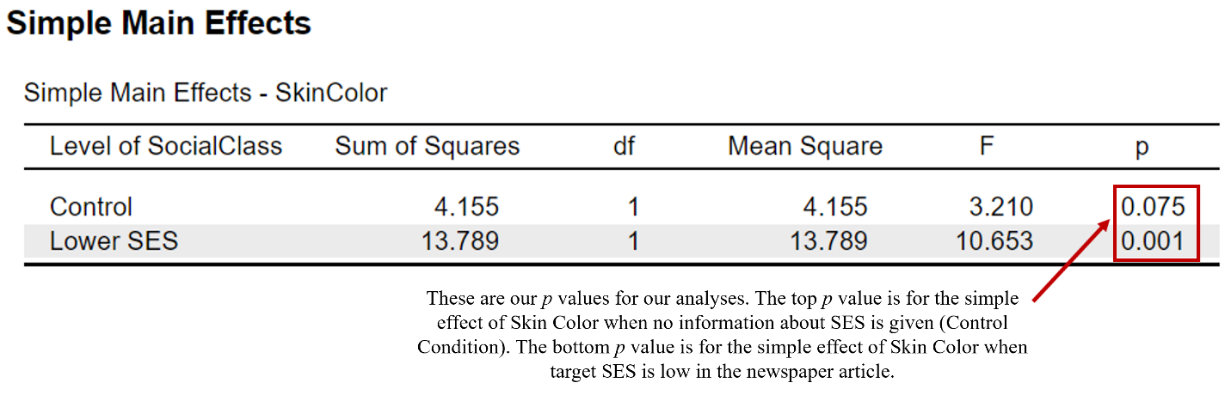

Figure 8 Simple Main Effect of Skin Color by Social Class.

To interpret the simple main effect of skin color by each level of social class, we will look at the *p* values reported in Figure 8. There is no effect of skin color for the control social class condition (*p* > .05), meaning there is no statistical difference in the mean levels of conviction agreement between the White and Black targets in the control condition. However, there is an effect of skin color for the lower social class condition (*p* < .05). Return to the ANOVA analysis window, click on “Simple Main Effects,” and rerun the analysis with Social Class in the “Simple Effect Factor” box and Skin Color in the “Moderator Factor 1” box.

Figure 9 Simple Main Effect of Social Class by Skin Color.

**Looking at our second set of results in Figure 9, we can see there is an effect of social class for both the White target (*p* < .05) and the Black target (*p* < .05) conditions. Meaning, for both skin color target conditions, students rated their levels of agreement with conviction significantly different depending on whether they were in the control social class condition or the low social class condition for White targets *and* Black targets. By referring to our descriptives table (see Figure 10), we can see the mean level of conviction agreement is higher for Black targets in the low social class condition compared to the control condition; however, the opposite is true for White targets. The mean level of conviction agreement is lower for White targets in the low social class condition compared to the control condition.**

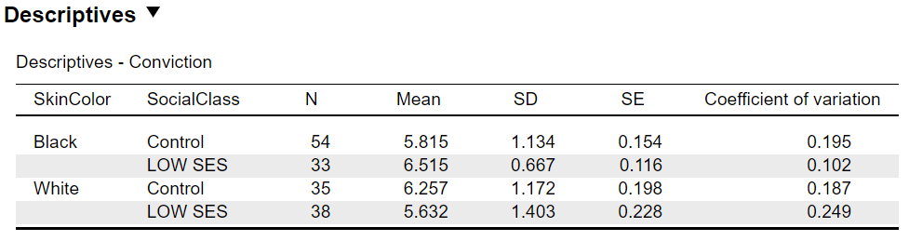

Figure 10 Descriptive Statistics for Study Conditions.

**Here is an example of how you can report the study results in APA format:**

**There was a statistically significant interaction between skin color and social class on level of conviction agreement, *F*(1, 156) = 13.09, p < .001, ω2 = .07. There was not a main effect of skin color on level of conviction agreement, *F*(1, 156) = 1.45, p > .05, ω2 = .00; there was also no support for a main effect of social class, *F*(1, 156) = 0.04, p > .05, ω2 = .00. After conducting analyses of simple main effects, there was not a significant difference in level of conviction agreement between White and Black targets in the control social class condition (*F*(1) = 3.21, p > .05), but there was a significant difference in the low social class condition (*F*(1) = 10.65, p < .001) such that student levels of conviction agreement were higher for Black targets (*M* = 6.52, *SD* = .67) compared to White targets (*M* = 5.63, *SD* = 1.40) in the low social class condition. The simple main effects for social class were significant between the control and low social class conditions for both the White (*F*(1) = 5.51, p < .05) and Black (*F*(1) = 7.76, p < .01) targets. Specifically, student levels of conviction agreement were higher for White targets in the control social class condition (*M* = 6.26, *SD* = 1.17) compared to the low social class condition (*M* = 5.63, *SD* = 1.40). Alternately, student levels of conviction agreement were higher for Black targets in the low social class condition (*M* = 6.52, *SD* = .67) compared to the control social class condition (*M* = 5.82, *SD* = 1.13).**

***Bayesian Factorial ANOVA***

In Bayesian statistics, the focus is on evaluating the strength of evidence for different models or hypotheses given the data, rather than strictly testing a null hypothesis. To write a Bayesian hypothesis for the de Lima and colleagues (2019) study, for example, we may say, “In this study, we hypothesize that the interaction model (SkinColor + SocialClass + SkinColor * SocialClass) will be the best-supported model to explain students' levels of agreement with convicting the suspect, as indicated by the highest posterior model probability and strongest Bayes factors.” Thus, Bayesian analyses do have hypotheses, but they are framed in terms of model comparison rather than null hypothesis testing. The focus is on evaluating which model the data supports most strongly, using posterior probabilities and Bayes factors to quantify the strength of evidence. For the current study, we will compare the null model (no effects) to the interaction model and models with only main effects (SkinColor or SocialClass).

To conduct our analyses, click on the “ANOVA” menu, select "ANOVA" under the Bayesian menu option, and input your variables. “Conviction” will be moved to the “Dependent Variable” box. “SkinColor” and “SocialClass” will be moved to the “Fixed Factors” box. Additionally, you will click on the following options:

* Under “Tables” click the boxes for “Descriptive statistics” and “Estimates of effect size.”
* Note that you can choose to edit the default option under “Order” to compare all models to the best model *or* you can change it to compare all models to the null model. For this example, we are going to select “Compare to null model.” You could also choose the default option, “Compare to best model,” as van den Bergh and colleagues (2023) did in their Bayesian repeated-measures ANOVA tutorial.

The first table we will be analyzing is the “Model Comparison” table in Figure 11. If you are new to Bayesian analyses, here is a breakdown of the information provided in this table.

* Models: This column lists the different models being compared. The first model is the “Null model” assumes no effect (only includes the intercept). This is followed by the interaction model which includes the main effects of skin color and social class, and their interaction (SkinColor + SocialClass + SkinColor * SocialClass). “SkinColor” includes only the main effect of skin color. “SocialClass” includes only the main effect of social class. Finally, “SkinColor + SocialClass” includes the main effects of both skin color and social class, but no interaction.
* Prior Model Probability (P(M)): This column shows the prior probability of each model. By default, JASP assigns equal prior probabilities to all models, which means each model is considered equally likely before analyzing the data. The Model Comparison table shows us each model was given an equal prior probability of .20 (20%) before the data were analyzed, indicating no initial preference for any model.
* Posterior Model Probability (P(M|data)): This column shows the probability of each model after considering the data. It is based on the Bayes factor and indicates the relative support for each model given the observed data. A higher posterior model probability means the data provides stronger evidence for that model. After considering the data, the “SkinColor + SocialClass + SkinColor * SocialClass” model has a posterior probability of 0.66 (66.1%), indicating strong support from the data. The null model has the second highest posterior probability value of .23 (23.4%). The other models have weak to very weak support, with posterior probability values between .01 – .05.
* Bayes Factor for Model Comparison (BFM): This column shows the Bayes factor for each model compared to the null model. Meaning, it quantifies how much more likely each model is compared to the null model. For example, the “SkinColor + SocialClass + SkinColor ✻ SocialClass” model is 7.81 times more likely than the null model. This suggests that considering both main effects and their interaction provides the most accurate explanation of the data.
* Bayes Factor (BF10): This column shows the Bayes factor comparing each model to the null model (often the simplest model without any effects). A BF10 value greater than 1 indicates evidence in favor of a given model compared to the null model, while a value less than 1 indicates evidence against it. The “SkinColor + SocialClass + SkinColor * SocialClass” model has the most support with a BF10 value of 2.83. The other models have much less support, with BF10 values between .04 - .23. You will notice the null model has a BF10 value of 1.0; this is because the null model is being compared to itself.
* Error Percentage (error %): This column shows the percentage of error in estimating the Bayes factor due to computational approximation. A lower error percentage indicates more precise estimates of the Bayes factors. If the error percentage is high, the results should be interpreted with caution. The relatively low error percentages (< .05) for the interaction model indicates a higher level of reliability in the estimation of Bayes factors.

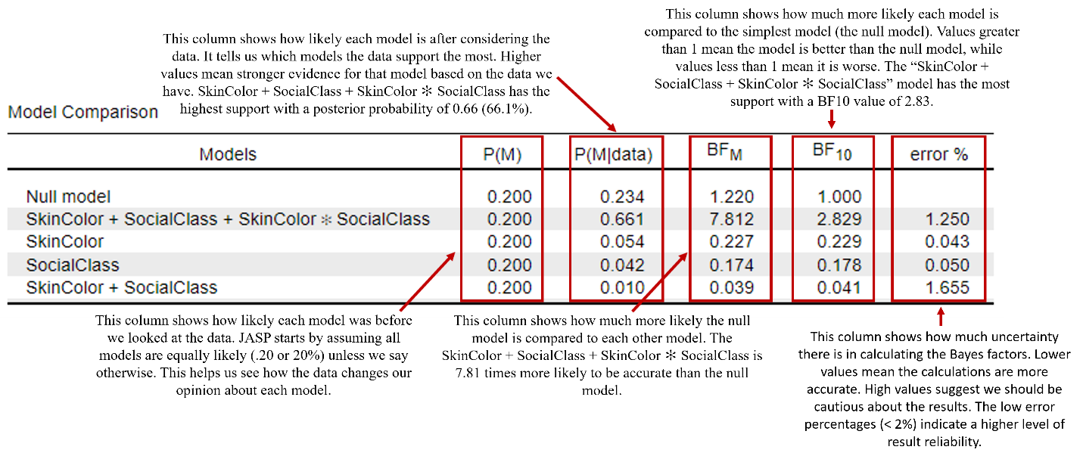

Figure 11 JASP model comparison table of null model compared to the interaction and main effect models.

Let’s also take a look at the analysis of effects, Figure 12, from our JASP results. This table tells us that skin color and social class are both likely to affect conviction rates, with moderate evidence supporting their inclusion in the model (SkinColor: P(incl|data) = 0.73, BFincl = 1.75; SocialClass: P(incl|data) = 0.71, BFincl = 1.65). More importantly, the interaction between skin color and social class has strong evidence (P(incl|data) = 0.66, BFincl = 7.81), supporting our hypothesis that the effect of social class on conviction rates significantly depends on skin color, and vice versa.

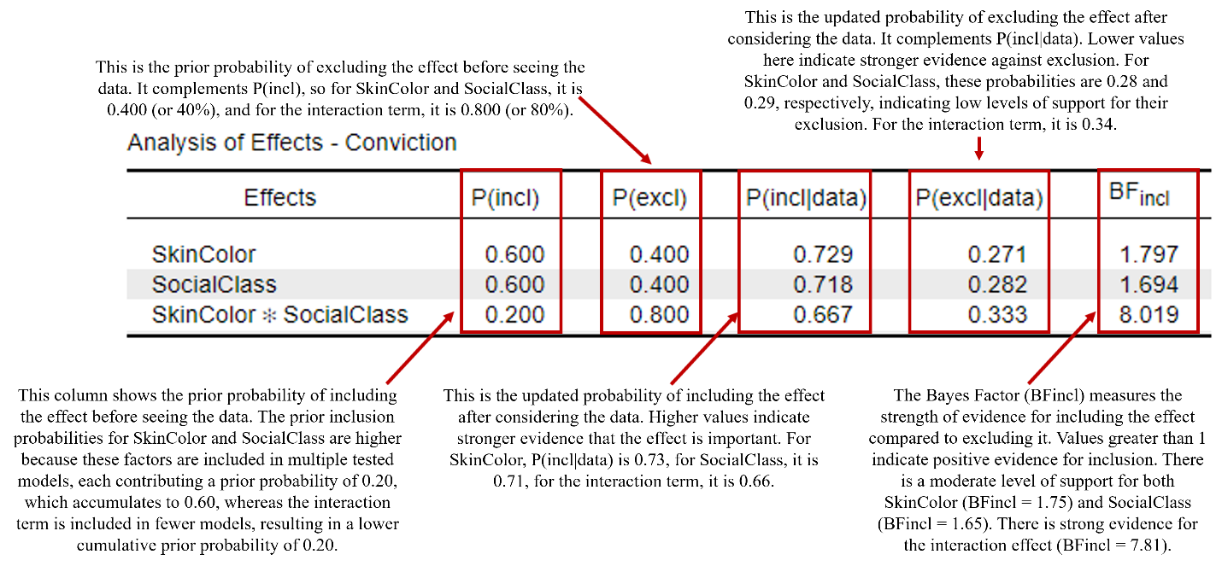

Figure 12 JASP Analysis of Effects Table.

Now that we know the interaction model has the highest probability of being the best model, we will conduct further analyses to understand what is driving the interaction. JASP does not currently have the functionality to conduct simple main effects for Bayesian ANOVA. Thus, we will analyze the descriptives plots, credible intervals, and parameter estimates. However, note that Bayesian *t*-tests using a Bonferroni correction are also recommended (van den Bergh et al., 2020). We already have the credible intervals and parameter estimates in our single model posterior summary table; however, we still need to plot the interaction.

* To visualize the interaction effect, we will create an interaction plot in JASP. To do this, navigate to the "Descriptives Plots" tab.
  + Place “SocialClass” in the “Horizontal Axis” box and “SkinColor” in the “Separate Lines” box.
  + Check the box to display the “Credible interval.” JASP defaults to displaying the 95.0% credible interval, which provides a range where we are 95% confident that the true interaction effect lies.

| **Table 2**  **JASP Single Model Posterior Summary Table** | | | | | | | | | | | |
| --- | --- | --- | --- | --- | --- | --- | --- | --- | --- | --- | --- |
|  | | | | | | | | **95% Credible Interval** | | | |
| **Variable** | | **Level** | | **Mean** | | **SD** | | **Lower** | | **Upper** | |
| Intercept |  |  |  | 6.052 |  | 0.092 |  | 5.876 |  | 6.236 |  |
| SkinColor |  | White |  | -0.095 |  | 0.085 |  | -0.253 |  | 0.074 |  |
|  |  | Black |  | 0.095 |  | 0.085 |  | -0.074 |  | 0.253 |  |
| SocialClass |  | Control |  | -0.016 |  | 0.085 |  | -0.179 |  | 0.153 |  |
|  |  | Low SES |  | 0.016 |  | 0.085 |  | -0.153 |  | 0.179 |  |
| SkinColor ✻  SocialClass |  | White & Control |  | 0.304 |  | 0.092 |  | 0.114 |  | 0.487 |  |
|  |  | White & Low SES |  | -0.304 |  | 0.092 |  | -0.487 |  | -0.114 |  |
|  |  | Black & Control |  | -0.304 |  | 0.092 |  | -0.487 |  | -0.114 |  |
|  |  | Black & Low SES |  | 0.304 |  | 0.092 |  | 0.114 |  | 0.487 |  |
|  | | | | | | | | | | | |

The model averaged posterior summary displayed in Table 2 provides estimates for the effects of skin color, social class, and their interaction on level of conviction agreement. The intercept provides the baseline conviction rate, 95% Credible Interval [5.88, 6.24]. The main effects of skin color and social class individually are not significant as all their credible intervals include zero. However, the interaction between skin color and social class has significant effects, with credible intervals that do not include zero for the White, control condition (95% Credible Interval [.11, .49]) and the Black, low SES condition (95% Credible Interval [.11, .49]), both of which are associated with higher conviction agreement compared to the White, low SES and the Black, control conditions.

This plot shows the density distributions for the interaction effects of SkinColor and SocialClass on conviction rates. Black & Control and White & Low SES: These combinations show a negative interaction effect on conviction rates, with density peaks centered around -0.30.
Black & Low SES and White & Control: These combinations show a positive interaction effect on conviction rates, with density peaks centered around 0.30.

Figure 13 JASP marginal posterior density plot of the distributions for the interaction effects of skin color and social class on conviction rates.

The "Marginal Posterior Density Plot" illustrated in Figure 13 shows how the interaction between skin color and social class affects conviction agreement rates. Each colored line represents the estimated effect for a different combination of skin color and social class: red (Black, control), green (Black, low SES), blue (White, control), and purple (White, low SES). The peaks of these lines indicate the most probable values for these effects. Horizontal lines at the top show the 95% credible intervals, meaning we are 95% confident that the true effect lies within these ranges. The combination of White and control and Black and low SES has a significant positive effect, while White and low SES and Black and control have a significant negative effect on conviction agreement rates.

Reporting the results in APA format:

A Bayesian model comparison was conducted to evaluate the effects of skin color and social class on conviction agreement. Five models were compared: the null model, a model with only the main effect of skin color, a model with only the main effect of social class, a model with both main effects but no interaction, and a model with both main effects and their interaction. The posterior model probability (P(M|data)) and Bayes factors (BF10 and BFM) were used to assess the strength of evidence for each model relative to the null model. The model including both main effects and their interaction (SkinColor + SocialClass + SkinColor * SocialClass) had the highest posterior model probability of 0.66, indicating strong support from the data. This model was 2.83 times more likely than the null model (BF10 = 2.83). The other models had significantly lower support, with posterior model probabilities ranging from 0.01 to 0.05 and BF10 values between 0.04 and 0.23. The null model itself had a posterior model probability of 0.23 and served as the baseline for comparison (BF10 = 1.00). The error percentage for the interaction model was low (1.25%), indicating reliable Bayes factor estimation. There is moderate evidence to support that skin color and social class affect conviction rates (SkinColor: P(incl|data) = 0.73, BFincl = 1.75; SocialClass: P(incl|data) = 0.71, BFincl = 1.65). Additionally, the interaction between skin color and social class on conviction agreement has strong support (P(incl|data) = 0.66, BFincl = 7.81). Specifically, the combinations of White and control and Black and low SES are associated with higher conviction rates (White, control condition: 95% Credible Interval [.11, .49]; Black, low SES condition: 95% Credible Interval [.11, .49]).

***Multiple Regression***

For an example of our second most popular JASP tutorial, we will be using a portion of the data from Madden et al., (2023). In this study, students in our undergraduate statistics in psychology laboratory course were assessed on a variety of individual difference measures (e.g., Statistical Math Anxiety Interpretation subscale, Vigil-Colet, et al., 2008; Diversity Fatigue, Smith, et al., 2021) pre- and post-course, and evaluated the effectiveness of the lab manual used in the course (Lab Manual Evaluation Scale, Madden, et al., 2023) at the end of the semester. Students also rated the classroom diversity climate of their lab section at the end of the semester (Classroom Diversity Climate Scale, Grover, et al., 2020). For this demonstration, we will be using the post-course measures (T2).

The Lab Manual Evaluation Scale was measured using a 4-point Likert Scale for 10-items assessing how well the manual supported the course learning outcomes (e.g., “I feel better prepared to take a class in research methods after taking this course”) with higher values indicating stronger agreement that learning outcomes were met. Here, we are using the average score from all 10 items. Diversity Fatigue was measured as an average score based on responses to 8-items (e.g., Diversity efforts on campus are becoming distracting) using a 5-point Likert Scale with higher values indicating higher agreement with the statements (Smith, et al., 2021). Classroom Diversity Climate Scale was also measured as an average score, based on the responses to 5-items (e.g., The instructor encouraged students to express different views and perspectives), using a 5-point Likert Scale with higher values indicating higher agreement (Grover, et al., 2020). The Interpretation subscale of the Statistical Math Anxiety Scale measured the degree to which 9 statements would make the student feel anxious (e.g., Explain to a classmate the meaning of an analysis you have conducted) with higher values reflecting more anxiety (Vigil-Colet, et al., 2008).

Our hypothesis concerns whether we can *predict* Lab Manual Evaluation scores using three separate covariates (predictor variables): Classroom Diversity Climate, Interpretation Statistical Math Anxiety, and Diversity Fatigue. Specifically, we hypothesize that Classroom Diversity Climate, Interpretation Statistical Math Anxiety, and Diversity Fatigue will predict Lab Manual Evaluations. We will assume that all assumptions have been met (see Chapter 9 of this volume for more information regarding assumption testing) and run our multiple regression model.

1. Begin by clicking on the regression tab at the top of the JASP menu bar and select the option for linear regression.
2. In the main regression menu, we will move over our Lab Manual Evaluations (LME_Avg) as our dependent variable and Classroom Diversity Climate (CD_Avg), Interpretation Statistical Math Anxiety (T2_SMA_Intp_Avg), and Diversity Fatigue (T2_DF_Avg) as our covariates.
3. There is nothing that we need to adjust in the “Model” drop down, so we will move on to “Statistics.” In addition to the default settings, we will click:
   1. Under the Coefficients, we will select “Confidence intervals”, “Model fit”, “Descriptives”, “Part and partial correlations”, and “Collinearity diagnostics”.
   2. Under the Residuals, we will select “Statistics” and “Durbin-Watson”.
4. We will also skip over the “Model specifications” drop down and move onto “Plots”. In the plot drop down, select Residuals histogram to request residuals plotted as a histogram.

Now we’re ready to look at our output. In the Model Summary table, we see that our three covariates together are correlated with our dependent variable (Lab Manual Evaluation) at .73 (Multiple *R*). Looking at the Model Summary table in Figure 14, we see that, together, Classroom Diversity Climate, Interpretation Statistical Math Anxiety, and Diversity Fatigue explain 52.1% (*R2*) of the Lab Manual Evaluation.

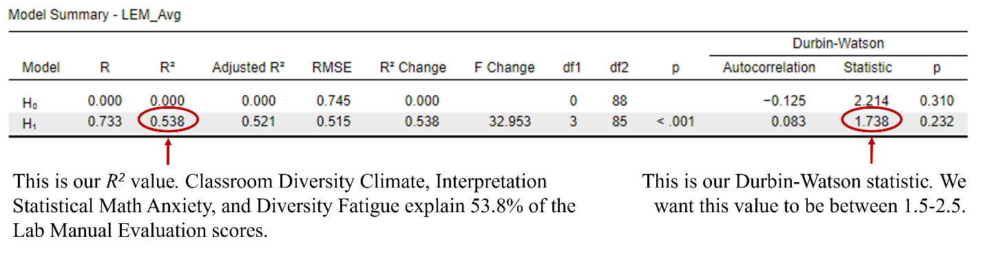

Figure 14 Annotated JASP Multiple Regression Model Summary Table.

Our ANOVA table shows us that our linear model, including the three predictors, is explaining a significant about of variance in Lab Manual Evaluation. The *F* value of 32.95 has a *p* value of less than .001, which is below our .05 cutoff. This tells us that our overall model is significant.

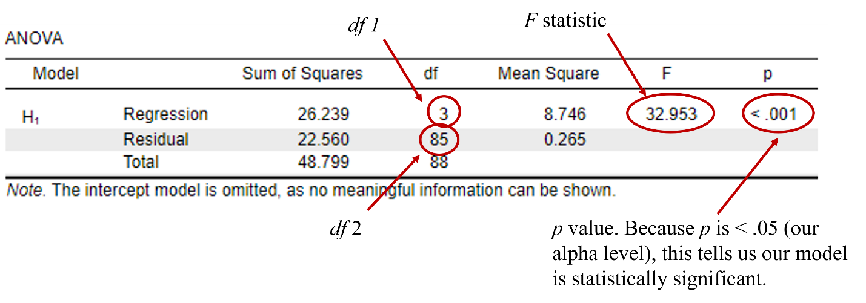

Now that we have determined the overall model as significant, we want to probe the relationship of each of the covariates with respect to the dependent variable. To do this, we are going to look at the slopes of each of our predictors, which we’ll find in the coefficients table (Figure 15). Our intercept now reflects if you are zero on all three predictors. So, we can say that if a person has no Classroom Diversity Climate, no Interpretation Statistical Math Anxiety, and no Diversity Fatigue, the average Lab Manual Evaluation is 1.98. The slope of Classroom Diversity Climate is significant (*b* = .48, *t* = 7.89, *p* <.001). That means that for every one-unit increase in Classroom Diversity Climate, you expect that Lab Manual Evaluation would increase by .48. Interpretation Statistical Math Anxiety also has a significant slope (*b* = -.23, *t* = -3.25, *p* = .002). Thus, for every one-unit increase in Interpretation Statistical Math Anxiety, you can expect Lab Manual Evaluation to decrease by .23. Interestingly, Diversity Fatigue does not have a significant slope (*b* = -.09, *t* = -1.41, *p* = .16). Our standardized slopes give us additional insight. Not all predictors contribute equally to the model: Classroom Diversity Climate (*β* = .62) is a stronger predictor than Interpretation Statistical Math Anxiety (*β* = -.24), and Diversity Fatigue (*β* = -.11).

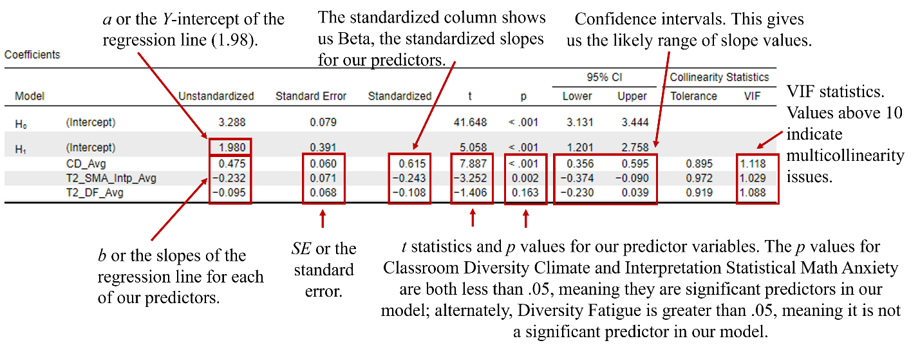

Figure 15 Annotated JASP Coefficients table.

The other piece of information we are interested in from this table is the collinearity statistics. The VIF (Variance Inflation Factor), which assess the degree to which our covariates are correlated, and Tolerance (which is the reciprocal of the VIF and measures the proportion of variation in one predictor variable that is not explained by any of the other predictors in the model) are in the last two columns. Generally, VIF values greater than 5 suggest that there may be too much collinearity between predictors, and values of 10 or greater require model modifications due to multicollinearity. With respect to Tolerance, values should be greater than 0.2.

**Here is an example of how you can report the study results in APA format:**

We conducted a multiple regression to examine how Classroom Diversity Climate, Interpretation Statistical Math Anxiety, and Diversity Fatigue predict Lab Manual Evaluation. We found that together, these three covariates explained a significant amount of variance of Lab Manual Evaluation, *F*(3, 85) = 32.95, *p* <.001, explaining 52.1% of the observed variance in Lab Manual Evaluation. Classroom Diversity Climate was significantly positively related to Lab Manual Evaluation (*b* = .48, *t* = 7.89, *p* <.001). Interpretation Statistical Math Anxiety was significantly negatively related to Lab Manual Evaluation (*b* = -.23, *t* = -3.25, *p* = .002). However, Diversity Fatigue was not a significant predictor of Lab Manual Evaluation (*b* = -.09, *t* = -1.41, *p* = .16).

***Bayesian Multiple Regression***

We will use the same data set for a brief Bayesian Multiple Regression walk-through. A Bayesian hypothesis for the Madden et al. (2023) study would be, “In this study, we hypothesize that Classroom Diversity Climate, Interpretation Statistical Math Anxiety, and Diversity Fatigue will be the best-supported model to explain students' Lab Manual Evaluation scores, as indicated by the highest posterior model probability and strongest Bayes factors.” For the current study, we will compare the null model (no effects) to the full model with all predictors included. This approach will help us compare each model's performance against the baseline model that assumes no effect (the null model), which simplifies the interpretation of the results (Wagenmakers et al., 2018). By comparing to the null model, we can evaluate whether these data provide substantial evidence for the alternative hypothesis

To run our analyses, click on the “Regression” tab at the top of the JASP menu bar and select “Bayesian Linear Regression.”

1. Move “Lab Manual Evaluations (LME_Avg)” to the “Dependent Variable” box.
2. Move “Classroom Diversity Climate (CD_Avg),” “Interpretation Statistical Math Anxiety (T2_SMA_Intp_Avg),” and “Diversity Fatigue (T2_DF_Avg)” to the “Covariates” box.
3. Check the boxes for “Descriptives,” “Compare to null model,” “BF10” and “Posterior summary.” We are choosing to use BF10 in this analysis because it directly quantifies the strength of evidence in favor of the alternative hypothesis relative to the null hypothesis, making it straightforward to interpret and commonly recommended in Bayesian analysis (Wagenmakers et al., 2018).
4. Under “Model,” add the full model with all predictors. This aligns with our research hypothesis that all predictors jointly influence Lab Manual Evaluations.
5. Click on “Advanced Options” and use the default settings unless you have specific prior information. Using default priors is recommended when there is limited prior knowledge, as they are weakly informative and minimize the introduction of bias (van de Schoot et al., 2014). If specific prior information is available, it should be incorporated to improve the model's accuracy and reflect existing knowledge (Gelman et al., 2017).

Let’s first look at and interpret the information presented in the model comparison table (Table ??). The columns present essentially similar information to the model comparison table we analyzed for the Bayesian ANOVA in Figure 11 earlier in the chapter, apart from the last column (*R2*). Like the frequentist version, *R2* is the proportion of variance in the dependent variable explained by the model. Let’s compare the two models that have the most support in the Figure 16: (1) the full model with Classroom Diversity Climate, Interpretation Statistical Math Anxiety, and Diversity Fatigue and (2) model two with only Classroom Diversity Climate and Interpretation Statistical Math Anxiety.

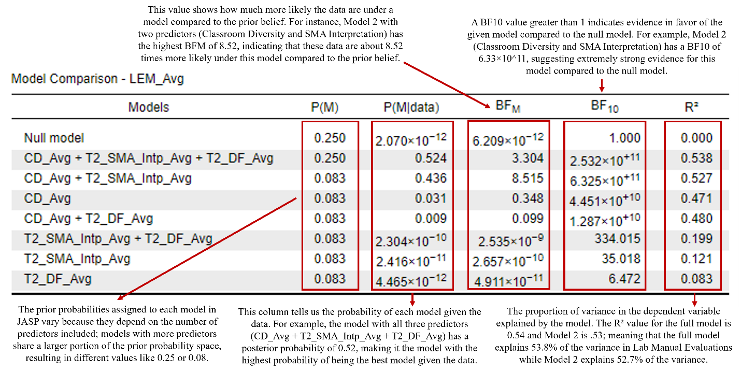

Figure 16 Annotated JASP Bayesian Regression multiple comparison table.

Both Model 1 and Model 2 show stronger support compared to the null model. Model 1 posterior probabilities (P(M|data)) value of .52 has a higher probability of being the best model given the data compared to Model 2 (P(M|data) = .44). The full model (Model 1) has a Bayes factor (BF10) of 2.532 × 10^11, indicating that the data are approximately 253 billion times more likely under this model than under the null model. Similarly, Model 2 has a BF10 of 6.325 × 10^11, suggesting even stronger support compared to the null model. The Bayes factor for model comparison (BFM) values are higher for Model 2 (BFM = 8.52) compared to Model 1 (BFM = 3.30), suggesting that although both models are supported compared to the prior, there is more support for Model 2. Looking at the *R2* values, Model 1 explains slightly more variance in Lab Manual Evaluations scores than Model 2, .54 and .53, respectively; however, this difference is marginal. Before deciding which model has the most support, let’s look at the Poster Summary table (Figure 17).

Figure 17 Annotated JASP Posterior Summaries of Coefficients table.

Classroom Diversity Climate has a significant positive effect on Lab Manual Evaluations, with a posterior inclusion probability (P(incl|data)) of 1.00 and a Bayes Factor (BFinclusion) of 3.83 x 109, providing extremely strong evidence for its inclusion in the model, 95% credible interval [0.35, 0.58]. Interpretation Statistical Math Anxiety also shows evidence for inclusion with a P(incl|data) of 0.96 and a BFinclusion of 24.26, indicating a negative effect (95% Credible Interval [-0.34, 0.00]) that is nearly significant. Diversity Fatigue has least support for inclusion (P(incl|data) = 0.53, BFinclusion = 1.14), 95% Credible Interval [-0.19, 0.02], indicating a negative effect with considerable uncertainty.

**Here is an example of how you can report the study results in APA format:**

A Bayesian linear regression analysis was conducted to evaluate the impact of Classroom Diversity Climate, Interpretation Statistical Math Anxiety, and Diversity Fatigue on Lab Manual Evaluations for undergraduate students taking a statistics lab. The analysis compared several models, including the null model, and models with different combinations of predictors. The model including Classroom Diversity Climate and Interpretation Statistical Math Anxiety was chosen as the final model due to its strong support and the lack of evidence supporting the inclusion of Diversity Fatigue. This model had a posterior probability of 0.44 and a Bayes Factor (BF10) of 6.33 x 1011, indicating strong support of this model compared to the null model. The model explains 53% of the variance in Lab Manual Evaluations. Classroom Diversity Climate has a significant positive effect on Lab Manual Evaluations (*M* = 0.47, 95% CI [0.35, 0.58]), with very strong evidence for its inclusion in the model (P(incl|data) = 1.00, BFinclusion = 3.83 x 109). Interpretation Statistical Math Anxiety shows a negative effect (*M* = -0.21, 95% CI [-0.34, 0.00]) with evidence for its inclusion (P(incl|data) = 0.96, BFinclusion = 24.26). Contrary to our hypothesis, there was no substantial evidence to support the inclusion of Diversity Fatigue in the model, (P(incl|data) = 0.53, BFinclusion = 1.14, *M* = -0.05, 95% Credible Interval [-0.19, 0.02]).

**Tips and Resources**

The JASP Team support page offers a robust compilation of resources and tools to support instructors and researchers (2024b). This includes more than 10 different free manuals offering step-by-step instructions (e.g., Walker et al., 2021), textbooks (e.g., Navarro et al., 2020), materials from annual workshops, community forums, and a variety of YouTube channels offering tutorials and videos (see Veenmanm, 2020 for recommendations). As mentioned previously, JASP also features interactive learning modules such as the "Learn Bayes" and “Learn Stats” modules, which provide tutorials and exercises on various concepts, to enhance understanding of fundamental and advanced statistical methods. JASP also provides a range of data sets, which are useful for educational purposes and for users new to statistical analysis. These examples cover a wide range of statistical tests and concepts such as descriptive statistics, traditional NHSTs, and more advanced statistics like meta-analysis and machine learning. Additionally, JASP provides options for creating and saving APA tables and publication-ready figures, with customizable backgrounds and language settings (van den Bergh et al., 2023).

Over the past three years of using JASP in our undergraduate statistics courses, we have found that students with either a MacBook or a Chromebook have sometimes reported difficulty installing and running JASP. This is particularly true for MacBook users with older macOS versions or newer M1 models. Some students have found that right-clicking the JASP icon and selecting "Open" or running the application from the terminal can sometimes bypass these issues. We also typically recommend that MacBook users save data files as .csv files to their computer, open JASP, then open the .csv file in JASP. Similarly, Chromebook users also experience difficulties, primarily due to the need to install JASP via Linux. Common issues include the application not starting after installation or errors related to unsupported file types. If this occurs, ensure the correct installation steps have been followed, such as using the appropriate commands in the Linux terminal and verifying JASP is installed correctly. Persistent issues can be reported to the JASP team (GitHub, 2024).

Despite its strengths, JASP has certain limitations that may affect its utility for more complex or specific Bayesian analyses. Some advanced Bayesian analyses, such as complex hierarchical models, are not fully supported or may require workarounds that are more easily implemented in other software like R (Marsman & Wagenmakers, 2017). This limitation can be a significant drawback for researchers needing sophisticated modeling techniques. Further, although JASP provides default priors, these can and should be adjusted to better fit specific research needs (Kelter, 2020). For additional information regarding best practices for conducting and reporting Bayesian analyses using JASP, please refer to van Doorn and colleagues (2021) and additional resources provided in Table 3.

**Table 3**

**Reference Articles for Bayesian Analyses in JASP**

|  |  |
| --- | --- |
| **Analysis** | **Reference Article** |
| *t*-tests | Kelter (2020); van Doorn et al. (2021) |
| ANOVAs | Hoffman et al., (2022); van den Bergh et al., (2023) |
| Correlation | Marsman & Wagenmakers (2017) |
| Regression | Wagenmakers (2018) |
| Reliability Analysis | Pfadt et al. (2023) |
| Network Analysis | Huth et al. (2023) |
| Confirmatory Factor Analysis | Feng & Hancock (2023) |
| Multilevel Modeling | Van den Bergh (2021) |
| Hierarchical Linear Modeling | Goss-Sampson (2022) |
| Meta-Analysis | Berkhout et al. (2024) |

**Conclusion**

JASP continues to evolve with regularly released updates, significantly enhancing its capabilities. The frequentist PROCESS module in JASP 0.18.2 facilitates mediation, moderation, and conditional process analyses, while the enhanced predictive analytics module incorporates advanced machine learning algorithms for both supervised and unsupervised learning (JASP Team, 2024c). The beta version of JASP 0.18.2 introduces nonparametric survival analysis for longitudinal studies. The newly released JASP 0.19 includes a Bayesian Classical Process Module Analysis and expanded descriptives (e.g., raincloud plots, times series descriptives, and flexplot). These updates demonstrate JASP's commitment to providing accessible, comprehensive, and cutting-edge statistical tools for researchers. Although JASP does not have the flexibility of R, it offers advanced statistical options that make it an excellent choice for researchers, especially those with collaborators who lack coding skills. Overall, JASP is a practical and accessible tool for a wide range of researchers and students.

**References**

Abelson, R. P., & Prentice, D. A. (1997). Contrast tests of interaction hypothesis. *Psychological Methods, 2*(4), 315–328. <https://doi.org/10.1037/1082-989X.2.4.315>

Berkhout, S. J., van Doorn, J., Marsman, M., Draws, T., van Kesteren, E.-J., Derks, K., & Wagenmakers, E.-J. (2024). A practical guide to Bayesian analyses in JASP: Applications and recommendations. Behavior Research Methods. https://doi.org/10.3758/s13428-023-02004-3

Davidson-Pilon, C. (2019). **Lifelines: Survival Analysis in Python.** *Journal of Open Source Software, 4*(40), 1317.

de Lima, T. J. S. (2019). Black people are convicted more for being black than for being poor. Open Science Framework. <https://doi.org/10.17605/OSF.IO/AR7WP>

de Lima, T. J. S., Pereira, C. R., Rosas Torres, A. R., Cunha de Souza, L. E., & Albuquerque, I. M. (2019). Black people are convicted more for being black than for being poor: The role of social norms and cultural prejudice on biased racial judgments. *PLOS ONE, 14*(9), e0222874. <https://doi.org/10.1371/journal.pone.0222874>

EFPSA. (2015, September 1). Introducing JASP: A free and intuitive statistics software that might finally replace SPSS. European Federation of Psychology Students' Associations. <https://blog.efpsa.org/2015/09/01/introducing-jasp-a-free-and-intuitive-statistics-software-that-might-finally-replace-spss/>

EFPSA. (2017, March 23). Introducing jamovi: Free and open statistical software combining ease of use with the power of R. European Federation of Psychology Students' Associations. <https://blog.efpsa.org/2017/03/23/introducing-jamovi-free-and-open-statistical-software-combining-ease-of-use-with-the-power-of-r/>

Field, A. (2013). *Discovering statistics with IBM SPSS statistics*. Newbury Park, CA: Sage.

Gelman, A., Simpson, D., & Betancourt, M. (2017). The prior can often only be understood in the context of the likelihood. *Entropy, 19*(10), 555.

GitHub. (2024). JASP issues. GitHub. Retrieved July 22, 2024, from <https://github.com/jasp-stats/jasp-issues/issues>

Grover, R. L., Golom, M. I., & Sherman, M. F. (2020). Assessing climate for diversity in the psychology classroom: Development of the classroom diversity climate (CDC) scale. *Scholarship of Teaching and Learning in Psychology, 6*(3), 235-243. <https://doi.org/10.1037/stl0000230>

Hayes, A. F. (2013). **Introduction to mediation, moderation, and conditional process analysis: A regression-based approach.** Guilford Press.

Hayes, A. F. (2017). **Introduction to mediation, moderation, and conditional process analysis: A regression-based approach (2nd ed.).** Guilford Press.

Hoffmann, A., Lee, M. D., & Wetzels, R. (2022). Bayesian inference in practice with JASP. *Journal of Mathematical Psychology, 76*, 132-147. <https://doi.org/10.1016/j.jmp.2022.06.001>

Hosmer, D. W., Lemeshow, S., & May, S. (2008). **Applied survival analysis: Regression modeling of time-to-event data.** John Wiley & Sons.

Huth, K., van Doorn, J., Marsman, M., & Wagenmakers, E.-J. (2023). Practical Bayesian data analysis with JASP. *Journal of Open Research Software, 11*(1), 45-58. <https://doi.org/10.5334/jors.392>

IBM. (2024). IBM SPSS Statistics VPAT. IBM. Retrieved July 19, 2024, from https://www.ibm.com/able/product_accessibility/

Jamovi. (2024). Voluntary Product Accessibility Template (VPAT) for Jamovi version 2.4.14. Retrieved from <https://www.jamovi.org/VPAT.pdf>

JASP Team. (2021). Introducing JASP 0.16.0: New Features and Improvements. Retrieved from <https://jasp-stats.org/blog/>

JASP Team. (2022). Introducing JASP 0.16.4: Sync SQL databases, Bland-Altman Plots, Improvements to Factor Analysis, and More. Retrieved from <https://jasp-stats.org/2022/10/03/introducing-jasp-0-16-4-sync-sql-databases-bland-altman-plots-improvements-to-factor-analysis-and-more/>

JASP Team. (2024). How to use JASP. JASP. <https://jasp-stats.org/how-to-use-jasp/>

JASP Team. (2024a). Features. JASP. <https://jasp-stats.org/features/>

JASP Team. (2024c). Introducing JASP 0.18.2: PROCESS, survival analysis, and more. Retrieved from <https://jasp-stats.org/2024/01/03/introducing-jasp-0-18-2-process-survival-analysis-and-more/>

JASP Team. (2024b). Support. JASP. Retrieved from <https://jasp-stats.org/support/>

JASP. (2023). Voluntary Product Accessibility Template (VPAT) for JASP version 0.17.1. Retrieved from <https://jasp-stats.org/wp-content/uploads/2023/07/VPAT_JASP.pdf>

Kazdin, A. E. (2021). Annual Research Review: Expanding mental health services through novel models of intervention delivery. Journal of Child Psychology and Psychiatry, 62(5), 574-593.

Kelter, R. (2020). Analysis of Bayesian models: A tutorial and practical guidance. *Behavior Research Methods, 52*(3), 1808-1825. <https://doi.org/10.3758/s13428-019-01243-7>

Kuhn, M. (2008). Building predictive models in R using the caret package. Journal of Statistical Software, 28(5), 1-26.

Lakens, D. (2013). Calculating and reporting effect sizes to facilitate cumulative science: A practical primer for t-tests and ANOVAs. *Frontiers in Psychology, 4*, 1–12. <https://doi.org/10.3389/fpsyg.2013.00863>

Littell, R. C., Milliken, G. A., Stroup, W. W., Wolfinger, R. D., & Schabenberger, O. (2006). **SAS for mixed models.** SAS Institute.

Love, J., Selker, R., Marsman, M., Jamil, T., Dropmann, D., Verhagen, J., Ly, A., Gronau, Q. F., Šmíra, M., Epskamp, S., Matzke, D., Wild, A., Knight, P., Rouder, J. N., Morey, R. D., & Wagenmakers, E. (2019). JASP: Graphical statistical software for common statistical designs. *Journal of Statistical Software, 88*(2), 1-17.

Madden, J., Osborn, H., Walker, R. V., & Black, K. J. (2023). Integrating diversity research into undergraduate statistics: A pre-post assessment of student perceptions. *Scholarship of Teaching and Learning in Psychology, 9*(4), 435-449. <https://doi.org/10.1037/stl0000386>

Marsman, M., & Wagenmakers, E.-J. (2017). Bayesian benefits with JASP. European Journal of *Developmental Psychology, 14*(5), 545-555. <https://doi.org/10.1080/17405629.2016.1259614>

Maxwell, S. E., & Delaney, H. D. (2004). *Designing experiments and analyzing data: A model comparison perspective* (2nd ed.). Mahwah, New Jersey: Lawrence Erlbaum Associates.

Muthén, L. K., & Muthén, B. O. (2017). **Mplus User's Guide (8th ed.).** Muthén & Muthén.

Navarro, D. J., Foxcroft, D. R., & Faulkenberry, T. J. (2020). Learning statistics with JASP: A tutorial for psychology students and other beginners. Retrieved from <https://learnstatswithjasp.com/>

Pedregosa, F., Varoquaux, G., Gramfort, A., Michel, V., Thirion, B., Grisel, O., ... & Vanderplas, J. (2011). Scikit-learn: Machine learning in Python. Journal of Machine Learning Research, 12, 2825-2830.

Pfadt, J. M., van den Bergh, D., Sijtsma, K., & Wagenmakers, E.-J. (2023). A tutorial on Bayesian single-test reliability analysis with JASP. *Behavior Research Methods, 55*, 1069-1078. <https://doi.org/10.3758/s13428-021-01778-0>

Rogers, P. (2024). Best practices for your confirmatory factor analysis: A JASP and lavaan tutorial. *Behavior Research Methods*. <https://doi.org/10.3758/s13428-022-02088-6>

Shmueli, G. (2010). To explain or to predict? Statistical Science, 25(3), 289-310.

Smith, J. L., McPartlan, P., Poe, J., & Thoman, D. B. (2021). Diversity fatigue: A survey for measuring attitudes towards diversity enhancing efforts in academia. *Cultural Diversity and Ethnic Minority Psychology*, *27*(4), 659–674. <https://doi.org/10.1037/cdp0000406>

Therneau, T. M. (2021). A package for survival analysis in R. R package version 3.2-11.

Tingley, D., Yamamoto, T., Hirose, K., Keele, L., & Imai, K. (2014). mediation: R package for causal mediation analysis. Journal of Statistical Software, 59(5), 1-38.

Vallat, R. (2018). Pingouin: statistics in Python. Journal of Open Source Software, 3(31), 1026.

van den Bergh, D., Marsman, M., Draws, T., van Kesteren, E. J., Derks, K., & Wagenmakers, E. J. (2023). Bayesian inference for psychological research: Concepts, computations, and applications. *Journal of Mathematical Psychology, 102*, 102446. <https://doi.org/10.1016/j.jmp.2023.102446>

van de Schoot, R., Kaplan, D., Denissen, J., Asendorpf, J. B., Neyer, F. J., & Van Aken, M. A. G. (2014). A gentle introduction to Bayesian analysis: Applications to developmental research. *Child Development, 85*(3), 842–860. <https://doi.org/10.1111/cdev.12169>

van Doorn. (2023). R syntax mode in JASP: The first button. JASP. <https://jasp-stats.org/2023/03/06/r-syntax-mode-in-jasp-the-first-button/>

van Doorn, J., Ly, A., Marsman, M., & Wagenmakers, E.-J. (2021). The JASP guidelines for conducting and reporting a Bayesian analysis. *Psychonomic Bulletin & Review, 28*, 1217-1230. <https://doi.org/10.3758/s13423-021-01956-1>

Veenman, M. (2020). How to use JASP: JASP on YouTube. JASP. Retrieved from <https://jasp-stats.org/2020/02/11/how-to-use-jasp-jasp-on-youtube/>

Vigil-Colet, A., Lorenzo-Seva, U., & Condon, L. (2008). Development and validation of the Statistical Math Anxiety Scale. *Psicothema*, *20*(1), 174–180.

Walker, R., Moraine, A. A., Osborn, H. J., Palmer, A. S., Prince, E. N., Humphrey, K. L., Scott, K. E., & Black, K. J. (2021). *Exploring diversity with statistics: Step-by-step JASP guides.* University of Tennessee at Chattanooga Pressbooks. Retrieved from <https://utc.pressbooks.pub/step-by-step-JASP-guides/>

Wagenmakers, E.-J., Kucharský, S., van Doorn, J., & van den Bergh, D. (2023). Accessible and sustainable statistics with JASP. *PsyArXiv Preprints.* <https://doi.org/10.31234/osf.io/ud2vj>

Wagenmakers, E.-J., Marsman, M., Jamil, T., Ly, A., Verhagen, A. J., Love, J., ... & Morey, R. D. (2018). Bayesian statistical inference for psychological science. Part I: Theoretical advantages and practical ramifications. *Psychonomic Bulletin & Review, 25*, 35-57. <https://doi.org/10.3758/s13423-017-1232-7>

Wagenmakers, E.-J., Wetzels, R., Borsboom, D., van der Maas, H. L. J., & Kievit, R. A. (2012). An agenda for purely confirmatory research. *Perspectives on Psychological Science, 7*, 627-633. <https://doi.org/10.1177/1745691612463078>