An Adventure in Statistics
Getting Started with R, RStudio and Quarto
Professor Andy Field, University of Sussex
Links: bsky.app | youtube.com | discoveringstatistics.com | discovr.rocks | statisticsadventure.com

About this version
This is a plain-text version of the lecture slides. Each slide starts with a heading such as “Slide 5”, and the numbers match the slide numbers shown in the lecture. Content that appeared one piece at a time, in columns or in tabs is shown in reading order. Videos and interactive apps are given as links.

Slide 2: Key information

Teaching
- 1 × weekly lecture (2 in weeks 1, 2 & 7) on theory
- 1 × weekly practical class (2 in weeks 1 and 2) about R, RStudio and Quarto

Assessment
- 2 × 48-hour Take Away Papers (TAPs)
  - TAP 1: 25% (Week 6)
  - TAP 2: 30% (Week 9)
- Report: 45% (A1)

Slide 3 (new section): Part 1: Introducing R and RStudio

Slide 4: Why R?
- Transferable skills
- R is the most widely used data analysis software
- Reproducible science
- Cutting edge
- One stop shop
- RStudio is amazeballs

Slide 5
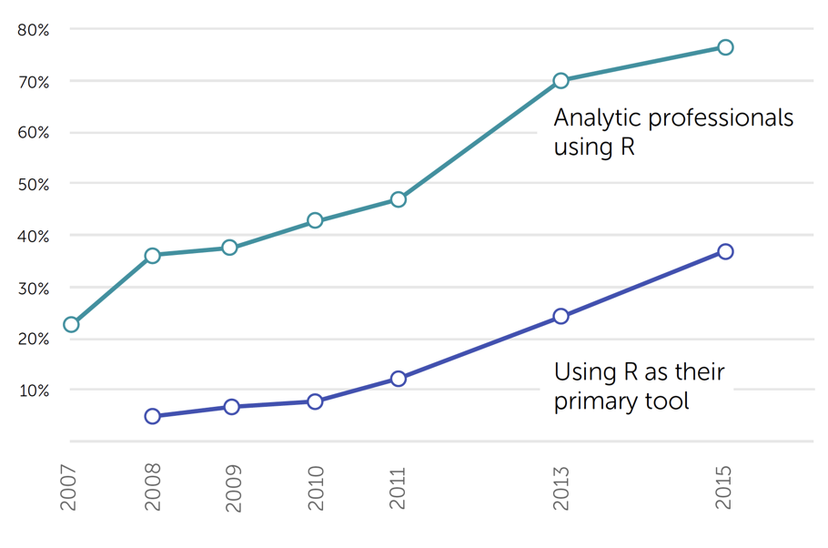

Slide 6
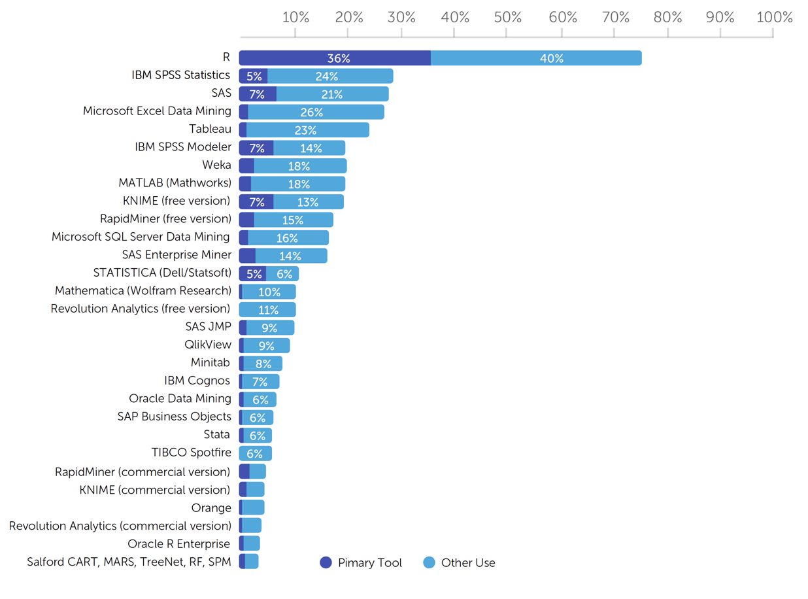

Slide 7: A Car Analogy

R The engine
- Free software environment for statistical analysis and graphics

RStudio The dashboard
- A free integrated development environment (IDE) for R
- You use RStudio as a way to interact with R

Quarto The paint job
- A document creation system used within RStudio
- A quarto document is like a word processing document in which you can embed (and execute) code
- ‘Render’ the quarto document into a beautiful report containing text, code and output from the code.

Slide 8
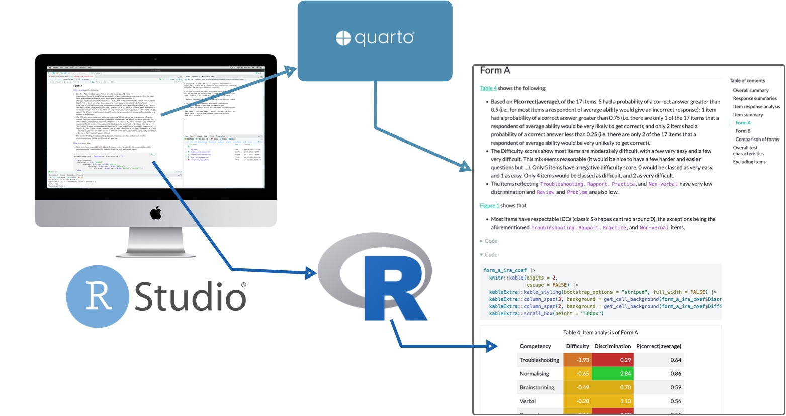

Slide 9 (new section): Part 2: Workflow in RStudio

Slide 10: RStudio project files
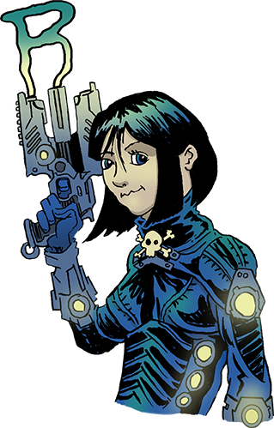
A file created by RStudio with the extension .Rproj
- Stores information about the containing folder
- Restores the previous state of the project (i.e. what documents/tabs were open)
- Opening a project file sets the working directory to the folder containing the project file
  - You can use relative file paths
  - Outside of Posit cloud you can share the project folder and it will work on any machine/operating system you care to use
Tip: Have a go!
- Use project files!
- Posit cloud automatically uses them!
- Create an RStudio project called my_adventr on RStudio cloud

Slide 11: Creating a project
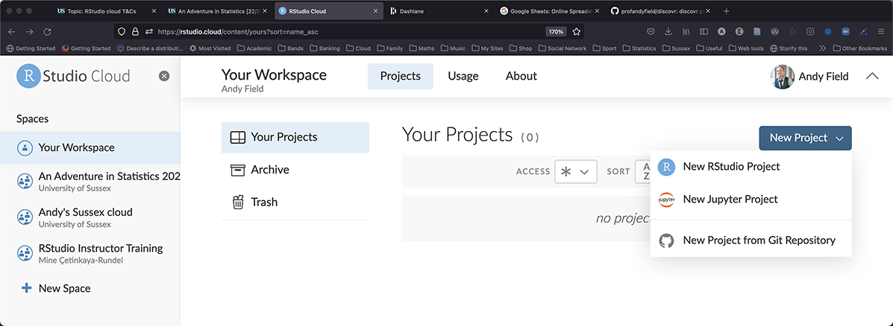

Slide 12
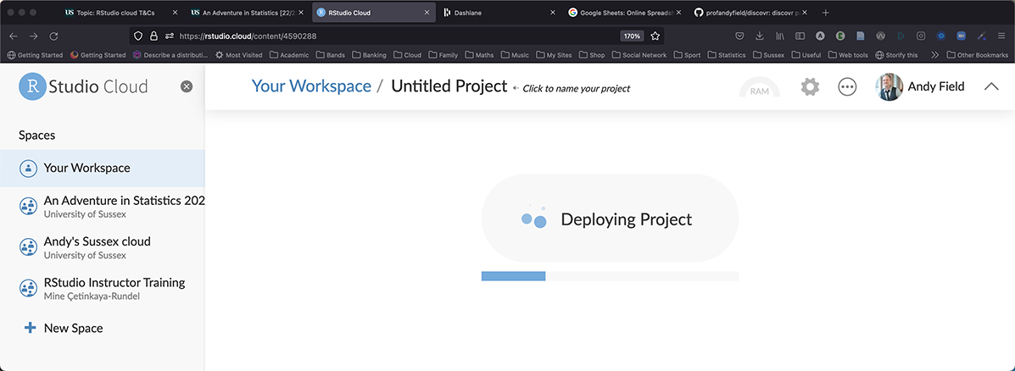

Slide 13
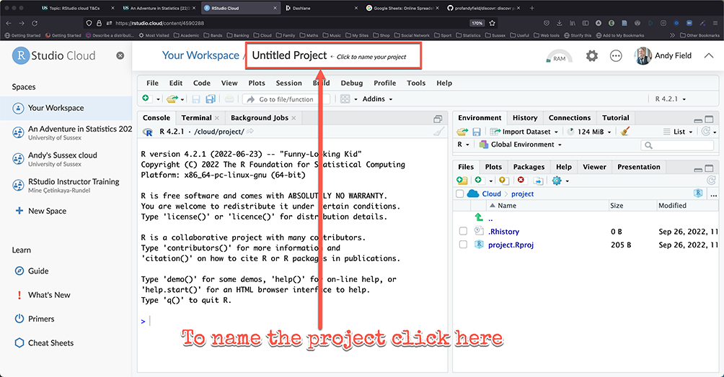

Slide 14: Get organized!
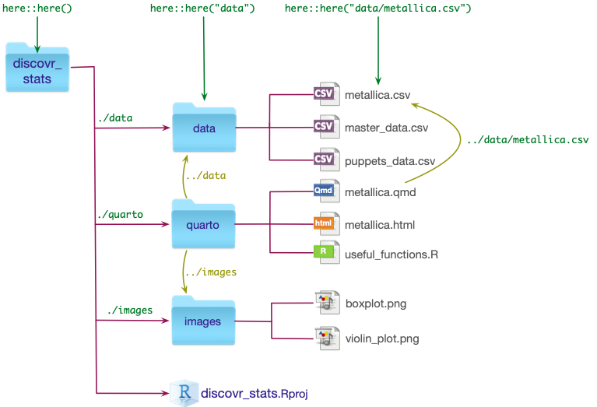

Slide 15: Try it!
Within your RStudio project called my_adventr create folders called
- data
- quarto
Copy the following files from canvas
- eddiefy.csv to the data folder

Slide 16: Customizing RStudio

Use the native pipe (|>)
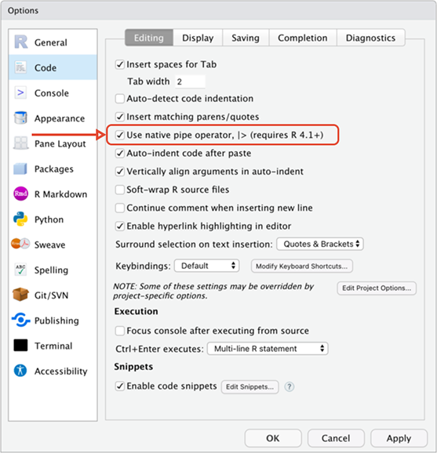

Slide 17: Colour scheme
Tip: Have a go!
- Windows
  - Tools > Options
- MacOS
  - Tools > Global Options
  - Tools > Project options
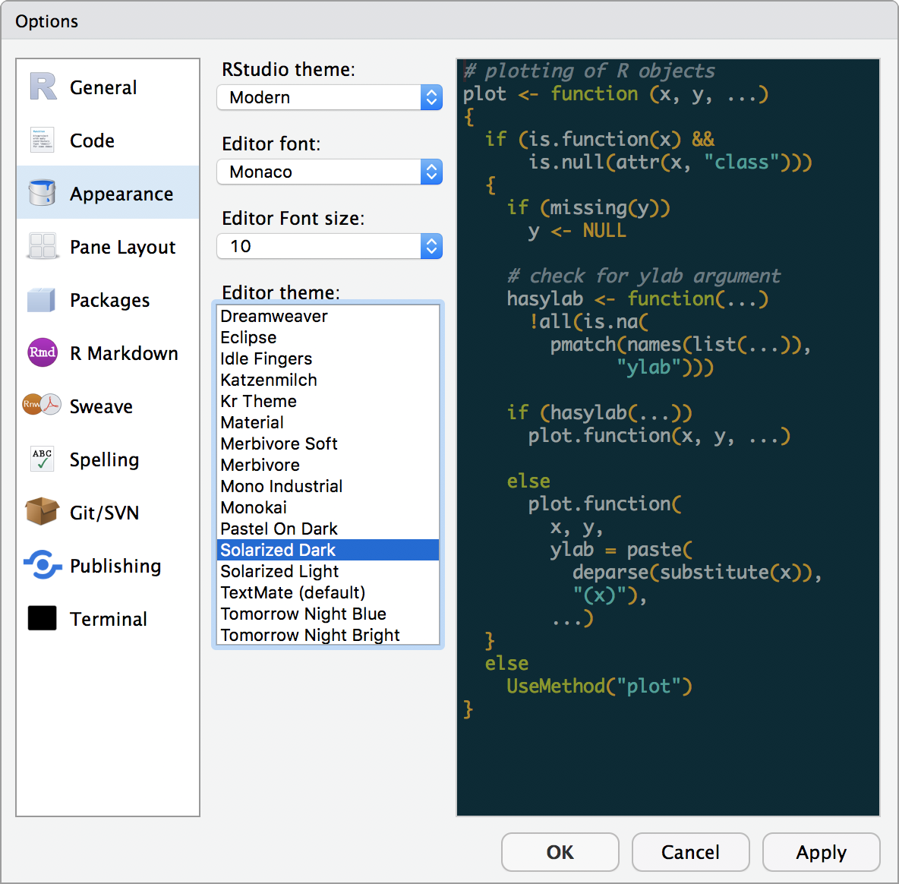

Slide 18: Pane locations

Have a go!
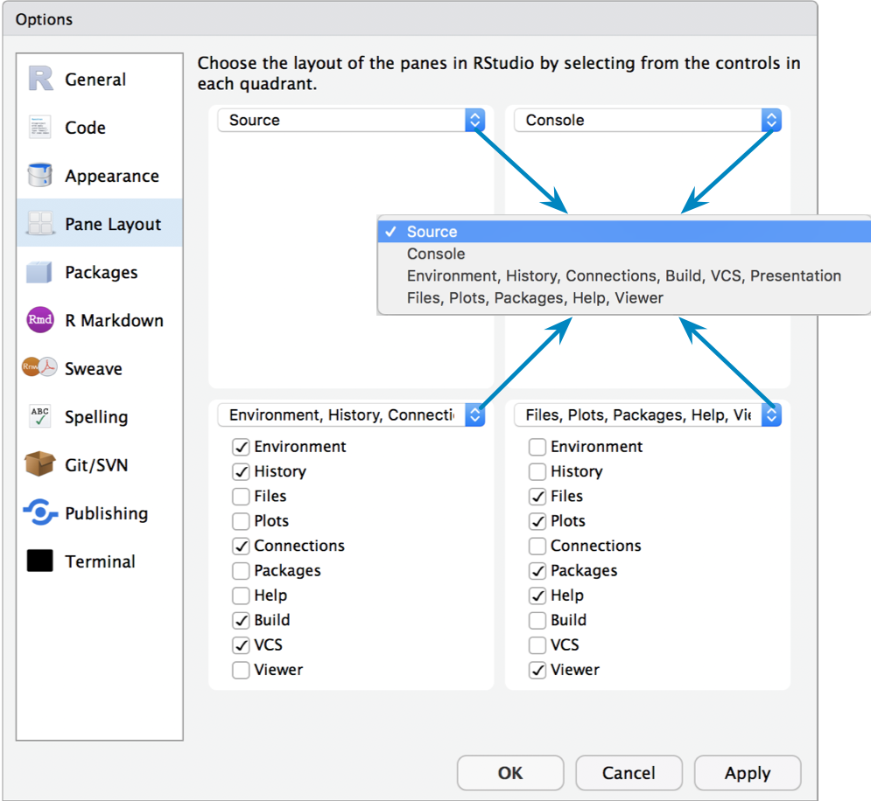

Slide 19
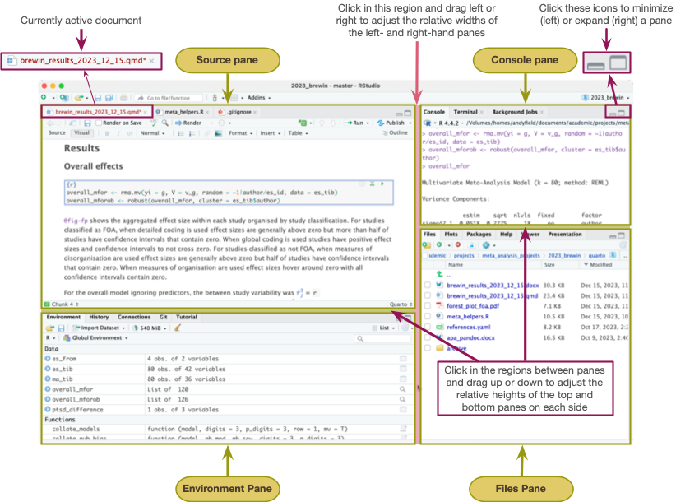

Slide 20: Have a go: create a report
- Test the hypothesis that Iron Maiden songs have got longer over the years.
Interactive content: A report about Iron Maiden

Slide 21: The process of E.V.I.L.
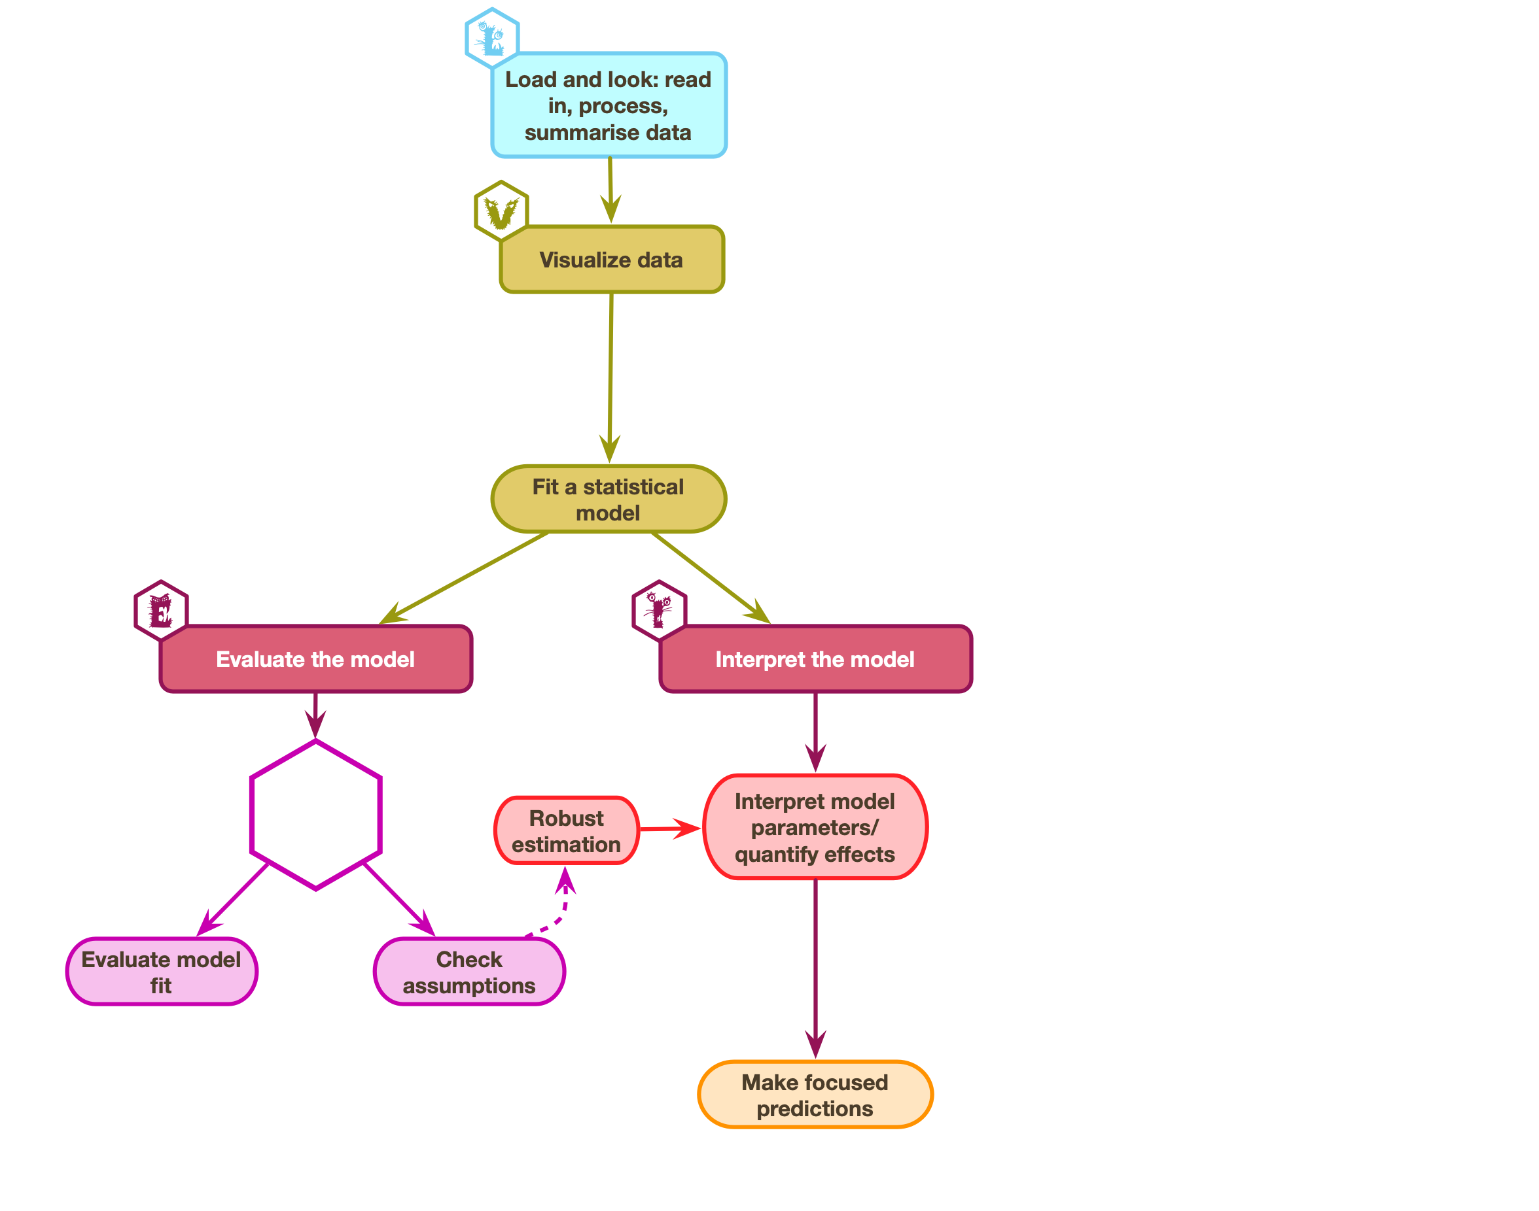

Slide 22: The process of E.V.I.L.
Interactive content: A report about Iron Maiden

Slide 23 (new section): Part 3: Introducing Quarto

Slide 24: Interacting with R
- The console (🤮)
  - Type commands at the console prompt
  - Bad for reproducibility/your sanity
  - Great for getting help, installing packages, trying things out
- Quarto document (🎂)
  - A document that combines text and code
  - renders to a nicely-formatted .html, .docx or .pdf (LaTeX required) file.
  - Code is executed (in sequence) when rendering
  - Great for reproducible documents
  - All coursework submitted as html file
Tip: Have a go!
- Create a new Quarto document
- Save it as iron_maiden.qmd in quarto
- Click  to render the document.

Slide 25: YAML
---
title: "Iron Maiden"
author: "Andy Field"
format: html
editor: visual
---
Warning: The danger zone!
This is IMPORTANT … always add embed-resources: true
---
title: "Iron Maiden"
author: "Andy Field"
format:
html:
embed-resources: true
editor: visual
---

Slide 26
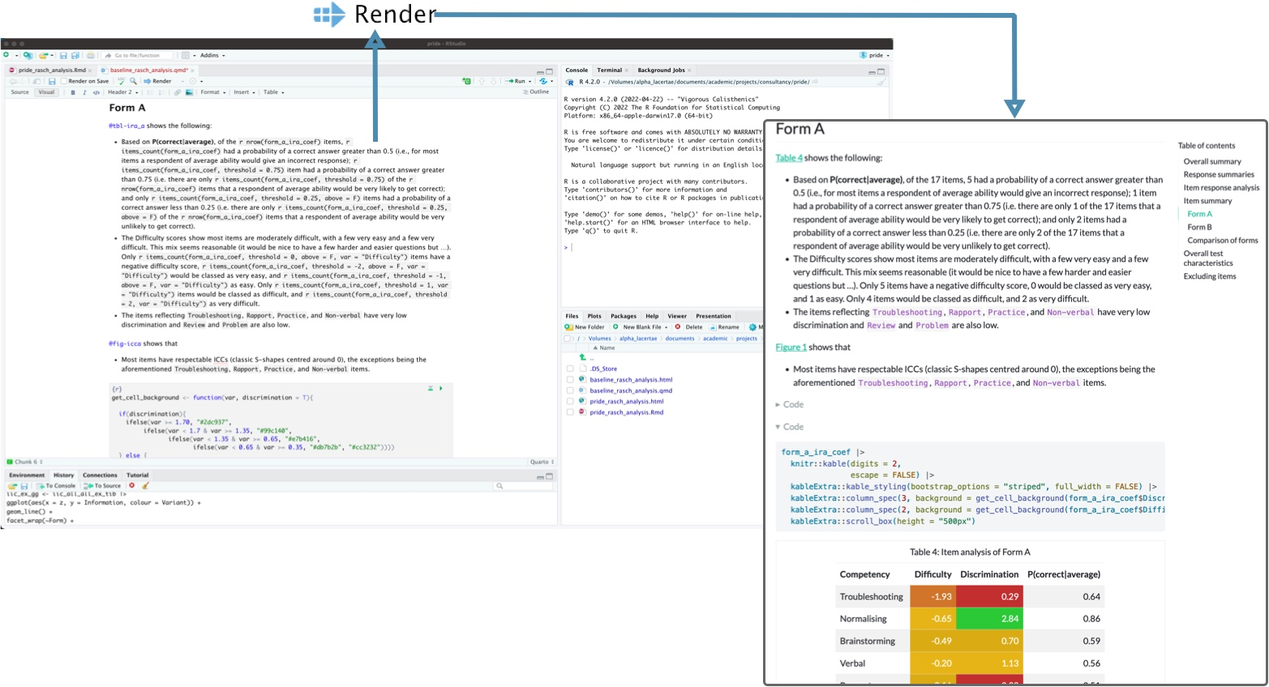

Slide 27: Writing text
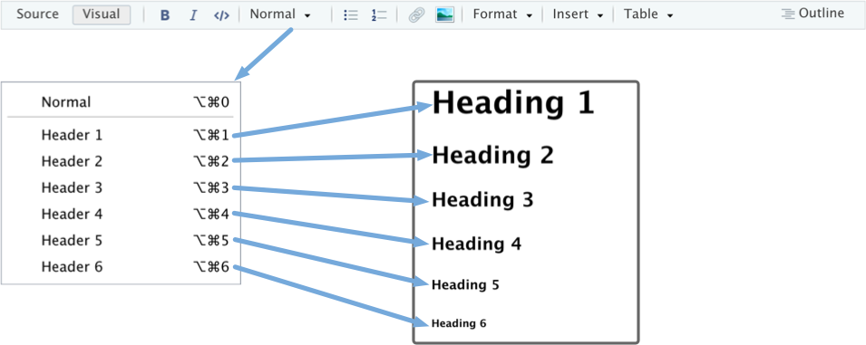

Slide 28: Our report
Important: ReportR
Iron Maiden are a British heavy metal band. Their best albums are
- Piece of Mind
- Powerslave
Tip: Have a go!
- In your Quarto document iron_maiden.qmd
- Create a level 2 header Introduction
- Reproduce the text and bullet list above

Slide 29: Our report
Interactive content: A report about Iron Maiden

Slide 30: Callouts
Insert > callout
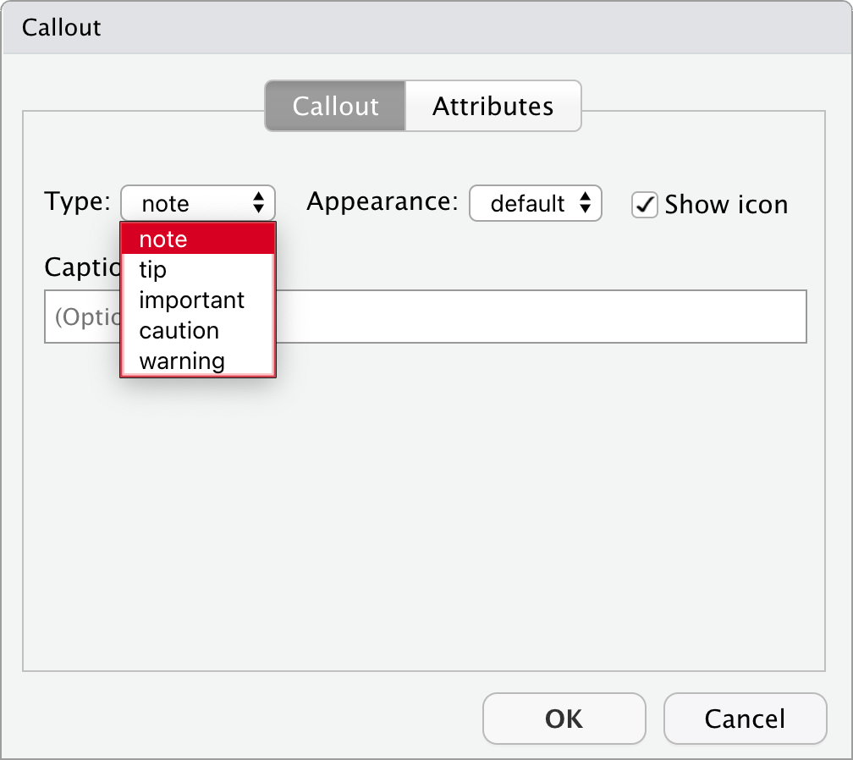
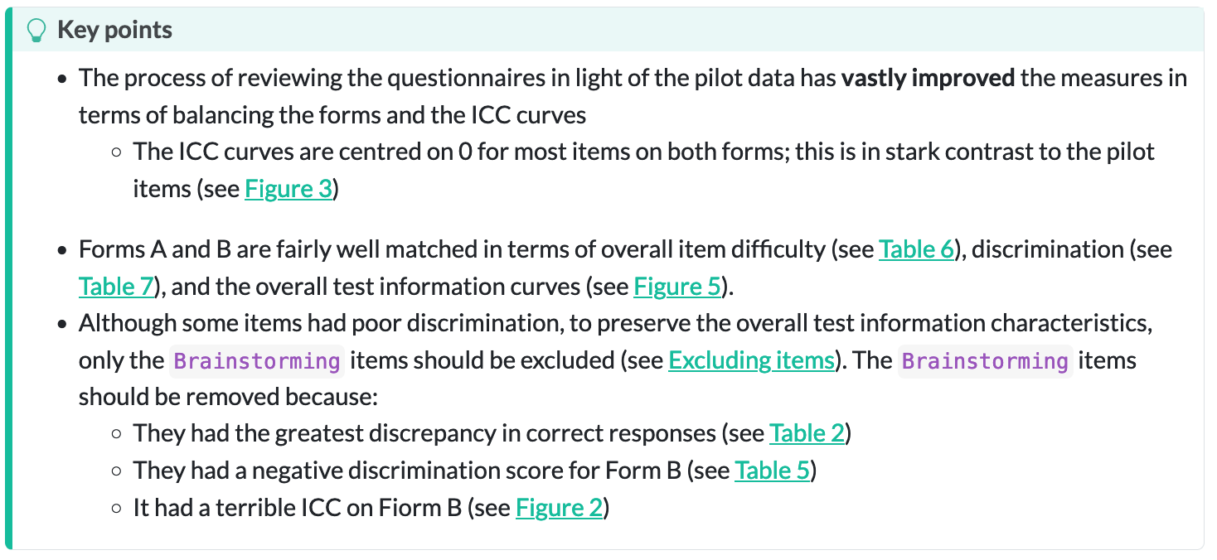

Slide 31: Have a go!
- Insert a callout
- Recreate the text below using bullets and other text styles.
Caution: Hypothesis
- H₁: Iron Maiden songs have got longer over time
- H₀: The length of Iron Maiden songs has not changed over time
The model
- Outcome: Song duration in seconds (song_duration)
- Predictor: Number of years since the first album (band_age)

Slide 32
Interactive content: A report about Iron Maiden
Tip: Have a go!
- In your Quarto document iron_maiden.qmd
- Create a level 2 header (at the bottom) called Iron Datum
- Create a level 3 header called Load and Look

Slide 33 (new section): Part 4: Packages and Functions

Slide 34: Inserting code chunks

Menu
- In Quarto
  - Insert > Code Chunk > R
- In RStudio
  - Code > Insert Chunk

Keyboard shortcuts
- ctrl alt i (Windows)
- ⌘ ⌥ i (MacOS)

Insert anything
- Windows (I assume): Press ctrl /
- MacOS: Press ⌘ /
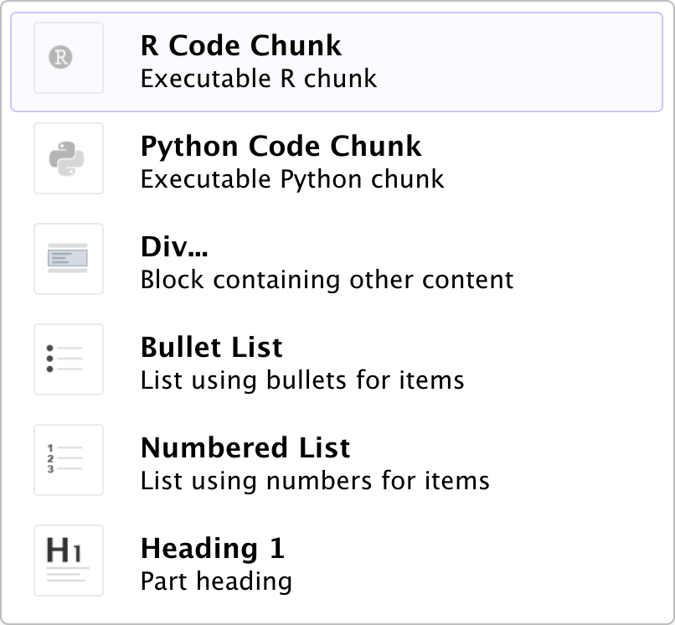

Slide 35
Tip: Have a go!
- In your Quarto document iron_maiden.qmd
- Insert a code chunk under the level 3 header Load and Look

Slide 36: Functions
- We use functions to do things in R
  - Inputs: What we put into the function
  - Outputs: what we get out of the function
- Functions look like this (prints the output)
name_of_function(inputs/arguments/options)
Tip: Have a go!
- In your code chunk execute
randomNames(n = 5)

Slide 37: Packages
- We can’t use randomNames() because we haven’t installed the package from which it comes!
- Installing a package gives you access to functions within it
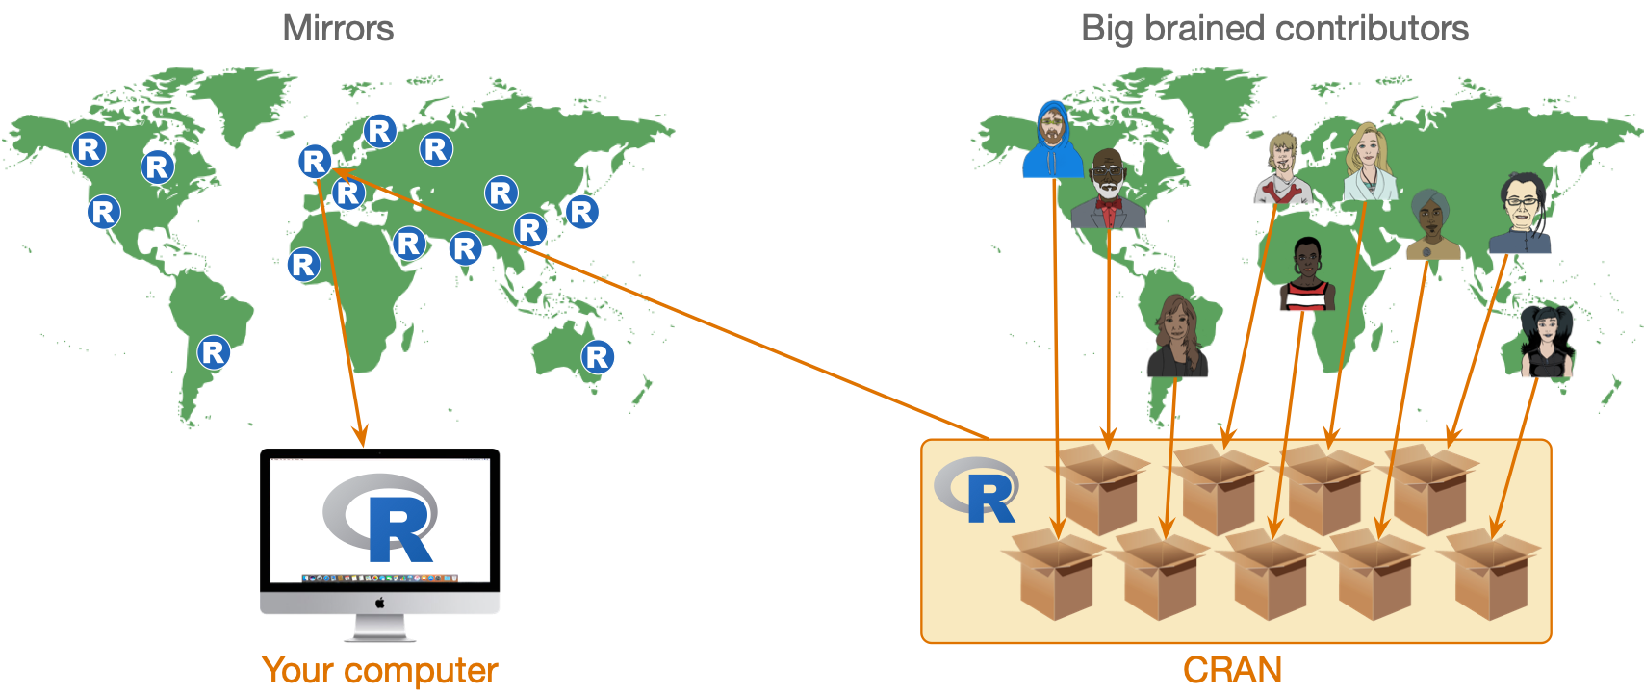

Slide 38: The process of E.V.I.L.

Slide 39: The process of E.V.I.L.: packages
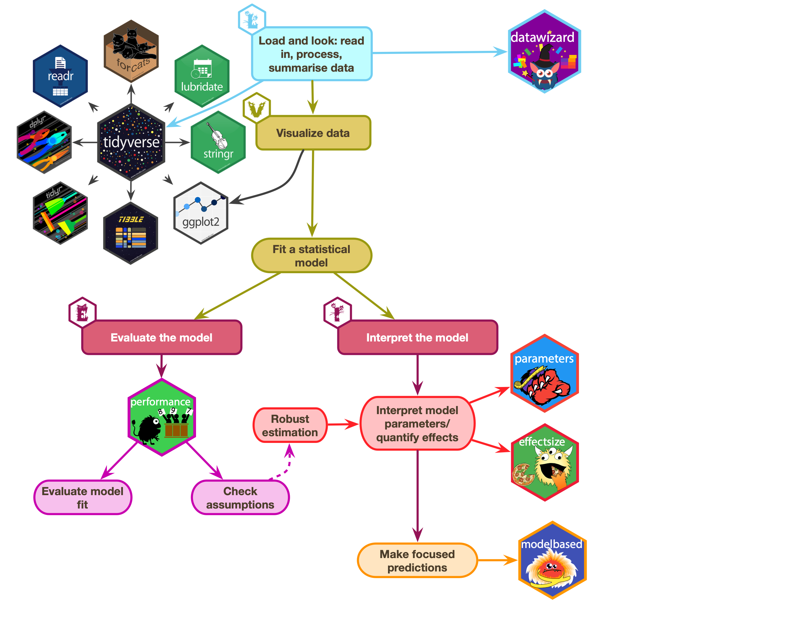

Slide 40: The process of E.V.I.L.: functions
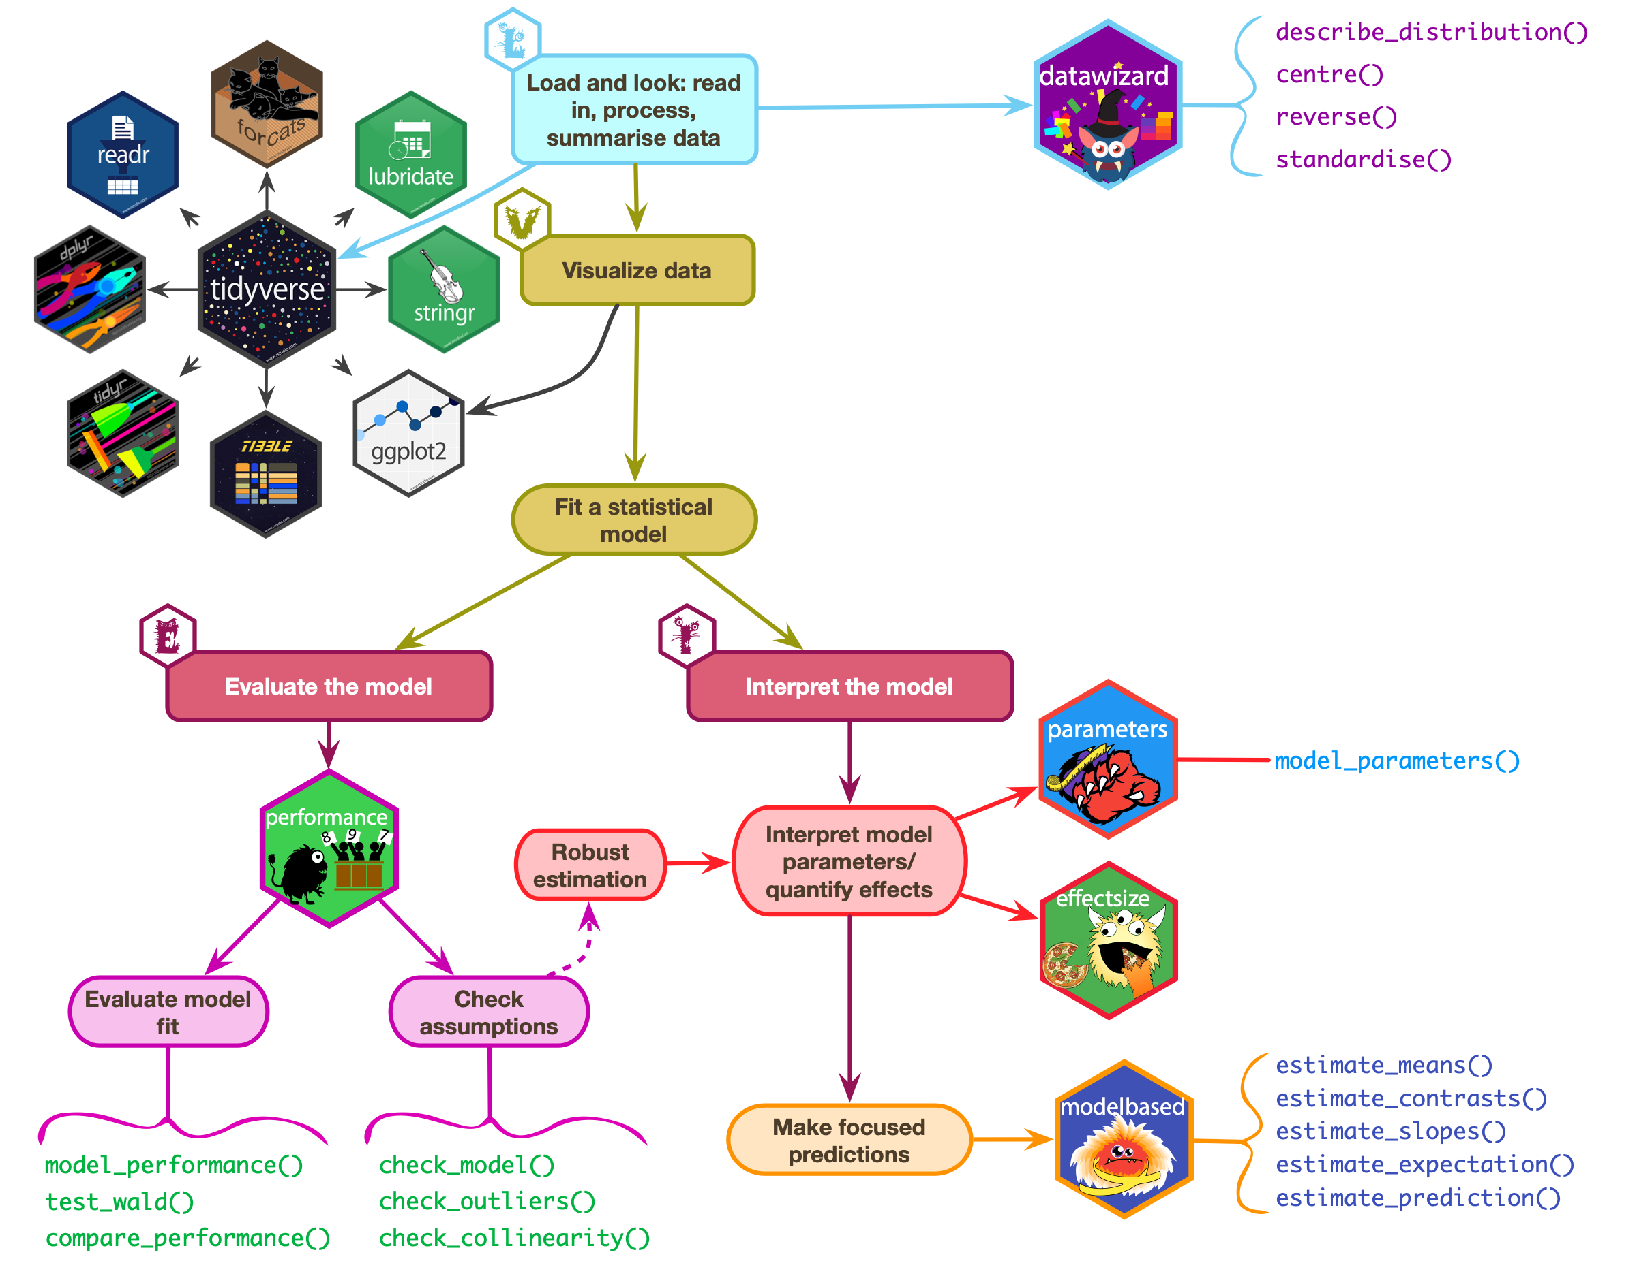

Slide 41: Installing and loading packages
- You need to install the package into R’s repository of packages on your computer.
- Every time you update or re-install R you need to re-install packages to use them.
install.packages("package_name")
Tip
- Do NOT include install.packages() in Quarto files or the package will be installed every time you render the document!
  - Use the console and command line to execute install.packages() commands
Tip: Have a go!
- Install the package randomNames from which the function randomNames() comes.
install.packages("randomNames")
In your code chunk execute:
randomNames(n = 5)

Slide 42: Loading packages
- That also didn’t work 🤔
- To use a particular package in a current session you need to load it from the repository on your machine

Concise code
- Load packages in a code chunk at the start of your document using library().
library(randomNames)
randomNames()
- Problematic for function name clashes
- Easy to load packages you don’t actually use

Explicit code
- Refer to functions using the package::function() format.
randomNames::randomNames()
- Problematic for some packages (e.g. dplyr, ggplot2)
- Less readable
- Longer to type!

Slide 43: Which to use
I use a mix:
- Concise code for umbrella packages that we (nearly) always use
  - easystats, which includes datawizard, effectsize, modelbased, parameters, performance …
  - tidyverse, which includes dplyr, ggplot2, readr, stringr, tibble, tidyr …
- Explicit code style for other packages
  - Helps to remember from where functions come

Slide 44: Referencing packages

Concise code style
Tip: Have a go!
- In your setup code chunk
library(easystats)
library(tidyverse)
library(randomNames)
- When you use the function:
randomNames(n = 5)

Explicit code style
Tip: Have a go!
- In your setup code chunk
library(easystats)
library(tidyverse)
- When you use the function
randomNames::randomNames(n = 5)

Slide 45: Creating objects in R
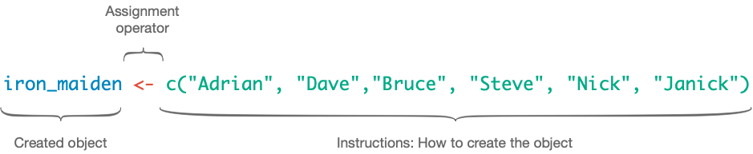

Slide 46: The eddiefy data 🧟
eddie_tib <- discovr::eddiefy
- Data are stored in tibbles (aka data frames)
Table 1: Spotify data for Iron Maiden (first 50 of 163 rows)
ID | artist_name | album_name | track_name | year | danceability | energy | key | loudness | mode | speechiness | acousticness | instrumentalness | liveness | valence | tempo | time_signature | song_ms
1 | Iron Maiden | Senjutsu | Senjutsu | 2021 | 0.347 | 0.885 | 9 | -6.121 | 0 | 0.0615 | 0.000171 | 0.0892 | 0.217 | 0.466 | 180.172 | 3 | 500170
2 | Iron Maiden | Senjutsu | Stratego | 2021 | 0.473 | 0.968 | 4 | -7.297 | 0 | 0.0642 | 0.000144 | 0.0347 | 0.612 | 0.465 | 138.054 | 4 | 299946
3 | Iron Maiden | Senjutsu | The Writing On The Wall | 2021 | 0.402 | 0.912 | 2 | -5.447 | 0 | 0.0442 | 0.00158 | 0.000179 | 0.0923 | 0.566 | 90.045 | 4 | 373898
4 | Iron Maiden | Senjutsu | Lost In A Lost World | 2021 | 0.251 | 0.871 | 4 | -6.414 | 0 | 0.0871 | 0.00407 | 0.00751 | 0.108 | 0.206 | 92.975 | 4 | 571584
5 | Iron Maiden | Senjutsu | Days Of Future Past | 2021 | 0.433 | 0.92 | 4 | -4.738 | 0 | 0.0409 | 0.000576 | 5.5e-05 | 0.123 | 0.476 | 92.466 | 4 | 243754
6 | Iron Maiden | Senjutsu | The Time Machine | 2021 | 0.297 | 0.889 | 9 | -5.287 | 0 | 0.0607 | 0.00654 | 0.000211 | 0.118 | 0.316 | 116.65 | 4 | 429443
7 | Iron Maiden | Senjutsu | Darkest Hour | 2021 | 0.222 | 0.925 | 4 | -5.939 | 0 | 0.24 | 0.0542 | 0.0863 | 0.395 | 0.162 | 133.772 | 4 | 440464
8 | Iron Maiden | Senjutsu | Death Of The Celts | 2021 | 0.291 | 0.804 | 2 | -5.807 | 1 | 0.0414 | 0.00711 | 0.21 | 0.12 | 0.26 | 134.561 | 4 | 620403
9 | Iron Maiden | Senjutsu | The Parchment | 2021 | 0.149 | 0.924 | 4 | -5.345 | 0 | 0.0933 | 0.0141 | 0.219 | 0.107 | 0.212 | 80.234 | 4 | 758990
10 | Iron Maiden | Senjutsu | Hell On Earth | 2021 | 0.298 | 0.842 | 4 | -6.692 | 0 | 0.0563 | 0.00952 | 0.0299 | 0.0846 | 0.0628 | 132.65 | 4 | 679134
11 | Iron Maiden | The Book of Souls | If Eternity Should Fail | 2015 | 0.291 | 0.868 | 7 | -6.499 | 1 | 0.0611 | 0.00679 | 0.000413 | 0.118 | 0.149 | 117.931 | 4 | 508207
12 | Iron Maiden | The Book of Souls | Speed Of Light | 2015 | 0.176 | 0.974 | 7 | -5.778 | 0 | 0.132 | 0.000419 | 2.62e-05 | 0.107 | 0.334 | 185.491 | 4 | 301745
13 | Iron Maiden | The Book of Souls | The Great Unknown | 2015 | 0.211 | 0.897 | 2 | -6.629 | 1 | 0.201 | 0.0195 | 0.000189 | 0.108 | 0.0702 | 92.082 | 4 | 397655
14 | Iron Maiden | The Book of Souls | The Red And The Black | 2015 | 0.275 | 0.932 | 4 | -5.54 | 0 | 0.0865 | 0.00176 | 0.109 | 0.116 | 0.377 | 114.008 | 4 | 813713
15 | Iron Maiden | The Book of Souls | When The River Runs Deep | 2015 | 0.271 | 0.947 | 9 | -5.424 | 1 | 0.0749 | 0.00252 | 3.21e-05 | 0.119 | 0.393 | 128.747 | 4 | 352882
16 | Iron Maiden | The Book of Souls | The Book Of Souls | 2015 | 0.198 | 0.935 | 4 | -5.505 | 0 | 0.0968 | 0.00383 | 8.16e-05 | 0.102 | 0.359 | 80.875 | 4 | 627626
17 | Iron Maiden | The Book of Souls | Death Or Glory | 2015 | 0.181 | 0.974 | 9 | -5.493 | 1 | 0.162 | 0.000365 | 3.47e-05 | 0.364 | 0.316 | 176.088 | 4 | 312867
18 | Iron Maiden | The Book of Souls | Shadows Of The Valley | 2015 | 0.231 | 0.977 | 4 | -4.918 | 0 | 0.11 | 0.00174 | 3.84e-05 | 0.111 | 0.284 | 149.675 | 4 | 452478
19 | Iron Maiden | The Book of Souls | Tears Of A Clown | 2015 | 0.311 | 0.874 | 9 | -5.327 | 0 | 0.0449 | 0.00696 | 1.17e-05 | 0.0861 | 0.503 | 95.194 | 4 | 298886
20 | Iron Maiden | The Book of Souls | The Man Of Sorrows | 2015 | 0.441 | 0.78 | 2 | -5.488 | 0 | 0.0418 | 0.0242 | 6.34e-05 | 0.23 | 0.291 | 110.18 | 4 | 387542
21 | Iron Maiden | The Book of Souls | Empire Of The Clouds | 2015 | 0.249 | 0.789 | 4 | -6.15 | 0 | 0.0496 | 0.0165 | 0.00239 | 0.104 | 0.19 | 76.293 | 4 | 1081316
22 | Iron Maiden | The Final Frontier | Satellite 15 | 2010 | 0.265 | 0.873 | 9 | -6.411 | 1 | 0.0682 | 0.000584 | 0.00148 | 0.113 | 0.435 | 133.376 | 4 | 520946
23 | Iron Maiden | The Final Frontier | El Dorado | 2010 | 0.265 | 0.92 | 11 | -7.012 | 1 | 0.0965 | 4.59e-05 | 0.00305 | 0.117 | 0.436 | 155.14 | 4 | 408786
24 | Iron Maiden | The Final Frontier | Mother Of Mercy | 2010 | 0.309 | 0.9 | 2 | -6.839 | 1 | 0.0625 | 0.00296 | 0.00012 | 0.0486 | 0.364 | 106.055 | 4 | 320133
25 | Iron Maiden | The Final Frontier | Coming Home | 2010 | 0.332 | 0.887 | 4 | -6.655 | 0 | 0.0537 | 0.00018 | 5.79e-05 | 0.278 | 0.467 | 79.761 | 4 | 352440
26 | Iron Maiden | The Final Frontier | The Alchemist | 2010 | 0.341 | 0.955 | 2 | -6.104 | 1 | 0.0654 | 0.000166 | 1.92e-05 | 0.345 | 0.64 | 124.023 | 4 | 268986
27 | Iron Maiden | The Final Frontier | Isle Of Avalon | 2010 | 0.291 | 0.902 | 9 | -7.217 | 1 | 0.0499 | 0.0103 | 0.00471 | 0.145 | 0.0739 | 151.904 | 3 | 546026
28 | Iron Maiden | The Final Frontier | Starblind | 2010 | 0.197 | 0.871 | 0 | -6.788 | 1 | 0.0548 | 0.00476 | 0.00283 | 0.0875 | 0.217 | 81.904 | 4 | 468360
29 | Iron Maiden | The Final Frontier | The Talisman | 2010 | 0.216 | 0.834 | 2 | -7.307 | 0 | 0.0763 | 0.00189 | 6.49e-06 | 0.0738 | 0.16 | 81.197 | 4 | 543106
30 | Iron Maiden | The Final Frontier | The Man Who Would Be King | 2010 | 0.212 | 0.828 | 11 | -7.453 | 0 | 0.0559 | 0.00288 | 0.0228 | 0.12 | 0.273 | 86.628 | 4 | 508173
31 | Iron Maiden | The Final Frontier | When The Wild Wind Blows | 2010 | 0.305 | 0.759 | 4 | -8.52 | 0 | 0.0462 | 0.00392 | 0.398 | 0.31 | 0.228 | 96.889 | 4 | 661760
32 | Iron Maiden | The Final Frontier | Satellite 15.....The Final Frontier | 2010 | 0.263 | 0.882 | 9 | -5.871 | 1 | 0.0681 | 0.000654 | 0.00111 | 0.113 | 0.411 | 133.801 | 4 | 520293
33 | Iron Maiden | A Matter of Life and Death | Different World | 2006 | 0.406 | 0.975 | 4 | -4.285 | 0 | 0.0937 | 0.000325 | 0.00018 | 0.613 | 0.602 | 91.826 | 4 | 258186
34 | Iron Maiden | A Matter of Life and Death | These Colours Don't Run | 2006 | 0.317 | 0.94 | 4 | -5.33 | 0 | 0.114 | 0.00573 | 0.0033 | 0.112 | 0.228 | 103.396 | 4 | 412213
35 | Iron Maiden | A Matter of Life and Death | Brighter Than A Thousand Suns | 2006 | 0.294 | 0.949 | 0 | -5.655 | 1 | 0.0851 | 0.00161 | 2.79e-05 | 0.101 | 0.266 | 125.892 | 4 | 526106
36 | Iron Maiden | A Matter of Life and Death | The Pilgrim | 2006 | 0.308 | 0.934 | 9 | -4.145 | 0 | 0.0606 | 0.000306 | 0.0313 | 0.0863 | 0.541 | 97.848 | 4 | 307866
37 | Iron Maiden | A Matter of Life and Death | The Longest Day | 2006 | 0.259 | 0.925 | 4 | -5.706 | 0 | 0.0713 | 0.00133 | 0.00289 | 0.128 | 0.337 | 101.244 | 4 | 468093
38 | Iron Maiden | A Matter of Life and Death | Out Of The Shadows | 2006 | 0.213 | 0.839 | 4 | -5.109 | 0 | 0.0406 | 0.00285 | 0.00195 | 0.279 | 0.288 | 81.402 | 4 | 336640
39 | Iron Maiden | A Matter of Life and Death | The Reincarnation Of Benjamin Breeg | 2006 | 0.353 | 0.837 | 4 | -5.551 | 0 | 0.0356 | 0.00268 | 0.000533 | 0.11 | 0.144 | 110.999 | 4 | 442053
40 | Iron Maiden | A Matter of Life and Death | For The Greater Good Of God | 2006 | 0.316 | 0.908 | 4 | -5.455 | 0 | 0.0779 | 0.00194 | 0.0578 | 0.111 | 0.3 | 107.743 | 4 | 565026
41 | Iron Maiden | A Matter of Life and Death | Lord Of Light | 2006 | 0.281 | 0.901 | 4 | -6.083 | 0 | 0.0739 | 0.00445 | 0.0044 | 0.166 | 0.0485 | 93.542 | 4 | 444653
42 | Iron Maiden | A Matter of Life and Death | The Legacy | 2006 | 0.328 | 0.928 | 2 | -5.839 | 0 | 0.131 | 0.0471 | 0.000681 | 0.179 | 0.15 | 148.276 | 4 | 562946
43 | Iron Maiden | Dance of Death | Wildest Dreams | 2003 | 0.302 | 0.923 | 9 | -4.621 | 1 | 0.0829 | 0.000616 | 8.28e-06 | 0.078 | 0.57 | 103.8 | 4 | 232106
44 | Iron Maiden | Dance of Death | Rainmaker | 2003 | 0.35 | 0.952 | 5 | -4.485 | 1 | 0.14 | 0.00122 | 0 | 0.262 | 0.539 | 86.146 | 4 | 228493
45 | Iron Maiden | Dance of Death | No More Lies | 2003 | 0.176 | 0.845 | 5 | -5.732 | 1 | 0.092 | 0.00546 | 0.00311 | 0.123 | 0.214 | 190.867 | 4 | 441786
46 | Iron Maiden | Dance of Death | Montségur | 2003 | 0.285 | 0.99 | 9 | -3.512 | 1 | 0.201 | 7.09e-05 | 0.00021 | 0.118 | 0.215 | 78.537 | 4 | 350373
47 | Iron Maiden | Dance of Death | Dance Of Death | 2003 | 0.311 | 0.876 | 4 | -5.115 | 0 | 0.0936 | 0.0466 | 0.00442 | 0.134 | 0.296 | 124.584 | 4 | 516426
48 | Iron Maiden | Dance of Death | Gates Of Tomorrow | 2003 | 0.245 | 0.963 | 7 | -4.532 | 0 | 0.209 | 0.000443 | 6.2e-05 | 0.367 | 0.336 | 95.677 | 4 | 312120
49 | Iron Maiden | Dance of Death | New Frontier | 2003 | 0.316 | 0.967 | 2 | -3.9 | 0 | 0.0884 | 0.000177 | 0 | 0.0685 | 0.521 | 104.3 | 4 | 304280
50 | Iron Maiden | Dance of Death | Paschendale | 2003 | 0.168 | 0.941 | 6 | -5.303 | 0 | 0.0938 | 0.0119 | 2.04e-05 | 0.069 | 0.188 | 89.221 | 4 | 508200

Slide 47
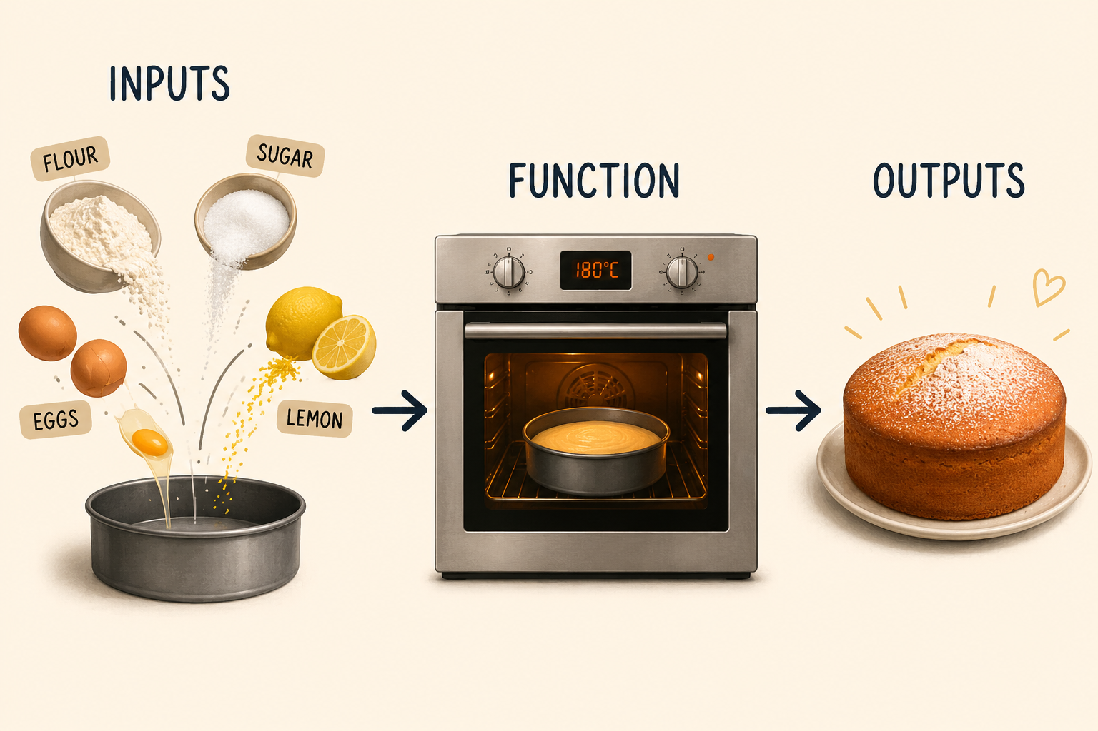

Slide 48: What are functions?
- We use functions to do things
- Inputs: what we put into the function
- Outputs: what we get out of the function
  - A dataframe or tibble
  - One or more values
  - A statistical model
  - A plot
  - A table
  - Multiple things
- Functions look like this (prints the output)
name_of_function(inputs/arguments/options)
- We can use <- to store the outputs
stuff_I_want_to_store <- name_of_function(inputs/arguments/options)

Slide 49: Functions as dialog boxes
the_mean <- mean(x = name_of_variable, na.rm = FALSE, trim = 0)
Arguments are like inputs in a dialog box
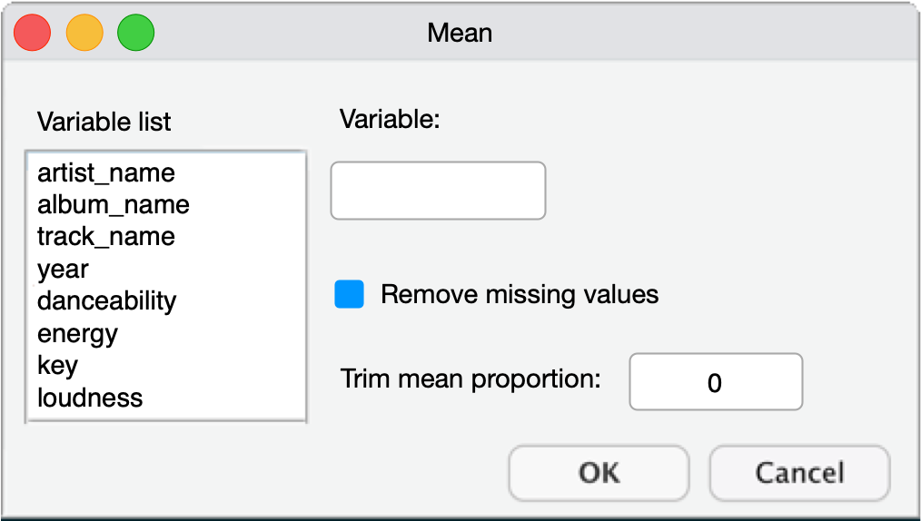

Slide 50: The mean() function if it were a dialog box
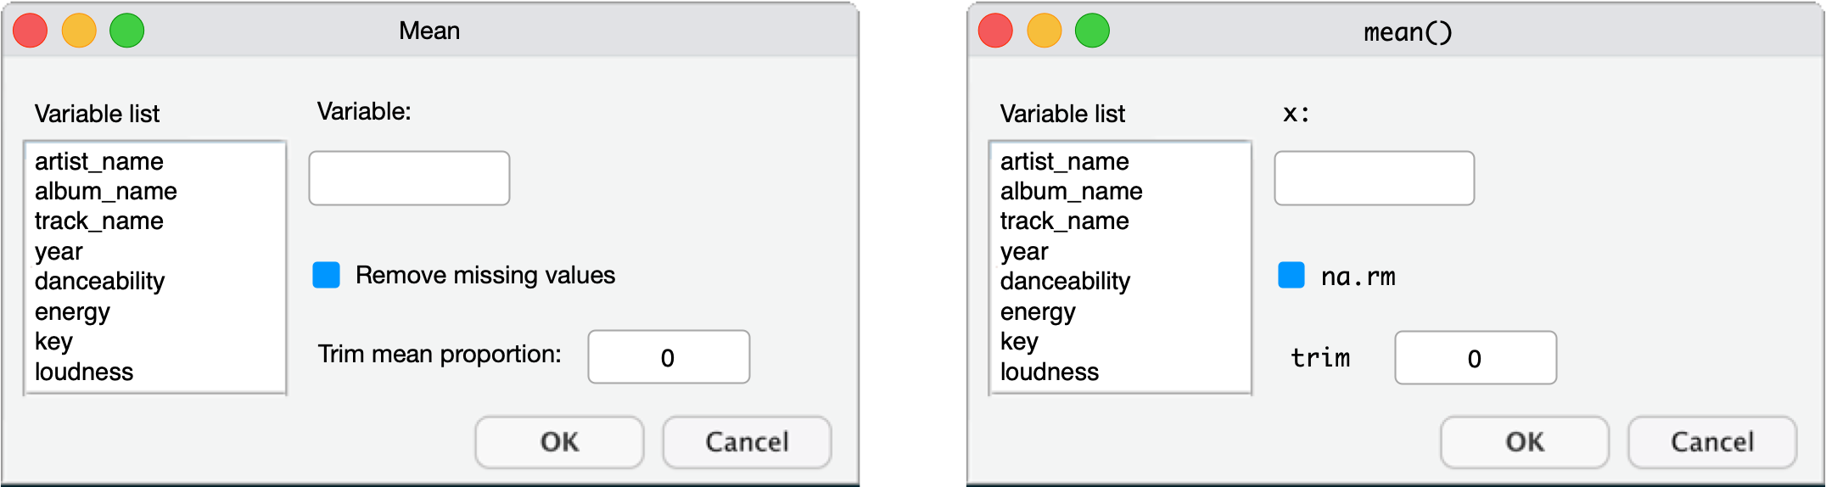

Slide 51: The mean() function if it were a dialog box
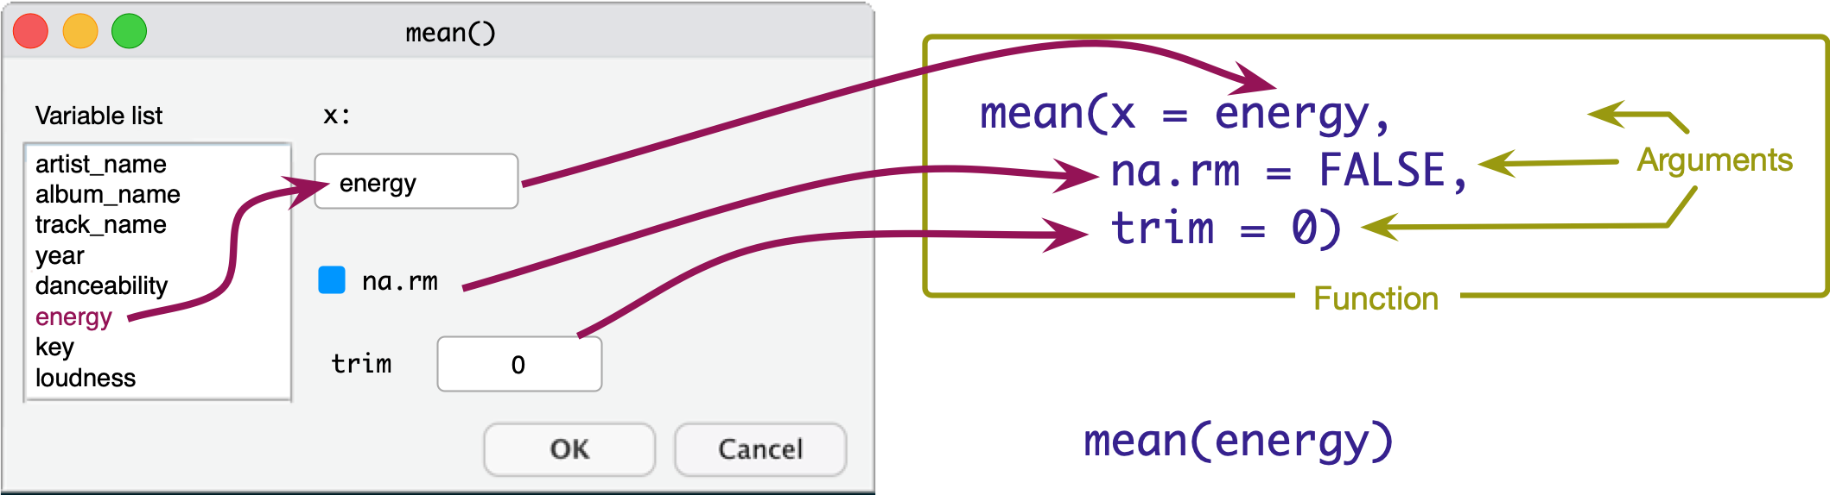

Slide 52: The mean() function if it were a dialog box
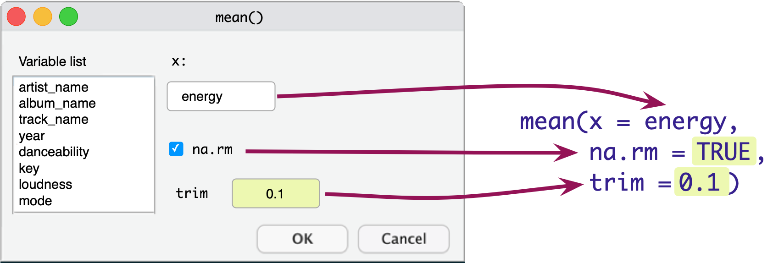

Slide 53: Our report
- How do we use a function to create some output?
Interactive content: A report about Iron Maiden

Slide 54: A function to describe variables
describe_distribution(x = your_tibble,
select = "a_variable",
by = "another_variable")
Tip: Have a go!
- In a code chunk execute
describe_distribution(x = eddie_tib,
select = "song_ms",
by = "year")
year | Mean | SD | IQR | Range | Skewness
-----------------------------------------------------------------------
1980 | 2.83e+05 | 82796.99 | 1.23e+05 | [1.98e+05, 4.41e+05] | 1.08
1981 | 2.33e+05 | 75902.68 | 1.08e+05 | [1.05e+05, 3.73e+05] | 0.28
1982 | 3.03e+05 | 84408.98 | 1.58e+05 | [2.03e+05, 4.31e+05] | 0.45
1983 | 3.08e+05 | 87482.27 | 1.64e+05 | [2.08e+05, 4.49e+05] | 0.46
1984 | 3.82e+05 | 1.88e+05 | 1.56e+05 | [2.46e+05, 8.19e+05] | 2.21
1986 | 3.88e+05 | 76617.90 | 1.28e+05 | [2.99e+05, 5.17e+05] | 0.52
1988 | 3.31e+05 | 1.17e+05 | 93150.00 | [2.11e+05, 5.94e+05] | 1.93
1990 | 2.65e+05 | 28016.26 | 27410.50 | [2.29e+05, 3.32e+05] | 1.63
1992 | 2.93e+05 | 83837.05 | 1.31e+05 | [1.89e+05, 4.38e+05] | 0.44
1995 | 3.88e+05 | 1.17e+05 | 1.34e+05 | [2.54e+05, 6.77e+05] | 1.62
1998 | 3.99e+05 | 1.37e+05 | 2.26e+05 | [1.75e+05, 5.93e+05] | -0.17
2000 | 4.02e+05 | 1.13e+05 | 2.36e+05 | [2.41e+05, 5.61e+05] | 0.02
2003 | 3.71e+05 | 98175.49 | 1.38e+05 | [2.28e+05, 5.16e+05] | 0.01
2006 | 4.32e+05 | 1.06e+05 | 2.06e+05 | [2.58e+05, 5.65e+05] | -0.31
2010 | 4.65e+05 | 1.16e+05 | 1.91e+05 | [2.69e+05, 6.62e+05] | -0.26
2015 | 5.03e+05 | 2.48e+05 | 3.15e+05 | [2.99e+05, 1.08e+06] | 1.57
2021 | 4.92e+05 | 1.66e+05 | 2.80e+05 | [2.44e+05, 7.59e+05] | 0.12
year | Kurtosis | n | n_Missing
--------------------------------
1980 | 0.48 | 8 | 0
1981 | 0.29 | 10 | 0
1982 | -1.44 | 8 | 0
1983 | -1.28 | 9 | 0
1984 | 5.34 | 8 | 0
1986 | -0.82 | 8 | 0
1988 | 4.43 | 8 | 0
1990 | 3.65 | 10 | 0
1992 | -1.00 | 12 | 0
1995 | 3.15 | 11 | 0
1998 | -0.52 | 8 | 0
2000 | -1.24 | 10 | 0
2003 | -0.90 | 11 | 0
2006 | -0.96 | 10 | 0
2010 | -0.43 | 11 | 0
2015 | 1.99 | 11 | 0
2021 | -0.90 | 10 | 0

Slide 55: Storing results
- Sometimes we want to store the results to use later
- We can do this using the assignment operator (<-)
Tip: Have a go!
- In a code chunk type the code below
- Click  to execute the code in the code chunk.
summary_tbl <- describe_distribution(x = eddie_tib,
select = "song_ms",
by = "year")

Slide 56: Using display() for nice tables
- Having stored the table, we can place it in display() to get nice rendering
Tip: Have a go!
summary_tbl <- describe_distribution(x = eddie_tib,
select = "song_ms",
by = "year")
display(summary_tbl)
year | Variable | Mean | SD | IQR | Range | Skewness | Kurtosis | n | n_Missing
1980 | song_ms | 2.83e+05 | 82796.99 | 1.23e+05 | (1.98e+05, 4.41e+05) | 1.08 | 0.48 | 8 | 0
1981 | song_ms | 2.33e+05 | 75902.68 | 1.08e+05 | (1.05e+05, 3.73e+05) | 0.28 | 0.29 | 10 | 0
1982 | song_ms | 3.03e+05 | 84408.98 | 1.58e+05 | (2.03e+05, 4.31e+05) | 0.45 | -1.44 | 8 | 0
1983 | song_ms | 3.08e+05 | 87482.27 | 1.64e+05 | (2.08e+05, 4.49e+05) | 0.46 | -1.28 | 9 | 0
1984 | song_ms | 3.82e+05 | 1.88e+05 | 1.56e+05 | (2.46e+05, 8.19e+05) | 2.21 | 5.34 | 8 | 0
1986 | song_ms | 3.88e+05 | 76617.90 | 1.28e+05 | (2.99e+05, 5.17e+05) | 0.52 | -0.82 | 8 | 0

Slide 57: Cross referencing and citations
Interactive content: A report about Iron Maiden


Slide 58: Cross-referencing tables
- We can use code-chunk options to label and caption tables by using the prefix tbl-
- For example, we could label our table tbl-spotify
- Referring to @tbl-spotify in our document creates an automatic cross-reference
#| label: tbl-spotify
#| tbl-cap: Descriptive statistics for Iron Maiden song durations (s)
display(summary_tbl)
- Table 1 shows the summary statistics
- The Table 1 x-ref was created using @tbl-spotify in the quarto document
year | Variable | Mean | SD | IQR | Range | Skewness | Kurtosis | n | n_Missing
1980 | song_ms | 2.83e+05 | 82796.99 | 1.23e+05 | (1.98e+05, 4.41e+05) | 1.08 | 0.48 | 8 | 0
1981 | song_ms | 2.33e+05 | 75902.68 | 1.08e+05 | (1.05e+05, 3.73e+05) | 0.28 | 0.29 | 10 | 0
1982 | song_ms | 3.03e+05 | 84408.98 | 1.58e+05 | (2.03e+05, 4.31e+05) | 0.45 | -1.44 | 8 | 0
1983 | song_ms | 3.08e+05 | 87482.27 | 1.64e+05 | (2.08e+05, 4.49e+05) | 0.46 | -1.28 | 9 | 0
1984 | song_ms | 3.82e+05 | 1.88e+05 | 1.56e+05 | (2.46e+05, 8.19e+05) | 2.21 | 5.34 | 8 | 0
1986 | song_ms | 3.88e+05 | 76617.90 | 1.28e+05 | (2.99e+05, 5.17e+05) | 0.52 | -0.82 | 8 | 0
Table 1: Descriptive statistics for Iron Maiden song durations (s)

Slide 59: CompRtition!
- Create a new Quarto file.
  - Save in quarto as about_me.qmd
  - Edit the yaml to include
format:
html:
embed-resources: true
- Write a document about you or something you feel passionate about. Include some of things we have learnt:
  - Different level headers/text formats (bold, italic, etc.)
  - Hyperlinks
  - Blockquote
  - Callout
  - Citations
  - Themes

Slide 60 (new section): Part 5: Using functions and the pipe operator

Slide 61: The eddiefy data 🧟
eddie_tib <- discovr::eddiefy
Table 1: Spotify data for Iron Maiden (first 50 of 163 rows)
ID | artist_name | album_name | track_name | year | danceability | energy | key | loudness | mode | speechiness | acousticness | instrumentalness | liveness | valence | tempo | time_signature | song_ms
1 | Iron Maiden | Senjutsu | Senjutsu | 2021 | 0.347 | 0.885 | 9 | -6.121 | 0 | 0.0615 | 0.000171 | 0.0892 | 0.217 | 0.466 | 180.172 | 3 | 500170
2 | Iron Maiden | Senjutsu | Stratego | 2021 | 0.473 | 0.968 | 4 | -7.297 | 0 | 0.0642 | 0.000144 | 0.0347 | 0.612 | 0.465 | 138.054 | 4 | 299946
3 | Iron Maiden | Senjutsu | The Writing On The Wall | 2021 | 0.402 | 0.912 | 2 | -5.447 | 0 | 0.0442 | 0.00158 | 0.000179 | 0.0923 | 0.566 | 90.045 | 4 | 373898
4 | Iron Maiden | Senjutsu | Lost In A Lost World | 2021 | 0.251 | 0.871 | 4 | -6.414 | 0 | 0.0871 | 0.00407 | 0.00751 | 0.108 | 0.206 | 92.975 | 4 | 571584
5 | Iron Maiden | Senjutsu | Days Of Future Past | 2021 | 0.433 | 0.92 | 4 | -4.738 | 0 | 0.0409 | 0.000576 | 5.5e-05 | 0.123 | 0.476 | 92.466 | 4 | 243754
6 | Iron Maiden | Senjutsu | The Time Machine | 2021 | 0.297 | 0.889 | 9 | -5.287 | 0 | 0.0607 | 0.00654 | 0.000211 | 0.118 | 0.316 | 116.65 | 4 | 429443
7 | Iron Maiden | Senjutsu | Darkest Hour | 2021 | 0.222 | 0.925 | 4 | -5.939 | 0 | 0.24 | 0.0542 | 0.0863 | 0.395 | 0.162 | 133.772 | 4 | 440464
8 | Iron Maiden | Senjutsu | Death Of The Celts | 2021 | 0.291 | 0.804 | 2 | -5.807 | 1 | 0.0414 | 0.00711 | 0.21 | 0.12 | 0.26 | 134.561 | 4 | 620403
9 | Iron Maiden | Senjutsu | The Parchment | 2021 | 0.149 | 0.924 | 4 | -5.345 | 0 | 0.0933 | 0.0141 | 0.219 | 0.107 | 0.212 | 80.234 | 4 | 758990
10 | Iron Maiden | Senjutsu | Hell On Earth | 2021 | 0.298 | 0.842 | 4 | -6.692 | 0 | 0.0563 | 0.00952 | 0.0299 | 0.0846 | 0.0628 | 132.65 | 4 | 679134
11 | Iron Maiden | The Book of Souls | If Eternity Should Fail | 2015 | 0.291 | 0.868 | 7 | -6.499 | 1 | 0.0611 | 0.00679 | 0.000413 | 0.118 | 0.149 | 117.931 | 4 | 508207
12 | Iron Maiden | The Book of Souls | Speed Of Light | 2015 | 0.176 | 0.974 | 7 | -5.778 | 0 | 0.132 | 0.000419 | 2.62e-05 | 0.107 | 0.334 | 185.491 | 4 | 301745
13 | Iron Maiden | The Book of Souls | The Great Unknown | 2015 | 0.211 | 0.897 | 2 | -6.629 | 1 | 0.201 | 0.0195 | 0.000189 | 0.108 | 0.0702 | 92.082 | 4 | 397655
14 | Iron Maiden | The Book of Souls | The Red And The Black | 2015 | 0.275 | 0.932 | 4 | -5.54 | 0 | 0.0865 | 0.00176 | 0.109 | 0.116 | 0.377 | 114.008 | 4 | 813713
15 | Iron Maiden | The Book of Souls | When The River Runs Deep | 2015 | 0.271 | 0.947 | 9 | -5.424 | 1 | 0.0749 | 0.00252 | 3.21e-05 | 0.119 | 0.393 | 128.747 | 4 | 352882
16 | Iron Maiden | The Book of Souls | The Book Of Souls | 2015 | 0.198 | 0.935 | 4 | -5.505 | 0 | 0.0968 | 0.00383 | 8.16e-05 | 0.102 | 0.359 | 80.875 | 4 | 627626
17 | Iron Maiden | The Book of Souls | Death Or Glory | 2015 | 0.181 | 0.974 | 9 | -5.493 | 1 | 0.162 | 0.000365 | 3.47e-05 | 0.364 | 0.316 | 176.088 | 4 | 312867
18 | Iron Maiden | The Book of Souls | Shadows Of The Valley | 2015 | 0.231 | 0.977 | 4 | -4.918 | 0 | 0.11 | 0.00174 | 3.84e-05 | 0.111 | 0.284 | 149.675 | 4 | 452478
19 | Iron Maiden | The Book of Souls | Tears Of A Clown | 2015 | 0.311 | 0.874 | 9 | -5.327 | 0 | 0.0449 | 0.00696 | 1.17e-05 | 0.0861 | 0.503 | 95.194 | 4 | 298886
20 | Iron Maiden | The Book of Souls | The Man Of Sorrows | 2015 | 0.441 | 0.78 | 2 | -5.488 | 0 | 0.0418 | 0.0242 | 6.34e-05 | 0.23 | 0.291 | 110.18 | 4 | 387542
21 | Iron Maiden | The Book of Souls | Empire Of The Clouds | 2015 | 0.249 | 0.789 | 4 | -6.15 | 0 | 0.0496 | 0.0165 | 0.00239 | 0.104 | 0.19 | 76.293 | 4 | 1081316
22 | Iron Maiden | The Final Frontier | Satellite 15 | 2010 | 0.265 | 0.873 | 9 | -6.411 | 1 | 0.0682 | 0.000584 | 0.00148 | 0.113 | 0.435 | 133.376 | 4 | 520946
23 | Iron Maiden | The Final Frontier | El Dorado | 2010 | 0.265 | 0.92 | 11 | -7.012 | 1 | 0.0965 | 4.59e-05 | 0.00305 | 0.117 | 0.436 | 155.14 | 4 | 408786
24 | Iron Maiden | The Final Frontier | Mother Of Mercy | 2010 | 0.309 | 0.9 | 2 | -6.839 | 1 | 0.0625 | 0.00296 | 0.00012 | 0.0486 | 0.364 | 106.055 | 4 | 320133
25 | Iron Maiden | The Final Frontier | Coming Home | 2010 | 0.332 | 0.887 | 4 | -6.655 | 0 | 0.0537 | 0.00018 | 5.79e-05 | 0.278 | 0.467 | 79.761 | 4 | 352440
26 | Iron Maiden | The Final Frontier | The Alchemist | 2010 | 0.341 | 0.955 | 2 | -6.104 | 1 | 0.0654 | 0.000166 | 1.92e-05 | 0.345 | 0.64 | 124.023 | 4 | 268986
27 | Iron Maiden | The Final Frontier | Isle Of Avalon | 2010 | 0.291 | 0.902 | 9 | -7.217 | 1 | 0.0499 | 0.0103 | 0.00471 | 0.145 | 0.0739 | 151.904 | 3 | 546026
28 | Iron Maiden | The Final Frontier | Starblind | 2010 | 0.197 | 0.871 | 0 | -6.788 | 1 | 0.0548 | 0.00476 | 0.00283 | 0.0875 | 0.217 | 81.904 | 4 | 468360
29 | Iron Maiden | The Final Frontier | The Talisman | 2010 | 0.216 | 0.834 | 2 | -7.307 | 0 | 0.0763 | 0.00189 | 6.49e-06 | 0.0738 | 0.16 | 81.197 | 4 | 543106
30 | Iron Maiden | The Final Frontier | The Man Who Would Be King | 2010 | 0.212 | 0.828 | 11 | -7.453 | 0 | 0.0559 | 0.00288 | 0.0228 | 0.12 | 0.273 | 86.628 | 4 | 508173
31 | Iron Maiden | The Final Frontier | When The Wild Wind Blows | 2010 | 0.305 | 0.759 | 4 | -8.52 | 0 | 0.0462 | 0.00392 | 0.398 | 0.31 | 0.228 | 96.889 | 4 | 661760
32 | Iron Maiden | The Final Frontier | Satellite 15.....The Final Frontier | 2010 | 0.263 | 0.882 | 9 | -5.871 | 1 | 0.0681 | 0.000654 | 0.00111 | 0.113 | 0.411 | 133.801 | 4 | 520293
33 | Iron Maiden | A Matter of Life and Death | Different World | 2006 | 0.406 | 0.975 | 4 | -4.285 | 0 | 0.0937 | 0.000325 | 0.00018 | 0.613 | 0.602 | 91.826 | 4 | 258186
34 | Iron Maiden | A Matter of Life and Death | These Colours Don't Run | 2006 | 0.317 | 0.94 | 4 | -5.33 | 0 | 0.114 | 0.00573 | 0.0033 | 0.112 | 0.228 | 103.396 | 4 | 412213
35 | Iron Maiden | A Matter of Life and Death | Brighter Than A Thousand Suns | 2006 | 0.294 | 0.949 | 0 | -5.655 | 1 | 0.0851 | 0.00161 | 2.79e-05 | 0.101 | 0.266 | 125.892 | 4 | 526106
36 | Iron Maiden | A Matter of Life and Death | The Pilgrim | 2006 | 0.308 | 0.934 | 9 | -4.145 | 0 | 0.0606 | 0.000306 | 0.0313 | 0.0863 | 0.541 | 97.848 | 4 | 307866
37 | Iron Maiden | A Matter of Life and Death | The Longest Day | 2006 | 0.259 | 0.925 | 4 | -5.706 | 0 | 0.0713 | 0.00133 | 0.00289 | 0.128 | 0.337 | 101.244 | 4 | 468093
38 | Iron Maiden | A Matter of Life and Death | Out Of The Shadows | 2006 | 0.213 | 0.839 | 4 | -5.109 | 0 | 0.0406 | 0.00285 | 0.00195 | 0.279 | 0.288 | 81.402 | 4 | 336640
39 | Iron Maiden | A Matter of Life and Death | The Reincarnation Of Benjamin Breeg | 2006 | 0.353 | 0.837 | 4 | -5.551 | 0 | 0.0356 | 0.00268 | 0.000533 | 0.11 | 0.144 | 110.999 | 4 | 442053
40 | Iron Maiden | A Matter of Life and Death | For The Greater Good Of God | 2006 | 0.316 | 0.908 | 4 | -5.455 | 0 | 0.0779 | 0.00194 | 0.0578 | 0.111 | 0.3 | 107.743 | 4 | 565026
41 | Iron Maiden | A Matter of Life and Death | Lord Of Light | 2006 | 0.281 | 0.901 | 4 | -6.083 | 0 | 0.0739 | 0.00445 | 0.0044 | 0.166 | 0.0485 | 93.542 | 4 | 444653
42 | Iron Maiden | A Matter of Life and Death | The Legacy | 2006 | 0.328 | 0.928 | 2 | -5.839 | 0 | 0.131 | 0.0471 | 0.000681 | 0.179 | 0.15 | 148.276 | 4 | 562946
43 | Iron Maiden | Dance of Death | Wildest Dreams | 2003 | 0.302 | 0.923 | 9 | -4.621 | 1 | 0.0829 | 0.000616 | 8.28e-06 | 0.078 | 0.57 | 103.8 | 4 | 232106
44 | Iron Maiden | Dance of Death | Rainmaker | 2003 | 0.35 | 0.952 | 5 | -4.485 | 1 | 0.14 | 0.00122 | 0 | 0.262 | 0.539 | 86.146 | 4 | 228493
45 | Iron Maiden | Dance of Death | No More Lies | 2003 | 0.176 | 0.845 | 5 | -5.732 | 1 | 0.092 | 0.00546 | 0.00311 | 0.123 | 0.214 | 190.867 | 4 | 441786
46 | Iron Maiden | Dance of Death | Montségur | 2003 | 0.285 | 0.99 | 9 | -3.512 | 1 | 0.201 | 7.09e-05 | 0.00021 | 0.118 | 0.215 | 78.537 | 4 | 350373
47 | Iron Maiden | Dance of Death | Dance Of Death | 2003 | 0.311 | 0.876 | 4 | -5.115 | 0 | 0.0936 | 0.0466 | 0.00442 | 0.134 | 0.296 | 124.584 | 4 | 516426
48 | Iron Maiden | Dance of Death | Gates Of Tomorrow | 2003 | 0.245 | 0.963 | 7 | -4.532 | 0 | 0.209 | 0.000443 | 6.2e-05 | 0.367 | 0.336 | 95.677 | 4 | 312120
49 | Iron Maiden | Dance of Death | New Frontier | 2003 | 0.316 | 0.967 | 2 | -3.9 | 0 | 0.0884 | 0.000177 | 0 | 0.0685 | 0.521 | 104.3 | 4 | 304280
50 | Iron Maiden | Dance of Death | Paschendale | 2003 | 0.168 | 0.941 | 6 | -5.303 | 0 | 0.0938 | 0.0119 | 2.04e-05 | 0.069 | 0.188 | 89.221 | 4 | 508200

Slide 62: Using functions
Let’s say we want to
- Retain only the variables album_name, track_name, year and energy
- Retain only albums before the year 1990
We can use the dplyr functions
- select() to choose variables
- filter() to retain rows that match a condition
energy_tib <- select(.data = eddie_tib, album_name, track_name, year, energy)
classic_tib <- filter(.data = energy_tib, year < 1990)
(first 50 of 59 rows)
ID | album_name | track_name | year | energy
1 | Seventh Son of a Seventh Son | Moonchild | 1988 | 0.96
2 | Seventh Son of a Seventh Son | Infinite Dreams | 1988 | 0.962
3 | Seventh Son of a Seventh Son | Can I Play With Madness | 1988 | 0.981
4 | Seventh Son of a Seventh Son | The Evil That Men Do | 1988 | 0.977
5 | Seventh Son of a Seventh Son | Seventh Son Of A Seventh Son | 1988 | 0.872
6 | Seventh Son of a Seventh Son | The Prophecy | 1988 | 0.828
7 | Seventh Son of a Seventh Son | The Clairvoyant | 1988 | 0.944
8 | Seventh Son of a Seventh Son | Only The Good Die Young | 1988 | 0.975
9 | Somewhere in Time | Caught Somewhere In Time | 1986 | 0.987
10 | Somewhere in Time | Wasted Years | 1986 | 0.959
11 | Somewhere in Time | Sea Of Madness | 1986 | 0.985
12 | Somewhere in Time | Heaven Can Wait | 1986 | 0.982
13 | Somewhere in Time | The Loneliness Of The Long Distance Runner | 1986 | 0.991
14 | Somewhere in Time | Stranger In A Strange Land | 1986 | 0.913
15 | Somewhere in Time | Deja Vu | 1986 | 0.981
16 | Somewhere in Time | Alexander The Great (356-323 B.c.) | 1986 | 0.944
17 | Powerslave | Aces High | 1984 | 0.936
18 | Powerslave | 2 Minutes To Midnight | 1984 | 0.97
19 | Powerslave | Losfer Words (Big 'Orra) | 1984 | 0.98
20 | Powerslave | Flash Of The Blade | 1984 | 0.963
21 | Powerslave | The Duellists | 1984 | 0.971
22 | Powerslave | Back In The Village | 1984 | 0.98
23 | Powerslave | Powerslave | 1984 | 0.974
24 | Powerslave | Rime Of The Ancient Mariner | 1984 | 0.932
25 | Piece of Mind | Where Eagles Dare | 1983 | 0.965
26 | Piece of Mind | Revelations | 1983 | 0.845
27 | Piece of Mind | Flight Of Icarus | 1983 | 0.917
28 | Piece of Mind | Die With Your Boots On | 1983 | 0.947
29 | Piece of Mind | The Trooper | 1983 | 0.908
30 | Piece of Mind | Still Life | 1983 | 0.827
31 | Piece of Mind | Quest For Fire | 1983 | 0.894
32 | Piece of Mind | Sun And Steel | 1983 | 0.921
33 | Piece of Mind | To Tame A Land | 1983 | 0.864
34 | The Number of the Beast | Invaders | 1982 | 0.937
35 | The Number of the Beast | Children Of The Damned | 1982 | 0.775
36 | The Number of the Beast | The Prisoner | 1982 | 0.88
37 | The Number of the Beast | 22 Acacia Avenue | 1982 | 0.907
38 | The Number of the Beast | The Number Of The Beast | 1982 | 0.89
39 | The Number of the Beast | Run To The Hills | 1982 | 0.943
40 | The Number of the Beast | Gangland | 1982 | 0.939
41 | The Number of the Beast | Hallowed Be Thy Name | 1982 | 0.882
42 | Killers | The Ides Of March | 1981 | 0.744
43 | Killers | Wrathchild | 1981 | 0.93
44 | Killers | Murders In The Rue Morgue | 1981 | 0.925
45 | Killers | Another Life | 1981 | 0.959
46 | Killers | Genghis Khan | 1981 | 0.894
47 | Killers | Innocent Exile | 1981 | 0.937
48 | Killers | Killers | 1981 | 0.939
49 | Killers | Prodigal Son | 1981 | 0.685
50 | Killers | Purgatory | 1981 | 0.965

Slide 63: The pipe operator (|>)1
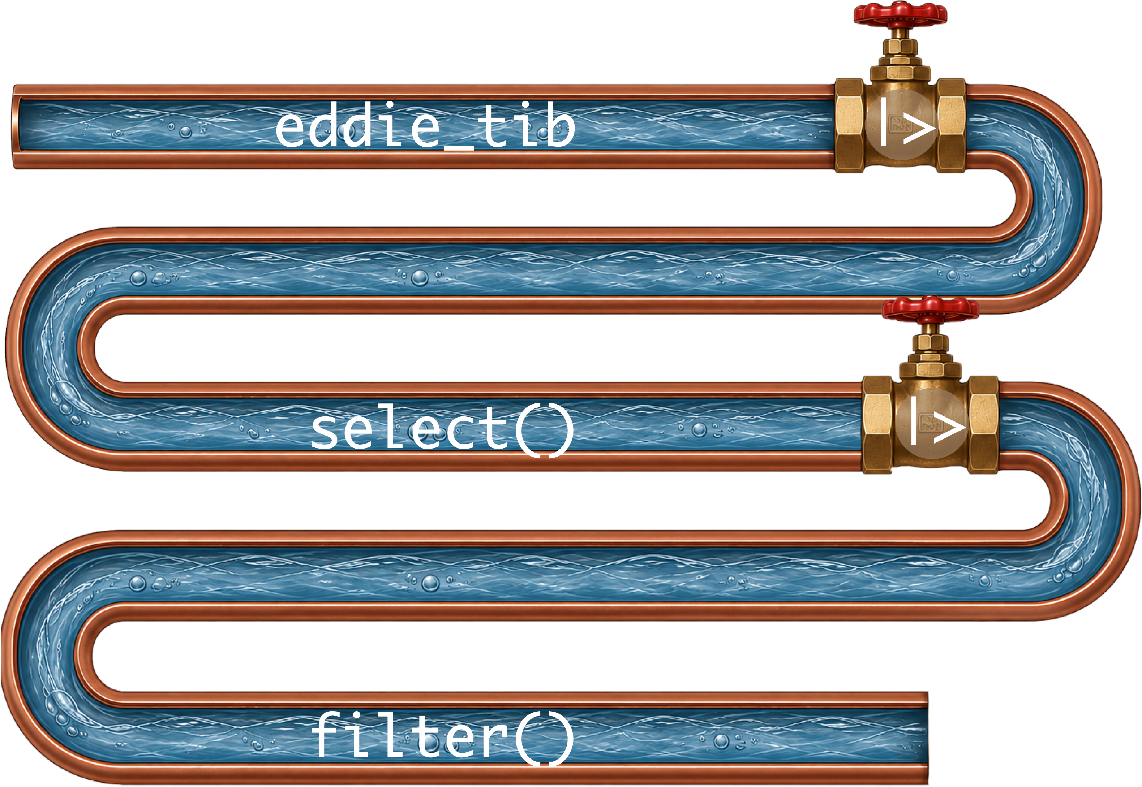
eddie_tib |>
select(album_name, track_name, year, energy) |>
filter(year < 1990)
Footnotes
- Older code uses %>%, treat the two pipe symbols as interchangeable

Slide 64: Try your first pipe
Tip: Have a go!
- The pipe operator allows you to combine functions
- Makes code more readable
- Create a new code chunk
energy_tib <- eddie_tib |>
select(album_name, track_name, year, energy) |>
filter(year < 1990)

Slide 65: Creating new variables
Caution: Hypothesis
- H₁: Iron Maiden songs have got longer over time
- H₀: The length of Iron Maiden songs has not changed over time
The model
- Outcome: Song duration in seconds (song_duration)
- Predictor: Number of years since the first album (band_age)
- These variables don’t exist in the data
Tip: We need to
Create two new variables in eddie_tib
- song_duration takes the existing variable song_ms, which is the song duration in milliseconds and converts to seconds by diving by 1000
- band_age converts the year the song was recorded into the number of years since their first album in 1980

Slide 66: The mutate() function
- We use mutate() to create new variables in a tibble/dataframe
- mutate() is from the dplyr package, which is part of tidyverse
- It takes the general form
my_tib <- my_tib |>
mutate(new_variable = some_instructions,
another_new_variable = some_instructions)

Slide 67
Tip: Have a go!
Create two new variables in eddie_tib
- song_duration takes the existing variable song_ms, which is the song duration in milliseconds and converts to seconds by diving by 1000
- band_age converts the year the song was recorded into the number of years since their first album in 1980
eddie_tib <- eddie_tib |>
mutate(song_duration = song_ms/1000,
band_age = year - 1980)

Slide 68: Revising descriptive statistics
Important: ReportR
Table 2 shows some data from spotify, which is stored in the discovr package (Field 2026).
summary_tbl <- describe_distribution(x = eddie_tib, select = "song_duration", by = "year") |>
data_remove(c("Variable", "n_Missing"))
display(summary_tbl)
year | Mean | SD | IQR | Range | Skewness | Kurtosis | n
1980 | 282.87 | 82.80 | 123.12 | (197.57, 441.47) | 1.08 | 0.48 | 8
1981 | 232.78 | 75.90 | 107.70 | (105.27, 373.27) | 0.28 | 0.29 | 10
1982 | 302.78 | 84.41 | 157.98 | (203.39, 431.09) | 0.45 | -1.44 | 8
1983 | 307.67 | 87.48 | 164.49 | (207.51, 448.75) | 0.46 | -1.28 | 9
1984 | 382.19 | 187.74 | 156.14 | (245.57, 818.69) | 2.21 | 5.34 | 8
1986 | 387.52 | 76.62 | 128.16 | (298.52, 517.09) | 0.52 | -0.82 | 8
1988 | 330.66 | 116.72 | 93.15 | (211.25, 594.08) | 1.93 | 4.43 | 8
1990 | 264.59 | 28.02 | 27.41 | (229.03, 332.00) | 1.63 | 3.65 | 10
1992 | 293.13 | 83.84 | 130.63 | (188.80, 438.12) | 0.44 | -1.00 | 12
1995 | 387.84 | 117.33 | 133.52 | (253.80, 676.99) | 1.62 | 3.15 | 11
1998 | 399.19 | 137.18 | 225.58 | (175.12, 592.72) | -0.17 | -0.52 | 8
2000 | 402.24 | 113.21 | 235.97 | (240.67, 561.21) | 0.02 | -1.24 | 10
2003 | 371.05 | 98.18 | 137.51 | (228.49, 516.43) | 0.01 | -0.90 | 11
2006 | 432.38 | 105.60 | 205.87 | (258.19, 565.03) | -0.31 | -0.96 | 10
2010 | 465.36 | 116.05 | 190.67 | (268.99, 661.76) | -0.26 | -0.43 | 11
2015 | 503.17 | 247.87 | 314.76 | (298.89, 1081.32) | 1.57 | 1.99 | 11
2021 | 491.78 | 166.07 | 279.68 | (243.75, 758.99) | 0.12 | -0.90 | 10
Table 2: Descriptive statistics for Iron Maiden song durations (s)

Slide 69: Citations
- Insert > @citation ...
- Use Zotero reference manager!
  - Guide: guides.lib.sussex.ac.uk/zotero
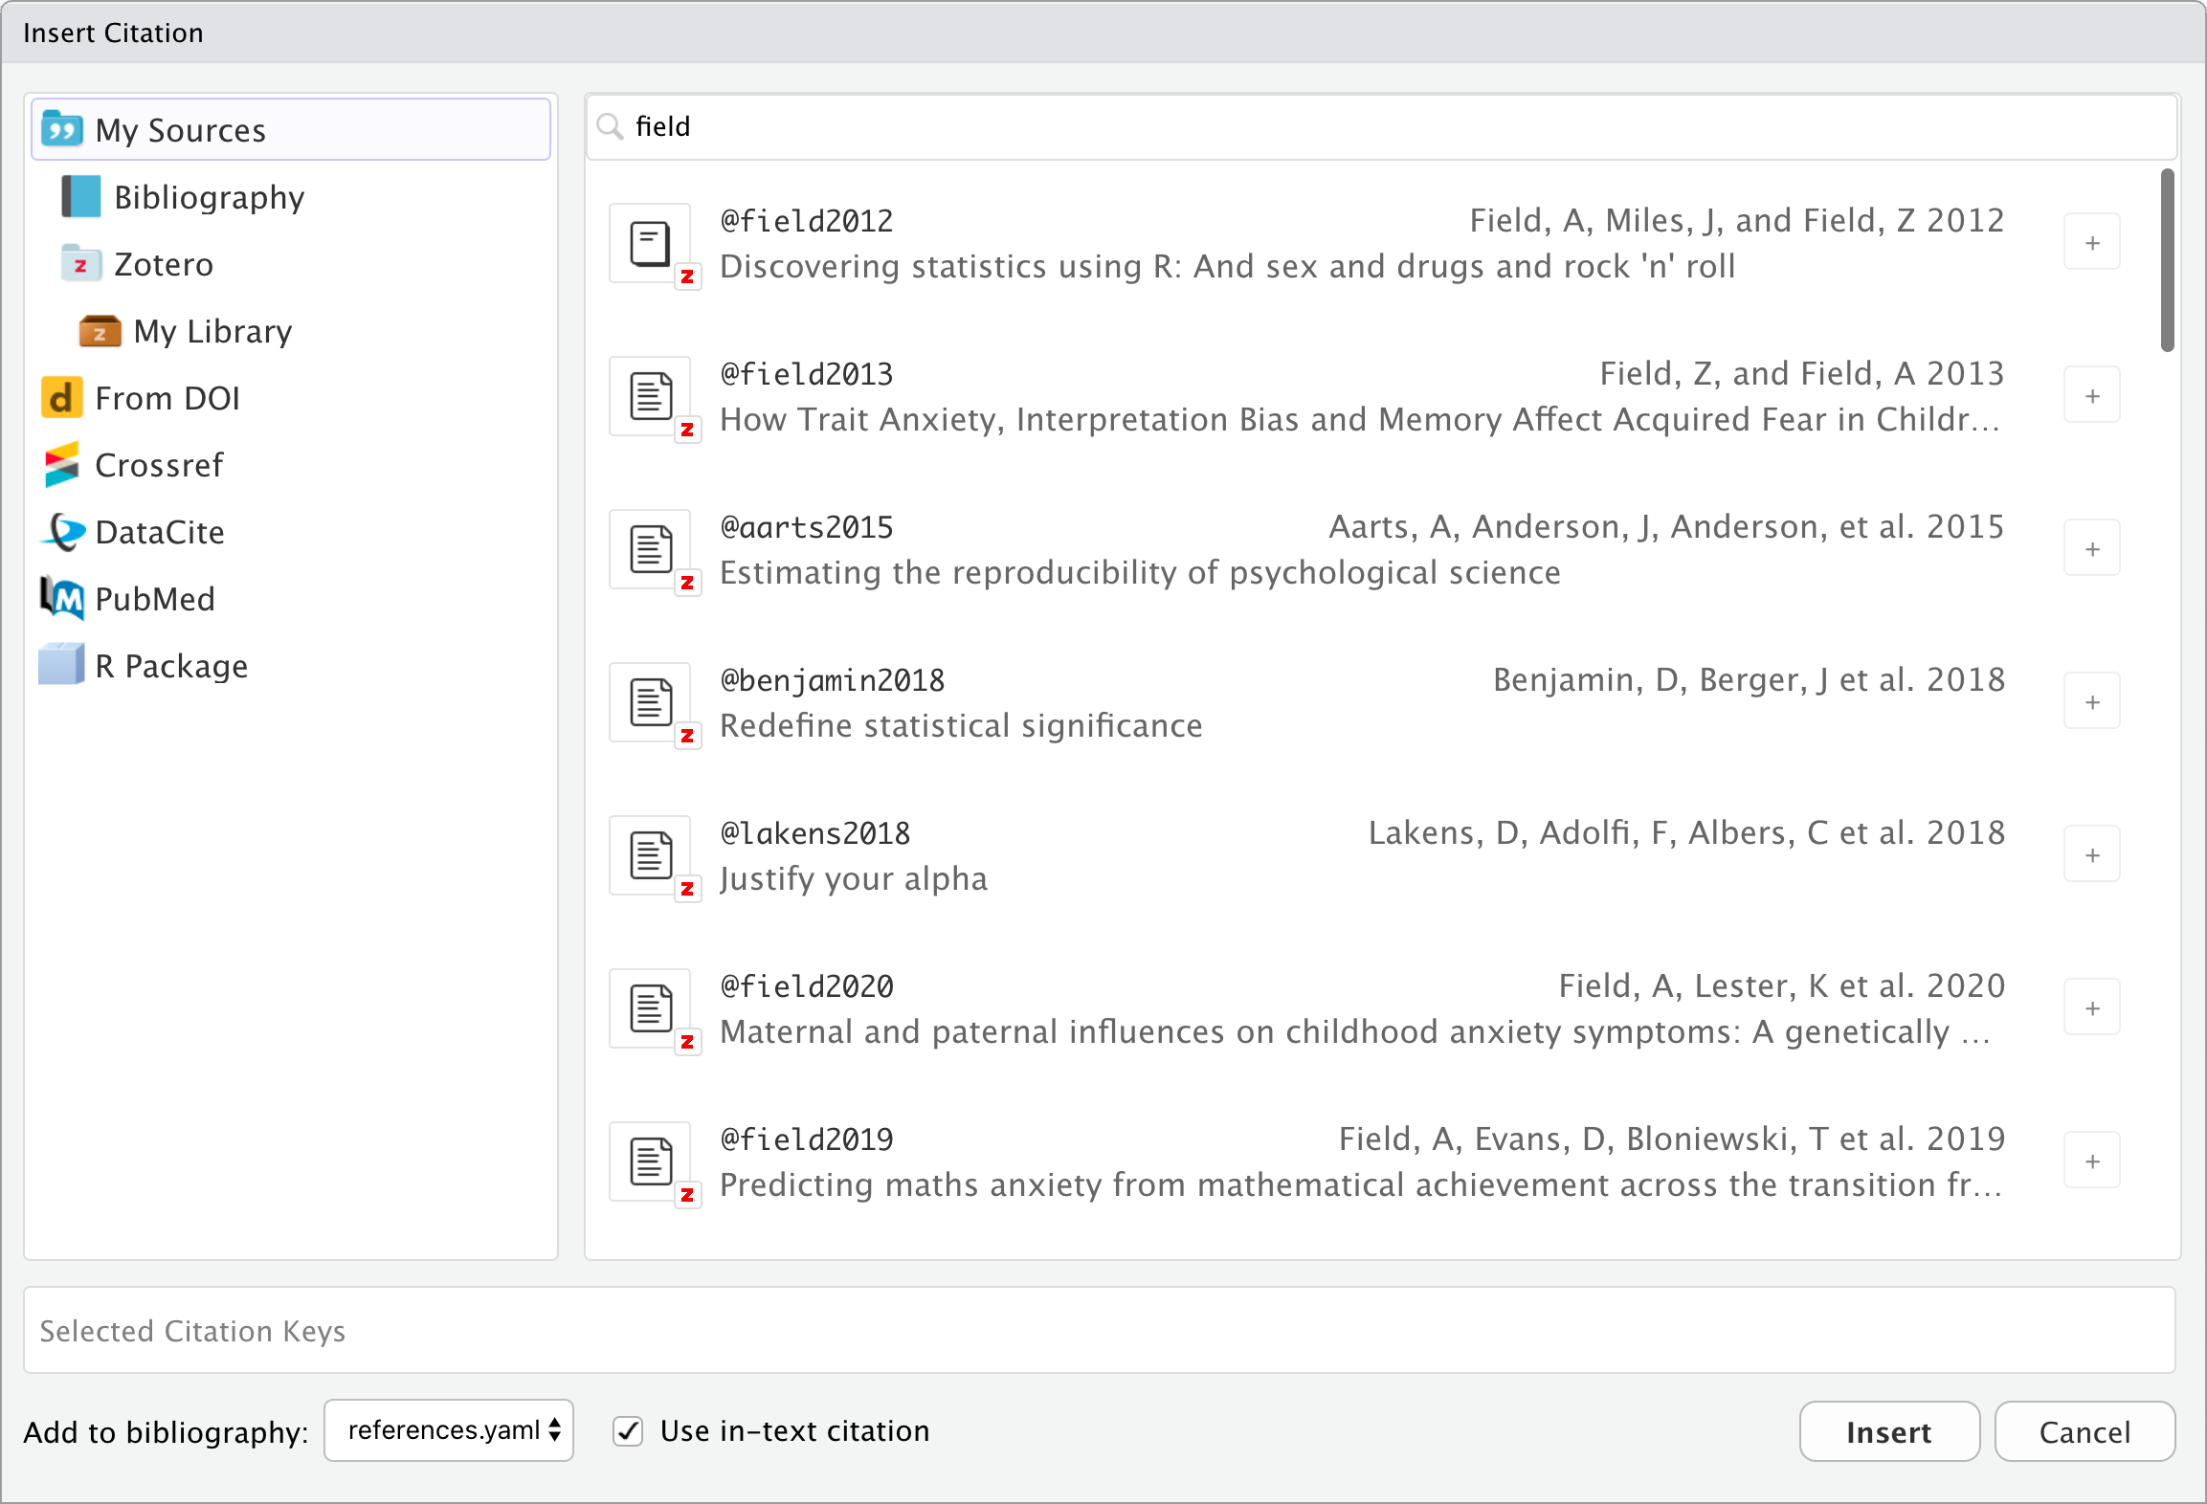

Slide 70: Citations from pubmed
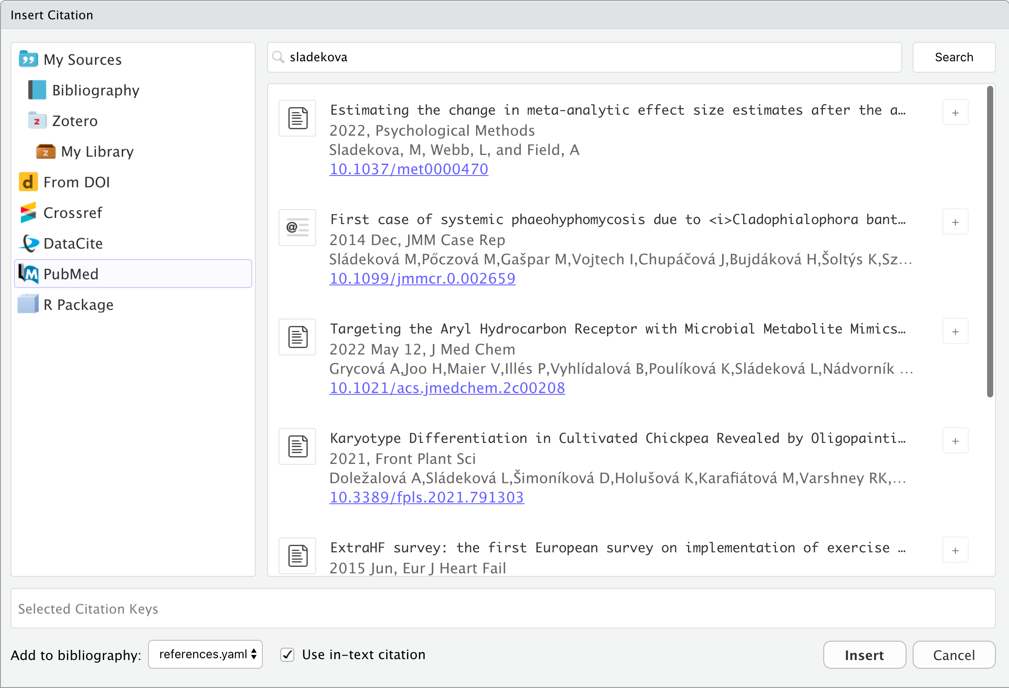

Slide 71: Cite R packages
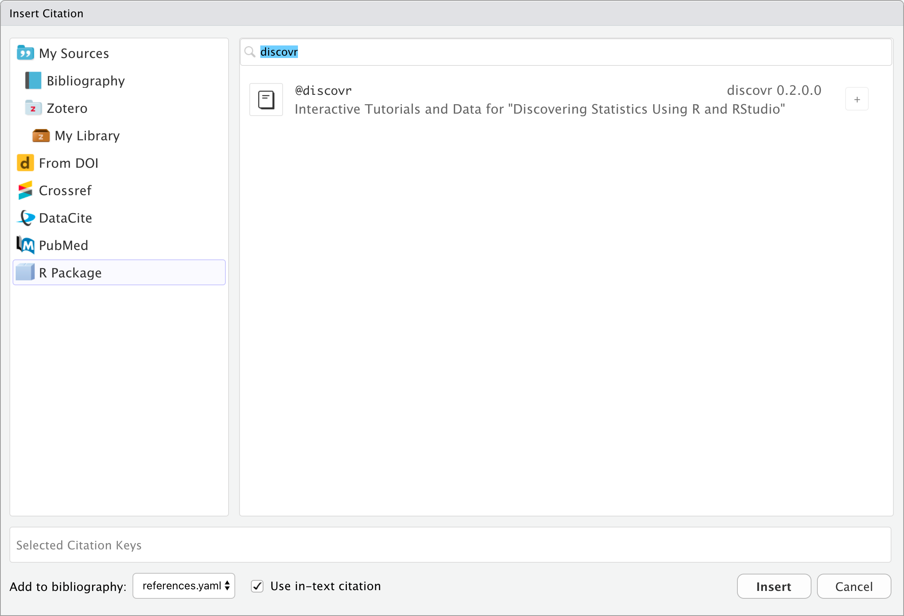

Slide 72: Visualise
Interactive content: A report about Iron Maiden


Slide 73
Tip: Have a go!
- Add a level 3 header Visualise
- Insert a code chunk
@fig-scatmat shows a plot of the distributions of song duration and years since the first album as well as a scatterplot.
#| label: fig-scatmat
#| fig-cap: Plots of song duration against time since the first album
#| fig-width: 7
#| fig-height: 7
eddie_tib |>
select(band_age, song_duration) |>
GGally::ggscatmat()

Slide 74: Evaluate
Interactive content: A report about Iron Maiden


Slide 75: LaTeX equations
- Insert > LaTeX Math > Display Math
- A syntax for writing mathematical notation
- See https://oeis.org/wiki/List_of_LaTeX_mathematical_symbols
We can include the linear model in its own paragraph like this:
$$
\text{duration} = \hat{b}_{0} + \hat{b}_1\text{years}
$$

Rendered text
We can include the linear model in its own paragraph like this:
$$\text{duration}={\hat{b}}_{0}+{\hat{b}}_{1}\text{years}$$

Slide 76 (new section): Part 6: Code tips

Slide 77: Use a ‘setup’ code chunk
- Use a setup code chunk at the start of your document (directly below the YAML) that
  - Loads all of the umbrella packages you plan to use (in alphabetic order)
  - Loads any data that you plan to use
library(easystats)
library(tidyverse)
tap_tib <- here::here("data/tap_parenting.csv") |>
read_csv()

Slide 78: Getting data into R

The here() function
here::here(text_to_add)
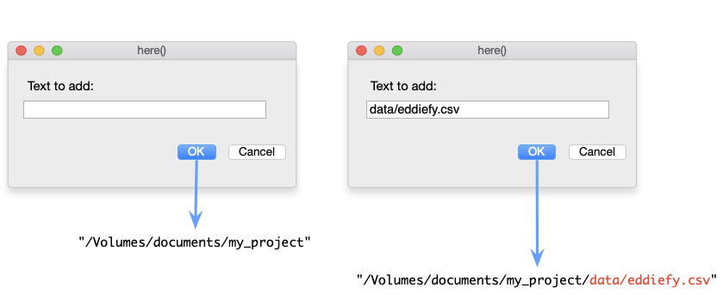

The readr package
- The read_csv(file = "filepath") function reads CSV files.

Slide 79: Getting data into R
Tip: Have a go!
- In your code chunk execute
eddie_tib <- here::here("data/eddiefy.csv") |>
read_csv()
eddie_tib

Slide 80: R Style (Wickham, 2014)
- R is case sensitive. In code chunks use lower case wherever possible
- Variable and function names should be lowercase with an underscore (_) to separate words
  - Names should be concise and meaningful
  - A variable representing children’s’ anxiety levels might be named child_anxiety
  - scores_on_the_child_manifest_anxiety_scale is meaningful but too long, and ca is concise but not meaningful
- Place spaces around all operators (=, +, -, <-) to make code easier on the eye!
- Use suffixes that identify types of objects. Some personal examples
  - _tib to denote a tibble (more them later), e.g. anx_tib for a tibble of data relating to anxiety)
  - _lm, _glm to denote models built using lm() and glm()
  - _mlm to denote multilevel models
  - _out to denote output (e.g., anx_out contains the summary output from the above model

Slide 81: Getting help
To get help, use the help() function or ?
- help(thing_you_want_help_with)
- ?thing_you_want_help_with
The R help files are frequently incomprehensible to mere mortals, but they are getting better!
Tip
Execute help commands at the command line
- Do NOT include help() or ? in Quarto files
Tip: Have a go!
Access the help files for the mean() function, by executing (in the console):
- ?mean

Slide 82 (new section): Part 7: Quarto tips

Slide 83: Rendering
Tip: Have a go!
- Move the code chunk containing the plot to the start of your document.
- Click to render the document.
Tip: Rendering tips
- Code chunks are rendered in the order they appear in the markdown document.
  - Make sure you create objects BEFORE you try to use them.
- Do NOT include install.packages() in Quarto files or the package will be installed every time you render the document!
  - Execute install.packages() commands at the command line

Slide 84: YAML: Other useful options
---
title: "Iron Maiden"
author: "Andy Field"
format:
html:
theme: materia
embed-resources: true
toc: true
code-fold: true
execute:
warning: false
editor: visual
---
- HTML options: quarto.org/docs/reference/formats/html.html
- Theme list: quarto.org/docs/output-formats/html-themes.html

Slide 85 (new section): Part 8: Getting the most from practical classes

Slide 86: Practical classes
The practical classes are based on a package of interactive tutorials called discovr that I wrote
- You work at your own pace
- You can work with friends/peers to support each other
- Tutors will wander around giving you one-to-one help when you need it


Slide 87: Running a tutorial
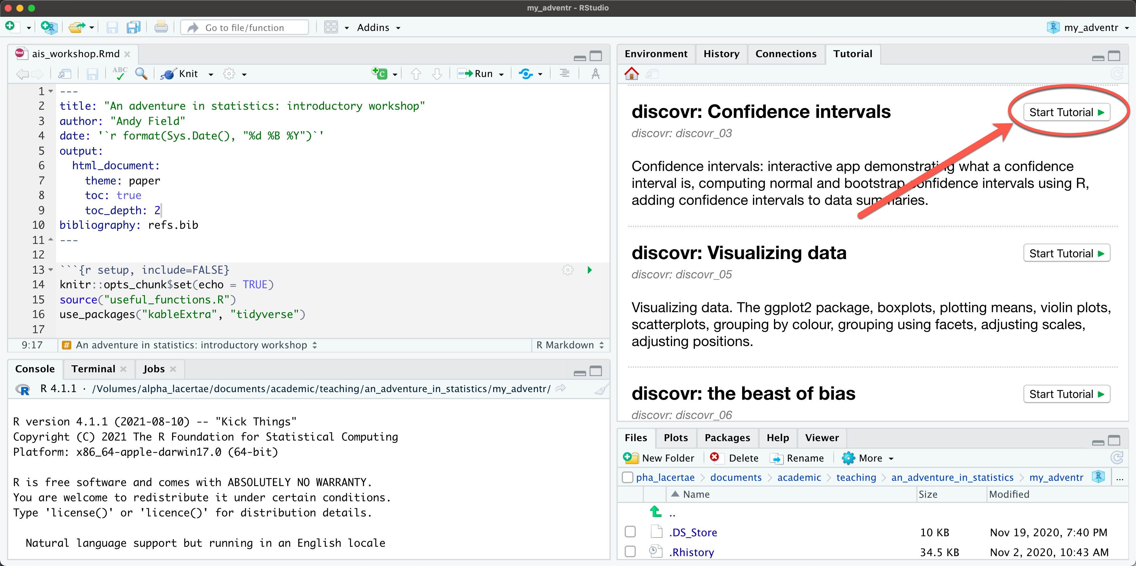

Slide 88: Suggested workflow
- Create an RStudio project called my_adventr
  - Within it create folders called data and quarto
  - Save all of the data files for the tutorials (on Canvas) into the data folder
- Run a tutorial and open it in a separate window
- Create a learning journal for the tutorial
  - Each time you start a tutorial create a new Quarto file and save it with a name related to the tutorial
  - As you work through the tutorial, copy some code you’ve written in the tutorial into code chunks in the Quarto file
  - Make notes (for example, anything you didn’t understand at first, or things to help you remember what you did and why you did it).
  - Save the Quarto file for future reference, and render it into an html document
- Watch the video at https://youtu.be/mqT7c17tofE

Slide 89: CompRtition!
Caution: CompRtition!
Write a document about you or something you feel passionate about. Include some of things we have learnt:
- Different level headers/text formats (bold, italic, etc.)
- Hyperlinks
- Callout
- Citations
- Themes
- Tables
- Figures
- Code/Data
Submit by the deadline for a chance to win a prize!

Slide 90: References
Field, Andy. 2026. “Discovr: Interactive Tutorials and Data for ‘Discovering Statistics Using R and RStudio’ .” https://doi.org/10.32614/CRAN.package.discovr .

