Multilevel models
Theory and concepts
Professor Andy Field, University of Sussex
Links: wittr prayer of transformation | bsky.app | youtube.com | discoveringstatistics.com | discovr.rocks | statisticsadventure.com

About this version
This is a plain-text version of the lecture slides. Each slide starts with a heading such as “Slide 5”, and the numbers match the slide numbers shown in the lecture. Content that appeared one piece at a time, in columns or in tabs is shown in reading order. Videos and interactive apps are given as links.

Slide 2: Learning outcomes
- Understand what hierarchical data are
  - Why we can’t use the OLS GLM
- Understand fixed and random coefficients
- Understand how to build models

Part 2
- Be able to conduct and interpret models of hierarchical data

Slide 3
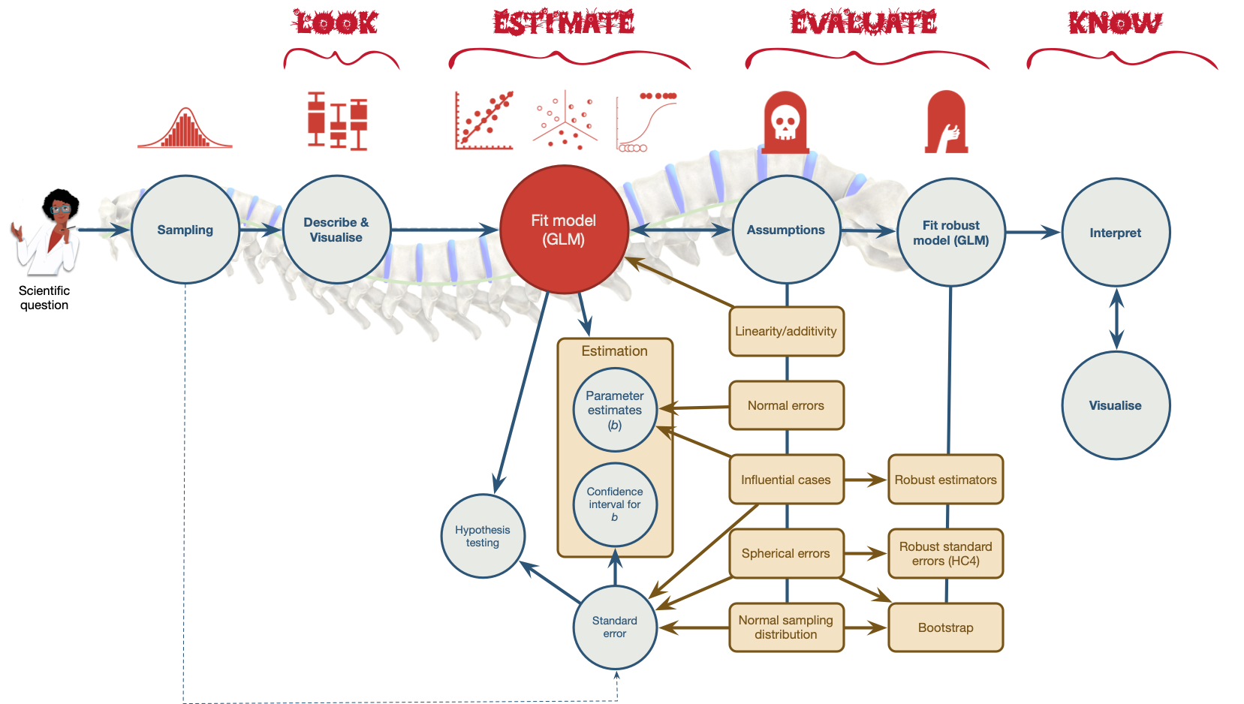
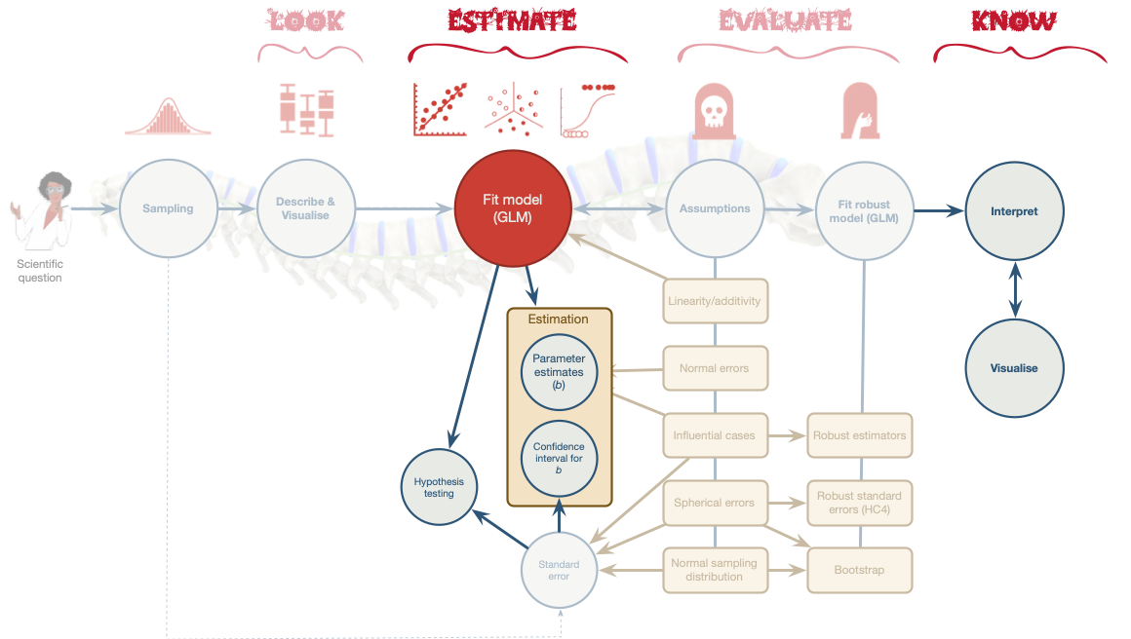

Slide 4: Hierarchical data
- Data structures are often hierarchical
  - Children nested within classrooms
  - Observations nested within people
  - Employees nested within organisations
  - Patients nested within hospitals
  - Patients nested within teams nested within hospitals
  - Service users nested within clinicians nested within hospitals nested within NHS trusts!
  - Zombies nested within rehabilitation clinics 😉

Slide 5: A two-level hierarchy
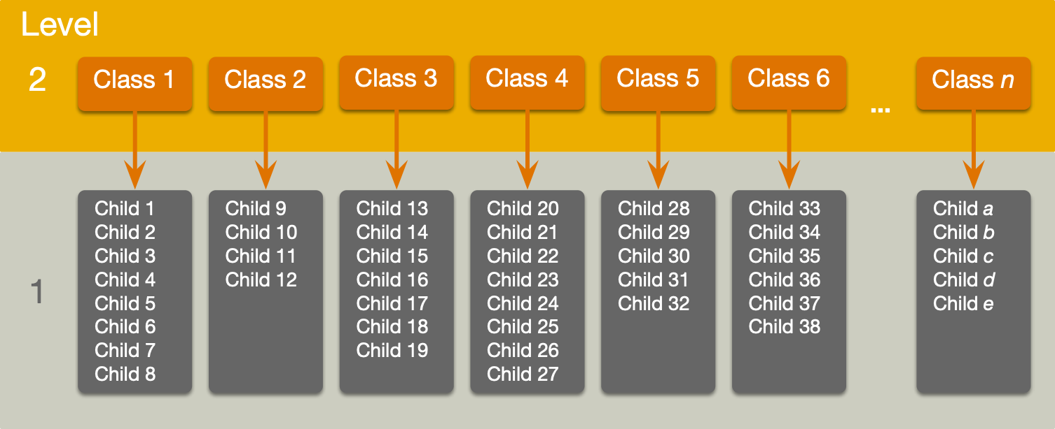

Slide 6: A three-level hierarchy
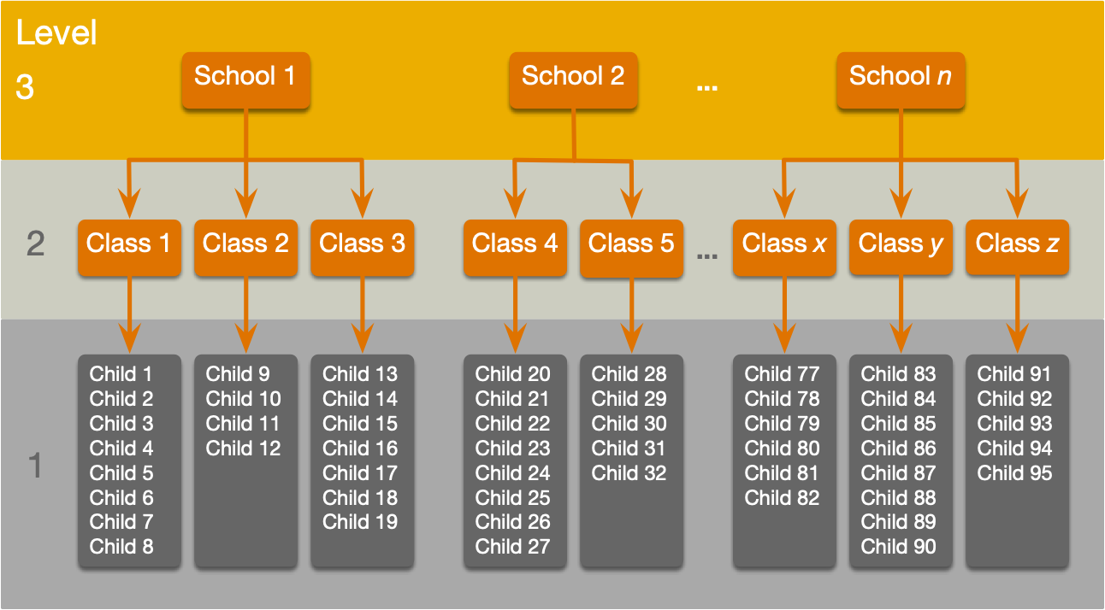

Slide 7: Why hierarchies matter
- Data from the same context will be more similar than data from different contexts
  - Children in the same class will perform more similarly than children from different classes
    - People treated in the same clinics should be more similar in response than those treated at different clinics
- Lack of independence
  - Violates the assumption of spherical errors (specifically, independence)
  - Biases SEs, CIs and p-values

Slide 8


Slide 9


Slide 10: A surgical example
Tip: Research Questions
- Is quality of life after cosmetic surgery predicted by the length of time since surgery?
- Does this relationship depend on the reason for the surgery?
- id: the participant’s participant code
- post_qol: This is the outcome variable and it measures quality of life after cosmetic surgery.
- base_qol: We need to adjust our outcome for quality of life before the surgery.
- days: The number of days after surgery that post-surgery quality of life was measured.
- clinic: This variable specifies which of 21 clinics the person attended to have their surgery.
- reason: This variable specifies whether the person had surgery purely to change their appearance or because of a physical reason.

Slide 11: An initial model
Important: Let’s start with ….
$$\begin{aligned}{\text{QoL}}_{i}&=β_{0}+β_{1}{\text{Days}}_{i}+ε_{i} \\ ε_{i}&∼N(0,σ^{2})\end{aligned}$$

Slide 12: The surgery data hierarchy
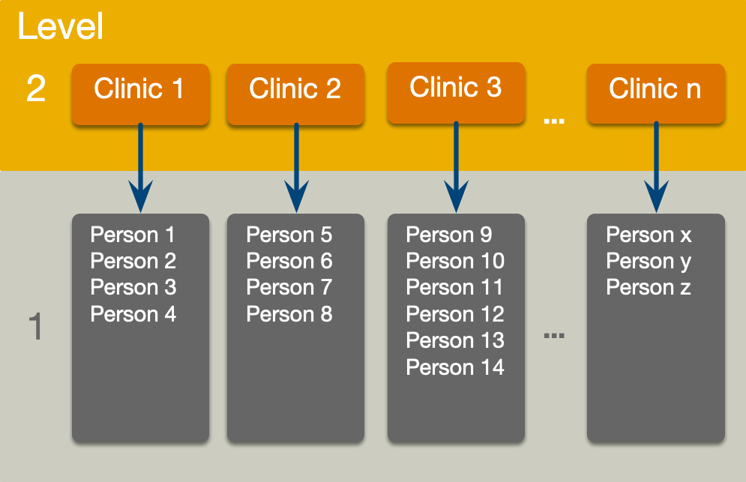

Slide 13: Fixed and random coefficients
- Intercepts and slopes can be fixed or random
  - In OLS regression they are fixed
- Fixed coefficients
  - Intercepts/slopes are assumed to be the same across different contexts (in this case clinics)
- Random coefficients
  - Intercepts/slopes are allowed to vary across different contexts (in this case clinics)

Slide 14
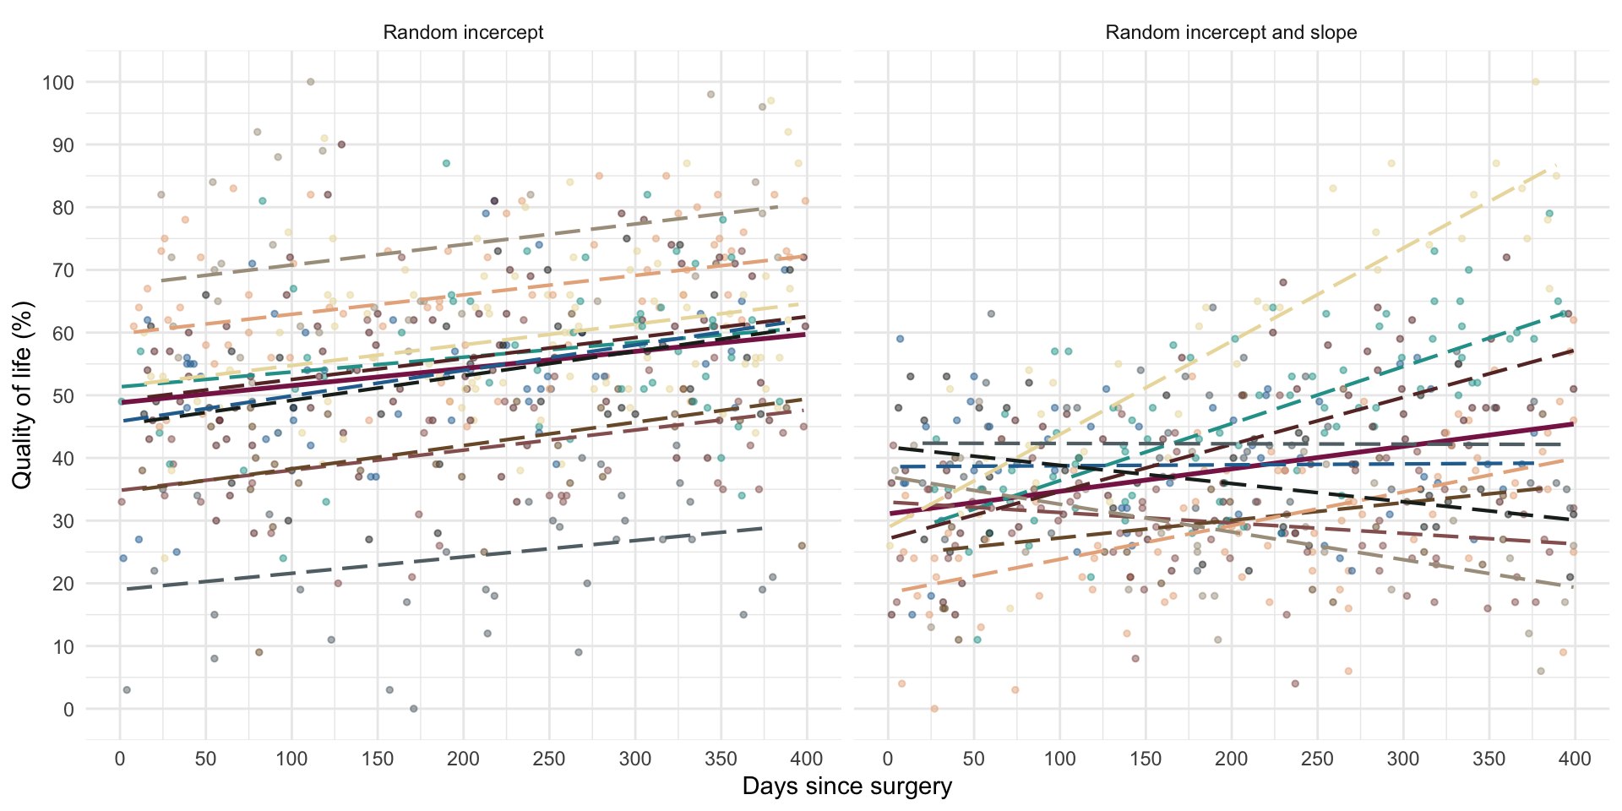

Slide 15: Random intercept
Important: OLS model
$$\begin{aligned}{\text{QoL}}_{i}&=β_{0}+β_{1}{\text{Days}}_{i}+ε_{i} \\ \end{aligned}$$
Important: Random intercept model (composite)
$$\begin{aligned}{\text{QoL}}_{ij}&=(β_{0}+u_{0j})+β_{1}{\text{Days}}_{ij}+ε_{ij} \\ {\text{QoL}}_{ij}&=[β_{0}+β_{1}{\text{Days}}_{ij}]+[u_{0j}+ε_{ij}] \\ \end{aligned}$$
Important: Random intercept model (alternative)
$$\begin{aligned}{\text{QoL}}_{ij}&=β_{0j}+β_{1}{\text{Days}}_{ij}+ε_{ij} \\ β_{0j}&=β_{0}+u_{0j} \\ \end{aligned}$$

Slide 16: Random intercept
$$\begin{aligned}{\text{QoL}}_{ij}&=[β_{0}+β_{1}{\text{Days}}_{ij}]+[u_{0j}+ε_{ij}] \\ \end{aligned}$$
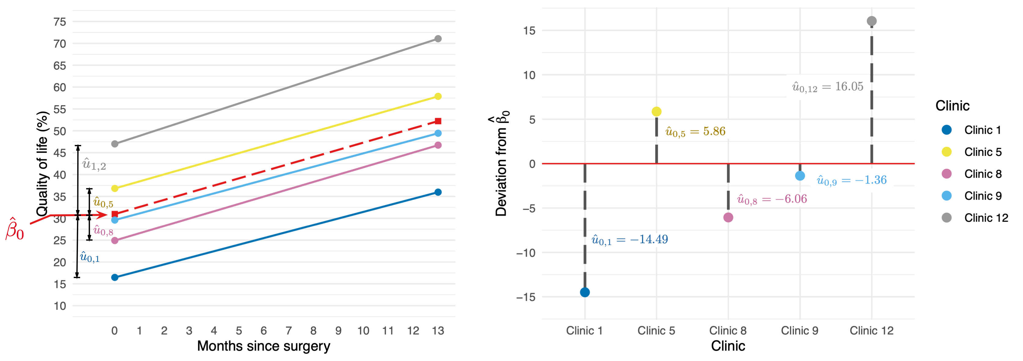
$$\begin{matrix}u_{0}∼N(0,σ_{u_{0}}^{2})\end{matrix}$$

Slide 17: Random slope
Important: Random intercept model (composite)
$$\begin{aligned}{\text{QoL}}_{ij}&=(β_{0}+u_{0j})+β_{1}{\text{Days}}_{ij}+ε_{ij} \\ {\text{QoL}}_{ij}&=[β_{0}+β_{1}{\text{Days}}_{ij}]+[u_{0j}+ε_{ij}] \\ \end{aligned}$$
Important: Random slope model (composite)
$$\begin{aligned}{\text{QoL}}_{ij}&=(β_{0}+u_{0j})+(β_{1}+u_{1j}){\text{Days}}_{ij}+ε_{ij} \\ {\text{QoL}}_{ij}&=[β_{0}+β_{1}{\text{Days}}_{ij}]+[u_{0j}+u_{1j}{\text{Days}}_{ij}+ε_{ij}] \\ \end{aligned}$$
Important: Random slope model (alternative)
$$\begin{aligned}{\text{QoL}}_{ij}&=β_{0j}+u_{0j}+β_{1}{\text{Days}}_{ij}+ε_{ij} \\ β_{0j}&=β_{0}+u_{0j} \\ β_{1j}&=β_{1}+u_{1j} \\ \end{aligned}$$

Slide 18: Random slope
$$\begin{aligned}{\text{QoL}}_{ij}&=[β_{0}+β_{1}{\text{Days}}_{ij}]+[u_{0j}+u_{1j}{\text{Days}}_{ij}+ε_{ij}] \\ \end{aligned}$$
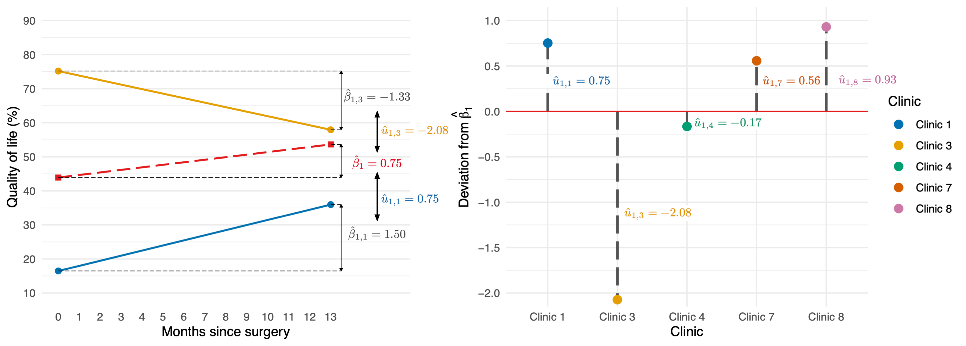
$$\begin{matrix}u_{1}∼N(0,σ_{u_{1}}^{2})\end{matrix}$$

Slide 19
Video clip: milton meditation distraction

Slide 20: The covariance structure of random effects
Important: Random intercept and slope for 1 predictor
$$\begin{matrix}\left[\begin{matrix}u_{0} \\ u_{1}\end{matrix}\right]∼N\left(\left[\begin{matrix}0 \\ 0\end{matrix}\right],\left[\begin{matrix}σ_{u_{0}}^{2} & σ_{u_{0},u_{1}} \\ σ_{u_{0},u_{1}} & σ_{u_{1}}^{2}\end{matrix}\right]\right)\end{matrix}$$
Important: Random intercept and slope for several predictor
$$\begin{matrix}\left[\begin{matrix}u_{0} \\ u_{1} \\ ⋮ \\ u_{n}\end{matrix}\right]∼N\left(\begin{matrix}\left[\begin{matrix}0 \\ 0 \\ ⋮ \\ 0\end{matrix}\right],\left[\begin{matrix}σ_{u_{0}}^{2} & σ_{u_{0},u_{1}} & … & σ_{u_{0},u_{n}} \\ σ_{u_{0},u_{1}} & σ_{u_{1}}^{2} & … & σ_{u_{1},u_{n}} \\ ⋮ & ⋮ & ⋱ & ⋮ \\ σ_{u_{0},u_{n}} & σ_{u_{1}}^{2} & … & σ_{u_{n}}^{2} \\ \end{matrix}\right]\end{matrix}\right)\end{matrix}$$
Warning: The danger zone!
Convergence
- As you include more random effects the number of parameters that need to be estimated from the data rapidly increases
- This increases the likelihood that the model won’t converge.

Slide 21: Level 1 errors
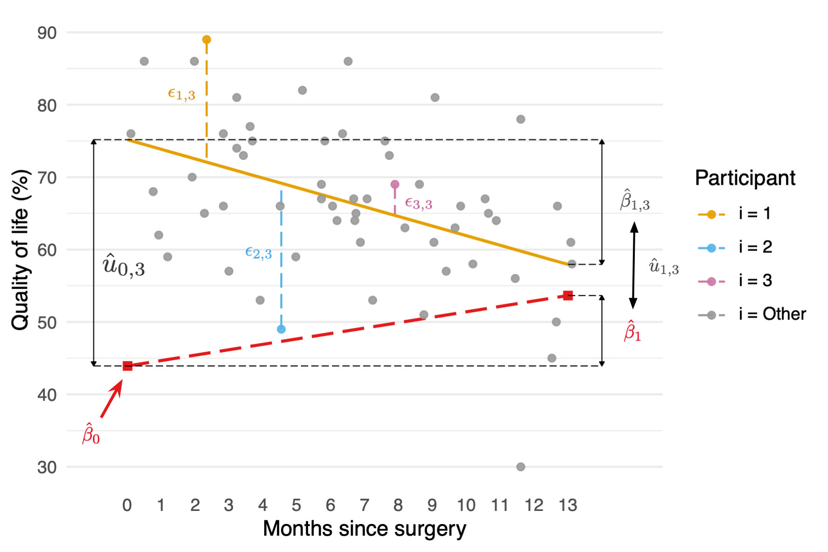
Important: Normally distrubuted errors
$$\begin{aligned}ε_{ij}&∼N(0,σ^{2})\end{aligned}$$

Slide 22: The covariance structure of level 1 errors
Important: Spherical errors
$$\begin{matrix}Φ=\left[\begin{matrix}σ_{1}^{2} & 0 & 0 & … & 0 \\ 0 & σ_{2}^{2} & 0 & … & 0 \\ 0 & 0 & σ_{3}^{2} & … & 0 \\ ⋮ & ⋮ & ⋱ & ⋮ \\ 0 & 0 & 0 & … & σ_{n}^{2} \\ \end{matrix}\right]\end{matrix}$$

Slide 23: (Potential) Benefits of MLMs
- Modelling variability in effects across contexts
  - Model the variability in intercepts
  - Model the variability in slopes
- Model violations of the assumption of spherical errors
  - Model differences in the variability of errors
  - Model relationships between errors
    - (Linear model for repeated observations – next two weeks!)
- Missing data
  - MLMs (in general) cope with missing data

Slide 24: Model assumptions
- MLMs use maximum likelihood estimation not OLS
- Familiar assumptions
  - Linearity and additivity
  - Level 1 errors are normally distributed with mean of zero and constant variance (i.e. homoscedasticity)
  - Independent errors (but we can model dependency)
- New assumptions
  - Random effects (slopes and intercepts) are assumed to be normally distributed with mean of zero and constant variance (i.e. homoscedasticity)

Slide 25: Practical issues

Computing p-values
- There is no unifying method to compute p-values in multilevel models because the degrees of freedom of the test statistic are rarely known.
- df can be approximated (e.g., Satterthwaite and Kenward-Roger methods) but it’s unclear how good these approximations are for complex models/complex covariance structures.

Slide 26: Practical issues

Should effects be fixed or random?
- Three approaches
  - Theory-driven
  - Maximal model (Barr et al., 2013)
  - Data-driven (include random effects that improve fit)
- Treat a predictor as a random effect if … (Bolker, 2015)
  - You’re not interested in differences between the levels.
  - You’re interested in quantifying the variability across levels of the variable.
  - You’re interested in generalizing beyond the observed levels of the contextual variable.
  - You have an unbalanced design.
  - You have a categorical predictor that is not direct relevant to the hypothesis but for which you need to adjust (a nuisance variable).

Slide 27: Summary
- Data can be hierarchical and this hierarchical structure can be important.
  - The OLS linear model simply ignores the hierarchy.
- Hierarchical models are just a fancy linear model in which you estimate the variability in the slopes and intercepts within contexts
- i.e. slopes and intercepts can be random variables (allowed to vary) rather than fixed (assumed to be equal in different situations).
- MLMs are a world of pain

