Take-Away papers
What are they and how to do them?
Professor Andy Field, University of Sussex
Links: bsky.app | youtube.com | discoveringstatistics.com | discovr.rocks | statisticsadventure.com

About this version
This is a plain-text version of the lecture slides. Each slide starts with a heading such as “Slide 5”, and the numbers match the slide numbers shown in the lecture. Content that appeared one piece at a time, in columns or in tabs is shown in reading order. Videos and interactive apps are given as links.

Slide 2: Overview
- Paper is released as an announcement on CANVAS
- You must submit a rendered .html file to CANVAS within 48 hours
  - Reasonable adjustments automatically added within the submission point
- The task deliberately requires you to make some of your own decisions
Important: ReportR
You will be given:
- A research scenario and data
- A hypothesis
Write a report containing two sections:
- Code: Create all of the objects you need to write the report
- Report: Write a succinct report that interprets the results of your model with reference to the hypothesis

Slide 3: Code
Important: Code overview
Create all objects you need in this section (tables, plots, models etc)

Tips
- Plan what you’re going to do before writing code - don’t just dive in
- Don’t print/view anything in this section
- Use the code that we teach
- Use of AI is NOT permitted
- Do not directly copy/paraphrase ANYTHING from the model answer
- Less is more
  - Find the relevant discovr tutorial - follow it
  - Don’t overthink it
  - You don’t have to include everything you do

Slide 4: Report
Important: Report overview
- Explain the model you have fitted and why.
- Include an equation that describes the main model you fit.
- Explain and justify any decisions you have made
- Interpret the main results
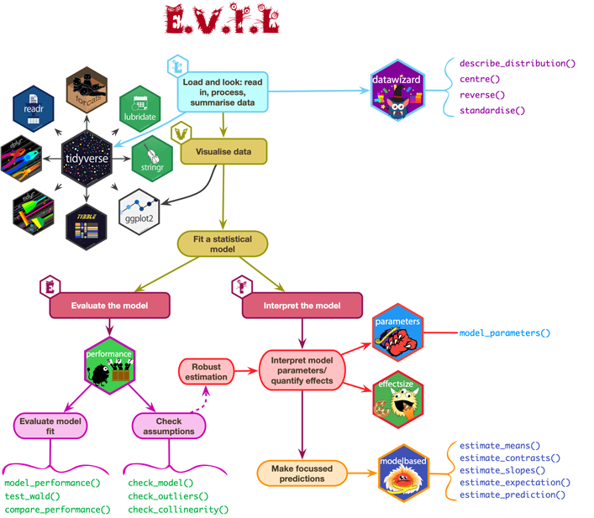

Slide 5: Report

Tips
- Follow the process of E.V.I.L.
  - Look: summarize the data.
  - Visualise key parts of the data.
  - Evaluate the fitted model
  - Interpret the fitted model.
- Print and refer to relevant tables and plots (created in the code section)
  - Use quarto cross-referencing
  - Use display() to render tables
- Interpret the size of the parameter estimates (and CIs) that test the hypotheses, and their real world substance.
  - Focussing only on p-values will not garner high marks.

Slide 6: Marking
Caution: Assessment criteria
- Theoretical understanding (70% of marks): This criterion assesses technical accuracy in your statistical thinking.
- Coding (15% of marks): These marks relate to your R code. How elegant, succinct, and discovr-like is your Code?
- Organization (15% of marks): how concise and well organised is your report? How well have you used the features of quarto to format your document?

Slide 7: General advice
- You don’t need 48 hours
  - Do it on day 1, sleep well, quick review on day 2, then submit
- Throwing the kitchen sink at it is a bad strategy
- Join discord - we will monitor during the TAP:
  - We can’t tell you what to do
  - We will try to help you top navigate errors
- Render regularly
- Remember RStudio has a spell check
Warning: The danger zone!
- Submit at the last minute at your own peril!
  - We cannot grant extensions
  - The submission portal shuts off automatically
- Use of AI is NOT permitted
- Do not directly copy/paraphrase ANYTHING from the model answer.
- Collusion of any kind is NOT permitted on this module

Slide 8: End on a positive note …
