Statistical Models
What are they and why do we need them?
Professor Andy Field, University of Sussex
Links: daft punk end of line | bsky.app | youtube.com | discoveringstatistics.com | discovr.rocks | statisticsadventure.com

About this version
This is a plain-text version of the lecture slides. Each slide starts with a heading such as “Slide 5”, and the numbers match the slide numbers shown in the lecture. Content that appeared one piece at a time, in columns or in tabs is shown in reading order. Videos and interactive apps are given as links.

Slide 2: Learning outcomes
- Articulate why we fit statistical models
- Understand the function and form of the linear model
  - The mathematical model
  - Visualizing the model
  - Familiar models as variants of the linear model
- List the common properties of all statistical models
- Understand what the model parameters (bs) represent
- Understand why we use sampling

Slide 3
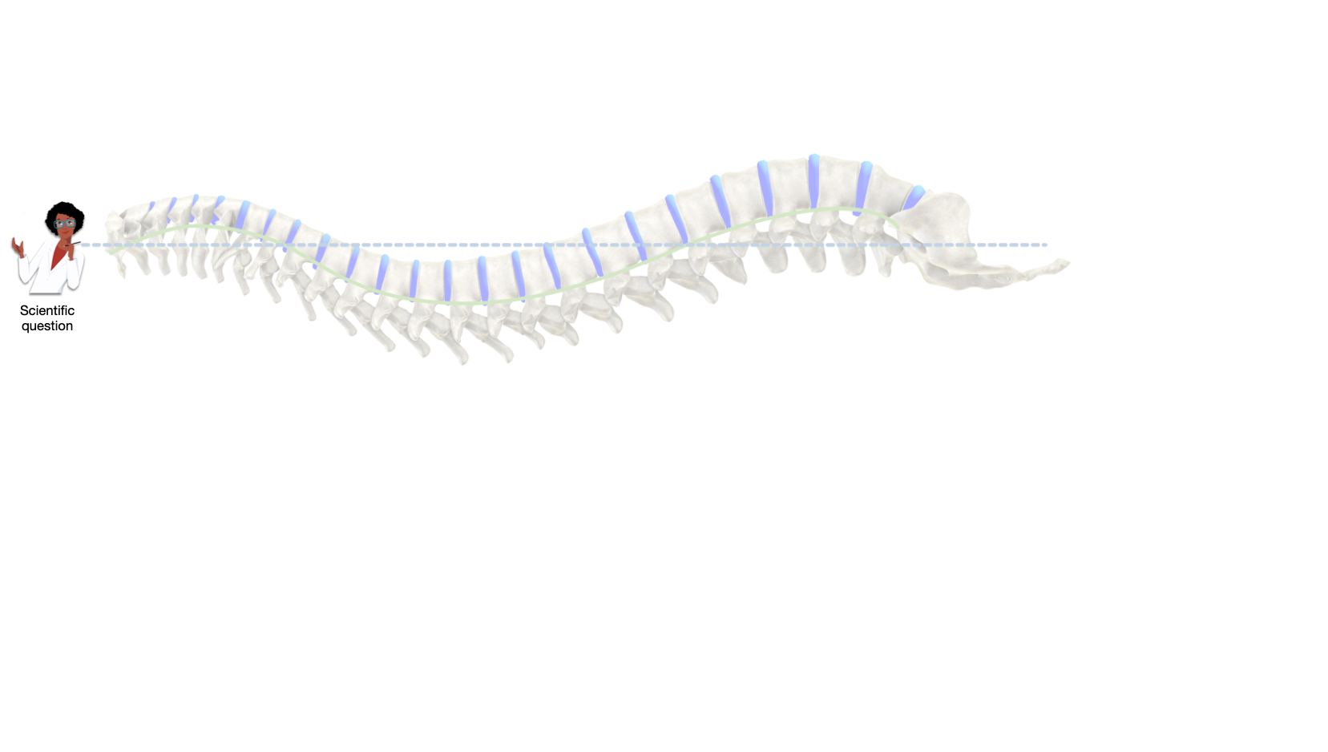

Slide 4
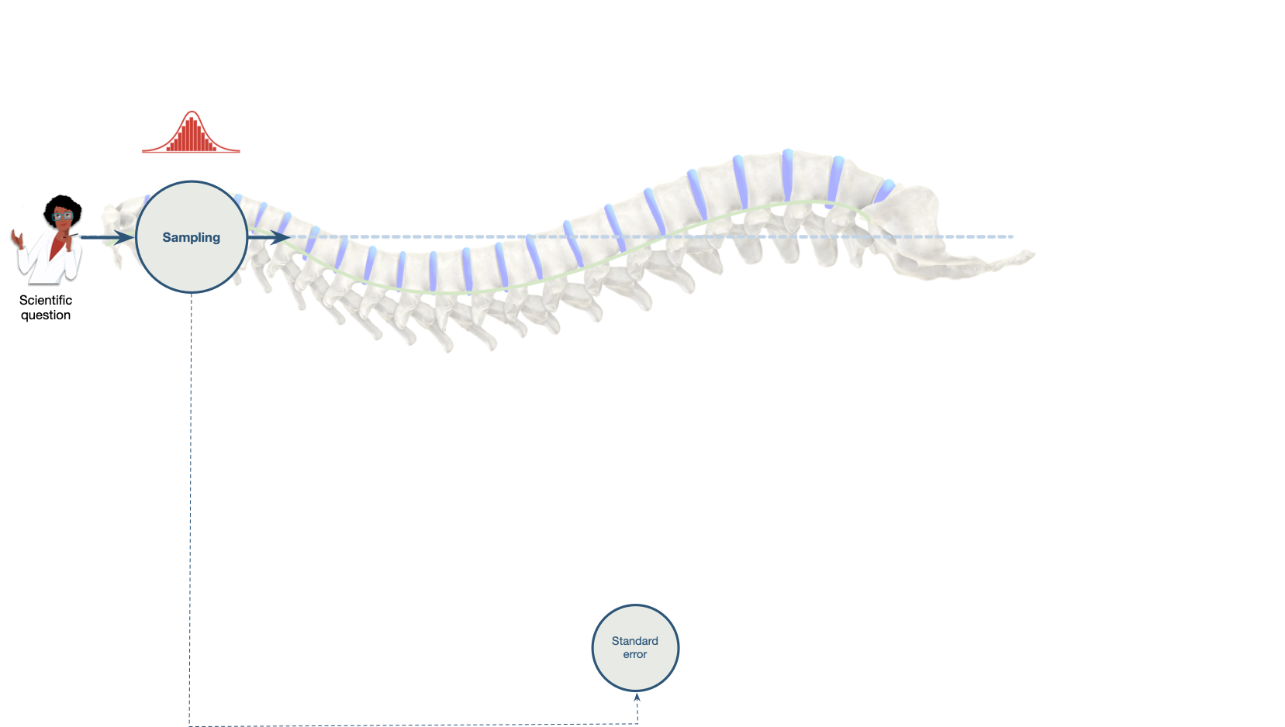

Slide 5
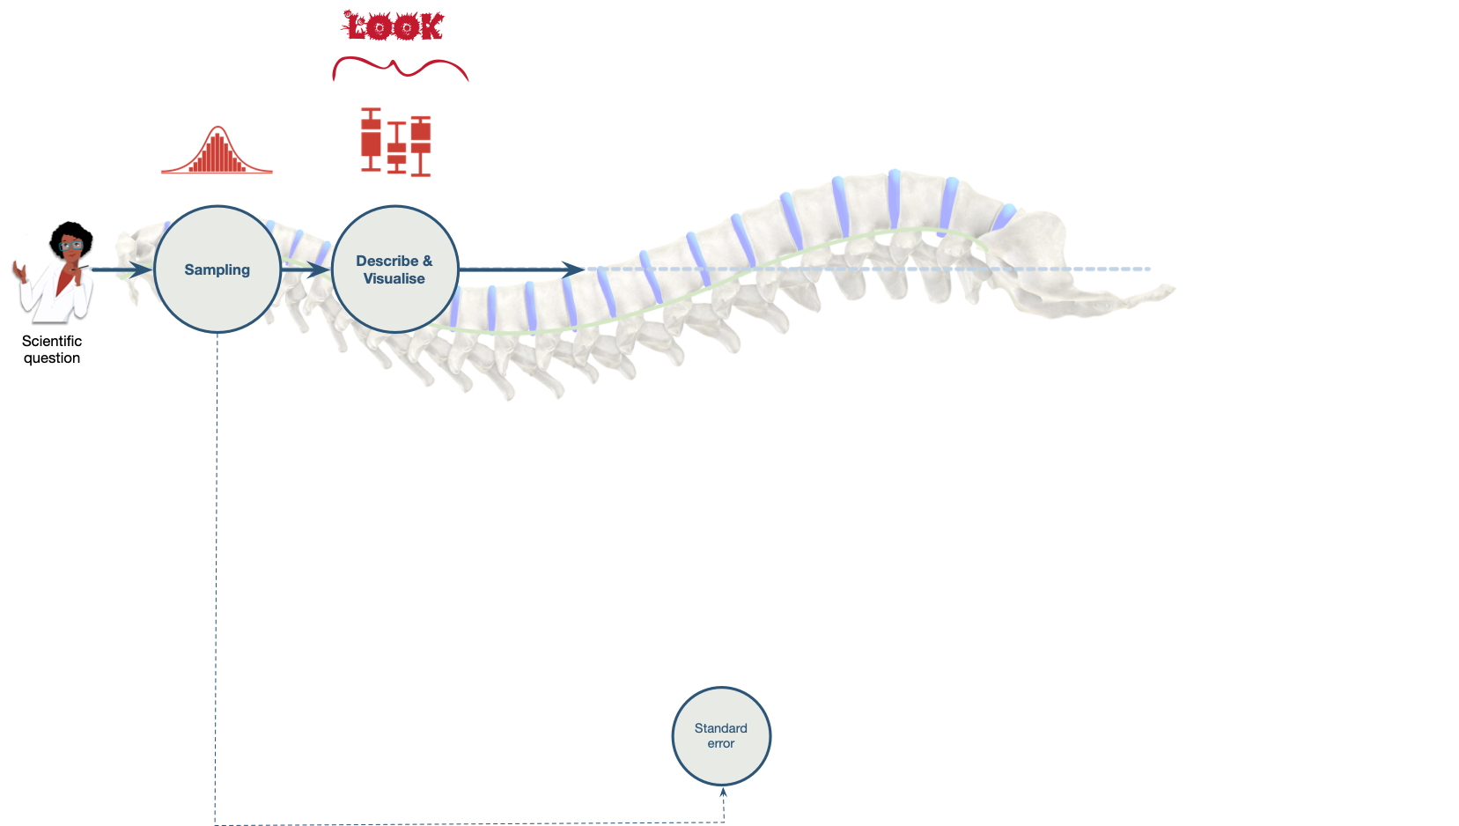

Slide 6
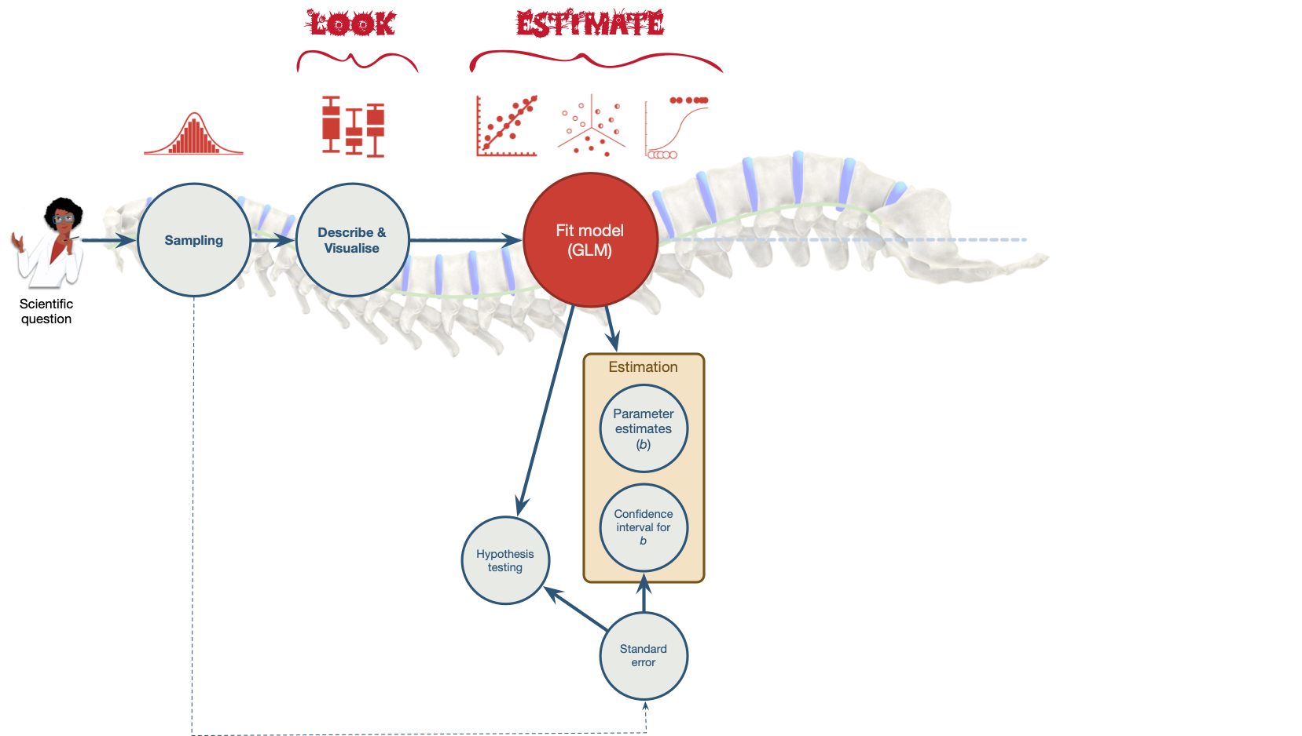

Slide 7
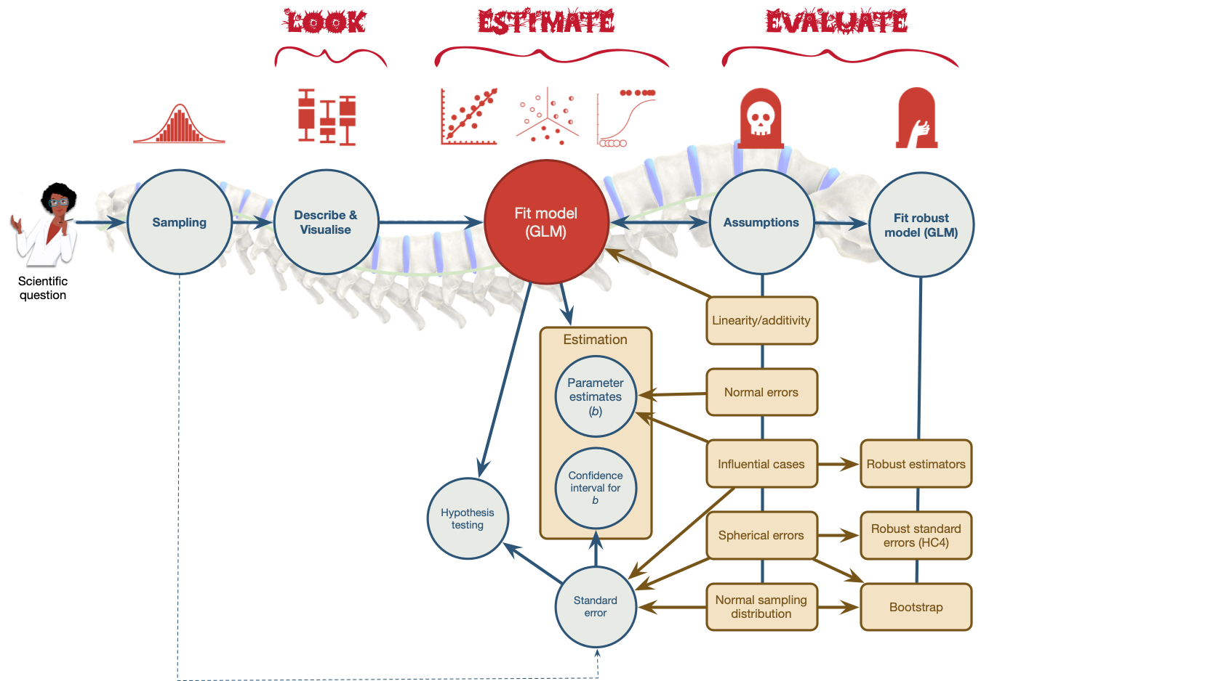

Slide 8
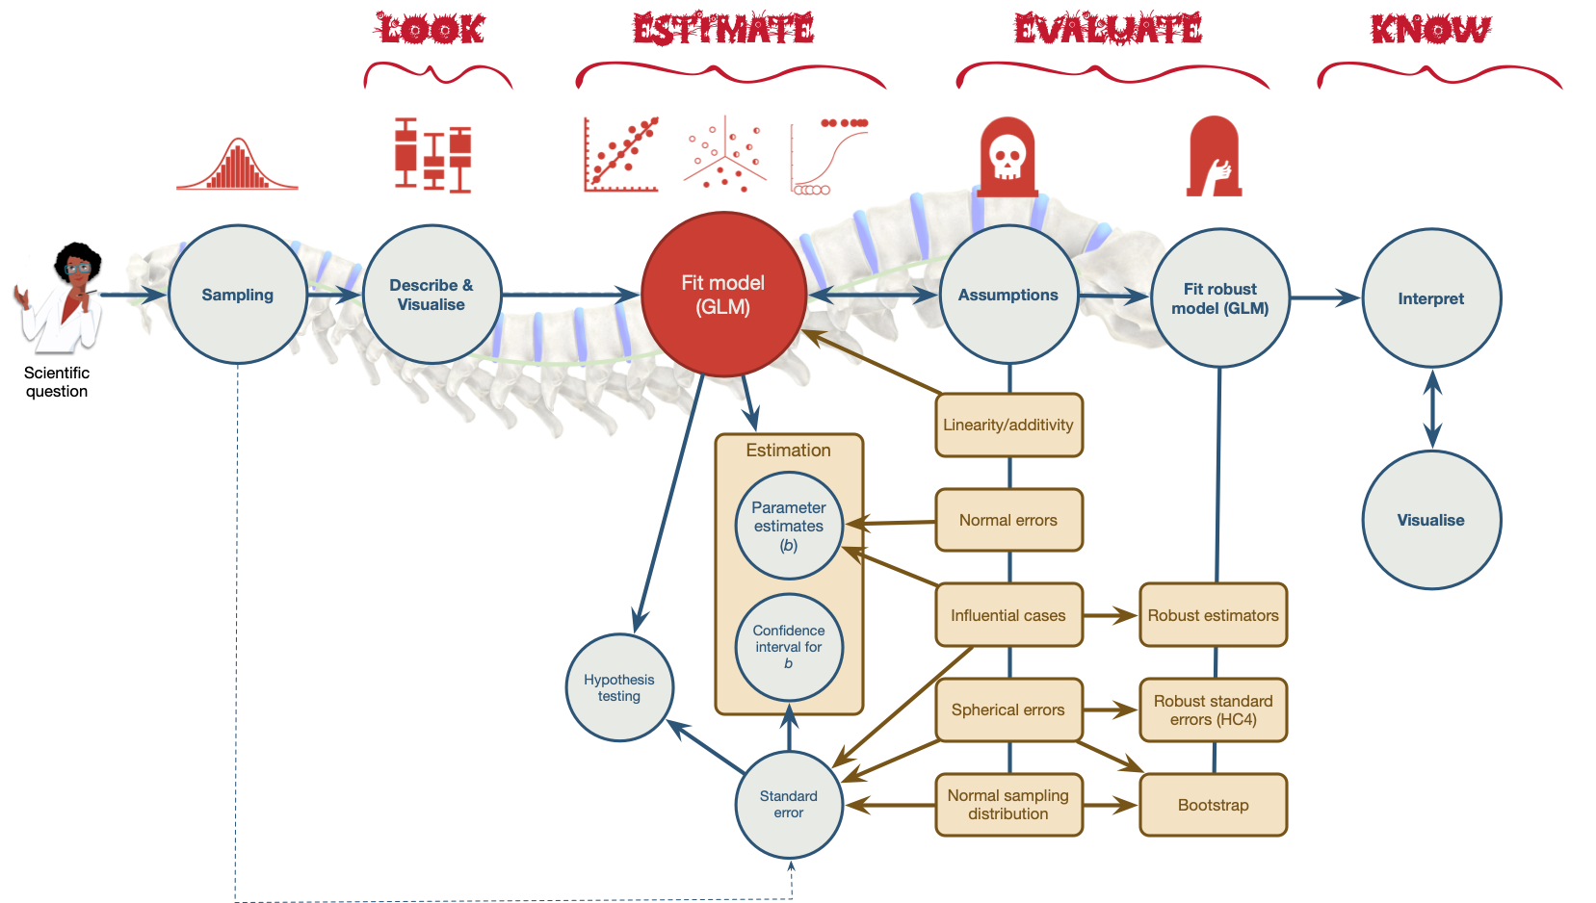

Slide 9
Caution: Think about it!
Hypothesis
- Does attending concerts harm hearing?



Slide 10
Interactive content: Shiny Gig Dashboard

Slide 11: Why do we fit models?
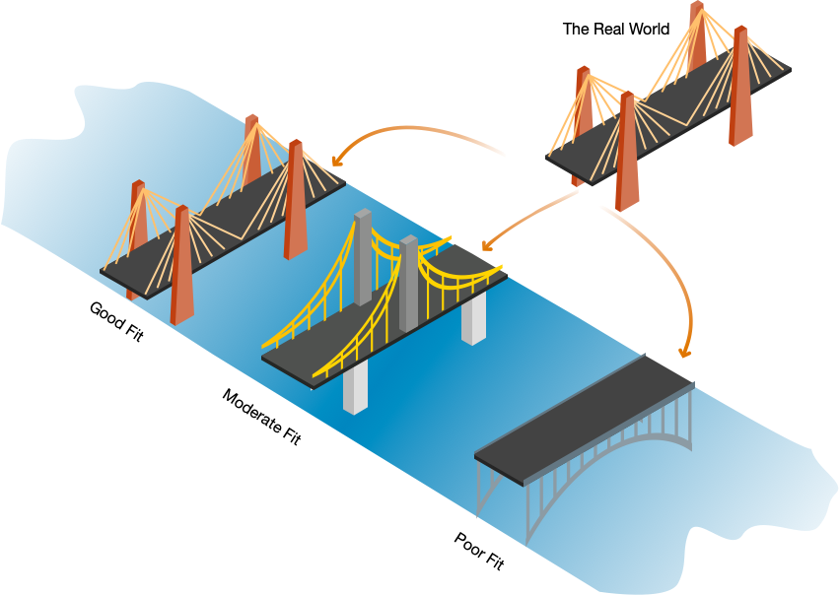

Slide 12
Video clip: bridge 01

Slide 13
Video clip: bridge water

Slide 14
Video clip: bridge wind

Slide 15
Video clip: bridge hippo

Slide 16
Interactive content: https://milton-the-cat.rocks/lm_sampling/

Slide 17 (new section): Why do (some) students hate statistics?

Slide 18
Video clip: dw 42 clip

Slide 19
$$Y_{i}={\hat{b}}_{0}+{\hat{b}}_{1}{\text{X}}_{i}+{\text{e}}_{i}$$
$$r=\frac{\sum_{i=1}^{n}{(}x_{i}−\overset{‾}{X})(y_{i}−\overset{‾}{Y})}{(N−1)s_{x}s_{y}}$$
$$t=\frac{{\overset{‾}{X}}_{1}−{\overset{‾}{X}}_{2}}{\sqrt{\frac{s_{1}^{2}}{n_{1}}+\frac{s_{2}^{2}}{n_{2}}}}$$
$$χ^{2}=∑\frac{({\text{observed}}_{ij}−{\text{model}}_{ij})^{2}}{{\text{model}}_{ij}}$$

Slide 20 (new section): Can we make statistics (a bit) less like this?

Slide 21
Video clip: andy dungeon scream

Slide 22

A Zombie Quiz

Slide 23: A zombie quiz
A researcher counted how many humans and zombies choose brain chips or potato chips to accompany their dinner at the university canteen
- How do I analyze these data?
Organism | Brain chips | Potato chips
Human | 28 | 42
Zombie | 61 | 57

Slide 24

A chi-square test
chisq.test(zom_fct_tib$organism, zom_fct_tib$chip, correct = FALSE)

Chi2 | df | p | Method
2.41 | 1 | 0.121 | Pearson's Chi-squared test

Slide 25

A Spearman correlation?
correlation::correlation(method = "spearman", data = zom_tib) |>
display()

Parameter1 | Parameter2 | rho | CI | CI_low | CI_high | S | p | Method | n_Obs
organism | chip | -0.113 | 0.95 | -0.256 | 0.035 | 1232810 | 0.122 | Spearman correlation | 188

Slide 26

A Kendall’s $τ$ correlation?
correlation::correlation(method = "kendall", data = zom_tib) |>
display()

Parameter1 | Parameter2 | tau | CI | CI_low | CI_high | z | p | Method | n_Obs
organism | chip | -0.113 | 0.95 | -0.206 | -0.018 | -1.548 | 0.122 | Kendall correlation | 188

Slide 27

A Pearson correlation?
correlation::correlation(data = zom_tib) |>
display()
Parameter1 | Parameter2 | r | CI | CI_low | CI_high | t | df_error | p | Method | n_Obs
organism | chip | -0.113 | 0.95 | -0.252 | 0.03 | -1.554 | 186 | 0.122 | Pearson correlation | 188

Slide 28

A t-test?
t.test(chip ~ organism, data = zom_tib) |>
model_parameters() |>
display()
Parameter | Group | Mean_Group1 | Mean_Group2 | Difference | CI | CI_low | CI_high | t | df_error | p | Method | Alternative
chip | organism | 0.6 | 0.483 | 0.117 | 0.95 | -0.031 | 0.265 | 1.561 | 147.014 | 0.121 | Welch Two Sample t-test | two.sided

Slide 29

One-way ANOVA?
aov(organism ~ factor(chip), data = zom_tib) |>
test_wald() |>
display()
Name | Model | df | df_diff | F | p
Null model | aov | 187 | NA | NA | NA
Full model | aov | 186 | 1 | 2.416 | 0.122

Slide 30

Linear model (Regression)?
lm(organism ~ factor(chip), data = zom_tib) |>
model_parameters() |>
display()
Parameter | Coefficient | SE | CI | CI_low | CI_high | t | df_error | p
(Intercept) | 0.685 | 0.051 | 0.95 | 0.584 | 0.786 | 13.390 | 186 | 0.000
factor(chip)1 | -0.110 | 0.071 | 0.95 | -0.249 | 0.030 | -1.554 | 186 | 0.122

Slide 31

Loglinear model?
me_lm <- glm(n ~ organism + chip, family = "poisson", data = zom_freq)
full_lm <- glm(n ~ organism*chip, family = "poisson", data = zom_freq)
performance::test_lrt(me_lm, full_lm) |>
display()
 | Name | Model | df | df_diff | Criterion | Chi2 | p
me_lm | me_lm | glm | 3 | NA | 25.013 | NA | NA
full_lm | full_lm | glm | 4 | 1 | 22.591 | 2.422 | 0.12

Slide 32

Multilevel model?
glmmTMB::glmmTMB(chip ~ organism + (1|canteen), data = zom_tib) |>
model_parameters() |>
display()

Parameter | Coefficient | SE | CI_low | CI_high | z | p
(Intercept) | 0.60 | 0.06 | 0.48 | 0.72 | 10.12 | 0.00
organism | -0.12 | 0.07 | -0.26 | 0.03 | -1.56 | 0.12

Slide 33
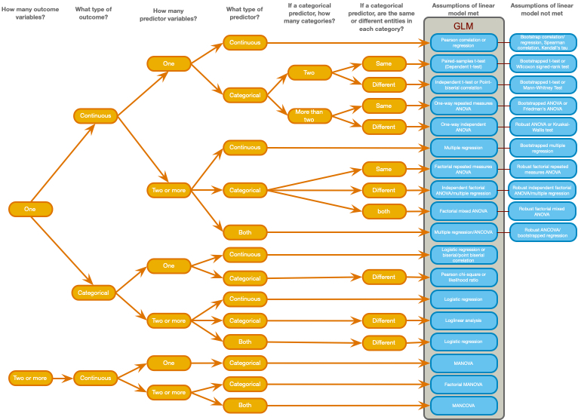

Slide 34
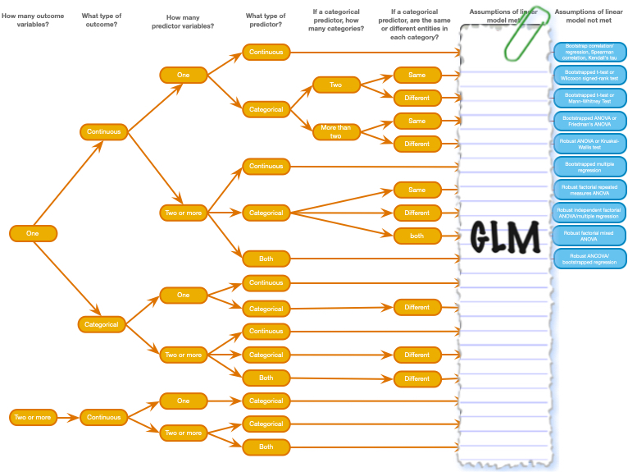

Slide 35: Spoiler! We are always fitting this model

The General Linear Model (GLM)
$$\begin{aligned}{\text{outcome}}_{i}&=({\text{model}}_{i})+{\text{error}}_{i} \\ {\text{outcome}}_{i}&=b_{0}+b_{1}{\text{predictor}}_{i}+{\text{error}}_{i} \\ {\text{outcome}}_{i}&=b_{0}+b_{1}{\text{predictor 1}}_{i}+b_{2}{\text{predictor 2}}_{i}+…+{\text{error}}_{i}\end{aligned}$$
Note: Statis-tip
All models have a S.P.I.N.E
- Parameters. The $b_{0}$, $b_{1}$ … $b_{n}$ are the model parameters.
- Estimation: model parameters are estimated from the data (${\hat{b}}_{0}$, ${\hat{b}}_{1}$ … ${\hat{b}}_{n}$)
- Standard errors: there is uncertainty around these estimates because they vary from sample to sample. The standard error quantifies by how much they vary across samples.
- Iinterval: the standard error can be used to quantify uncertainty using a confidence interval
- NHST: we can test hypotheses using significance test of these parameter estimates (which also involved the standard error)

Slide 36: Fitting models
Caution: Think about it
Questions to ask yourself
- What variable is my outcome? What type is it?
- What variable(s) are my predictors? What types are they?
- What is the resulting form of the model?
- Is it a good representation of the phenomenon?
- Is this model a good fit of the data?

Fitting models is E.V.I.L.
- Look and Load: get the data into R, process it, summarize it (look)
- Visualise: plot relevant information to understand the data/model
- Evaluate: is the model any good? Are its assumptions met? Does it ‘fit’ the data?
- Interpret: use the model to answer your question

Slide 37
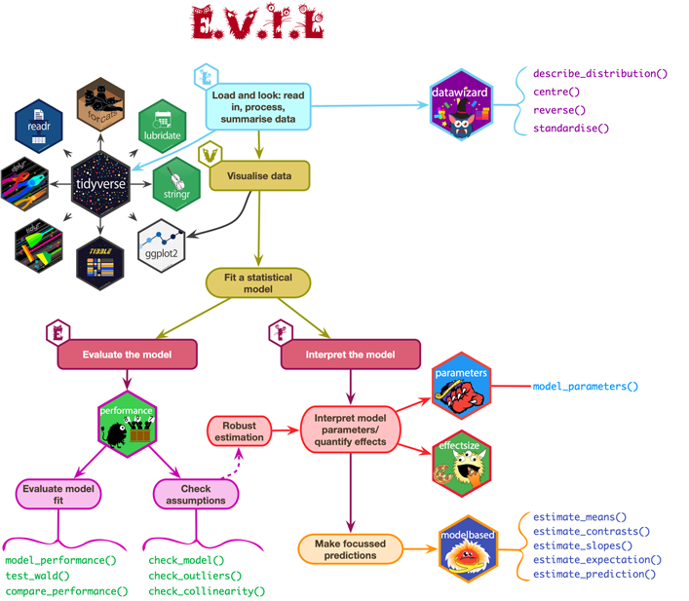

Slide 38: Let’s return to our question
Caution: Hypothesis
- Does attending concerts harm hearing?

Slide 39: The General Linear Model (GLM)

What variable is my outcome? What type is it?
- Ringing in ears (minutes)
- Continuous

What variable(s) are my predictors? What types are they?
- Volume (db)
- Continuous

What is my model?
$$\begin{aligned}{\text{outcome}}_{i}&=({\text{model}}_{i})+{\text{error}}_{i} \\ {\text{outcome}}_{i}&=b_{0}+b_{1}{\text{predictor}}_{i}+{\text{error}}_{i} \\ {\text{ringing}}_{i}&=b_{0}+b_{1}{\text{volume}}_{i}+e_{i}\end{aligned}$$

Slide 40 (new section): Collect data

Slide 41
Interactive content: https://milton-the-cat.rocks/lm_sampling/

Slide 42 (new section): Use the data to estimate the model parameters

Slide 43: Parameters and parameter estimates

The unobservable truth (population)
$$\begin{aligned}{\text{ringing}}_{i}&=b_{0}+b_{1}{\text{volume}}_{i}+ε_{i}\end{aligned}$$

The observable truth (sample)
$$\begin{aligned}{\text{ringing}}_{i}&={\hat{b}}_{0}+{\hat{b}}_{1}{\text{volume}}_{i}+e_{i}\end{aligned}$$

What are the parameter estimates?
- ${\hat{b}}_{1}$: Estimate of the parameter for a predictor
  - Direction/strength of relationship/effect between the predictor and the outcome (when other variables are constant)
  - Difference in means when predictors are categorical
- ${\hat{b}}_{0}$: the intercept
  - Estimate of the value of the outcome when predictor(s) = 0

Slide 44: How are parameters estimated?

Ordinary Least Squares (OLS)
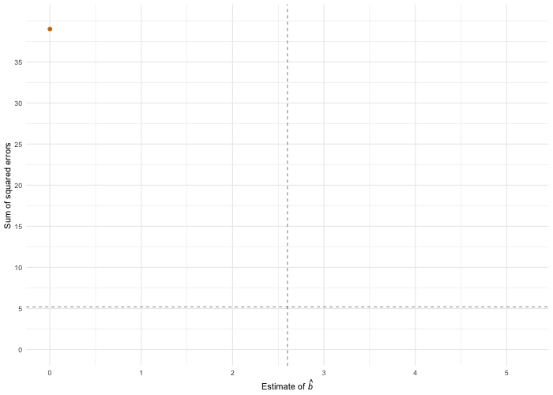

Slide 45: Visualise: What does the model look like?

$$\begin{aligned}{\text{ringing}}_{i}&={\hat{b}}_{0}+{\hat{b}}_{1}{\text{volume}}_{i}+e_{i}\end{aligned}$$
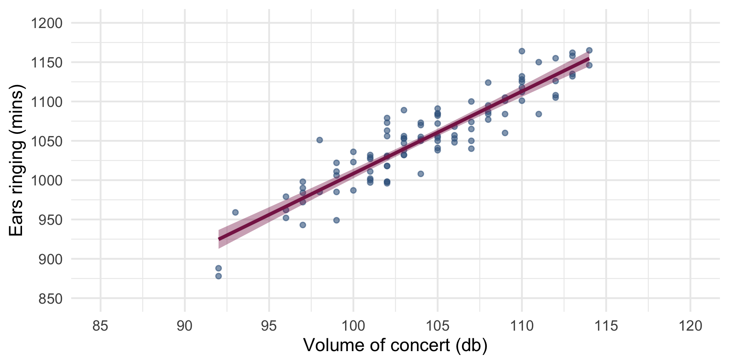

Slide 46: Visualise
$$\begin{aligned}{\text{ringing}}_{i}&={\hat{b}}_{0}+{\hat{b}}_{1}{\text{volume}}_{i}+e_{i}\end{aligned}$$
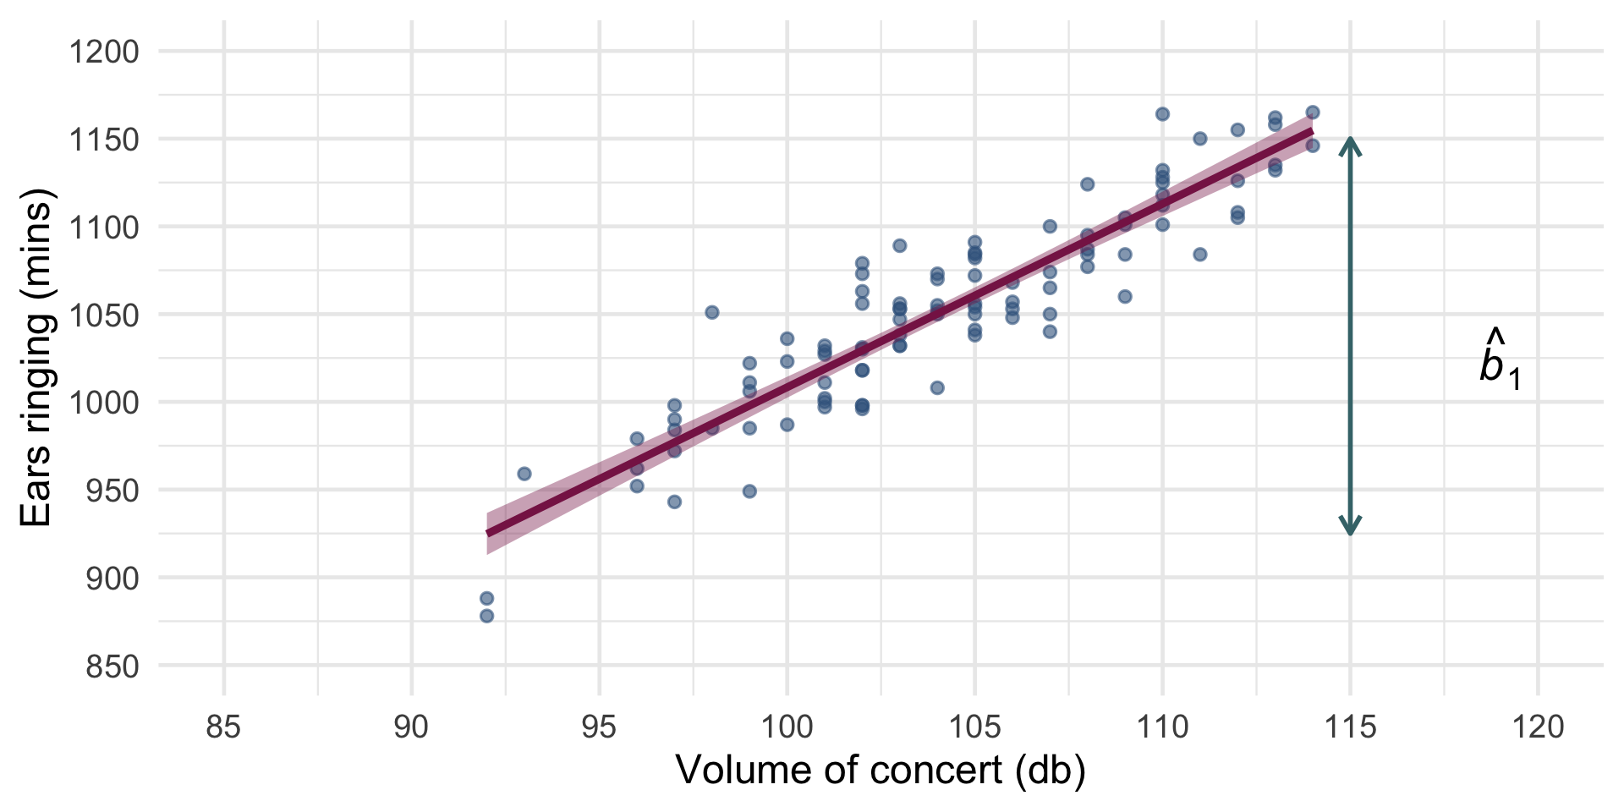

Slide 47: Visualise
$$\begin{aligned}{\text{ringing}}_{i}&={\hat{b}}_{0}+{\hat{b}}_{1}{\text{volume}}_{i}+e_{i}\end{aligned}$$
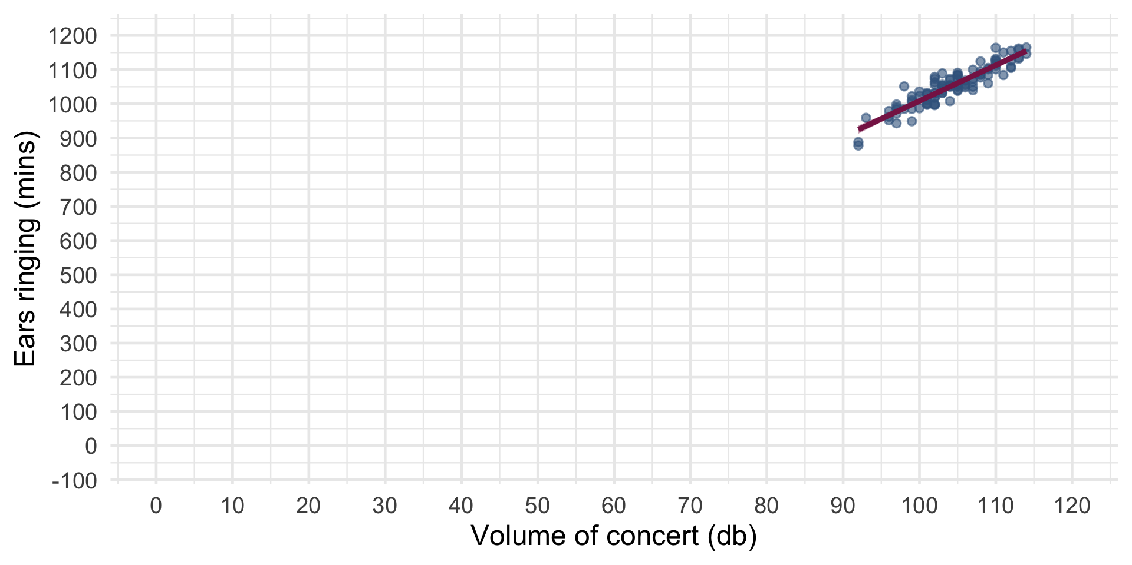

Slide 48: Interpret: what does the model mean?

$$\begin{aligned}{\hat{\text{ringing}}}_{i}&=−37.12+10.45{\text{volume}}_{i}\end{aligned}$$
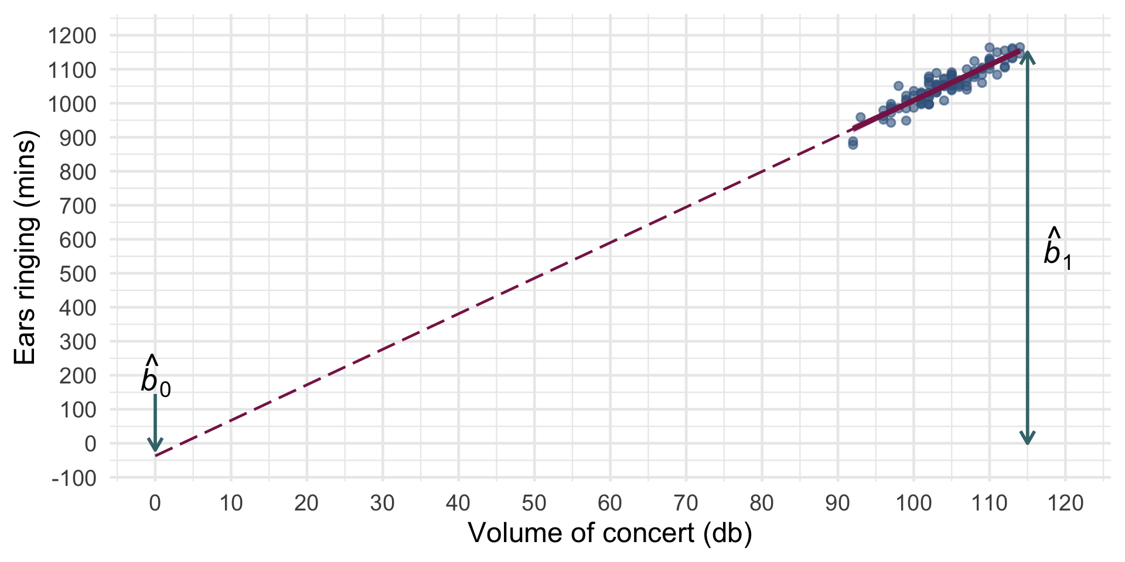
- ${\hat{b}}_{1}=10.45$:
  - Direction/strength of relationship/effect between volume and ringing
  - As volume goes up by 1db, we can expect 10.45 more minutes of ringing
- ${\hat{b}}_{0}=−37.12$:
  - For how long we can expect ears to ring when volume is 0db (silence)
  - In silence, ears ring for -37.12 minutes 🤔

Slide 49: Summary
- We fit statistical models to answer interesting questions
- All models are variations on the linear model
- Fitting models is E.V.I.L.
- Parameters tell us about the effects of interest
- We estimate these parameters from our data
- There will be uncertainty around those estimates
- Confidence intervals quantify that uncertainty

