The Beast of Bias
Professor Andy Field, University of Sussex
Links: bsky.app | youtube.com | discoveringstatistics.com | discovr.rocks | statisticsadventure.com

About this version
This is a plain-text version of the lecture slides. Each slide starts with a heading such as “Slide 5”, and the numbers match the slide numbers shown in the lecture. Content that appeared one piece at a time, in columns or in tabs is shown in reading order. Videos and interactive apps are given as links.

Slide 2

Audio clip: beast of bias narration
All is not well in the island of linearis modelus.
For years, humans and dragons have lived in harmony, until recently.
The rulers of the 134 kingdoms want the island for themselves.
Through a campaign of propaganda, they have convinced their subjects
that the dragons should be banished.
They have sent their best knights to slay the dragons.
Only Melvin, a wise wizzard of statistics, can save them.
He meets with the commander in chief of the knights of the 134 kingdoms.

Slide 3
Video clip: zach i am zach field caption

Slide 4
Video clip: zach kill dragons thank you caption

Slide 5
Video clip: zach reasons captions

Slide 6
Video clip: zach only kidnap princesses caption

Slide 7
Video clip: arlo stop zach caption

Slide 8
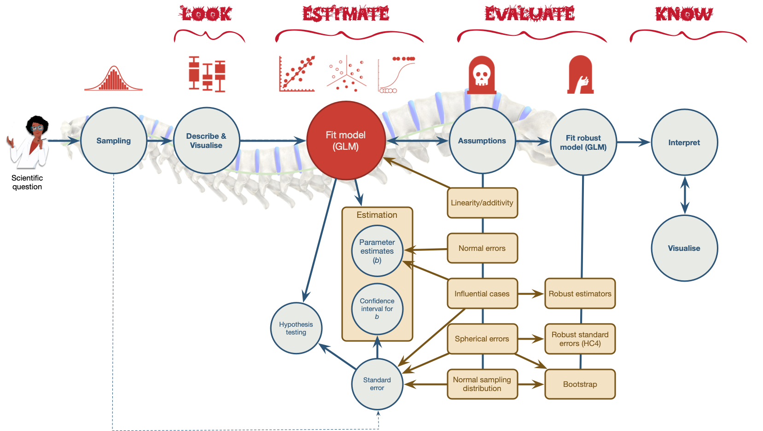

Slide 9
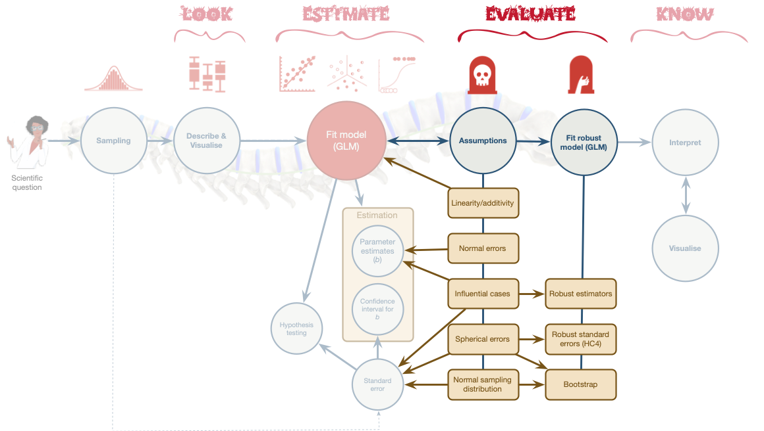

Slide 10 (new section): Part 1: Outliers and do dragons eat sheep?
“Coz they eat all our sheep”
Sir Knight Zach, Defender of the world of Military

Slide 11
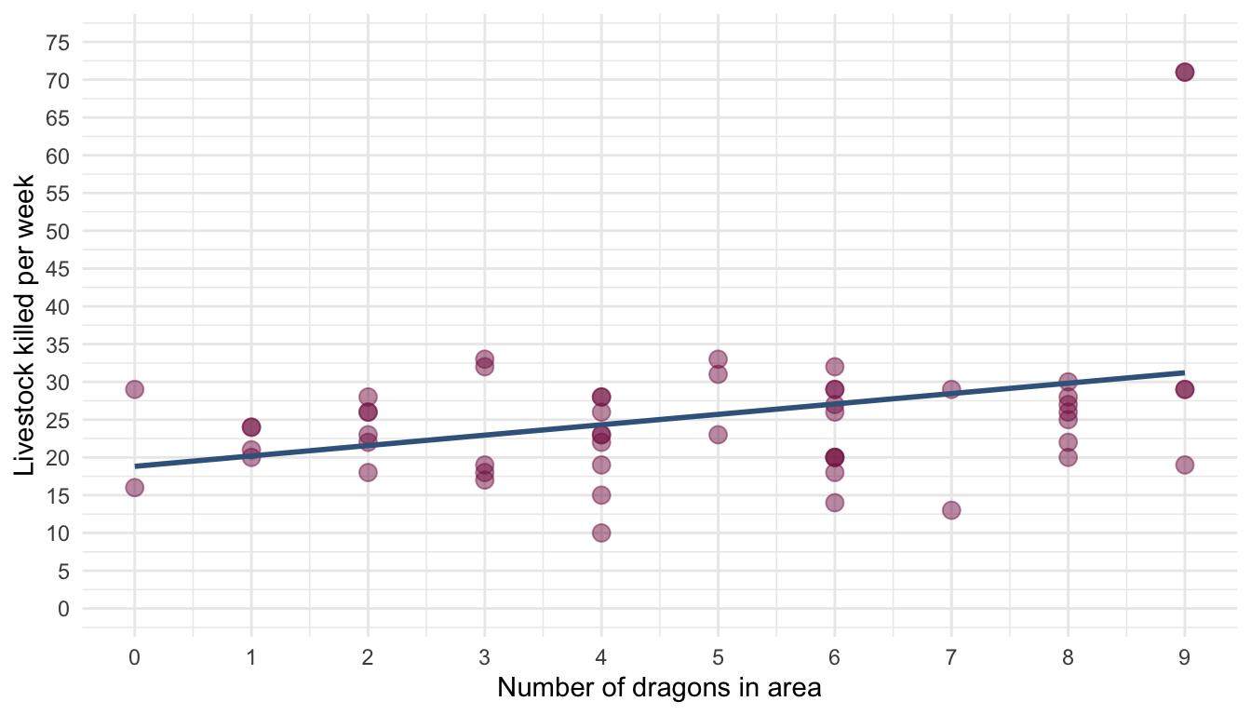

Slide 12
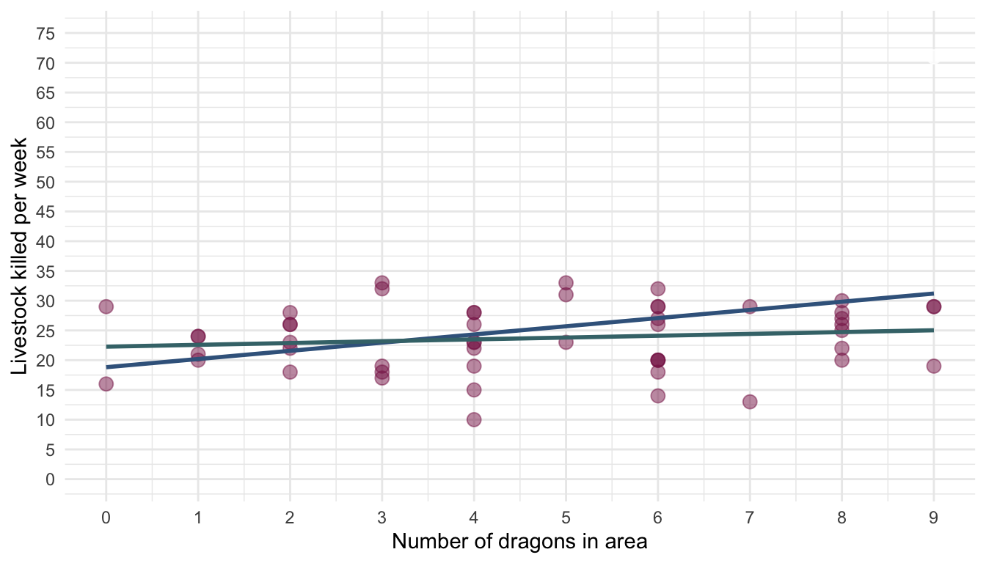

Slide 13: Detecting outliers
- Graphs
  - Scatterplots (less helpful with several predictors)
  - Histograms
- Standardized residual
  - In an average sample, 95% of standardized residuals should lie between $±2$
  - 99% of standardized residuals should lie between $±2.5$
  - Any case for which the absolute value of the standardized residual is 3 or more, is likely to be an outlier

Slide 14: Detecting influential cases

DF Beta
- The change in b when a case is removed
- Be wary of standardized values with absolute values > 1

Full sample
Parameter | Coefficient | SE | 95% CI | t(51) | p
(Intercept) | 18.82 | 2.93 | (12.94, 24.69) | 6.43 | < .001
dragons | 1.38 | 0.53 | (0.31, 2.44) | 2.59 | 0.013

Influential cases removed
Parameter | Coefficient | SE | 95% CI | t(49) | p
(Intercept) | 22.27 | 1.64 | (18.98, 25.56) | 13.60 | < .001
dragons | 0.31 | 0.31 | (-0.31, 0.93) | 0.99 | 0.325

Slide 15: Detecting influential cases

Cook’s distance
- Measures the influence of a single case on the model as a whole
- Absolute values greater than 1 are cause for concern (Cook & Weisberg , 1982), but check any > 0.5.
out_lm <- lm(livestock ~ dragons, data = out_tib)
check_outliers(out_lm,
method = "cook",
threshold = list('cook' = 0.5)
) |>
plot()
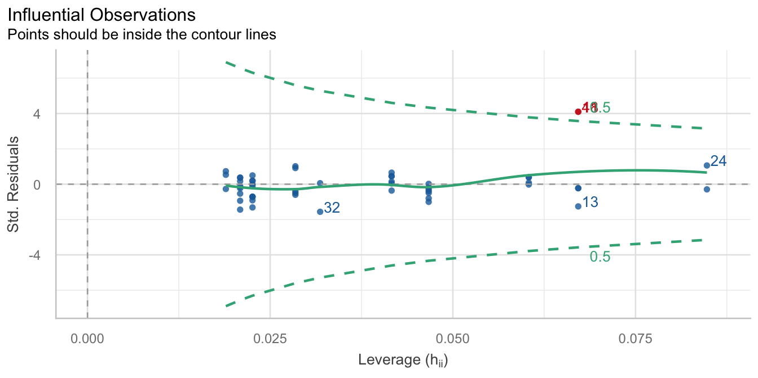

Slide 16
Video clip: shrek burp

Slide 17: Robust estimation

Normal model (OLS)
out_lm <- lm(livestock ~ dragons, data = out_tib)
model_parameters(out_lm) |>
display()
Parameter | Coefficient | SE | 95% CI | t(51) | p
(Intercept) | 18.82 | 2.93 | (12.94, 24.69) | 6.43 | < .001
dragons | 1.38 | 0.53 | (0.31, 2.44) | 2.59 | 0.013

Robust model
out_rob <- robust::lmRob(livestock ~ dragons, data = out_tib)
model_parameters(out_rob) |>
display()
Fixed Effects
Parameter | Coefficient | SE | 95% CI | t(51) | p
(Intercept) | 22.35 | 1.81 | (18.72, 25.98) | 12.36 | < .001
dragons | 0.30 | 0.34 | (-0.38, 0.98) | 0.88 | 0.381

Slide 18
Video clip: arlo have you saved the dragons yet 2 caption

Slide 19


Slide 20
Video clip: zach shakes head

Slide 21
Video clip: dragon chase

Slide 22 (new section): Part 2: Linearity, spherical errors and do dragons kidnap royalty?
“Coz they kidnap the princesses”
Sir Knight Zach, Defender of the world of Military

Slide 23: Are more princesses kidnapped in areas with more dragons?
$${\hat{\text{royalty}}}_{i}=3.98+0.12{\text{dragons}}_{i}$$
Parameter | Coefficient | SE | 95% CI | t(128) | p
(Intercept) | 3.98 | 0.30 | (3.39, 4.57) | 13.32 | < .001
dragons | 0.12 | 0.06 | (5.30e-03, 0.23) | 2.07 | 0.040
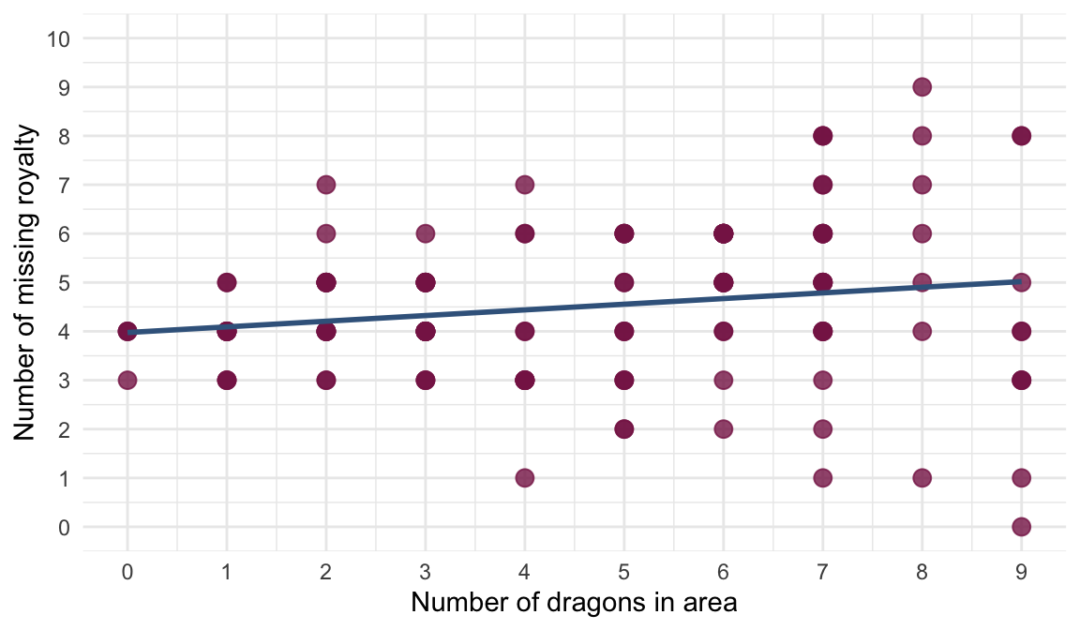

Slide 24: Are more princesses kidnapped in areas that have dragons?
$${\hat{\text{royalty}}}_{i}=4.26+1.21{\text{dragons}}_{i}$$
Parameter | Coefficient | SE | 95% CI | t(87) | p
(Intercept) | 4.26 | 0.41 | (3.43, 5.08) | 10.28 | < .001
dragons (Dragons) | 1.21 | 0.53 | (0.15, 2.26) | 2.27 | 0.026
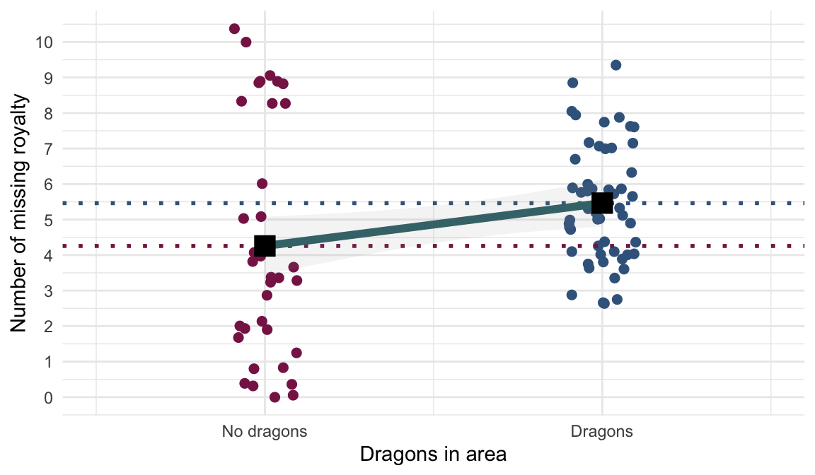

Slide 25: Key assumptions of the General Linear Model

Linearity and additivity

Spherical errors
The population model should have:
- Homoscedastic errors
  - Inspect the model residuals
- Independent errors
  - Inspect the model residuals

Normality of something-or-other
- Population model errors
- Sampling distribution

Slide 26: Linearity and additivity
The relationship between predictor(s) and outcome is, in reality, linear
$${\text{royalty}}_{i}={\hat{b}}_{0}+{\hat{b}}_{1}{\text{dragons}}_{i}+e_{i}$$
The combined effect of predictors is additive
$${\text{royalty}}_{i}={\hat{b}}_{0}+{\hat{b}}_{1}{\text{dragons}}_{i}+{\hat{b}}_{2}{\text{strict regime}}_{i}+e_{i}$$
Note: Statis-tip
- Test linearity using plots. If the data cloud looks banana shaped (curved), linearity probably can’t be assumed.

Slide 27: Errors vs. Residuals
Note: Statis-tip
- A model’s ERRORs refer to the differences between predicted values and observed values of the outcome variable in the population model
- These values cannot be observed
Note: Statis-tip
- A model’s RESIDUALs refer to the differences between predicted values and observed values of the outcome variable in the sample model
- These values can be observed and are representative of the population model errors.

Slide 28
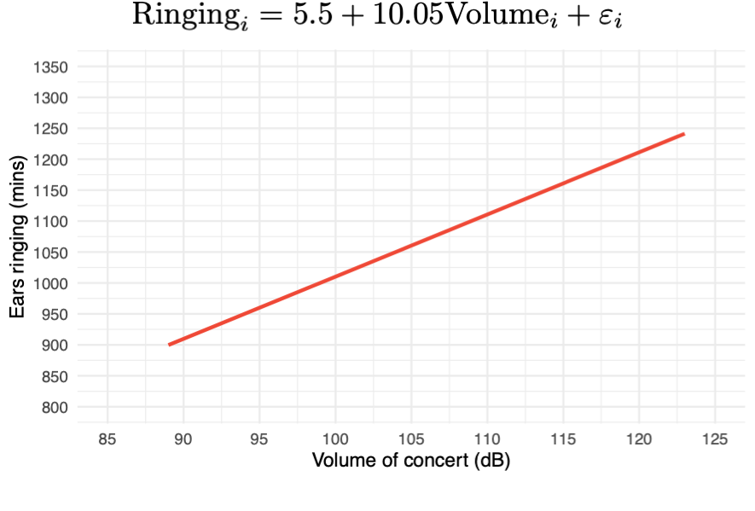

Slide 29: Normally distributed errors
$$\begin{aligned}{\text{Ringing}}_{i}&={\hat{b}}_{0}+{\hat{b}}_{1}{\text{Volume}}_{i}+ε_{i} \\ ε_{i}&∼N(0,σ^{2})\end{aligned}$$

Slide 30: Errors (Population model)
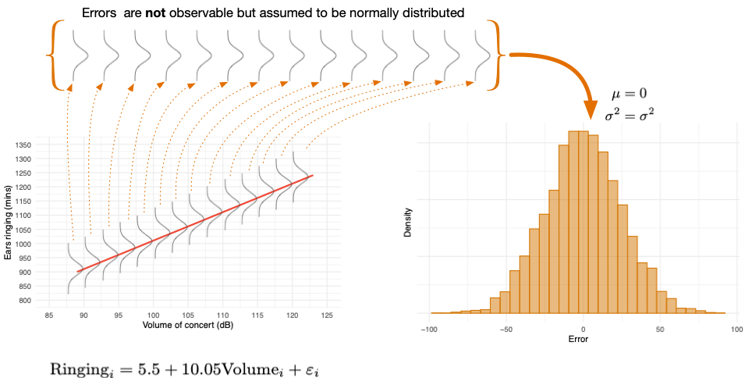

Slide 31: Residuals (are observable)
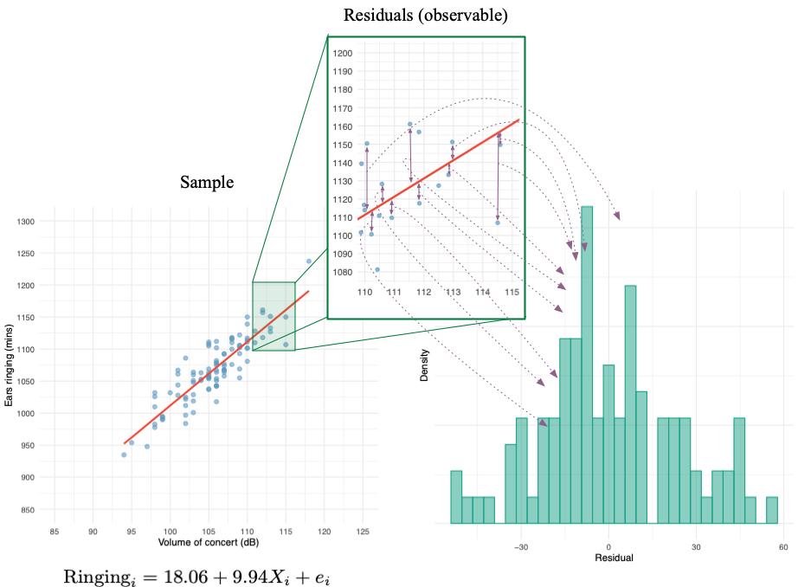

Slide 32: Spherical errors

Errors should be independent
- The population error in prediction for one case should not be related to the error in prediction for another case (autocorrelation).
- Independent observations tend to lead to independent errors
- Because we cannot observe population errors we inspect the sample residuals

Errors should be homoscedastic
- Variance of population errors (residuals) should be consistent at different values of the predictor variable
- Because we cannot observe population errors we inspect the sample residuals

Violation of the assumption
- bs are unbiased but not optimal
- Standard error is incorrect
  - Therefore, t-tests, p-values and confidence intervals will also be incorrect

Slide 33: Residuals vs. Predicted values
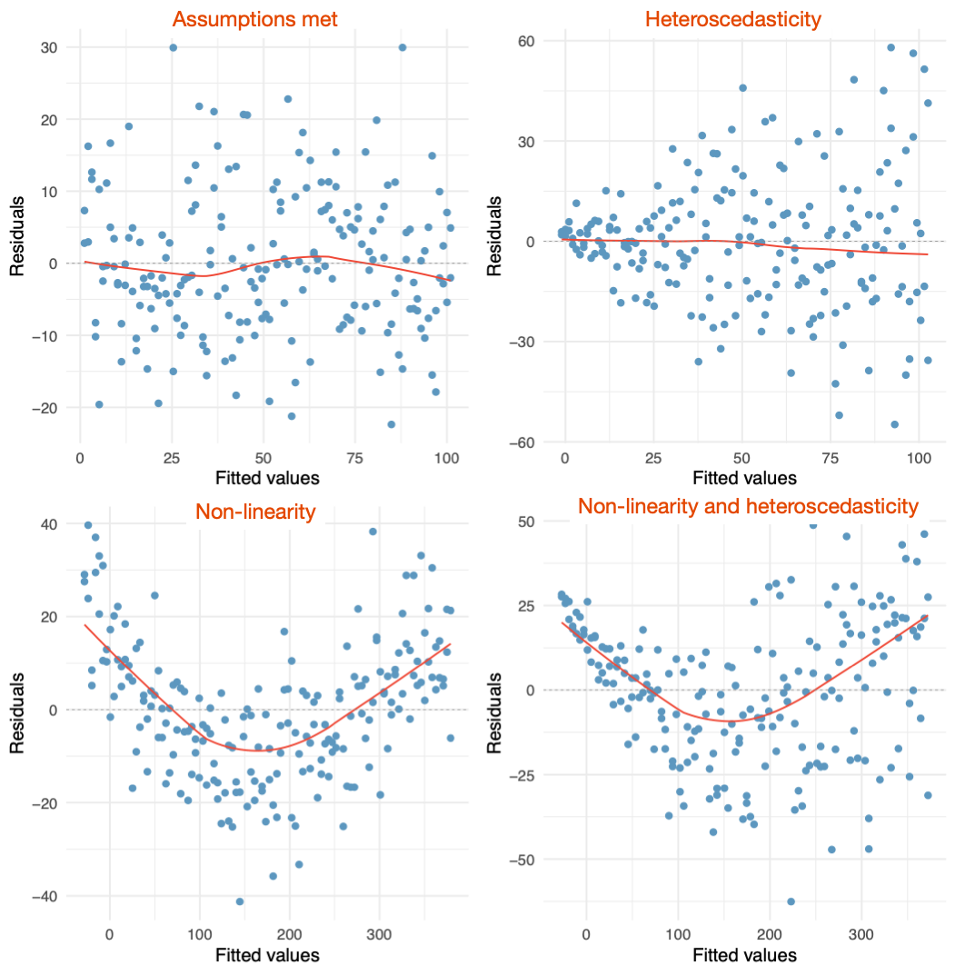

Slide 34: Residuals vs. Predicted values
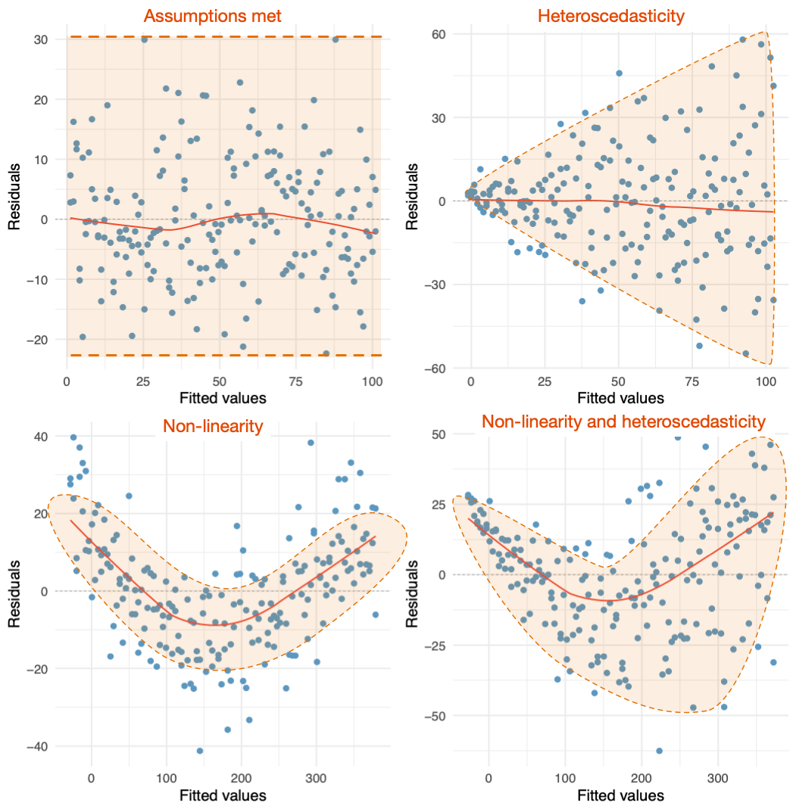

Slide 35

Homoscedastic
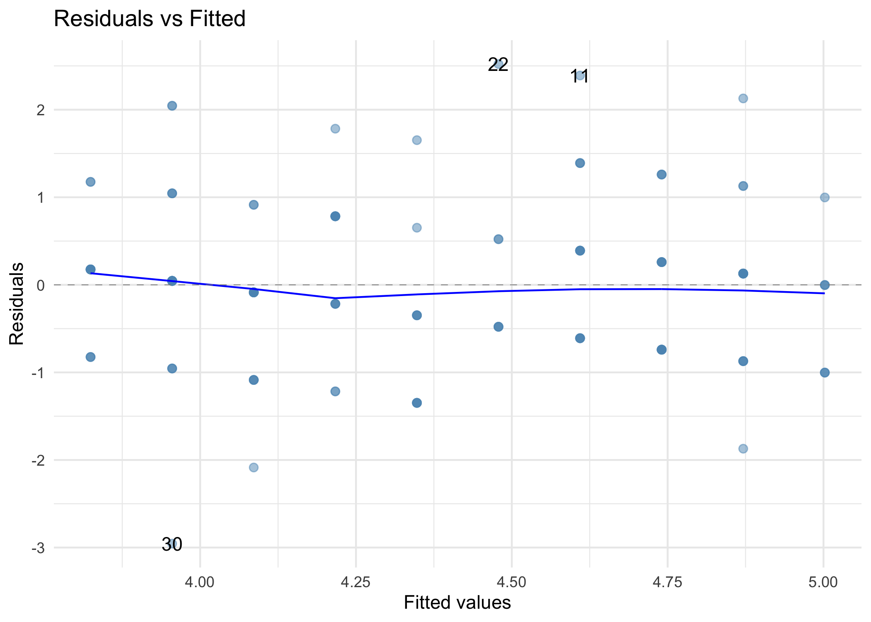

Our data
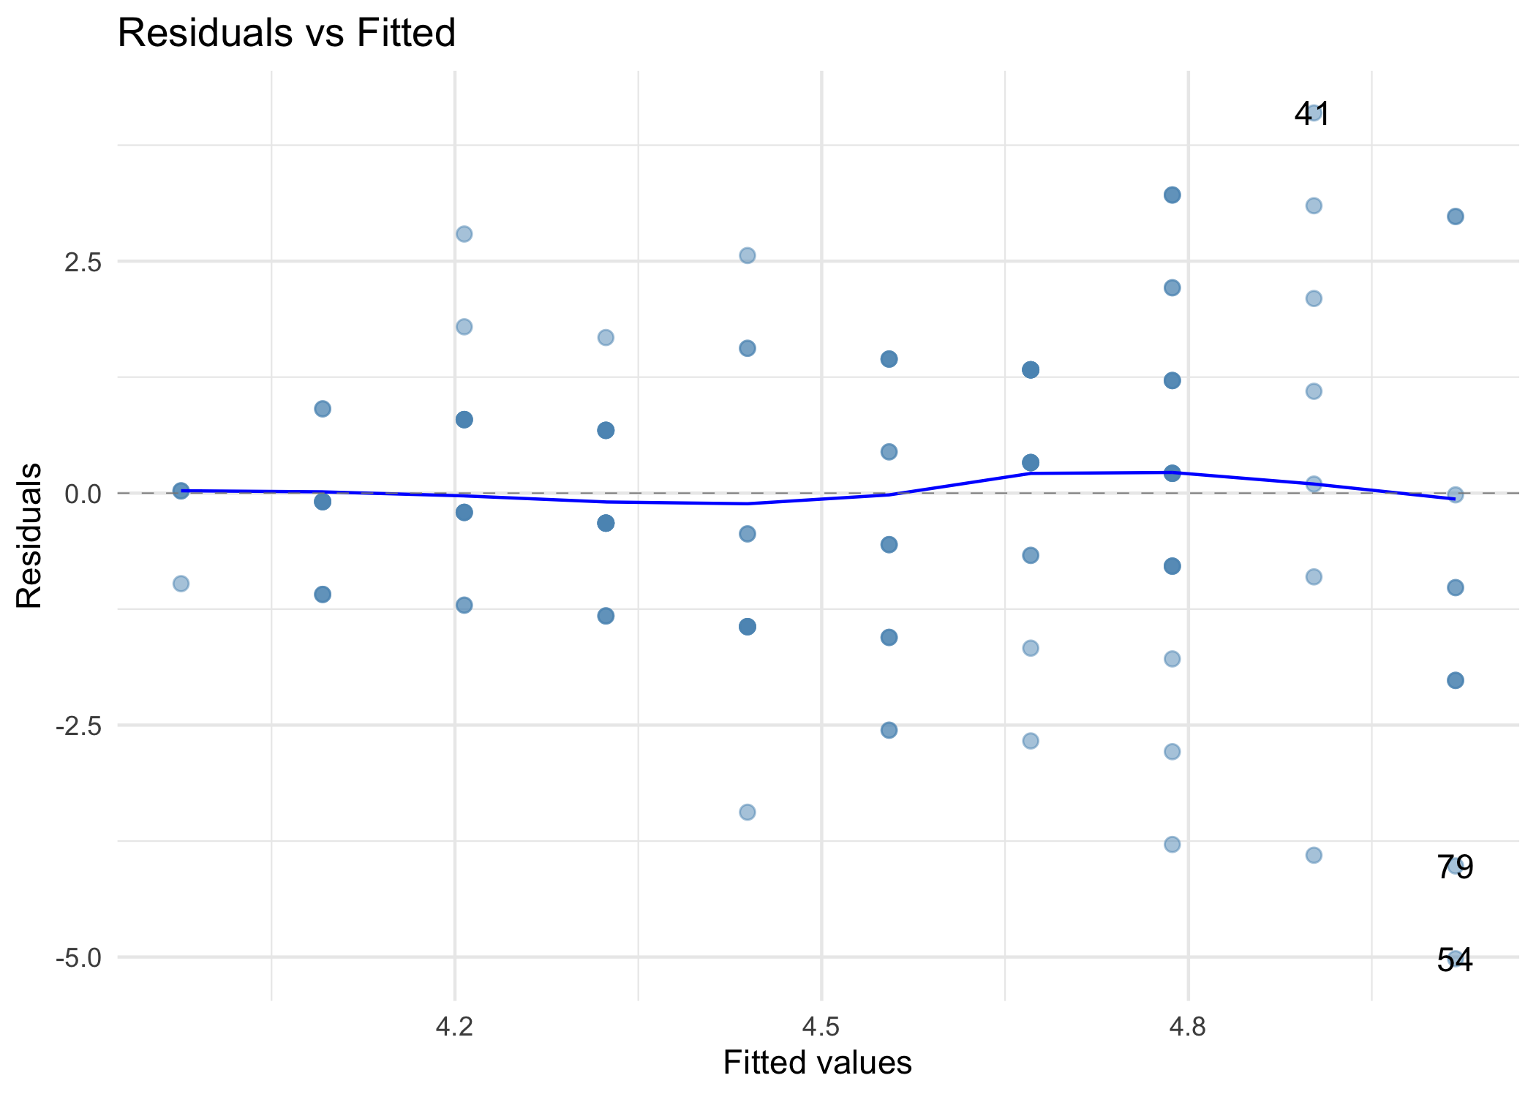

Slide 36

Homoscedastic
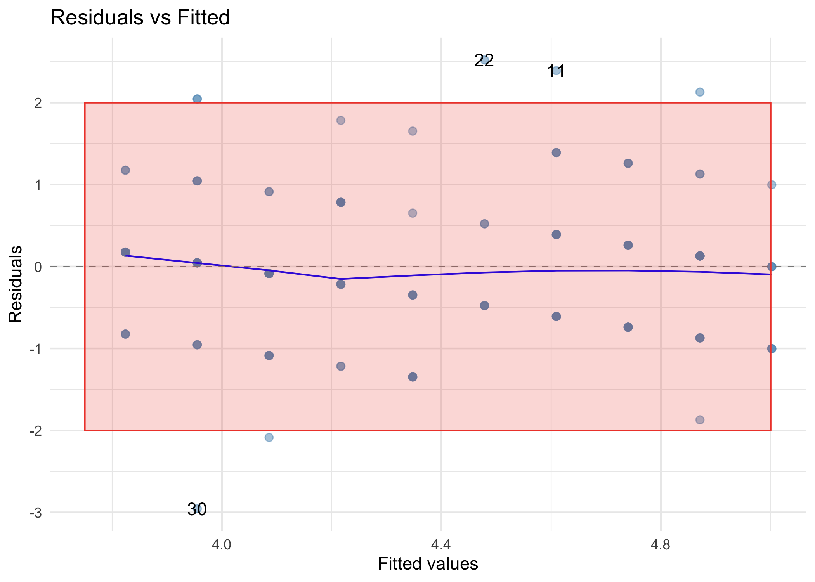

Our data: Heteroscedastic
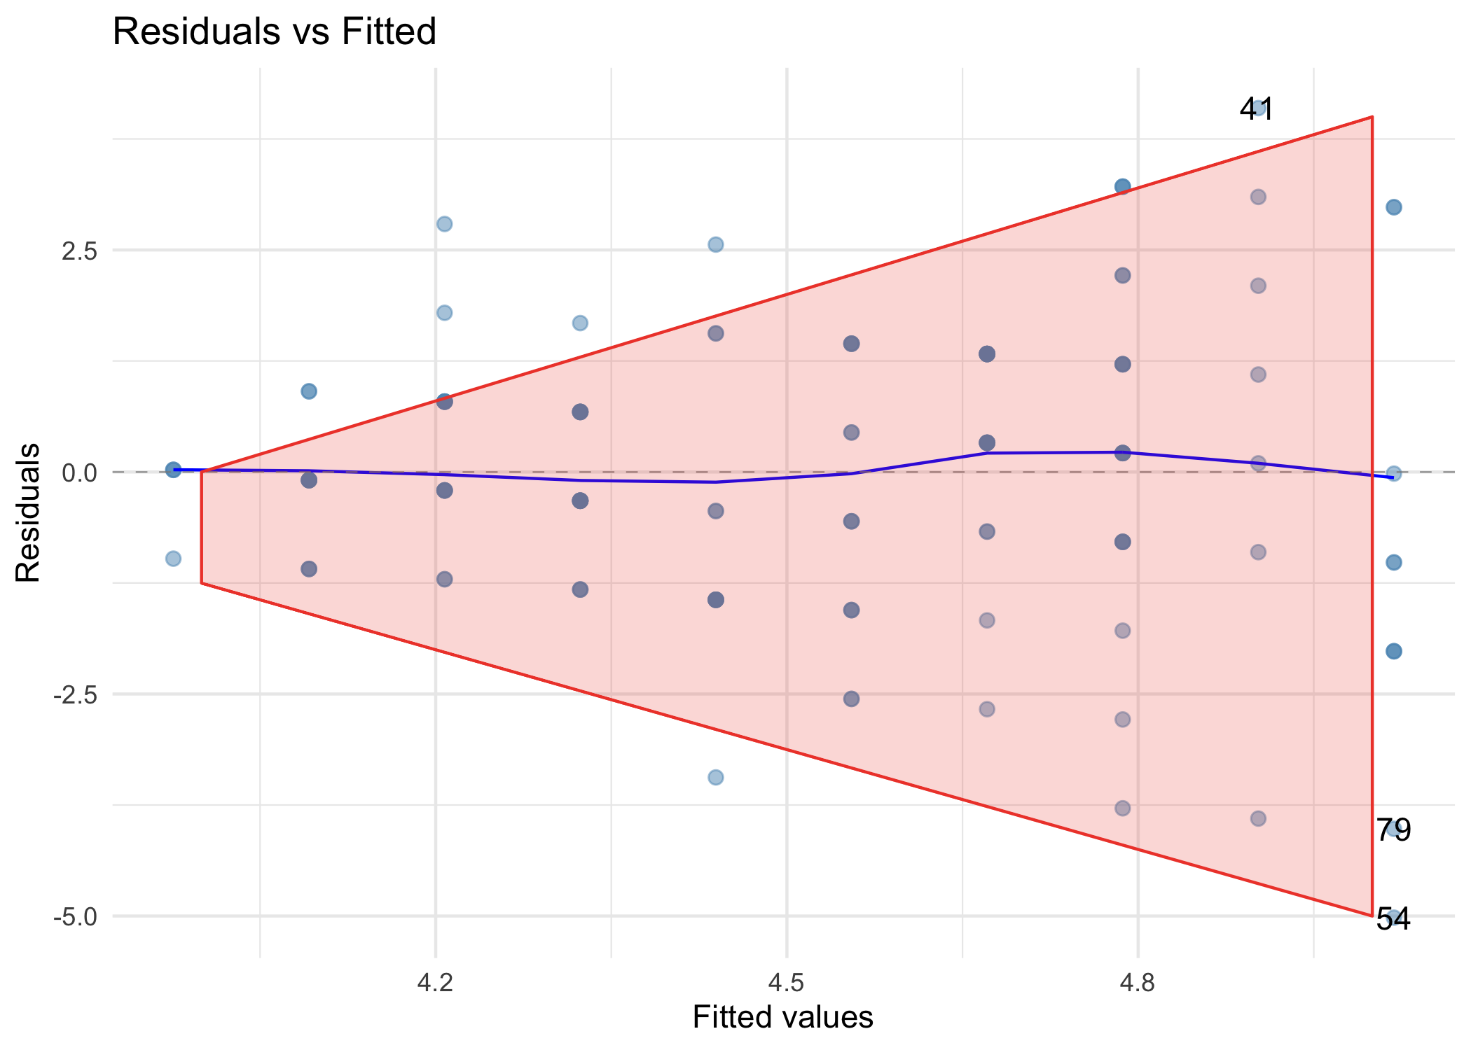

Slide 37

Homoscedastic
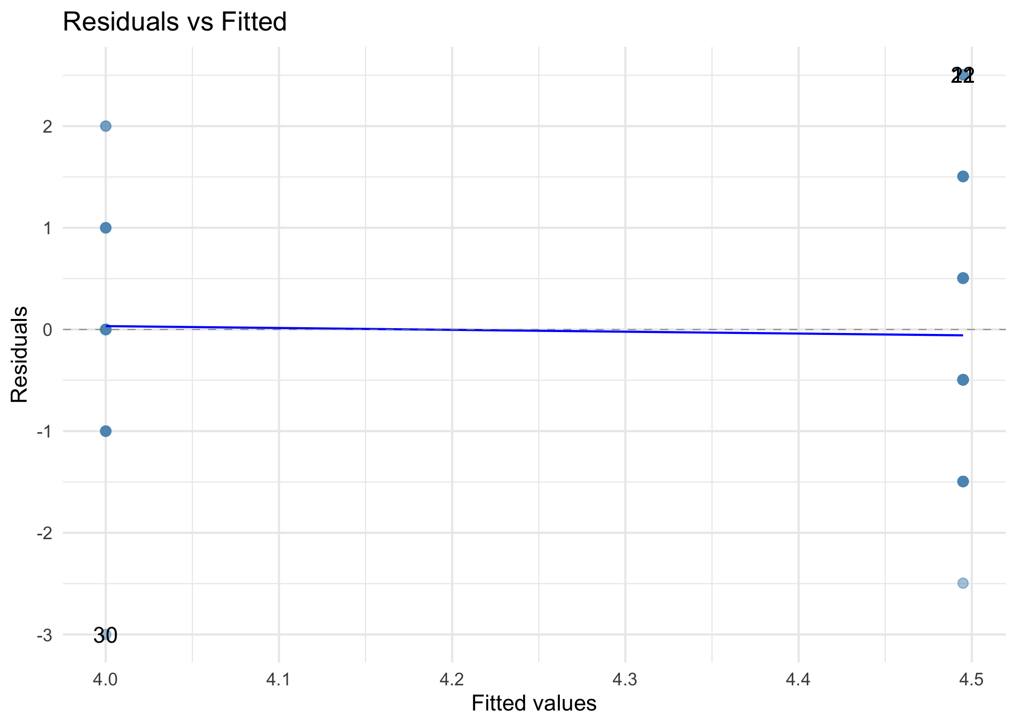

Our data
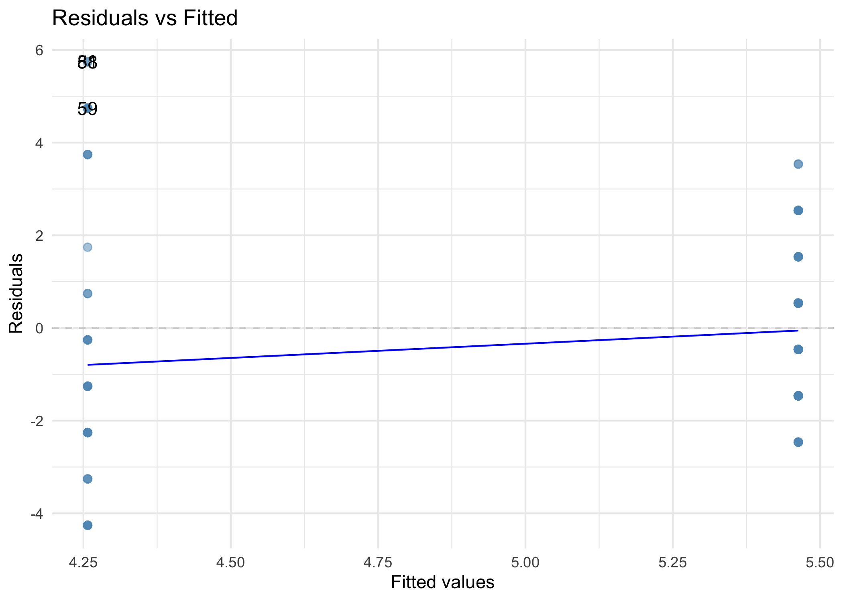

Slide 38

Homoscedastic
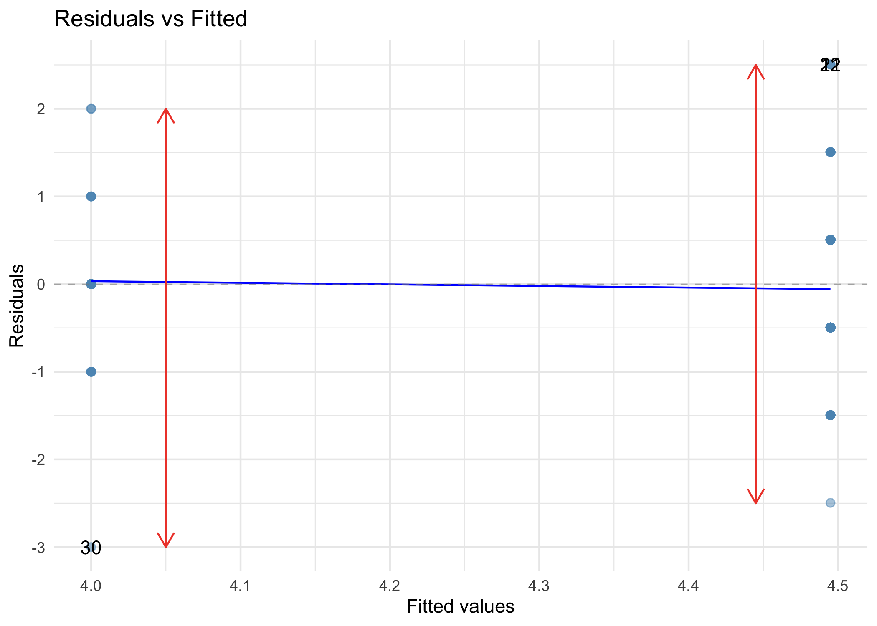

Our data: Heteroscedastic
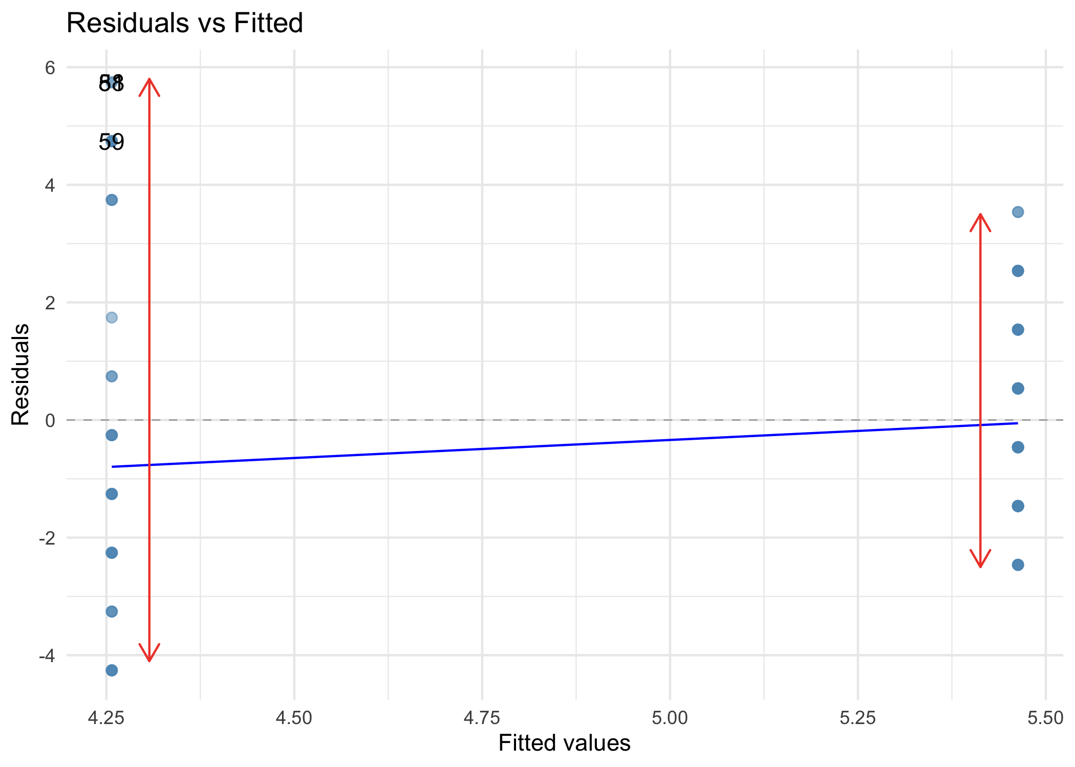

Slide 39
Video clip: heteroscedasticity song

Slide 40: Levene’s Test
Warning: The danger zone!
- You might hear about it but don’t use it: think about what we know about sample sizes and significance.
- For the avoidance of doubt, don’t use it.
- One more time … don’t use it

Slide 41
Video clip: shocked baby levene

Slide 42
Video clip: zach dragon hunt caption

Slide 43
Video clip: dragon chase 2

Slide 44 (new section): Part 3: Normality and does dragons poo kill crops?
“Coz their dung doesn’t help our crops to grow”
Sir Knight Zach, Defender of the world of Military

Slide 45: Is dung associated with crop yield?
$${\hat{\text{yield}}}_{i}=14.34+2.02{\text{poop}}_{i}$$
term | estimate | std.error | statistic | p.value | conf.low | conf.high
(Intercept) | 14.34 | 6.77 | 2.12 | 0.04 | 0.56 | 28.12
poop | 2.02 | 1.37 | 1.48 | 0.15 | -0.77 | 4.82
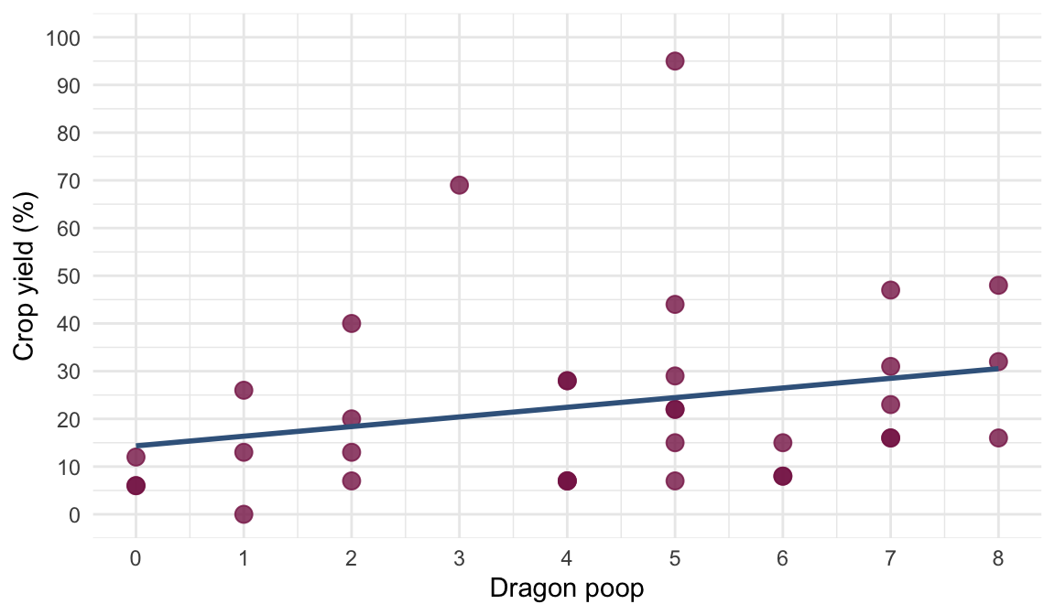

Slide 46: Normally distributed errors
Warning: The danger zone!
People usually (falsely) think the data or population need to be normally distributed.
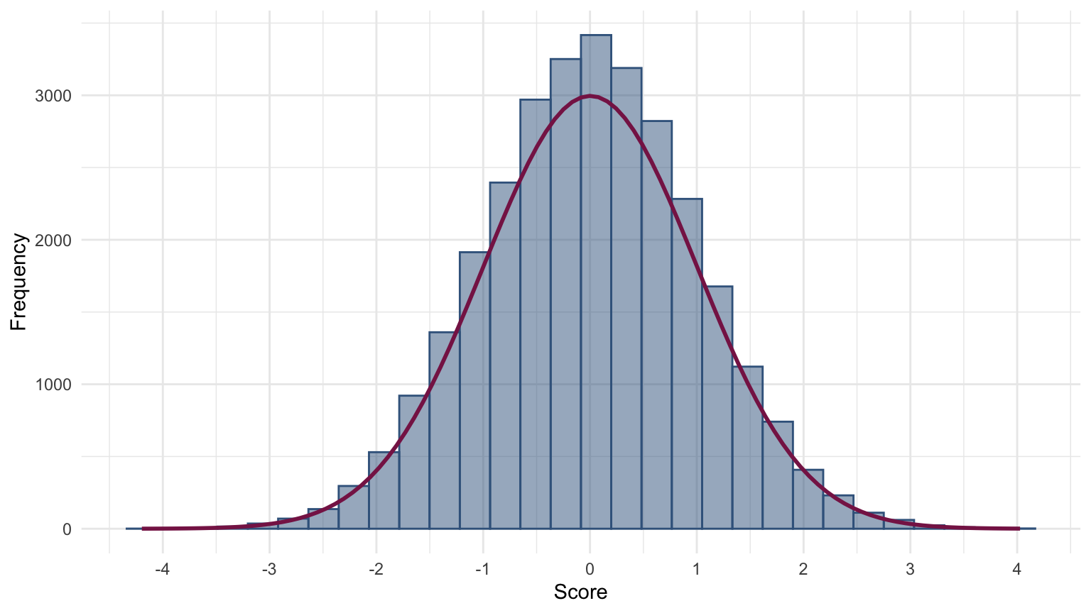

Slide 47: Normally distributed errors

Estimation
- Normal errors don’t really matter
- When errors are not normally distributed, b will be unbiased and optimal (i.e., will minimize the variance), but there may be classes of estimator (other than OLS) that are more accurate (Wilcox, 2010)

Confidence intervals and significance tests
- When residuals are normal
  - It can be shown that the bs have a normal sampling distribution.
  - Test statistics of bs (usually testing the null of b = 0) follow a t-distribution.
- If they are not normal then
  - We can’t base confidence intervals on the properties of the normal distribution.
  - We don’t know what distribution tests statistics have.

Slide 48: The Central Limit Theorem (CLT)
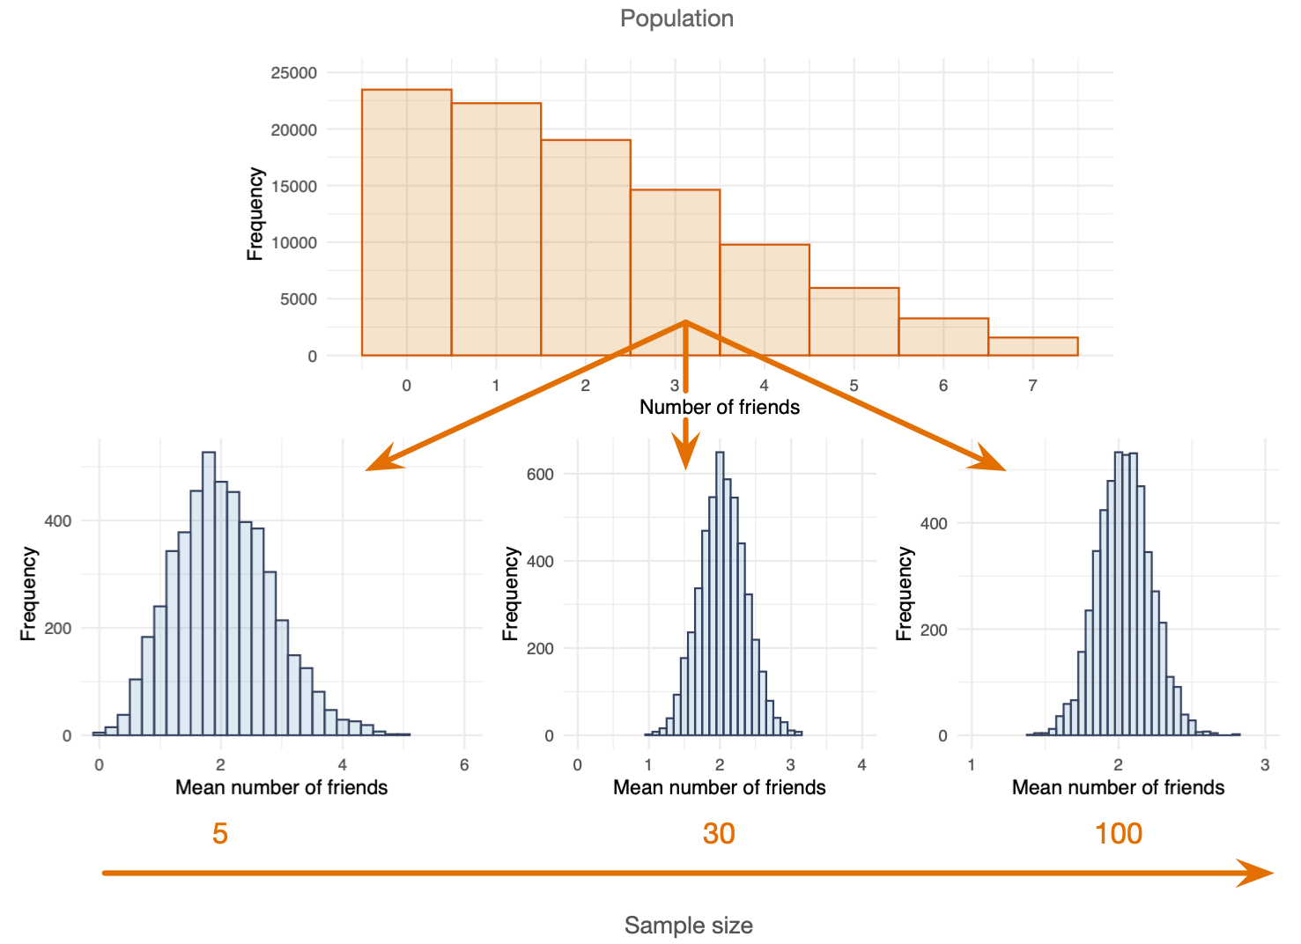

Slide 49: Exploring normality of model errors
- Check the distribution of the model residuals using a P-P/Q-Q plot

Large samples
- You don’t need to worry about this assumption in large samples because of the CLT

Small samples
- Use a bootstrap to get an empirical confidence interval and standard error (more on this later …)

Slide 50: The K-S Test
Warning: The danger zone!
- You might hear about it but don’t use it: think about what we know about sample sizes and significance.
- For the avoidance of doubt, don’t use it.
- One more time … don’t use it

Slide 51
Video clip: shocked cat ks

Slide 52

Normal residuals
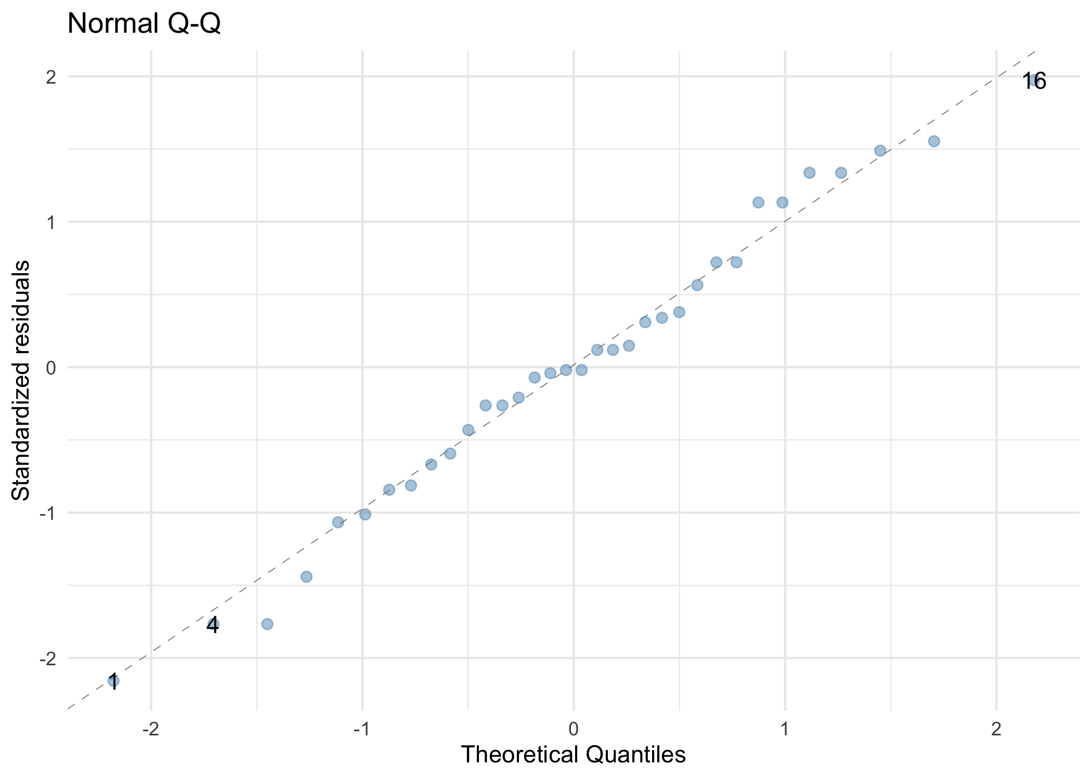

Our residuals: Non-normal
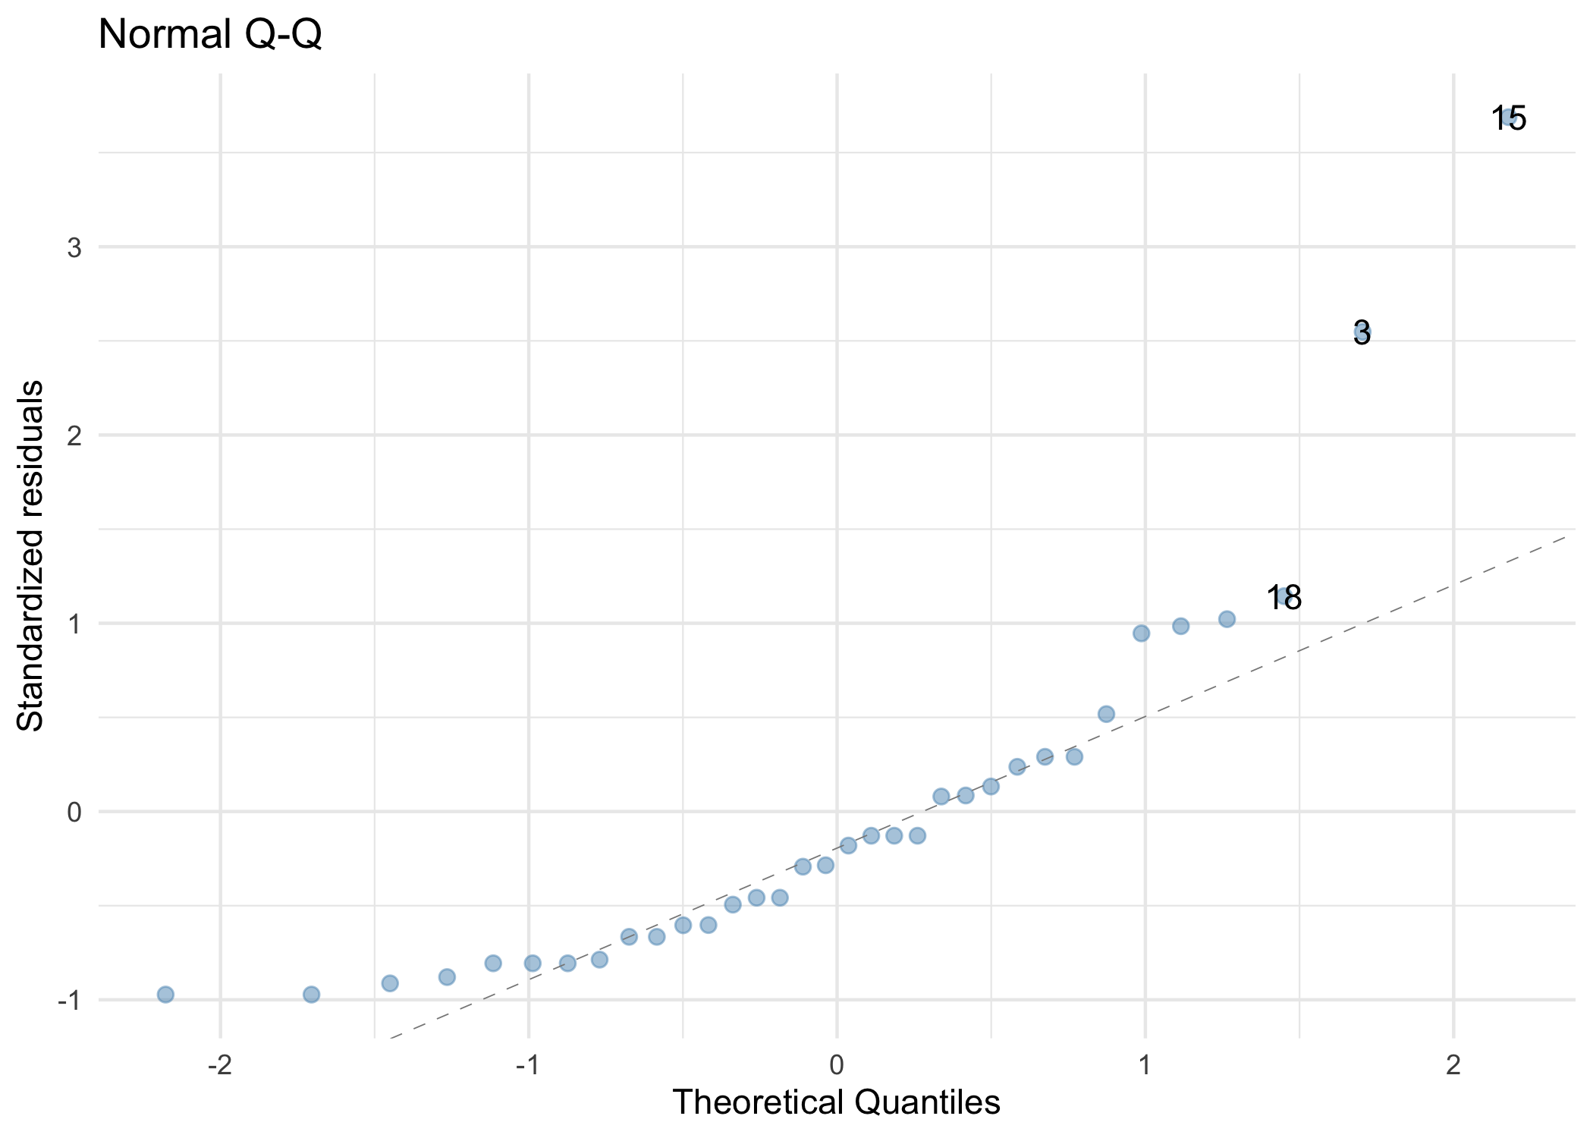

Slide 53
Video clip: normality song

Slide 54
Video clip: normality song instrumental

Slide 55 (new section): Part 4: Correcting problems

Slide 56: Robust procedures
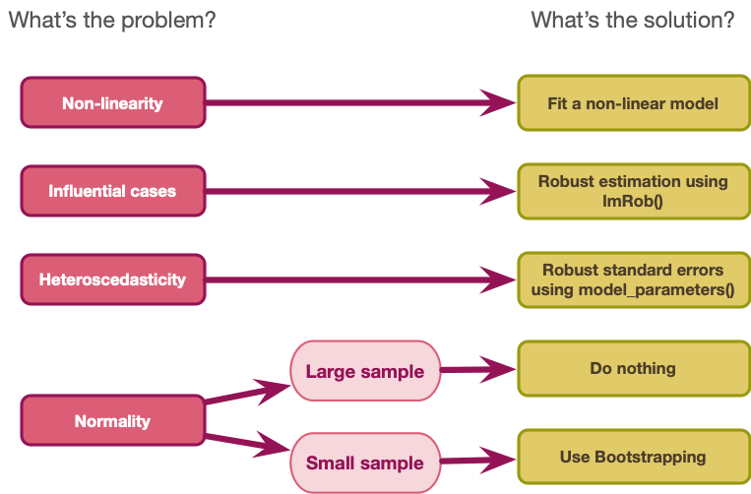

Slide 57: Robust procedures

The bootstrap
- Standard errors are derived empirically using a resampling technique
- Results in robust confidence intervals and p-values
- Designed for small samples (when normality matters)

Heteroskedasticity-consistent standard errors
- Use a sandwich estimator
- HC3 and HC4 methods work best

Slide 58
Video clip: bootstrap hippo

Slide 59: The Bootstrap
yield | 0 | 6 | 6 | 7 | 7 | 7 | 7 | 7 | 8 | 8 | 12 | 13 | 13 | 15 | 15 | 16 | 16 | 16 | 20 | 22 | 22 | 23 | 26 | 28 | 28 | 29 | 31 | 32 | 40 | 44 | 47 | 48 | 69 | 95
Mean = 23.03
Bootstrap sample 1:
yield | 0 | 0 | 6 | 7 | 7 | 7 | 7 | 7 | 8 | 8 | 8 | 12 | 12 | 13 | 13 | 15 | 16 | 16 | 20 | 22 | 22 | 22 | 22 | 23 | 26 | 28 | 29 | 32 | 47 | 48 | 48 | 69 | 69 | 95
Mean = 23.06
Bootstrap sample 2:
yield | 0 | 0 | 6 | 7 | 7 | 7 | 7 | 7 | 7 | 7 | 7 | 7 | 8 | 8 | 15 | 15 | 16 | 16 | 20 | 20 | 22 | 23 | 23 | 28 | 31 | 40 | 44 | 44 | 44 | 47 | 48 | 48 | 69 | 95
Mean = 23.32

Slide 60
yield | 0 | 6 | 6 | 7 | 7 | 7 | 7 | 7 | 8 | 8 | 12 | 13 | 13 | 15 | 15 | 16 | 16 | 16 | 20 | 22 | 22 | 23 | 26 | 28 | 28 | 29 | 31 | 32 | 40 | 44 | 47 | 48 | 69 | 95
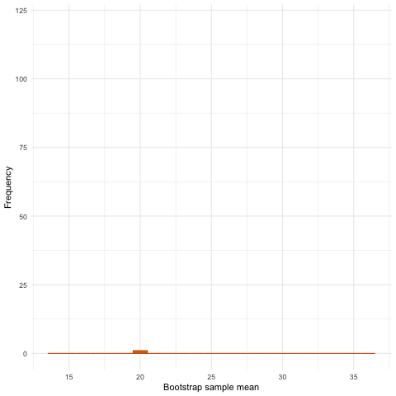

Slide 61
yield | 0 | 6 | 6 | 7 | 7 | 7 | 7 | 7 | 8 | 8 | 12 | 13 | 13 | 15 | 15 | 16 | 16 | 16 | 20 | 22 | 22 | 23 | 26 | 28 | 28 | 29 | 31 | 32 | 40 | 44 | 47 | 48 | 69 | 95
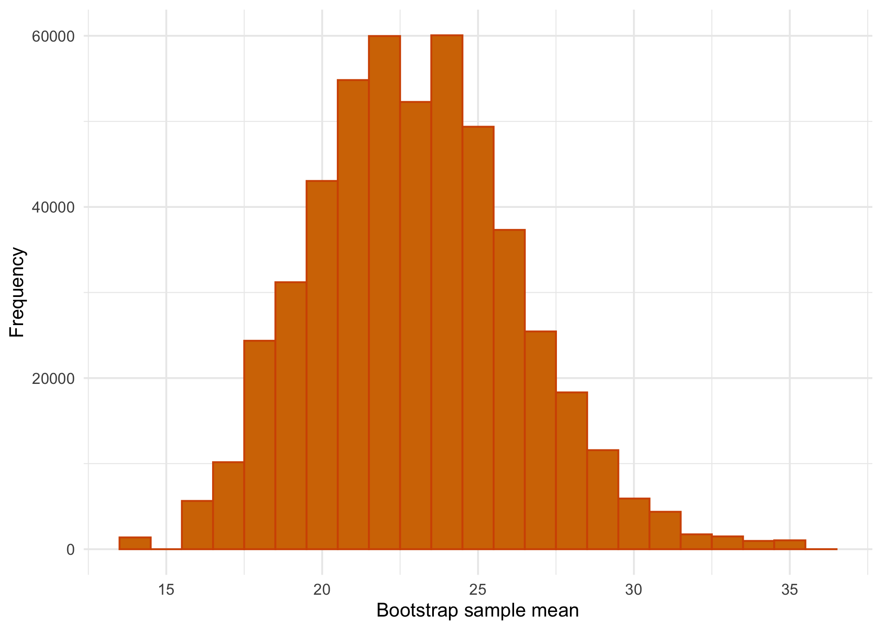

Slide 62
Video clip: zach chops arlos tail

Slide 63: Do dragons really kidnap royalty?

Normal model (number of dragons)
kidnap_lm <- lm(royalty ~ dragons,data = hov_cont_tib)
model_parameters(kidnap_lm) |>
display()
Parameter | Coefficient | SE | 95% CI | t(128) | p
(Intercept) | 3.98 | 0.30 | (3.39, 4.57) | 13.32 | < .001
dragons | 0.12 | 0.06 | (5.30e-03, 0.23) | 2.07 | 0.040

Robust model (number of dragons) HC4 Standard errors
kidnap_lm <- lm(royalty ~ dragons, data = hov_cont_tib)
model_parameters(kidnap_lm, vcov = "HC4") |>
display()
Parameter | Coefficient | SE | 95% CI | t(128) | p
(Intercept) | 3.98 | 0.24 | (3.50, 4.45) | 16.49 | < .001
dragons | 0.12 | 0.06 | (-0.01, 0.24) | 1.81 | 0.072

Slide 64: Do dragons really kidnap royalty?

Normal model (dragons or not)
kidnap_gp_lm <- lm(royalty ~ dragons, data = hov_cat_tib)
model_parameters(kidnap_gp_lm) |>
display()
Parameter | Coefficient | SE | 95% CI | t(87) | p
(Intercept) | 4.26 | 0.41 | (3.43, 5.08) | 10.28 | < .001
dragons (Dragons) | 1.21 | 0.53 | (0.15, 2.26) | 2.27 | 0.026

Robust model (dragons or not) HC4 standard errors
kidnap_gp_lm <- lm(royalty ~ dragons, data = hov_cat_tib)
model_parameters(kidnap_gp_lm, vcov = "HC4") |>
display()
Parameter | Coefficient | SE | 95% CI | t(87) | p
(Intercept) | 4.26 | 0.57 | (3.13, 5.39) | 7.50 | < .001
dragons (Dragons) | 1.21 | 0.61 | (-5.94e-03, 2.42) | 1.98 | 0.051

Slide 65: Does dragon poo help crops to grow?

Normal model
poop_lm <- lm(yield ~ poop, data = poop_tib)
model_parameters(poop_lm) |>
display()
Parameter | Coefficient | SE | 95% CI | t(32) | p
(Intercept) | 14.34 | 6.77 | (0.56, 28.12) | 2.12 | 0.042
poop | 2.02 | 1.37 | (-0.77, 4.82) | 1.48 | 0.150

Bootstrap model
poop_lm <- lm(yield ~ poop, data = poop_tib)
model_parameters(poop_lm, bootstrap = TRUE) |>
display()
Parameter | Coefficient | 95% CI | p
(Intercept) | 14.14 | (5.12, 25.92) | 0.002
poop | 2.06 | (0.09, 3.92) | 0.046

Slide 66
Video clip: arlo have you saved the dragons yet 2 caption

Slide 67
Video clip: zach not allowed to kill dragons caption

Slide 68
Video clip: zach what can i kill caption

Slide 69
Video clip: zach kill you caption

