Contrast coding
Different ways to explore categorical predictors
Professor Andy Field, University of Sussex
Links: rush subdivisions | bsky.app | youtube.com | discoveringstatistics.com | discovr.rocks | statisticsadventure.com

About this version
This is a plain-text version of the lecture slides. Each slide starts with a heading such as “Slide 5”, and the numbers match the slide numbers shown in the lecture. Content that appeared one piece at a time, in columns or in tabs is shown in reading order. Videos and interactive apps are given as links.

Slide 2: Learning outcomes
- Explain the different ways to break down categorical predictors in a linear model
  - Planned contrasts/comparisons)
  - Choosing contrasts
  - Contrast coding
- Post hoc tests
- Polynomial contrasts (trend analysis)

Slide 3
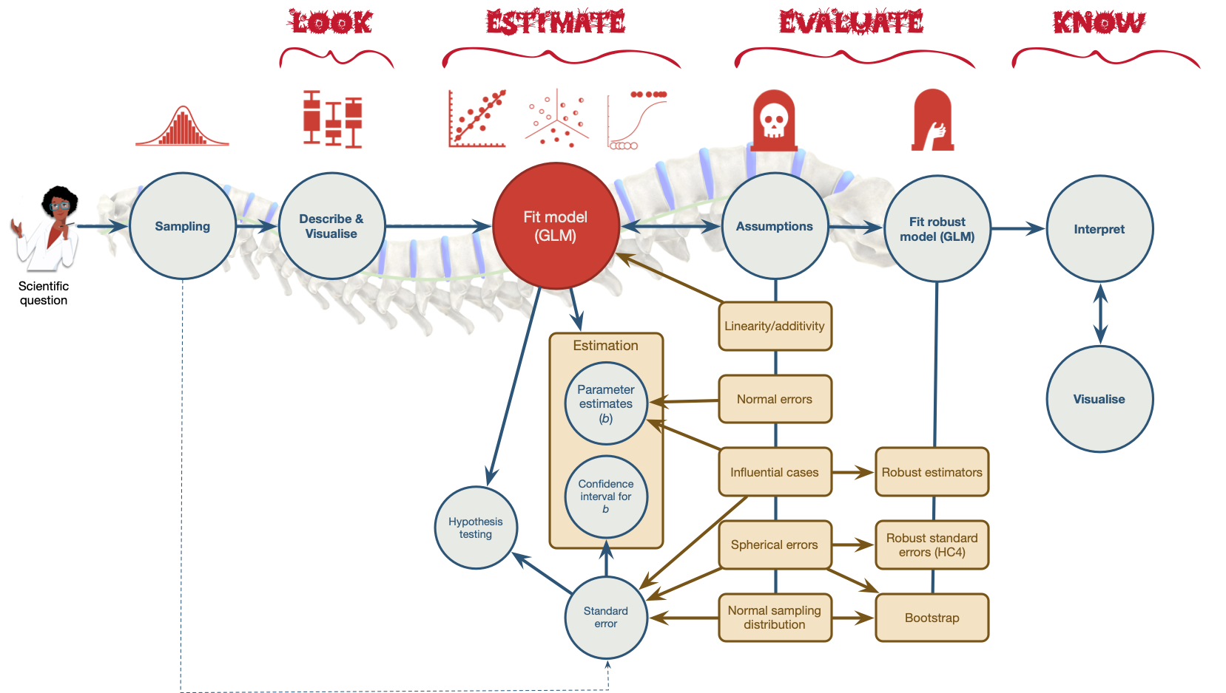
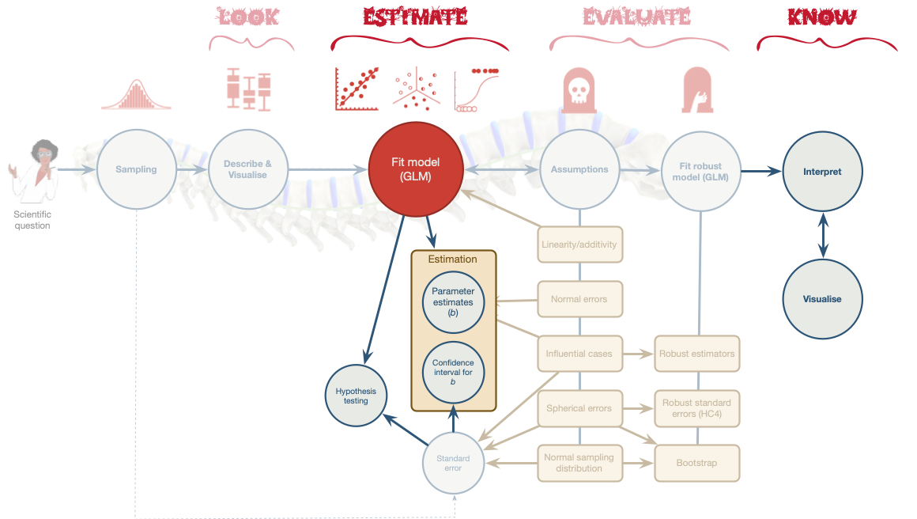

Slide 4
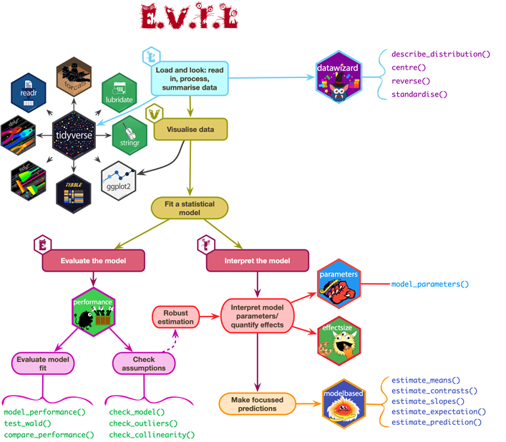

Slide 5: Contrast coding
- The F-statistic tests the overall fit of the model
  - i.e. It is a general test of model fits/whether group means significantly differ
- Model parameters tells us about specific differences between means
  - Dummy coding compares each category to a baseline
- What do we do when dummy coding does not reflect our a priori hypotheses?

Slide 6: Options for breaking down categorical predictors
- Orthogonal contrasts (contrast coding)
- Hypothesis driven
- Planned a priori
- Control Type I error rate
- Post hoc tests
  - Not planned (not hypothesis driven)
  - Compare all pairs of means
  - Multiple t-tests adjusted for the number of tests
- Trend analysis
  - Useful only for ordered means
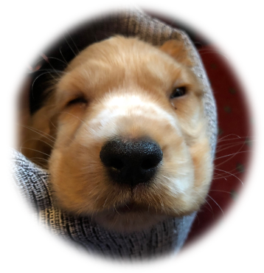

Slide 7
Video clip: milton insert puppies

Slide 8: A puppy-tastic example
- A puppy therapy RCT in which we randomized people into three groups:
  - A control group
  - 15 minutes of puppy therapy
  - 30 minutes of puppy contact
- The outcome is happiness (0 = unhappy) to 10 (happy).
- Predictions:
  - Any form of puppy therapy should be better than the control (i.e. higher happiness scores)
  - A dose-response hypothesis that as exposure time increases (from 15 to 30 minutes) happiness will increase too.

Slide 9: Load and Look


 | No puppies | 15 mins | 30 mins
 | 3 | 5 | 7
 | 2 | 2 | 4
 | 1 | 4 | 5
 | 1 | 2 | 3
 | 4 | 3 | 6
Mean | 2.20 | 3.20 | 5.00
Variance (s²) | 1.70 | 1.70 | 2.50
Standard deviation (s) | 1.30 | 1.30 | 1.58
$\text{Overall mean (}{\overset{‾}{X}}_{\text{grand}}\text{)}=3.467$

Slide 10: The general linear model
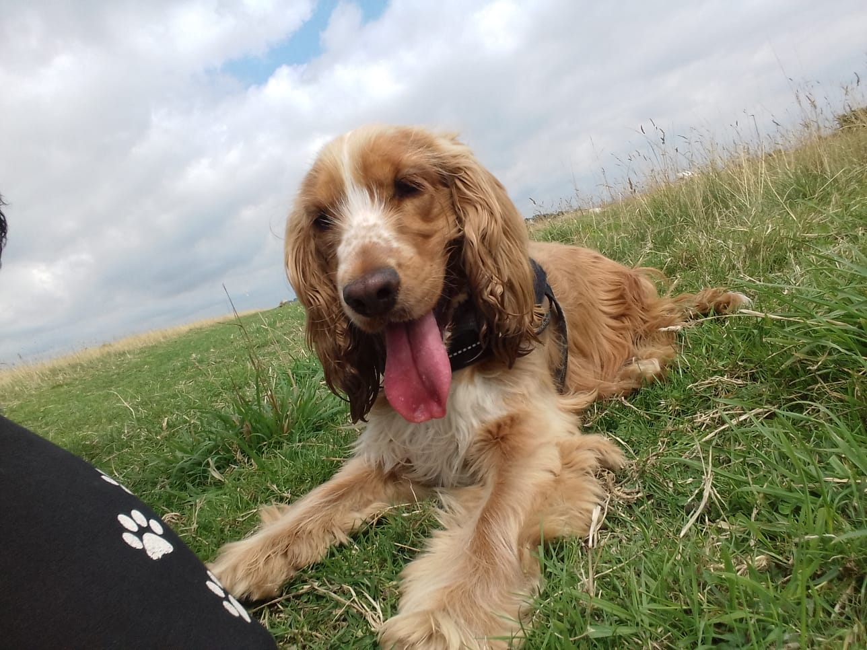

Dummy coding
Therapy group | Long (30 mins vs. no puppies) | Short 1 (15 mins vs. no puppies)
No Puppies | 0 | 0
15 mins | 0 | 1
30 mins | 1 | 0
$$\begin{aligned}{\text{Happiness}}_{i}&={\hat{b}}_{0}+{\hat{b}}_{1}{\text{Long}}_{i}+{\hat{b}}_{2}{\text{Short}}_{i}+e_{i}\end{aligned}$$

Slide 11: Visualize the ‘dummy’ model
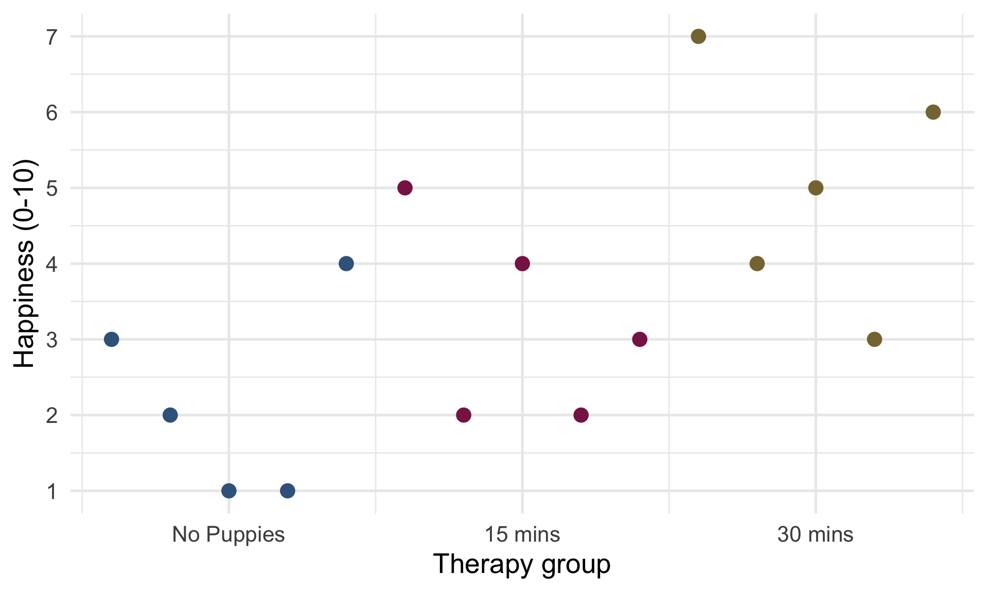


Slide 12: Visualize the ‘dummy’ model
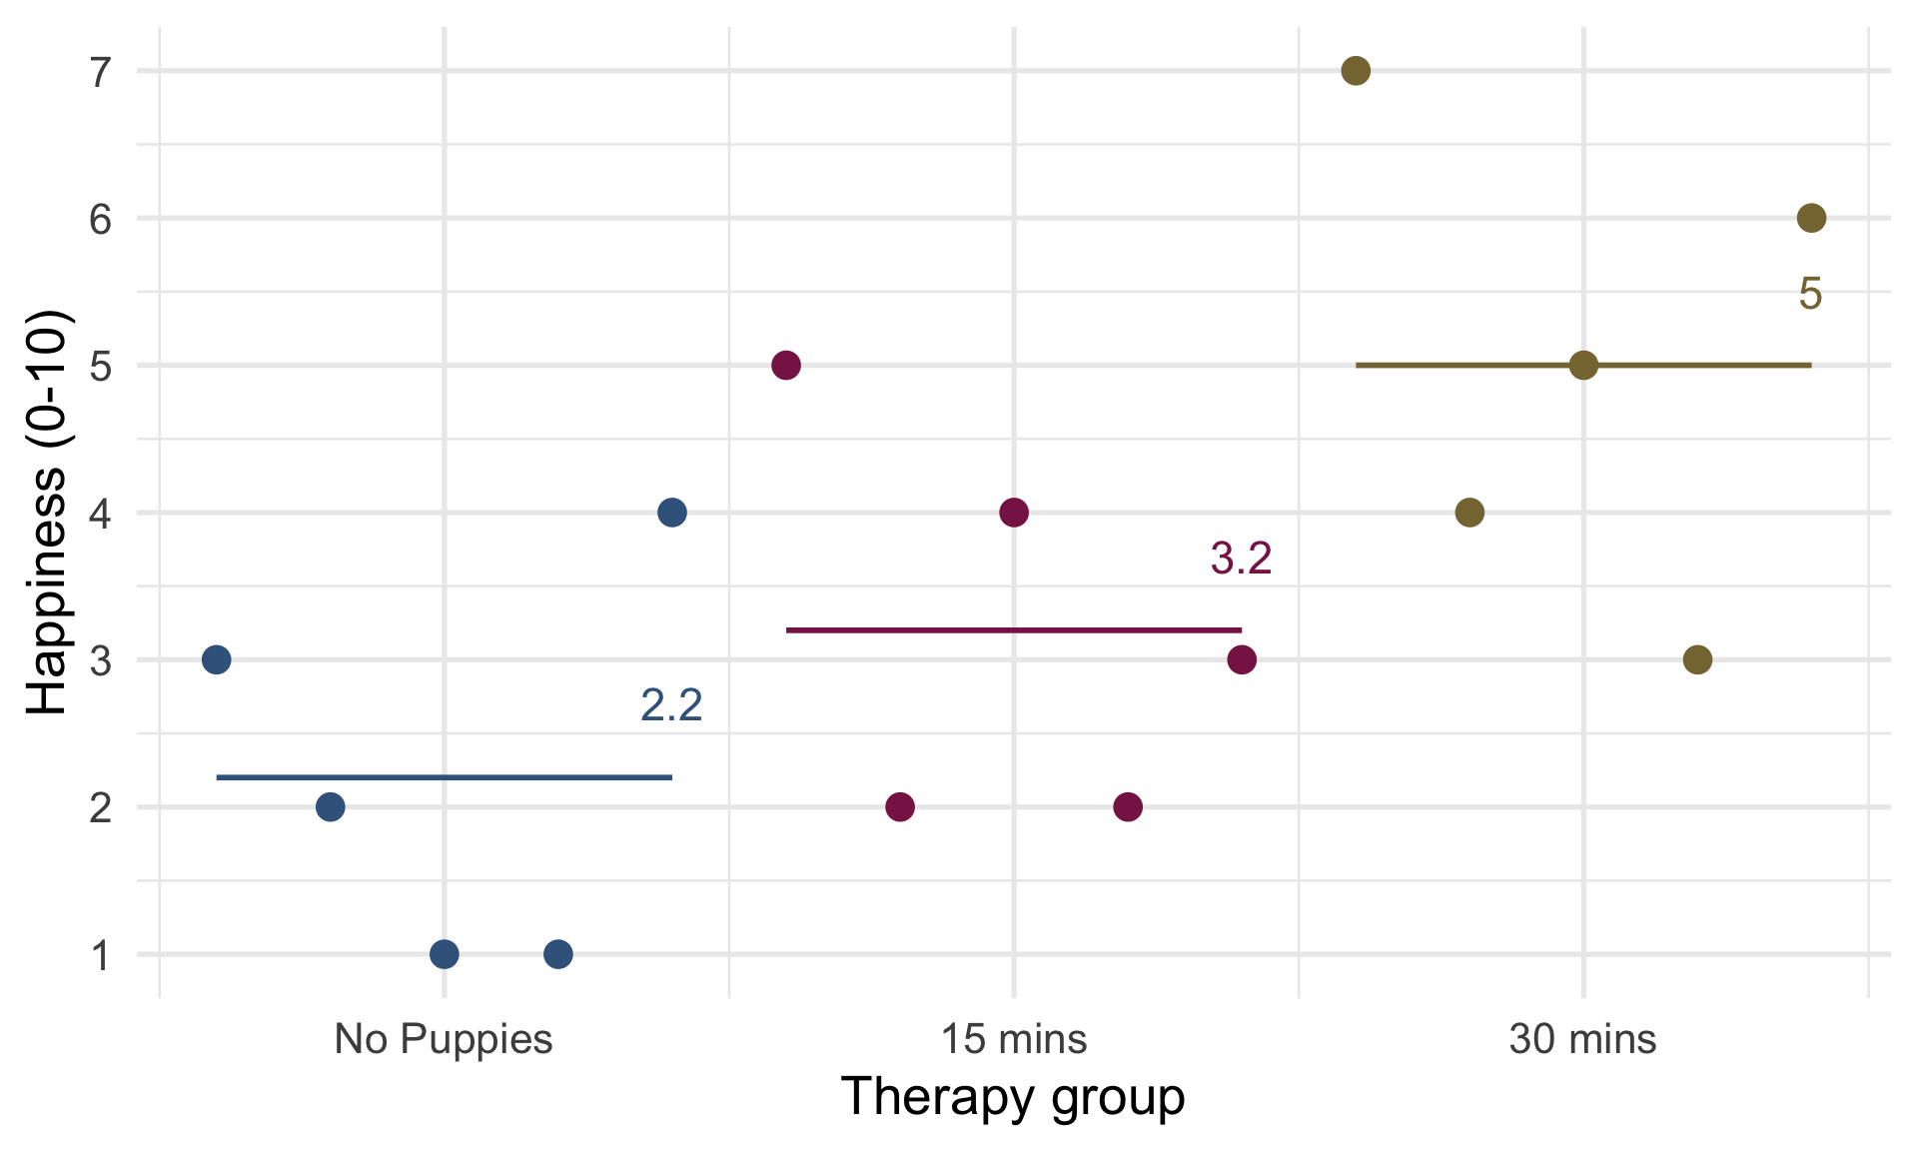

Slide 13: Visualize the ‘dummy’ model
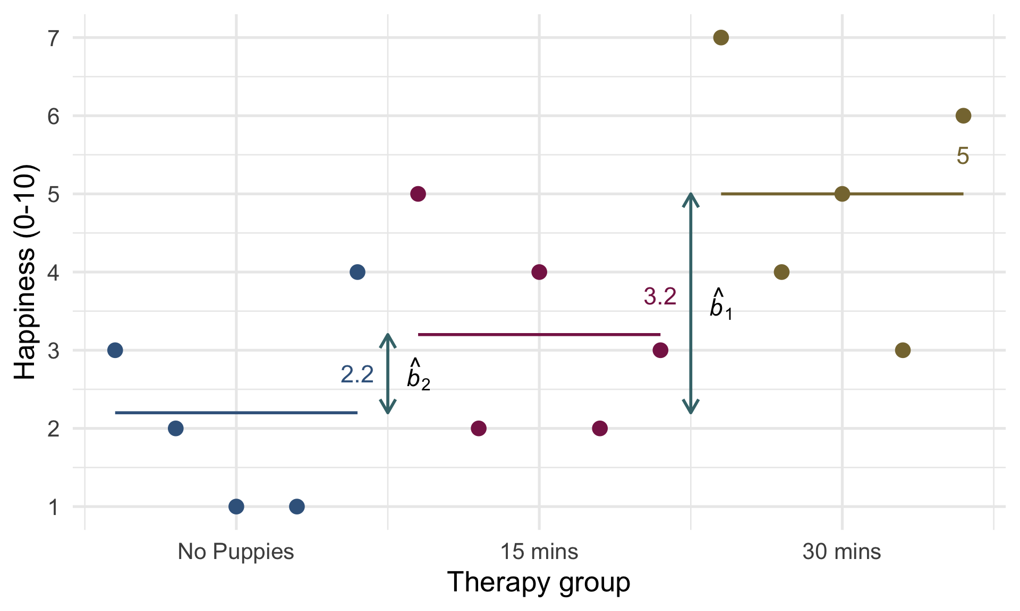

Slide 14: Fit the model
$$\begin{aligned}{\hat{\text{Happiness}}}_{i}&={\hat{b}}_{0}+{\hat{b}}_{1}{\text{Long}}_{i}+{\hat{b}}_{2}{\text{Short}}_{i}\end{aligned}$$
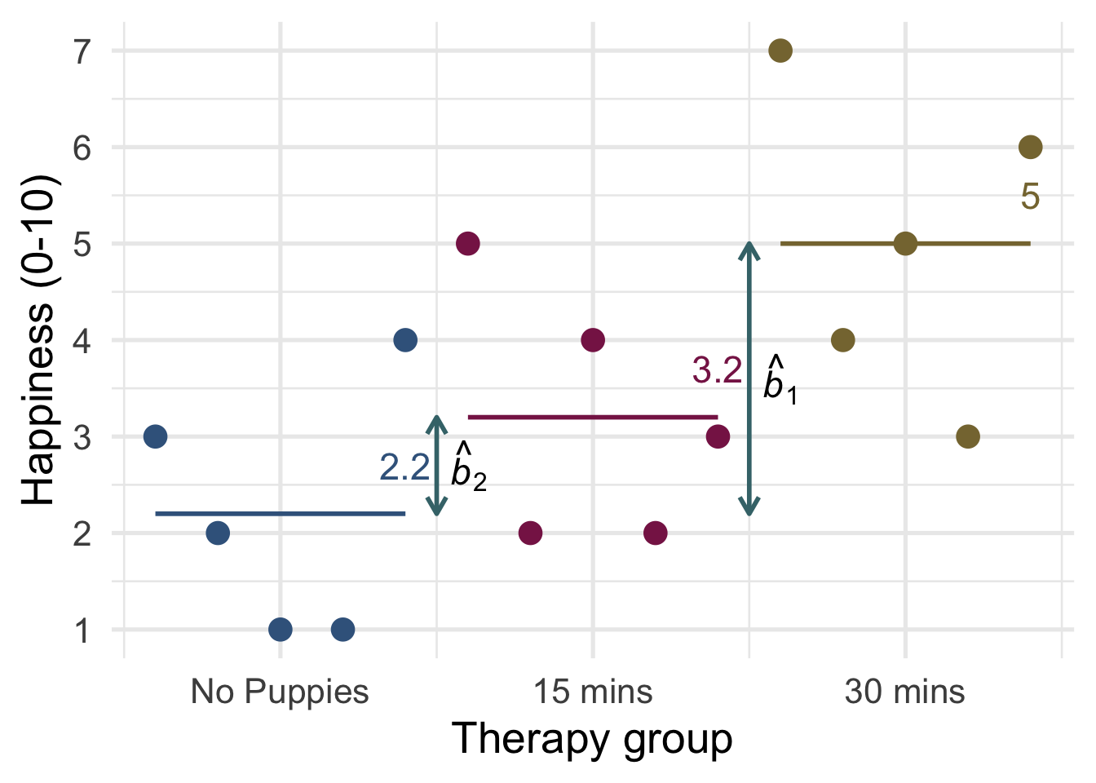
$$\begin{aligned}{\hat{b}}_{0}&={\overset{‾}{X}}_{\text{No puppies}}=2.2 \\ {\hat{b}}_{1}&=5.0−2.2=2.8 \\ {\hat{b}}_{2}&=3.2−2.2=1.0\end{aligned}$$

Slide 15: Evaluate fit
# get F
anova(puppy_lm) |>
model_parameters(es_type = "omega", ci = 0.95) |>
display()
Parameter | Sum_Squares | df | Mean_Square | F | p | Omega2 | Omega2 95% CI
dose | 20.13 | 2 | 10.07 | 5.12 | 0.025 | 0.35 | (0.00, 1.00)
Residuals | 23.60 | 12 | 1.97
# get R^2
model_performance(puppy_lm) |>
display()
AIC | AICc | BIC | R2 | R2 (adj.) | RMSE | Sigma
57.4 | 61.4 | 60.2 | 0.46 | 0.37 | 1.25 | 1.40

Slide 16: Evaluate assumptions
check_model(puppy_lm)
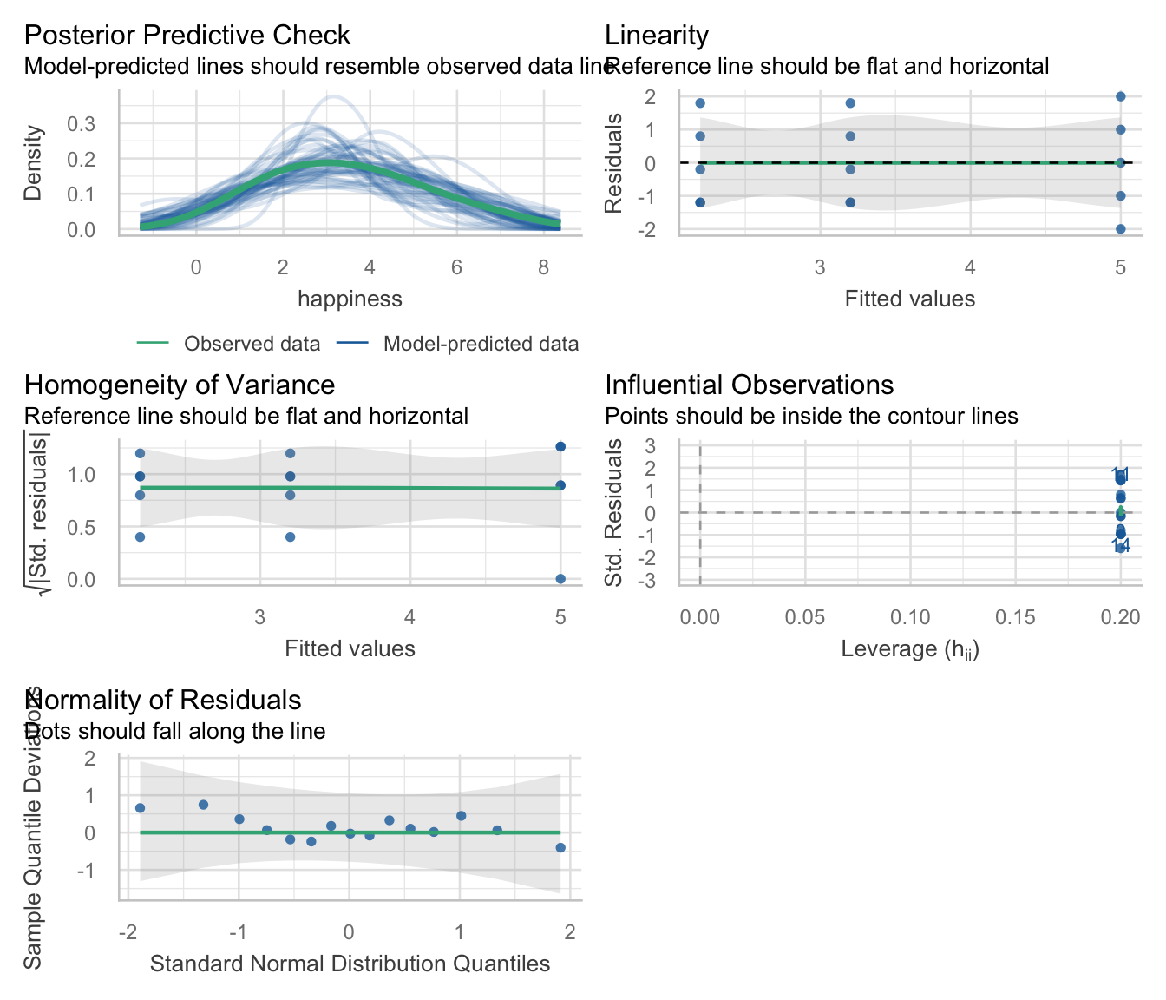


Slide 17: Interpret parameter estimates, CIs and tests
model_parameters(puppy_lm) |>
display()
Parameter | Coefficient | SE | 95% CI | t(12) | p
(Intercept) | 2.20 | 0.63 | (0.83, 3.57) | 3.51 | 0.004
dose (15 mins) | 1.00 | 0.89 | (-0.93, 2.93) | 1.13 | 0.282
dose (30 mins) | 2.80 | 0.89 | (0.87, 4.73) | 3.16 | 0.008


Slide 18: Planned contrasts
- The variability explained by the model, SS_{M} is due to participants being assigned to different groups
  - This variability sometimes represents an experimental manipulation
- This variability (SS_{M}) can be broken down further to test specific hypotheses about which groups might differ
- We break down the variance according to hypotheses made a priori (before the experiment)
- It’s like cutting up a cake (yum yum!)

Slide 19
Video clip: partitioning chocolate silent

Slide 20: The cake analogy again
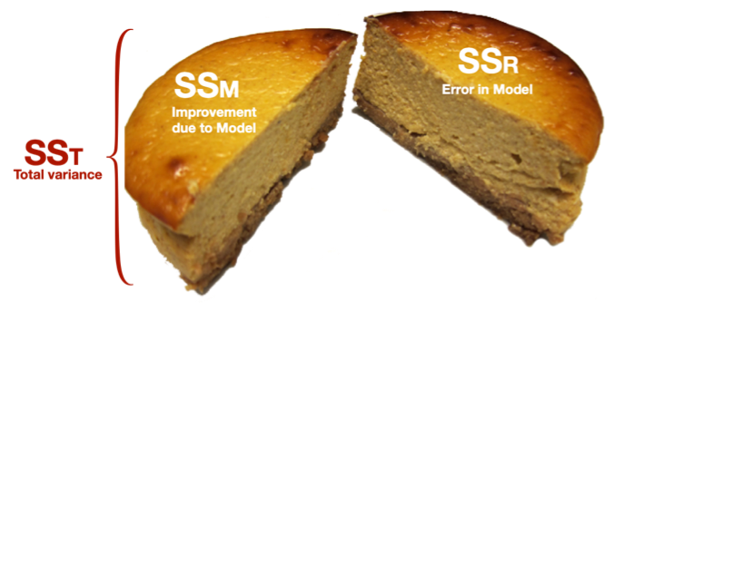

Slide 21: The cake analogy again
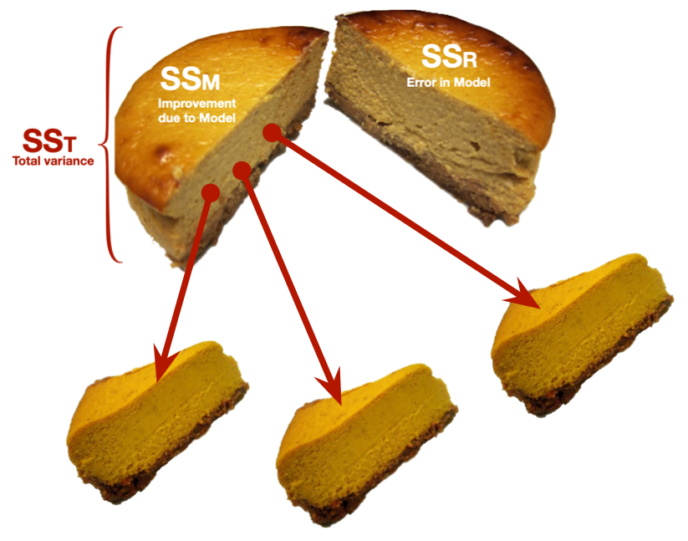

Slide 22: Choosing contrasts
- Independent
  - To control Type I error rates contrasts must be independent (they must test unique hypotheses)
  - If a group is singled out in a contrast, then that group should not be used in any subsequent contrasts
- Only 2 Chunks
  - Each contrast should compare only 2 chunks of variation (why?)
- K-1
  - You should always end up with one less contrast than the number of groups

Slide 23: How do I choose contrasts?
Note: Statis-tip
- Most experimental designs typically have one or more control groups
- The logic of control groups means that we expect scores within them to differ from those in the groups we’ve manipulated
- The first contrast will usually compare any control conditions (chunk 1) with any experimental ones (chunk 2)

Slide 24
Video clip: milton slideshow

Slide 25: Hypotheses
Caution: Think about it!
Hypothesis 1:
- People who have puppy therapy will be happier (have have higher happiness scores) than those who don’t
- Control $≠$ (15 mins, 30 mins)
Caution: Think about it!
Hypothesis 2:
- People receiving a high dose of puppy therapy (30 mins) will be happier than those receiving a low dose (15 mins)
- 15 mins $≠$ 30 mins

Slide 26
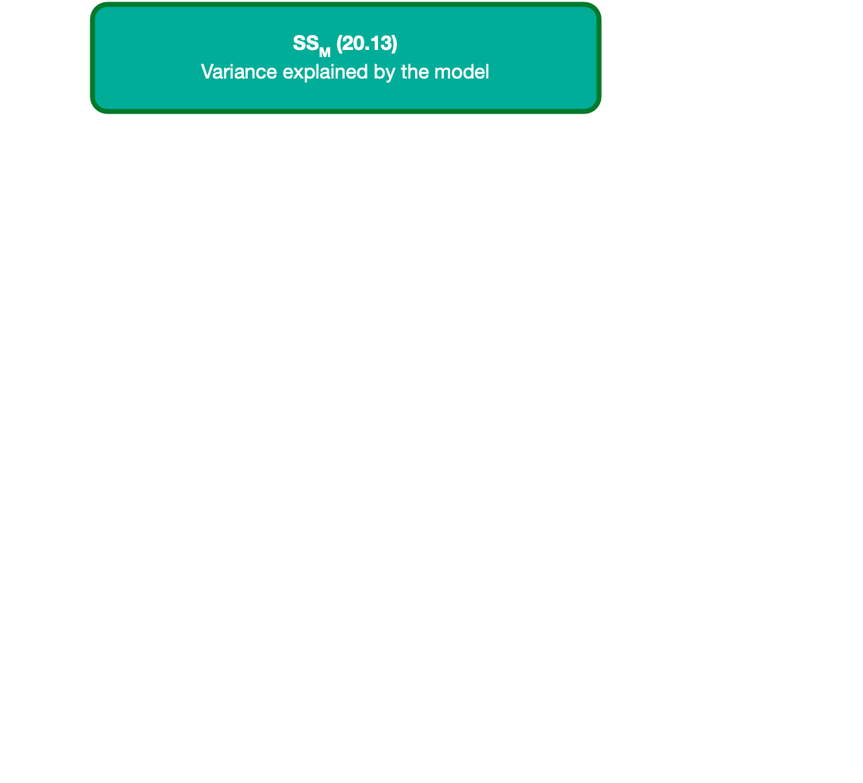

Slide 27
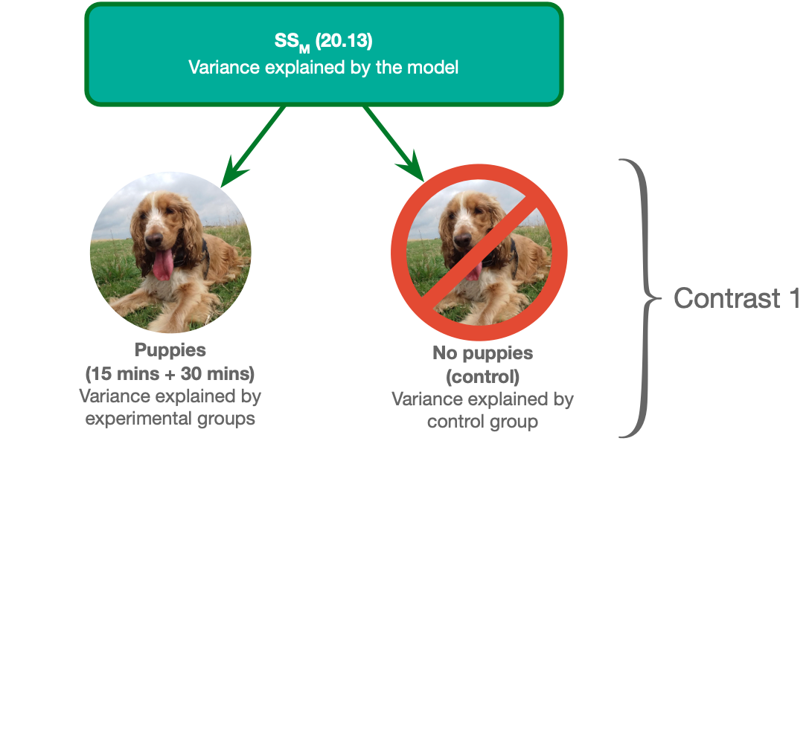

Slide 28
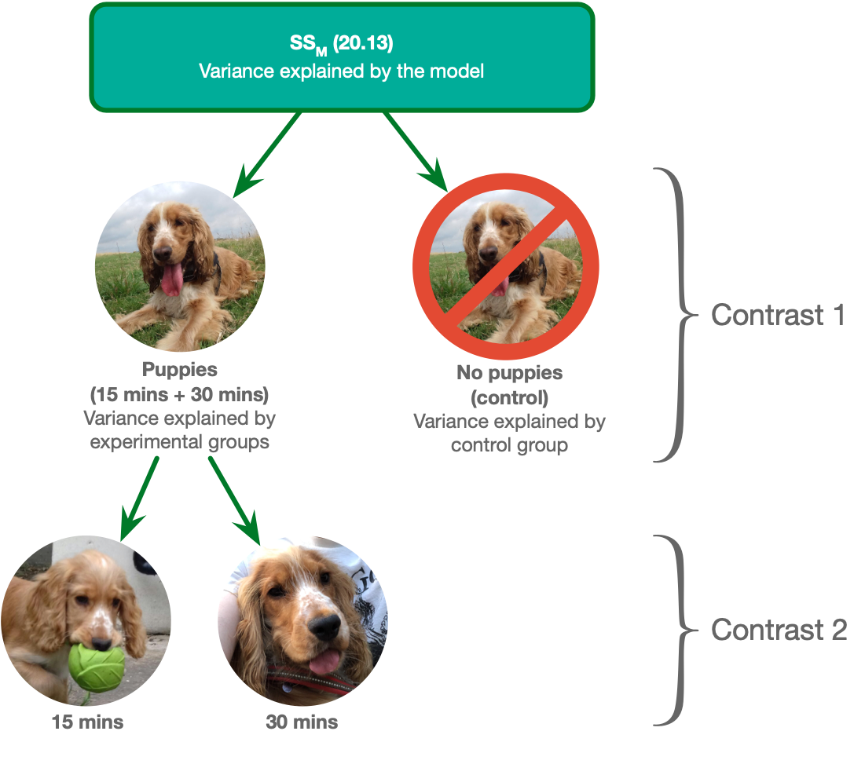

Slide 29

Slide 30

Slide 31

Slide 32

Slide 33

Slide 34

Slide 35

Slide 36

Slide 37: Coding planned contrasts
- Rule 1
  - Groups coded with positive weights compared to groups coded with negative weights
- Rule 2
  - The sum of weights for a comparison should be zero
- Rule 3
  - If a group is not involved in a comparison, assign it a weight of zero
- Rule 4
  - For a given contrast, the initial weight assigned to the group(s) in one chunk of variation should be equal to the number of groups in the opposite chunk of variation
- Rule 5
  - To get the final weight, divide the initial weights by the number of groups with non-zero weights

Slide 38

Slide 39

Slide 40

Slide 41

Slide 42

Slide 43

Slide 44

Slide 45

Slide 46

Slide 47

Slide 48
Video clip: lazinc durt your time will come

Slide 49: What the coding does


Dummy coding
Therapy group | Long (30 mins vs. no puppies) | Short 1 (15 mins vs. no puppies)
No Puppies | 0 | 0
15 mins | 0 | 1
30 mins | 1 | 0

Contrast coding
Therapy group | Contrast 1 (Puppies vs. no puppies) | Contrast 2 (15 mins vs. 30 mins)
No Puppies | -2/3 | 0
15 mins | 1/3 | -1/2
30 mins | 1/3 | 1/2

Slide 50


The ‘dummy’ model
$$\begin{aligned}{\hat{\text{Happiness}}}_{i}&={\hat{b}}_{0}+{\hat{b}}_{1}{\text{Long}}_{i}+{\hat{b}}_{2}{\text{Short}}_{i} \\ {\hat{\text{Happiness}}}_{i}&={\hat{b}}_{0}+{\hat{b}}_{1}{\text{30 vs. control}}_{i}+{\hat{b}}_{2}{\text{15 vs.control}}_{i} \\ \end{aligned}$$

The ‘contrast’ model
$$\begin{aligned}{\hat{\text{Happiness}}}_{i}&={\hat{b}}_{0}+{\hat{b}}_{1}{\text{Contrast 1}}_{i}+{\hat{b}}_{2}{\text{Contrast 2}}_{i} \\ {\hat{\text{Happiness}}}_{i}&={\hat{b}}_{0}+{\hat{b}}_{1}{\text{Therapy vs. control}}_{i}+{\hat{b}}_{2}{\text{15 vs. 30 mins}}_{i} \\ \end{aligned}$$

Slide 51: Visualize the ‘dummy’ model

Slide 52: Visualize the ‘dummy’ model

Slide 53: Visualize the ‘dummy’ model

Slide 54: Visualize the contrast model
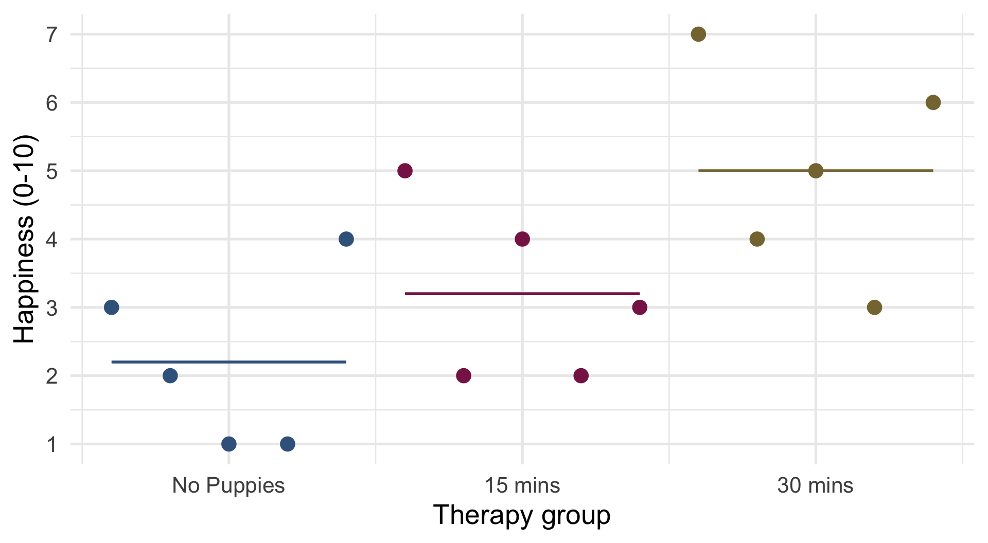

Slide 55: Visualize contrast 1
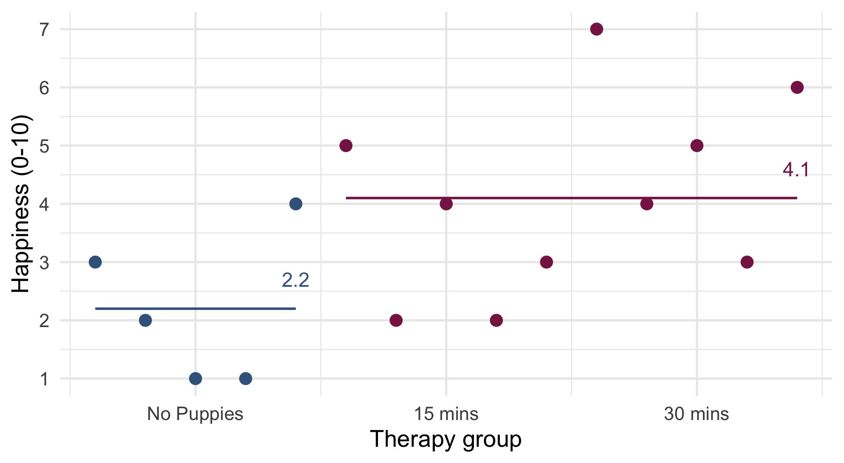

Slide 56: Visualize contrast 1
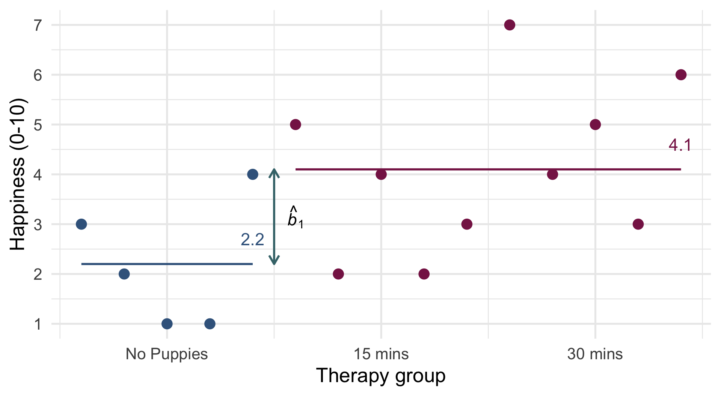
$$\begin{aligned}{\hat{b}}_{1}&=4.1−2.2=1.9\end{aligned}$$

Slide 57: Visualize contrast 2
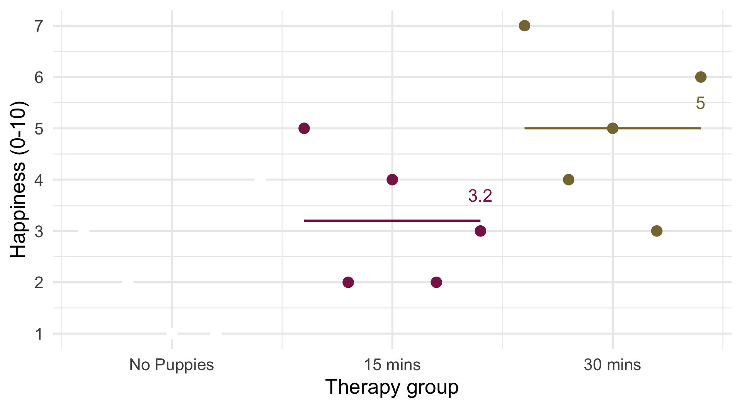

Slide 58: Visualize contrast 2
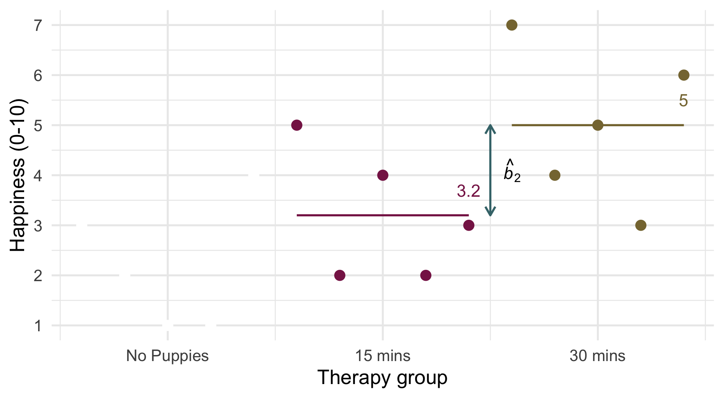
$$\begin{aligned}{\hat{b}}_{2}&=5−3.2=1.8\end{aligned}$$

Slide 59: Evaluate
Note: Statis-tip
- Changing the contrast codes will not affect the fit statistics or residual plots.

Slide 60: Interpret parameter estimates, CIs and tests
puppy_vs_none <- c(-2/3, 1/3, 1/3)
long_vs_short <- c(0, -1/2, 1/2)
contrasts(puppy_tib$dose) <- cbind(puppy_vs_none, long_vs_short)
puppy_lm <- lm(happiness ~ dose, data = puppy_tib)
model_parameters(puppy_lm) |>
display()
Parameter | Coefficient | SE | 95% CI | t(12) | p
(Intercept) | 3.47 | 0.36 | (2.68, 4.26) | 9.57 | < .001
dose (puppy_vs_none) | 1.90 | 0.77 | (0.23, 3.57) | 2.47 | 0.029
dose (long_vs_short) | 1.80 | 0.89 | (-0.13, 3.73) | 2.03 | 0.065
Important: ReportR
Overall, happiness was significantly different across the three therapy groups, F(2, 12) = 5.12, p = 0.025, ${\hat{ω}}^{2}$ = 0.35 (0.00, 1.00). Happiness was significantly different to zero in the no puppies group, $\hat{b}$ = 3.47 (2.68, 4.26), t(12) = 9.57, p < 0.001. Happiness was significantly higher for those that had any puppy therapy compared to the no puppy control, $\hat{b}$ = 1.90 (0.23, 3.57), t(12) = 2.47, p = 0.029, but was not significantly different in the 30-minute therapy group compared to the 15-minute group, $\hat{b}$ = 1.80 (-0.13, 3.73), t(12) = 2.03, p = 0.065. A dose of puppies, therefore, appears to improve happiness compared to no puppies but the duration of therapy did not have a significant impact.

Slide 61
Video clip: milton insert snow

Slide 62: Post hoc tests
- In the absence of specific hypotheses
  - Compare all pairs of means to see where the specific differences lie
- Problem
  - Inflates the Type I error rate
$$\begin{matrix}\text{Familywise error}=1−{0.95}^{n}\end{matrix}$$
- Solution
  - Adjust the alpha (or test statistic) to be more conservative
$$\begin{matrix}\text{Bonferroni} α=\frac{α}{\text{number of tests}}\end{matrix}$$

Slide 63: Post hoc tests
estimate_contrasts(puppy_lm, p_adjust = "bonferroni") |>
display()
Marginal Contrasts Analysis
Level1 | Level2 | Difference | SE | 95% CI | t(12) | p
15 mins | No puppies | 1.00 | 0.89 | (-0.93, 2.93) | 1.13 | 0.845
30 mins | No puppies | 2.80 | 0.89 | ( 0.87, 4.73) | 3.16 | 0.025
30 mins | 15 mins | 1.80 | 0.89 | (-0.13, 3.73) | 2.03 | 0.196

Slide 64: Trend analysis (Polynomial contrasts)
- Test for trends in the means
- Makes sense only for ordered groups
contrasts(puppy_tib$dose) <- contr.poly(3)
puppy_trend <- lm(happiness ~ dose, data = puppy_tib)
model_parameters(puppy_trend) |>
display()
Parameter | Coefficient | SE | 95% CI | t(12) | p
(Intercept) | 3.47 | 0.36 | (2.68, 4.26) | 9.57 | < .001
dose (.L) | 1.98 | 0.63 | (0.61, 3.35) | 3.16 | 0.008
dose (.Q) | 0.33 | 0.63 | (-1.04, 1.69) | 0.52 | 0.612
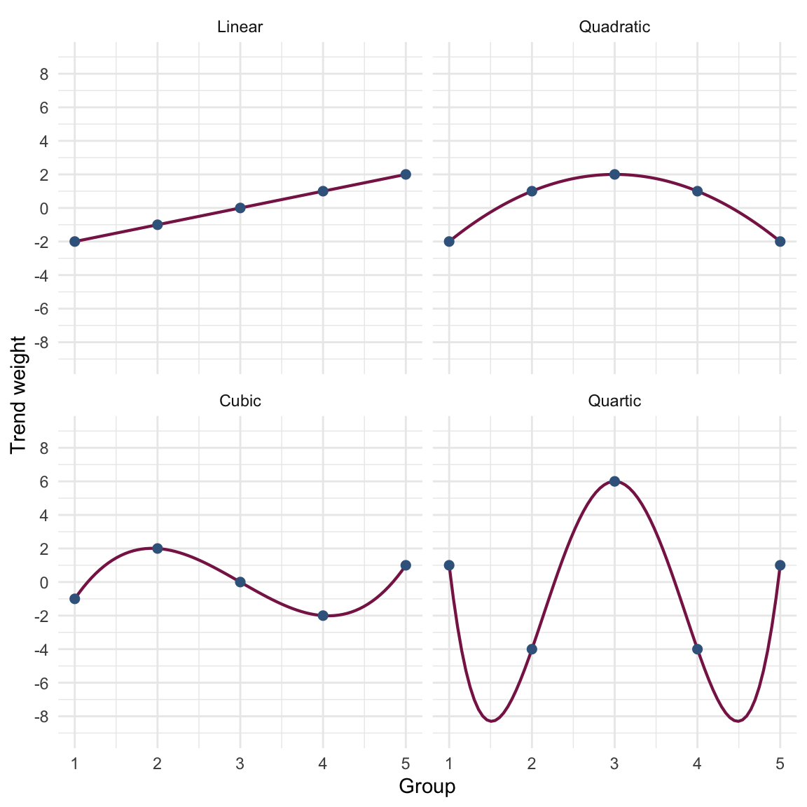

Slide 65: Summary
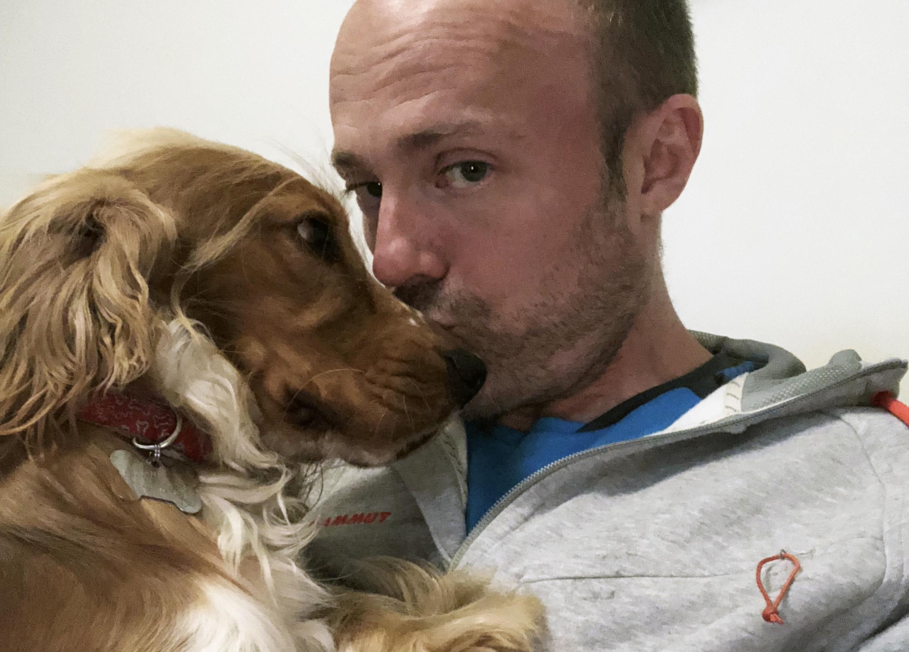
- Categorical predictors can be coded to test specific a priori hypotheses
- First devise contrasts to test your hypotheses
  - Independent
  - K-1 contrasts
  - Each compares 2 ‘chunks’ -Assign ‘weights’ to each group within each contrast
  - Assign 1 chunk positive values and the other negative
  - Assign an initial weight equal to the number of conditions in the opposite chunk
  - Divide the initial weight by the number of groups with non-zero weights
- Post hoc tests
  - Compare all pairs of group means but adjusting for multiple tests
- Polynomial contrasts (trend analysis)
  - Test for trends in the means of ordered categories

