Comparing means adjusted for other predictors
including Analysis of Covariance
Professor Andy Field, University of Sussex
Links: primus too many puppies | bsky.app | youtube.com | discoveringstatistics.com | discovr.rocks | statisticsadventure.com

About this version
This is a plain-text version of the lecture slides. Each slide starts with a heading such as “Slide 5”, and the numbers match the slide numbers shown in the lecture. Content that appeared one piece at a time, in columns or in tabs is shown in reading order. Videos and interactive apps are given as links.

Slide 2: Learning outcomes
- Describe the non-parallel slopes model
- Describe the parallel slopes model
- Explain how to compare means adjusting for other predictors using a linear model
  - Linear model with a categorical and continuous predictor
  - a.k.a. analysis of covariance (ANCOVA)
- Type I vs. Type III sums of squares
- Interpreting the model
  - Main effects
  - Covariates

Slide 3
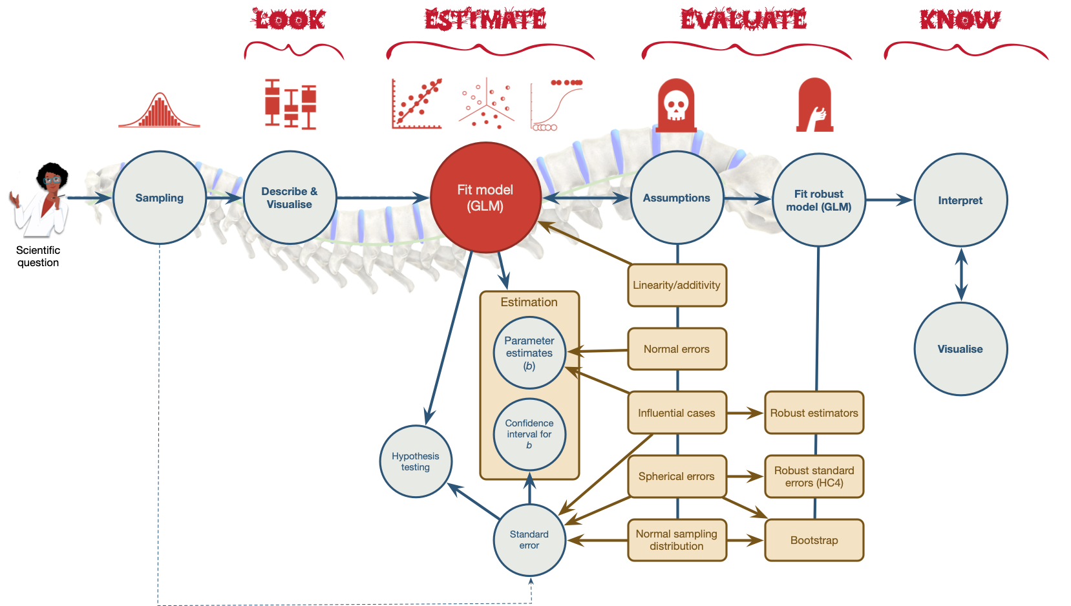
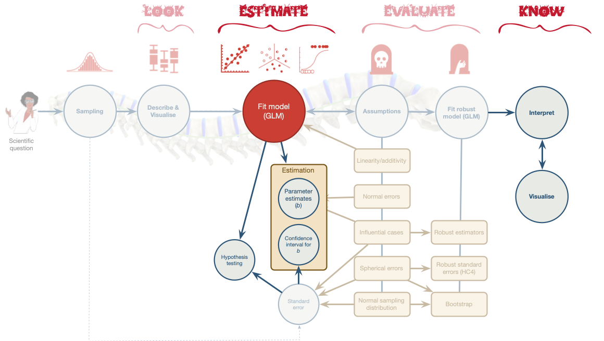

Slide 4: Extending the puppy example
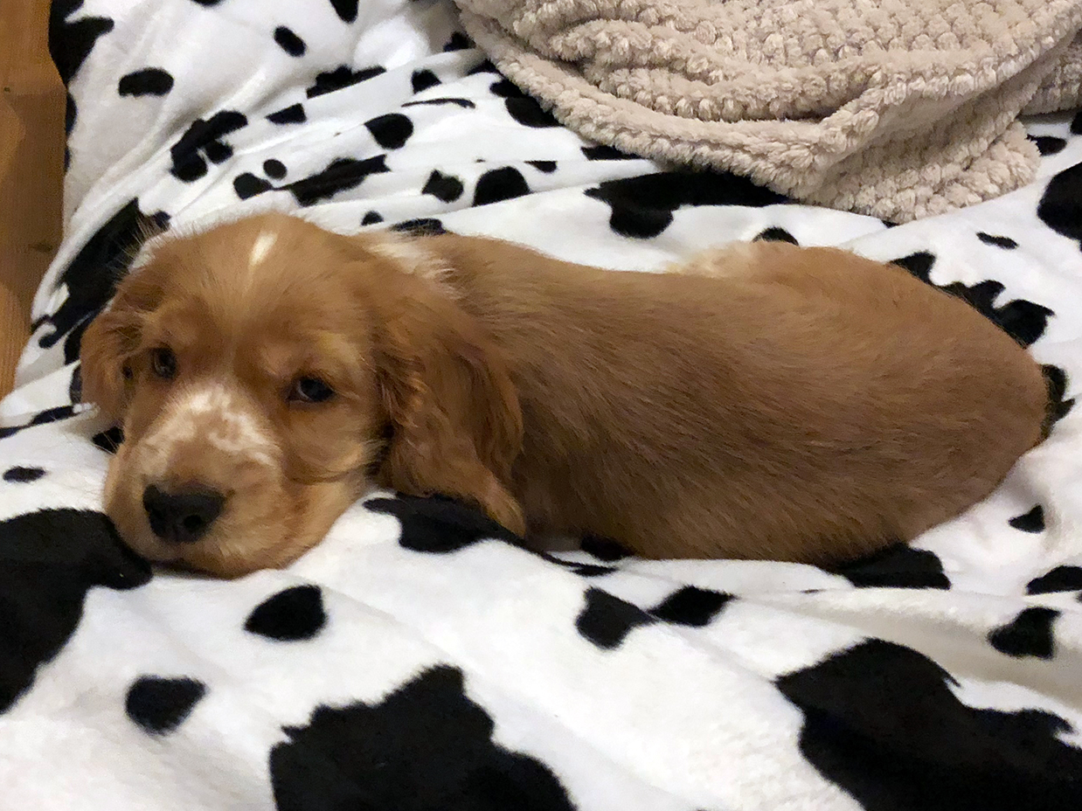
- A puppy therapy RCT
  - A no puppies control group
  - 15 minutes of puppy therapy
  - 30 minutes of puppy therapy
- Outcome variable
  - Happiness (0 = unhappy to 10 = happy) after (post) treatment
- Continuous predictor
  - Happiness (0 = unhappy to 10 = happy) before (pre) treatment

Slide 5: The data

Table 1: Data for the puppy therapy example
 | id | dose | pre_happy | post_happy
1 | 1dl4x | 15 mins | 2 | 3
2 | nafnu | No puppies | 2 | 2
3 | 213u4 | 15 mins | 3 | 2
4 | 0g144 | 15 mins | 6 | 6
5 | g6216 | 15 mins | 5 | 8
6 | mw911 | No puppies | 2 | 2
7 | ov70d | No puppies | 4 | 3
8 | 8v8y1 | No puppies | 5 | 4
9 | g1mhs | 30 mins | 3 | 5
10 | 2c432 | 15 mins | 6 | 5
11 | 6r4is | 15 mins | 4 | 4
12 | 3v2jl | 15 mins | 3 | 4
13 | 75477 | No puppies | 7 | 7
14 | 8g05h | 30 mins | 2 | 4
15 | 83g9a | 15 mins | 5 | 4
16 | l8sxg | 30 mins | 2 | 4
17 | 1209t | No puppies | 1 | 2
18 | 85y83 | 15 mins | 6 | 2
19 | 06558 | 15 mins | 5 | 7
20 | 94fd8 | No puppies | 5 | 5
21 | 76g3e | No puppies | 4 | 2
22 | 61xkp | 15 mins | 3 | 6
23 | 9gf5g | 30 mins | 4 | 5
24 | miu7f | No puppies | 1 | 2
25 | 2yg6b | 30 mins | 1 | 3
26 | 1jkqm | 15 mins | 1 | 3
27 | 5y5jy | 15 mins | 3 | 4
28 | y1q8f | 30 mins | 2 | 4
29 | 6ide8 | 30 mins | 6 | 7
30 | o84p7 | 30 mins | 5 | 7

Slide 6: The parallel slopes model
$$\begin{aligned}{\text{happy (post)}}_{i}&={\hat{b}}_{0}+{\hat{b}}_{1}{\text{happy (pre)}}_{i}+e_{i} \\ \end{aligned}$$

Slide 7: The parallel slopes model
The parallel slopes model assumes no combined effect of the predictors.
$$\begin{aligned}{\text{happy (post)}}_{i}&={\hat{b}}_{0}+{\hat{b}}_{1}{\text{happy (pre)}}_{i}+{\hat{b}}_{2}{\text{dose}}_{i}+e_{i} \\ \end{aligned}$$

Slide 8: The parallel slopes model
$$\begin{aligned}{\text{happy (post)}}_{i}&={\hat{b}}_{0}+{\hat{b}}_{1}{\text{happy (pre)}}_{i}+{\hat{b}}_{2}{\text{Contrast 1}}_{i}+{\hat{b}}_{3}{\text{Contrast 2}}_{i}+e_{i} \\ \end{aligned}$$

Slide 9: Contrasts
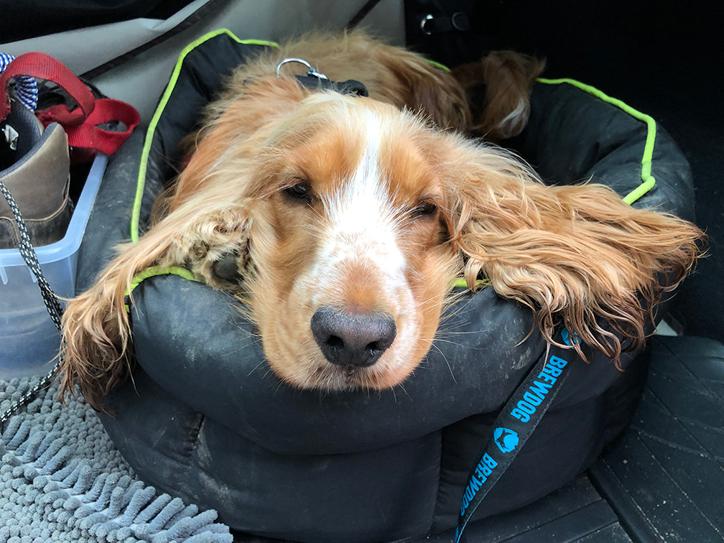
Caution: Think about it!
Hypothesis 1:
- People who have puppy therapy will be happier (have have higher happiness scores) than those who don’t
- Control $≠$ (15 mins, 30 mins)
Caution: Think about it!
Hypothesis 2:
- People receiving a high dose of puppy therapy (30 mins) will be happier than those receiving a low dose (15 mins)
- 15 mins $≠$ 30 mins

Contrast coding
Therapy group | Contrast 1 (Puppies vs. no puppies) | Contrast 2 (15 mins vs. 30 mins)
No Puppies | -2/3 | 0
15 mins | 1/3 | -1/2
30 mins | 1/3 | 1/2

Slide 10: Extending the parallel slopes model
$$\begin{aligned}{\text{happy (post)}}_{i}&={\hat{b}}_{0}+{\hat{b}}_{1}{\text{happy (pre)}}_{i}+{\hat{b}}_{2}{\text{dose}}_{i}+e_{i} \\ \end{aligned}$$

Slide 11: The non-parallel slopes model
Models the combined effect of predictors (interaction)
$$\begin{aligned}{\text{happy (post)}}_{i}= &{\hat{b}}_{0}+{\hat{b}}_{1}{\text{happy (pre)}}_{i}+{\hat{b}}_{2}{\text{dose}}_{i} \\ &+{\hat{b}}_{3}[\text{dose}×\text{happy (pre)}]_{i}+e_{i}\end{aligned}$$

Slide 12: The non-parallel slopes model
$$\begin{aligned}{\text{happy (post)}}_{i}= &{\hat{b}}_{0}+{\hat{b}}_{1}{\text{happy (pre)}}_{i}+{\hat{b}}_{2}{\text{contrast 1}}_{i}+{\hat{b}}_{3}{\text{contrast 2}}_{i} \\ &+{\hat{b}}_{4}[\text{contrast 1}×\text{happy (pre)}]_{i}+ \\ &+{\hat{b}}_{5}[\text{contrast 2}×\text{happy (pre)}]_{i}+e_{i}\end{aligned}$$

Slide 13: What is an interaction?
The effect of one predictor on the outcome changes as a function of another predictor.
- The relationship between pre-therapy happiness and post-therapy happiness is ‘different’ in the different treatment groups (Heterogeneity of regression slopes).
- The relationship between pre-therapy happiness and post-therapy happiness is ‘the same’ in the different treatment groups (Homogeneity of regression slopes).
- Interactions represent the concept of (Moderation) - more on this in factorial designs

Slide 14: Homogeneity of regression slopes (no interaction)

Parallel slopes
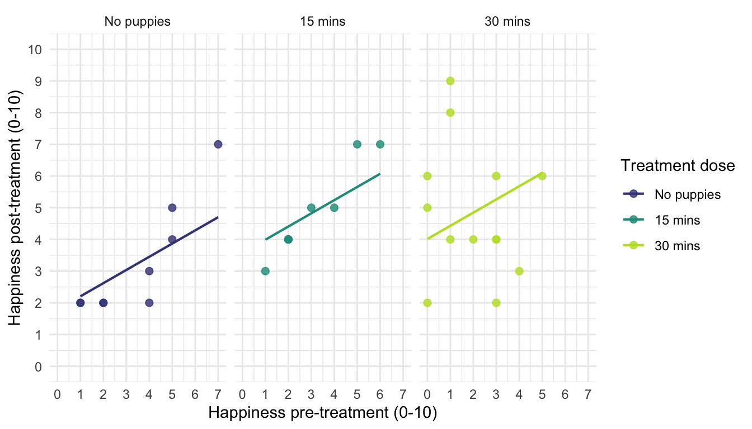

Slide 15: Heterogeneity of regression slopes (interaction)

Non-parallel slopes
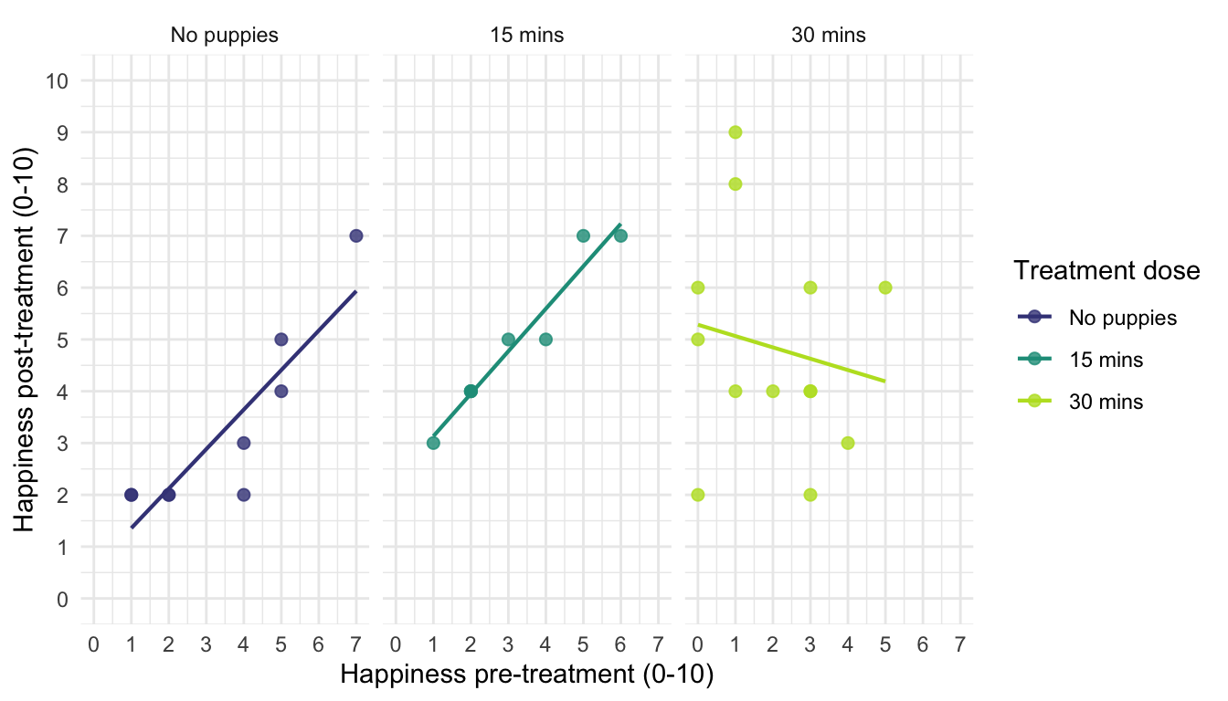

Slide 16
Video clip: milton just as boring

Slide 17 (new section): The non-parallel slopes model
Checking Homogeneity of regression slopes

Slide 18: Overview
Note: Statis-tip
- Use a non-parallel slopes when you predict a combined effect of the categorical and continuous predictor.
- In this case, we’d use it if we believed that the relationship between pre- and post-treatment happiness would be different in the three therapy groups.
- Also for checking homogeneity of regression slopes before a parallel slopes model
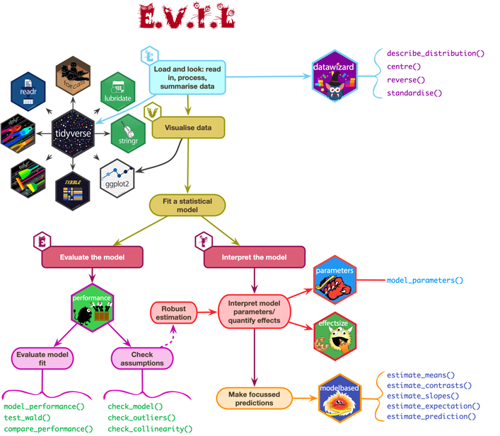

Slide 19: Visualize
ggplot2::ggplot(puptreat_tib, aes(x = pre_happy, y = post_happy)) +
geom_smooth(method = "lm", colour = "#CC6677", fill = "#CC6677", alpha = 0.2) +
geom_point(colour = "#882255") +
coord_cartesian(ylim = c(0, 10), xlim = c(0, 10)) +
scale_x_continuous(breaks = 0:10) +
scale_y_continuous(breaks = 0:10) +
labs(x = "Pre-treatment happiness (0-10)", y = "Post-treatment happiness (0-10)", colour = "Treatment", fill = "Treatment") +
facet_wrap(~dose) +
theme_minimal()
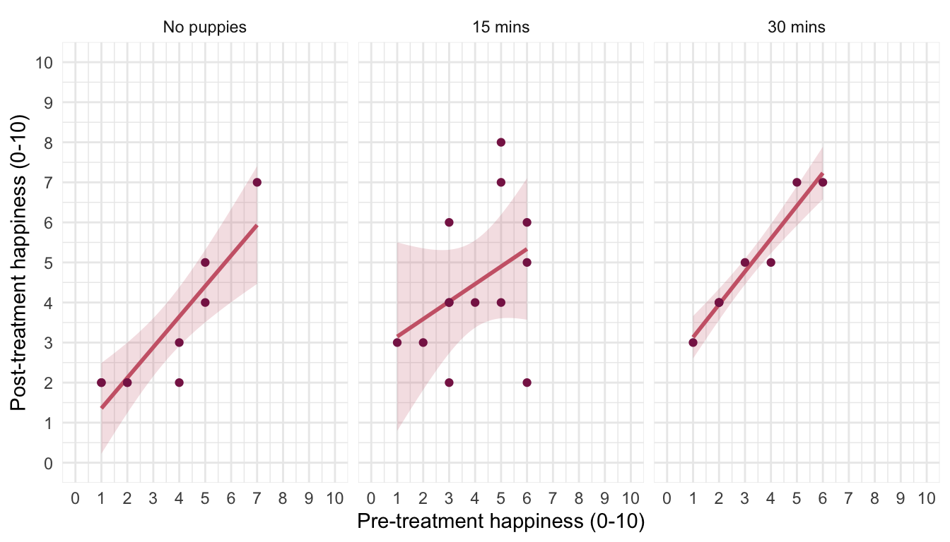


Slide 20: Fit the model

Set contrasts
puppy_vs_none <- c(-2/3, 1/3, 1/3)
long_vs_short <- c(0, -1/2, 1/2)
contrasts(puptreat_tib$dose) <- cbind(puppy_vs_none, long_vs_short)

Fit the model
intcpt_lm <- lm(post_happy ~ 1, data = puptreat_tib)
pre_lm <- lm(post_happy ~ pre_happy, data = puptreat_tib)
dose_lm <- lm(post_happy ~ pre_happy + dose, data = puptreat_tib)
interact_lm <- lm(post_happy ~ pre_happy + dose + dose:pre_happy, data = puptreat_tib)
test_wald(intcpt_lm, pre_lm, dose_lm, interact_lm) |>
display()
Name | Model | df | df_diff | F | p
intcpt_lm | lm | 29
pre_lm | lm | 28 | 1 | 20.86 | < .001
dose_lm | lm | 26 | 2 | 4.22 | 0.027
interact_lm | lm | 24 | 2 | 0.72 | 0.498
The interaction is not significant so a parallel slopes model seems reasonable

Slide 21 (new section): The parallel slopes model (ANCOVA)

Slide 22: Overview

Generally
Note: Statis-tip
- To test for differences between group means when we know that an extraneous variable affects the outcome variable
- Used to adjust the means for extraneous and confounding variables

In experimental research (ANCOVA)
Note: Statis-tip
- Reduce error variance (sometimes)
  - By explaining some of the unexplained variance (SS_{R}) the error variance in the model can be reduced
- Greater experimental control
  - By adjusting for known confounds, we can gain greater insight into the effect of the predictor variable(s)

Slide 23: Partitioning variance

Slide 24: Partitioning variance: ideal

Slide 25: Partitioning variance: reality

Slide 26: Independence of the covariate
Note: Statis-tip
- If, and only if, you care about reducing error variance you should test that the covariate and categorical predictor are ‘independent’
- In this case, does treatment group (dose) predict pre-treatment happiness (pre_happy)
pre_lm <- lm(pre_happy ~ dose, data = puptreat_tib)
test_wald(pre_lm) |>
display()
Name | Model | df | df_diff | F | p
Null model | lm | 29
Full model | lm | 27 | 2 | 0.64 | 0.537

Slide 27
Video clip: milton even prettier as a puppy

Slide 28: The model

$$\begin{aligned}{\text{happy (post)}}_{i}&={\hat{b}}_{0}+{\hat{b}}_{1}{\text{happy (pre)}}_{i}+{\hat{b}}_{2}{\text{Contrast 1}}_{i}+{\hat{b}}_{3}{\text{Contrast 2}}_{i}+e_{i} \\ {\text{happy (post)}}_{i}&={\hat{b}}_{0}+{\hat{b}}_{1}{\text{happy (pre)}}_{i}+{\hat{b}}_{2}{\left(\text{puppies vs. none}\right)}_{i}+ \\ & {\hat{b}}_{3}{\left(\text{30 vs 15 minutes}\right)}_{i}+e_{i} \\ \end{aligned}$$

Slide 29: Load and Look

Overall summary
puptreat_tib |>
describe_distribution(select = pre_happy) |>
data_remove(c(Skewness, Kurtosis, n_Missing)) |>
display()
Variable | Mean | SD | IQR | Range | n
pre_happy | 3.60 | 1.77 | 3 | (1.00, 7.00) | 30
puptreat_tib |>
describe_distribution(select = post_happy) |>
data_remove(c(Skewness, Kurtosis, n_Missing)) |>
display()
Variable | Mean | SD | IQR | Range | n
post_happy | 4.20 | 1.81 | 2.50 | (2.00, 8.00) | 30

Slide 30: Load and Look

By group
puptreat_tib |>
group_by(dose) |>
describe_distribution(select = pre_happy) |>
data_remove(c(Skewness, Kurtosis, n_Missing)) |>
display()
dose | Variable | Mean | SD | IQR | Range | n
No puppies | pre_happy | 3.44 | 2.07 | 3.50 | (1.00, 7.00) | 9
15 mins | pre_happy | 4.00 | 1.63 | 2.50 | (1.00, 6.00) | 13
30 mins | pre_happy | 3.12 | 1.73 | 2.75 | (1.00, 6.00) | 8
puptreat_tib |>
group_by(dose) |>
describe_distribution(select = post_happy) |>
data_remove(c(Skewness, Kurtosis, n_Missing)) |>
display()
dose | Variable | Mean | SD | IQR | Range | n
No puppies | post_happy | 3.22 | 1.79 | 2.50 | (2.00, 7.00) | 9
15 mins | post_happy | 4.46 | 1.85 | 3.00 | (2.00, 8.00) | 13
30 mins | post_happy | 4.88 | 1.46 | 2.50 | (3.00, 7.00) | 8

Slide 31: Visualize
ggplot(puptreat_tib, aes(x = dose, y = post_happy, colour = dose)) +
geom_point(position = position_jitter(width = 0.1), alpha = 0.6) +
geom_violin(alpha = 0.2) +
stat_summary(fun.data = "mean_cl_normal", geom = "pointrange", position = position_dodge(width = 0.9)) +
coord_cartesian(ylim = c(0, 10)) +
scale_y_continuous(breaks = 0:10) +
scale_colour_viridis_d(begin = 0.3, end = 0.8) +
labs(x = "Puppy therapy group", y = "Post-therapy happiness (0-10)", colour = "Puppy therapy group") +
theme_minimal() +
theme(legend.position = "none")
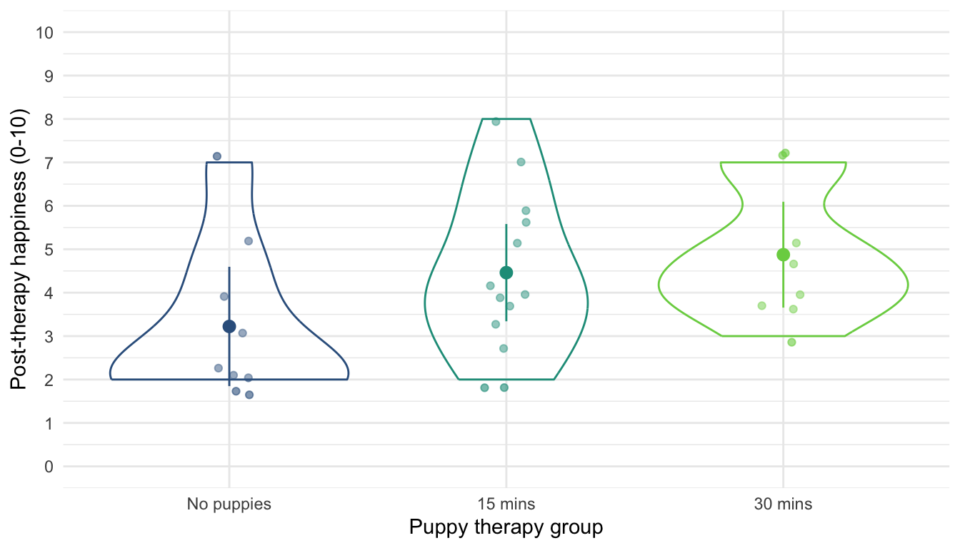

Slide 32: Fit the model


Set contrasts
puppy_vs_none <- c(-2/3, 1/3, 1/3)
long_vs_short <- c(0, -1/2, 1/2)
contrasts(puptreat_tib$dose) <- cbind(puppy_vs_none, long_vs_short)

Fit the model
puptreat_lm <- lm(post_happy ~ pre_happy + dose, data = puptreat_tib)

Slide 33: Evaluate

The F-statistic with multiple predictors
- The F-statistic is calculated using sums of squares
- Type I (sequential)
  - The default in R
  - Each predictor is evaluated taking account of previous predictors
  - The order of predictors matters!
- Type III
  - Each predictor is evaluated taking account of all other predictors
  - The order of predictors doesn’t matter
Note: Statis-tip
- When we want to evaluate individual predictors simultaneously using an F-statistic, we must:
  - Set orthogonal contrasts
  - Use Type III sums of squares
- We use car::Anova(mod = my_model, type = 3) rather than test_wald()


Slide 34: Evaluate fit
car::Anova(mod = puptreat_lm, type = 3) |>
model_parameters(es_type = "omega") |>
display(use_symbols = TRUE)
Parameter | Sum_Squares | df | Mean_Square | F | p | ω² (partial)
pre_happy | 37.61 | 1 | 37.61 | 22.20 | < .001 | 0.41
dose | 14.62 | 2 | 7.31 | 4.32 | 0.024 | 0.18
Residuals | 44.05 | 26 | 1.69
Anova Table (Type 3 tests)
Important: ReportR
Pre-treatment happiness significantly predicted post-treatment happiness, F(1, 26) = 22.20, p < 0.001, ${\hat{ω}}_{p}^{2}$ = 0.41
The dose of puppy therapy had a significant effect on happiness, F(2, 26) = 4.32, p = 0.024, ${\hat{ω}}_{p}^{2}$ = 0.18.

Slide 35: Evaluate assumptions
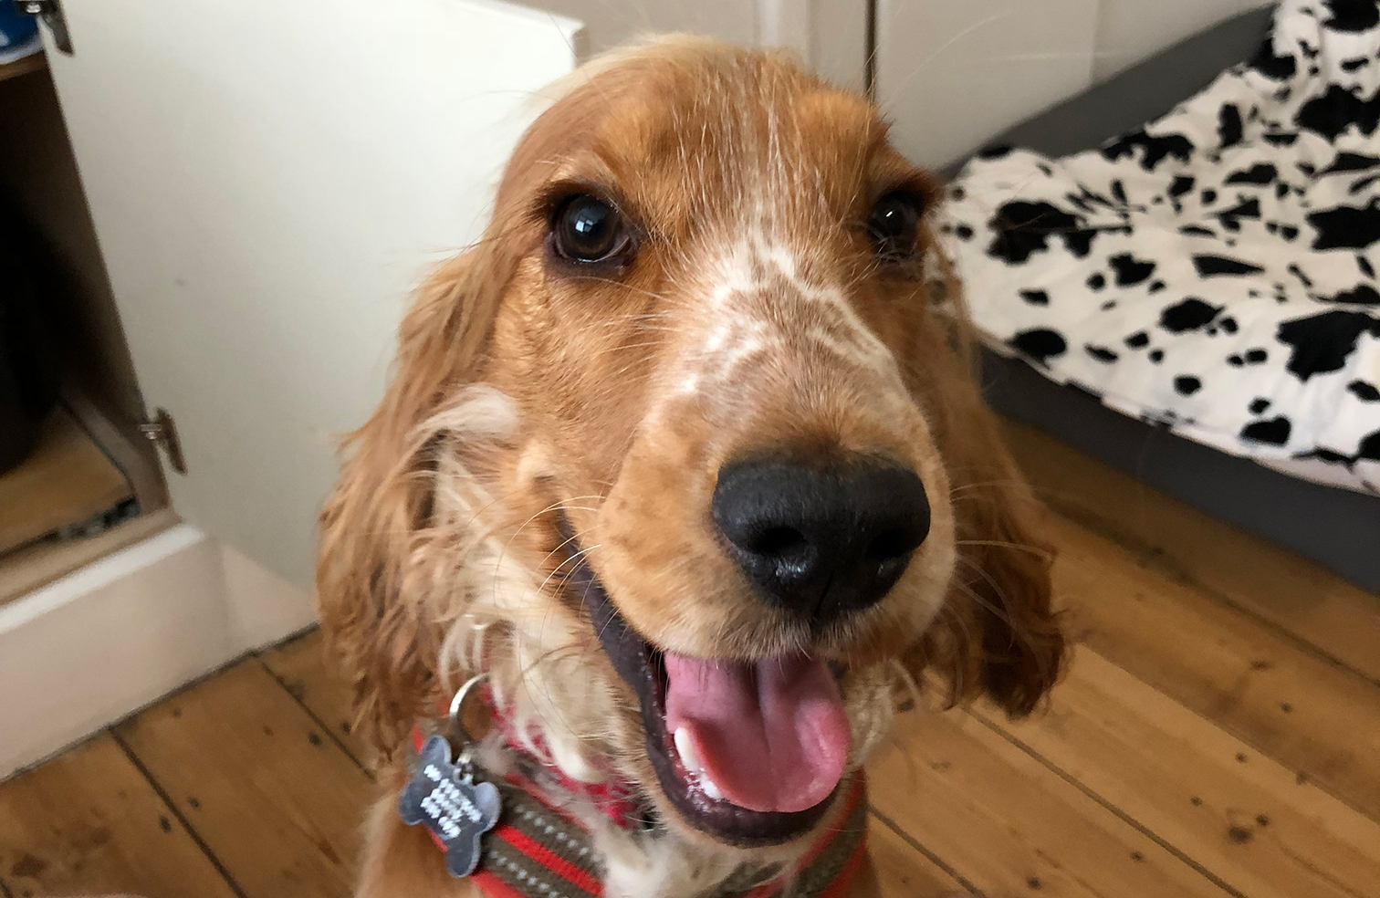
check_model(puptreat_lm)
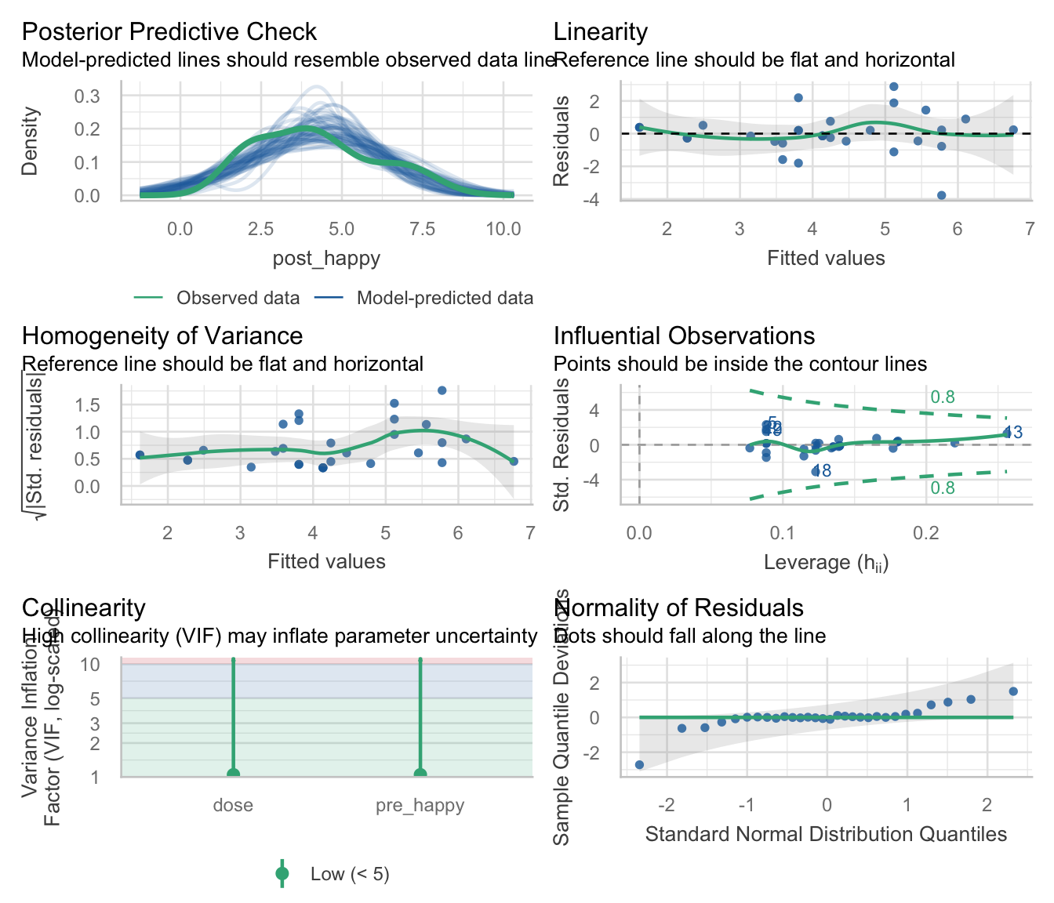

Slide 36: Robust procedures
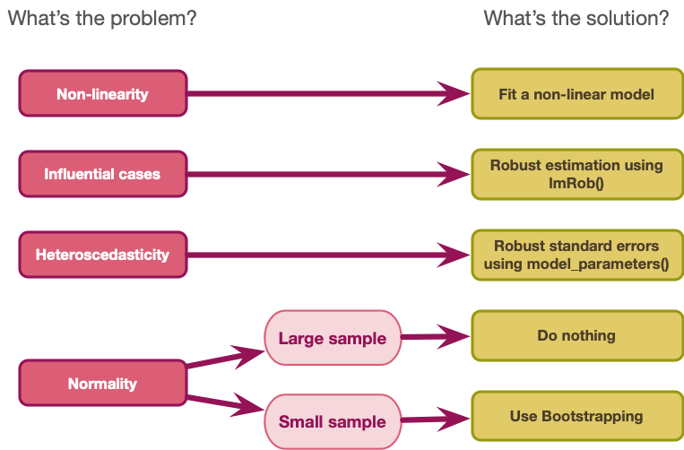

Slide 37
Video clip: milton tickly tummy

Slide 38: Interpret parameter estimates, CIs and tests
model_parameters(puptreat_lm, vcov = "HC4") |>
display()
Parameter | Coefficient | SE | 95% CI | t(26) | p
(Intercept) | 1.87 | 0.40 | (1.05, 2.69) | 4.69 | < .001
pre happy | 0.66 | 0.14 | (0.37, 0.95) | 4.66 | < .001
dose (puppy_vs_none) | 1.37 | 0.41 | (0.53, 2.21) | 3.35 | 0.002
dose (long_vs_short) | 0.99 | 0.47 | (0.01, 1.96) | 2.09 | 0.047
Caution: Think about it!
- What do we expect the parameter estimates of dose to represent?

Slide 39: Visualize the contrast model
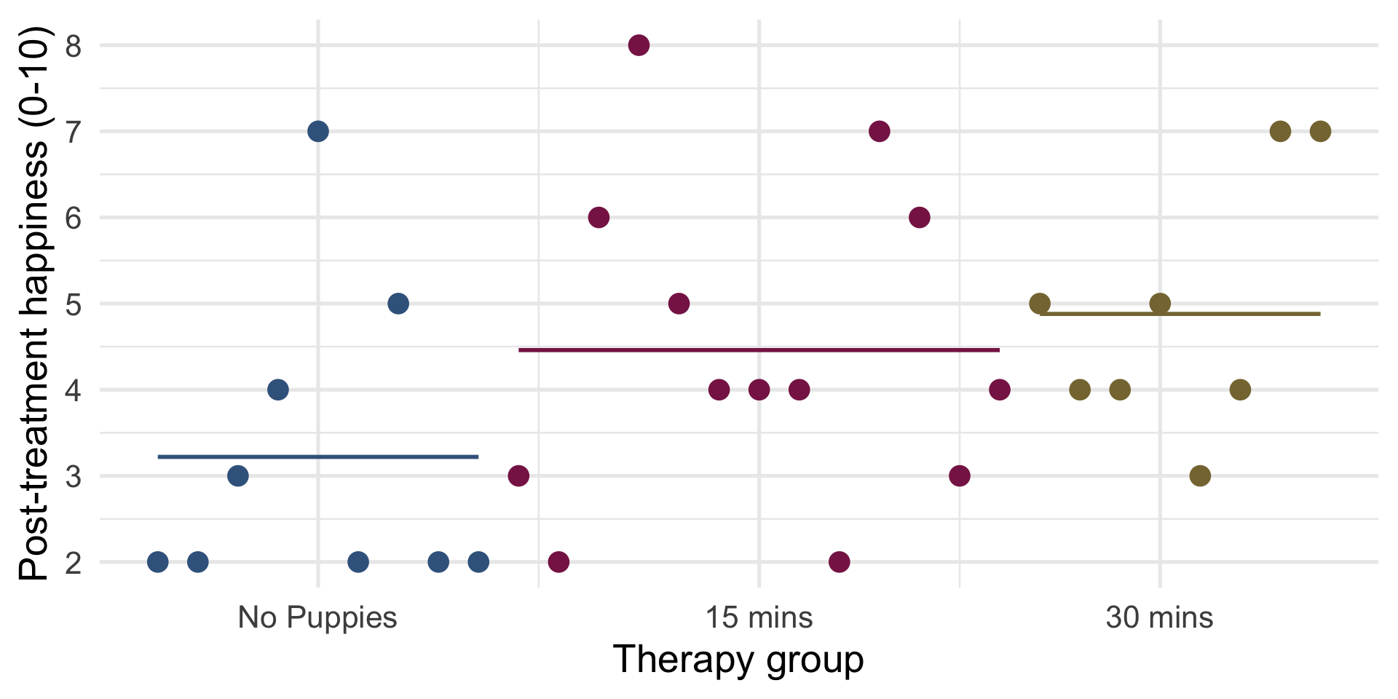

Slide 40: Visualize contrast 1
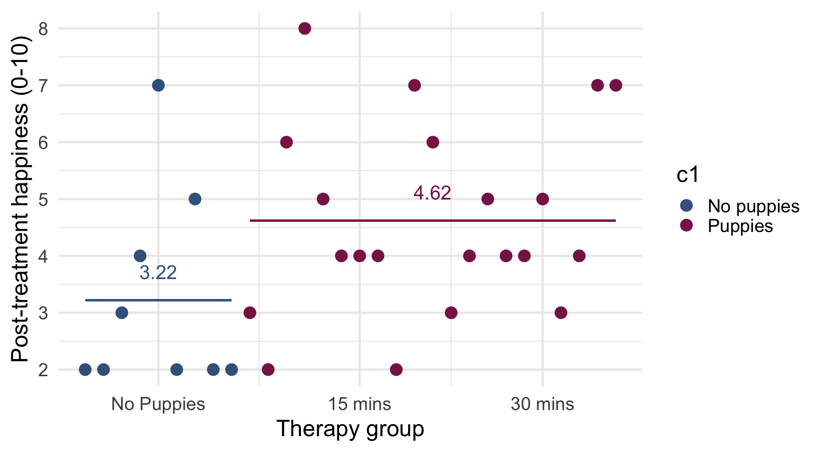

Slide 41: Visualize contrast 1
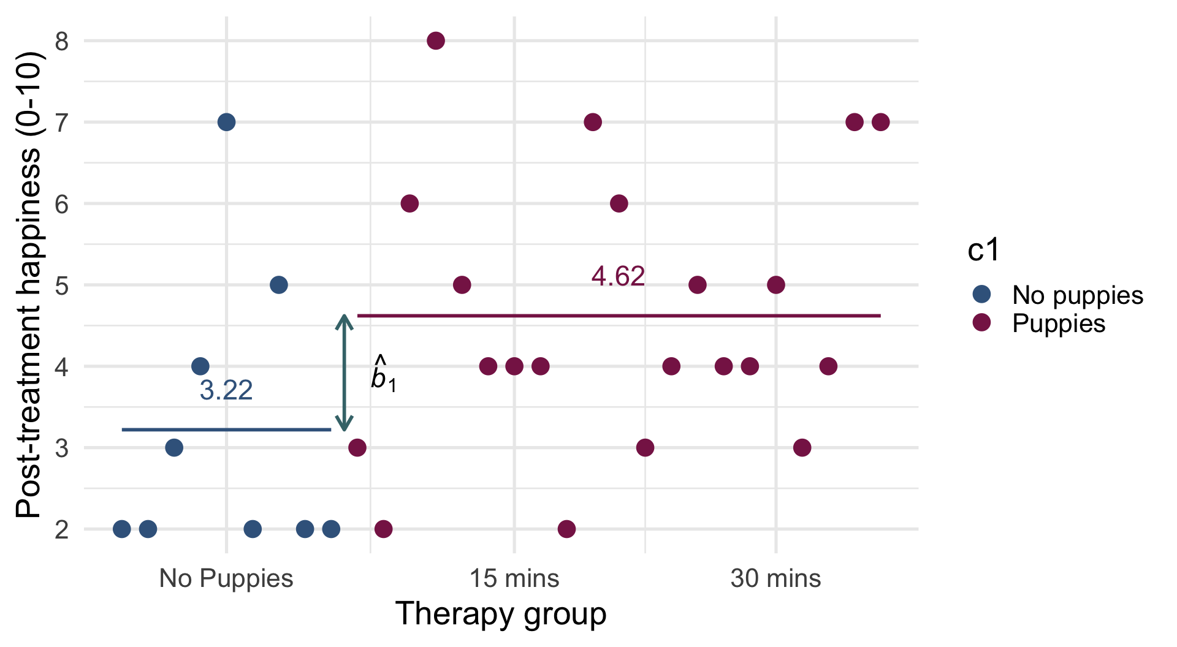
$$\begin{aligned}{\hat{b}}_{1}&=4.62−3.22=1.4\end{aligned}$$

Slide 42: Visualize contrast 2
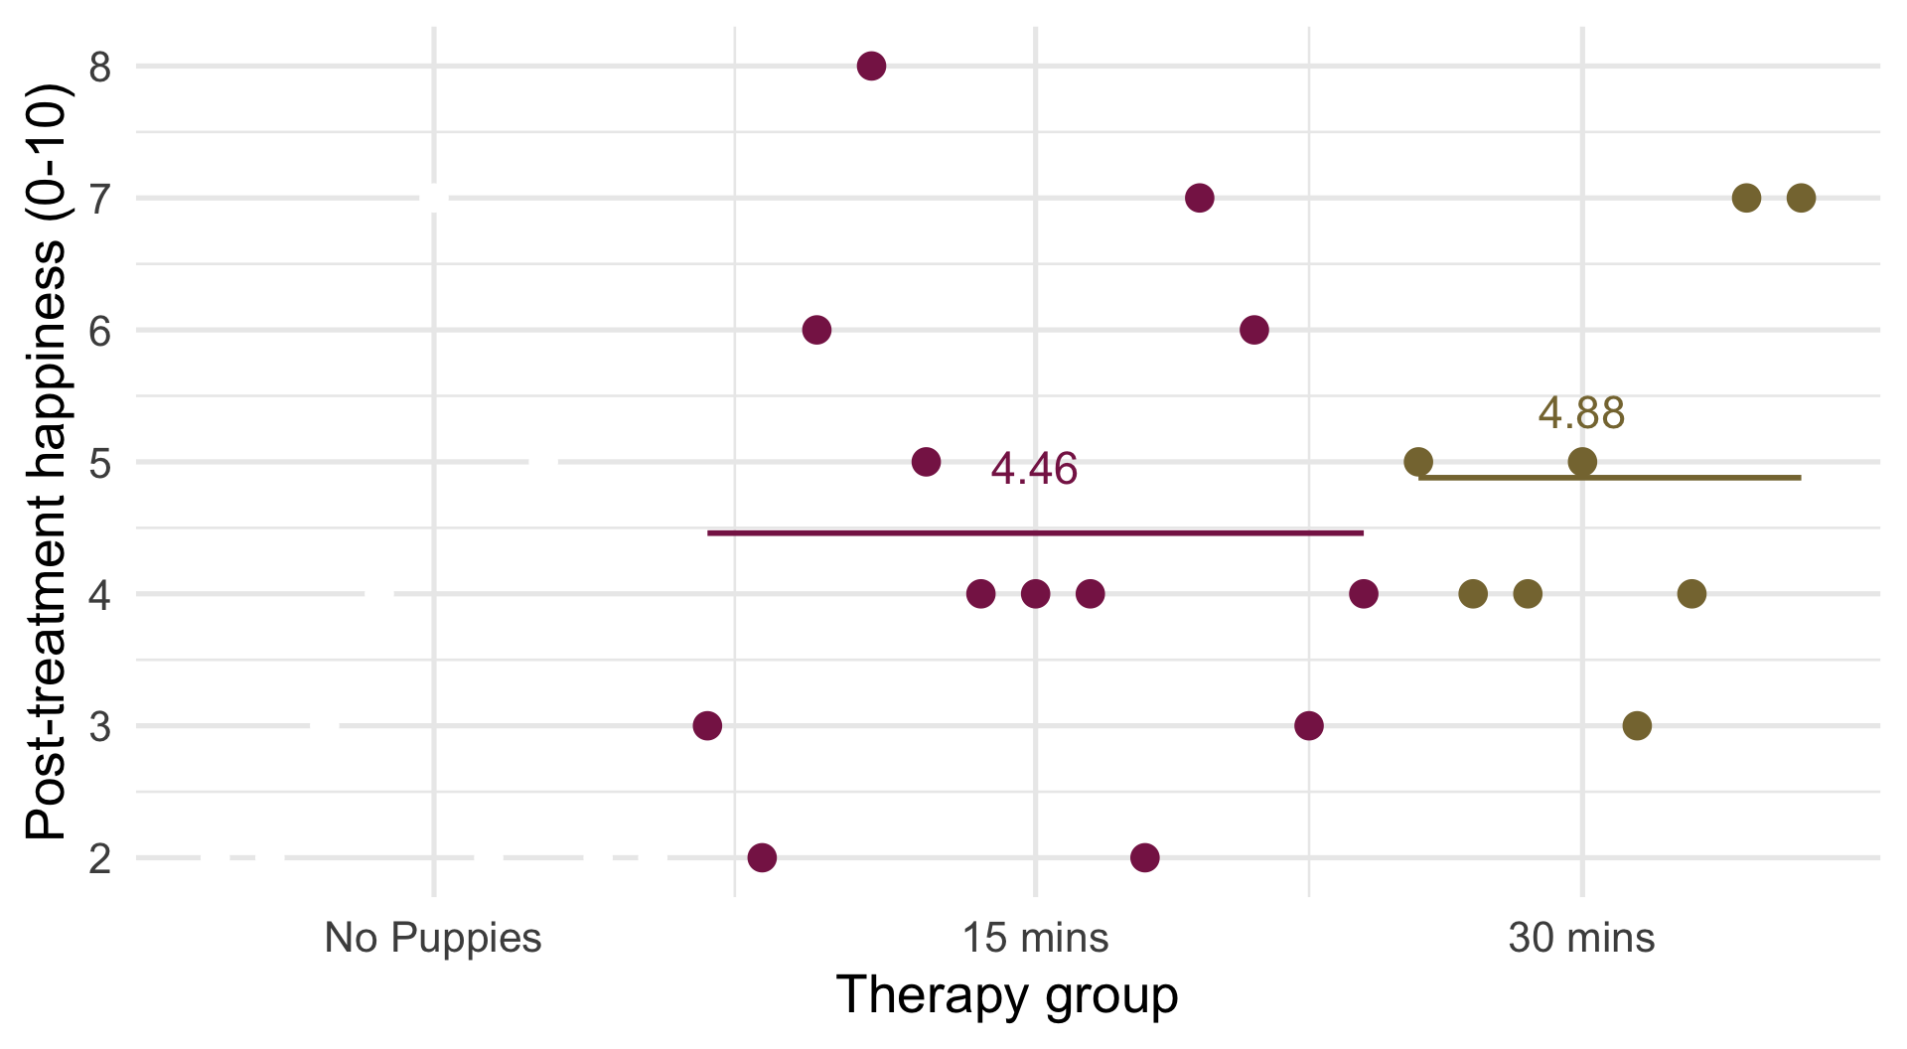

Slide 43: Visualize contrast 2
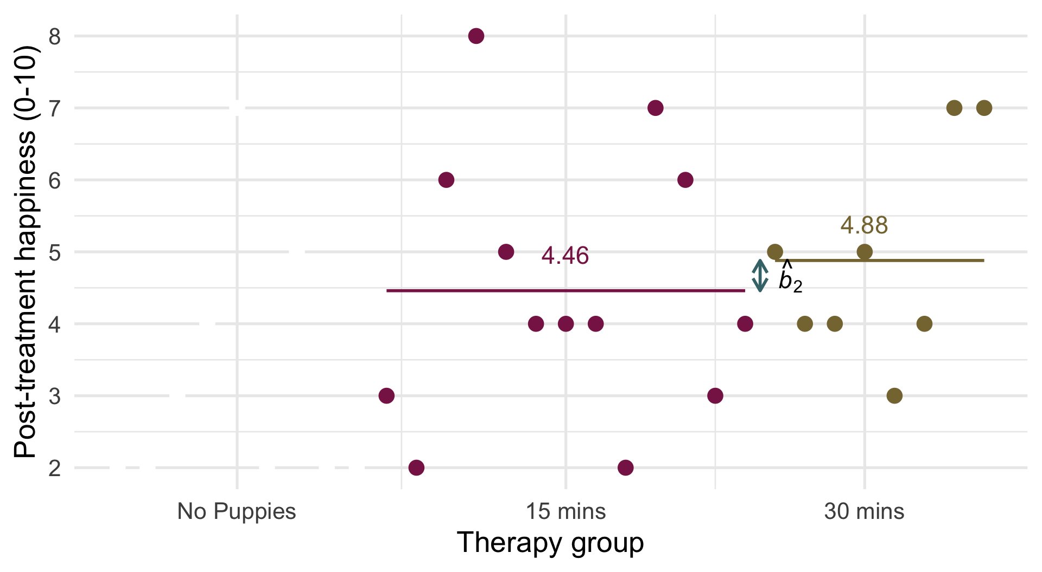
$$\begin{aligned}{\hat{b}}_{2}&=4.88−4.46=0.42\end{aligned}$$

Slide 44: Interpret parameter estimates, CIs and tests
Caution: Think about it!
What do we expect the parameter estimates for dose to represent?
- The difference between the mean of the puppy groups and the no puppy group (${\hat{b}}_{1}=4.62−3.22=1.4$)
- The difference between means in the 30- and 15-minute groups (${\hat{b}}_{2}=4.88−4.46=0.42$)

What do we get?
model_parameters(puptreat_lm, vcov = "HC4") |>
display()
Parameter | Coefficient | SE | 95% CI | t(26) | p
(Intercept) | 1.87 | 0.40 | (1.05, 2.69) | 4.69 | < .001
pre happy | 0.66 | 0.14 | (0.37, 0.95) | 4.66 | < .001
dose (puppy_vs_none) | 1.37 | 0.41 | (0.53, 2.21) | 3.35 | 0.002
dose (long_vs_short) | 0.99 | 0.47 | (0.01, 1.96) | 2.09 | 0.047

Slide 45: Adjusting means
- The parameter estimates represent the differences between means adjusted for the covariate
estimate_means(puptreat_lm, by = c("dose")) |>
display()
Estimated Marginal Means
dose | Mean | SE | 95% CI | t(26)
No puppies | 3.32 | 0.43 | (2.43, 4.22) | 7.65
15 mins | 4.20 | 0.37 | (3.45, 4.95) | 11.49
30 mins | 5.19 | 0.46 | (4.23, 6.14) | 11.16
$$\begin{aligned}{\hat{b}}_{1}&≈\frac{{\overline{X}}_{\text{15 mins}}+{\overline{X}}_{\text{30 mins}}}{2}−{\overline{X}}_{\text{No puppies}} \\ &≈\frac{4.20+5.19}{2}−3.32 \\ &≈4.7−3.32 \\ &≈1.38\end{aligned}$$
$$\begin{aligned}{\hat{b}}_{2}&={\overline{X}}_{\text{30 mins}}−{\overline{X}}_{\text{15 mins}} \\ &=5.19−4.20 \\ &=0.99\end{aligned}$$

Slide 46: Interpret parameter estimates, CIs and tests
model_parameters(puptreat_lm, vcov = "HC4") |>
display()
Parameter | Coefficient | SE | 95% CI | t(26) | p
(Intercept) | 1.87 | 0.40 | (1.05, 2.69) | 4.69 | < .001
pre happy | 0.66 | 0.14 | (0.37, 0.95) | 4.66 | < .001
dose (puppy_vs_none) | 1.37 | 0.41 | (0.53, 2.21) | 3.35 | 0.002
dose (long_vs_short) | 0.99 | 0.47 | (0.01, 1.96) | 2.09 | 0.047
Important: ReportR
Pre-treatment happiness significantly predicted post-treatment happiness, $\hat{b}$ = 0.66 (0.37, 0.95), t(26) = 4.66, p < 0.001. For every unit increase in pre-treatment happiness, predicted (post-treatment) happiness increased by 0.66 units.
The dose of puppy therapy also significantly predicted happiness at average levels of pre-treatment happiness. Compared to no puppy controls, post-treatment happiness was significantly higher after any puppy therapy, $\hat{b}$ = 1.37 (0.53, 2.21), t(26) = 3.35, p = 0.002. Post-treatment happiness was also significantly higher after 30 minutes than after 15 minuted of therapy, $\hat{b}$ = 0.99 (0.01, 1.96), t(26) = 2.09, p = 0.047.

Slide 47: Summary
- When we include both a categorical and continuous predictor, the categorical predictor compares means adjusted for the effect of the continuous predictor.
  - The effect of the categorical variable at average levels of the continuous predictor
- Test the overall effect of categorical predictors using the F-statistic
  - Use Type III sums of squares (other things being equal)
  - Test for homogeneity of regression slopes
- Break down the effects of categorical predictors using parameter estimates and their associated tests
  - Interpret in the same way as in previous lectures
- Test and correct for the usual assumptions in the usual way

