Bayesian Approaches
What are they and why do we need them?
Professor Andy Field, University of Sussex
Links: winterfylleth a careworn heart | bsky.app | youtube.com | discoveringstatistics.com | discovr.rocks | statisticsadventure.com

About this version
This is a plain-text version of the lecture slides. Each slide starts with a heading such as “Slide 5”, and the numbers match the slide numbers shown in the lecture. Content that appeared one piece at a time, in columns or in tabs is shown in reading order. Videos and interactive apps are given as links.

Slide 2: Learning outcomes
Bayes factors
- Articulate the principles of Bayesian approaches
- Define what a Bayes factor represents
Bayesian estimation
- Uninformative priors
- Informatibe priors
- Interpretation

Slide 3
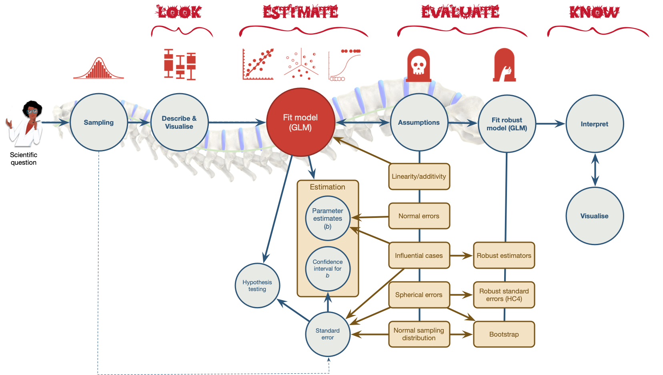
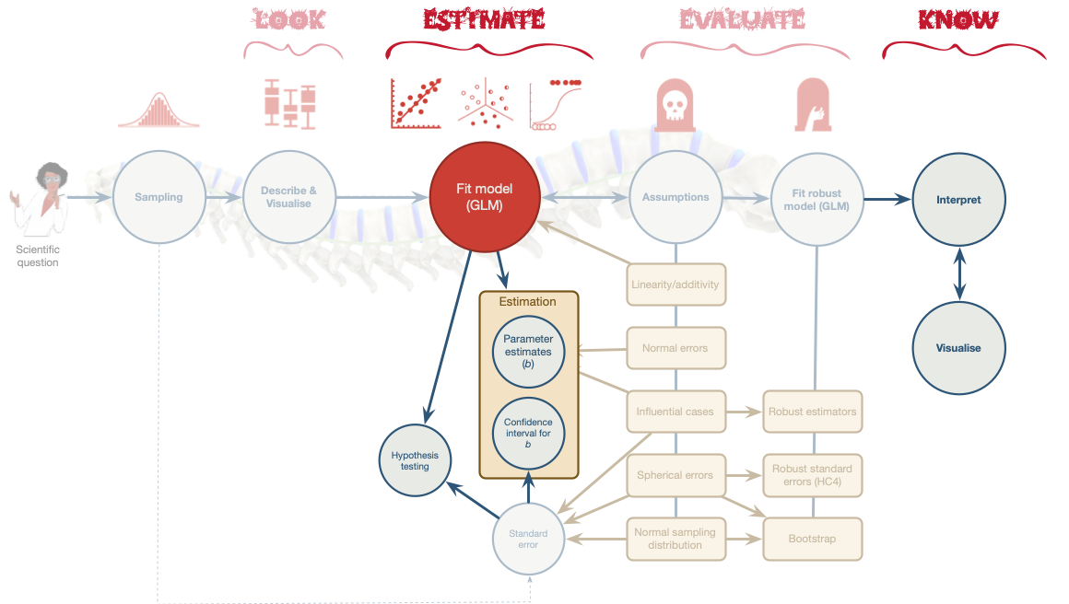

Slide 4: Problems with p – A recap
- Tells us nothing about importance because p depends upon sample size.
- Provides little evidence about the null (or alternative) hypothesis
- Encourages all-or-nothing thinking
- Based on long-run probabilities
  - p is the frequency of the observed test statistic relative to all test statistics from an infinite number of identical experiments with the exact same a priori sample size.
  - The type I error rate is in a given study is either 0 or 1, but we don’t know which.

Slide 5: Effect sizes and p
- Wetzels et al. (2011). Statistical Evidence in Experimental Psychology: An Empirical Comparison Using 855 t-tests. Perspectives on Psychological Science, 6, 291–298. https://doi.org/10.1177/1745691611406923
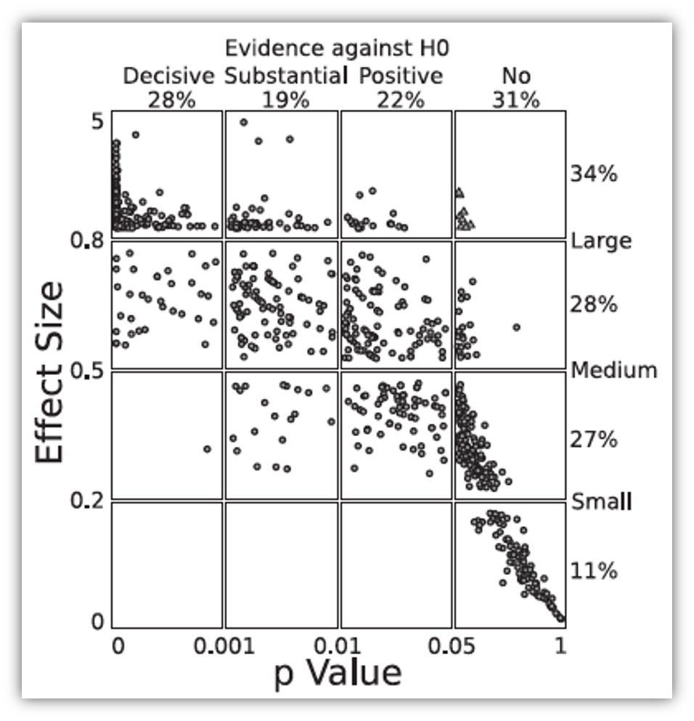

Slide 6 (new section): Bayesian estimation

Slide 7
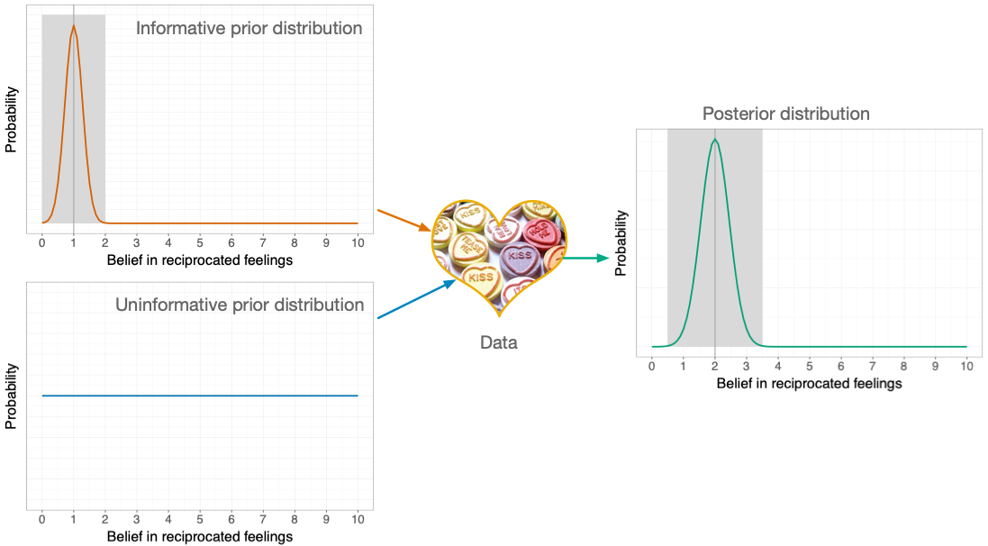

Slide 8
Video clip: miltons walks 01

Slide 9
Video clip: miltons walks 02

Slide 10

Slide 11: A musical example1

Outcome
- sales: Revenue from physical, download and streamed album sales in first week (£ thousands)

Predictors
- adverts: amount spent promoting the album before release (£ thousands)
- airplay: how many times songs from the album were played on a prominent national radio station in the week before release
- image: ratings of the ‘look’ of the band out of 10

The model
$$\begin{aligned}{\text{Sales}}_{i}&=b_{0}+b_{1}{\text{Advertising}}_{i}+ε_{i} \\ ε_{i}&∼N(0,σ^{2})\end{aligned}$$
Footnotes
- Chapter 8 from Field (2026). Discovering Statistics using R and RStudio. London: Sage.

Slide 12: Priors
- You need a prior for each parameter in the model
  - $b_{0}$
  - $b_{1}$
  - $σ^{2}$
- Uninformative priors
  - A.K.A ‘flat priors’
  - Uniform distribution or very wide distribution
  - Estimates heavily data-driven

Slide 13

OLS
Parameter | Coefficient | SE | 95% CI | t(198) | p
(Intercept) | 134.14 | 7.54 | (119.28, 149.00) | 17.80 | < .001
adverts | 0.10 | 9.63e-03 | (0.08, 0.12) | 9.98 | < .001

Bayesian
Parameter | Median | 95% CI | pd | Rhat | ESS | Prior
(Intercept) | 134.21 | (119.22, 149.23) | 100% | 1.000 | 3630 | Normal (193.20 +- 201.75)
adverts | 0.10 | (0.08, 0.11) | 100% | 0.999 | 3845 | Normal (0.00 +- 0.42)

Slide 14: Confidence vs. Credible intervals
Warning: The danger zone!
What confidence intervals are NOT:
- There is NOT a 95% probability that a given interval contains the population value.
  - It is p = 0 or p = 1, but you can’t know which!
- They do NOT reflect confidence in the value of the population parameter.
Note: Statis-tip
What credible intervals ARE:
- Intervals that contain the ‘true’ population value of the parameter in 95% of samples

Slide 15: Informative priors
- Reflect prior knowledge
- The prior exerts more influence on estimates than an uninformative prior
- Can be strong
  - A narrow distribution
  - The prior has more influence than for a weak prior
- Can be weak
  - A wider distribution
  - The prior has less influence than for a strong prior
- ‘Congugate’ distributions
  - Normal, Gamma, Beta

Slide 16: Prior for the intercept (\(b_0\))
Caution: Think about it!
- What do we already know about album sales when advertising = £0
- Historic data:
  - Expect 20,000 sales on average
  - It varies for different artists (SD = 7,000)
$$b_{0}∼N(20,7)$$
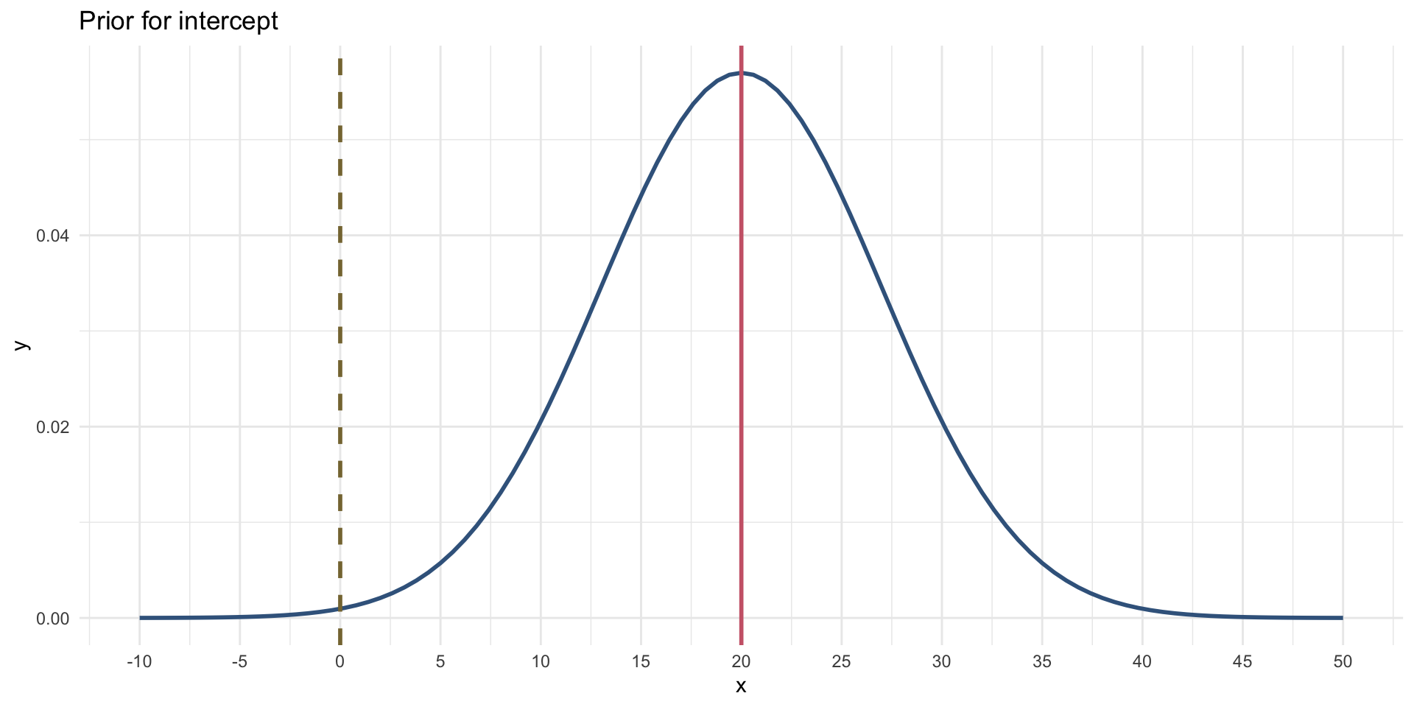

Slide 17: Prior for the effect of advertising (\(b_1\))
Caution: Think about it!
- Historic data:
  - For every £1000 pounds they spend on advertising they can expect 1000 album sales. This equates to a $b$ = 1.
  - Although spending money on advertising typically increases sales, they have been known to go down.

$$b_{1}∼N(1,0.5)$$
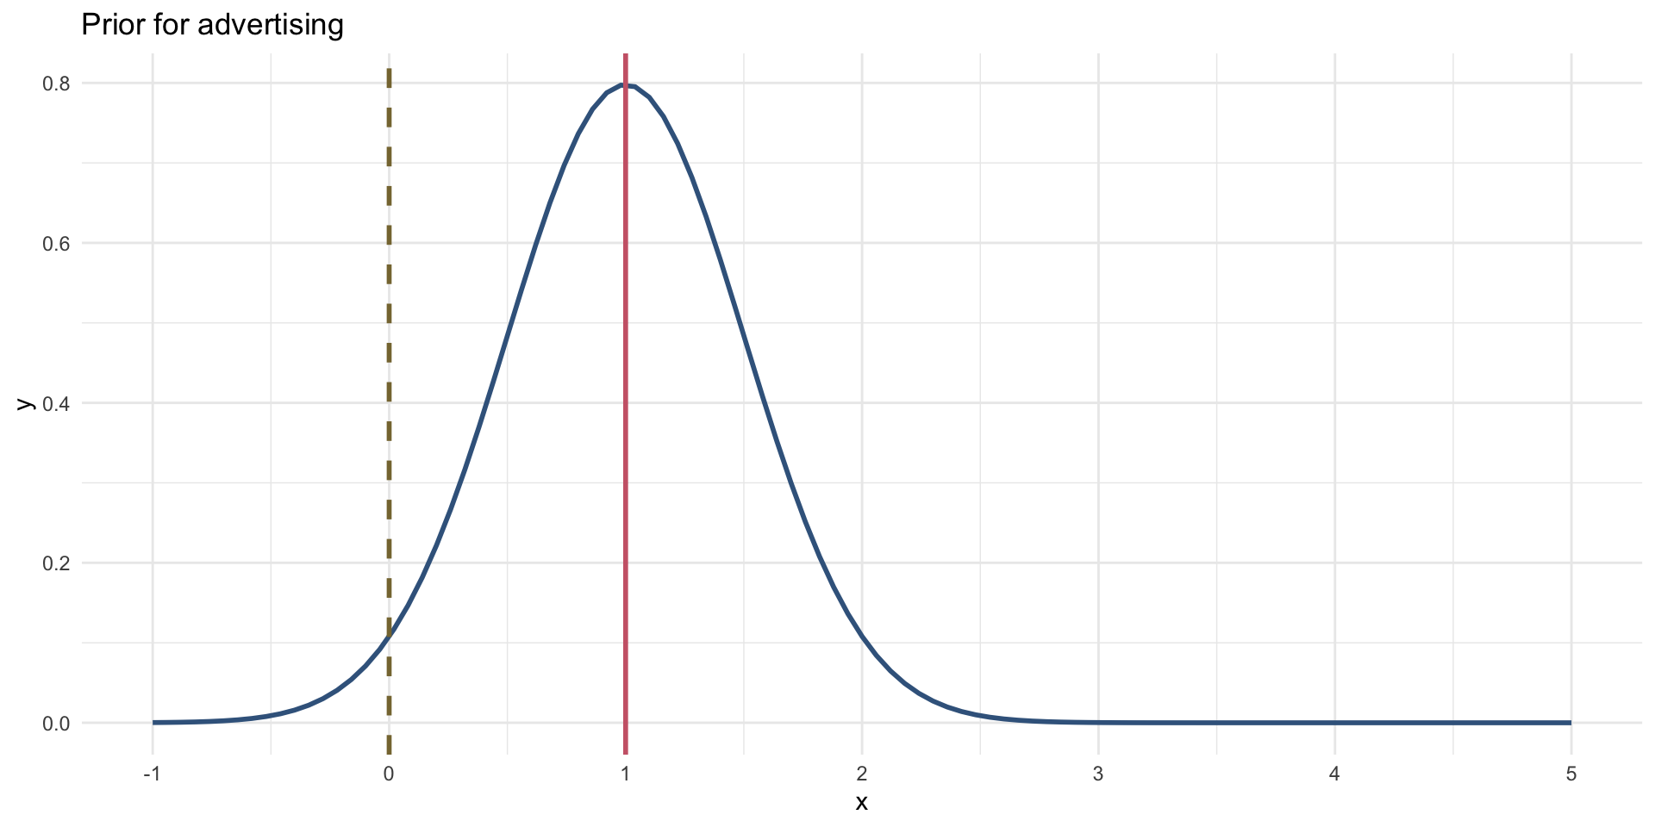

Slide 18

OLS
Parameter | Coefficient | SE | 95% CI | t(198) | p
(Intercept) | 134.14 | 7.54 | (119.28, 149.00) | 17.80 | < .001
adverts | 0.10 | 9.63e-03 | (0.08, 0.12) | 9.98 | < .001

Bayesian
Parameter | Median | 95% CI | pd | Rhat | ESS | Prior
(Intercept) | 26.25 | (-0.97, 53.35) | 97.10% | 1.000 | 2115 | Normal (20 +- 7.00)
adverts | 0.10 | (0.06, 0.13) | 100% | 1.000 | 2440 | Normal (1 +- 0.50)

Slide 19
Video clip: miltons walks 03

Slide 20
Video clip: miltons walks 04

Slide 21
Video clip: miltons walks 05

Slide 22 (new section): Bayes Factors

Slide 23: Bayes theorem
$$\begin{aligned}p(\text{A}|\text{B})&=\frac{p(\text{B}|\text{A})×p(\text{A})}{p(\text{B})}\end{aligned}$$
$$\begin{aligned}p(\text{model}|\text{data})&=\frac{p(\text{data}|\text{model})×p(\text{model})}{p(\text{data})}\end{aligned}$$
$$\begin{aligned}\text{posterior probability}&=\frac{\text{liklihood}×\text{prior probability}}{\text{marginal liklihood}}\end{aligned}$$

Slide 24


Null hypothesis: You’re human

Slide 25


Null hypothesis: You’re human

Alt hypothesis: You’re alien!

Slide 26
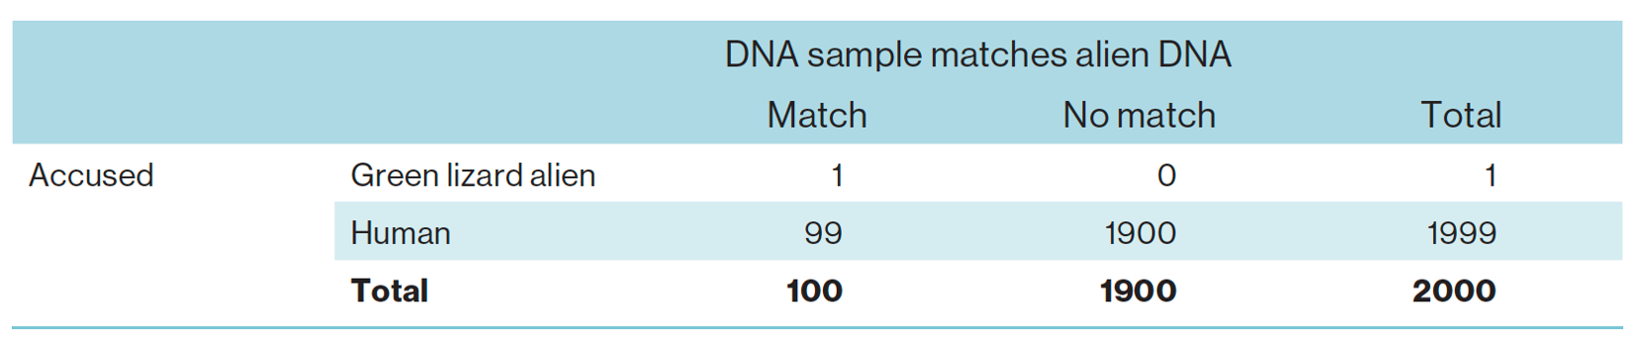
$$\begin{aligned}p(\text{hypothesis}|\text{match})&=\frac{p(\text{match}|\text{hypothesis})×p(\text{hypothesis})}{p(\text{match})}\end{aligned}$$
$$\begin{aligned}\text{posterior probability}&=\frac{\text{liklihood}×\text{prior probability}}{\text{marginal liklihood}}\end{aligned}$$

Slide 27
$$\begin{matrix}\text{prior probability}=p(\text{alien})=\frac{1}{2000}=0.0005\end{matrix}$$
$$\begin{matrix}\text{marginal liklihood}=p(\text{match})=\frac{100}{2000}=0.05\end{matrix}$$
$$\begin{matrix}\text{liklihood}=p(\text{match}|\text{alien})=\frac{p(\text{alien}∩\text{match})}{p(\text{alien})}=\frac{\frac{1}{2000}}{\frac{1}{2000}}=1\end{matrix}$$

Slide 28: Alternative hypothesis (you’re alien)
$$\begin{aligned}p(\text{alien}|\text{match})&=\frac{p(\text{match}|\text{alien})×p(\text{alien})}{p(\text{match})} \\ &=\frac{1×0.0005}{0.05} \\ &=0.01\end{aligned}$$

Slide 29
$$\begin{matrix}\text{prior probability}=p(\text{human})=\frac{1999}{2000}=0.9995\end{matrix}$$
$$\begin{matrix}\text{marginal liklihood}=p(\text{match})=\frac{100}{2000}=0.05\end{matrix}$$
$$\begin{matrix}\text{liklihood}=p(\text{match}|\text{human})=\frac{p(\text{human}∩\text{match})}{p(\text{human})}=\frac{\frac{99}{2000}}{\frac{1999}{2000}}=0.0495\end{matrix}$$

Slide 30: Null hypothesis (you’re human)
$$\begin{aligned}p(\text{human}|\text{match})&=\frac{p(\text{match}|\text{human})×p(\text{human})}{p(\text{match})} \\ &=\frac{0.0495×0.9995}{0.05} \\ &=0.99\end{aligned}$$

Slide 31
$$\begin{matrix}\text{posterior odds}=\frac{p(\text{hypothesis 1}|\text{data})}{p(\text{hypothesis 2}|\text{data})}=\frac{p(\text{alien}|\text{match})}{p(\text{human}|\text{match})}=\frac{0.01}{0.99}=0.01\end{matrix}$$
$$\begin{matrix}\frac{p(\text{alternative}|\text{data})}{p(\text{null}|\text{data})}=\frac{\frac{p(\text{data}|\text{alternative})×p(\text{alternative})}{p(\text{data})}}{\frac{p(\text{data}|\text{null})×p(\text{null})}{p(\text{data})}}=\frac{p(\text{alien}|\text{match})}{p(\text{human}|\text{match})}=\frac{0.01}{0.99}=0.01\end{matrix}$$
$$\begin{matrix}\frac{p(\text{alternative}|\text{data})}{p(\text{null}|\text{data})}=\frac{p(\text{data}|\text{alternative})}{p(\text{data}|\text{null})}×\frac{p(\text{alternative})}{p(\text{null})}\end{matrix}$$




Slide 32
$$\begin{matrix}\frac{p(\text{alien}|\text{match})}{p(\text{human}|\text{match})}=\frac{p(\text{match}|\text{alien})}{p(\text{match}|\text{human})}×\frac{p(\text{alien})}{p(\text{human})}\end{matrix}$$
$$\begin{aligned}\frac{0.01}{0.99}&=\frac{1}{0.0495}×\frac{0.0005}{0.9995} \\ 0.01&=20.20×0.0005\end{aligned}$$
Note: Statis-tip
- Given a DNA match, we should shift our belief towards that person being an alien by a factor of about 20

Slide 33: Bayes factor (BF10)
- The probability of the data given the alternative hypothesis relative to the probability of the data given the null.
- The extent to which you should change your beliefs about the alternative hypothesis relative to the null
- You sometimes see Bayes factors expressed the opposite way around (BF₀₁)
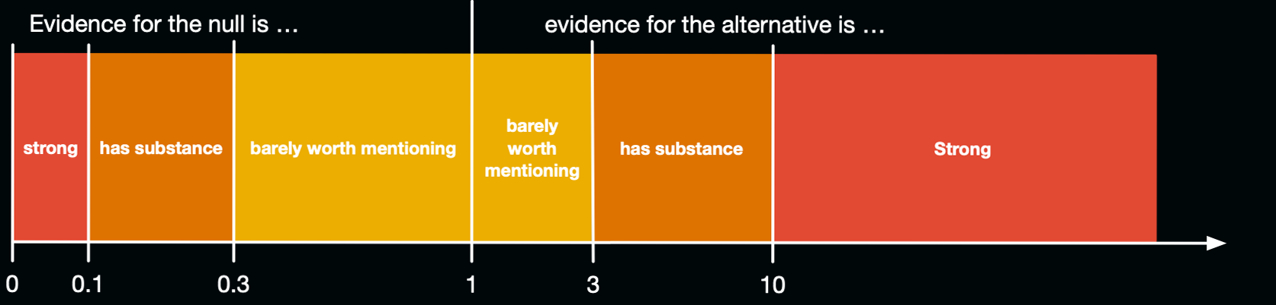

Slide 34: Bayes factors, p and effect sizes1
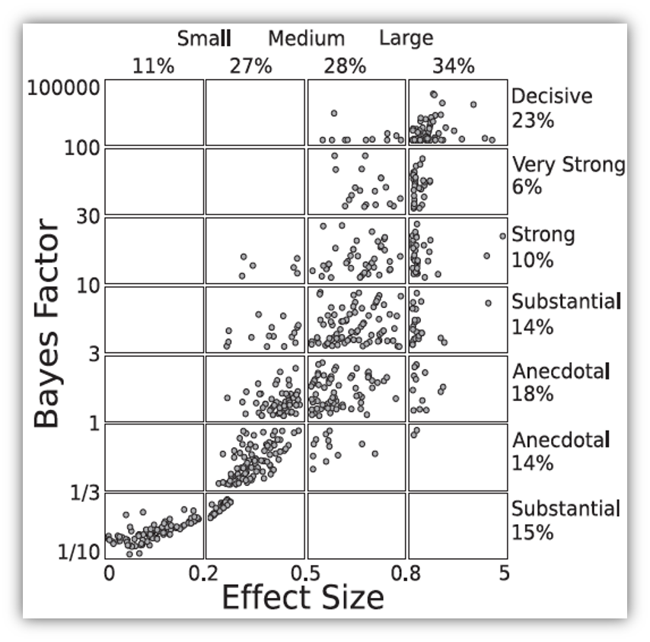
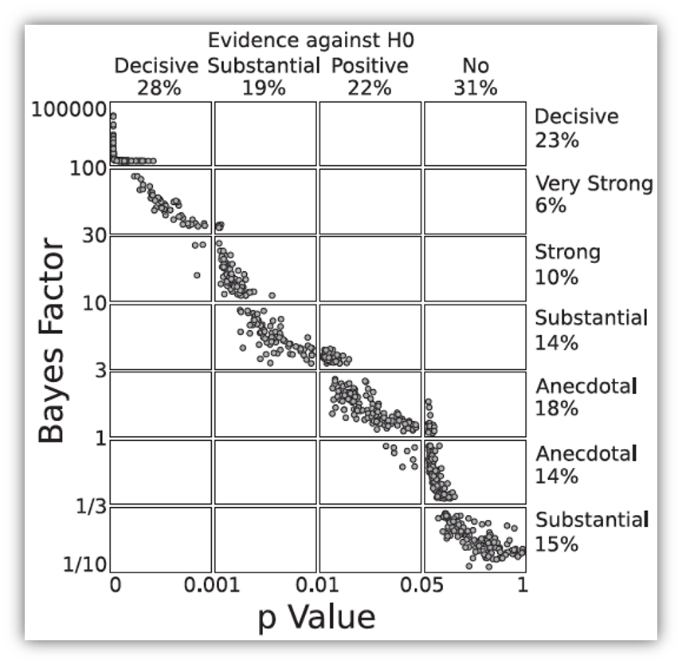
Footnotes
- Wetzels et al. (2011). Perspectives on Psychological Science, 6, 291–298. https://doi.org/10.1177/1745691611406923

Slide 35: Back to album sales
Parameter | Median | 95% CI | BF | Rhat | ESS | Prior
(Intercept) | 26.25 | (-0.97, 53.35) | 0.041 | 1.000 | 2115 | Normal (20 +- 7.00)
adverts | 0.10 | (0.06, 0.13) | 601.16 | 1.000 | 2440 | Normal (1 +- 0.50)
- We should shift our beliefs in advertising having a non-zero relationship to sales by a factor of about 601.

Slide 36: Summary
- We can go beyond p to evaluate the plausibility of a hypothesis
- Other methods address more useful questions, are less dependent on sample sizes, and avoid all-or-nothing thinking
- Bayesian estimation allows us to factor in prior knowledge
- Credible intervals tell us the plausible population values
- Bayes factors quantify the relative probability of the data given the null and alternative hypothesis

