Factorial designs
Testing moderation using interactions
Professor Andy Field, University of Sussex
Links: acdc that the way | bsky.app | youtube.com | discoveringstatistics.com | discovr.rocks | statisticsadventure.com

About this version
This is a plain-text version of the lecture slides. Each slide starts with a heading such as “Slide 5”, and the numbers match the slide numbers shown in the lecture. Content that appeared one piece at a time, in columns or in tabs is shown in reading order. Videos and interactive apps are given as links.

Slide 2: Learning outcomes
- What is a factorial design?
- Moderation and interaction effects
- Factorial designs and the GLM
  - The process of E.V.I.L.
- Breaking down interactions
  - Plots
  - Simple effects analysis

Slide 3
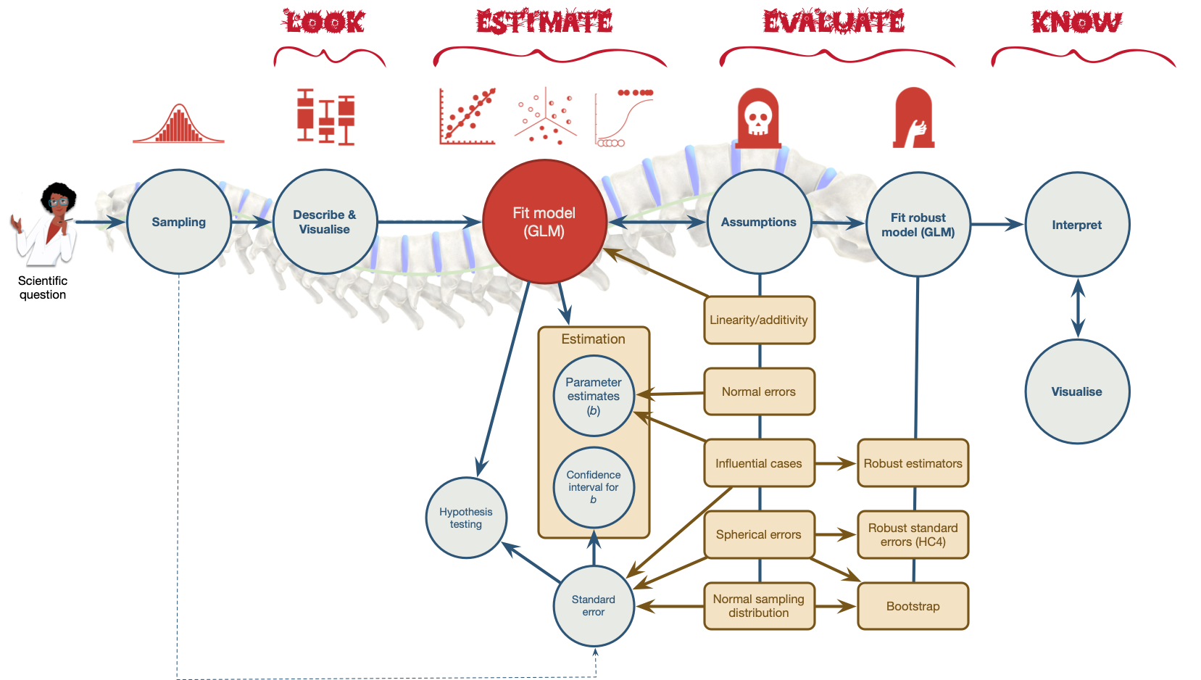
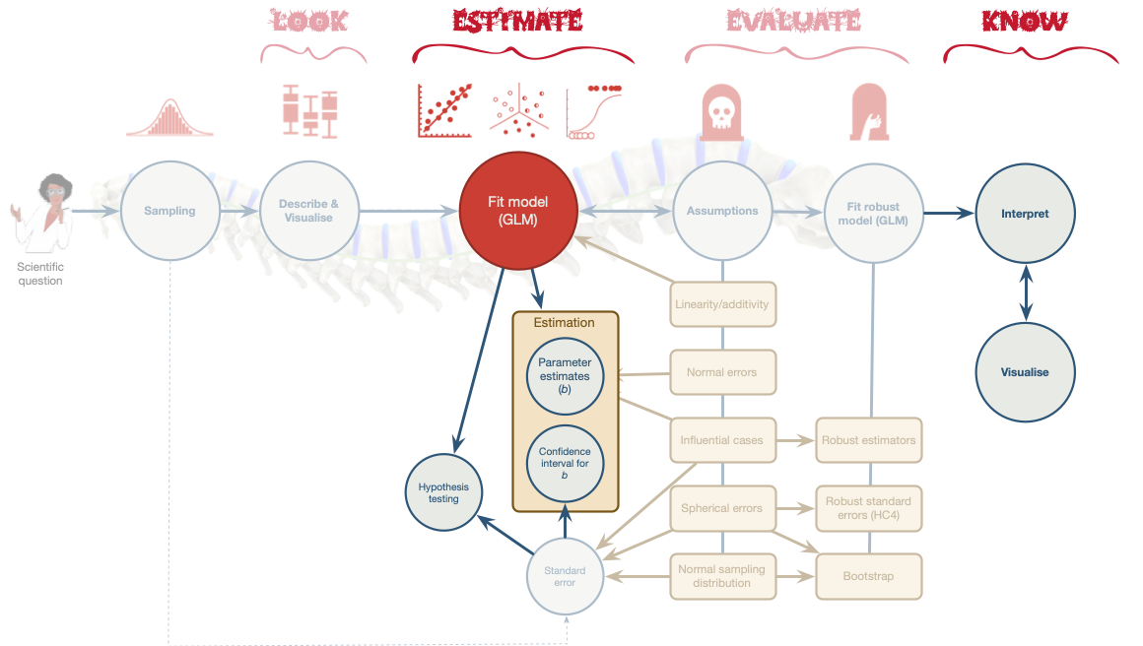

Slide 4
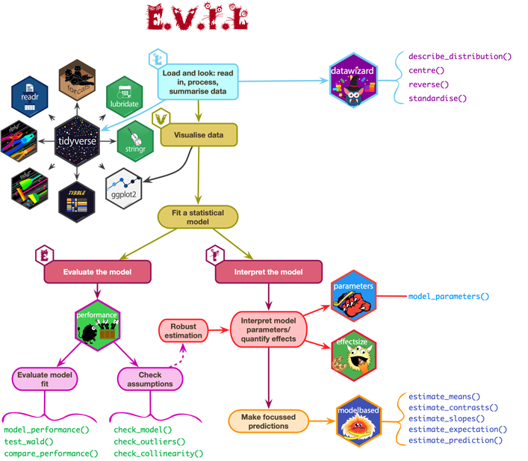

Slide 5: Terminology
- Variables in experimental designs
  - Predictor variables referred to as independent variables (IV) because their value is independent of (is not being predicted from) other variables.
  - Outcome variable referred to as the dependent variables (DV), because their value ‘depends’ upon (is being predicted from) other variables.
- Factorial design: Two or more predictor variables/IV have been manipulated
- n-way design: The number of predictor variables/IVs manipulated
  - Two-way = 2 predictor variables/IVs manipulated
  - Three-way = 3 predictor variables/IVs manipulated
- The allocation of participants
  - Independent design = different entities in all conditions
  - Repeated measures design = the same entities in all conditions
  - Mixed design = different entities in all conditions of at least one predictor/IV, the same entities in all conditions of at least one other predictor variable/IV

Slide 6 (new section): Moderation: Do video games lead to aggression?

Slide 7
Video clip: warcraft final

Slide 8: Moderation
- Is there a link between video games and aggression?
  - Outcome = aggressive behaviour (aggress)
  - Callus Unemotional Traits (caunts)
  - Video game Use (vid_game)

Slide 9: Moderation: The theoretical model

Slide 10: Categorical moderator variable
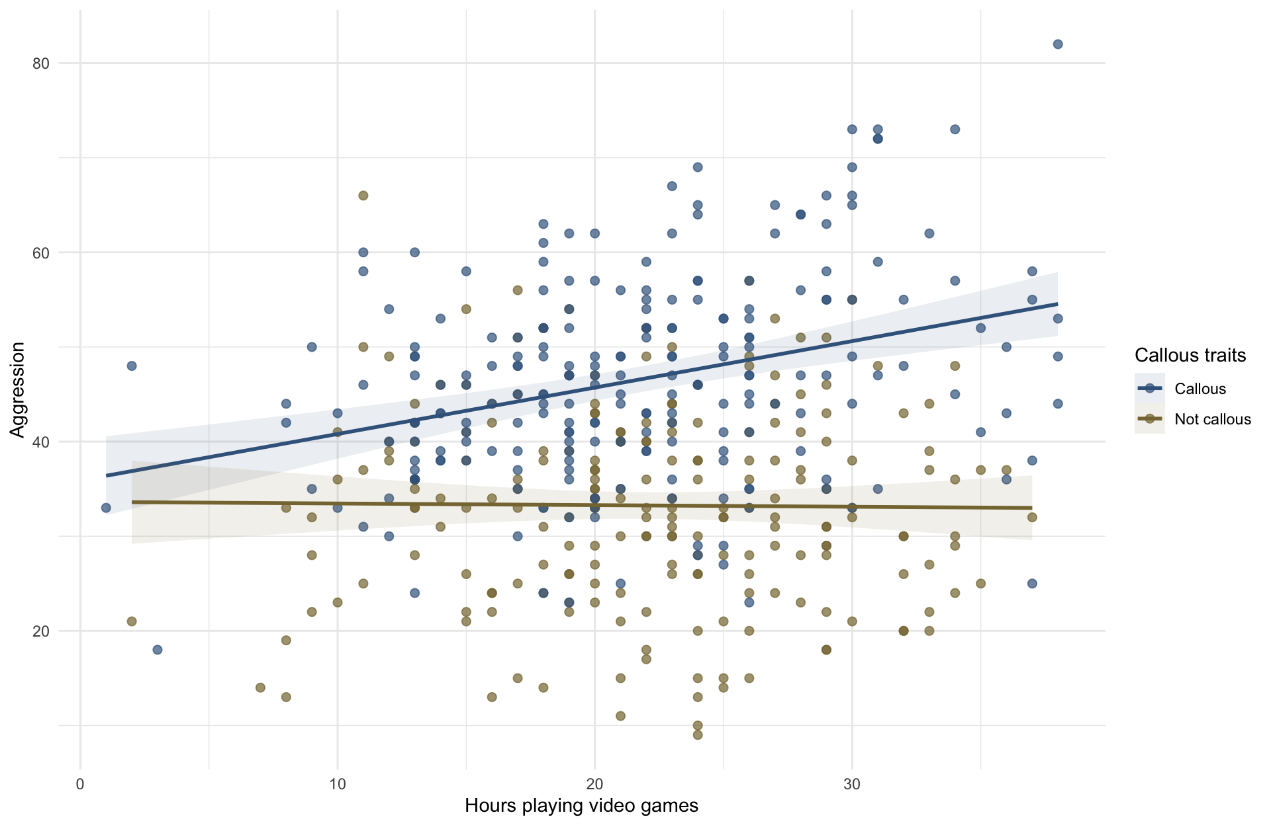

Slide 11: Continuous moderator variable
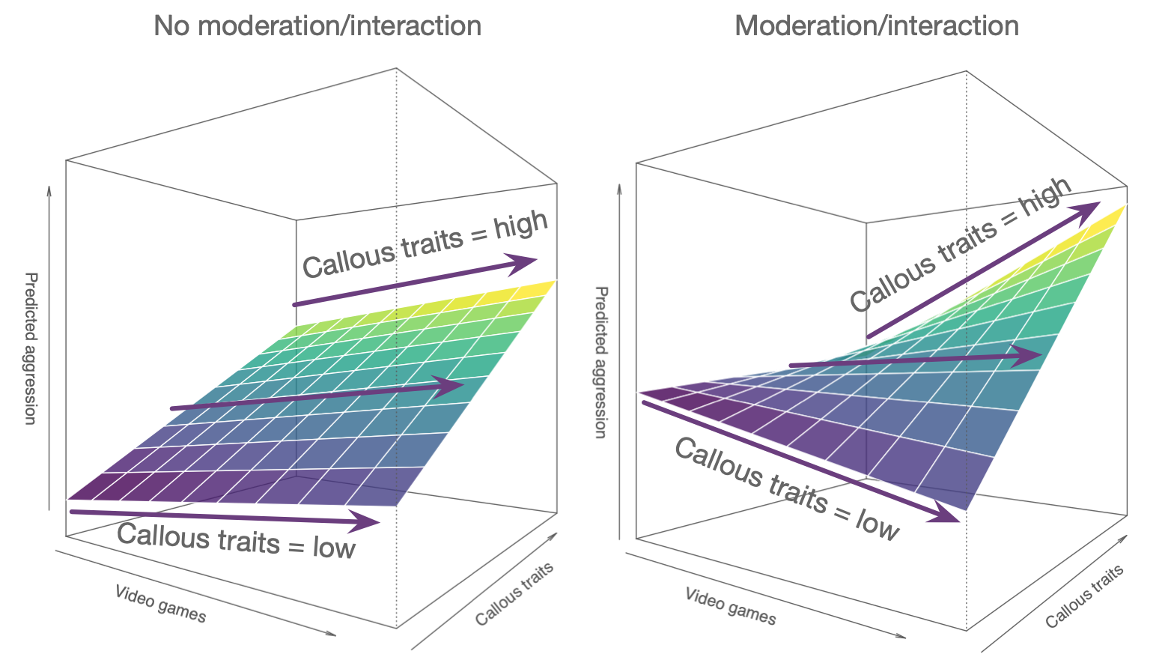

Slide 12: Moderation: The statistical model
$$\begin{matrix}{\text{aggression}}_{i}={\hat{b}}_{0}+{\hat{b}}_{1}{\text{video games}}_{i}+{\hat{b}}_{2}{\text{caunts}}_{i}+{\hat{b}}_{3}\text{video games}×{\text{caunts}}_{i}+e_{i}\end{matrix}$$

Slide 13: Interactions in the linear model
- An interaction term is the product of the two variables:
$$\text{interaction}=\text{video_games}×\text{caunts}$$

Interpretation
- If the interaction term is significant, we have a significant moderation effect
- The parameter estimate (b) for the interaction quantifies the size of the interaction effect
- The effect of one predictor is stronger at some levels of another predictor
- In factorial designs, the effect of one predictor is stronger in certain categories of the other predictor
- Simple effects analysis

Slide 14
Video clip: wii injuries

Slide 15: A dangerous example
- Injury severity (0-20) measured during video games
- 40 Participants
  - 10 = Xbox One kinect (Static game)
  - 10 = Xbox One kinect (Active game)
  - 10 = Nintendo Switch (Static game)
  - 10 = Nintendo Switch (Active game)
- Variables:
  - Predictor = Type of console (Xbox or Switch)
  - Predictor = Type of game (static or active)
  - Outcome = injury severity (0 = no injury, 20 = severe injury)
Note: Statis-tip
This is a two-way independent factorial design.

Slide 16: The model
$$\begin{matrix}{\text{injuries}}_{i}={\hat{b}}_{0}+{\hat{b}}_{1}{\text{game}}_{i}+{\hat{b}}_{2}{\text{console}}_{i}+{\hat{b}}_{3}\text{game}×{\text{console}}_{i}+e_{i}\end{matrix}$$

Slide 17: Partitioning variance

Slide 18: Partitioning variance

Slide 19: Partitioning variance

Slide 20: Load and Look
xbox_tib |>
group_by(game, console) |>
describe_distribution(select = injury, ci = 0.95) |>
data_remove(c(Variable, Skewness, Kurtosis, n_Missing)) |>
display()
game | console | Mean | 95% CI (Mean) | SD | IQR | Range | n
Static | Xbox One | 7.00 | (5.65, 8.90) | 2.67 | 4.50 | (3.00, 11.00) | 10
Active | Xbox One | 9.40 | (7.15, 11.10) | 3.37 | 5.75 | (4.00, 14.00) | 10
Static | Switch | 6.70 | (5.50, 7.96) | 1.95 | 2.25 | (3.00, 10.00) | 10
Active | Switch | 12.90 | (11.50, 14.75) | 2.51 | 4.00 | (10.00, 18.00) | 10


Slide 21: Visualize
ggplot(xbox_tib, aes(x = console, y = injury, colour = game, shape = game)) +
stat_summary(fun.data = "mean_cl_normal", geom = "pointrange", position = position_dodge(width = 0.2)) +
coord_cartesian(ylim = c(0,15)) +
scale_y_continuous(breaks = 0:15) +
scale_colour_viridis_d(begin = 0.3, end = 0.85) +
labs(x = "Type of console", y = "Injury severity (0-20)", colour = "Type of game", shape = "Type of game") +
theme_minimal()
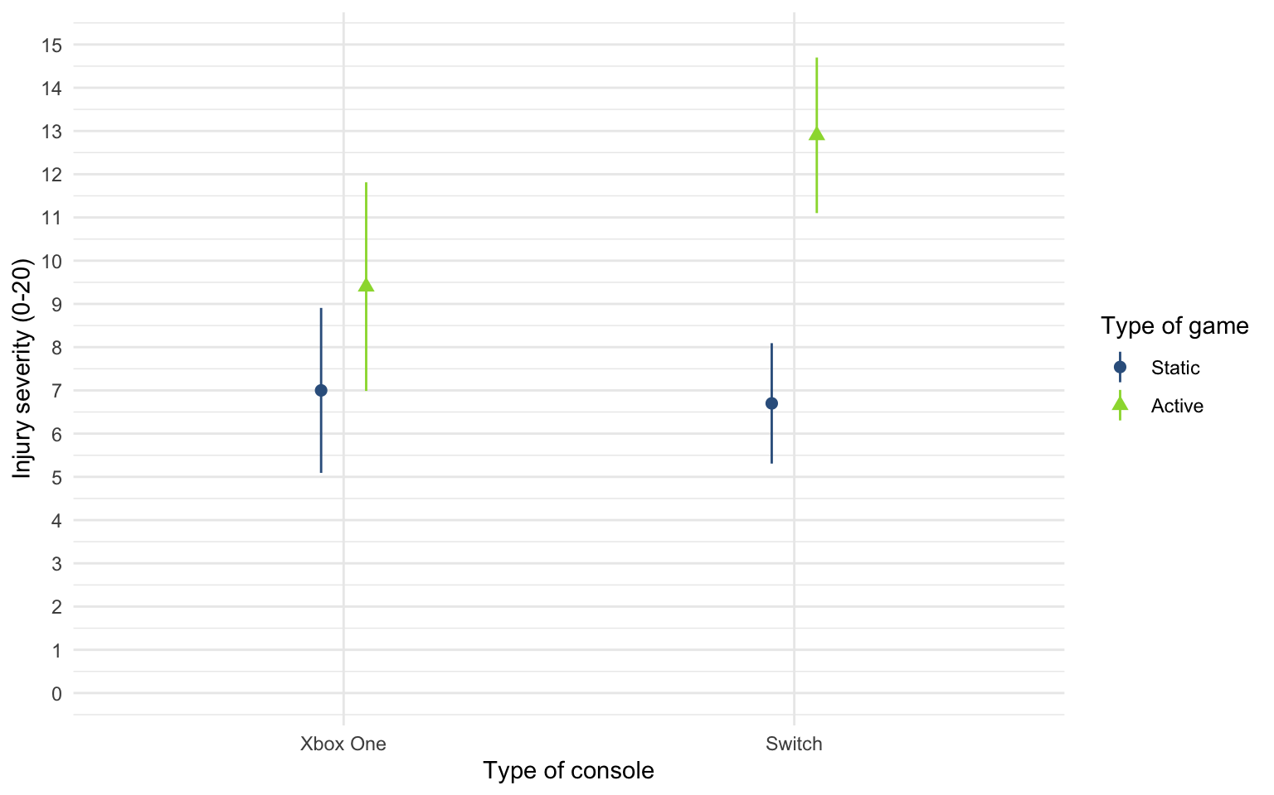


Slide 22: Fit the model
- Remember that for F-statistics we typically want Type III sums of squares
- We can fit the model in the usual way using lm()

Set contrasts
active_vs_static <- c(-1/2, 1/2)
switch_vs_xbox <- c(-1/2, 1/2)
contrasts(xbox_tib$game) <- active_vs_static
contrasts(xbox_tib$console) <- switch_vs_xbox

Fit the models
incpt_lm <- lm(injury ~ 1, data = xbox_tib)
game_lm <- lm(injury ~ game, data = xbox_tib)
console_lm <- lm(injury ~ game + console, data = xbox_tib)
xbox_lm <- lm(injury ~ game*console, data = xbox_tib)

Slide 23: Evaluate model fit
test_wald(incpt_lm, game_lm, console_lm, xbox_lm) |>
display()
Name | Model | df | df_diff | F | p
incpt_lm | lm | 39
game_lm | lm | 38 | 1 | 25.86 | < .001
console_lm | lm | 37 | 1 | 3.58 | 0.067
xbox_lm | lm | 36 | 1 | 5.05 | 0.031
Important: ReportR
The type of game significantly moderated the effect of the games console on injury severity, F(1, 36) = 5.05, p = 0.031.


Slide 24: Evaluate assumptions
check_model(xbox_lm)
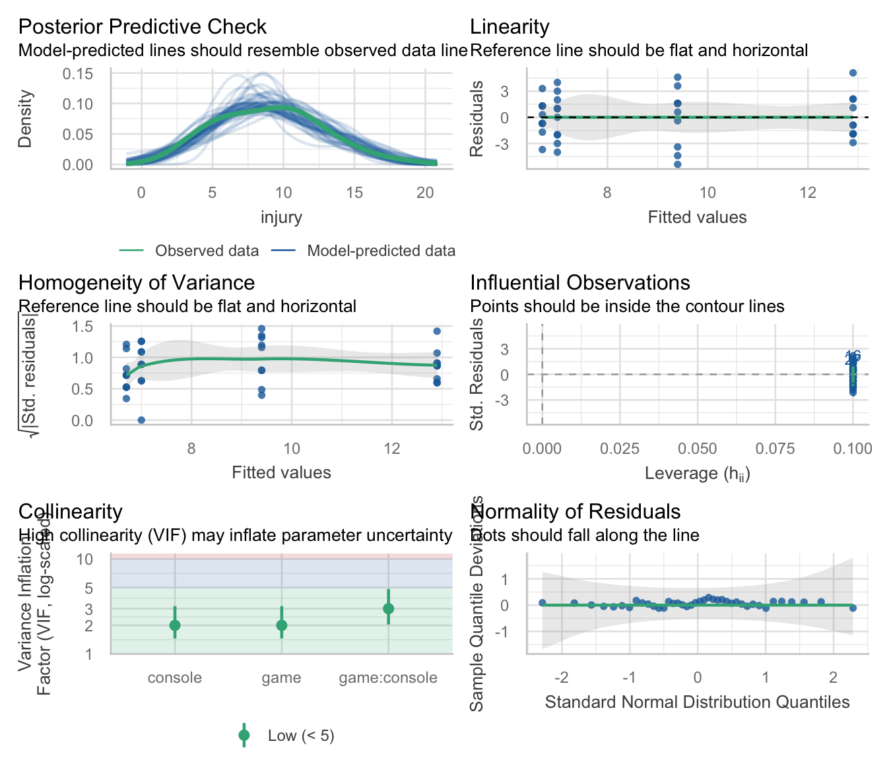

Slide 25: Interpret parameter estimates, CIs and tests

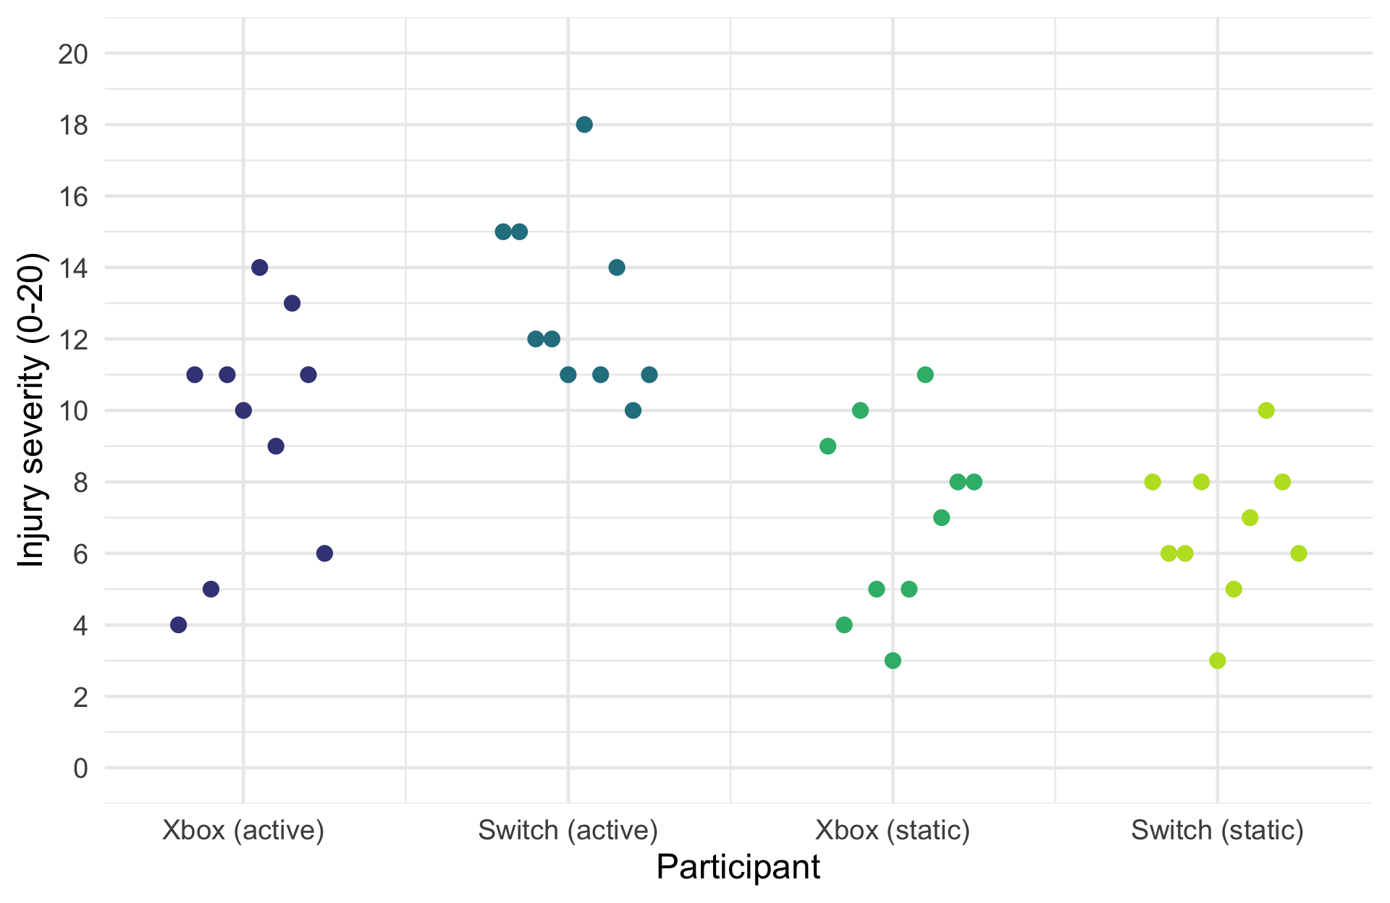

Slide 26: Interpret
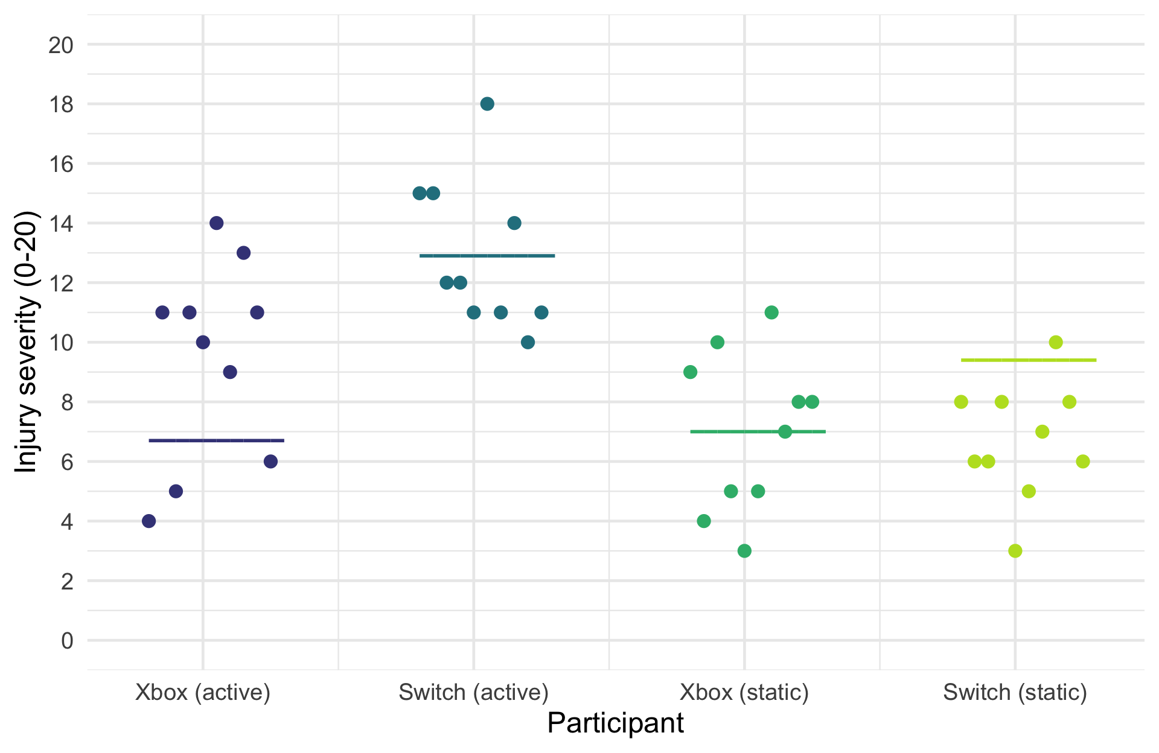

Slide 27: Interpret the main effect of console

Slide 28: Interpret the main effect of console
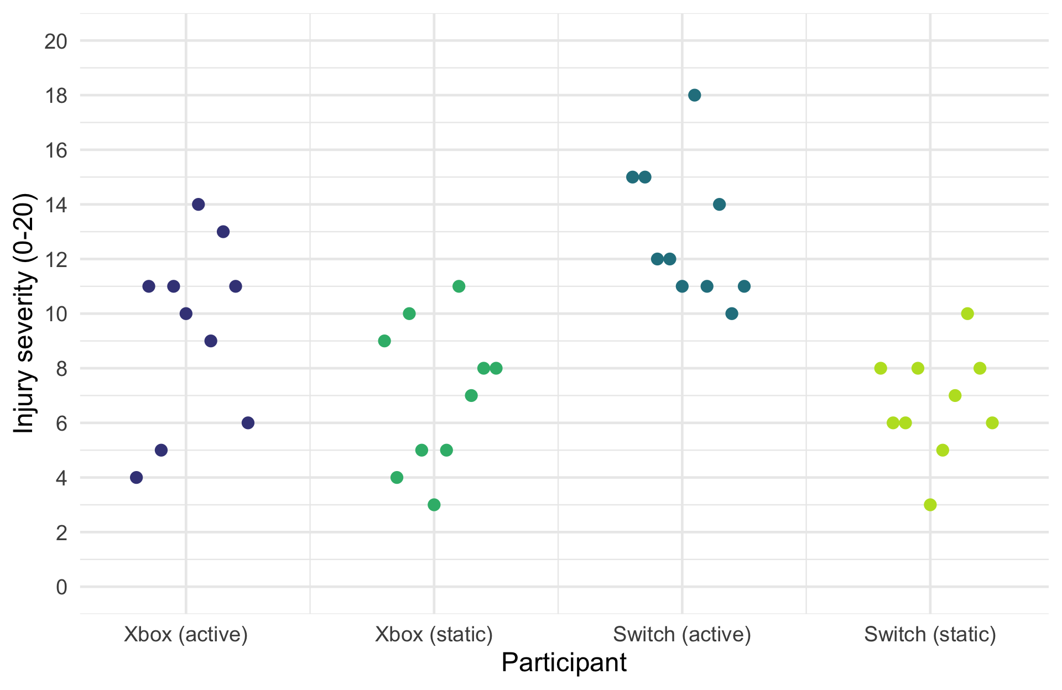

Slide 29: Interpret the main effect of console
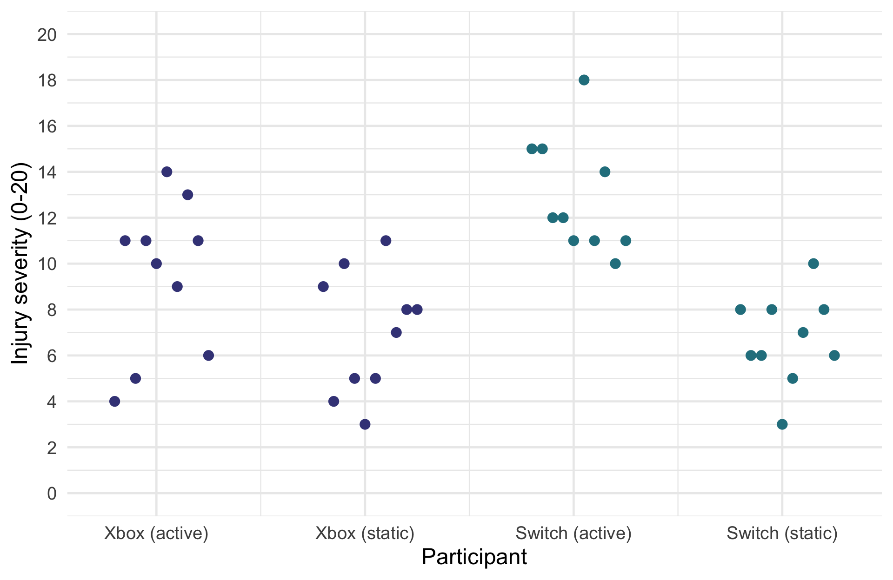

Slide 30: Interpret the main effect of console
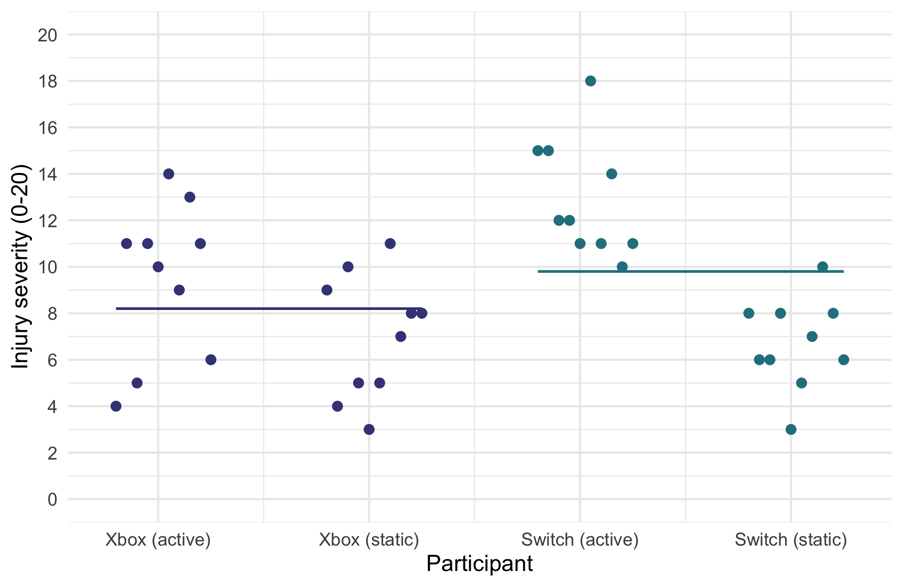

Slide 31: Interpret the main effect of game

Slide 32: Interpret the main effect of game
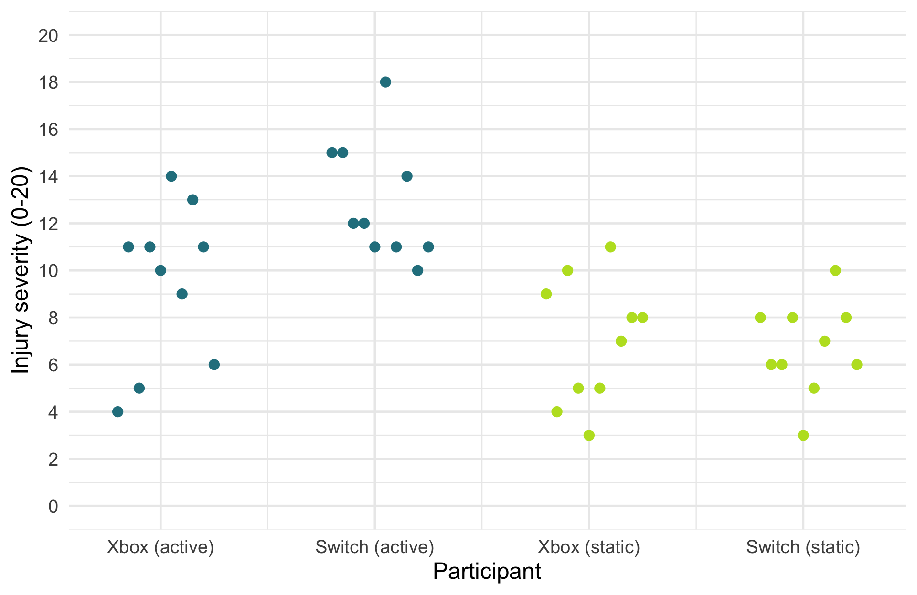

Slide 33: Interpret the main effect of game
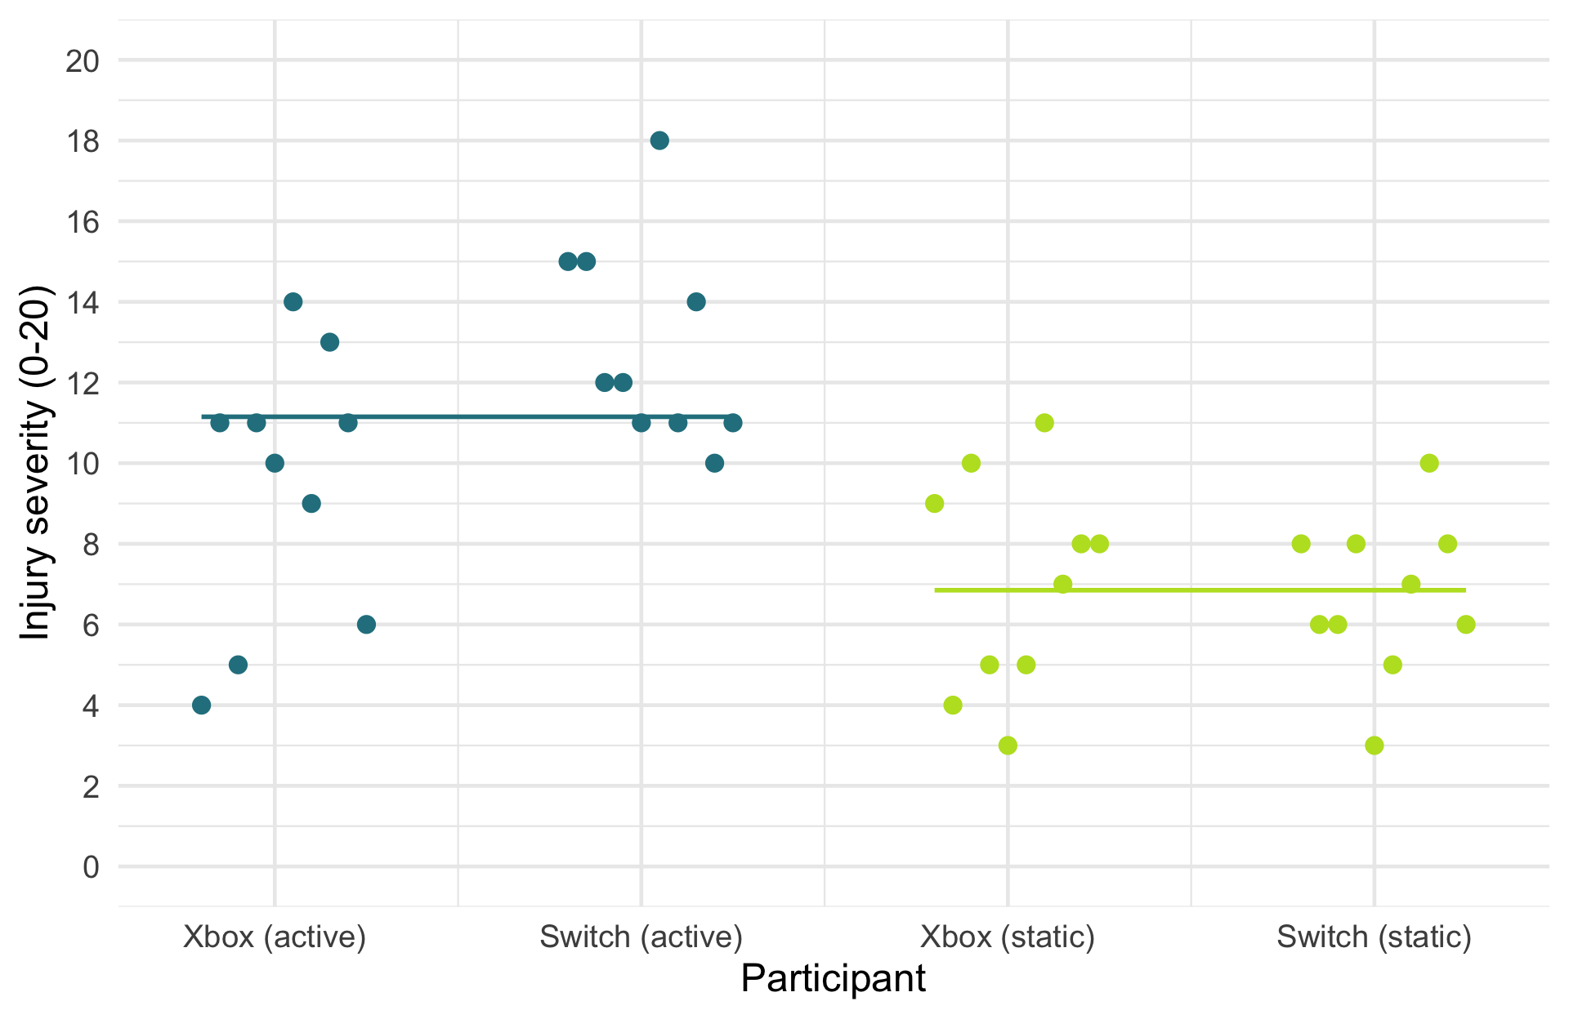

Slide 34: Interpret the interaction (moderation effect)
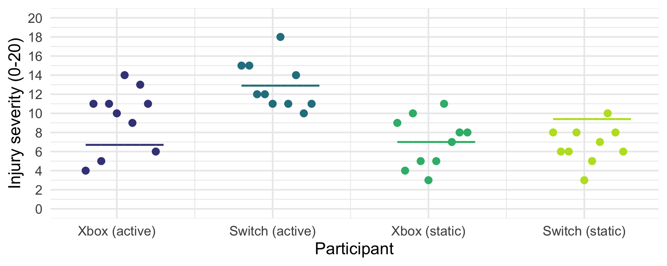
Parameter | Coefficient | SE | 95% CI | t(36) | p
(Intercept) | 7.00 | 0.85 | (5.29, 8.71) | 8.28 | < .001
game (Active) | 2.40 | 1.20 | (-0.03, 4.83) | 2.01 | 0.052
console (Switch) | -0.30 | 1.20 | (-2.73, 2.13) | -0.25 | 0.803
game (Active) × console (Switch) | 3.80 | 1.69 | (0.37, 7.23) | 2.25 | 0.031

Slide 35: Interpreting interactions

Console moderating the effect of game
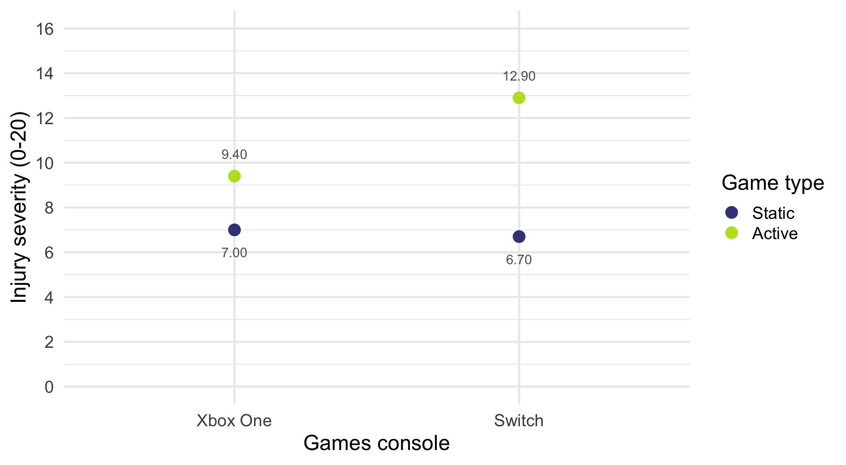

Slide 36: Interpreting interactions

Console moderating the effect of game
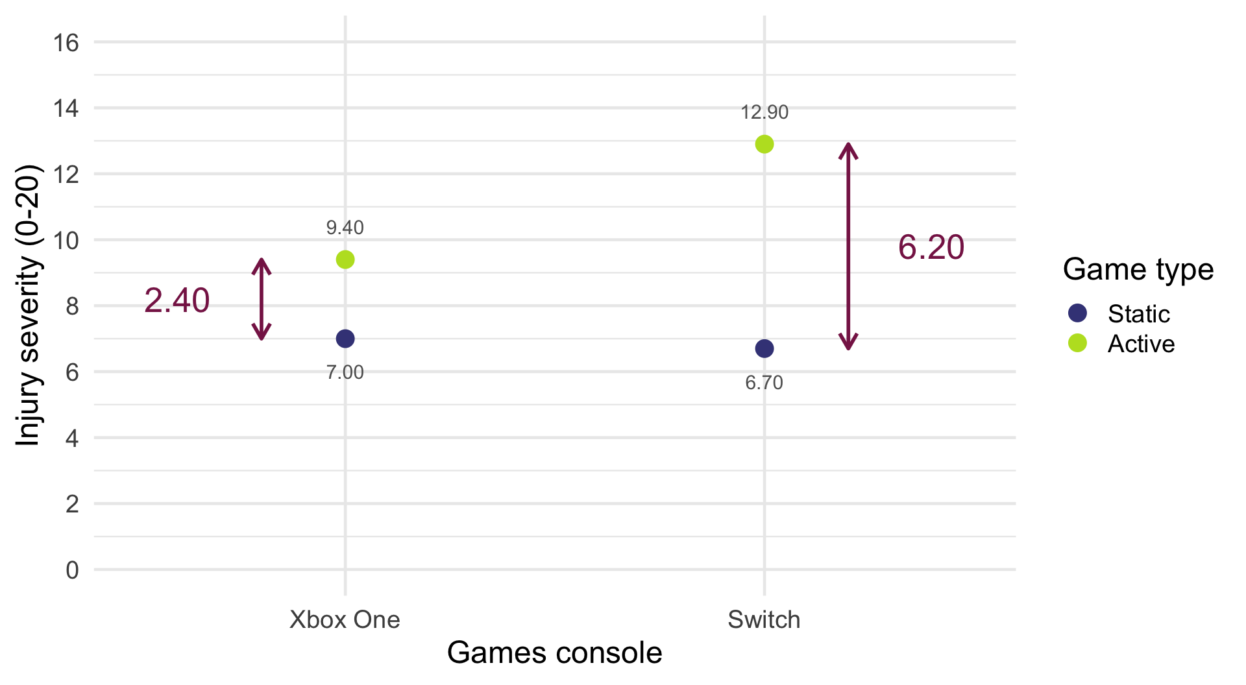
$$\begin{aligned}{\text{game}}_{\text{Switch}}&={\overset{‾}{X}}_{\text{active, Switch}}−{\overset{‾}{X}}_{\text{static, Switch}} \\ &=12.90−6.70 \\ &=6.20\end{aligned}$$
$$\begin{aligned}{\text{game}}_{\text{Xbox}}&={\overset{‾}{X}}_{\text{active, Xbox}}−{\overset{‾}{X}}_{\text{static, Xbox}} \\ &=9.40−7.00 \\ &=2.40\end{aligned}$$
$$\begin{aligned}\text{Interaction}&={\text{game}}_{\text{Switch}}−{\text{game}}_{\text{Xbox}} \\ &=6.2−2.40 \\ &=3.8\end{aligned}$$

Slide 37: Interpret simple effects

The effect of type of game within consoles
estimate_contrasts(model = xbox_lm,
contrast = "game",
by = "console",
comparison = "joint",
p_adjust = "bonferroni") |>
display()
Marginal Joint Test
Contrast | console | df1 | df2 | F | p
game | Xbox One | 1 | 36 | 4.03 | 0.105
game | Switch | 1 | 36 | 26.88 | < .001
p-value adjustment method: Bonferroni
Important: ReportR
The effect of playing active vs. static games is less significant for the Xbox than the switch. The difference in mean injuries between active and static games was not significantly different for the Xbox, F(1, 36) = 4.03, p = 0.105, but was for the Switch, F(1, 36) = 26.88, p < 0.001.

Slide 38: Interpreting interactions

Game moderating the effect of console
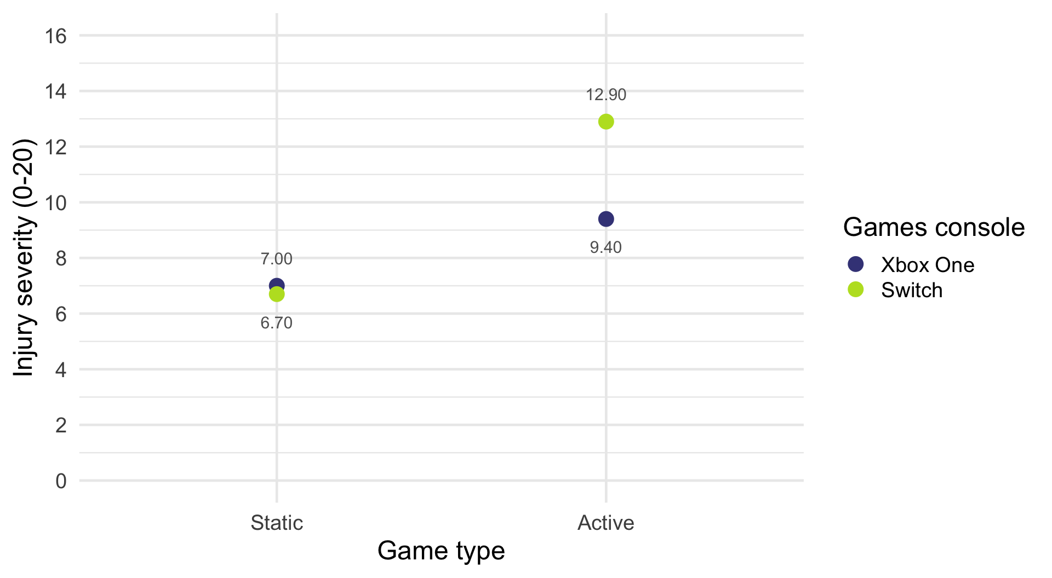

Slide 39: Interpreting interactions

Game moderating the effect of console
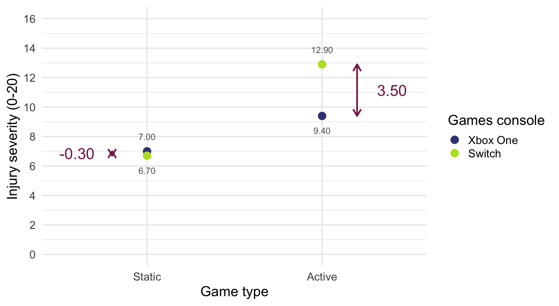
$$\begin{aligned}{\text{console}}_{\text{active}}&={\overset{‾}{X}}_{\text{active, Switch}}−{\overset{‾}{X}}_{\text{active, Xbox}} \\ &=12.90−9.4 \\ &=3.5\end{aligned}$$
$$\begin{aligned}{\text{console}}_{\text{static}}&={\overset{‾}{X}}_{\text{static, Switch}}−{\overset{‾}{X}}_{\text{static, Xbox}} \\ &=6.7−7.00 \\ &=−0.3\end{aligned}$$
$$\begin{aligned}\text{Interaction}&={\text{console}}_{\text{active}}−{\text{console}}_{\text{static}} \\ &=3.5−(−0.3) \\ &=3.8\end{aligned}$$

Slide 40: Interpret: simple effects analysis

The effect of console within the type of game
estimate_contrasts(model = xbox_lm,
contrast = "console",
by = "game",
comparison = "joint",
p_adjust = "bonferroni") |>
display()
Marginal Joint Test
Contrast | game | df1 | df2 | F | p
console | Static | 1 | 36 | 0.06 | > .999
console | Active | 1 | 36 | 8.57 | 0.012
p-value adjustment method: Bonferroni
Important: ReportR
The effect of playing Xbox vs. Switch games is less significant for static games than active ones. The difference in mean injuries between Xbox and Switch games was not significantly different for static games, F(1, 36) = 0.06, p = 1.000, but was for the active games, F(1, 36) = 8.57, p = 0.012.

Slide 41
Warning: The danger zone!
Repeat the following mantra:
“It is never sensible to interpret main effects in the presence of a significant interaction effect.”

Slide 42
Video clip: lazinc durt the time is here

Slide 43 (new section): The beer goggles effect

Slide 44: A science reflecting art example
- The beer goggles effect: subjective perceptions of physical attractiveness become inaccurate after drinking alcohol
- Chen et al., (2014)¹
  - Alcohol consumption reduces accuracy in symmetry judgements
  - Symmetric faces have been shown to be rated as more attractive.
  - If the beer-goggles effect is driven by alcohol impairing symmetry judgements then you’d expect a stronger effect for unattractive (asymmetric) faces than attractive (symmetric) ones
- Fictional data but matches Chen et al. findings
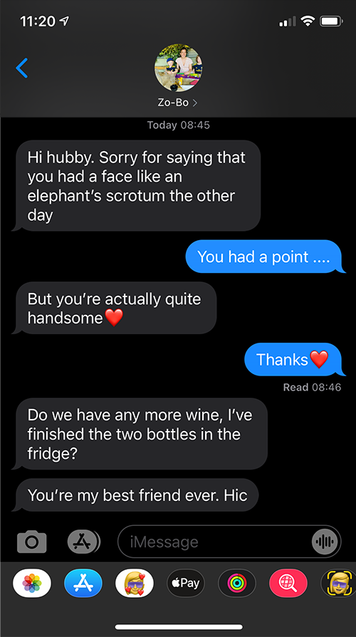
Footnotes
- Chen, et al., (2014). The moderating effect of stimulus attractiveness on the effect of alcohol consumption on attractiveness ratings. Alcohol and Alcoholism, 49, 515–519. https://doi.org/10.1093/alcalc/agu026

Slide 45: Study design
- 48 Participants (8 per group)
- Predictor: alcohol
  - Placebo group: 500 ml of alcohol-free beer
  - Low-dose group: 500 ml of beer (4% ABV);
  - High-dose group: 500 ml of beer (7% ABV).
- Predictor: facetype
- Rated 50 unattractive (asymmetric) faces
- Rated 50 attractive (symmetric) faces
- Outcome:
  - Median rating of the 50 photos on a scale from 0 (pass me a paper bag) to 10 (pass me their phone number)
Note: Statis-tip
This is a two-way independent factorial design.

Slide 46: Hypotheses
- H₁: Ratings will be higher for attractive compared to unattractive faces
- H₂: Ratings will be higher after alcohol compared to no alcohol
- H₃: Ratings will be higher after a high dose of alcohol compared to a low dose
- H₄: The effect of alcohol on ratings will depend on the type of face being rated (i.e. moderation)

Contrasts
Alcohol group | Contrast 1 (Alcohol vs. placebo) | Contrast 2 (High vs. Low dose)
Placebo | -2/3 | 0
Low dose | 1/3 | -1/2
High dose | 1/3 | 1/2

Facetype | Contrast
Unattractive | -0.5
Attractive | 0.5

Slide 47: The model
$$\begin{aligned}Y_{i}&={\hat{b}}_{0}+{\hat{b}}_{1}X_{i}+e_{i} \\ {\text{attractiveness}}_{i}&={\hat{b}}_{0}+{\hat{b}}_{1}{\text{facetype}}_{i}+{\hat{b}}_{2}(\text{alcohol vs. none})_{i}+{\hat{b}}_{3}(\text{high vs. low})_{i}+ \\ & {\hat{b}}_{4}[\text{facetype}×(\text{alcohol vs. none})]_{i}+ \\ & {\hat{b}}_{5}[\text{facetype}×(\text{high vs. low})]_{i}+e_{i}\end{aligned}$$

Slide 48: Load and Look
goggles_tib |>
group_by(facetype, alcohol) |>
describe_distribution(select = attractiveness, ci = 0.95) |>
data_remove(c(Variable, Skewness, Kurtosis, n_Missing)) |>
display()
facetype | alcohol | Mean | 95% CI (Mean) | SD | IQR | Range | n
Unattractive | Placebo | 3.50 | (2.43, 4.38) | 1.60 | 2.50 | (1.00, 6.00) | 8
Attractive | Placebo | 6.38 | (5.75, 7.00) | 0.92 | 1.00 | (5.00, 8.00) | 8
Unattractive | Low dose | 4.88 | (4.25, 5.50) | 1.25 | 1.75 | (3.00, 7.00) | 8
Attractive | Low dose | 6.50 | (5.88, 7.12) | 0.93 | 1.00 | (5.00, 8.00) | 8
Unattractive | High dose | 6.62 | (6.12, 7.25) | 1.06 | 1.75 | (5.00, 8.00) | 8
Attractive | High dose | 6.12 | (5.50, 6.82) | 1.13 | 2.00 | (5.00, 8.00) | 8

Slide 49: Visualize
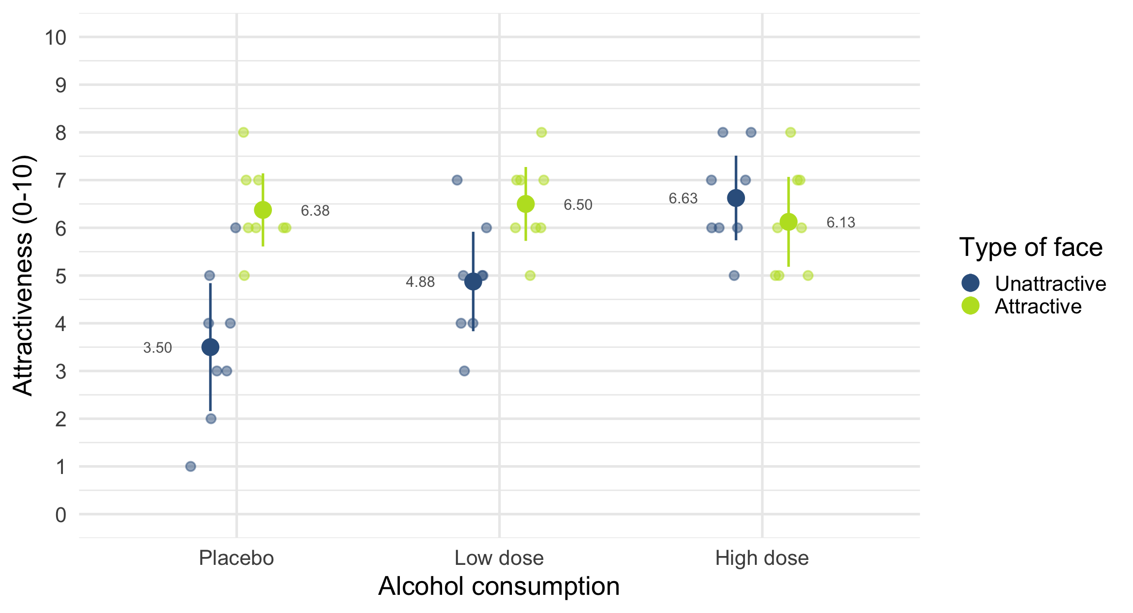

Slide 50: Fit the model

Set contrasts
# contrasts for alcohol
alcohol_vs_none <- c(-2/3, 1/3, 1/3)
high_vs_low <- c(0, -1/2, 1/2)
contrasts(goggles_tib$alcohol) <- cbind(alcohol_vs_none, high_vs_low)
# contrasts for facetype
att_vs_unatt <- c(-1/2, 1/2)
contrasts(goggles_tib$facetype) <- att_vs_unatt

Fit models
incpt_lm <- lm(attractiveness ~ 1, data = goggles_tib)
face_lm <- lm(attractiveness ~ facetype, data = goggles_tib)
alcohol_lm <- lm(attractiveness ~ facetype + alcohol, data = goggles_tib)
goggles_lm <- lm(attractiveness ~ facetype*alcohol, data = goggles_tib)

Slide 51: Evaluate fit
test_wald(incpt_lm, face_lm, alcohol_lm, goggles_lm) |>
display()
Name | Model | df | df_diff | F | p
incpt_lm | lm | 47
face_lm | lm | 46 | 1 | 15.58 | < .001
alcohol_lm | lm | 44 | 2 | 6.04 | 0.005
goggles_lm | lm | 42 | 2 | 8.51 | < .001
Important: ReportR
The dose of alcohol significantly moderated the effect of the type of face on attractiveness ratings, F(2, 42) = 8.51, p < 0.001.

Slide 52: Evaluate assumptions
check_model(goggles_lm)
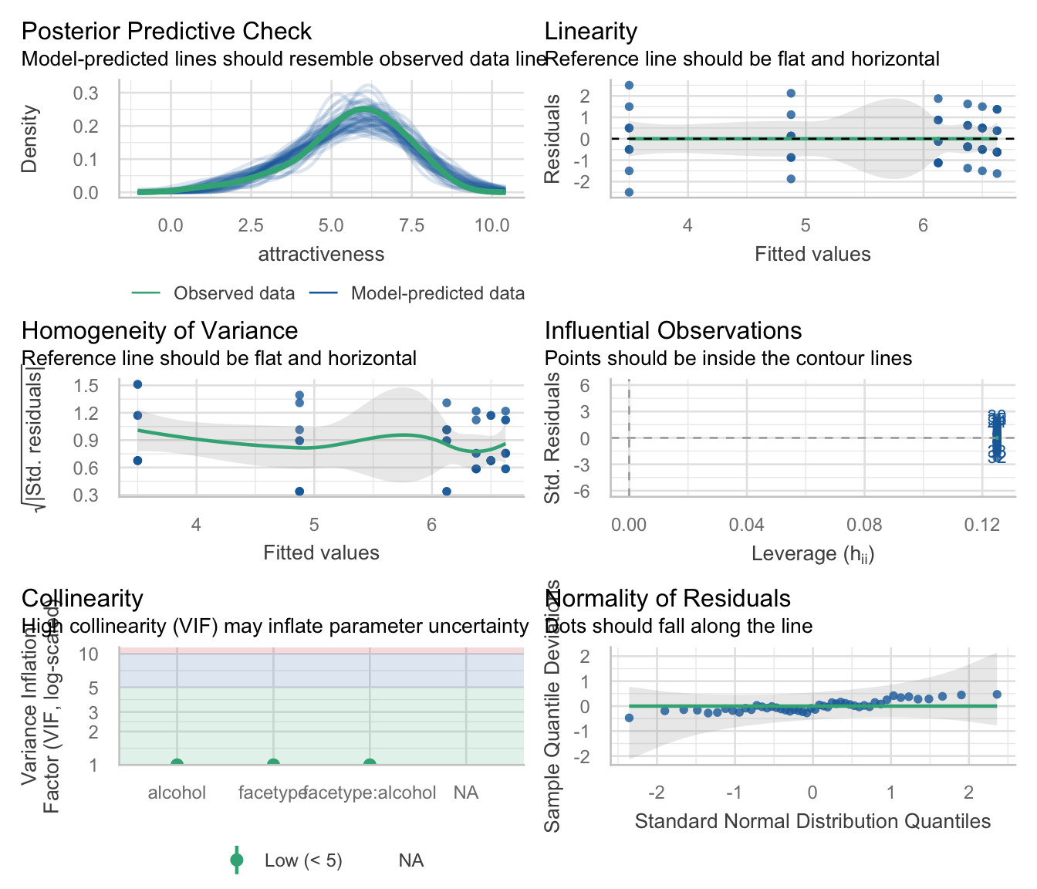

Slide 53: Interpret simple effects

Simple effects: facetype within alcohol group
Marginal Joint Test
Contrast | alcohol | df1 | df2 | F | p
facetype | Placebo | 1 | 42 | 24.15 | < .001
facetype | Low dose | 1 | 42 | 7.72 | 0.024
facetype | High dose | 1 | 42 | 0.73 | > .999
p-value adjustment method: Bonferroni

Slide 54: Interpret simple effects

Simple effects: facetype within alcohol group

Slide 55: Interpret simple effects

Simple effects: facetype within alcohol group
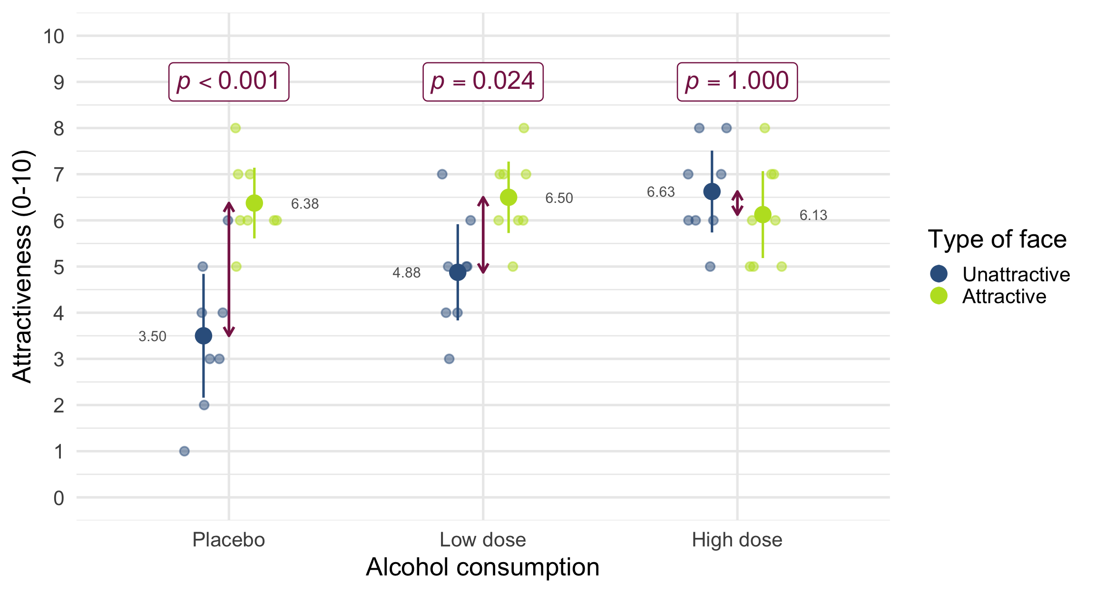

Slide 56: Interpret simple effects

Simple effects: alcohol within facetype
Marginal Joint Test
Contrast | facetype | df1 | df2 | F | p
alcohol | Unattractive | 2 | 42 | 14.33 | < .001
alcohol | Attractive | 2 | 42 | 0.21 | > .999
p-value adjustment method: Bonferroni

Slide 57: Interpret simple effects

Simple effects: alcohol within facetype

Slide 58: Interpret simple effects

Simple effects: alcohol within facetype
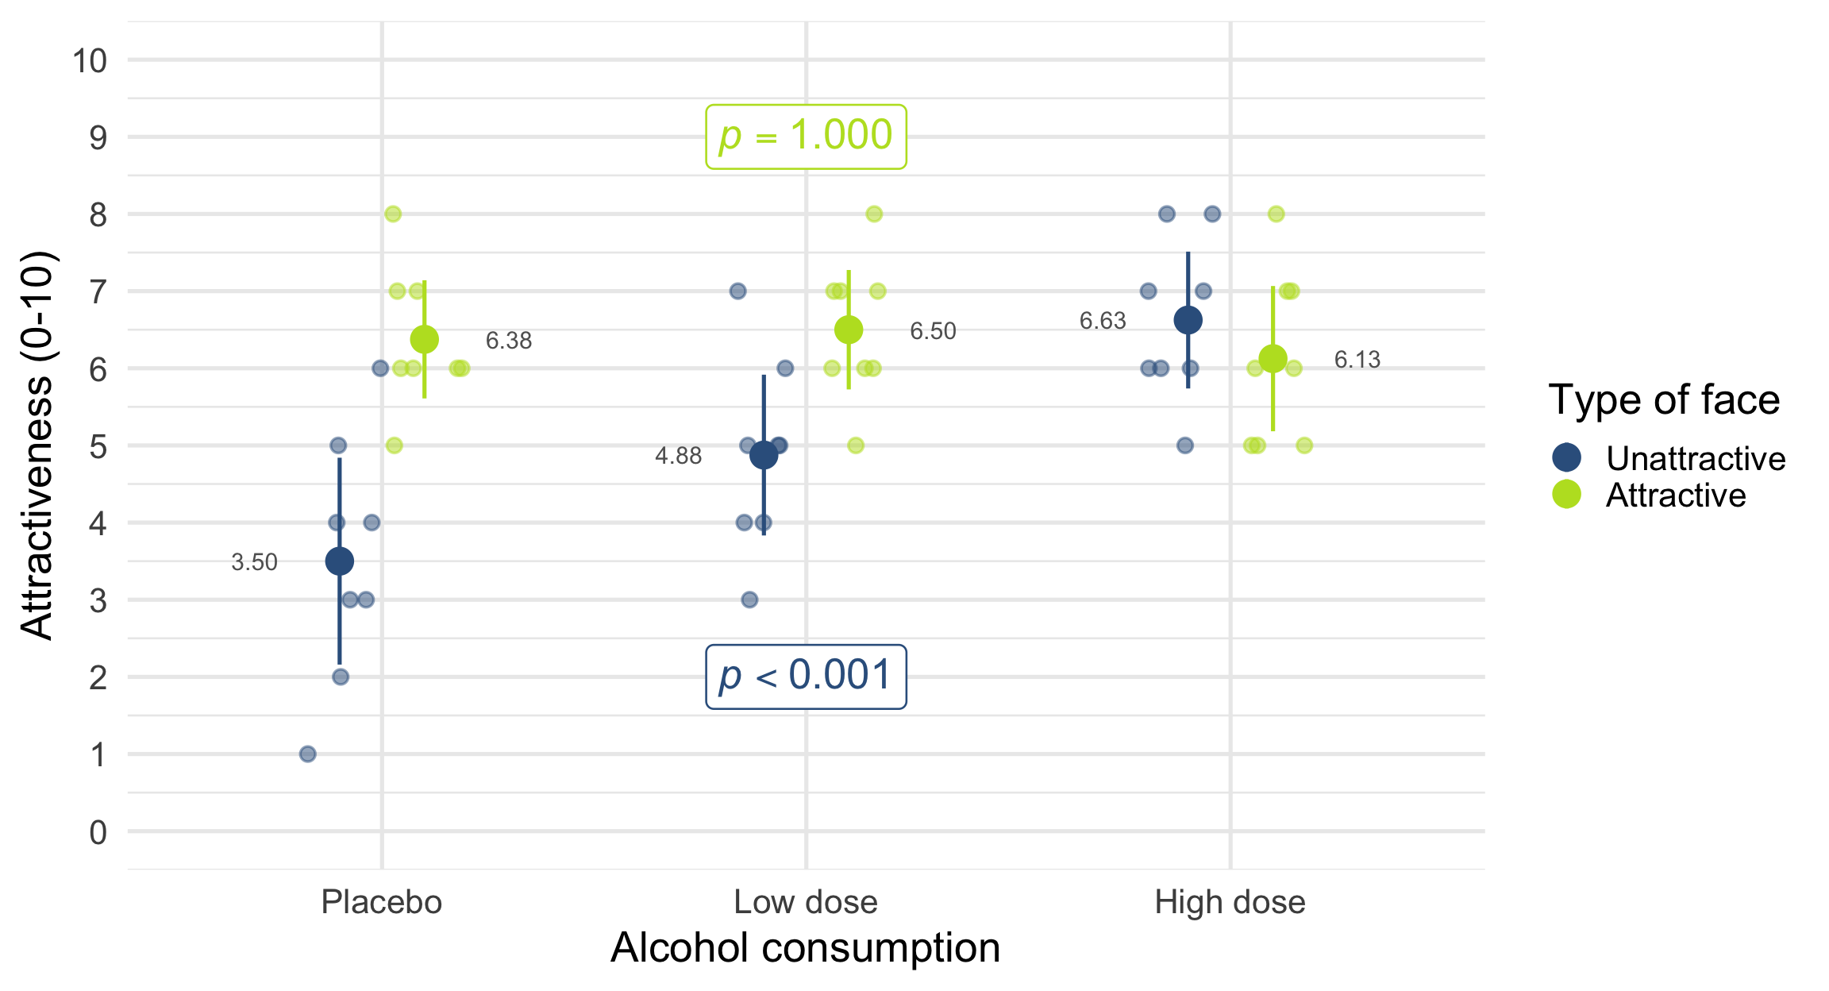

Slide 59: Summary
- Factorial designs: two or more predictor variables are manipulated
- Moderation: Where the effect of one predictor differs at levels of another-
- Testing moderation (interaction effects)
  - The model: a linear model in which predictors are entered as well as their interaction
  - Interpret interactions using plots or simple effects analysis, which quantifies the effect of one predictor at each level of another
  - The process of E.V.I.L.
- Main effects
  - The effect of one predictor variable collapsed across levels of other predictors
  - Uninteresting in the presence of a significant interaction

