Repeated measures designs
Andy Field, University of Sussex
Links: bsky.app | youtube.com | discoveringstatistics.com | discovr.rocks | statisticsadventure.com

About this version
This is a plain-text version of the lecture slides. Each slide starts with a heading such as “Slide 5”, and the numbers match the slide numbers shown in the lecture. Content that appeared one piece at a time, in columns or in tabs is shown in reading order. Videos and interactive apps are given as links.

Slide 2
Video clip: space opening scene

Slide 3
Video clip: daze intro 01

Slide 4
Video clip: daze intro 02

Slide 5
Video clip: transmission 01

Slide 6
Video clip: daze intro 03

Slide 7
Video clip: daze intro 04

Slide 8
Video clip: space hippo

Slide 9
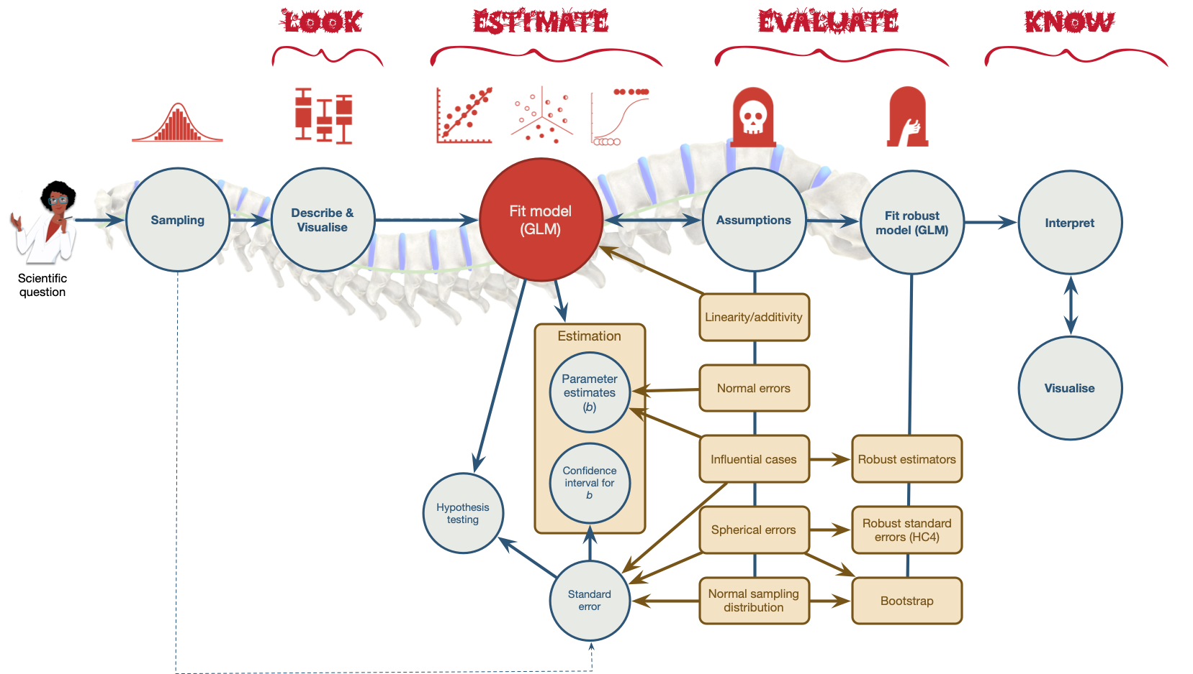
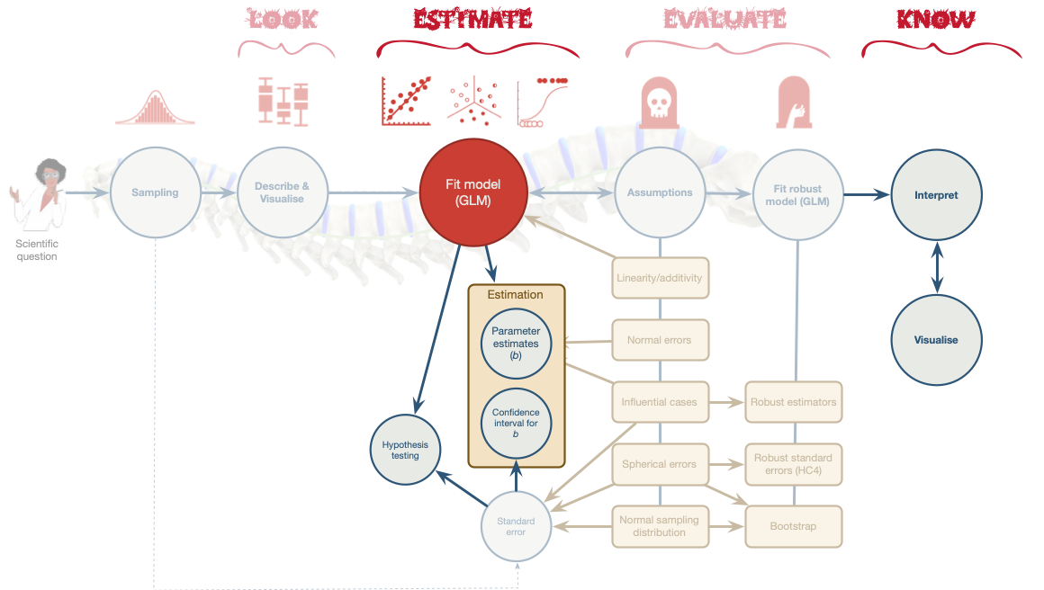

Slide 10
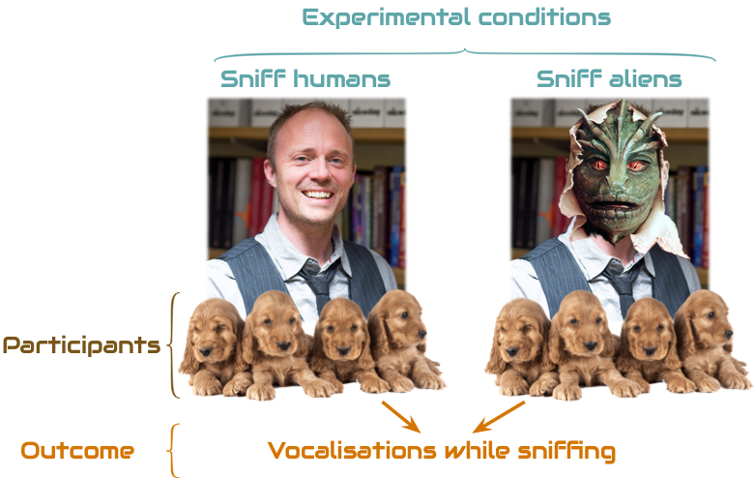
- Systematic variance: created by our manipulation
- Unsystematic variance: variance created by unknown factors

Slide 11: Benefits of repeated measures designs
- Sensitivity
  - Unsystematic variance is reduced
  - More sensitive to experimental effects
- Economy
  - Less participants are needed
  - But, be careful of fatigue

Slide 12: Can puppies sniff out aliens?
- Outcome = vocalizations during 1 min sniffing (vocalizations)
- Predictor: type of entity being sniffed (entity)
  - Alien (not in humanoid form)
  - Human (control for alien vs human)
  - Mannequin (control for humanoid form)
  - Shapeshifter (alien in humanoid form)
- dog_name indicates the name of the dog (N = 8)
Note: Statis-tip
This is a one-way repeated measures design.

Slide 13: The data
 | dog_name | Alien | Human | Mannequin | Shapeshifter | Mean | Variance
 | Milton | 8 | 7 | 1 | 6 | 5.50 | 7.25
 | Woofy | 9 | 5 | 2 | 5 | 5.25 | 6.19
 | Ramsey | 6 | 2 | 3 | 8 | 4.75 | 5.69
 | Mr. Snifficus III | 5 | 3 | 1 | 9 | 4.50 | 8.75
 | Willock | 8 | 4 | 5 | 8 | 6.25 | 3.19
 | The Venerable Dr. Waggy | 7 | 5 | 6 | 7 | 6.25 | 0.69
 | Lord Scenticle | 10 | 2 | 7 | 2 | 5.25 | 11.69
 | Professor Nose | 12 | 6 | 8 | 1 | 6.75 | 15.69
Mean | — | 8.12 | 4.25 | 4.12 | 5.75 | — | —

Slide 14: The data in R
Table 2: Data for the sniffer dog example
 | dog_name | entity | vocalizations
1 | Milton | Alien | 8
2 | Milton | Human | 7
3 | Milton | Mannequin | 1
4 | Milton | Shapeshifter | 6
5 | Woofy | Alien | 9
6 | Woofy | Human | 5
7 | Woofy | Mannequin | 2
8 | Woofy | Shapeshifter | 5
9 | Ramsey | Alien | 6
10 | Ramsey | Human | 2
11 | Ramsey | Mannequin | 3
12 | Ramsey | Shapeshifter | 8
13 | Mr. Snifficus III | Alien | 5
14 | Mr. Snifficus III | Human | 3
15 | Mr. Snifficus III | Mannequin | 1
16 | Mr. Snifficus III | Shapeshifter | 9
17 | Willock | Alien | 8
18 | Willock | Human | 4
19 | Willock | Mannequin | 5
20 | Willock | Shapeshifter | 8
21 | The Venerable Dr. Waggy | Alien | 7
22 | The Venerable Dr. Waggy | Human | 5
23 | The Venerable Dr. Waggy | Mannequin | 6
24 | The Venerable Dr. Waggy | Shapeshifter | 7
25 | Lord Scenticle | Alien | 10
26 | Lord Scenticle | Human | 2
27 | Lord Scenticle | Mannequin | 7
28 | Lord Scenticle | Shapeshifter | 2
29 | Professor Nose | Alien | 12
30 | Professor Nose | Human | 6
31 | Professor Nose | Mannequin | 8
32 | Professor Nose | Shapeshifter | 1

Slide 15: Repeated measures and the linear model
To keep things simple, imagine a design where dogs sniff only aliens or humans (e.g., two conditions)
$$\begin{aligned}{\text{vocalizations}}_{i}&=b_{0}+b_{1}{\text{entity}}_{i}+ε_{i}\end{aligned}$$
Entity sniffed | Dummy variable (entity)
Alien | 1
Human | 0
Warning: The danger zone!
Same participants in all conditions
- Scores across conditions correlate
- Violates the assumption of independent residuals (think back to the lecture on bias)

Slide 16: Repeated measures: hierrachical data structure
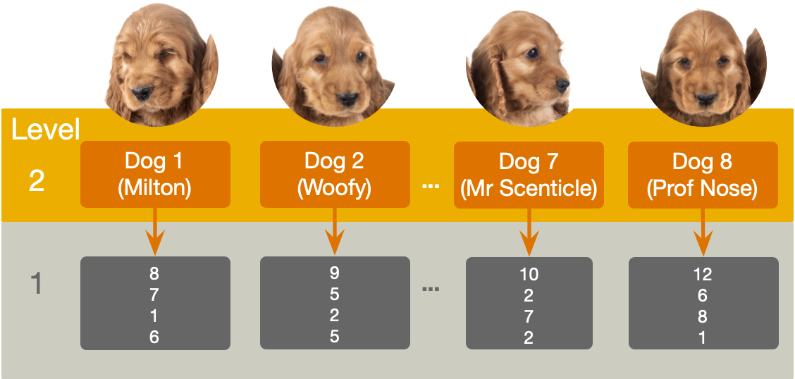

Slide 17: Repeated measures and the linear model
Need to adjust the model to estimate this dependency
$$\begin{aligned}{\text{vocalizations}}_{ij}&=(β_{0}+u_{0j})+(β_{1}+u_{1j}){\text{entity}}_{ij}+ε_{ij} \\ &=\left[β_{0}+β_{1}{\text{entity}}_{ij}\right]+\left[u_{0j}+u_{1j}{\text{entity}}_{ij}+ε_{ij}\right] \\ \end{aligned}$$

Slide 18
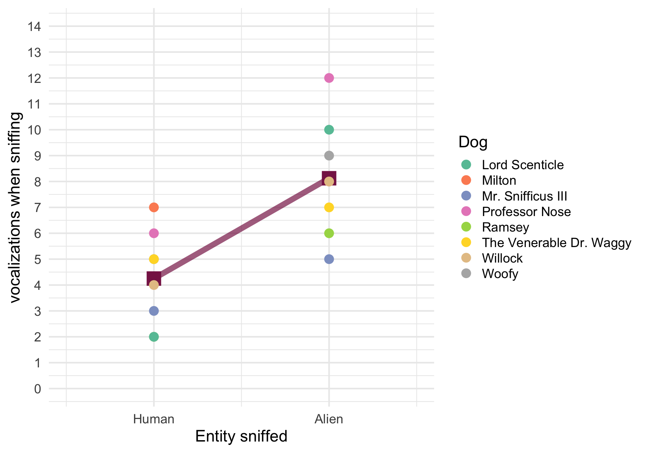
$$\begin{aligned}{\text{vocalizations}}_{ij}&=(β_{0}+u_{0j})+β_{1}{\text{entity}}_{ij}+ε_{ij}\end{aligned}$$

Slide 19
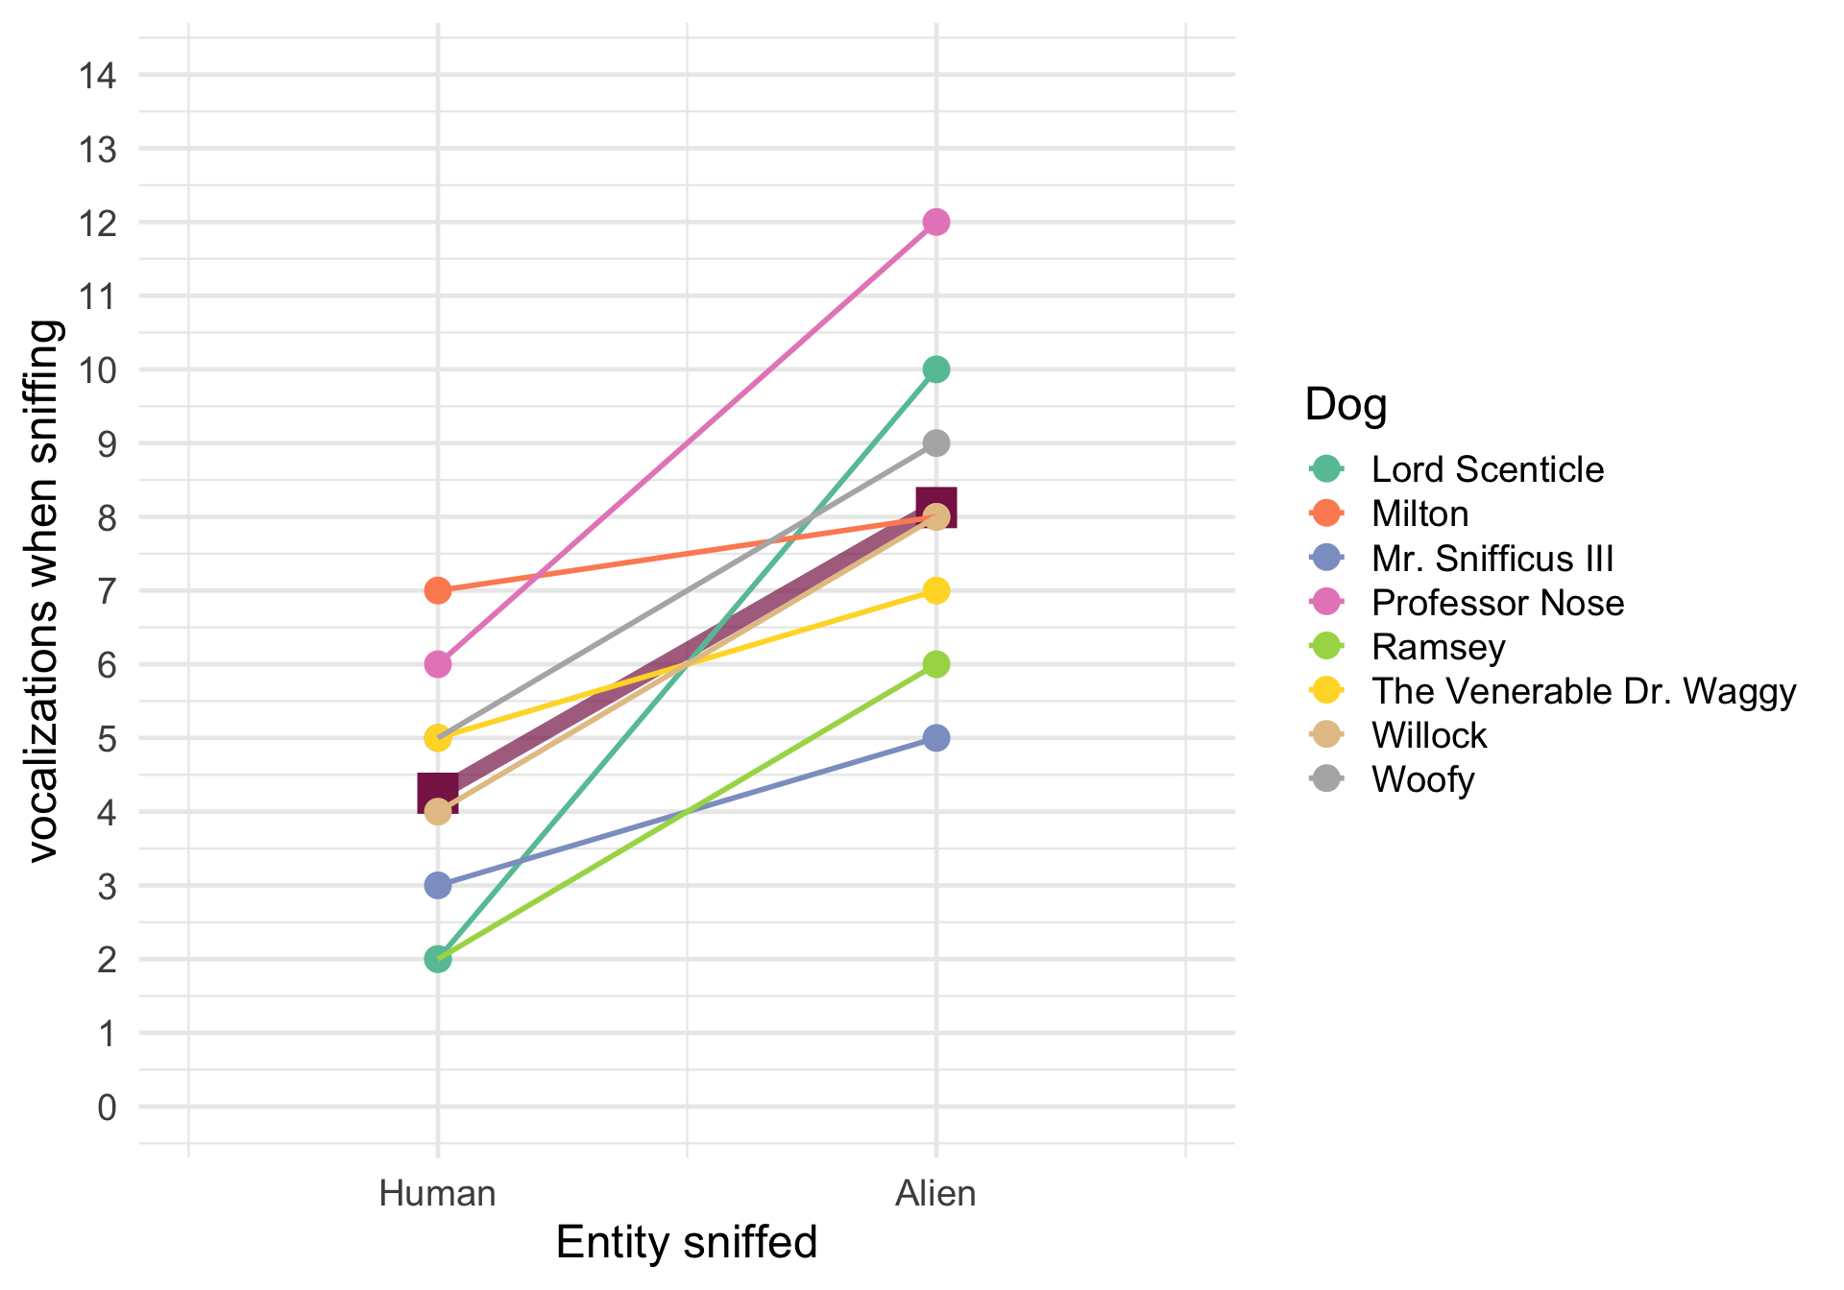
$$\begin{aligned}{\text{vocalizations}}_{ij}&=(β_{0}+u_{0j})+(β_{1}+u_{1j}){\text{entity}}_{ij}+ε_{ij}\end{aligned}$$

Slide 20: Repeated measures and the linear model
Back to our actual design (with 4 conditions: Alien, Human, Mannequin, Shapeshifter)
- entity would be split into 3 dummy/contrast variables
- Let’s just use default dummy coding
Entity sniffed | Dummy 1 (Alien vs. mannequin) | Dummy 2 (Shapeshifter vs. mannequin) | Dummy 3 (Human vs. mannequin)
Alien | 1 | 0 | 0
Shapeshifter | 0 | 1 | 0
Human | 0 | 0 | 1
Mannequin | 0 | 0 | 0

Slide 21
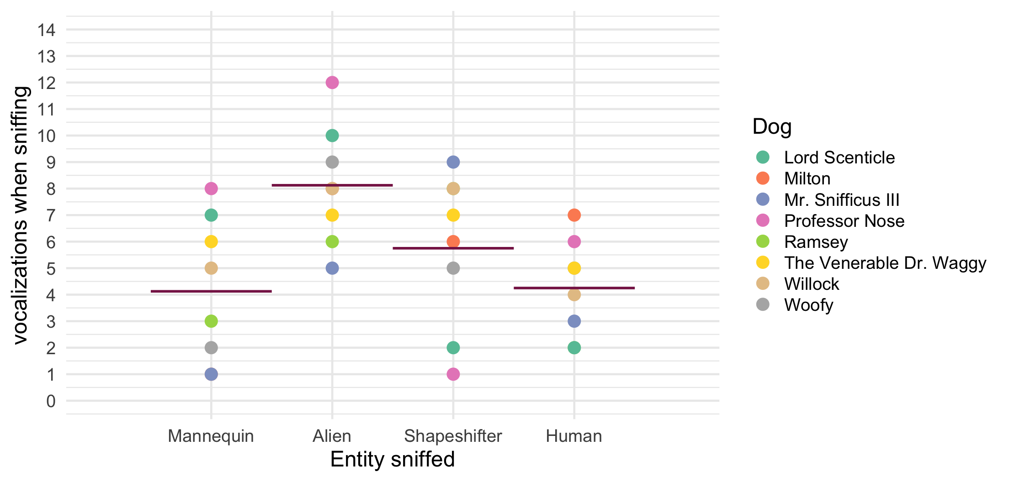

Slide 22
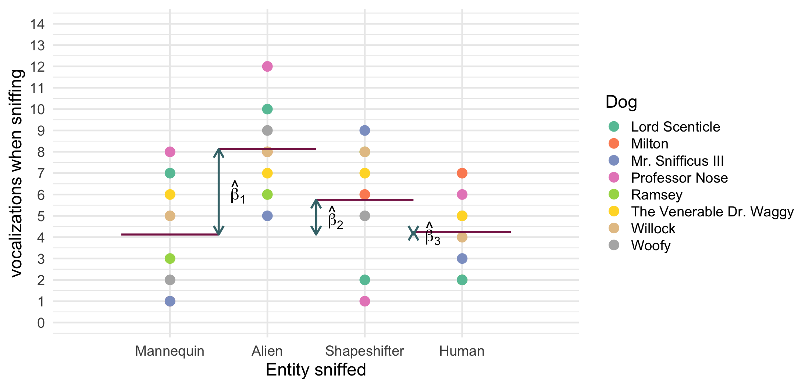
$$\begin{aligned}{\text{vocalizations}}_{ij}&=\left[β_{0}+β_{1}{\text{alien vs. manq}}_{ij}+β_{2}{\text{shape vs. manq}}_{ij}+β_{3}{\text{human vs. manq}}_{ij}\right] \\ & +\left[u_{0j}+ε_{ij}\right] \\ \end{aligned}$$

Slide 23
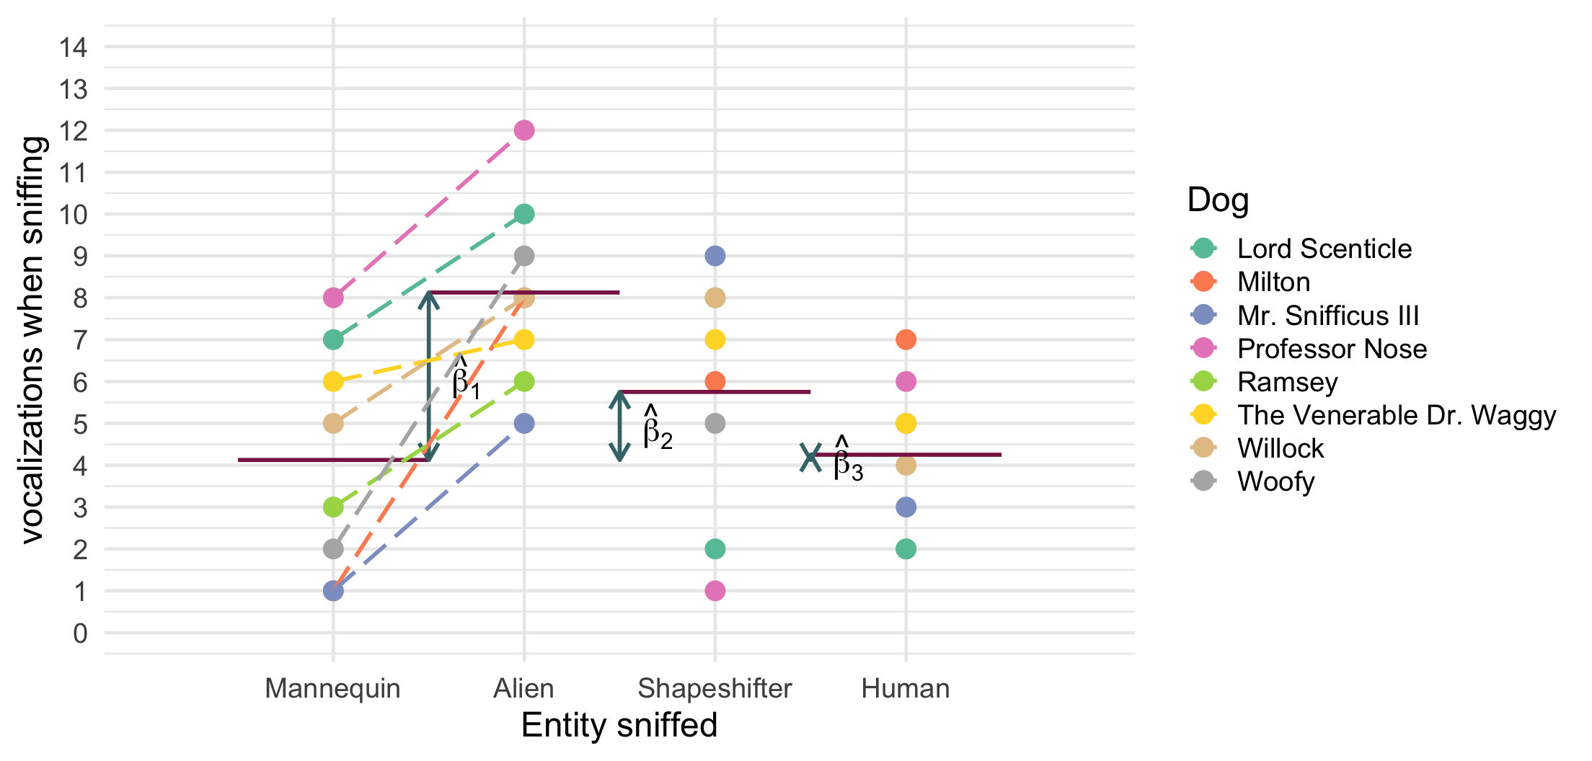
$$\begin{aligned}{\text{vocalizations}}_{ij}&=\left[β_{0}+β_{1}{\text{alien vs. manq}}_{ij}+β_{2}{\text{shape vs. manq}}_{ij}+β_{3}{\text{human vs. manq}}_{ij}\right] \\ & +\left[u_{0j}+u_{1j}{\text{alien vs. manq}}_{ij}+ε_{ij}\right] \\ \end{aligned}$$

Slide 24
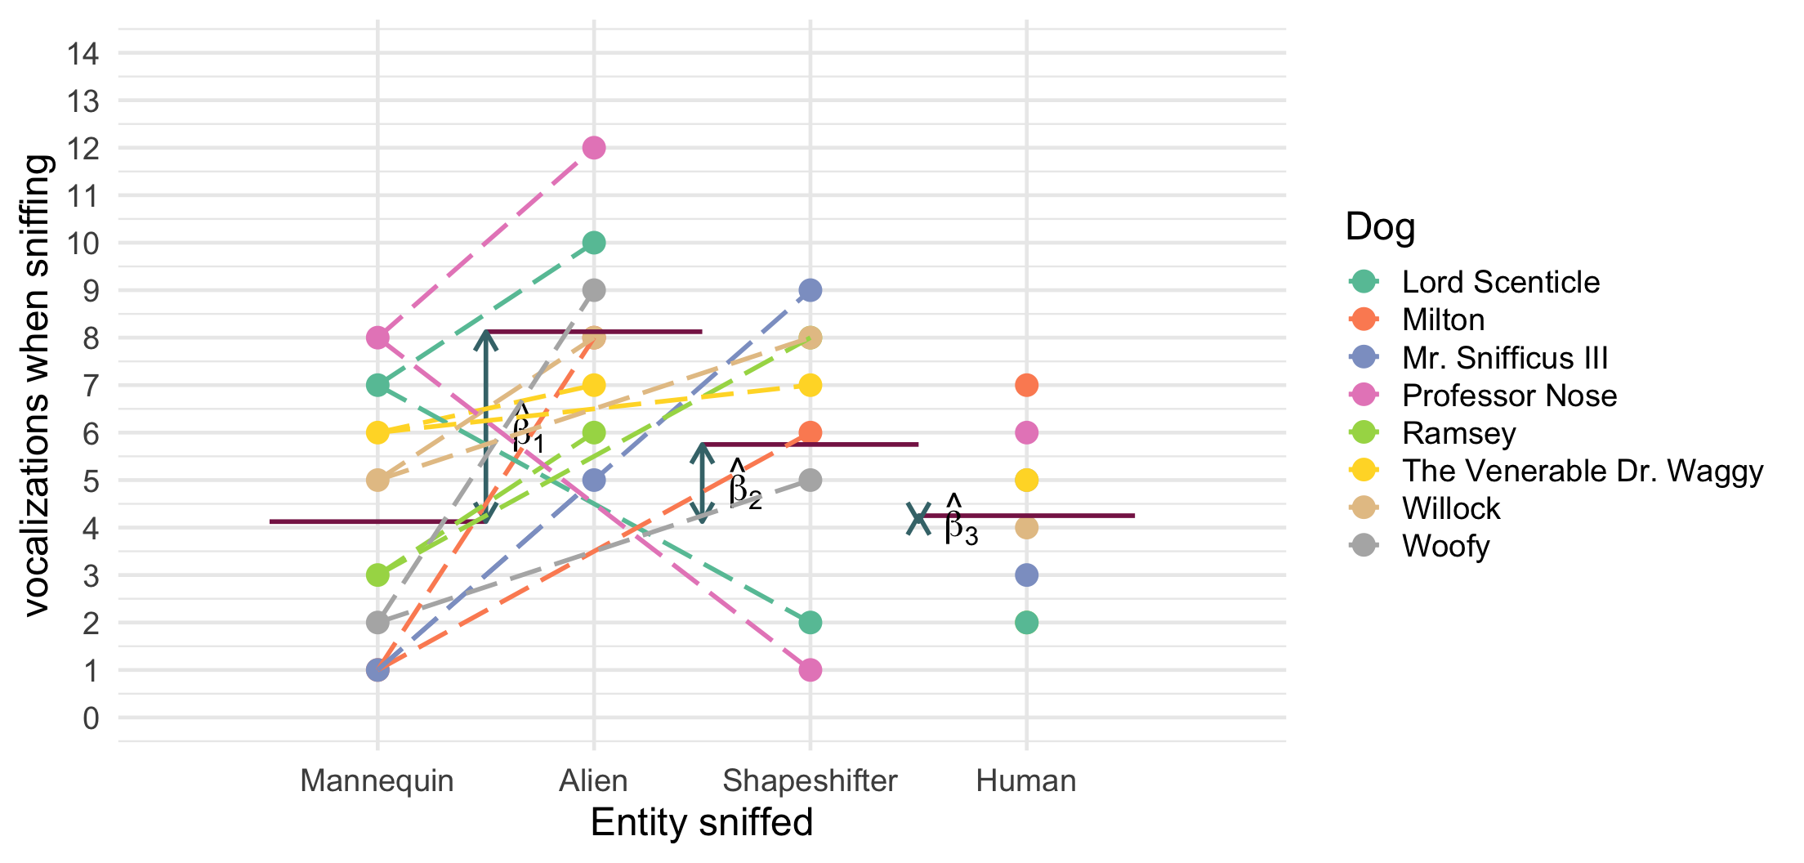
$$\begin{aligned}{\text{vocalizations}}_{ij}&=\left[β_{0}+β_{1}{\text{alien vs. manq}}_{ij}+β_{2}{\text{shape vs. manq}}_{ij}+β_{3}{\text{human vs. manq}}_{ij}\right] \\ & +\left[u_{0j}+u_{1j}{\text{alien vs. manq}}_{ij}+u_{2j}{\text{shape vs. manq}}_{ij}+ε_{ij}\right] \\ \end{aligned}$$

Slide 25
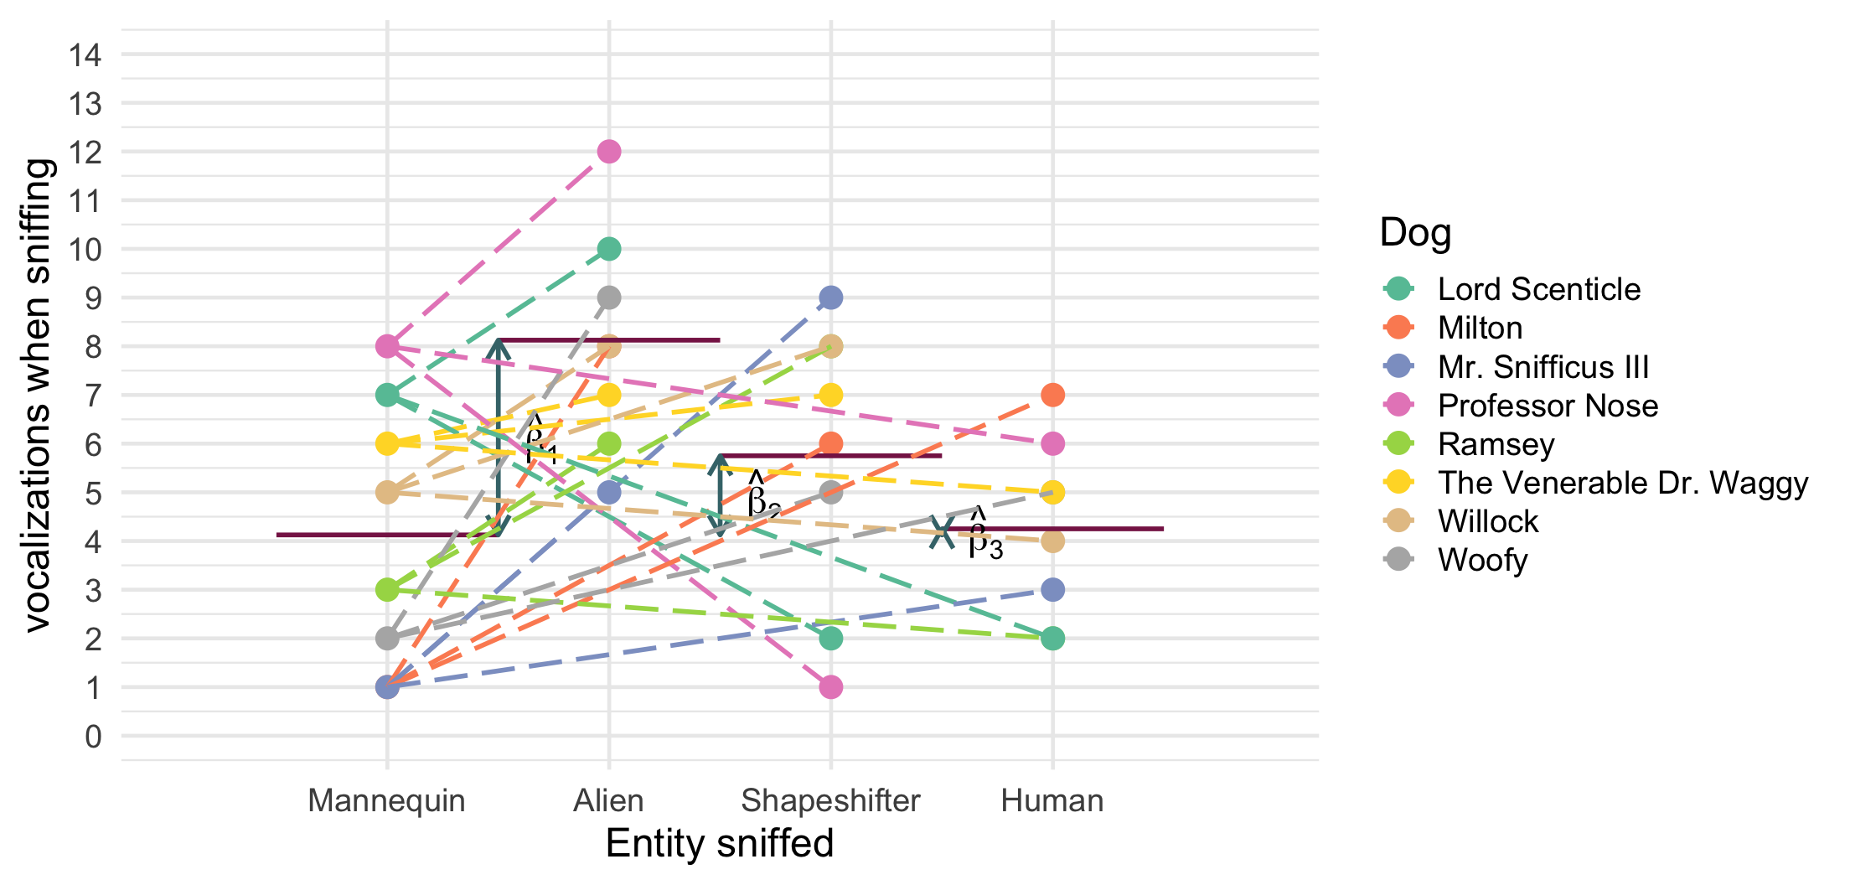
$$\begin{aligned}{\text{vocalizations}}_{ij}&=\left[β_{0}+β_{1}{\text{alien vs. manq}}_{ij}+β_{2}{\text{shape vs. manq}}_{ij}+β_{3}{\text{human vs. manq}}_{ij}\right] \\ & +\left[u_{0j}+u_{1j}{\text{alien vs. manq}}_{ij}+u_{2j}{\text{shape vs. manq}}_{ij}+u_{3j}{\text{human vs. manq}}_{ij}+ε_{ij}\right] \\ \end{aligned}$$

Slide 26: Approaches to repeated measures designs

Historic: Repeated measures ANOVA (RM-ANOVA)
- Restricts the model in two (unrealistic) ways
  - Assumes effects are equivalent across participants (the effect in participant 1 is the same as in participant 2)
  - Errors have compound symmetry/sphericity
  - CS: The correlation between scores across conditions is the same
  - Sphericity: differences between scores in pairs of conditions have equal variances

Multilevel modelling (MLM) approach
- Fewer restrictions: doesn’t require CS or sphericity
- Can include multiple hierarchical structures (e.g., observations within people, within clinics)
- In general, copes with missing values (RM-ANOVA doesn’t)
- Can be extended to categorical outcomes (RM-ANOVA cannot)
- Contrast coding is possible

Slide 27: Fitting the model
- Use glmmTMB::glmmTMB()
  - A trickier but more flexible option
  - Manually set contrasts
  - Can get parameter estimates, diagnostic plots, and robust methods
- The afex::aov_4() function
  - Specify the repeated measures with (rm_predictors|id_var)
  - Automatically sets contrasts
  - Built in interaction plot with afex_plot()
  - But … no parameter estimates, limited diagnostic plots, or robust methods
  - See alternative tutorial

Slide 28
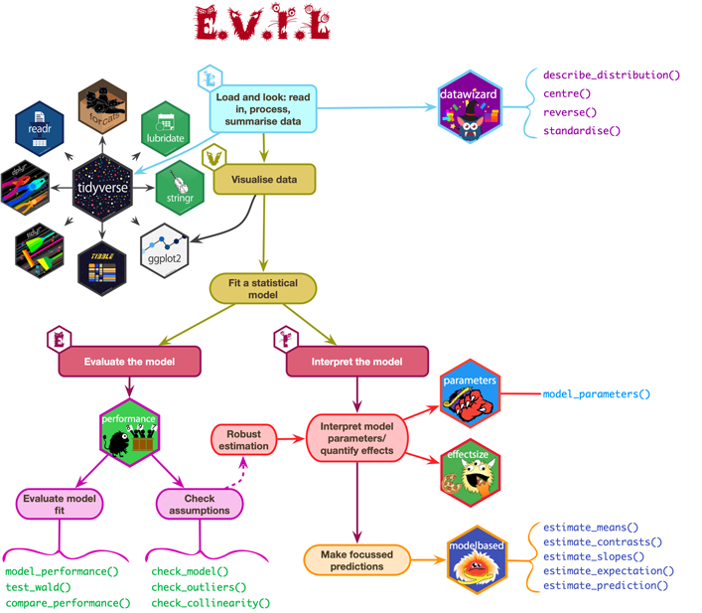

Slide 29: Load and Look
sniff_tib |>
group_by(entity) |>
describe_distribution(select = "vocalizations") |>
data_remove(c("Variable", "n_Missing")) |> # optional to remove redundant column
display()
entity | Mean | SD | IQR | Range | Skewness | Kurtosis | n
Alien | 8.12 | 2.23 | 3.50 | (5.00, 12.00) | 0.41 | 0.01 | 8
Human | 4.25 | 1.83 | 3.50 | (2.00, 7.00) | 0.07 | -1.22 | 8
Mannequin | 4.12 | 2.75 | 5.50 | (1.00, 8.00) | 0.16 | -1.78 | 8
Shapeshifter | 5.75 | 2.92 | 5.25 | (1.00, 9.00) | -0.78 | -0.76 | 8


Slide 30: Visualize
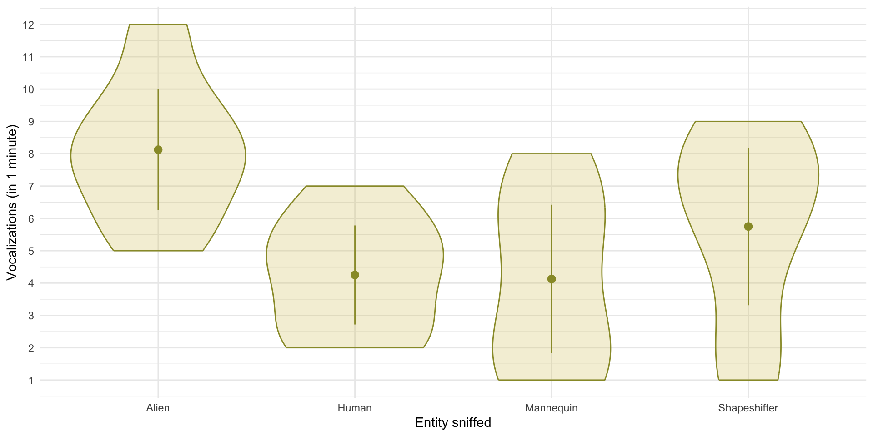


Slide 31: Fit the model: Contrasts
If the dog training has been successful then we’d expect sniffer dogs to make more vocalizations when sniffing alien entities than non alien-entities.
- Contrast 1: {alien, shapeshifter} vs. {human, mannequin}
We have two ‘chunks’ in contrast 1 that would then need to be decomposed:
- Contrast 2: {alien} vs. {shapeshifter}
- Contrast 3: {human} vs. {mannequin}
Using the rules for contrast coding we’d get the codes in Table 4:
Table 4: Contrast coding for the entity variable
Group | Contrast 1 | Contrast 2 | Contrast 3
Alien | 1/2 | 1/2 | 0
Human | -1/2 | 0 | 1/2
Mannequin | -1/2 | 0 | -1/2
Shapeshifter | 1/2 | -1/2 | 0

Slide 32: Fitting the model
aliens_vs_non = c(1/2, -1/2, -1/2, 1/2)
alien_vs_shape = c(1/2, 0, 0, -1/2)
human_vs_manquin = c(0, 1/2, -1/2, 0)
contrasts(sniff_tib$entity) <- cbind(aliens_vs_non,
alien_vs_shape,
human_vs_manquin)
sniff_mlm <- glmmTMB::glmmTMB(vocalizations ~ entity + (1|dog_name),
data = sniff_tib)

Slide 33: Evaluate the model
test_lrt(sniff_mlm) |>
display()
Likelihood-Ratio-Test (LRT) for Model Comparison
Name | df | df_diff | Chi2 | p
Null model | 3
Full model | 6 | 3 | 12.69 | 0.005
Important: ReportR
The entity sniffed had a significant effect on the number of vocalizations by sniffer dogs, $χ^{2}$(3) = 12.69, p = 0.005.


Slide 34: Evaluate the model
model_performance(sniff_mlm) |>
display()
Random effect variances not available. Returned R2 does not account for random effects.
AIC | AICc | BIC | R2 (cond.) | R2 (marg.) | RMSE | Sigma
156.4 | 159.8 | 165.2 |  | 0.33 | 2.31 | 2.31

Slide 35: Evaluate assumptions
check_model(sniff_mlm)
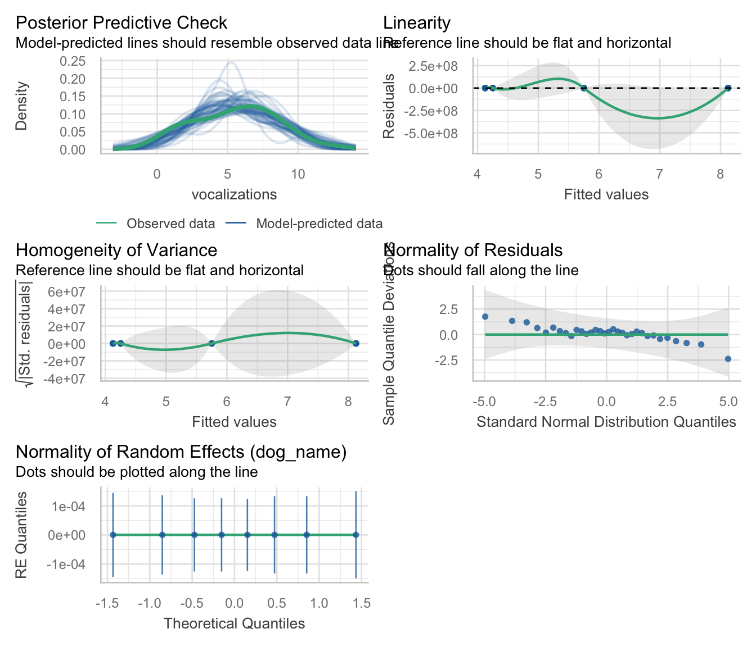

Slide 36: Interpret parameter estimates, CIs and tests
model_parameters(sniff_mlm, effects = "fixed") |>
display()
Fixed Effects
Parameter | Coefficient | SE | 95% CI | z | p
(Intercept) | 5.56 | 0.41 | (4.76, 6.36) | 13.62 | < .001
entityaliens vs non | 2.75 | 0.82 | (1.15, 4.35) | 3.37 | < .001
entityalien vs shape | 2.38 | 1.15 | (0.11, 4.64) | 2.06 | 0.040
entityhuman vs manquin | 0.12 | 1.15 | (-2.14, 2.39) | 0.11 | 0.914
Important: ReportR
Contrasts revealed that vocalizations were significantly higher when sniffing aliens compared to non-aliens, $\hat{b}$ = 2.75 (1.15, 4.35), z = 3.37, p < 0.001), and when sniffing an alien compared to a shapeshifter, $\hat{b}$ = 2.38 (0.11, 4.64), z = 2.06, p = 0.040 but not when sniffing a human compared to a mannequin, $\hat{b}$ = 0.12 (-2.14, 2.39), z = 0.11, p = 0.914).


Slide 37
Audio clip: spaceship interior

Slide 38
Video clip: daze middle 01

Slide 39
Video clip: transmission 02 lme

Slide 40
Video clip: daze middle 02

Slide 41 (new section): Scenting a victory … factorial repeated measures designs

Slide 42: Can scents distract the sniffer dogs?
- 50 sniffer dogs
  - Participated in all conditions
  - Sniffed 9 different ‘things’
- Predictor: entity
  - Human: the dog sniffs a human
  - Shapeshifter the dog sniffs an alien in humanoid form
  - Alien the dog sniffs an alien in lizard form
- Predictor: scent_mask
  - The entity had no masking scent (none)
  - The entity was smeared with human pheromones
  - The entity was smeared with fox pheromones
- Outcome: The number of vocalizations during each 1 minute sniff
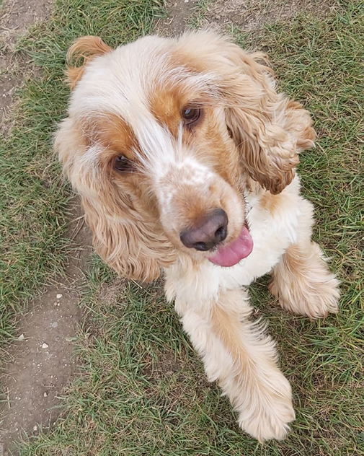
Note: Statis-tip
This is a two-way repeated measures design.

Slide 43: The model
- Let’s simplify things by ignoring the fact that entity and scent_mask will be represented by two dummy variables each (and the interaction by 4!)
- We can model individual differences in all parameters
$$\begin{aligned}{\text{vocalizations}}_{ij}&=\left[β_{0}+β_{1}{\text{entity}}_{ij}+β_{2}{\text{scent}}_{ij}+β_{3}({\text{entity}}_{ij}×{\text{scent}}_{ij})\right]+ \\ & \left[u_{0j}+u_{1j}{\text{entity}}_{ij}+u_{2j}{\text{scent}}_{ij}+u_{3j}({\text{entity}}_{ij}×{\text{scent}}_{ij})+ε_{ij}\right] \\ \end{aligned}$$
- This model will be too complex to fit
- The simplest version of the repeated measures model instead treats the effects of predictor variables as fixed, but acknowledges that dogs, overall, will vary in their vocalizations:
$$\begin{aligned}{\text{vocalizations}}_{ij}&=\left[β_{0}+β_{1}{\text{entity}}_{ij}+β_{2}{\text{scent}}_{ij}+β_{3}({\text{entity}}_{ij}×{\text{scent}}_{ij})\right]+ \\ & \left[u_{0j}+ε_{ij}\right] \\ u_{0j}&∼N(0,σ_{μ_{0}}^{2})\end{aligned}$$

Slide 44: Load and Look
Table 7: Data for the scent masking example (first 50 of 450 rows)
 | dog_id | entity | scent_mask | vocalizations
1 | 56f9p | Alien | Fox | 7
2 | 56f9p | Alien | Human | 9
3 | 56f9p | Alien | None | 8
4 | 56f9p | Shapeshifter | Fox | 11
5 | 56f9p | Shapeshifter | Human | 6
6 | 56f9p | Shapeshifter | None | 8
7 | 56f9p | Human | Fox | 3
8 | 56f9p | Human | Human | 3
9 | 56f9p | Human | None | 3
10 | 2m89y | Alien | Fox | 8
11 | 2m89y | Alien | Human | 8
12 | 2m89y | Alien | None | 10
13 | 2m89y | Shapeshifter | Fox | 10
14 | 2m89y | Shapeshifter | Human | 7
15 | 2m89y | Shapeshifter | None | 10
16 | 2m89y | Human | Fox | 6
17 | 2m89y | Human | Human | 4
18 | 2m89y | Human | None | 3
19 | 682h3 | Alien | Fox | 13
20 | 682h3 | Alien | Human | 5
21 | 682h3 | Alien | None | 5
22 | 682h3 | Shapeshifter | Fox | 4
23 | 682h3 | Shapeshifter | Human | 4
24 | 682h3 | Shapeshifter | None | 7
25 | 682h3 | Human | Fox | 8
26 | 682h3 | Human | Human | 2
27 | 682h3 | Human | None | 2
28 | 7o1d2 | Alien | Fox | 7
29 | 7o1d2 | Alien | Human | 10
30 | 7o1d2 | Alien | None | 12
31 | 7o1d2 | Shapeshifter | Fox | 9
32 | 7o1d2 | Shapeshifter | Human | 6
33 | 7o1d2 | Shapeshifter | None | 12
34 | 7o1d2 | Human | Fox | 8
35 | 7o1d2 | Human | Human | 2
36 | 7o1d2 | Human | None | 2
37 | 2k3vo | Alien | Fox | 11
38 | 2k3vo | Alien | Human | 9
39 | 2k3vo | Alien | None | 11
40 | 2k3vo | Shapeshifter | Fox | 10
41 | 2k3vo | Shapeshifter | Human | 9
42 | 2k3vo | Shapeshifter | None | 7
43 | 2k3vo | Human | Fox | 7
44 | 2k3vo | Human | Human | 5
45 | 2k3vo | Human | None | 2
46 | ik011 | Alien | Fox | 6
47 | ik011 | Alien | Human | 9
48 | ik011 | Alien | None | 11
49 | ik011 | Shapeshifter | Fox | 8
50 | ik011 | Shapeshifter | Human | 9

Slide 45: Load and Look
scent_tib |>
group_by(entity, scent_mask) |>
describe_distribution(select = "vocalizations") |>
data_remove(c("Variable", "n_Missing")) |> # optional to remove redundant column
display()
entity | scent_mask | Mean | SD | IQR | Range | Skewness | Kurtosis | n
Human | None | 2.98 | 1.08 | 2.00 | (1.00, 6.00) | 0.45 | 0.27 | 50
Shapeshifter | None | 10.42 | 2.79 | 4.25 | (5.00, 16.00) | 0.04 | -0.73 | 50
Alien | None | 12.06 | 3.03 | 4.00 | (5.00, 19.00) | 0.18 | -0.21 | 50
Human | Human | 4.16 | 1.42 | 2.00 | (1.00, 8.00) | 0.33 | 0.26 | 50
Shapeshifter | Human | 8.78 | 2.47 | 2.50 | (4.00, 16.00) | 0.44 | 0.94 | 50
Alien | Human | 9.98 | 2.75 | 2.50 | (3.00, 19.00) | 0.61 | 1.82 | 50
Human | Fox | 7.32 | 1.98 | 3.00 | (3.00, 11.00) | -0.25 | -0.45 | 50
Shapeshifter | Fox | 8.84 | 2.43 | 4.00 | (4.00, 16.00) | 0.46 | 0.53 | 50
Alien | Fox | 9.18 | 2.41 | 4.00 | (5.00, 14.00) | 0.14 | -0.68 | 50

Slide 46: Visualize
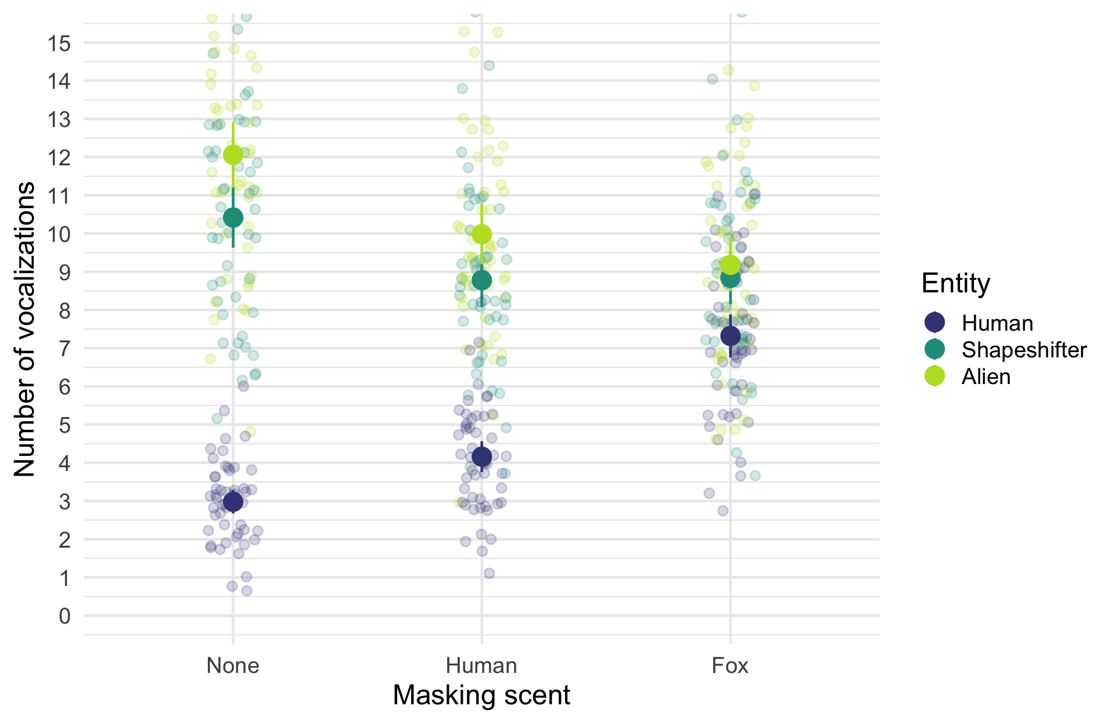

Slide 47: Fit the model: contrasts
We have a natural control group for the entity (human) so a natural contrast is to use dummy coding.
- Contrast 1: {alien} vs. {human}
- Contrast 2: {shapeshifter} vs. {human}
We have a natural control group for the scent masks (no scent) so a natural contrast is to use dummy coding.
- Contrast 1: {human} vs. {none}
- Contrast 2: {fox} vs. {none}

Slide 48: Specifying contrasts
The level order of the variables is:
levels(scent_tib$entity)
[1] "Human" "Shapeshifter" "Alien"
levels(scent_tib$scent_mask)
[1] "None" "Human" "Fox"
We can do nothing (default dummy coding will do the above) or set up contrasts explicitly with:
contrasts(scent_tib$entity) <- contr.treatment(3, base = 1)
contrasts(scent_tib$scent_mask) <- contr.treatment(3, base = 1)

Slide 49: Building models
scent_base <- glmmTMB::glmmTMB(
vocalizations ~ 1 + (1|dog_id),
data = scent_tib)
scent_ent <- glmmTMB::glmmTMB(
vocalizations ~ entity + (1|dog_id),
data = scent_tib)
scent_scent <- glmmTMB::glmmTMB(
vocalizations ~ entity + scent_mask + (1|dog_id),
data = scent_tib)
scent_int <- glmmTMB::glmmTMB(
vocalizations ~ entity + scent_mask + entity:scent_mask + (1|dog_id),
data = scent_tib)

Slide 50: Evaluate
test_lrt(scent_base, scent_ent, scent_scent, scent_int) |>
display()
Likelihood-Ratio-Test (LRT) for Model Comparison (ML-estimator)
Name | df | df_diff | Chi2 | p
scent_base | 3
scent_ent | 5 | 2 | 327.42 | < .001
scent_scent | 7 | 2 | 13.36 | 0.001
scent_int | 11 | 4 | 183.79 | < .001
Warning: The danger zone!
“It is never sensible to interpret main effects in the presence of a significant interaction effect.”

Slide 51: Evaluate
model_performance(scent_int) |>
display()
AIC | AICc | BIC | R2 (cond.) | R2 (marg.) | ICC | RMSE | Sigma
1918.9 | 1919.5 | 1964.1 | 0.76 | 0.59 | 0.41 | 1.70 | 1.78

Slide 52: Evaluate assumptions
check_model(scent_int)
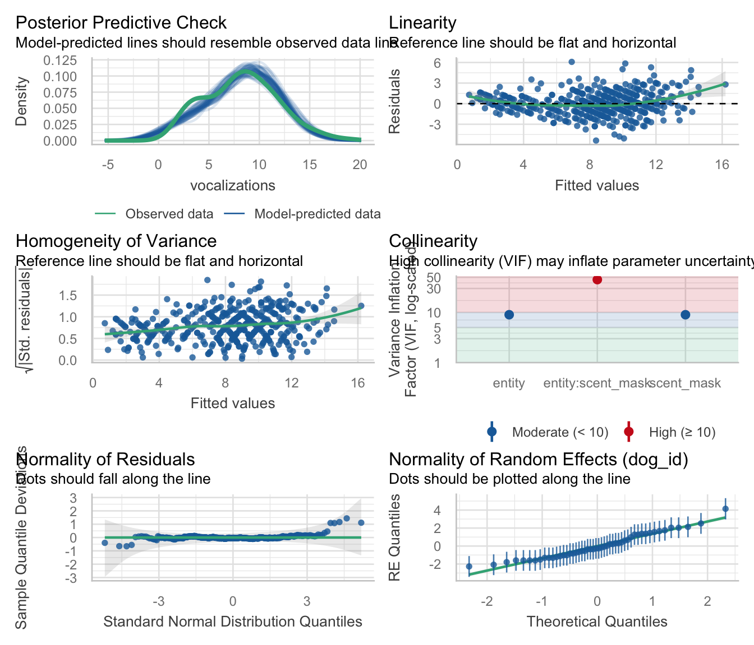

Slide 53: Interpret: Entity × scent_mask interaction
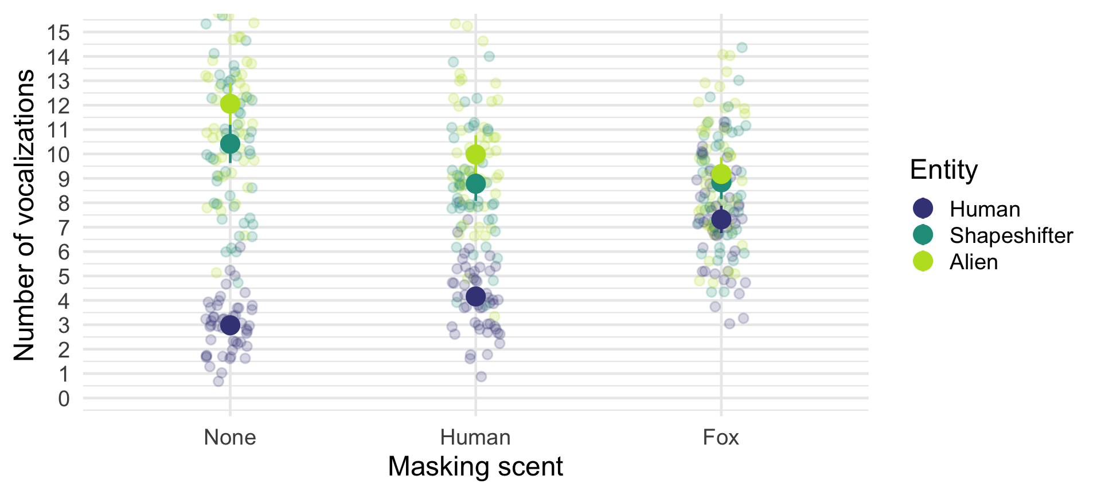
Important: ReportR
The interaction effect suggests that the effect of entity on vocalizations was significantly moderated by what scent the entity was wearing, $χ^{2}$(4) = 183.79, p < 0.001.

Slide 54: Interpret
model_parameters(scent_int, effects = "fixed") |>
display()
Fixed Effects
Parameter | Coefficient | SE | 95% CI | z | p
(Intercept) | 2.98 | 0.33 | (2.34, 3.62) | 9.08 | < .001
entity (Shapeshifter) | 7.44 | 0.36 | (6.74, 8.14) | 20.85 | < .001
entity (Alien) | 9.08 | 0.36 | (8.38, 9.78) | 25.45 | < .001
scent mask (Human) | 1.18 | 0.36 | (0.48, 1.88) | 3.31 | < .001
scent mask (Fox) | 4.34 | 0.36 | (3.64, 5.04) | 12.16 | < .001
entity (Shapeshifter) × scent mask (Human) | -2.82 | 0.50 | (-3.81, -1.83) | -5.59 | < .001
entity (Alien) × scent mask (Human) | -3.26 | 0.50 | (-4.25, -2.27) | -6.46 | < .001
entity (Shapeshifter) × scent mask (Fox) | -5.92 | 0.50 | (-6.91, -4.93) | -11.73 | < .001
entity (Alien) × scent mask (Fox) | -7.22 | 0.50 | (-8.21, -6.23) | -14.31 | < .001

Slide 55: Entity × scent_mask interaction: parameter 1
Fixed Effects
Parameter | Coefficient | SE | 95% CI | z | p
entity (Shapeshifter) × scent mask (Human) | -2.82 | 0.50 | (-3.81, -1.83) | -5.59 | < .001
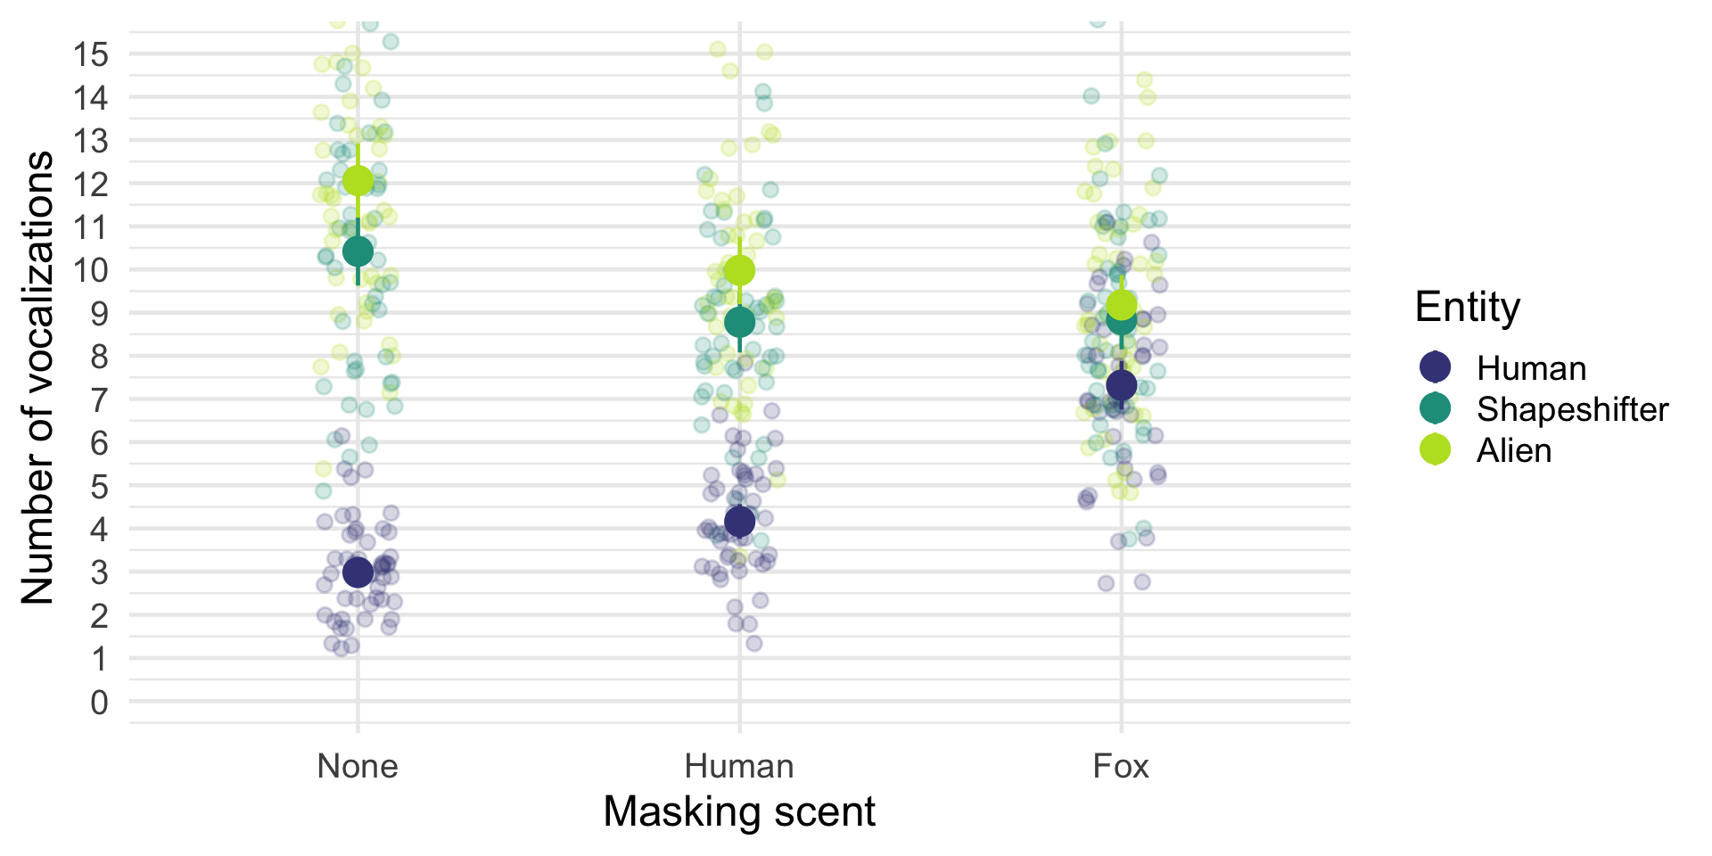

Slide 56: Entity × scent_mask interaction: parameter 1
Fixed Effects
Parameter | Coefficient | SE | 95% CI | z | p
entity (Shapeshifter) × scent mask (Human) | -2.82 | 0.50 | (-3.81, -1.83) | -5.59 | < .001
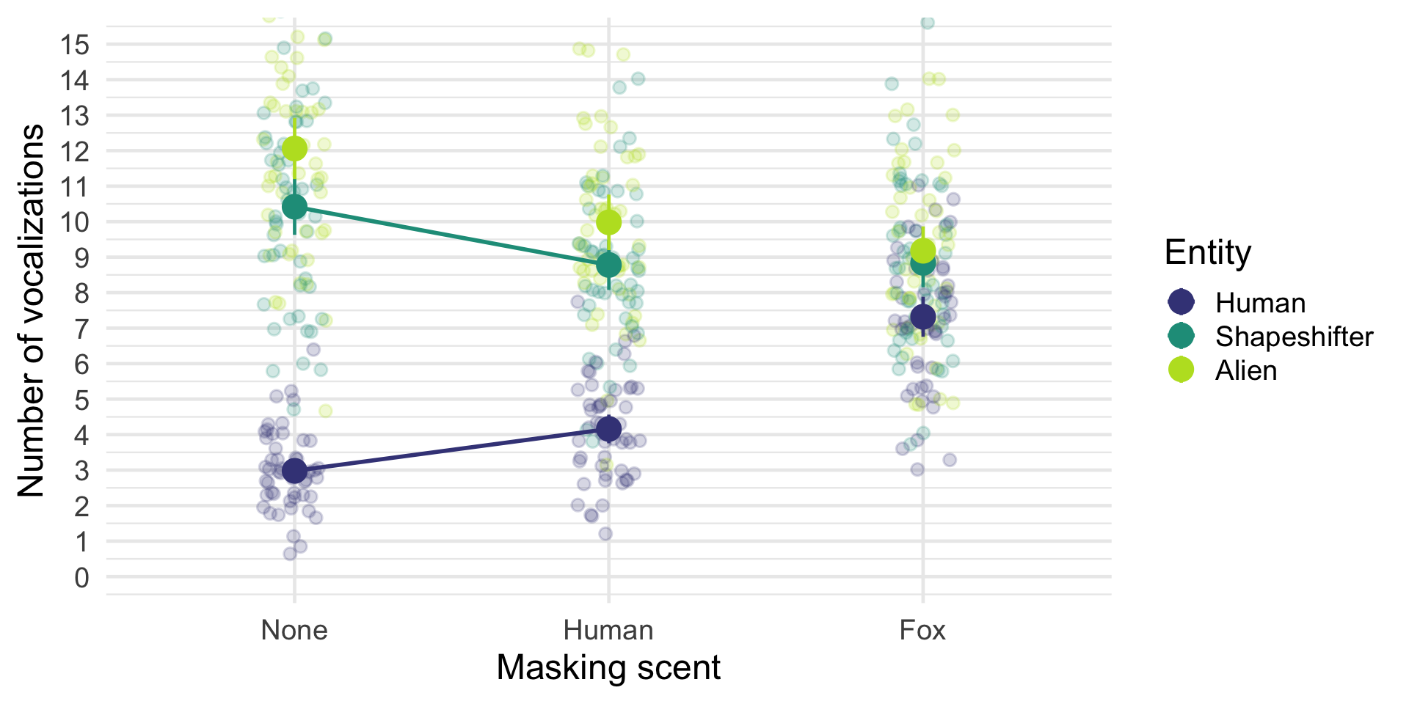

Slide 57: Entity × scent_mask interaction: parameter 2
Fixed Effects
Parameter | Coefficient | SE | 95% CI | z | p
entity (Alien) × scent mask (Human) | -3.26 | 0.50 | (-4.25, -2.27) | -6.46 | < .001
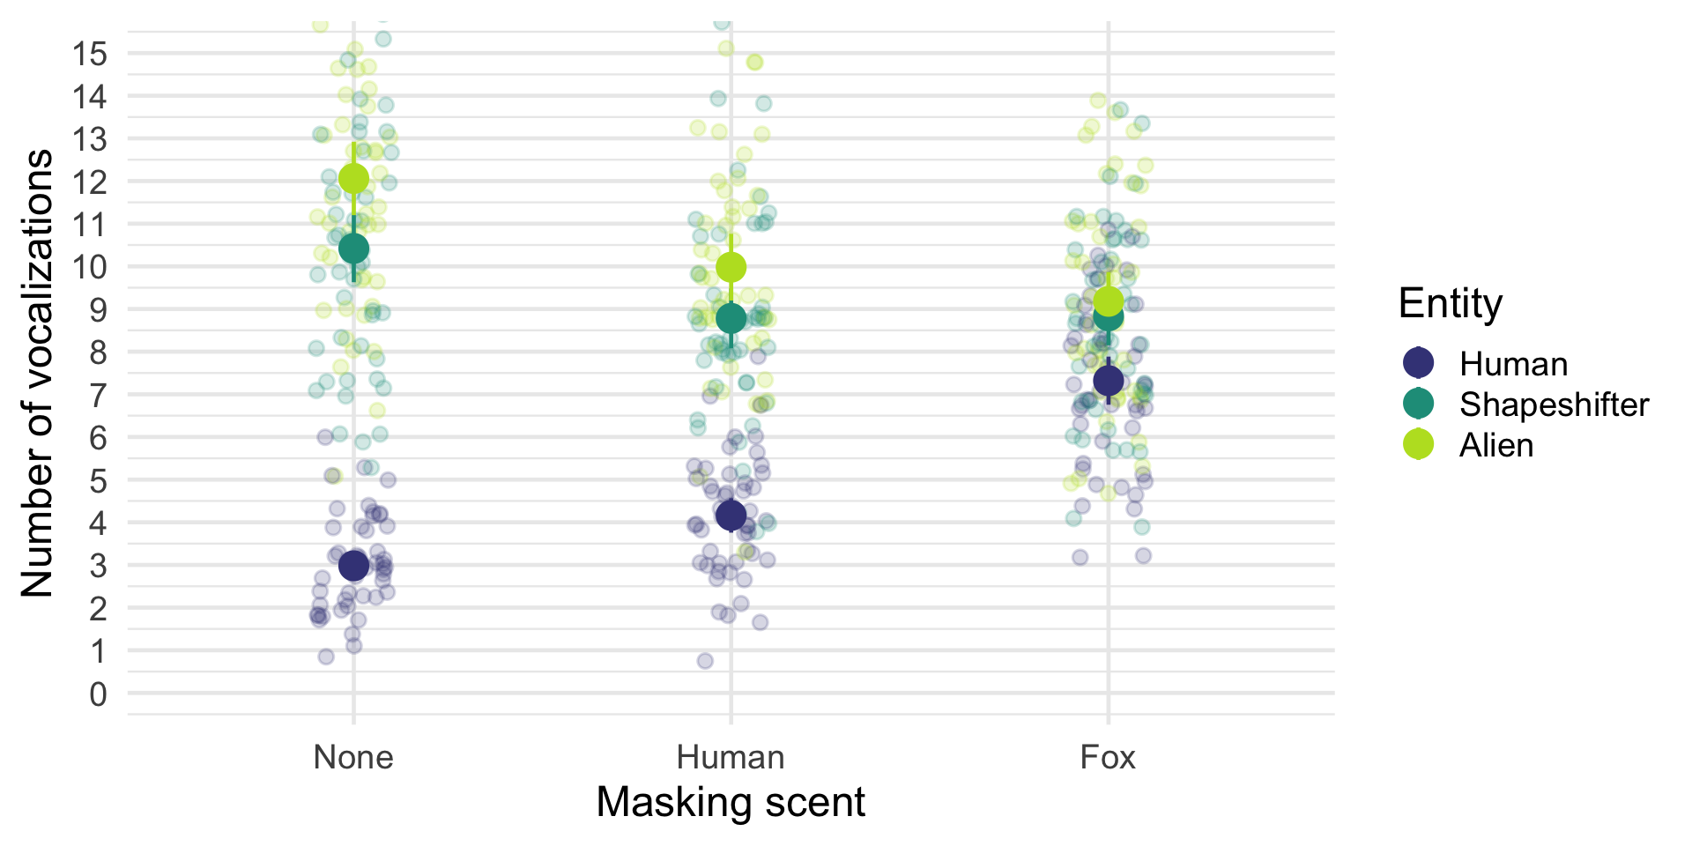

Slide 58: Entity × scent_mask interaction: parameter 2
Fixed Effects
Parameter | Coefficient | SE | 95% CI | z | p
entity (Alien) × scent mask (Human) | -3.26 | 0.50 | (-4.25, -2.27) | -6.46 | < .001
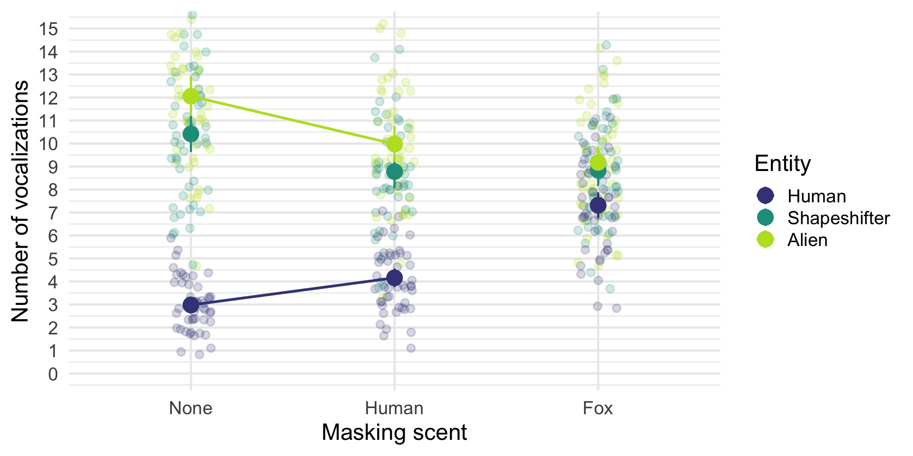

Slide 59: Entity × scent_mask interaction: parameter 3
Fixed Effects
Parameter | Coefficient | SE | 95% CI | z | p
entity (Shapeshifter) × scent mask (Fox) | -5.92 | 0.50 | (-6.91, -4.93) | -11.73 | < .001
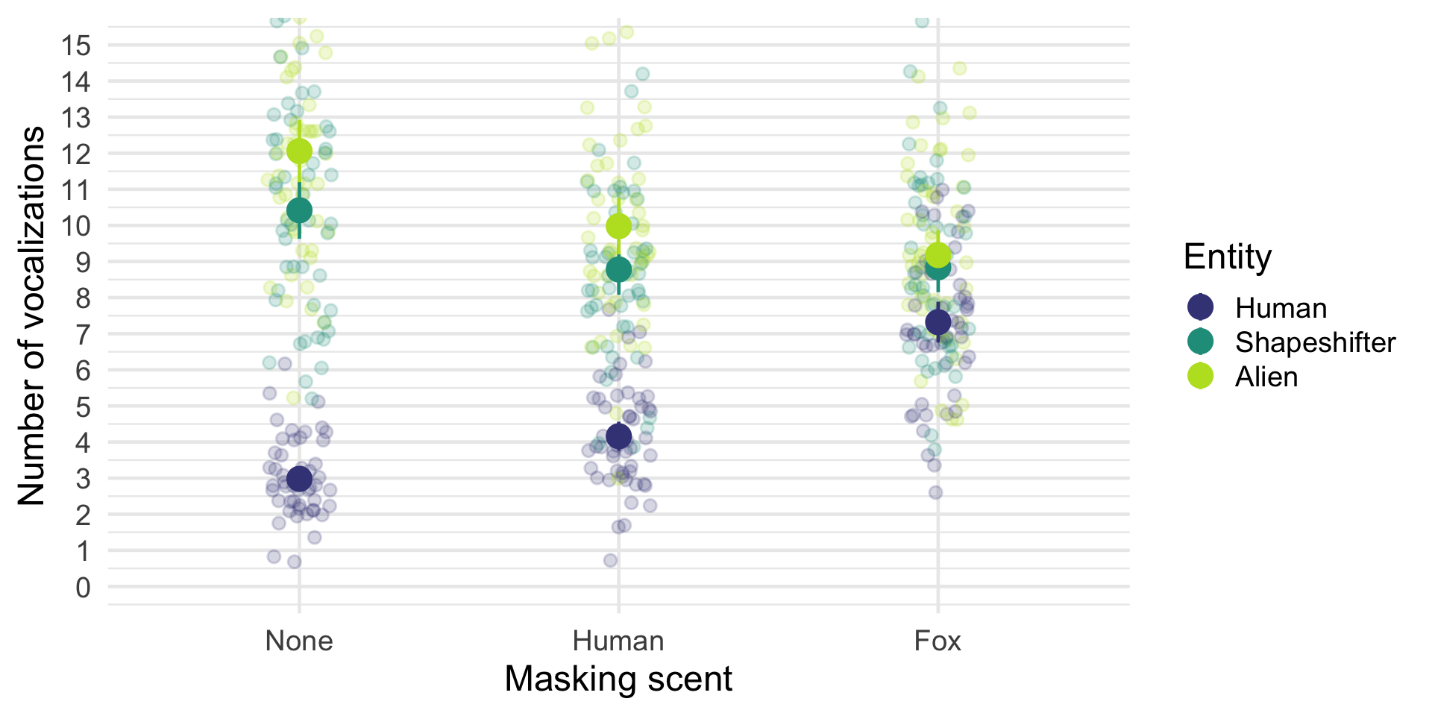

Slide 60: Entity × scent_mask interaction: parameter 3
Fixed Effects
Parameter | Coefficient | SE | 95% CI | z | p
entity (Shapeshifter) × scent mask (Fox) | -5.92 | 0.50 | (-6.91, -4.93) | -11.73 | < .001
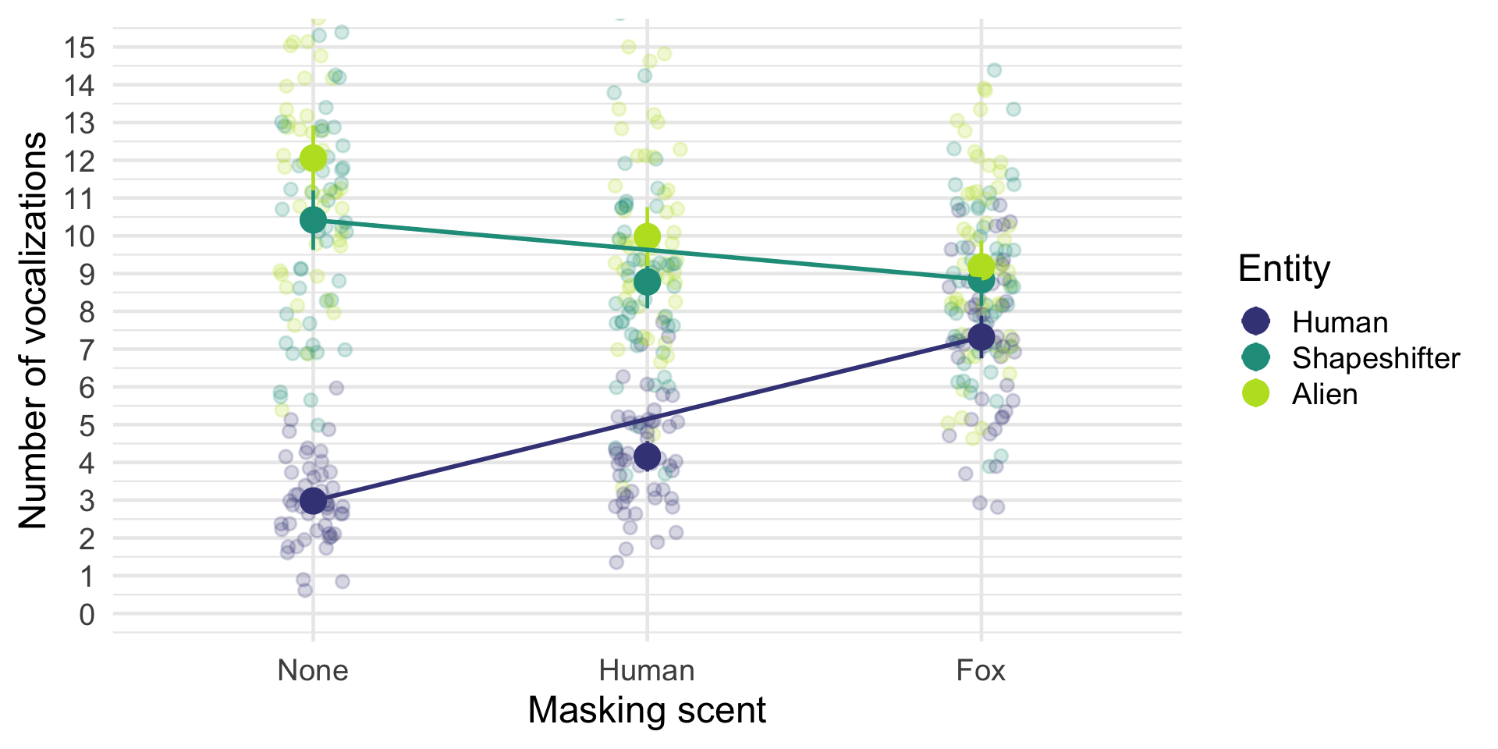

Slide 61: Entity × scent_mask interaction: parameter 4
Fixed Effects
Parameter | Coefficient | SE | 95% CI | z | p
entity (Alien) × scent mask (Fox) | -7.22 | 0.50 | (-8.21, -6.23) | -14.31 | < .001
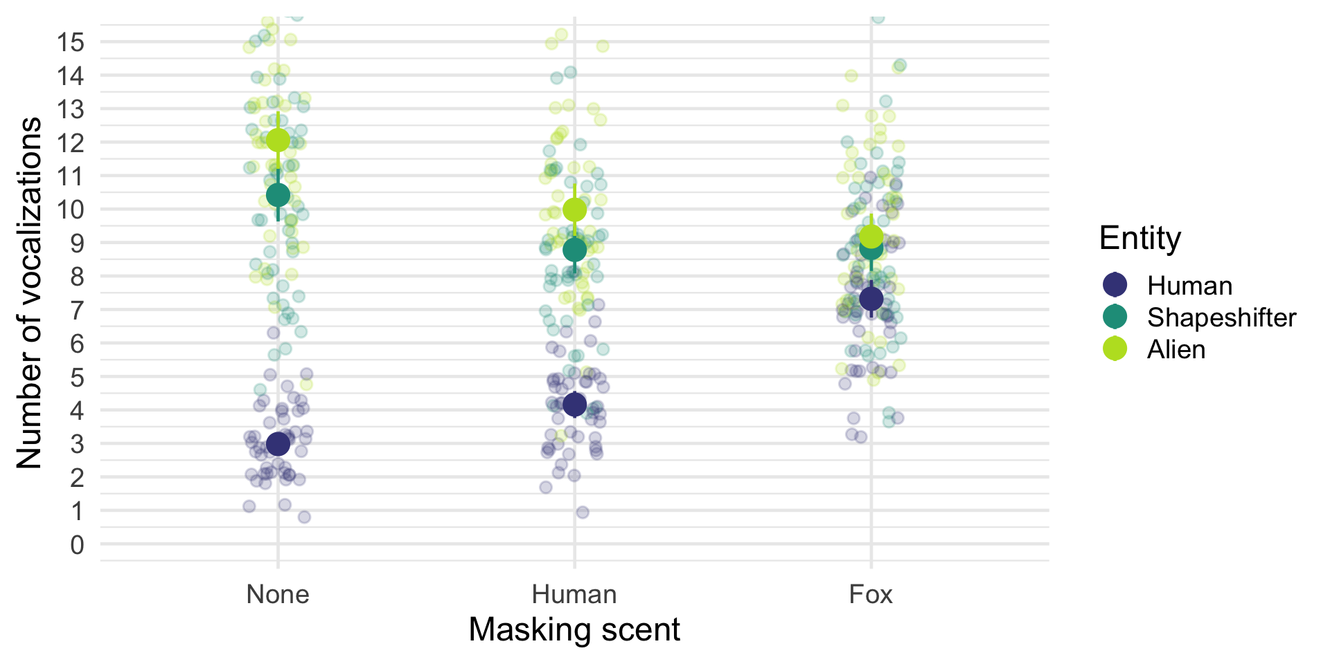

Slide 62: Entity × scent_mask interaction: parameter 4
Fixed Effects
Parameter | Coefficient | SE | 95% CI | z | p
entity (Alien) × scent mask (Fox) | -7.22 | 0.50 | (-8.21, -6.23) | -14.31 | < .001
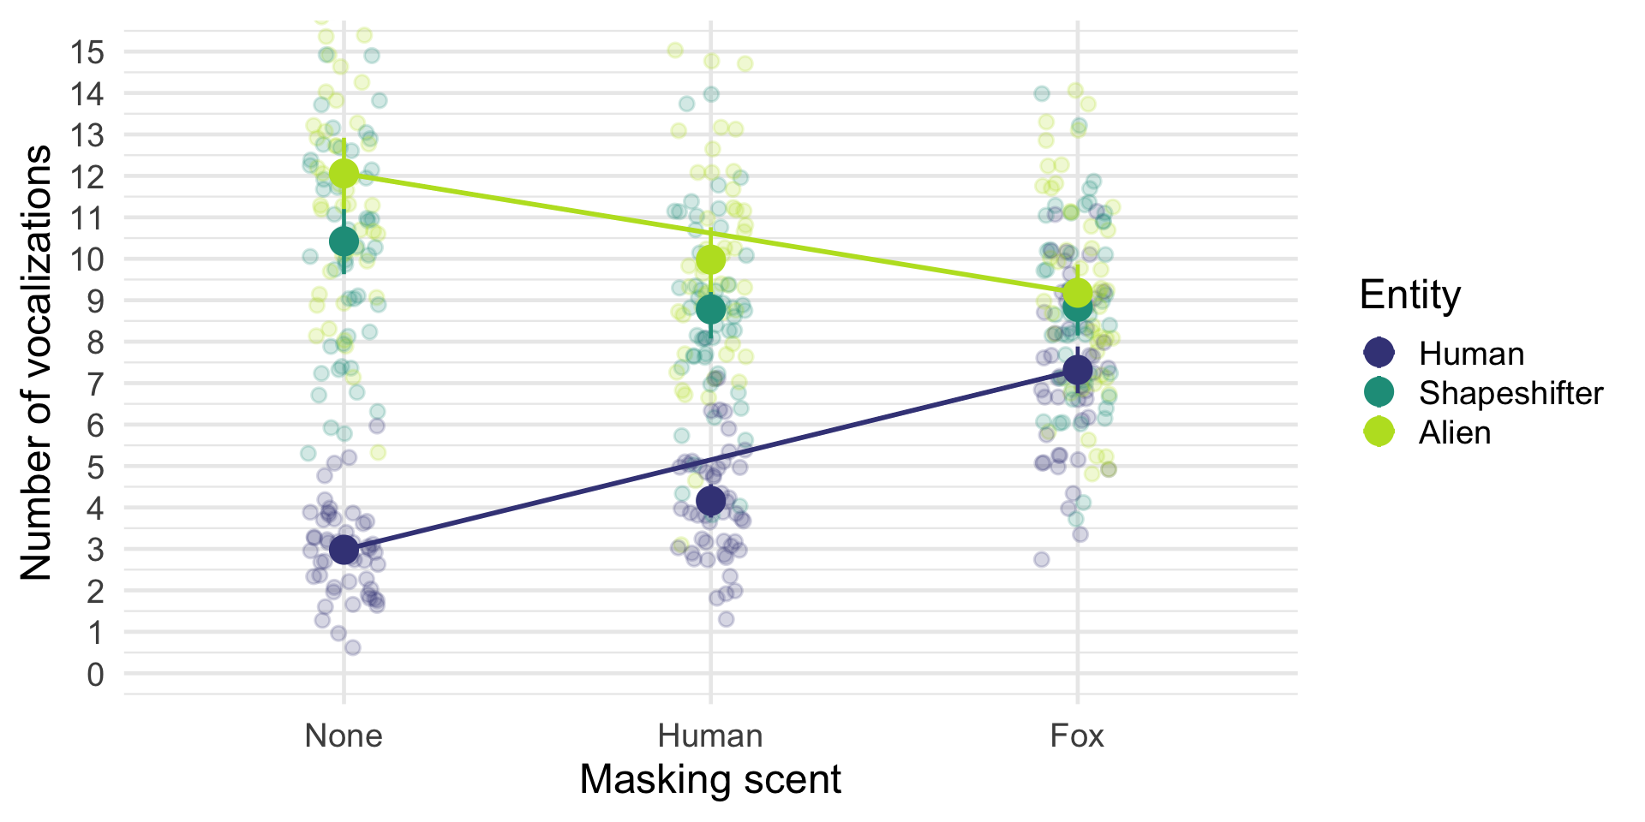

Slide 63
Video clip: space closing scene

