Categorical outcomes
Logistic regression
Professor Andy Field, University of Sussex
Links: bsky.app | youtube.com | discoveringstatistics.com | discovr.rocks | statisticsadventure.com

About this version
This is a plain-text version of the lecture slides. Each slide starts with a heading such as “Slide 5”, and the numbers match the slide numbers shown in the lecture. Content that appeared one piece at a time, in columns or in tabs is shown in reading order. Videos and interactive apps are given as links.

Slide 2
Video clip: xmas santa 01

Slide 3
Video clip: xmas santa 02

Slide 4
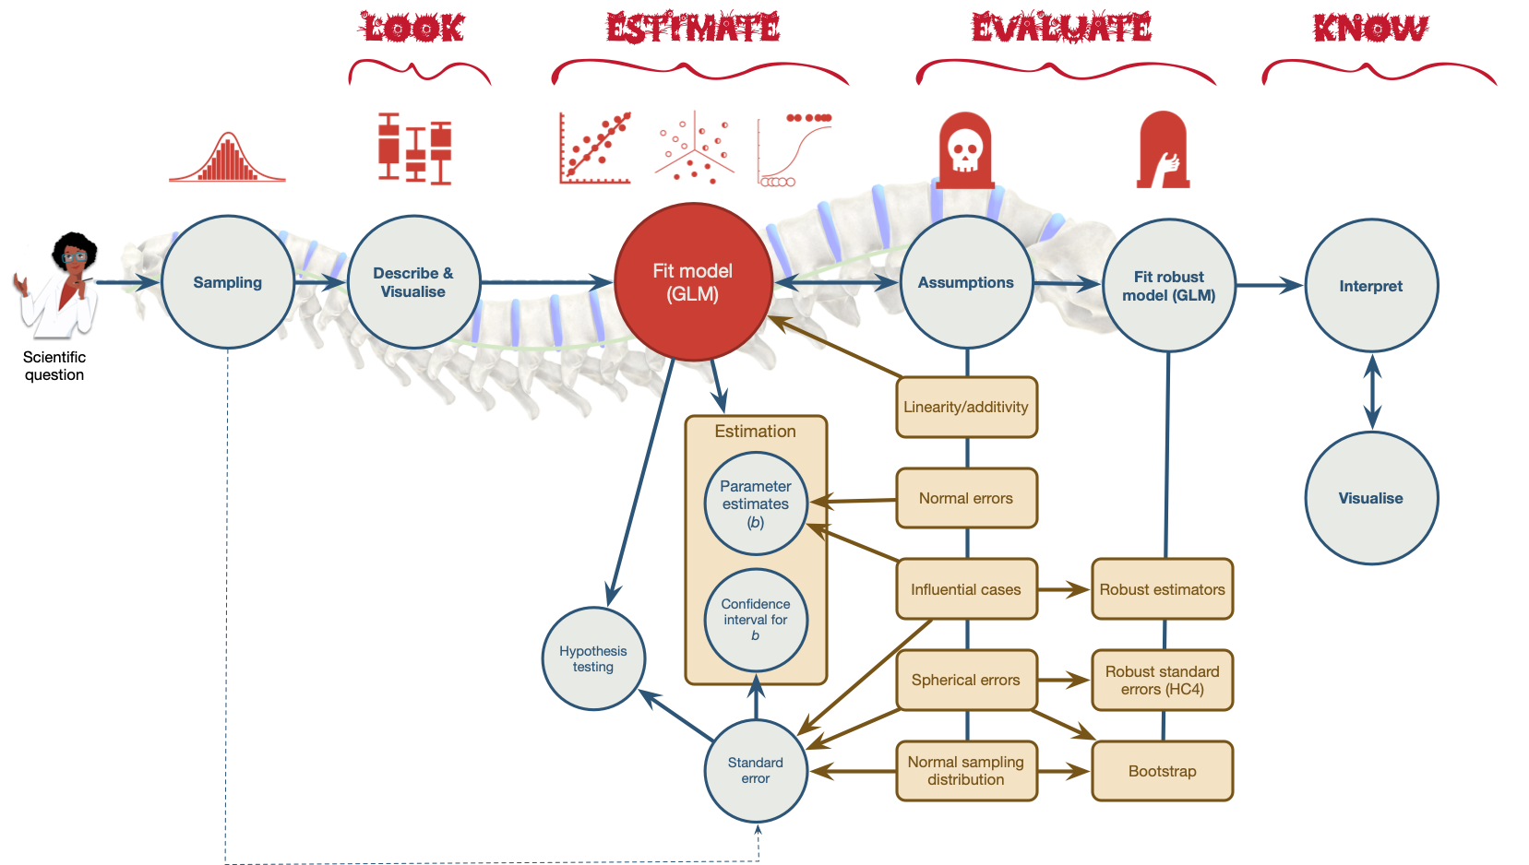
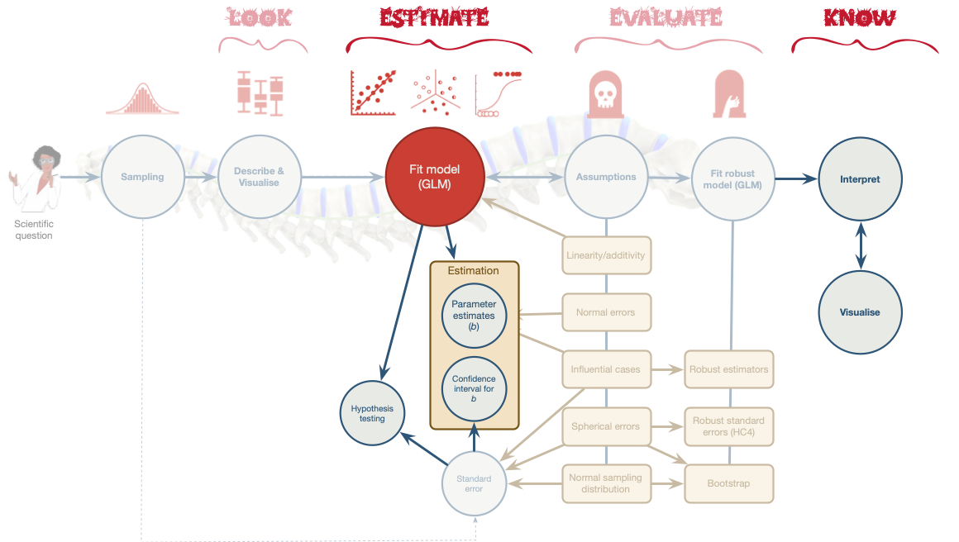

Slide 5
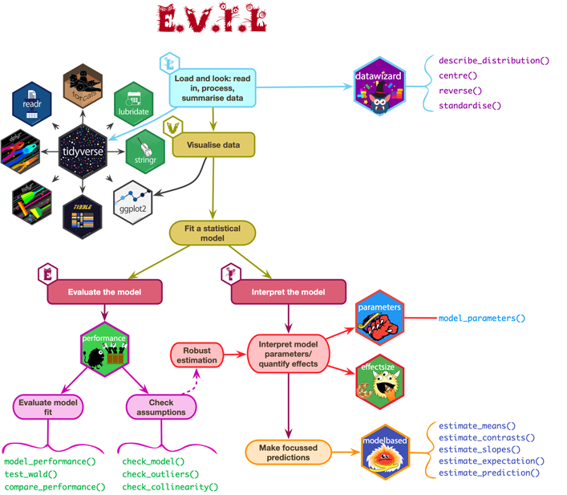

Slide 6: A festive example
Santa Claus wanted to test the effects of different types of treats on whether presents got delivered:
- Predictors
  - treat: Christmas pudding, Mulled wine
- Outcome
  - delivered: Did the presents get delivered?

Slide 7: Load and Look
Table 1: Santa's data (first 50 of 400 rows)
 | id | treat | delivered
1 | Fankle the Determined | Mulled wine | Not delivered
2 | Amber the Cuddle | Mulled wine | Not delivered
3 | Snorklum the Content | Pudding | Delivered
4 | Henri the Biddible | Pudding | Delivered
5 | Ainsley the Eigen vector | Mulled wine | Delivered
6 | Funnelcup the Iron maiden fan | Mulled wine | Delivered
7 | Ramsey the Surprised | Pudding | Delivered
8 | Bindlestiff the Surprised | Mulled wine | Not delivered
9 | Lardy the Strong | Pudding | Delivered
10 | Theo the Small | Pudding | Delivered
11 | Alexis the Cute | Pudding | Delivered
12 | Per the Egalitarian | Pudding | Delivered
13 | Nergal the Lollygag | Mulled wine | Delivered
14 | Hughy the Content | Mulled wine | Not delivered
15 | Ramsey the Partial derivative | Mulled wine | Delivered
16 | Flo the Sangoma | Mulled wine | Delivered
17 | Flumin the Nostril-checker | Pudding | Delivered
18 | Nicko the Forgetful | Pudding | Not delivered
19 | Tulip the Hincklepump | Mulled wine | Not delivered
20 | Nicko the Nostril-checker | Mulled wine | Not delivered
21 | Cleo the Dextrous | Pudding | Delivered
22 | Quo the Dextrous | Pudding | Delivered
23 | Tinsel the Pointless dancer | Pudding | Delivered
24 | Petr the Puddle jumper | Mulled wine | Not delivered
25 | Juniper the Tall | Mulled wine | Not delivered
26 | Jezebel the Determined | Mulled wine | Not delivered
27 | Quo the Vagarious | Pudding | Delivered
28 | Alexis the Mudlark | Mulled wine | Not delivered
29 | Amulet the Hincklepump | Pudding | Delivered
30 | Geeling the Puddle jumper | Mulled wine | Delivered
31 | Bumfissue the Dotish | Mulled wine | Not delivered
32 | Vanessa the Visible | Mulled wine | Delivered
33 | Bumbo the Partial derivative | Mulled wine | Not delivered
34 | Vanessa the Hipster | Pudding | Delivered
35 | Charlie the Mischievous | Mulled wine | Not delivered
36 | Edwin the Kind | Mulled wine | Not delivered
37 | Evra the Jubulant | Pudding | Delivered
38 | Arlo the Nondescript | Pudding | Delivered
39 | Iwobi the Lollygag | Pudding | Delivered
40 | Nicko the Wrapper | Pudding | Not delivered
41 | Juniper the Biddible | Mulled wine | Not delivered
42 | Wickham the Xylopolist | Pudding | Delivered
43 | Geeling the Mischievous | Mulled wine | Not delivered
44 | Ramsey the Neurotic | Mulled wine | Delivered
45 | Juniper the Statistical | Pudding | Delivered
46 | Oxter the Knee-scratcher | Mulled wine | Not delivered
47 | Bardy the Agreeable | Mulled wine | Delivered
48 | Amber the Nondescript | Mulled wine | Not delivered
49 | Jongle the Determined | Pudding | Delivered
50 | Liv the Carpenter | Mulled wine | Not delivered


Slide 8: If it were a standard linear model
$$\begin{aligned}{\text{delivered}}_{i}&={\hat{b}}_{0}+{\hat{b}}_{1}{\text{treat}}_{i}+e_{i}\end{aligned}$$
Assumption of linearity
- Violated with categorical outcomes
- We can’t fit this model
Group | Treat
Christmas pudding | 0
Mulled wine | 1

Slide 9: But it’s not a standard linear model
We predict the probability of the outcome occurring
$$\begin{aligned}P(Y)&=\frac{1}{1+e^{−({\hat{b}}_{0}+{\hat{b}}_{1}X_{i}+e_{i})}} \\ P(\text{delivery})&=\frac{1}{1+e^{−({\hat{b}}_{0}+{\hat{b}}_{1}{\text{treat}}_{i}+e_{i})}} \\ \end{aligned}$$
Note: Statis-tip
Note the equation contains the linear model

Slide 10: Alternatively …
$$\begin{aligned}ln\left(\frac{P(Y)}{1−P(Y)}\right)&={\hat{b}}_{0}+{\hat{b}}_{1}X_{i}+e_{i} \\ ln\left(\frac{P(\text{delivery})}{1−P(\text{delivery})}\right)&={\hat{b}}_{0}+{\hat{b}}_{1}{\text{treat}}_{i}+e_{i} \\ \end{aligned}$$

Outcome
- We predict the log odds of the outcome occurring

${\hat{b}}_{0}$ and ${\hat{b}}_{1}$
- Note the the logistic regression equation is the same as the linear model, except we predict the log odds of the outcome
- ${\hat{b}}_{1}$ is the change in the log odds of the outcome associated with a unit change in the predictor

Slide 11: Logs and exponents
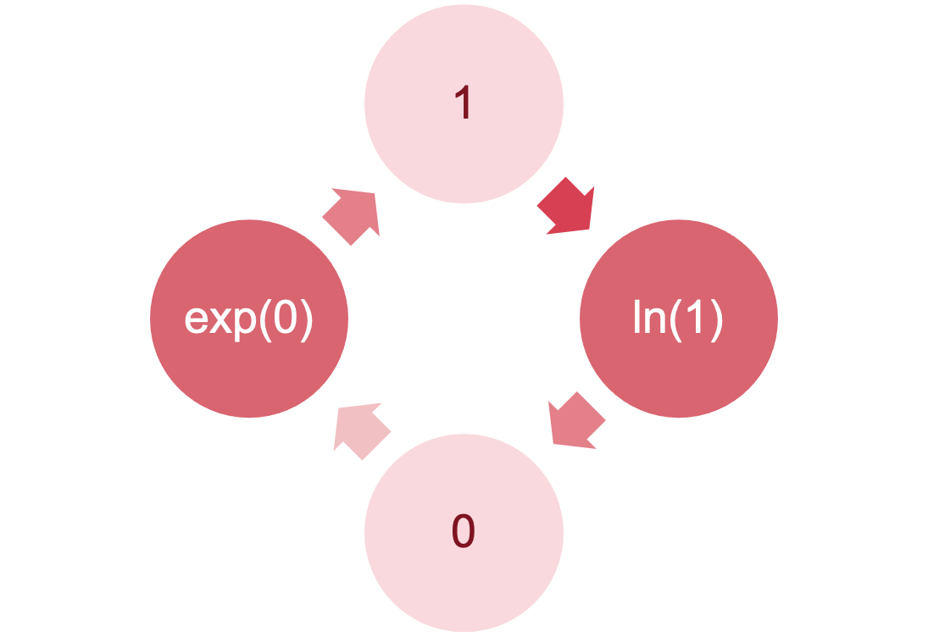

Slide 12: The odds ratio: exp(b)
$$\begin{matrix}exp(b)=\frac{\text{odds after a unit change in the predictor}}{\text{original odds}}\end{matrix}$$

b₀
- Log odds of outcome when the predictors are 0
- Easier to interpret exp(b₀), the odds of outcome when predictor is 0

b₁
- Change in the log odds of outcome associated with a unit change in the predictor
- Easier to interpret exp (b₁), the odds ratio associated with a unit change in the predictor
- OR > 1: Predictor $↑$, probability of outcome occurring $↑$
- OR < 1: Predictor $↑$, probability of outcome occurring $↓$

Slide 13: Classification table
 | Delivered | Not delivered | Total
Christmas pudding | 150 | 28 | 178
Mulled wine | 100 | 122 | 222
Total | 250 | 150 | 400

$$\begin{aligned}{\text{odds}}_{\text{delivery}}&=\frac{\text{Number delivered}}{\text{Number not delivered}} \\ &=\frac{250}{150} \\ &=1.67\end{aligned}$$

Slide 14: The odds ratio
$$\begin{aligned}{\text{odds}}_{\text{delivered after pudding}}&=\frac{\text{Number delivered after pudding}}{\text{Number not delivered after pudding}} \\ &=\frac{150}{28} \\ &=5.36\end{aligned}$$
$$\begin{aligned}{\text{odds}}_{\text{delivered after wine}}&=\frac{\text{Number delivered after wine}}{\text{Number not delivered after wine}} \\ &=\frac{100}{122} \\ &=0.82\end{aligned}$$

Slide 15: The odds ratio
$$\begin{aligned}\text{odds ratio}&=\frac{{\text{odds}}_{\text{delivered after wine}}}{{\text{odds}}_{\text{delivered after pudding}}} \\ &=\frac{0.82}{5.36} \\ &=0.15\end{aligned}$$

Slide 16: The odds ratio
$$\begin{aligned}\text{odds ratio}&=\frac{{\text{odds}}_{\text{delivered after pudding}}}{{\text{odds}}_{\text{delivered after wine}}} \\ &=\frac{5.36}{0.82} \\ &=6.54\end{aligned}$$

Slide 17: Interpret the parameters
santa_mod <- glm(delivered ~ treat, data = santa_tib, family = binomial())
model_parameters(santa_mod) |>
display()
Parameter | Log-Odds | SE | 95% CI | z | p
(Intercept) | 1.68 | 0.21 | (1.29, 2.10) | 8.15 | < .001
treat (Mulled wine) | -1.88 | 0.25 | (-2.37, -1.41) | -7.63 | < .001


Slide 18: Interpret the odds ratios
model_parameters(santa_mod, exponentiate = TRUE) |>
display()
Parameter | Odds Ratio | SE | 95% CI | z | p
(Intercept) | 5.36 | 1.10 | (3.64, 8.18) | 8.15 | < .001
treat (Mulled wine) | 0.15 | 0.04 | (0.09, 0.24) | -7.63 | < .001

Slide 19
Video clip: xmas scene 2

Slide 20: A festive example
Santa Claus wanted to test the effects of different types of treats and the quantity of them consumed on whether presents got delivered:
- Predictors
  - treat: Christmas pudding, Mulled wine
  - quantity: 0, 1, 2, 3, or 4
- Outcome
  - delivered: Did the presents get delivered?

Slide 21: Load and Look
Table 2: Santa's data (first 50 of 400 rows)
 | id | quantity | treat | delivered
1 | Fankle the Determined | 4 | Mulled wine | Not delivered
2 | Amber the Cuddle | 3 | Mulled wine | Not delivered
3 | Snorklum the Content | 3 | Pudding | Delivered
4 | Henri the Biddible | 0 | Pudding | Delivered
5 | Ainsley the Eigen vector | 0 | Mulled wine | Delivered
6 | Funnelcup the Iron maiden fan | 1 | Mulled wine | Delivered
7 | Ramsey the Surprised | 2 | Pudding | Delivered
8 | Bindlestiff the Surprised | 3 | Mulled wine | Not delivered
9 | Lardy the Strong | 1 | Pudding | Delivered
10 | Theo the Small | 1 | Pudding | Delivered
11 | Alexis the Cute | 1 | Pudding | Delivered
12 | Per the Egalitarian | 3 | Pudding | Delivered
13 | Nergal the Lollygag | 3 | Mulled wine | Delivered
14 | Hughy the Content | 1 | Mulled wine | Not delivered
15 | Ramsey the Partial derivative | 3 | Mulled wine | Delivered
16 | Flo the Sangoma | 2 | Mulled wine | Delivered
17 | Flumin the Nostril-checker | 1 | Pudding | Delivered
18 | Nicko the Forgetful | 1 | Pudding | Not delivered
19 | Tulip the Hincklepump | 2 | Mulled wine | Not delivered
20 | Nicko the Nostril-checker | 3 | Mulled wine | Not delivered
21 | Cleo the Dextrous | 1 | Pudding | Delivered
22 | Quo the Dextrous | 1 | Pudding | Delivered
23 | Tinsel the Pointless dancer | 0 | Pudding | Delivered
24 | Petr the Puddle jumper | 2 | Mulled wine | Not delivered
25 | Juniper the Tall | 3 | Mulled wine | Not delivered
26 | Jezebel the Determined | 2 | Mulled wine | Not delivered
27 | Quo the Vagarious | 2 | Pudding | Delivered
28 | Alexis the Mudlark | 4 | Mulled wine | Not delivered
29 | Amulet the Hincklepump | 3 | Pudding | Delivered
30 | Geeling the Puddle jumper | 1 | Mulled wine | Delivered
31 | Bumfissue the Dotish | 2 | Mulled wine | Not delivered
32 | Vanessa the Visible | 1 | Mulled wine | Delivered
33 | Bumbo the Partial derivative | 4 | Mulled wine | Not delivered
34 | Vanessa the Hipster | 1 | Pudding | Delivered
35 | Charlie the Mischievous | 3 | Mulled wine | Not delivered
36 | Edwin the Kind | 2 | Mulled wine | Not delivered
37 | Evra the Jubulant | 4 | Pudding | Delivered
38 | Arlo the Nondescript | 0 | Pudding | Delivered
39 | Iwobi the Lollygag | 1 | Pudding | Delivered
40 | Nicko the Wrapper | 2 | Pudding | Not delivered
41 | Juniper the Biddible | 3 | Mulled wine | Not delivered
42 | Wickham the Xylopolist | 1 | Pudding | Delivered
43 | Geeling the Mischievous | 3 | Mulled wine | Not delivered
44 | Ramsey the Neurotic | 2 | Mulled wine | Delivered
45 | Juniper the Statistical | 2 | Pudding | Delivered
46 | Oxter the Knee-scratcher | 3 | Mulled wine | Not delivered
47 | Bardy the Agreeable | 1 | Mulled wine | Delivered
48 | Amber the Nondescript | 1 | Mulled wine | Not delivered
49 | Jongle the Determined | 2 | Pudding | Delivered
50 | Liv the Carpenter | 3 | Mulled wine | Not delivered

Slide 22: Extending the model
$$\begin{aligned}{\text{delivered}}_{i}&={\hat{b}}_{0}+{\hat{b}}_{1}{\text{treat}}_{i}+{\hat{b}}_{2}{\text{quantity}}_{i}+{\hat{b}}_{3}\text{treat}×{\text{quantity}}_{i}+e_{i}\end{aligned}$$
Group | Treat
Christmas pudding | 0
Mulled wine | 1
$$\begin{aligned}P(\text{delivery})&=\frac{1}{1+e^{−({\hat{b}}_{0}+{\hat{b}}_{1}{\text{treat}}_{i}+{\hat{b}}_{2}{\text{quantity}}_{i}+{\hat{b}}_{3}\text{treat}×{\text{quantity}}_{i}+e_{i})}} \\ \end{aligned}$$
$$\begin{aligned}ln\left(\frac{P(\text{delivery})}{1−P(\text{delivery})}\right)&={\hat{b}}_{0}+{\hat{b}}_{1}{\text{treat}}_{i}+{\hat{b}}_{2}{\text{quantity}}_{i}+{\hat{b}}_{3}\text{treat}×{\text{quantity}}_{i}+e_{i} \\ \end{aligned}$$

Slide 23: Building the model
- Forced entry: all variables entered simultaneously.
- Hierarchical: variables entered in blocks.
  - Blocks should be based on past research, or theory being tested.
  - Good method.
- Stepwise: variables entered on the basis of statistical criteria (i.e., Relative contribution to predicting outcome).
  - Should be used only for exploratory analysis.

Slide 24: Things that can go wrong

Things we’ve met before
- Linearity (of the logit)
- Spherical residuals
  - Independent errors
- Multicollinearity

Unique problems
- Incomplete information
- Complete separation

Slide 25: Incomplete information

Empty cells
- We don’t know how many presents are delivered after two puddings or not delivered after 5 wines
- Problem quickly escalates with continuous predictors
- Inflates standard errors
 | Quantity | Delivered | Not delivered
Pudding | 0 | 27 | 3
Pudding | 1 | 36 | 10
Pudding | 2 | - | 5
Pudding | 3 | 37 | 6
Pudding | 4 | 12 | 4
Mulled wine | 0 | 27 | 3
Mulled wine | 1 | 32 | 11
Mulled wine | 2 | 24 | 36
Mulled wine | 3 | 14 | 48
Mulled wine | 4 | 3 | -

Slide 26: Complete separation
When the outcome variable can be perfectly predicted
- Predicting whether someone is a krampus based on weight

Santa vs. krampus
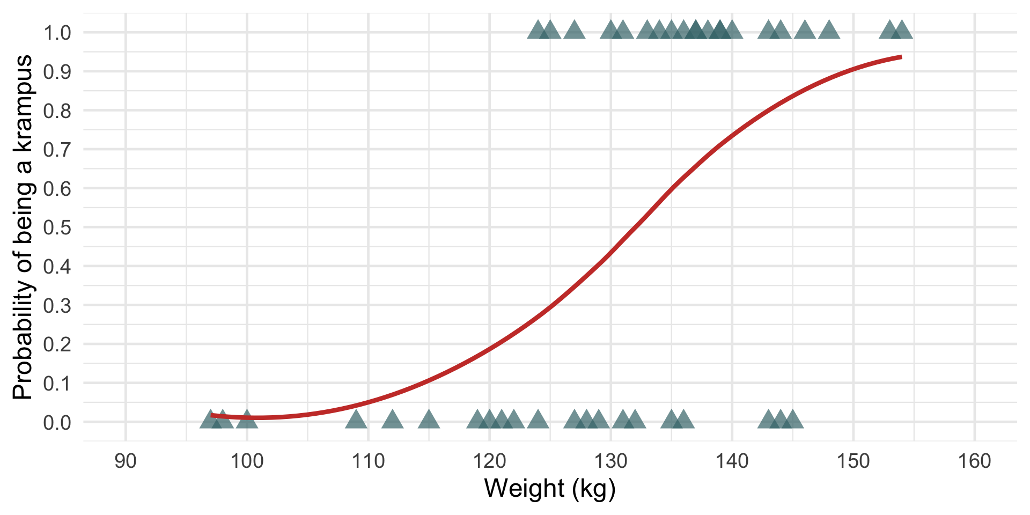

Elves vs. krampus
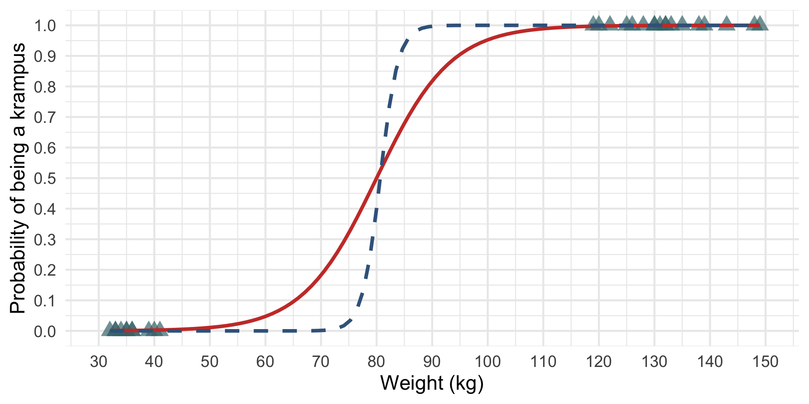

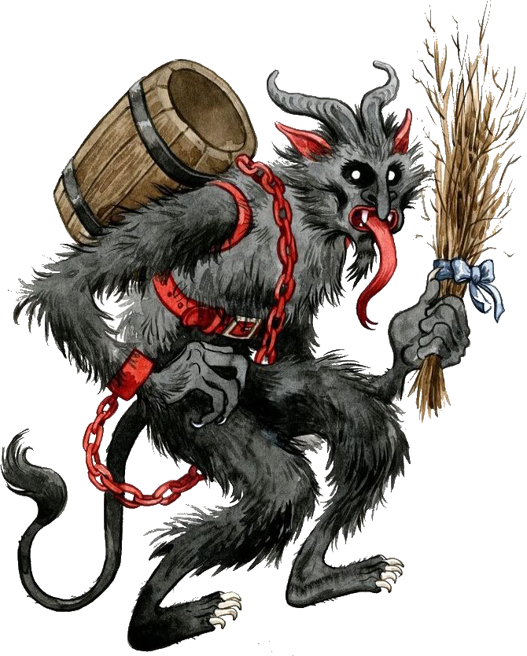


Slide 27
Video clip: logistic regression song instrumental

Slide 28
Video clip: logistic regression song

Slide 29: Build the model
int_glm <- glm(delivered ~ 1, data = santa_tib, family = binomial())
treat_glm <- update(int_glm, .~. + treat)
quantity_glm <- update(treat_glm, .~. + quantity)
santa_glm <- update(quantity_glm, .~. + treat:quantity)

Slide 30: Evaluate
test_lrt(int_glm, treat_glm, quantity_glm, santa_glm) |>
display()
Likelihood-Ratio-Test (LRT) for Model Comparison (ML-estimator)
Name | Model | df | df_diff | Chi2 | p
int_glm | glm | 1
treat_glm | glm | 2 | 1 | 68.76 | < .001
quantity_glm | glm | 3 | 1 | 49.79 | < .001
santa_glm | glm | 4 | 1 | 20.52 | < .001


Slide 31: Evaluate assumptions
check_model(santa_glm)
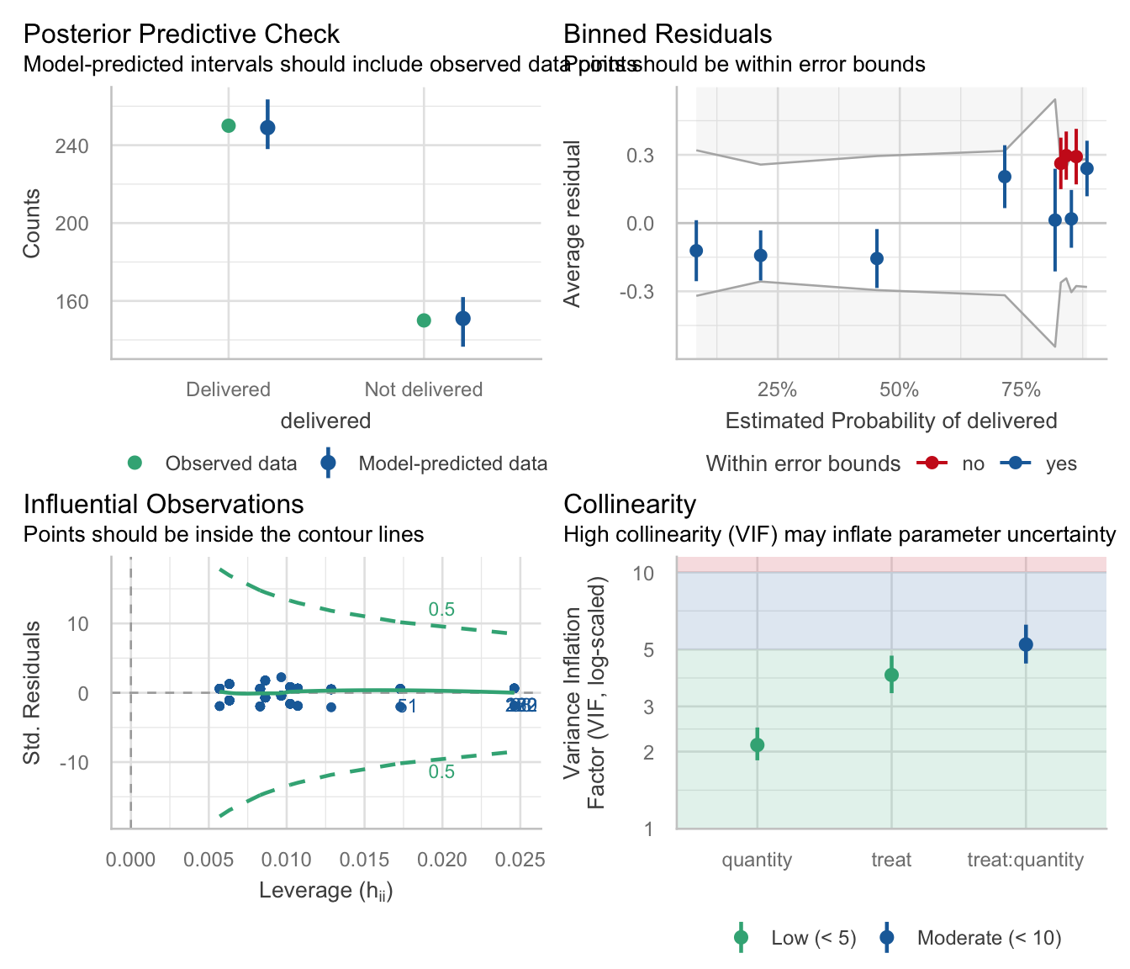

Slide 32: Interpret parameter estimates, CIs and tests
model_parameters(santa_glm) |>
display()
Parameter | Log-Odds | SE | 95% CI | z | p
(Intercept) | 1.83 | 0.38 | (1.13, 2.63) | 4.80 | < .001
treat (Mulled wine) | 0.20 | 0.52 | (-0.83, 1.22) | 0.38 | 0.701
quantity | -0.08 | 0.17 | (-0.41, 0.25) | -0.48 | 0.629
treat (Mulled wine) × quantity | -1.03 | 0.23 | (-1.49, -0.58) | -4.45 | < .001

Slide 33: Interpret parameter estimates, CIs and tests
santa_tib |>
filter(treat == "Pudding") |>
glm(delivered ~ quantity, data = _, family = binomial()) |>
model_parameters() |>
display()
Parameter | Log-Odds | SE | 95% CI | z | p
(Intercept) | 1.83 | 0.38 | (1.13, 2.63) | 4.80 | < .001
quantity | -0.08 | 0.17 | (-0.41, 0.25) | -0.48 | 0.629
santa_tib |>
filter(treat == "Mulled wine") |>
glm(delivered ~ quantity, data = _, family = binomial()) |>
model_parameters() |>
display()
Parameter | Log-Odds | SE | 95% CI | z | p
(Intercept) | 2.03 | 0.35 | (1.37, 2.76) | 5.73 | < .001
quantity | -1.11 | 0.16 | (-1.44, -0.81) | -6.99 | < .001
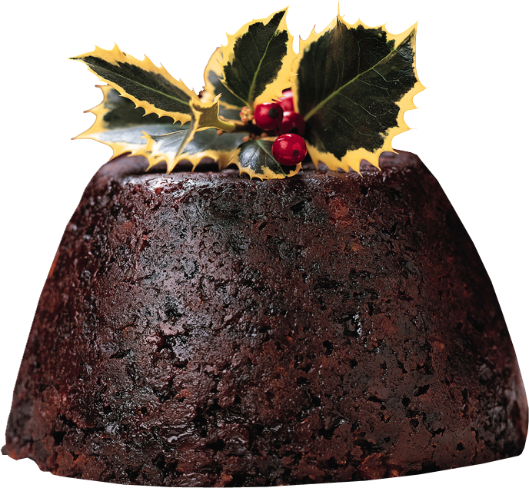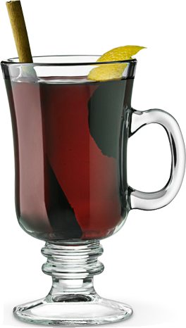
$$\begin{aligned}b_{\text{wine}}−b_{\text{pudding}}&=−1.11−(−0.08) \\ &=−1.03\end{aligned}$$

Slide 34: Interpret odds ratios
model_parameters(santa_glm, exponentiate = TRUE) |>
display()
Parameter | Odds Ratio | SE | 95% CI | z | p
(Intercept) | 6.23 | 2.37 | (3.08, 13.86) | 4.80 | < .001
treat (Mulled wine) | 1.22 | 0.63 | (0.43, 3.37) | 0.38 | 0.701
quantity | 0.92 | 0.15 | (0.66, 1.28) | -0.48 | 0.629
treat (Mulled wine) × quantity | 0.36 | 0.08 | (0.23, 0.56) | -4.45 | < .001

Slide 35: Interpret parameter estimates, CIs and tests
santa_tib |>
filter(treat == "Pudding") |>
glm(delivered ~ quantity, data = _, family = binomial()) |>
model_parameters() |>
display()
Parameter | Log-Odds | SE | 95% CI | z | p
(Intercept) | 1.83 | 0.38 | (1.13, 2.63) | 4.80 | < .001
quantity | -0.08 | 0.17 | (-0.41, 0.25) | -0.48 | 0.629
santa_tib |>
filter(treat == "Mulled wine") |>
glm(delivered ~ quantity, data = _, family = binomial()) |>
model_parameters() |>
display()
Parameter | Log-Odds | SE | 95% CI | z | p
(Intercept) | 2.03 | 0.35 | (1.37, 2.76) | 5.73 | < .001
quantity | -1.11 | 0.16 | (-1.44, -0.81) | -6.99 | < .001
$$\begin{aligned}b_{\text{wine}}−b_{\text{pudding}}&=−1.11−(−0.08) \\ &=−1.03\end{aligned}$$
$$\begin{aligned}exp(b)_{\text{difference}}&=e^{−1.03} \\ &=0.36\end{aligned}$$

Slide 36: Visualize
santa_probs <- estimate_means(santa_glm, by = c("quantity", "treat"))
plot(santa_probs) +
scale_colour_viridis_d(begin = 0.3, end = 0.85) +
scale_fill_viridis_d(begin = 0.3, end = 0.85) +
labs(x = "Quantity of treats", y = "Probability of delivery", colour = "Treat", fill = "Treat") +
theme_minimal()
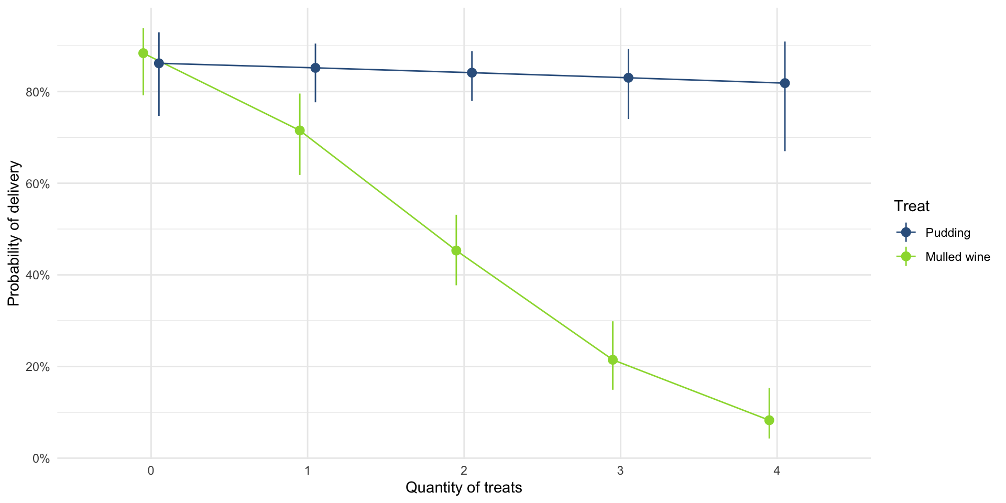


Slide 37
Video clip: xmas santa 03

Slide 38
Video clip: i wish it could be christmas

