Extending and Evaluating the model
Adding predictors, model fit and hidden messages
Professor Andy Field, University of Sussex
Links: opeth the lines in my hand | bsky.app | youtube.com | discoveringstatistics.com | discovr.rocks | statisticsadventure.com

About this version
This is a plain-text version of the lecture slides. Each slide starts with a heading such as “Slide 5”, and the numbers match the slide numbers shown in the lecture. Content that appeared one piece at a time, in columns or in tabs is shown in reading order. Videos and interactive apps are given as links.

Slide 2: Learning outcomes

Extending the model
- Understanding how to incorporate multiple predictors in the general linear model
  - The mathematical model
  - Visualizing the model
  - Methods for entering predictors to the model
  - Interpreting parameter estimates

Model fit
- Understand how we establish the fit of a general linear model to the
  - Sums of squares
  - Mean squares
  - The F-statistic
  - R²

Slide 3
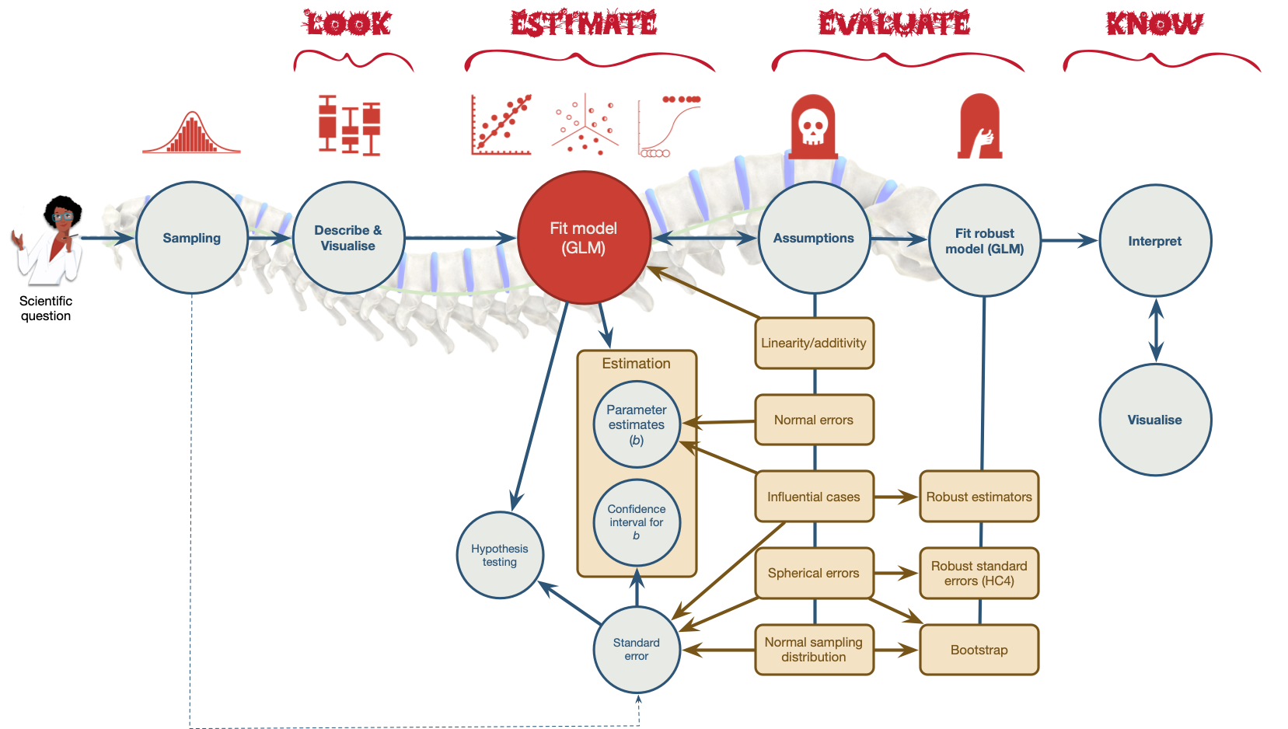
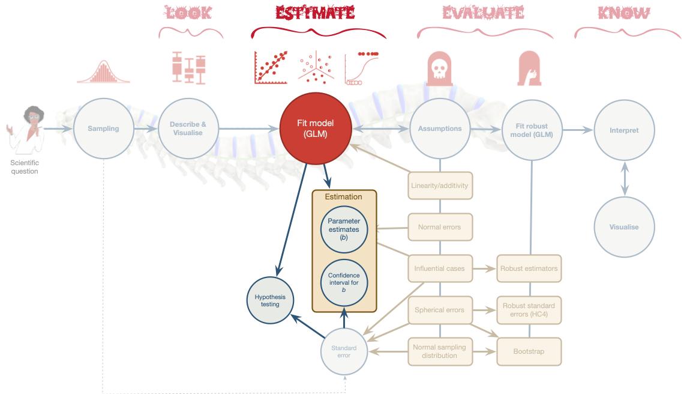

Slide 4
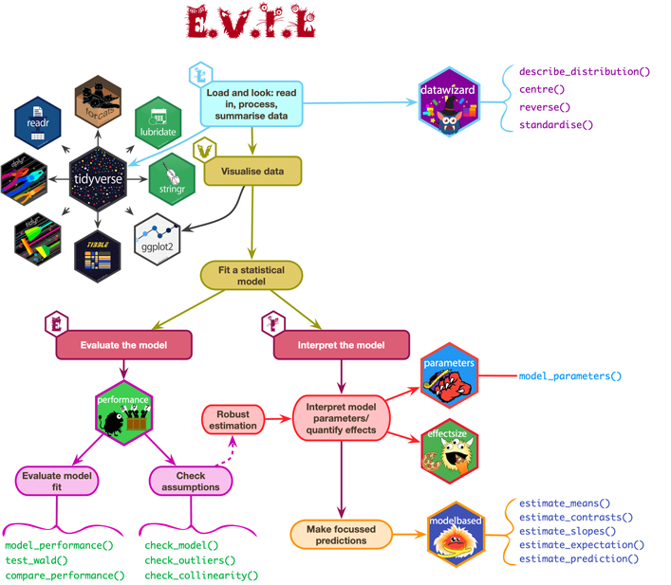

Slide 5 (new section): Extending the model

Slide 6: Birnbaum revisited

- Does playing hard to get work?¹
- Heterosexual participants conversed with an opposite-sex confederate over Instant Messenger for 8 mins
- Interest: Final message coded for the number of expressions of romantic interest (range 0 to 4)
- Hard to get: 3 items rated 1 (not at all) and 5 (very much so)
  - The other participant is hard to get
- Mate value: 4 items rated 1 (not at all) and 5 (very much so)
  - I perceive the other participant as a valued mate
Footnotes
- Birnbaum et al. (2020). Journal of Social and Personal Relationships. Study 3.

Slide 7: The model
$${\text{interest}}_{i}={\hat{b}}_{0}+{\hat{b}}_{1}{\text{hard to get}}_{i}+e_{i}$$
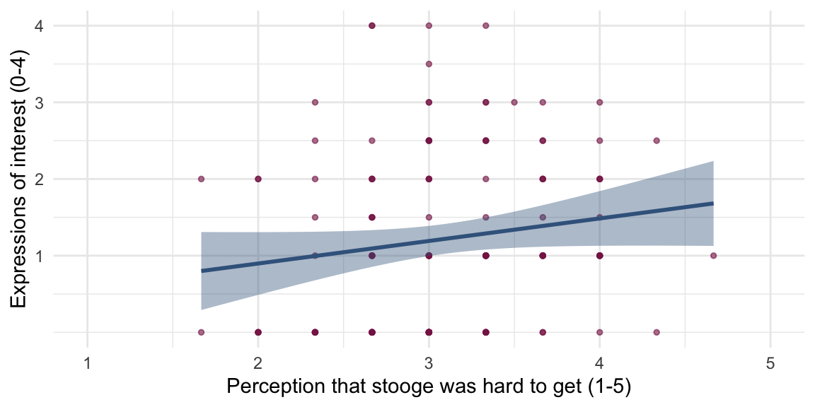
Parameter | Coefficient | SE | 95% CI | t(126) | p
(Intercept) | 0.31 | 0.52 | (-0.73, 1.35) | 0.59 | 0.556
hard to get | 0.29 | 0.17 | (-0.04, 0.62) | 1.76 | 0.080
Caution: Think about it!
- How do we extend the model to include mate value?

Slide 8: Extending the linear model
$${\text{interest}}_{i}={\hat{b}}_{0}+{\hat{b}}_{1}{\text{hard to get}}_{i}+{\hat{b}}_{2}{\text{mate value}}_{i}+e_{i}$$
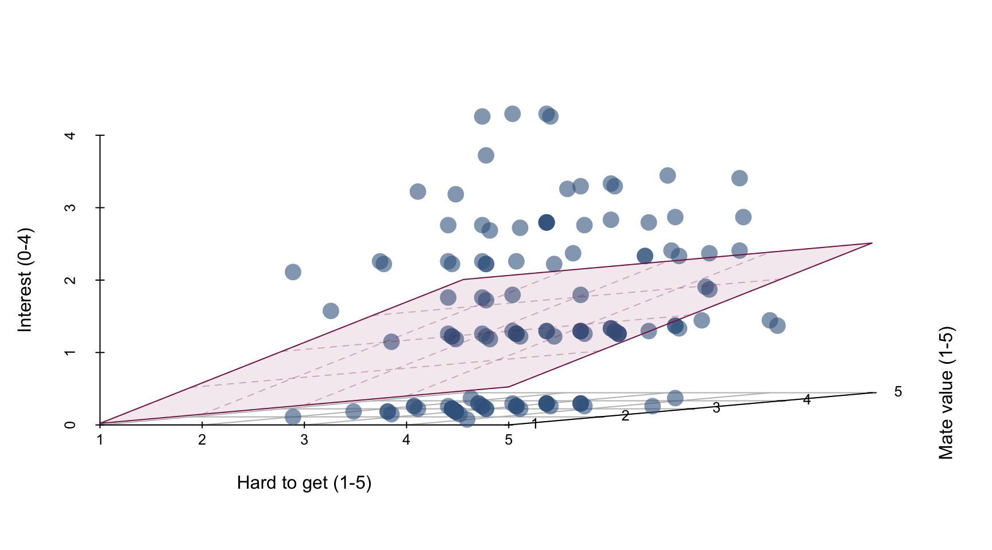

Slide 9: Parameter estimates
${\hat{\text{interest}}}_{i}=−0.49+0.13{\text{ hard to get}}_{i}+0.39{\text{ mate value}}_{i}$
Parameter | Coefficient | SE | 95% CI | t(125) | p
(Intercept) | -0.49 | 0.62 | (-1.72, 0.74) | -0.79 | 0.432
hard to get | 0.13 | 0.18 | (-0.23, 0.48) | 0.70 | 0.484
mate value | 0.39 | 0.17 | (0.05, 0.72) | 2.31 | 0.023
- As the perception that the other person was hard to get increased by 1 (on a scale from 1-5), 0.13 more expressions of interest were made (when mate value is constant)
  - This effect is not significant, $\hat{b}$ = 0.13 (-0.23, 0.48), t(125) = 0.70, p = 0.484
  - This is the effect of ‘hard to get’ on interest adjusted for the effect of ‘mate value’
- As the perception of mate value increased by 1 (on a scale from 1-5), 0.39 more expressions of interest were made (when perceptions of being hard to get are constant)
  - This effect is significant, $\hat{b}$ = 0.39 (0.05, 0.72), t(125) = 2.31, p = 0.023
  - This is the effect of ‘mate value’ on interest adjusted for the effect of ‘hard to get’

Slide 10: How to enter predictors
- Hierarchical
  - Experimenter decides the order in which variables are entered into the model
  - Best for theory testing
- Forced entry
  - All predictors are entered simultaneously
- Stepwise
  - Predictors are selected using their semi-partial correlation with the outcome
  - The model is unlikely to replicate in other samples (i.e., can produce spurious results)
  - Use only for exploratory analysis

Slide 11 (new section): When a hierarchical model gets you dressed

Slide 12
Video clip: arlo hierarchical small

Slide 13 (new section): When a stepwise model gets you dressed

Slide 14
Video clip: arlo stepwise small

Slide 15
Video clip: arlo outtake small

Slide 16 (new section): Model fit

Slide 17: How do we tell if a model is a good fit?
- Let’s look at a simple model: the mean
- How do we tell if it’s a good fit?
- With some help from Taylor Swift
  - The album 1989
- Spotify produce measures of song content
  - Energy
  - Valence
  - Danceability
“Energy is a measure from 0.0 to 1.0 and represents a perceptual measure of intensity and activity.” (Spotify, API)
- The spotifyr package scrapes this data!

Slide 18: Is the average energy score a good fit?
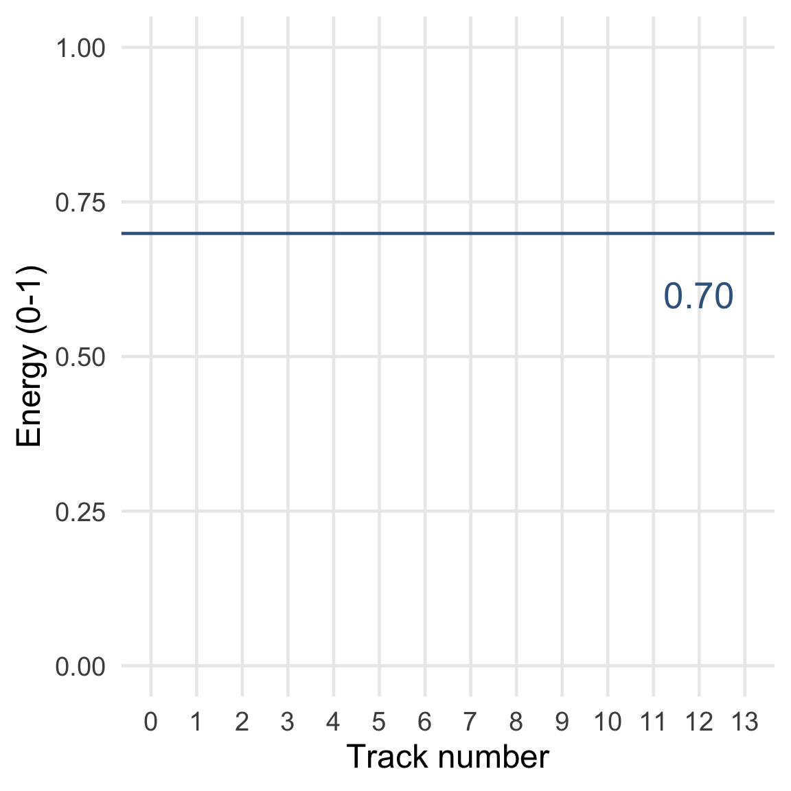


Slide 19: Is the average energy score a good fit?
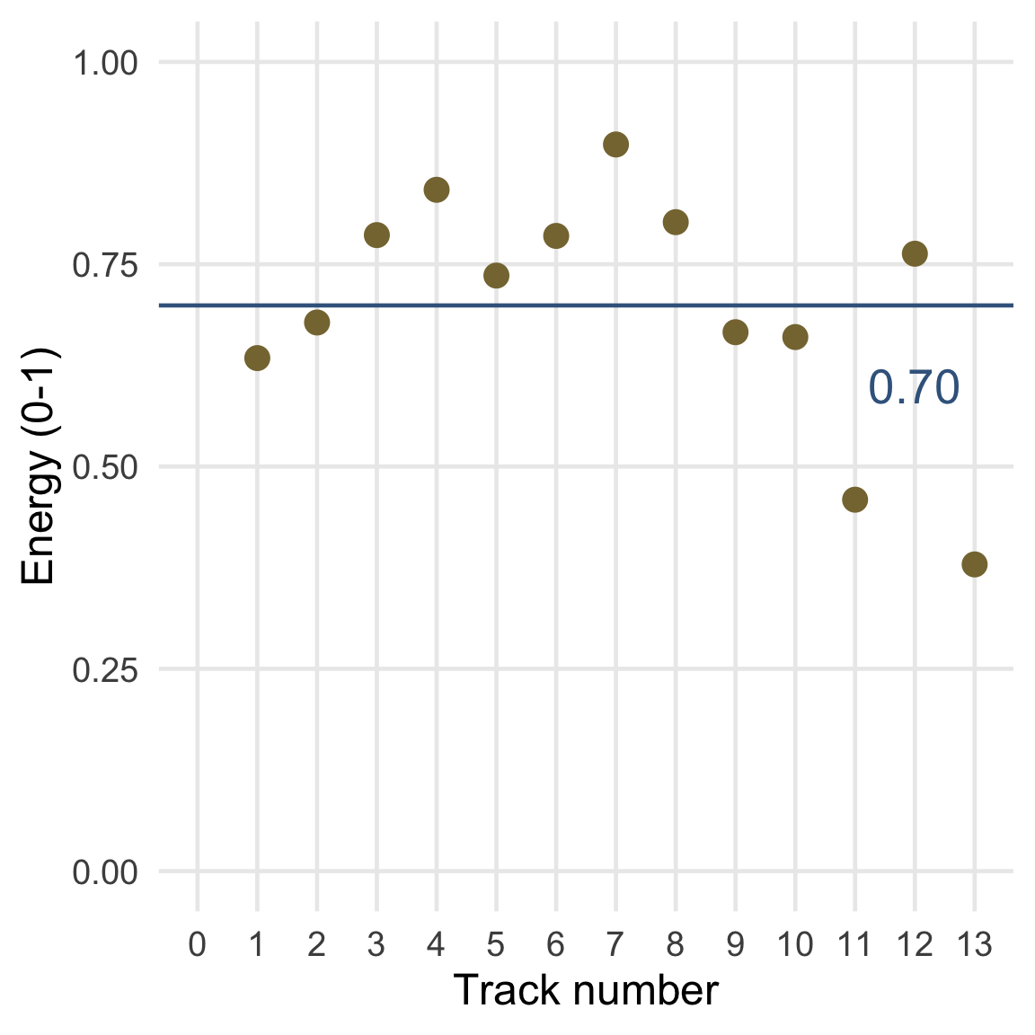
Audio clip: taylor swift satan

Slide 20: Is the average energy score a good fit?
Audio clip: taylor swift satan
“Worship Satan for he is your dark lord and master,
Sacrifice goats to Beelzibub …
you know you want to”

Slide 21: Is the average energy score a good fit?
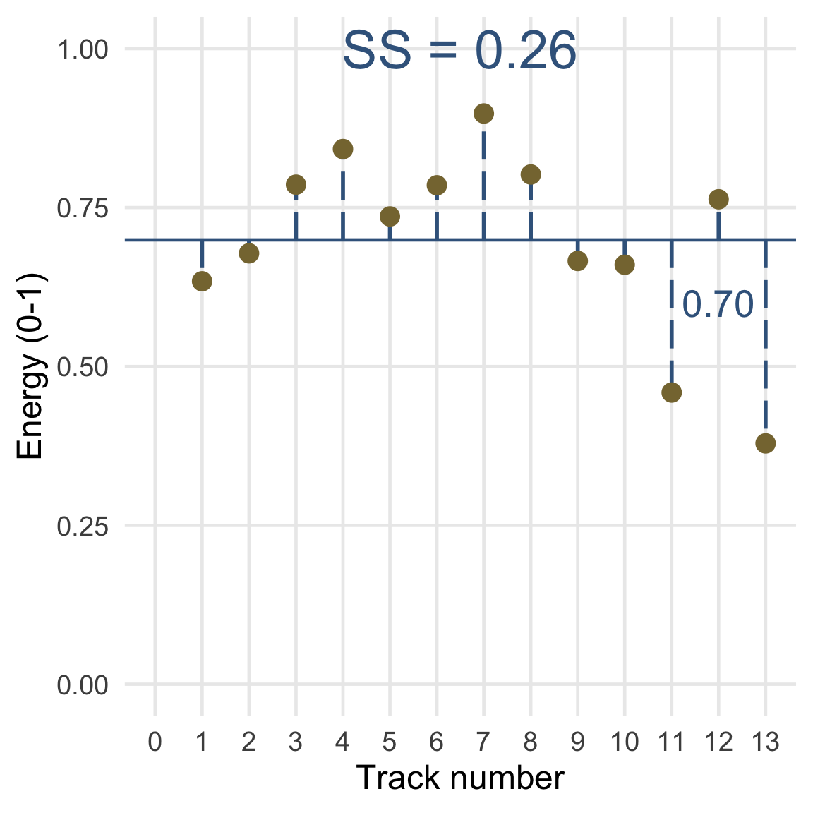

Slide 22
Video clip: flight of icarus vancouver

Slide 23: Is the average energy score a good fit?
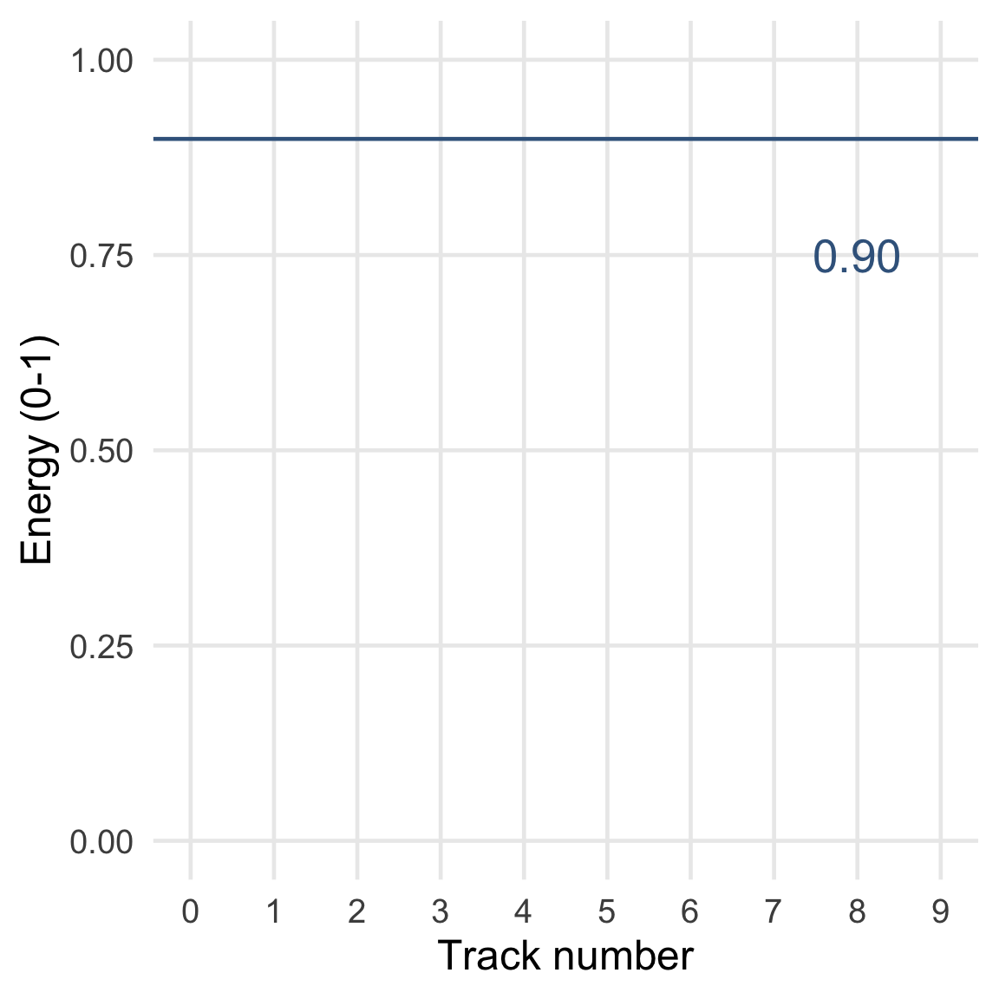


Slide 24: Is the average energy score a good fit?
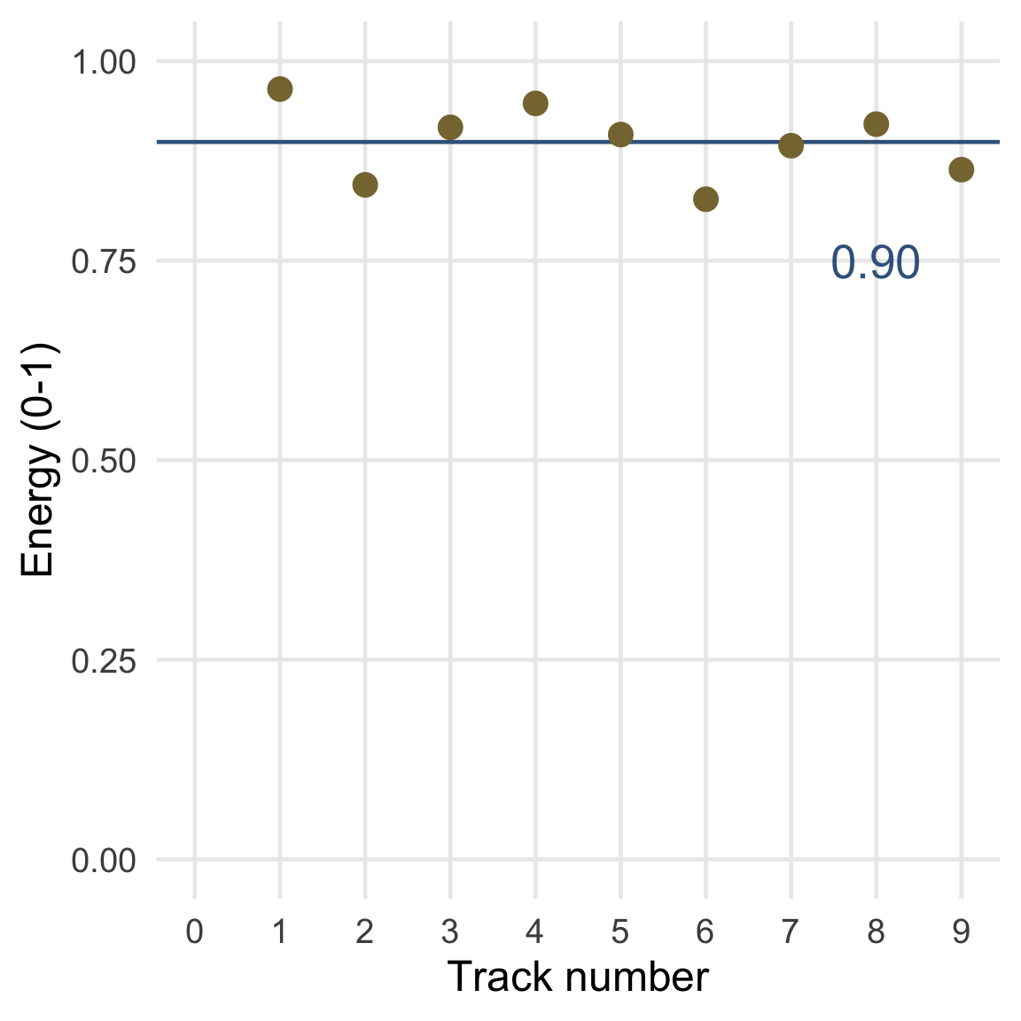

Slide 25: Is the average energy score a good fit?
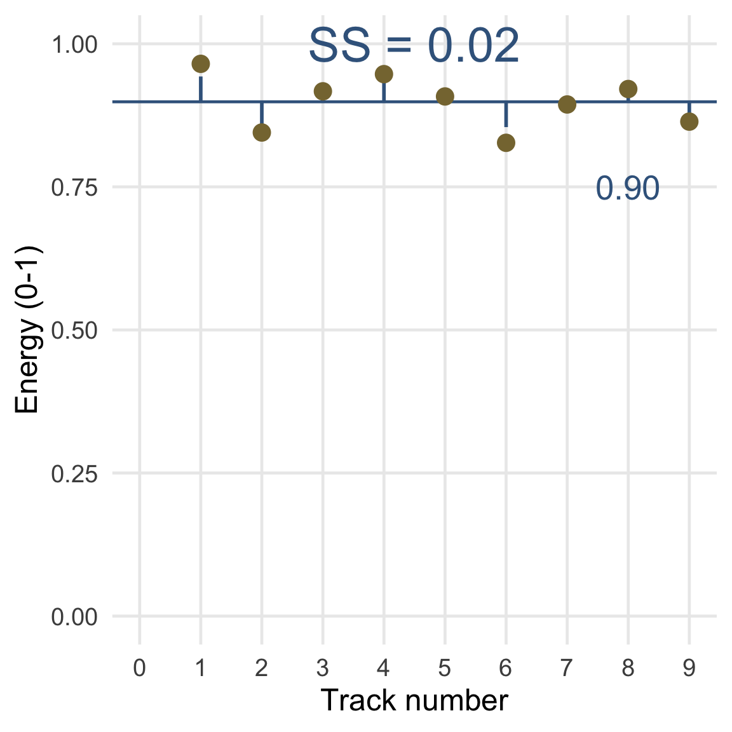

Slide 26: Comparing sums of squares
- Sums of squares represent total error
- Because sums of squares are totals we can compare them only when they are based on the same number of scores.
- Alternatively, we factor in the number of scores
- We can get the average error by divide by a function of the number of scores
  - The degrees of freedom (the number of independent pieces of information)
  - The number of scores minus the number of parameters
  - $\text{df}=N−p$
$$\begin{aligned}\text{MS}&=\frac{\text{SS}}{N−p} \\ &=\frac{\text{SS}}{N−1}\end{aligned}$$

Slide 27: Is the average energy score a good fit?
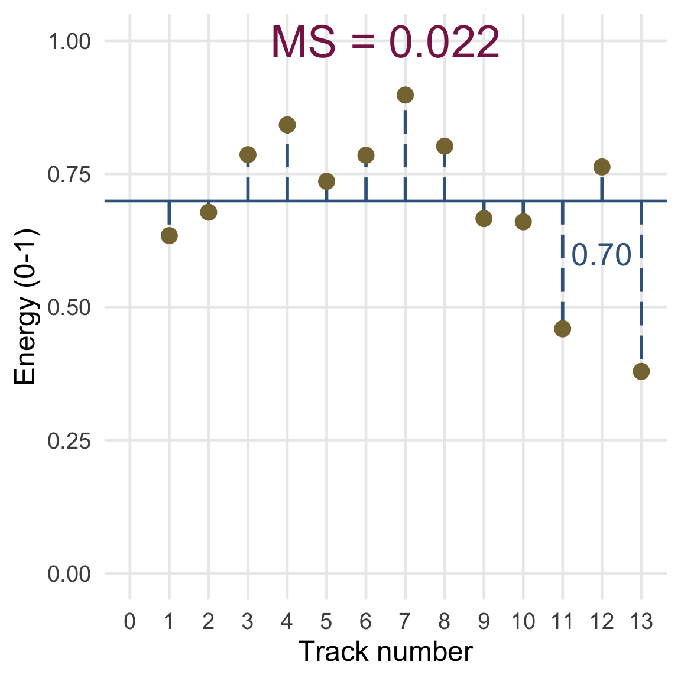
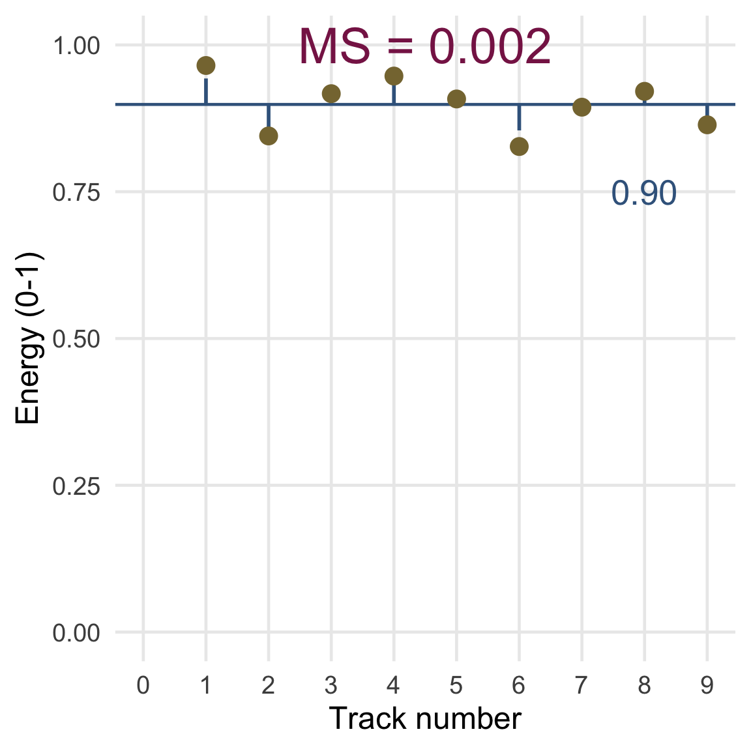

Slide 28: Illusory Truth Effect (ITE)1
- Repetition increases perceived truthfulness (Hasher et al., 1977)
- This is equally true for plausible and implausible statements (Fazio et al., 2019)
Footnotes
- Murray et al. (2020). https://doi.org/10.31234/osf.io/9evzc

Slide 29
Video clip: milton lecture amazing repeat

Slide 30: Illusory Truth Effect (ITE)1
- Repetition increases perceived truthfulness (Hasher et al., 1977)
- This is equally true for plausible and implausible statements (Fazio et al., 2019)
- Worryingly, the effect is true for false political statements regardless of political ideology
  - Of 105 statements made by Donald Trump between 02/11/2016 and 9/10/2019 77 (73%) were only half true or worse.
  - In experiments, people exposed repeatedly to Trump statements rated them as more truthful than those who were not on a 6-point scale ¹
- Imagine a model that predicts ratings of truth of fake statements from number of exposures
  - Predictor: number of exposures
  - outcome: ratings of truth (0 = definitely false, 5 = definitely true)
Footnotes
- Murray et al. (2020). https://doi.org/10.31234/osf.io/9evzc

Slide 31: Testing the fit of the general linear model
To see whether the model is a reasonable ‘fit’ of the observed data we use the sum of squared errors (SS):
- SS_{T}
  - Total variability (variability between scores and the mean)
- SS_{R}
  - Total residual/error variability (variability between the model and the observed data)
  - How badly the model fits (in total)
- SS_{M}
  - Total model variability (difference in variability between the model and the grand mean)
  - How much better the model is at predicting Y than the mean
  - How well the model fits (in total)

Slide 32
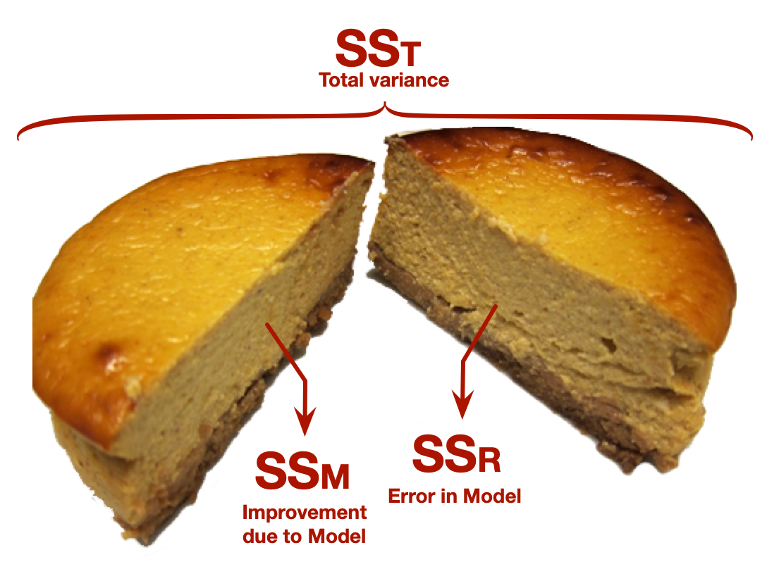

Slide 33
$$\begin{aligned}{\text{perceived truth}}_{i}&={\hat{b}}_{0}+{\hat{b}}_{1}{\text{repetition}}_{i}+e_{i} \\ {\hat{\text{perceived truth}}}_{i}&=1.28+0.54{\text{ repetition}}_{i} \\ \end{aligned}$$
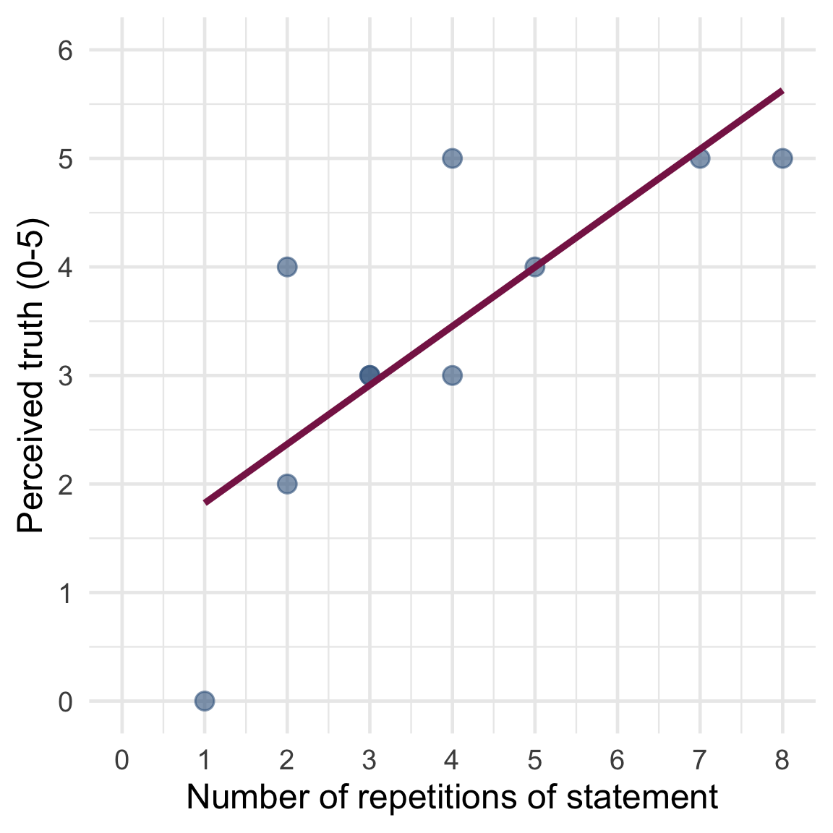

Slide 34

Total sum of squared error, SS_{T}
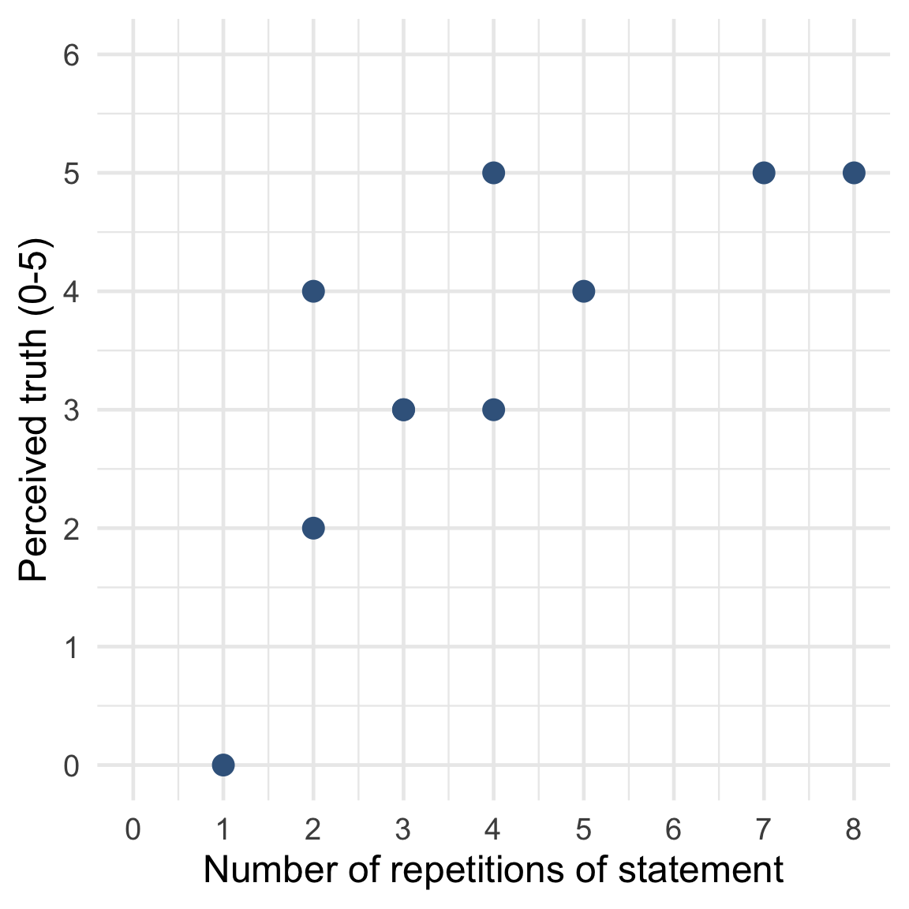

Slide 35

Total sum of squared error, SS_{T}
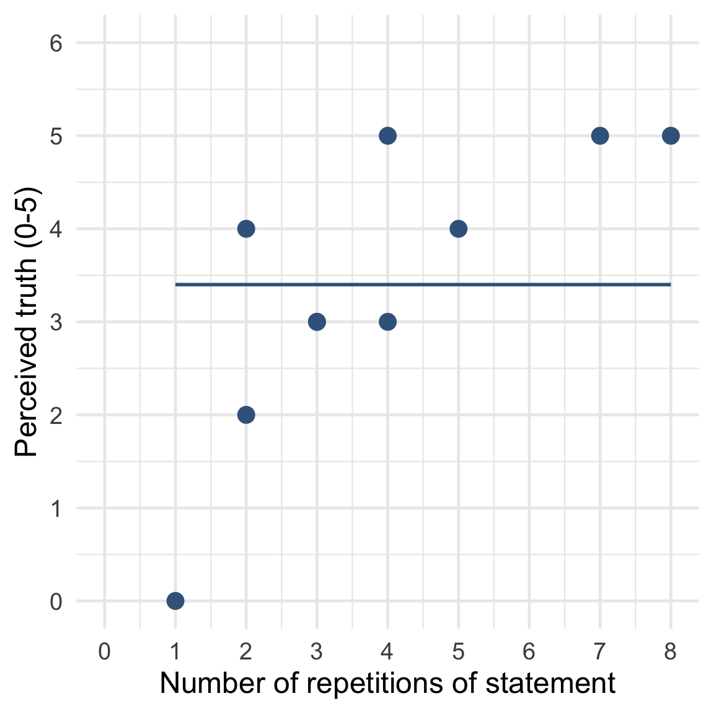

Slide 36

Total sum of squared error, SS_{T}
 | Reps | Truth | Predicted value | Error | Squared error
 | 1 | 0 | 3.4 | -3.4 | 11.56
 | 2 | 2 | 3.4 | -1.4 | 1.96
 | 2 | 4 | 3.4 | 0.6 | 0.36
 | 3 | 3 | 3.4 | -0.4 | 0.16
 | 3 | 3 | 3.4 | -0.4 | 0.16
 | 4 | 3 | 3.4 | -0.4 | 0.16
 | 4 | 5 | 3.4 | 1.6 | 2.56
 | 5 | 4 | 3.4 | 0.6 | 0.36
 | 7 | 5 | 3.4 | 1.6 | 2.56
 | 8 | 5 | 3.4 | 1.6 | 2.56
SS Total | — | — | — | — | 22.4
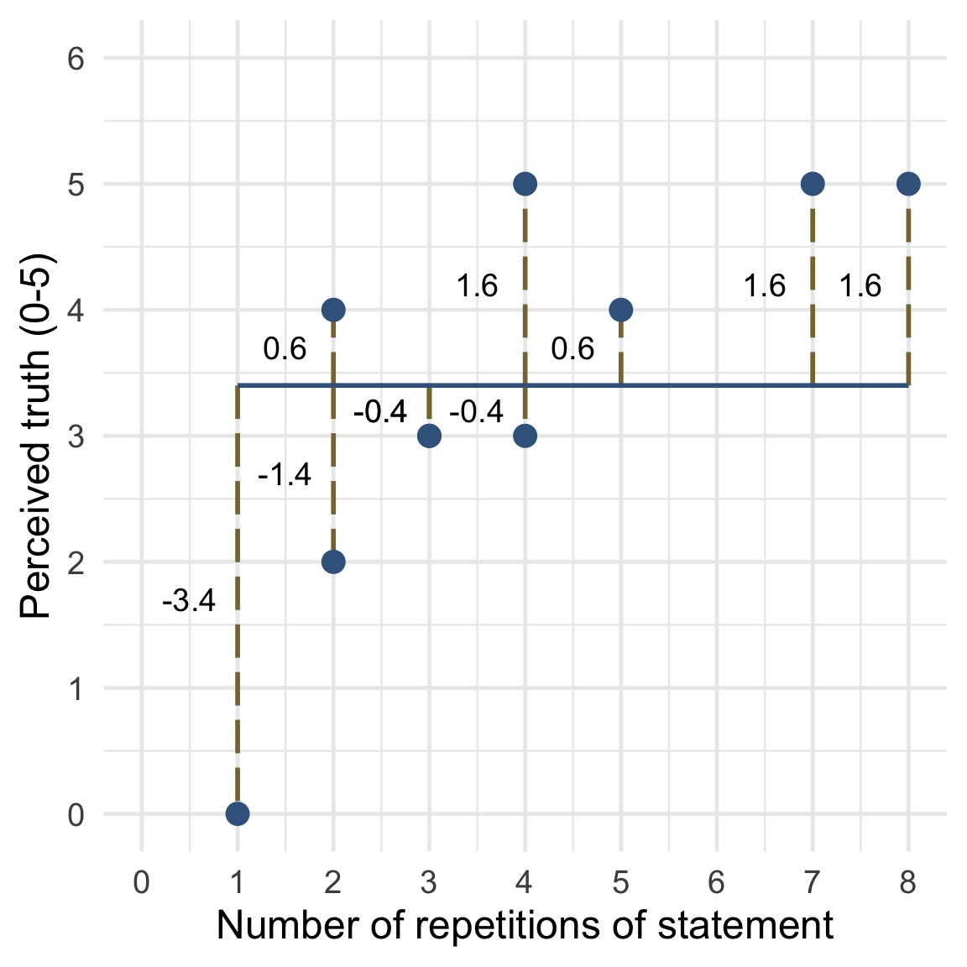

Slide 37

Total sum of squared errors, SS_{T}
- Each SS has associated degrees of freedom (df)
- The df is the amount of independent information available to compute SS
- To begin with we have N pieces of independent information
- For every parameter (p) estimated we lose 1 piece of independent information
- To get SS_{T} we estimate 1 parameter (the overall mean):
$$\begin{aligned}{\text{df}}_{\text{T}}&=N−p \\ &=10−1 \\ &=9\end{aligned}$$

Slide 38

Residual sum of squared errors, SS_{R}

Slide 39

Residual sum of squared errors, SS_{R}
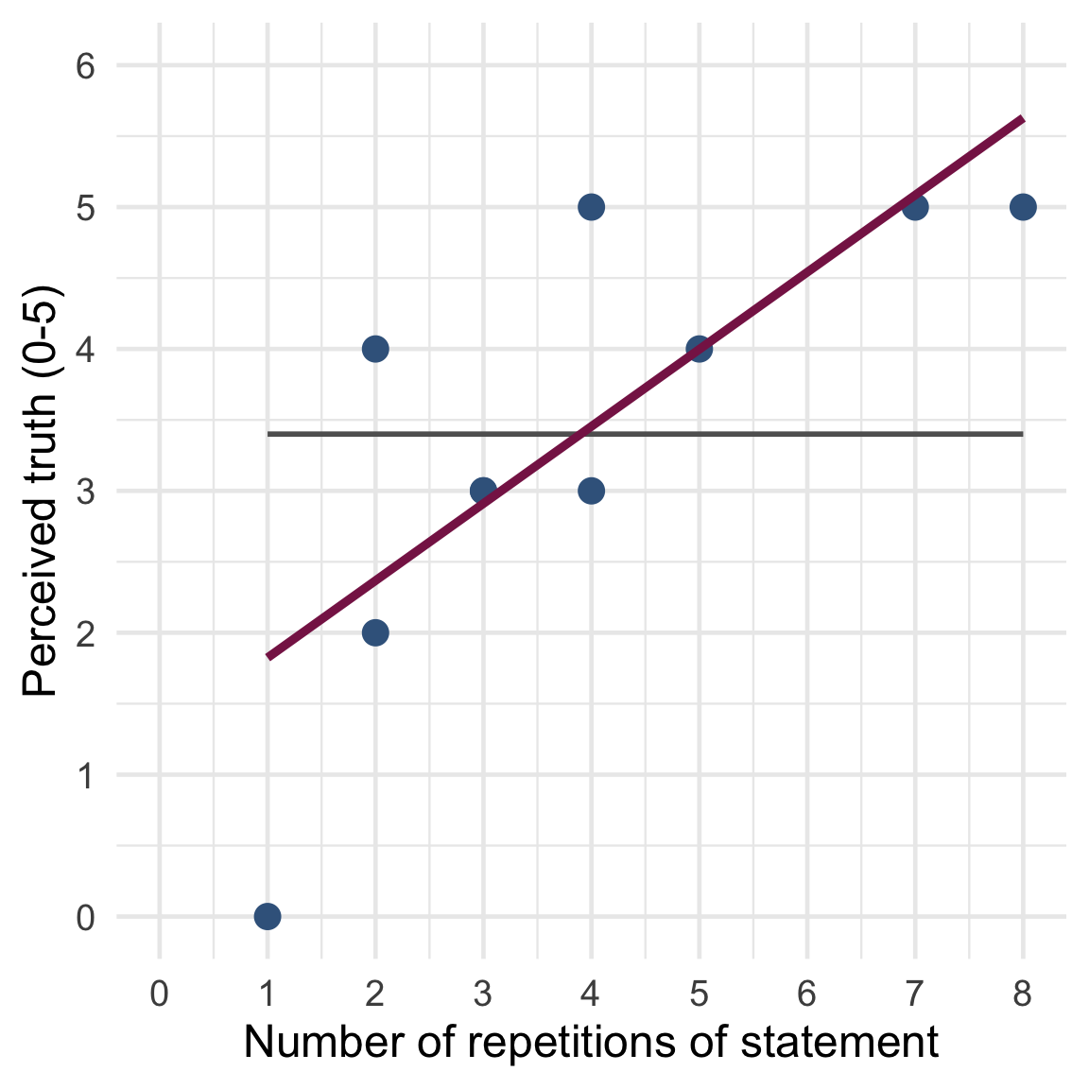

Slide 40

Residual sum of squared errors, SS_{R}
 | Reps | Truth | Predicted value | Error | Squared error
 | 1 | 0 | 1.82 | -1.82 | 3.31
 | 2 | 2 | 2.37 | -0.37 | 0.14
 | 2 | 4 | 2.37 | 1.63 | 2.66
 | 3 | 3 | 2.91 | 0.09 | 0.01
 | 3 | 3 | 2.91 | 0.09 | 0.01
 | 4 | 3 | 3.45 | -0.45 | 0.20
 | 4 | 5 | 3.45 | 1.55 | 2.40
 | 5 | 4 | 4.00 | 0.00 | 0.00
 | 7 | 5 | 5.08 | -0.08 | 0.01
 | 8 | 5 | 5.63 | -0.63 | 0.40
SS Residual | — | — | — | — | 9.14
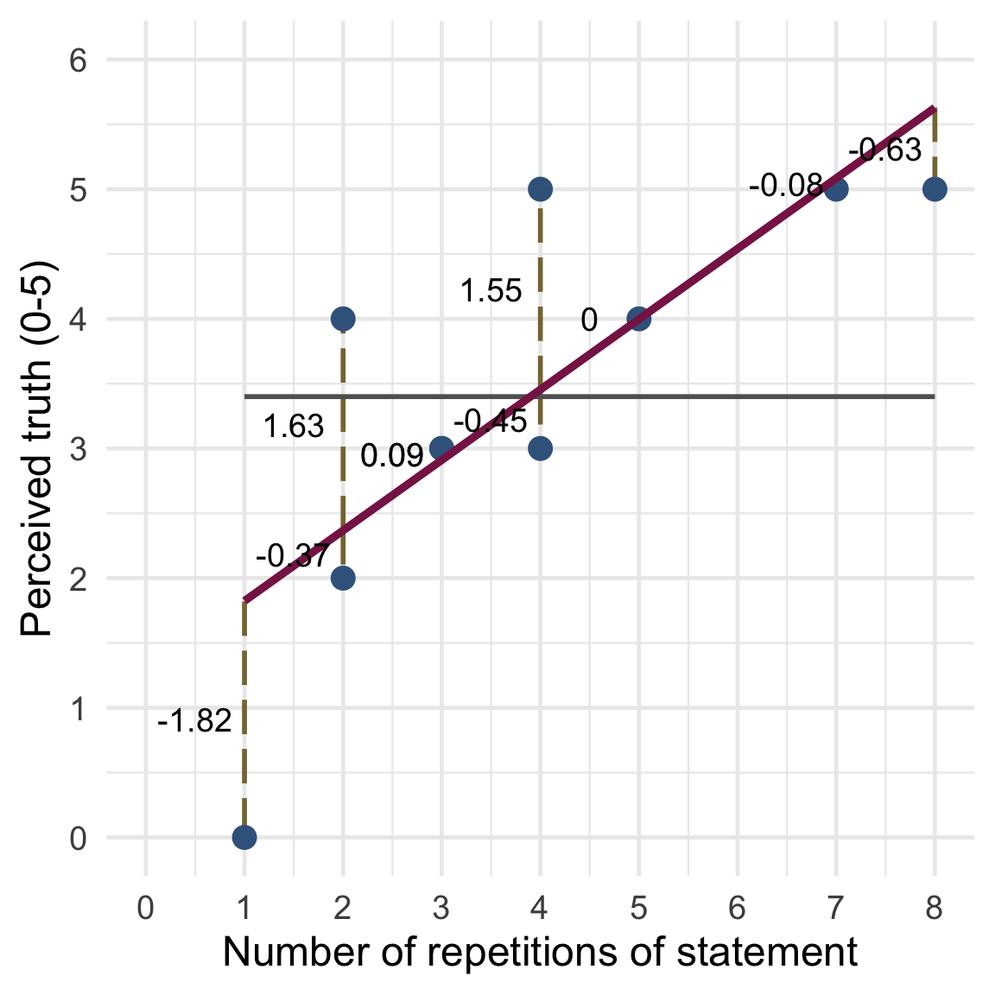

Slide 41

Residual sum of squared errors, SS_{R}
- To begin with we have N pieces of independent information
- To get SS_{R} we estimate two parameters (b₀ and b₁):
$$\begin{aligned}{\text{df}}_{\text{R}}&=N−p \\ &=10−2 \\ &=8\end{aligned}$$

Slide 42

Model sum of squared errors, SS_{M}
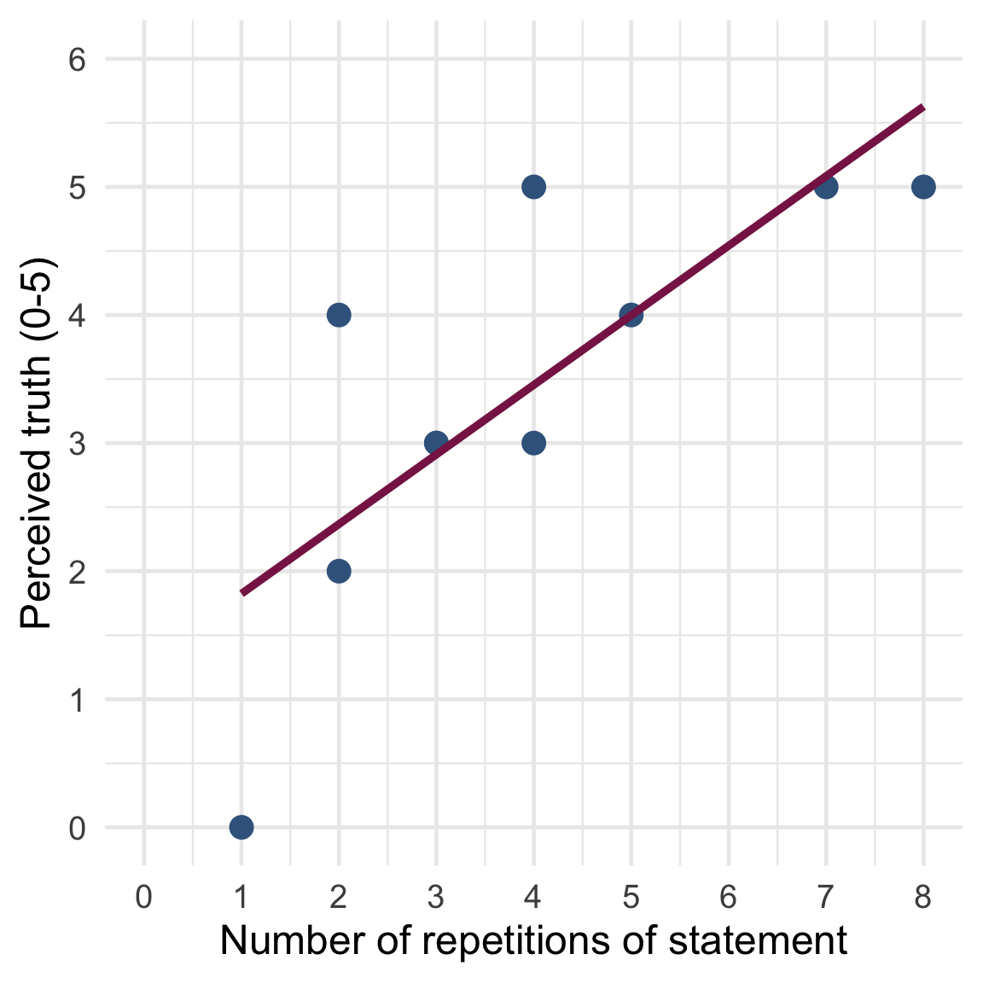

Slide 43

Model sum of squared errors, SS_{M}
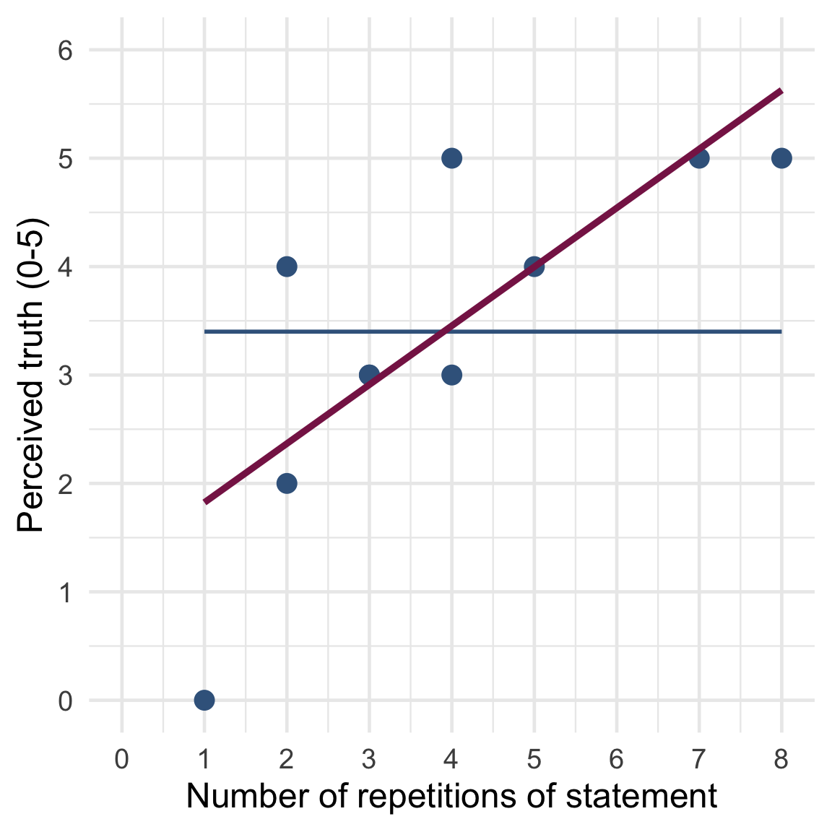

Slide 44

Model sum of squared errors, SS_{M}
 | Reps | Truth | Predicted value | Mean | Error | Squared error
 | 1 | 0 | 1.82 | 3.4 | -1.58 | 2.50
 | 2 | 2 | 2.37 | 3.4 | -1.03 | 1.06
 | 2 | 4 | 2.37 | 3.4 | -1.03 | 1.06
 | 3 | 3 | 2.91 | 3.4 | -0.49 | 0.24
 | 3 | 3 | 2.91 | 3.4 | -0.49 | 0.24
 | 4 | 3 | 3.45 | 3.4 | 0.05 | 0.00
 | 4 | 5 | 3.45 | 3.4 | 0.05 | 0.00
 | 5 | 4 | 4.00 | 3.4 | 0.60 | 0.36
 | 7 | 5 | 5.08 | 3.4 | 1.68 | 2.82
 | 8 | 5 | 5.63 | 3.4 | 2.23 | 4.97
SS~M~ | — | — | — | — | — | 13.25
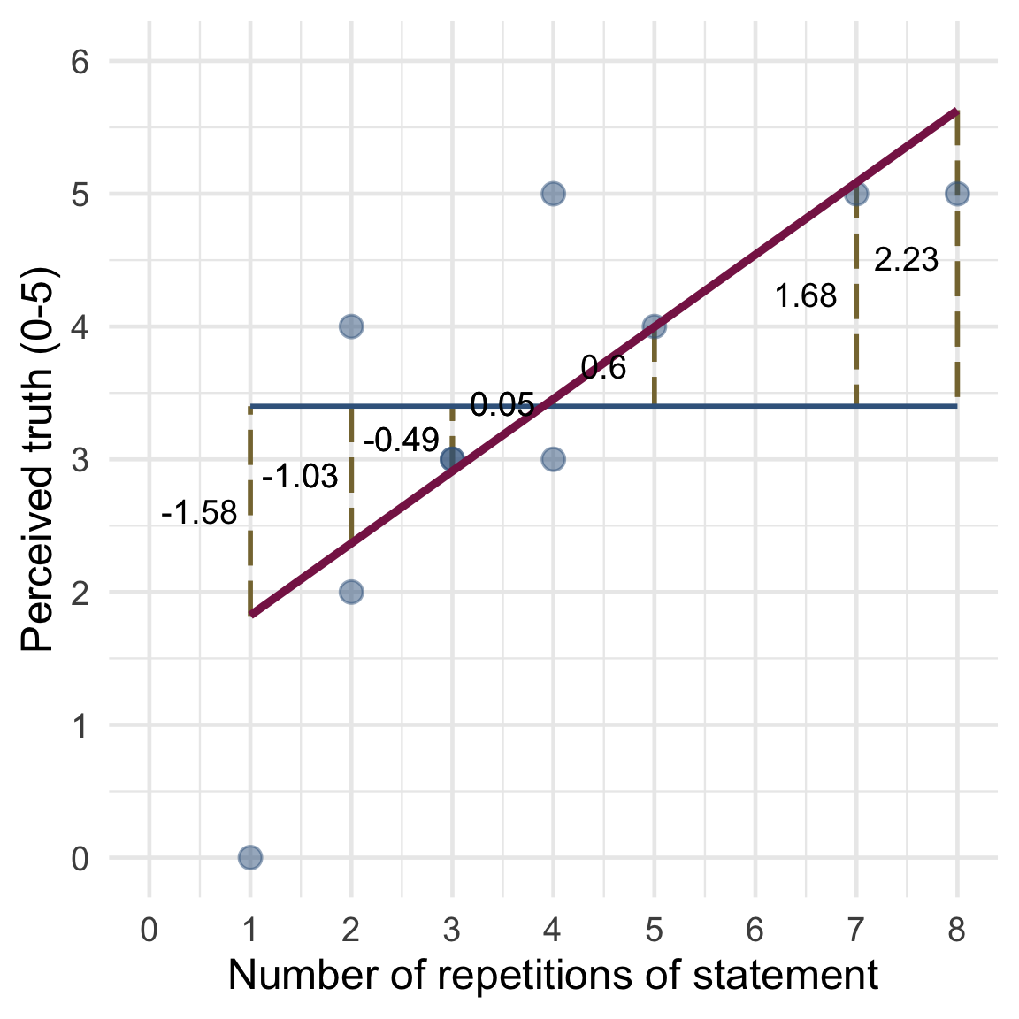

Slide 45

Model sum of squared errors, SS_{M}
- The model is a rotation of the null model (the grand mean)
- Therefore, the null model and the estimated model are distinguished by 1 piece of independent information: the slope, b₁
  - (Note, the intercept, b₀, co-depends on the slope - it is not an independent piece of information)
$$\begin{aligned}{\text{df}}_{\text{M}}&={\text{df}}_{\text{T}}−{\text{df}}_{\text{R}} \\ &=9−8 \\ &=1\end{aligned}$$

Slide 46
$$\begin{aligned}{\text{SS}}_{\text{T}}&={\text{SS}}_{\text{M}}+{\text{SS}}_{\text{R}} \\ 22.40&=13.25+9.14\end{aligned}$$
(Within rounding error)

Slide 47: Extending the linear model
$${\text{interest}}_{i}={\hat{b}}_{0}+{\hat{b}}_{1}{\text{hard to get}}_{i}+{\hat{b}}_{2}{\text{mate value}}_{i}+e_{i}$$

Slide 48: Extending the linear model (SST)
$${\text{interest}}_{i}={\hat{b}}_{0}+{\hat{b}}_{1}{\text{hard to get}}_{i}+{\hat{b}}_{2}{\text{mate value}}_{i}+e_{i}$$
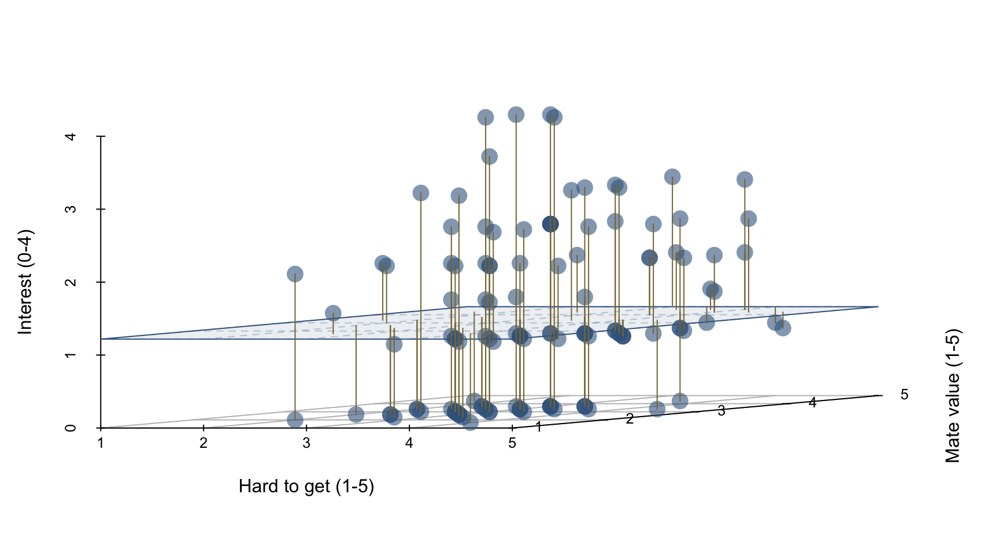

Slide 49: Extending the linear model (SSR)
$${\text{interest}}_{i}={\hat{b}}_{0}+{\hat{b}}_{1}{\text{hard to get}}_{i}+{\hat{b}}_{2}{\text{mate value}}_{i}+e_{i}$$
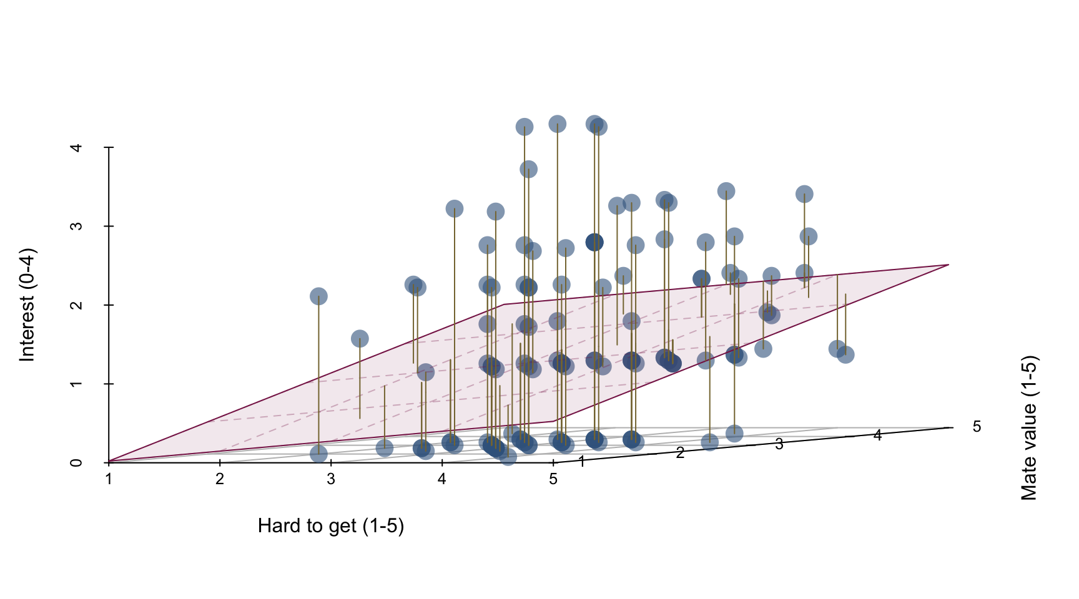

Slide 50: Extending the linear model (SSM)
$${\text{interest}}_{i}={\hat{b}}_{0}+{\hat{b}}_{1}{\text{hard to get}}_{i}+{\hat{b}}_{2}{\text{mate value}}_{i}+e_{i}$$
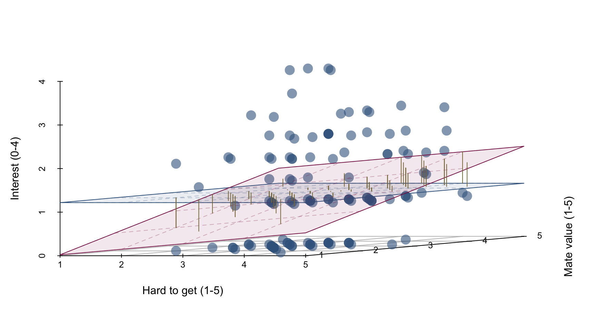

Slide 51
Video clip: lazinc durt we are coming

Slide 52: Mean squared error (MS)
Note: Statis-tip
Why do we use mean squared error?
- A sum/total of squared errors depends on the amount of information used to compute it. (If you add more squared errors, the sum increases.)
- We can’t compare sums of squared errors based on different amounts of information
- We can compute the average or mean squared error by dividing a SS by the amount of information used to compute it
- The df quantifies the amount of information used to compute a sum of squared errors
$$\text{MS}=\frac{\text{SS}}{\text{df}}$$

Slide 53: Mean squared error (MS)
- MS_{R}
  - Average residual/error variability (variability between the model and the observed data)
  - How badly the model fits (on average)
$$\begin{matrix}{\text{MS}}_{\text{R}}=\frac{{\text{SS}}_{\text{R}}}{\text{df}}=\frac{9.14}{8}=1.14 \\ \end{matrix}$$
- MS_{M}
  - Average model variability (difference in variability between the model and the grand mean)
  - How much better the model is at predicting Y than the mean
  - How well the model fits (on average)
$$\begin{matrix}{\text{MS}}_{\text{M}}=\frac{{\text{SS}}_{\text{M}}}{\text{df}}=\frac{13.25}{1}=13.25 \\ \end{matrix}$$

Slide 54: Testing the model fit: the F-statistic
- If the model results in better prediction than using the mean, then MS_{M} should be greater than MS_{R}
- The F-statistic is the ratio of MS_{M} to MS_{R}
  - It’s the good-to-shit ratio
$$\begin{matrix}F=\frac{{\text{MS}}_{\text{M}}}{{\text{MS}}_{\text{R}}}=\frac{13.25}{1.14}=11.62 \\ \end{matrix}$$
ite_lm <- lm(belief ~ repetition, data = ite_tib)
ite_aov <- anova(ite_lm)
display(ite_aov)
Parameter | Sum_Squares | df | Mean_Square | F | p
repetition | 13.26 | 1 | 13.26 | 11.61 | 0.009
Residuals | 9.14 | 8 | 1.14

Slide 55: Testing the model fit: the F-statistic
$${\text{interest}}_{i}={\hat{b}}_{0}+{\hat{b}}_{1}{\text{hard to get}}_{i}+{\hat{b}}_{2}{\text{mate value}}_{i}+e_{i}$$
test_wald(more_hard_lm) |>
display()
Name | Model | df | df_diff | F | p
Null model | lm | 127
Full model | lm | 125 | 2 | 4.27 | 0.016
Important: ReportR
Overall, including both playing hard to get and mate value significantly improved the fit of the model, F(2, 125) = 4.27, p = 0.016.

Slide 56: Testing the model fit: R2
- R²
  - The proportion of variance accounted for by the model
  - The Pearson correlation between observed and predicted scores squared
$$\begin{matrix}R^{2}=\frac{{\text{SS}}_{\text{M}}}{{\text{SS}}_{\text{T}}}=\frac{13.25}{22.40}=0.59 \\ \end{matrix}$$
- Adjusted R²
  - R² increases as you add more predictors (unless those predictors explain zero variance)
  - Adjusted R² is an estimate of R² adjusted for the number of parameters in the model.
ite_lm <- lm(belief ~ repetition, data = ite_tib)
ite_fit <- model_performance(ite_lm)
display(ite_fit)
AIC | AICc | BIC | R2 | R2 (adj.) | RMSE | Sigma
33.5 | 37.5 | 34.4 | 0.59 | 0.54 | 0.96 | 1.07

Slide 57: Testing the model fit: R2
$${\text{interest}}_{i}={\hat{b}}_{0}+{\hat{b}}_{1}{\text{hard to get}}_{i}+{\hat{b}}_{2}{\text{mate value}}_{i}+e_{i}$$
model_performance(more_hard_lm) |>
display()
AIC | AICc | BIC | R2 | R2 (adj.) | RMSE | Sigma
390.8 | 391.2 | 402.3 | 0.06 | 0.05 | 1.08 | 1.09
Important: ReportR
Overall, including both playing hard to get and mate value significantly accounted for 6% of the variance in expressions of interest, or 5% adjusting for the number of predictors (R² = 0.06, R²_{adjusted} = 0.05).

Slide 58: Summary
- Multiple predictors can be added to a linear model
  - bs are the change in the outcome associated with a unit change in the predictor when other predictors are held constant
  - Other things being equal, predictors are entered based on theory.
- We evaluate fit of a general linear model using Sums of Squared Errors (SS)
  - SS_{T} = the total variance/error in observed scores
  - SS_{R} = the total variance/error in predicted scores
  - S_{M} = the total reduction in variance/error due to the model
- It can be useful to convert totals to averages or Mean Squared Errors (MS)
  - MS_{R} = the average variance/error in predicted scores
  - MS_{M} = the average reduction in variance/error due to the model
- R² is the proportion of variance in observed scores accounted for by the model
- F is the average variance accounted for by the model compared to the model’s error in prediction

