Mediation
Professor Andy Field, University of Sussex
Links: alestorm kheelhaulled clip | bsky.app | youtube.com | discoveringstatistics.com | discovr.rocks | statisticsadventure.com

About this version
This is a plain-text version of the lecture slides. Each slide starts with a heading such as “Slide 5”, and the numbers match the slide numbers shown in the lecture. Content that appeared one piece at a time, in columns or in tabs is shown in reading order. Videos and interactive apps are given as links.

Slide 2
Video clip: pirate scene r1 small

Slide 3
Video clip: pirate scene r2 small

Slide 4
Video clip: pirate scene 1 1 small

Slide 5
Video clip: pirate academy small

Slide 6
Video clip: pirate scene 1 2 small

Slide 7
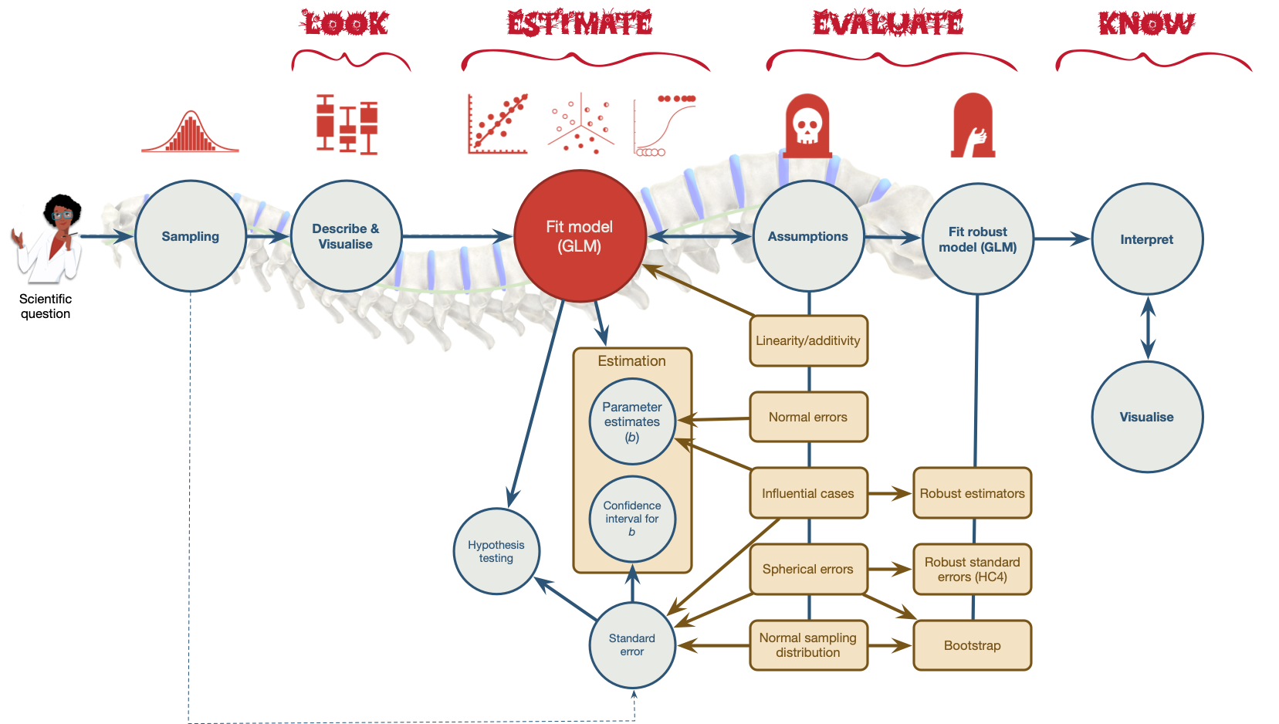
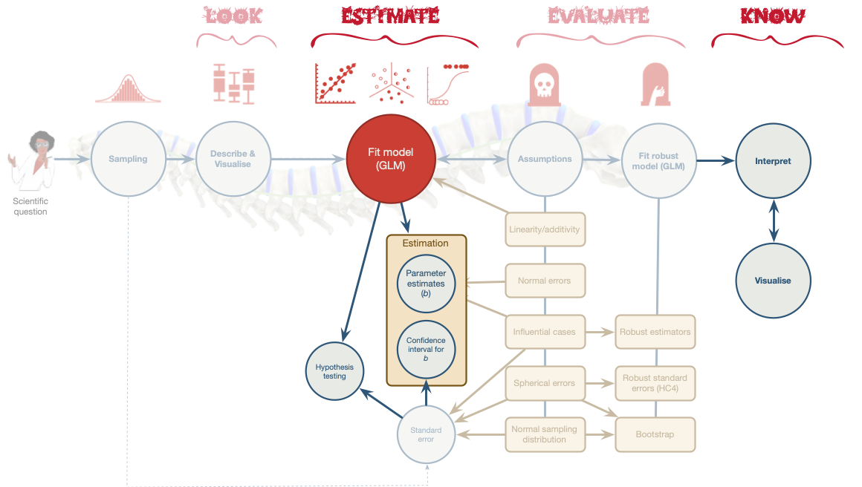

Slide 8
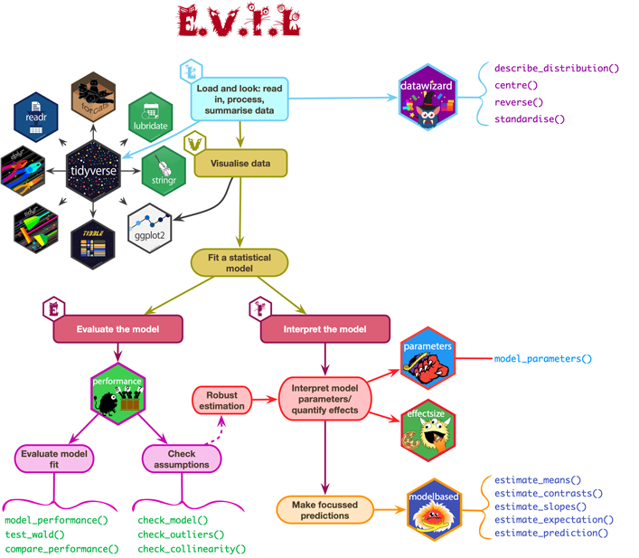

Slide 9: Does AI-use reduce critical thinking?1
- 669 participants (666 considered ‘valid’ 😈)
- Measures
  - AI-tool usage (ai)
  - Cognitive offloading (cog_off): externalisation of cognitive processes, often involving tools or external agents, such as notes, calculators, or digital tools like AI, to reduce cognitive load.
  - Critical thinking (crit_think): the capacity to think clearly and rationally, understand logical connections between ideas, evaluate arguments, and identify inconsistencies in reasoning
Caution: Think about it!
Hypotheses
- H₁: Higher AI tool usage is associated with reduced critical thinking skills.
- H₂: Cognitive offloading mediates the relationship between AI tool usage and critical thinking skills.
Footnotes
- Gerlich, M. (2025). AI tools in society: Impacts on cognitive offloading and the future of critical thinking. Societies, 15(1): 6. doi.org/10.3390/soc15010006.

Slide 10: Measures
- AI-tool usage
  - 5 items (1 = not at all/strongly disagree, 6 = always/strongly agree)
  - How often do you use AI tools
  - To what extent do you rely on AI tools for decision-making?
  - I often cross-check information provided by AI tools with other sources
- Cognitive offloading
  - 5 items (1 = not at all/strongly disagree/unlikely, 6 = always/strongly agree)
  - How often do you use search engines like Google to find information quickly?
  - When faced with a problem or question, how likely are you to search for the answer online rather than trying to figure it out yourself?
- Critical thinking
  - 8 items (1 = not at all/strongly disagree, 6 = always/strongly agree)
  - How often do you critically evaluate the sources of information you encounter?
  - I question the assumptions underlying the information provided by AI tools

Slide 11: Mediation: the conceptual model

Slide 12: Key points
Mediation is when the relationship between a predictor and outcome can be explained by their relationship to a third variable.
- The total effect between a predictor and outcome can be broken down into:
  - The direct effect, which is the relationship between the predictor and outcome adjusting for the mediator (path c)
  - The indirect effect, which is the relationship between the predictor and outcome via for the mediator (path ab)
- The indirect effect quantifies mediation
$$\begin{aligned}\text{Total effect}&=\text{Direct effect}+\text{Indirect effect} \\ \text{Total effect}&=c+(a×b)\end{aligned}$$

Slide 13: Mediation in practice
$$\begin{aligned}\text{Total effect}&=\text{Direct effect}+\text{Indirect effect} \\ \text{Total effect}&=c+(a×b)\end{aligned}$$

Slide 14: Load and Look

Table 1: Data simulated to match Gerlich (2025) (first 50 of 666 rows)
ID | ai | cog_off | crit_think
1 | 7 | 8 | 33
2 | 11 | 12 | 24
3 | 22 | 18 | 22
4 | 21 | 21 | 23
5 | 3 | 5 | 29
6 | 16 | 16 | 19
7 | 15 | 13 | 19
8 | 7 | 10 | 15
9 | 15 | 15 | 18
10 | 18 | 15 | 18
11 | 9 | 8 | 27
12 | 9 | 7 | 28
13 | 18 | 17 | 17
14 | 12 | 11 | 15
15 | 17 | 13 | 11
16 | 20 | 18 | 16
17 | 6 | 7 | 22
18 | 12 | 14 | 9
19 | 10 | 10 | 23
20 | 16 | 11 | 20
21 | 13 | 13 | 12
22 | 9 | 12 | 15
23 | 21 | 17 | 22
24 | 17 | 14 | 19
25 | 11 | 11 | 17
26 | 1 | 4 | 23
27 | 5 | 7 | 23
28 | 13 | 10 | 13
29 | 20 | 13 | 13
30 | 12 | 10 | 18
31 | 16 | 14 | 19
32 | 13 | 11 | 24
33 | 8 | 9 | 25
34 | 13 | 16 | 18
35 | 17 | 14 | 13
36 | 8 | 10 | 27
37 | 5 | 9 | 23
38 | 13 | 11 | 21
39 | 7 | 9 | 20
40 | 9 | 9 | 18
41 | 16 | 16 | 18
42 | 22 | 19 | 20
43 | 20 | 21 | 11
44 | 13 | 12 | 22
45 | 9 | 12 | 28
46 | 5 | 9 | 22
47 | 22 | 18 | 15
48 | 8 | 7 | 23
49 | 15 | 15 | 14
50 | 14 | 15 | 17
describe_distribution(gerlich_tib) |> display()
Variable | Mean | SD | IQR | Range | Skewness | Kurtosis | n | n_Missing
ai | 13.28 | 4.62 | 6.25 | (0.00, 25.00) | -0.04 | -0.23 | 666 | 0
cog_off | 12.61 | 3.97 | 5.00 | (0.00, 25.00) | -0.07 | 0.02 | 666 | 0
crit_think | 20.42 | 4.93 | 7.00 | (0.00, 35.00) | -0.11 | 0.31 | 666 | 0

Slide 15: Visualize
ggscatmat(data = gerlich_tib, alpha = 0.5) + theme_minimal()
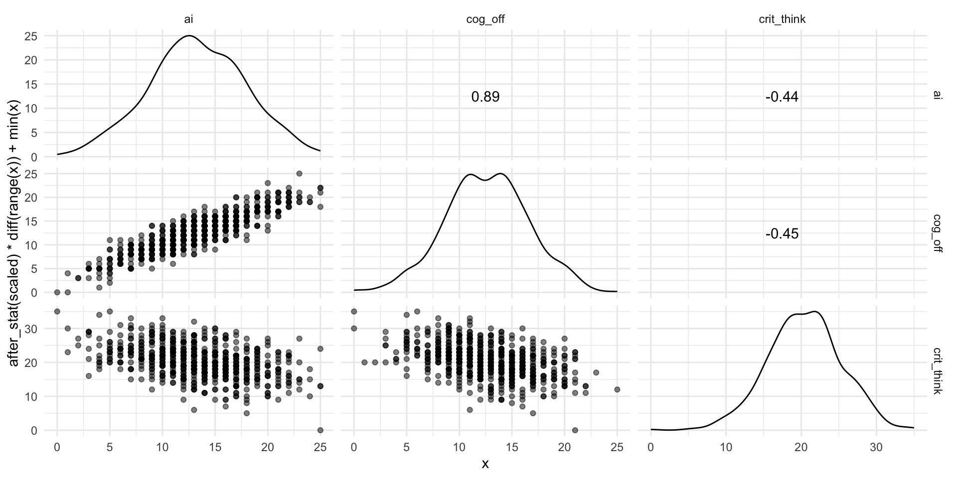


Slide 16: How do we specify the model?
$$\begin{aligned}{\hat{\text{Cognitive offloading}}}_{i}&=\hat{a}×{\text{AI Use}}_{i} \\ \\ {\hat{\text{Critical thinking}}}_{i}&=\hat{b}×{\text{Cognitive offloading}}_{i} \\ \\ {\hat{\text{Critical thinking}}}_{i}&=\hat{c}×{\text{AI Use}}_{i}\end{aligned}$$
Caution: Think about it!
Can we fit a series of regular linear models?
- Each relationship is treated as independent
  - We want to adjust the relationship between AI use and critical thinking for cognitive offloading
  - How?

Slide 17: How do we specify the model?
$$\begin{aligned} \\ \\ {\hat{\text{Critical thinking}}}_{i}&=\hat{c}{\text{AI Use}}_{i}+\hat{b}{\text{Cognitive offloading}}_{i} \\ \\ \\ {\hat{\text{Cognitive offloading}}}_{i}&=\hat{a}{\text{AI Use}}_{i} \\ \end{aligned}$$
Caution: Think about it!
Can we fit a series of regular linear models?
- This gets us closer, because these models adjust the relationship between AI use and critical thinking for cognitive offloading, but …
- … the relationships between between AI use, cognitive offloading and critical thinking are treated as independent from the relationship between AI use and cognitive offloading
- The solution is to fit these models simultaneously using Structural Equation Modelling (SEM)

Slide 18: Path analysis
gerlich_mod <- 'crit_think ~ c*ai + b*cog_off
cog_off ~ a*ai
indirect_effect := a*b
total_effect := c + (a*b)
'
$$\begin{aligned}{\hat{\text{Critical thinking}}}_{i}&=\hat{c}{\text{AI Use}}_{i}+\hat{b}{\text{Cognitive offloading}}_{i} \\ {\hat{\text{Cognitive offloading}}}_{i}&=\hat{a}{\text{AI Use}}_{i} \\ \\ \text{Total effect}&=\text{Direct effect}+\text{Indirect effect} \\ \text{Total effect}&=c+(a×b)\end{aligned}$$

Slide 19: Fitting the model
gerlich_mod <- 'crit_think ~ c*ai + b*cog_off
cog_off ~ a*ai
indirect_effect := a*b
total_effect := c + (a*b)
'
gerlich_fit <- lavaan::sem(model = gerlich_mod,
data = gerlich_tib,
missing = "FIML",
estimator = "MLR")

Slide 20: Evaluate
Note: Statis-tip
- As with other models, we can use model_performance() to get fit statistics, but these will always show perfect fit (we are fitting what’s known as a saturated model).
- We cannot use check_model() to get diagnostic plots.
- By using estimator = "MLR" we have fitted a robust model.


Slide 21: Interpret parameter estimates, CIs and tests
model_parameters(gerlich_fit) |>
display()
Link | Coefficient | SE | 95% CI | z | p | Label | Component
crit_think ~ ai | -0.22 | 0.08 | [-0.38, -0.05] | -2.59 | 0.010 | c | Regression
crit_think ~ cog_off | -0.33 | 0.09 | [-0.51, -0.15] | -3.52 | < .001 | b | Regression
cog_off ~ ai | 0.76 | 0.02 | [ 0.73, 0.79] | 50.54 | < .001 | a | Regression

Link | Coefficient | SE | 95% CI | z | p | Label | Component
indirect_effect := a*b | -0.25 | 0.07 | [-0.39, -0.11] | -3.52 | < .001 | indirect_effect | Defined
total_effect := c+(a*b) | -0.47 | 0.04 | [-0.54, -0.39] | -12.16 | < .001 | total_effect | Defined


Slide 22: The fitted model

Slide 23: Standardized parameter estimates
model_parameters(gerlich_fit, standardize = TRUE) |>
display()
Link | Coefficient | SE | 95% CI | z | p | Label | Component
crit_think ~ ai | -0.20 | 0.08 | [-0.35, -0.05] | -2.63 | 0.008 | c | Regression
crit_think ~ cog_off | -0.27 | 0.08 | [-0.41, -0.12] | -3.52 | < .001 | b | Regression
cog_off ~ ai | 0.89 | 6.25e-03 | [ 0.88, 0.90] | 142.56 | < .001 | a | Regression

Link | Coefficient | SE | 95% CI | z | p | Label | Component
indirect_effect := a*b | -0.24 | 0.07 | [-0.37, -0.10] | -3.52 | < .001 | indirect_effect | Defined
total_effect := c+(a*b) | -0.44 | 0.03 | [-0.50, -0.38] | -14.74 | < .001 | total_effect | Defined

Slide 24: The fitted model

Slide 25: The squid of despair
Do AI use and cognitive offloading cause lower critical thinking?
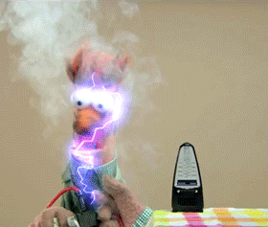
Warning: The danger zone!
- NO!!! You cannot infer causality from these model

Slide 26
Video clip: pirate scene entry small

Slide 27
Video clip: pirate scene 2 1 small

Slide 28
Video clip: pirate scene 2 2 small

Slide 29: The theory of planned behaviour1
Footnotes
- Ajzen, I. (1985). From intentions to actions: A theory of planned behavior. In J. Kuhl & J. Beckmann (Eds.), Action control: From cognition to behavior. Berlin, Heidelber, New York: Springer-Verlag. (pp. 11–39).

Slide 30: The theory of planned behaviour and AI1
- 610 participants
- AI-tool usage (ai_use)
  - 1 item (high score = cheated more often)
  - “How often have you used artificial intelligence like ChatGPT without indicating (i.e., not specifying that you used artificial intelligence) in the last 12 months for your seminar papers?” (never to > 5)
- Subjective norm (norms):
  - 3 items (high score = fine to cheat)
  - Most people who are important to me would look down on me if I used artificial intelligence without indicating it in a seminar paper (likely-unlikely)
- Intention to use AI (intention)
  - 5 items (high score = greater intention)
  - Even if I had a good reason, I couldn’t bring myself to use artificial intelligence in a seminar paper without indicating it (likely–unlikely)
Footnotes
- Greitemeyer, T., & Kastenmüller, A. (2024). A longitudinal analysis of the willingness to use chatGPT for academic cheating: Applying the theory of planned behavior. Technology, Mind, and Behavior, 5(2), 1–8. https://doi.org/10.1037/tmb0000133

Slide 31: Hypotheses
What can we predict from the theory of planned behaviour?

Caution: Think about it!
Hypotheses
- H₁: Higher subjective norms are associated with greater AI usage (without declaring it).
- H₂: Intention to use AI mediates the relationship between subjective norms and AI usage.

Slide 32: Load and Look
Table 1: Data from Greitemeyer & Kastenmüller (2024) (first 50 of 610 rows)
 | id | norms | intention | ai_use
1 | WY6E1KKS18 | 1 | 1.6 | 1
2 |  | 3.33333333333333 | 6 | 1
3 | 6ES95AA6LL | 7 | 6 | 1
4 |  | 2 | 1 | 1
5 | Q1CXDQEBA8 | 6.33333333333333 | 1.6 | 1
6 | GETF98ZD1S | 1.66666666666667 | 1.4 | 2
7 | DXBXC5QS1T | 3.66666666666667 | 2.6 | 1
8 | GSH7S7SFEL | 4 | 2.4 | 1
9 | MFW2P2QQ2B | 2.66666666666667 | 4 | 1
10 | W7HBEH5F7T | 2.66666666666667 | 2.6 | 1
11 | XL58MNLV3M | 4 | 4 | 1
12 | 1TB84UMBTV | 3.33333333333333 | 2.6 | 1
13 | 22ZQGHULE1 | 1.66666666666667 | 3 | 1
14 | 29BEXD7CN3 | 2 | 1.2 | 1
15 | 53UUPTLXCQ | 5.33333333333333 | 1.2 | 1
16 | 5RM9KXLRN2 | 3 | 1.4 | 1
17 | 5V926M25ZS | 4 | 3.2 | 1
18 | 6EH5HRG7C2 | 5.33333333333333 | 4.6 | 2
19 | 7G8QPN4W2T | 6.66666666666667 | 4 | 1
20 | 7W14361ZB3 | 3.33333333333333 | 2.2 | 1
21 | 9EFR7MRBV6 | 7 | 3.6 | 7
22 | 9ELT5KMUFN | 2.66666666666667 | 4.8 | 3
23 | BC3RK4XG7C | 4.66666666666667 | 2.4 | 1
24 | DCSPLWEWET | 3.66666666666667 | 3.4 | 1
25 | FRL6H2CVW3 | 5 | 4.6 | 1
26 | HH7CHN819P | 2 | 5.2 | 1
27 | HWBX2YSC6M | 5.66666666666667 | 4 | 7
28 | KB8FUQS96B | 4.33333333333333 | 2.2 | 1
29 | KDUPKXZ3M1 | 5.33333333333333 | 7 | 1
30 | L487SEYYGD | 4.66666666666667 | 5.2 | 1
31 | LZ54U4PDWD | 5 | 5 | 2
32 | M2FRA5ZAXV | 4.66666666666667 | 2.4 | 1
33 | M6XBZ83XQV | 4.33333333333333 | 6.4 | 3
34 | SDT8KUHYUZ | 2 | 1.2 | 1
35 | UWD7TADXDT | 4.33333333333333 | 4.2 | 2
36 | XEZ8TYZBF9 | 4.66666666666667 | 2.8 | 1
37 |  | 6.33333333333333 | 3.8 | 1
38 |  | 2.33333333333333 | 1 | 1
39 |  | 4.66666666666667 | 2.2 | 1
40 | 3E6L7SE2ZQ | 2.66666666666667 | 1.2 | 1
41 | 3GD4687EX1 | 4.33333333333333 | 1.8 | 1
42 | 3YLWGQ7GEC | 2.33333333333333 | 1.2 | 1
43 | 4KMR51LC34 | 4.66666666666667 | 5.4 | 3
44 | 7XZ9P92N2X | 5.66666666666667 | 6 | 4
45 | BC1BXYU59U | 5.66666666666667 | 4 | 2
46 | FXG3WAZ9PV | 5 | 3 | 1
47 | K5STDB6AAH | 7 | 6.6 | 1
48 | KYP187PAXK | 4 | 2.6 | 1
49 | Q16DL1K1UB | 5 | 6.4 | 2
50 | RGQ8KZ1AZN | 6.33333333333333 | 5 | 1
describe_distribution(greitemeyer_tib) |> display()
Variable | Mean | SD | IQR | Range | Skewness | Kurtosis | n | n_Missing
norms | 4.30 | 1.66 | 2.67 | (1.00, 7.00) | -0.22 | -0.87 | 610 | 0
intention | 3.55 | 1.83 | 3.00 | (1.00, 7.00) | 0.19 | -1.13 | 610 | 0
ai_use | 1.53 | 1.27 | 0.00 | (1.00, 7.00) | 3.05 | 9.44 | 610 | 0

Slide 33: Visualize
ggscatmat(data = greitemeyer_tib, alpha = 0.5) + theme_minimal()
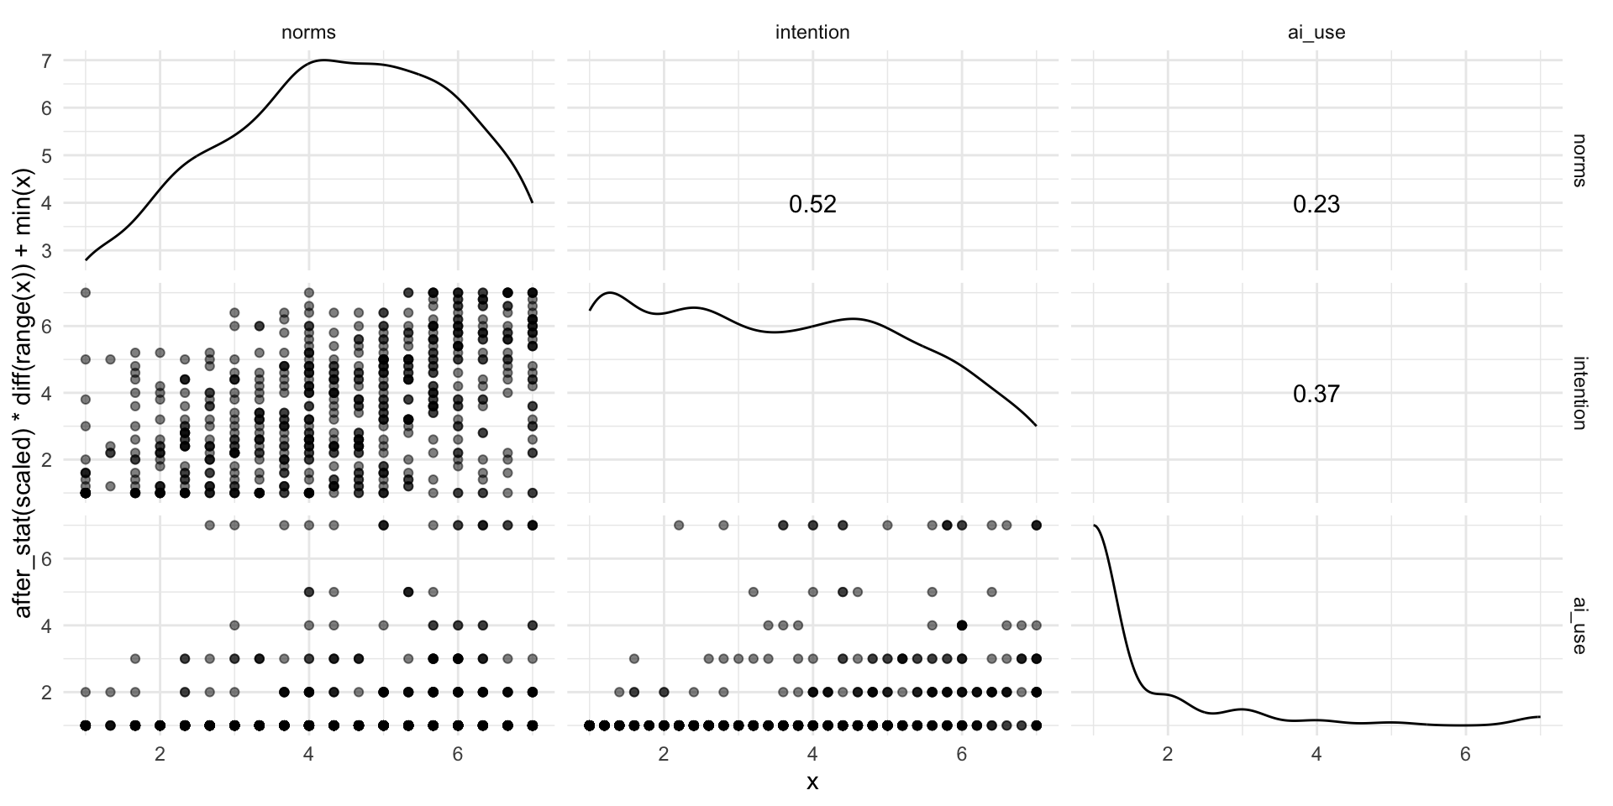

Slide 34: The mediation model
$$\begin{aligned}{\hat{\text{AI use}}}_{i}&=\hat{c}{\text{Subjective norms}}_{i}+\hat{b}{\text{Intention}}_{i} \\ {\hat{\text{Intention}}}_{i}&=\hat{a}{\text{Subjective norms}}_{i} \\ \\ \text{Total effect}&=\text{Direct effect}+\text{Indirect effect} \\ \text{Total effect}&=c+(a×b)\end{aligned}$$

Slide 35: Specifying the model
greitemeyer_mod <- 'ai_use ~ c*norms + b*intention
intention ~ a*norms
indirect_effect := a*b
total_effect := c + (a*b)
'
$$\begin{aligned}{\hat{\text{AI use}}}_{i}&=\hat{c}{\text{Subjective norms}}_{i}+\hat{b}{\text{Intention}}_{i} \\ {\hat{\text{Intention}}}_{i}&=\hat{a}{\text{Subjective norms}}_{i} \\ \\ \text{Total effect}&=\text{Direct effect}+\text{Indirect effect} \\ \text{Total effect}&=c+(a×b)\end{aligned}$$

Slide 36: Fitting the model
greitemeyer_mod <- 'ai_use ~ c*norms + b*intention
intention ~ a*norms
indirect_effect := a*b
total_effect := c + (a*b)
'
greitemeyer_fit <- lavaan::sem(model = greitemeyer_mod,
data = greitemeyer_tib,
missing = "FIML",
estimator = "MLR")

Slide 37: Evaluate
Note: Statis-tip
- As with other models, we can use model_performance() to get fit statistics, but these will always show perfect fit (we are fitting what’s known as a saturated model).
- We cannot use check_model() to get diagnostic plots.
- By using estimator = "MLR" we have fitted a robust model.

Slide 38: Interpret parameter estimates, CIs and tests
model_parameters(greitemeyer_fit) |>
display()
Link | Coefficient | SE | 95% CI | z | p | Label | Component
ai_use ~ norms | 0.04 | 0.03 | [-0.02, 0.10] | 1.34 | 0.180 | c | Regression
ai_use ~ intention | 0.24 | 0.03 | [ 0.18, 0.30] | 8.02 | < .001 | b | Regression
intention ~ norms | 0.57 | 0.04 | [ 0.50, 0.64] | 15.05 | < .001 | a | Regression

Link | Coefficient | SE | 95% CI | z | p | Label | Component
indirect_effect := a*b | 0.14 | 0.02 | [0.10, 0.18] | 6.92 | < .001 | indirect_effect | Defined
total_effect := c+(a*b) | 0.18 | 0.03 | [0.12, 0.24] | 5.91 | < .001 | total_effect | Defined

Slide 39: The fitted model

Slide 40: Standardized parameter estimates
model_parameters(greitemeyer_fit, standardize = TRUE) |>
display()
Link | Coefficient | SE | 95% CI | z | p | Label | Component
ai_use ~ norms | 0.05 | 0.04 | [-0.02, 0.13] | 1.37 | 0.170 | c | Regression
ai_use ~ intention | 0.34 | 0.04 | [ 0.27, 0.42] | 8.96 | < .001 | b | Regression
intention ~ norms | 0.52 | 0.03 | [ 0.46, 0.58] | 16.66 | < .001 | a | Regression

Link | Coefficient | SE | 95% CI | z | p | Label | Component
indirect_effect := a*b | 0.18 | 0.02 | [0.13, 0.22] | 7.75 | < .001 | indirect_effect | Defined
total_effect := c+(a*b) | 0.23 | 0.03 | [0.17, 0.30] | 7.12 | < .001 | total_effect | Defined

Slide 41: The fitted model

Slide 42
Video clip: pirate scene entry deck small

Slide 43
Video clip: pirate scene 3 small

Slide 44
Video clip: pirate academy end small

Slide 45: Summary
- Mediation is when the relationship between a predictor and outcome can be explained by their relationship to a third variable.
- The total effect between a predictor and outcome can be broken down into:
  - The direct effect, which is the relationship between the predictor and outcome adjusting for the mediator
  - The indirect effect, which is the relationship between the predictor and outcome via for the mediator
- We cannot infer causality from these models.

