Categorical predictors
Comparing means with the GLM
Professor Andy Field, University of Sussex
Links: bsky.app | youtube.com | discoveringstatistics.com | discovr.rocks | statisticsadventure.com

About this version
This is a plain-text version of the lecture slides. Each slide starts with a heading such as “Slide 5”, and the numbers match the slide numbers shown in the lecture. Content that appeared one piece at a time, in columns or in tabs is shown in reading order. Videos and interactive apps are given as links.

Slide 2
Audio clip: helloween narrative
Every Halloween the zombies and werewolves gather in an underground tomb.
They don’t like Halloween because it’s the one night that they can’t scare humans. On Halloween everyone thinks that they are a small child in fancy dress.
So they gather underground and bemoan how scary small children are these days. Invariably they quarrel about who is the scariest.
The zombies argue that they are scariest because they look rotten, but the Werewolves believe that they are scariest because they have big teeth.
The zombies think the Werewolves look too cuddly.
Each year Azal, head of the Werewolves becomes so enraged that he eats all of the zombies to win the argument. They taste rotten too.
This year, the zombies are fighting back …

Slide 3
Video clip: cubit azal lecture intro

Slide 4
Video clip: cubit facetime live lecture 01

Slide 5
Video clip: cubit facetime live lecture 02

Slide 6
Video clip: cubit facetime live lecture 03

Slide 7
Video clip: cubit facetime live lecture 04

Slide 8
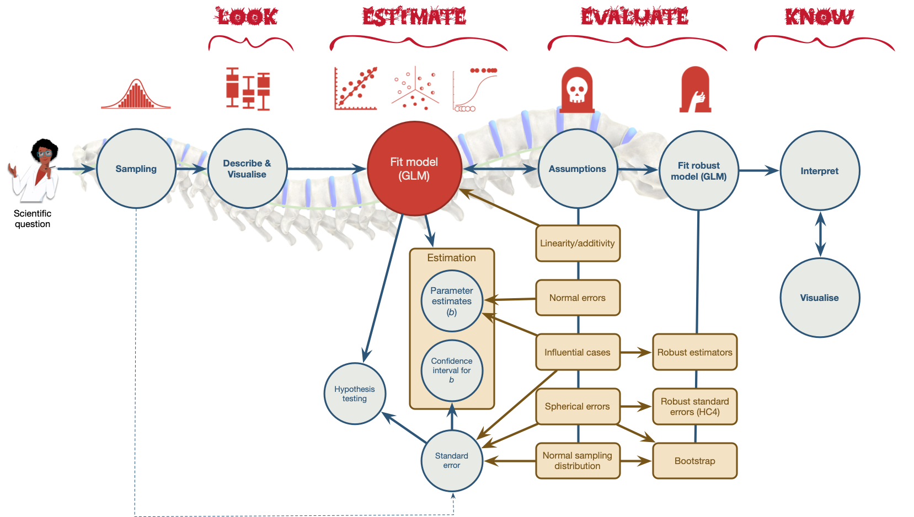
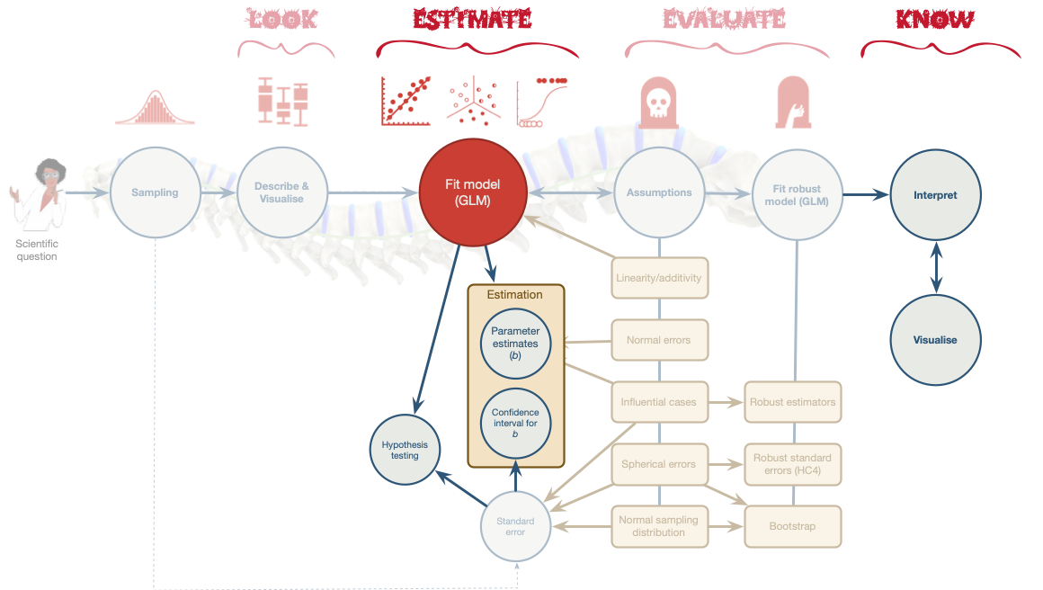

Slide 9
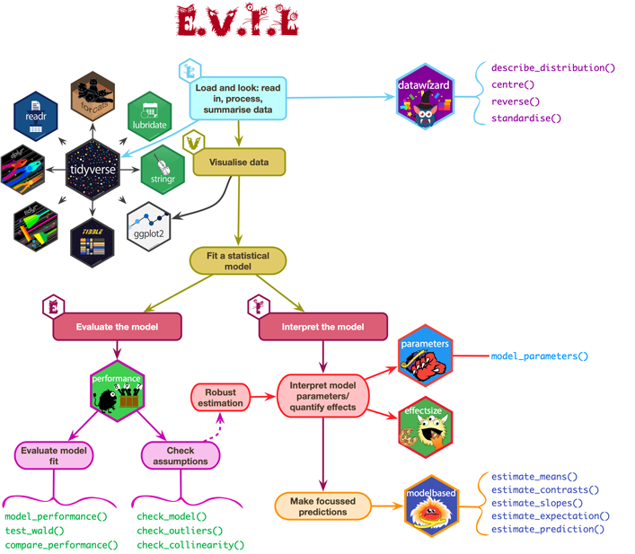

Slide 10: The GLM and experiments
- In experimental research, predictors in the linear model are defined by a manipulation
  - By manipulating a predictor variable can we cause (and therefore predict) a change in behaviour?
- The F-statistic
  - Still quantifies the fit of the model to the data
  - Still has an associated significance test
  - The ‘fit’ represents the experimental manipulation (which defines the predictor)
  - ‘Significant’ fit equates to a ‘significant’ effect of the experimental manipulation

Slide 11 (new section): A ghoulish example

Slide 12
Video clip: zombie prank

Slide 13
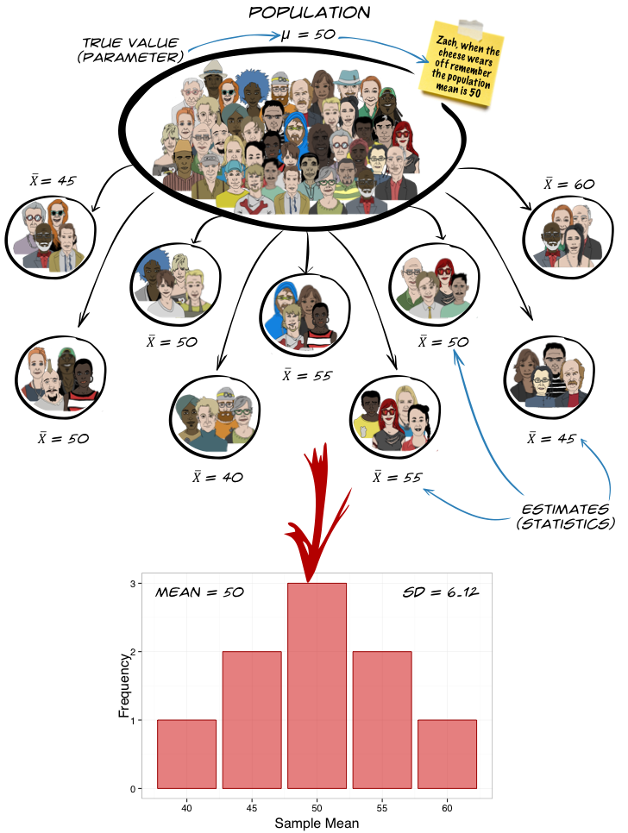

Same ghoul
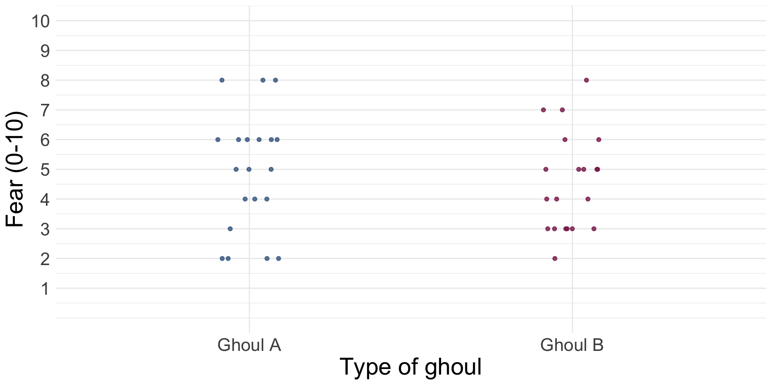

Slide 14

Same ghoul
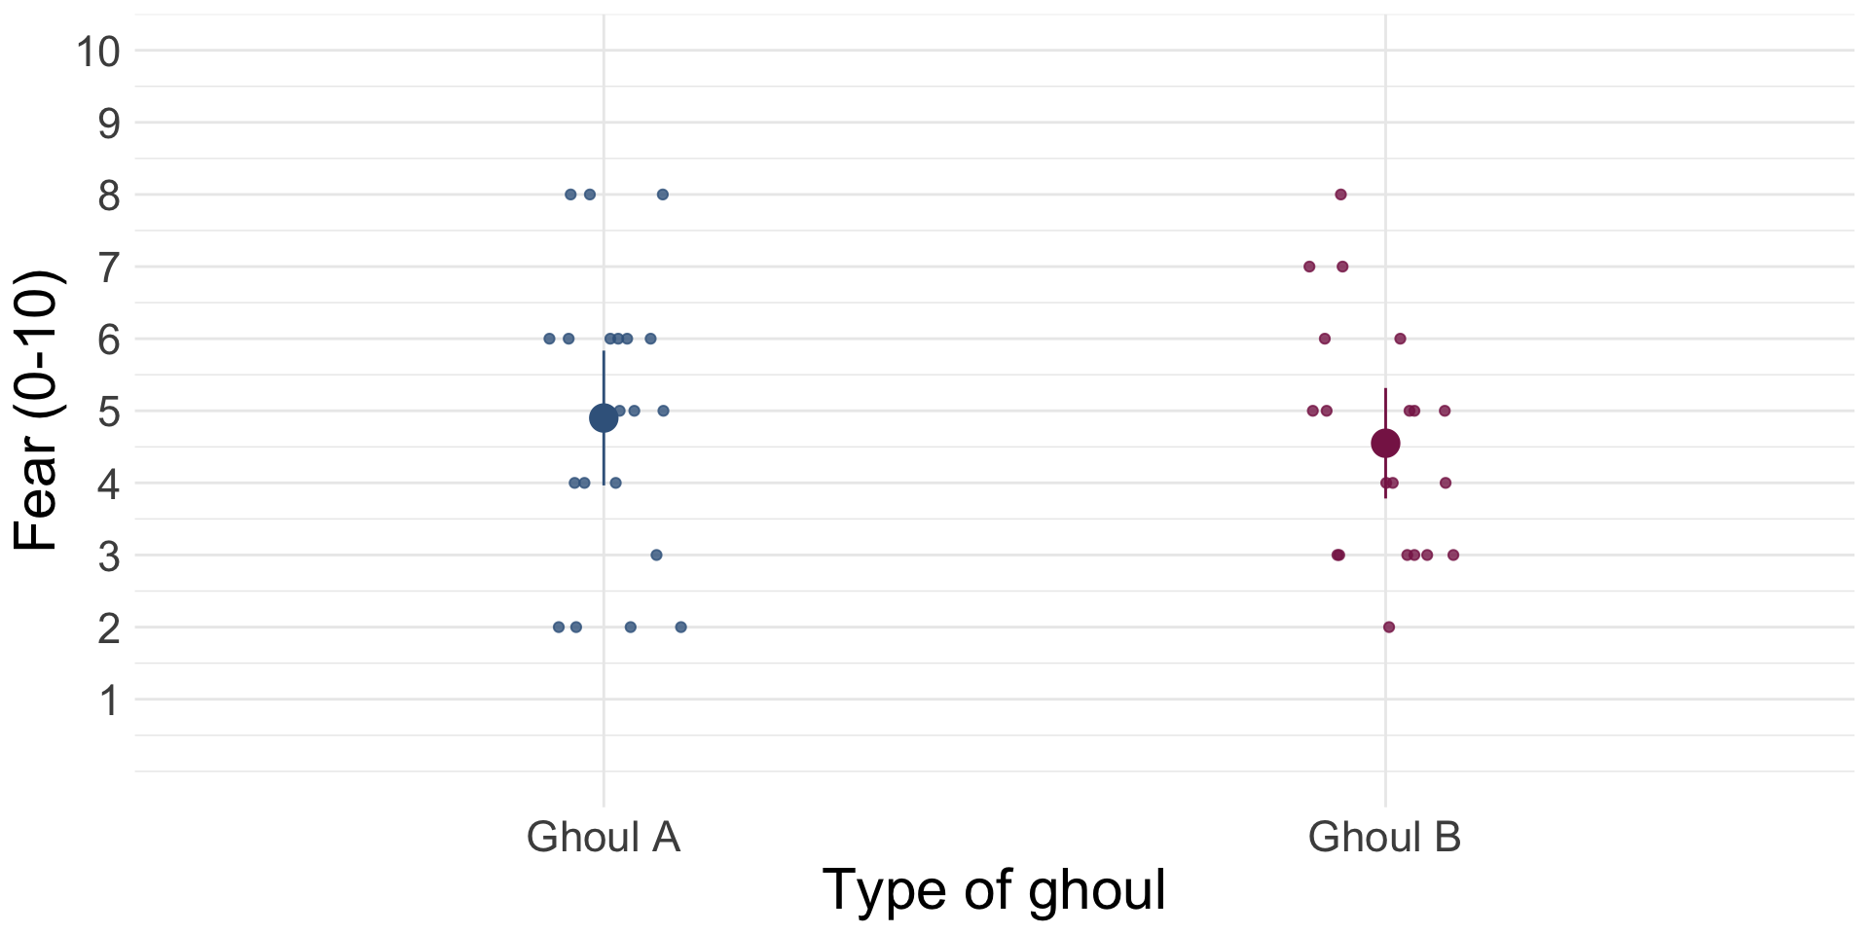

Slide 15

Different ghouls
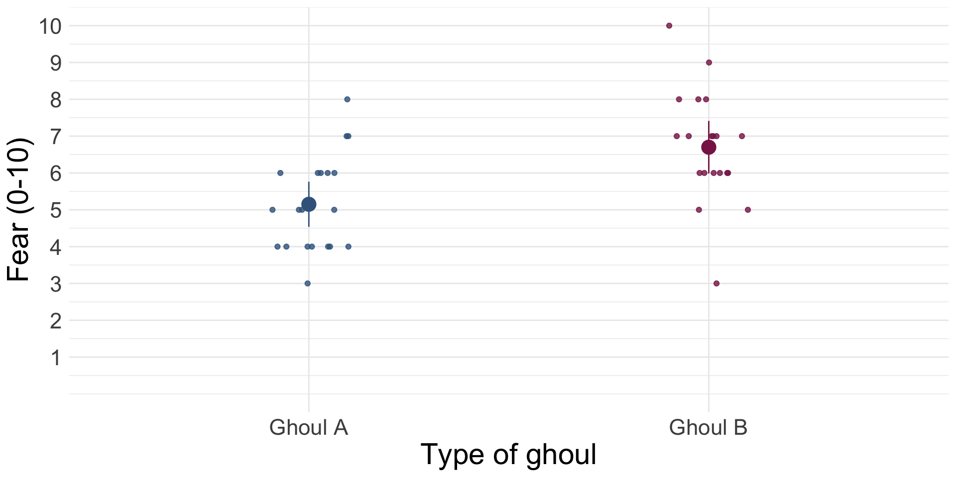

Slide 16
Table 1: Data for the zombie vs. werewolf costume experiment (first 50 of 100 rows)
ID | Costume | Fear | Numeric code
1 | Zombie | 6 | 0
2 | Zombie | 8 | 0
3 | Zombie | 5 | 0
4 | Zombie | 6 | 0
5 | Zombie | 8 | 0
6 | Zombie | 8 | 0
7 | Zombie | 7 | 0
8 | Zombie | 10 | 0
9 | Zombie | 7 | 0
10 | Zombie | 3 | 0
11 | Zombie | 6 | 0
12 | Zombie | 8 | 0
13 | Zombie | 8 | 0
14 | Zombie | 7 | 0
15 | Zombie | 2 | 0
16 | Zombie | 5 | 0
17 | Zombie | 8 | 0
18 | Zombie | 10 | 0
19 | Zombie | 7 | 0
20 | Zombie | 9 | 0
21 | Zombie | 4 | 0
22 | Zombie | 8 | 0
23 | Zombie | 9 | 0
24 | Zombie | 6 | 0
25 | Zombie | 9 | 0
26 | Zombie | 3 | 0
27 | Zombie | 3 | 0
28 | Zombie | 6 | 0
29 | Zombie | 8 | 0
30 | Zombie | 6 | 0
31 | Zombie | 8 | 0
32 | Zombie | 8 | 0
33 | Zombie | 7 | 0
34 | Zombie | 3 | 0
35 | Zombie | 8 | 0
36 | Zombie | 9 | 0
37 | Zombie | 7 | 0
38 | Zombie | 9 | 0
39 | Zombie | 6 | 0
40 | Zombie | 4 | 0
41 | Zombie | 7 | 0
42 | Zombie | 7 | 0
43 | Zombie | 10 | 0
44 | Zombie | 6 | 0
45 | Zombie | 7 | 0
46 | Zombie | 9 | 0
47 | Zombie | 7 | 0
48 | Zombie | 9 | 0
49 | Zombie | 10 | 0
50 | Zombie | 9 | 0

Slide 17: The model
$$\begin{aligned}Y_{i}&={\hat{b}}_{0}+{\hat{b}}_{1}X_{i}+e_{i} \\ {\text{Fear}}_{i}&={\hat{b}}_{0}+{\hat{b}}_{1}{\text{Costume}}_{i}+e_{i}\end{aligned}$$
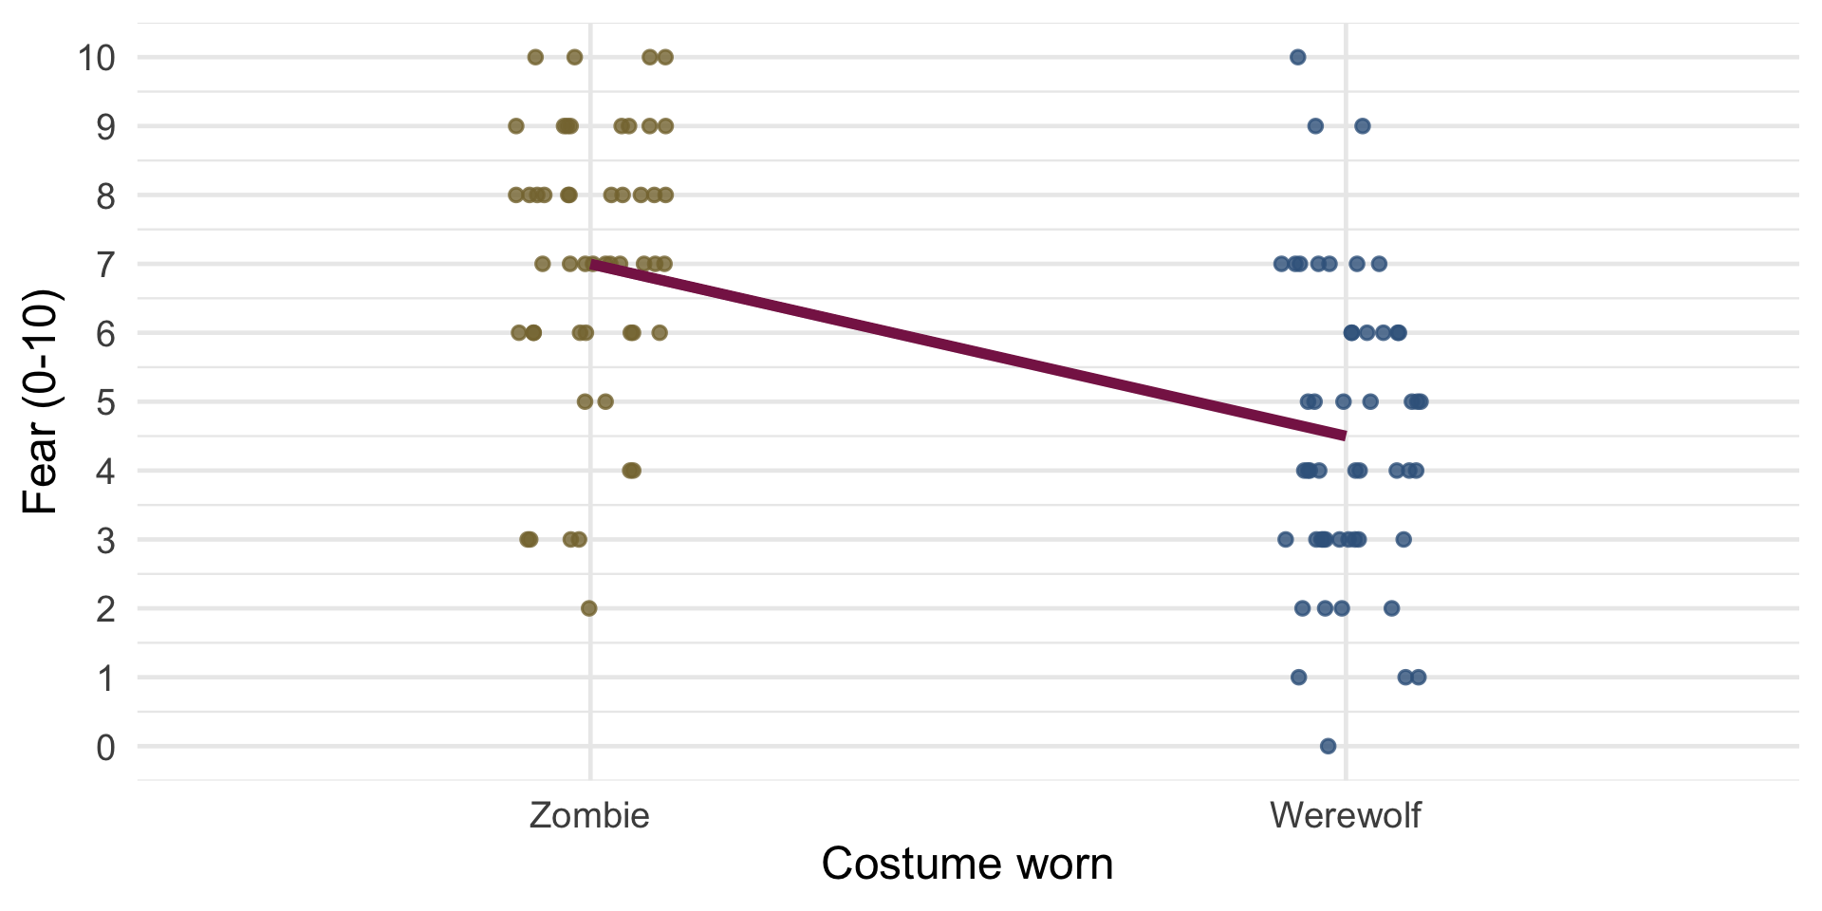

Slide 18: The model
$$\begin{aligned}Y_{i}&={\hat{b}}_{0}+{\hat{b}}_{1}X_{i}+e_{i} \\ {\text{Fear}}_{i}&={\hat{b}}_{0}+{\hat{b}}_{1}{\text{Costume}}_{i}+e_{i}\end{aligned}$$
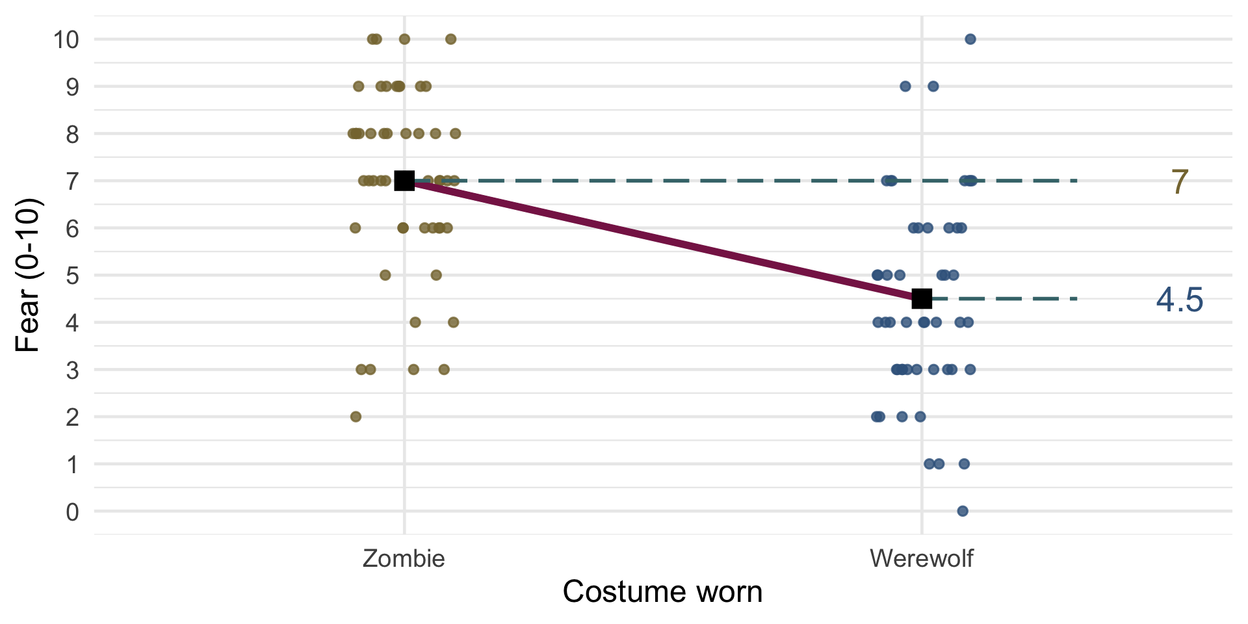

Slide 19: The model
$$\begin{aligned}{\text{Fear}}_{i}&={\hat{b}}_{0}+{\hat{b}}_{1}{\text{Costume}}_{i}+e_{i} \\ {\hat{\text{Fear}}}_{i}&={\hat{b}}_{0}+{\hat{b}}_{1}{\text{Costume}}_{i} \\ \end{aligned}$$
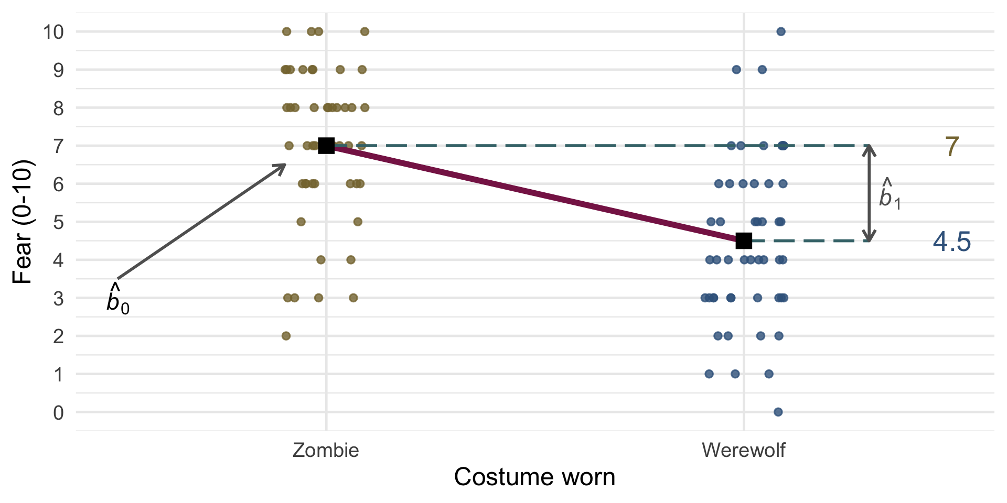

Slide 20: Dummy coding: b0
- Dummy Coding
  - Zombie = 0,
  - Werewolf = 1
- When costume = zombie
  - Costume = 0
  - Predicted fear = mean of zombie group:
$$\begin{aligned}{\hat{\text{fear}}}_{i}&={\hat{b}}_{0}+{\hat{b}}_{1}{\text{Costume}}_{i} \\ {\overset{‾}{X}}_{\text{zombie}}&={\hat{b}}_{0}+{\hat{b}}_{1}×0 \\ {\overset{‾}{X}}_{\text{zombie}}&={\hat{b}}_{0}\end{aligned}$$

Slide 21: Dummy coding: b1
- When costume = werewolf
  - Costume = 1
  - Predicted fear = mean of werewolf group:
$$\begin{aligned}{\hat{\text{fear}}}_{i}&={\hat{b}}_{0}+{\hat{b}}_{1}{\text{Costume}}_{i} \\ {\overset{‾}{X}}_{\text{werewolf}}&={\hat{b}}_{0}+{\hat{b}}_{1}×1 \\ {\overset{‾}{X}}_{\text{werewolf}}&={\hat{b}}_{0}+{\hat{b}}_{1}\end{aligned}$$
$$\begin{aligned}{\overset{‾}{X}}_{\text{werewolf}}&={\overset{‾}{X}}_{\text{zombie}}+{\hat{b}}_{1} \\ {\hat{b}}_{1}&={\overset{‾}{X}}_{\text{werewolf}}−{\overset{‾}{X}}_{\text{zombie}}\end{aligned}$$

Slide 22: The linear model
- We can fit a linear model with fear as the outcome and the type of costume (zombie or werewolf) as the predictor, note:
  - Intercept (b₀) is the mean of ‘zero coded’ group
  - b for the dummy variable is the difference between the means of the two costume groups (4.5 − 7 = −2.5)
zombie_lm <- lm(Fear ~ Costume, zombie_tib)
model_parameters(zombie_lm) |>
display()
Parameter | Coefficient | SE | 95% CI | t(98) | p
(Intercept) | 7.00 | 0.30 | (6.41, 7.59) | 23.40 | < .001
Costume (Werewolf) | -2.50 | 0.42 | (-3.34, -1.66) | -5.91 | < .001

Slide 23: Standardized effect size: Cohens \(\hat{d}\)
- Cohens $\hat{d}$ expresses the difference in means in standard deviation units
- Guide (but we’re not selling T-shirts …)
  - $\hat{d}$ = 0.2 is small
  - $\hat{d}$ = 0.5 is medium
  - $\hat{d}$ = 0.8 is large
$$\begin{aligned}\hat{d}&=\frac{{\overset{‾}{X}}_{1}−{\overset{‾}{X}}_{2}}{s_{p}} \\ s_{p}&=\sqrt{\frac{(N_{1}−1)s_{1}^{2}+(N_{2}−1)s_{2}^{2}}{N_{1}+N_{2}−2}}\end{aligned}$$
cohens_d(Fear ~ Costume, data = zombie_tib, reference = "Werewolf") |>
display()
Cohen’s d | 95% CI
1.18 | [0.75, 1.60]

Slide 24
Video clip: cubit azal lecture middle captioned

Slide 25
Video clip: cubit facetime live lecture 05

Slide 26
Video clip: cubit facetime live lecture 06

Slide 27
Video clip: cubit facetime live lecture 07

Slide 28
Video clip: cubit facetime live lecture 08

Slide 29: Another ghoulish example
- Which is more scary?
  - Human
  - Zombie
  - Werewolf
- Design
  - Prank
- Outcome
  - Fear
- Process
  - E.V.I.L.
Note: Statis-tip
- This experiment is using a one-way independent design.
  - One-way = one predictor variable is manipulated (costume)
  - Participants are assigned to independent groups
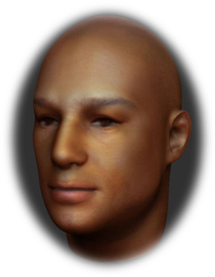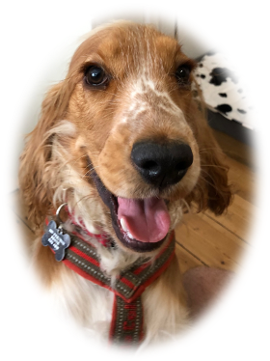

Slide 30: Load and Look

 | Human | Zombie | Werewolf
 | 2 | 10 | 6
 | 6 | 8 | 3
 | 1 | 5 | 0
 | 1 | 7 | 2
 | 2 | 6 | 8
Mean | 2.40 | 7.20 | 3.80
Variance (s²) | 4.30 | 3.70 | 10.20
Standard deviation (s) | 2.07 | 1.92 | 3.19
$\text{Overall mean (}{\overset{‾}{X}}_{\text{grand}}\text{)}=4.47$

Slide 31: Visualize the model

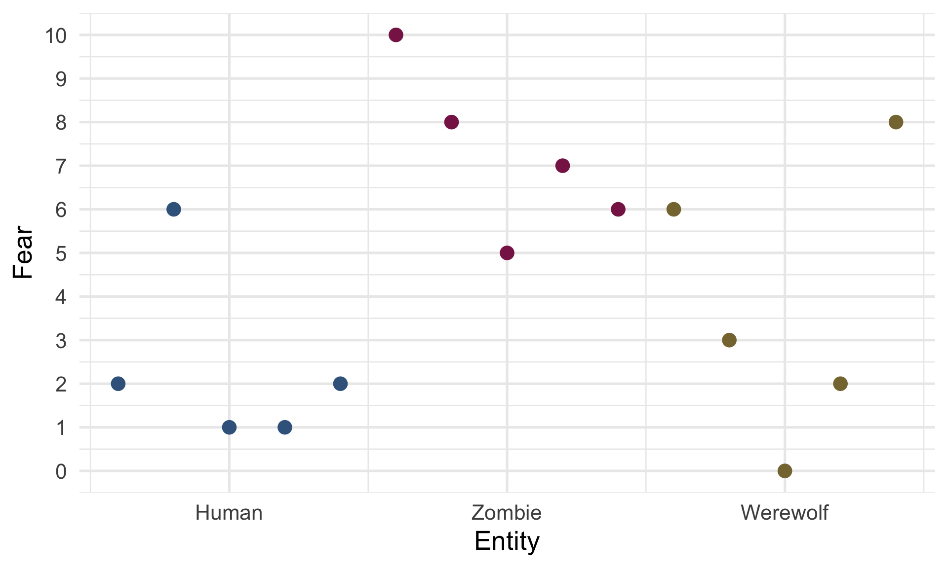

Slide 32: Visualize the model
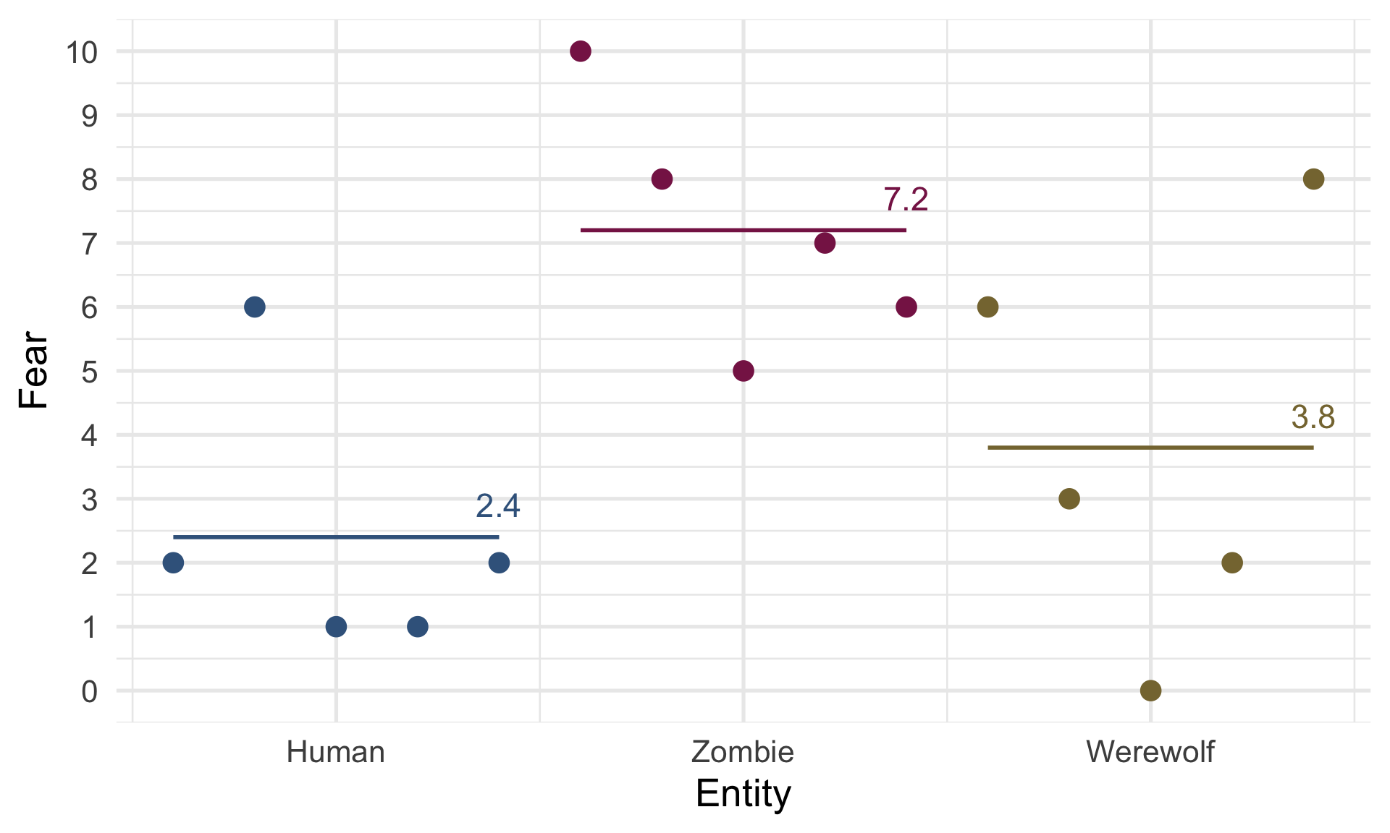

Slide 33: Dummy coding multiple categories
- You can code any categorical predictor into a series of dummy variables
  - Dummy variables must be entered in the same block
  - Choose a baseline category - it is always coded as 0
    - (By default R chooses the first level of the factor)
  - The b for each dummy variable will be the difference in means between each category and the baseline
Entity | Dummy 1 (Zombie vs. Human) | Dummy 2 (Werewolf vs. Human)
Human | 0 | 0
Zombie | 1 | 0
Werewolf | 0 | 1
$$\begin{aligned}{\hat{\text{Fear}}}_{i}&={\hat{b}}_{0}+{\hat{b}}_{1}{\text{Zombie vs. Human}}_{i}+{\hat{b}}_{2}{\text{Werewolf vs. Human}}_{i}\end{aligned}$$

Slide 34: Dummy coding: b0
- When entity = human
  - Zombie vs. Human = 0
  - Wolf vs. Human = 0
- Predicted fear = mean of human group:
Entity | Zombie vs. Human | Werewolf vs. Human
Human | 0 | 0
Zombie | 1 | 0
Werewolf | 0 | 1
$$\begin{aligned}{\hat{\text{Fear}}}_{i}&={\hat{b}}_{0}+{\hat{b}}_{1}{\text{Zombie vs. Human}}_{i}+{\hat{b}}_{2}{\text{Werewolf vs. Human}}_{i} \\ {\overset{‾}{X}}_{\text{human}}&={\hat{b}}_{0}+{\hat{b}}_{1}×0+{\hat{b}}_{2}×0 \\ {\hat{b}}_{0}&={\overset{‾}{X}}_{\text{human}}\end{aligned}$$

Slide 35: Dummy coding: b1
- When entity = zombie
  - Zombie vs. Human = 1
  - Wolf vs. Human = 0
- Predicted fear = mean of zombie group:
Entity | Zombie vs. Human | Werewolf vs. Human
Human | 0 | 0
Zombie | 1 | 0
Werewolf | 0 | 1
$$\begin{aligned}{\hat{\text{Fear}}}_{i}&={\hat{b}}_{0}+{\hat{b}}_{1}{\text{Zombie vs. Human}}_{i}+{\hat{b}}_{2}{\text{Werewolf vs. Human}}_{i} \\ {\overset{‾}{X}}_{\text{zombie}}&={\hat{b}}_{0}+{\hat{b}}_{1}×1+{\hat{b}}_{2}×0 \\ {\overset{‾}{X}}_{\text{zombie}}&={\hat{b}}_{0}+{\hat{b}}_{1} \\ {\hat{b}}_{1}&={\overset{‾}{X}}_{\text{zombie}}−{\hat{b}}_{0} \\ &={\overset{‾}{X}}_{\text{zombie}}−{\overset{‾}{X}}_{\text{human}}\end{aligned}$$

Slide 36: Dummy coding: b2
- When entity = werewolf
  - Zombie vs. Human = 0
  - Wolf vs. Human = 1
- Predicted fear = mean of werewolf group:
Entity | Zombie vs. Human | Werewolf vs. Human
Human | 0 | 0
Zombie | 1 | 0
Werewolf | 0 | 1
$$\begin{aligned}{\hat{\text{Fear}}}_{i}&={\hat{b}}_{0}+{\hat{b}}_{1}{\text{Zombie vs. Human}}_{i}+{\hat{b}}_{2}{\text{Werewolf vs. Human}}_{i} \\ {\overset{‾}{X}}_{\text{werewolf}}&={\hat{b}}_{0}+{\hat{b}}_{1}×0+{\hat{b}}_{2}×1 \\ {\overset{‾}{X}}_{\text{werewolf}}&={\hat{b}}_{0}+{\hat{b}}_{2} \\ {\hat{b}}_{2}&={\overset{‾}{X}}_{\text{werewolf}}−{\hat{b}}_{0} \\ &={\overset{‾}{X}}_{\text{werewolf}}−{\overset{‾}{X}}_{\text{human}}\end{aligned}$$

Slide 37: The model
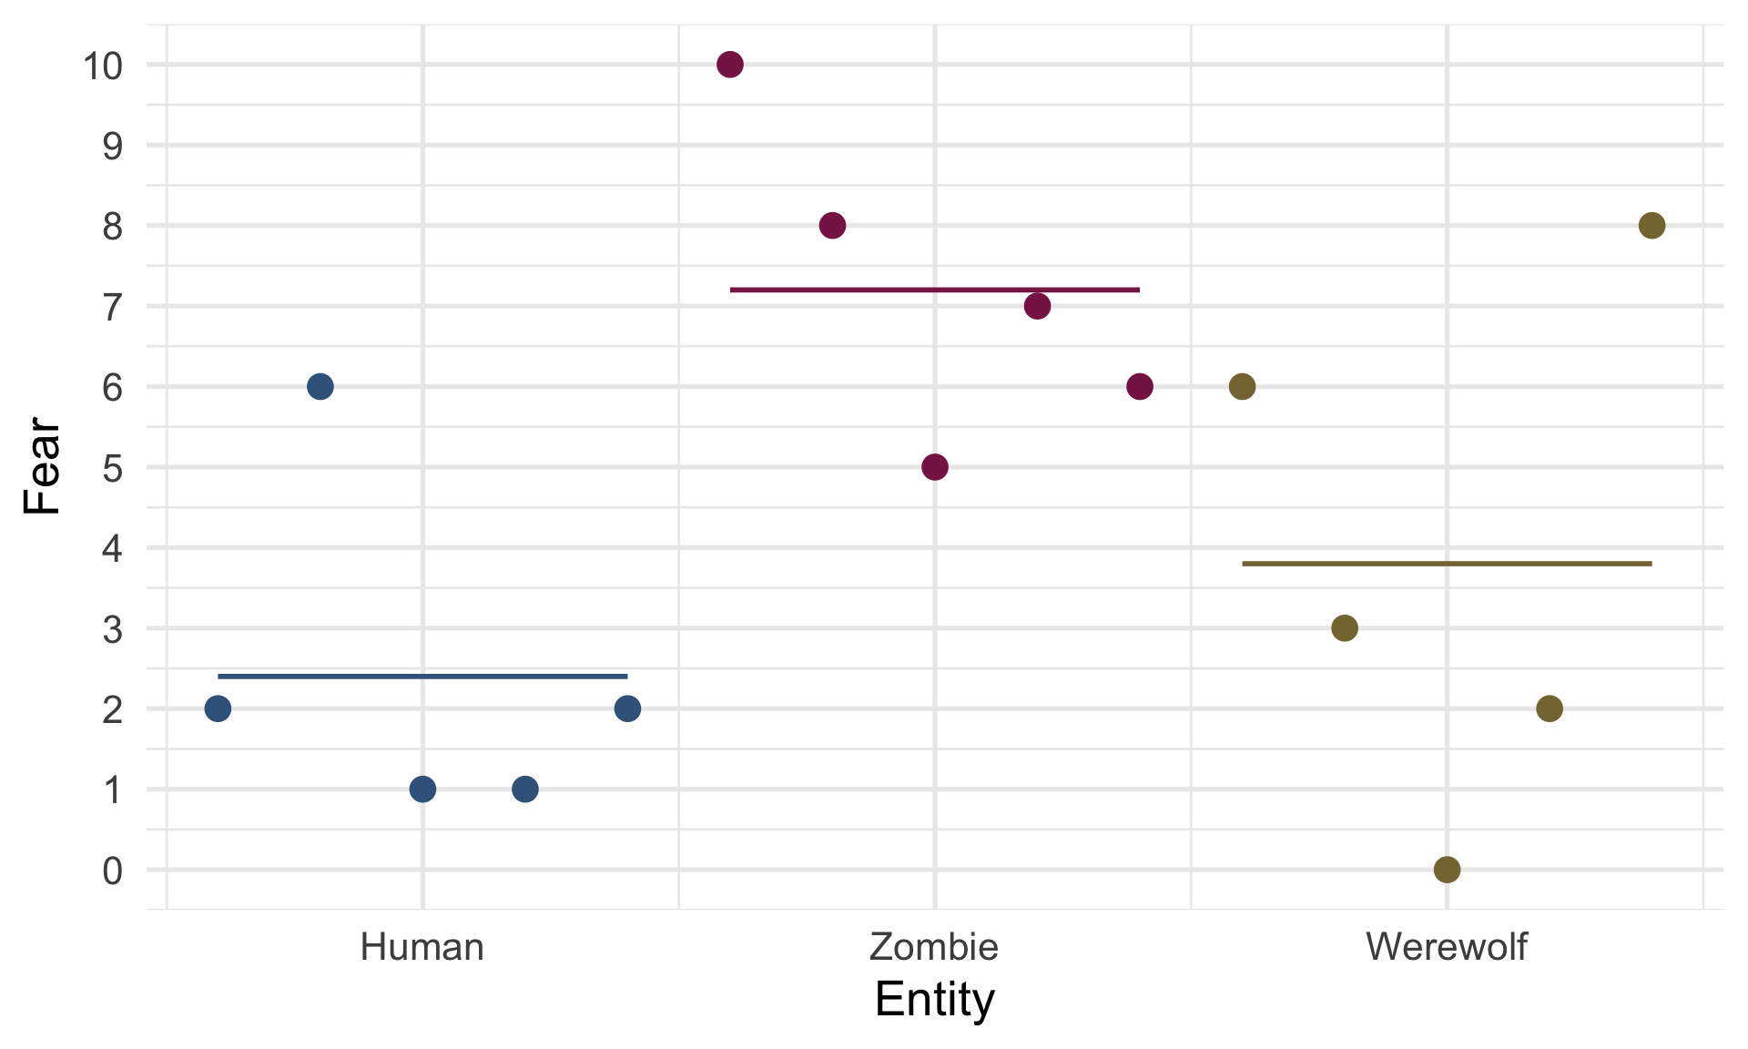

Slide 38: The parameter values
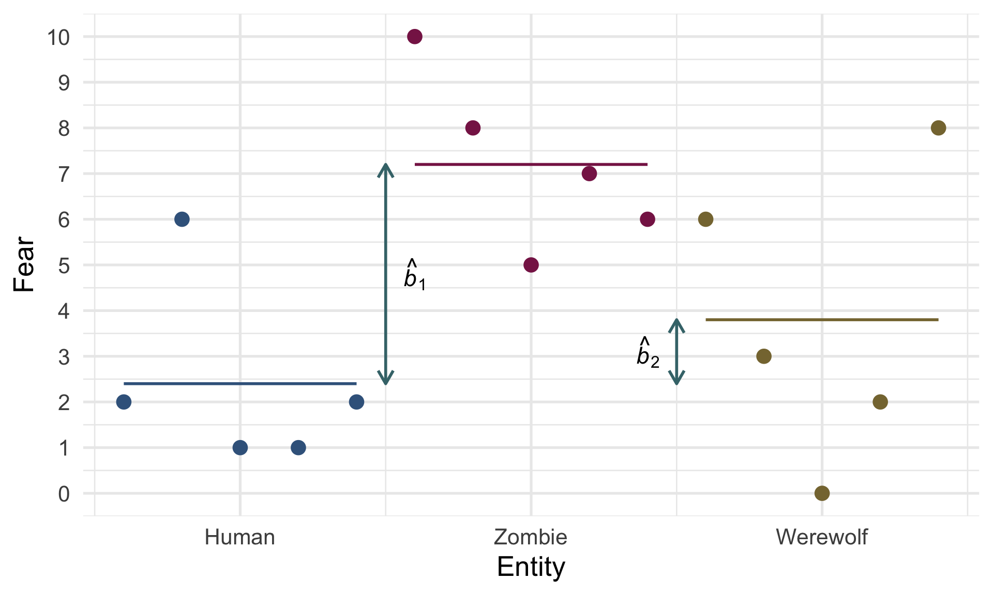

Slide 39: The parameter values
 | Human | Zombie | Werewolf
 | 2 | 10 | 6
 | 6 | 8 | 3
 | 1 | 5 | 0
 | 1 | 7 | 2
 | 2 | 6 | 8
Mean | 2.4 | 7.2 | 3.8
${\hat{b}}_{0}={\overset{‾}{X}}_{\text{human}}=2.40$
${\hat{b}}_{1}={\overset{‾}{X}}_{\text{zombie}}−{\overset{‾}{X}}_{\text{human}}=7.20−2.40=4.80$
${\hat{b}}_{2}={\overset{‾}{X}}_{\text{werewolf}}−{\overset{‾}{X}}_{\text{human}}=3.80−2.40=1.40$

Slide 40

The model
$$\begin{aligned}{\hat{\text{Fear}}}_{i}&={\hat{b}}_{0}+{\hat{b}}_{1}{\text{Zombie vs. Human}}_{i}+{\hat{b}}_{2}{\text{Werewolf vs. Human}}_{i}\end{aligned}$$
$$\begin{aligned}{\hat{\text{Fear}}}_{i}&=2.4+4.8{\text{Zombie vs. Human}}_{i}+1.4{\text{Werewolf vs. Human}}_{i}\end{aligned}$$
# Fit model
human_lm <- lm(fear ~ entity, data = humans_tib)

Slide 41 (new section): Evaluate the model

Slide 42: How to Evaluate


Overall fit (F-statistic)
- The ratio of how well the model fits to how much error it has
- In the case of experiments: _ The model = differences between means
  - F is the ratio of the experimental effect to the background ‘error’
  - Tests whether group means differ overall

Overall fit (R²)
- How much variance in the outcome is explained by group membership?

Assumptions
- Interpreted the same as other models
- Residual plots will show vertical lines of dots (review the Beast of Bias lecture)

Slide 43: Total sum of squared error, SST
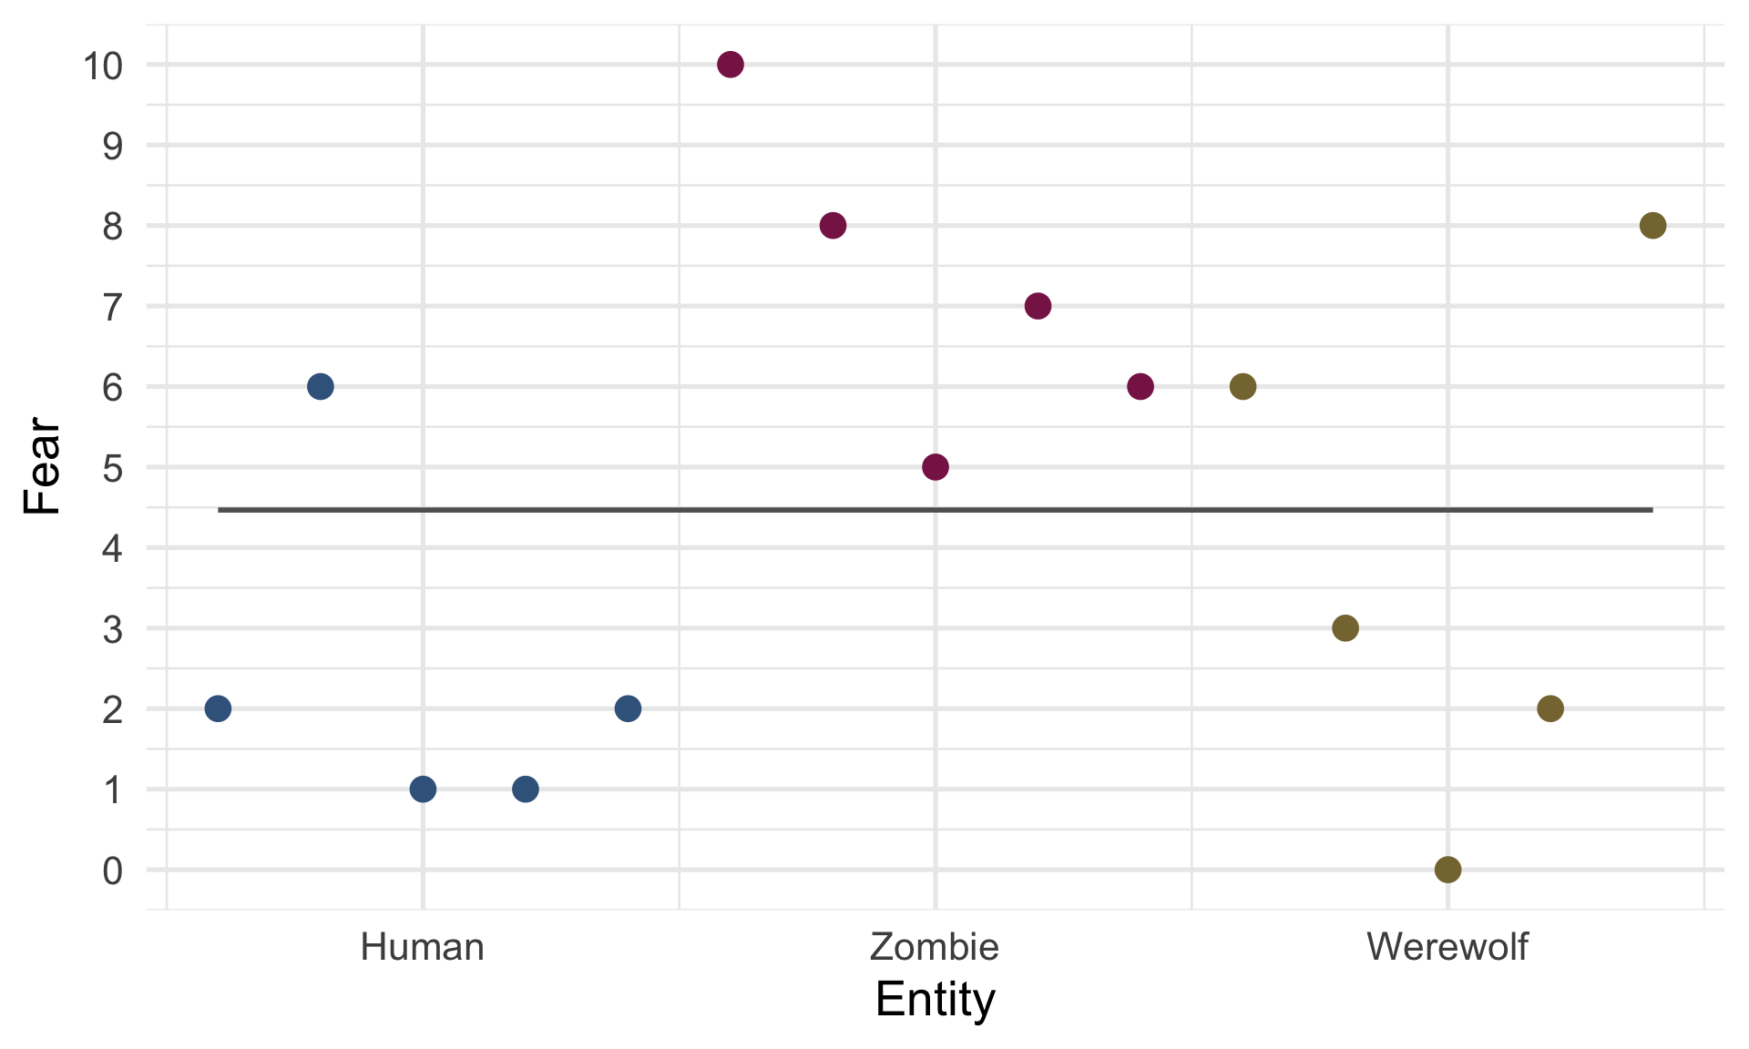

Slide 44: Total sum of squared error, SST
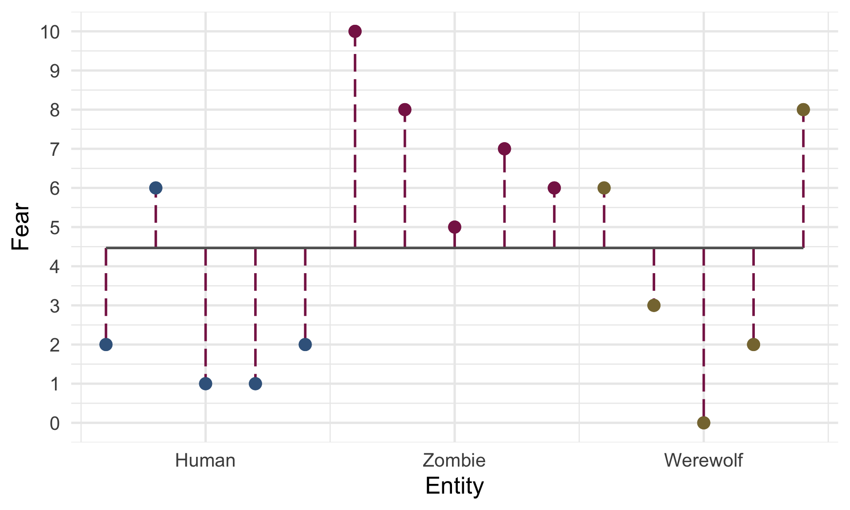

Slide 45: Residual sum of squared error, SSR

Slide 46: Residual sum of squared error, SSR
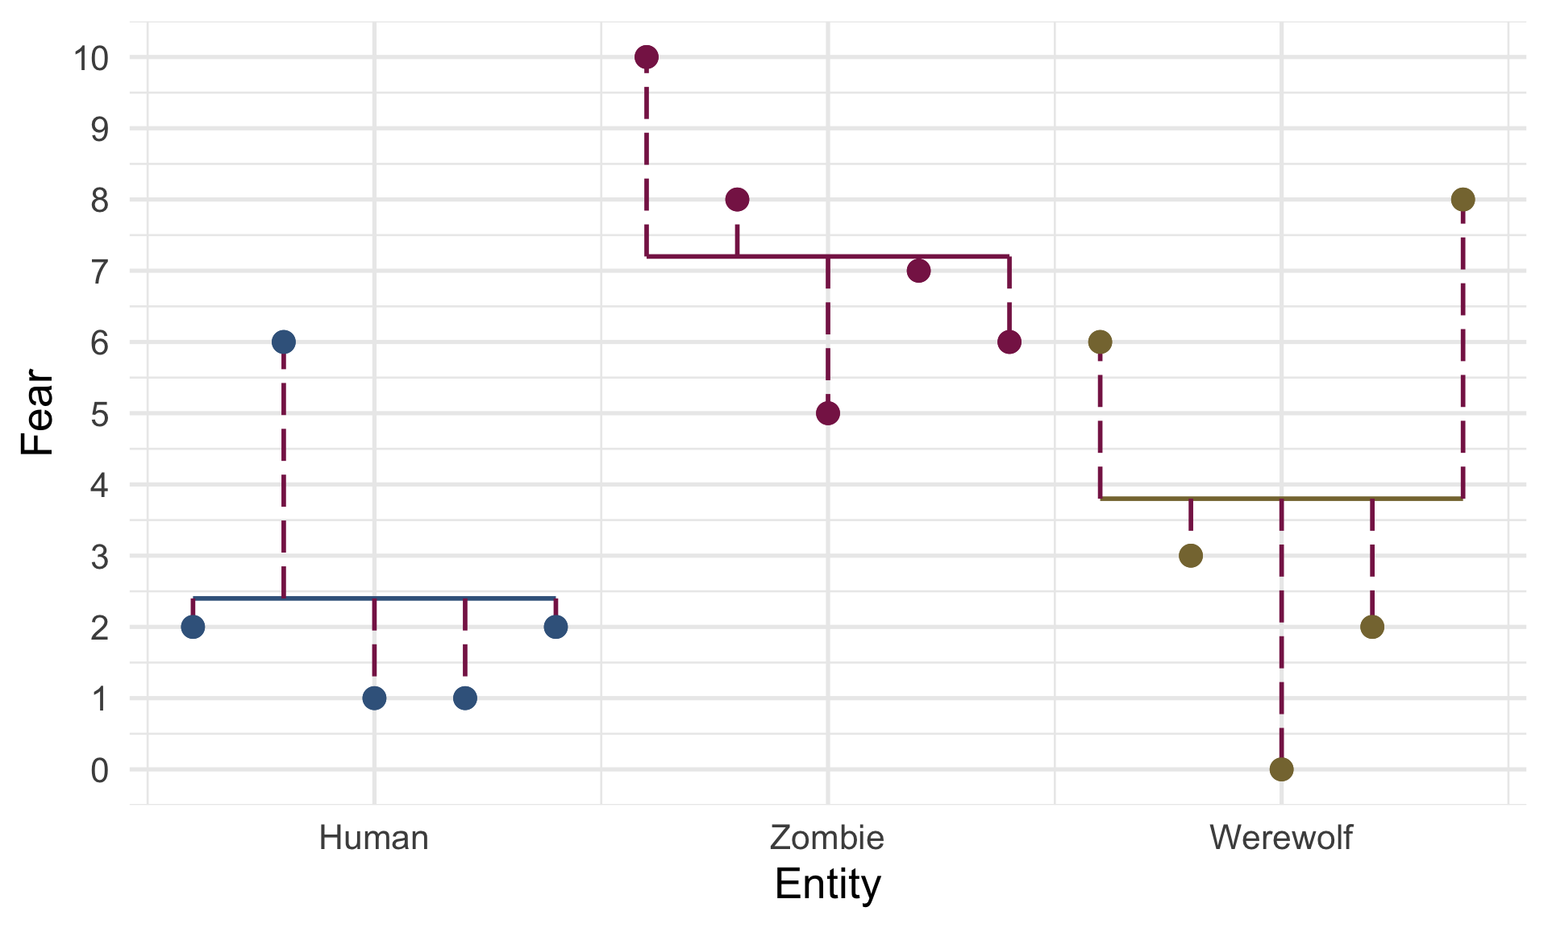

Slide 47: Model sum of squared error, SSM

Slide 48: Model sum of squared error, SSM
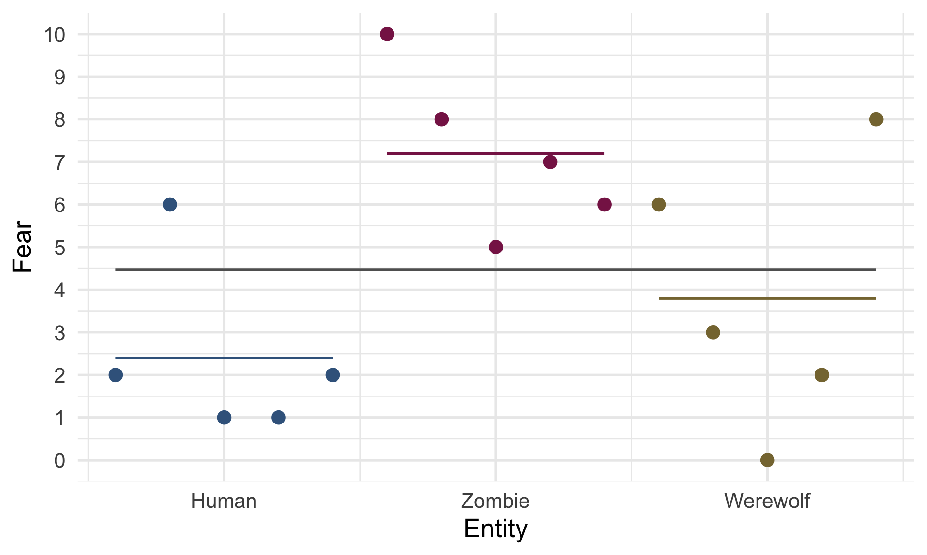

Slide 49: Model sum of squared error, SSM
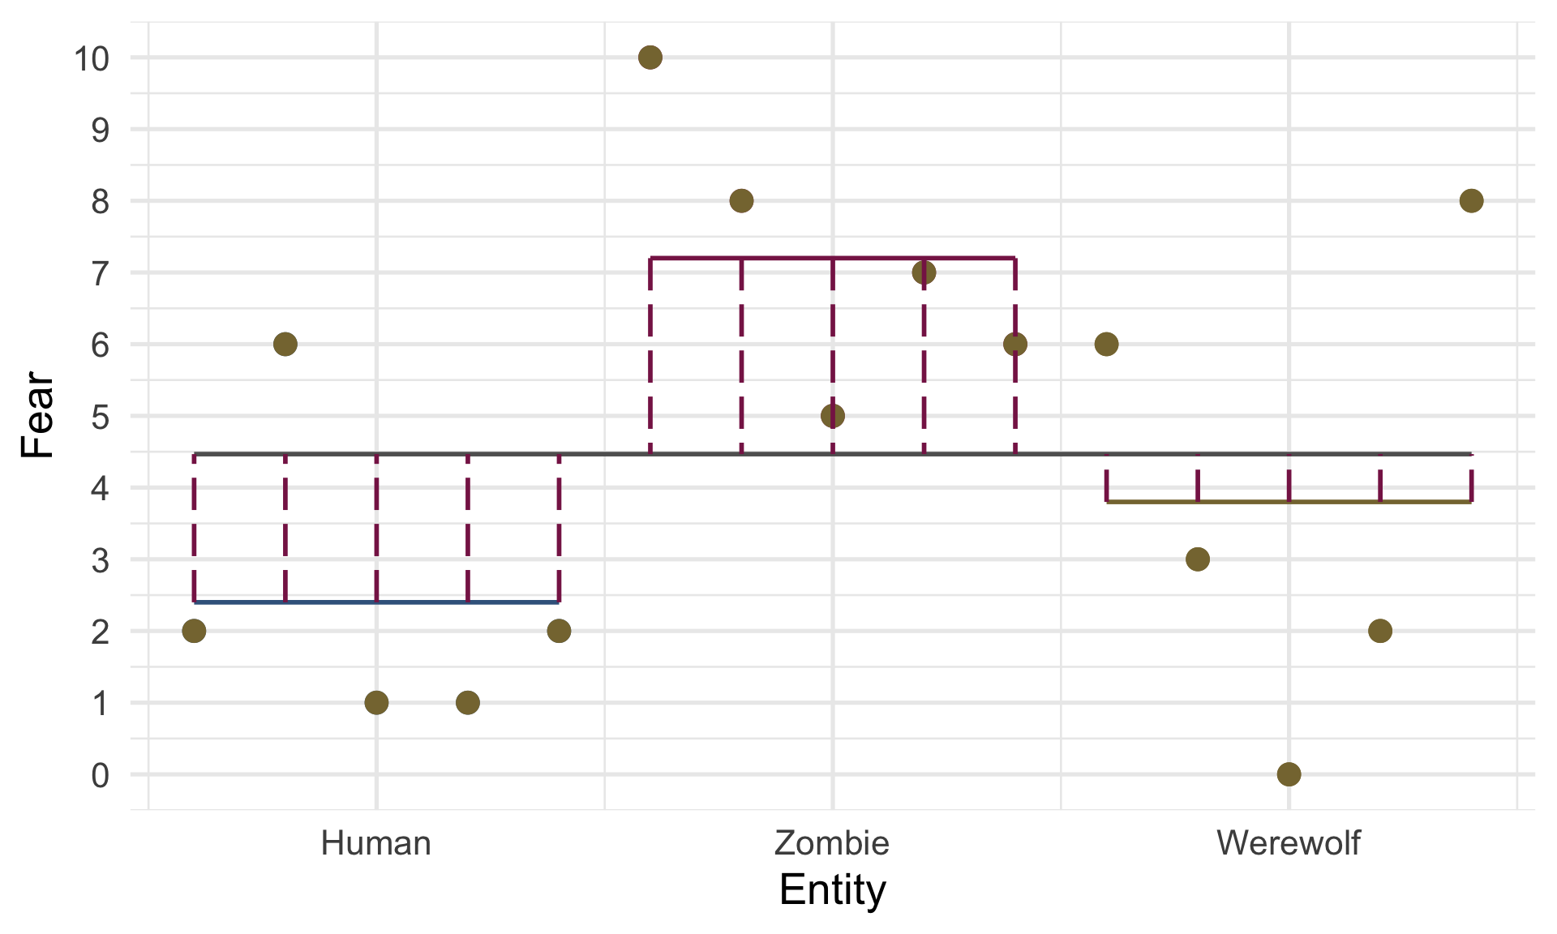

Slide 50: Overall fit
# get F
test_wald(human_lm) |>
display()
Name | Model | df | df_diff | F | p
Null model | lm | 14
Full model | lm | 12 | 2 | 5.02 | 0.026
# get R^2
model_performance(human_lm) |>
display()
AIC | AICc | BIC | R2 | R2 (adj.) | RMSE | Sigma
74.3 | 78.3 | 77.1 | 0.46 | 0.36 | 2.20 | 2.46
Important: ReportR
The type of monster in the prank had a significant effect on fear levels, F(2, 12) = 5.02, p = 0.026, R² = 0.46.

Slide 51: Evaluate assumptions
check_model(human_lm)
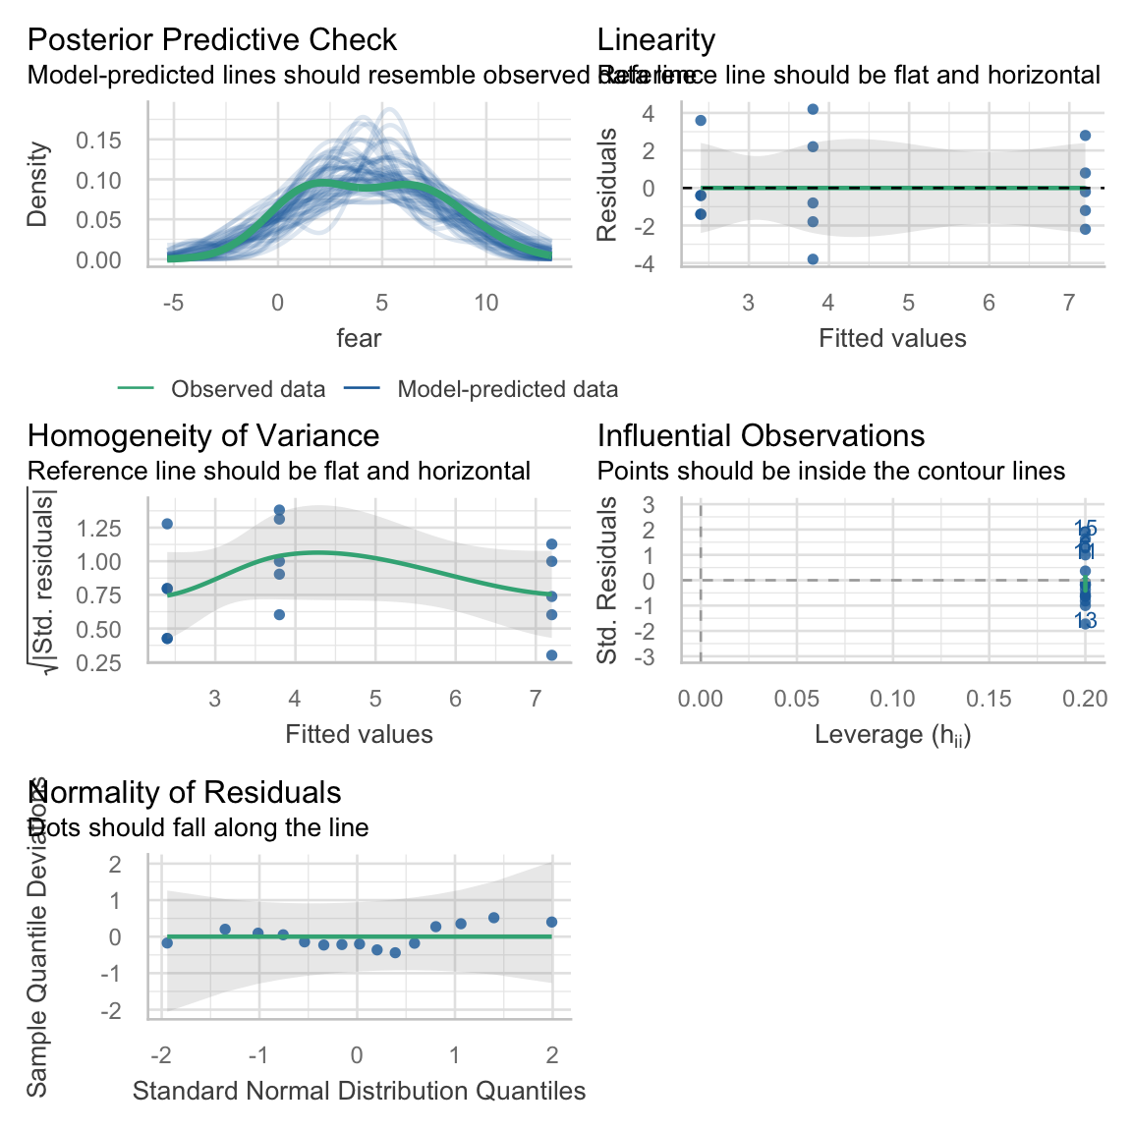

Slide 52: Robust F-statistic
welchf <- oneway.test(fear ~ entity, data = humans_tib)
model_parameters(welchf) |>
display()
One-way analysis of means (not assuming equal variances)
F | df | df (error) | p
6.89 | 2 | 7.74 | 0.019
Important: ReportR
The type of monster in the prank had a significant effect on fear levels, F(2, 7.74) = 6.89, p = 0.019.

Slide 53 (new section): Interpret the model

Slide 54: Robust procedures
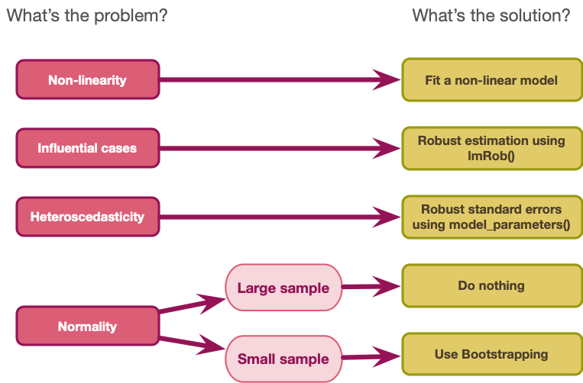

Slide 55: Interpret parameter estimates, CIs and tests

- Break down the overall fit
- Tell us, specifically, which means differ
model_parameters(human_lm, vcov = "HC4") |>
display()
Parameter | Coefficient | SE | 95% CI | t(12) | p
(Intercept) | 2.40 | 0.93 | (0.38, 4.42) | 2.59 | 0.024
entity (Zombie) | 4.80 | 1.26 | (2.04, 7.56) | 3.79 | 0.003
entity (Werewolf) | 1.40 | 1.70 | (-2.31, 5.11) | 0.82 | 0.427
Important: ReportR
The type of monster in the prank had a significant effect on fear levels, F(2, 7.74) = 6.89, p = 0.019. Compared to humans, zombies elicited greater fear, $\hat{b}$ = 4.80 (2.04, 7.56), t(12) = 3.79, p = 0.003, but werewolves did not, $\hat{b}$ = 1.40 (-2.31, 5.11), t(12) = 0.82, p = 0.427.

Slide 56
Video clip: cubit azal lecture end captioned

Slide 57
Video clip: f song instrumental

Slide 58
Video clip: f song

