Mixed designs
… and three-way interactions
Professor Andy Field, University of Sussex
Links: bsky.app | youtube.com | discoveringstatistics.com | discovr.rocks | statisticsadventure.com

About this version
This is a plain-text version of the lecture slides. Each slide starts with a heading such as “Slide 5”, and the numbers match the slide numbers shown in the lecture. Content that appeared one piece at a time, in columns or in tabs is shown in reading order. Videos and interactive apps are given as links.

Slide 2
Video clip: xmas santa 01

Slide 3
Video clip: xmas santa 02

Slide 4
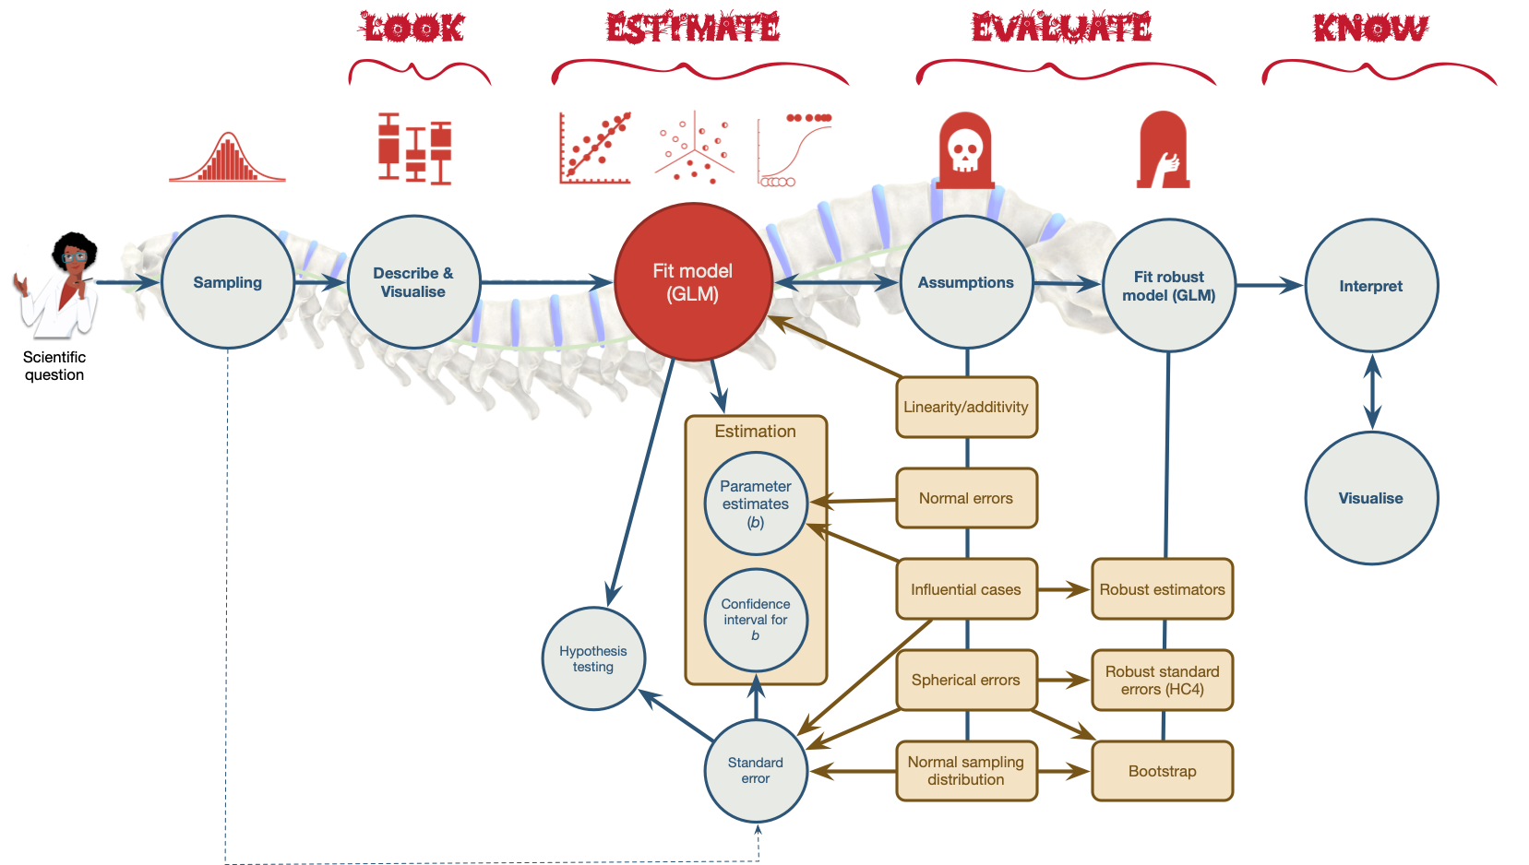
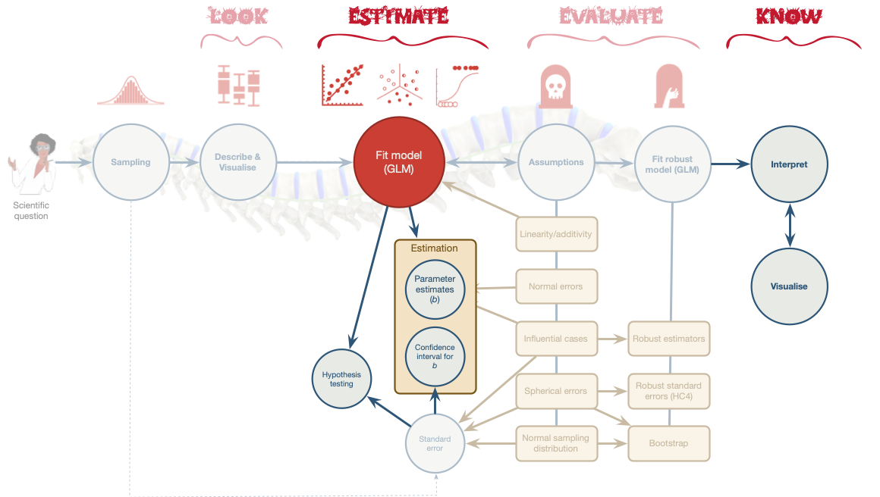

Slide 5
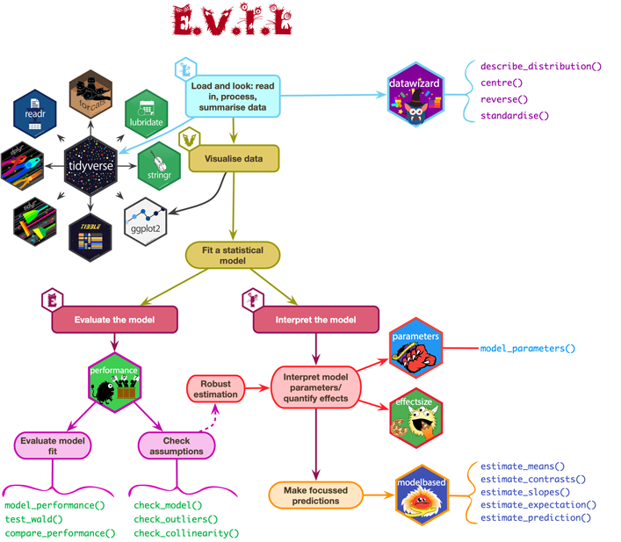

Slide 6: A festive example
Santa Claus wanted to test the effect of different types of treats on the speed of delivery in two types of helpers :
- Predictors
  - treat: Christmas pudding, Mulled wine (within-participant, repeated measures)
  - helper: Elf, Fairy (between-participant, independent)
- Outcome
  - speed: The speed at which presents were delivered (ms).

Slide 7: The design
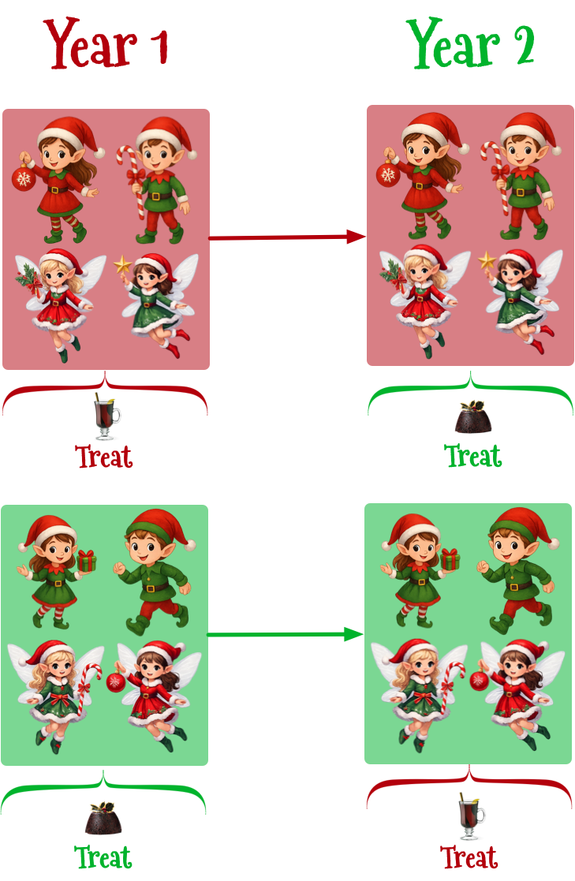
Note: Statis-tip
This is a two-way mixed design
- treat is a repeated measures because all participants consumed all treats
- helper is an independent measure because participants could be an elf or a fairy but not both

Slide 8: Load and Look
Table 1: Santa's data (first 50 of 200 rows)
 | id | helper | treat | speed
1 | Aaron the Delighted | Elf | Pudding | 17
2 | Rand the Pinguid | Elf | Pudding | 17
3 | Dreary the Fergal-fargel | Elf | Pudding | 19
4 | Jongle the Determined | Elf | Pudding | 13
5 | Ogdoad the Eigen vector | Elf | Pudding | 16
6 | Vicki the Invisible | Elf | Pudding | 17
7 | Sisifus the Dextrous | Elf | Pudding | 14
8 | Milton the Jubulant | Elf | Pudding | 21
9 | Jojo the Statistical | Elf | Pudding | 18
10 | Merkin the Dwaal | Elf | Pudding | 15
11 | Belphegor the Jubulant | Elf | Pudding | 17
12 | Mustafi the Argute | Elf | Pudding | 13
13 | Edwin the Witch | Elf | Pudding | 19
14 | Oxter the Knee-scratcher | Elf | Pudding | 22
15 | Ogdoad the Xylopolist | Elf | Pudding | 11
16 | Oxter the Chopwooder | Elf | Pudding | 22
17 | Ogdoad the Crank | Elf | Pudding | 14
18 | Vicki the Unconscious | Elf | Pudding | 19
19 | Hughy the Jubulant | Elf | Pudding | 11
20 | Fipple the Potato carver | Elf | Pudding | 16
21 | Edwin the Visible | Elf | Pudding | 17
22 | Cleo the Defensive midfielder | Elf | Pudding | 12
23 | Cog the Mudlark | Elf | Pudding | 25
24 | Juniper the Fairy disguised as an elf | Elf | Pudding | 20
25 | Jangle the Pickler | Elf | Pudding | 23
26 | Rob the Extroverted | Elf | Pudding | 15
27 | Dojan the Conscious | Elf | Pudding | 18
28 | Ramsey the Truculent | Elf | Pudding | 15
29 | Skelf the Fugacious | Elf | Pudding | 32
30 | Wickham the Chopwooder | Elf | Pudding | 15
31 | Cleo the Innocuous | Elf | Pudding | 9
32 | Milton the Industrious | Elf | Pudding | 16
33 | Liv the Nepharious | Elf | Pudding | 14
34 | Vicki the Biddible | Elf | Pudding | 14
35 | Jingle the Eigen vector | Elf | Pudding | 20
36 | Sisifus the Rubiginous | Elf | Pudding | 10
37 | Dreary the Cuddle | Elf | Pudding | 22
38 | Edwin the Partial derivative | Elf | Pudding | 19
39 | Erwin the Knee-scratcher | Elf | Pudding | 32
40 | Per the Wrapper | Elf | Pudding | 22
41 | Tinsel the Busy | Elf | Pudding | 25
42 | Bellerin the Xylopolist | Elf | Pudding | 18
43 | Petr the Musical | Elf | Pudding | 24
44 | Compote the Xylopolist | Elf | Pudding | 24
45 | Jingle the Dextrous | Elf | Pudding | 14
46 | Gillan the Truculent | Elf | Pudding | 21
47 | Compote the Invisible | Elf | Pudding | 13
48 | Quo the Dextrous | Elf | Pudding | 14
49 | Petr the Strong | Elf | Pudding | 19
50 | Florence the Cute | Elf | Pudding | 25


Slide 9: Load and Look
treat_tib |>
group_by(treat, helper) |>
describe_distribution(select = "speed") |>
data_remove(c("Variable", "n_Missing")) |>
display()
treat | helper | Mean | SD | IQR | Range | Skewness | Kurtosis | n
Pudding | Elf | 17.96 | 5.02 | 7.25 | (9.00, 32.00) | 0.76 | 0.80 | 50
Mulled wine | Elf | 25.06 | 7.05 | 9.00 | (10.00, 42.00) | 0.07 | 0.03 | 50
Pudding | Fairy | 20.02 | 5.04 | 7.00 | (7.00, 29.00) | -0.51 | 0.05 | 50
Mulled wine | Fairy | 25.92 | 8.00 | 11.25 | (8.00, 41.00) | -0.21 | -0.28 | 50

Slide 10: Visualize
treat_int_gg <- ggplot(treat_tib, aes(x = treat, y = speed, colour = helper, shape = helper, fill = helper)) +
geom_violin(alpha = 0.1) +
stat_summary(fun.data = "mean_cl_normal", geom = "pointrange", position = position_dodge(width = 0.9)) +
coord_cartesian(ylim = c(0, 45)) +
scale_y_continuous(breaks = seq(0, 45, 5)) +
scale_colour_manual(values = c("#B3000C", "#00B32C")) +
scale_fill_manual(values = c("#B3000C", "#00B32C")) +
labs(x = "Treat consumed", y = "Speed of delivery (ms)", colour = "Helper", fill = "Helper", shape = "Helper") +
theme_minimal()
treat_int_gg
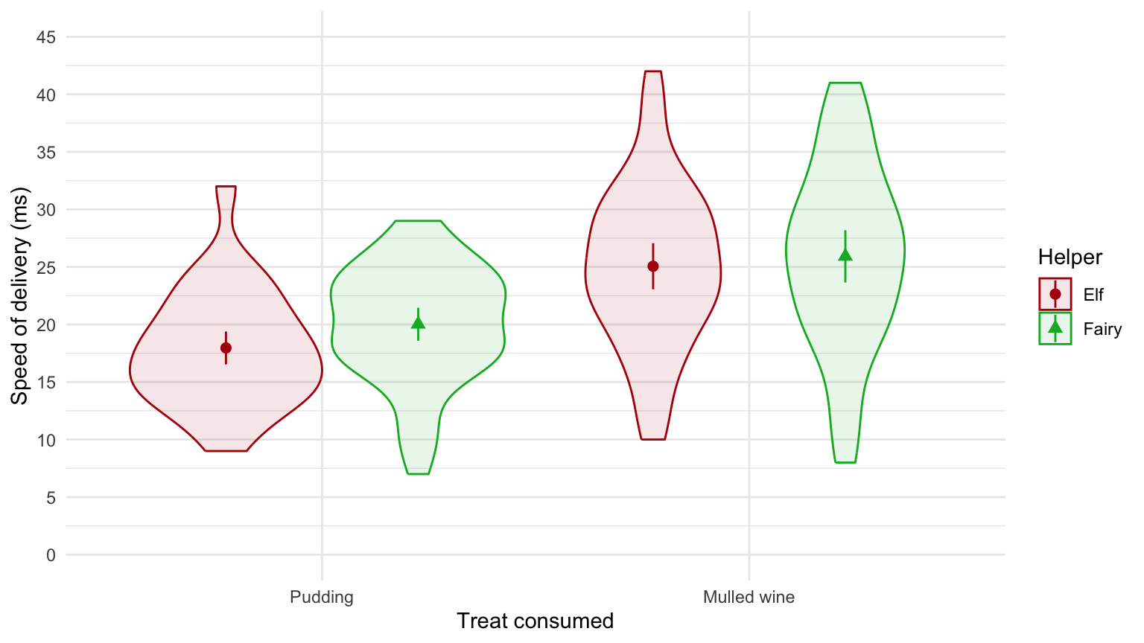


Slide 11: The model
$$\begin{aligned}{\text{speed}}_{ij}&={\hat{b}}_{0}+{\hat{b}}_{1}{\text{helper}}_{i}+{\hat{b}}_{2}{\text{treat}}_{ij}+{\hat{b}}_{3}\left({\text{helper}}_{i}×{\text{treat}}_{ij}\right)+u_{0j}+e_{i}\end{aligned}$$
treat_afx <- afex::aov_4(speed ~ treat*helper + (treat|id), data = treat_tib)

Slide 12: Evaluate
model_parameters(treat_afx, es_type = "omega") |>
display(use_symbols = TRUE)

ANOVA estimation for factorial designs using ‘afex’
Parameter | Sum_Squares | Sum_Squares_Error | df | df (error) | Mean_Square | F | p | ω² (partial)
helper | 106.58 | 5136.90 | 1 | 98 | 52.42 | 2.03 | 0.157 | 0.01
treat | 2112.50 | 2910.50 | 1 | 98 | 29.70 | 71.13 | < .001 | 0.20
helper:treat | 18.00 | 2910.50 | 1 | 98 | 29.70 | 0.61 | 0.438 | 0.00


Slide 13: Evaluate assumptions
check_model(treat_afx)
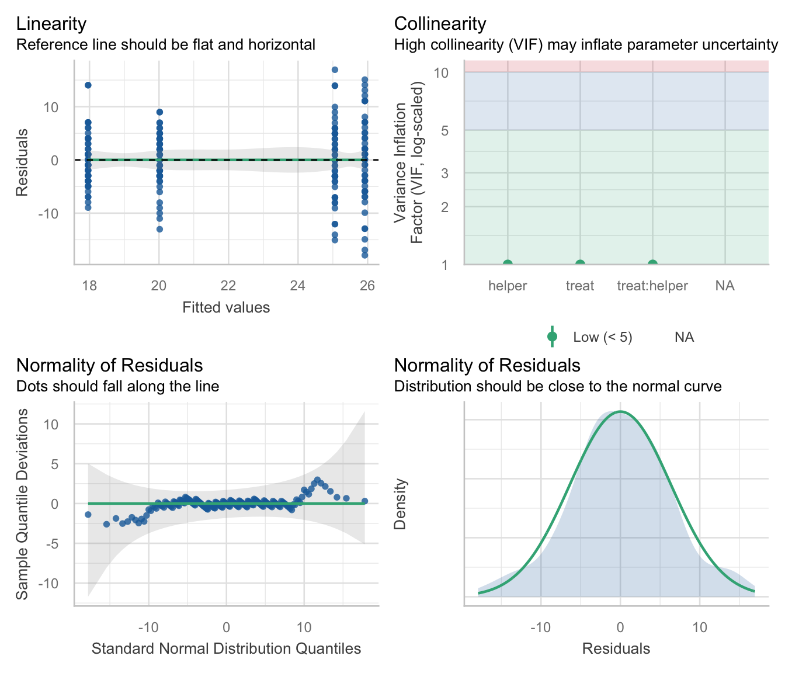

Slide 14: Interpret the main effect of treat
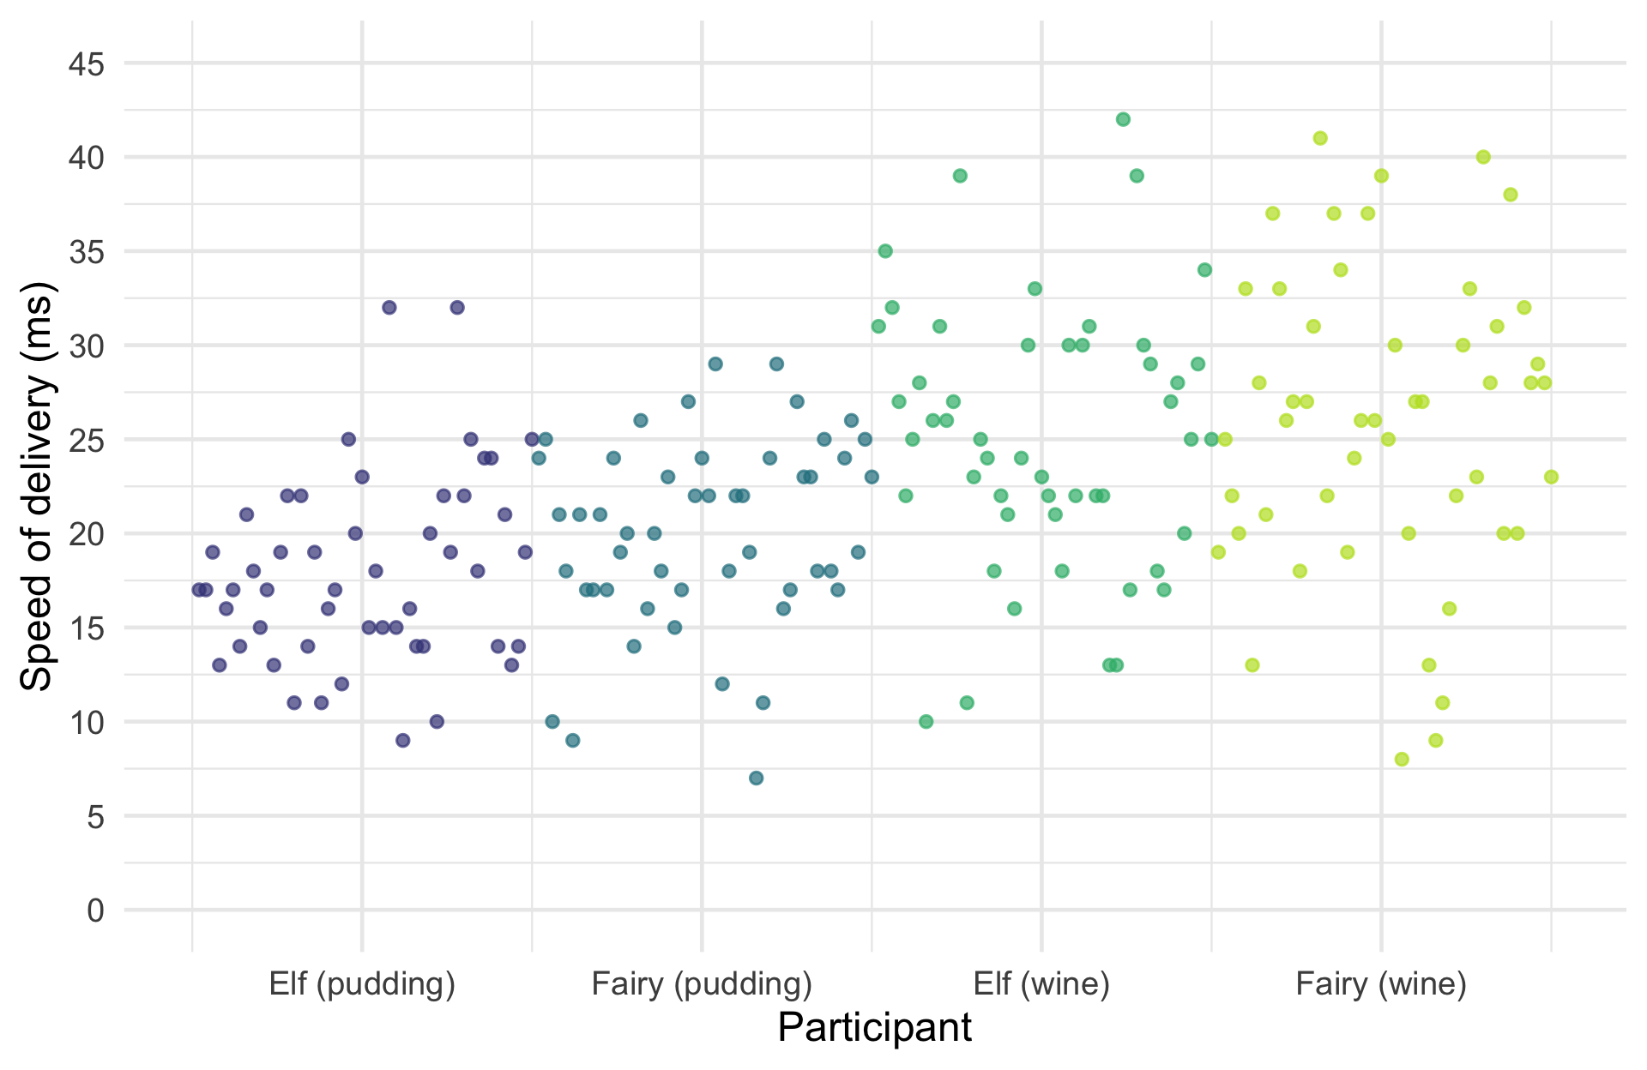


Slide 15: Interpret the main effect of treat
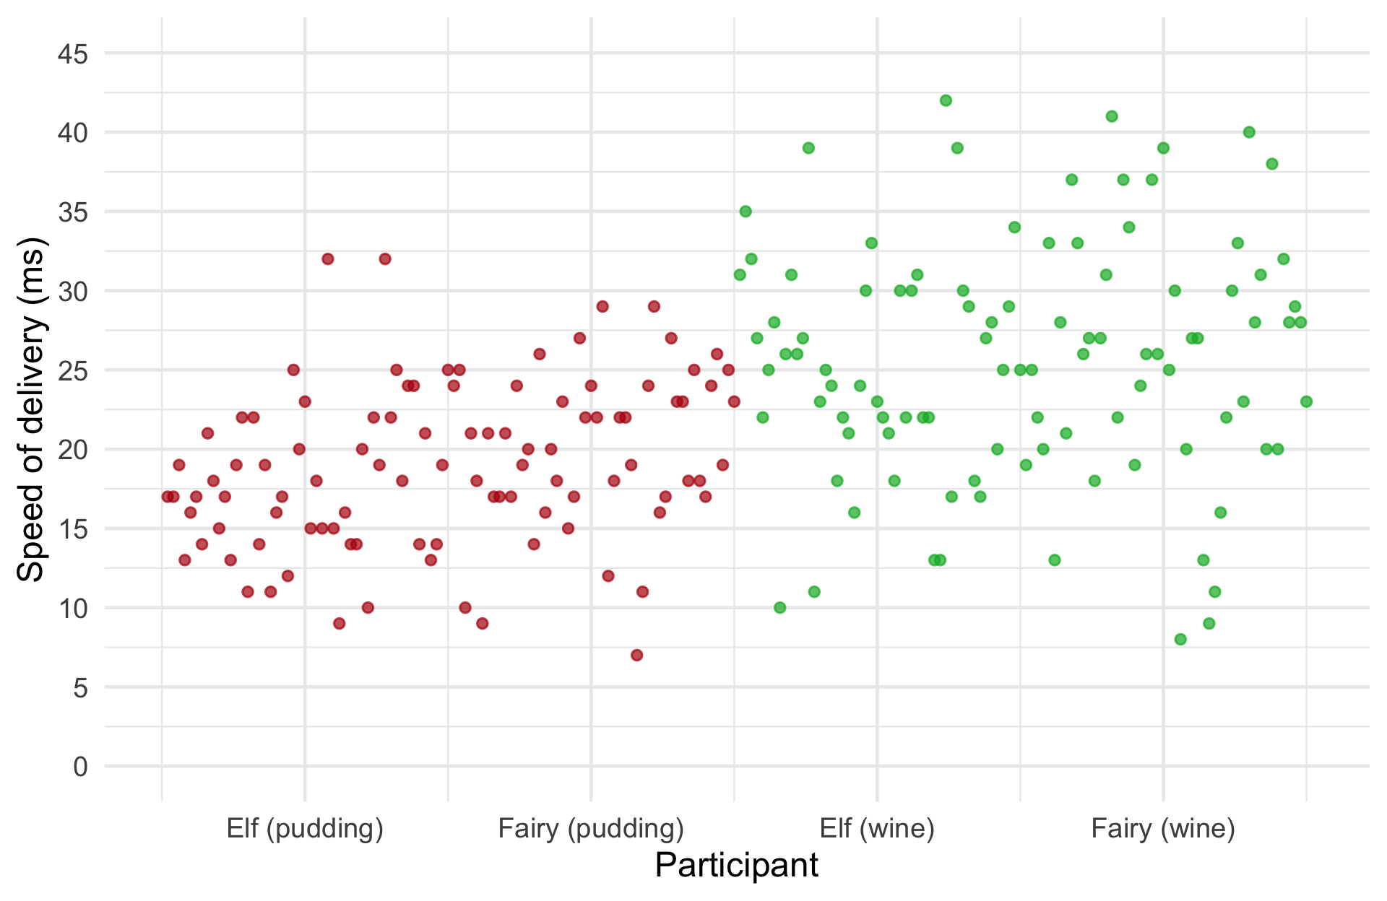

Slide 16: Interpret the main effect of treat
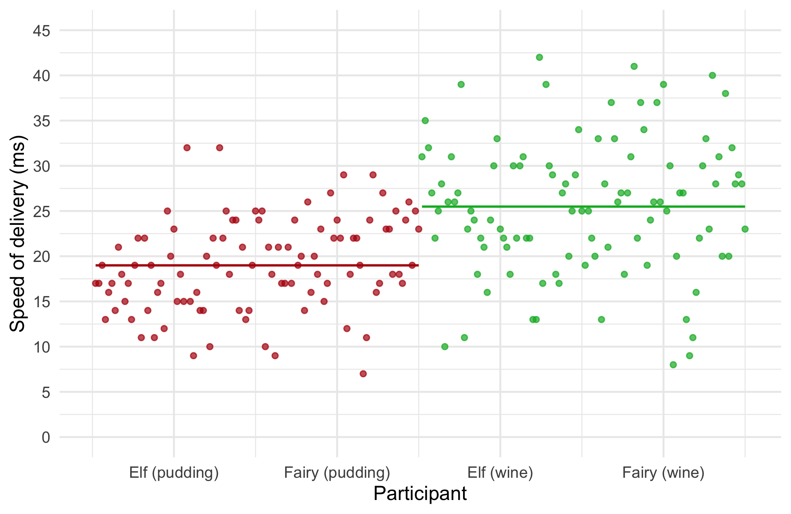

Slide 17: Interpret
ANOVA estimation for factorial designs using ‘afex’
Parameter | Sum_Squares | Sum_Squares_Error | df | df (error) | Mean_Square | F | p | ω² (partial)
helper | 106.58 | 5136.90 | 1 | 98 | 52.42 | 2.03 | 0.157 | 0.01
treat | 2112.50 | 2910.50 | 1 | 98 | 29.70 | 71.13 | < .001 | 0.20
helper:treat | 18.00 | 2910.50 | 1 | 98 | 29.70 | 0.61 | 0.438 | 0.00
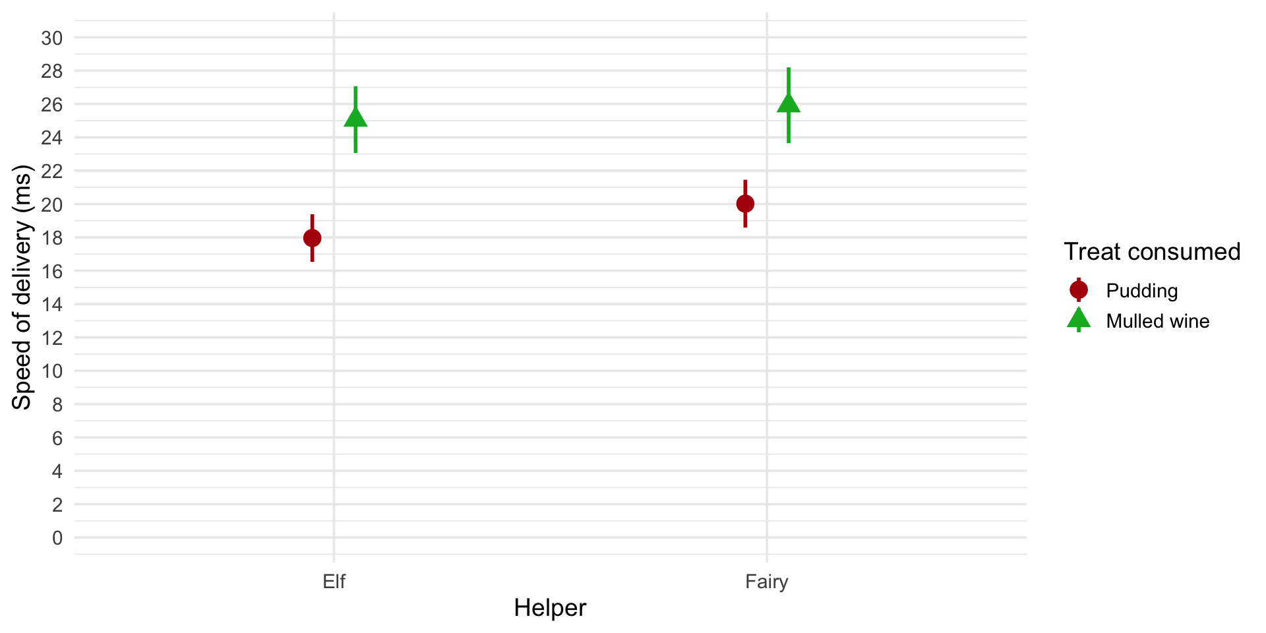
Important: ReportR
Delivery speeds were significantly longer after mulled wine than pudding, F(1, 98) = 71.13, p < 0.001. This effect was not significantly moderated by the type of helper, F(1, 98) = 0.61, p = 0.438.

Slide 18
Video clip: xmas scene 2

Slide 19: A festive example
Santa Claus wanted to test the effect of different quantities of different types of treats on the speed of delivery in two types of helpers.
Predictors
- treat: Christmas pudding, Mulled wine (within-participant, repeated measures)
- quantity: one, two, three, four, five (within-participant, repeated measures)
- helper: Elf, Fairy (between-participant, independent)
Outcome
- speed: The speed at which presents were delivered (ms).

Slide 20: The design
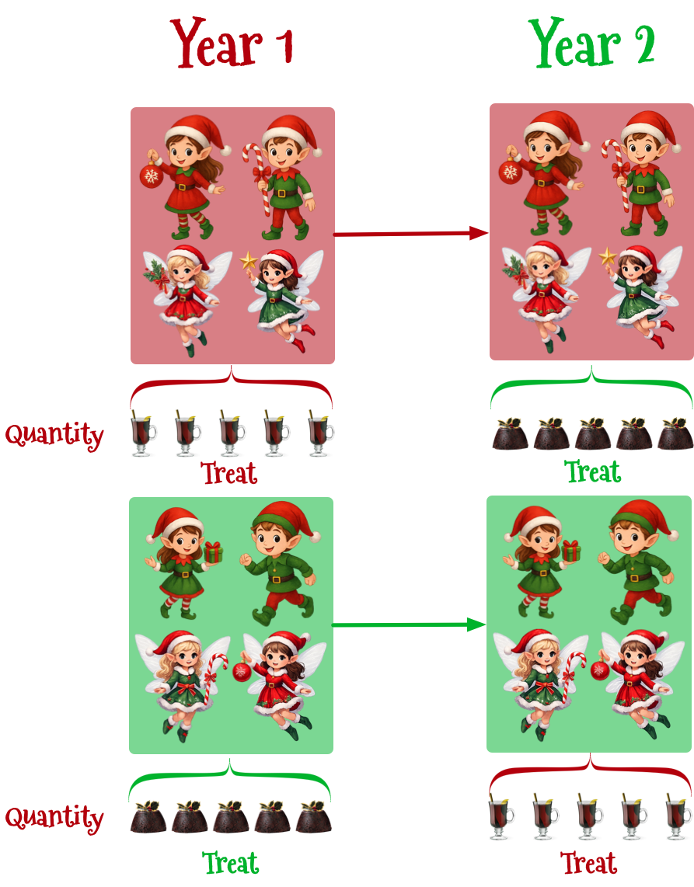
Note: Statis-tip
This is a three-way mixed design
- treat is a repeated measures because all participants consumed all treats
- quantity is a repeated measures because speed was measured after each participant consumed, 1, 2, 3, 4 and 5 treats
- helper is an independent measure because participants could be an elf or a fairy but not both

Slide 21: Load and Look
Table 2: Santa's data (first 50 of 1000 rows)
 | id | helper | treat | quantity | speed
1 | Aaron the Delighted | Elf | Pudding | One | 10
2 | Rand the Pinguid | Elf | Pudding | One | 13
3 | Dreary the Fergal-fargel | Elf | Pudding | One | 10
4 | Jongle the Determined | Elf | Pudding | One | 11
5 | Ogdoad the Eigen vector | Elf | Pudding | One | 12
6 | Vicki the Invisible | Elf | Pudding | One | 11
7 | Sisifus the Dextrous | Elf | Pudding | One | 9
8 | Milton the Jubulant | Elf | Pudding | One | 14
9 | Jojo the Statistical | Elf | Pudding | One | 11
10 | Merkin the Dwaal | Elf | Pudding | One | 12
11 | Belphegor the Jubulant | Elf | Pudding | One | 15
12 | Mustafi the Argute | Elf | Pudding | One | 14
13 | Edwin the Witch | Elf | Pudding | One | 17
14 | Oxter the Knee-scratcher | Elf | Pudding | One | 4
15 | Ogdoad the Xylopolist | Elf | Pudding | One | 8
16 | Oxter the Chopwooder | Elf | Pudding | One | 11
17 | Ogdoad the Crank | Elf | Pudding | One | 12
18 | Vicki the Unconscious | Elf | Pudding | One | 11
19 | Hughy the Jubulant | Elf | Pudding | One | 12
20 | Fipple the Potato carver | Elf | Pudding | One | 15
21 | Edwin the Visible | Elf | Pudding | One | 14
22 | Cleo the Defensive midfielder | Elf | Pudding | One | 8
23 | Cog the Mudlark | Elf | Pudding | One | 9
24 | Juniper the Fairy disguised as an elf | Elf | Pudding | One | 12
25 | Jangle the Pickler | Elf | Pudding | One | 14
26 | Rob the Extroverted | Elf | Pudding | One | 12
27 | Dojan the Conscious | Elf | Pudding | One | 12
28 | Ramsey the Truculent | Elf | Pudding | One | 15
29 | Skelf the Fugacious | Elf | Pudding | One | 13
30 | Wickham the Chopwooder | Elf | Pudding | One | 12
31 | Cleo the Innocuous | Elf | Pudding | One | 14
32 | Milton the Industrious | Elf | Pudding | One | 8
33 | Liv the Nepharious | Elf | Pudding | One | 13
34 | Vicki the Biddible | Elf | Pudding | One | 12
35 | Jingle the Eigen vector | Elf | Pudding | One | 10
36 | Sisifus the Rubiginous | Elf | Pudding | One | 10
37 | Dreary the Cuddle | Elf | Pudding | One | 14
38 | Edwin the Partial derivative | Elf | Pudding | One | 14
39 | Erwin the Knee-scratcher | Elf | Pudding | One | 15
40 | Per the Wrapper | Elf | Pudding | One | 16
41 | Tinsel the Busy | Elf | Pudding | One | 15
42 | Bellerin the Xylopolist | Elf | Pudding | One | 13
43 | Petr the Musical | Elf | Pudding | One | 14
44 | Compote the Xylopolist | Elf | Pudding | One | 10
45 | Jingle the Dextrous | Elf | Pudding | One | 13
46 | Gillan the Truculent | Elf | Pudding | One | 12
47 | Compote the Invisible | Elf | Pudding | One | 8
48 | Quo the Dextrous | Elf | Pudding | One | 13
49 | Petr the Strong | Elf | Pudding | One | 9
50 | Florence the Cute | Elf | Pudding | One | 13

Slide 22: Extending the model
- Let’s simplify things by ignoring the fact that quantity will be represented by four dummy variables (as will all interactions that involve it)
$$\begin{aligned}{\text{speed}}_{ij}&={\hat{b}}_{0}+{\hat{b}}_{1}{\text{helper}}_{i}+{\hat{b}}_{2}{\text{treat}}_{ij}+{\hat{b}}_{3}{\text{quantity}}_{ij} \\ & +{\hat{b}}_{4}\left({\text{helper}}_{i}×{\text{treat}}_{ij}\right)+{\hat{b}}_{5}\left({\text{helper}}_{i}×{\text{quantity}}_{ij}\right) \\ & +{\hat{b}}_{6}\left({\text{treat}}_{ij}×{\text{quantity}}_{ij}\right)+ \\ & +{\hat{b}}_{7}\left({\text{helper}}_{i}×{\text{treat}}_{ij}×{\text{quantity}}_{ij}\right)+u_{0j}+e_{i}\end{aligned}$$

Slide 23: Summary of effects
We will get an F-statistic for the following effects:
- Main effects
  - helper
  - treat
  - quantity
- Two-way interactions
  - helper × treat
  - helper × quantity
  - treat × quantity
- Three-way Interaction
  - helper × treat × quantity
Note: Statis-tip
Repeat the following mantras:
- “It is never sensible to interpret main effects in the presence of a significant interaction effect.”
- “It is also never sensible to interpret interaction effects in the presence of a significant higher-order interaction effect.”

Slide 24: Contrasts
- For both helper and treat there are two categories so the Fs are directly interpretable.
- For quantity we need 4 contrast variables. These would work:
  - Contrast 1: {two} vs. {one}
  - Contrast 2: {three} vs. {one}
  - Contrast 3: {four} vs. {one}
  - Contrast 4: {five} vs. {one}
- We can extract these using estimate_contrasts()
  - "trt.vs.ctrl": compares each category to a declared reference category (by default the first category). Use ref = x to make x the reference category.
  - "consec": compares each level/category (except the first) to the previous

Slide 25
Video clip: three way design song instrumental

Slide 26
Video clip: three way design song

Slide 27: Fit the model
xmas_afx <- afex::aov_4(speed ~ treat*quantity*helper + (treat*quantity|id), data = xmas_tib)

Evaluate
model_parameters(xmas_afx, es_type = "omega") |>
display(use_symbols = TRUE)
ANOVA estimation for factorial designs using ‘afex’
Parameter | Sum_Squares | Sum_Squares_Error | df | df (error) | Mean_Square | F | p | ω² (partial)
helper | 1334.02 | 14765.23 | 1.00 | 98.00 | 150.67 | 8.85 | 0.004 | 0.07
treat | 18054.00 | 3845.67 | 1.00 | 98.00 | 39.24 | 460.07 | < .001 | 0.49
helper:treat | 893.02 | 3845.67 | 1.00 | 98.00 | 39.24 | 22.76 | < .001 | 0.04
quantity | 1.21e+05 | 15073.70 | 2.84 | 278.23 | 54.18 | 784.93 | < .001 | 0.80
helper:quantity | 2141.75 | 15073.70 | 2.84 | 278.23 | 54.18 | 13.92 | < .001 | 0.06
treat:quantity | 20918.91 | 13104.42 | 2.83 | 277.81 | 47.17 | 156.44 | < .001 | 0.42
helper:treat:quantity | 3390.47 | 13104.42 | 2.83 | 277.81 | 47.17 | 25.36 | < .001 | 0.10

Slide 28: Evaluate assumptions
check_model(xmas_afx)
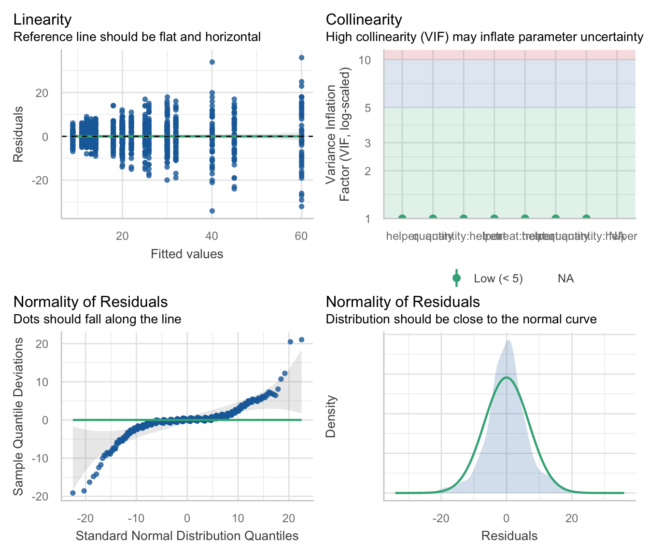

Slide 29: Interpret the highest-order interaction
ggplot(xmas_tib, aes(x = quantity, y= speed, colour = treat)) +
geom_point(size = 0.75, position = position_jitter(width = 0.1), alpha = 0.2) +
stat_summary(aes(group = treat), fun = mean, geom = "line") +
stat_summary(fun.data = "mean_cl_normal", size = 0.25) +
scale_colour_manual(values = c("#B3000C", "#00B32C")) +
facet_wrap(~helper) +
labs(x = "Number of portions", y = "Speed of delivery (ms)", colour = "Treat") +
scale_y_continuous(breaks = seq(0, 100, 10)) +
coord_cartesian(ylim = c(0, 100)) +
theme_minimal(base_size = 18)
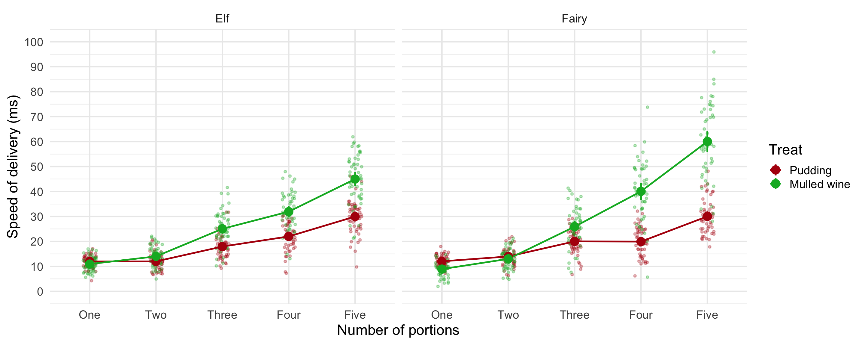

Slide 30: Contrasts across the interaction
three_way_emm <- estimate_means(model = xmas_afx,
by = c("quantity", "treat", "helper"))
estimate_contrasts(model = xmas_afx,
contrast = c("quantity", "treat", "helper"),
interaction = c(quantity = "trt.vs.ctrl", treat = "trt.vs.ctrl", helper = "trt.vs.ctrl"),
ref = 1,
p_adjust = "bonferroni",
backend = "emmeans") |>
display()
Marginal Contrasts Analysis
quantity_trt.vs.ctrl | treat_trt.vs.ctrl | helper_trt.vs.ctrl | Difference | 95% CI | SE | t(98) | p
Five - One | Mulled.wine - Pudding | Fairy - Elf | 17.06 | (10.54, 23.58) | 2.56 | 6.66 | < .001
Four - One | Mulled.wine - Pudding | Fairy - Elf | 12.26 | ( 6.90, 17.62) | 2.11 | 5.82 | < .001
Three - One | Mulled.wine - Pudding | Fairy - Elf | 0.88 | (-3.37, 5.13) | 1.67 | 0.53 | > .999
Two - One | Mulled.wine - Pudding | Fairy - Elf | -0.90 | (-3.67, 1.87) | 1.09 | -0.83 | > .999

Slide 31: Contrast 1
quantity_trt.vs.ctrl | treat_trt.vs.ctrl | helper_trt.vs.ctrl | Difference | CI | SE | t(98) | p
Five - One | Mulled.wine - Pudding | Fairy - Elf | 17.06 | (10.54, 23.58) | 2.56 | 6.66 | < .001
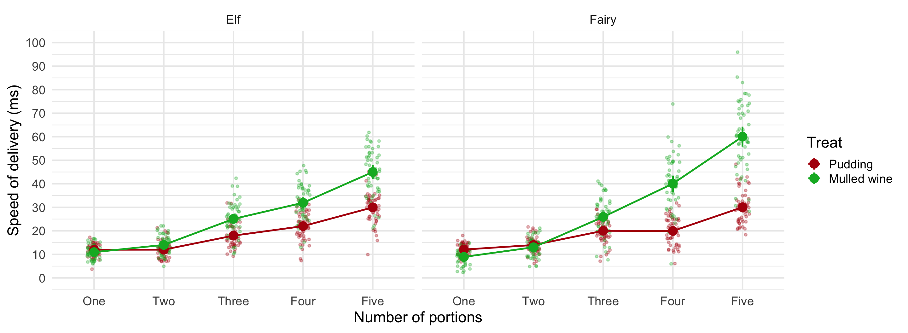


Slide 32: Contrast 1
quantity_trt.vs.ctrl | treat_trt.vs.ctrl | helper_trt.vs.ctrl | Difference | CI | SE | t(98) | p
Five - One | Mulled.wine - Pudding | Fairy - Elf | 17.06 | (10.54, 23.58) | 2.56 | 6.66 | < .001
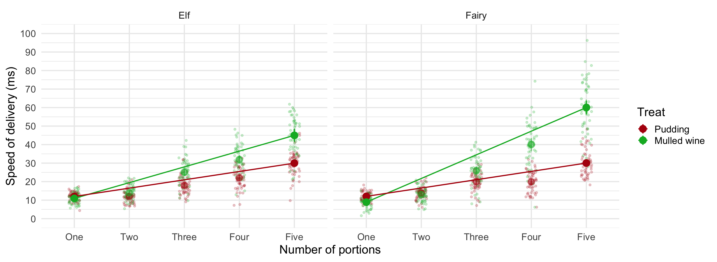

Slide 33: Contrast 2
quantity_trt.vs.ctrl | treat_trt.vs.ctrl | helper_trt.vs.ctrl | Difference | CI | SE | t(98) | p
Four - One | Mulled.wine - Pudding | Fairy - Elf | 12.26 | (6.90, 17.62) | 2.11 | 5.82 | < .001
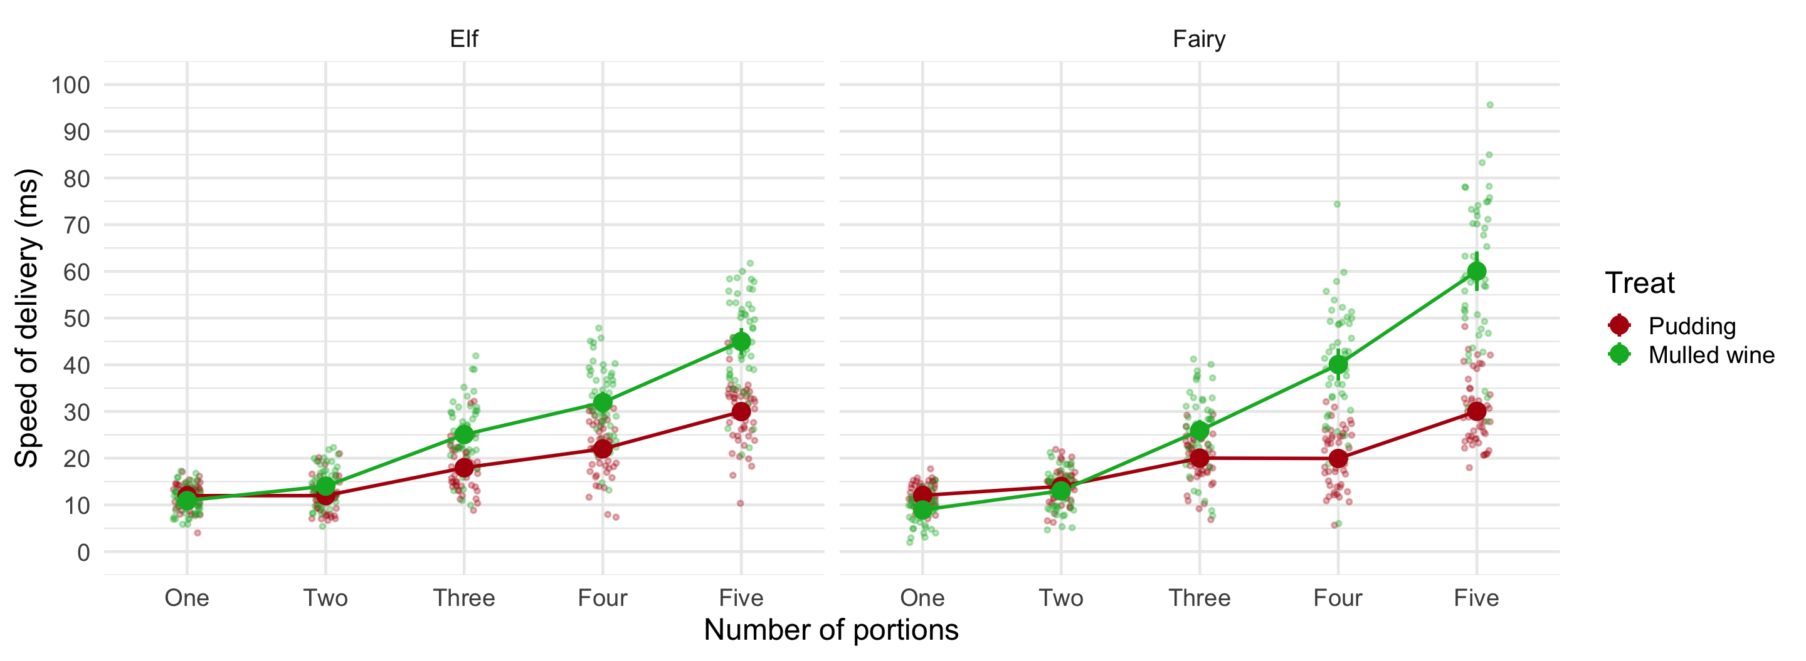


Slide 34: Contrast 2
quantity_trt.vs.ctrl | treat_trt.vs.ctrl | helper_trt.vs.ctrl | Difference | CI | SE | t(98) | p
Four - One | Mulled.wine - Pudding | Fairy - Elf | 12.26 | (6.90, 17.62) | 2.11 | 5.82 | < .001
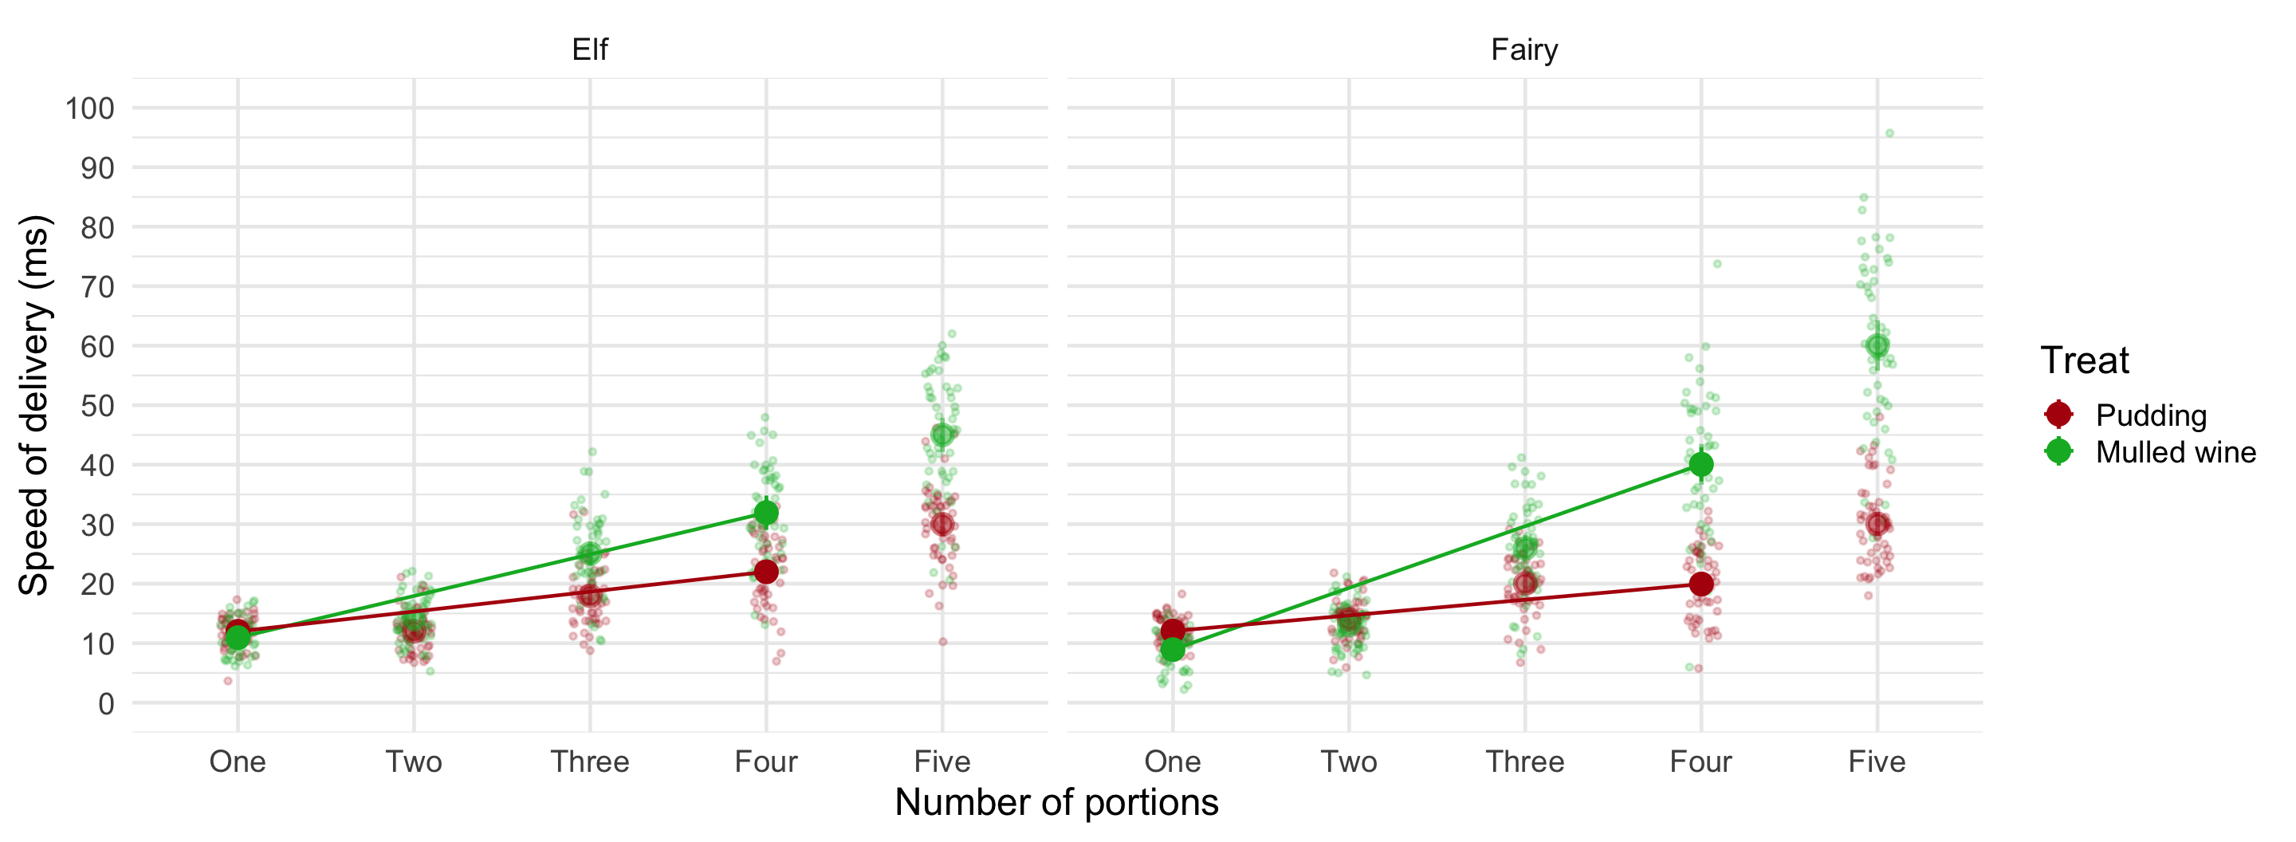

Slide 35: Contrast 3
quantity_trt.vs.ctrl | treat_trt.vs.ctrl | helper_trt.vs.ctrl | Difference | CI | SE | t(98) | p
Three - One | Mulled.wine - Pudding | Fairy - Elf | 0.88 | (-3.37, 5.13) | 1.67 | 0.53 | > .999
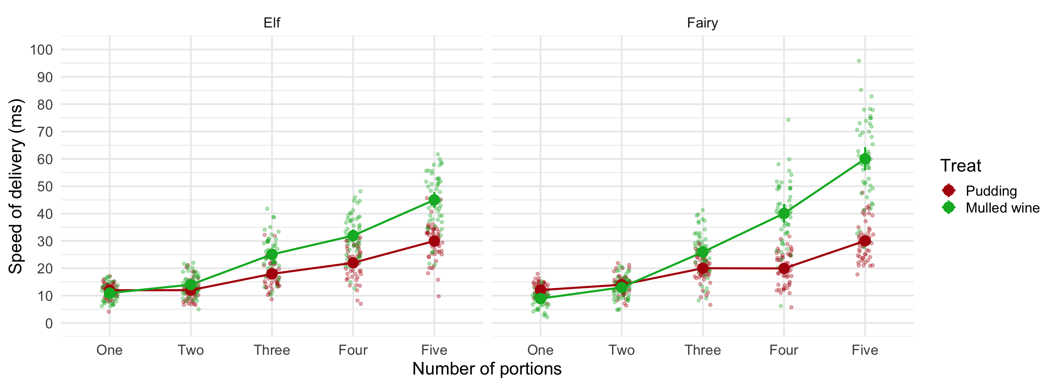
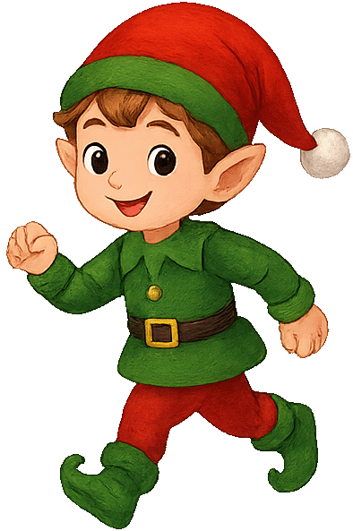

Slide 36: Contrast 3
quantity_trt.vs.ctrl | treat_trt.vs.ctrl | helper_trt.vs.ctrl | Difference | CI | SE | t(98) | p
Three - One | Mulled.wine - Pudding | Fairy - Elf | 0.88 | (-3.37, 5.13) | 1.67 | 0.53 | > .999
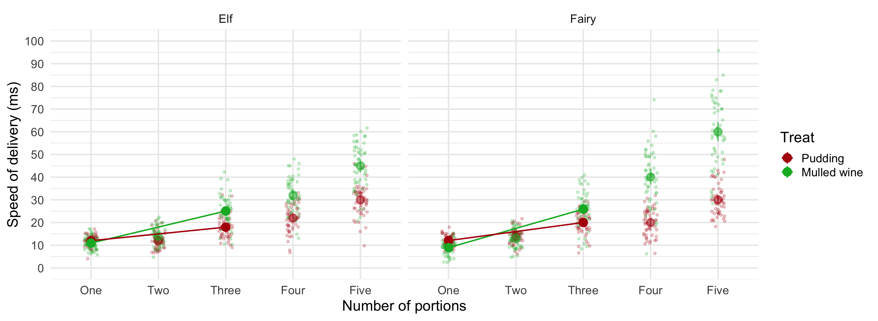

Slide 37: Contrast 4
quantity_trt.vs.ctrl | treat_trt.vs.ctrl | helper_trt.vs.ctrl | Difference | CI | SE | t(98) | p
Two - One | Mulled.wine - Pudding | Fairy - Elf | -0.90 | (-3.67, 1.87) | 1.09 | -0.83 | > .999
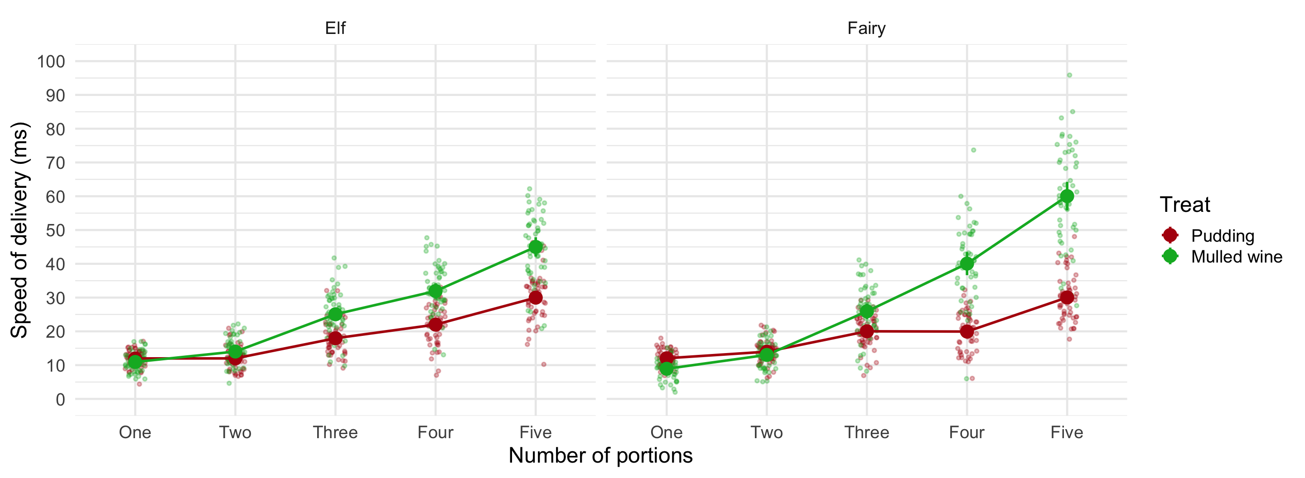


Slide 38: Contrast 4
quantity_trt.vs.ctrl | treat_trt.vs.ctrl | helper_trt.vs.ctrl | Difference | CI | SE | t(98) | p
Two - One | Mulled.wine - Pudding | Fairy - Elf | -0.90 | (-3.67, 1.87) | 1.09 | -0.83 | > .999
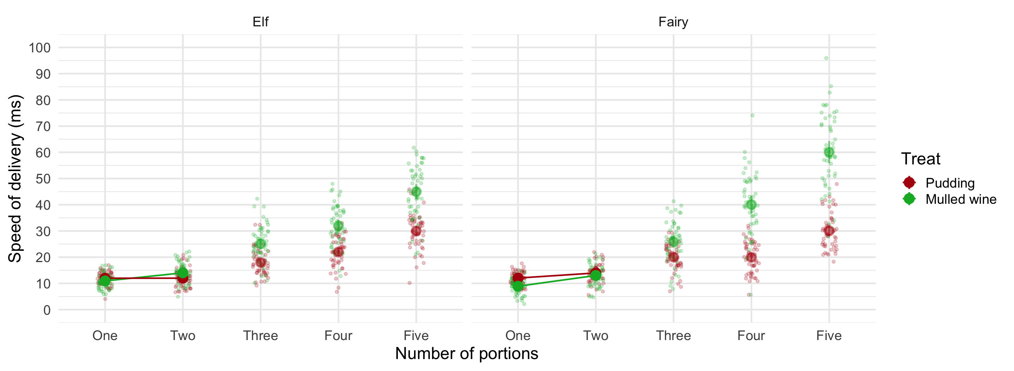

Slide 39
Video clip: xmas santa 03

Slide 40
Video clip: i wish it could be christmas

