The Chi Square test
Professor Andy Field, University of Sussex
Links: bsky.app | youtube.com | discoveringstatistics.com | discovr.rocks | statisticsadventure.com

About this version
This is a plain-text version of the lecture slides. Each slide starts with a heading such as “Slide 5”, and the numbers match the slide numbers shown in the lecture. Content that appeared one piece at a time, in columns or in tabs is shown in reading order. Videos and interactive apps are given as links.

Slide 2: tl;dw
Note: Statis-tip
Use a chi-square test to:
- Test for an association between two categorical variables
  - H₁: There is an association between the variables.
  - H₀: There is no association between the variables.
- Each observation must fall into only 1 combination of categories (independence)
- Data are frequencies
- A significant test statistic $χ^{2}$
  - The observed frequencies are inconsistent with the null hypothesis being true
  - Conclude: the association between variables is not zero
- A non-significant test statistic $χ^{2}$
  - The observed frequencies are consistent with the null hypothesis being true
  - Conclude: the association between variables could be zero

Slide 3: Do zombie’s like to eat brains?
- There is a common cultural belief that zombies like to eat brains
- If this is true we’d expect zombies to choose brains to eat more than other foods.
- We wouldn’t expect this preference in non-zombies.
- A researcher counted how many humans and zombies choose brain chips or potato chips to accompany their dinner at the university canteen
Caution: Hypothesis
- H₁: There is an association between the type of organism and the type of chips eaten.
- H₀: There is no association between the type of organism and the type of chips eaten.

Slide 4: The Data
- Data are counts/frequencies
- Imagine we observed 50 humans and 50 zombies
- If there is no association, how many observations would we expect in each cell?
Organism | Brain chips | Potato chips | Total
Human |  |  | 50
Zombie |  |  | 50
Total |  |  | 100

Slide 5: Expected values
- What about if 40 had brain chips and 60 Potato chips?
Organism | Brain chips | Potato chips | Total
Human |  |  | 50
Zombie |  |  | 50
Total | 40 | 60 | 100

Slide 6: Expected values (generally)
Organism | Brain chips | Potato chips | Total
Human | $\frac{{\text{RT}}_{1}×{\text{CT}}_{1}}{N}$ | $\frac{{\text{RT}}_{2}×{\text{CT}}_{1}}{N}$ | RT₁
Zombie | $\frac{{\text{RT}}_{1}×{\text{CT}}_{2}}{N}$ | $\frac{{\text{RT}}_{2}×{\text{CT}}_{2}}{N}$ | RT₂
Total | CT₁ | CT₂ | $N$

Slide 7: Model (expected) values
- The expected values when there’s no association (i.e. the null is true)
Organism | Brain chips | Potato chips | Total
Human | 20 | 30 | 50
Zombie | 20 | 30 | 50
Total | 40 | 60 | 100
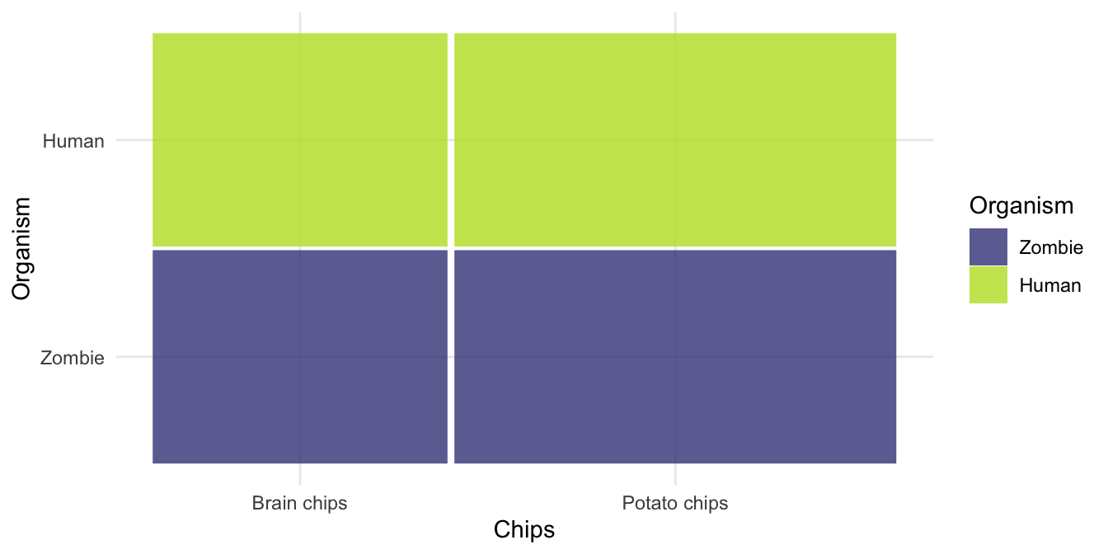

Slide 8: Observed values
Organism | Brain chips | Potato chips | Total
Human | 10 | 40 | 50
Zombie | 30 | 20 | 50
Total | 40 | 60 | 100
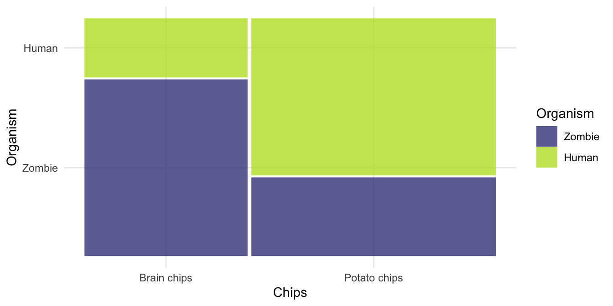

Slide 9: The Chi-square test
$$χ^{2}=∑\frac{{\left({\text{observed}}_{ij}−{\text{model}}_{ij}\right)}^{2}}{{\text{model}}_{ij}}$$

Model
Organism | Brain chips | Potato chips | Total
Human | 20 | 30 | 50
Zombie | 20 | 30 | 50
Total | 40 | 60 | 100
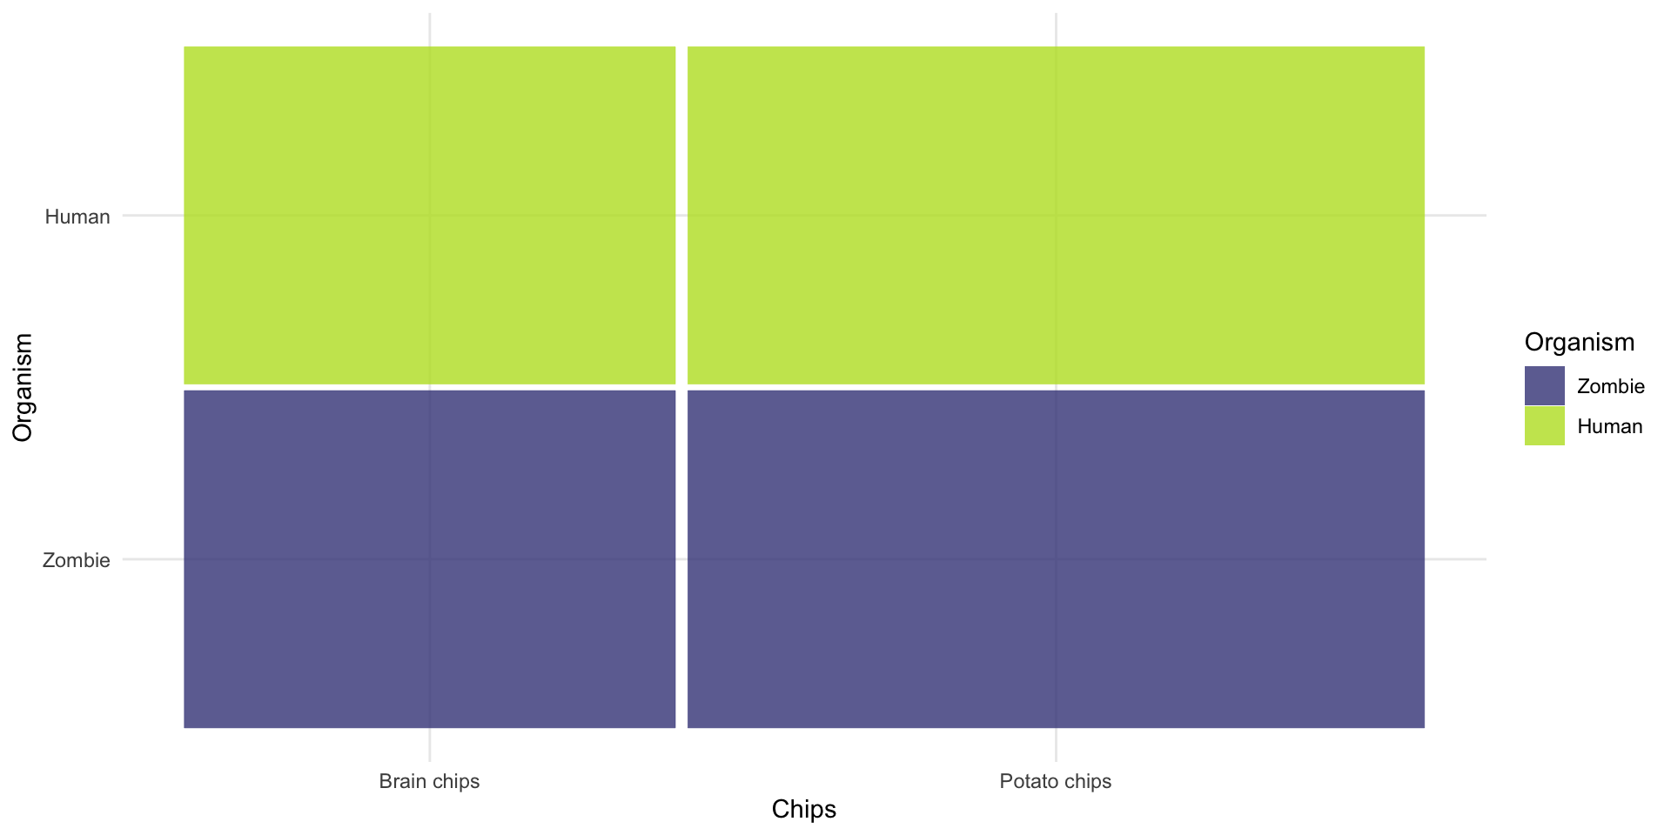

Observed
Organism | Brain chips | Potato chips | Total
Human | 10 | 40 | 50
Zombie | 30 | 20 | 50
Total | 40 | 60 | 100
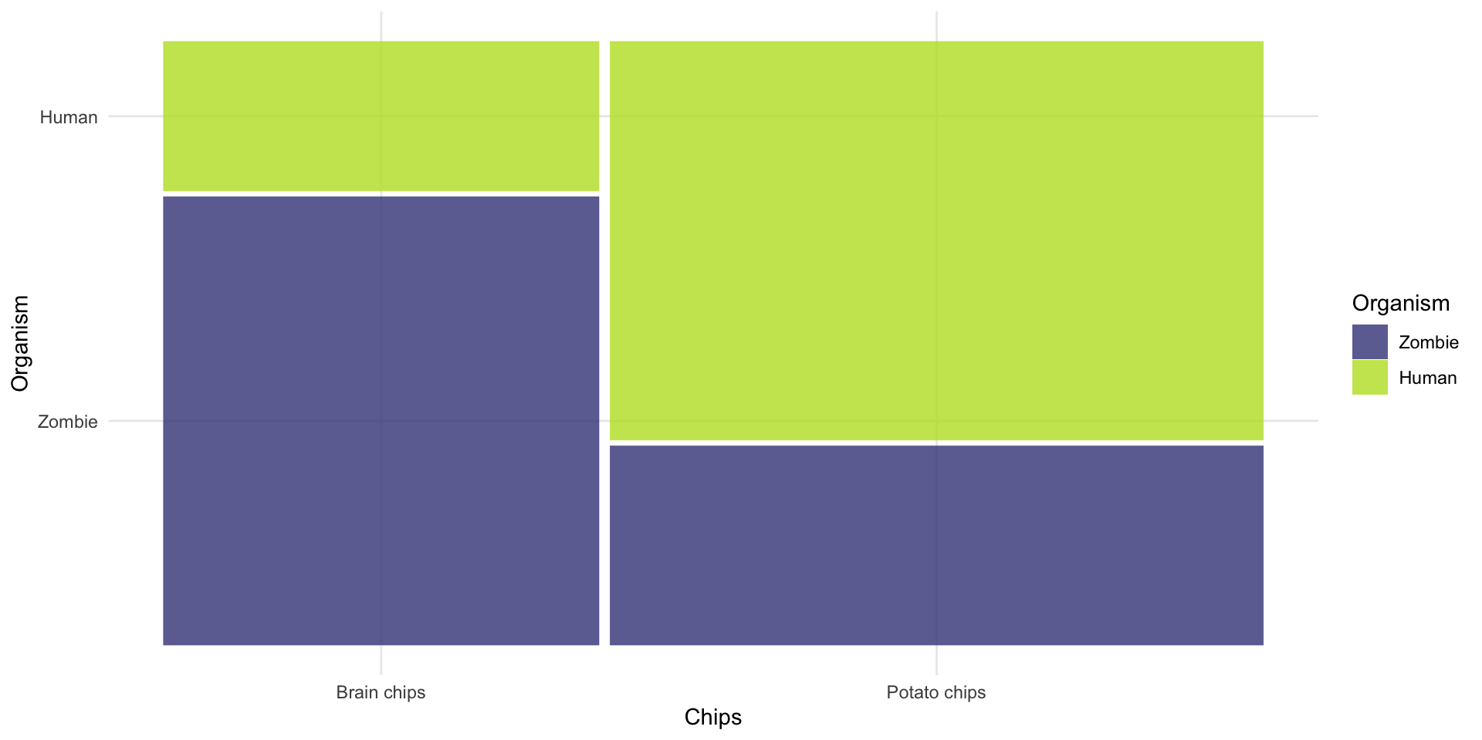

Slide 10: In reality
Organism | Brain chips | Potato chips | Total
Human | 27 | 106 | 133
Zombie | 36 | 53 | 89
Total | 63 | 159 | 222

Slide 11: In reality
$$χ^{2}=∑\frac{{\left({\text{observed}}_{ij}−{\text{model}}_{ij}\right)}^{2}}{{\text{model}}_{ij}}$$

Observed
organism | Brain chips | Potato chips
Human | 27 | 106
Zombie | 36 | 53

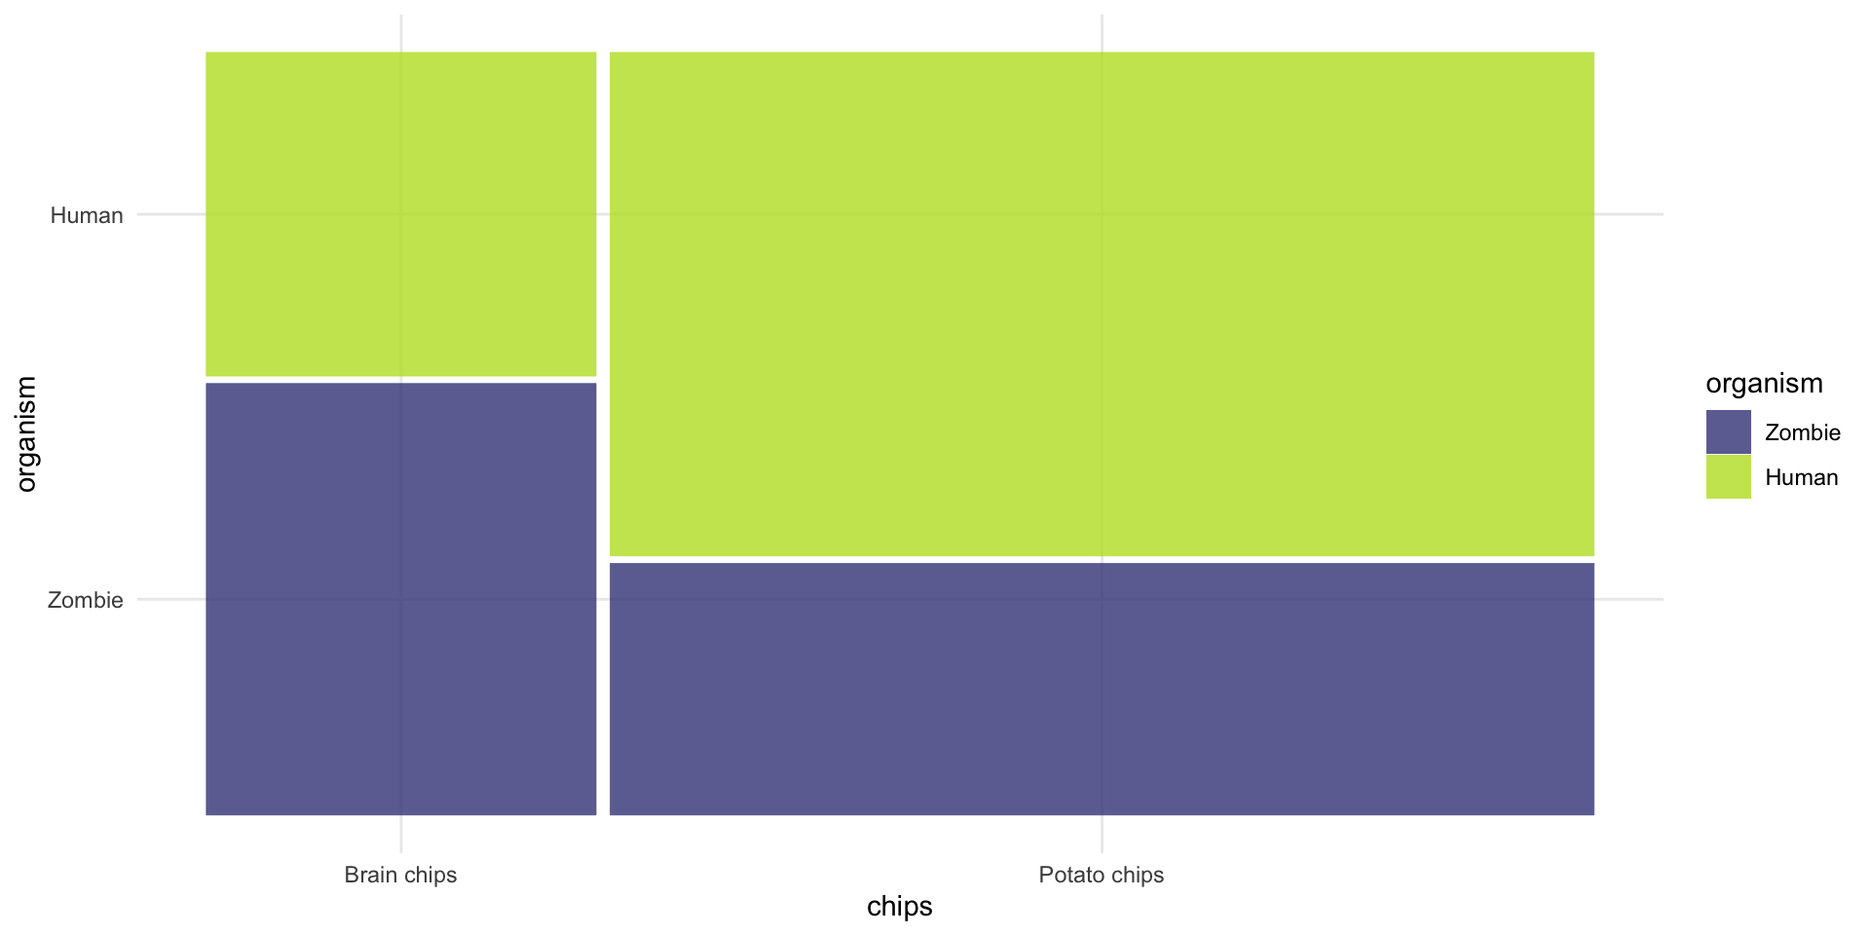

Model
organism | Brain chips | Potato chips
Human | 38 | 95
Zombie | 25 | 64

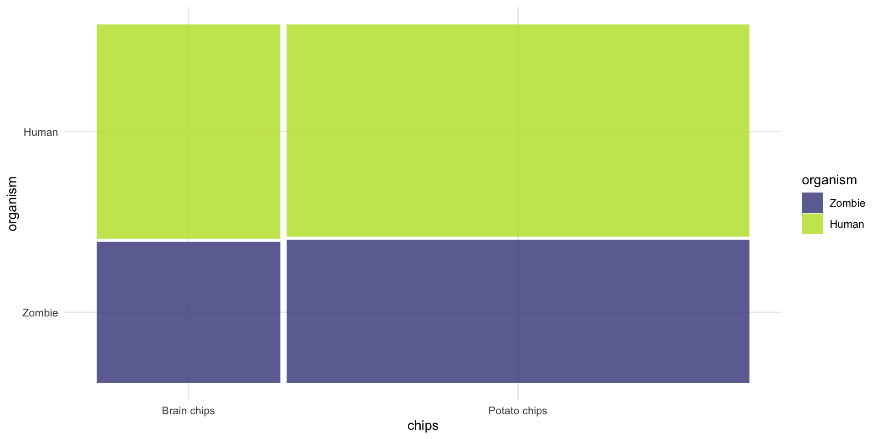

Slide 12 (new section): The chi-square test using R

Slide 13: Fitting models is E.V.I.L.
- Look and Load: get the data into R, process it, summarize it (look)
- Visualise: plot relevant information to understand the data/model
- Evaluate: is the model any good? Are its assumptions met? Does it ‘fit’ the data?
- Interpret: use the model to answer your question

Slide 14: Load and Look
Table 1: Zombie data (first 50 of 222 rows)
 | organism | chips
1 | Human | Brain chips
2 | Human | Brain chips
3 | Human | Brain chips
4 | Human | Brain chips
5 | Human | Brain chips
6 | Human | Brain chips
7 | Human | Brain chips
8 | Human | Brain chips
9 | Human | Brain chips
10 | Human | Brain chips
11 | Human | Brain chips
12 | Human | Brain chips
13 | Human | Brain chips
14 | Human | Brain chips
15 | Human | Brain chips
16 | Human | Brain chips
17 | Human | Brain chips
18 | Human | Brain chips
19 | Human | Brain chips
20 | Human | Brain chips
21 | Human | Brain chips
22 | Human | Brain chips
23 | Human | Brain chips
24 | Human | Brain chips
25 | Human | Brain chips
26 | Human | Brain chips
27 | Human | Brain chips
28 | Human | Potato chips
29 | Human | Potato chips
30 | Human | Potato chips
31 | Human | Potato chips
32 | Human | Potato chips
33 | Human | Potato chips
34 | Human | Potato chips
35 | Human | Potato chips
36 | Human | Potato chips
37 | Human | Potato chips
38 | Human | Potato chips
39 | Human | Potato chips
40 | Human | Potato chips
41 | Human | Potato chips
42 | Human | Potato chips
43 | Human | Potato chips
44 | Human | Potato chips
45 | Human | Potato chips
46 | Human | Potato chips
47 | Human | Potato chips
48 | Human | Potato chips
49 | Human | Potato chips
50 | Human | Potato chips


Slide 15: Load and Look
# create the table
brain_xtbl <- brain_tib |>
data_tabulate(select = "organism", by = "chips", remove_na = TRUE)
# format for rendering
display(brain_xtbl)
organism | Brain chips | Potato chips | Total
Zombie | 36 | 53 | 89
Human | 27 | 106 | 133
Total | 63 | 159 | 222

Slide 16: Visualize
ggplot(data = brain_tib) +
geom_mosaic(aes(x = product(organism, chips), fill = organism)) +
theme_minimal()
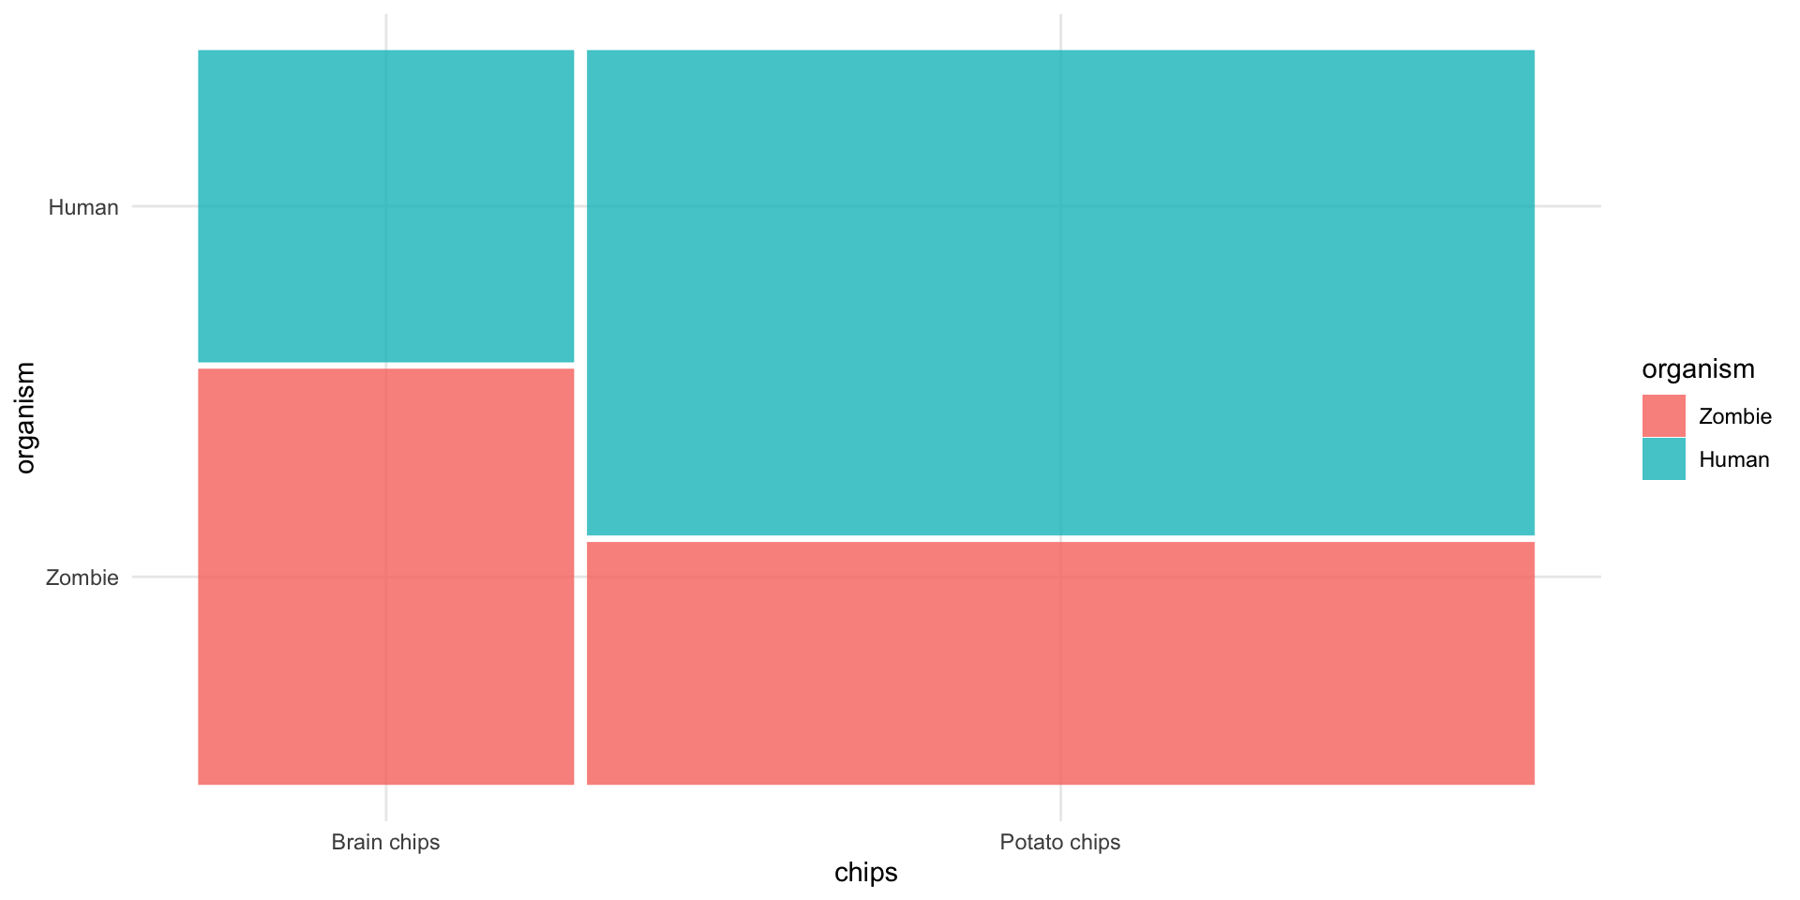


Slide 17: Interpret
# fit model
brain_chi <- brain_xtbl |>
as.table(simplify = TRUE) |>
chisq.test()
# show results
model_parameters(brain_chi) |>
display()
Pearson’s Chi-squared test with Yates’ continuity correction
Chi2(1) | p
9.68 | 0.002


Slide 18: Interpret
get_residuals(brain_chi) |>
display()
 | Brain chips | Potato chips
Zombie | 2.14 | -1.35
Human | -1.75 | 1.10

Slide 19: Interpret
brain_xtbl |>
as.table(simplify = TRUE) |>
oddsratio() |>
display()
Odds ratio | 95% CI
2.67 | [1.47, 4.85]

Slide 20: Evaluate assumptions
get_predicted(brain_chi) |>
display()
 | Brain chips | Potato chips
Zombie | 25.26 | 63.74
Human | 37.74 | 95.26


Slide 21 (new section): The Odds Ratio

Slide 22: tl;dw
Note: Statis-tip
The odds ratio:
- The odds of an event in one group relative to a comparison group
  - The odds of recovery in those receiving surgery compared to those not receiving surgery
  - The odds of getting a six pack in those doing Tai-Chi walking compared to those that don’t
- OR > 1: the odds of an event occurring are greater in the group of interest than in the comparison group.
- OR < 1: the odds of an event occurring are smaller in the group of interest than in the comparison group.

Slide 23: The Data
- There is a common cultural belief that zombies like to eat brains
- If this is true we’d expect zombies to choose brains to eat more than other foods.
- A researcher counted how many humans and zombies choose brain chips or potato chips to accompany their dinner at the university canteen
- Data are counts/frequencies

Slide 24: The odds of eating brain
Organism | Brain chips | Potato chips | Total
Human | 27 | 106 | 133
Zombie | 36 | 53 | 89
Total | 63 | 159 | 222
$$\begin{aligned}{\text{odds}}_{\text{human eating brain}}&=\frac{\text{Number eating brain}}{\text{Number eating potato}} \\ &=\frac{27}{106} \\ &=0.255\end{aligned}$$
$$\begin{aligned}{\text{odds}}_{\text{zombie eating brain}}&=\frac{\text{Number eating brain}}{\text{Number eating potato}} \\ &=\frac{36}{53} \\ &=0.679\end{aligned}$$

Slide 25: The odds ratio
$$\begin{aligned}\text{odds ratio}&=\frac{{\text{odds}}_{\text{human eating brain}}}{{\text{odds}}_{\text{zombie eating brain}}} \\ &=\frac{0.255}{0.679} \\ &=0.38\end{aligned}$$
Note: Statis-tip
- The odds of a human eating brains are 0.38 times those of a zombie eating brains
$$\begin{aligned}\text{odds ratio}&=\frac{{\text{odds}}_{\text{zombie eating brain}}}{{\text{odds}}_{\text{human eating brain}}} \\ &=\frac{0.679}{0.255} \\ &=2.66\end{aligned}$$
Note: Statis-tip
- The odds of a zombie eating brains are 2.66 times greater than the odds of a human eating brains

