**Chapter 17**

**Introduction to Soft Computing And Fuzzy Logic**

**The chapter consist of Short type Questions & Answers , Descriptive Question & Answer and MCQs & answers.**

Contents

Short type Questions & Answers 2

Q Who is the founder of fuzzy logic? 2

Q What is the reason that logic function has rapidly become one of the most successful technology for developing sophisticated control systems? 2

Q What is sequence of steps taken in designing a fuzzy logic machine? 2

Q What is the main difference between the probability and fuzzy logic? 2

Q What is the fuzzy approximation theorem (FAT)? 2

Q What is an adaptive fuzzy system? 3

Q What is the principle of fuzzy logic? 3

Q What is the artificial intelligence fuzzy logic? 3

Q What are the types of fuzzy logic sets? 3

Q What can we do with type-2 Fuzzy logic sets? 3

Q What is Soft computing 3

Descriptive Question & Answer 4

Q In computer vision, techniques for using stereo vision are in some ways similar to techniques for dealing with images of a fixed scene by a moving camera. What are the similarities? What are the differences? 4

Q Difference between Soft Computing versus Hard Computing 4

Q Explain in Detail Soft computing versus Hard computing 5

Q Explain Genetic Algorithm 7

Q Explain in details Fuzzy Controllers 8

Q Difference between Fuzzification and Defuzzification 9

Q Describe Fuzzy Inference System 11

Q State the difference between Fuzzy set & crisp set 12

MCQs & answers 13

# Short type Questions & Answers

## Q Who is the founder of fuzzy logic?

Ans. Zader Lotfi is the founder of the fuzzy logic. He founded in the 60s the word ‘fuzzy’ itself.

## Q What is the reason that logic function has rapidly become one of the most successful technology for developing sophisticated control systems?

Ans. There are mainly two reasons:

(i)Fuzzy logic applies the concept of ‘certain degree’ which is similar to the way human beings think.Instead of just being either true or false,fuzzy logic can be true partially and also false partially at the same time.This is similar to the human mind.

(ii)Fuzzy logic can uses exact points representing to what degree an event occurs and with fuzzy rules it generates precise outcomes.

## Q What is sequence of steps taken in designing a fuzzy logic machine?

Ans. Following is the sequence for the designing a fuzzy logic machine:

Fuzzification->Rule Evaluation->Defuzzification

when designing a fuzzy logic,we first have to define the fuzzy sets and make appropriate member function.The rule evaluation comes in which matches the sets to its corresponding rules.

## Q What is the main difference between the probability and fuzzy logic?

Ans. Probability is ADDITIVE, means all its values must add up to one. This is main difference between fuzzy logic and probability. Although both probability and fuzzy logic contain values between the range of 1 and 0, fuzzy logic tells the extent of a specific member function, whereas probability gives the frequency,hence all values of its set must add up to  
one.

## Q What is the fuzzy approximation theorem (FAT)?

Ans.The fuzzy approximation(FAT) as stated by Bart Kosko shows a fuzzy system, can model any continuous system. Each of the rules acts as a fuzzy patch that the system places so as to resemble the response of the continues system.

## Q What is an adaptive fuzzy system?

Ans. An Adaptive fuzzy machine works using the DIRO (Data in Rules Out) principle. This means that as data is fed into a black box, rules are generated. The black box is nueral network. Nueral networks are used to generate the fuzzy rules.

## Q What is the principle of fuzzy logic?

Ans. Fuzzy logic is a concept of ‘certain degree’. Japan is currently the most active users of fuzzy logic. Boolean logic is a subset of fuzzy logic*.*

## Q What is the artificial intelligence fuzzy logic?

Ans. Fuzzy logic is formed from many-logic values. It deals with reasoning that is approximate rather than fixed and exact. In contrast with traditional theory, where binary sets have two-valued logic: true or false, fuzzy logic variables may have a truth value that ranges in between 0 and 1.

## Q What are the types of fuzzy logic sets?

Ans. There are mainly two types of fuzzy sets:  
(i) Type-1 fuzzy set

(ii) Type-2 fuzzy set

## Q What can we do with type-2 Fuzzy logic sets?

Ans. Whatever we do with type-1 fuzzy sets we can also do with type-2 fuzzy sets. Its how to do it that is different. For type-1 fuzzy sets, we perform set theoretic operations,such as union,intersection and complement. We can do the same for type-2 fuzzy sets. Procedures for how to do this have been worked out and are especially simple for interval type-2 fuzzy sets.

## Q What is Soft computing

SC is the use of approximate calculations to produce in exact however usable solutions to complicated issues of machines. The approach allows solutions for the issues, which will either be unsolvable or too long to resolve with the current hardware. Typically, soft computing is termed as machine intelligence. Soft computing provides associate in nursing approach to the problem-solving exploitation, which suggests that aside from the computers. With the human mind as a task model, soft computing is tolerant of partial truths, uncertainty, inexactness and approximation. It does not behave like the ancient computing models. The tolerance of soft computing permits researchers to approach some issues that ancient computing method cannot.

# Descriptive Question & Answer

## Q In computer vision, techniques for using stereo vision are in some ways similar to techniques for dealing with images of a fixed scene by a moving camera. What are the similarities? What are the differences?

**Answer:**Two successive images of a fixed scene, like the two images in stereo vision, are images of the same scene taken from slightly different vantage points. The process of using this information, in both cases, involves first matching features between the two images and then using the shift in the apparent position of the feature in the two images to determine the distance to the actual object, using triangulation.

Analysis of motion has two advantages over stereo vision. First, there are many images as opposed to just two, giving more information. Second, the distance between successive images is typically substantially less than the distance between two stereo cameras, so the change in the image is less, simplifying the matching problem.

Stereo vision also has two advantages. First, the distance between two stereo cameras, which are bolted to a frame, is known more precisely than the distance between successive images of a moving camera. Second, the displacement of two stereo cameras is always a horizontal displacement, so matching always involves corresponding rows of the two images. With a moving camera, the relation between successive images, though known, can be much more complicated, involving expansions from the center point, or rotations, and do not fit the built-in structures of pixels in the same way.

## Q Difference between Soft Computing versus Hard Computing

***Soft computing and hard computing are computing methods where hard computing is the conventional methodology that relies on the principles of accuracy, certainty and inflexibility. Conversely, soft computingmight be a new approach premised on the concept of the approximation, uncertainty and flexibility.***

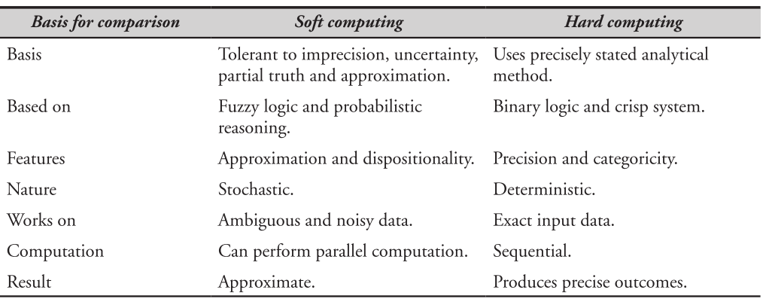

## Q Explain in Detail Soft computing versus Hard computing

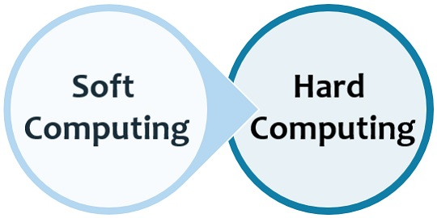 Soft computing and hard computing are computing methods where hard computing is the conventional methodology relies on the principles of accuracy, certainty, and inflexibility.Conversely, soft computing may be a trendy approach premised on the concept of theapproximation, uncertainty, and flexibility.

Before perceiving soft computing and arduous computing we should alwaysunderstand, what is computing?

The computing in terms of engineering is that the method of accomplishing the actual task with the assistance of a laptop or a electronic computer.

There squaremeasure many characteristics of the computing am passionate about itoughtto give precise answer, correct and clear management actions, facilitate the answer of the issues which will be solved mathematically.The traditional computing technique, hard computing is suitable for mathematical problems, although it might be used to solve real-world problems, but the major associated demerit is that it consumes alarge amount of computation time and cost.This is the rationale the soft computing is that the higher various for determinationthe important world issues.

Comparison chart

|  |  |  |
| --- | --- | --- |
| Basis for comparison | Soft computing | Hard computing |
| Basis | Tolerant to imprecision, uncertainty, partial truth and approximation. | Uses precisely stated analytical method |
| Based on | Fuzzy logic and probabilistic reasoning | Binary logic and crisp system |
| Features | Approximation and dispositionality | Precision and categoricity |
| Nature | Stochastic | Deterministic |
| Works on | Ambiguous and noisy data | Exact input data |
| Computation | Can perform parallel computation | Sequential |
| Result | Approximate | Produces precise outcomes |

Definition of soft computing

Soft computing is a computing model evolved to solve the non-linear problems which involve uncertain, imprecise and approximate solutions of a problem.

These forms of issues area unit thought of as real-life issues wherever the human-like intelligence is needed to resolve it.

The soft computing term is coined by Dr Lotfi Zadeh, consistent with him, soft computing is AN approach that imitates the human mind to reason and learns in an

environment of uncertainty and impression.

It is created through 2 components adaptivity and information and encompasses aset of tools like mathematical logic, neural networks, genetic algorithm, etcetera.

The soft computing model is distinct from its antecedent model called exhaustingcomputing model as a result of it doesn't work on the mathematical model of problem-solving.

Definition of hard computing

Hard computing is that the ancient approach utilized in computing that wantsAssociate in Nursing accurately declared analytical model.It was additionally planned by Dr Lotfi Zadeh before soft computing.Hard computing approach produces a secure, settled, correct result and defines definite management actions employing a mathematical model or rule.It deals with binary and crisp logic that need the precise input file consecutive.However, arduous computing isn't capable of resolution the $64000 world issueswhose behaviour is extraordinarily general and wherever the knowledge changes systematically.

Key difference between soft computing and hard computing

1. The soft computing model is inexactness tolerant, partial truth, approximation.On the opposite hand, laborious computing doesn't work on the above-given principles; it's terribly correct and bound.
2. Soft computing employs fuzzy logic and probabilistic reasoning whereaslaborious computing is predicated on binary or crisp systems.
3. Hard computing has options like exactitude and categoricity.As against, approximation and dispositionality are the characteristics of sentimentalcomputing.
4. Soft computing approach is probabilistic in nature whereas laborious computing is settled.
5. Soft computing will be simply operated on the clattering and ambiguous knowledge.In distinction, laborious computing will work solely on actual computer file.
6. Parallel computations can be performed in soft computing.On the contrary, in laborious computing consecutive computation is performed on the information.
7. Soft computing will turn out approximate results whereas laborious computing generates precise results.

## Q Explain Genetic Algorithm

Genetic algorithms are parts of artificial intelligence and fuzzy computing and they are mainly used to solve  
various optimization problems encountered in real-life applications.

The basic plan of a genetic algorithmic program is to

mimic the choice|survival|survival of the fittest|selection|naturalprocess|naturalaction|action|activity} in nature so as to seek out a decent selection for ANapplication.

Genetic algorithm is

basically a model of machine learning impressed by the method of evolution in nature.

A genetic algorithm can be

used for locating solutions complicated search issues found in engineering applications.

For example they can search, through various designs and components to find the best combination that will result in overall better and cheaper design.

Genetic algorithms are used in many diverse fields nowadays, such as climatology, biomedical engineering,code-breaking, control engineering, games theory, electronic design, and automated manufacturing and design.

The basic processes in genetic algorithms are:

* Initialization, where an initial population is created randomly.
* Evaluation, where each member of the population is evaluated and the fitness of the individuals are assessedbased on however well they match the required needs.
* Selection, where only the ones that fit the desired requirements are selected.
* Crossover, where new individual are created by combining best aspects of the existing individuals. At the end ofthis it's expected to make people that square measure nearer to the required needs.The process is recurrent from the second step till a termination condition is finally reached.

## Q Explain in details Fuzzy Controllers

Adaptive fuzzy controller is meant with some adjustable parameters beside associate degree embedded mechanism for adjusting them. Adaptive controller has been used for the performance of controller.

1. Basic Steps for Implementing Adaptive Algorithm

Currently, let us discuss the fundamental steps for implementing adaptational algorithmic program.

1. Collection of observable data: The observable data is collected to calculate the performance of controller.

2. Adjustment of controller parameters: Currently with the assistance of controller performance, calculation

of adjustment of controller parameters would be done.

3. Improvement in performance of controller: During this step, the controller parameters are adjusted to improve the performance of controller.

1. Operational Concepts

Design of a controller is based on an assumed mathematical model that resembles a real system. The error

between actual system and its mathematical representation is calculated and if it is relatively insignificant the

model is then assumed to work effectively.

A threshold constant that sets a boundary for the effectiveness of a controller, also exists. The management

input is fed into each $64000 system and mathematical model. Here, assume x(t) is the output of the

real system and y(t) is the output of the mathematical model. Then the error ϵ(t) can be calculated as follows −  
ϵ(t)=x(t)−y(t)  
Here, x desired is the output we want from the system and μ(t) is the output coming from controller and going to both real as well as mathematical model.

The following diagram shows however the error operate is half-track between output of a true system and Mathematical model −

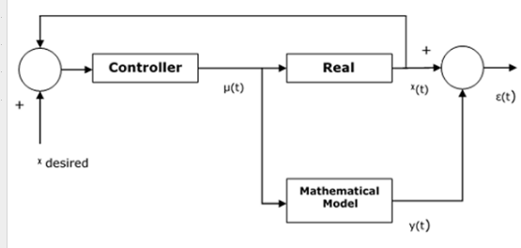

## Q Difference between Fuzzification and Defuzzification

1. Fuzzification It may be outlined because the method of remodeling a crisp set to a fuzzy set or a fuzzy set to fuzzier set.

Basically, this operation interprets correct crisp input values into linguistic variables.

Following square measure the 2 vital ways of fuzzification −

Support Fuzzification(s-fuzzification) Method

In this methodology, the fuzzified set will be expressed with the assistance of the subsequent relation −

$\tilde{A}$ = $μ_{1}Q(x_{1})$ + $μ_{2}Q(x_{2})$ +…..+ $μ_{n}Q(x_{n})$

Here the fuzzy set Q(xi)is called as kernel of fuzzification. This method is implemented by keeping μi constant and xi being transformed to a fuzzy set Q(xi)Q(xi).

Grade fuzzification method

It is quite similar to the above method but the main difference is that it kept xi constant and μi is expressed as a fuzzy set.

1. Defuzzification

It may be outlined because the method of reducing a fuzzy set into a crisp set or to convert a fuzzy member into a crisp member.

We have already studied that the fuzzification method involves conversion from crisp quantities to fuzzy quantities.

In a variety of engineering applications, it's necessary to defuzzify the result or rather “fuzzy result” so it should be regenerate to crisp result.

Mathematically, the method of Defuzzification is additionally known as “rounding it off”.

The different strategies of Defuzzification ar represented below −

Max-Membership Method

This technique is restricted to peak output functions and conjointly called height technique.

Mathematically it can be represented as follows –

Max-mean membership method

This method is limited to peak output functions and also known as height method. Mathematically it can be represented as follows –

$μ_{\tilde{A}}\left(x^{*}\right)>μ_{\tilde{A}}(x)$ for all x $∈$ X

Here, x* is the defuzzified output.

Centroid method

This method is also known as the center of area or the center of gravity method. Mathematically, the defuzzified output x* will be represented as −

X*  = $\frac{\int{μ_{\tilde{A}}\left(x\right) . xdx}}{\int{μ_{\tilde{A}}\left(x\right) . dx}}$

Weighted average method

In this method, each membership function is weighted by its maximum membership value. Mathematically, the defuzzified output x* will be represented as −

X*  = $\frac{\sum{μ_{\tilde{A}}\left(\overline{x_{i}}\right). \overline{x_{i}}}}{\sum{μ_{\tilde{A}}\left(\overline{x_{i}}\right)}}$

Mean-max method

This method is also known as the middle of the maxima. Mathematically, the defuzzified output x* will be represented as −

X* = $\frac{\sum_{i=0}^{n}{\overline{x_{i}}}}{n}$

## Q Describe Fuzzy Inference System

Fuzzy Inference System is the key unit of a fuzzy logic system having decision making as its primary work. It uses the “IF…THEN” rules along with connectors “OR” or “AND” for drawing essential decision rules.

Characteristic of fuzzy inference system

Following are some characteristics:

* The output from FIS is always a fuzzy set irrespective of its input which can be fuzzy or crisp.
* It is necessary to own fuzzy output once it's used as a controller.
* A defuzzification unit would be there with FIS to convert fuzzy variables into crisp variables.

Function block of FIS

The following five functional blocks will help you understand the construction of FIS −

* Rule Base − It contains fuzzy IF-THEN rules.
* Database − It defines the membership functions of fuzzy sets used in fuzzy rules.
* Decision-making Unit − It performs operation on rules.
* Fuzzification Interface Unit − It converts the crisp quantities into fuzzy quantities.
* Defuzzification Interface Unit − It converts the fuzzy quantities into crisp quantities. Following is a block diagram of fuzzy interference system.

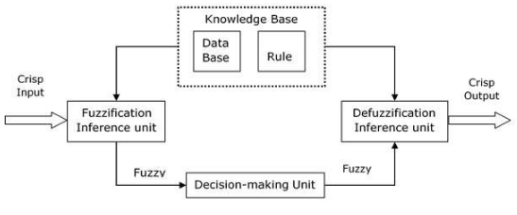

Working of FIS

The working of FIS consist of following steps:

* A fuzzification unit supports the appliance of various fuzzification strategies, and converts the crisp input into fuzzy input.
* A mental object - assortment of rule base and information is made upon the conversion of crisp input into fuzzy input.
* The defuzzification unit fuzzy input is finally reborn into crisp output.

## Q State the difference between Fuzzy set & crisp set

Fuzzy set and crisp set are the part of the distinct set theories, where the fuzzy set implements infinitevalued logic while crisp set employs bivalued logic. Previously, professional system principles were developed premised on the mathematical logic wherever crisp sets area unit is used. But then scientists argued that human thinking does not perpetually follow crisp “Yes”/”No” logic, and

it may be well-obscure, qualitative, uncertain, general or fuzzy in nature. This gave commencement to the

development of the fuzzy set theory to imitate human thinking.

For an element in a universe comprising fuzzy sets can have a progressive transition among several degrees of membership. Whereas in the crisp sets the transition for an element in the universe between membership and nonmembership in a given set is sudden and well-defined.

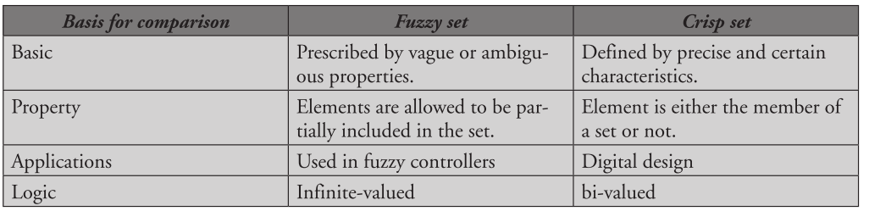

Key Difference

1. A fuzzy set is determined by its indeterminate boundaries, there exists an uncertainty about the set boundaries. On the other hand, a crisp set is defined by the crisp boundaries, and contain the precise location of the set boundaries.

2. Fuzzy set elements are permitted to be accommodated partly by the set (exhibiting gradual membership degrees). Conversely, crisp set elements can have a total membership or nonmembership.

3. There are several applications of the crisp and fuzzy set theory, but both are driven towards the development of the efficient expert systems.

4. The fuzzy set follows the infinite-valued logic whereas a crisp set is based on bi-valued logic

# MCQs & answers

**1.** Fuzzy logic is a form of

(a) Two-valued logic

(b) Crisp set logic

(c) Many-valued logic

(d) Binary set logic

**2.** Traditional set theory is also known as Crisp set theory.

(a) True

(b) False

**3.** The room temperature is hot. Here, the hot (use of linguistic variable is used) can be represented by _______.

(a) Fuzzy set

(b) Crisp set

(c) Fuzzy and crisp set

(d) None of the above

**4.** The values of the set membership is represented by

(a) Discrete set

(b) Degree of truth

(c) Probabilities

(d) Both degree of truth and probabilities

**5.** Fuzzy set theory defines fuzzy operators. Choose the fuzzy operators from the following.

(a) AND

(b) OR

(c) NOT

(d) All of the above

**6.** There are also other operators, more linguistic in nature, called __________ that can be applied to fuzzy set theory.

(a) Hedges

(b) Lingual variable

(c) Fuzz variable

(d) None of the above

**7.** Fuzzy logic is usually represented as___________.

(a) IF–THEN–ELSE rules

(b) IF–THEN rules

(c) Both IF–THEN–ELSE rules and IF– THEN rules

(d) None of the above

8. Core of soft Computing is

(a) Fuzzy Computing, Neural Computing, Genetic Algorithms

(b) Fuzzy Networks and Artificial Intelligence

(c) Artificial Intelligence and Neural Science

(d) Neural Science and Genetic Science

9. Who initiated the idea of Soft Computing

(a) Charles Darwin

(b) Lofti A Zadeh

(c) Rechenberg

(d) Mc_Culloch

10. Fuzzy Computing

(a) mimics human behaviour

(b) doesn’t deal with 2 valued logic

(c) deals with information which is vague, imprecise, uncertain, ambiguous, inexact, or probabilistic

(d) All of the above

**Answers**

**1. (c) 2. (a) 3. (a) 4. (b) 5. (b) 8. (a) 9. (b) 10. (d)**