**Chapter 8**

Knowledge and Reasoning

**The chapter consist of Short type Questions & Answers , Descriptive Question & Answer and MCQs & answers**

Contents

Short type Questions & Answers 2

1. What are the standard quantifiers of First Order Logic? 2

2. Define Universal Quantifier with an example 2

3. Define Existential Quantifier with an example. 3

6. What is the use of equality symbol? 4

7. Define Higher Order Logic. 4

8. Define First Order Logic. 4

9. What is called declarative approach 5

10. State the aspects of a knowledge representation language. 5

11. What is called entailment? 6

12. What is meant by tuple? 6

13. What is Propositional Logic? 6

14. What is compositionality in propositional logic? 7

15. Define Symbols. 7

16. Define ground term, Inference. 7

17. Define Datalog. 8

18. What is Pattern Matching? 8

19. What is Data complexity? 9

20. Define Prolog. 9

21. What are the principal sources of Parallelism? 9

22. Define conjunctive normal form. 10

23. Define Skolemization. 11

24. What is the other way to deal with equality? 11

25.            Define the ontology of situation calculus 11

Descriptive Question & Answer 12

q explain types of knowledge. 12

MCQs & answers 18

# Short type Questions & Answers

## 1. What are the standard quantifiers of First Order Logic?

The First Order Logic contains two standard ~~q~~uantifiers.

They are:

i)                                           Universal Quantifiers

ii)                                        Existential Quantifiers

2. Define Universal Quantifier with an example**.**

To represent “All elephants are mammal” “Raj is an elephant” is represented by Elephant (Raj) and “Raj is a mammal”. The first order logic is given by

https://www.brainkart.com/media/extra/6CE7c1I.jpg

**Elephant (Raj) => Mammal (Raj)**

**Elephant (John) => Mammal (John)**

Thus it is true if and only if, all the above sentences are true that is if p is true for all objects x in the universe. Hence, is called universal quantifier.

## 3. Define Existential Quantifier with an example.

Universal quantification makes statements about every object. Similarly, We can make statement about some object in the universe without naming it, by using an existential quantifier.

To say, for example, that king john has a crown on his head, we write

https://www.brainkart.com/media/extra/EGRs0OC.jpg

x is pronounced “There exists an x such that…..” or “For some x…”

The sentence says that P is true for at least one object x. Hence, is called existential quantifier.

## 

## 6. What is the use of equality symbol?

The equality symbol is used to make the statements more effective that two terms refer to the same object.

**Eg: Father (John) = Henry**

## 7. Define Higher Order Logic.

The Higher Order Logic allows quantifying over relations and functions as well as over objects.

**Eg:**The two objects are equal if and only if, all the properties to them areequivalent.

https://www.brainkart.com/media/extra/DA5pS1e.jpg

## 8. Define First Order Logic.

First Order Logic, a representation language that is far more powerful than propositional logic. First Order Logic commits to the existence of objects and relations.

**Eg: One plus two equals three**

**Objects**                **- one, two & three**

**Relations - equals**

**Functions - plus**

9. What is called declarative approach**?**

The representation language makes it easy to express the knowledge in the form of sentences. This simplifies the construction problem enormously. This is called as declarative approach.

## 10. State the aspects of a knowledge representation language.

A knowledge representation language is defined in two aspects:

**i) Syntax:**The syntax of a language describes the possible configurationthat can constitute sentences.

**ii) Semantics:**It determines the facts in the world to which the sentences refer.

## 11. What is called entailment?

The generations of new sentences that are necessarily true given the old sentences are true. This relation between sentences is called **entailment.**

## 12. What is meant by tuple?

A tuple is a collection of objects arranged in a fixed order and is written with angle brackets surrounding the objects.

**{< Richard the Lionheart, King John>, <King John, Richard the Lion heart>}**

## 13. What is Propositional Logic?

Propositional Logic is a declarative language because its semantics is based on a truth relation between sentences and possible worlds. It also has sufficient expressive power to deal with partial information, using disjunction and negation.

## 14. What is compositionality in propositional logic?

Propositional Logic has a third property that is desirable in representation

languages, namely compositionality. In a compositionality language, **the meaning of** **sentences is a function of the meaning of its parts**. For example, “S1 ^ S2” is related tothe meanings of “S1 and S2”.

## 15. Define Symbols.

The basic syntactic elements of first order logic are the symbols that stand for objects, relations and functions. The symbols are in three kinds. Constant symbols which stand for objects, Predicate symbols which stand for relations and Function symbol which stand for functions.

## 16. Define ground term, Inference.

The term without variables is called **ground term.**

The task of deriving the new sentence from the old is called **Inference.**

## 17. Define Datalog.

The set of first order definite clauses with no function symbols is called

**datalog.**

**Eg: “The country Nono, an enemy of America”**

**Enemy(Nono, America)**

The absence of function symbols makes inference much easier.

## 18. What is Pattern Matching?

The “inner loop” of the algorithm involves finding all possible unifiers such that the premise of a rule unifies with a suitable set of facts in the knowledge base. This is called Pattern Matching.

## 19. What is Data complexity?

The complexity of inference as a function of the number of ground facts in the database is called data complexity.

## 20. Define Prolog.

Prolog programs are sets of definite clauses written in a notation somewhat different from standard first-order logic.

## 21. What are the principal sources of Parallelism?

The first called **OR-Parallelism** comes from the possibility of a goal unifying with many different clauses in the knowledge base. Each gives rise to an independent branch in the search space that can lead to a potential solution and branches can be solved in parallel.

The second called **AND-Parallelism** comes from the possibility of solving each conjunct in the body of an implication in parallel.

## 22. Define conjunctive normal form.

First Order resolution requires that sentences be in conjunctive normal form that is, a conjunction of clauses, where each clause is a disjunction of literals. Literals can contain variables, which are assumed to universally quantified.

For ex, the sentence

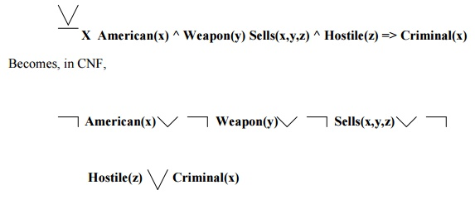

## 23. Define Skolemization.

**Skolemization**is the process of removing existential quantifiers by elimination.

## 24. What is the other way to deal with equality?

Another way to deal with an additional inference rule is

•                                                                    Demodulation

•                                                                    Para modulation

▪

▪

25.            Define the ontology of situation calculus**.**

Situations, which denote the states resulting from executing actions. This approach is called Situation Calculus.

•                                            **Situations**are logical terms consisting of the initial situation and allsituations that are generated by applying an action to a situation.

▪

•                                            **Fluent**are functions and predicates that vary from one situation to the next,such as the location of the agent.

▪

•                                            **Atemporal**or**eternal**predicates and functions are also allowed.

# Descriptive Question & Answer

## q explain types of knowledge.

The categorisation of knowledge is very much large and interesting. They can be of following types:

**Declarative knowledge**

It is the passive knowledge expressed as statements of facts about the world. It gives the simple facts and ideas about any phenomenon. It means just the representation of facts or assertions. This tells the total description about the situation. For example, the facts about an organization may be its buildings, location, no. of departments, no. of employees etc. The facts may be of two types i.e. static and dynamic. The static facts do not change with time where as the dynamic facts change with time. For example, the name and location of an organization is permanent. But some additional departments may be added.

**Procedural knowledge**

Procedural knowledge is the compiled knowledge related to the performance of some task. For example the steps used to solve an algebric equation can be expressed as procedural knowledge. It also eradicates the limitations of declarative knowledge i.e. declarative knowledge tells about the organization but it cannot tell how the employees are working in that organization and how the products are developed. But procedural knowledge describes everything about the organization by using production rules and dynamic attributes.

For example, If: All the employees are very hardworking

They are very punctual

They have productive ideas.

Then: Large no. of products can be produced within a very limited time period.

The advantages of using procedural knowledge are as follows:

1)    Domain specific knowledge can be easily represented.

2)    Extended logical inferences, such as default reasoning facilitated.

3) Side effects of actions may be modeled. Some disadvantages of procedural knowledge are

1)    Completeness:  In procedural knowledge not all cases may be represented.

2)    Consistency:Not all deductions may be correct.

3) Modularity: Changes in knowledge base might have far-reaching effects.

**Inheritable knowledge**

There are many situations in the world, where the object of an event inherits some properties of that particular event or any other event.

For example, consider a college. A college has certain features like classrooms, teachers, play ground, furniture, students etc. Besides these, there will be some general concepts regarding the functioning of the college, like it will have time table for each class, a fee deposit plan, examination pattern, course module etc. It can have many more deep concepts like placement of students etc. Now, if we say “A is a Colleg e”, then A will automatically inherits all the features of the college. It may be possible that X has some additional features. The inheritable knowledge is diagrammatically represented below. Here, the relationship **‘has’**indicates the silent features or attributes and **‘is a’** represents the variable or instance of that type. A inherits all the properties of college and has one additional feature of having male students. In this type of knowledge, data must be organized into a hierarchy of classes. The arrows represent the point from object to its value in the diagram. Boxed nodes represent the objects and values of attributes of objects.

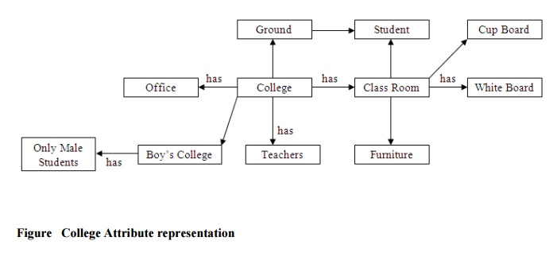

**Relational Knowledge**

Relational knowledge is made up of objects consisting of attributes and corresponding associated values. In this type of knowledge, the facts are represented as set of relations in a tabular form. The table stores or captures all the hidden attributes of objects.

For example the knowledge about doctors may be as mentioned in figure .

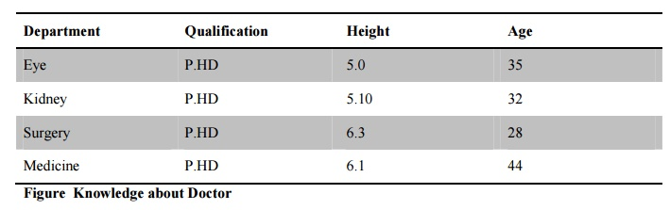

**Figure Knowledge about Doctor**

This form of representation is the simplest and can be used in database systems. But this representation cannot store any semantic, information. For example, from this information we cannot answer the questions like “What is the name of the doctor”? or “How many doctors are in eye department”?

**Inferential Knowledge**

The knowledge, which can use inference mechanism to use this knowledge is called inferential knowledge. The inheritance property is a very powerful form of inferential knowledge. The inference procedures implement the standard logic rules of inference. There are two types of inference procedures like forward inference and backward inference. Forward inference moves from start state to goal state whereas backward inference moves from goal state to start state. In this type of knowledge several symbols are generally used like  (universal quantifier), (existential quantifier),  (arrow indicator) etc.

For example: All cats have tails

 X: cat (x)  has tail (x)

**Advantages:**

1)                A set of strict rules are defined which can be used to derive more facts.

2)                Truths of new statements can be verified.

3)                It gives guarantee about the correctness.

4)                Many inference procedures available to implement standard rules of logic.

**Heuristic Knowledge**

This type of knowledge is fully experimental. This knowledge requires some judgments about any performance. One can guess a good thing and also one can think bad thing. But good performances are generally taken in heuristic knowledge. For example, suppose it is asked that “Ram will score how much percentage in his final semester?” Then the answer might be 80%, 70%, 30% or 95%. The individual answers of this question based on the heuristic knowledge. The answer would be based on various factors such as past performance, his talent etc. If his previous semester percentage was 78%, then if one will say he will secure 10% in this semester then obviously he has not any knowledge about Ram.

**Tacit Knowledge**

This kind of knowledge is acquired by experience. Tacit knowledge is subconsciously understood and applied, difficult to articulate and formalize. This type of knowledge is developed from direct experience and action. This knowledge is usually shared through highly interactive conversation, story telling and experience. It also includes cognitive skills such as intuition as well as technical skills such as craft and know-how. Tacit knowledge cannot be transmitted before it is converted into words, models or numbers that can be understood. Tacit knowledge can be defined in two dimensions, such as technical dimension and cognitive dimension. In technical dimension highly subjective and personal insights, intuitions and inspirations derived from long experience. The dimensions such as beliefs, ideals, principles, values and emotions fall in the category of cognitive dimension.

**Explicit Knowledge**

This knowledge is formalized, coded in several natural languages (English, Italian and Spanish) or artificial languages (UML, Mathematics etc). This knowledge can be easily transmitted. It includes theoretical approaches, problem solving, manuals and database. As explicit knowledge, it was the first to be or, at least, to be archived. Tacit and explicit knowledge are not totally separate, but mutually complementary entities. Without any experience, we cannot truly understand. Explicit knowledge is playing an increasingly large role in organization and it is considered by some to be the most important factor of production in the knowledge economy. Imagine an organization without procedure manuals product literature or computer software. Also with explicit knowledge, some tacit knowledge is required to run the business in an organization. Without explicit knowledge, the organization is simply has a zero performance.

**Research Knowledge**

There are many standards for the generation and critical appraisal of research knowledge, but judging the quality of knowledge in this source is not without difficulty. There are disputes about the nature and content of standards in areas such as qualitative research, and the implementation of standards is sometimes weak so that conformity with them is not necessarily a guarantee of quality. This type of knowledge is very useful for researchers to improve the research quality.

# MCQs & answers

**1.** Treatment chosen by a doctor for a patient’s disease is based on

(a) Only current symptoms

(b) Current symptoms plus some knowledge from the textbooks

(c) Current symptoms plus some knowledge from the textbooks plus experience

(d) All of the above

**2.** A knowledge-based agent can combine general knowledge with current percepts to infer hidden aspects of the current state prior to selecting actions. State whether it is true or false.

(a) True

(b) False

**3.** (A) Knowledge base (KB) consists of set of statements. (B) Inference is deriving a new sentence from the KB. Choose the correct option.

(a) Both A and B are true

(b) Both A and B are false

(c) A is true, B is false

(d) A is false, B is true

**4.** Wumpus world is a classic problem and the best example of _______

(a) Single-player game

(b) Two-player game

(c) Reasoning with knowledge

(d) Knowledge-based game

**5.** “*a* |= *b*” (to mean that the sentence *a* entails the sentence *b* ), if and only if, in every model in which *a* is _____ and *b* is also _____

(a) True, true

(b) True, false

(c) False, true

(d) False, false

**6.** Which is not a property of representation of knowledge?

(a) Representational verification

(b) Representational adequacy

(c) Inferential adequacy

(d) Inferential efficiency

7. Which is also called single inference rule?

(a) Reference

(b) Resolution

(c) Reform

(d) None of the mentioned

8. What can be viewed as a single literal of disjunction?

(a) Multiple clause

(b) Combine clause

(c) Unit clause

(d) None of the mentioned

**Answers**

**1. (c) 2. (a) 3. (a) 4. (c) 5. (a) 6. (a) 7. (b) 8. (c)**