Experiment No: | 02
Aim: | Tutorial Compile and run Haskell Program.
Lab Objective: | Design and implement declarative programs in functional and logic programming languages.
Lab Outcomes: | Design and Develop solution based on declarative programming paradigm using functional and logic programming (LO2)
Requirements: | Any Text Editor and Glasgow Haskell Compiler 8.0+ Version
Theory: | Haskell is a purely functional programming language. We can trace roots of Functional Programming concepts in Lambda Calculus theory proposed by mathematician Alonzo Church in 1930s. Lambda Calculus (also written as λ – calculus) is formal system in Mathematical Logic for expressing computation on the basis of function abstraction and function application using variable binding and substitution.  The λ calculus is universal in the sense that any computable function can be expressed and evaluated using this formalism. It is thus equivalent to Turing machines. However, the λ calculus emphasizes the use of transformation rules and does not care about the actual machine implementing them. It is an approach more related to software than to hardware.  The central concept in λ calculus is the “expression”. A “name”, also called a  “variable”, is an identifier which, for our purposes, can be any of the letters a, b, c, . . .  An expression is defined recursively as follows:  <expression> := <name> | <function> | <application>  <function> := λ <name>.<expression>  <application> := <expression><expression>  An expression can be surrounded with parenthesis for clarity, that is, if E is an  expression, (E) is the same expression. The only keywords used in the language are λ and the dot. In order to avoid cluttering expressions with parenthesis, we adopt the convention that function application associates from the left, that is, the expression E₁ E₂ E₃ . . . E_{n} is evaluated applying the expressions as follows:  (. . . ((E1 E2 )E3 ) . . . En )  As can be seen from the definition of λ expressions given above, a single identifier is a λ expression. An example of a function is λx.x This expression defines the identity function. The name after the λ is the identifier of the argument of this function. The expression after the point (in this case a single  x) is called the “body” of the definition. Functions can be applied to expressions. An example of an application is (λx.x)y this is the identity function applied to y.  Parenthesis are used for clarity in order to avoid ambiguity. Function applications are evaluated by substituting the value of the argument x (in this case with y) in the body of the function definition, i.e. (λx.x)y = [y/x]x = y  In this transformation the notation [y/x] is used to indicate that all occurrences of x are substituted by y in the expression to the right. The names of the arguments in function definitions do not carry any meaning by themselves. They are just “place holders”, that is, they are used to indicate how to rearrange the arguments of the function when it is evaluated. We use the symbol “≡” to indicate that when A ≡ B, A is just a synonym of B.  To summarize
Performance: | [Note: While writing the write up student need to change the wording such that it coveys that students have done all following steps. Also where ever output is generated the output must be written by the student ]  Students need to perform following steps to complete this Experiment:  - Understand how to create Haskell code with main function and run it in ghci  - Understand how to compile and execute haskell code having main using ghc compiler  - Understand more standard Prelude functions  Create a file named : sum.hs using your favorite editor having following code  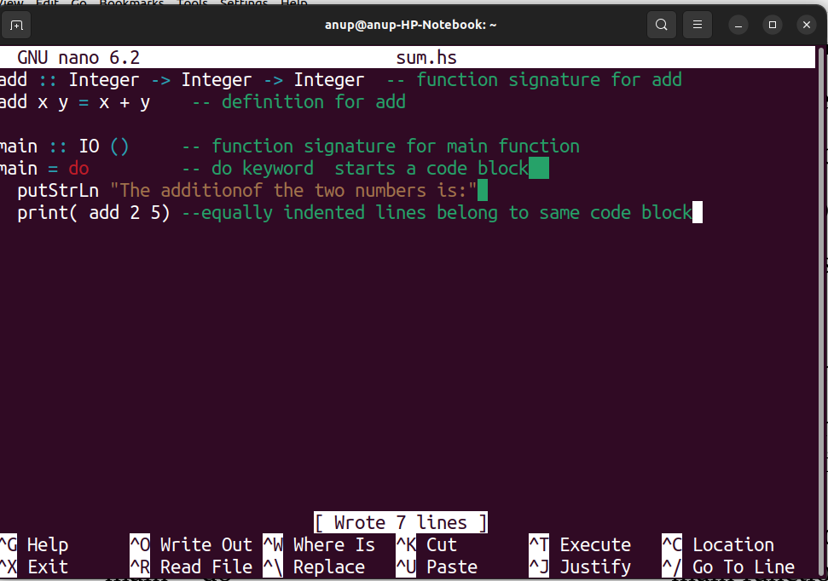  Part 1. Running sum.hs in ghci  - Open ghci and set the editor to nano using command  Prelude> :set editor nano <enter>  - Open file sum.hs for editing and type above code in nano editor, save the buffer using CTRL+O and exit the editor.  - To load the file use command  Prelude> :load sum.hs<enter>  - If successfully compiled just run main code block using command  *Main> main<enter>  - Note the output.  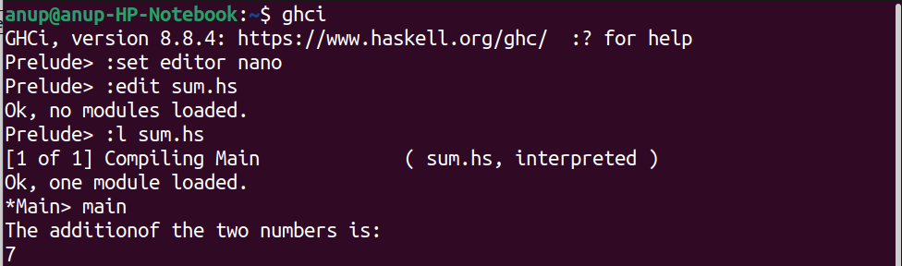  Part 2. Compile and execute sum.hs using ghc compiler  - Consider you have already above code in sum.hs file  - Open terminal and go do folder that has file sum.hs  - To compile sum.hs to sum binary executable type  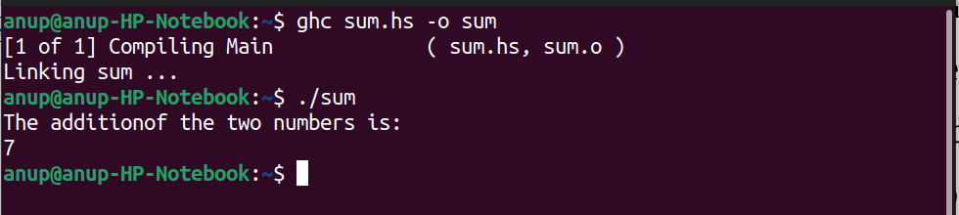  $ ghc sum.hs -o sum <enter>  - To exucute code sum type commands  $./sum<enter>  Part 3. Understand use of standard Prelude functions  Execute following Haskell prelude library functions in ghci and note the output create a table having four columns name of function, use, output and explanation. [Write this on unruled pages]  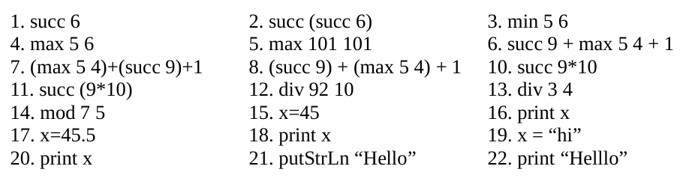
Exersize: | Write following codes and run it using ghci or ghc:  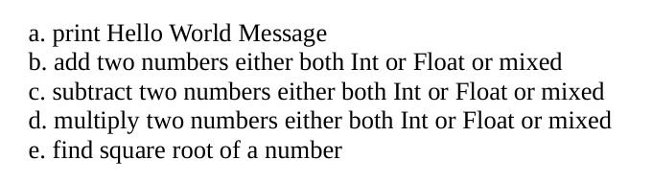
Conclusion: | Thus we have learned how to compile and run Haskell code using ghci and ghc.
Reference: | - Glasgow Haskell Project Home Page. https://www.haskell.org/  - Learn You a Haskell for Great Good ! A Beginner's Guide http://learnyouahaskell.com/  - Michael L Scott, ‘Programming Language Pragmatics’, 3rd Edition, Elsevier Publication.  - Introduction to Lambda Calculus,

