Experiment No: | 07
Aim: | To learn prolog programming through an online prolog environment.
Lab Objective: | Design and implement declarative programs in functional and logic programming languages.
Lab Outcomes: | Design and Develop solution based on declarative programming paradigm using functional and logic programming (LO2)
Requirements: | swish online prolog environment
Theory: | Describe components of SWISH online prolog environment.
Performance: | Students are made familiar with the online prolog environment available named swish-prolog. Students are shown how to access example prolog KBs in examples interface and asked to perform following steps on 4 of the example knowledge bases.  - Enlist all distinct predicates with mentioning their arity and meaning  - Form 5 distinct Queries and write down output for all of them after executing them in swish-prolog.  - Explain how does SWI Prolog find the query result for each of five queries fired in earlier step  KBs chosen are shown in below image : Knowledge bases, Lists, Movie Database, N-Queens ( Traditional)  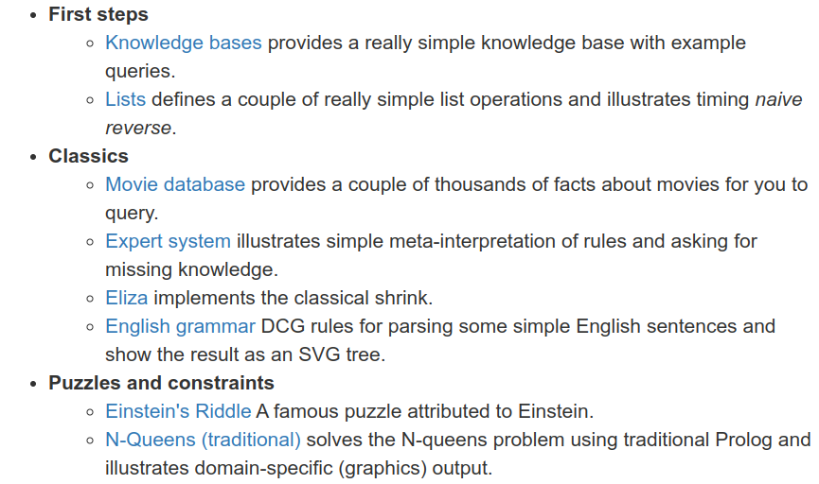
Conclusion: | Thus we have learned prolog programming through an online prolog environment.
Reference: | - swi-prolog getting started online tutorial, https://www.swi-prolog.org/pldoc/man?section=quickstart, 01 Jan 2023.  - Wikipedia Article: Prolog, https://en.wikipedia.org/wiki/Prolog, 01 Jan 2023.

