RFBitBanger Manual
by Daniel Marks, KW4TI

2023-Oct-15, document version 0.7
NOTE: If you intend to be able to use the RFBitBanger without a computer available to view this document, print out these instructions and keep them with your radio.
Make a note of the calibrated crystal frequencies here in case the nonvolatile memory of the radio is corrupted. This can be found in the “Xtal Freq” under the “Cfg” menu. This frequency is usually close to 25 MHz.
Radio Serial Number | Crystal Frequency (Hz)

NOTE: The operator of the radio is responsible for compliance with all applicable telecommunications regulations, especially those regarding operating high frequency transmitters. An amateur radio license is generally required to be permitted to transmit with this radio in most countries.

Introduction

The RFBitBanger is a self-contained high frequency long-distance two-way transceiver radio (frequencies 1.8 MHz to 30 MHz). It is designed to be easy to build, easy to maintain, easy to operate, and able to communicate hundreds or thousands of kilometers with low levels of RF power. It can be built without any surface mount parts. It is constructed from the minimum number of specialized parts so that replacement parts can be located more easily. The design of this radio prioritizes robustness and maintainability over efficiency. Parts have been selected on the basis of high availability and low cost when performance is not significantly compromised. The radio has many features included intended to make long-distance contacts easier to conduct.
The RFBitBanger is intended to be self-contained so that only the transceiver itself is needed to communicate alphanumeric messages long distances. The radio specializes in text-based transactions, through CW, RTTY, or a new protocol created for this radio called SCAMP which uses forward error correction to achieve more reliable transmission. It provides keyboard input to make control easier, but the transceiver can be operated from just five buttons. The radio can also be controlled remotely using a sound card, so that FSK modes, for example, FT8 may also be used. Therefore it is hoped that this can be used for ordinary contacts, but also be usable and maintainable should there we widespread supply chain or communications disruptions. This radio receives dual sideband DSB and can transmit voice (phono) upper or lower sideband (USB/LSB) using a frequency tracking/PLL and envelope modulation method.
This radio is intended to be able to be assembled and maintained off the grid without access to parts suppliers. The parts should be sufficiently inexpensive so that many replacement parts can be kept on hand. Where possible, there should be multiple vendors that can provide similarly working parts. For example, the ATMEGA328P is used in the transceiver which is one of the most common microcontrollers available as it is used in the Arduino Uno and Nano, and furthermore Logic Green has a part that is designed to be a near drop-in replacement. The SI5351A is used as a frequency synthesizer, which is readily available in the form of a prototyping board, and there is also a work-alike MS5351 part. LM358 and LM386 are used which are produced by many manufacturers. A diode ring mixer is constructed from 1N4148 diodes which are some of the most commonly available diodes. The 2N7000 is used as an RF MOSFET, which is very similar to the BS170 except for the 2N7000 having a pinout of source-gate-drain, and the BS170 having the opposite pinout drain-gate-source. The MOSFET is the most likely part to be damaged. At the time of this writing 2N7000 transistors can be bought for approximately $0.03 each USD in quantity 100. The HD44780-type displays are probably the most common LCDs available.
The radio is first and foremost intended to be used with low-bandwidth modes such as CW and RTTY. A new protocol called SCAMP was created especially for this radio. SCAMP is designed to be simple enough to be implemented on an 8-bit microcontroller but incorporates features such as forward error correction. It has several modes which can be selected based on desired symbol rate and receiving conditions, and user selectable levels of redundancy which can be increased to compensate for poor receiving conditions. This protocol is both described in a standards document and has an open source implementation included with the RFBitBanger.

Features and specifications
The RFBitBanger has the following features and specifications:
• Supports the high frequency (HF) band between 1.8 and 30 MHz, with the best performance obtained at the 80m, 60m, 40m, 30m, and 20m bands (3.5 to 14.35 MHz).
• Uses a simple direct conversion receiver architecture with demodulation using a double sideband (DSB) balanced ring mixer. This does not require any specialized integrated circuits, only 1N4148 diodes and 2N3904 NPN transistors.
• Achieves 4 W or greater radiated power on the 80 to 20 m bands.
• Supports CW (Morse code) transmission and reception, with a built-in decoder.
• Supports RTTY (radio teletype) transmission and reception.
• Supports a new protocol called SCAMP for teletype-like communication that is narrow bandwidth and uses forward error correction.
• Supports upper sideband (USB) or lower sideband (LSB) voice/phono communication using a frequency tracking/PLL and envelope modulation method.
• Has an external control mode which can be used with the audio card of a PC for FSK data protocols, for example FT8.
• Supports replaceable bandpass modules for each frequency band.
• All functions can be controlled with five buttons, even alphanumeric message entry.
• Supports an external PS/2 keyboard for easier message entry.
• Signal strength bar graph to aid in tuning.
• Has an external speaker for listening to audio and data signals.
• Volume and gain control potentiometers.
• External microphone, line out, and keyer jacks.
• A jumper can be pulled to support full break-in QSK.

Radio Ports

Before operating the transceiver
Check the following before operating the transceiver:
• For the through-hole version of the RFBitBanger, check that the main transceiver PCB and the display PCB are connected using a 40-pin IDC ribbon cable.
• A 12V to 14.6V DC power supply is connected to the barrel jack or screw terminals. The center pin of the barrel jack is positive.
• Connect an antenna for a particular frequency band to the antenna connector. This antenna may operate only on a single band, or may be designed to operate on multiple bands.
• Insert a bandpass module, which has dual 4 pin sockets, onto the dual 4-pin connectors. One of the pin sockets and pins is silkscreened “INP,” and the other of the pin sockets is silkscreened “OUT.” Plug the 4 pin socket on the band module marked “INP” to the 4 pin port on the transceiver marked “INP.” Similarly, plug the 4 pin socket on the band module marked “OUT” to the 4 pin port on the transceiver marked “OUT.” Check to make sure that both are firmly secured and are not offset by a pin.
• Ensure the bandpass module is appropriate to the frequencies being used. Consult the bandpass module table to determine which band module is indicated for each set of frequencies. A white spot on the band module silkscreen is reserved so that a number indicating the identity of the band module can be written on it.
• A PS/2 keyboard may be connected to the mini 6 pin DIN connector if used.
• If operating using a sound card, connect 3.5 mm stereo patch cables, one from the SPEAKER/HEADPHONE output of the transceiver to the microphone input of the sound card, and a second from the MICROPHONE/LINE IN of the transceiver to the line output of the sound card. Jumpers JP6/JP9 on the SMT version and jumpers JP3/JP4 on the RFBitBanger display board should be closed if a microphone input is used, and left open if line-level input is used.
• If using a key, connect it to the keyer jack. If using a push-to-talk (PTT) button, this can be connected to the keyer jack. The “dit” paddle of a keyer or a straight key may be used as the PTT button. The dah paddle should not be pressed when input audio is present.

Bandpass module frequency ranges
Bandpass module / number | Frequencies (Hz)
160 m / “16” | 1800000 – 2000000
80 m / “8” | 3500000 – 4000000
60 m / “6” | 5250000 – 5450000
40 m / “4” | 7000000 – 7300000
30 m / “3” | 10000000 – 10150000
20 m / “2” | 14000000 – 14350000
17 m / “17” | 18068000 – 18168000
15 m / “15” | 21000000 – 21450000
12 m / “12” | 24890000 – 24990000
10 m / “10” | 28000000 – 29700000

Gain, volume, and sensitivity
The RFBitBanger has two potentiometer controls for adjusting reception: gain and volume. The gain control determines the amount of amplification of a demodulated radio frequency before it is decoded by digital processing or amplified for the audio speaker. When adjusting the gain so that a signal can be decoded off of the air, there is a bar graph on the upper right hand corner of the display. Increasing the gain (turning the knob clockwise) increases the magnitude of the signal as shown on the bar graph. It also increases the loudness of the sound in the speaker or headphones. There are four bar positions of the bar graph. The ideal setting of the gain is such that the magnitude of the bar graph barely reaches the fourth bar. If the gain is too high, the noise is overly amplified and reduces the ability of the noise to be distinguished from the signal. If the gain is too low, the signal is insufficient to be decoded. If there is strong interference near the decoded signal, decreasing the gain may help the digital processing reject the interference while keeping enough of the desired signal to decode.
The maximum gain is over 120 dB (amplifying 1 uV to 1 V) to ensure that the sensitivity of the receiver is limited only by the noise in the receiver and not the gain. However, at the highest gain and volume settings, one will notice some microphonic noise, especially with no antenna connected, when buttons are pressed in the speaker as even tiny vibrations of circuit board components are amplified to produce an audible signal. This is normal and generally does not prevent successful decoding of signals.
The volume does not affect the signal being decoded by the digital processing, only the loudness of the sound in the speaker or headphones. Therefore the gain should be adjusted for the most accurate digital processing (signal level in the bar graph), and the volume adjusted for the desired loudness. The loudness control is generally set to a much higher setting for an external speaker than headphones. When connecting the speaker output to a computer line-in, the volume should be set at a low level as to not exceed the limits of the analog-to-digital converter.
The RFBitBanger is a direct conversion receiver with a VFO generated by a fractional phase-locked-loop integrated circuit (SI5351A) or a crystal oscillator. A fractional phase-locked-loop integrated circuit generates many spurious frequencies internally in the process of synthesizing an output frequency. Because of the high sensitivity of the RFBitBanger receiver, and the fact that it is a direct conversion receiver, these frequencies can be detected by the receiver and unfortunately interfere with a desired signal. This is an unfortunate disadvantage of a PLL synthesizer and the simple direct conversion architecture used. These frequencies tend to be confined to 1-10 Hz bandwidths and so can be worked around by tuning the frequency slightly.

Operating the menu system
The user interface consists of an alphanumeric LCD and five buttons, the buttons being up, down, left, right, and enter. The transceiver can be completely controlled using only these give buttons: menus of the transceiver may be navigated, and numbers and messages may be entered using these buttons. If a PS/2 keyboard is connected, the four arrow keys of the PS/2 keyboard act as the left/right/up/down buttons, and the enter key on the keyboard acts as the enter key on the transceiver. Numbers and alphanumeric messages can be entered using the keyboard as well. For example, the frequency may be changed in the “Frq” menu option using either the numeric keys or the arrow keys.
To navigate a menu, the up/down buttons are used, and to select a menu option, the left/right buttons or the enter buttons are pressed.

The radio main menu:
The 2 by 16 LCD display is divided into several areas:
07000000 Frq||||
CQ CQ DE KW4TI
In the main menu, the current frequency is displayed at the upper left. The current menu option is displayed next to it (for example “Frq”), and to the right of that is a signal strength bar indicating the signal strength of the signal being decoded in the current mode.
The bottom line is reserved for decoded text. For example, if “CW” transmission mode is selected, when CW is decoded, the message scrolls across the bottom line of the display.
When entering an alphanumeric message, the top line is replaced by the message being entered.
Pressing the up/down buttons cycles through the various main menu options, with three letters indicating the option being displayed in the top line. An option can be selected by pressing the left or right button, or the enter button.

Changing the frequency
07000000 Frq||||
CQ CQ DE KW4TI
To change the VFO frequency, select the “Frq” option. If the left button is pressed, the cursor is placed on the rightmost (least significant) digit. If the right button or enter button is pressed, the cursor is placed on the leftmost (most significant) digit.
Pressing the up/down button on a digit increments or decrements that digit by one. The frequency is immediately changed, and the demodulated audio can be heard in the speaker.
When tuning the frequency for best reception of a data mode, the signal strength bar can be used. For on-off keying modes, such as CW, the signal strength bar pulses with the transmission. Tune the frequency for the maximum bar length when the signal is received. For frequency-shift keying modes, such as RTTY or SCAMP, tune the signal strength bar so that the bar is as long as possible, and the bar is on constantly. The frequency-shift keying mode consists of two tones, and if the signal strength indicates a strong signal when only one of the two tones occurs, the frequency is only aligned with one of the two tones, and should be changed by a small amount (less than 250 Hz) so that both tones cause the signal strength bar to remain at a high level. For very low data rate modes, often 1 to 10 Hz increment adjustments may be necessary to maximize the signal.
The buttons are used in lieu of a rotary encoder to change frequency as replacements for buttons may be more readily improvised than a replacement rotary encoder.

Scanning for a signal
07000000 ScF||||
CQ CQ DE KW4TI
The RFBitBanger can automatically scan for a signal with high signal strength. The “ScF” option scans for a signal “fast” or with 100 Hz scan increments, while the “ScS” option scans for a signal “slow” with 30 Hz scan increments. Select the “ScF” or “ScS” option with the up/down buttons. Pressing the right button scans with increasing frequency starting at the current frequency, while pressing the left button scans with decreasing frequency starting at the current frequency. Pressing the enter button aborts scanning.
The RFBitBanger will step in a 100 or 30 Hz increments until it finds a high strength signal. It will then back up and scan back over the last 300 Hz of bandwidth with smaller 10 Hz steps to maximize the signal strength. The RFBitBanger stops once it maximizes the signal. If the signal is not found when backing up, three attempts are made are finding the signal, and if this fails, the scanning is resumed to look for a new strong signal.

Selecting a transmission mode
CW TrM||||
CQ CQ DE KW4TI
To select the transmission mode, the “TrM” menu option may be selected. The transmission mode can then be selected using the left and right buttons, with the enter button selecting a transmission mode. As of the time of writing, these are the available modes:
• CW continuous wave (Morse code) with the BFO 667 Hz below the transmitted frequency (USB).
• USB. Upper sideband voice (phono) transmission.
• LSB. Lower sideband voice (phono) transmission.
• RTTY, or radioteletype 45/170, that is 45.45 symbols per second with a 170 Hz separation between mark and space frequencies, with the space frequency 583 Hz above the VFO, and the mark frequency 750 Hz above the VFO.
• RTTYREV, or radioteletype 45/170 on the lower sideband, with the space frequency 750 Hz below the VFO, and the mark frequency 583 Hz below the VFO.
• SCAMPFSK, the standard SCAMP FSK mode. Use this mode by default for SCAMP communications. See the SCAMP protocol description document for more details (26 bits/s).
• SCAMPOOK, the standard SCAMP OOK mode (26 bits/s).
• SCFSKFST the higher symbol rate FSK SCAMP (83 bits/s).
• SCFSKSLW the slow symbol rate FSK SCAMP (14 bits/s).
• SCOOKSLW the slow symbol rate OOK SCAMP (14 bits/s).
• SCFSKVSL the very slow symbol rate FSK SCAMP (7 bits/s).
Generally the slower the symbol rate, the high the signal-to-noise ratio and the lower the communications error rate.
If a new mode is selected, the “Mode Set” message appears briefly.
Because USB/LSB uses audio input rather than key/paddle or text input, transmission is activated differently. Rather than using the “Key” or “Tx” modes, the push-to-talk (PTT) button is pressed, and one speaks into a microphone plugged into the MIC/Line In jack, and the transmitter is automatically keyed. The PTT input is the same as the “dit” paddle/straight key input. One will not receive a band-change warning in this instance. For sufficient amplification of the audio signal, the gain jumpers (JP6/JP9 on SMT board or JP3/JP4 on display board) should be placed on the microphone audio circuit. While one is transmitting, the signal strength bar shows the magnitude of the audio signal. Speak so that it fills the entire range of the bar, but only briefly peaks at the end of the range rather than spending most of its time peaked, so that the audio is not overmodulated.

Reviewing the receive buffer
07000000 Rxv||||
OLD MESSAGE CQCQ
To review the received decoded message buffer, the “Rxv” option may be selected. If the option is selected with the enter or right button, the leftmost edge of the buffer is shown. If the option is selected with the left button, the rightmost edge of the buffer is shown. The left/right buttons may be used to move through the receive buffer to show its entire contents across the bottom line of the display. New decodes are added to the message buffer when received. Press the enter button to leave the review mode.

Transmit message mode
_
CQ CQ DE KW4TI
To enter and transmit a message, select the “Tx” option. If the right or enter button is pressed, the cursor is placed at the left edge of the transmit buffer. If the left button is pressed, the cursor is placed at the right edge of the transmit buffer. Any previous message remains in the transmit buffer until it is deliberately cleared or power is lost. To enter a character, the up and down buttons may be used to scroll through the available characters with which a message may be composed at the current cursor position. The left or right buttons may be used to change the cursor position. If a PS/2 keyboard is present, this may be used to enter a message.
When one has finished composing the message, the enter button can be pressed. The top line then contains transmit options, which may be viewed using the up and down buttons, and selected with the enter button. The options are:
• Return: return to message composition.
• Txmit: transmit the message immediately. As the message is transmitted, the outgoing message is scrolled across the display, with the cursor indicating the current symbol being transmitted. Pressing enter again aborts the transmission.
• Quit: leave the transmit message mode back to the main menu. The contents of the transmit message buffer are preserved.
• Clear: clear the contents of the transmit buffer and re-enter the transmit buffer compose mode, with the cursor at the left edge of the buffer.

Band change warning
If one attempts to transmit at a frequency that does not correspond to an amateur frequency band, the following message is displayed when entering transmit, keying, and external control modes:
13560000 Tx ||||
Unknown band
For example, this is an ISM band frequency (13.56 MHz), which is not a valid amateur radio band frequency, and so the RFBitBanger reminds the operator that this is not a valid frequency.
If one attempts to transmit in a known band, but this band is different than the last band in which the radio transmitted, the following message is displayed:
14074000 Tx ||||
Chg band module
For example, if the last transmission was in the 40 meter band, perhaps 7.074 MHz, and a transmit is attempted in the 20 meter band, at 14.074 MHz, this message is displayed.
When these messages are displayed, the right button may be pressed to proceed, or the left button may be pressed to return to the main menu.
When one attempts to transmit with the radio the first time after powering on, the “Chg band module” message is displayed to remind the operator to check to see if the installed band module is appropriate for the transmit frequency.
The “Band Warn Off” under the configuration “Cfg” may be set to 1 to eliminate this warning. However, having the wrong band module inserted when transmitting may cause damage to the output RF transistors, so it is wise to keep the warning turned on so that one is reminded to change the band module any time the transmit band is changed.

Keying Mode
07000000 Key||||
CQ CQ DE KW4TI
Keying mode may be entered by selecting the “Key” option. “Keying Mode” is briefly displayed when entering this mode. To exit this mode, press the enter button, and “Keying Exit” is briefly displayed. The CW transmission mode is automatically selected when entering the keying mode. In this mode, one can use an external key or the buttons to send CW. Either a straight key may be used, in which case the tip of the connector is the key, or an iambic key is supported, with the tip being the dit and the ring being the dah. The CW WPM should be configured if iambic key is used to control the lengths of the dits, dahs, and interelement pauses. The down button can be used to key the transmitter in straight key mode. The transmitted signal at the shown VFO frequency and the BFO frequency is 667 Hz below the VFO frequency. Incoming CW transmissions are decoded with the built-in CW decoder if these fall within the receive filter centered at the VFO frequency. Outgoing transmissions are also decoded.
If the “CW Practice” option in the configuration “Cfg” menu is set to 1, the transceiver does not transmit when in the keying mode and decodes the keyed input, so that one can practice keying with the built-in radio CW decoder.

External Control Mode
07074000 Ext||||

External control mode may be used to operate the transceiver using a sound card with FSK modes. This would be commonly used for FT8 and other modes of WSJTX. Digital mode software should be configured for VOX rig control as the presence of a tone is used to key the transmitter. Before entering the external control mode, the frequency should be set to the VFO frequency assuming upper sideband modulation (for example 7.074 MHz for FT8 in the 40 m band). Select the external control mode and press the enter button, and the “Ext Mode” message is displayed briefly. Tones received in the microphone input port prompt the transmitter to key up and transmit the tone at an offset from the VFO frequency. The received audio is transmitted through the speaker/headphone jack. The volume and gain should be set at a moderate level so that the software can decode the signal. Pressing the enter button leaves the external control mode, with the message “Ext Exit” being displayed briefly.

Configuration Mode
CW WPM
20
The configuration mode brings up a menu of items that can be changed to customize the radio’s operation and calibrate the crystal frequency. Each item is a number that may be changed by using the left and right buttons to select a digit, up and down buttons to change the digit, and the enter button to accept the change. The options are:
• Quit: return to the main menu.
• Save Conf: save the configuration in EEPROM to be restored on power-up.
• Calib Xtal Src: calibrate the crystal frequency by tuning to an external transmission (see procedure).
• Wide Filters: 0 for narrowband standard filters for CW and RTTY decode, 1 for wide filters.
• Backlight: backlight off (0) or on (1).
• CW WPM: send speed for CW in words per minute.
• SSB Gain: a number from 0-31 indicating the gain of the audio signal.
• SCAMP Resync: how often a resync signal should be sent during a SCAMP transmission. Zero means only send at the beginning of a transmission. A nonzero number indicates a sync to be resent again after the number of frames have been transmitted. More frequent resync transmissions prevents desynchronization at the receiver.
• SCAMP Repeat: how many times each SCAMP frame should be repeated. The default is one, which means each frame should be sent only once, but it can be increased to try and ensure the message gets through.
• RTTY Repeat: how many times letters and figures codes should be repeated. The default is one, but more repeats can help the receiver be more resistant to selecting the wrong character set.
• RIT Shift Freq: The RIT (Receiver Incremental Tuning) frequency is an offset that the receiving frequency should be from the transmitting frequency. Normally this is zero, so that a transmitted and received signal occur at the same frequency. By specifying a nonzero RIT shift frequency, the receive frequency may be above or below the transmit frequency.
• RIT Dir 0+ 1-: This specifies the direction of the frequency shift for RIT. 0 means that the receive frequency is higher than the transmit frequency by the shift frequency, 1 means the receive frequency is lower than the transmit frequency by the shift frequency.
• Sidetone Freq: frequency in Hz that should be sounded over the speaker (not over the transmission) when a dit or dah is transmitted.
• Sidetone On: whether or not a sound should occur over the speaker when a dit or dah is transmitted. 0 is no sidetone, 1 adds sidetone.
• Ext Fast Mode: set to one for a faster but less accurate way to measure external tone frequency in external control mode which is useful for faster FSK modes. Generally set this to zero for WSJTX.
• Ext LSB: directs the external control mode to transmit on the lower side band (=1) rather than the upper side band (=0). Generally leave this zero.
• CW Iambic: Iambic paddle mode (1) or straight key mode (0).
• CW Iambic Type: Iambic mode B (1) or iambic mode A (0).
• Iambic switch: swap the dit and dah paddles (1) or do not swap (0).
• CW Practice: if this equals one, then the radio does not transmit in Keyer mode and decodes the keyed input.
• CW Mark->Spaces: Determine the spaces timing from the marks timing when decoding CW, rather than determining these independently.
• CW Smooth: Smooth the received amplitude envelope when decoding CW, which is helpful when decoding slow CW in heavy noise. It is recommended to use smooth or sticky interval at a given time, but not both.
• CW Sticky Interval: Increase/decrease the amount of time before a change in or mark or space is registered when decoding CW. It is recommended to use smooth or sticky interval at a given time, but not both. A longer sticky interval (6 to 9) is useful for slower CW receive speeds with noisy conditions.
• Band Warn Off: If this equals one, disable band change warnings. If this equals zero, display a band change warning when first transmitting on startup, and also when transmitting on a different band than before.
• Erase on send: erase the outgoing message buffer after sending the message (1), or keep the outgoing message buffer and it must be manually erased (0).
• Xtal Freq: the frequency of the crystal on the SI5351A oscillator. It can be calibrated using a frequency counter by setting the Xtal Freq to 25000000 Hz, setting the VFO frequency to 25000000 Hz, and then measuring the frequency on jumper JP5 with the frequency counter. This frequency can then be entered as the Xtal Freq. If the crystal calibration becomes corrupted, changing the Xtal Freq back to 25000000 Hz can be useful as a default calibration.

Calibrating the crystal oscillator frequency with a source on the air
The crystal in the radio can be calibrated using a broadcasted frequency standard such as WWV at 10 MHz. Here is the procedure for doing so:

1. Turn on the radio and wait 15 minutes or so for the crystal to reach an equilibrium temperature.
2. Set the transmission mode to CW.
3. Set the VFO frequency (in the Frq menu option) to the nominal calibration frequency, for example, for WWV at 10 MHz, set the VFO to 10000000.
4. Tune the VFO frequency down until the signal strength bar indicates a maximum amplitude. One should be able to get the signal strength to vary on a scale of +/- 10 Hz. Make sure the calibration signal is in the upper sideband (the BFO frequency is below the calibration frequency). If one increases the VFO frequency, the beat frequency tone should lower in pitch, and if one decreases the VFO frequency, the beat frequency tone should raise in pitch, if the calibration frequency is above the BFO frequency. If it is reversed, decrease the VFO frequency by approximately 1300 Hz and tune again for maximum amplitude.
5. Once the signal strength bar is maximized in amplitude, enter the “Cfg” menu option and the “Calib Xtal Src.”
6. Use the buttons to enter the actual nominal frequency. The frequency should already be filled in with a value close to the actual nominal frequency. For example, if the broadcasted frequency is 10 MHz, enter 10000000 and press the enter button.
7. The radio performs an adjustment of the crystal frequency. Save the data to EEPROM memory and turn the radio off and on to have the calibration take effect.
8. Select the “Xtal Freq” in the “Cfg” menu. This should show the calibrated crystal frequency.
9. Set the radio to CW mode and tune to the actual nominal frequency. The signal strength should now be peaked at the nominal frequency if the procedure is performed properly.
10. Write this frequency on the front page of this document to save it in case the calibration should be erased from the EEPROM memory.

Using the serial port for external control

The serial port of the ATMEGA328P may be used for various functions. It is set up at 2400 baud, 8 bits, 1 stop bit, no parity. A USB-TTL interface such as a FT232R, FT232H, CP2102, or CH340 serial TTL converter may be used to connect to the RFBitBanger for both control of the transceiver and to flash the firmware. The GND pin of the RFBitBanger should be connected to the GND of the serial TTL converter, the RX of the RFBitBanger should be connected to the TX of the serial TTL converter, and the TX of the RFBitBanger should be connected to the RX of the serial TTL converter. The DTR pin of the RFBitBanger should be connected to the DTR pin of the serial TTL converter ONLY when flashing new firmware onto the RFBitBanger.

It is best used with a “split terminal” program with separate areas for inputting data to be sent to the RFBitBanger serial port, and another area to display data received from the RFBitBanger serial port. The Arduino serial terminal is a split terminal. Another split terminal program is ScriptCommunicator ( https://sourceforge.net/projects/scriptcommunicator/ ) which does not require the full Arduino development environment and is available for Windows, Mac OS X, or Linux.

Any text that is decoded by the RFBitBanger is sent to the serial port so that it might be logged by the terminal software. Menu options can be selected through the serial port by either entering a digit (1-9) for menu options 1 to 9, or (A-Z) for menu options 1 to 26 for menus that have more than 9 options. The “!” (exclamation point) character may be sent to abort from a menu, so that sending the “!” multiple times can abort multiple menus to return to the top-level menu.

By selecting the “Tx” menu option and entering message composition mode, text may be sent through the serial port to fill the transmit buffer, and then by sending the carriage return twice, the message is transmitted. This way the serial terminal may be used to enter messages and receive the decoded text.

The decoded text received is prefixed by “rx:” and the transmitted text prefixed by “tx:” in the receive window so that it shows a transcript of the communication. The received text is word-wrapped to an 80 character terminal.

Constructing a wire antenna

A quarter-wavelength wire antenna can be easily constructed for a particular frequency band. The length of an antenna for a frequency band with a given wavelength is 0.235 to 0.24 times the wavelength, so for example, for the 40 meter band, the antenna length would be 9.4 to 9.6 m. If more objects are closer to the antenna, or the antenna element is closer to the ground, the antenna length tends to be shorter. In feet, the antenna length is 0.75 to 0.79 times the band wavelength in meters, so for example, for the 40 meter band, the antenna length is 30 to 31.6 feet long. If you are unsure of how long the antenna should be, start off with the antenna cut long because it is much more difficult to add length to an antenna than to cut off length. The following table shows the range of antenna lengths for the common bands:

Bandpass module / number | Antenna length range (meters) | Antenna length range (feet)
160 m / “16” | 36.8 – 38.4 m | 120.0 – 126.4 ft (120’0” – 126’5”)
80 m / “8” | 18.4 – 19.2 m | 60.0 – 63.2 ft (60’0” - 63’2”)
60 m / “6” | 13.8 – 14.4 m | 45.0 – 47.4 ft (45’0” - 47’5”)
40 m / “4” | 9.2 – 9.6 m | 30.0 – 31.6 ft (30’0” – 31’7”)
30 m / “3” | 6.9 – 7.2 m | 22.5 – 23.7 ft (22’6” – 23’8”)
20 m / “2” | 4.6 – 4.8 m | 15.0 – 15.8 ft (15’0” – 15’10”)
17 m / “17” | 3.9 – 4.1 m | 12.7 – 13.5 ft (12’8” – 13’6”)
15 m / “15” | 3.45 – 3.6 m | 11.3 – 11.8 ft (11’4” – 11’10”)
12 m / “12” | 2.75 – 2.9 m | 9.0 – 9.5 ft (9’0” – 9’6”)
10 m / “10” | 2.3 – 2.4 m | 7.5 – 7.9 ft (7’6” - 7’11”)

The antenna system consists of two parts: the wire antenna, which needs to be cut to the correct length and suspended from a high, nonconductive object such as a tree branch, and the ground, which is a large metallic object placed on or near the ground. The ground may be a long wire on the ground, a metal plate or sheet metal shed, a metal vehicle body, a water pipe, or other such improvised metal objects. Do not use pipes containing natural gas or other flammable contents as the ground.
The transceiver has two types of connections for antennas: a coaxial cable connection and a screw terminal connection. The coaxial cable connection is a metallic round connector over which a coaxial cable is connected. The coaxial cable has an inner conductor surrounded by an insulating dielectric, and an outer conductor which surrounds the inner conductor. The inner and outer conductor may be carefully separated so that they are not touching or electrically shorted together by ensuring the insulator between them remains intact. The antenna wire can be attached to the inner conductor by twisting the two wires together, or alternatively soldering or crimping them together. The outer conductor can be twisted with the ground wire, or the ground wire can be tied tightly around the conductor. Keep the wire connecting the outer conductor and the ground object (for example vehicle body) as short as possible, and try to get the end of the antenna wire as high as possible. For example, one might be able to tie the end of the antenna wire to a weight and throw the weight up into a tree.
The transceiver may be equipped with screw terminals for the antenna and ground wire connections rather than a coaxial connector. If this is the case, the terminal closer to the corner of the circuit board is the antenna terminal and should be marked “ANT” while the ground terminal is further from the corner of the circuit board and should be marked “GND.” A small screwdriver may be used to loosen the antenna terminal screw and open and widen the gap which holds the wires. One should see the gap widen as one loosens the screw. Insert the end of the wire into the gap and tighten the screw in order to secure it. The gap closes as the screw is tightened, clasping the wire. After the screw is tightened, give the wire a gentle tug to make sure it is being held firmly by the terminal.

Using the built-in RF ammeter
There is a built-in RF ammeter that can be used to optimize the antenna length for maximum power output. This is enabled by removing a shorting jumper from JP2. The red LED D16 glows brighter as the RF current through the antenna port increases. The power and LED brightness is maximized when the length of the antenna is slightly less than one-quarter wavelength at the frequency used as explained in the previous section. Output power can be transmitted briefly by entering Keying mode and using the down button to key up the transmitter. A dummy load such as a 50 ohm, 3 watt resistor may be attached to see how brightly the LED should glow with a matched antenna. A ground should be connected to the radio such as a large metallic object or counterpoise wire. The jumper JP2 should be replaced for normal operation. It is normal for the red LED to glow weakly during normal transmission even with JP2 shorted.
To tune an antenna, start with the antenna wire longer than the expected. Test the antenna by attempting to transmit. Note the level of glowing of the LED, and compare the brightness of glowing to that of the 50 ohm dummy load resistor. Disconnect the antenna wire from the transmitter, shorten it about 5 cm at a time by clipping the end of the wire, reconnect the new end into the transmitter, and transmit again. As the wire is shortened, it should become a more efficient radiator and the LED should gradually get brighter. The antenna may not be able to light up the LED quite as brightly as the dummy load, but the levels should be comparable.

Choosing a frequency band

High frequency radio waves (1.8 MHz to 30 MHz) rely on a number of effects to be able to propagate around the world, and it is beyond the scope of this document to describe these effects. Propagation on a particular frequency band depends on the time of day, season, and current solar activity, among other factors. Some simple rules of thumb may be used to select a frequency band.

The frequency band that is most likely to be available at any time is the 40 m band (7000 to 7300 kHz in Region 2, 7000 to 7200 kHz other regions), and so if the most reliable communication is required, this band should be considered first. It is generally available both during the daytime and at nighttime, with night propagation being slightly better.

During the day, the most likely frequency band that is useful is the 20 m band (14000 to 14350 kHz). This band typically becomes available in the early morning and lasts until dusk. Propagation is most likely on this band between two stations that are both on the daylight side of the planet.

During the night, a useful frequency band is the 80 m band (3500 to 4000 kHz). This band becomes available in early evening and lasts until dawn. During summer months, lightning strikes and thunderstorms can create a significant noise background heard as pops in the receiver. Propagation is most likely on this band between two stations that are both on the nighttime side of the planet.

The 60 m, 30 m, 17 m, and 12 m bands are known as WARC bands and tend to be less frequented, but also less congested, than the main three bands of 20, 40, and 80 m bands.

Each band generally has a “band plan” which indicates which types of transmissions that are favored by amateur radio operators on particular frequency ranges inside the band. A response is more likely if the transmission type conforms to the band plan. Generally, the lowest frequencies of a band are reserved for low bandwidth modes such as CW, RTTY, and low bandwidth data modes, and the higher frequencies tend to be phone/AM/SSB and high bandwidth data modes. For example, CW is most often communicated in CW in the 80 meter band at 3500-3570 kHz, in the 40 meter band at 7000-7070 kHz, and in the 20 meter band at 14000-14070 kHz. These are not hard limits and only guidelines. Because the RFBitBanger specializes in low bandwidth modes, a response is more likely to a call on the lower frequencies on a band as permitted by one’s station license.

International Amateur Radio Union Emergency Communications Frequencies
The following is a table of the frequencies designated by the IARU for emergency communications. This does not include other frequencies that countries designate for emergency communications. Because of message traffic congestion, one may need to connect on a nearby frequency up to 20 kHz from the designated frequency.
Region 1  Europe, Africa, Russia, Middle East west of the Persian Gulf (kHz) | Region 2  North America, South America, Greenland  (kHz) | Region 3  East Asia, India, Australia, New Zealand, Oceania, Middle East east of the Persian Gulf (kHz)
3760 | 3750 or 3985 | 3600
7110 | 7060, 7240, or 7275 | 7110
14300 | 14300 | 14300
18160 | 18160 | 18160
21360 | 21360 | 21360

The IARU has information about published emergency communications frequencies:
https://www.iaru-r1.org/about-us/committees-and-working-groups/emcomm/emergency-communications-frequencies/
Write down any emergency frequencies below:
Frequency (kHz) | Description

Listening to terrestrial AM broadcasts and shortwave stations with the RFBitBanger

The RFBitBanger may be used to listen to AM (amplitude modulation) stations in the terrestrial broadcast band in the range of 530 to 1700 kHz, however, it is not ideal for doing so. If the radio receiver is tuned to an AM broadcast station, a strong tone is likely to be heard as well as a “warbling” sound. This is because the demodulator of the RFBitBanger uses a mixer, not an envelope detector, as a typical AM broadcast receiver would use. However, if one tunes the receive frequency so that the tone is as low frequency as possible as to be inaudible, so that the receiver frequency is closely aligned with the carrier frequency of the AM station, the tone and warbling effects are minimized and the station can become clearly audible. However, this may require tuning the radio to a frequency accuracy better than 10 Hz.
Similarly, shortwave radio stations that use AM broadcasting can be similarly tuned. The following are common shortwave broadcast bands:
Frequency Range
2.3 – 2.5 MHz | Mostly used locally in tropical regions.
3.2 – 3.4 MHz | Mostly used locally in tropical regions.
3.9 – 4.0 MHz | Mostly used in the Eastern Hemisphere after dark.
4.75 – 4.995 MHz | Mostly used locally in tropical regions.
5.9 – 6.2 MHz | Night-time reception year-round.
7.2 – 7.45 MHz | Good reception at night, 7.2 – 7.3 MHz is in 40 m amateur radio band in ITU Region 2.
9.4 – 9.9 MHz | Night-time reception year-round, during the day at various times of the year.
11.6 – 12.1 MHz | Best during the summer and around sunset every season.
13.57 – 13.87 MHz | Used in Europe and Asia, best in summer.
15.1 – 15.83 MHz | Daytime reception is good, nighttime intermittent, best season is summer.
17.48 – 17.9 MHz | Daytime reception is good, nighttime intermittent, best season is summer.

Constructing the RFBitBanger

The RFBitBanger is designed to have options for its construction:
• A SI5351A may be used as the oscillator for the VFO. A SI5351A and crystal may be soldered directly to the PCB, or a SI5351A module may be plugged into the PCB through a seven pin socket.
• A pulled crystal oscillator may also be used as the VFO, which can tune over a narrow bandwidth.
• The RFBitBanger may be constructed to not require the display PCB. The push buttons may be added to the main PCB, or may be added to the display PCB. The HD44780 display itself can be attached to the main PCB or the display PCB. Push buttons should not be soldered onto the main PCB and the display PCB at the same time or both sets of buttons may become inoperable.
• The MOSFETs may either be 2N7000 or BS170 types. 2N7000 types have the order of the leads as source-gate-drain, while BS170 have the order as drain-gate-source, and so BS170s may be used in place of the 2N7000s if these are soldered in the opposite way.
• Transistors Q3, Q5, Q6, Q7, and Q8 may be placed in contact with the PCB so that the PCB can act as a heatsink. Holes in the PCB can be used with appropriate screws, nuts, and washers (4/40 or M3) to put pressure on the transistors against the PCB, and heatsink compound between the transistors and the PCB can also help heat conduction.
• Two different types of potentiometers are supported: B10K-types, and ALPS miniature types, both being 10k in maximum resistance.
• The 100 uH axial RF choke inductors can be wound on small ferrite beads or cores if the axial inductors are not available, as the value of the inductance is not sensitive.

Schematic indications and footprints
• Resistors and capacitors that are marked as “NC” indicate no connection and should be omitted.
• Resistors that are marked as “0R” mean 0 ohms and may be substituted with a zero ohm resistor or a wire.
• All resistors are ¼ watt through-hole types, except where as indicated.
• 10 nF and 100 nF are 2.5 mm lead spacing ceramic disc capacitors, all others are 5 mm lead spacing capacitors, except for a few 10 and 100 nF capacitors that also have 5 mm lead spacing.
• All TO-92 devices use a wide lead spacing for easy mounting and repair.

Winding and mounting the toroids
• The wire used should be a minimum of 0.5 mm diameter (26 AWG) magnet wire.
• The wire enamel may be removed from the wire by drawing the wire through sandpaper several times with gentle pressure applied. A razor blade may also be used to scrape the enamel off carefully, as the copper wire cuts easily.
• L4 and L6 are RF chokes wound on T37-43 or T50-43. There should be at least 12 turns of 0.5 mm wire on these toroids. These will stand up on the PCB.
• T4 is a bifilar common-mode choke wound on a T37-43 or T50-43 core. Twist two magnet wires together for a total length of approximately 30 cm. Wind them together around the core at least 7 times. Separate the two pairs of wires on each side and use a continuity tester to determine which wire is connected to the other on each side. Keep the two ends of the two wires together on each side; do not swap the ends of the wires. Solder one of the connected wires between the pads marked 1 and 2, and the other connected wire between be pads marked 3 and 4. If the two ends of the two wires are kept together and soldered into pads 1 and 3, and the other two ends of the two wires are soldered into the other two pads 2 and 4, the toroid should stand up freely on the PCB and not be twisted over by the wires. The silkscreening shows the pads that are connected together by wires through the ferrite core.
• T1 and T2 are trifilar (three winding) balun transformers wound on a T37-43 or T50-43 core. Twist three wires together for a total length of approximately 30 cm. Wind them together around the core at least 5 times. Separate the ends of the three wires on each side and use a continuity tester to determine which wire on each side is connected to each wire on the other side. Keep each end of the three wires separated on each side; do not swap the ends of the wires. Solder one of the connected wire between the pads marked 1 and 2, another of the wires between the pads marked 3 and 4, and a last of the three wires between the pads marked 5 and 6. If the three ends of the wires are kept together on one side and soldered in pads 1, 3, and 5, and the other three ends of the wires are kept together on the other side and soldered in the pads market 2, 4, and 6, the toroid should stand up freely on the PCB and not be twisted over by the wires.
• T3 is the current sampling transformer. There are five turns around T3 that connect to the two pads with the undulating line between them. There is a single turn (a wire passing through) the center of the toroid which is soldered between the two pads that are connected by the dotted line.
• The toroids on the band pass filter PCBs are on T37-2 or T50-6 forms. Wind the indicated number of turns through the toroid and solder the toroid down to the PCB through the mounting holes. These lay flat on the PCB.

Jumpers used on the main PCB
JP1: This is normally shorted, and is removed for full break in QSK.
JP2: This is shorted to take the RF current sample LED out of the circuit, or opened so that the RF sample LED grows brightly with added RF current at the antenna port.
JP4: This may be placed to bypass the output bandpass filter. The transceiver should always be operated with a bandpass filter in order to comply with telecommunications regulations, however, in an emergency, this jumper may be placed to bypass the filter so that a signal may be transmitted.
JP5: This selects either the SI5351A oscillator or the pulled crystal oscillator.
JP8: This should be shorted if the pulled crystal oscillator is not used.
JP6/JP9: SMT only-Closed when a microphone is attached to input, open for line-level audio input.

Jumpers used on the display PCB (through-hole only)
JP1, JP2: Swap RX/TX to tip/ring of 3.5 mm jack used for a serial connection.
JP3/JP4: Closed when a microphone is attached to input, open for line-level audio input.

Adjustment potentiometers
RV3: This is used to adjust the contrast on the LCD. If the LCD appears blank or has dark bars on it, adjust this so that the letters appear.
RV4: This is the MOSFET bias adjustment. This should be adjusted so that the bias on the MOSFET gates Q3, Q5, Q6, Q7, Q15 is 2.0 to 2.5 volts. If power consumption is excessive when transmitting, this voltage may be reduced. The voltage on the MOSFET gates can be measured using a voltmeter either at the center lead of Q3, Q5, Q6, or Q7, or at the cathode of diode D17.

Connecting the main and display PCB

A 40 pin dual female IDC ribbon cable is used to connect the main and display PCB. A short cable can be made by pressing two 40 pin IDC female connectors onto a 40 pin ribbon cable, all of which often can be found from old IDE cables. If the cable is too long, often the connector can be pried off the cable and reclamped at another place.

Constructing the serial resonant bandpass filters

Each serial resonant bandpass filter is assembled onto a small PCB that plugs into the main PCB in the lower right corner. There are two pin sockets on the filter, the input socket “INP” and the output socket “OUT” which are connected to the same silkscreened sockets on the main PCB. The components used in each filter are denoted in the table below. The capacitors C2 and C3 may be either a single capacitor of the full value, or two capacitors that add up to the total capacitance. The range of capacitance and two common values capacitances that add up to the total capacitance are suggested in the table. Similarly, C5 and C7 may be a single capacitor or two capacitors that add up to the total capacitance shown in the table. There are two inductors L2 and L3. These should be wound onto the toroid types given, for example T50-6 (which is a ½ inch or 50/100” diameter toroid made of type 6 powder iron core material and is a yellow color, or T37-2 (which is a 37/100” diameter toroid made of type 2 powder iron core material and is a red color). For the smallest values of inductance, an air core inductor may be used, which is wound on a 1/4” or 3/8” diameter form. A drill bit is convenient to use as a form. The wire used is 1 mm diameter or 18 AWG so that it more readily holds its shape. The inductance of the air core may be fine tuned by separating the coils to decrease the inductance. Paper may be placed over the form before winding the coil, especially a slippery paper such as wax paper, so that it is easier to slide the coil off of the form after winding.

The capacitors used in the serial resonant bandpass filter should be NP0/C0G which have low loss and a nearly constant capacitance with temperature. The capacitors found in most ceramic capacitor assortment kits are X7R or Y5V type and are unfortunately unsuitable, and so it is likely that NP0/C0G types have to be specially obtained. Unfortunately, through-hole ceramic disc NP0/C0G capacitors have become quite rare and expensive as of the time of this writing. Mica capacitors can also be substituted as well, but may be even harder to obtain. For this reason, 1206-size NP0/C0G surface mount capacitors are recommended to be used. These are relatively inexpensive and large enough to handle so that most people comfortable who can solder ceramic disc capacitors can also solder 1206-size surface mount capacitors. The surface mount capacitors can be held with tweezers or tacked down temporarily with tape so that one terminal of the capacitor is soldered, at which point the temporary support can be removed and the other terminal soldered. The footprints on the serial resonant filter PCB are designed to take either a 1206 surface mount or a ceramic disc through-hole capacitor, and a 0805-size capacitor can be attached as well.

The 4 pin headers should be added last to the serial resonant bandpass PCB as this will make the PCB easier to assemble. These should be inserted into the bottom side of the PCB. There is a white region of the silkscreen on which a number indicating the filter band may be written.

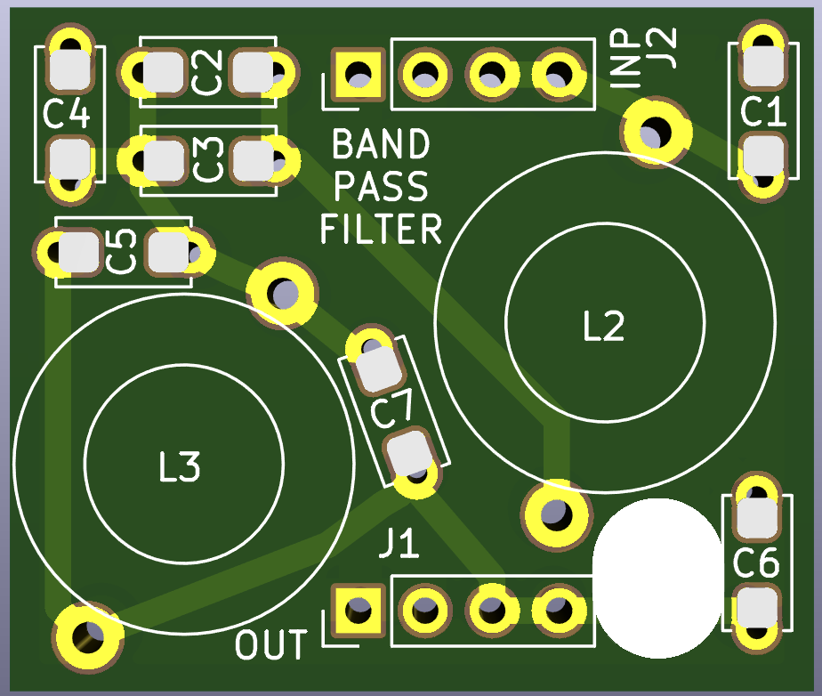
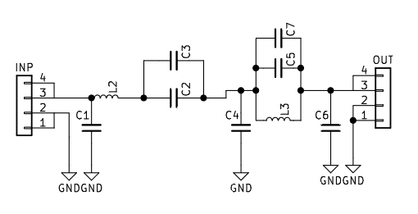

Under normal circumstances, the transceiver should be operated with the appropriate bandpass filter so that when transmitting, the signal being transmitted complies with telecommunications regulations. However, in an emergency, the JP4 jumper may be closed to bypass the bandpass filter. The resulting radiated signal will be inefficient and rich in harmonics, however, the signal should be able to be received.

Serial resonant bandpass filters component values
Band | C1 | C2+C3 | C4, C6 | C5+C7 | L2 | L3
80 m | 680 pF | 2200 pF | 2200 pF | 680 pF | 1.45 uH  T50-6 or T37-2, 19 turns  air coil, 1 mm wire, 13-14 turns around 12.5 mm (1/2” drill bit) form | 0.68 uH  T50-6 or T37-2, 13 turns  air coil, 1 mm wire, 10-11 turns around 9.5 mm (3/8” drill bit) form
60 m | 470 pF | 1500 pF | 1500 pF | 470 pF | 1.05 uH  T50-6 or T37-2, 16 turns  air coil, 1 mm wire, 10-11 turns around 12.5 mm (1/2” drill bit) form | 0.49 uH  T50-6 or T37-2, 8-9 turns  air coil, 1 mm wire, 15-16 turns around 9.5 mm (3/8” drill bit) form
40 m | 330 pF | 1000 pF | 1000 pF | 330 pF | 0.77 uH  T50-6 or T37-2, 12 turns  air coil, 1 mm wire, 12-13 turns around 9.5 mm (3/8” drill bit) form | 0.36 uH  T50-6 or T37-2, 8 turns  air coil, 1 mm wire, 7-8 turns around 9.5 mm (3/8” drill bit) form
30 m | 220 pF | 680 pF | 680 pF | 220 pF | 0.54 uH  T50-6 or T37-2, 11 turns  air coil, 1 mm wire, 9-10 turns around 9.5 mm (3/8” drill bit) form | 0.25 uH  T50-6 or T37-2, 7 turns  air coil, 1 mm wire, 5-6 turns around 9.5 mm (3/8” drill bit) form
20 m | 150 pF | 470 pF | 470 pF | 150 pF | 0.39 uH  T50-6, 9 turns,  air coil, 1 mm wire, 7-8 turns around 9.5 mm (3/8” drill bit) form | 0.18 uH  T50-6, 5 turns  air coil, 1 mm wire, 4-5 turns around 9.5 mm (3/8” drill bit) form
17 m | 100 pF | 390 pF | 390 pF | 100 pF | 0.32 uH  T50-6, 8 turns  air coil, 1 mm wire, 5-6 turns around 9.5 mm (3/8” drill bit) form | 0.14 uH  T50-6, 5 turns  air coil, 1 mm wire, 5-6 turns around 9.5 mm (3/8” drill bit) form
15 m | 68 pF | 330 pF | 330 pF | 100 pF | 0.26 uH  T50-6, 8 turns  air coil, 1 mm wire, 5-6 turns around 9.5 mm (3/8” drill bit) form | 0.12 uH  T50-6, 5 turns  air coil, 1 mm wire, 5-6 turns around 6.25 mm (1/4” drill bit) form
12 m | 47 pF | 330 pF | 330 pF | 100 pF | 0.22 uH  T50-6, 7 turns  air coil, 1 mm wire, 5-6 turns around 9.5 mm (3/8” drill bit) form | 0.10 uH  T50-6, 4 turns  air coil, 1 mm wire, 5-6 turns around 6.25 mm (1/4” drill bit) form
10 m | 33 pF | 270 pF | 220 pF | 82 pF | 0.19 uH  T50-6, 7 turns  air coil, 1 mm wire, 4-5 turns around 9.5 mm (3/8” drill bit) form | 0.09 uH  T50-6, 4 turns  air coil, 1 mm wire, 4-5 turns around 6.25 mm (1/4” drill bit) form

Nominal air-core inductance values calculated from 1 mm diameter wire with 1 to 1.5 mm turn spacing. When in doubt, an extra turn or two can be added to the coil length and the inductance decreased by spacing coils apart.

Troubleshooting the serial resonant bandpass filters
The serial resonant bandpass filters are resonant and so tuning the filter for maximum power is generally desirable. Because the capacitors are fixed values, the inductors are easier to tune in value. By spacing the turns on an inductor toroid or solenoid further apart, the inductance may be decreased. Therefore an extra turn or two may be wound on the inductor to increase the inductance over the nominal value and then the inductance increased by spacing out the turns, or increased by bunching up the turns. The components L2 and C2+C3 form a series resonant circuit that is tuned so that it is resonant at the frequency band of interest, or perhaps up to 10% in frequency above the band of interest. The components L3 and C5+C7 form a parallel resonant circuit that is tuned so that it is resonant at the second harmonic (two times) the frequency band of interest, or up to 20% above the frequency band of interest. If one has access to a VNA such as the NanoVNA, one can sweep out the frequency range between 1 MHz and 30 MHz. In the frequency band of interest, generally the transmitted power S21 should be -1 dB to 0 dB. At the second harmonic, the transmitted power should be -40 dB or less. One then can adjust the spacing of the inductor turns to adjust the inductance. Once the desired inductance value is achieved, cyanoacrylate glue can be placed on the turns to tack them down to immobilize the turns. Moisture, such as from one’s breath, can be used to accelerate the curing of the glue.
In case a NanoVNA or other VNA is not available, there are some other tips to try. If one has access to a dummy load with a power meter, one can troubleshoot the filter by measuring the power output. By temporarily shorting across L3, one can remove the influence of the second harmonic filter. If the power improves, then it is likely that the parallel resonant frequency of the combination of L3 and C5+C7 is too low. One can separate the turns of L3 to increase the parallel resonant frequency, or if that is insufficient, remove a turn from L3. If even after shorting across L3 the power is still too low, one can tune the series resonance frequency of the combination of L2 and C2+C3 by spreading or bunching the coils of L2. One can try transmitting into the dummy load on frequencies above or below the frequency of interest to determine if the power improves, taking care to minimize the spurious radiation. If one transmits into the dummy load at a lower frequency than the desired band and the power improves, then the resonance frequency needs to be increased by either spreading the turns of L2 apart, removing a turn from L2, or in some cases decreasing C2+C3 by substituing in a smaller capacitance. If one transmits into the dummy load at a higher frequency than the desired band and the power improves, then bunching up the turns on L2, or perhaps adding a turn to L2, or in some cases increasing the capacitance of C2+C3 by adding a small capacitor can improve the power. In some cases, decreasing C1 may also help increase output power but may decrease overall efficiency of the amplifier.
One can construct a dummy load with a peak detector to measure the power being outputted by the RFBitBanger. A simple circuit can be used to measure the power output of the transceiver as shown below. The CW mode with a straight key (down button) may be used to transmit a continuous wave signal for measurement. A dummy load of 50 ohm and 5 W resistor is used, or perhaps two 100 ohm resistors in parallel rated for 3 W, and it should be a thick or thin film metal resistor or a carbon resistor, but not a wirewound resistor which has significant inductance. The dummy load should be placed into a shielded metal enclosure to minimize spurious radiation with the shield of the coaxial cable connected to the enclosure. One can wrap aluminum or copper tape around an insulating box if a metal enclosure is not available. A diode is used to rectify the RF voltage and it is measured on a ceramic capacitor using a voltmeter (for example a multimeter or galvanometer). The voltage output V is the peak RF voltage, and the RF power P can be calculated by P=V²/100 so for example 20 V peak output voltage corresponds to 4 W of RF power.

3-D printable parts in the RFBitBanger project

There are a number of helpful 3-D printable forms included in the RFBitBanger project. These were designed with the FreeCAD software ( https://www.freecad.org/ ) as parametric models and so their dimensions can be modified by changing values in a spreadsheet.

RFBitBanger Case for SMT version: a case consists of three files “TopCase-SMT.stl,” “BottomCase-SMT.stl,” and “ButtonExtension.stl.” The “TopCase-SMT” and “BottomCase-SMT” files are a top and bottom piece that clamp over the SMT version of the radio. They are held together by 4-40 X ½” screws and nuts or M2.5 X 12 screws and nuts. Five “ButtonExtension” parts are used to push through the “Topcase-SMT” part so that the buttons on the PCB can be pressed from the outside of the case.

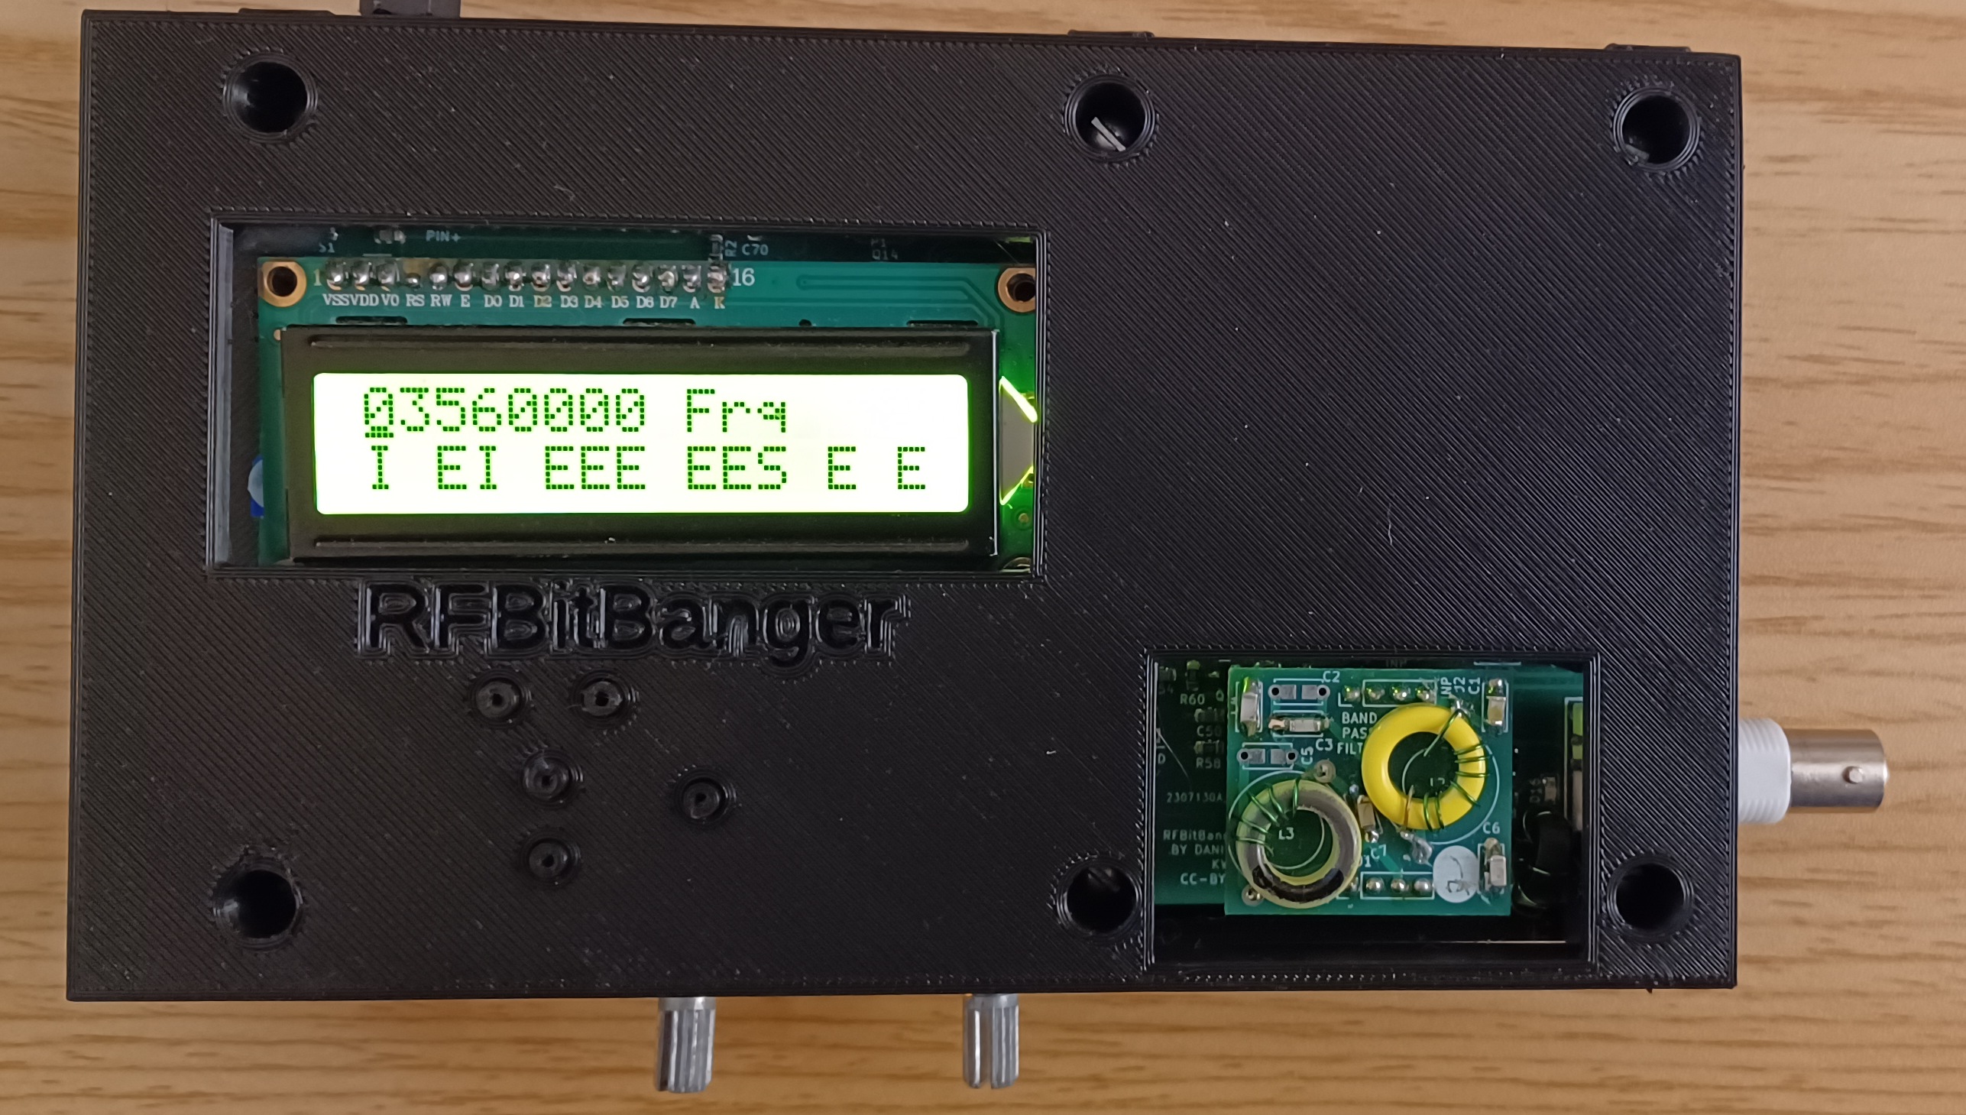

“InductorBobbin” and “AxialInductorBobbin”: these are parametric FreeCAD files that can be used to design printable coil forms for air core inductors. The various dimensions of the form are entered at the top of the form and the part is modified to conform to these dimensions. At the same time, the wire diameter may be entered to determine the pitch. The inductance, resistance, and reactance of the coil form with the given wire diameter and number of turns is calculated, and the form dimensions may be adjusted to achieve a desired inductance. The axial inductor bobbin and the corresponding spreadsheet is shown below.

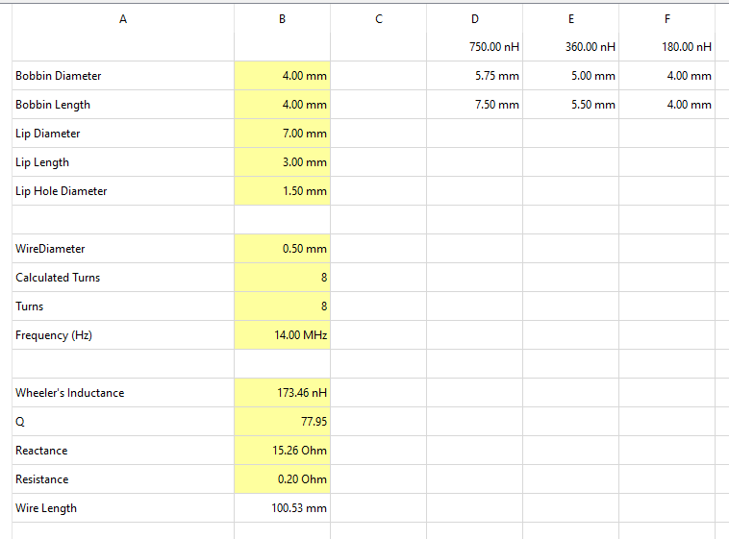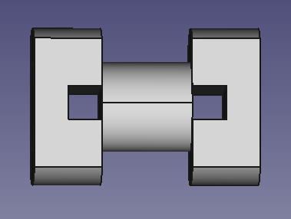

“PaddlesKey” and “PaddlesKeyGroundCenter”: two iambic keys, the difference between them being that the ground center is the more common arrangement with the two paddles wire to the tip and ring of the jack and a grounded post between the paddles, while the other arrange is with the less common arrangement with two posts wired to the tip and the ring, and each paddle grounded.

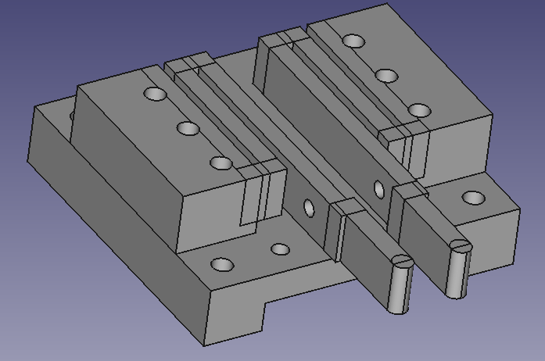

Replacing the crystal with a temperature compensated crystal oscillator (TCXO)

The crystal may be replaced with a TCXO for additional frequency stability, which is especially helpful when using low bit rate SCAMP modes. A 3225-sized TCXO may be fitted, with pin 1 of the TCXO coinciding with the corner of the L shape on the silkscreen. This has been tested with the ECS-TXO-3225MV-250-TR TCXO, 25 MHz, 2 ppm -40 to 85 C TCXO. This TCXO has pin 1 floating, pin 2 grounded, pin 3 oscillator output, and pin 4 connected to 3.3V. The ABRACON I538-2O7- 25.000 MHz may also be suitable as well. To install the TCXO, first remove the existing crystal. A hot air rework station may be used to remove it. The TCXO may be placed, applying flux to the pads, placing the TCXO on the pads, and using hot air to solder the TCXO to the pads. Then cut the trace from pin 3 of the SI5351A to pin 1 of the TCXO, so that pin 1 of the TCXO is floating, which is shown in the picture below surrounded by double black boxes. Note other TCXOs may require pin 1 to be grounded. The solder jumper JP11 should be bridged to connect power to the TCXO.

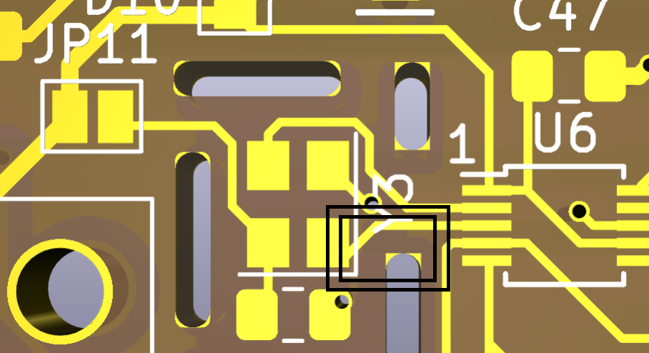

Troubleshooting problems with the RFBitBanger

If the RFBitBanger stops functioning, usually it is due to a few types of problems.
First, make sure the gain and volume are turned up so that the audio can be heard and that the speaker is connected.
Like any electronic device, 90% of the time when there is a failure, it is because of a mechanical problem. It can be, for example, a loose cable or a worn connector. One can gently push on a questionable connector or part with one’s finger to determine if it is making intermittent contact. If so, sometimes the problem is because the connector is worn and needs to be replaced. If integrated circuits are socketed, push the integrated circuits back into their sockets to make sure these are firmly seated and no pins are bent out of the socket. Near the integrated circuit socket, the digit “1” has been silkscreened to indicate the position of pin 1 of the integrated circuit. The side of the integrated circuit with pin 1 is usually marked with a notch on the edge of the package, or a dot on the package in the corner with pin 1. Cables should also be pushed back onto their pins to make sure they are seated properly, and are not offset by a row or column of pins.
Sometimes it is because of a solder joint that has either cracked, because solder is a brittle metal, or because the solder joint was not formed properly. In either case, one can reheat the solder joint with a soldering iron to melt and reform the joint. There is usually little risk in reheating a solder joint, so any questionable connections can be reheated as needed as long as the heat is applied only long enough for the solder to melt. If electricity is not available, there are soldering irons that are heated by butane torches, or the end of a metal rod can be heated and placed in contact with the solder joint.
If the radio does not transmit, it is likely that one or more of the 2N7000 transistors which are positions Q3,Q5,Q6, and Q7 could be damaged. If when transmitting, one or more of the transistors becomes too hot to touch in a few seconds, this transistor has likely failed. The transistor should be removed and replaced. The flat side of the transistor should face the same direction as the flat side of the half-circle showing the orientation of the transistor on the silk screen.
The thin magnet wires on the toroids should be inspected to see there are any kinks or cuts as these are rather thin and can be severed easily. If the wire on the toroid is broken, it can be replaced with an insulated wire that is thin enough to be wrapped a sufficient number of times around the toroid.

Schematic and PCB Layout of the Main PCB
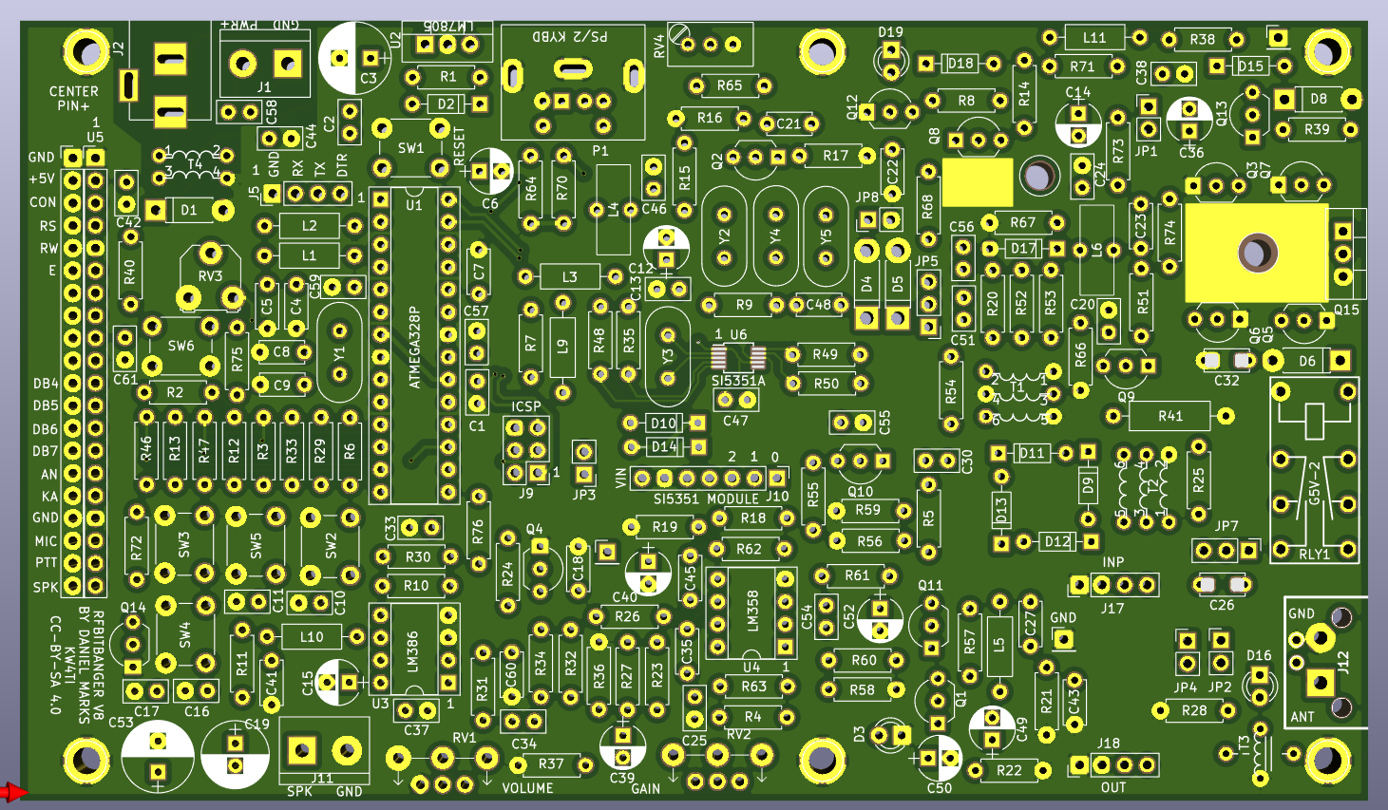
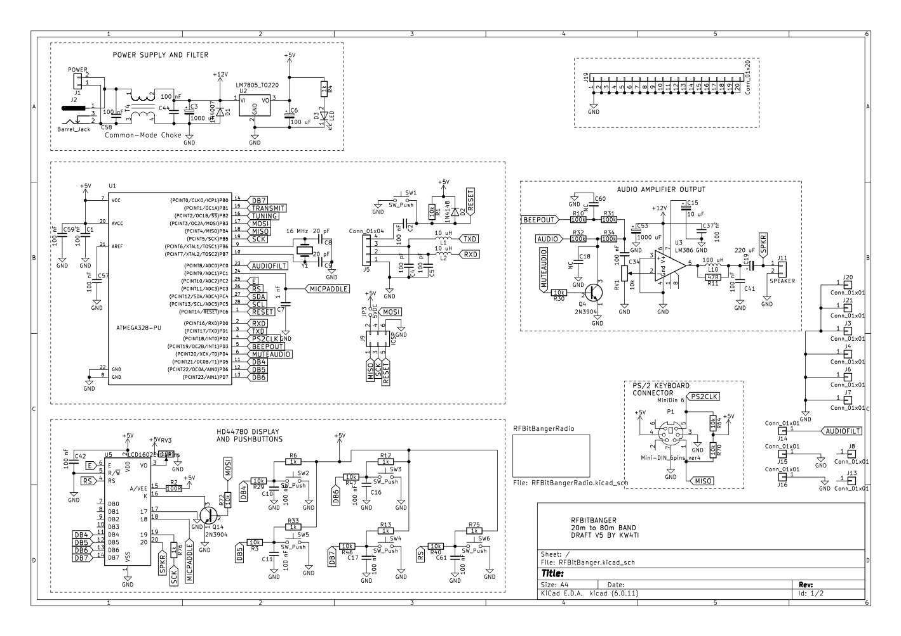
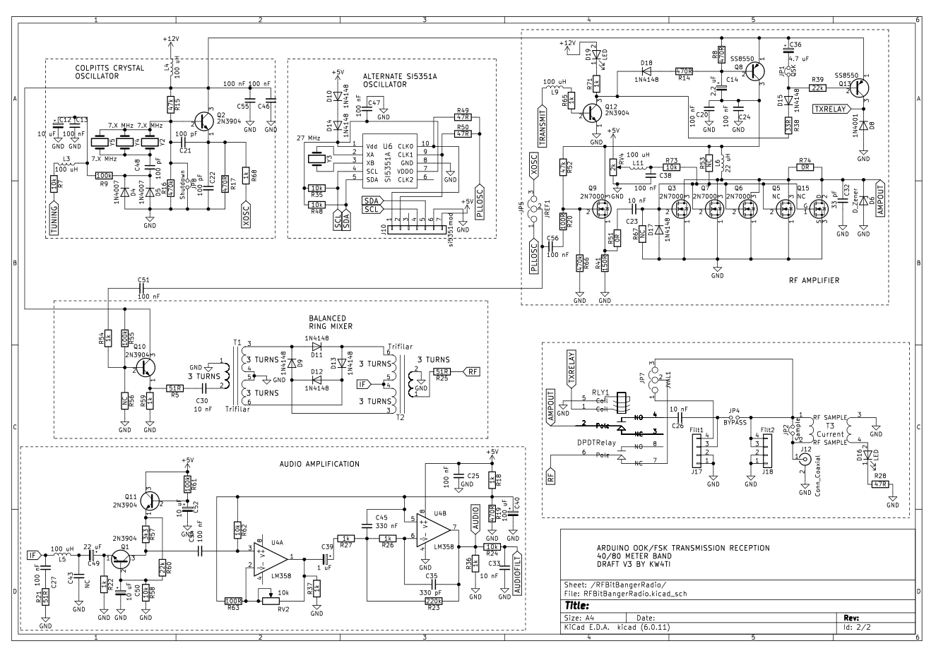

Bill of Materials, Main PCB

Ref | Value | Footprint
C1 | 100 nF | 50 V, 2.5 mm lead spacing ceramic disc capacitor
C2 | 100 nF | 50 V, 2.5 mm lead spacing ceramic disc capacitor
C3 | 1000 uF | 10 mm, 25 V radial electrolytic capacitor
C4 | 100 pF | 50 V, 5 mm lead spacing ceramic disc capacitor
C5 | 100 pF | 50 V, 5 mm lead spacing ceramic disc capacitor
C6 | 100 uF | 50 V, 2.5 mm lead spacing ceramic disc capacitor
C7 | 1 nF | 50 V, 5 mm lead spacing ceramic disc capacitor
C8 | 20 pF | 50 V, 5 mm lead spacing ceramic disc capacitor
C9 | 20 pF | 50 V, 5 mm lead spacing ceramic disc capacitor
C10 | 100 nF | 50 V, 2.5 mm lead spacing ceramic disc capacitor
C11 | 100 nF | 50 V, 2.5 mm lead spacing ceramic disc capacitor
C12 | 10 uF | 5 mm, 25 V radial electrolytic capacitor
C13 | 100 nF | 50 V, 2.5 mm lead spacing ceramic disc capacitor
C14 | 2.2 uF | 50 V, 2.5 mm lead spacing ceramic disc capacitor
C15 | 10 uF | 5 mm, 25 V radial electrolytic capacitor
C16 | 100 nF | 50 V, 2.5 mm lead spacing ceramic disc capacitor
C17 | 100 nF | 50 V, 2.5 mm lead spacing ceramic disc capacitor
C18 | NC | Open circuit
C19 | 220 uF | 8 mm, 25 V radial electrolytic capacitor
C20 | 100 nF | 50 V, 2.5 mm lead spacing ceramic disc capacitor
C21 | 100 pF | 50 V, 5 mm lead spacing ceramic disc capacitor
C22 | 100 pF | 50 V, 5 mm lead spacing ceramic disc capacitor
C23 | 10 nF | 50 V, 2.5 mm lead spacing ceramic disc capacitor
C24 | 100 nF | 50 V, 2.5 mm lead spacing ceramic disc capacitor
C25 | 100 nF | 50 V, 2.5 mm lead spacing ceramic disc capacitor
C26 | 10 nF | 50 V, 2.5 mm lead spacing ceramic disc capacitor
C27 | 100 nF | 50 V, 2.5 mm lead spacing ceramic disc capacitor
C30 | 10 nF | 50 V, 2.5 mm lead spacing ceramic disc capacitor
C32 | 33 pF | 50 V, 5 mm lead spacing ceramic disc capacitor
C33 | 10 nF | 50 V, 2.5 mm lead spacing ceramic disc capacitor
C34 | 100 nF | 50 V, 2.5 mm lead spacing ceramic disc capacitor
C35 | 330 pF | 50 V, 5 mm lead spacing ceramic disc capacitor
C36 | 4.7 uF | 5 mm, 25 V radial electrolytic capacitor
C37 | 100 nF | 50 V, 2.5 mm lead spacing ceramic disc capacitor
C38 | 100 nF | 50 V, 2.5 mm lead spacing ceramic disc capacitor
C39 | 1 uF | 5 mm, 25 V radial electrolytic capacitor
C40 | 100 uF | 50 V, 2.5 mm lead spacing ceramic disc capacitor
C41 | 100 nF | 50 V, 2.5 mm lead spacing ceramic disc capacitor
C42 | 100 nF | 50 V, 2.5 mm lead spacing ceramic disc capacitor
C43 | NC | 50 V, 2.5 mm lead spacing ceramic disc capacitor
C44 | 100 nF | 50 V, 2.5 mm lead spacing ceramic disc capacitor
C45 | 330 nF | 50 V, 5 mm lead spacing ceramic disc capacitor
C46 | 100 nF | 50 V, 2.5 mm lead spacing ceramic disc capacitor
C47 | 100 nF | 50 V, 2.5 mm lead spacing ceramic disc capacitor
C48 | 100 pF | 50 V, 5 mm lead spacing ceramic disc capacitor
C49 | 22 uF | 5 mm, 25 V radial electrolytic capacitor
C50 | 10 uF | 50 V, 2.5 mm lead spacing ceramic disc capacitor
C51 | 100 nF | 50 V, 2.5 mm lead spacing ceramic disc capacitor
C52 | 10 uF | 50 V, 2.5 mm lead spacing ceramic disc capacitor
C53 | 1000 uF | 10 mm, 25 V radial electrolytic capacitor
C54 | 100 nF | 50 V, 2.5 mm lead spacing ceramic disc capacitor
C55 | 100 nF | 50 V, 2.5 mm lead spacing ceramic disc capacitor
C56 | 100 nF | 50 V, 2.5 mm lead spacing ceramic disc capacitor
C57 | 100 nF | 50 V, 2.5 mm lead spacing ceramic disc capacitor
C58 | 100 nF | 50 V, 2.5 mm lead spacing ceramic disc capacitor
C59 | 100 nF | 50 V, 2.5 mm lead spacing ceramic disc capacitor
C60 | NC | NC
C61 | 100 nF | 50 V, 2.5 mm lead spacing ceramic disc capacitor
D1 | 1N4007 | DO-41 axial diode
D2 | 1N4148 | DO-35 axial diode
D3 | LED | LED 3 mm
D4 | 1N4007 | DO-41 axial diode
D5 | 1N4007 | DO-41 axial diode
D6 | D_Zener | optional zener diode DO-41 1N4757A
D8 | 1N4007 | DO-41 axial diode
D9 | 1N4148 | DO-35 axial diode
D10 | 1N4148 | DO-35 axial diode
D11 | 1N4148 | DO-35 axial diode
D12 | 1N4148 | DO-35 axial diode
D13 | 1N4148 | DO-35 axial diode
D14 | 1N4148 | DO-35 axial diode
D15 | 1N4148 | DO-35 axial diode
D16 | LED | RED LED 3 mm
D17 | 1N4148 | DO-35 axial diode
D18 | 1N4148 | DO-35 axial diode
D19 | LED | LED 3 mm
J1 | POWER | 5.08 mm spacing screw terminal block
J2 | Barrel_Jack | Dc Barrel Jack 2.5 mm
J5 | Conn_01x04 | 4 pin header 2.54 mm pitch
J9 | ICSP | 2 by 3 (6 pins) header 2.54 mm pitch
J10 | si5351mod | 7 pin socket 2.54 mm pitch
J11 | SPEAKER | 5.08 mm spacing screw terminal block
J12 | Conn_Coaxial | PCB BNC Board Edge Connector e.g. (LCSC C2837588, Shenzhen Kinghelm Elec KH-BNC75-3511)
J17 | Filt1 | 4 pin header 2.54 mm pitch
J18 | Filt2 | 4 pin header 2.54 mm pitch
J19 | Conn_01x20 | 20 pin header 2.54 mm pitch
JP1 | QSK | 2 pin header 2.54 mm pitch
JP2 | Sample | 2 pin header 2.54 mm pitch
JP3 | 5VDC | 2 pin header 2.54 mm pitch
JP4 | BYPASS | 2 pin header 2.54 mm pitch
JP5 | JREF1 | 3 pin header 2.54 mm pitch
JP7 | JVAL1 | 3 pin header 2.54 mm pitch
JP8 | Shutdown | 2 pin header 2.54 mm pitch
L1 | 10 uH | 10 uH axial inductor, 100 mA maximum
L2 | 10 uH | 10 uH axial inductor, 100 mA maximum
L3 | 100 uH | 100 uH axial inductor, 100 mA maximum
L4 | 100 uH | RF choke, FT37-43 or FT50-43, wind to instructions
L5 | 100 uH | 100 uH axial inductor, 100 mA maximum
L6 | 22 uH | RF choke, FT37-43 or FT50-43, wind to instructions
L9 | 100 uH | 100 uH axial inductor, 100 mA maximum
L10 | 100 uH | 100 uH axial inductor, 100 mA maximum
L11 | 100 uH | 100 uH axial inductor, 100 mA maximum
P1 | Mini-DIN_6pins_ver4 | MiniDin 6 female connector, e.g. (LCSC C77848, CONNFLY DS1093-01-PN60)
Q1 | 2N3904 | TO-92 NPN transistor, EBC
Q2 | 2N3904 | TO-92 NPN transistor, EBC
Q3 | 2N7000 | TO-92 N-channel MOSFET, SGD
Q4 | 2N3904 | TO-92 NPN transistor, EBC
Q5 | NC | Optional fourth TO-92 MOSFET, EBC
Q6 | 2N7000 | TO-92 N-channel MOSFET, SGD
Q7 | 2N7000 | TO-92 N-channel MOSFET, SGD
Q8 | SS8550 | TO-92 PNP transistor (LCSC C8541), 1.5A max collector current, EBC
Q9 | 2N7000 | TO-92 N-channel MOSFET, SGD
Q10 | 2N3904 | TO-92 NPN transistor, EBC
Q11 | 2N3904 | TO-92 NPN transistor, EBC
Q12 | 2N3904 | TO-92 NPN transistor, EBC
Q13 | SS8550 | TO-92 PNP transistor (LCSC C8541), 1.5A max collector current, EBC
Q14 | 2N3904 | TO-92 NPN transistor, EBC
Q15 | NC | NC (optional TO-220 MOSFET, e.g. IRF510), GDS
R1 | 10k | ¼ watt axial resistor metal film
R2 | 100R | ¼ watt axial resistor metal film
R3 | 10k | ¼ watt axial resistor metal film
R4 | 1k | ¼ watt axial resistor metal film
R5 | 51R | ¼ watt axial resistor metal film
R6 | 1k | ¼ watt axial resistor metal film
R7 | 10k | ¼ watt axial resistor metal film
R8 | 470R | ¼ watt axial resistor metal film
R9 | 100k | ¼ watt axial resistor metal film
R10 | 100k | ¼ watt axial resistor metal film
R11 | 47R | ¼ watt axial resistor metal film
R12 | 1k | ¼ watt axial resistor metal film
R13 | 1k | ¼ watt axial resistor metal film
R14 | 470R | ¼ watt axial resistor metal film
R15 | 47k | ¼ watt axial resistor metal film
R16 | 470k | ¼ watt axial resistor metal film
R17 | 470R | ¼ watt axial resistor metal film
R18 | 1k | ¼ watt axial resistor metal film
R19 | 470R | ¼ watt axial resistor metal film
R20 | 100R | ¼ watt axial resistor metal film
R21 | 51R | ¼ watt axial resistor metal film
R22 | 1k | ¼ watt axial resistor metal film
R23 | 220k | ¼ watt axial resistor metal film
R24 | 10k | ¼ watt axial resistor metal film
R25 | 51R | ¼ watt axial resistor metal film
R26 | 1k | ¼ watt axial resistor metal film
R27 | 1k | ¼ watt axial resistor metal film
R28 | 47R | ¼ watt axial resistor metal film
R29 | 10k | ¼ watt axial resistor metal film
R30 | 10k | ¼ watt axial resistor metal film
R31 | 100k | ¼ watt axial resistor metal film
R32 | 100k | ¼ watt axial resistor metal film
R33 | 1k | ¼ watt axial resistor metal film
R34 | 100k | ¼ watt axial resistor metal film
R35 | 10k | ¼ watt axial resistor metal film
R36 | 1k | ¼ watt axial resistor metal film
R37 | 1k | ¼ watt axial resistor metal film
R38 | 33R | ¼ watt axial resistor metal film
R39 | 22k | ¼ watt axial resistor metal film
R40 | 10k | ¼ watt axial resistor metal film
R41 | 150R | 2 watt axial resistor metal film
R46 | 10k | ¼ watt axial resistor metal film
R47 | 10k | ¼ watt axial resistor metal film
R48 | 10k | ¼ watt axial resistor metal film
R49 | 47R | ¼ watt axial resistor metal film
R50 | 47R | ¼ watt axial resistor metal film
R51 | 0R | Wire jumper
R52 | 47k | ¼ watt axial resistor metal film
R53 | NC | Open circuit
R54 | 1k | ¼ watt axial resistor metal film
R55 | 100k | ¼ watt axial resistor metal film
R56 | NC | Open circuit
R57 | 3k3 | ¼ watt axial resistor metal film
R58 | 10k | ¼ watt axial resistor metal film
R59 | 1k | ¼ watt axial resistor metal film
R60 | 22k | ¼ watt axial resistor metal film
R61 | 100k | ¼ watt axial resistor metal film
R62 | 10k | ¼ watt axial resistor metal film
R63 | 100R | ¼ watt axial resistor metal film
R64 | 10k | ¼ watt axial resistor metal film
R65 | 1k | ¼ watt axial resistor metal film
R66 | 470k | ¼ watt axial resistor metal film
R67 | NC | Open circuit
R68 | 1k | ¼ watt axial resistor metal film
R70 | 10k | ¼ watt axial resistor metal film
R71 | 1k | ¼ watt axial resistor metal film
R72 | 10k | ¼ watt axial resistor metal film
R73 | 10k | ¼ watt axial resistor metal film
R74 | 0R | Wire jumper
R75 | 1k | ¼ watt axial resistor metal film
R76 | 1k | ¼ watt axial resistor metal film
RLY1 | DPDTRelay | Omron G5V-2 type DPDT relay, e.g. Hongfa HK19F, 12 volt coil, LCSC C42803
RV1 | 10k | B10K potentiometer
RV2 | 10k | B10K potentiometer
RV3 | 10k | 10k trimmer-type potentiometer (e.g. BOURNS 3306P-1-103, LCSC C840697)
RV4 | 2k | 2k 3296W-type potentiometer, e.g. LCSC C118206
SW1 | SW_Push | 6 mm normally open push button, e..g Diptronics DTS-62K-V, LCSC C100057
SW2 | SW_Push | 6 mm normally open push button, e..g Diptronics DTS-62K-V, LCSC C100057
SW3 | SW_Push | 6 mm normally open push button, e..g Diptronics DTS-62K-V, LCSC C100057
SW4 | SW_Push | 6 mm normally open push button, e..g Diptronics DTS-62K-V, LCSC C100057
SW5 | SW_Push | 6 mm normally open push button, e..g Diptronics DTS-62K-V, LCSC C100057
SW6 | SW_Push | 6 mm normally open push button, e..g Diptronics DTS-62K-V, LCSC C100057
T1 | Trifilar | Transformer (balun) on FT37-43, FT50-43 core, wind according to instructions
T2 | Trifilar | Transformer (balun) on FT37-43, FT50-43 core, wind according to instructions
T3 | RF Current Sampler | Transformer on FT37-43, FT50-43 core, wind according to instructions
T4 | Common-Mode Choke | Transformer on FT37-43, FT50-43 core, wind according to instructions
U1 | ATMEGA328-PU | ATMEGA328P-PU 28 pin DIP microcontroller
U2 | LM7805_TO220 | LM7805 5 volt regulator
U3 | LM386 | LM386 8-pin DIP speaker amplifier
U4 | LM358 | LM358 8-pin DIP dual opamp
U5 | LCD1602ExtraPins | 20 pin header 2.54 mm pitch
U6 | SI5351A | SI5351A integrated circuit (only install if no module)
Y1 | 16 MHz | HC-49 16 MHz crystal
Y2 | 7.X MHz | HC-49 crystal for pulled oscillator
Y3 | 25 MHz | 25 MHz crystal for SI5351A (only install if no module)
Y4 | 7.X MHz | HC-49 crystal for pulled oscillator
Y5 | 7.X MHz | HC-49 crystal for pulled oscillator

Schematic and PCB Layout of the Display PCB

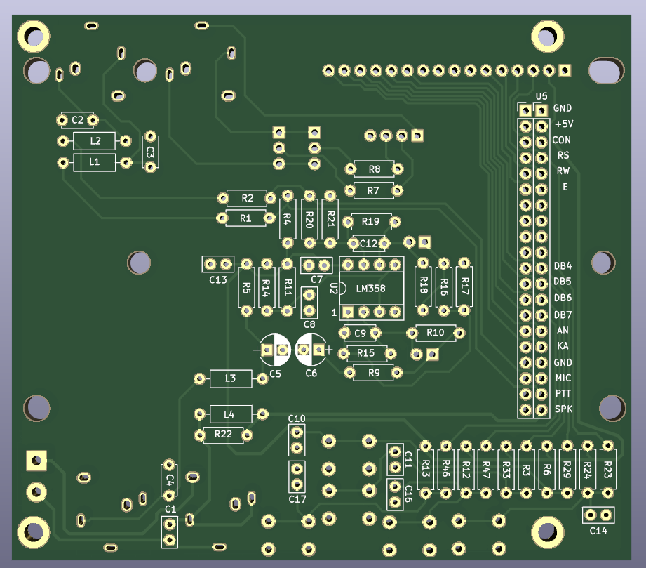
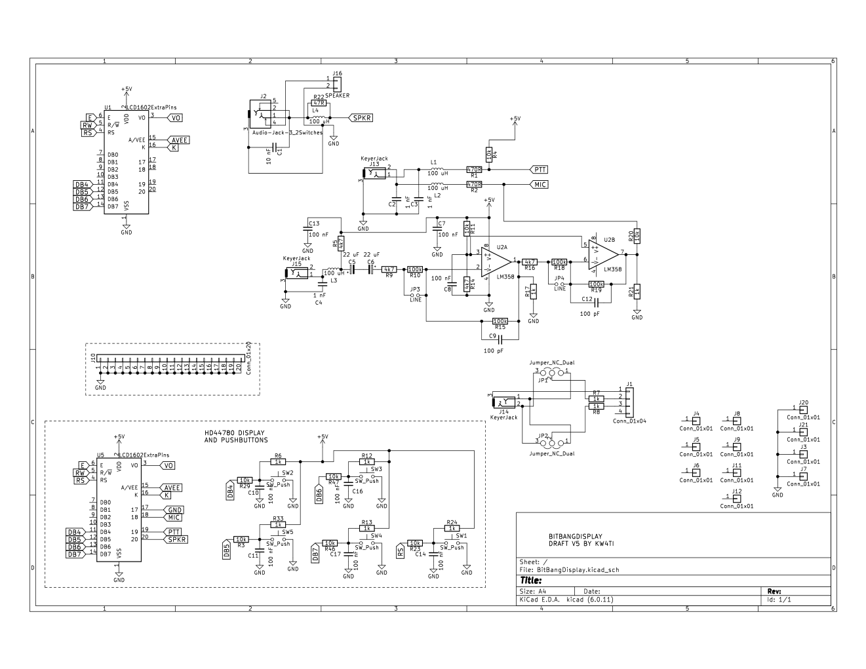

Bill of Materials, Display PCB

Ref | Value | Component
C1 | 10 nF | 50 V, 2.5 mm lead spacing ceramic disc capacitor
C2 | 1 nF | 50 V, 5 mm lead spacing ceramic disc capacitor
C3 | 1 nF | 50 V, 5 mm lead spacing ceramic disc capacitor
C4 | 1 nF | 50 V, 5 mm lead spacing ceramic disc capacitor
C5 | 22 uF | 5 mm, 25 V radial electrolytic capacitor
C6 | 22 uF | 5 mm, 25 V radial electrolytic capacitor
C7 | 100 nF | 50 V, 2.5 mm lead spacing ceramic disc capacitor
C8 | 100 nF | 50 V, 2.5 mm lead spacing ceramic disc capacitor
C9 | 100 pF | 50 V, 5 mm lead spacing ceramic disc capacitor
C10 | 100 nF | 50 V, 2.5 mm lead spacing ceramic disc capacitor
C11 | 100 nF | 50 V, 2.5 mm lead spacing ceramic disc capacitor
C12 | 100 pF | 50 V, 5 mm lead spacing ceramic disc capacitor
C13 | 100 nF | 50 V, 2.5 mm lead spacing ceramic disc capacitor
C14 | 100 nF | 50 V, 2.5 mm lead spacing ceramic disc capacitor
C16 | 100 nF | 50 V, 2.5 mm lead spacing ceramic disc capacitor
C17 | 100 nF | 50 V, 2.5 mm lead spacing ceramic disc capacitor
J1 | Conn_01x04 | 4 pin header 2.54 mm pitch
J2 | 3.5 mm stereo jack | 3.5 mm stereo jack (Korean Hroparts Elec, PJ-3240-5A, LCSC C148514)
J10 | Conn_01x20 | 20 pin header 2.54 mm pitch
J13 | 3.5 mm stereo jack | 3.5 mm stereo jack (Korean Hroparts Elec, PJ-3240-5A, LCSC C148514)
J14 | 3.5 mm stereo jack | 3.5 mm stereo jack (Korean Hroparts Elec, PJ-3240-5A, LCSC C148514)
J15 | 3.5 mm stereo jack | 3.5 mm stereo jack (Korean Hroparts Elec, PJ-3240-5A, LCSC C148514)
J16 | Speaker connector | 5.08 mm spacing screw terminal block
JP1 | Jumper_NC_Dual | 3 pin header 2.54 mm pitch
JP2 | Jumper_NC_Dual | 3 pin header 2.54 mm pitch
JP3 | LINE | 2 pin header 2.54 mm pitch
JP4 | LINE | 2 pin header 2.54 mm pitch
L1 | 100 uH | 100 uH axial inductor, 100 mA max
L2 | 100 uH | 100 uH axial inductor, 100 mA max
L3 | 100 uH | 100 uH axial inductor, 100 mA max
L4 | 100 uH | 100 uH axial inductor, 100 mA max
R1 | 470R | ¼ watt axial resistor metal film
R2 | 470R | ¼ watt axial resistor metal film
R3 | 10k | ¼ watt axial resistor metal film
R4 | 10k | ¼ watt axial resistor metal film
R5 | 4k7 | ¼ watt axial resistor metal film
R6 | 1k | ¼ watt axial resistor metal film
R7 | 1k | ¼ watt axial resistor metal film
R8 | 1k | ¼ watt axial resistor metal film
R9 | 4k7 | ¼ watt axial resistor metal film
R10 | 100k | ¼ watt axial resistor metal film
R11 | 10k | ¼ watt axial resistor metal film
R12 | 1k | ¼ watt axial resistor metal film
R13 | 1k | ¼ watt axial resistor metal film
R14 | 4k7 | ¼ watt axial resistor metal film
R15 | 100k | ¼ watt axial resistor metal film
R16 | 4k7 | ¼ watt axial resistor metal film
R17 | 1k | ¼ watt axial resistor metal film
R18 | 100k | ¼ watt axial resistor metal film
R19 | 100k | ¼ watt axial resistor metal film
R20 | 10k | ¼ watt axial resistor metal film
R21 | 1k | ¼ watt axial resistor metal film
R22 | 47R | ¼ watt axial resistor metal film
R23 | 10k | ¼ watt axial resistor metal film
R24 | 1k | ¼ watt axial resistor metal film
R29 | 10k | ¼ watt axial resistor metal film
R33 | 1k | ¼ watt axial resistor metal film
R46 | 10k | ¼ watt axial resistor metal film
R47 | 10k | ¼ watt axial resistor metal film
SW1 | SW_Push | 6 mm normally open push button, e..g Diptronics DTS-62K-V, LCSC C100057
SW2 | SW_Push | 6 mm normally open push button, e..g Diptronics DTS-62K-V, LCSC C100057
SW3 | SW_Push | 6 mm normally open push button, e..g Diptronics DTS-62K-V, LCSC C100057
SW4 | SW_Push | 6 mm normally open push button, e..g Diptronics DTS-62K-V, LCSC C100057
SW5 | SW_Push | 6 mm normally open push button, e..g Diptronics DTS-62K-V, LCSC C100057
U1 | LCD1602ExtraPins | 16 pin header 2.54 mm pitch, HD44780 display
U2 | LM358 | 8 pin DIP socket
U5 | LCD1602ExtraPins | 20 pin header 2.54 mm pitch

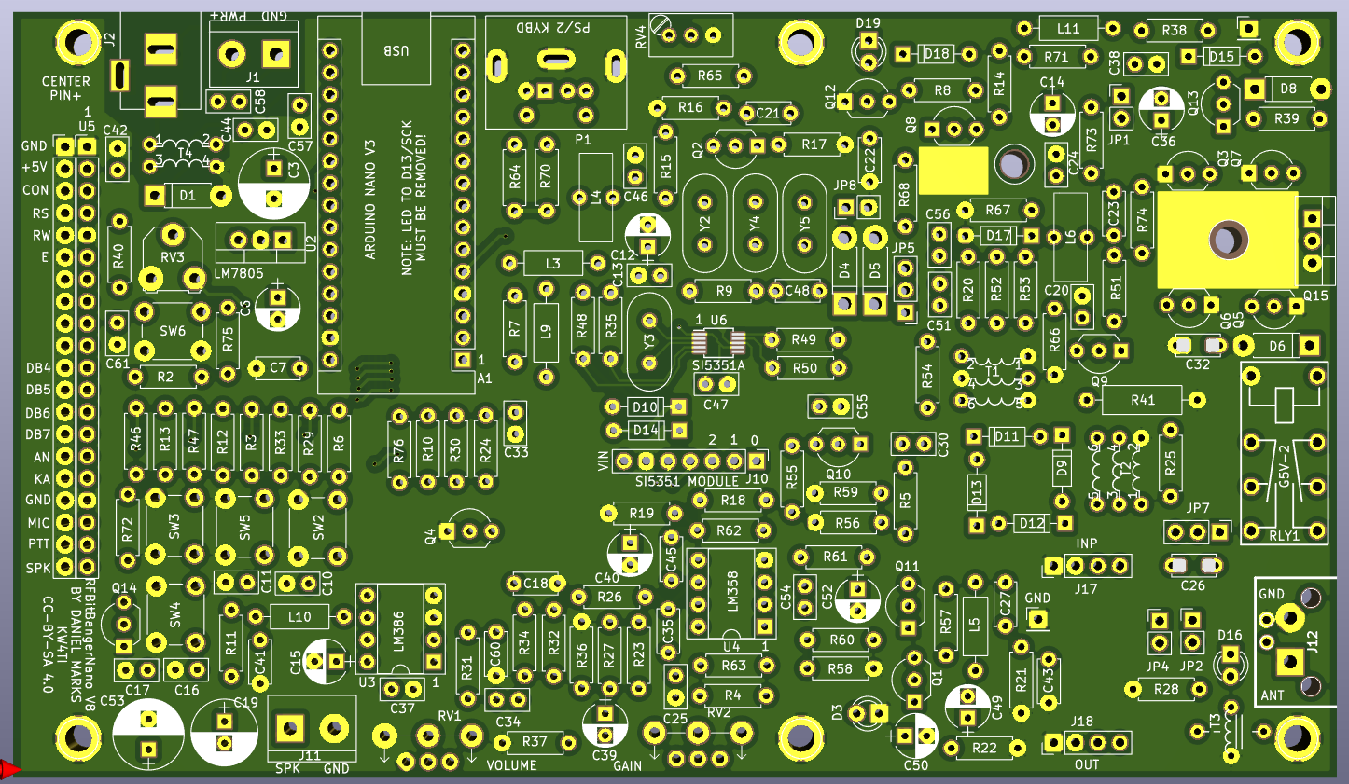
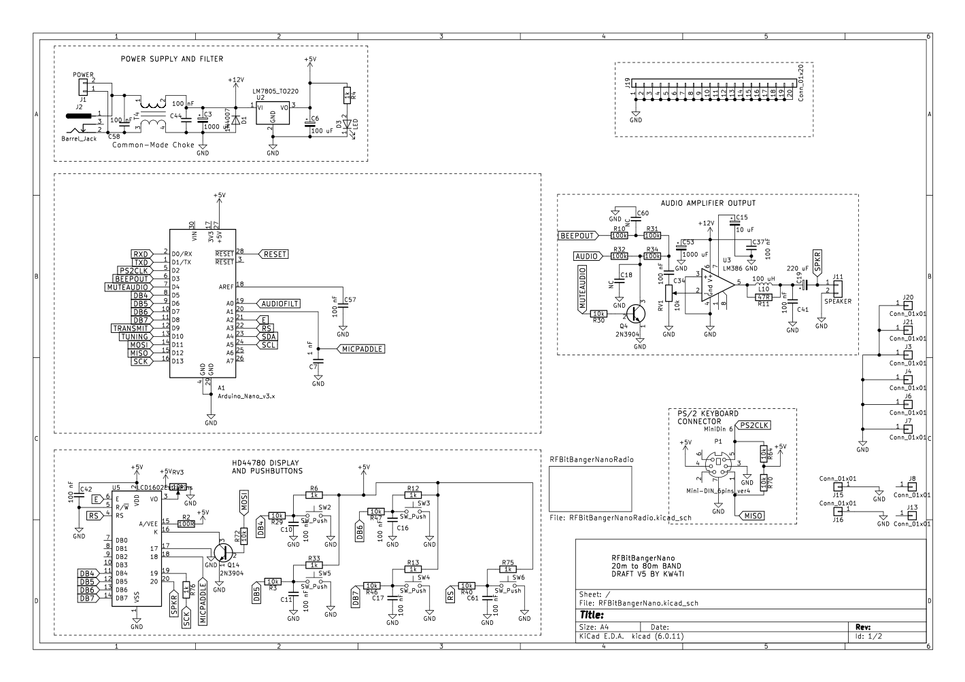
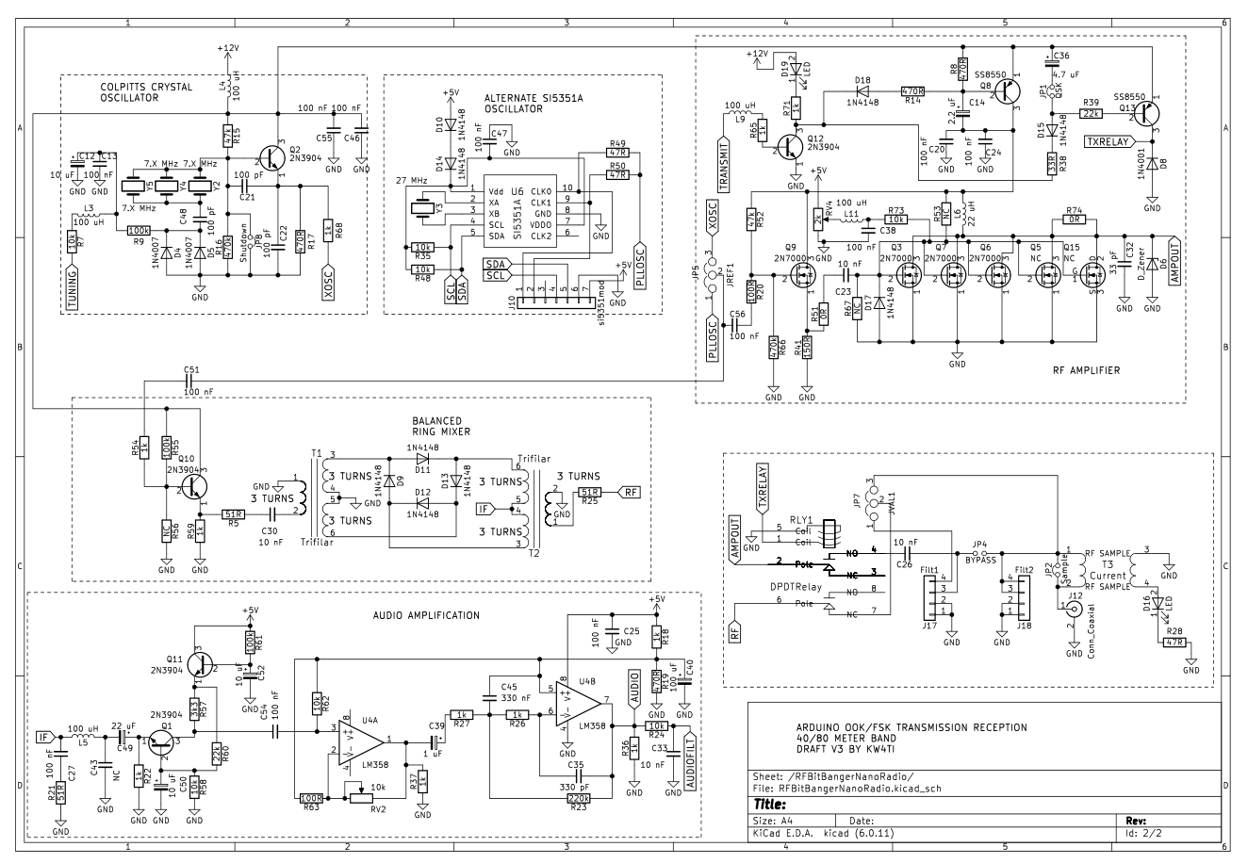
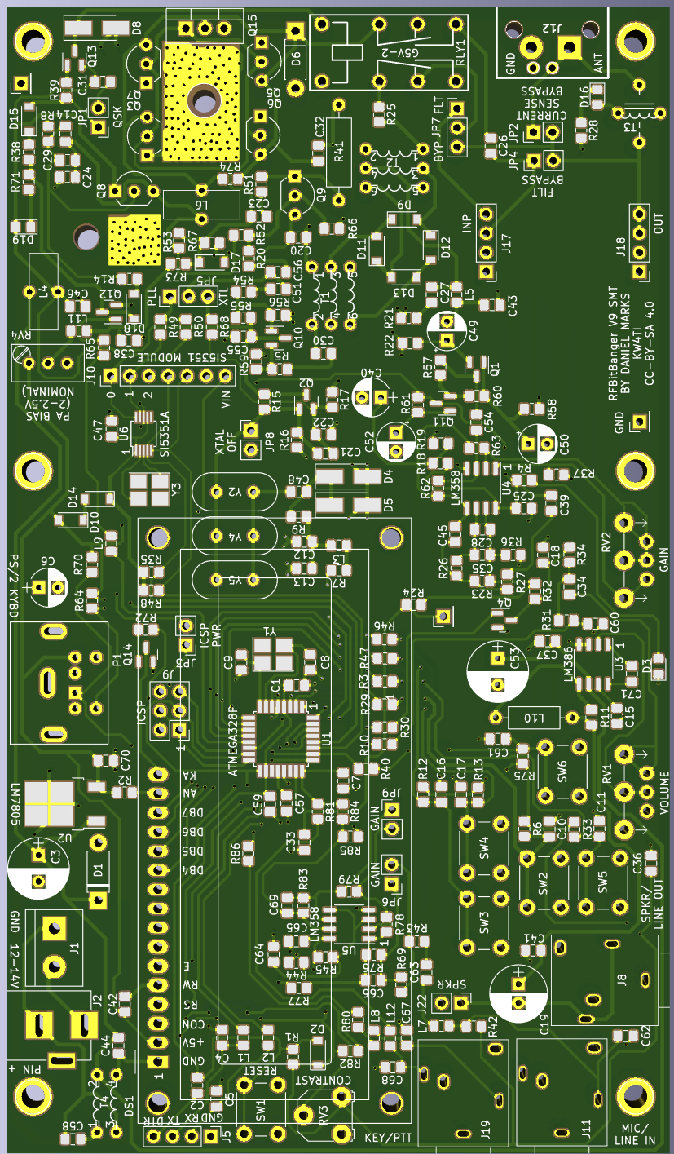
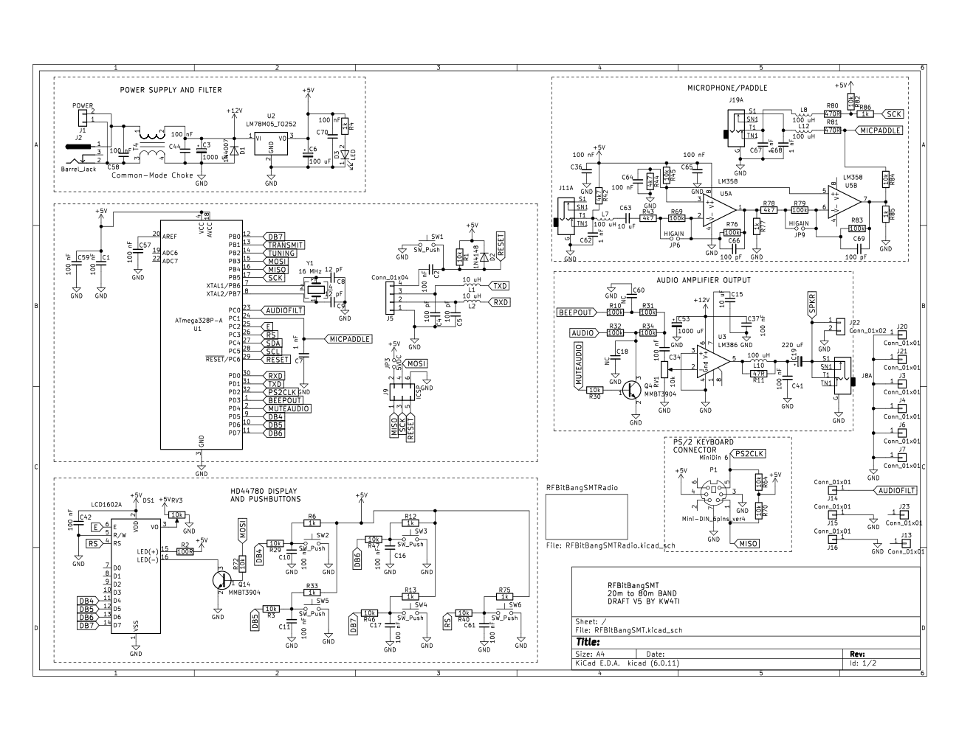
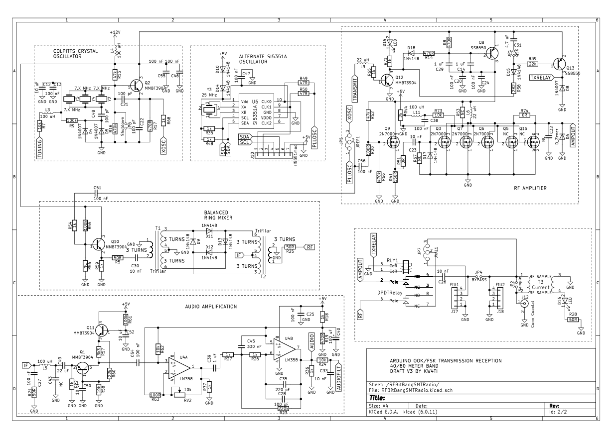

Arduino Uno/Nano equivalent pins to ATMEGA328P
If one constructs the transceiver using an Arduino Uno/Nano and point-to-point wiring, here is the correspondence between the Arduino Uno/Nano pins and the ATMEGA328P pins:

PD0 2 Digital Pin 0
PD1 3 Digital Pin 1
PD2 4 Digital Pin 2
PD3 5 Digital Pin 3
PD4 6 Digital Pin 4
PD5 11 Digital Pin 5
PD6 12 Digital Pin 6
PD7 13 Digital Pin 7
PB0 14 Digital Pin 8
PB1 15 Digital Pin 9
PB2 16 Digital Pin 10
PB3 17 Digital Pin 11
PB4 18 Digital Pin 12
PB5 19 Digital Pin 13
PC0 23 Analog Input 0
PC1 24 Analog Input 1
PC2 25 Analog Input 2
PC3 26 Analog Input 3
PC4 27 Analog Input 4
PC5 28 Analog Input 5
PC6 1 Reset
AREF 21 Analog Reference (Leave Open)
AVCC 20 Analog Voltage (Connect to +5V)
VCC 7 LM7805 5V output
GND 8,22 GND

Programming the ATMEGA328P/Arduino
The RFBitBanger software has been created to be compiled in the Arduino IDE environment with the Arduino Uno/Nano as a target. The ATMEGA328P operates at a frequency and with fuse bits identical to the standard Arduino Uno/Nano configuration. The Arduino bootloader may be flashed onto the ATMEGA328P. To do this, a ISP programmer such as the ArduinoISP or ATTinyUSB may be connected to the ICSP connector and the “Burn Bootloader” may be invoked in the Arduino development environment with the “Arduino Uno” or “Arduino Nano” selected as the target / board. This programs the bootloader and the correct fuse bits for operation of the ATMEGA328P with the RFBitBanger software.
A serial/TTL USB interface (e.g. CP2102 or CH340) may be used to program the ATMEGA328P once the bootloader is installed. The four pin header J5 has a ground pin, RX, TX, and DTR/reset pins. The ground on the RFBitBanger should be connected to the serial programmer ground, the RX pin on the RFBitBanger should be connected to the TX pin on the serial programmer, the TX pin on the RFBitBanger should be connected to the RX pin on the serial programmer, and the DTR pin should be connected to the DTR pin on the serial programmer. Once these are connected, the RFBitBanger can be programmed using the Upload Sketch function of the Arduino IDE. The RFBitBanger needs to be powered on to be programmed. The serial programmer should be able to reset the ATMEGA328P through the DTR pin to invoke the bootloader, but if it fails to do so, holding down the reset button on the RFBitBanger after invoking the Upload Sketch function and releasing it when it starts to attempt to upload usually allows successful contact with the bootloader.

Hardware and Software Licenses

Hardware is licensed under the Creative Commons, Share-Alike, Attribution 4.0 license (CC-BY-SA 4.0).
Software is licensed under the zlib license:

/*
* Copyright (c) 2021 Daniel Marks

This software is provided 'as-is', without any express or implied
warranty. In no event will the authors be held liable for any damages
arising from the use of this software.

Permission is granted to anyone to use this software for any purpose,
including commercial applications, and to alter it and redistribute it
freely, subject to the following restrictions:

1. The origin of this software must not be misrepresented; you must not
claim that you wrote the original software. If you use this software
in a product, an acknowledgment in the product documentation would be
appreciated but is not required.
2. Altered source versions must be plainly marked as such, and must not be
misrepresented as being the original software.
3. This notice may not be removed or altered from any source distribution.
*/

Alphabetical Index
2N7000 2, 21
AM broadcasts 20
Amateur radio 1, 10
Antenna 5, 15ff., 23
Arduino 2, 41f.
ATMEGA328P 2, 36, 41f.
Balun 22, 36
Band change warning 10, 13
Bandpass module 3, 5f., 15
Bifilar 22
Bill of Materials 31, 39
BS170 2, 21
Calibrating the crystal oscillator frequency 14
Coaxial 16, 33
Common-Mode Choke 22, 36
Configuration 11f., 41
Current sampling transformer 22
CW 2f., 7ff., 11ff., 18
EEPROM 12, 14
Emergency Communications Frequencies 19
External control mode 3, 11ff.
Frequency band 3, 5, 10, 15, 18
FT8 2f., 11
Jumpers 23
Keyer 3, 6, 11, 13
Keying mode 8, 11, 17
LCD 7
License 1, 43
LM358 2, 36, 40
LM386 2, 36
PCB Layout 28, 37
Potentiometers 3, 21, 23
PS/2 keyboard 3, 6f., 10
Pulled crystal 21, 23
QSK 3, 23, 33
Receive 9, 11
Ribbon cable 5, 24
RIT 12f.
RTTY 2f., 8f., 12, 18
SCAMP 2f., 8f., 12
Scanning for a signal 8
Schematic 21, 28, 37
Serial resonant bandpass filters 24f.
Shortwave stations 20
SI5351A 2, 13, 21, 23, 36
Signal strength 3, 7f., 14
Speaker 3, 6, 8, 12ff., 33, 36, 39
Transmit 1, 9ff., 17
Trifilar 22, 36
VFO 7, 9, 11ff., 21

