The RF Bit Banger, by Daniel Marks KW4TI

Abstract: The RFBitBanger is a CW (Morse Code) and simple digital HF transceiver that can be improvised from commonly available parts. It specifically eschews parts that may be only readily available from specialized electronics suppliers (e.g. Digikey or Mouser) and proprietary single source parts (except the widely available ATMEGA328P or Arduino Uno/Nano) in favor of simple parts with generic versions that are widely available, and perhaps can be built from components salvaged from other electronics. It is designed to be a simple, cheap, highly available device that can be used in situations when there is large-scale failure of communications infrastructure such as mobile phones or internet connectivity.

Note: If you intend to use this at a time where other resources may not be available, print and save these instructions. You are responsible for obtaining any license required by your government to broadcast needed to use this equipment, amateur radio or otherwise. You are responsible for proper operation of this equipment and your compliance with any telecommunications regulations of your government.

Parts:

1. ATMEGA328P microcontroller. It may also be built to use an Arduino Nano or Arduino Uno as well.
2. LM358 operational amplifier.
3. LM386 audio amplifier.
4. LM7805 regulator.
5. HC44780 LCD. These are common 2X20 alphanumeric displays.
6. 16 MHz HC-49 crystal if Arduino Nano/Uno is not used.
7. A crystal for the frequency of use, for example, 3.579545 MHz or 3.6864 MHz for the 80 meter band, or 7.023 MHz, 7.030 MHz, or 7.15909 MHz for the 40 meter band.
8. Q2 is a S9018 transistor, however, a 2N3904 or 2N2222 may be used instead. The basic requirement is 250-1000 MHz transition frequency, minimum 50 mA collector current.
9. Q1, Q3, Q5, Q6, and Q7 and SS8050 transistors, however, 2N4401 or 2N2222 may be used instead. The basic requirement is 100-300 MHz transition frequency, minimum 600 mA collector current, power dissipation 1 W minimum. If the power dissipation requirement can not be met then power supply voltage may be reduced to lower output power.
10. Q4 is a S8050 transistor, but a 2N3904 or 2N2222 may be used instead, with the same requirements of Q1, Q3, Q5, Q6, and Q7.
11. Two 10k potentiometers.
12. 6 mm momentary closed push buttons, though these can be easily improvised.
13. A small 8 ohm audio speaker, ¼ watt.
14. A straight key if you wish to manually send code.
15. Type 2 or type 6 powdered iron inductor cores, for example T37-2, T50-2, T37-6, or T50-6 for L7 and L8. Also, thin wire, preferably magnet wire, to wind inductors. Air wound inductors could also be used in a pinch, which requires somewhat stiffer and larger diameter wire to maintain shape.
16. Small toroidal RF chokes can be used for L1, L2, L3, L4 L5, L6, L9, which can be 5-10 turns on a small ferrite core. These can be scrounged sometimes from ferrites used for common-mode chokes in power supplies or clamp-on ferrites used on cables.
17. Four 2 W 50 or 51 ohm load resistors for the reflection bridge.
18. Various values of ¼ watt resistors, mostly 100, 1k, 10k, and 100k ohms.
19. 10 nF, 100 nF, and 1000 pF and less ceramic capacitors, 50 V minimum.
20. 10 uF and 100 uF electrolytic capacitors, 25 V minimum.
21. Diodes such as 1N4148 and 1N4001/1N4007. 1N5711 is specified for the reflection bridge for D11, D12 but 1N4148 could be used in a pinch with reduced sensitivity.
22. Pin headers and/or pin header sockets if you use the PCB.
23. For the PCB, a barrel jack for input power, and 5 mm terminal blocks for input power, key input, antenna output, and speaker output.
24. As a power source, it is highly recommended to use a battery or a solar panel. It may be plugged into a mains power supply, however, being a direct conversion receiver, it is highly susceptible to noise introduced into the power by the power supply caused by the local oscillator power exciting mixing products in the rectifying junctions of the power supply. Since this device may be used in situations where mains power may be unreliable or unavailable, having an alternative power source is probably wise.

Arduino Uno/Nano equivalent pins to ATMEGA328P

An Arduino Uno/Nano may be substituted for the ATMEGA328P. The 5 volt output of the LM7805 regulator should be connected to the 5 V pin of the Arduino Uno/Nano, so that the LM7805 is providing the supply to run the Arduino Uno/Nano as well as the other components. There is the following correspondence between the Arduino Uno/Nano and ATMEGA328P pins:

PD0 2 Digital Pin 0
PD1 3 Digital Pin 1
PD2 4 Digital Pin 2
PD3 5 Digital Pin 3
PD4 6 Digital Pin 4
PD5 11 Digital Pin 5
PD6 12 Digital Pin 6
PD7 13 Digital Pin 7
PB0 14 Digital Pin 8
PB1 15 Digital Pin 9
PB2 16 Digital Pin 10
PB3 17 Digital Pin 11
PB4 18 Digital Pin 12
PB5 19 Digital Pin 13
PC0 23 Analog Input 0
PC1 24 Analog Input 1
PC2 25 Analog Input 2
PC3 26 Analog Input 3
PC4 27 Analog Input 4
PC5 28 Analog Input 5
PC6 1 Reset
AREF 21 Analog Reference (Leave Open)
AVCC 20 Analog Voltage (Connect to +5V)
VCC 7 LM7805 5V output
GND 8,22 GND

Assembly:

Gerber files are provided for a 100 by 100 mm two-sided PCB. However, all of the components are through hole, and it can be wired point-to-point on a perforated breadboard. However, lead lengths between the components in the RF section (crystal oscillator and amplifier) should be kept very short, tied together with their leads where possible. They can also be assembled dead-bug style on copper clad.

Differences between the 40 m and 80 m band construction.

The 40 m band has the following values for C11 and C12: 100 pF. For the filters, the component values are C28=C31=220 pF, C29=680 pF, L7=L8=1.35 uH. An air core inductor with 12.5 mm diameter, 12.5 mm length, and 13 turns is approximately 1.35 uH. A T37-2 core requires 18 turns, a T37-6 requires 21 turns, a T50-2 requires 16 turns, and a T50-6 requires 18 turns, a T68-2 requires 15 turns, and a T68-6 requires 17 turns.

The 80 m band has the following values for C11 and C12: 220 pF. For the filters, the component values are C28=C31=390 pF, C29=1200 pF, L7=L8=2.6 uH. An air core inductor with 16 mm diameter, 16 mm length, and 16 turns is approximately 2.6 uH. A T37-2 requires 26 turns, a T37-6 requires 30 turns, a T50-2 requires 23 turns, a T50-6 requires 26 turns, a T68-2 requires 22 turns, and a T68-6 requires 24 turns.

Type 2 cores such as T37-2, T50-2, and T68-2 are typically red colored, while type 6 cores such as T37-6, T50-6, and T68-6 are yellow colored.

In an emergency, the filter can be bypassed using the jumper around JP4 if the correct components can not be obtained or the filter is not working properly. However, this will produce harmonics that are likely to interfere with other amateur radio bands which may irritate your amateur radio neighbors, and is also probably not compliant with the harmonic attenuation required of transmitters in your jurisdiction. Nevertheless, it is an option that may be required under sufficiently urgent situations.

A makeshift antenna

An antenna can be easily made from a length of wire slightly less than a quarter wavelength at the band of use. For the 80 meter band, this is approximately 18 to 19 m long (59 to 65 feet), and for the 40 m band it is 8.5 m to 9.5 m long (28-31 feet). This wire is inserted into the antenna terminal of the transmitter. This wire should be erected with its end as high as possible from the ground away from other metallic objects. For example, a high tree branch can be a good support for the end of the antenna. A second wire is attached to “ground”. An ideal ground would be a large number (10 or more) of long wires radiating away from the transmitter on the ground. However, this may be difficult to set up. An alternative would be a large metallic object such as a vehicle, a metal garage or shed door, gutter piping, etc. A short wire (less than 1 meter / 3 feet) should be connected between the ground terminal of the transmitter and the metallic object. An alligator clip or other spring clip may be used to affix the end of the wire to the object as long it touches the metal and not a paint layer.

The antenna must be tuned within about 2-3% of the correct length to efficiently transmit. Because that is hard to do by guessing, and because the optimal antenna length can be slightly influenced by the environment, a reflection bridge has been included on the transmitter to aid with finding the antenna length.

Using the reflection bridge.

JP1 and JP2 are two jumper blocks that select if the reflection bridge is to be used. It should not be used for normal transmit operation as it will significantly reduce the transmitted power. JP1 and JP2 should be in the “TRANSMIT” positions during normal operation. When testing the antenna, move JP1 and JP2 to the “TEST” positions.

The light emitted diode D13 lights up brightly when the radio is transmitting and the antenna is efficiently radiating. Test the reflection bridge by connecting a 50 or 51 ohm, 2 W resistor as the “dummy” load to the antenna terminals. Transmit into the load. If the transmitter and reflection bridge are working properly, the LED should brightly light. This provides an idea of approximately the level of brightness of the LED an ideally configured antenna would produce.

To tune the antenna, start with the antenna wire longer than the expected. The antenna must be erected to obtain a useful reading from the reflection bridge. Test the antenna by attempting to transmit. Most likely, the LED will not glow much. Disconnect the antenna wire from the transmitter, shorten it about 5 cm at a time by clipping the wire, reconnect the new end into the transmitter, and transmit again. As the wire is shortened, it should become a more efficient radiator and the LED should gradually get brighter. Reattach the dummy load if you need to check to see how the level of brightness from the antenna compares to the dummy load. The antenna may not be able to light up the LED quite as brightly as the dummy load, but the levels should be comparable.

After using the reflection bridge, make sure JP1 and JP2 are restored to the transmit position.

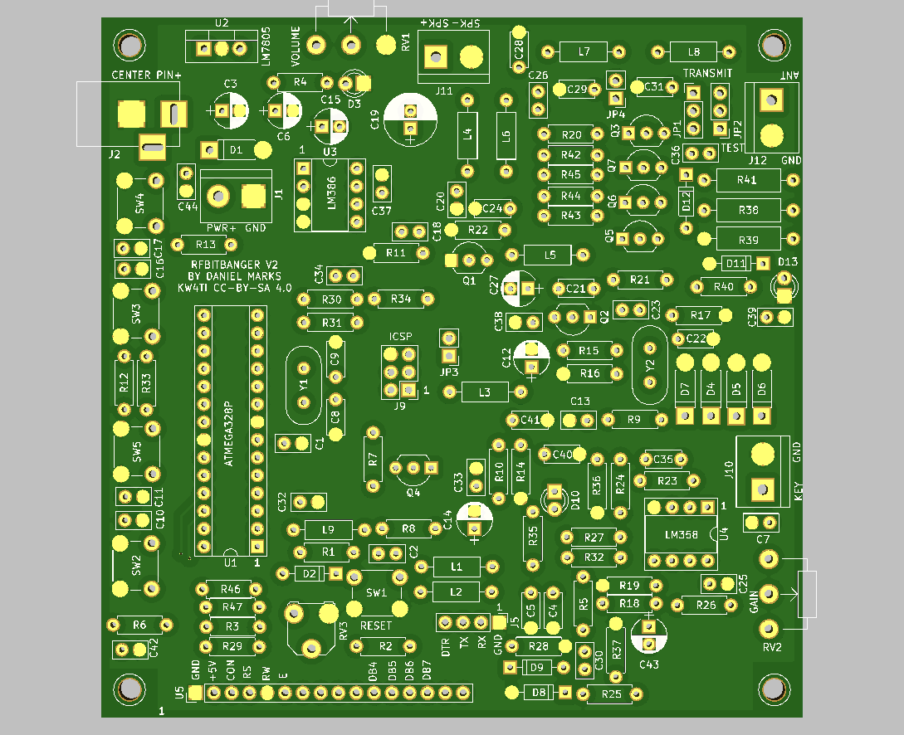
Printed Circuit Board Component Layout and Schematic
