PROGRAM-1: PRINT HELLO,WORLD

*************************************
package main

import "fmt"

func main() {
fmt.Printf("hello, world\n")
}
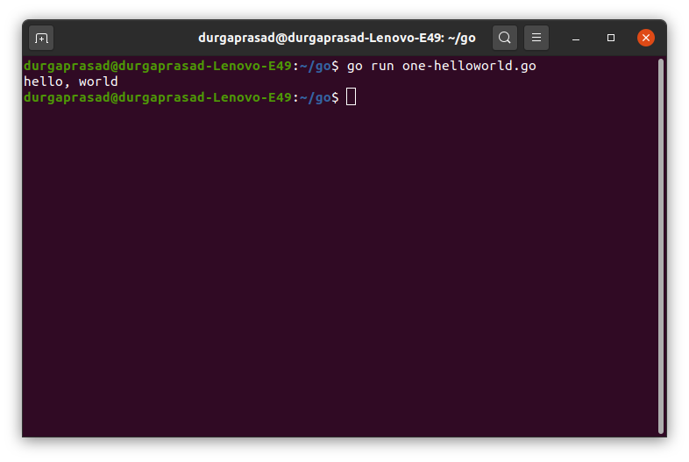

TO BUILD FILE
BELOW COMMAND
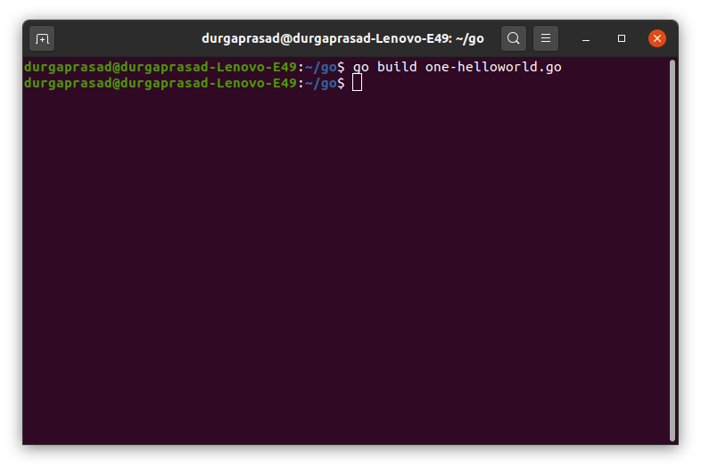

THEN EXECUTE BUILD FILE
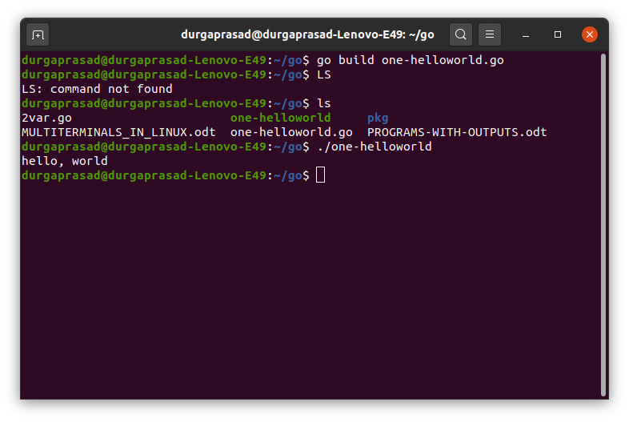

errors-1:

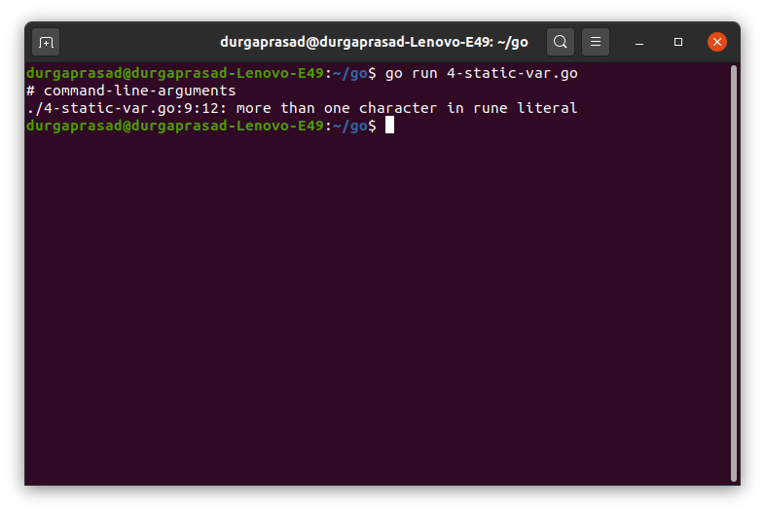

mt.Printf(‘i=’,i)---→mt.Printf("i=",i)
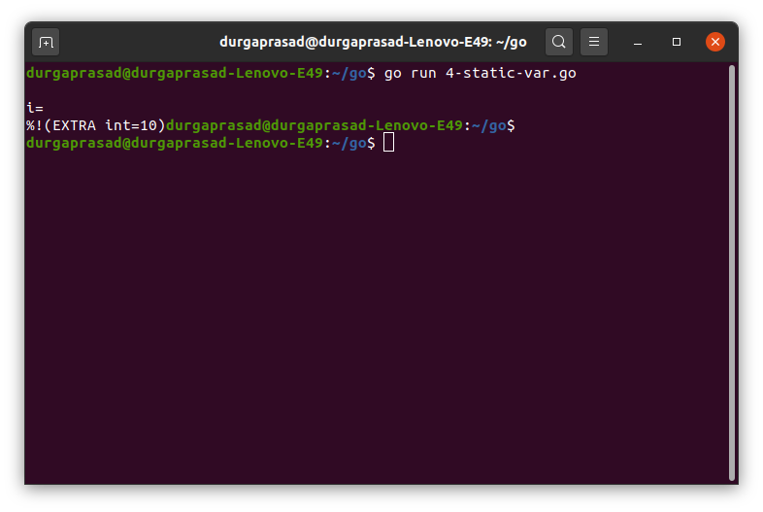
fmt.Printf("i=%d\n",i)
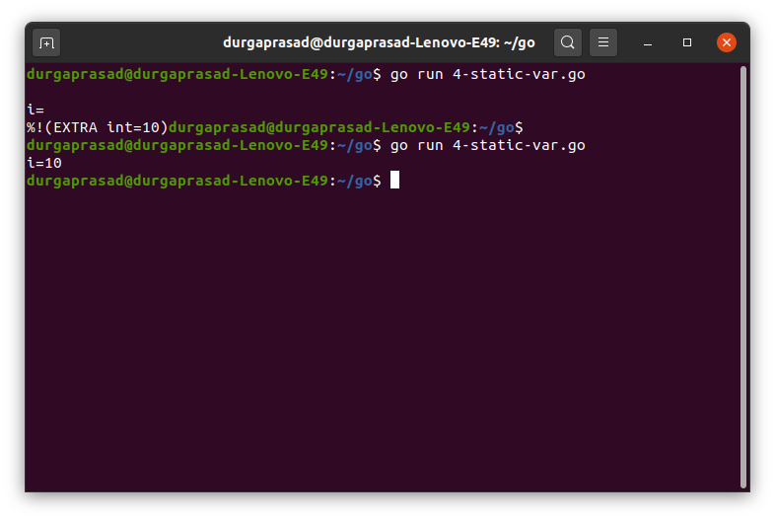

PROGRAM-2:
4-static-var.go
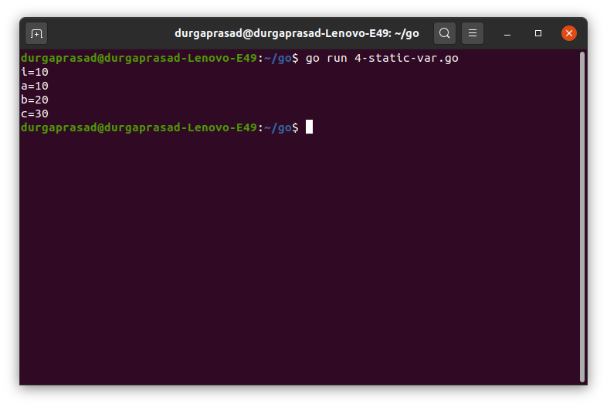

program-3:
5-dynamic-var.go
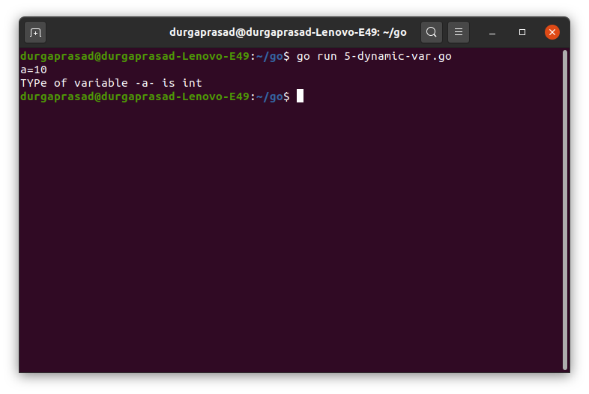

program-4:
6-staticdynamic-var.go
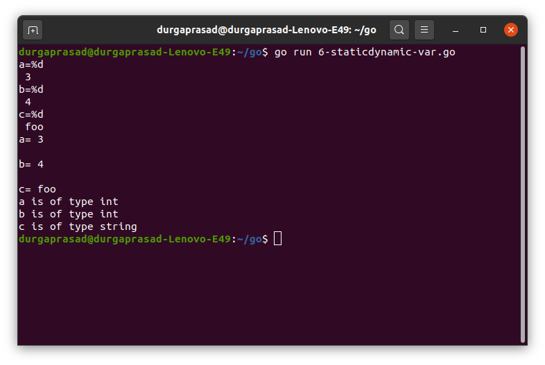

LINUX COMMAND TO MOVE ALL FILES EXCEPT SOME:

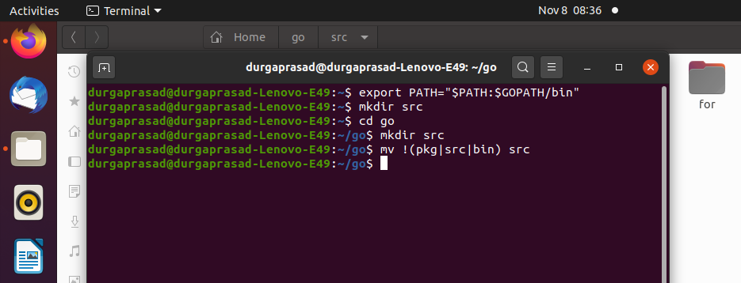

GIT ERRORS AND:

durgaprasad@durgaprasad-Lenovo-E49:~/go$ cd..
cd..: command not found
durgaprasad@durgaprasad-Lenovo-E49:~/go$ cd-

Command 'cd-' not found, did you mean:

command 'cdb' from deb tinycdb (0.78build1)
command 'cdi' from deb cdo (1.9.9~rc1-1)
command 'cdp' from deb irpas (0.10-7)
command 'cdo' from deb cdo (1.9.9~rc1-1)
command 'cde' from deb cde (0.1+git9-g551e54d-1.1build1)
command 'cdw' from deb cdw (0.8.1-1build4)
command 'cd5' from deb cd5 (0.1-4)

Try: sudo apt install <deb name>

durgaprasad@durgaprasad-Lenovo-E49:~/go$ cd ..
durgaprasad@durgaprasad-Lenovo-E49:~$ git init
Initialized empty Git repository in /home/durgaprasad/.git/
durgaprasad@durgaprasad-Lenovo-E49:~$ git add '.\go'
fatal: pathspec '.\go' did not match any files
durgaprasad@durgaprasad-Lenovo-E49:~$ cd go
durgaprasad@durgaprasad-Lenovo-E49:~/go$ git init
Initialized empty Git repository in /home/durgaprasad/go/.git/
durgaprasad@durgaprasad-Lenovo-E49:~/go$ git add'src'
git: 'addsrc' is not a git command. See 'git --help'.
durgaprasad@durgaprasad-Lenovo-E49:~/go$ git add 'src'
durgaprasad@durgaprasad-Lenovo-E49:~/go$ git commit -m "Initial Commit"

*** Please tell me who you are.

Run

git config --global user.email "you@example.com"
git config --global user.name "Your Name"

to set your account's default identity.
Omit --global to set the identity only in this repository.

fatal: unable to auto-detect email address (got 'durgaprasad@durgaprasad-Lenovo-E49.(none)')
durgaprasad@durgaprasad-Lenovo-E49:~/go$ git remote add origin https://github.com/durgaprasad-palanati-AI/golang
durgaprasad@durgaprasad-Lenovo-E49:~/go$ git remote -v
origin https://github.com/durgaprasad-palanati-AI/golang (fetch)
origin https://github.com/durgaprasad-palanati-AI/golang (push)
durgaprasad@durgaprasad-Lenovo-E49:~/go$ git push -u origin master
error: src refspec master does not match any
error: failed to push some refs to 'https://github.com/durgaprasad-palanati-AI/golang'
durgaprasad@durgaprasad-Lenovo-E49:~/go$ git add './src'

durgaprasad@durgaprasad-Lenovo-E49:~/go$
durgaprasad@durgaprasad-Lenovo-E49:~/go$ git commit -m "Initial Commit"

*** Please tell me who you are.

Run

git config --global user.email "you@example.com"
git config --global user.name "Your Name"

to set your account's default identity.
Omit --global to set the identity only in this repository.

fatal: unable to auto-detect email address (got 'durgaprasad@durgaprasad-Lenovo-E49.(none)')
durgaprasad@durgaprasad-Lenovo-E49:~/go$ git remote add origin https://github.com/durgaprasad-palanati-AI/golang
fatal: remote origin already exists.
durgaprasad@durgaprasad-Lenovo-E49:~/go$ git remote -v
origin https://github.com/durgaprasad-palanati-AI/golang (fetch)
origin https://github.com/durgaprasad-palanati-AI/golang (push)
durgaprasad@durgaprasad-Lenovo-E49:~/go$ git push -u origin master
error: src refspec master does not match any
error: failed to push some refs to 'https://github.com/durgaprasad-palanati-AI/golang'
durgaprasad@durgaprasad-Lenovo-E49:~/go$
durgaprasad@durgaprasad-Lenovo-E49:~/go$ ^C
durgaprasad@durgaprasad-Lenovo-E49:~/go$ git push -f origin master
error: src refspec master does not match any
error: failed to push some refs to 'https://github.com/durgaprasad-palanati-AI/golang'
durgaprasad@durgaprasad-Lenovo-E49:~/go$ git add './src/iff/if-1.go'
durgaprasad@durgaprasad-Lenovo-E49:~/go$ git commit -m "Initial Commit"

*** Please tell me who you are.

Run

git config --global user.email "you@example.com"
git config --global user.name "Your Name"

to set your account's default identity.
Omit --global to set the identity only in this repository.

fatal: unable to auto-detect email address (got 'durgaprasad@durgaprasad-Lenovo-E49.(none)')
durgaprasad@durgaprasad-Lenovo-E49:~/go$ git remote add origin https://github.com/durgaprasad-palanati-AI/golang
fatal: remote origin already exists.
durgaprasad@durgaprasad-Lenovo-E49:~/go$ git remote -v
origin https://github.com/durgaprasad-palanati-AI/golang (fetch)
origin https://github.com/durgaprasad-palanati-AI/golang (push)
durgaprasad@durgaprasad-Lenovo-E49:~/go$ git push -f origin master
error: src refspec master does not match any
error: failed to push some refs to 'https://github.com/durgaprasad-palanati-AI/golang'
durgaprasad@durgaprasad-Lenovo-E49:~/go$ git commit -m "Initial Commit"

*** Please tell me who you are.

Run

git config --global user.email "you@example.com"
git config --global user.name "Your Name"

to set your account's default identity.
Omit --global to set the identity only in this repository.

fatal: unable to auto-detect email address (got 'durgaprasad@durgaprasad-Lenovo-E49.(none)')
durgaprasad@durgaprasad-Lenovo-E49:~/go$ git config --global user.email dp.cse5@gmail.com
durgaprasad@durgaprasad-Lenovo-E49:~/go$ git config --global user.email "dp.cse5@gmail.com"
durgaprasad@durgaprasad-Lenovo-E49:~/go$ git config --global user.name "durgaprasad-palanati-AI"
durgaprasad@durgaprasad-Lenovo-E49:~/go$ git commit -m "Initial Commit"
[master (root-commit) 34fa07c] Initial Commit
24 files changed, 140 insertions(+)
create mode 100644 src/.~lock.PROGRAMS-WITH-OUTPUTS.odt#
create mode 100755 src/1/one-helloworld
create mode 100644 src/1/one-helloworld.go
create mode 100755 src/2/2var
create mode 100644 src/2/2var.go
create mode 100644 src/3/3-hello.go
create mode 100755 src/4/4-static-var
create mode 100644 src/4/4-static-var.go
create mode 100755 src/5/5-dynamic-var
create mode 100644 src/5/5-dynamic-var.go
create mode 100755 src/6/6-staticdynamic-var
create mode 100644 src/6/6-staticdynamic-var.go
create mode 100644 src/MULTITERMINALS_IN_LINUX.odt
create mode 100644 src/PROGRAMS-WITH-OUTPUTS.odt
create mode 100755 src/for/for-1
create mode 100644 src/for/for-1.go
create mode 100755 src/for/for-2
create mode 100644 src/for/for-2.go
create mode 100755 src/iff/if-1
create mode 100644 src/iff/if-1.go
create mode 100755 src/iff/if-2
create mode 100644 src/iff/if-2.go
create mode 100755 src/iff/if-3
create mode 100644 src/iff/if-3.go
durgaprasad@durgaprasad-Lenovo-E49:~/go$ git remote add origin https://github.com/durgaprasad-palanati-AI/golang
fatal: remote origin already exists.
durgaprasad@durgaprasad-Lenovo-E49:~/go$ git remote -v
origin https://github.com/durgaprasad-palanati-AI/golang (fetch)
origin https://github.com/durgaprasad-palanati-AI/golang (push)
durgaprasad@durgaprasad-Lenovo-E49:~/go$ git push -f origin master
Missing or invalid credentials.
Error: socket hang up
at connResetException (internal/errors.js:570:14)
at Socket.socketOnEnd (_http_client.js:440:23)
at Socket.emit (events.js:228:7)
at endReadableNT (_stream_readable.js:1185:12)
at processTicksAndRejections (internal/process/task_queues.js:81:21) {
code: 'ECONNRESET'
}
remote: No anonymous write access.
fatal: Authentication failed for 'https://github.com/durgaprasad-palanati-AI/golang/'
durgaprasad@durgaprasad-Lenovo-E49:~/go$ git push -f origin master
Enumerating objects: 35, done.
Counting objects: 100% (35/35), done.
Delta compression using up to 4 threads
Compressing objects: 100% (33/33), done.
Writing objects: 100% (35/35), 5.23 MiB | 480.00 KiB/s, done.
Total 35 (delta 9), reused 0 (delta 0)
remote: Resolving deltas: 100% (9/9), done.
remote:
remote: Create a pull request for 'master' on GitHub by visiting:
remote: https://github.com/durgaprasad-palanati-AI/golang/pull/new/master
remote:
To https://github.com/durgaprasad-palanati-AI/golang
* [new branch] master -> master
durgaprasad@durgaprasad-Lenovo-E49:~/go$ git push -u origin master
Branch 'master' set up to track remote branch 'master' from 'origin'.
Everything up-to-date
durgaprasad@durgaprasad-Lenovo-E49:~/go$ git status
On branch master
Your branch is up to date with 'origin/master'.

Untracked files:
(use "git add <file>..." to include in what will be committed)
.vscode/
bin/
pkg/

nothing added to commit but untracked files present (use "git add" to track)
durgaprasad@durgaprasad-Lenovo-E49:~/go$ git add
Nothing specified, nothing added.
Maybe you wanted to say 'git add .'?
durgaprasad@durgaprasad-Lenovo-E49:~/go$ git add "./1"
fatal: pathspec './1' did not match any files
durgaprasad@durgaprasad-Lenovo-E49:~/go$ git add "1"
fatal: pathspec '1' did not match any files
durgaprasad@durgaprasad-Lenovo-E49:~/go$ git add "./iff/if-1.go"
fatal: pathspec './iff/if-1.go' did not match any files
durgaprasad@durgaprasad-Lenovo-E49:~/go$

