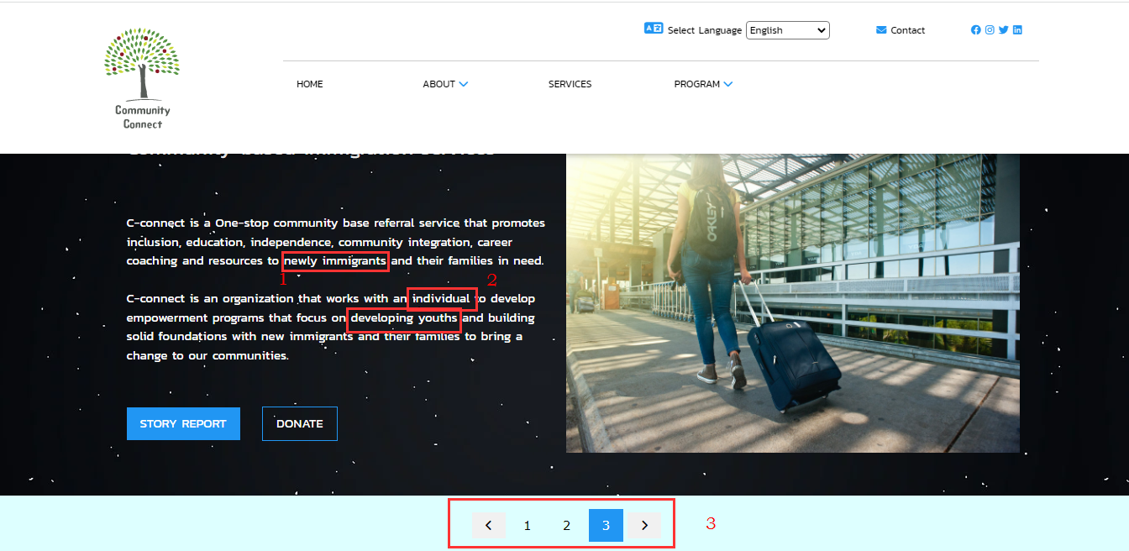

Home Page (marked up): Observations are as follows:

1. Typographical Error: “Newly Immigr Suggestion = “New Immigrants”, “Newly Located Imigrants” or “New Immigrants”
2. Acceptable grammatical structure with room for improvement: Suggestion: “works with individuals” and “focus on Youth Development”
3. Page Efficiency Issue: Since the numbered horizontal scroll is just for the header images it may be unnecessary since the images can scroll without it. No new information is conveyed per say: Suggestion: Remove it

The Logo is SUPERB. The image of a tree conveys the message of the brand perfectly!

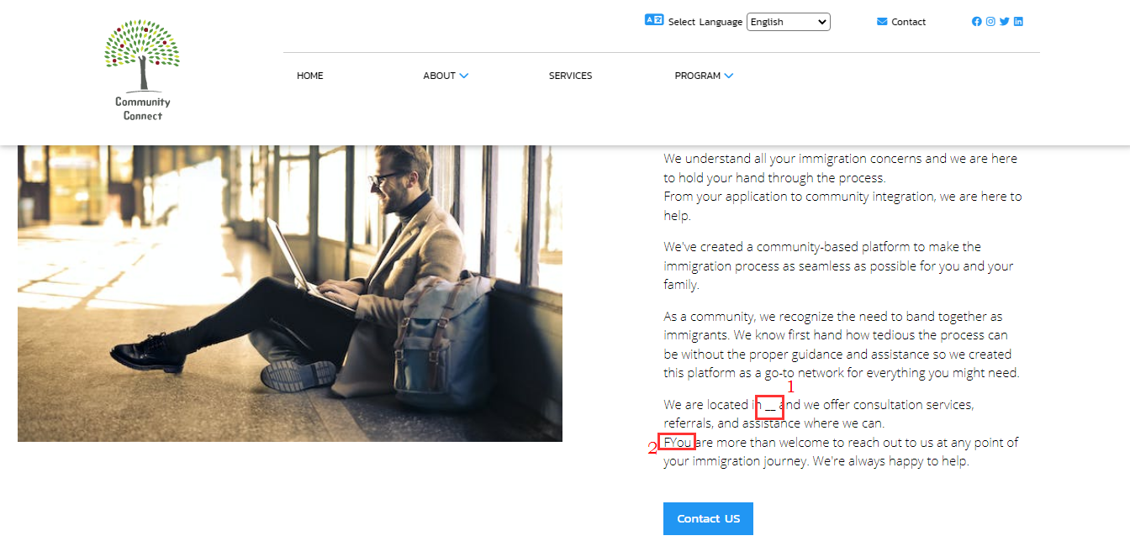

1. Location Information: Suggestion: Add a link to google maps showing location and direction to contact address
2. Typographical Error: FYou: Correction “You”

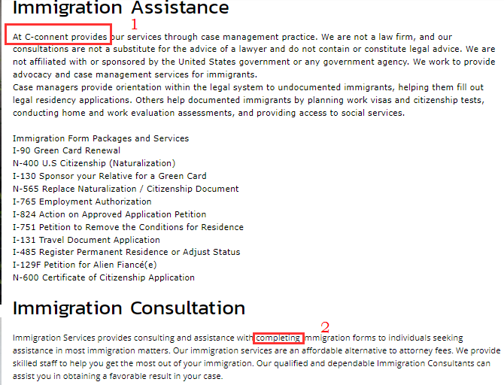

1. Typographical Error? Suggestion: “At C-connect we provide…”
2. ‘Completing’ immigration forms or ‘complete’ immigration forms

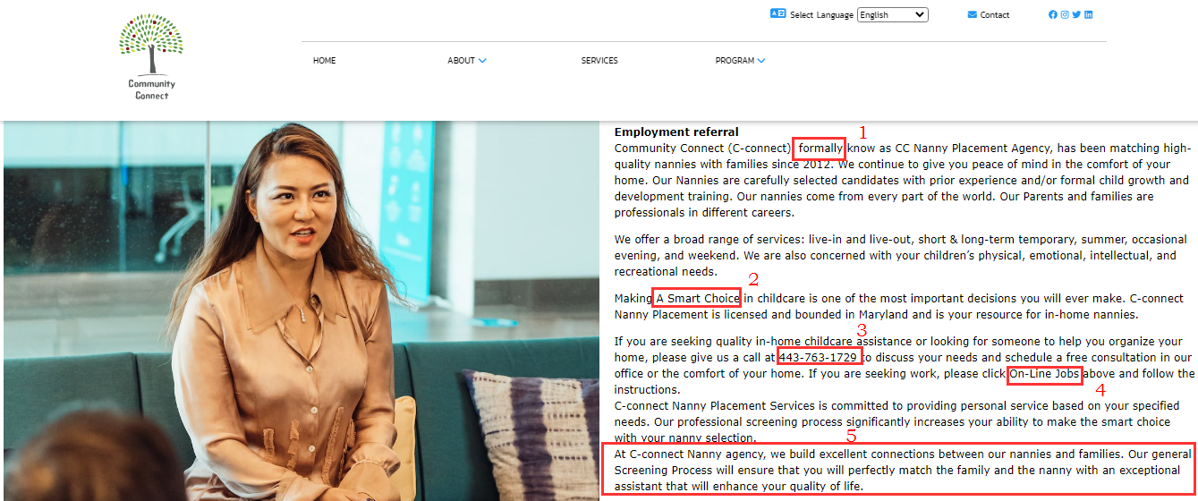

1. Formally or Formerly?
2. Smart Choice: Suggestion: Lower case: ‘smart choice’
3. Phone Number Contact: Add link to dialer (for mobile browser)
4. Add link
5. “At C-connect Nanny Agency, we build excellent connections between our nannies and famiies. Our general Screening Process ensures that we perfectly match families with our nannies for exceptional assistance that will enhance your quality of life

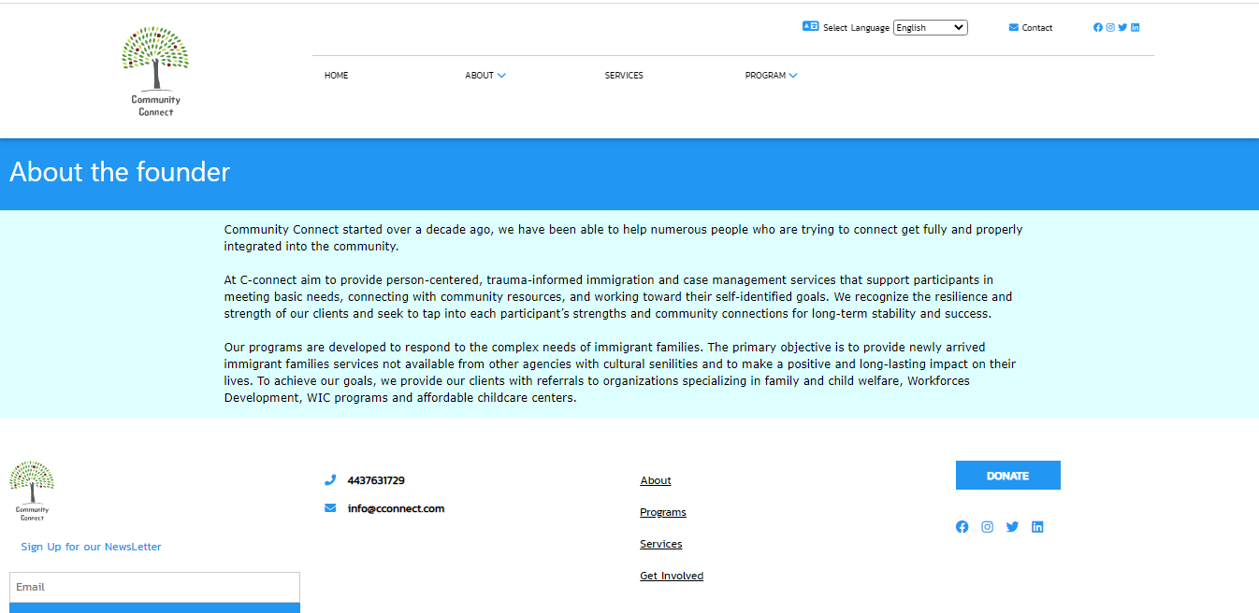

About the founder

Depending on your guidelines and policies, you may personalize the about page by adding photos and bios of the individuals behind C-connect

Other Pages

* FAQ page
* Testimonials
* Community centered blog links
* Notifications (Based on user checklist and opt in)