Term Project Manual:
- Correct settings – Critical to link the files correctly and for the program to run
- Settings - >
- Click “Assemble all files in directory”
- Click “Initialize Program Counter to global main”
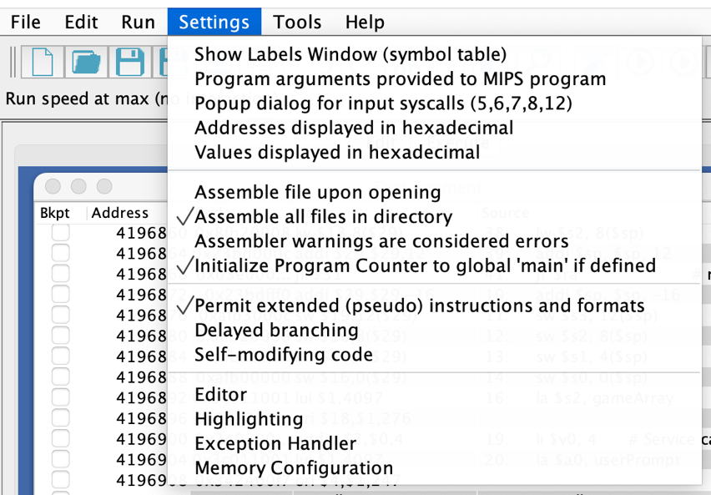
- Have it look exactly as the image below

- Navigate to the main.asm file in the TermProject_Abdullah_Naeem folder
- Open main.asm on Mars simulator
- Once open go to run in the top task bar, click assemble (F3)
- Verify that the Message console says “Assemble: operation completed successfully.”
- Go back to run in the top task bar and click Go (F5)
- The game will start automatically, and you should hear an intro tune before you see anything
How to play:
- Black hole is a two-player game where players take turns filling out 20 out of the 21 holes. This version pits a user(you) against a randomly generated procedure(computer). Each turn you decide which hole position you want to fill and every round the value of the number placed inside the hole increases by 1. Players take turns placing a number in any of the 21 holes for 10 rounds each. The last unfilled hole becomes the blackhole. The player whose tiles adjacent to the blackhole have the lowest total sum win.
- The game starts by displaying an empty triangular board with 21 holes “( )”
- Each round you will see a prompt asking you for an input between 1-21
- Simply pick the hole you want, count from the top hole which is 1, to the hole of your choosing (ensuring that it is empty) and type the hole number into the designated area
- Press enter after you’ve typed a number between 1-21
- Your tile will be placed into the board and you will see the visual
- The computer will also place a tile on the board which you will be able to see, and a prompt will tell you exactly what hole the computer placed the tile in
- The board updates after each players moves so you can see the current state of the board at all times
- This goes on for 10 rounds total
- After 10 rounds the game auto picks the winner and reveals the score.
- You will hear a happy tune if you win, alongside a congratulations message.
- If you lose, you will hear a sadder tone, alongside a retry message.
- If you tie, you will hear no sound, just a “Both players tied at: (score sum)” message.

Input Errors:
- If you enter a number out of the range of 1-21 you will see a “Error: out or range, Retry” message; simply retry and pick another valid number within the range
- If you enter a number and that hole is already full you will see a “Error: Spot is full, Retry” message; Simply retry with another number
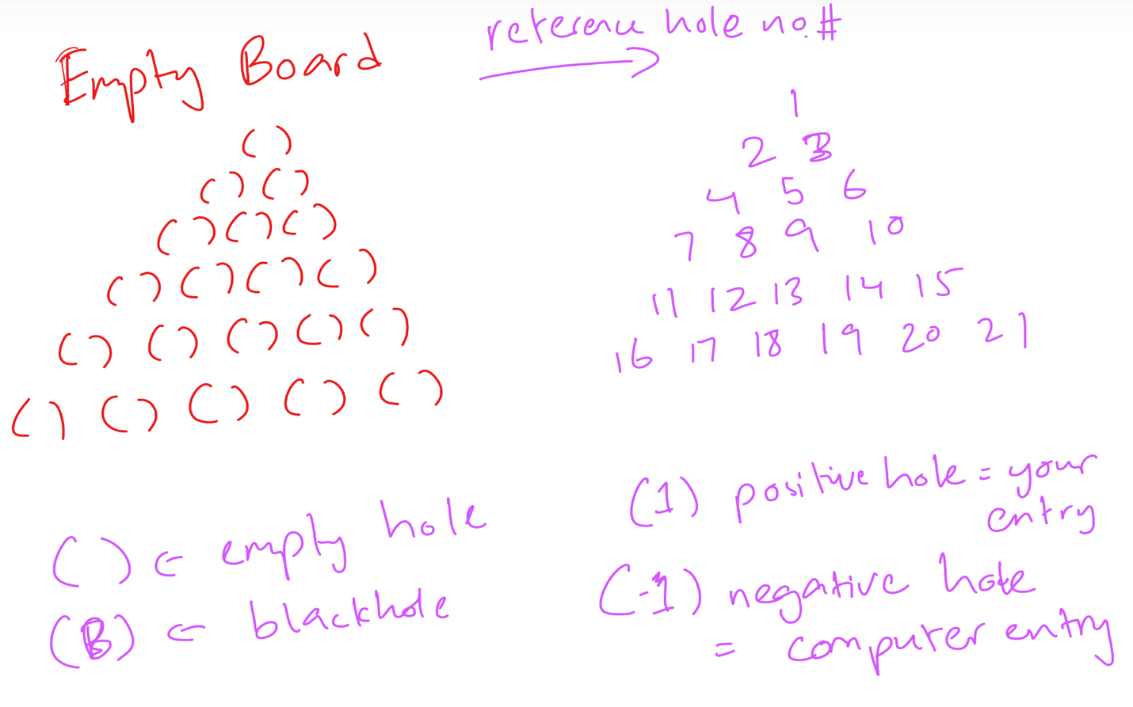
How to read the board:

