Abdullah Naeem
CS-2340.005
Mar 26, 2026
REFERENCE PAGE
Project Report:
- Description of Program | Pg 2
- Challenges | Pg 6
- What I learned | Pg 9
- Algorithm Analysis | Pg 10
- Pseudocode | Pg 14
- Extra Credit | Pg 15

EXTRA CREDIT: MIDI OUT SYNC, ADDED CREATIVE SOUNDS, EXPLAINED ON THE LAST PAGE

Description:
- The program consists of 6 files, excluding SysCalls.asm
- Board.asm, display.asm, computer.asm, input.asm, main.asm, scoring.asm
- Uses ASCII to display and update the board as the user inputs more indexes

Main.asm
- Acts as the entry point to the entire program
- It initializes the game and plays the intro music (Using MIDI OUT SYNC)
- Calls the Drawboard procedure to display an empty board
- It has 10 organized rounds that follow the gameplay sequentially.
- The 10 rounds consist of the same pattern:
  - Call Input Validation to get a valid player move
  - Gets a valid indexed value back
  - Calculates the memory offset and saves the correct tile value (corresponding to round, for e.g. round 1 = tile value 1) into the player selected hole position
  - Calls DrawBoard again to display the user’s input visually
  - It then calls ComputerInput procedure to get a randomly generated index
  - Returns a random index number into $v0
  - Calculates memory offset and saves the correct tile value (value = negative round no.#) into the randomly generated index position)
  - Calls DrawBoard again to display the most up to date gameArray
- After the 10 rounds finish, the main file has an inbuilt loop to find the final empty spot.
- When it loops and finds the sentinel value (-99), it replaces the -99 with a 0 to mark it as a blackhole for the ScoreGame and DrawBoard procedure to recognize it as such
- Calls the DrawBoard procedure one final time to show the completed board, plus the blackhole (marked as (B))
- Calls the ScoreGame procedure to calculate the scores and announce the winner
- Terminates the program with a SysExit syscall

Board.asm
- This is the data base for the entire program
- It defines the gameArray: 21 words initialized to -99 (sentinel value to indicate empty hole)
- Defines LookUpTable: 21 rows, 6 words wide (to make calculating offset easier)
  - Each row corresponds to a specific index
  - Each entry in any row is the corresponding neighboring index
  - -1 is used as the LookUpTables own sentinel value, telling procedures to stop looking for more neighbors
  - Max neighbors that any index can have is 6 (thus the table being 6 words wide)
  - Serves as a data base for other procedures to simply look up the neighbors instead of spending time on neighbor calculation
- Declares the musicLength, musicDuration and the startIntroMusic arrays to correctly define the main.asm intro song attributes
- Uses .globl for all the arrays in the .data section, allowing all files within the folder to easily access the information
- Has an empty .text section as it does not run any code nor is it a procedure

Display.asm
- Display procedure responsible solely for displaying the board visually using ASCII
- The DrawBoard procedure is declared with .globl at the top to make it available for main.asm
- Allocated 12 bytes to stack for three saved registers, deallocates when it restores at the end
- Takes the baseAddress of gameArray as input parameter via $a0
- Uses a nested loop structure (Pseudocode provided in this report further down):
  - Outer while loop, iterates all the way from row 1 to 6
  - For each row the loop calculates the correct amount of leading spaces = (6-row)*2
  - Space loop prints the calculated leading spaces
  - Hole Loop iterates from hole 1 to hole row number (for e.g row 2 has 2 holes)
- For each hole:
  - Calculates memory offset, arrayIndex * 4
  - Loads value from gameArray at that offset
  - Branches using If Else statement equivalents:
    - if value == -99, prints “( )” for empty hole
    - if value == 0, prints “(B)” for black hole
    - for all other values, prints “(“ + value + “)”, showing the tile number, negative = computer input, positive = user Input
    - arrayIndex increments continuously and never resets between rows
- Returns via jr $ra
- Contains its own ascii display board strings in its own .data section
- Never modified the gameArray, only reads and prints

Input.asm
- This procedure is responsible for getting a valid user Input
- Defines InputValidation procedure via .globl
- Allocates 16 bytes on the stack for 4 saved registers
- Loads base Address of gameArray via load Address instruction
- Prints prompt asking user for input “Enter hole position 1-21: “
- Enters a while loop which only exits once the user enters a valid input:
  - Reads user Input using SysReadInt syscall
  - Takes userInput of hole position and subtracts 1 to get 0-based index
  - Checks for range, $s1 < 0, $s1 > 20, and prints out of range error if input is out of this range
  - Checks whether the hole is empty or not, if loaded value of that specific index spot == -99, then it is valid spot, or else it branches to hole not empty error
  - If all checks pass, it returns the value via $v0
  - It then restores the stack, deallocating the 16 bytes
- All error messages and prompts are defined in its own .data section
- Never writes to the array, it only reads the user input and returns it to main.asm

Computer.asm
- Defines the ComputerInput procedure responsible for generating a random index
- .globl is used to make it a global procedure
- Allocates 12 bytes for three saved registers
- Loads base gameArray via load address instruction
- Uses a while loop to generate a valid random index input
  - Calls SysRandIntRange syscall
  - Sets range from 0 to 21
  - The result lands in $a0
  - This result is immediately saved to $s0 in order to ensure that the randomly generated index is not lost
  - Calculates offset = $s0 * 4, because a word is 4 bytes
  - Loads value from gameArray to verify if it’s valid
  - If value != -99, then the spot is full, it jumps back to while loop
  - If value == -99, then randomly generated index is a valid input
- Puts index value from $s0 into $v0 to return it back to main.asm
- Not hard coded; in this fashion every game is a unique game
- Doesn’t have anything in its .data section since the computer is simply generating a number and requires no user Input
- Restores stack by deallocating 12 bytes
- Uses jr $ra to jump back to the caller in main.asm

Scoring.asm
- Scoring module defines the ScoreGame procedure via .globl
- This procedure is responsible for taking the final gameArray and then declaring the winner
- It allocates 24 bytes to the stack for 5 saved registers, plus $ra
- Loads gameArray via load address instruction
- It loads gameArray baseAddress directly into $s3 and the LookUpTable baseAddress directly into $t3
- Initializes indexBlackhole, P1Score, P2Score and table variables to 0
- The outer loop scans all 21 holes to find the black hole:
  - It loads value at each index
  - If value != 0, it increments and moves forward
  - If value == 0, it’s a blackhole and the index is noted
  - Once the blackhole is found, it calculates the correct row on the LookUpTable by simply doing rowOffset = blackholeIndex * 24 (6 words per row * 4 bytes per word)
- Inner loop iterates through all 6 neighbor slots in the LookUpTable:
  - Loads neighbor index values from the table
  - If neighbor index == -1, that is a sentinel value which tells the code to skip
  - Otherwise it loads the value from the gameArray at the neighborindex
  - If value == -99, the hole is empty skip to next neighborIndex (shouldn’t happen since it is the end of the game)
  - If value > 0, adds to P1Score
  - If value < 0, subtracts from P2Score(Computer), two negatives make a positive
- After the loops have run and scanned the neighbors and added to each relative players’ score, it compares P1Score and P2Score in the WinnerLogic:
  - P1Score < P2Score, Player 1 wins, congratulation message plus a winning tune using MIDIOUTSYNC syscall
  - P2Score < P1Score, Player 2 win, try again message, computer wins, plays a sad tune using MIDIOUTSYNC syscall
  - Equal Score results in a Tie, prints tie message
- Deallocates the 24 bytes and restores the stack
- Returns via jr $ra
- All the result strings are in its own .data section.

Challenges:
- Challenge 1: Building the Lookup table:
When initially starting the assignment, I was dumbfounded as to how to even tackle the problem with the neighbors. I stumbled across the slides provided by the TA and professor which stated something about a look up table. I spent days trying to figure it out, until one day I understood that I must first understand what the neighbor indexes even are. I devised a plan where each row would correspond to an index, and I would put all the neighbor indexes on that specific row.
This idea was working well, but then I stumbled into the issue where some holes had 6 neighboring holes, and some had only 2. To mitigate this, I developed a plan where all of the rows would be 6 words wide but for holes that didn’t have the full 6 neighbors, I padded it with -1, to let the Scoring logic know to stop reading neighbors past this point.
Initially this assignment was done for 10 holes (assignment 4), planning shown below:
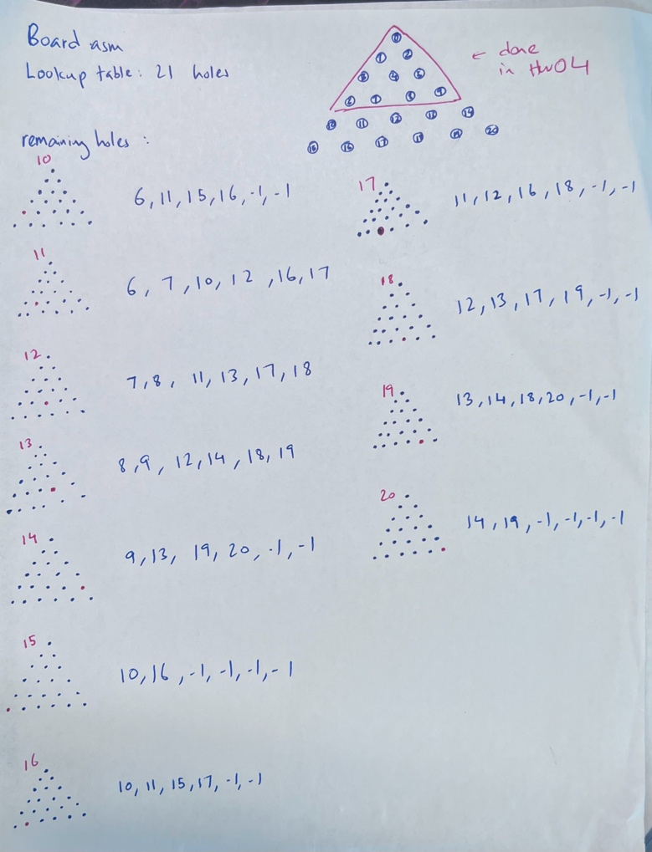
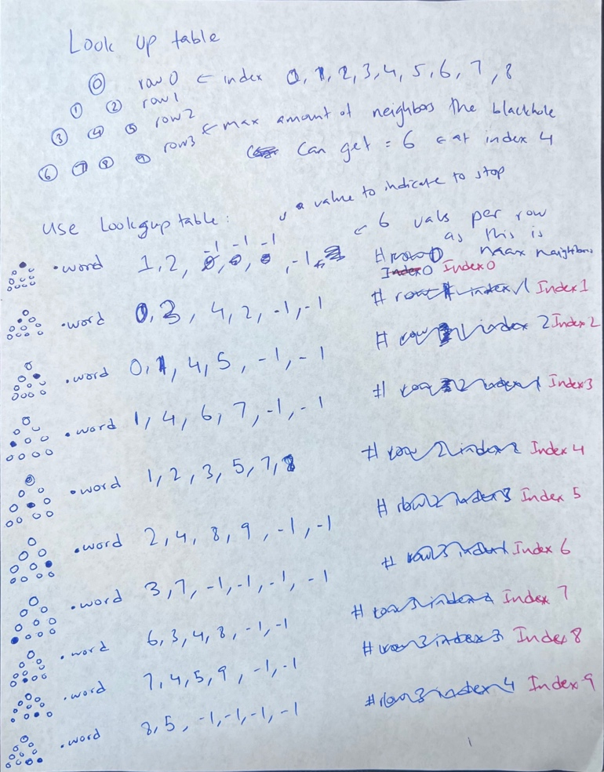
The picture on the left illustrates my initial working with the 10 holes, and the right picture shows me using the same exact logic but extending it to 21 holes.
I verified the neighbor indexes by trying out some physical games on paper by using the look up table and then I tested the final game multiple times to ensure that the score was matching my visual assessment.

- Challenge 2: Modular design
Although short lived, I was unsure on how to make procedures and arrays in different files talk to each other. Additionally, I wasn’t sure what settings needed to be changed.
However, my answer came in the form of the term project slides from teams, where it stated to use the .globl command to make the procedure or array available to any other file in the folder. Additionally, it provided me with the exact settings I needed to ensure that the program worked seamlessly.

- Challenge 3: Differentiating between computer and user hole input when scoring
When I started creating the scoring logic for the game in Assignment 4, I had to research quite a bit in order to understand how I could differentiate between a tile being placed by the user or by a computer.
After some time, I realized that by making one positive and one negative, I could easily distinguish between the two inputs.
However, the issue didn’t stop there. My next issue was the points logic, where I was trying to figure out how to add a negative number to P2Score and still be able to compare it to P1Score (negative is always lower than positive). This was a short-lived challenge, since to make something negative, positive, you simply just subtract it. So, by essentially doing P2Score -= points, I was able to ensure that the negative tile value was actually adding up in the variable P2Score as a positive value, making it easy for me to compare the two scores.
In this fashion I just used the blt and beq logic to check whether P1 or P2 won or whether they tied.

- Challenge 4: Centering the Triangle Board Display
To even create the board in ASCII format, I was confused. I simply used a string “( )” to print out the empty hole, and for each row I printed out a set number of holes needed, with a space in between. However, this created the triangle board and made it left aligned. This wasn’t satisfactory as the board itself is meant to be visually centered.
To fix this issue I had to spend some time searching for ways to fix this cleanly. I finally found the fix in form of an easy formula, (6 – rowNum) * 2. Six because the largest layer (the bottom layer) has a total of 6 holes. I subtracted rowNum because there are exactly equal amount of holes per row as the rowNum. Then multiplied it by the number two because each empty string “( ) “ has four characters, left parenthesis, space, right parenthesis, and the trailing space at the end that maintains the visual gap between each hole on the same row. A space is only 1 character, so to ensure that I was shifting each row over exactly half, I simply did *2 instead of *4. This ensured that the triangle was neither left aligned nor right aligned, instead it was visually centered.
The final issue that I was presented was the fact that any negative input would be 2 characters, whereas a positive input would only be one character. This naturally slightly messes up the alignment as the game progresses; however I simply accepted this as part of the limitations of using an ASCII based board display.

- Challenge 5: Time management
Having other courses meant that I had to prioritize my time. I struggled quite a bit to find time in between my other projects and exams to write code. Due to this time limitation, I prioritized working on building the core game over extra credit.
Once I understood how to plan, do the Lookup Table and make my program modular, I spent time going back and cannibalizing my old assignments to easily create the ScoreGame and the DrawBoard procedure.
I then created pseudocode for any other part that I had to code up, making it easier for me to maintain the core logic of the code while writing tedious MIPS Code.
Finally, after I had made the core game, I went back and picked an easy extra credit, MIDIOUTSYNC, creating an intro and outro tune for some extra credit.
In this fashion I finished my code within two weeks, and the remaining time was used to write up the project report.

- Challenge 6: MARS editor being slow and sluggish
This was perhaps my most difficult challenge. I am quite a fast typer, so when writing code in short bursts, the MARS editor would always lag or delay its refresh, causing me to lose my train of thought. I knew that this would inhibit my ability to efficiently write code.
To combat this, I installed a Mars Mips extension on VS code. Now I could write code on an excellent and familiar IDE, and when it came time to test the code, I would simply open it in mars and test it, come back to VSCODE and edit, and then go back to Mars to test it again. This shaved of a huge portion of my time simply writing the code.

What I have learned:
- MIPS Calling Convention:
- Learned the difference between the use case of saved registers $s and temporary registers $t
- $t registers are temporary scratch pads that can be used everywhere
- $s are saved registers that must be preserved
- Learned that if a procedure is a non-leaf procedure, the $ra register must be saved
- Understood how to effectively use stacks and how the order matters when allocating and restoring the stack
- Modular Project development:
- Learned how to make projects where the project is split into multiple sections and into different files
- Learned how to make all the files communicate with other files
- Learned how to use .globl to make any array or procedure be known to other files
- Learned that all files must have .data or .text section even if they aren’t used
- Syscall usage:
- Learned how to use SysCall.asm effectively throughout the code, instead of relying on numbers
- Learned how to generate random numbers using SysCall
- Learned how to produce sound using SysCall
- Learned how MIPS views and uses syscalls to execute commands
- Learned how to exit a program using SysExit
- Translating High level languages to Assembly (Mips):
- Learned how java logic maps to Mips Assembly language
- Learned how the computer handles bytes directly to execute simple functions like add
- Learned how much work actually goes into doing something as simple as print
- Understood the importance of JVM, and the vast amount of work it automates
- Understood how to branch, jump and construct if/else and while/for loops in Mips Assembly
- Understood how to use registers and memory in Assembly
- Using prior work:
- Learned the importance of understanding your own code, so that when you reuse that code you can correctly and efficiently implement it in your other codes
- Learned how to use code from HW04 and HW05, modifying it and using it in the term project
- Learned how to comment accurately and precisely
- Learned how to use VSCODE to comment easily on repeating lines
- Work plan:
- Learned how to effectively plan and execute a project
- Learned how to use resources to craft my own solutions
- Learned how to effectively craft pseudocode logic beforehand so that during the project I don’t lose my train of thought
- Learned how projects are built from scratch to finish
- Understood the importance of writing reports to describe the project in detail
Algorithm Analysis:
Board Display Algorithm (display.asm)
- Purpose: To display the 21-hole game board in ascii format visually to the user:
Nested Loops:
  - Triangle has 6 rows, outer loop traversing 6 times guarantees that the code hits every hole, especially because any row N has N holes in it.
  - The outer Loop controls the rows, the inner loop controls the holes per row
Centering Formula:
- Widest row has 6 holes in it
- Each ( ) , has four characters including the trailing space at the end to keep it separate from the other holes.
- So 6 – rowNum (because any row N has N holes In it), gives us the value of missing holes per row in relation to the final row.
- Since each “( ) “ has four characters, to get the triangular shape, naturally we divide the characters by 2 and get 4/2 = 2
- This suggests that in order to get the triangular shape, we compensate for every missing hole (6-rowNum) and times it by 2 characters. (6-rowNum) *2 = Spaces needed before we even print the hole string for each time we print a row of holes.
- For e.g. Row 1 gets 10 spaces whereas row 6 gets 0 spaces.
- The trailing space at the end of each hole is hardcoded in the ForHoleIncrement section
Continuous Index: arrayIndex
- This index runs from 0 – 20
- Doesn’t get reset every hole or row
- Offset = arrayIndex * 4, (since 4 bytes for one word)
- Is essential for loading and incrementing to the next word in the main gameArray
If/Else logic for Displaying the holes:
- This uses a simple if and else using li and bne
- The algorithm is simple, load value from gameArray
- If value == -99 (mips uses bne so that if value != -99, it branches to elseIf statement), print emptyHoleString “( )”
- If value == 0 (mips uses bne so that if value != 0, it branches to the else statement), prints blackHoleString “(B)”
- Else it prints “(“ + value + “)”
- Negative values suggest computer entries, whereas positive values suggest user entries.

Input Validation Algorithm (input.asm)
- Purpose: Get a valid index input from the user
Loop structure:
- Uses a while(true) loop logic, that runs indefinitely until the user gives a valid input.
- Has a validation logic in built, every time the user trips those errors it automatically jumps back to the top of the while loop
Validation:
- Has two validations
- Stage 1: outOfRange
  - It takes the userInput(1-21), and then subtracts 1 to get the indexedInput 0 – based.
  - If indexedInput > 20, branches to outOfRange label
  - If indexedInput < 0, branches to outOfRange label
- Stage 2: notEmpty
  - Offset = indexedInput * 4
  - Loads value from gameArray at offset
  - If value != -99, the hole is full, branches to notEmpty label
  - If value == -99, empty hole, so it accepts the value
- outOfRange Label: Prints an out of range string and jumps back to while loop
- notEmpty Label: Prints out a HoleNotEmpty string and jumps back to while loop
Return:
- It sets $v0 to the indexed input before restoring the stack
- Restores stack by deallocating the bytes, using jr $ra to return the indexed value back to the main file
- The 0-based index is then written by main.asm into the gameArray

Computer generated index Algorithm (computer.asm)
- Purpose: Get a randomly generated index from the computer between 0 – 20
Loop Structure:
- Uses while(true) loop logic, that runs indefinitely until the computer generates a valid index
- Has an isEmpty loop built in to check whether index generated already has a value in it
Random Generation:
- The random generation happens using the SysRandIntRange syscall
- Using the MARS reference sheet, $a0 = 0, $a1 = 21, acting as the upper bound, excluding 21
- Produces a number between 0 – 20
- The result of this lands in $a0 which is then put into $s0, then into $v0 for return at the end

Since the index is randomly generated and not hardcoded, every game will be different. Additionally, in this case we don’t have to worry about the range since the computer is limited on what numbers it can even generate via the SysRandIntRange syscall.

Scoring Algorithm (scoring.asm)
- Purpose: To take the final gameArray, sum the final values, determine the lowest value and announce who won/tied
Loop Structure:
- Uses a nested loop structure
- Outer loop goes from 0-20
- Inner loop goes from 0-6 (max number of neighbors = 6)
Finding the blackhole:
- The loops scan through 0-20
- While this is happening the code looks for value == 0 in the gameArray
- This 0 is set prior to calling this procedure by main.asm after the rounds have finished
- Only one position in the gameArray has 0
LookUpTable navigation:
- Once the 0 value is found in the gameArray, the blackholeIndex value is noted.
- rowOffset = blackholeIndex * 24 (6 words per row, 4 bytes per word)
- The table address = LookUpTable baseAddress + rowOffset
- Inner loops reads all 6 entries from that row
Neighbor Scoring:
- Loads neighbor index from the LookUpTable
- If index == -1, then it skips and increments to the next neighbor index
- If index != -1, it loads value from the gameArray
- If value > 0, P1Score += value
- If value < 0, P2Score -= value (negative+negative = positive, making it easier to compare the two scores)
Winner Logic:
- Compares the two scores, P1Score and P2Score, the lower score wins and it branches to the correct label
- There are three outcomes: P1 wins, P2 wins or a tie
- Each outcome prints the appropriate ending array plus its relative tune using MIDIOUTSYNC
This algorithm has a large amount of saved registers, therefore it allocates 24 bytes to the stack and later restores that stack before jumping back to the main.asm file for SysExit.

Blackhole Insertion Algorithm (main.asm)
- Purpose: Find the last empty slot in the gameArray after the 10 rounds and replace the -99 with 0 for the scoring game logic.
- Loops from 0-20
- Calculates offset, and loads value from gameArray
- If value = -99, it has found the last empty slot and writes it as 0, marking it as a blackhole
- Jumps out of loop and calls the ScoreGame procedure.

Overall design choice:
- Blackhole is set after because it is selected by whatever index neither of the players choose
- The blackhole can’t be known until the players have made their 10 moves each
- .globl is used to ensure that crucial arrays (LookUpTable, gameArray etc.) and the procedures are made available to every file in the folder
- SysCalls.asm file is attached in order to use SysCalls instead of numbers
- The 10 rounds are just hardcoded in the main.asm file; I used this method instead of realizing that a simple loop would’ve sufficed
- Next time using a loop will drastically reduce instruction count

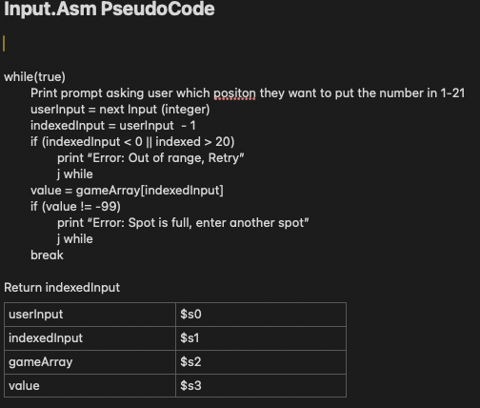
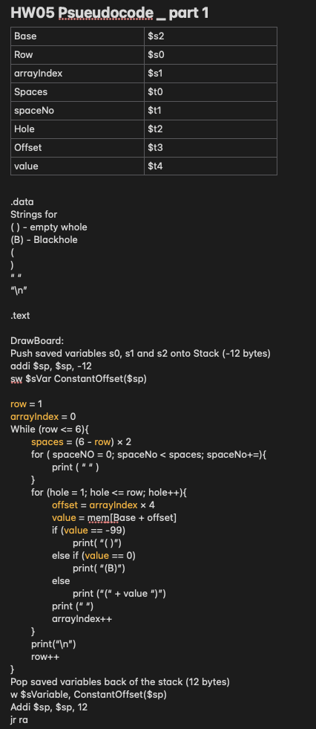
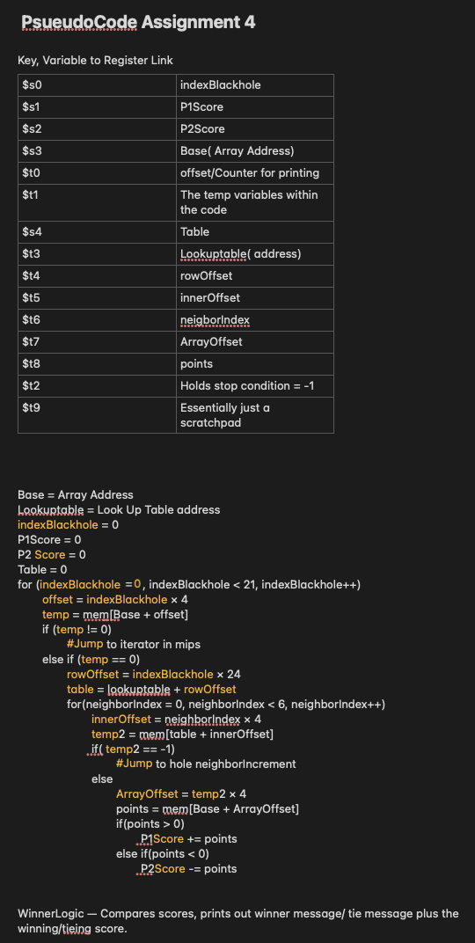
Pseudocodes:

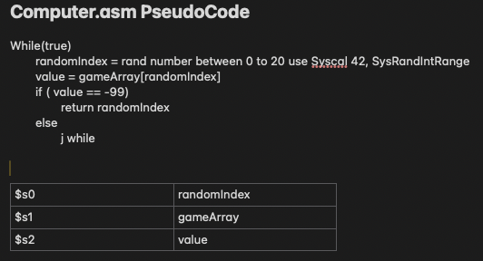

Extra Credit:
- Implemented SysMidiOutSync syscall
- I used it to play a tune in the beginning of the game
- Then played music if the player wins or if the player loses
Three distinct tunes:
- Intro tune – Uses arrays found in board.asm to play a tune before the game begins
- It has the duration, pitch and length in the array
- Winning Tune – hardcoded into the ScoreGame procedure when P1Score < P2Score
- Losing Tune – hardcoded into the ScoreGame procedure if P1Score > P2Score
SysMidiOutSync:
As per mars reference sheet, specific attributes are loaded into specific registers
$a0 = pitch
$a1 = duration in milliseconds (varying depending on what tune)
$a2 = instrument, which is 0 for me (piano = 0)
$a3 = volume (0-127)
This is implemented deeply into the Code to ensure that I meet the extra credit criteria

Manual to run the game is found in the zip file as AXN230068_ManualTermProject.docx

