**User acceptance test**

User acceptance test checks whether the whole application is working properly or not. The following screenshots show the outputs.

Menu display:

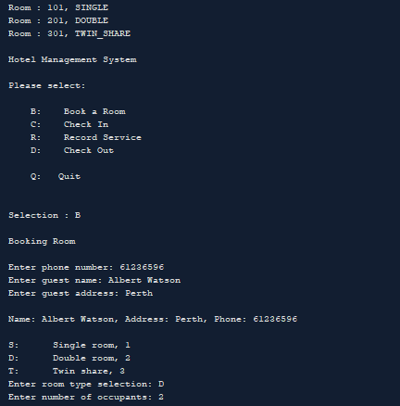

Selecting ‘Book a Room’:



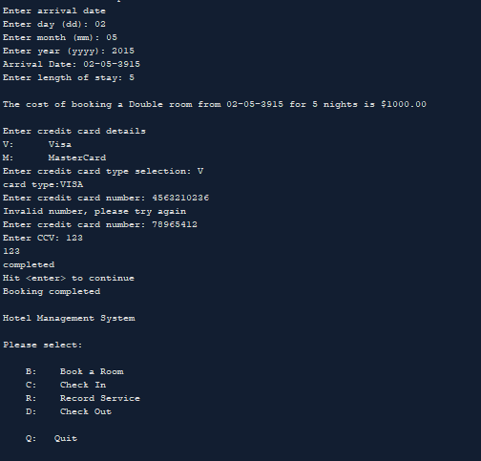

Selecting ‘Check In’:

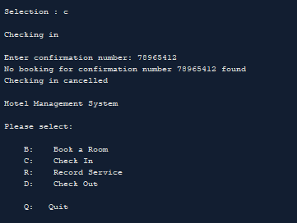

Selecting ‘Record Service’:

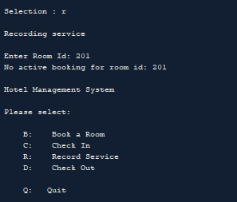

Selecting ‘Check Out’:

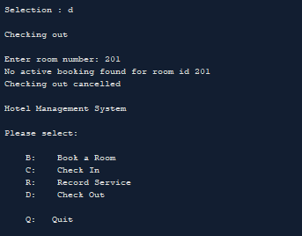

Selecting ‘Quit’

