Normal Form
Below data is used to describe information of treatment for pets at a pet medical center. Using decomposition technique to model these data into relational model basing normal forms. You should start from 1NF to 3NF.

- Healthy history report

PET ID PET NAME PET TYPE PET AGE OWNER VISIT DATE PROCEDURE
246 ROVER DOG 12 SAM COOK JAN 13/2002 01 - RABIES VACCINATION
MAR 27/2002 10 - EXAMINE and TREAT WOUND
APR 02/2002 05 - HEART WORM TEST
298 SPOT DOG 2 TERRY KIM JAN 21/2002 08 - TETANUS VACCINATION
MAR 10/2002 05 - HEART WORM TEST
341 MORRIS CAT 4 SAM COOK JAN 23/2001 01 - RABIES VACCINATION
JAN 13/2002 01 - RABIES VACCINATION
519 TWEEDY BIRD 2 TERRY KIM APR 30/2002 20 - ANNUAL CHECK UP
APR 30/2002 12 - EYE WASH

1NF
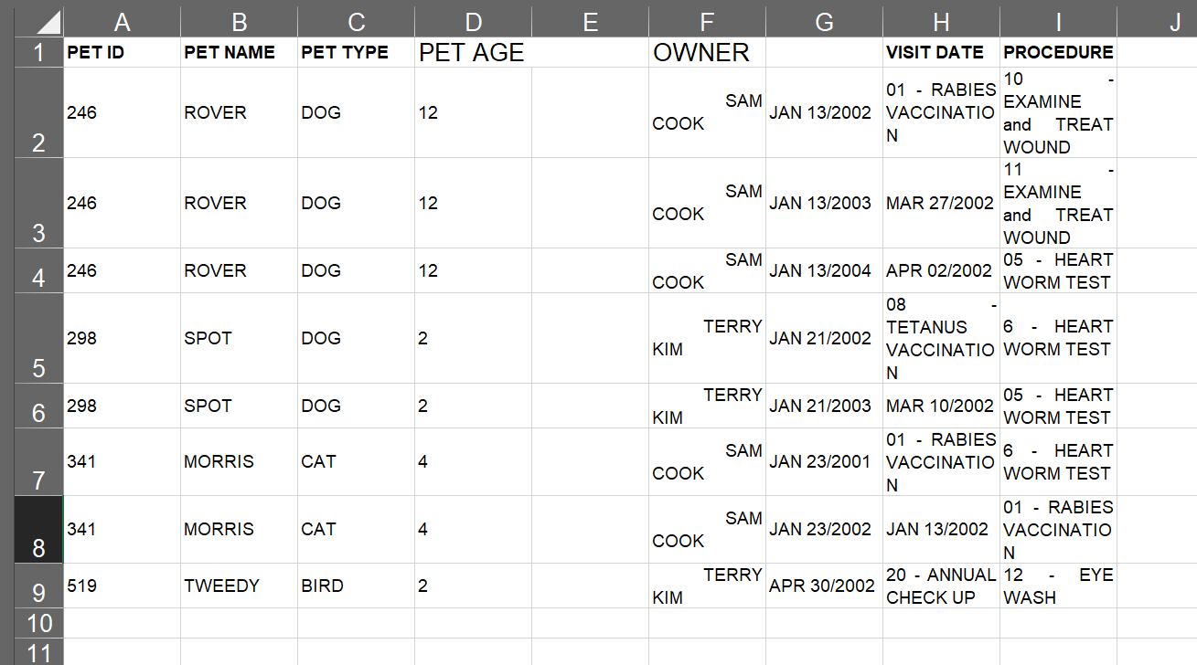

2NF: 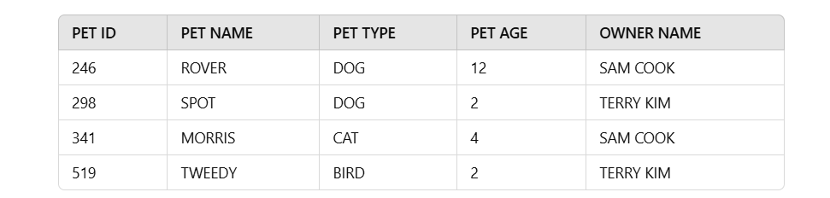

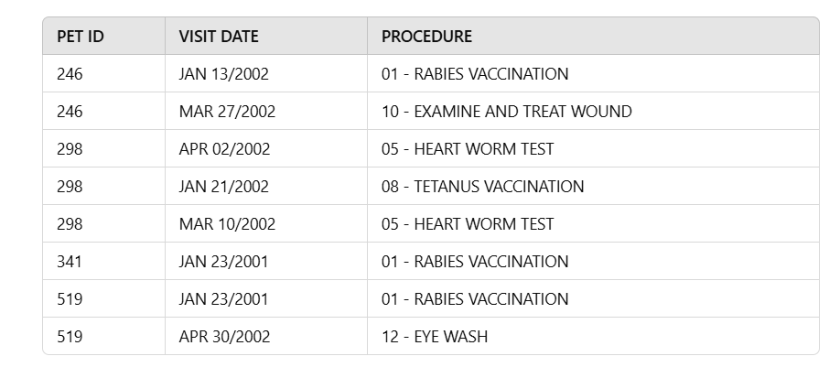

3NF

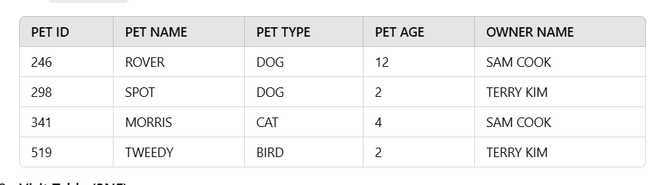
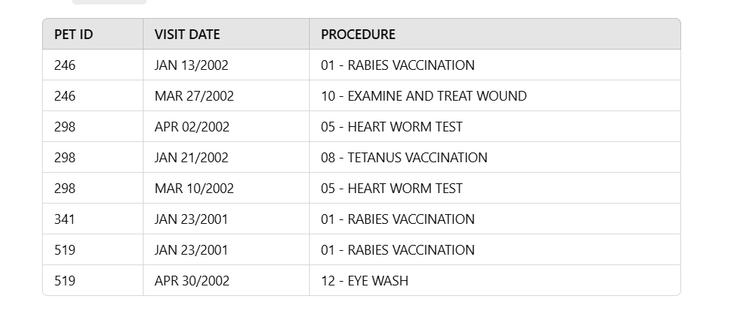
- Invoice

HILLTOP ANIMAL HOSPITAL DATE: JAN 13/2002
INVOICE # 987
MR. RICHARD COOK - 123 THIS STREET - MY CITY, ONTARIO
Z5Z 6G6
PET PROCEDURE AMOUNT
ROVER RABIES VACCINATION 30.00
MORRIS RABIES VACCINATION 24.00
TOTAL 54.00
TAX (8%) 4.32
AMOUNT OWING 58.32

2NF 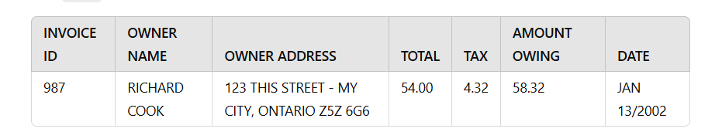
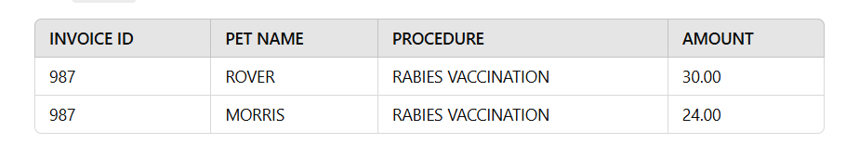

3NF 