**UMPLE DIAGRAM**

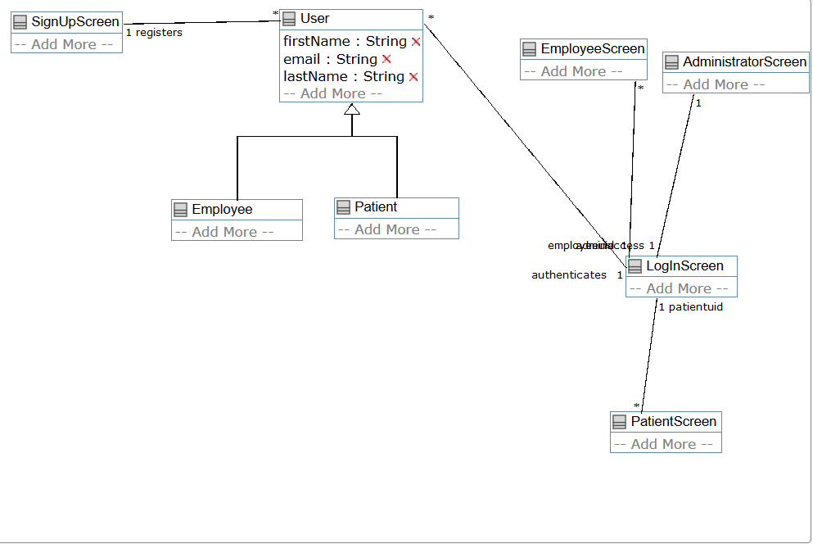

**UMPLE CODE**

class User

{

firstName;

email;

lastName;

}

class Patient

{

isA User;

}

class Employee

{

isA User;

}

class AdministratorScreen

{

}

class LogInScreen

{

1 authenticates --* User;

1 employeeuid --* EmployeeScreen;

1 patientuid--* PatientScreen;

1 adminaccess --1 AdministratorScreen;

}

class SignUpScreen

{

1 registers -- * User;

}

class PatientScreen

{

}

class EmployeeScreen

{

}

//$?[End_of_model]$?

namespace -;

class User

{

position 282 11 140 91;

}

class Patient

{

position 335 195 122 40;

}

class Employee

{

position 176 197 128 40;

}

class AdministratorScreen

{

position 656 53 143 40;

}

class LogInScreen

{

position 620 252 109 40;

position.association LogInScreen__User 0,17 141,60;

position.association LogInScreen__PatientScreen 109,40 2,0;

position.association EmployeeScreen__LogInScreen 0,10 124,0;

position.association LogInScreen:authenticates__User 0,10 141,13;

position.association EmployeeScreen__LogInScreen:employeeuid 3,0 112,40;

position.association AdministratorScreen__LogInScreen 47,0 13,40;

}

class SignUpScreen

{

position 19 14 109 40;

position.association SignUpScreen__User 110,31 0,30;

position.association SignUpScreen:registers__User 110,10 0,10;

}

class PatientScreen

{

position 605 404 109 40;

}

class EmployeeScreen

{

position 517 40 124 40;

}