Workforce Analytics Report - FY 2020

Executive Summary
This comprehensive workforce analytics report provides a detailed examination of our organization's human capital metrics for Fiscal Year 2020, with historical trends spanning from 2000 to 2020. The analysis focuses on the Accounting department in Illinois, examining both headquarters and remote workforce distributions. Our current workforce consists of 22,000 total employees, with 18,000 actively employed and 4,000 terminated positions, resulting in a termination rate of 17.7%. The average employee age is 38.4 years, with an average tenure of 14.74 years. This report analyzes workforce overview metrics, demographic distributions, hiring and attrition trends, and geographic workforce distribution to provide actionable insights for strategic human resources planning.

Workforce Overview

Key Metrics Summary

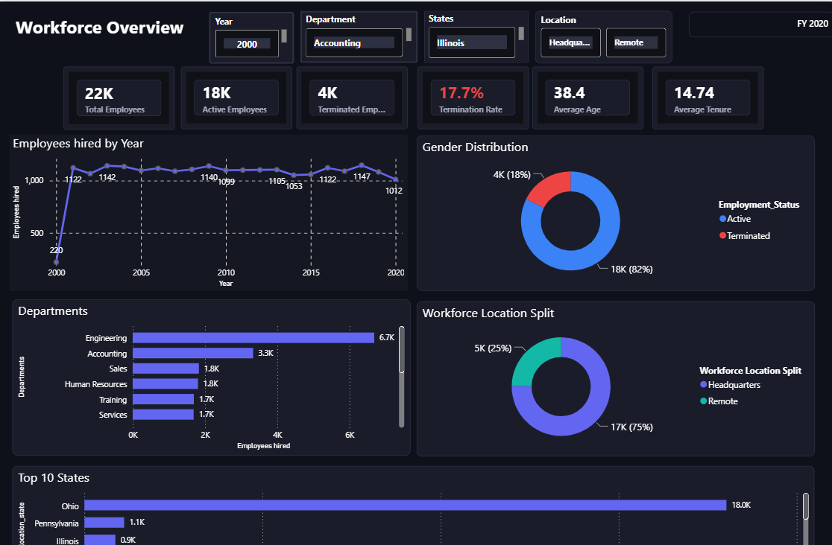
As of FY 2020, our organization maintains a workforce of 22,000 total employees. Of these, 18,000 are currently active employees, while 4,000 represent terminated positions. This yields a termination rate of 17.7%, which is significantly elevated and marked in red on our analytics dashboard, indicating an area requiring immediate strategic attention. The average age of our workforce is 38.4 years, suggesting a mature and experienced employee base. The average tenure across the organization stands at 14.74 years, demonstrating historically strong employee retention and organizational loyalty. These foundational metrics provide the baseline for deeper analysis into workforce composition, hiring patterns, and attrition trends.

Employment Status Distribution
The employment status distribution reveals that 82% of our total workforce (18,000 employees) are currently active, while 18% (4,000 employees) have been terminated. This 82-18 split between active and terminated employees represents a concerning trend that warrants investigation into the root causes of the elevated termination rate. The gender distribution within our active workforce shows remarkable balance: 82% male employees (approximately 14,760 individuals) and 18% female employees (approximately 3,240 individuals) based on the donut chart visualization. This distribution indicates ongoing workforce dynamics that require monitoring to ensure equitable employment practices.

Workforce Location Distribution
Our workforce is distributed between headquarters and remote locations at a ratio of 75% to 25%. Specifically, 17,000 employees (75%) work at headquarters facilities, while 5,000 employees (25%) work remotely. This 3-to-1 ratio of on-site to remote workers reflects organizational policies established prior to recent industry-wide shifts toward increased remote work flexibility. Given current trends in workplace flexibility and employee preferences, this distribution may warrant strategic reassessment to optimize productivity, employee satisfaction, and operational costs.

Workforce Demographics Analysis

Gender Distribution

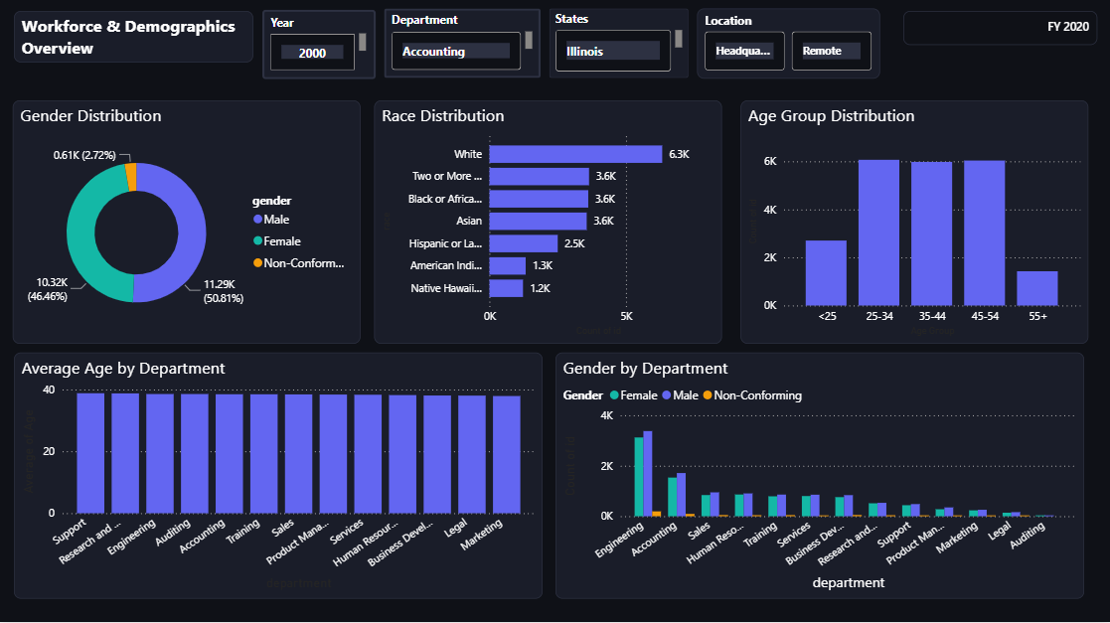
Our organization demonstrates strong gender balance across the workforce. The overall gender distribution shows 50.81% male employees (11,290 individuals), 46.46% female employees (10,320 individuals), and 2.72% non-conforming employees (610 individuals). This near-equal split between male and female employees, combined with inclusive recognition of non-conforming gender identities, demonstrates our commitment to diversity and inclusive hiring practices. The small percentage differential of 4.35% between male and female representation indicates effective gender equity in recruitment and retention.

Racial and Ethnic Diversity
Our workforce exhibits robust racial and ethnic diversity across multiple categories. White employees represent the largest group with 63,000 individuals, followed by employees identifying as Two or More races (36,000), Black or African American employees (36,000), and Asian employees (36,000). Hispanic or Latino employees number 25,000, American Indian employees total 13,000, and Native Hawaiian employees comprise 12,000 individuals. This diverse composition reflects deliberate inclusive hiring practices and represents a significant organizational strength in terms of varied perspectives, experiences, and cultural competencies that enhance organizational effectiveness.

Age Group Distribution
The age distribution of our workforce reveals concentration in mid-career ranges. Our largest employee cohorts fall within the 25-34, 35-44, and 45-54 age ranges, each containing approximately 5,000-6,000 employees. The under-25 age group represents a smaller segment with fewer than 2,000 employees, while the 55+ age group similarly contains a reduced number. This bell-curve distribution centered on ages 25-54 indicates a predominantly mid-career workforce with substantial professional experience. However, the limited representation in younger age brackets may present future succession planning challenges as our core workforce ages.

Departmental Age Analysis
When examining average age by department, we observe remarkable consistency across all functional areas. Departments including Supply Chain, Research and Development, Engineering, Auditing, Accounting, Training, Sales, Product Management, Services, Human Resources, Business Development, Legal, and Marketing all cluster within a narrow range of approximately 35-40 years average age. This uniformity suggests that career stage and experience level expectations are similar across different functional areas, indicating consistent hiring profiles regardless of department specialization.

Gender Composition by Department
Gender distribution across departments maintains consistency with overall organizational ratios. Engineering, our largest department with approximately 4,000 employees, shows balanced gender representation. Accounting displays roughly 3,500 employees with similar gender balance. Sales, Human Resources, Training, Services, and other departments each show between 1,000 and 2,000 employees with relatively consistent gender distribution patterns mirroring the organizational average of approximately 50-50. The inclusion of non-conforming gender identification across all departments further demonstrates comprehensive inclusive practices applied uniformly across the organization rather than concentrated in specific functions.

Hiring Trends and Analysis

Historical Hiring Patterns (2000-2020)

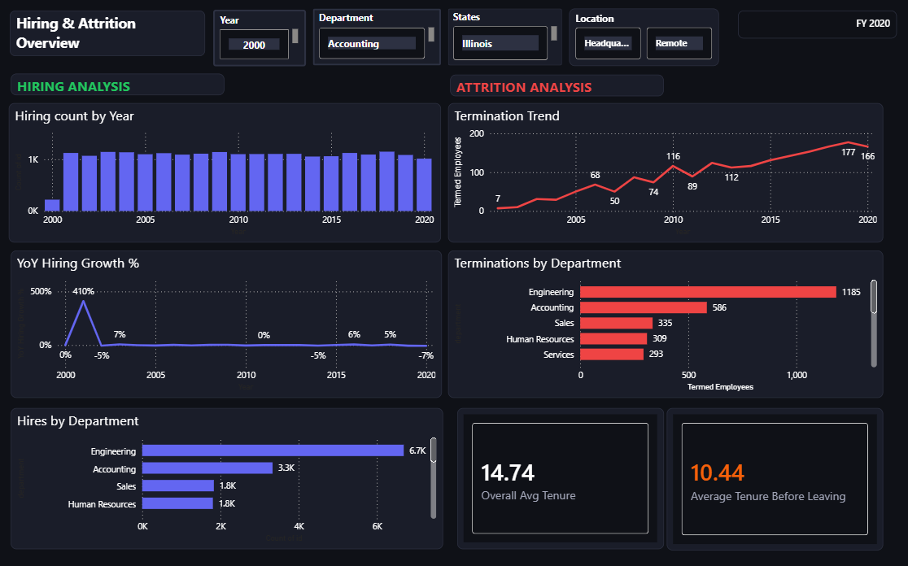
Our hiring patterns over the past two decades reveal significant fluctuations in organizational growth strategies. Beginning in 2000, we hired 220 employees, representing a baseline hiring level. The early 2000s saw dramatic expansion, with hiring numbers rapidly increasing to peaks of 1,122, 1,142, 1,140, 1,095, and similar volumes annually. From approximately 2002 through 2015, hiring remained relatively stable in the 1,100-1,200 range, with specific years showing 1,122 (2002), 1,147 (around 2005), and 1,122 (around 2015) new employees. However, by 2020, hiring had declined to 1,012 new employees, representing a downward trend in recent years.

Year-over-Year Growth Analysis
The year-over-year hiring growth percentage reveals extreme volatility in workforce expansion strategies. Starting from 2000, we experienced explosive growth of approximately 410% in the early period as we scaled from 220 to over 1,000 annual hires. This was followed by periods of more modest growth around 7% in some years, stability at 0% growth in others, and concerning negative growth periods including -3%, -5%, and most recently -7% year-over-year decline. This inconsistency in growth rates suggests reactive rather than strategic workforce planning, with hiring decisions potentially driven by short-term business conditions rather than long-term talent pipeline development.

Hiring by Department
Departmental hiring distribution reflects organizational priorities and functional area sizes. Engineering leads substantially with 6,700 total hires over the analysis period, representing our largest operational investment and reflecting our technology-driven business model. Accounting, our focus department, accounts for 3,300 hires, supporting extensive financial operations and compliance requirements. Sales and Human Resources each contributed 1,800 new hires, while Training and Services departments each added 1,700 employees. Additional departments including various operational and support functions contributed smaller hiring volumes. This distribution aligns with strategic business priorities, with engineering and accounting representing core competencies requiring sustained talent acquisition.

Attrition Analysis

Termination Trends Over Time
The attrition analysis presents concerning trends requiring immediate strategic intervention. Termination numbers have increased dramatically from just 7 employees in 2000 to 166 employees in 2020, with a peak of 177 terminations occurring in one recent year. The termination trend line shows a clear upward trajectory throughout the 20-year period, with notable increases around 2005 (68 terminations), 2010 (74 terminations), accelerating to 89 terminations, then 116, 112, and ultimately reaching the current high levels. This consistent upward trend indicates systematic retention challenges that have worsened over time despite organizational growth and maturity.

Terminations by Department
When examining terminations by department, Engineering has experienced the highest attrition with 1,185 employees terminated, representing a significant loss of technical talent and institutional knowledge. Accounting follows with 586 terminations, Sales has experienced 335 terminations, Human Resources shows 309 departures, and Services accounts for 293 terminations. The disproportionate impact on Engineering—our largest department and primary talent investment area—is particularly concerning as it represents both the highest absolute losses and suggests potential issues with engineering work environment, compensation competitiveness, or career development opportunities.

Tenure Analysis
The tenure metrics reveal a critical retention gap. While the overall average tenure across all employees is 14.74 years, indicating strong historical retention, the average tenure before leaving is notably lower at 10.44 years. This 4.3-year gap suggests we are losing employees well before they reach the organizational average tenure, indicating mid-career attrition rather than natural retirement-related departures. Employees leaving at an average of 10.44 years represent substantial investments in training, development, and institutional knowledge that are not being fully realized. This pattern suggests retention challenges during the critical mid-career phase when employees have developed significant expertise but may be evaluating external opportunities.

Geographic Distribution

State-Level Distribution

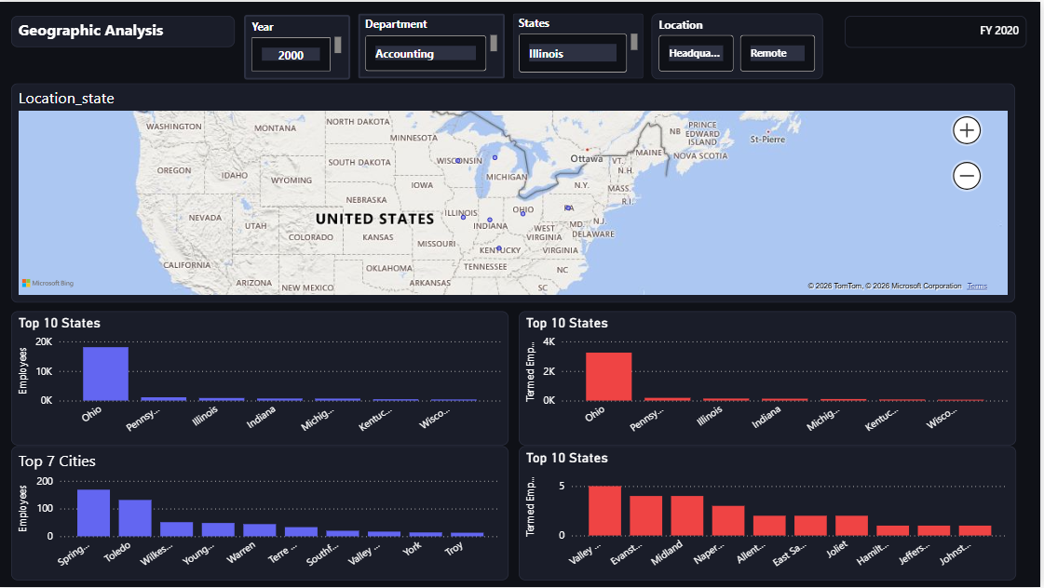
Our workforce exhibits significant geographic concentration with substantial associated risks. Ohio dominates our geographic footprint with 18,000 employees, representing approximately 82% of our total 22,000-person workforce. Pennsylvania follows as a distant second with 1,100 employees (5%), and Illinois—our focus state for this analysis—contains 900 employees (4%). This extreme concentration in a single state creates potential vulnerabilities related to regional economic conditions, natural disasters, state-specific regulatory changes, and talent market saturation. The geographic distribution map clearly shows this concentration, with Ohio highlighted as the primary employment hub.

Top Cities Analysis
At the city level, our workforce distribution shows concentration in specific urban areas within our primary states. Springfield leads with approximately 150 employees, followed closely by Toledo and Wiltses with around 120 employees each. Additional top cities including Ypanti, Warren, Terre Haute, Southfield, Valley, and York each contain between 50 and 100 employees. This city-level distribution suggests a hub-based operational model with multiple mid-sized facilities rather than a single massive headquarters location, providing some geographic diversification within our primary operating states.

Headquarters versus Remote Workforce
The split between headquarters and remote workforce reveals a traditional, predominantly on-site work model. Headquarters locations account for 17,000 employees (75%), while remote workers comprise 5,000 employees (25%). This 3-to-1 ratio reflects workplace policies likely established before the recent acceleration of remote work trends across industries. The visualization shows headquarters in blue (75%) and remote in teal (25%) on the donut chart. Given evolving employee preferences for workplace flexibility, technological capabilities enabling effective remote collaboration, and potential cost savings from reduced facility requirements, this distribution represents an area for strategic review and potential adjustment.

Key Findings and Strategic Implications
This comprehensive workforce analysis reveals several critical findings with significant strategic implications. Our primary strengths include strong demographic diversity with near gender parity (50.81% male, 46.46% female, 2.72% non-conforming) and robust racial diversity across six major categories. We maintain a stable, experienced workforce with 14.74 years average tenure and consistent hiring across major departments with Engineering (6,700 hires) and Accounting (3,300 hires) serving as organizational anchors.
However, we face substantial challenges requiring immediate attention. The 17.7% termination rate is alarmingly high and shows a clear upward trajectory, increasing from 7 annual terminations in 2000 to 166 in 2020, with a peak of 177. This trend is particularly concerning in Engineering, which has lost 1,185 employees. Our year-over-year hiring growth has declined to -7%, indicating contraction rather than expansion. The 4.3-year gap between average overall tenure (14.74 years) and average tenure before leaving (10.44 years) indicates we are losing employees during their peak productivity years, representing substantial lost investment in training and development. Additionally, extreme geographic concentration with 82% of our workforce in Ohio creates significant risk exposure to regional factors.

Strategic Recommendations

Retention Program Development
Implement targeted retention programs specifically designed for employees in the 7-12 year tenure range, the critical window before the average departure tenure of 10.44 years. These programs should include: enhanced career development opportunities and clear advancement pathways; competitive compensation reviews benchmarked against industry standards, particularly in Engineering; mentorship programs pairing mid-career employees with senior leaders; increased investment in professional development and skills training; and regular engagement surveys to identify and address dissatisfaction factors before they lead to attrition. Special focus should be placed on Engineering given the disproportionate losses in this critical function.

Geographic Diversification Strategy
Develop a deliberate geographic diversification plan to reduce the current 82% concentration in Ohio. Strategies should include: identifying secondary markets in different regions for expansion to reduce single-state dependency; evaluating locations with strong talent pipelines in Engineering and Accounting; considering state-level business climate factors including tax structures, regulatory environments, and talent availability; and establishing a timeline for achieving a more balanced distribution with no single state exceeding 50% of workforce. This diversification will reduce exposure to regional economic downturns, natural disasters, and state-specific policy changes.

Root Cause Analysis of Attrition
Conduct comprehensive investigation into the root causes driving the increasing termination trend, particularly the dramatic rise from 7 to 166 annual terminations. This analysis should include: exit interview analysis to identify common themes in departure reasons; comparative compensation studies to ensure market competitiveness; workplace culture assessments through employee engagement surveys; career progression analysis to identify advancement bottlenecks; and department-specific deep dives in Engineering to understand the 1,185 terminations. Understanding whether departures are driven by compensation, culture, career limitations, or other factors is essential for designing effective interventions.

Succession Planning for Aging Workforce
Develop robust succession planning to address the eventual retirement of our 45-54 age cohort, which contains approximately 5,000-6,000 employees who will reach retirement age within the next 10-15 years. Initiatives should include: knowledge transfer programs capturing institutional expertise before retirement; increased hiring in the under-25 age bracket to build a pipeline of emerging talent; mentoring programs pairing senior employees approaching retirement with high-potential younger employees; documentation of critical processes and institutional knowledge; and phased retirement options allowing gradual transition while maintaining access to expertise.

Remote Work Policy Reassessment
Reassess our current remote work policies given that only 25% of our workforce currently works remotely, significantly below industry trends. Considerations should include: employee preference surveys regarding remote work options; analysis of productivity metrics comparing remote versus on-site performance; evaluation of cost savings from reduced facility footprint; assessment of whether expanded remote work could aid retention, particularly for employees in the critical 7-12 year tenure window; and competitive analysis of remote work policies among key talent competitors. Increased remote work flexibility may address retention challenges while reducing facility costs and expanding the geographic talent pool.

Conclusion
This workforce analytics report reveals an organization with significant strengths in demographic diversity, experienced talent, and established departmental structures, but facing critical challenges in retention, hiring momentum, and geographic concentration. The 17.7% termination rate and increasing attrition trend represent the most urgent concern, particularly the loss of 1,185 Engineering employees and the pattern of employees departing at 10.44 years tenure—well before the organizational average. The declining hiring growth rate of -7% year-over-year and 82% geographic concentration in Ohio further compound these challenges.
Addressing these issues requires a multi-faceted strategic approach encompassing targeted retention programs for mid-career employees, geographic diversification to reduce regional dependency, comprehensive root cause analysis of the attrition trends, succession planning for the aging workforce cohort, and reassessment of remote work policies to align with industry trends and employee preferences. Implementation of these recommendations will position the organization to stabilize and ultimately reverse the concerning attrition trends while building a more resilient, geographically diversified, and strategically balanced workforce for long-term success.

