Automation .
Operations
- STS Documentation.
- If the status is in progress more than 7 days /reached 30 days then mail -mail trigger .

Subject: Follow-up on Operation Status – [Operation Reference Number]
Dear Team,
Please note that the operation [Operation Reference Number], dated [Date], has been in “In Progress” status for **7**days or more
Kindly recheck and review the status. If the operation has been completed, please update the status accordingly.
Best regards,
Ocean Group
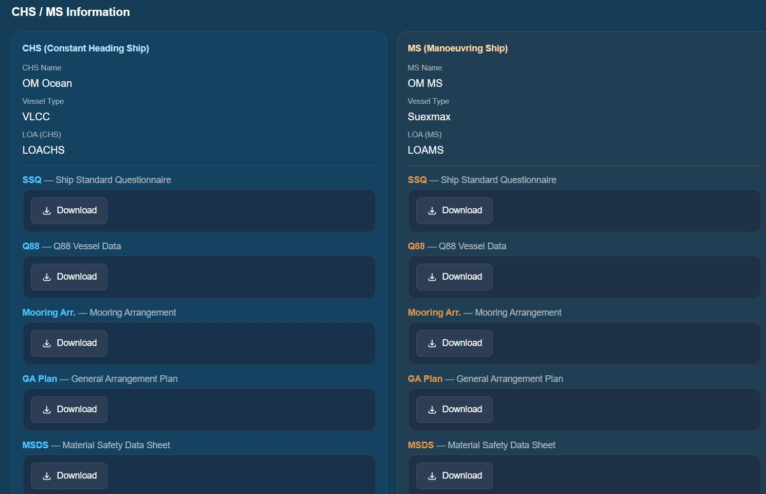

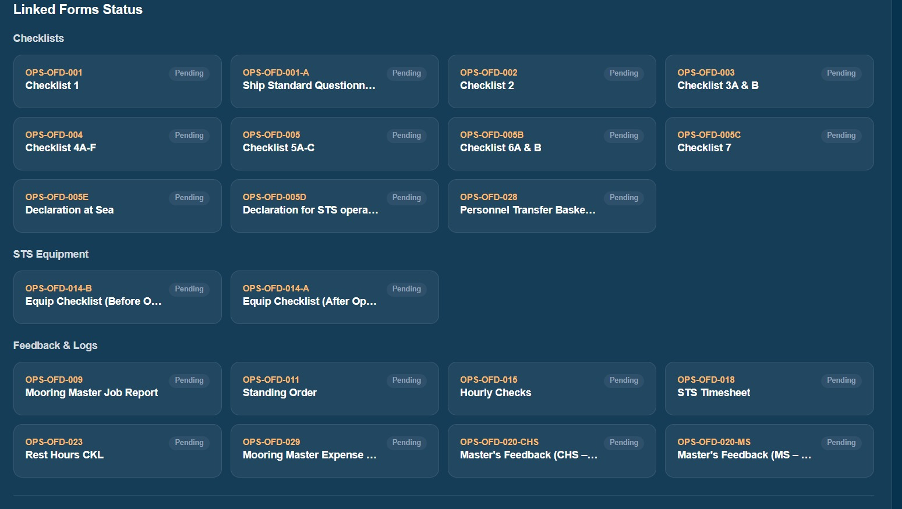

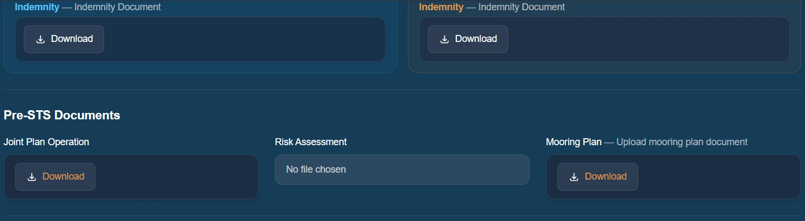
Similar mail, if the any of the selected documents haven’t been uploaded in the folder after the job is in status completed , for 7 days .Then trigger similar mail stating that particular doc is not uploaded in document.

PMS

- 15 days / 13 days testing reminder before the next test date ( 2 emails for 15 & 30 days before nest test date )

Dear Team,
This is an automated reminder for the upcoming testing schedule (_____days prior to the next test date).
Equipment Name : ____________
Serial Number : ______________
Last test date :_______________
Next Test date:____________
Kindly send it out for testing before the next due date to ensure accurate tracking ahead of the next test date.
Thank you for your cooperation.
Best regards,
Ocean Group
This is an automated email. Please do not reply.
- Retirement Mail ( For fenders if it reaches 15 years from the year of manufacturing , For hoses 10 years from the date of manufacturing )
And similar mail for overdue too.
Dear Team,
This is an automated reminder regarding the upcoming retirement of equipment
[Equipment Name : ____________
Serial Number : ______________
Year of manufacturing :_______________
As per records, the equipment is approaching its retirement year .Kindly review and take the necessary actions to ensure proper closure, replacement, or decommissioning as required.
Please update the system accordingly once the retirement process is completed to maintain accurate records.
Thank you for your cooperation.
Best regards,
Ocean Group
This is an automated email. Please do not reply.

- If the warehouse management estimated end date is passed 2 days from the give date then there should be mail .
Dear Team,
This is an automated notification that the Estimated End Date for Equipment name , Location, scheduled on [Estimated End Date], has been exceeded by more than 2 days.
Kindly review the status of this activity and take the necessary action. If the task has been completed, please update the system accordingly. If still in progress, ensure the timeline is revised and updated.
Your prompt attention to this matter is highly appreciated to maintain accurate warehouse management records.
Best regards,
Ocean Group
This is an automated email. Please do not reply.
QHSE
- For Subcontractor and due diligence audit -is there possibility where if we shore the mail and time line and the default message body - with the give timeline can the mail drop to the particular mail id ? the mail Ids can also be changed in future .
- There is no copy link for nearmiss .
- For Each near miss which was Submitted in form , that particular mail id should receive successfully submitted , Mail to their mail id .
Like:
Dear_____________,
This is to inform you that your near miss report has been successfully submitted in Ocean Group database .
Job No :_____
Location :
Thank you for your proactive effort in reporting and contributing to a safer working environment. The report will be reviewed, and any necessary actions will be taken accordingly.
Best regards,
Ocean Group
This is an automated email. Please do not reply.

- Similar for nearmiss if it is submitted our company should received mail saying the person submitted a nearmiss .
Dear Team,
This is to inform you that a near miss report has been submitted by _____________
Date :
Location :
Please review the submitted report by clicking the below link and take the necessary actions as required.
Link to Access
Details of the report can be accessed in the system for your reference.
Best regards,
Ocean Group
This is an automated email. Please do not reply.

- If a nearmiss is reviewed from office side , then a mail with detailed review of the nearmiss should be sent to the personnel who raised it (third party)
Dear _______________
This is to inform you that the near miss report you submitted has been successfully reviewed.
Job No : Date :
Nearmiss Description:
***********************
Immediate cause :
**************************
Root cause :
*************************
Coorective action :
*************************
Remarks by reviewer :
**************************

Thank you for your proactive effort in reporting and contributing to a safer working environment. Appropriate actions have been taken based on your report.
We encourage you to continue reporting any near misses going forward, as this helps us maintain and improve safety standards across all operations.
Best regards,
Ocean Group
This is an automated email. Please do not reply.
- There is no option to add documents into archive “No add option “
- Defect list : As soon as a defect is closed there should be an mail .
Dear team
This is to inform you that the defect _____________________has been successfully resolved and closed.
Link to check the defect
Kindly review the update in the system. If you have any concerns or require further clarification, please feel free to raise them.
Thank you for your cooperation.
Best regards,
Ocean Group
This is an automated email. Please do not reply.
HR
- Statutory Certificates – 30 days & 15 days reminder before the date of expiry .
Dear Team,
This is an automated reminder that the statutory certificate [Certificate Name] is due to expire on [Expiry Date].
Kindly take the necessary action to arrange for renewal before the expiry date to ensure compliance and avoid any operational disruptions.
Please update the system once the renewal process is completed.
Thank you for your prompt attention to this matter.
Best regards,
Ocean Group
This is an automated email. Please do not reply.
- Oil Major - whenever a new company is added with the status of approved -mail trigger
Sub : Approval Confirmed – Thanks to Our Amazing Team!
Dear Team,
We are thrilled to share that we are now officially approved by the ___________! 🎉
This milestone is a testament to the hard work, dedication, and commitment of our entire team. We look forward to leveraging this approval to deliver even greater value in our operations and future projects.
Keep up the fantastic work, and let’s continue to achieve excellence together!
Warm regards,
Oceane Group
This is an automated notification. No reply is necessary.
- CID – if the CID validity is expiring 5 days before validity date .
Subject: Reminder: CID Validity Expiring Soon
Dear Team ,
This is a friendly reminder that the CID of _Person for the location is set to expire on ________To avoid any interruptions in Port Entry , please ensure that to renew it before the expiry date.
Thank you for your attention to this matter.
Best regards,
Oceane Group
This is an automated notification.

- Overall list download is for - STS Equipment base Stock level , defect list , best practices ,KPI , Audits and Inspection Planner is list altogether download
___________End________________________________________

