JOB REFERNCE:
2026-007
MT Gas Laggon
MT Inception
SS: STBL :
*All calculations are in Meters

- HOSE CALCULATIONS

POINT A
POINT B
4
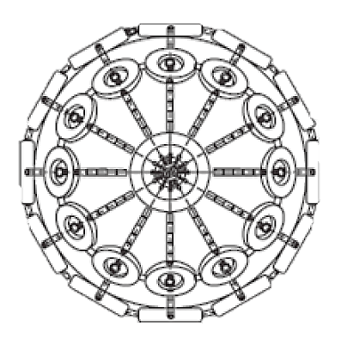
STBL -MIN Freeboard
17.5
HOSE LENGTH REQUIRED:
10.7
16.1
STBL -MAX Freeboard
10.1
13.4
SS -MIN Freeboard
SS -MAX Freeboard
POINT C
STBL -Distance manifold to ship rail
SS -Distance manifold to ship rail
3.5
4

- FENDER CALCULATIONS
STBL DWT
64220
49723
SS DWT
36.04
SS BEAM
36.6
SS BEAM
SS DISP
72237
40848
SS DISP
SS DRAFT
11.85
SS DRAFT
7
Equivalent Disp. Coefficient Combined virtual displacement
STBL Mass Coefficient Energy Coefficient Calm
SS Mass Coefficient Energy Coefficient Moderate
Virtual Displacement STBL Energy Coefficient Rough
Virtual Displacement SS
38374.71
52186.18
1199.21
1.66
2026.66
1.38
3069.98
119742.88
56472.92
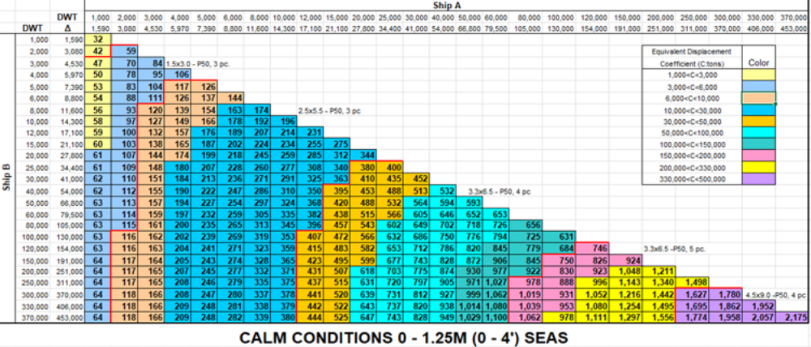

4Nos x 3.3M x 6.5M
FENDERS REQUIRED FOR CALM WEATHER

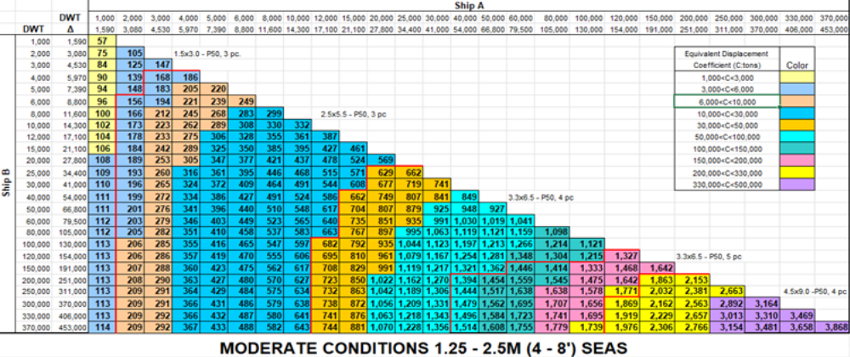
4Nos x 3.3M x 6.5M
FENDERS REQUIRED FOR MODERATE WEATHER

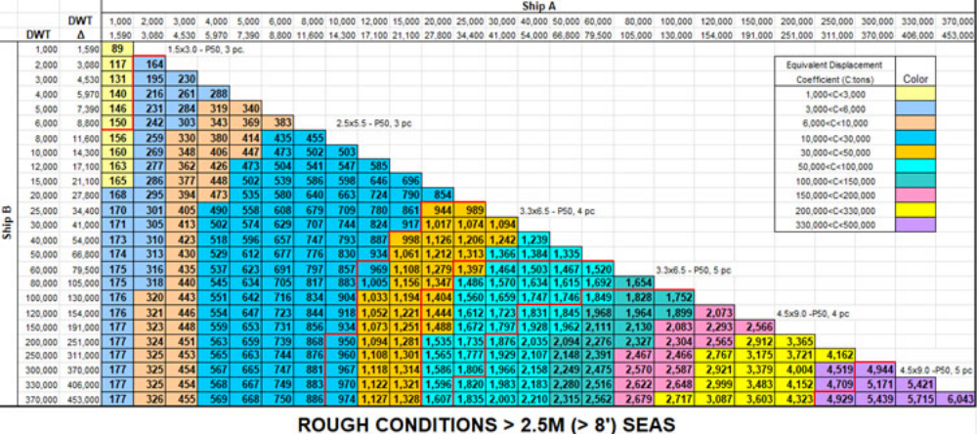
FENDERS REQUIRED FOR ROUGH WEATHER
5Nos x 3.3M x 6.5M

