JOB REFERNCE:

SS: STBL :
*All calculations are in Meters

- HOSE CALCULATIONS

POINT A
POINT B

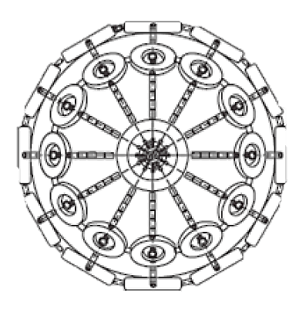
STBL -MIN Freeboard

HOSE LENGTH REQUIRED:

STBL -MAX Freeboard

SS -MIN Freeboard
SS -MAX Freeboard
POINT C
STBL -Distance manifold to ship rail
SS -Distance manifold to ship rail

- FENDER CALCULATIONS
STBL DWT

SS DWT

SS BEAM

SS BEAM
SS DISP

SS DISP
SS DRAFT

SS DRAFT

Equivalent Disp. Coefficient Combined virtual displacement
STBL Mass Coefficient Energy Coefficient Calm
SS Mass Coefficient Energy Coefficient Moderate
Virtual Displacement STBL Energy Coefficient Rough
Virtual Displacement SS

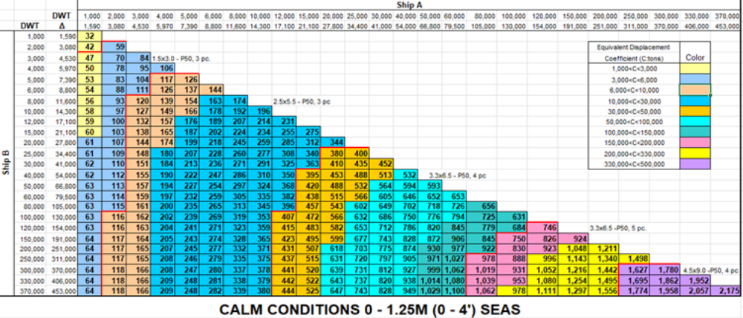

FENDERS REQUIRED FOR CALM WEATHER

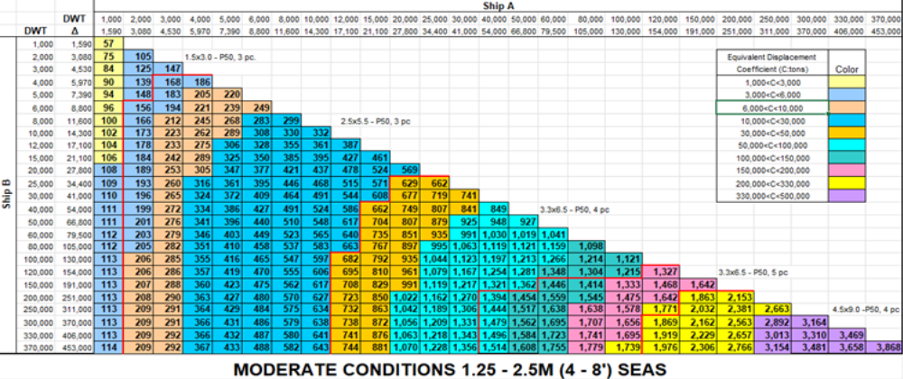

FENDERS REQUIRED FOR MODERATE WEATHER

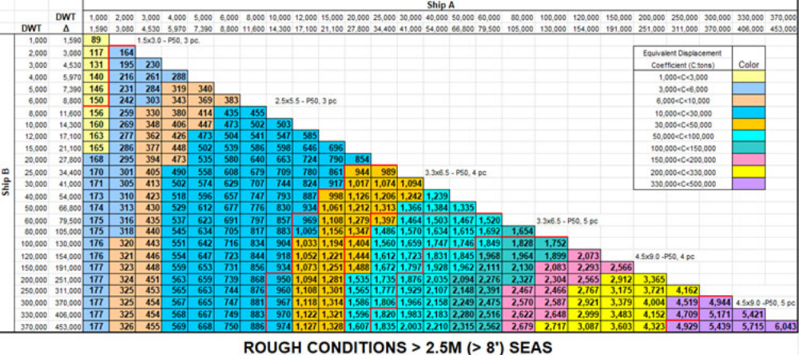
FENDERS REQUIRED FOR ROUGH WEATHER

