Creating a Skybox in Blender
Nick V. Flor (nickflor@unm.edu, @ProfessorF)

- Startup Blender
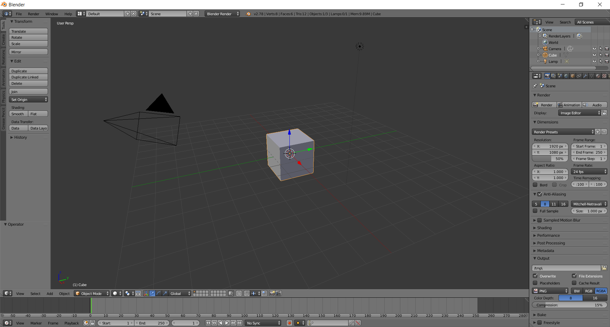
- Pop-up the cube
  - Type N
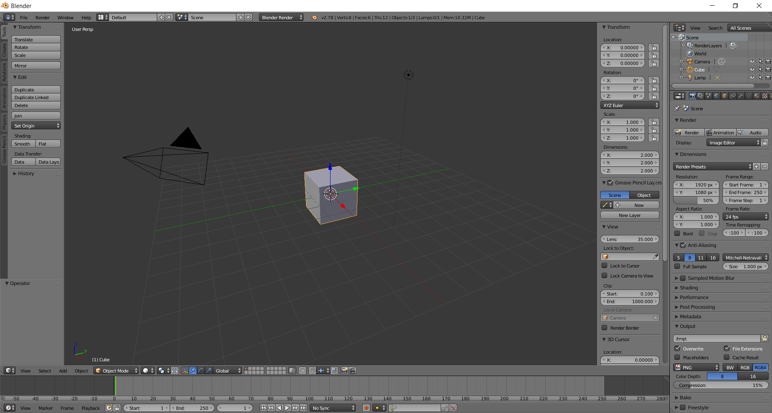
  - Type 1 in Transform > Location > Z
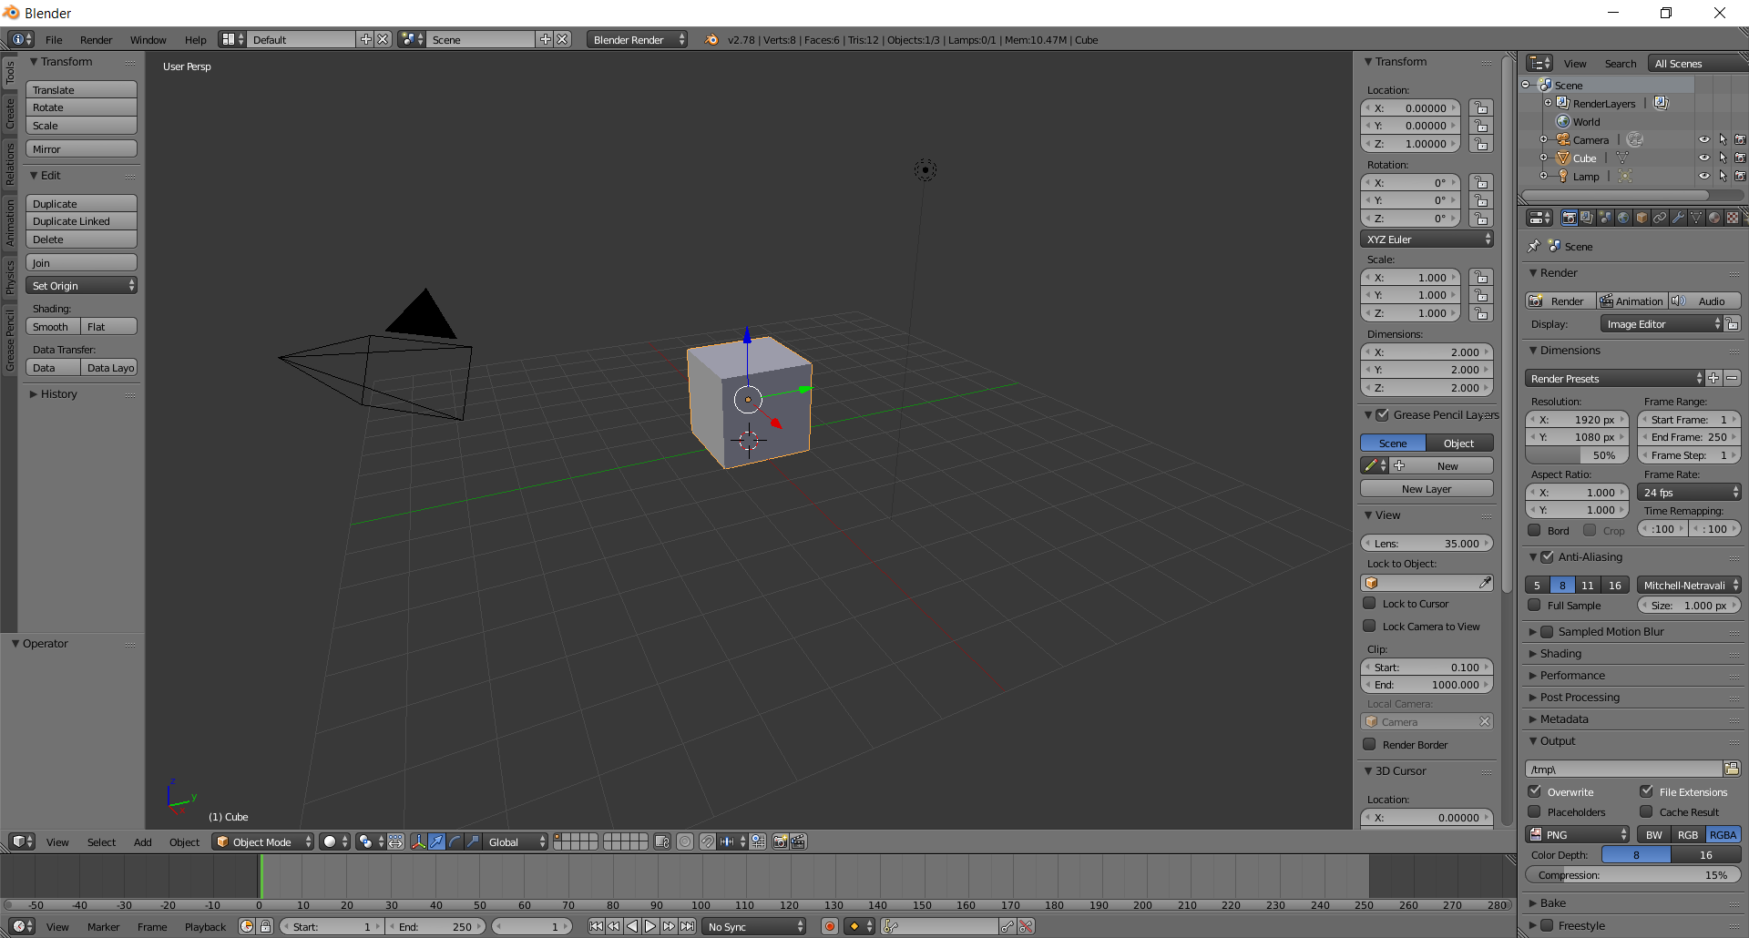
- Add a sphere
  - Menu over Add > Mesh > UV Sphere
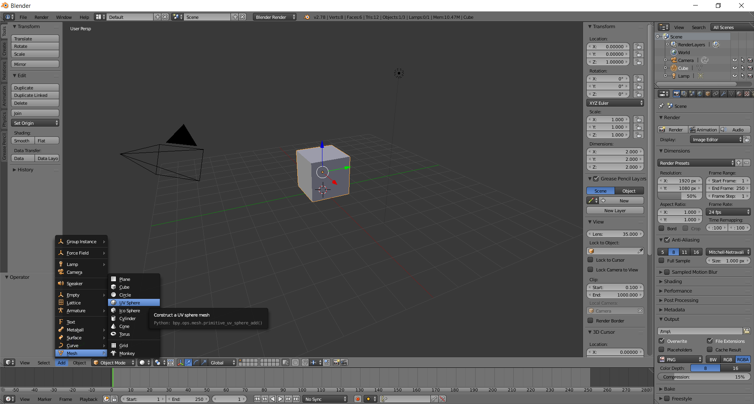
  - Click
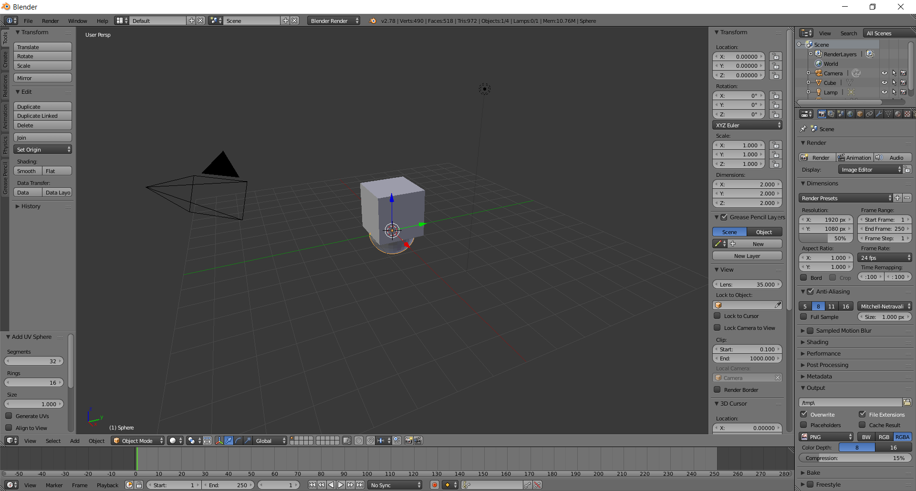
  - Transform > Scale X, Y, Z > 5, 5, 5
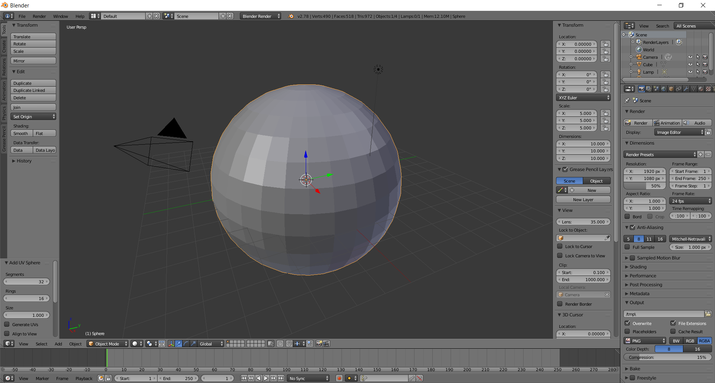
- Delete the bottom half of the sphere
  - View Front (Toggle Numeric Pad 1, 5)
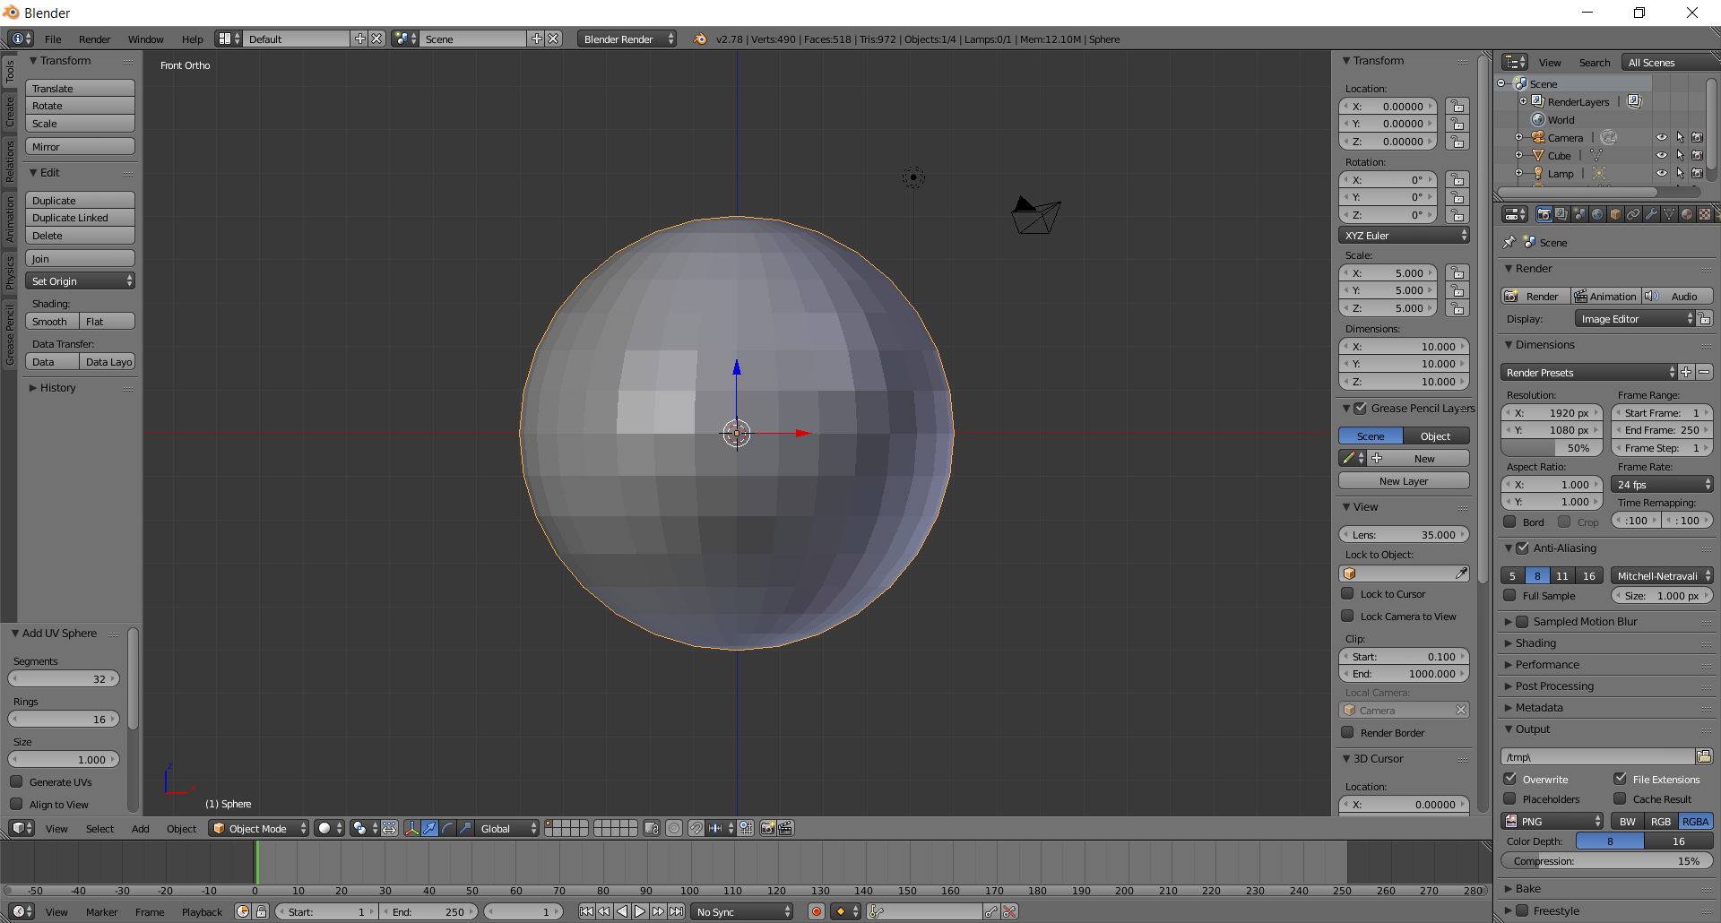
  - Edit Mode (bottom panel) > B > Drag select bottom vertices
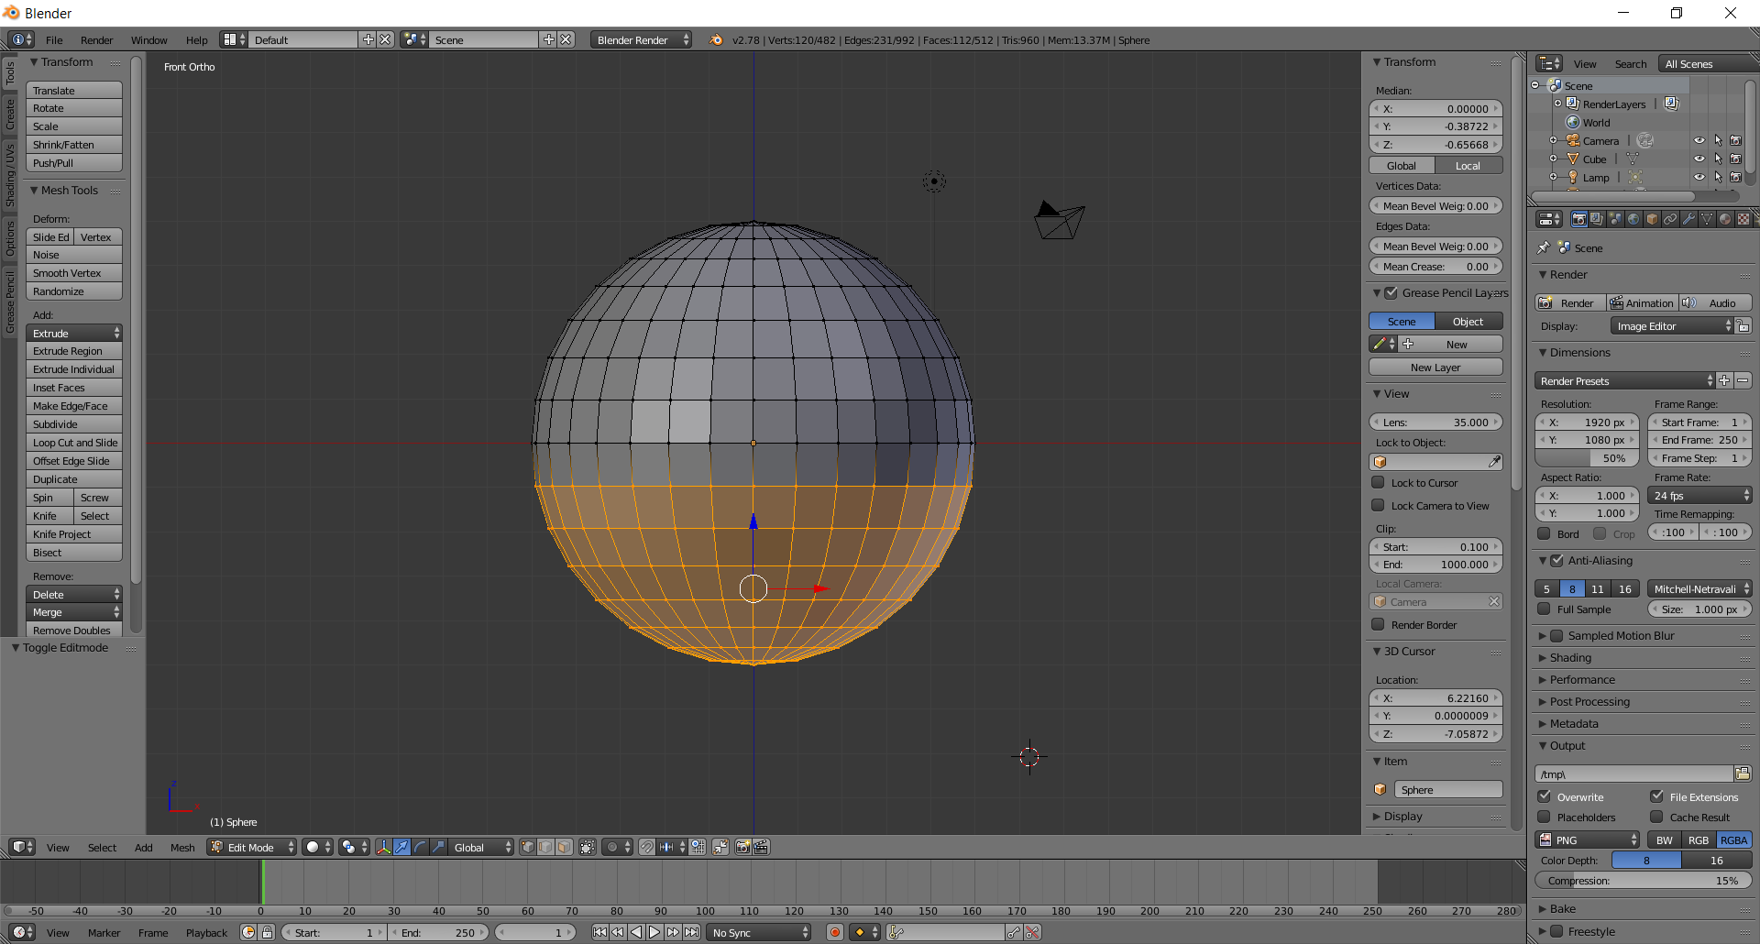
  - Hit the delete key
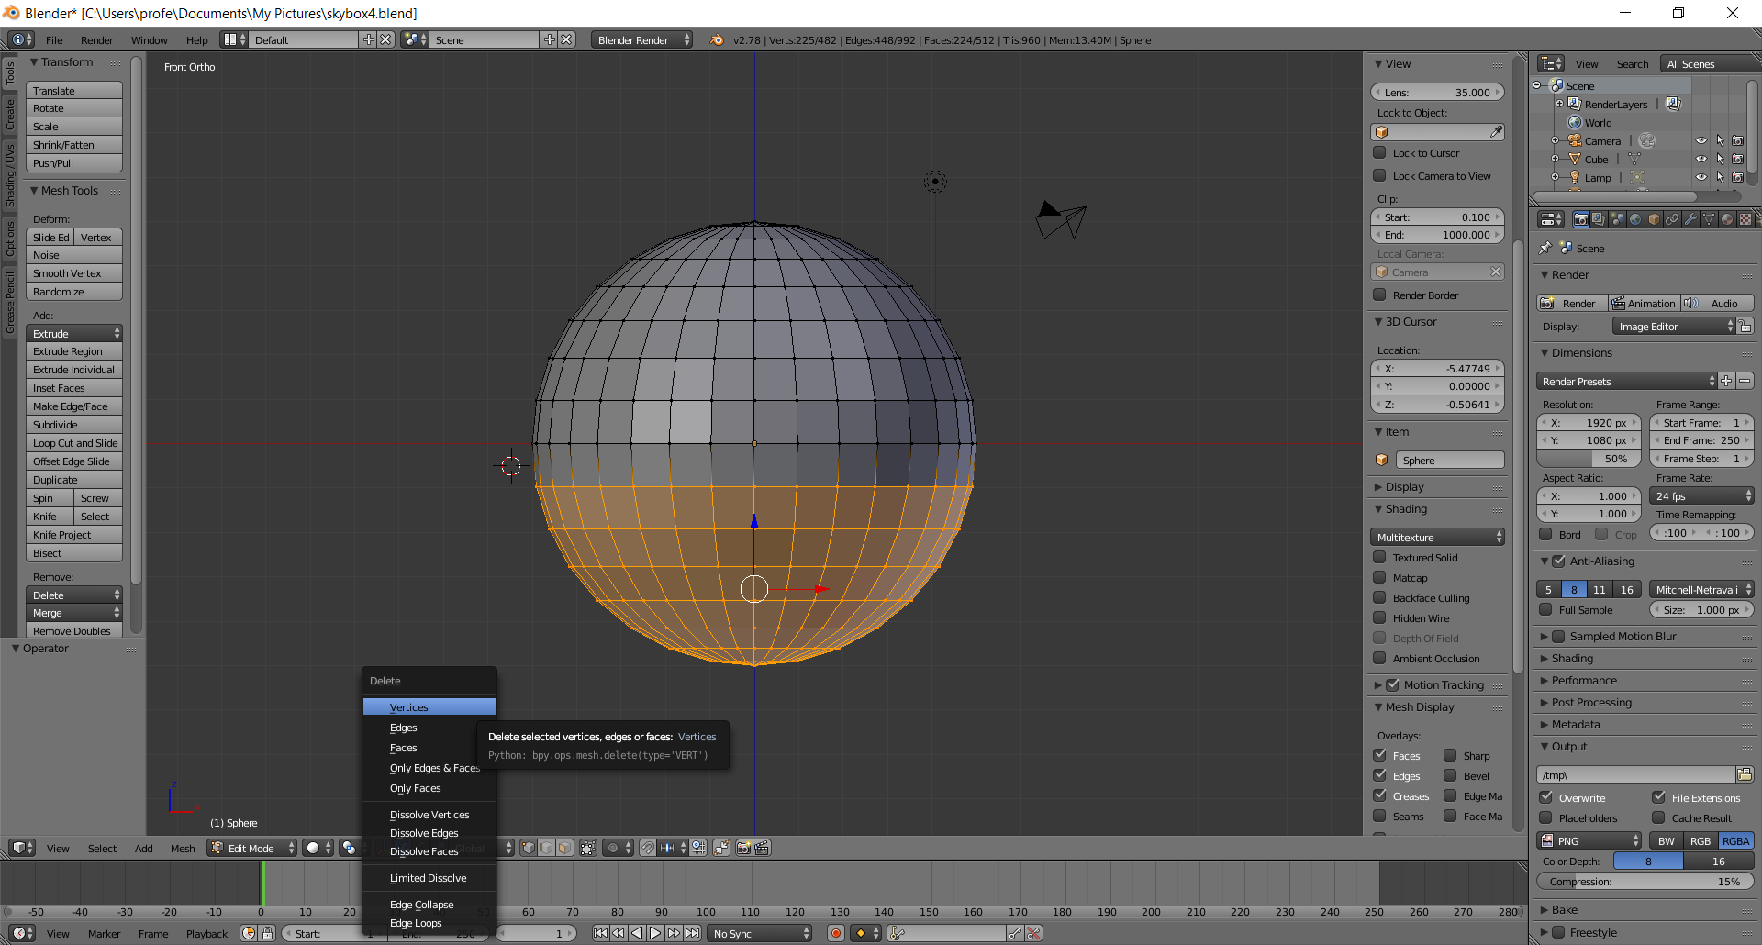
  - Click vertices
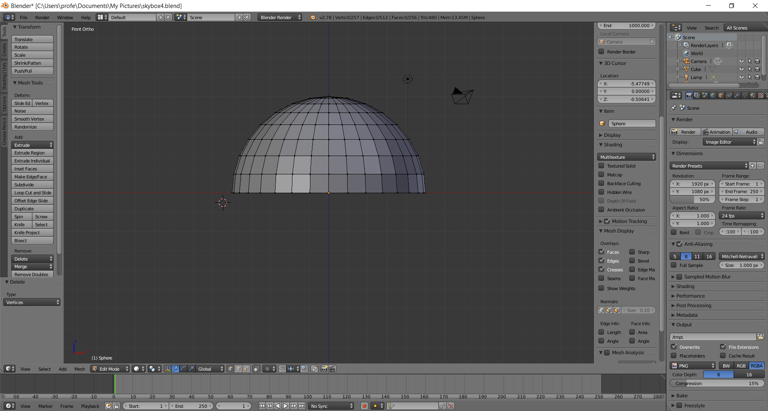
  - Hold middle-click and rotate mouse, making sure the underside looks as follows
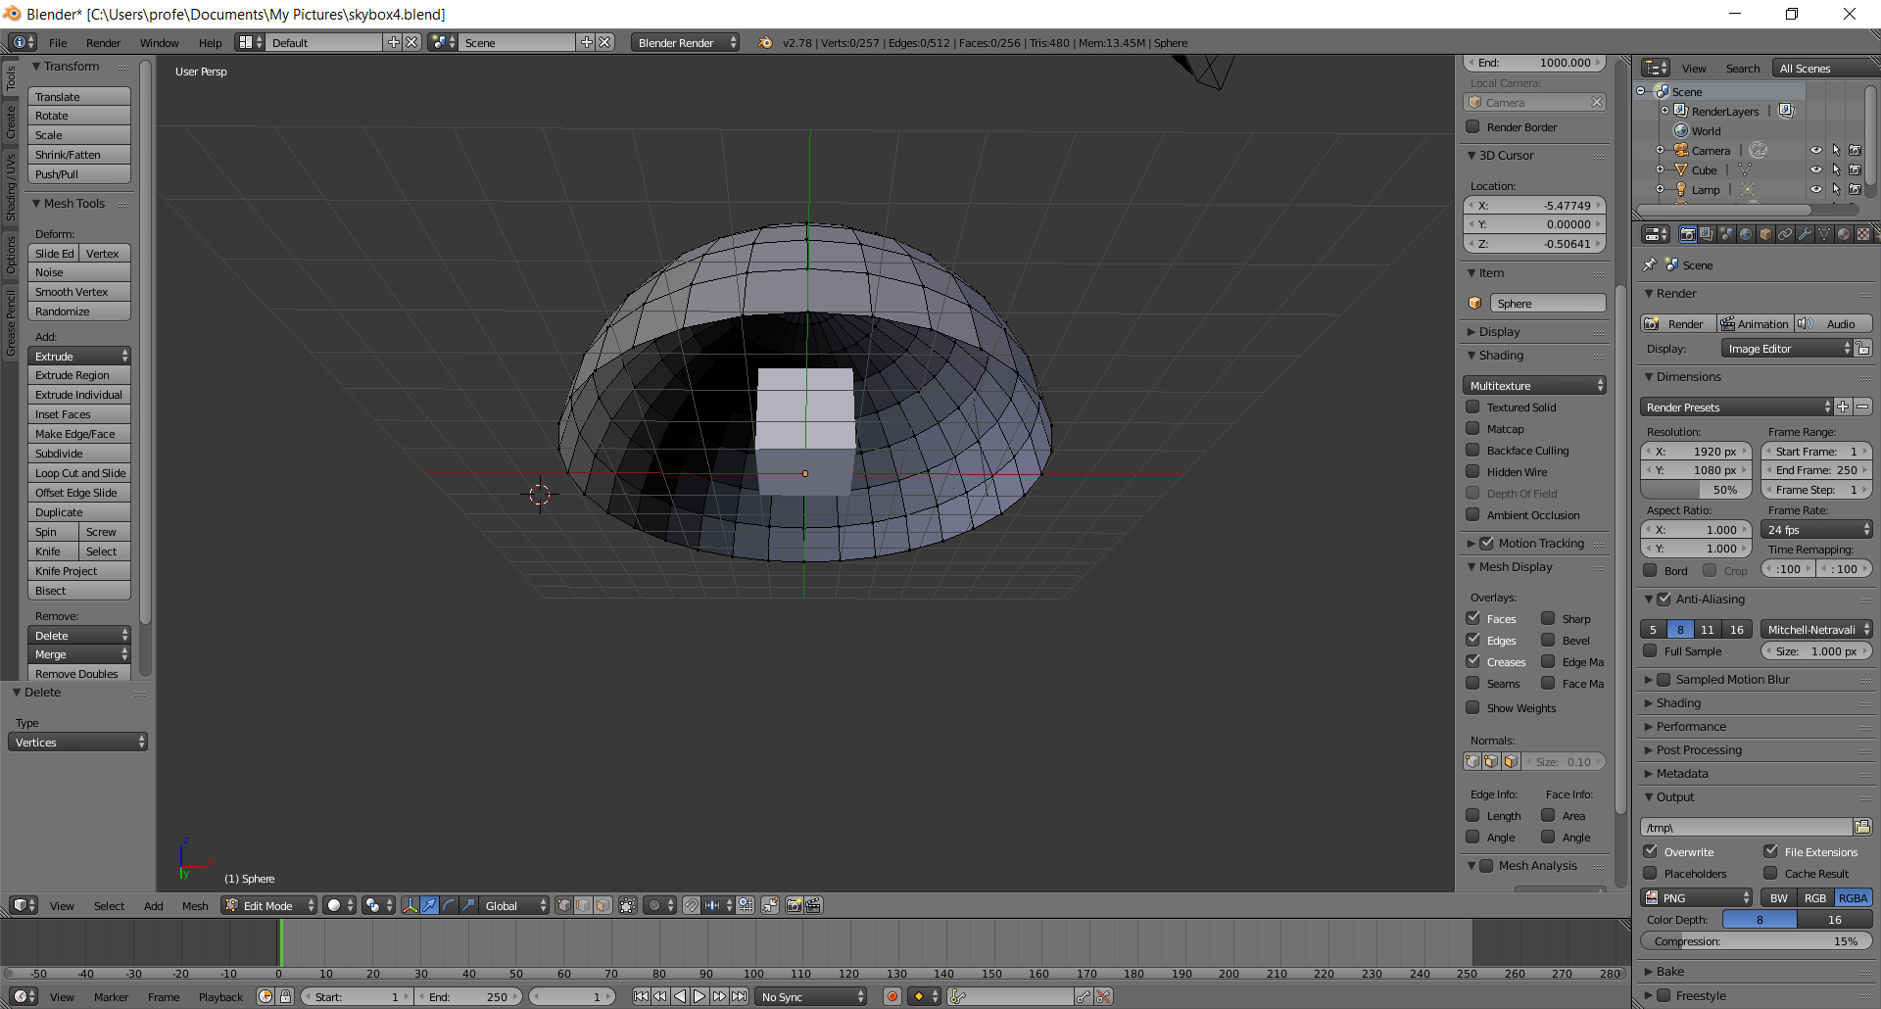
  - Delete any faces remaining until your viewport looks similar to 4e, a sphere with a cube inside
- Flip Normals
  - Press the A-Key to select the entire figure
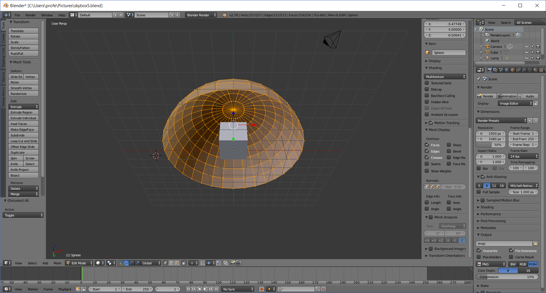
  - Click the Normals: Face icon in the N-panel on the right
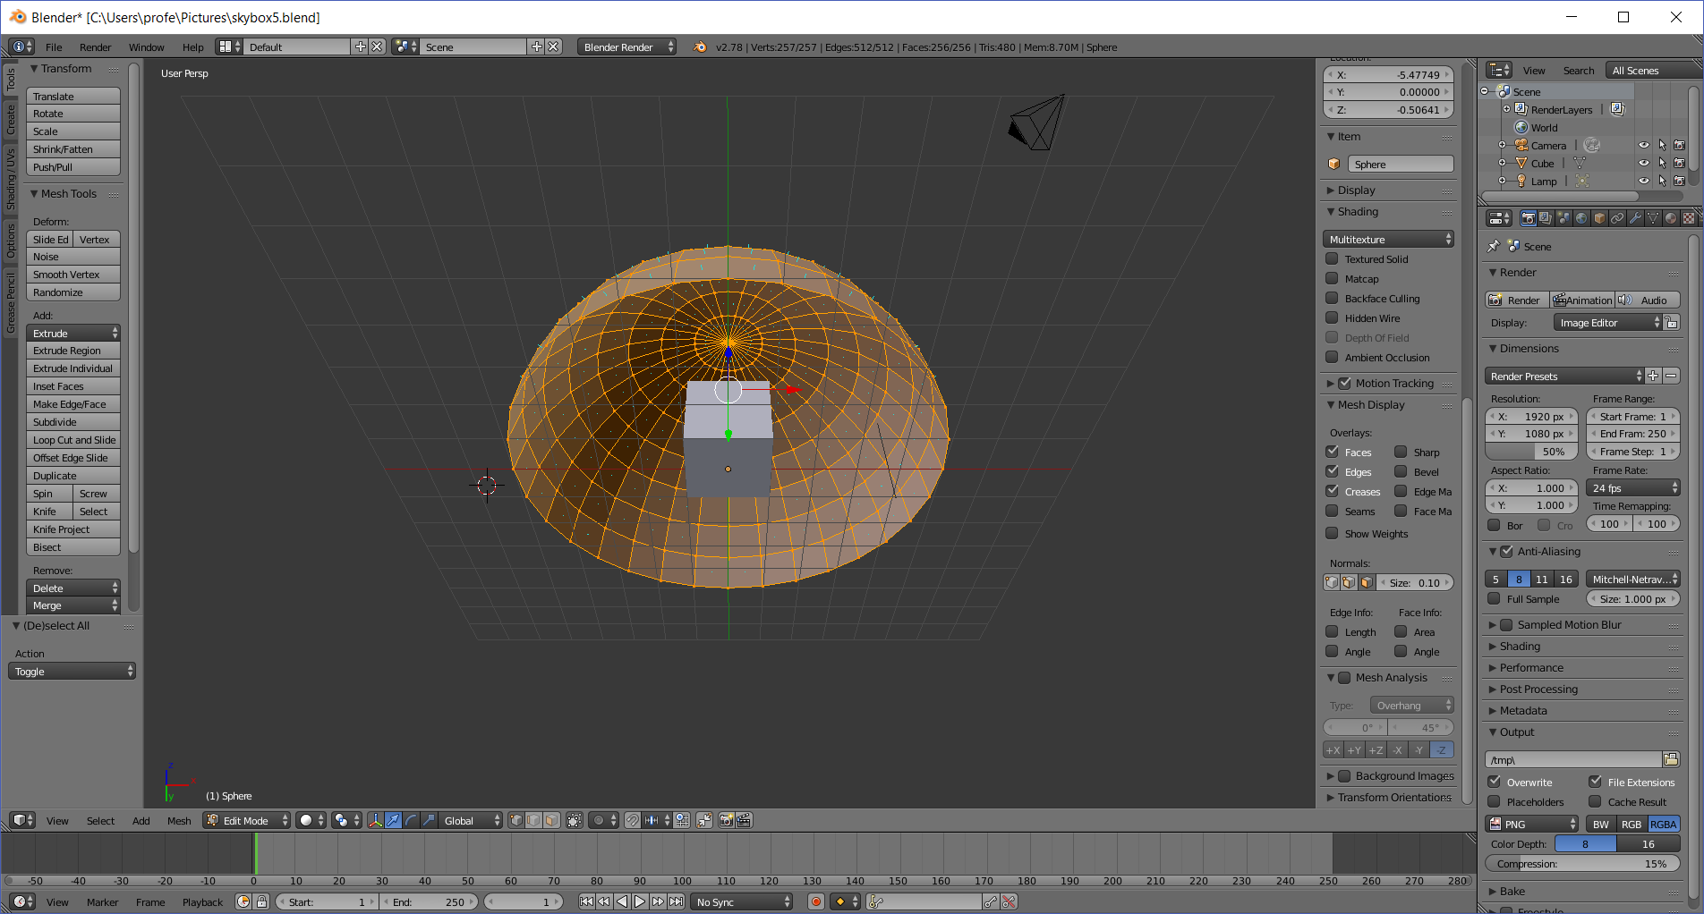
  - Hover over: Mesh > Normals > Flip Normals
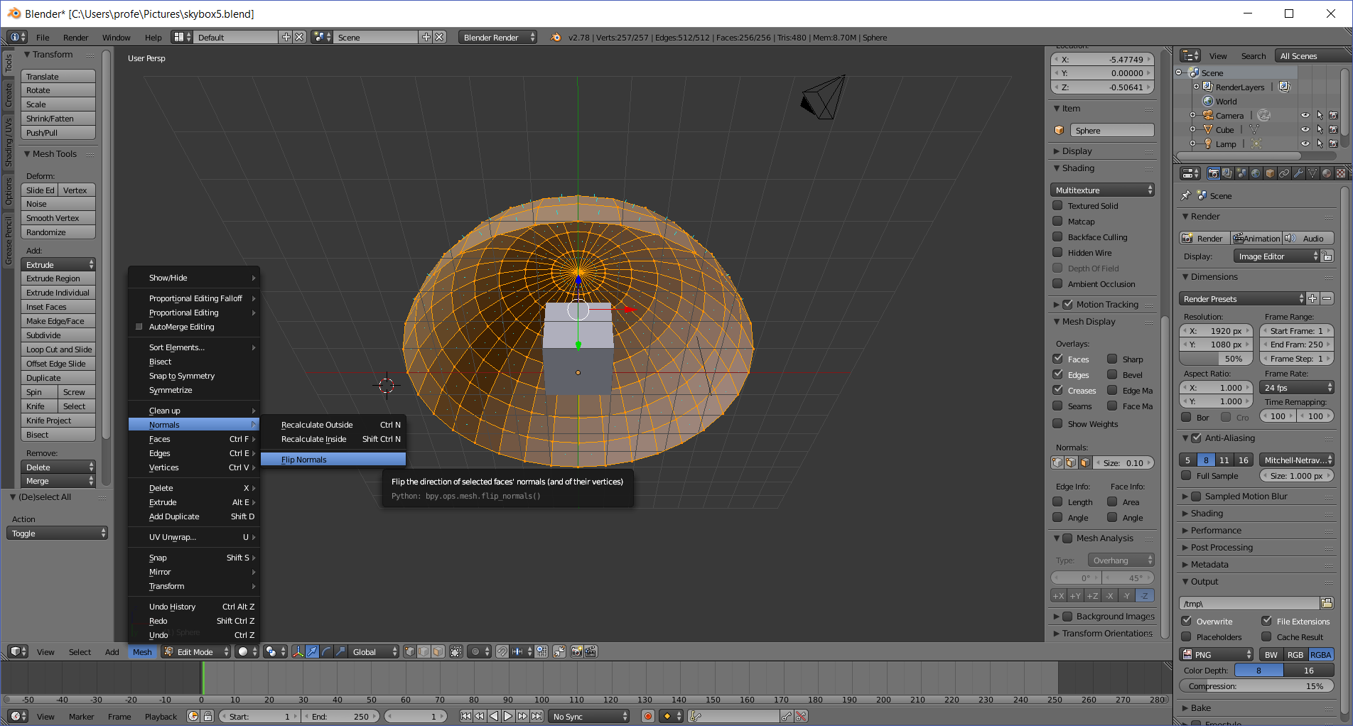
  - *click*
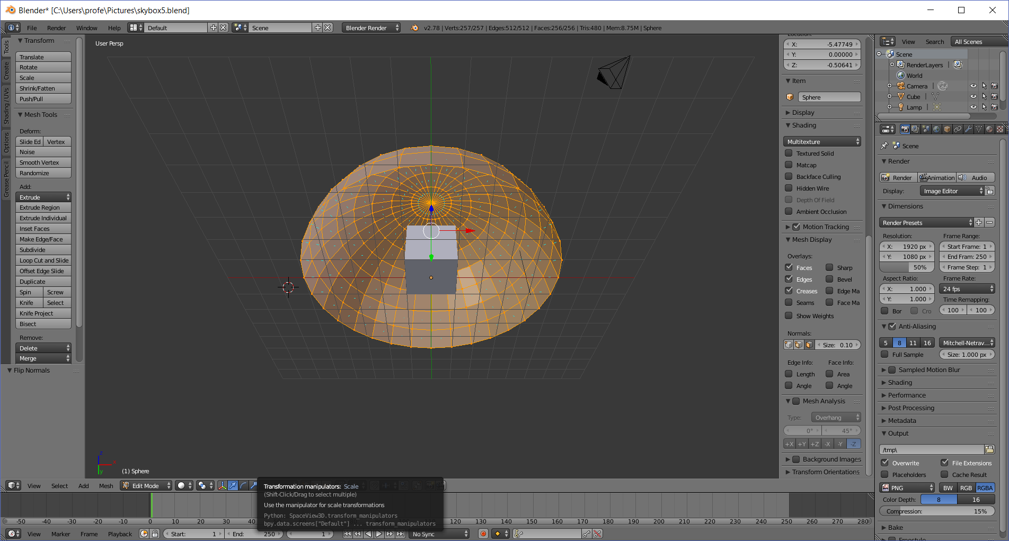
- Unwrap UVs
  - Hover over Layout > UV Editing
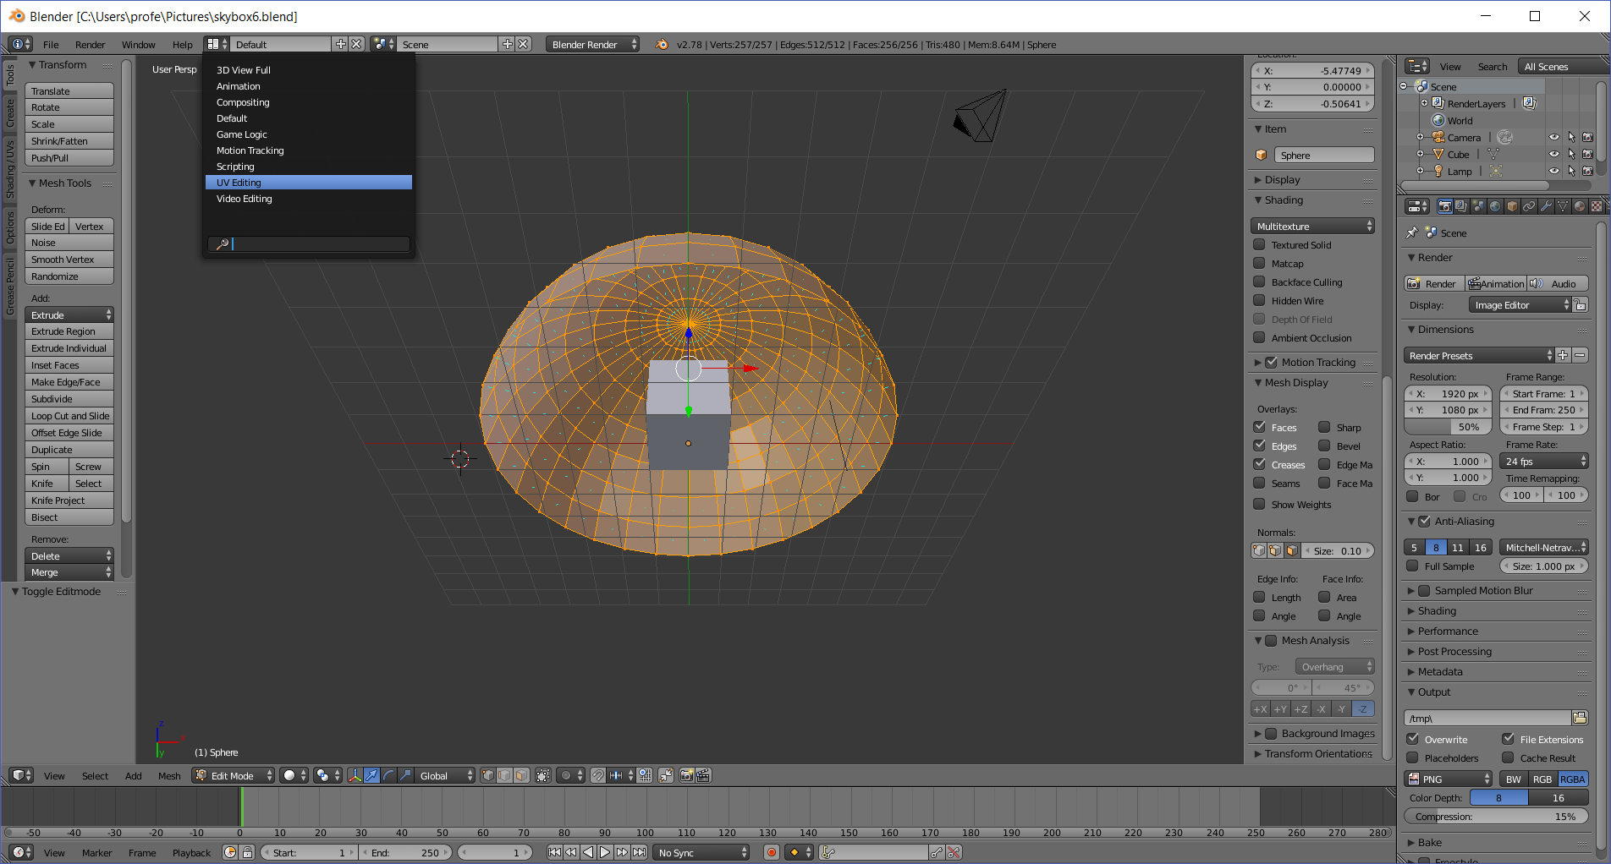

  - *click*
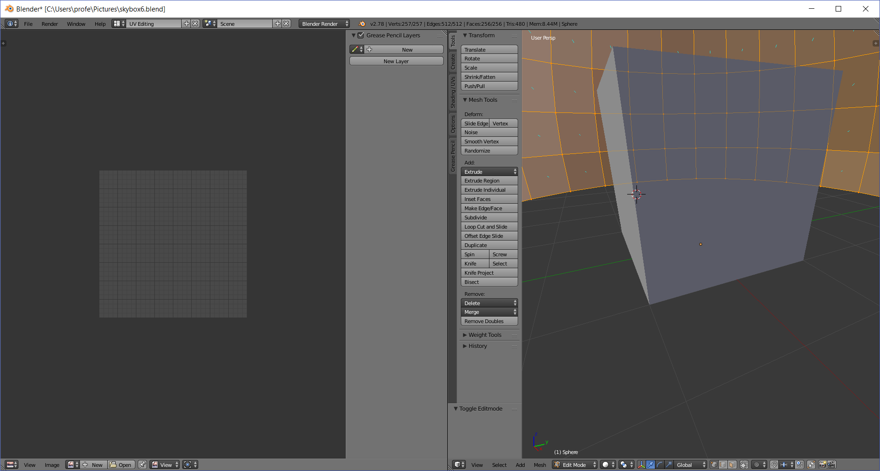
  - (on the numeric pad, with mouse in right window) Type 7 9 5, to switch to bottom ortho mode
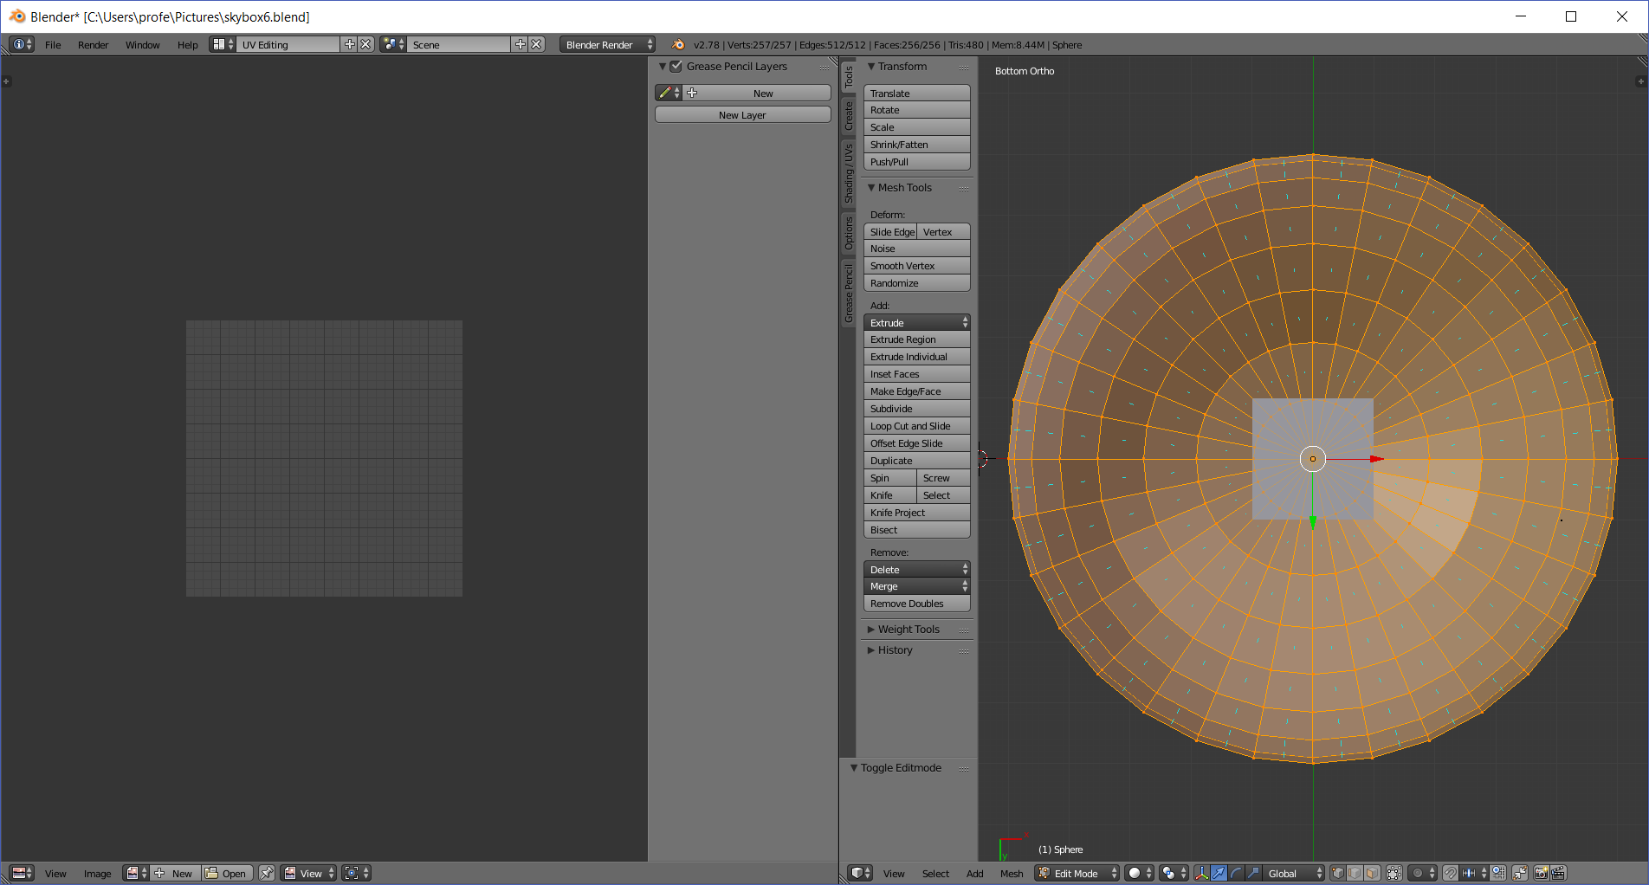
(Use the mouse wheel to move back)
  - Hover over Mesh > UV Unwrap > Projection from View (Bounds)
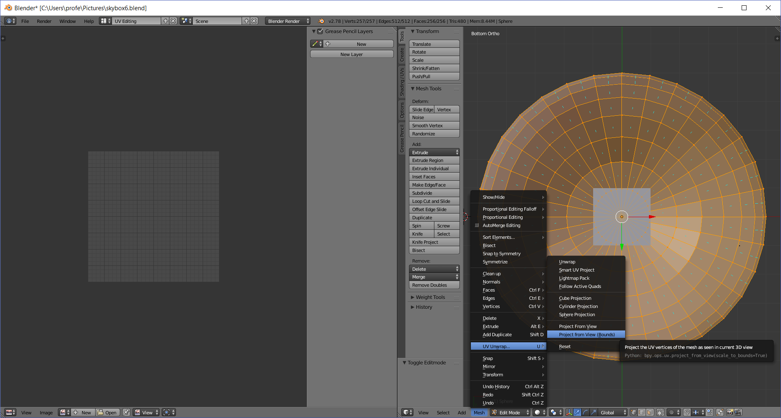
  - *click*
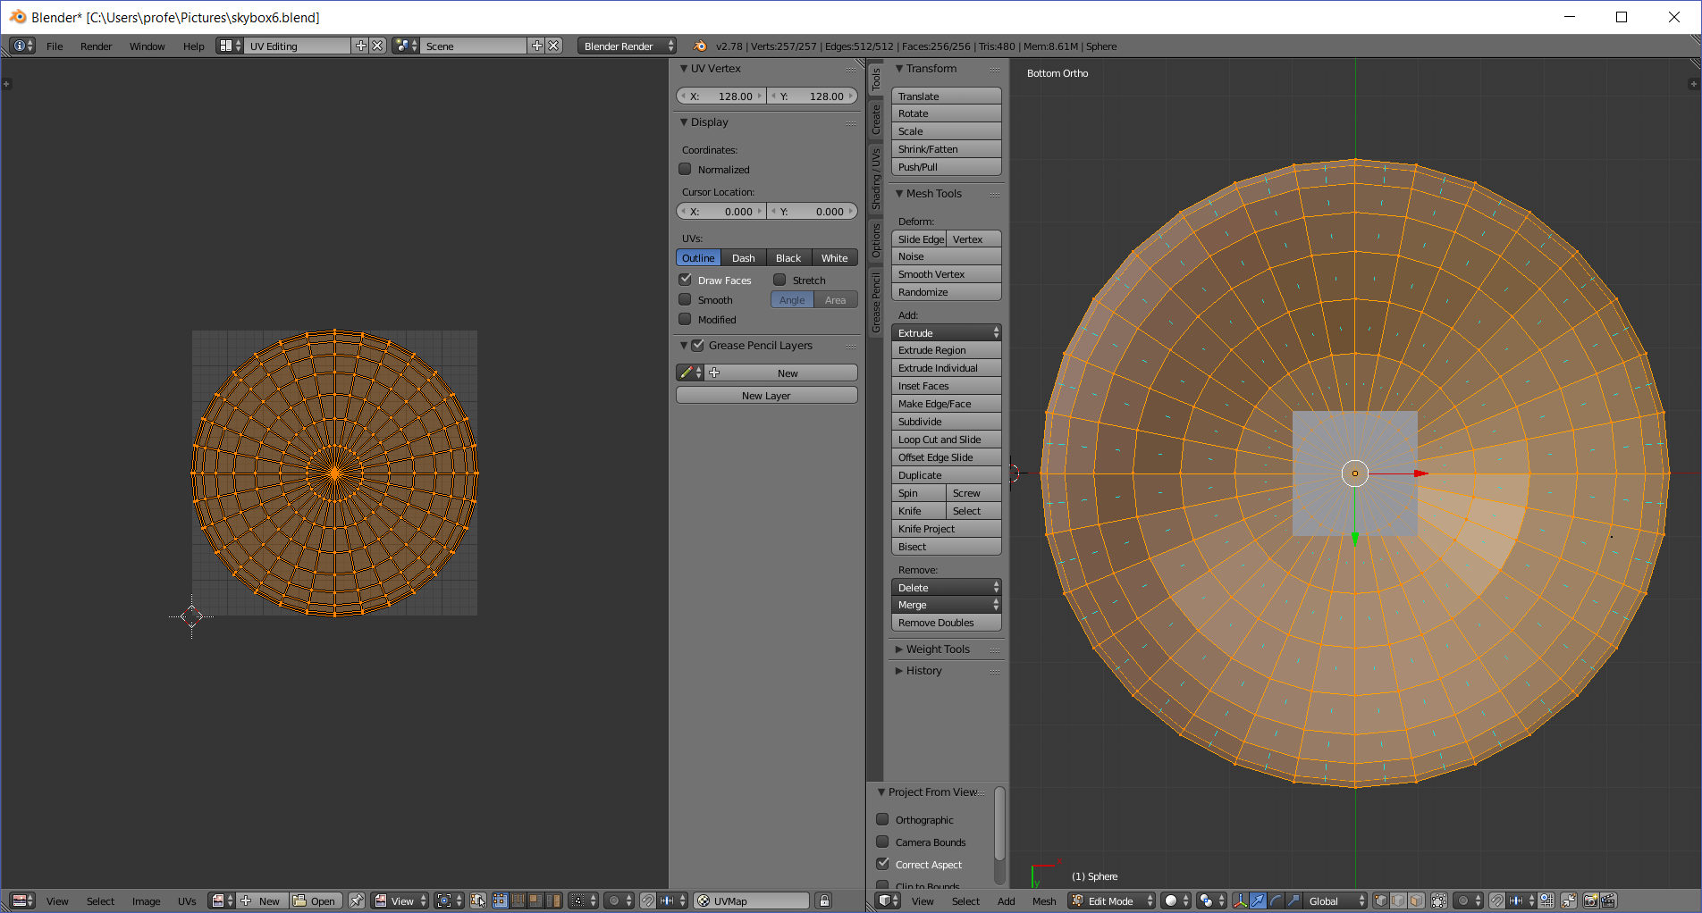
  - Hover over Layout Icon > Default
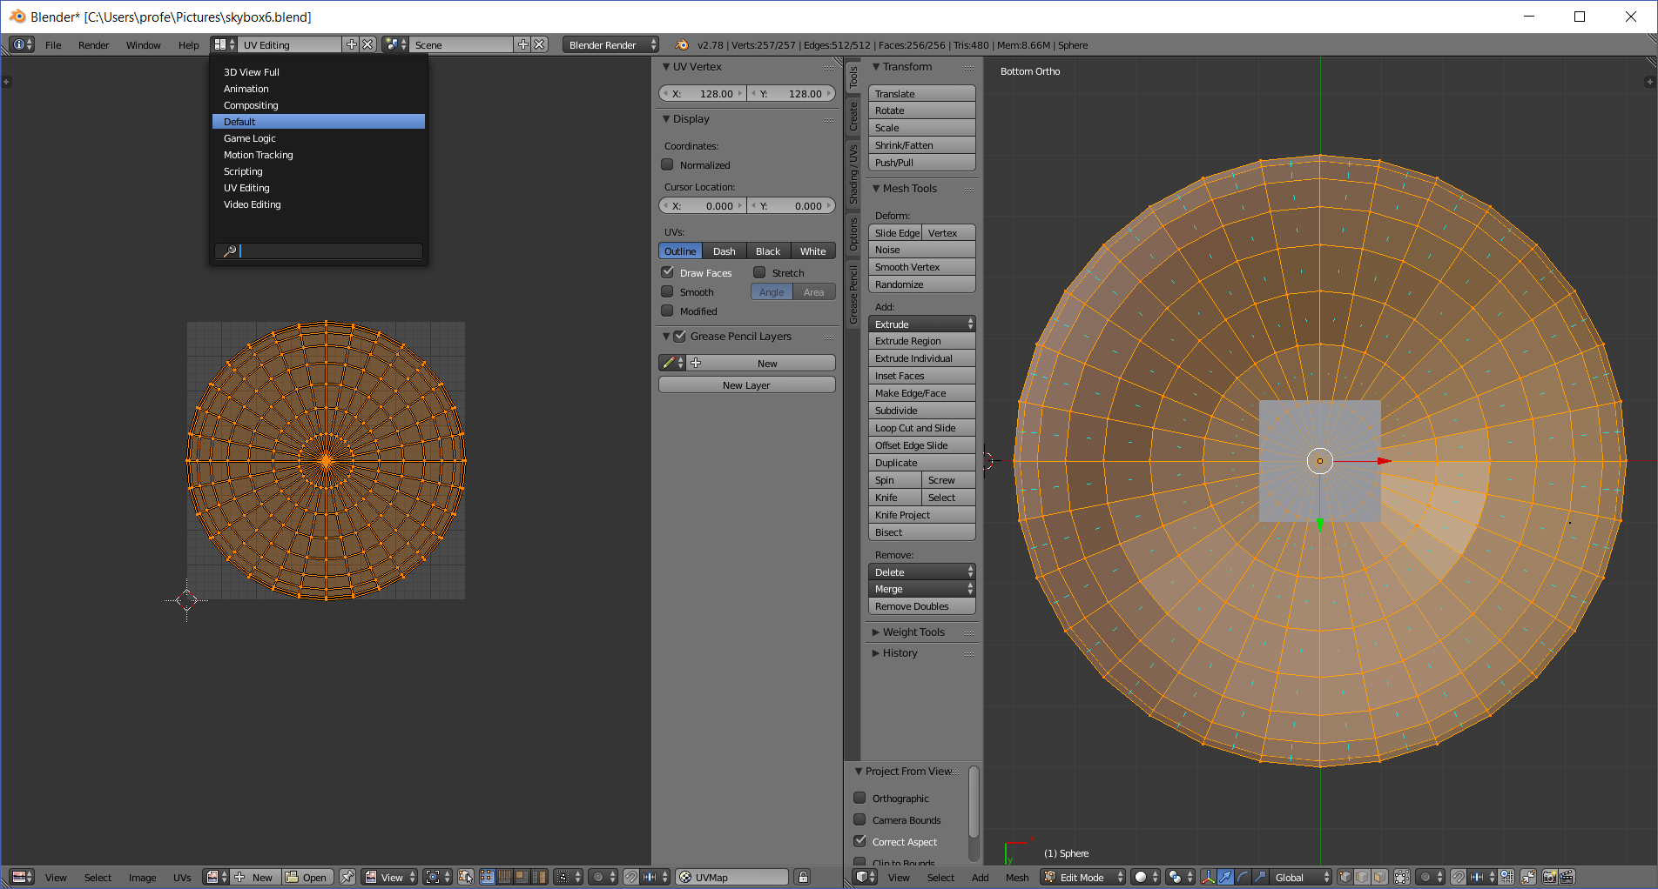
  - *click*
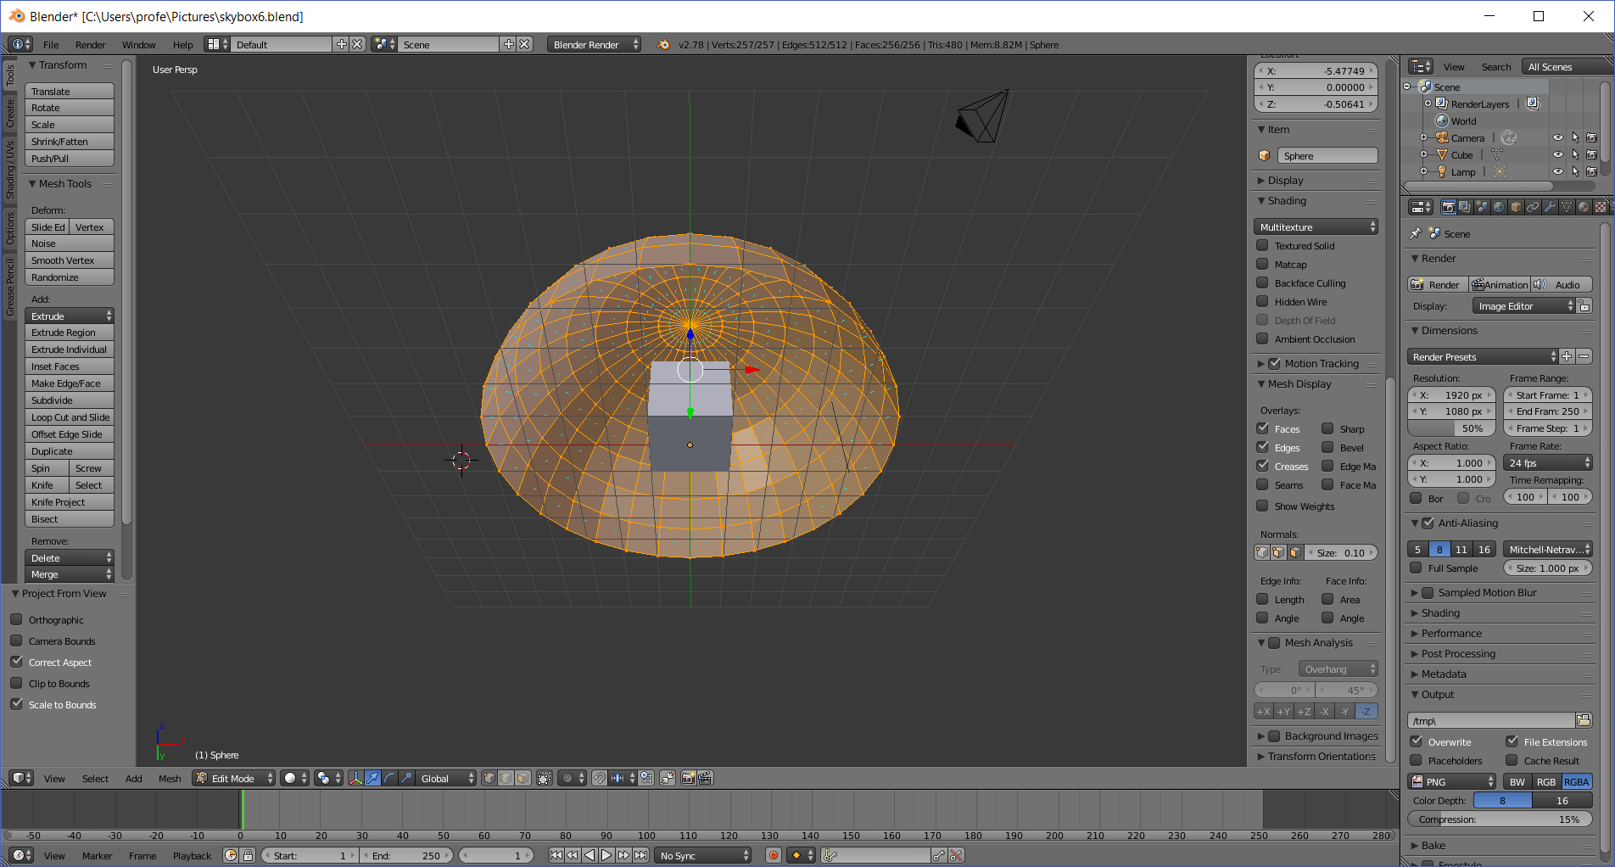

- Add a SkyBox Material
  - Hover over the Material Icon > Material
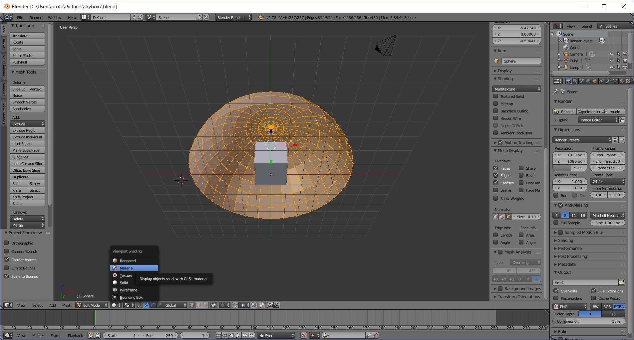
  - *click*
  - *click*
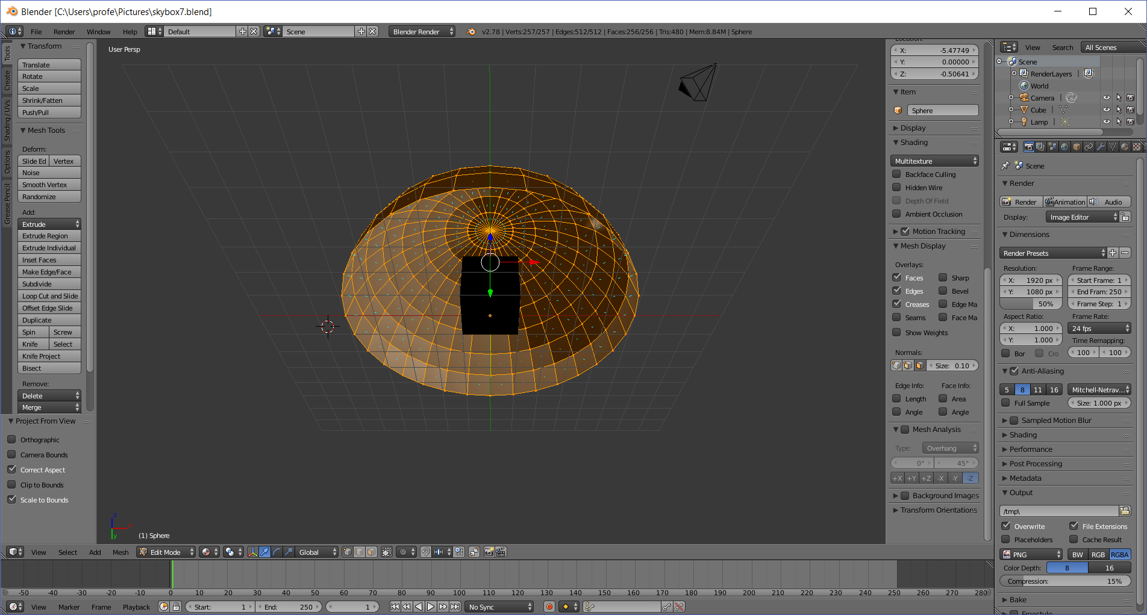
  - Click on the tiny material icon (looks like a checkered ball) in the far right panel
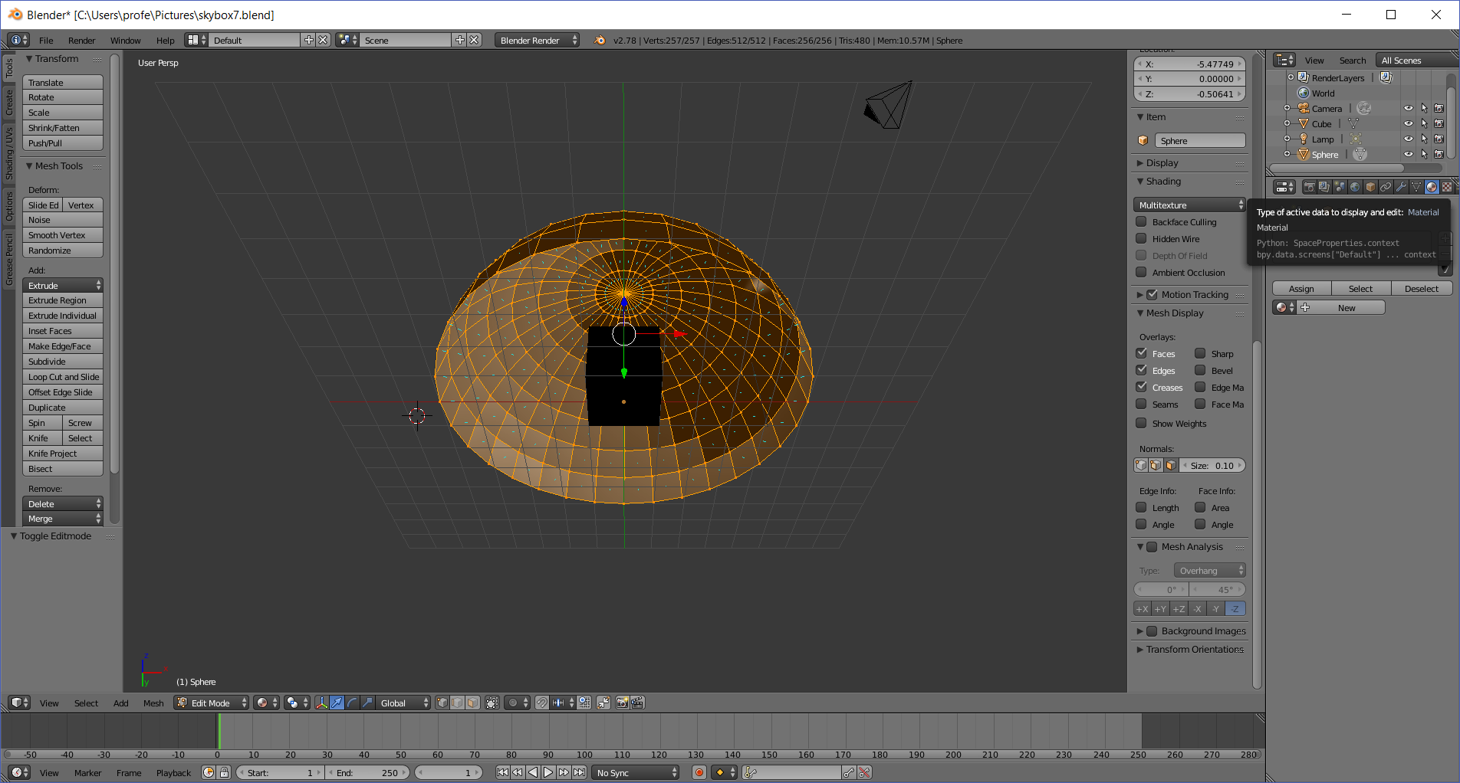
  - Click the New button
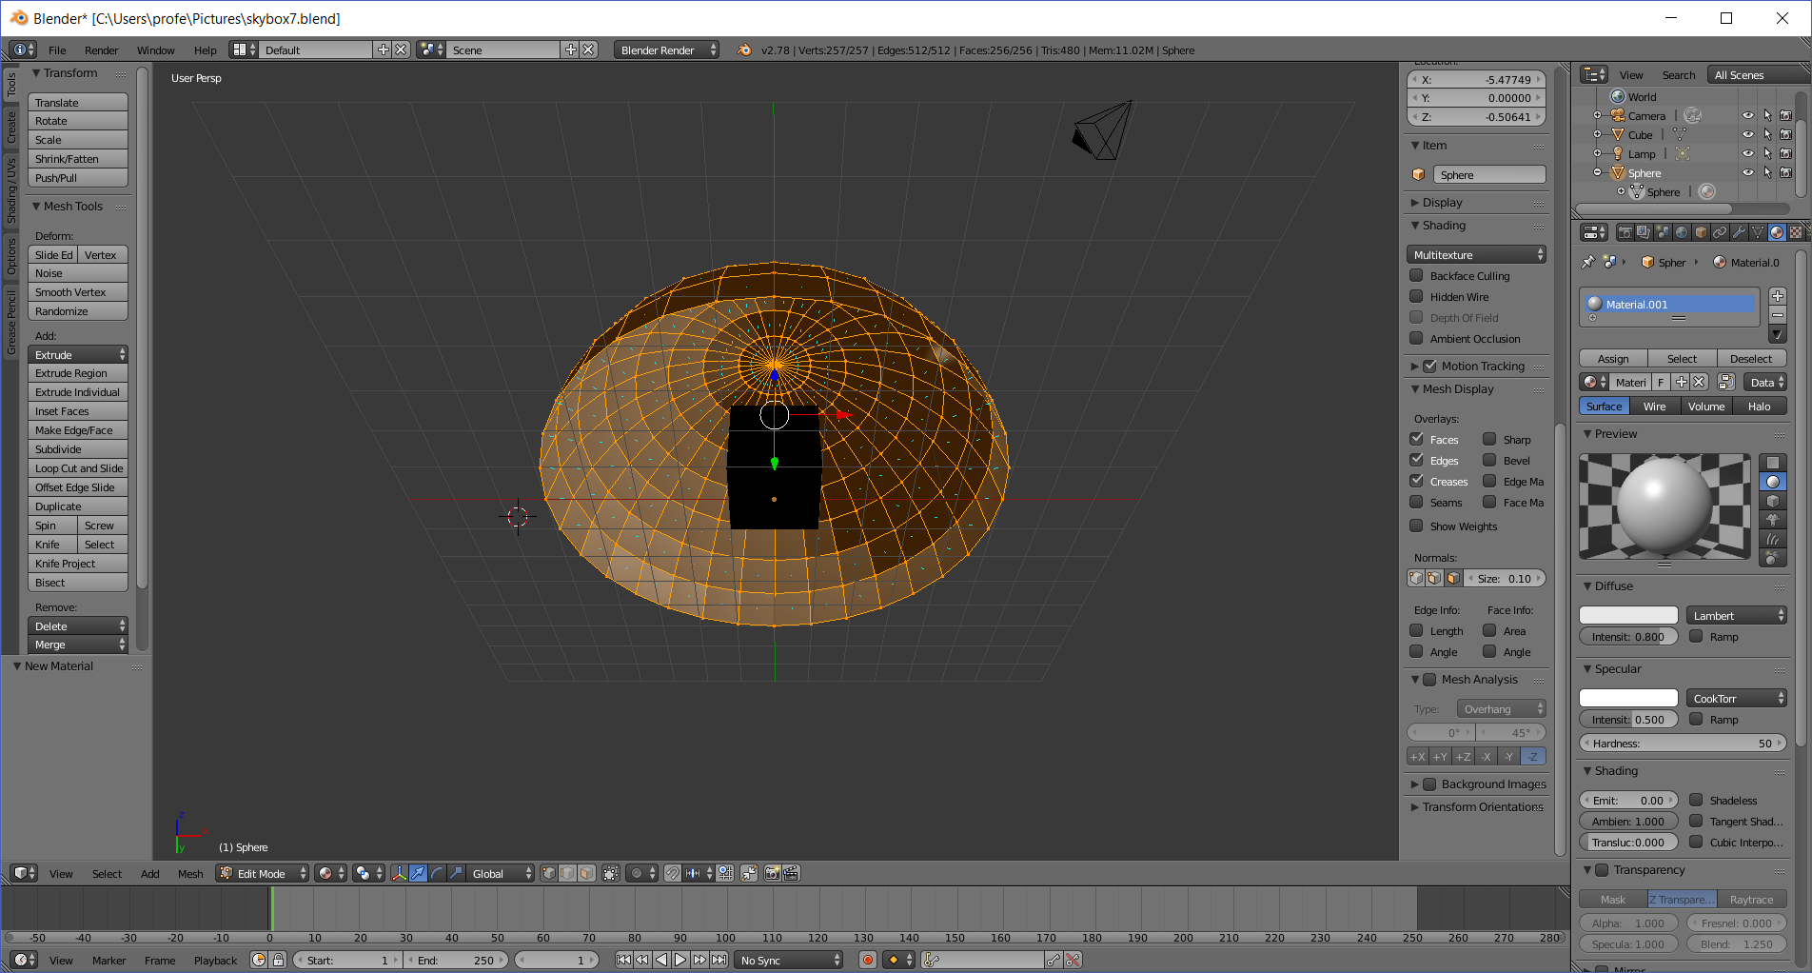
  - Click the Shading > Shadeless checkbox
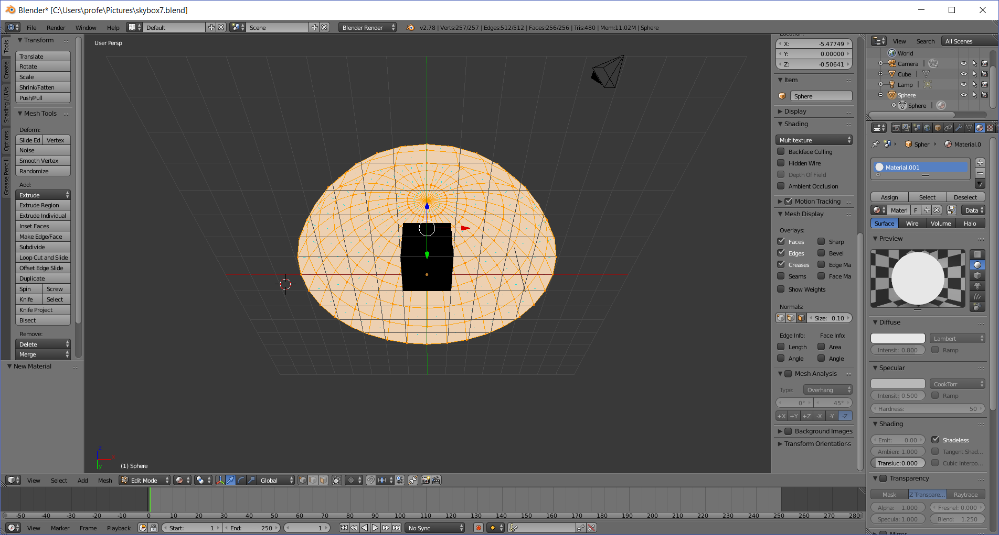
  - Click the texture icon (looks like a checkerboard) in the far right panel
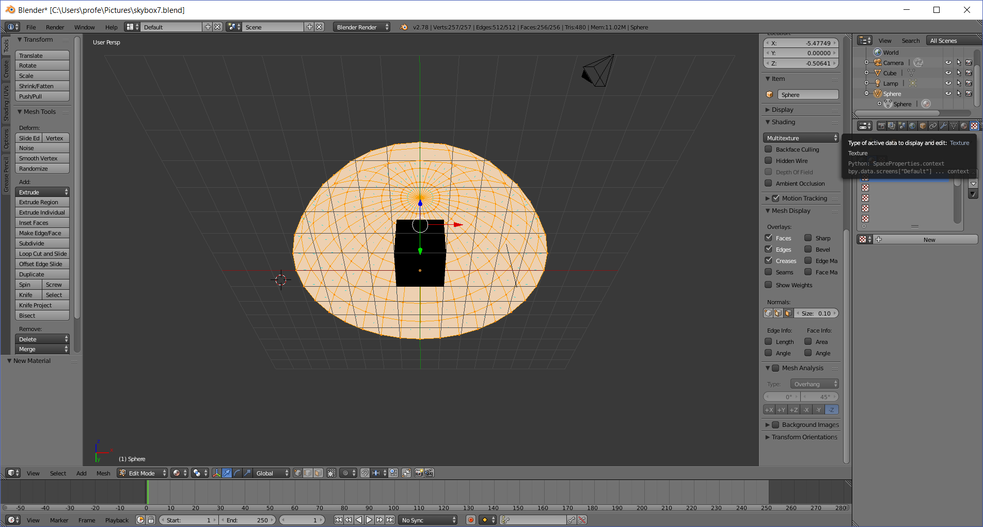
  - Click the New button
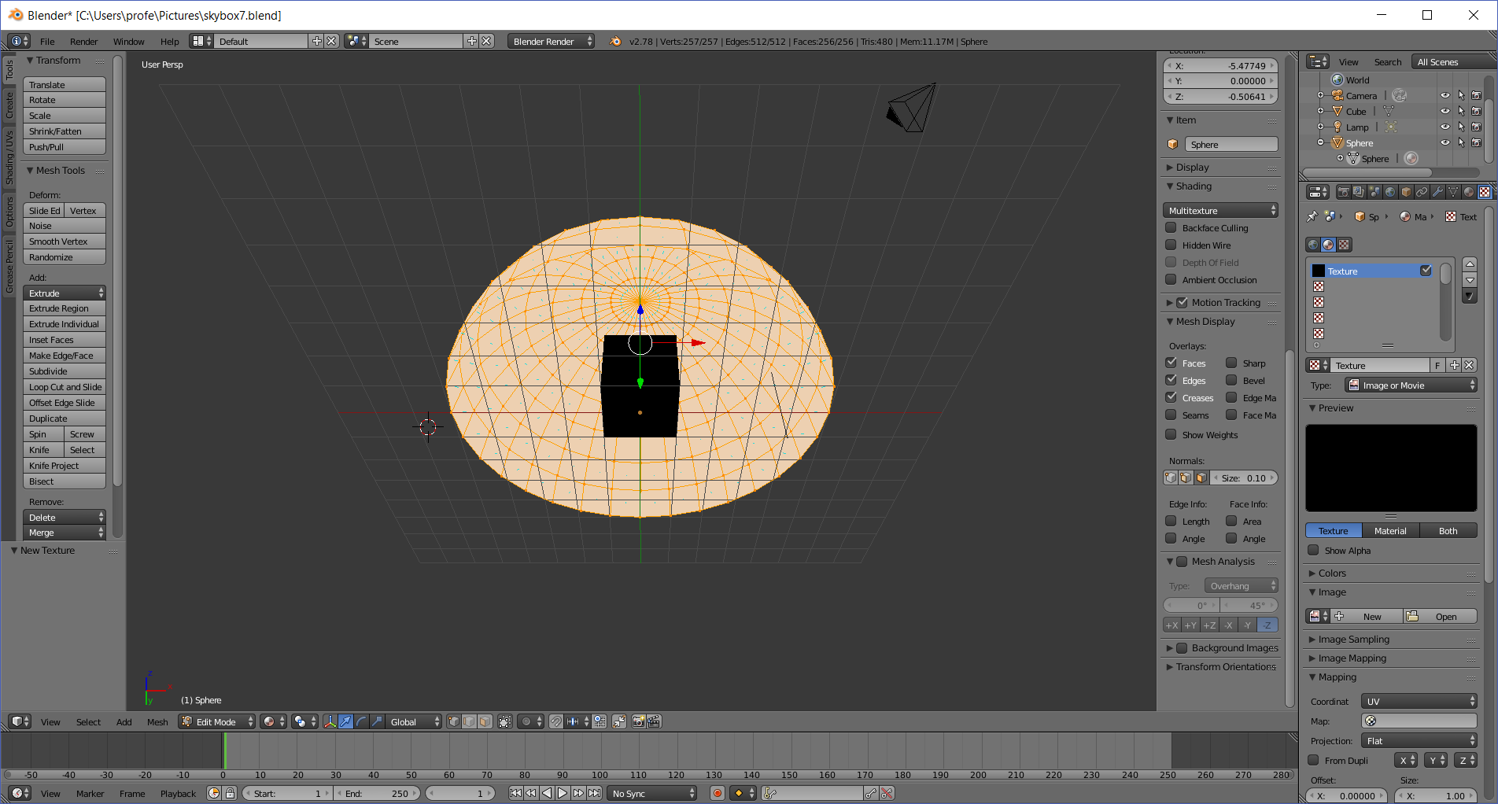
  - Click the Open button & navigate and select some picture on your computer (your screen will look different from mine)
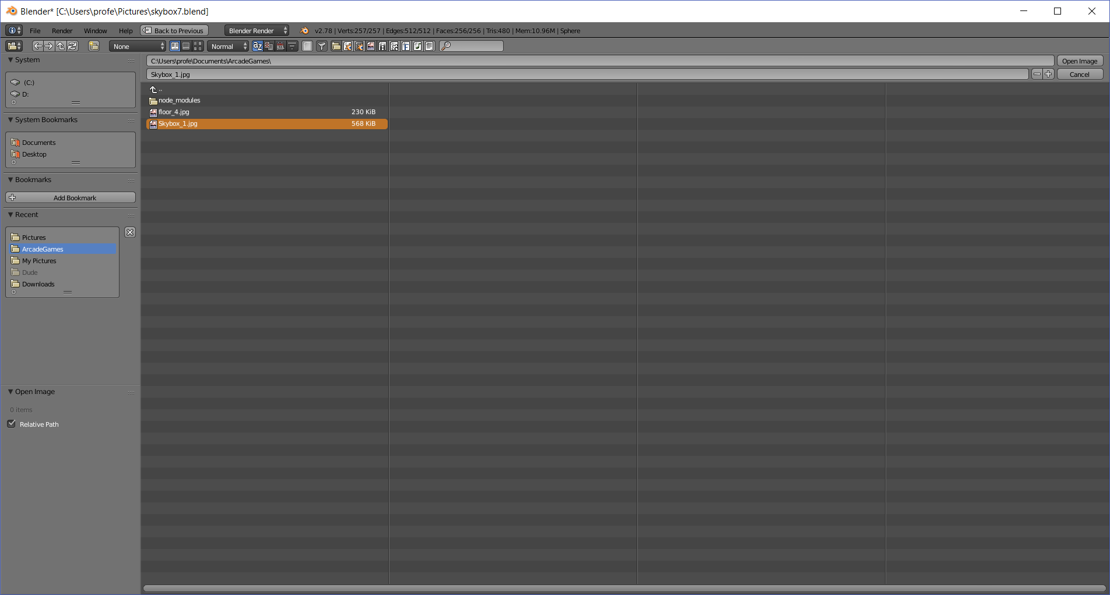
  - Click the Open Image button
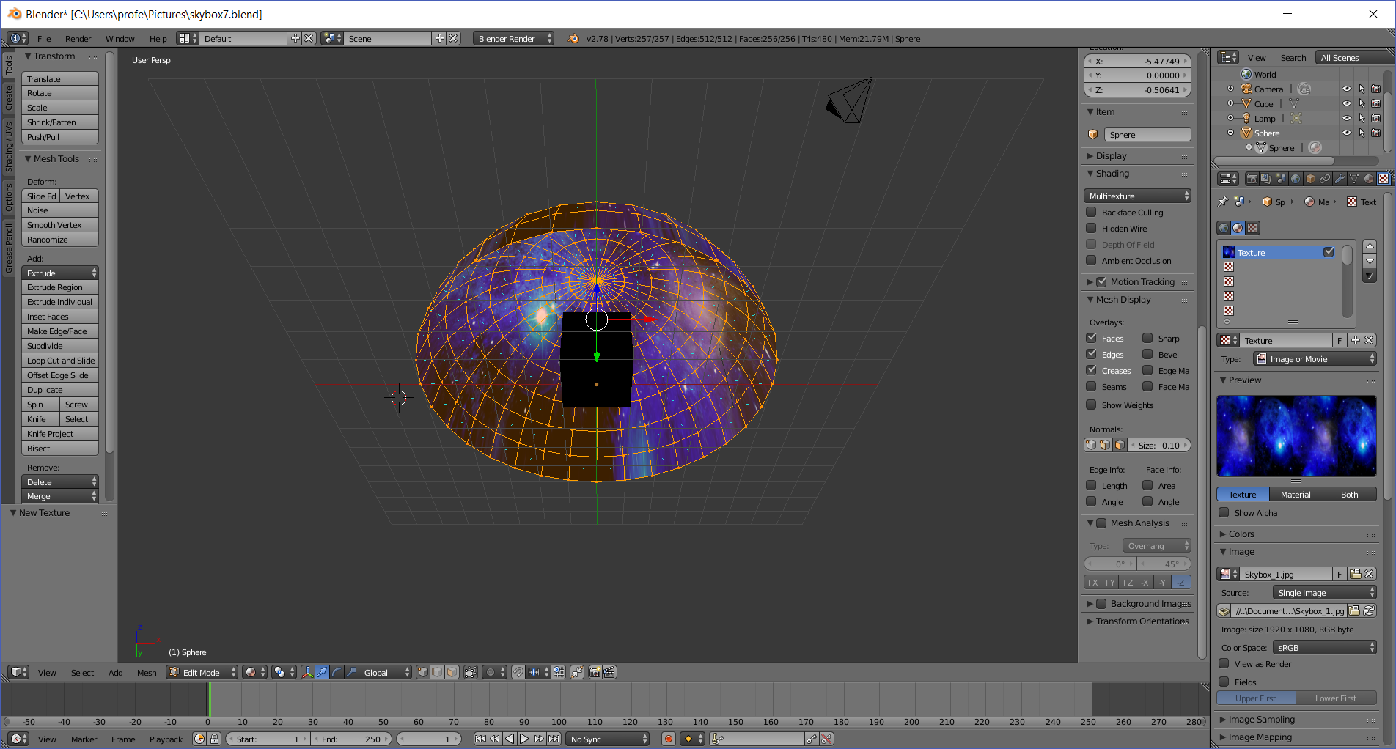
- Add an environment map to the cube
  - Select the Cube in the far-right object panel (upper right)
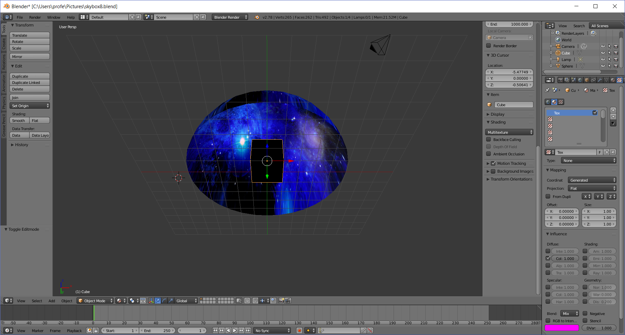
  - Click on the material icon on the far-right panel
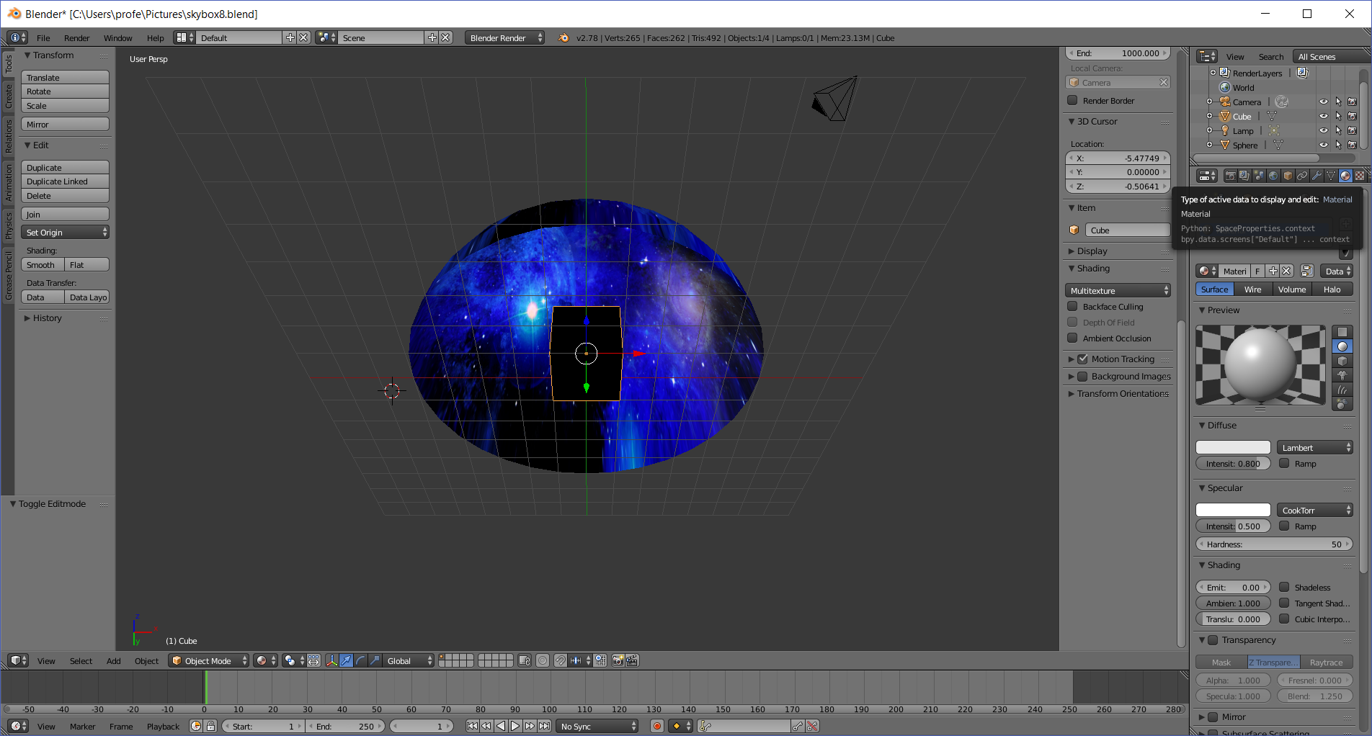
  - Click on the + (new material) button
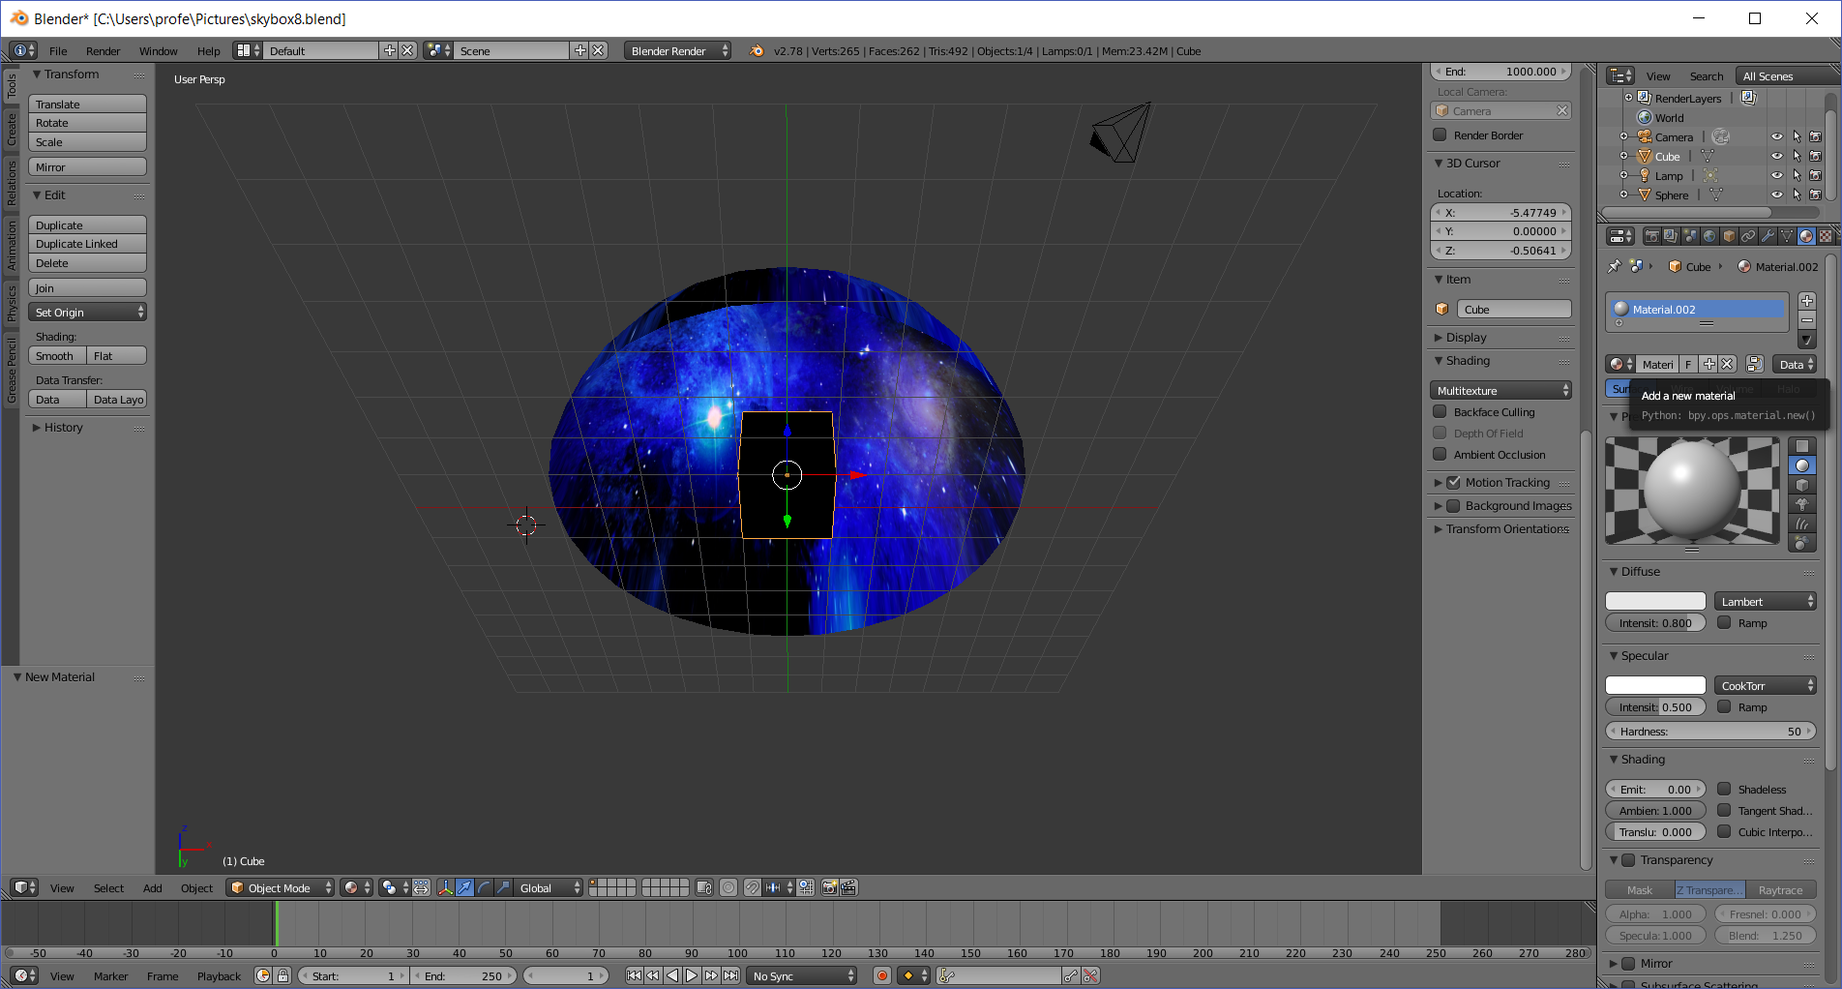
  - Click on the texture icon
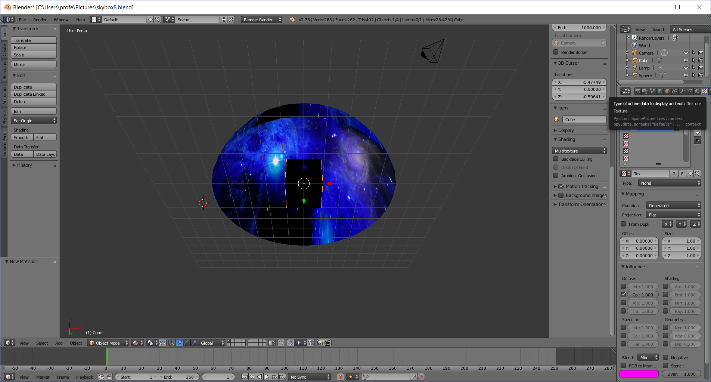
  - Click on the + (add a new texture) button
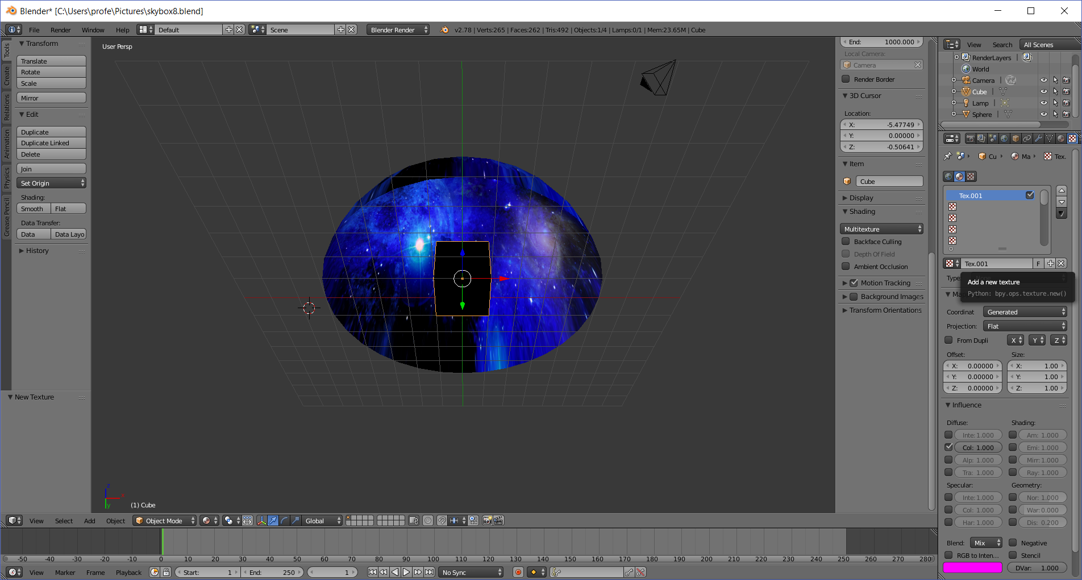
  - Click on the Type dropdown:
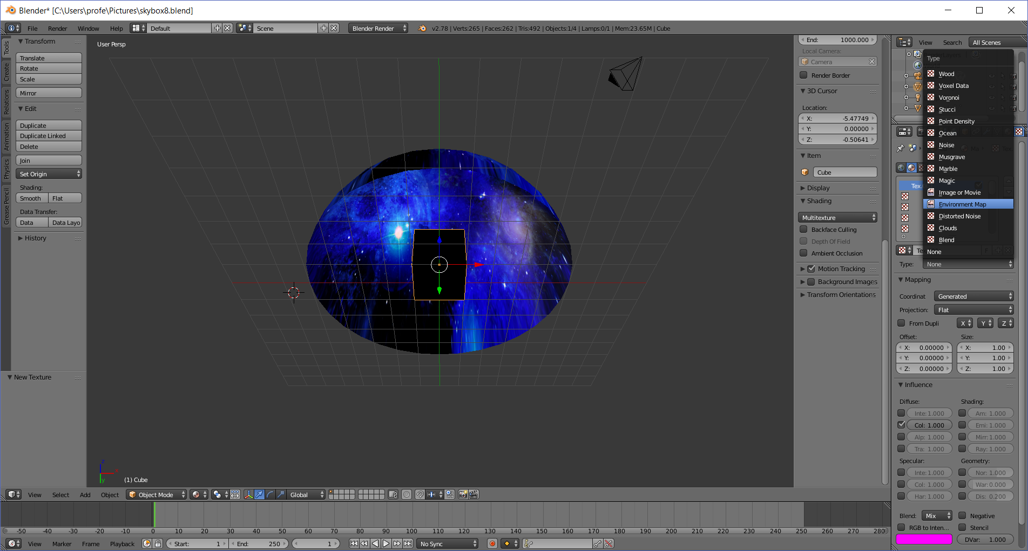
  - Click on Environment Map
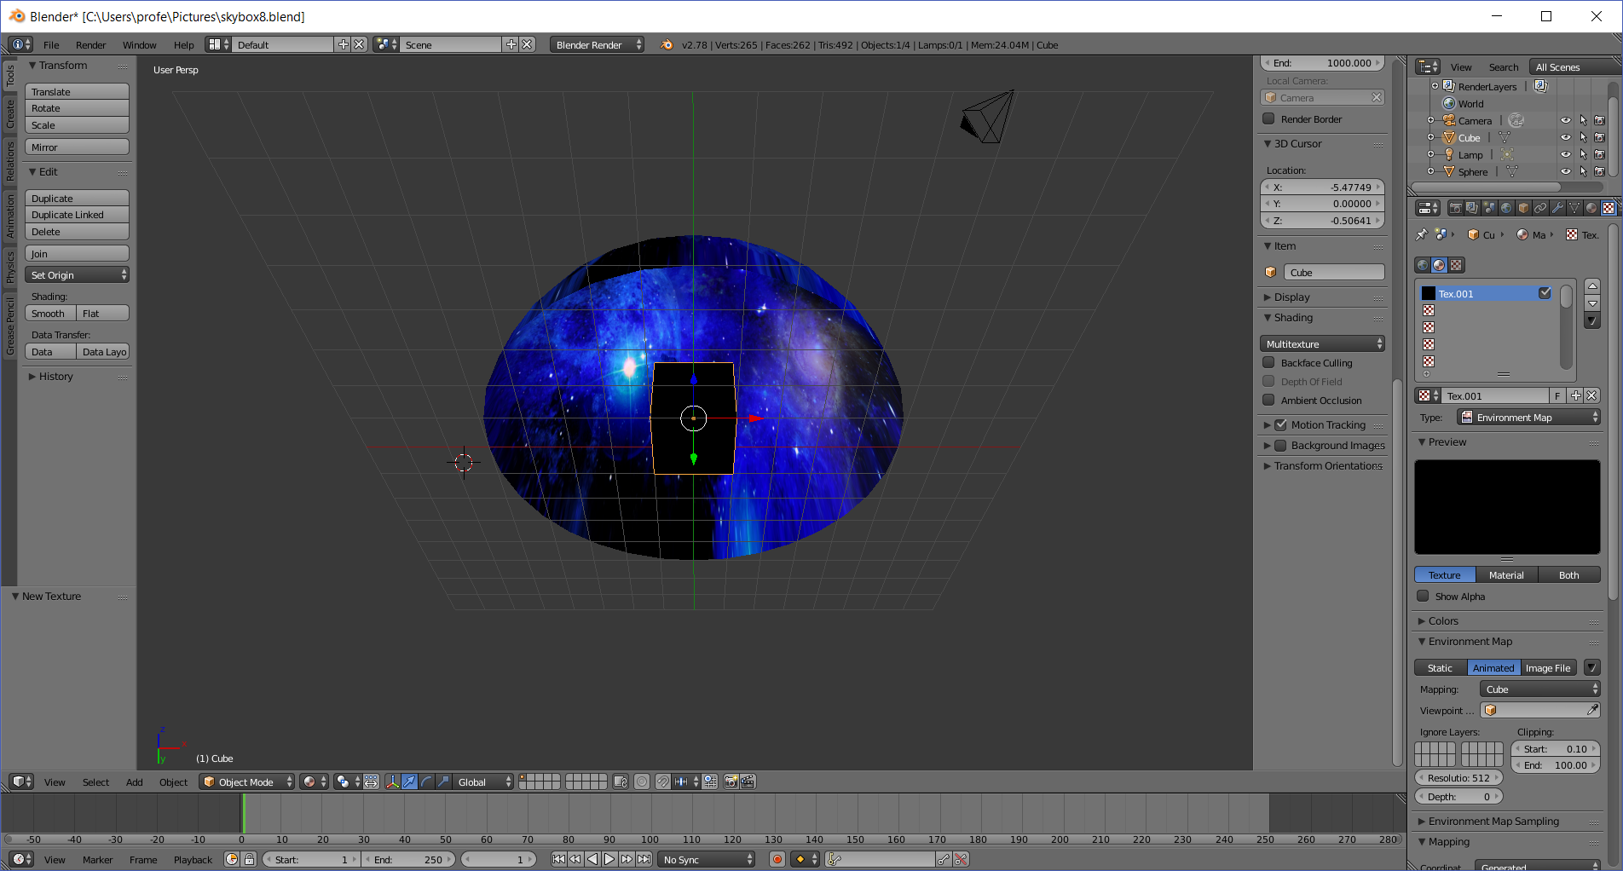
  - Click on the Viewpoint… dropdown
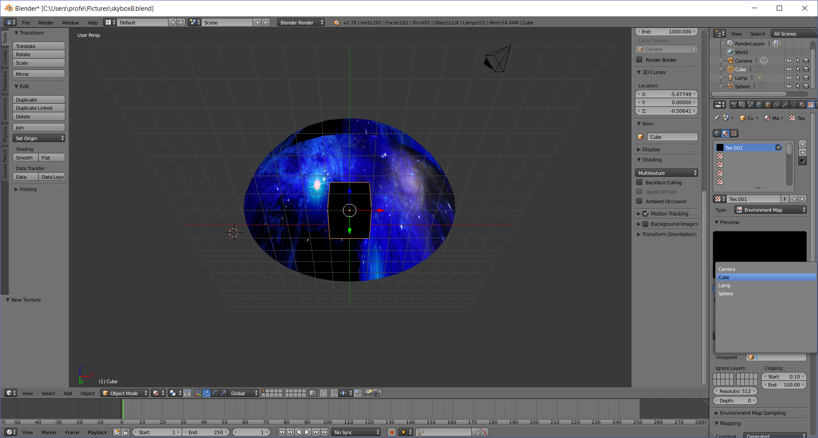
  - Select Cube
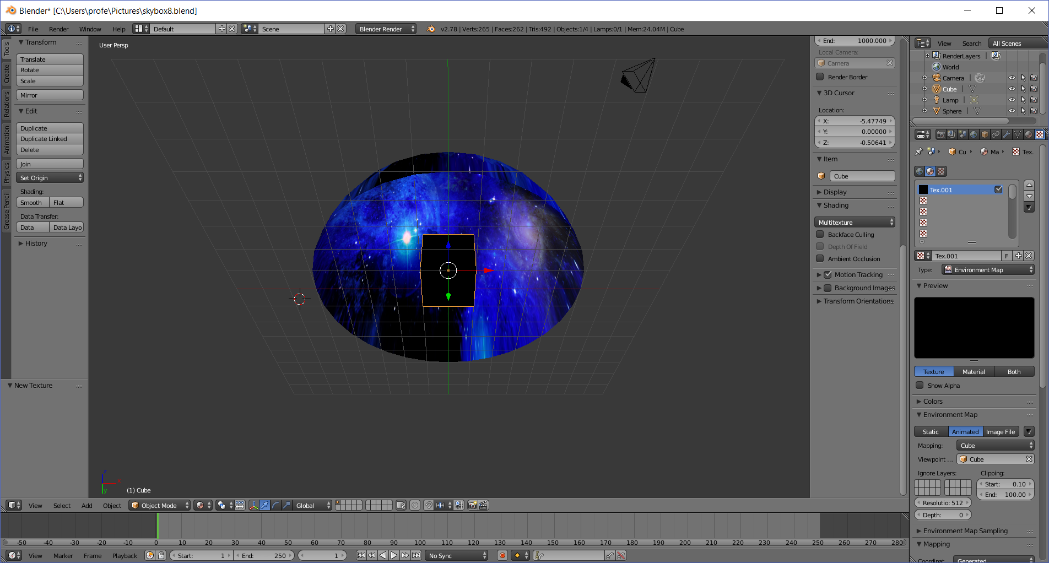
- Generate the Skybox
  - Click on the Camera (render) icon in the far-right panel
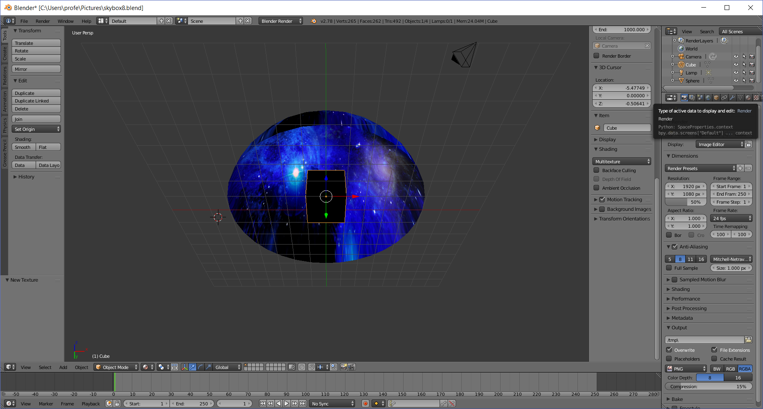
  - Click on the Render button
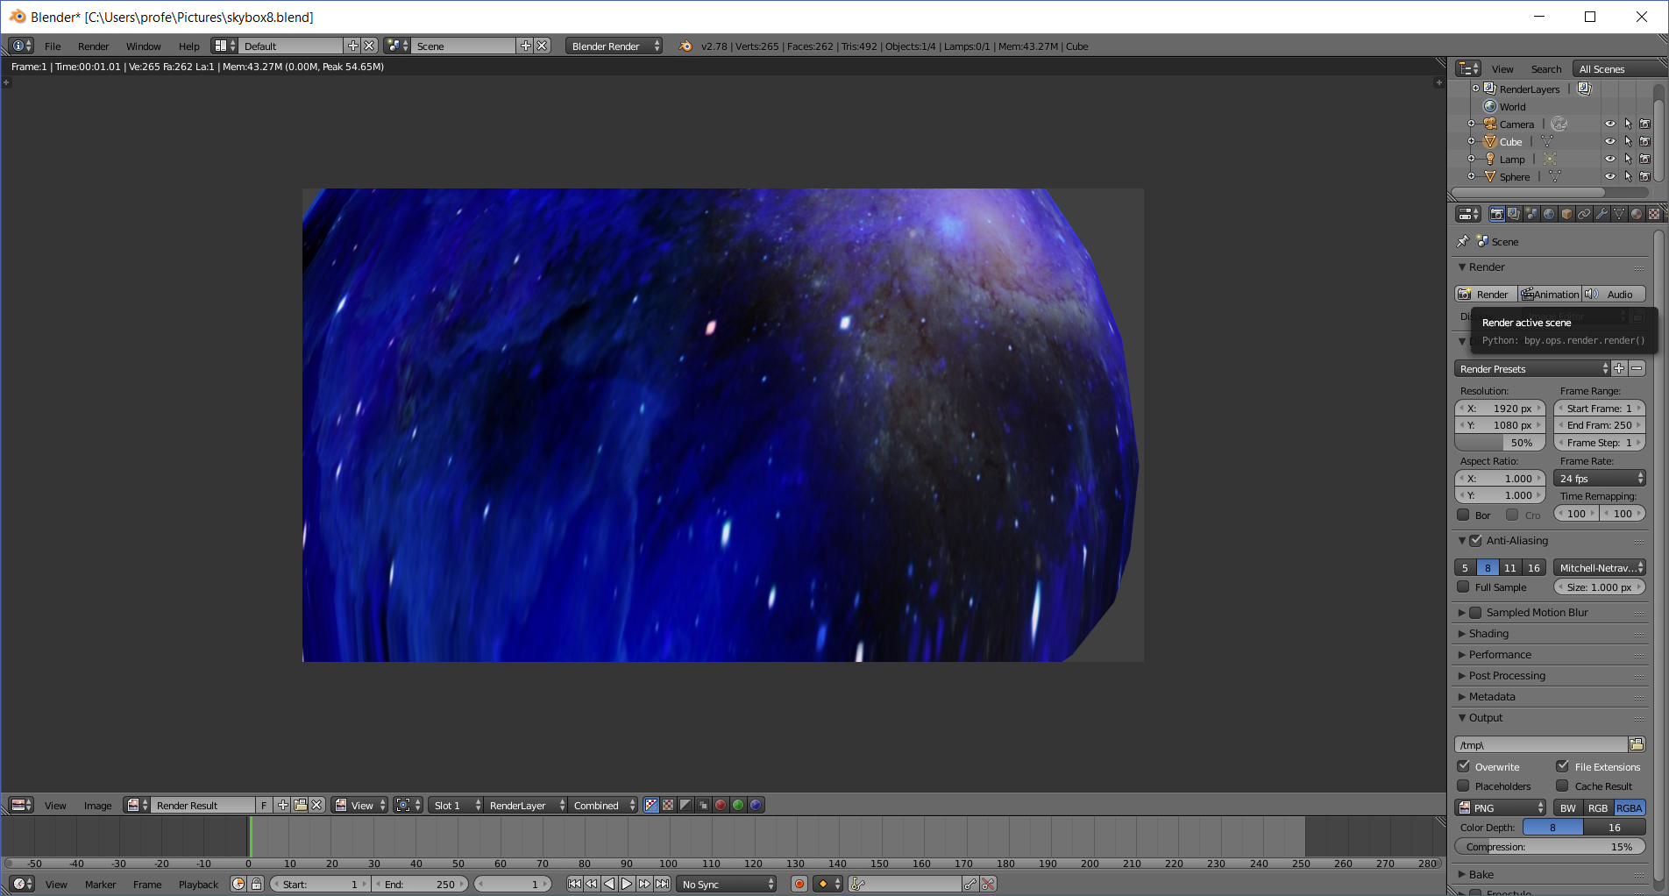
  - With the mouse cursor in the render window, press the escape key to exit render mode
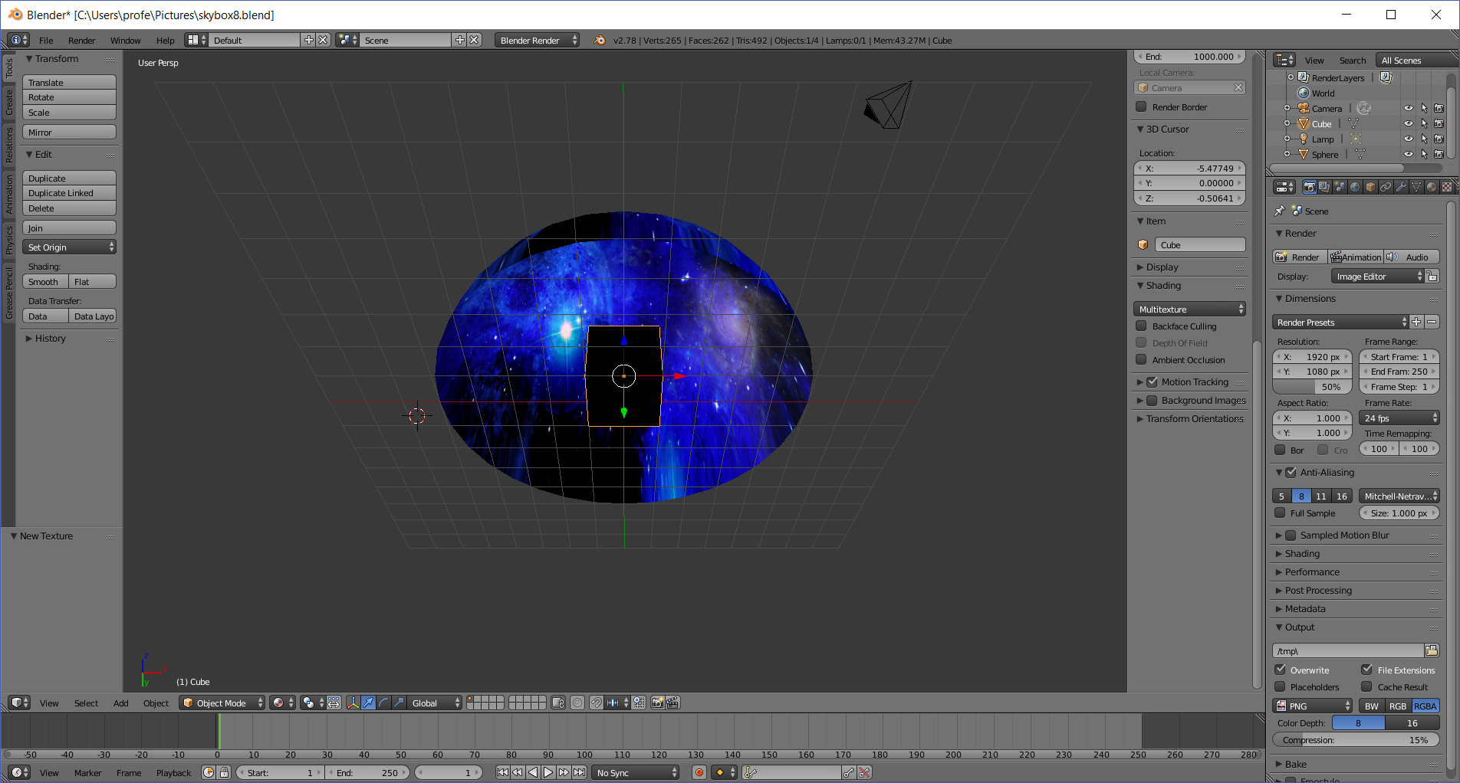
Your skybox is generated, although some computers (like mine) won’t show it on the cube.
- Save the SkyBox
  - Click on the Texture (checkerboard) icon on the far-right panel
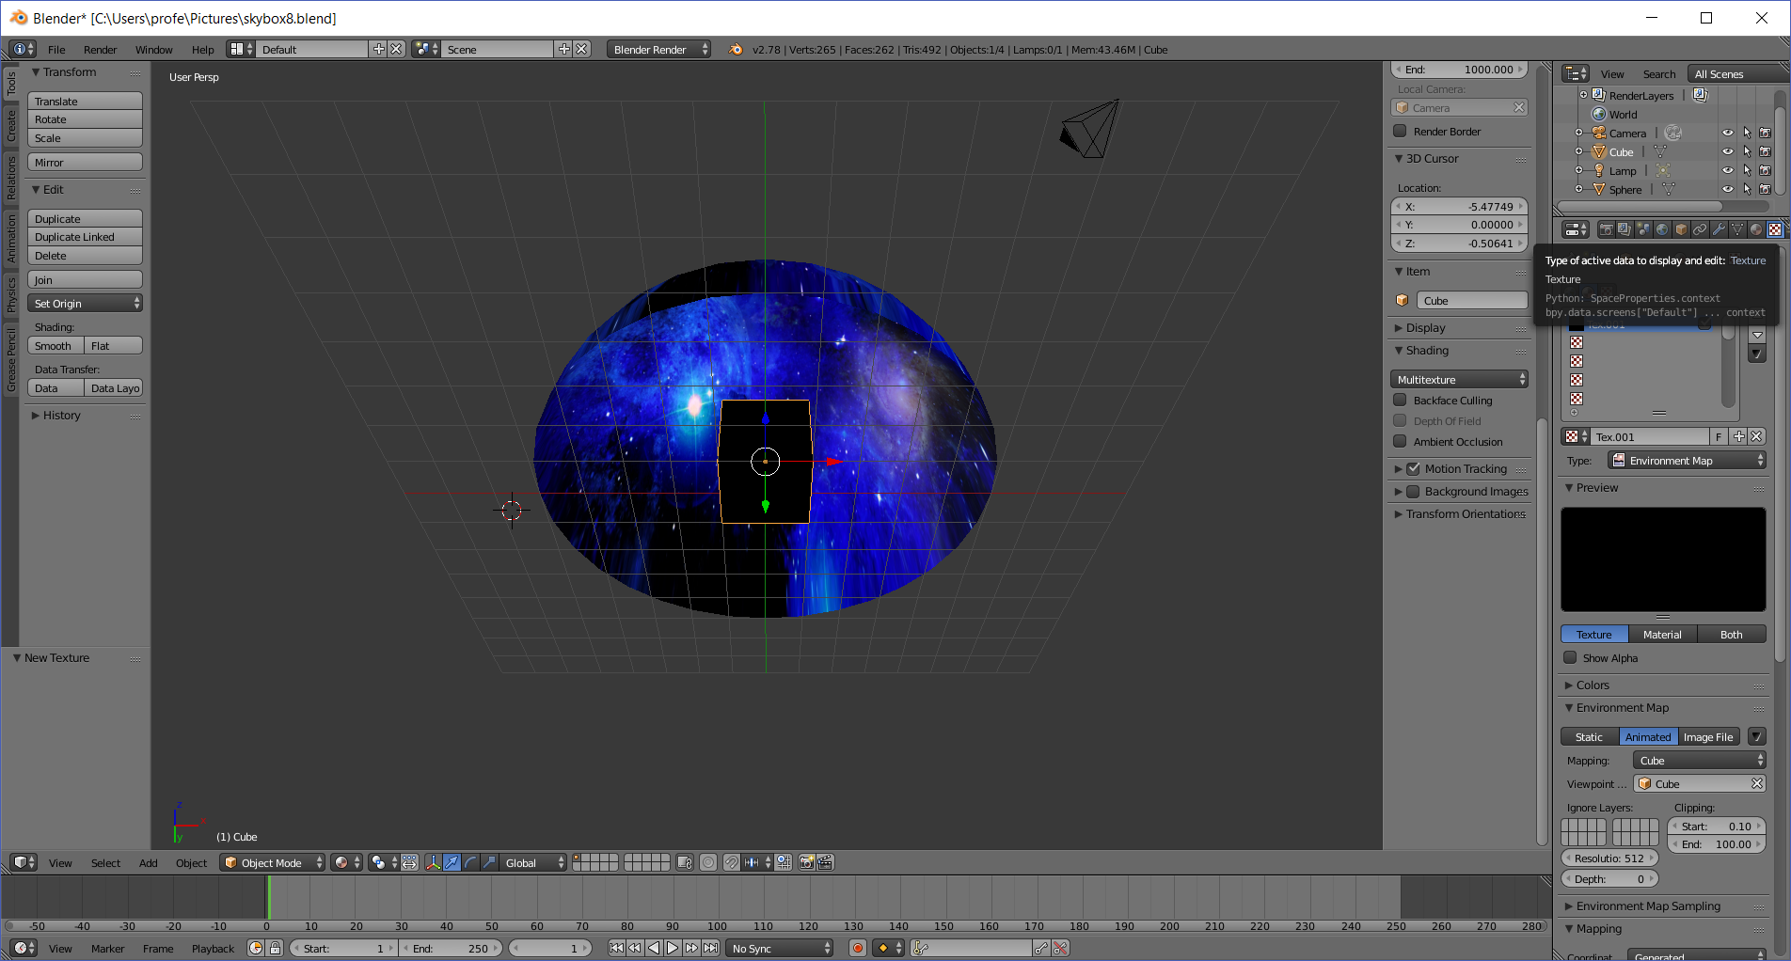
  - Click the Environment Map dropdown (near lower-right corner)
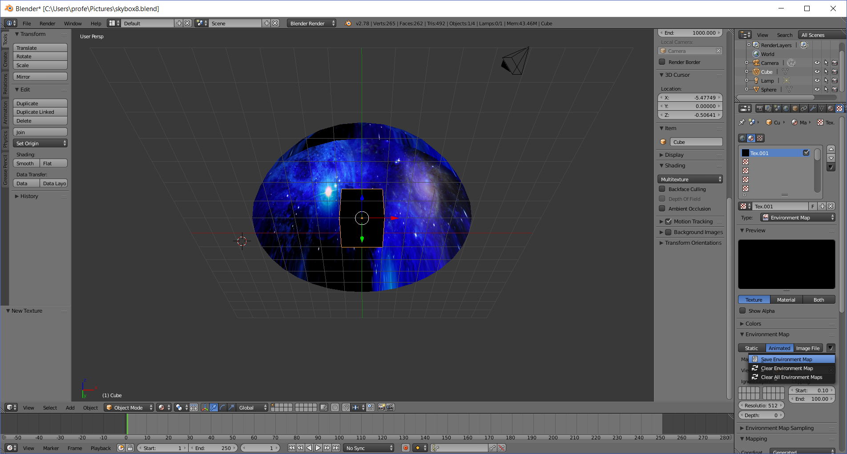
  - Click Save Environment Map
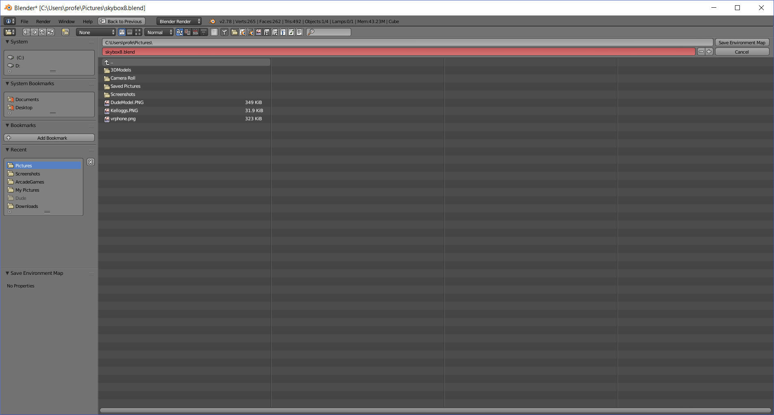
  - Navigate to a folder (yours will be different) and type in a name, like MySkyBox
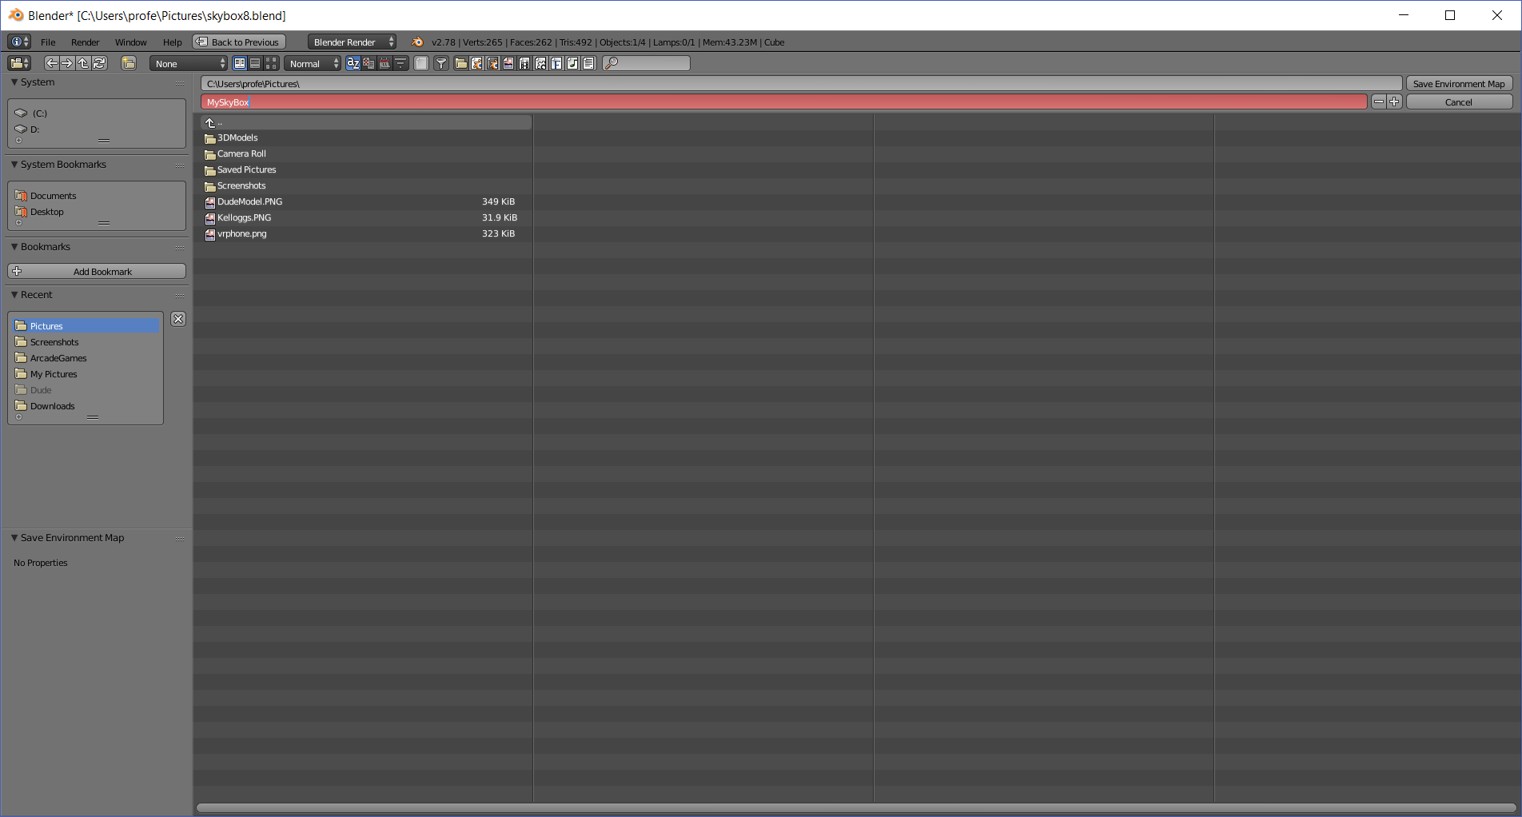
  - Click the Save Environment Map button (may have to click twice)
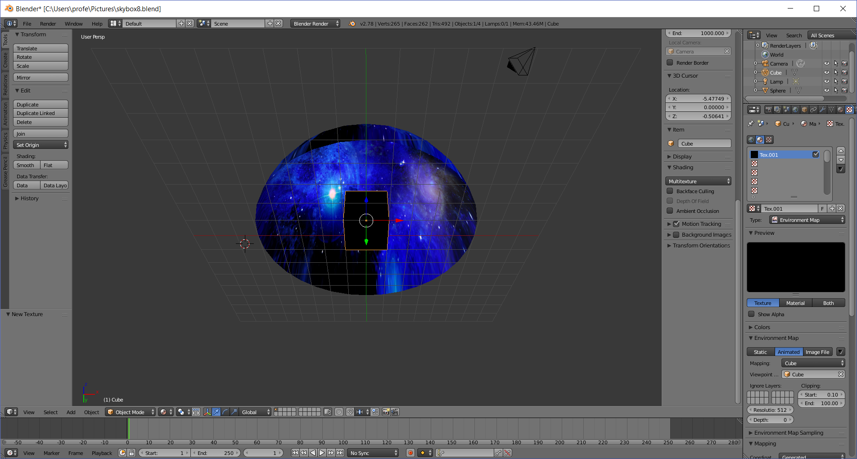
You’re done!
- Verify your SkyBox
  - Open up the file explorer and navigate to the folder you saved your SkyBox in
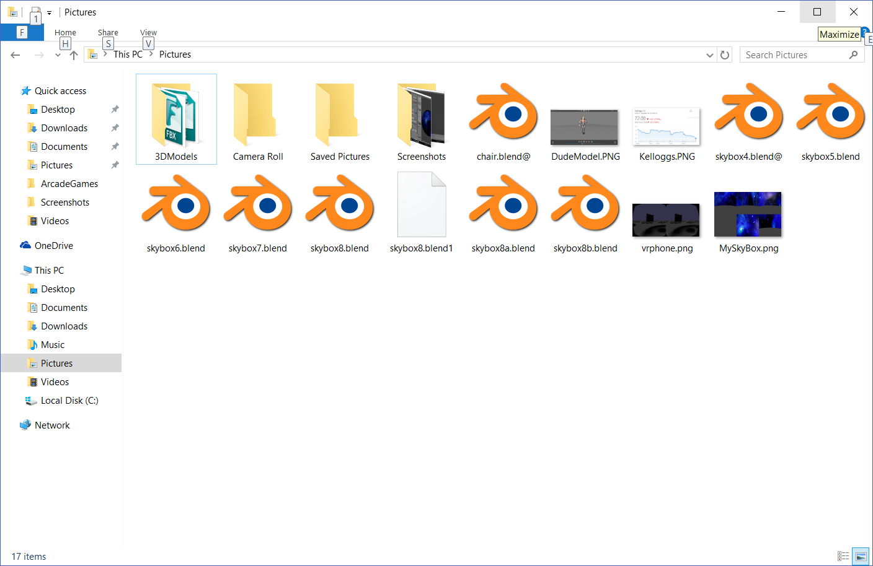
  - Double-click on your SkyBox (in my case MySkyBox.png)
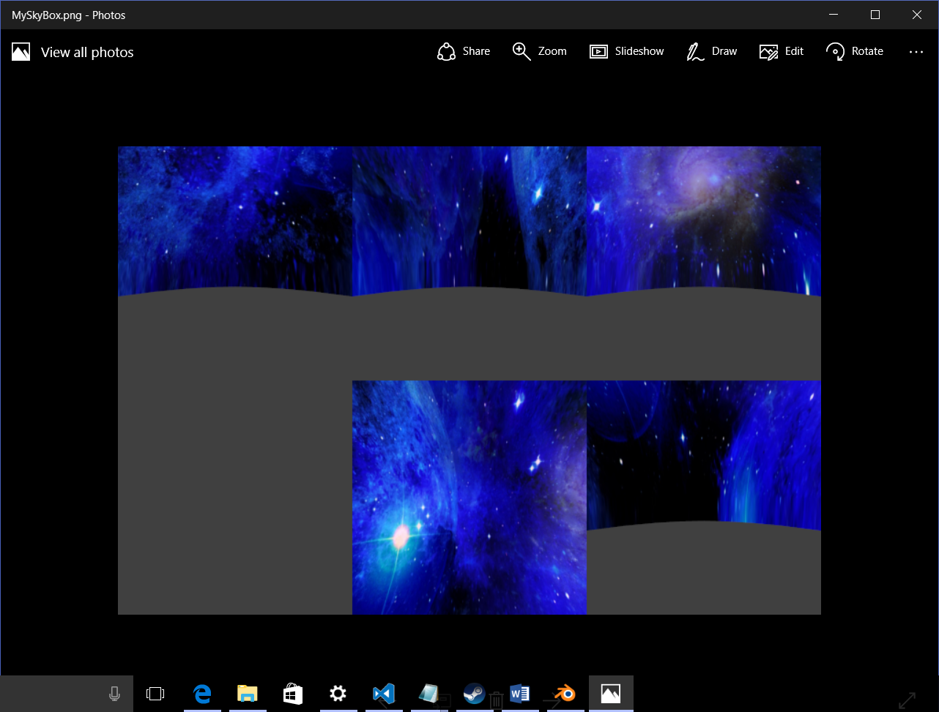
The image is 768x512→each image is 256x256 pixels. You’ll have to input it into a program like photoshop to cut it up, but the images from L-R, top down, are:
Left, Front, Right,
Bottom, Top, Back


