Blender Navigation
Nick V. Flor (nickflor@unm.edu, @ProfessorF)

IF YOU DON’T HAVE A MOUSE AND/OR NUMERIC KEYPAD:
File > User Preferences > Input (then click the appropriate check boxes)
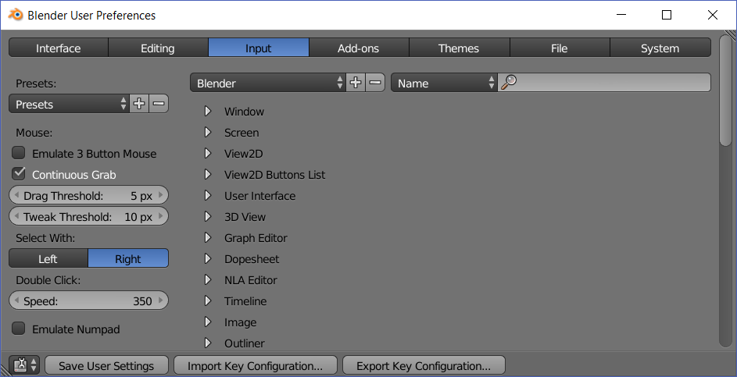

BASIC NAVIGATION
- Zoom: Roll mouse wheel
- Rotate: Click and hold mouse wheel (also known as middle-mouse button or MMB), then move mouse
- Pan: Hold shift key, then click-and-hold MMB, then drag mouse
- Alternate Zoom: CTRL then click-and-hold MMB, then drag mouse

CENTERING CAMERA
- SHIFT-C: Zooms out so you can view the entire scene
- . on the keypad zooms in on the currently selected object
- You can also use the view menu, in the lower left corner

BASIC KEYPAD NAVIGATION
- 1: Front
- 3: Right
- 5: Toggle between perspective and ortho
- 7: Top
- 9: Toggle between Top / Bottom or Right / Left

MODES
- TAB toggles between Object and Edit mode
- CTRL-TAB in Edit Mode lets you select Vertex, Edge, & Face Modes
- In Edit Mode you can also click these buttons to select Vertex, Edge, & Face Modes
