Blender Manikin Connecting the Head & Body
Nick V. Flor (nickflor@unm.edu, @ProfessorF)

- Open up both your head file (LastnameFirstnameHead.blend)…
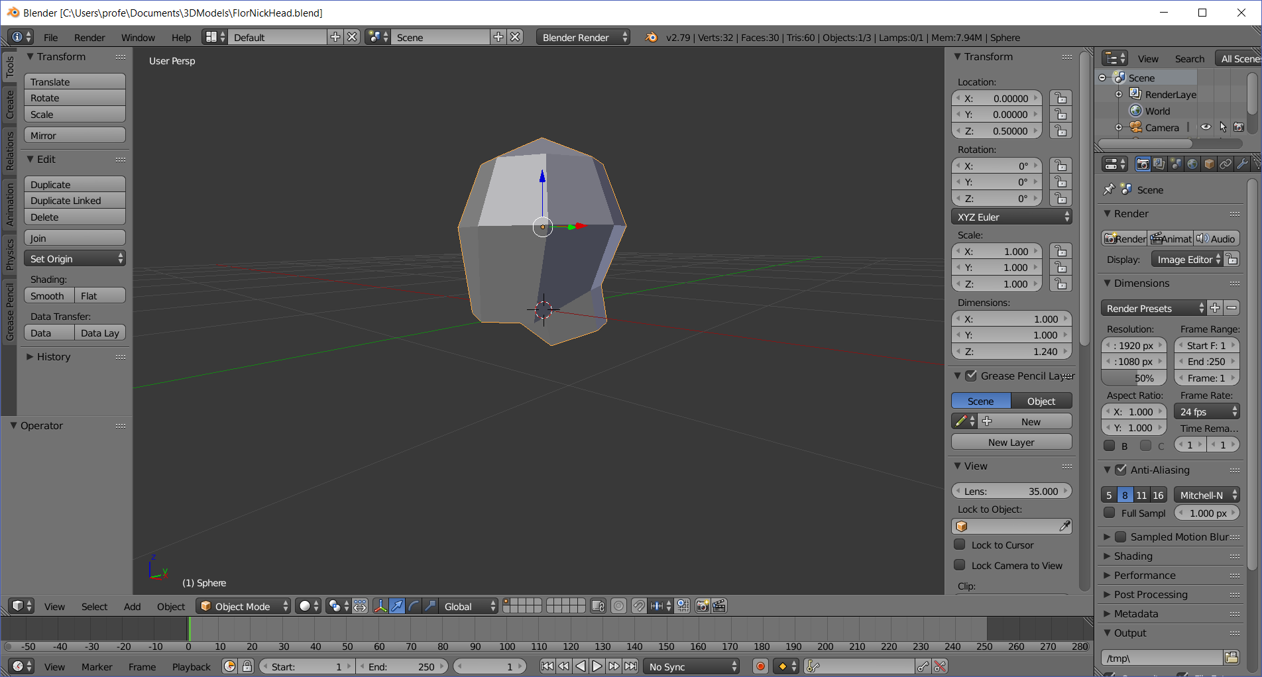
and your body file (LastnameFirstnameBody.blend)
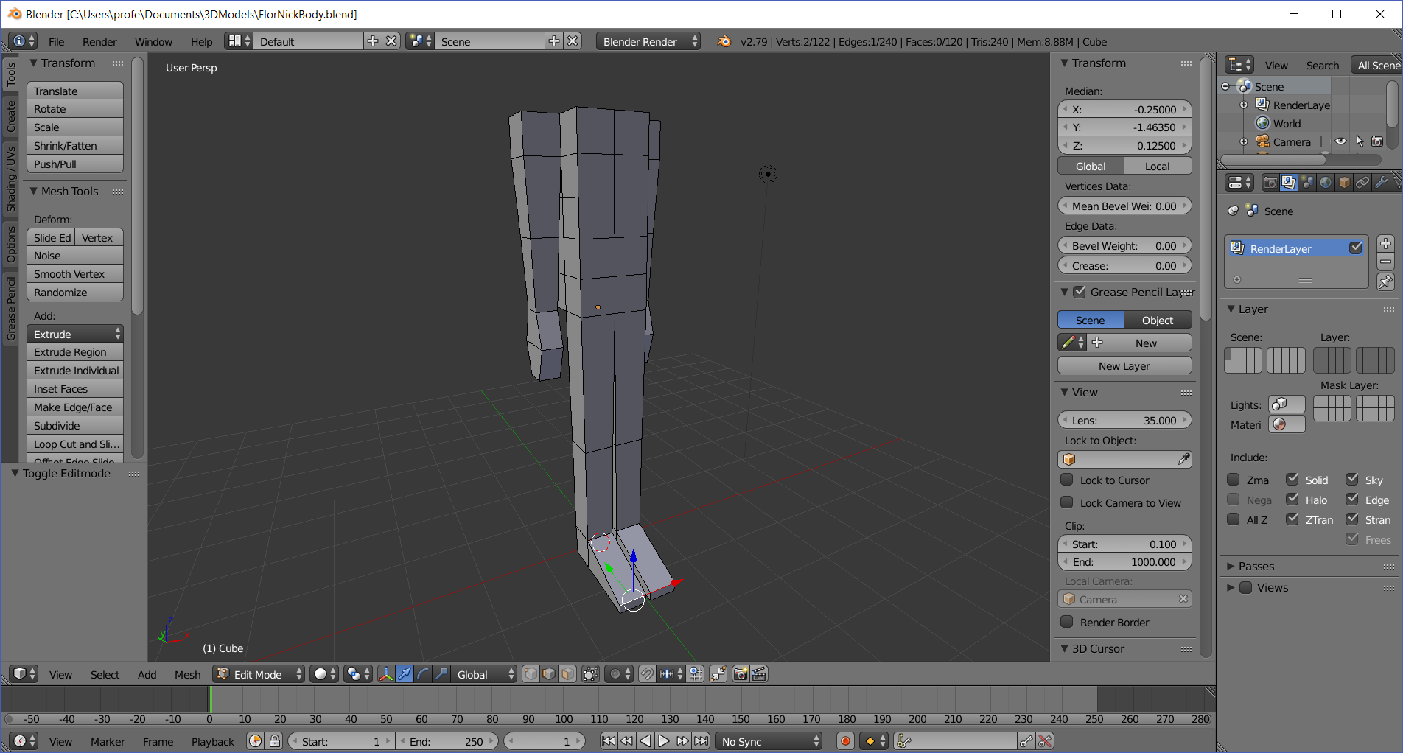

- Ensure both files are in Object mode
  - Toggle Tab until both objects have a yellow outline around the entire model
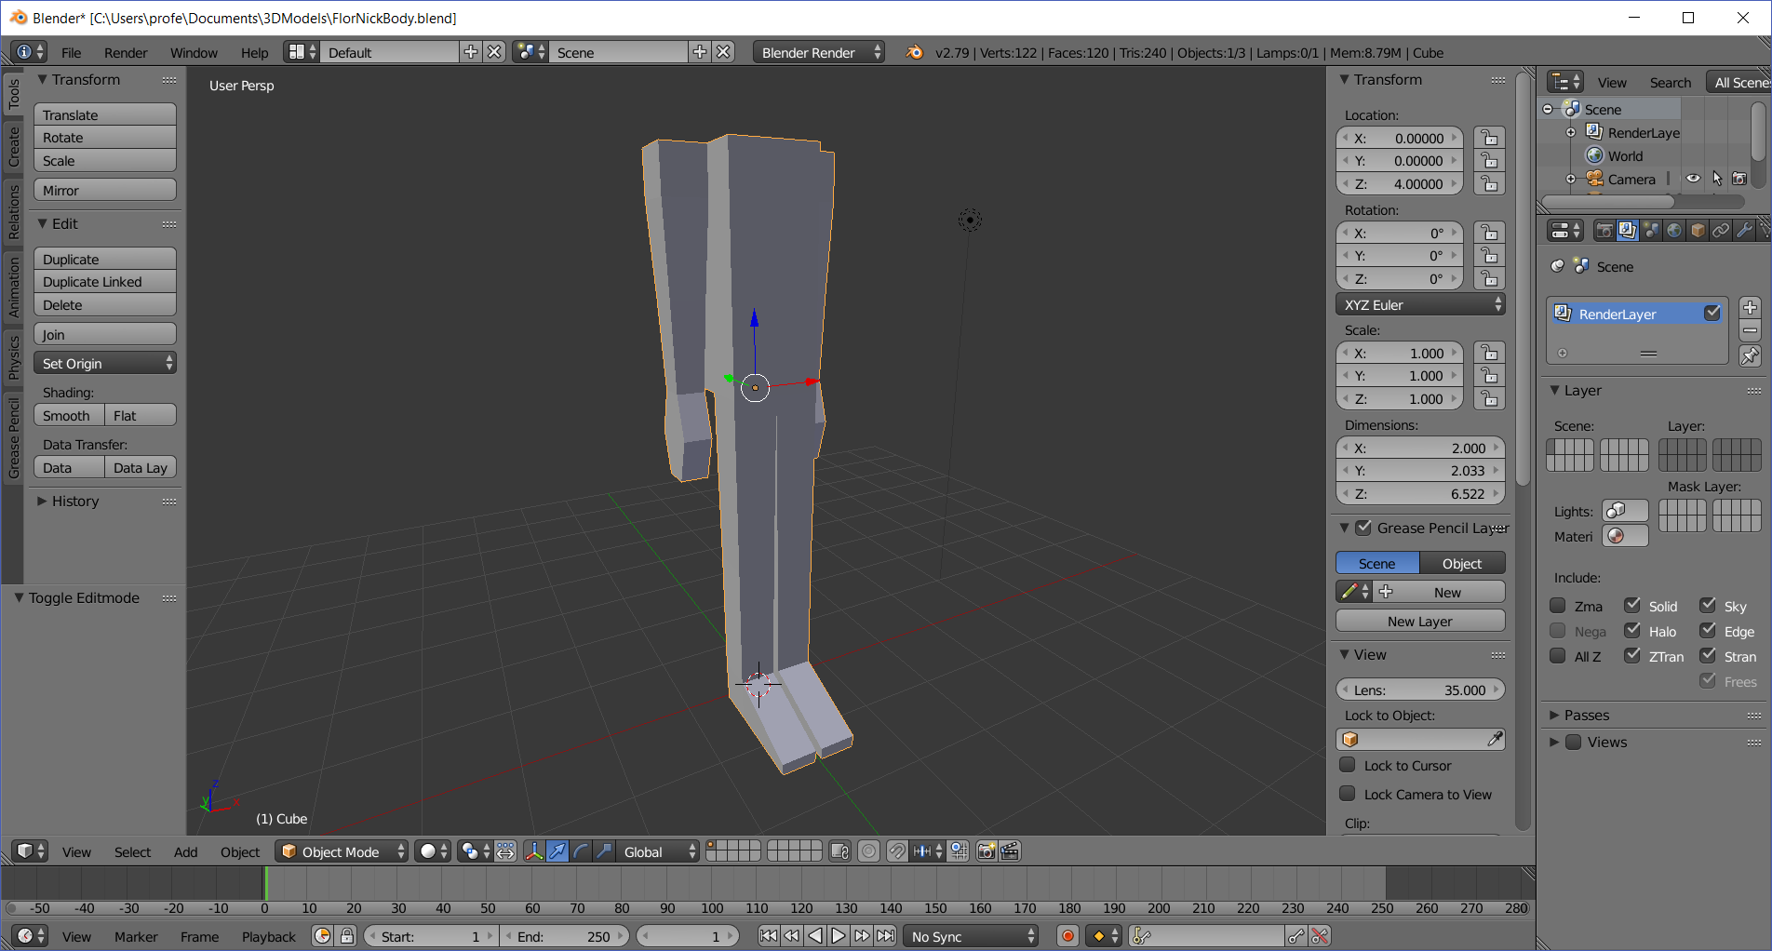

- Copy the head by right-clicking on it and typing CTRL-C (no visible effect)

- Paste the head on the body
  - Switch to the body window (mouse cursor must be in the 3-D work area)
Paste the head by typing CTRL-V.
Rotate the view behind the body and you should see the head on the floor
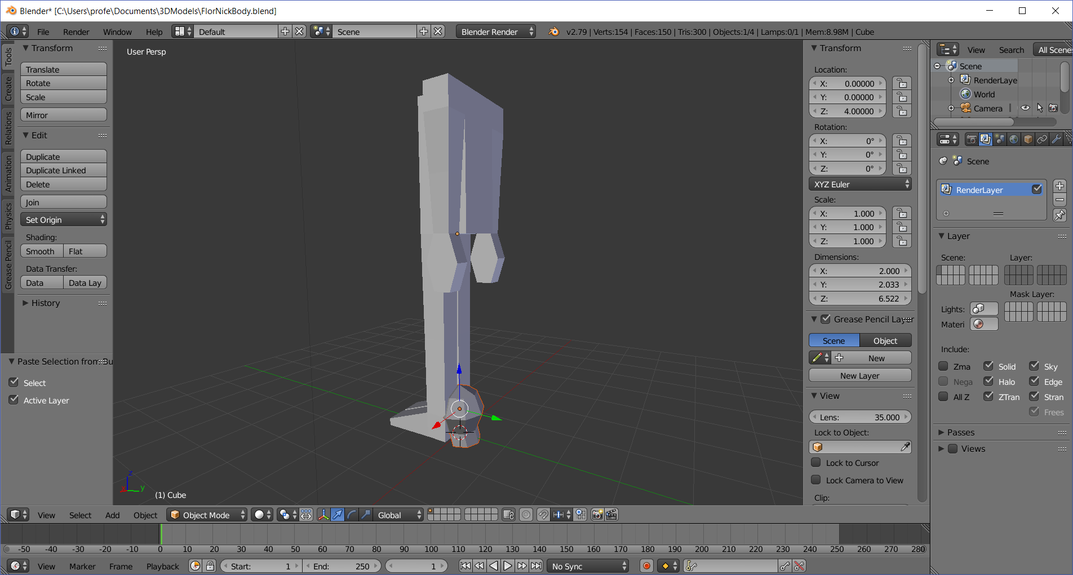

- Pop the head above the shoulders
  - Select the head by right-clicking on it
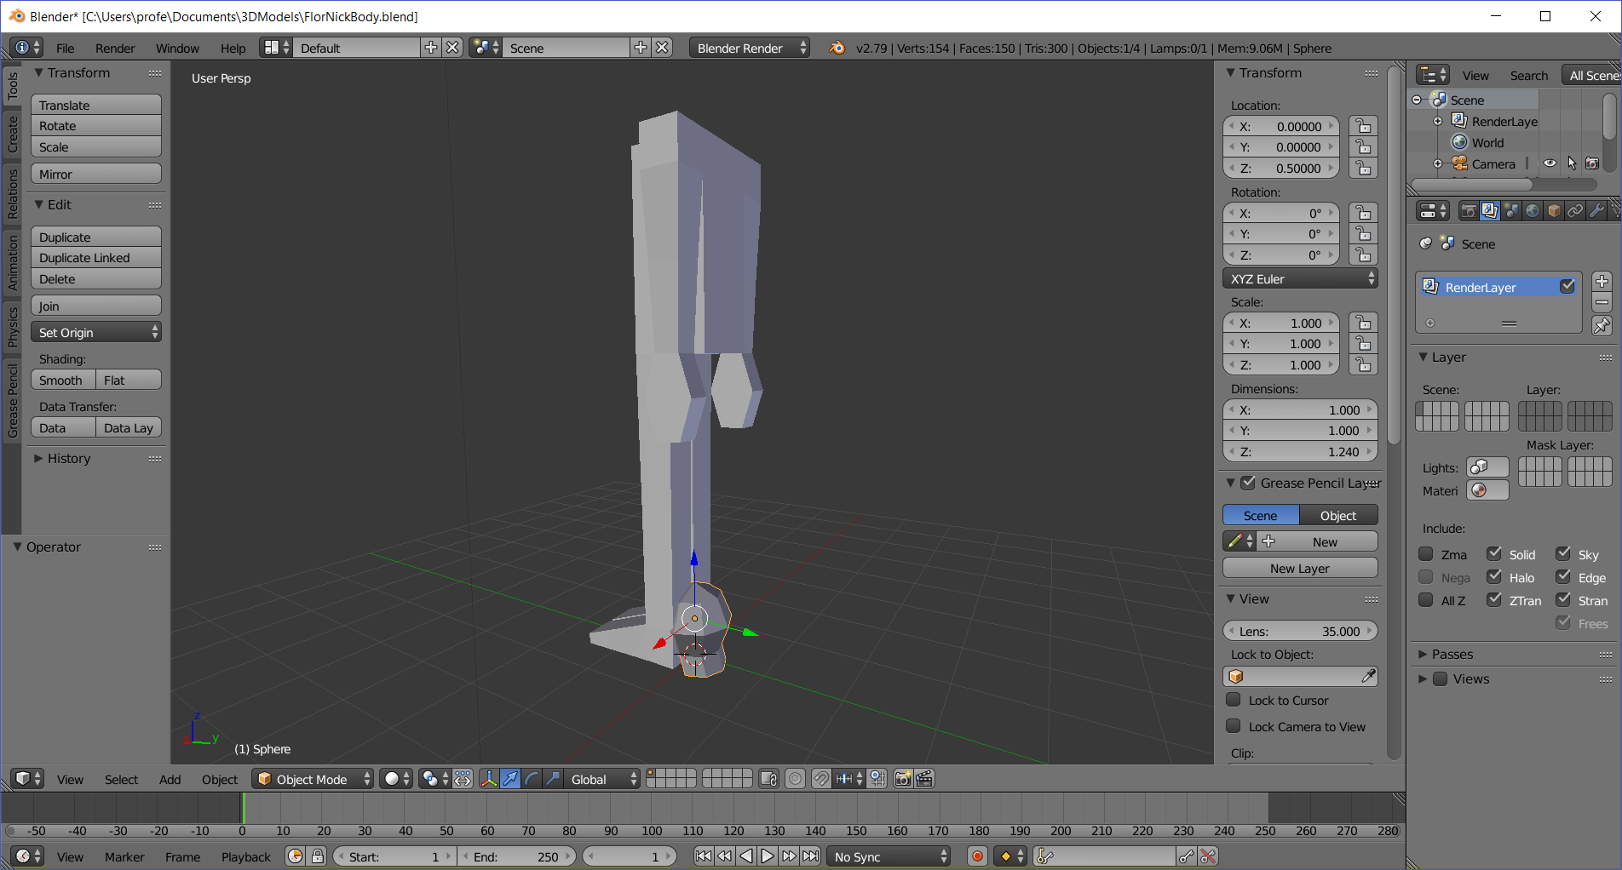

  - Type 7.5 into Transform > Location > Z
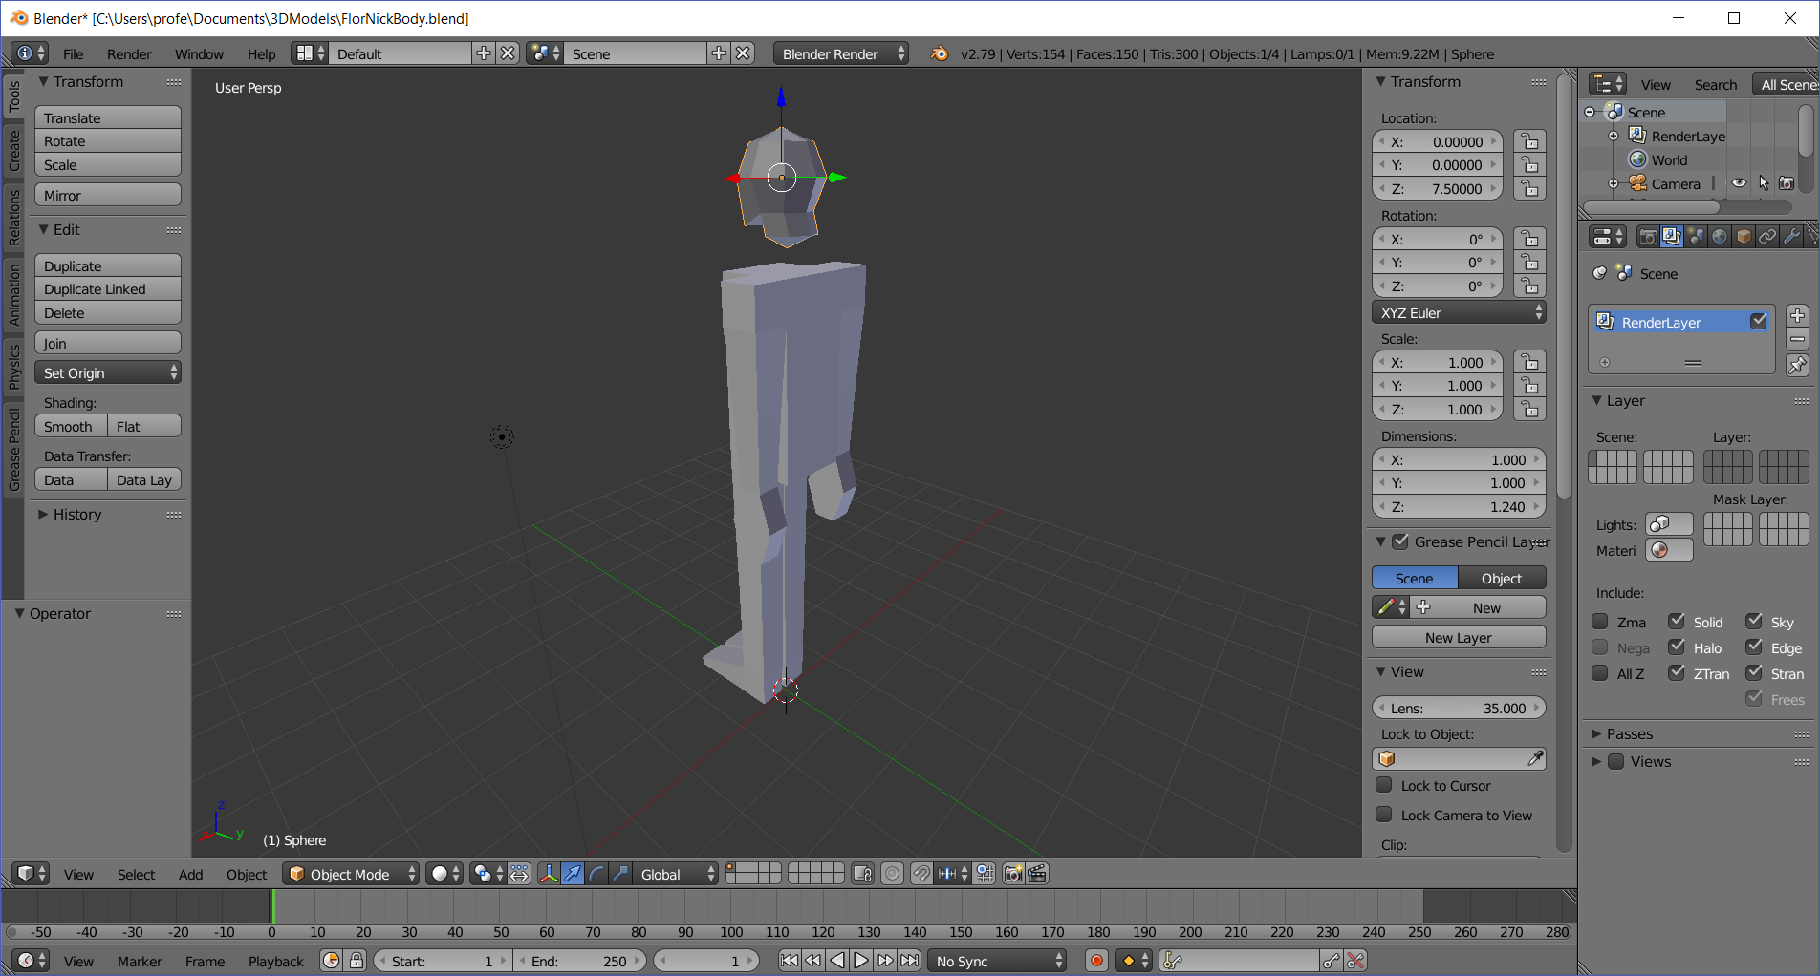

- Join the head to the body (note head should be already selected [yellow border])
  - Create one mesh by holding the shift key down and right-clicking the body
Note the read head and the yellow body
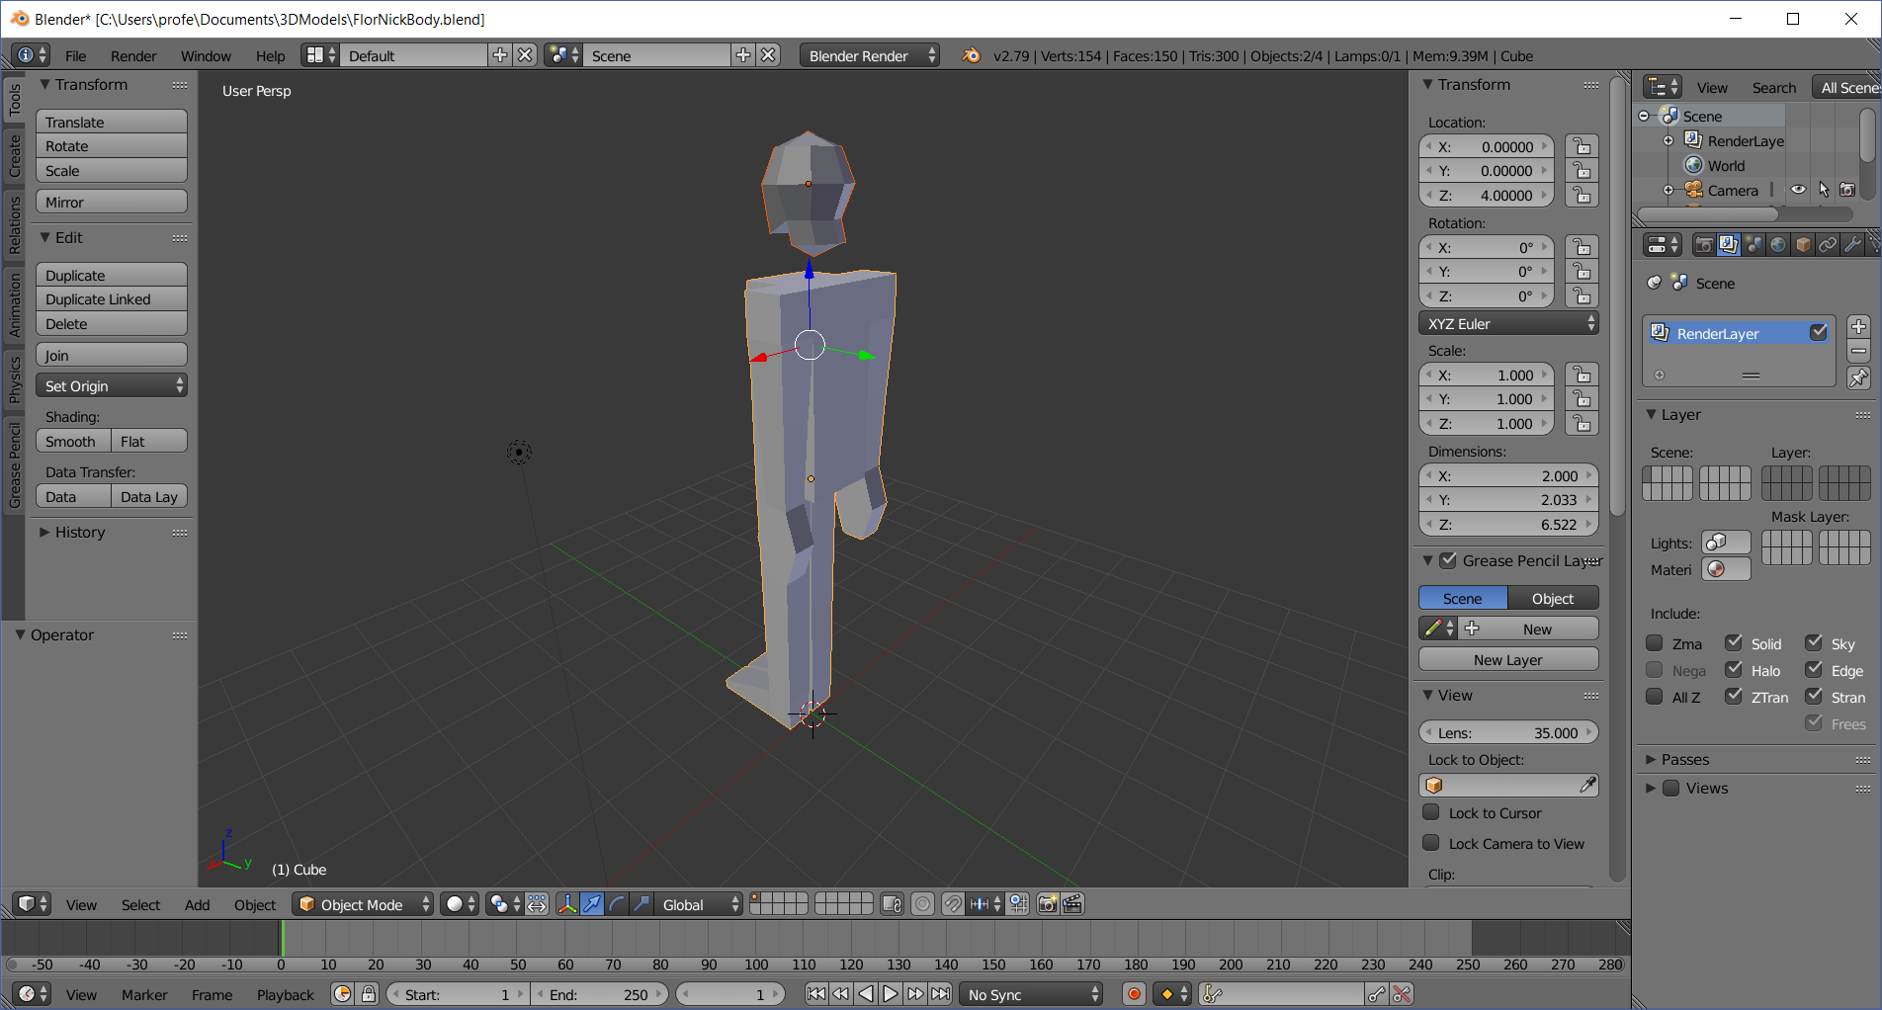
  - Join the two meshes by typing CTRL-J
Note both head and body are yellow indicating a single mesh. You cannot select the head separately in object mode. You will have to now go to edit mode to select the head
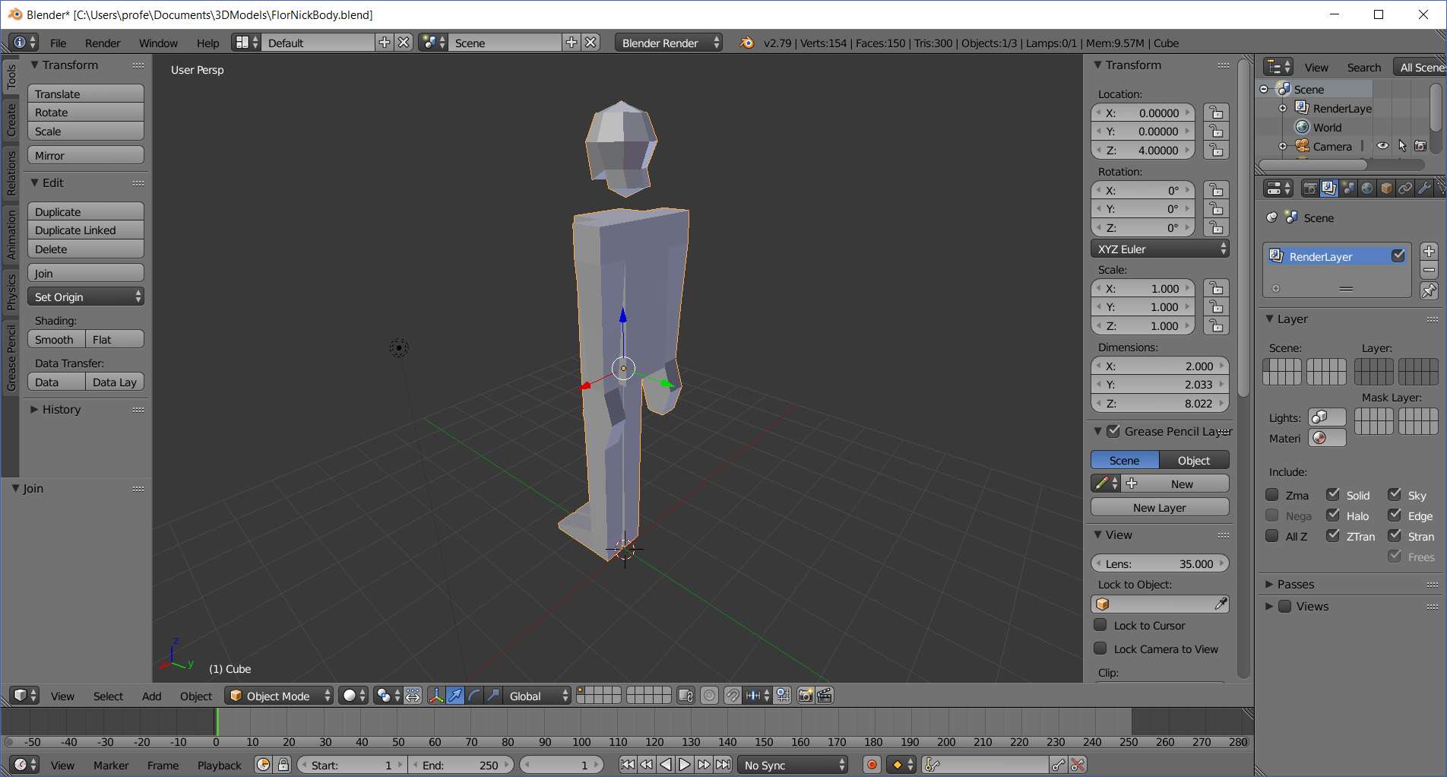
  - Toggle to edit mode (TAB key), Switch to Face Selection Mode (CTRL-TAB > Face) then select the bottom neck faces of the head, and the two top-middle-back faces—for a total of four faces. To select right click on one face, then shift-right-click the other three faces
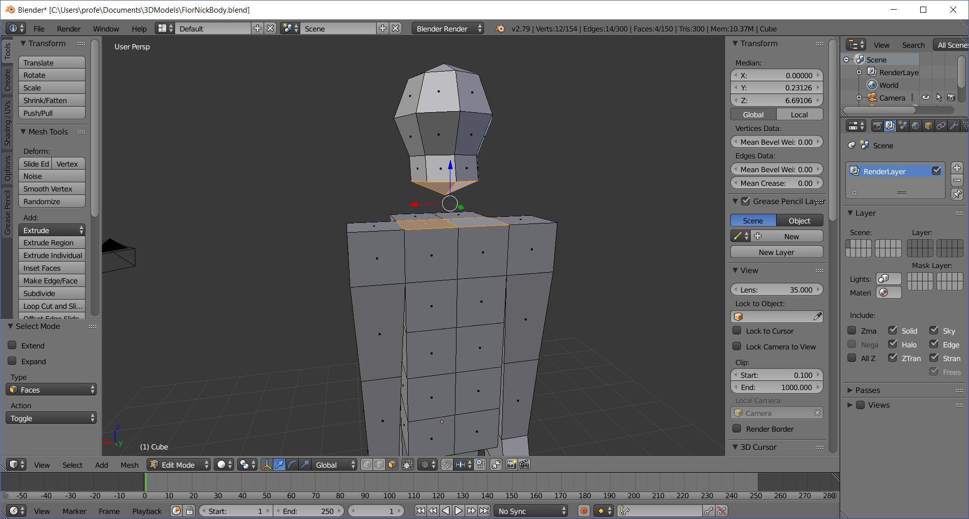
  - Delete these four faces by pressing the DELETE key, then selecting Faces
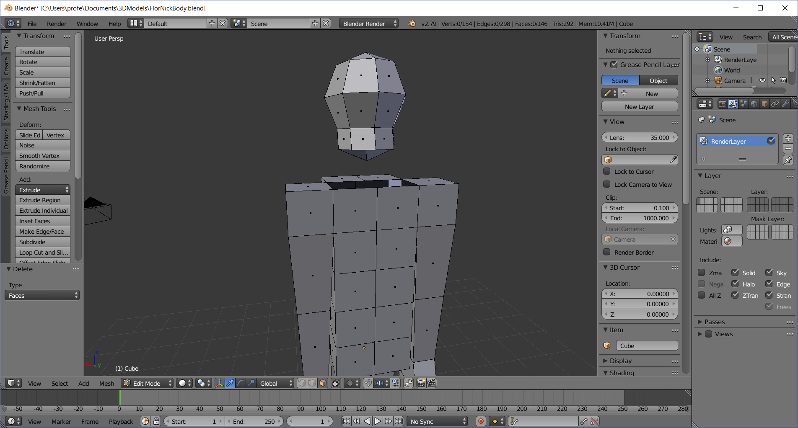

  - Switch to edge mode (CTRL-TAB > Edge), then right-click a neck edge, and shift-right-click the body edge below it
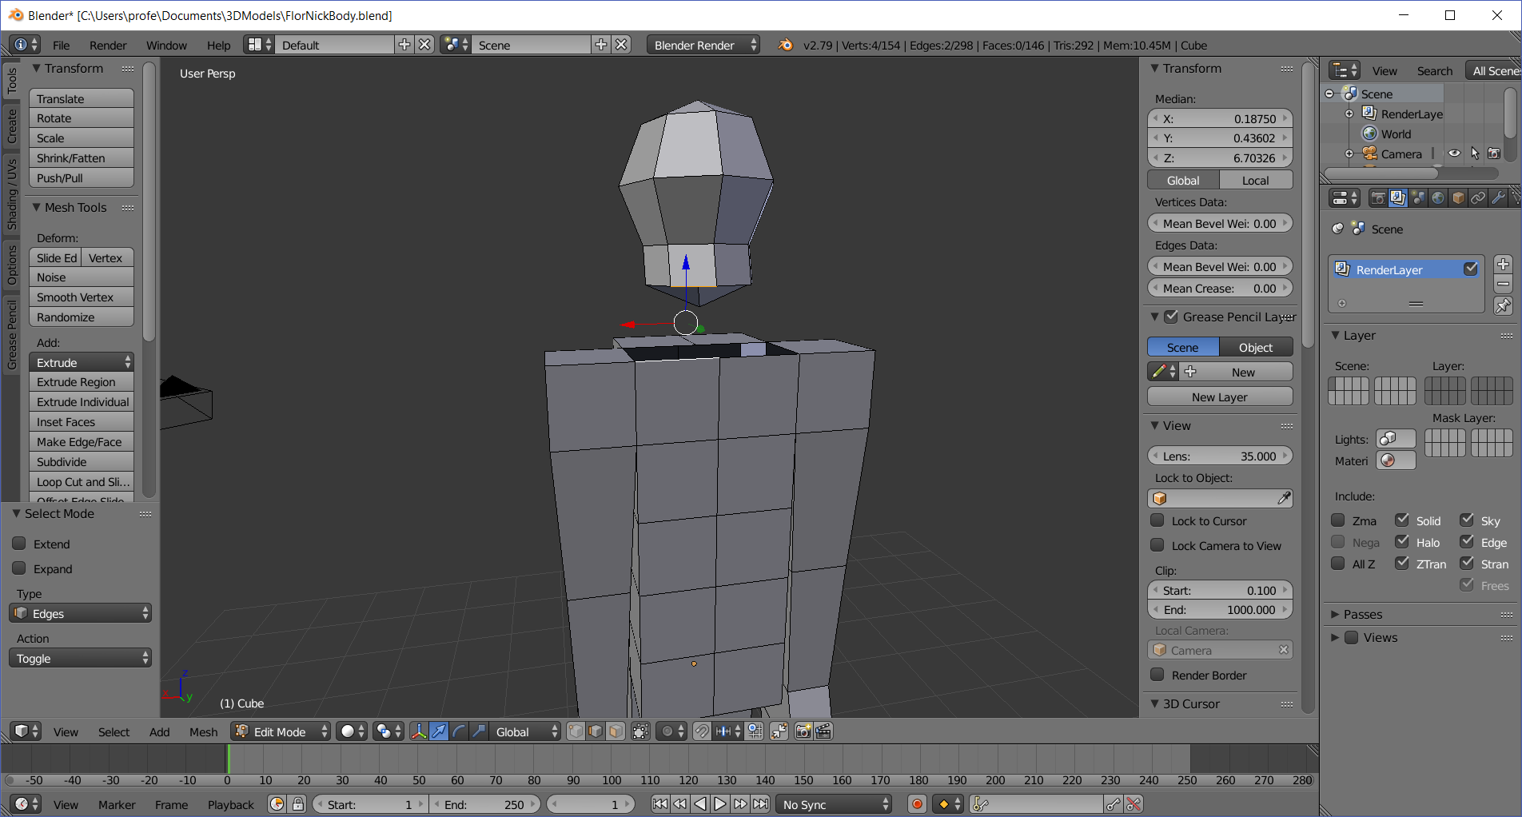

  - Fill the edge gap by pressing the F key
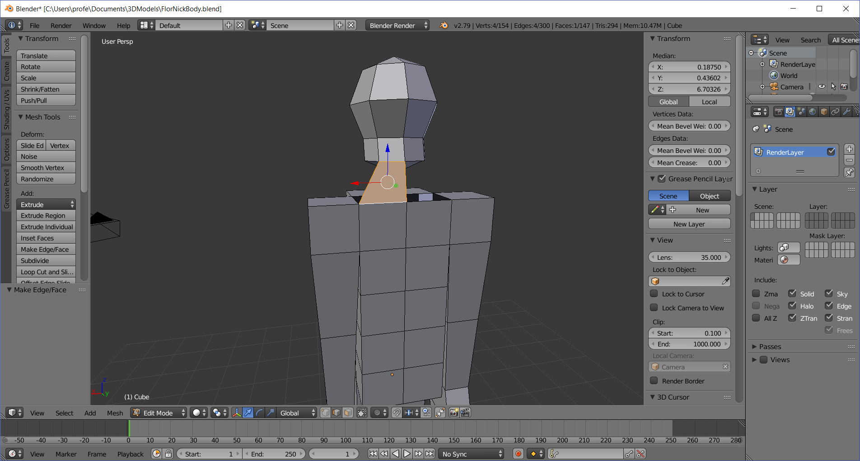

  - (Repeat this process 5 more times, rotating the body to get a better view)
Right-click a neck edge, and shift-right-click the body edge below it
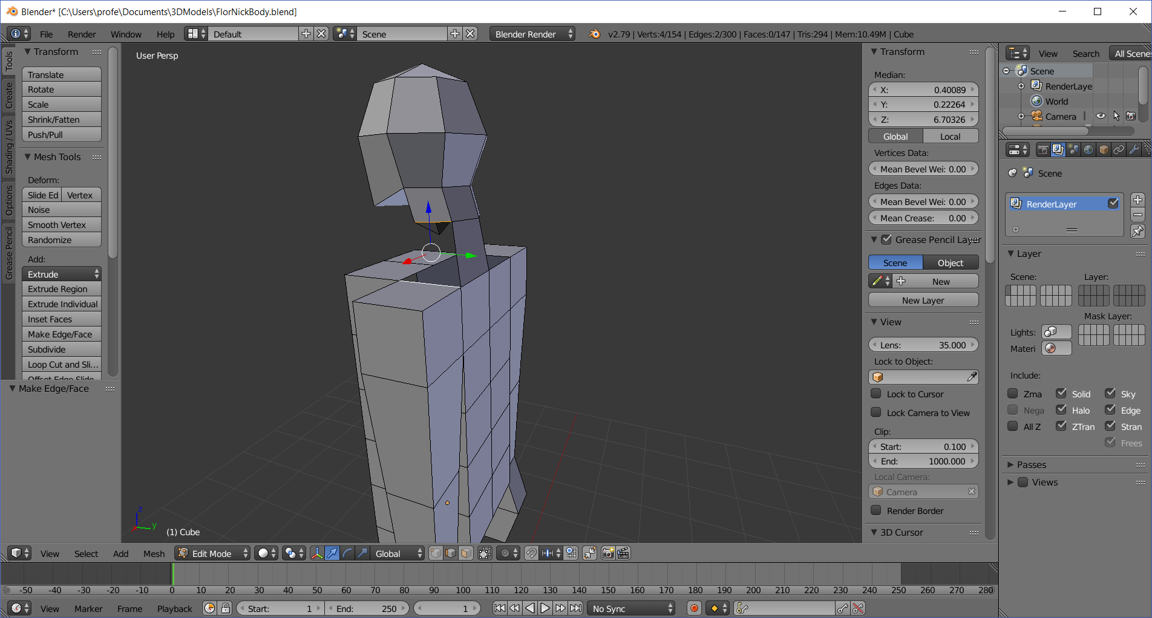

  - Fill the edge gap by pressing the F key
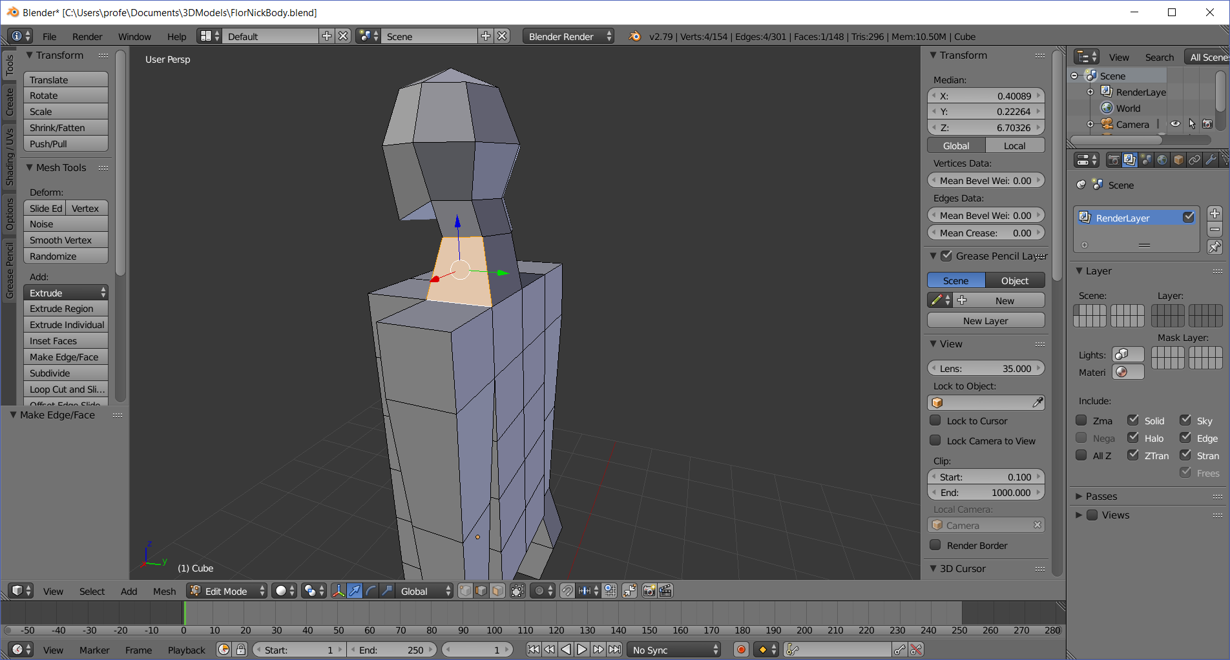
  - Right-click a neck edge, and shift-right-click the body edge below it
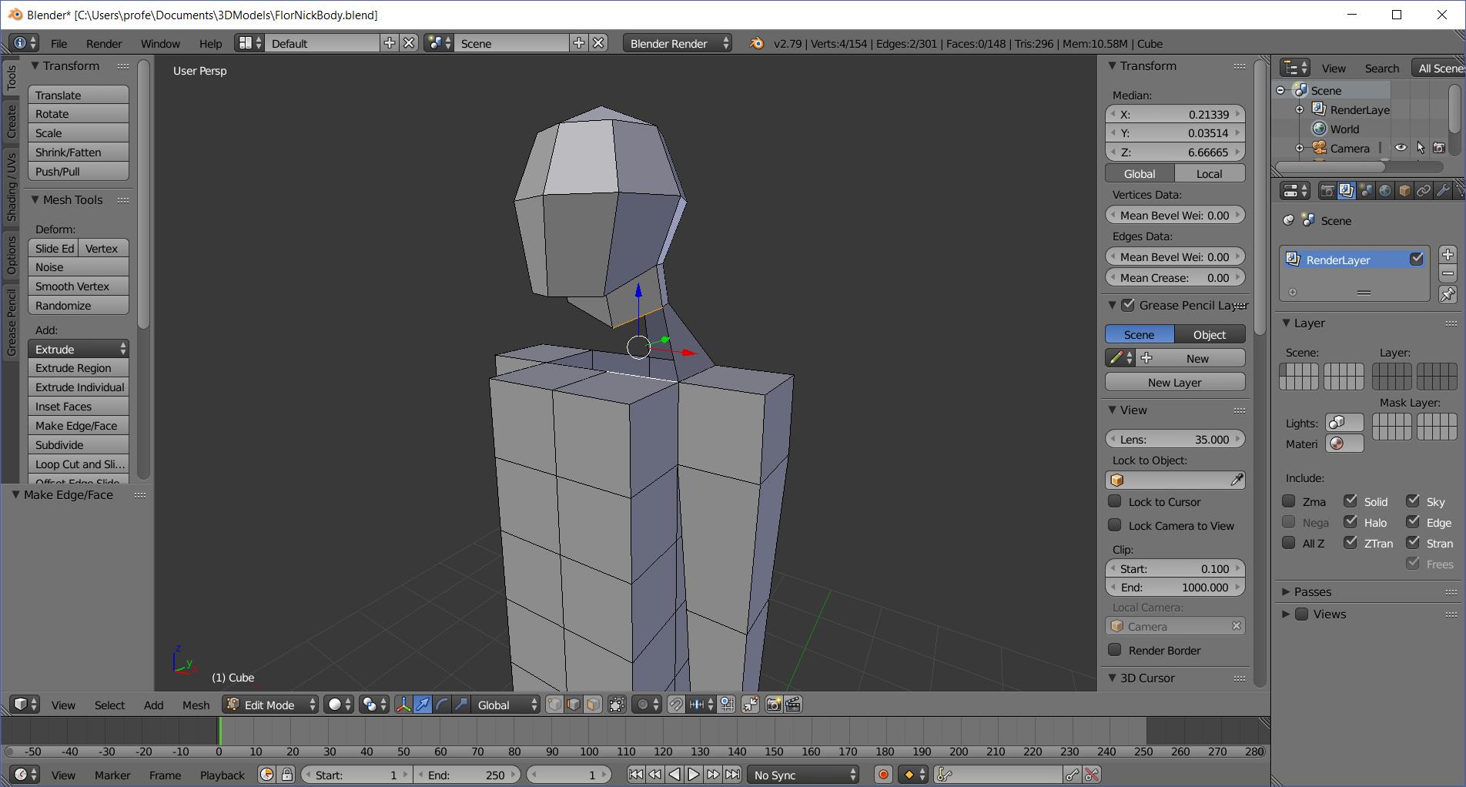

  - Fill the edge gap by pressing the F key
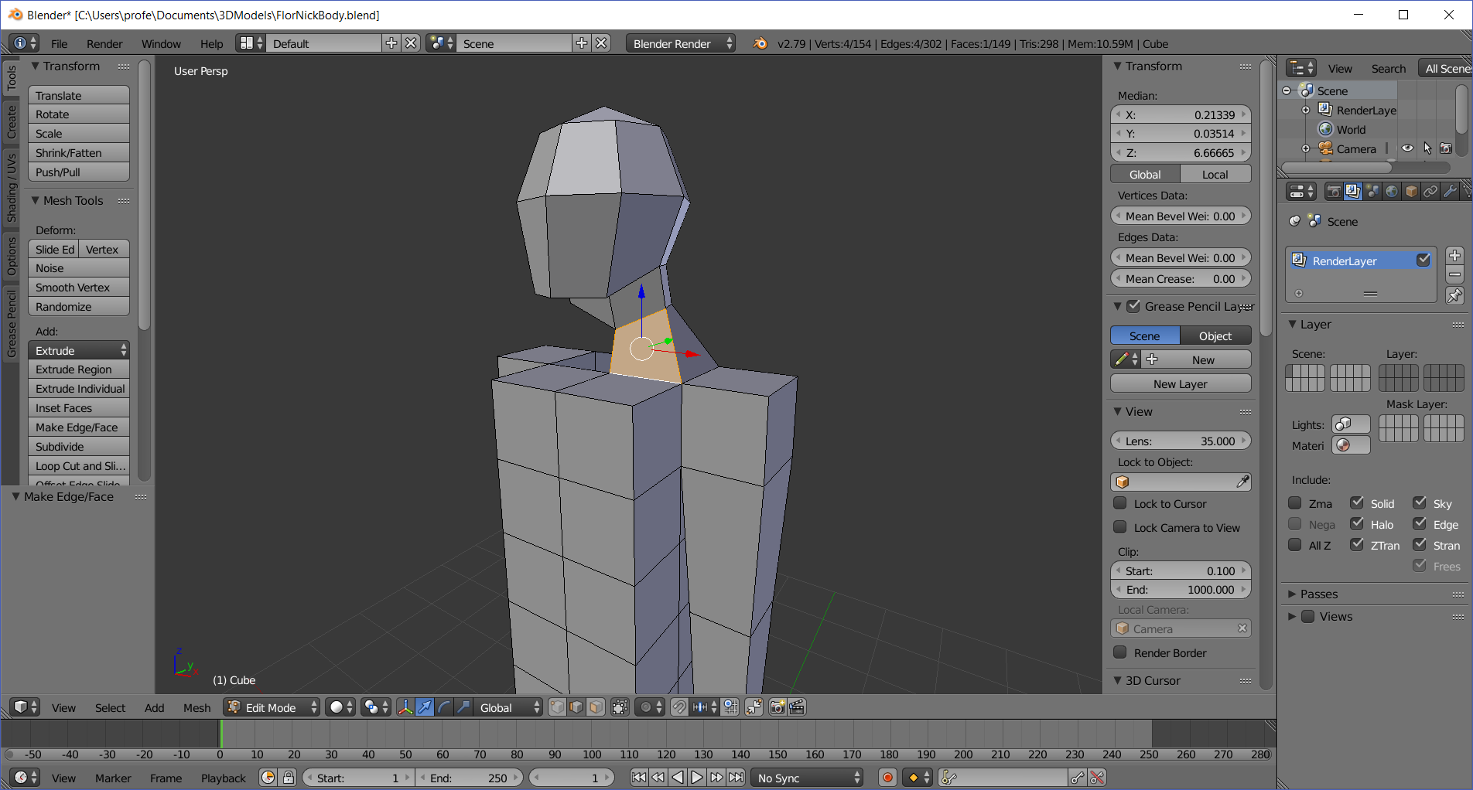

  - Right-click a neck edge, and shift-right-click the body edge below it
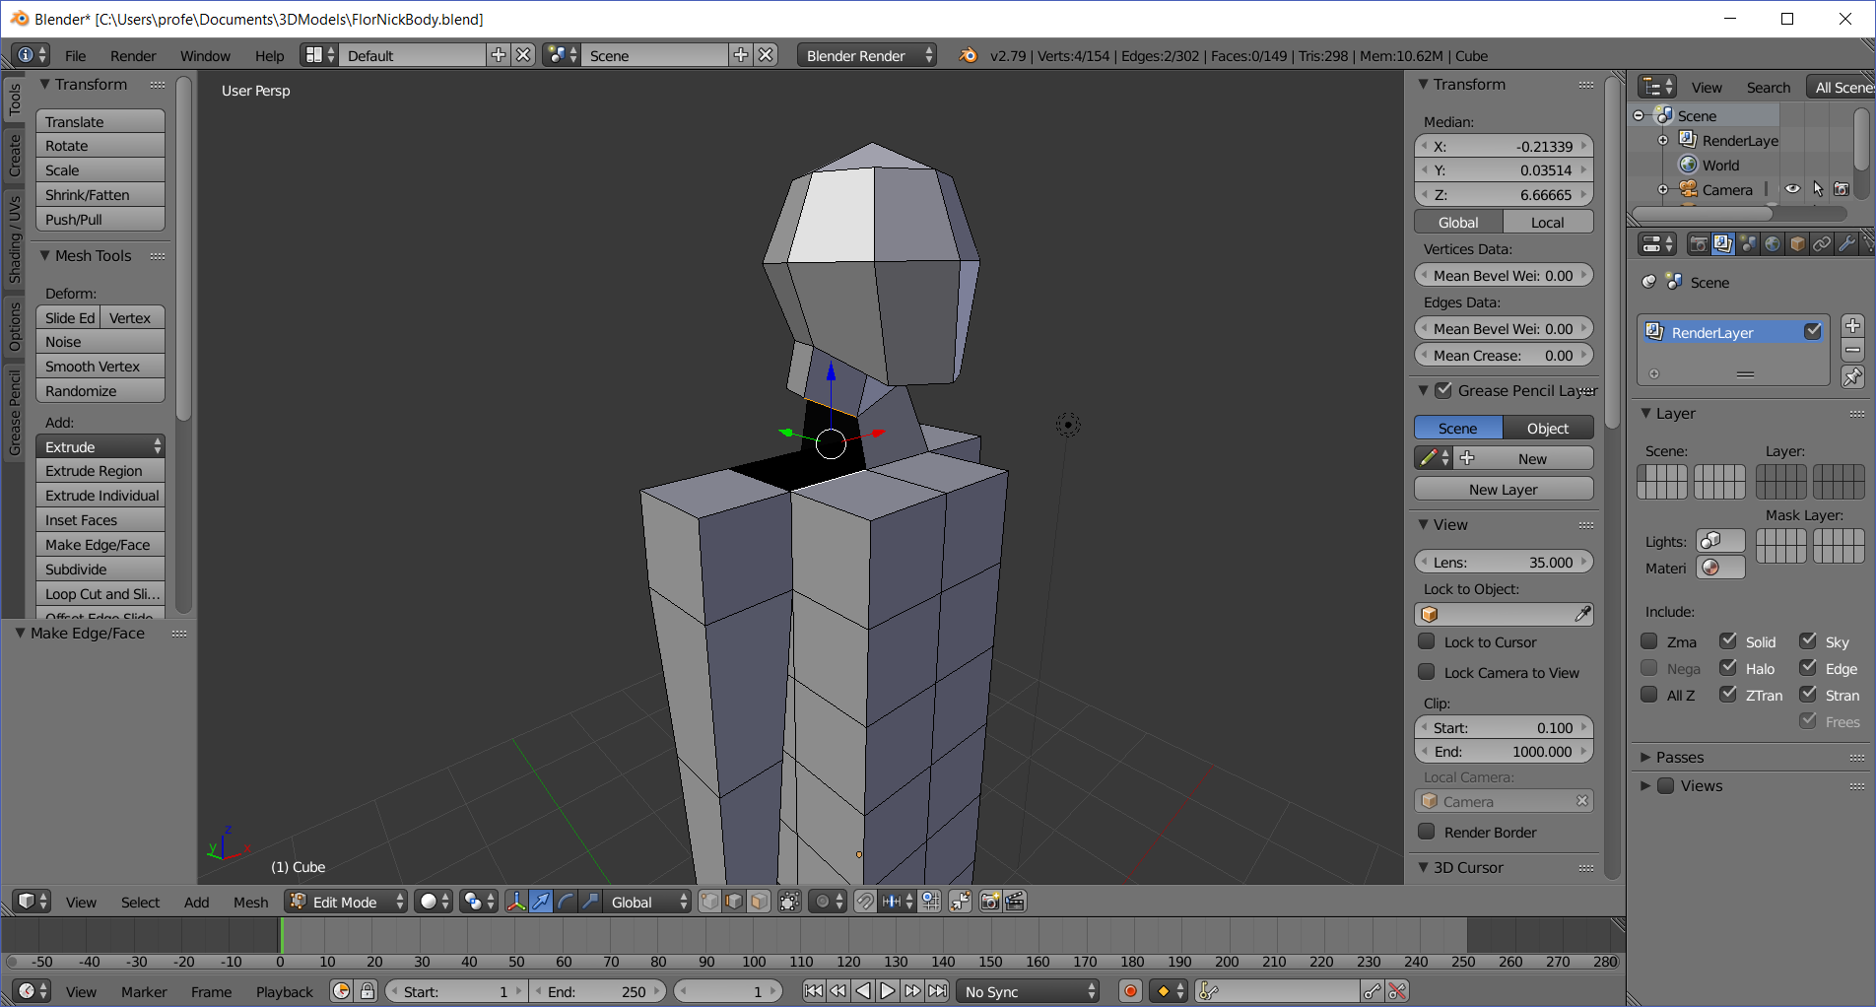

  - Fill the edge gap by pressing the F key
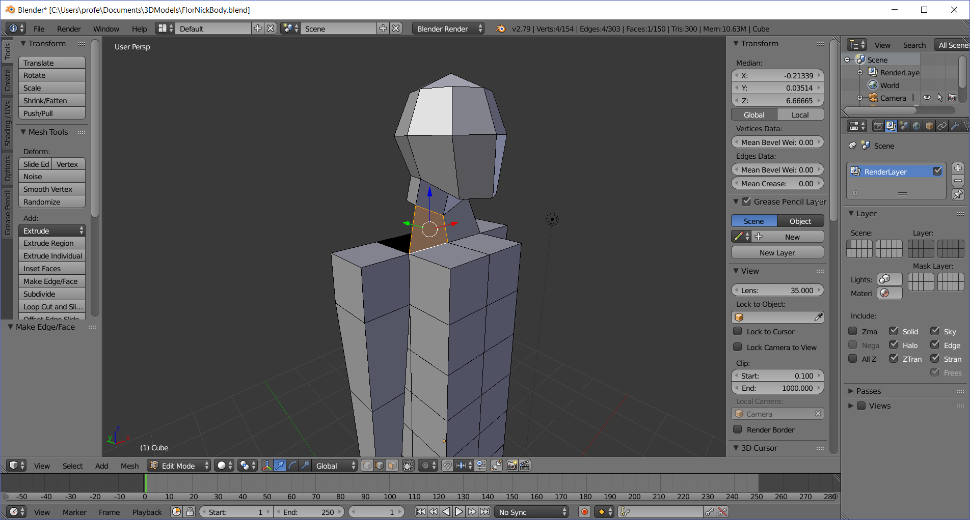
  - Right-click a neck edge, and shift-right-click the body edge below it
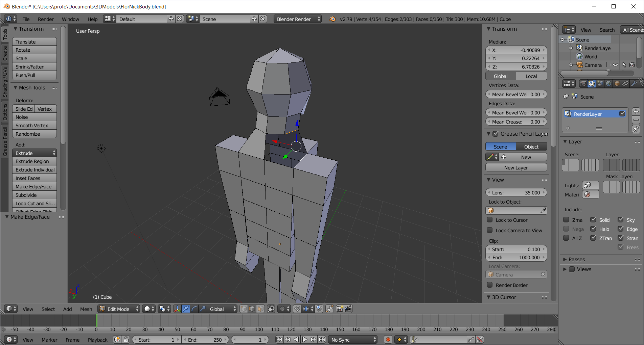

  - Fill the edge gap by pressing the F key
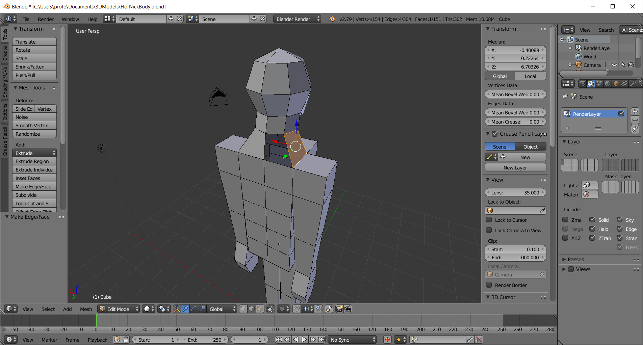
  - Right-click a neck edge, and shift-right-click the body edge below it
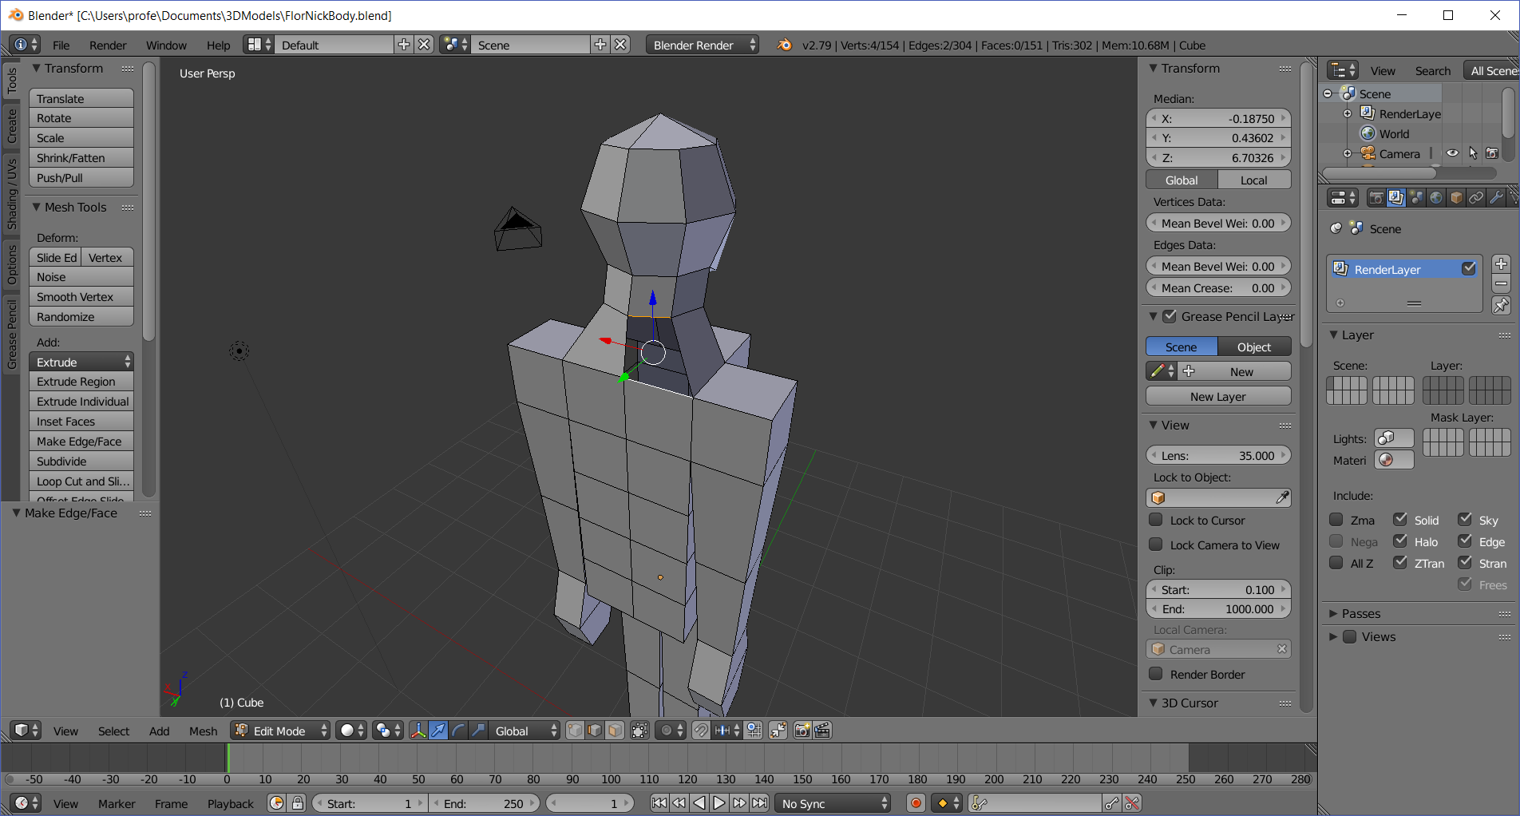

  - Fill the edge gap by pressing the F key
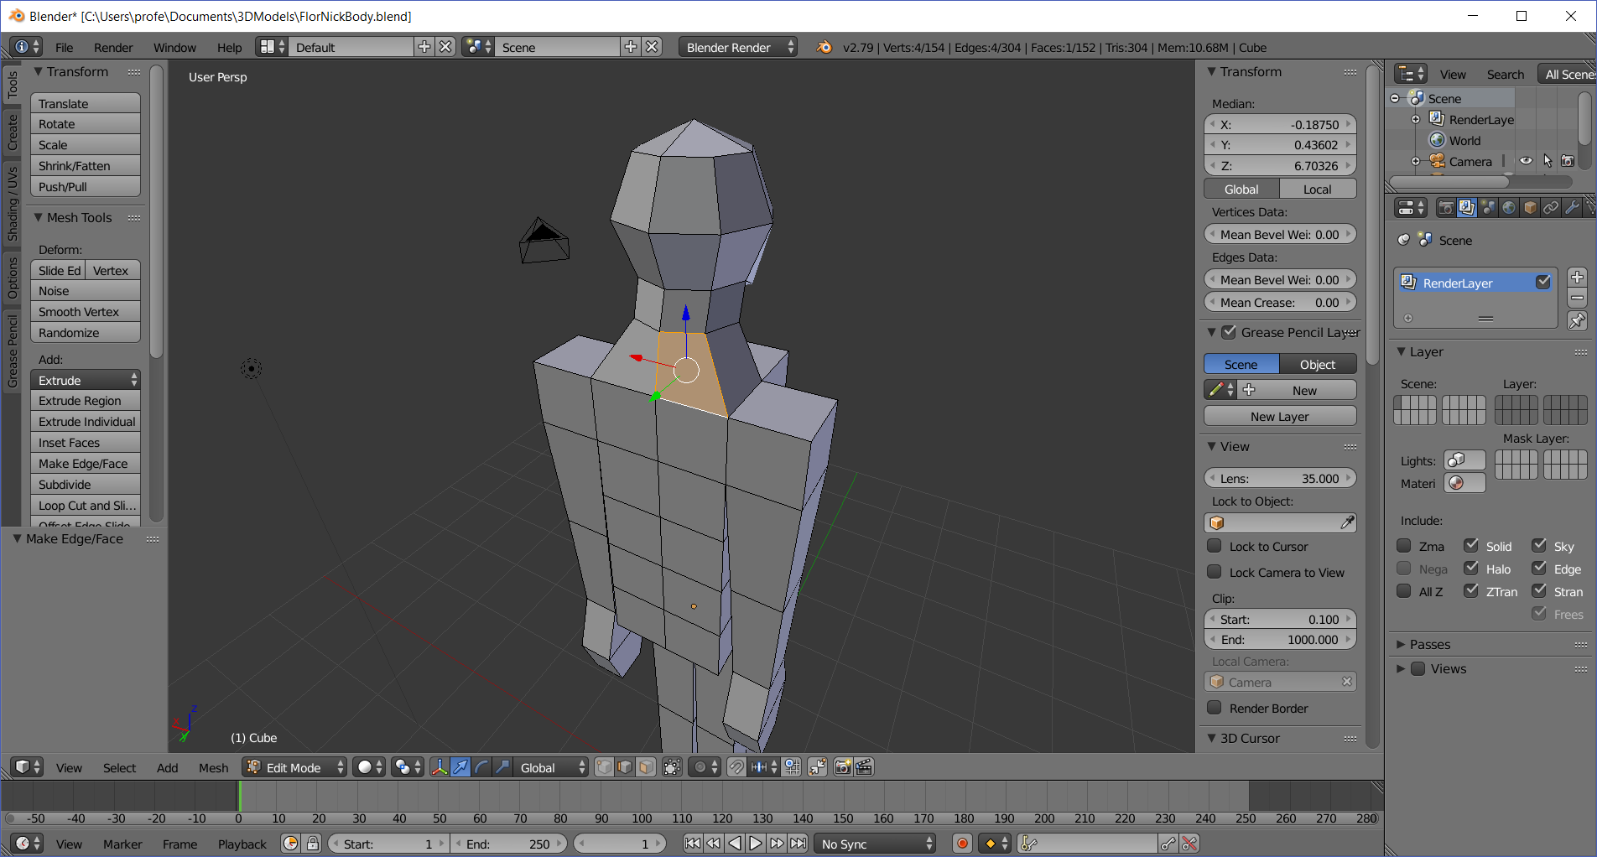
  - Rotate the body so and make sure everything looks good. I like switching to Face selection mode first (CTRL-TAB > Face), then toggling the A key (usually twice) to deselect all faces
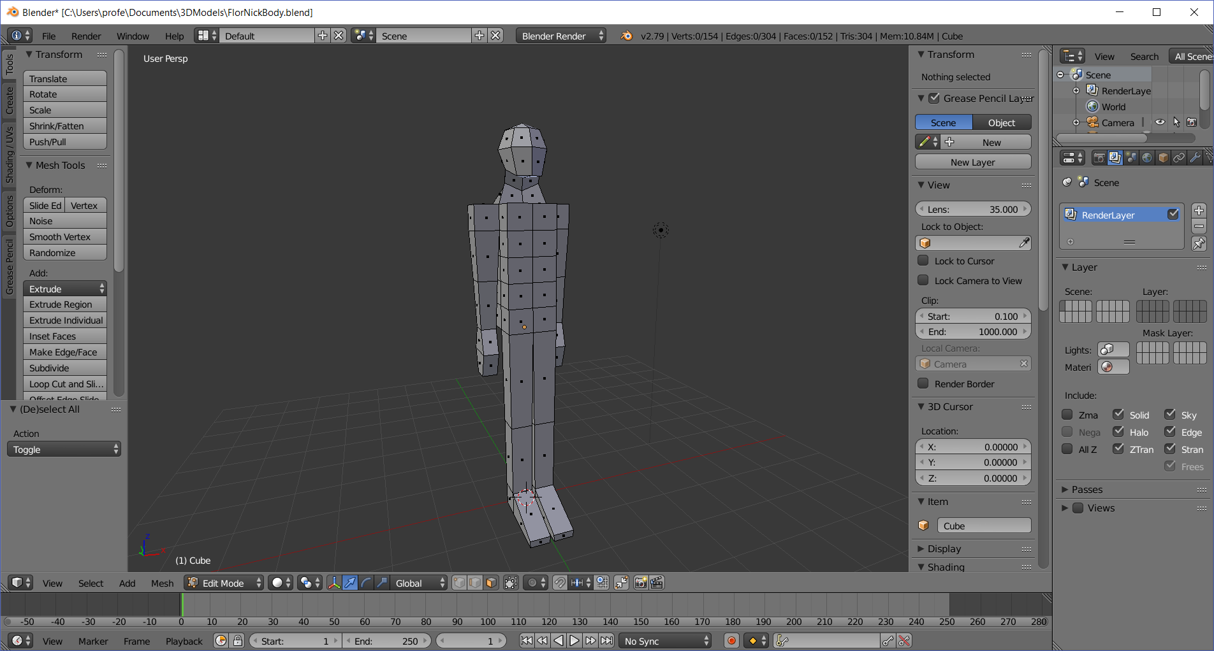

- Save your file as LastnameFirstnameManikin.blend

You’re almost done! It doesn’t look very interesting because it is a “manikin”, the 3-d equivalent of a stick figure. But in the next section I’ll show you how to tweak it with extrusions and by moving vertices so that you get a somewhat interesting robot figure

