Blender Manikin Body
Nick V. Flor (nickflor@unm.edu, @ProfessorF)

- Startup Blender
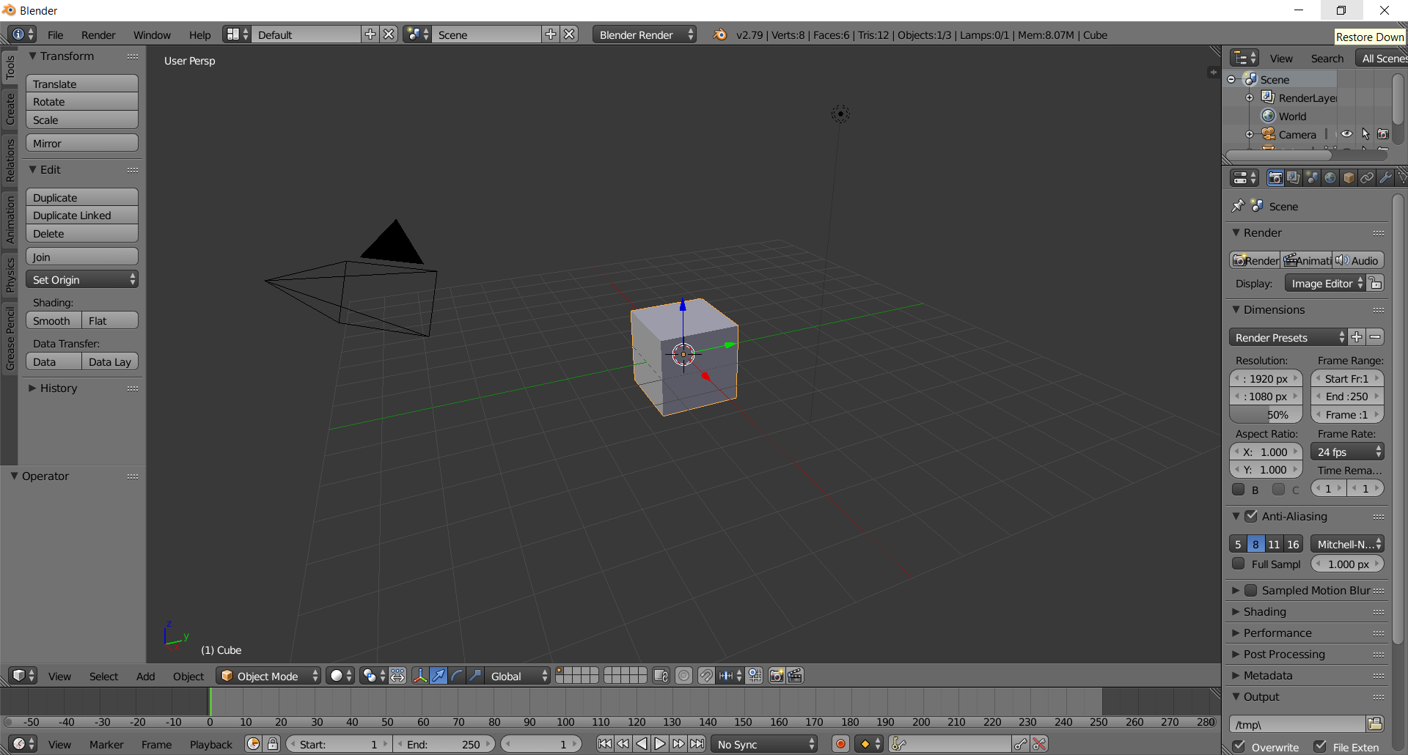

- Create the body (crotch to shoulder=2.5 units)
  - Type N to bring up the information panel
Type Transform > Dimensions > X: 1, Y:1, Z:2.5
Pop-up the body by typing Transform > Location > Z:1.25
Zoom in using ‘.’
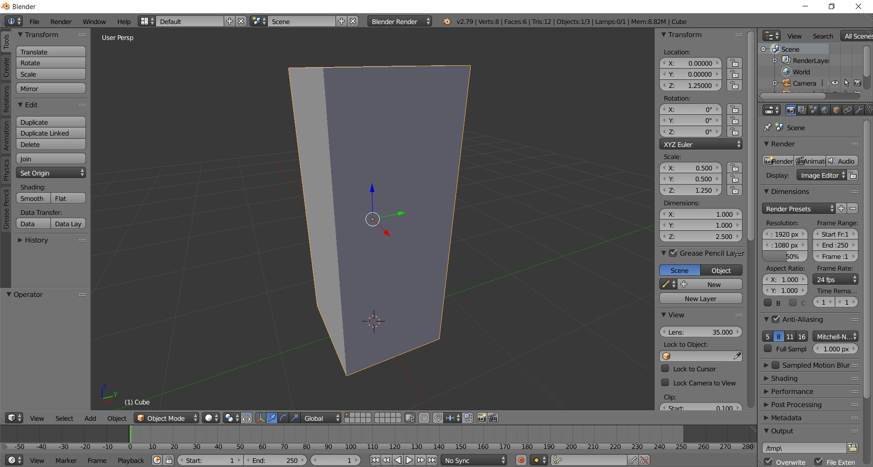

  - Normalize rotation and scale via CTRL-A > Location, CTRL-A > Scale
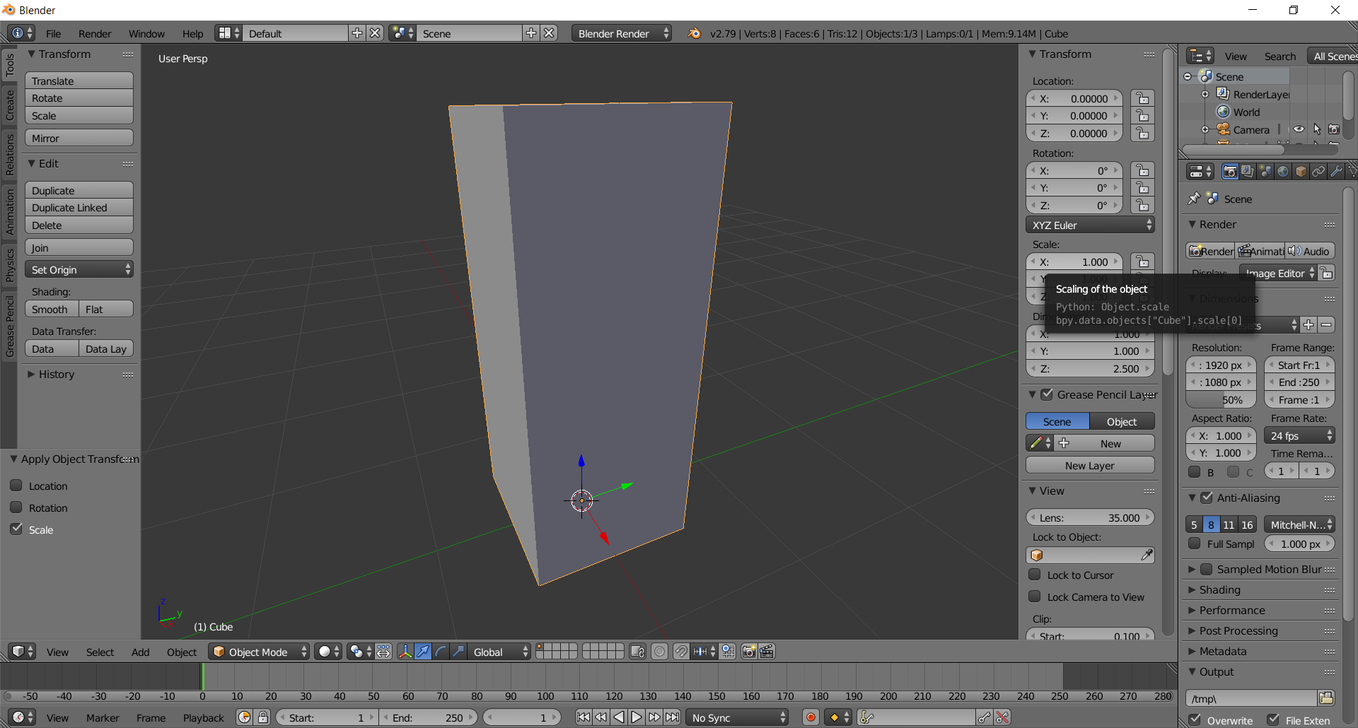

- Add 2x2x5 faces for extrusion (might want to rotate the object so it looks as below first)
  - Type TAB to enter Edit Mode
  - Type CTRL-R and move your mouse over a vertical edge of the negative-Y face (the green axis is the Y-axis)
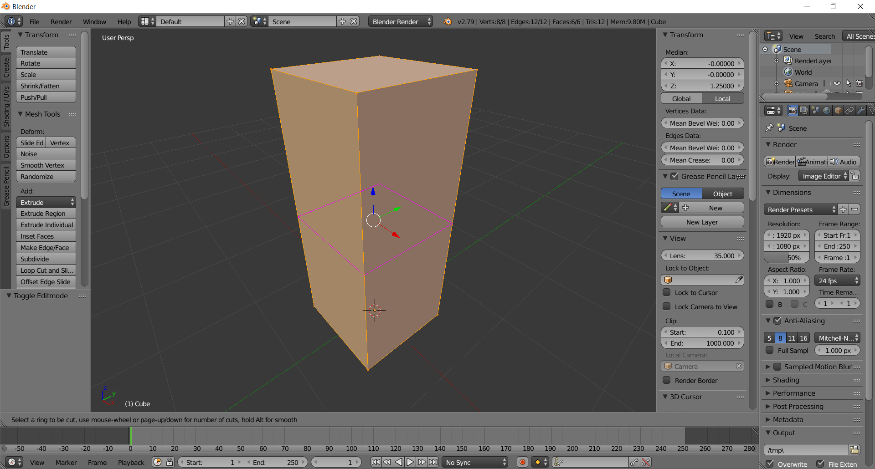

  - Roll the MMB wheel forward until you get four edge loops (in purple)
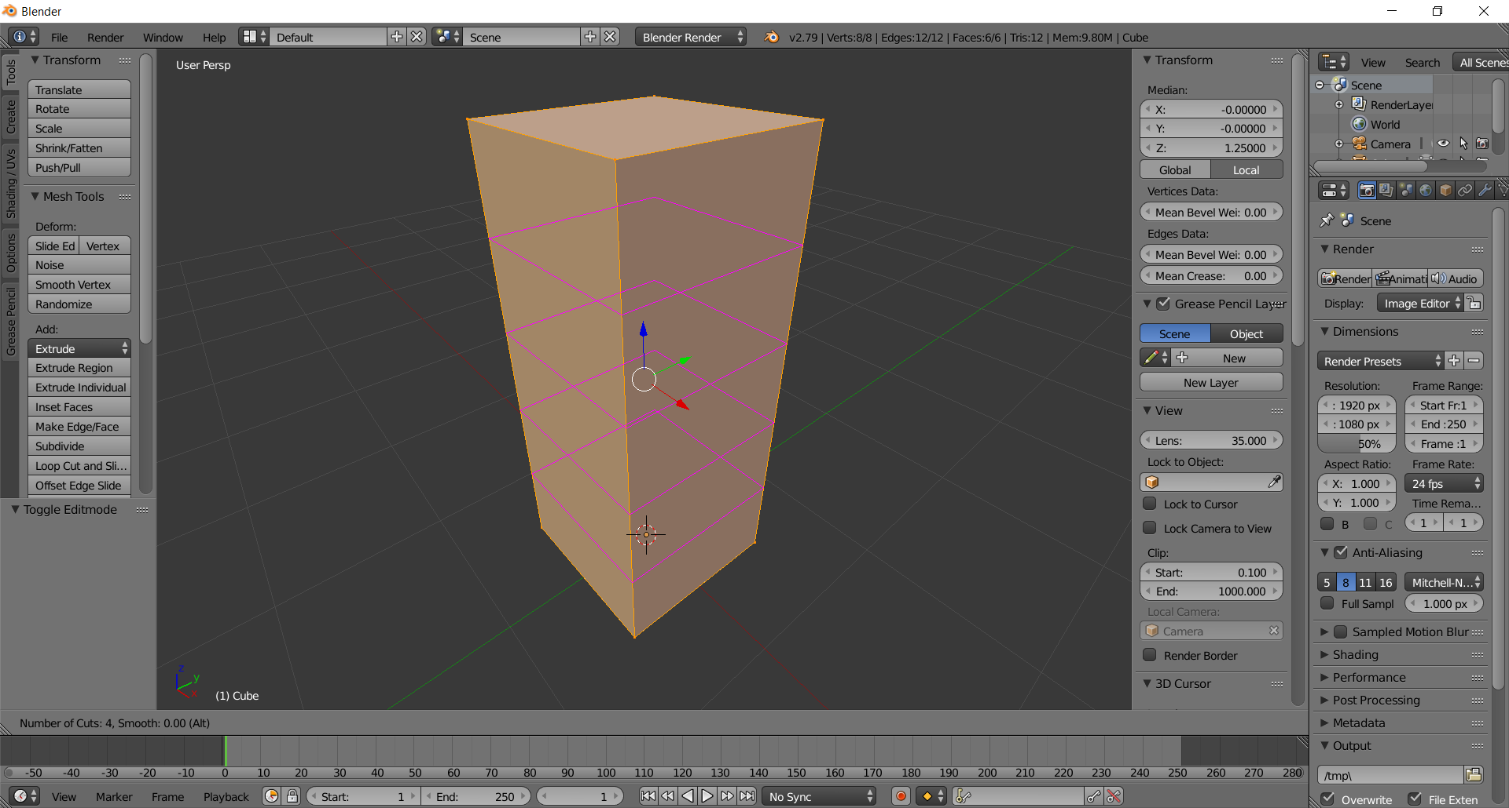

  - Left-click and then press the ESC key to fix the edge loops
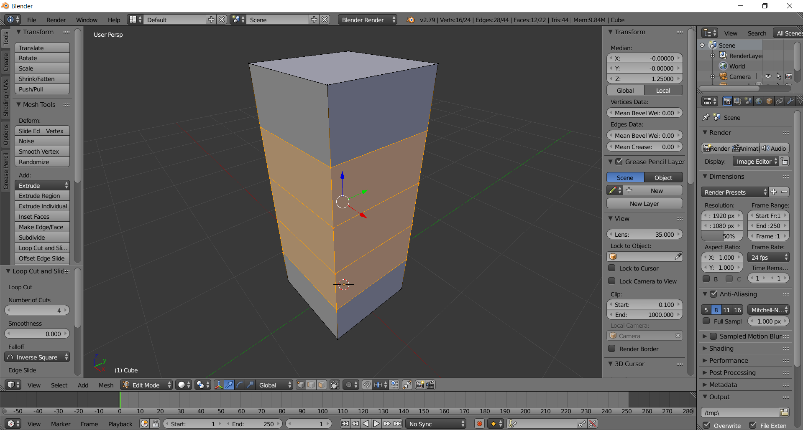
  - Type CTRL-R and move your mouse over a horizontal edge of the positive-X face (the red axis is the X-axis)
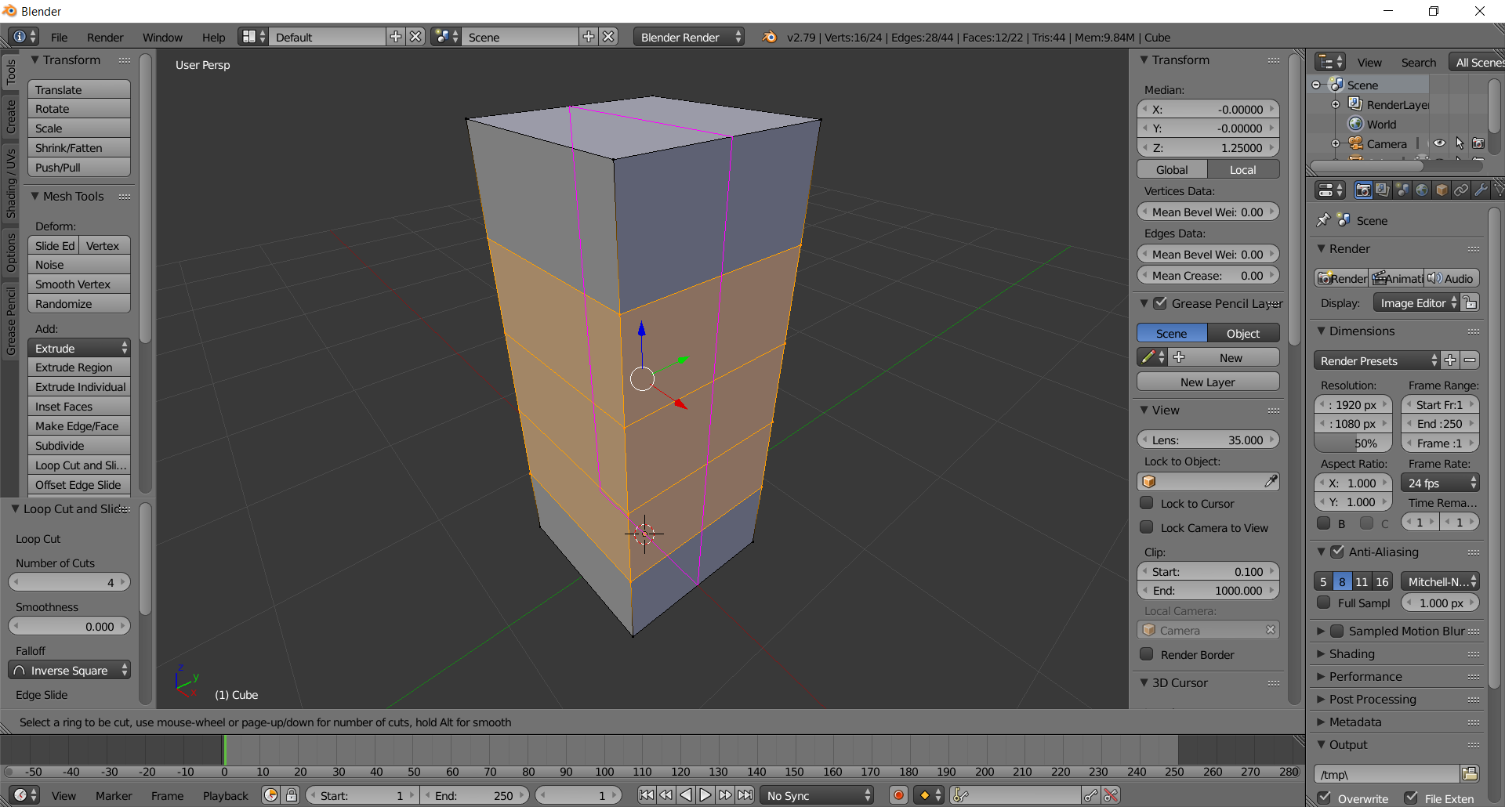

  - Left-Click and press the ESC key to fix the edge loop
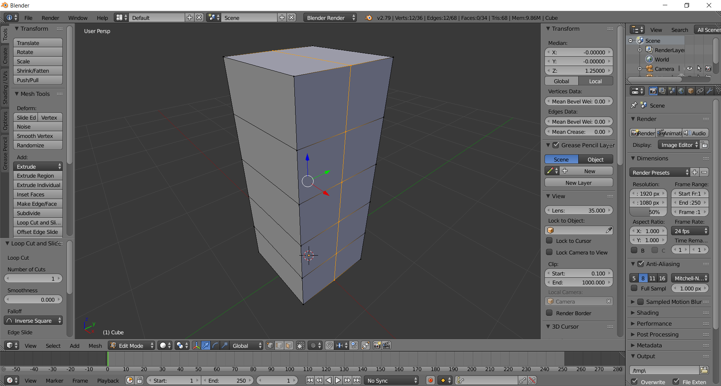

  - Type CTRL-R and move your mouse over the top horizontal edge of the negative Y-face
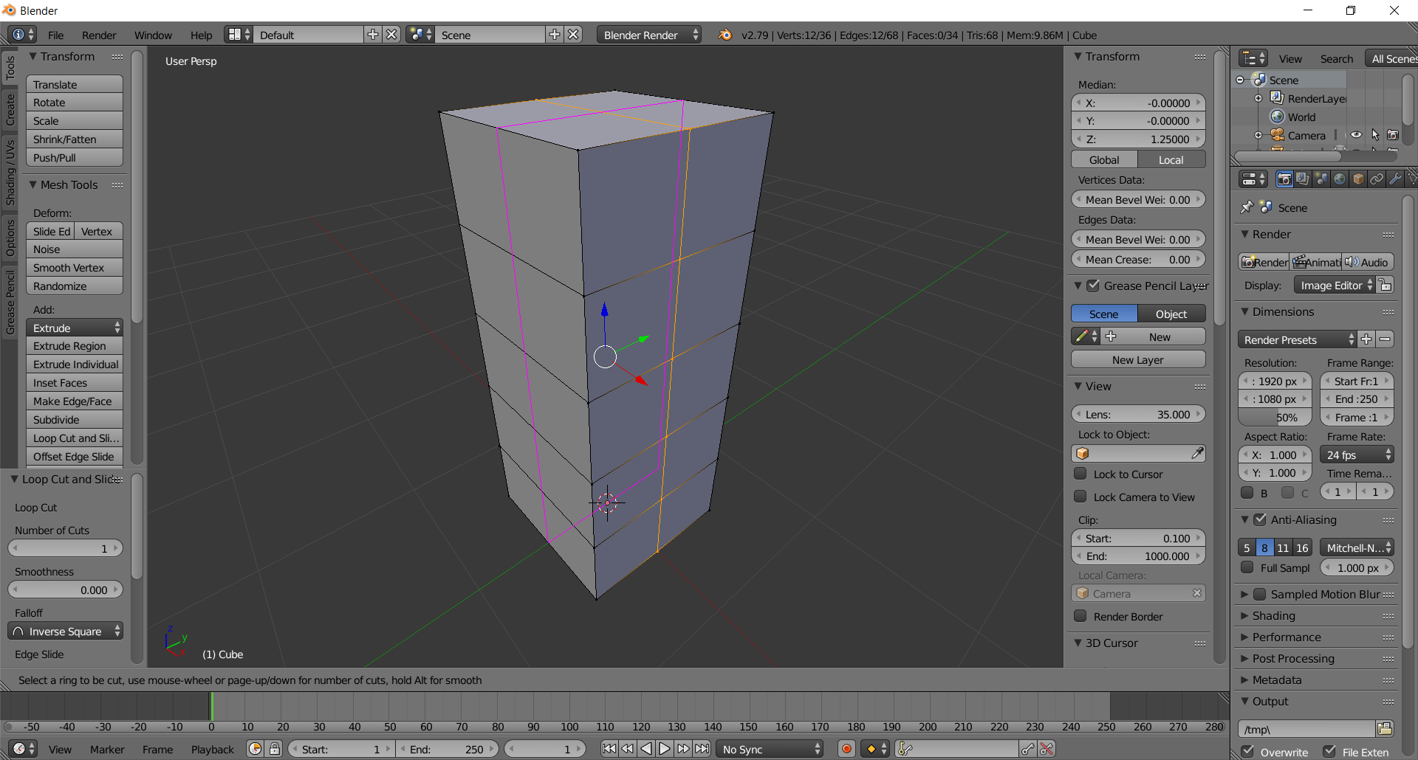
  - Left-Click and press the ESC key to fix the edge-loop.
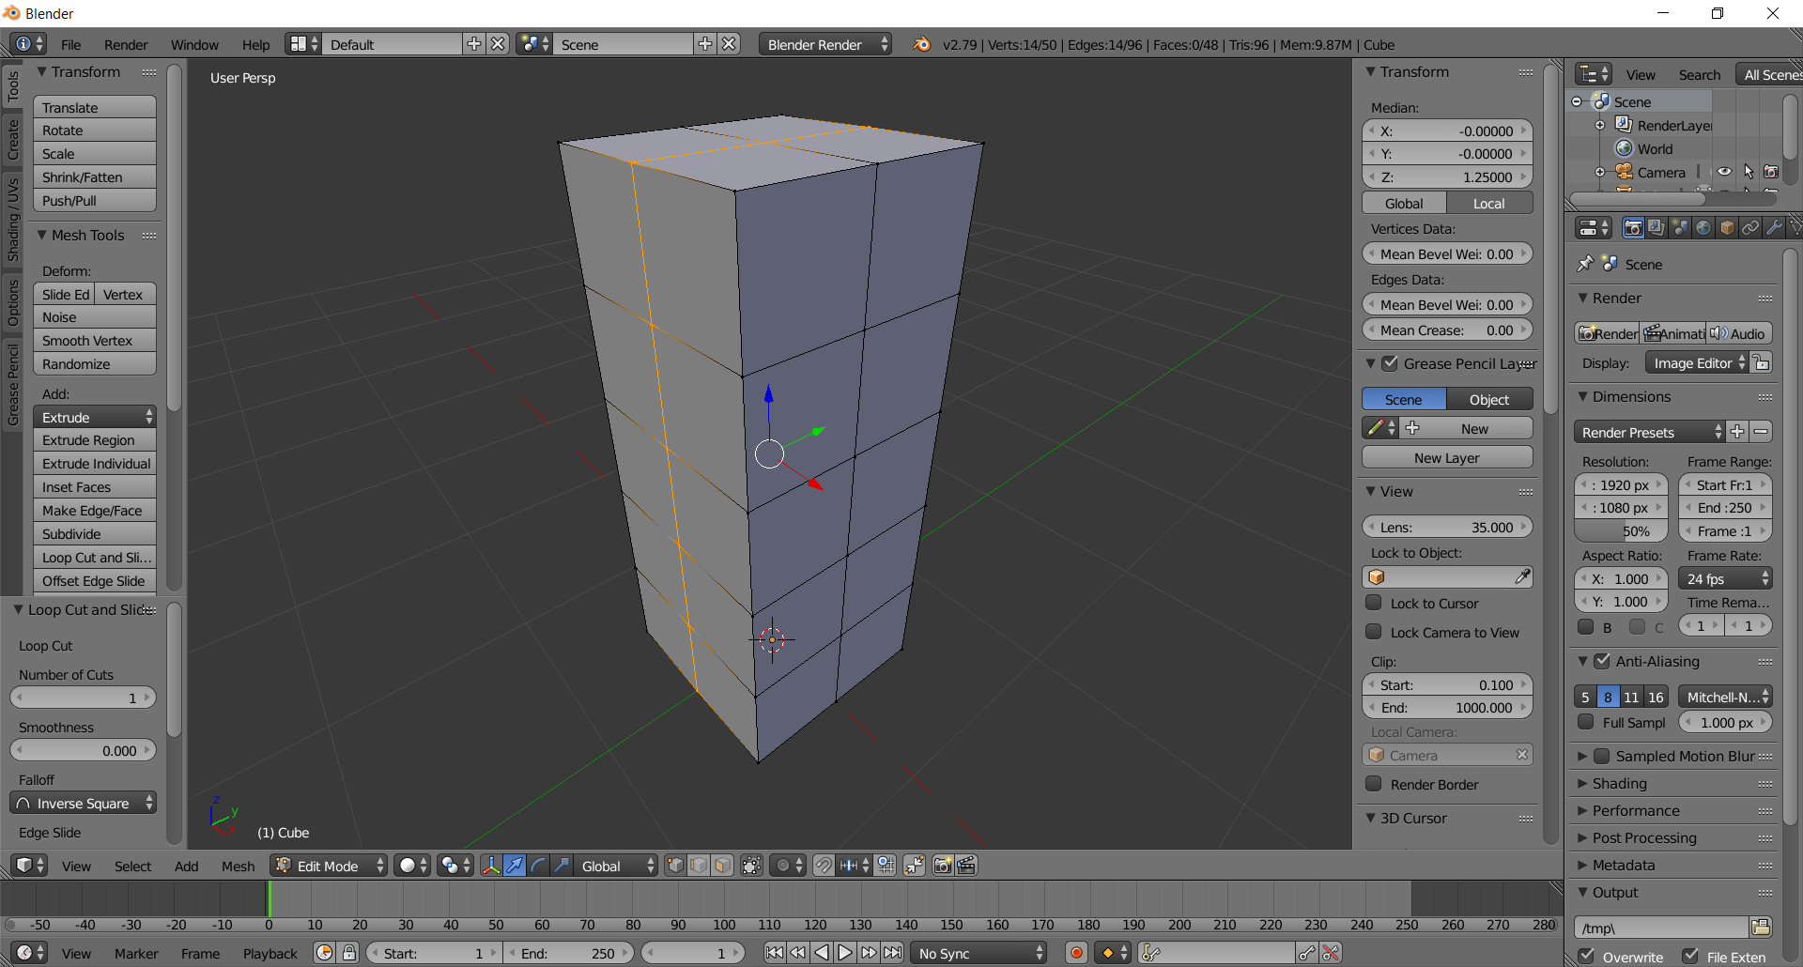

- Create the Legs
  - Switch to Face selection mode using CTRL-TAB > Face
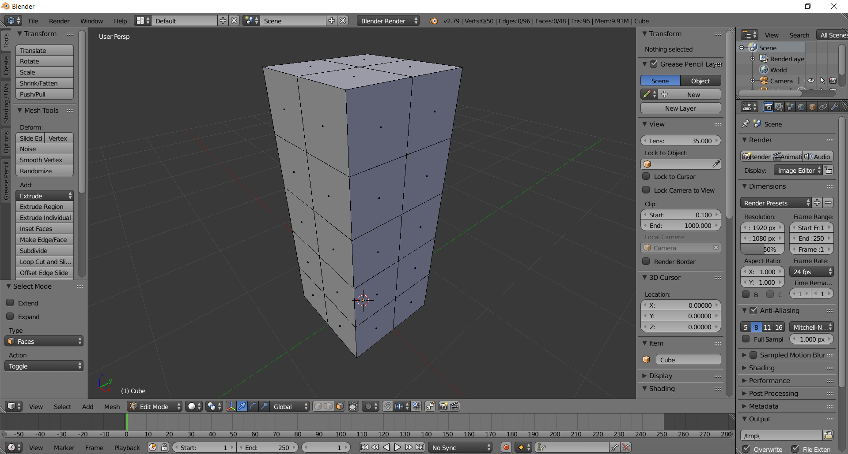

  - Rotate until you see the bottom of the box
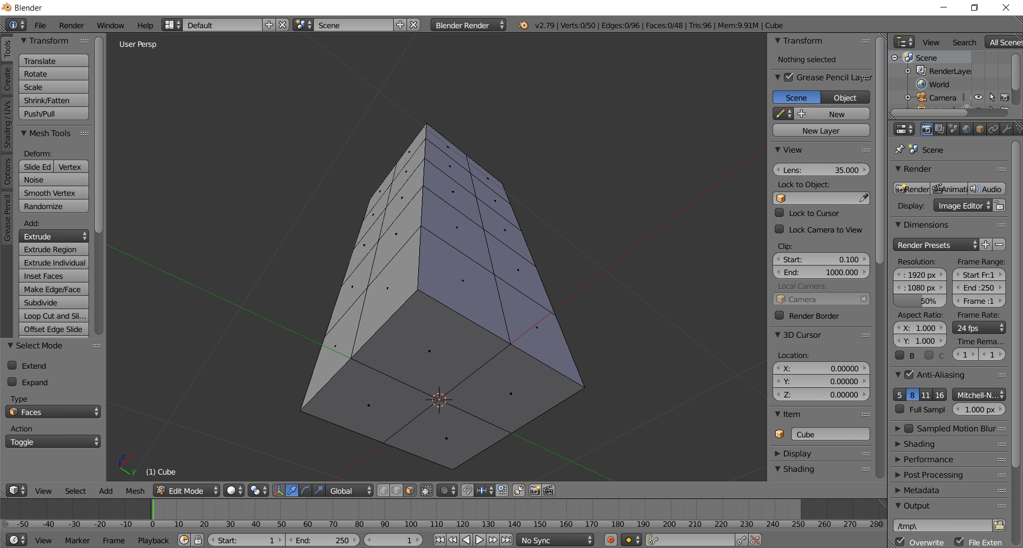
  - (LEFT LEG) Select the left-leg face by right-clicking on it
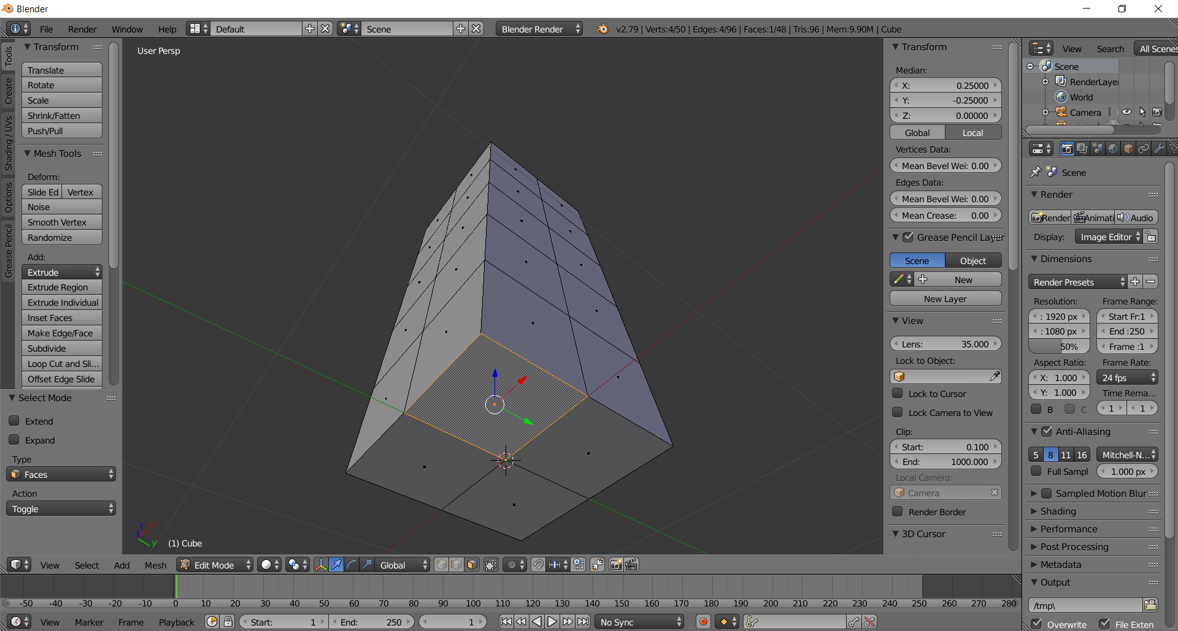

  - Create the thigh-knee by extruding this face two units by typing E 2 Enter
(zoom back to see the entire extrusion)
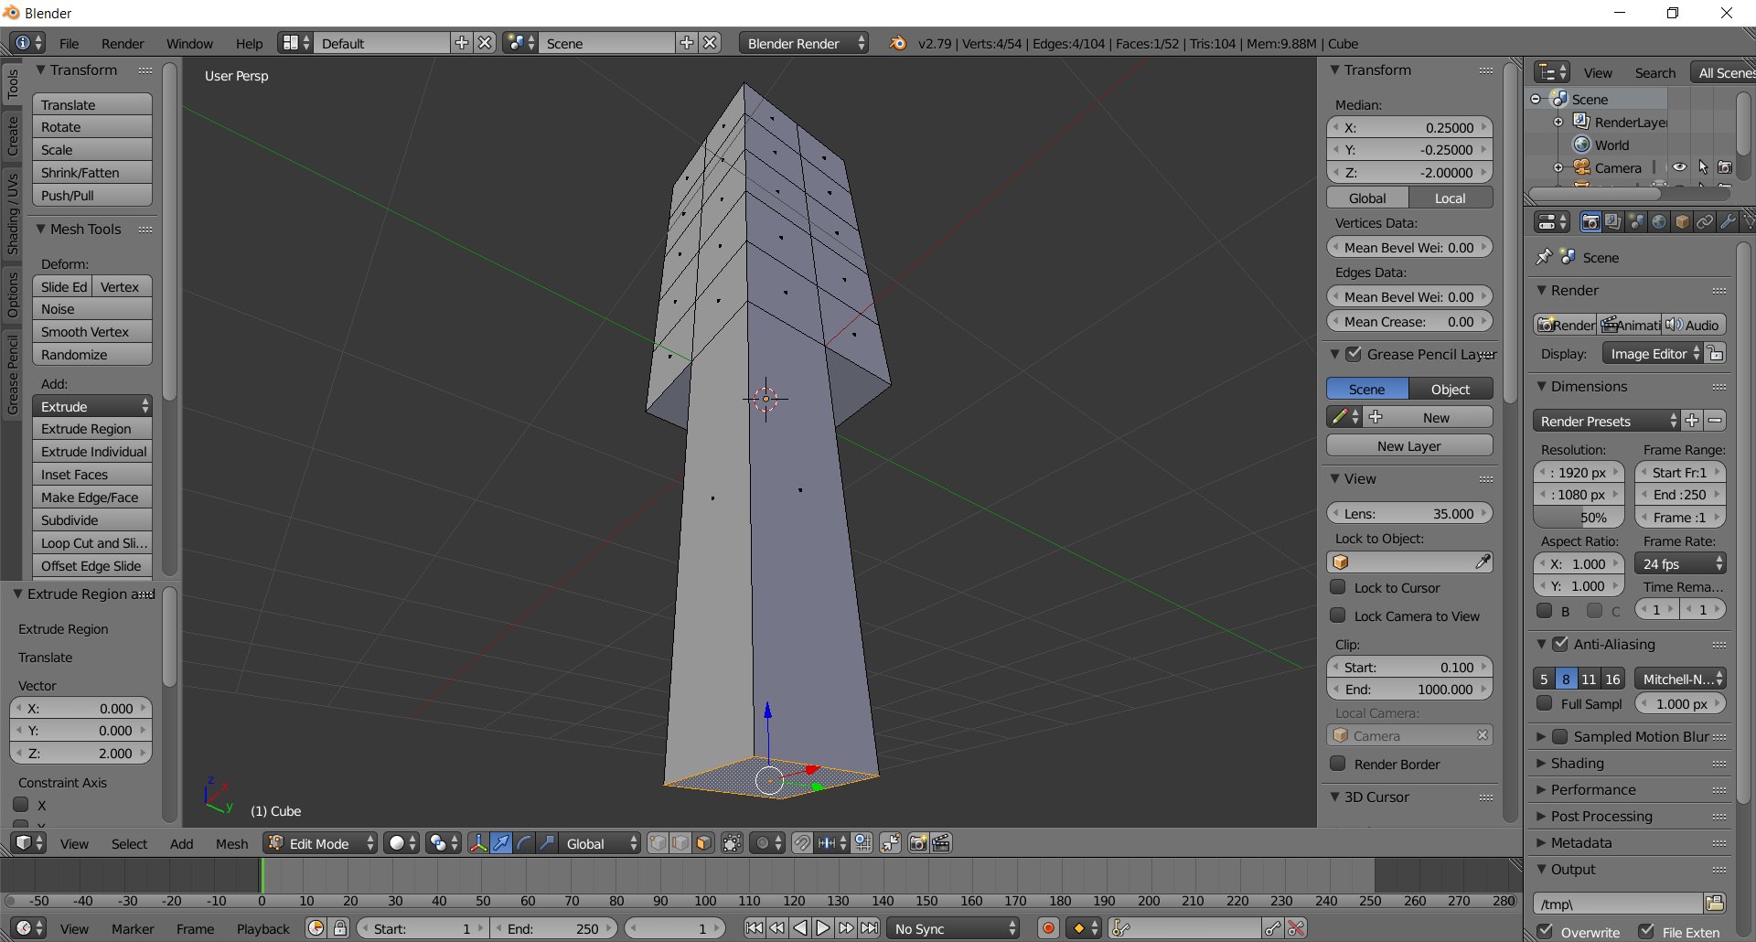

  - Taper the knee 90% by typing S .9 Enter
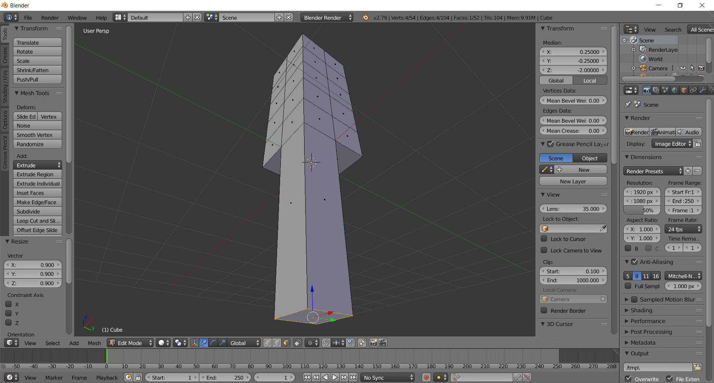
  - Create the knee-heel by extruding this face two units by typing E 2 Enter
(zoom back to see the entire extrusion)
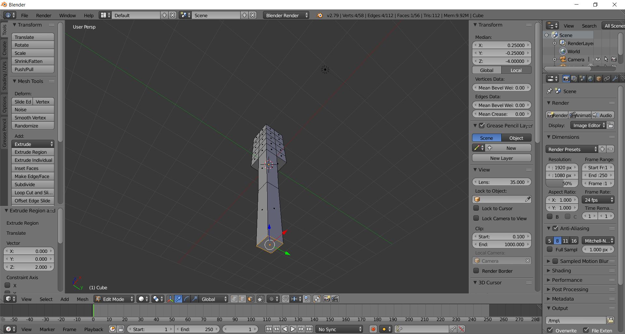

  - Taper the knee 90% by typing S .9 Enter
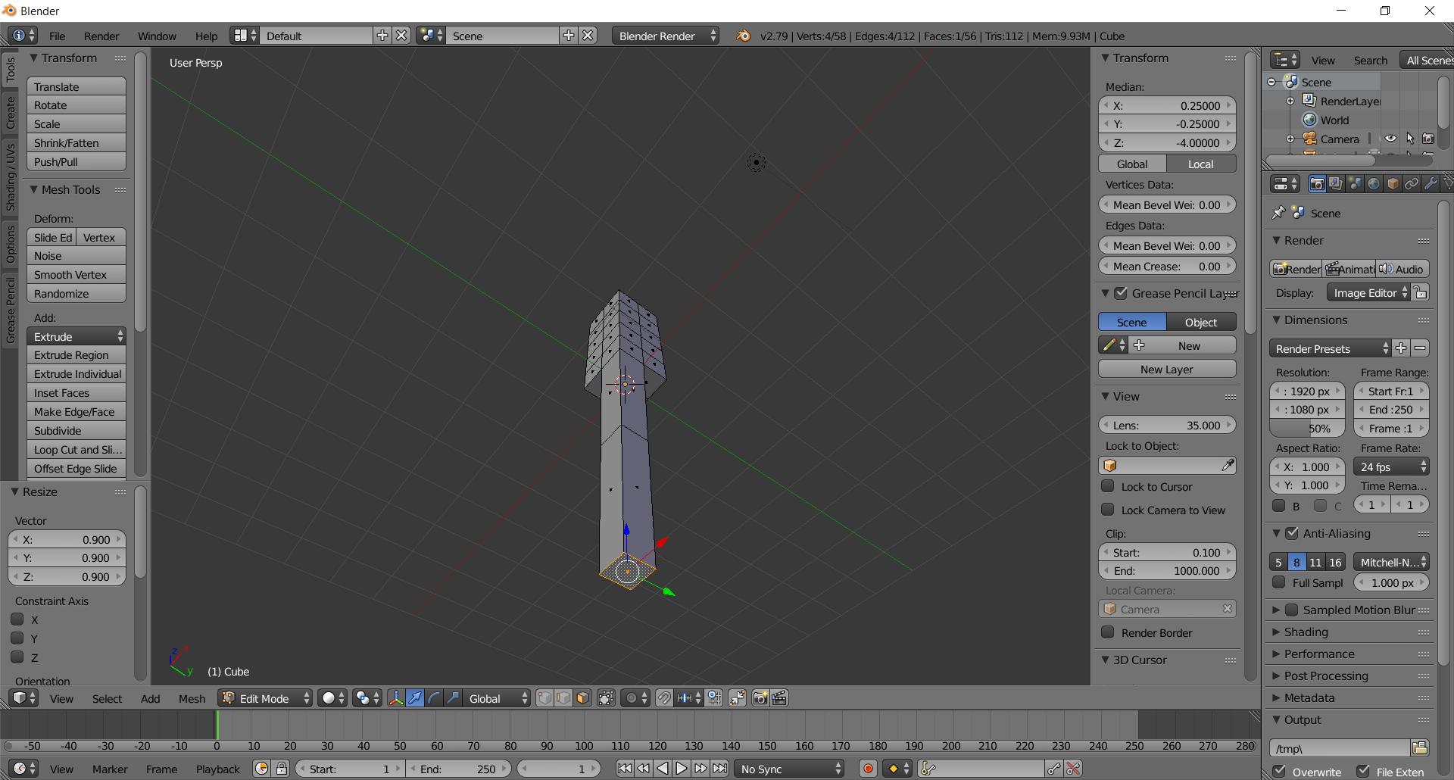

  - (RIGHT LEG) Select the right-leg face by right-clicking on it
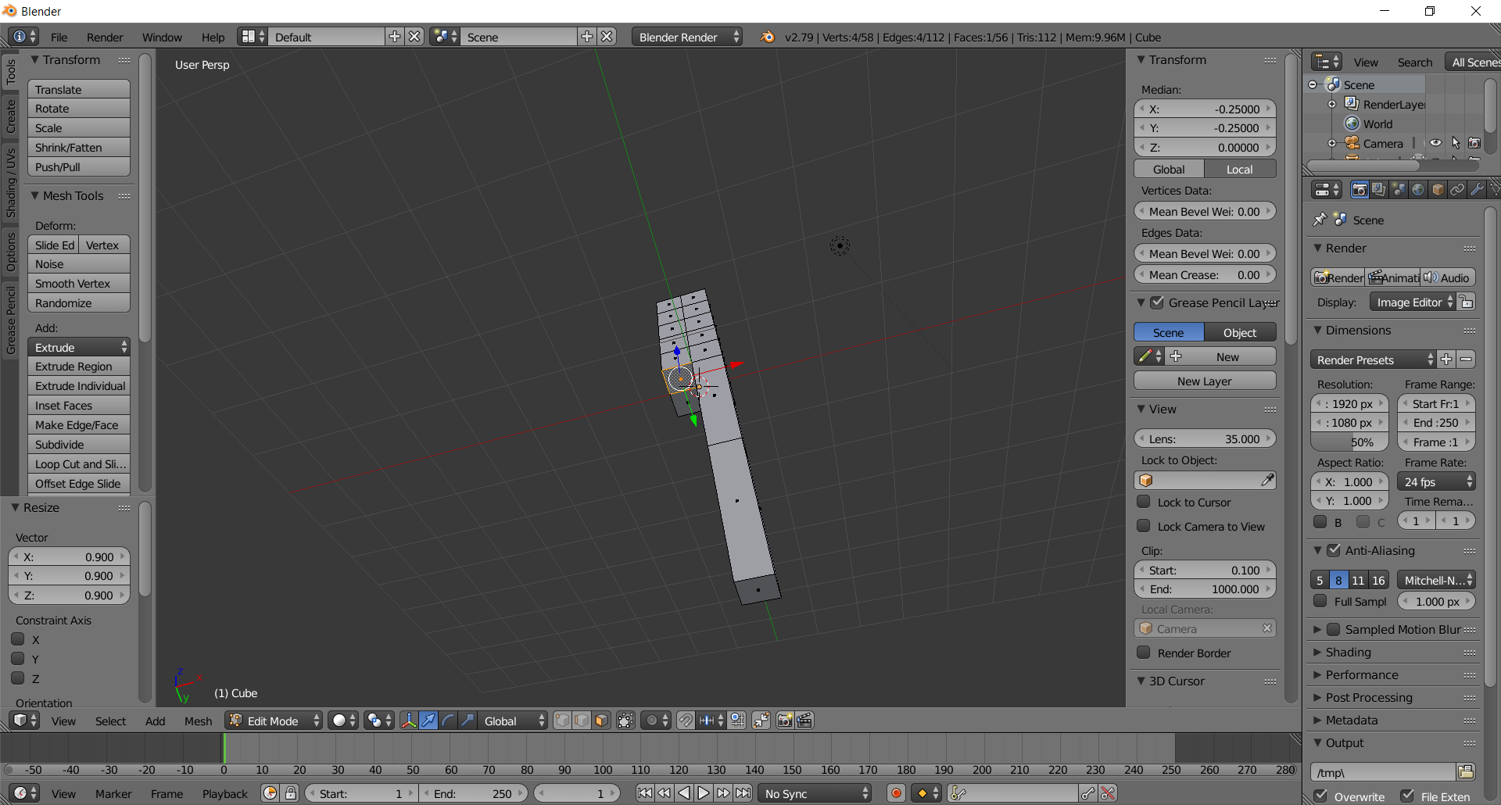
  - Create the thigh-knee by extruding this face two units by typing E 2 Enter
(zoom back to see the entire extrusion)
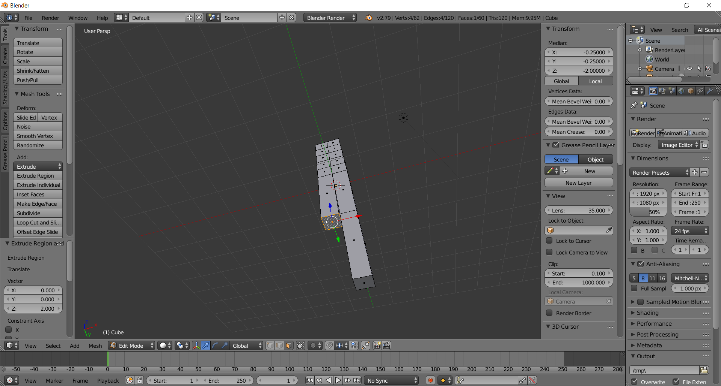

  - Taper the knee 90% by typing S .9 Enter
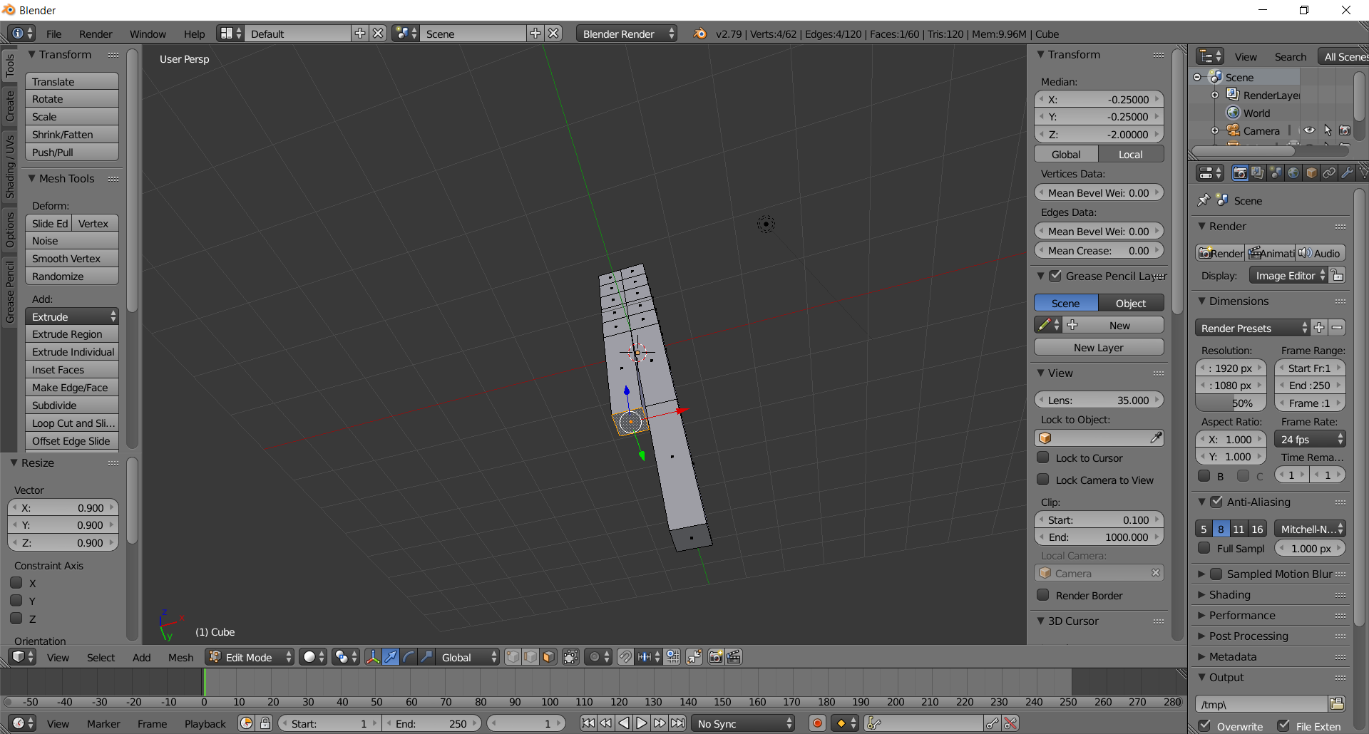

  - Create the knee-heel by extruding this face two units by typing E 2 Enter
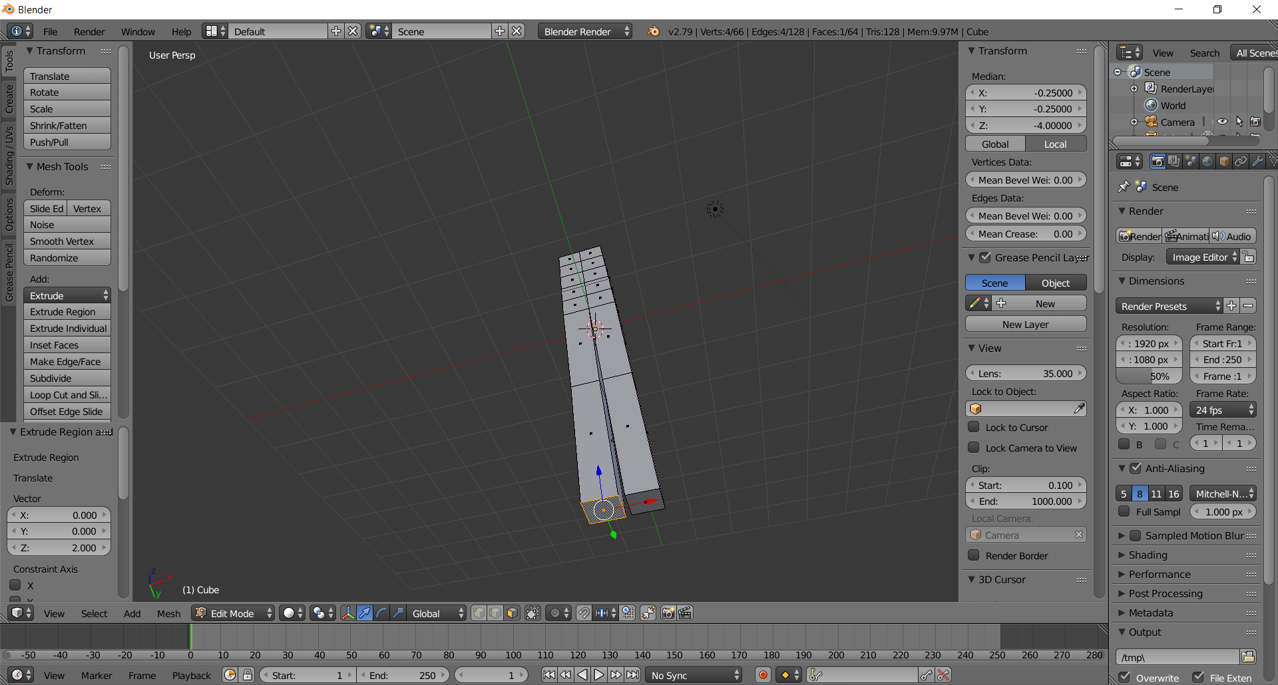
  - Taper the knee 90% by typing S .9 Enter
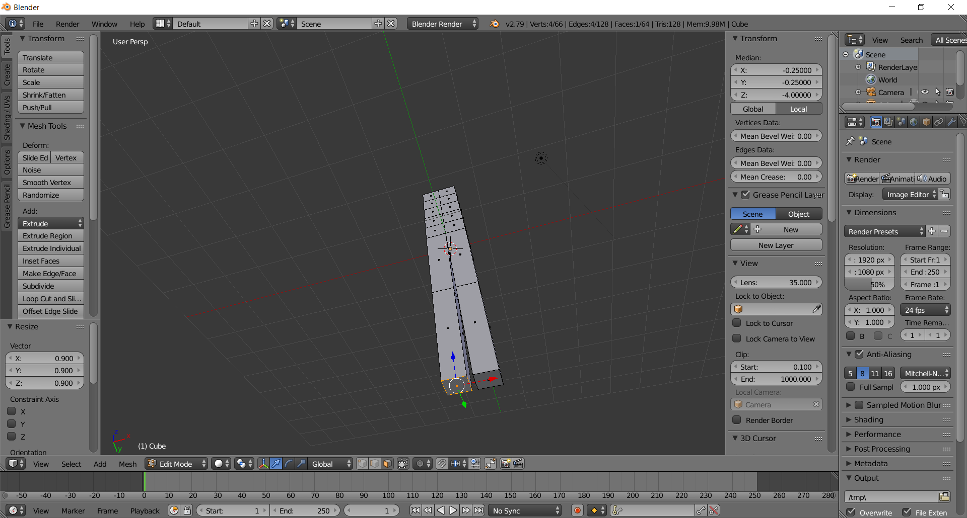

  - Exit Edit Mode by pressing the TAB key
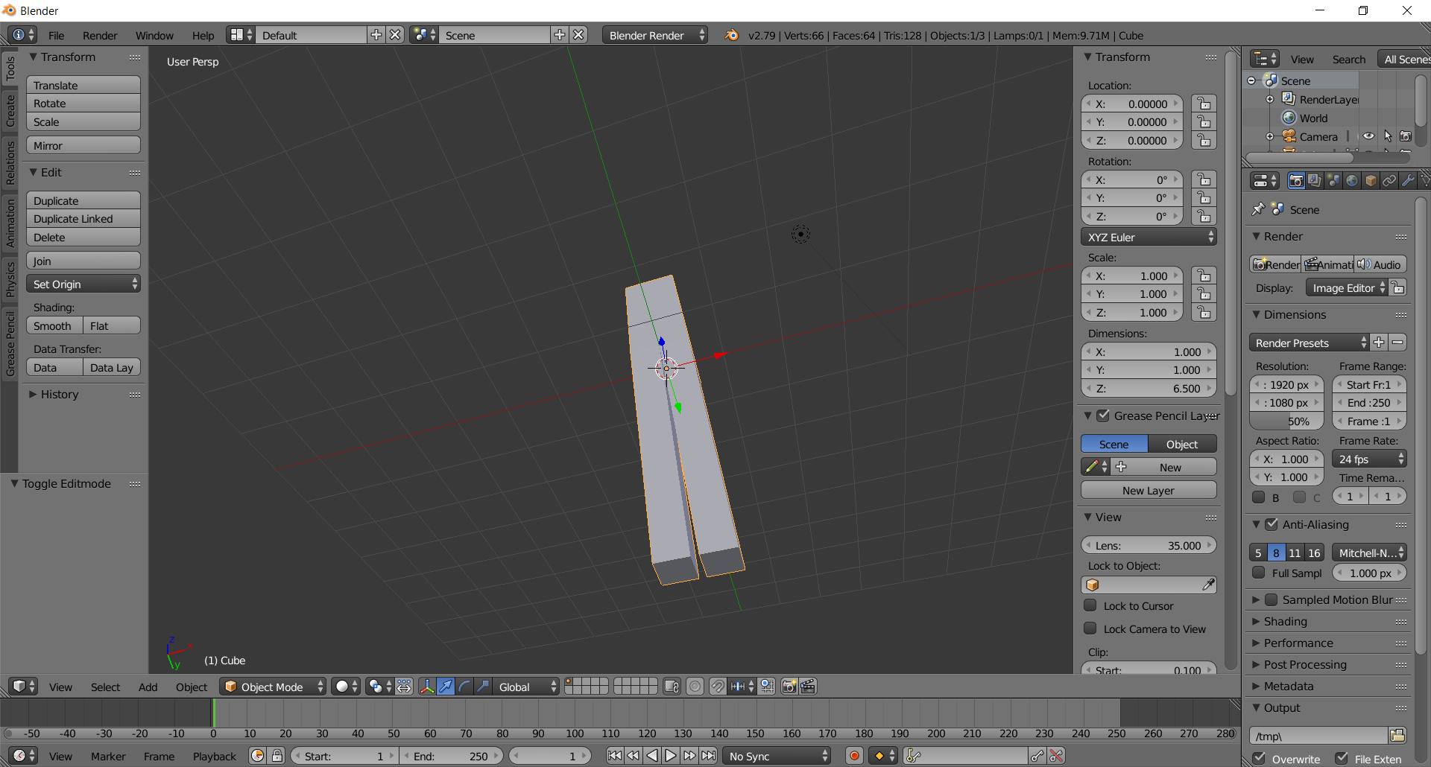

  - Pop-up the legs so the heel is ground level by typing 4 into Transform > Location > Z
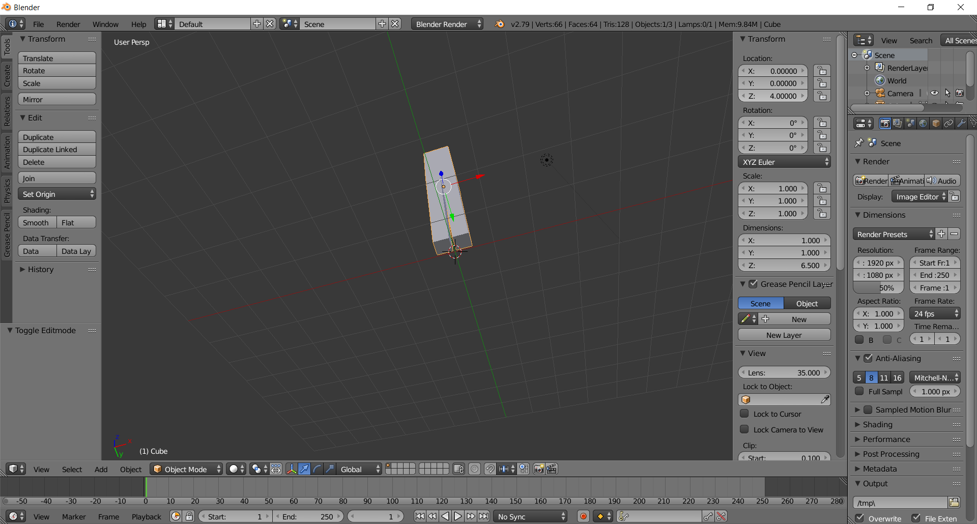
  - Reposition the view so you can see the body and legs
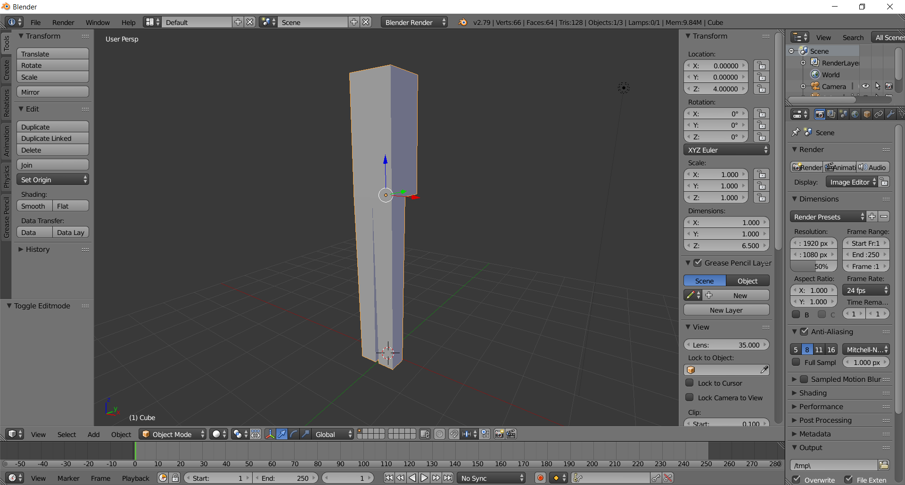

- Create the arms
  - Press TAB to enter edit mode (you should still be in Face selection mode, if not CTRL-TAB > Face)
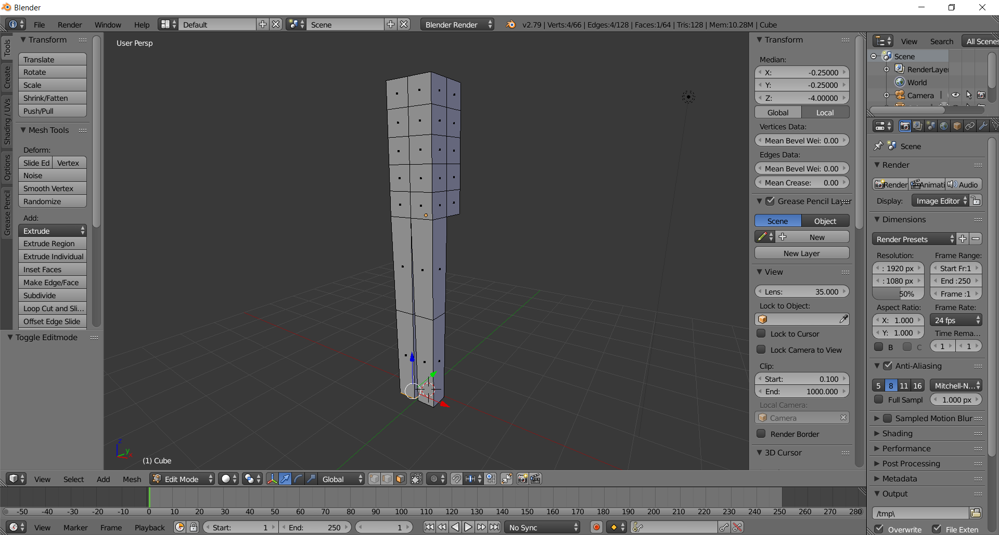

  - (LEFT ARM) Select the back left-shoulder face by right-clicking on it
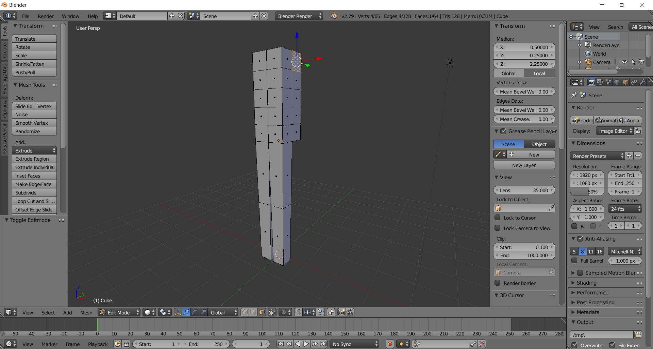
  - Create the shoulder by extruding this face .5 units via E .5 Enter
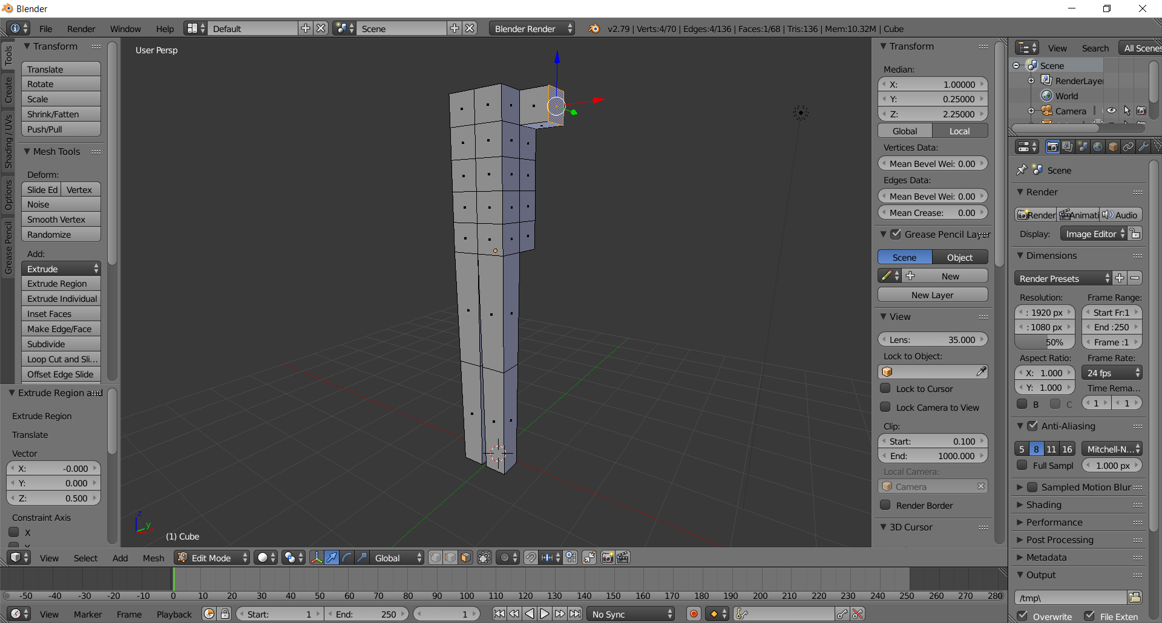

  - Select the arm-pit face by right-clicking it
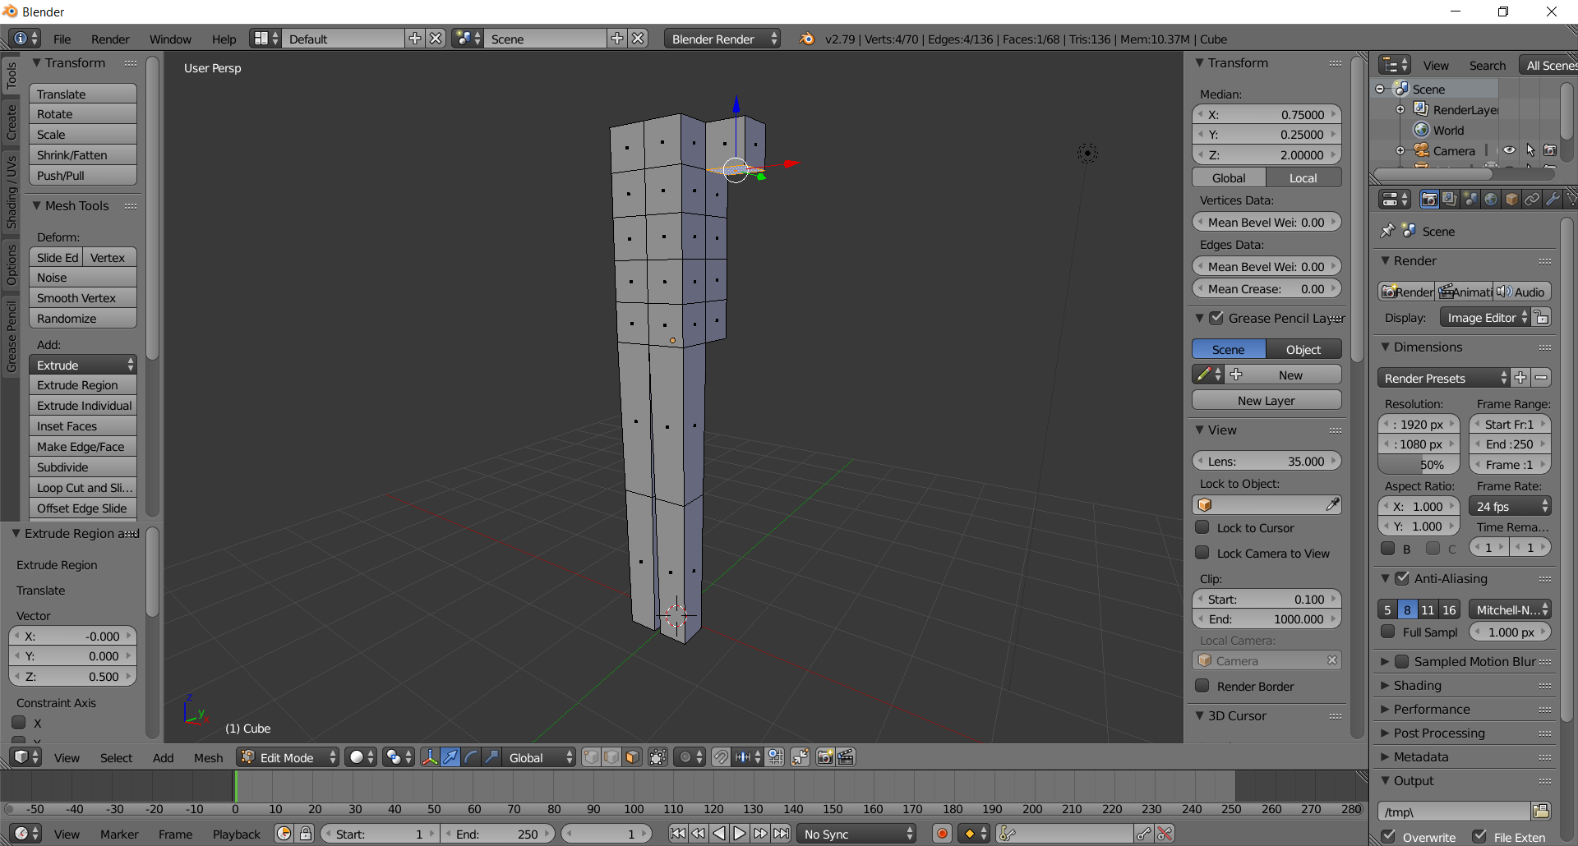

  - Create the bicep-elbow by extruding 1 unit via E 1 Enter
(rotate view so you can see the bottom)
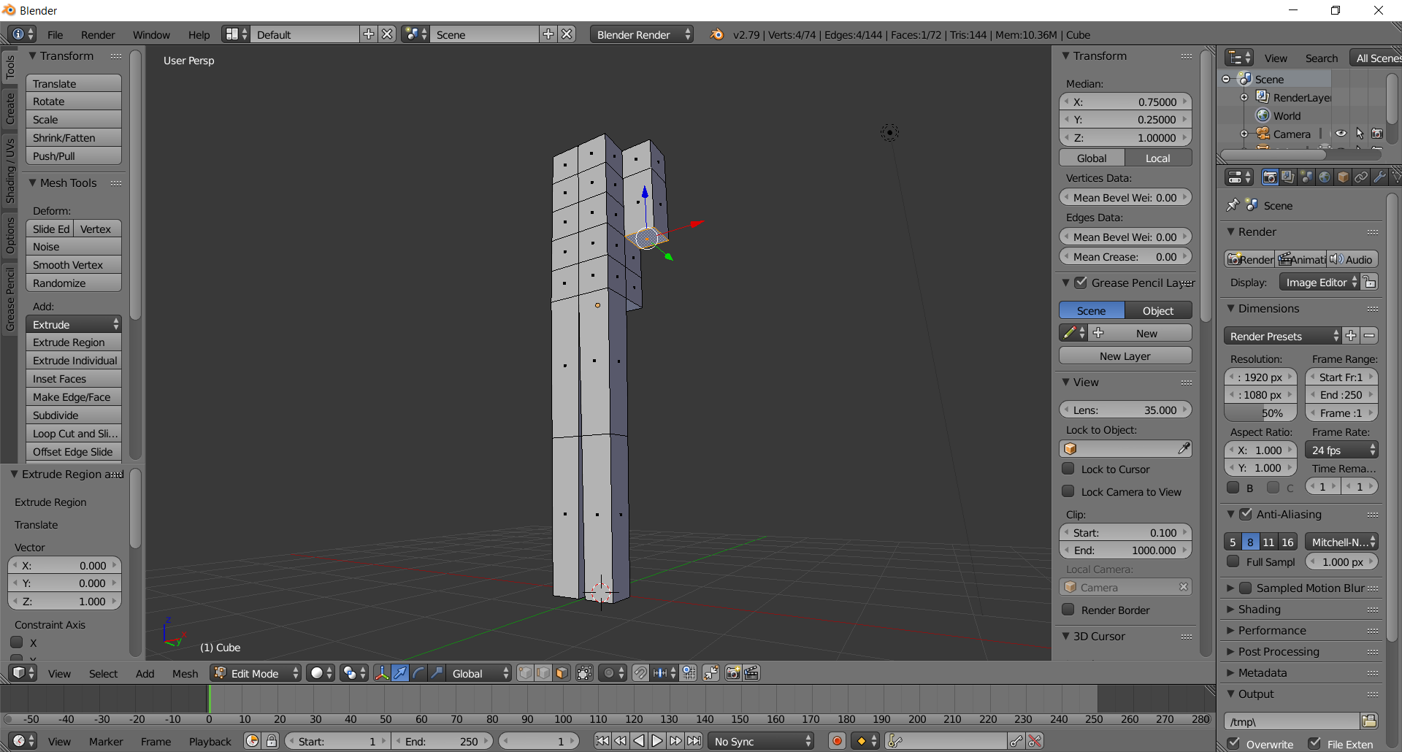
  - Taper this face 80% via S .8 Enter
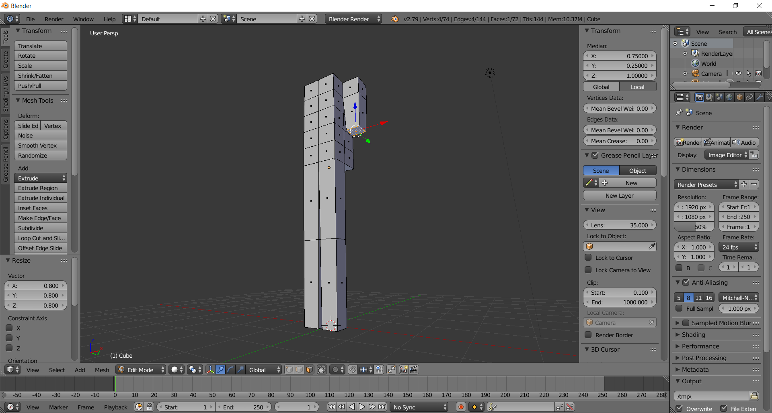

  - Create the elbow-wrist by extruding this face 1 unit via E 1 Enter
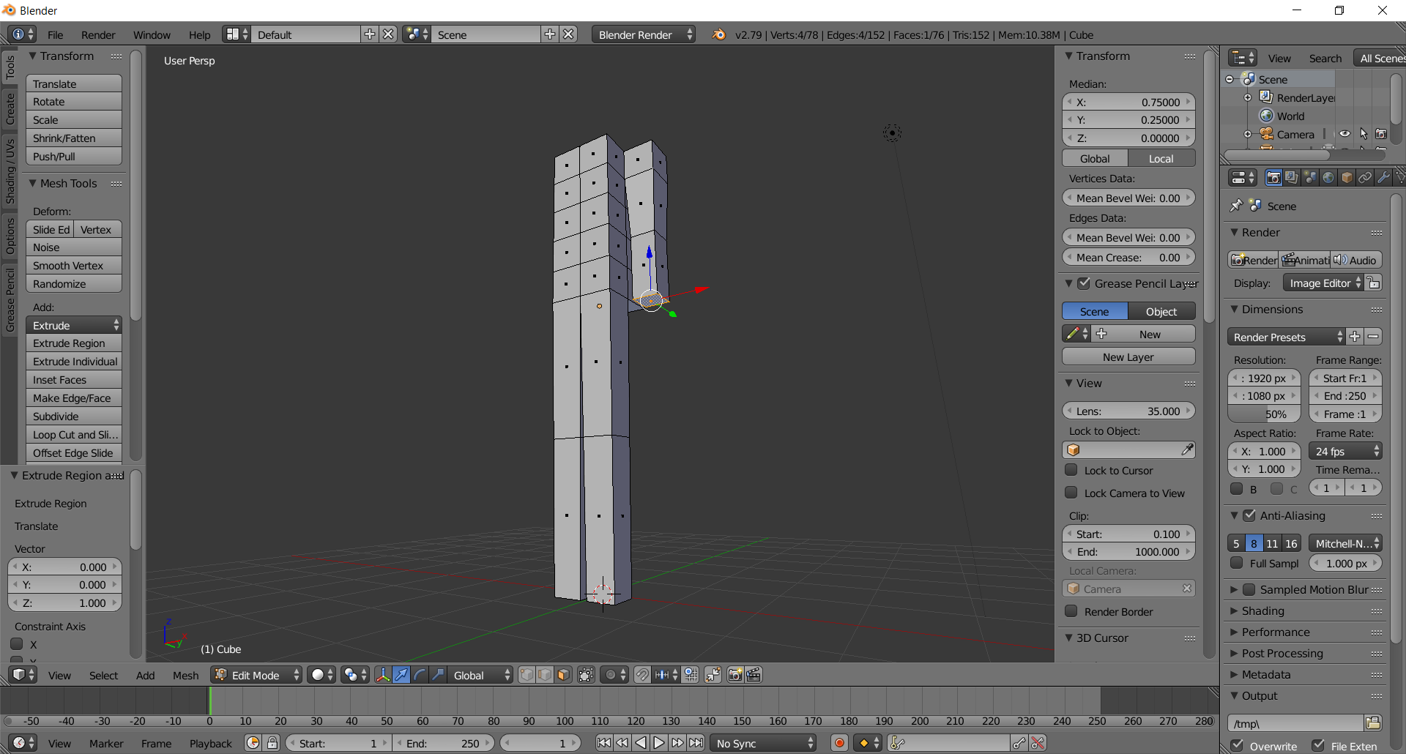

  - Taper this face 80% via S .8 Enter
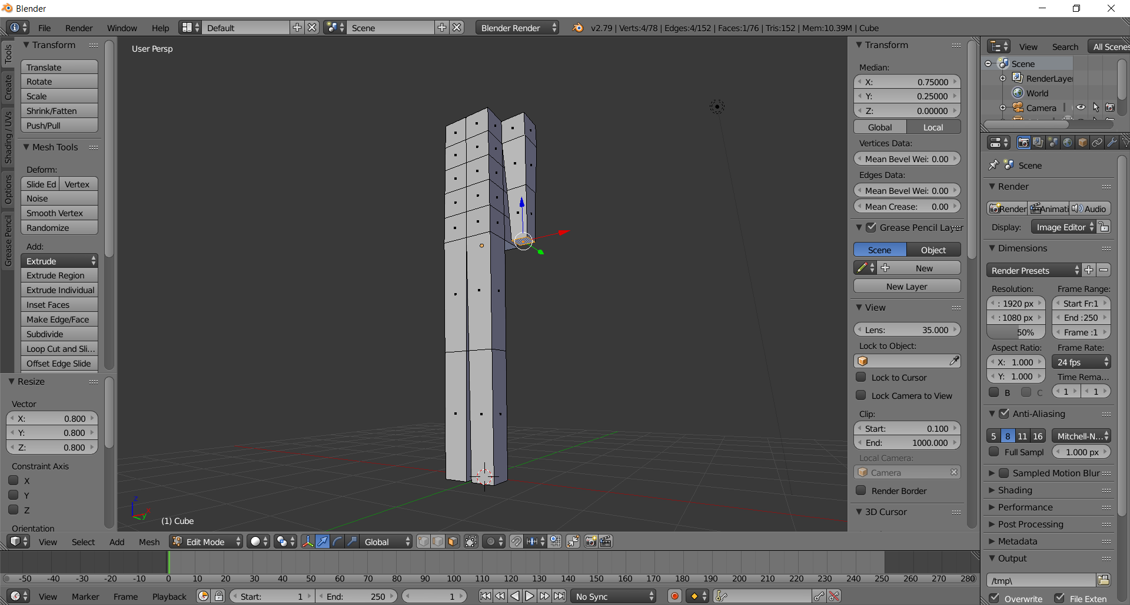
  - (RIGHT ARM, rotate until you can see the right side of the body)
Select the back right-shoulder face by right-clicking on it
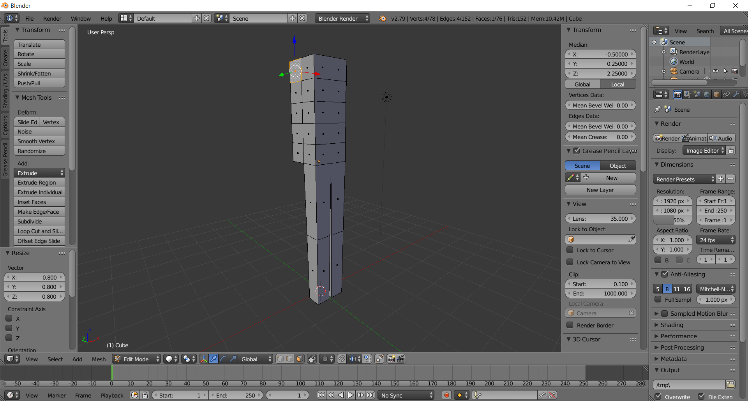

  - Create the shoulder by extruding this face .5 units via E .5 Enter
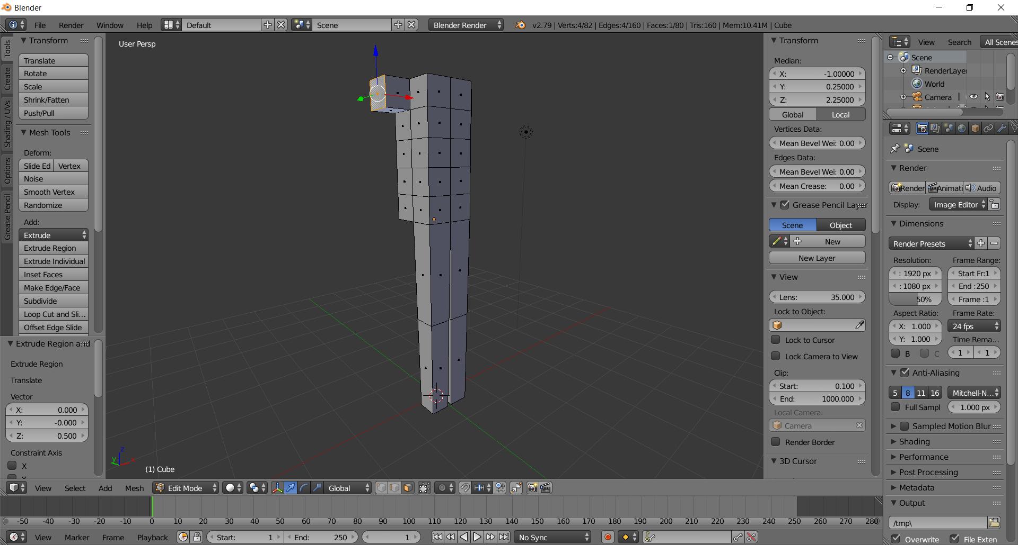

  - Select the arm-pit face by right-clicking it
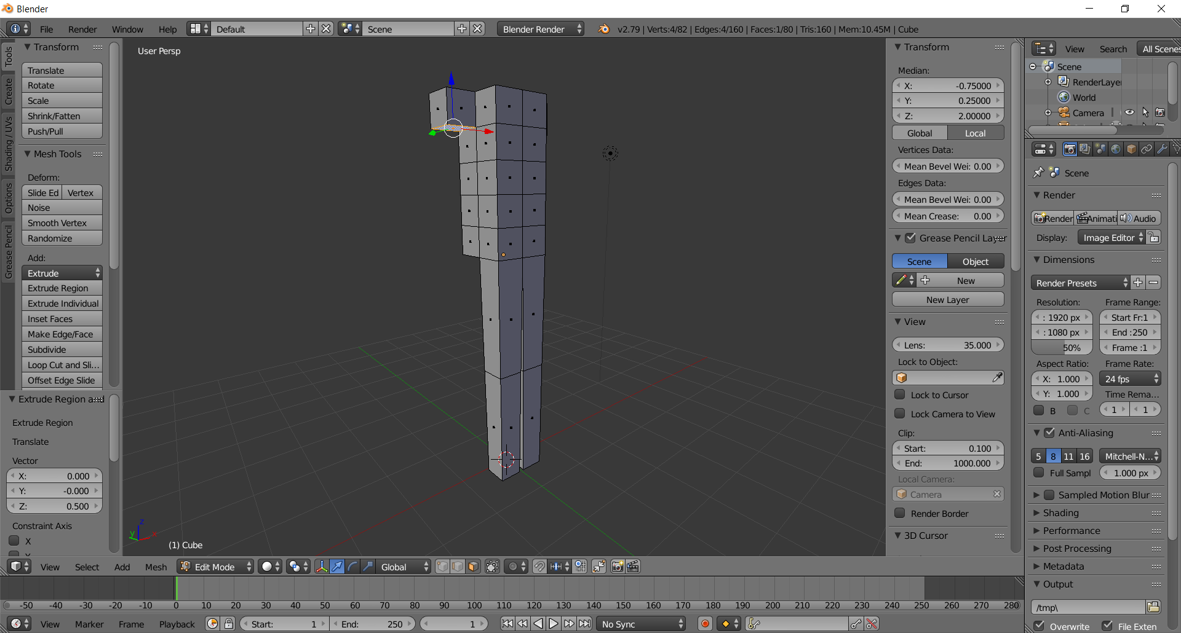

  - Create the bicep-elbow by extruding 1 unit via E 1 Enter
(rotate view so you can see the bottom)
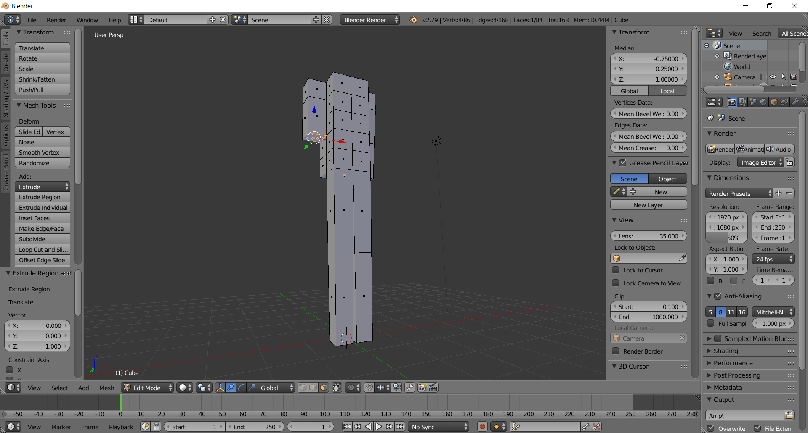

  - Taper this face 80% via S .8 Enter
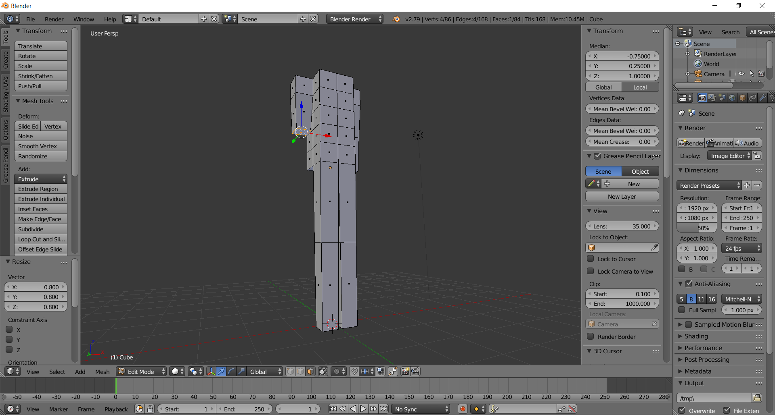

  - Create the elbow-wrist by extruding this face 1 unit via E 1 Enter
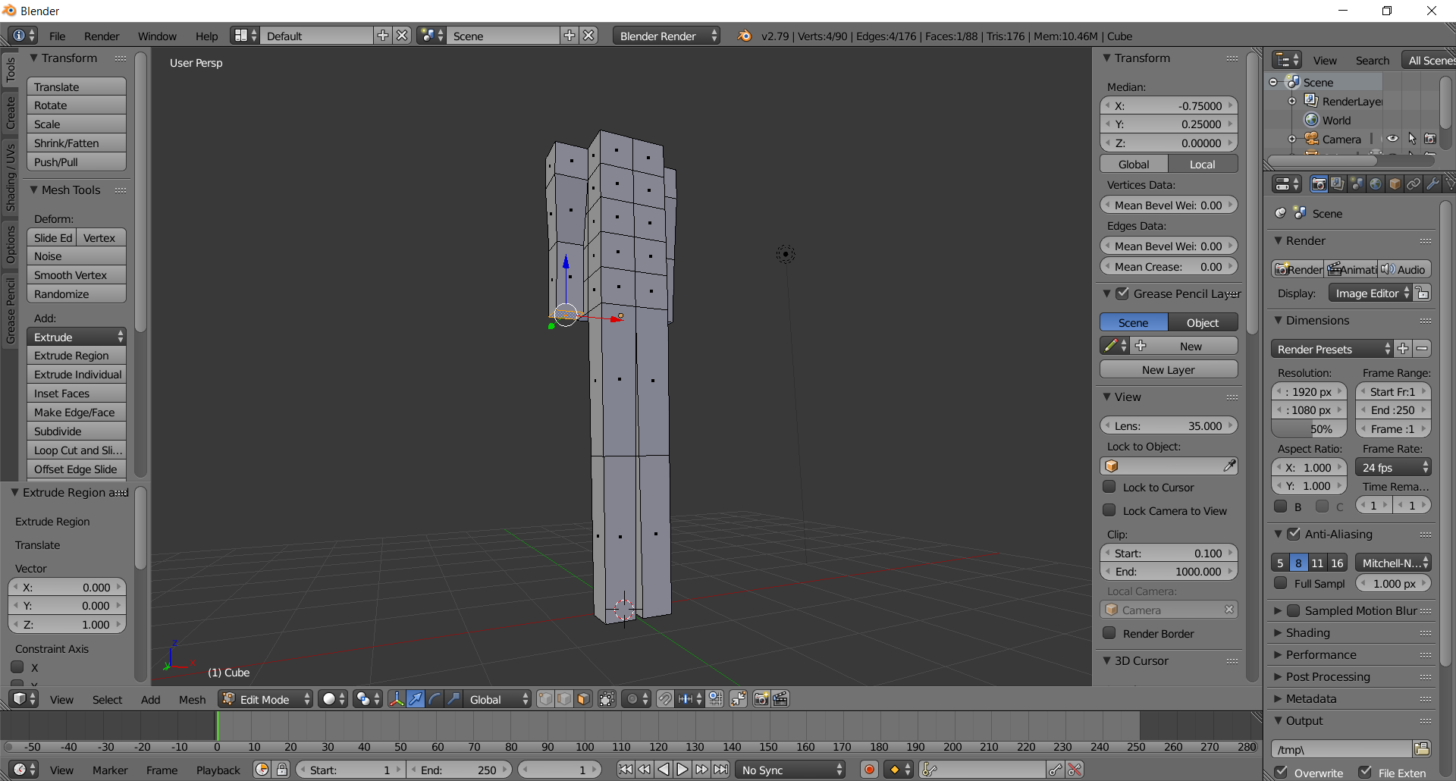

  - Taper this face 80% via S .8 Enter
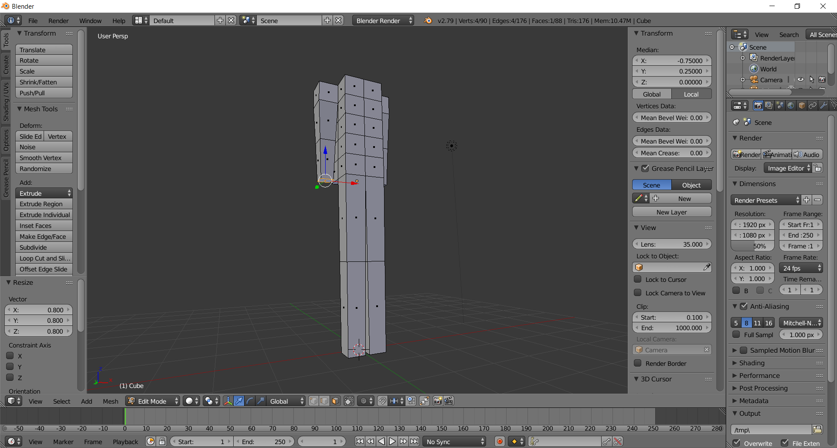

- Create the Hands
  - (RIGHT HAND) Create the hand by extruding a wrist face 1 unit via E 1 Enter
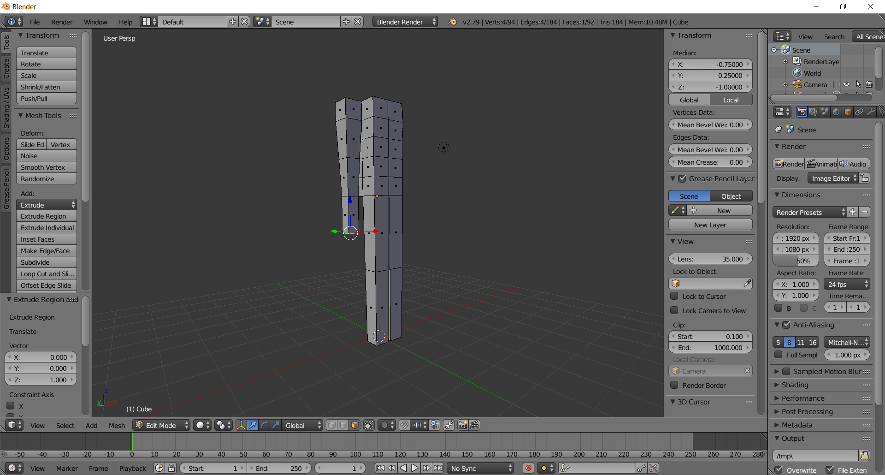
  - Create an edge-loop on the hand by via CTRL-R (hover near hand edge) Left-Click ESC-key
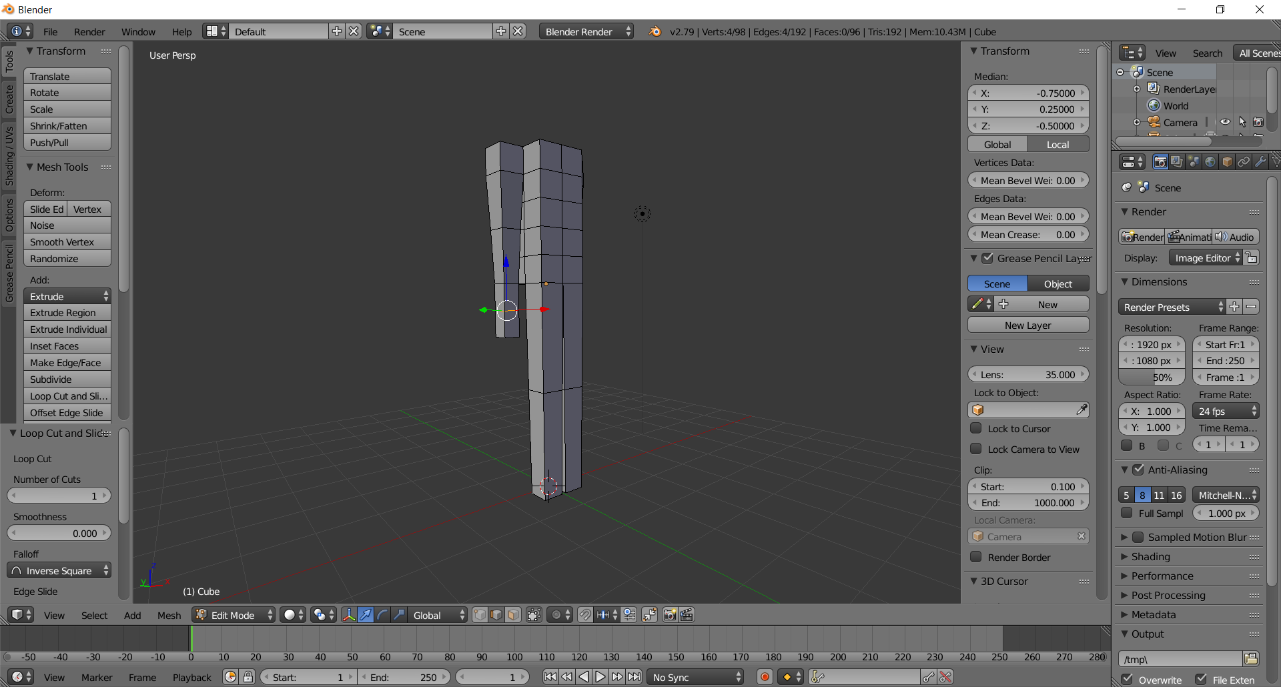
  - Create the hand by scaling in the Y-direction 2 units via typing S Y 2 Enter
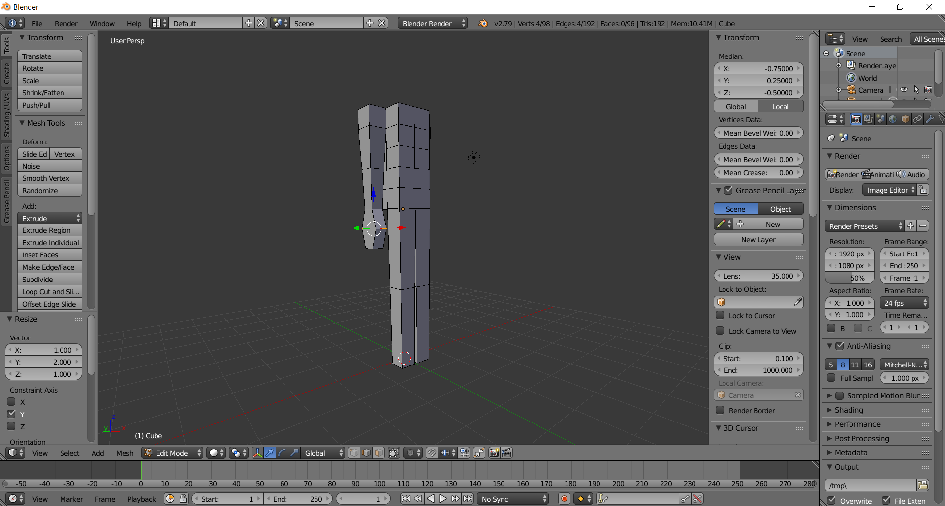

  - (LEFT HAND, rotate view to see left arm )
Make sure you are in face mode via CTRL-TAB > Face
Select the wrist face by right-clicking on it
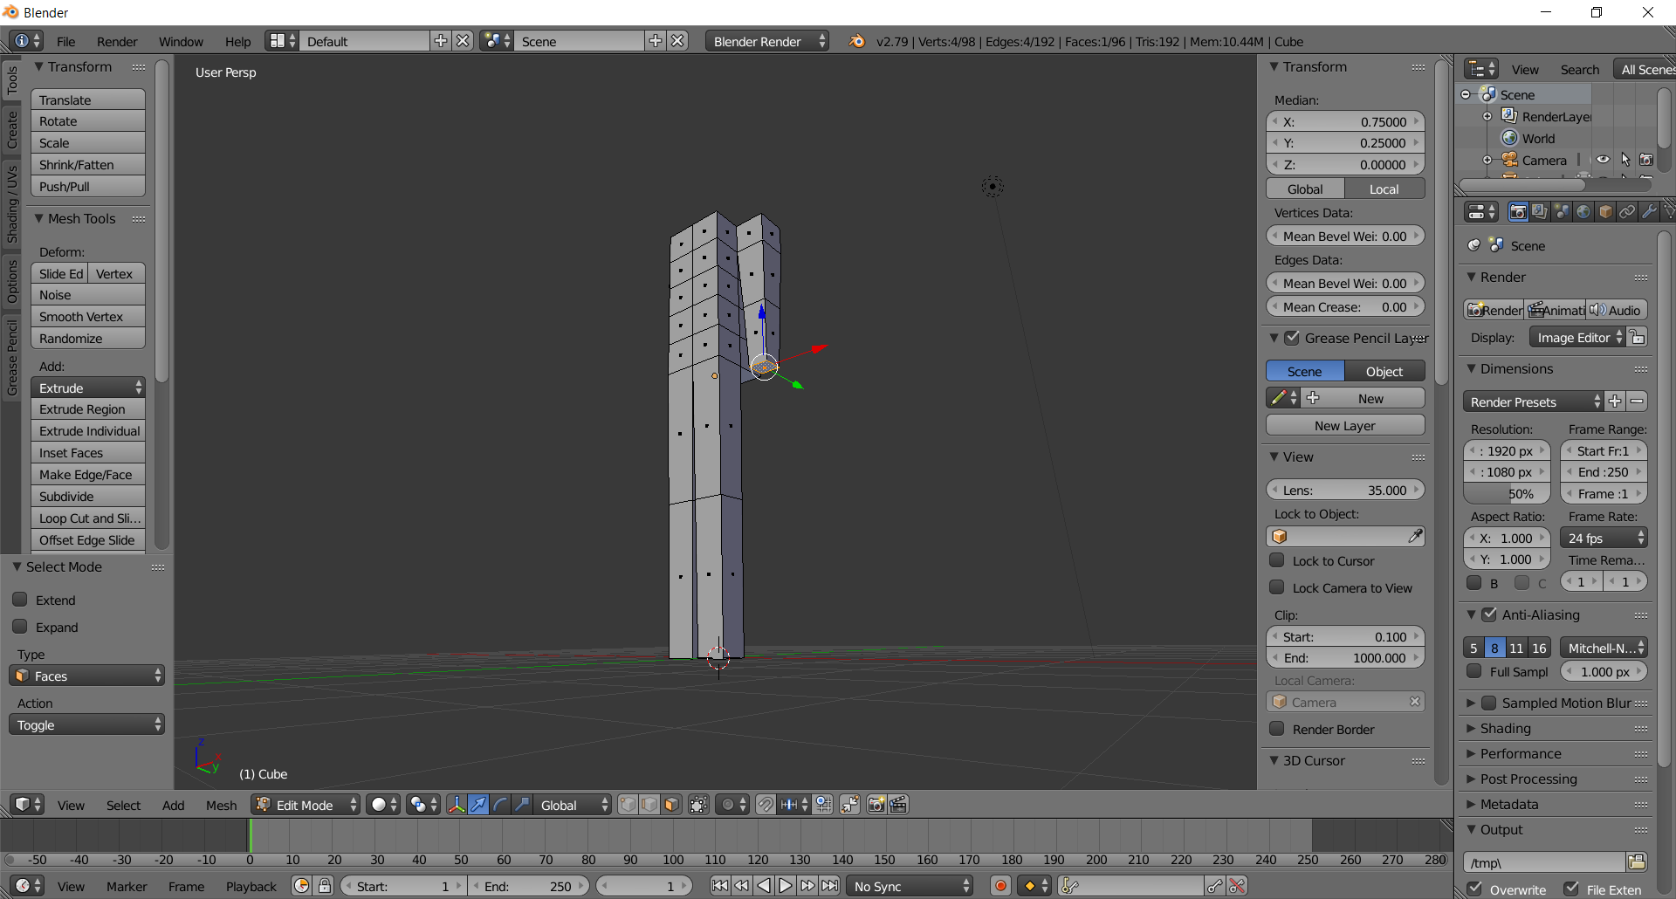

  - Create the hand by extruding a wrist face 1 unit via E 1 Enter
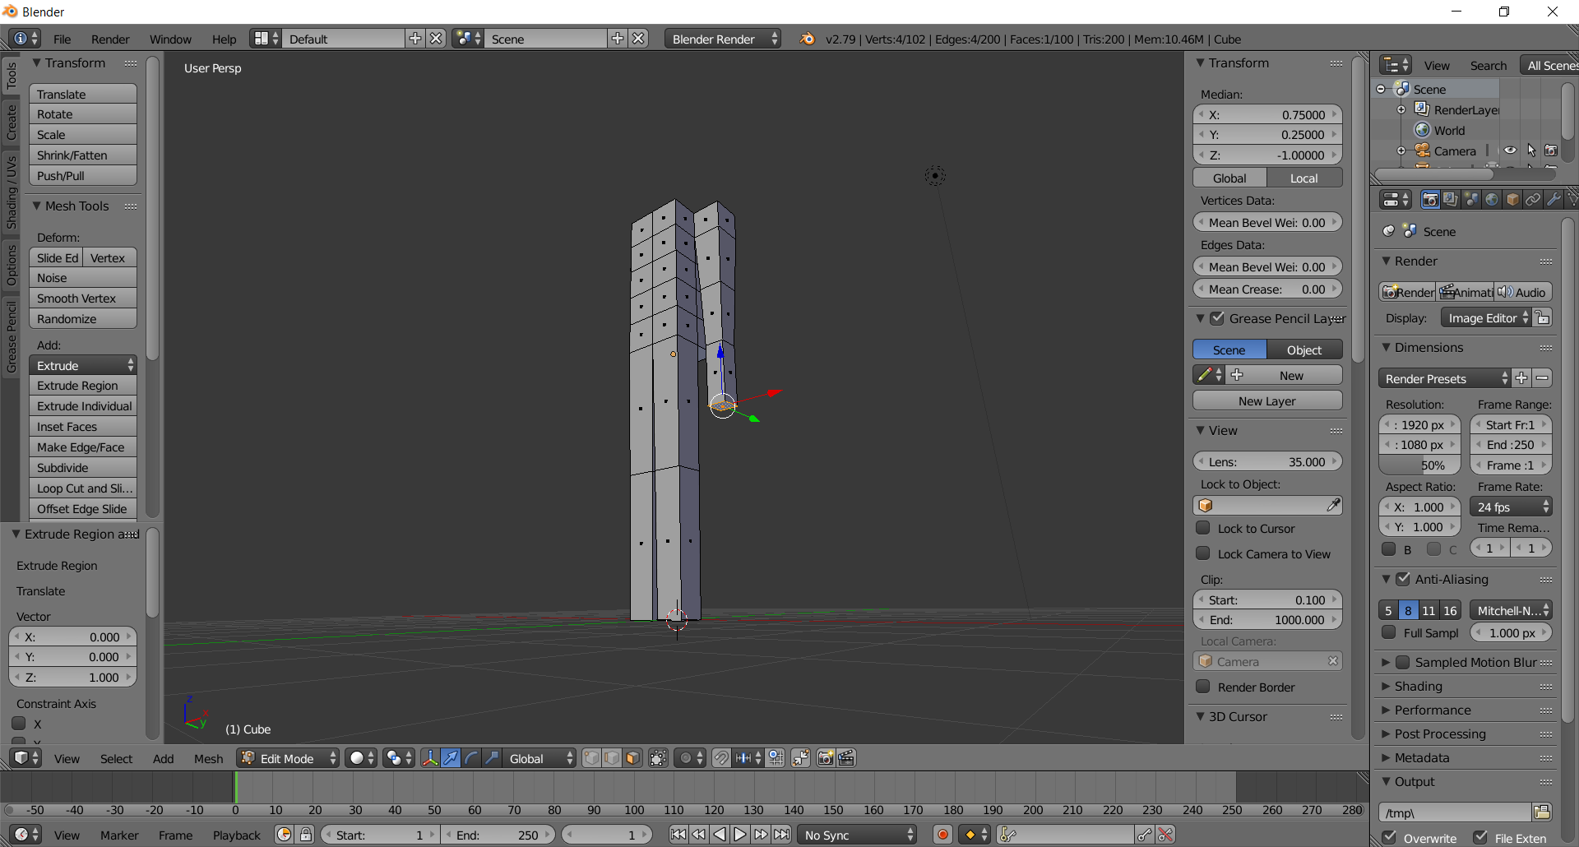
  - Create an edge-loop on the hand by via CTRL-R (hover near hand edge) Left-Click ESC-key
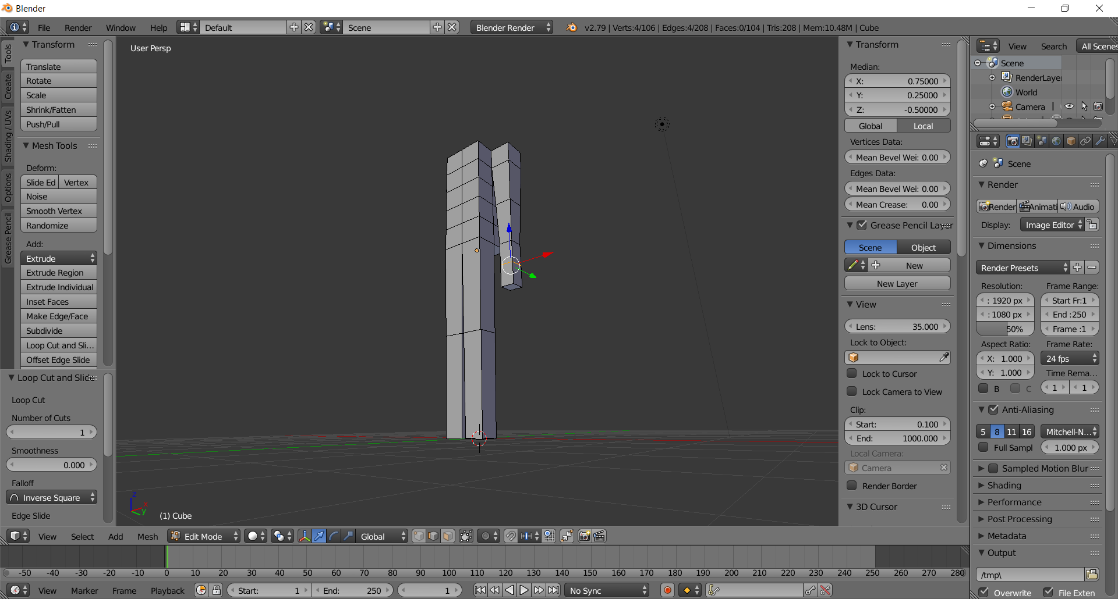

  - Create the hand by scaling in the Y-direction 2 units via typing S Y 2 Enter
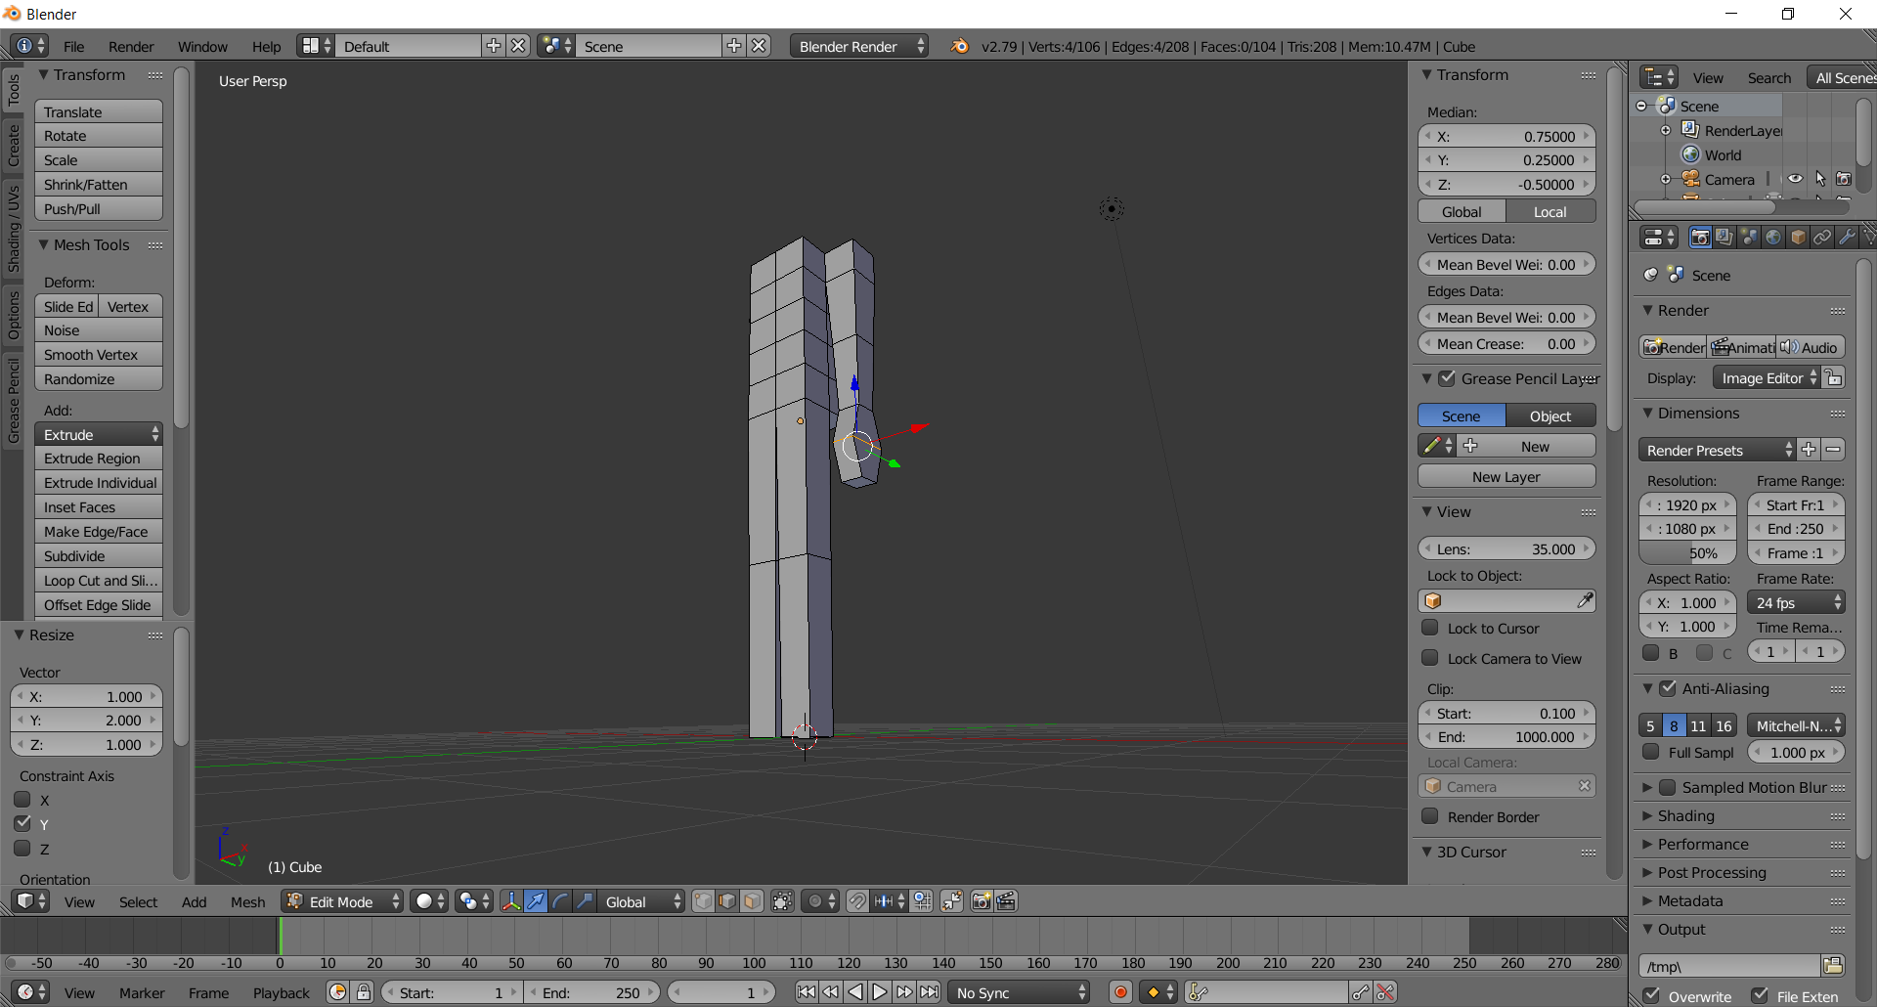

  - Rotate view to see both arms
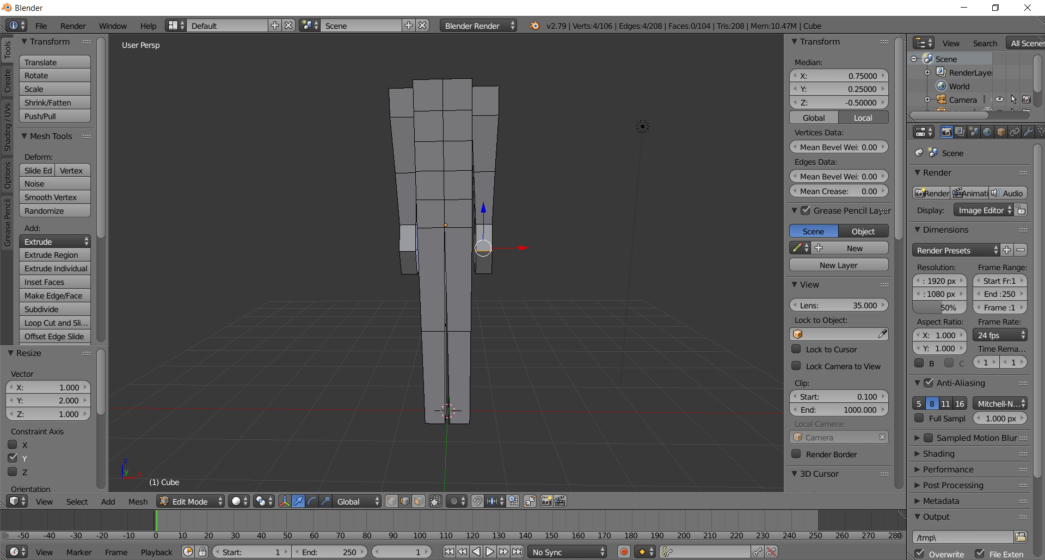

- Create the feet
  - (LEFT FOOT) Create an edge-loop on the bottom left leg via CTRL-R (hover mouse on bottom left leg) Left-Click ESC
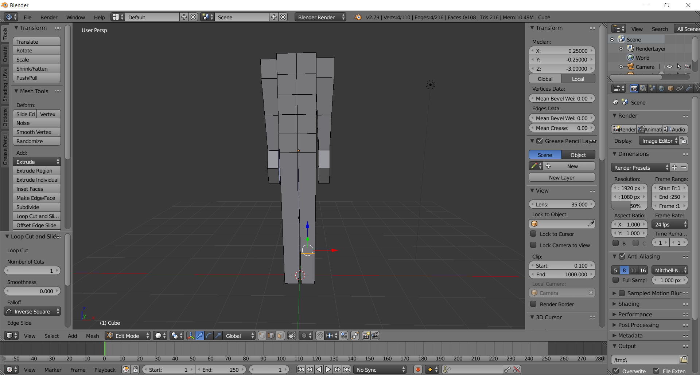

  - Position at .5 by first clicking on the global button in the Transform panel, then entering .5 into Transform > Median > Z
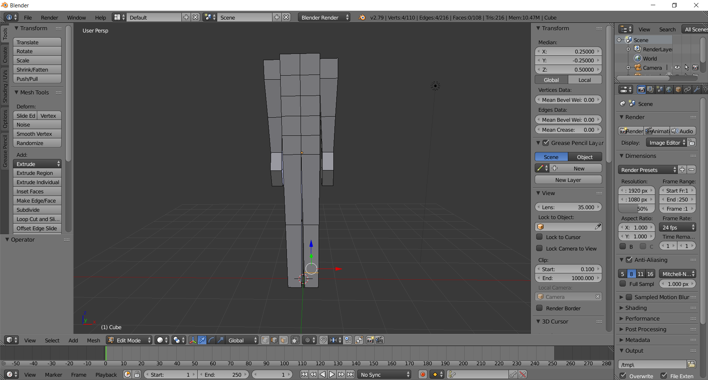

  - Switch to Face mode via CTRL-TAB > Face, then select the bottom leg face by right-clicking on it
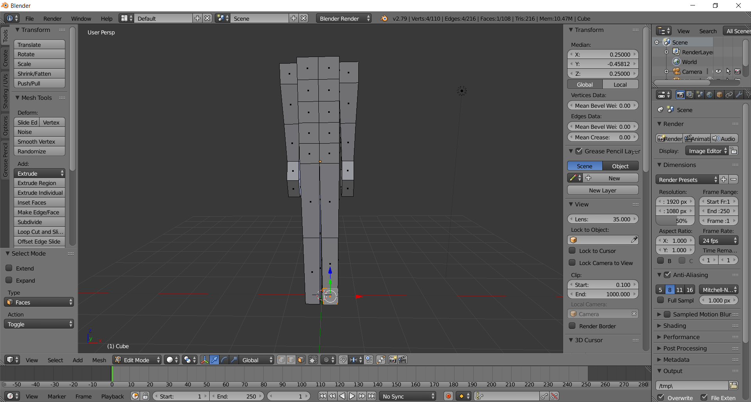
  - Extrude this face one unit via typing E 1 Enter
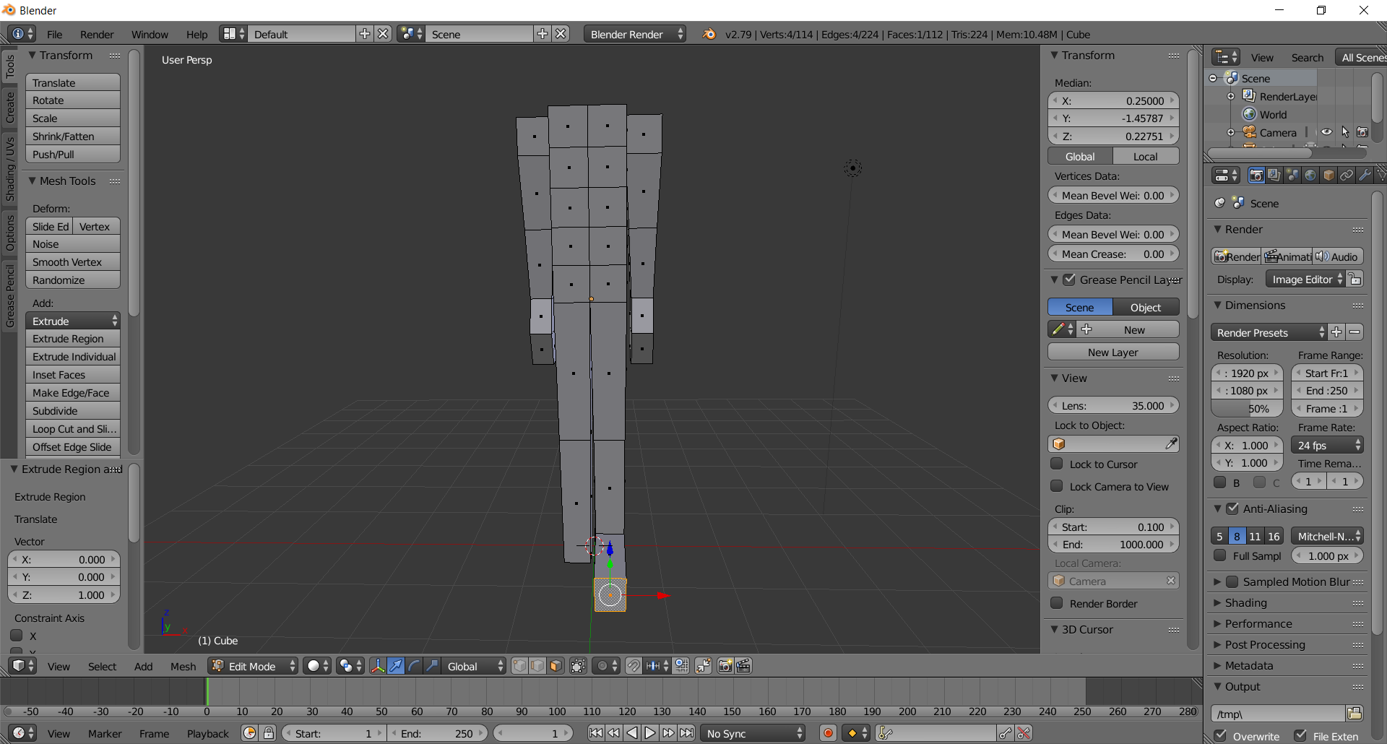

  - Switch to edge mode via CTRL-Tab > Edge, and select the foot’s top edge by right-clicking on it
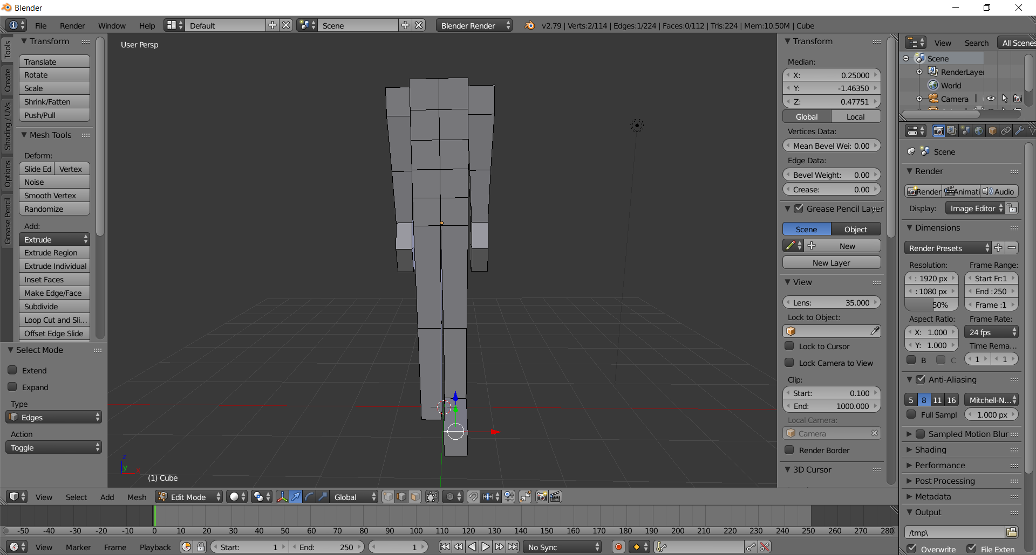

  - Create the toe face by moving this edge down via entering .1250 into Transform > Median > Z
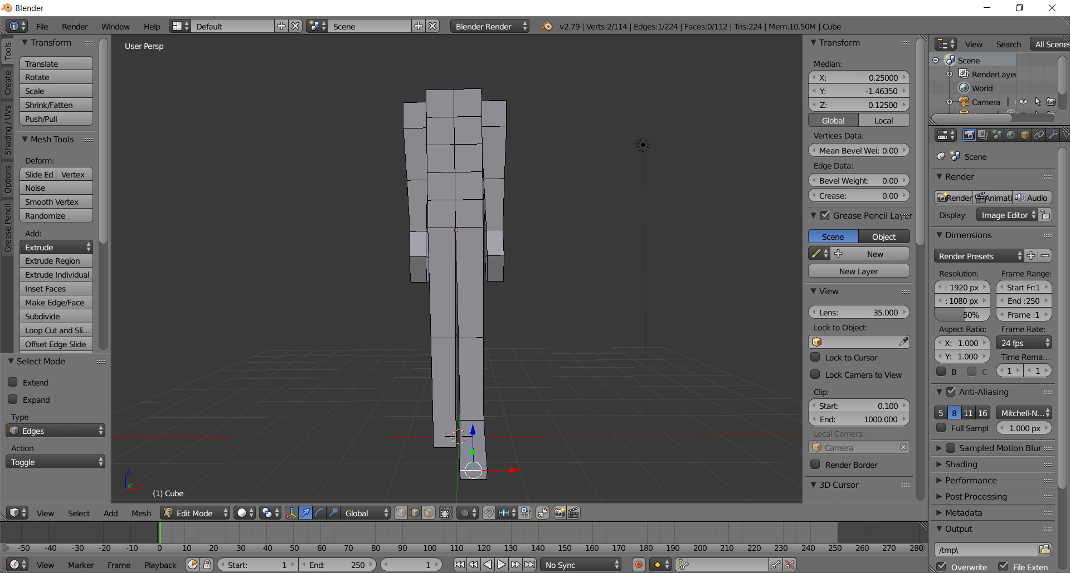
  - (RIGHT FOOT) Create an edge-loop on the bottom right leg via CTRL-R (hover mouse on bottom left leg) Left-Click ESC
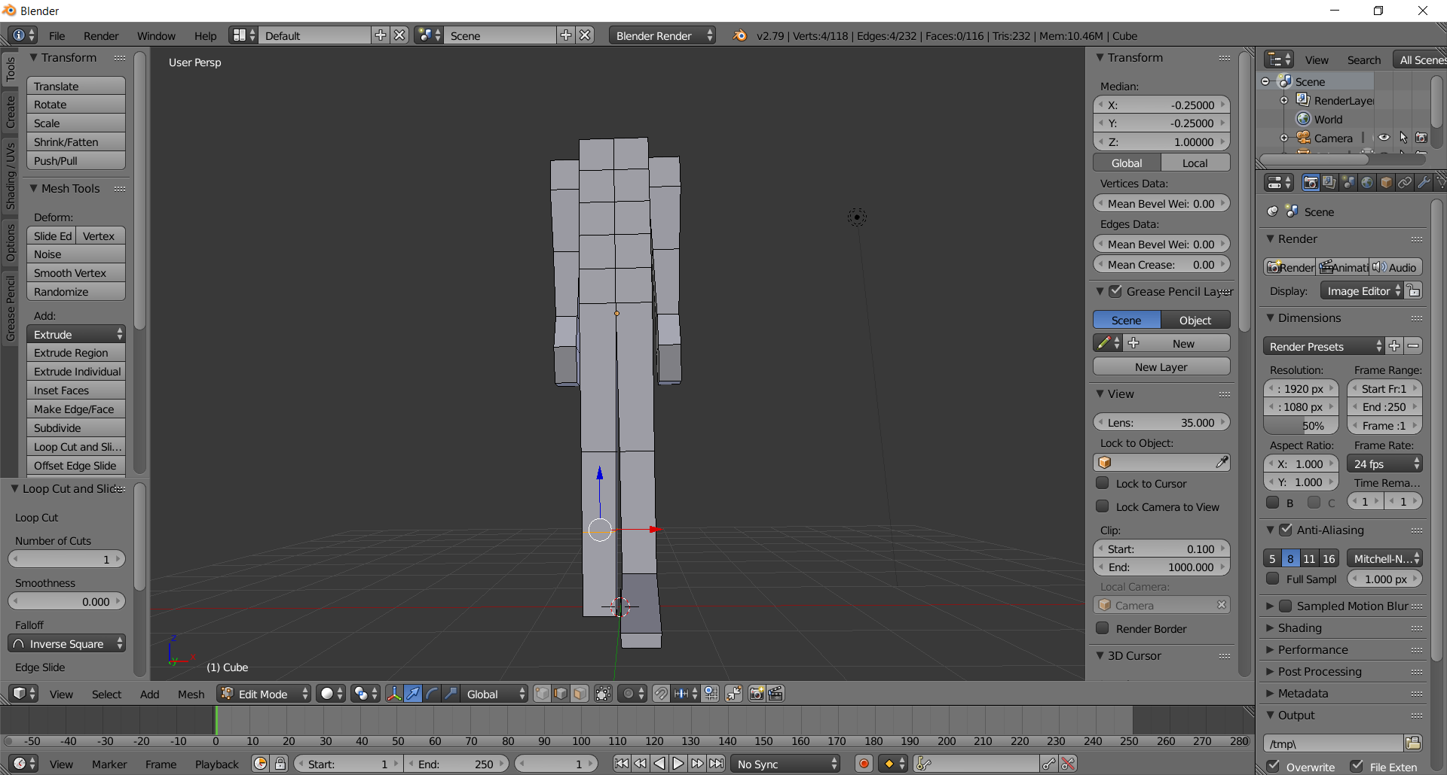

  - Position at .5 by first clicking on the global button in the Transform panel, then entering .5 into Transform > Median > Z
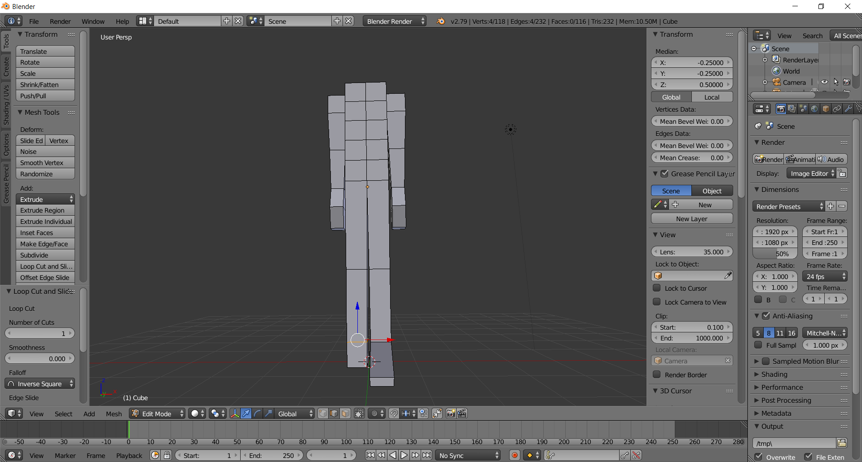

  - Switch to Face mode via CTRL-TAB > Face, then select the bottom leg face by right-clicking on it
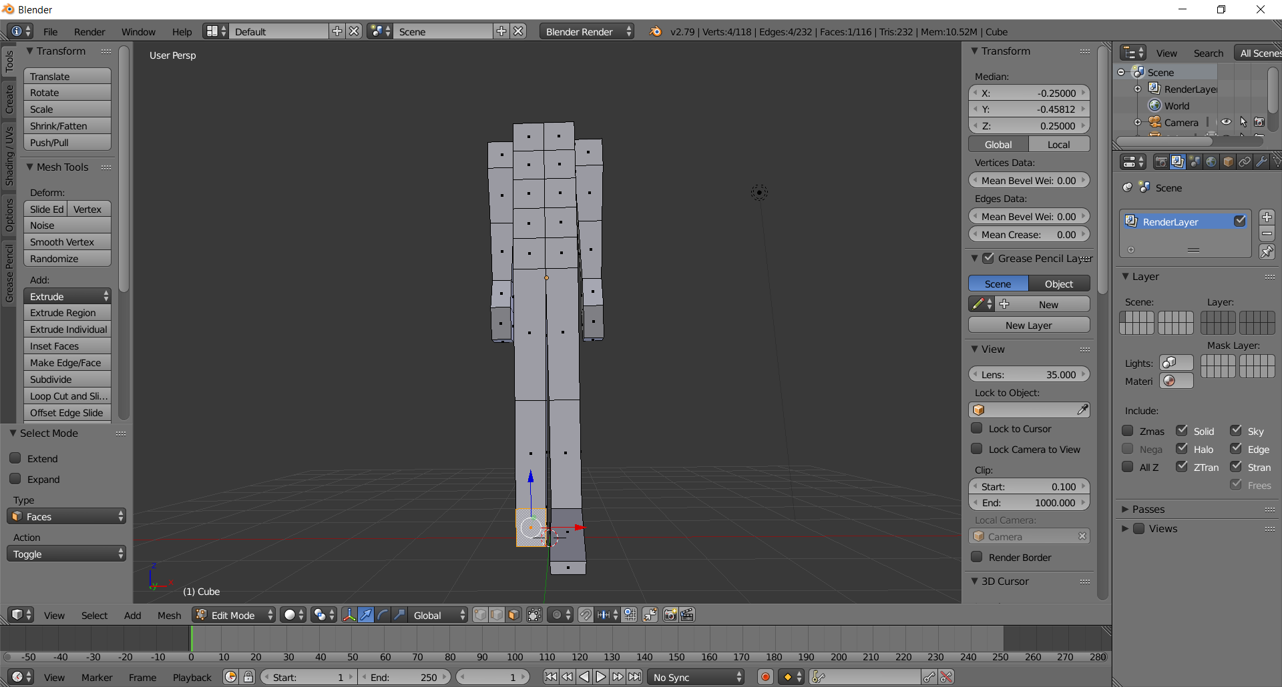
  - Extrude this face one unit via typing E 1 Enter
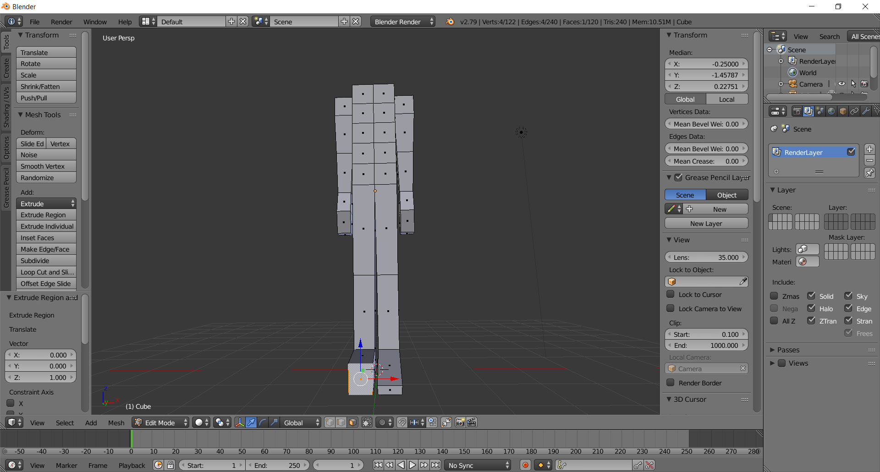

  - Switch to edge mode via CTRL-Tab > Edge, and select the foot’s top edge by right-clicking on it
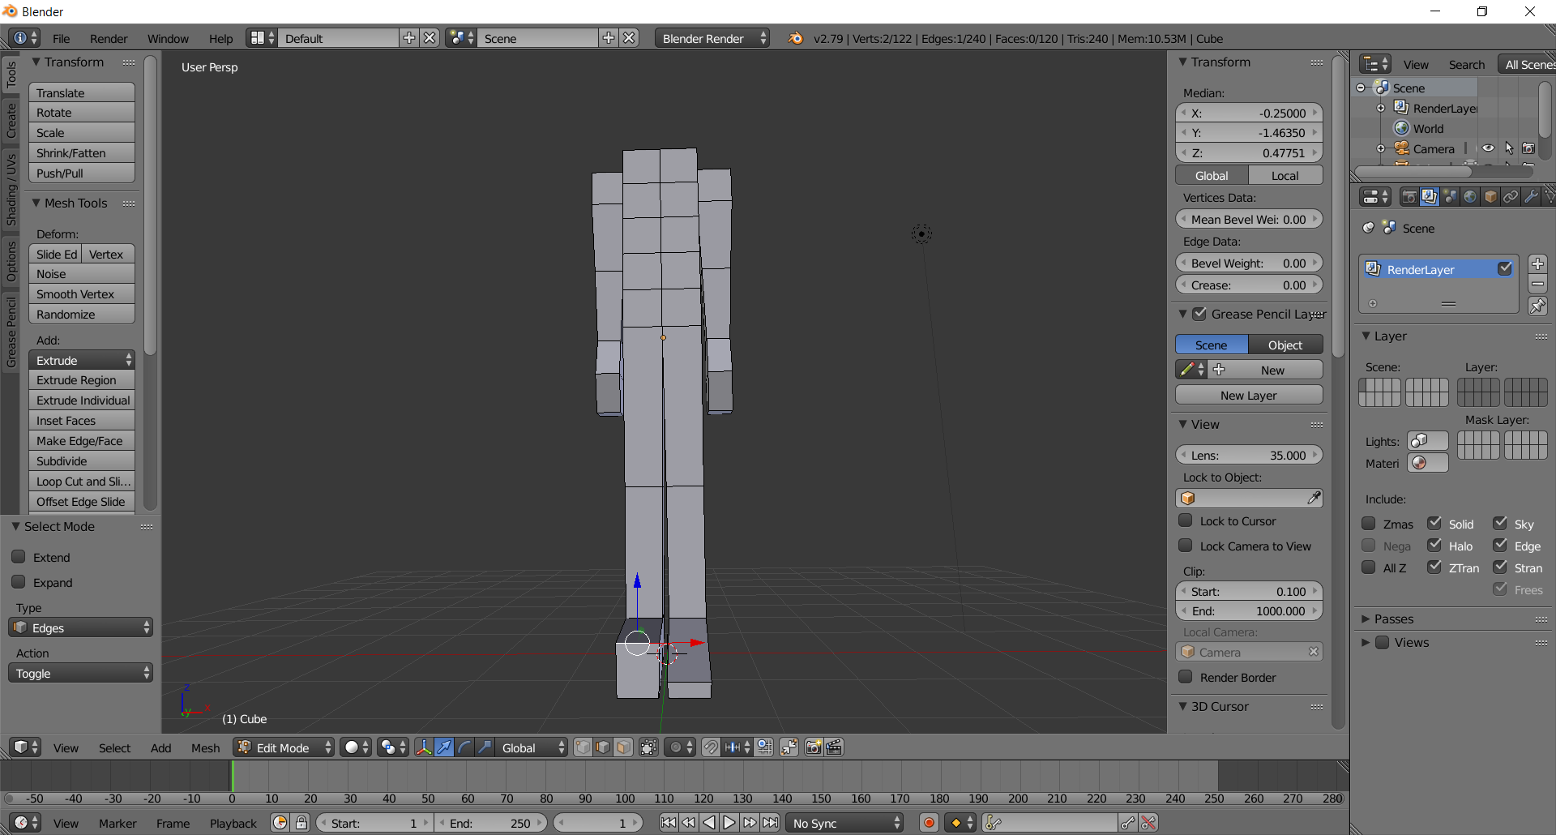

  - Create the toe face by moving this edge down via entering .1250 into Transform > Median > Z
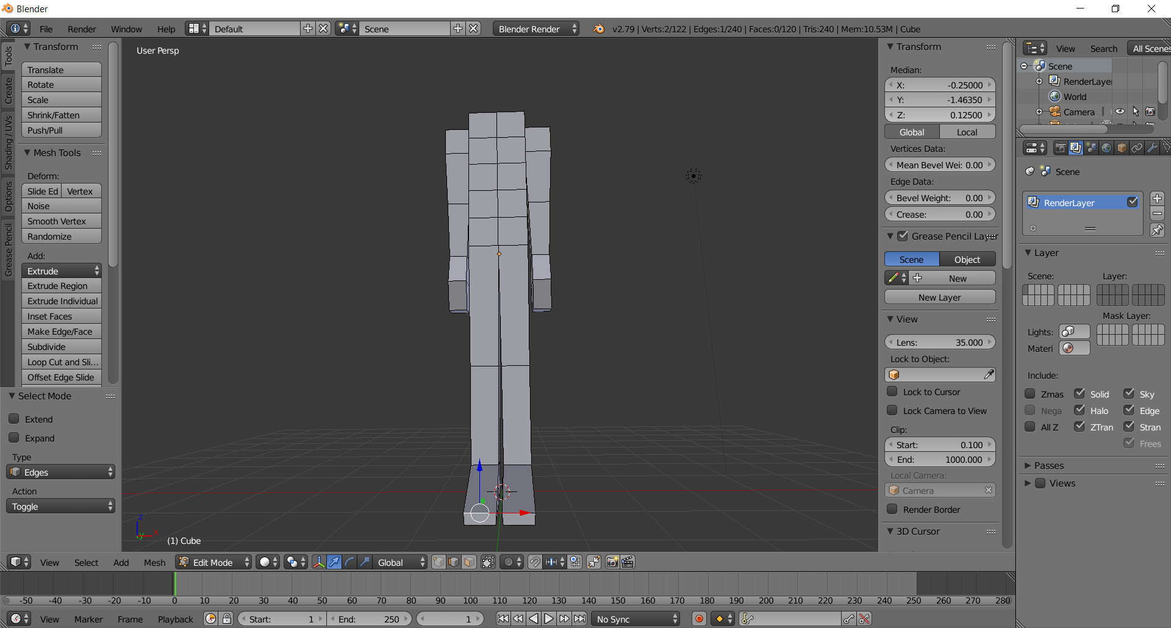

  - Rotate so you can see the body in ¾’s view to make sure everything looks good. Fix anything that’s wrong
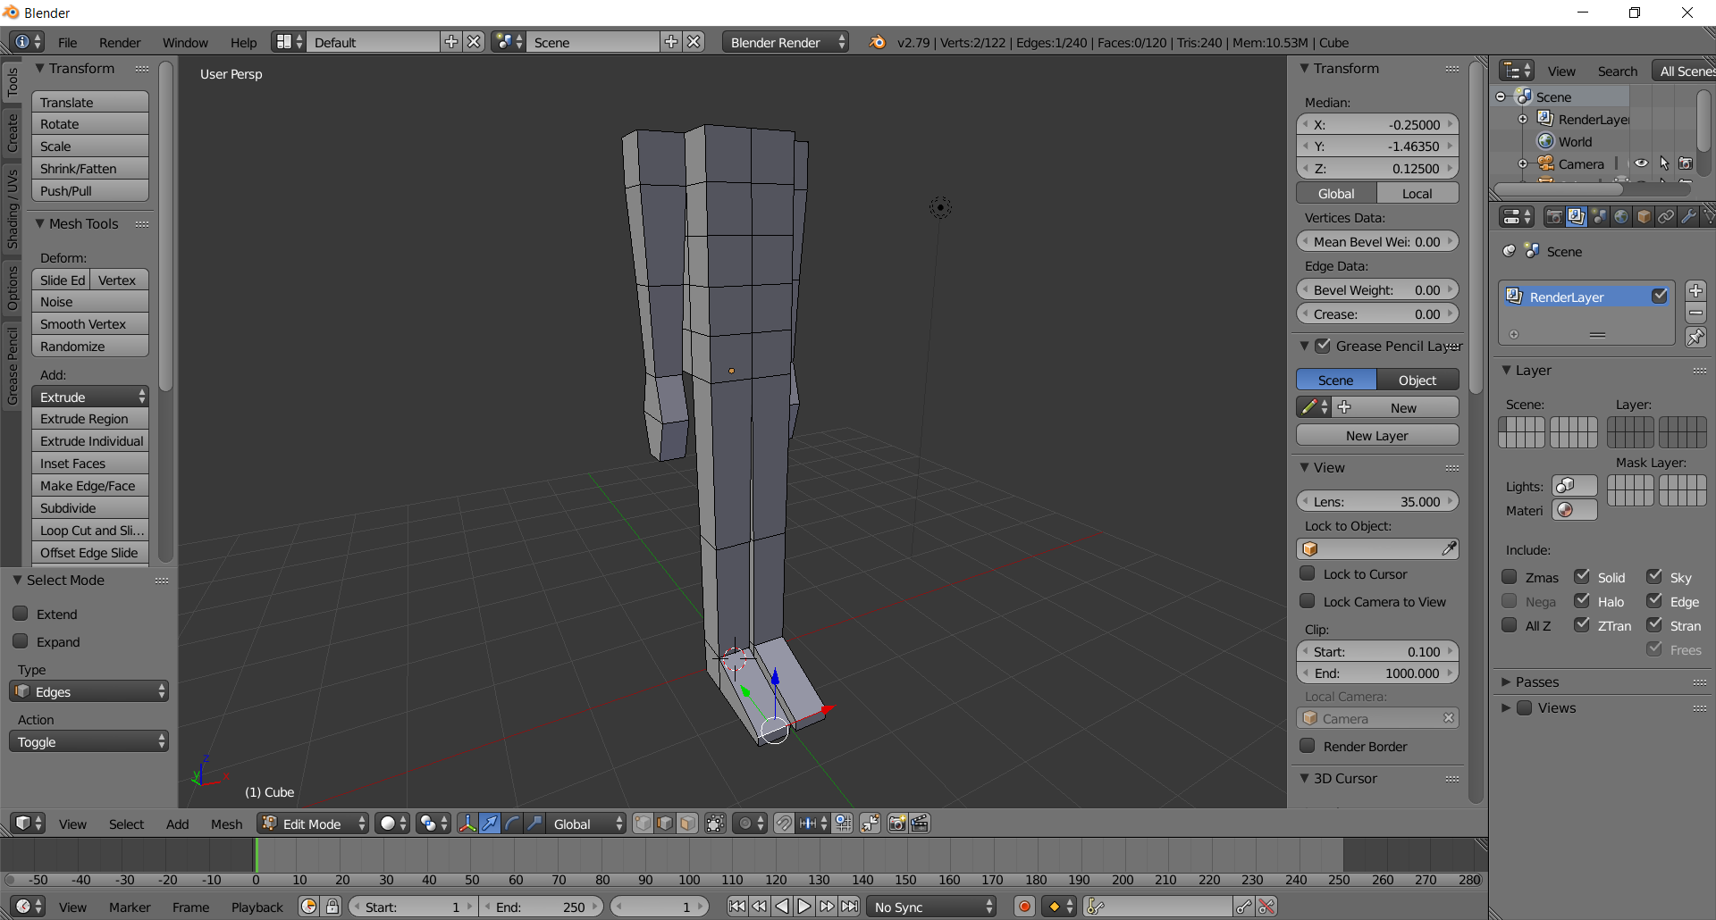

  - Save your file as LastnameFirstnameBody.blend

You’re done. In the next tutorial we’ll attach the head you made to the body.

