Converting Your Blender Scene to Babylon.js Format
Nick V. Flor (nickflor@unm.edu, @ProfessorF)

- Note: I’m assuming you’ve done the tutorial on creating a chair, and you have a folder named VRMeme (so, replace VRMeme with whatever your actual folder name is). So your VRMeme folder should look something like this:
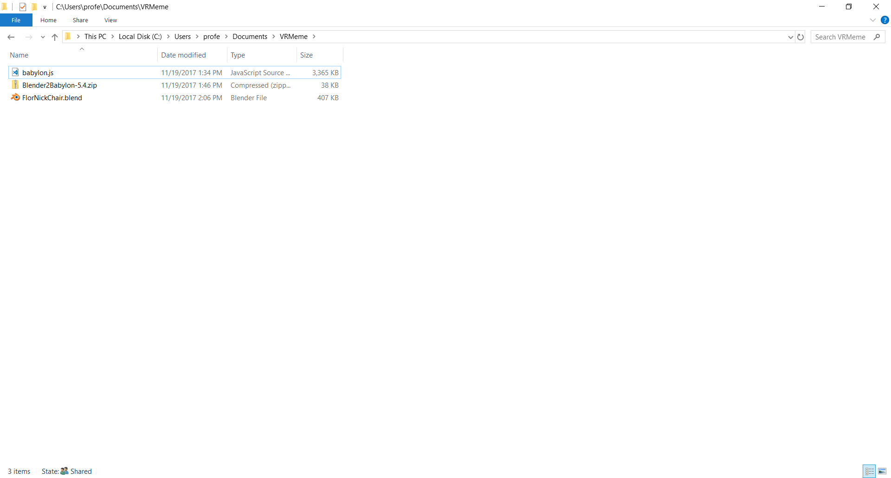

- Run Blender and open your 3D Model:
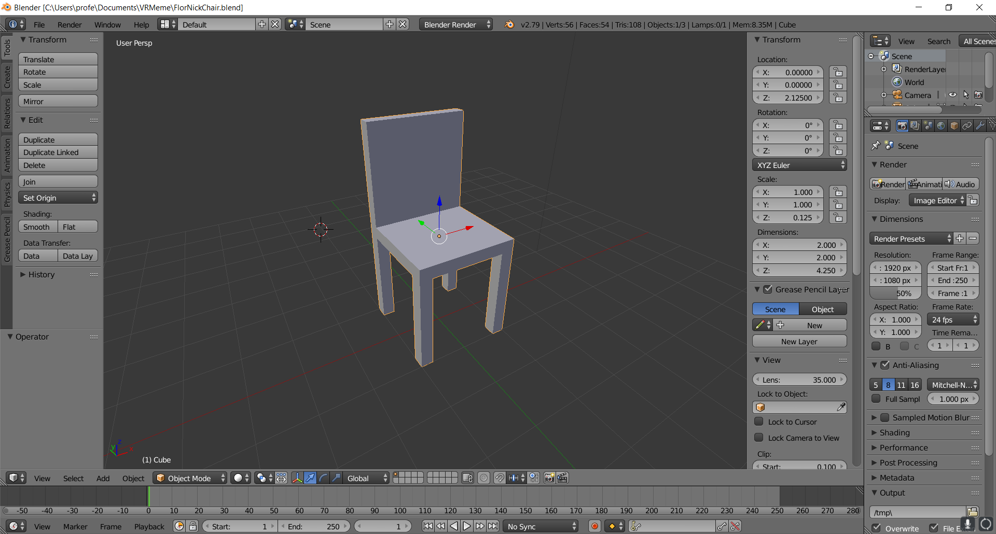

- Shift the transform axis to the bottom (this makes scaling more intuitive in Babylon)
  - Type SHIFT-C (Note: the 3D cursor moves to the origin)
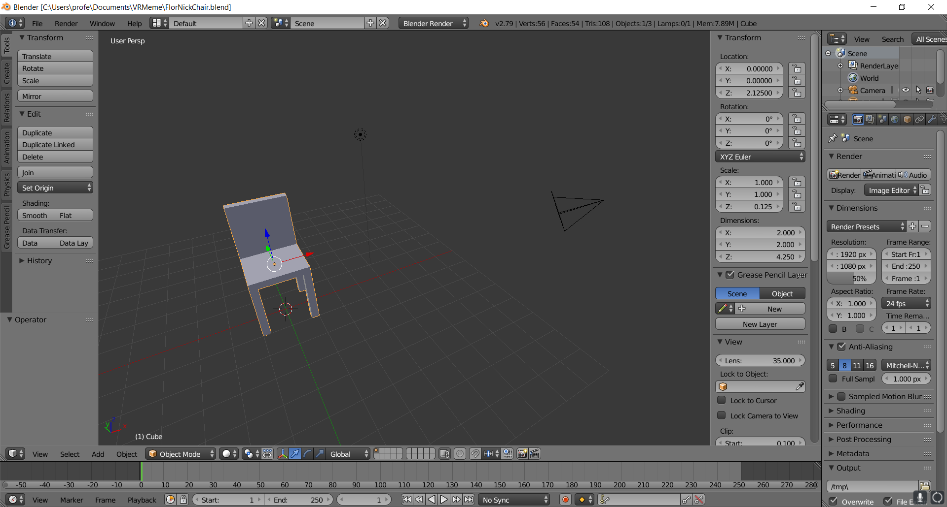
  - Type SHIFT-CTRL-ALT-C:
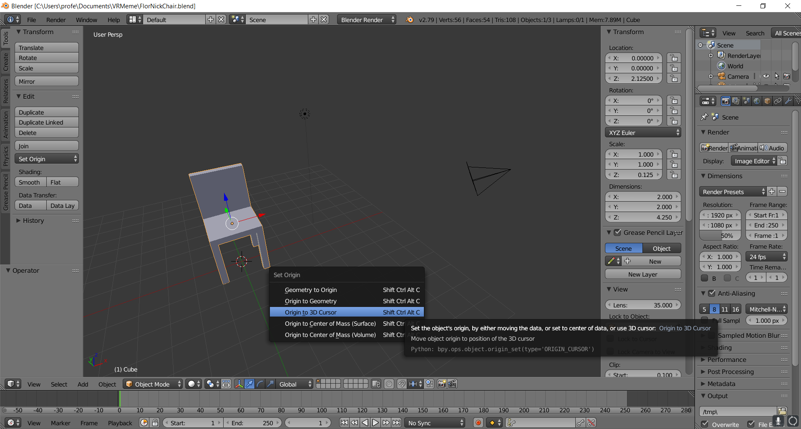
  - Click on Origin to 3D Cursor (Note the Transform axis is now at the Origin):
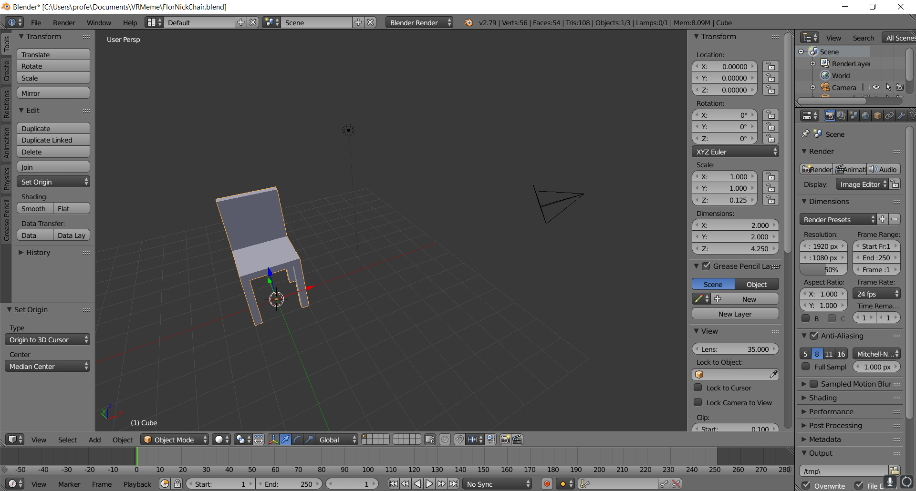
- Remove any Scaling and Rotation
  - Type CTRL-A
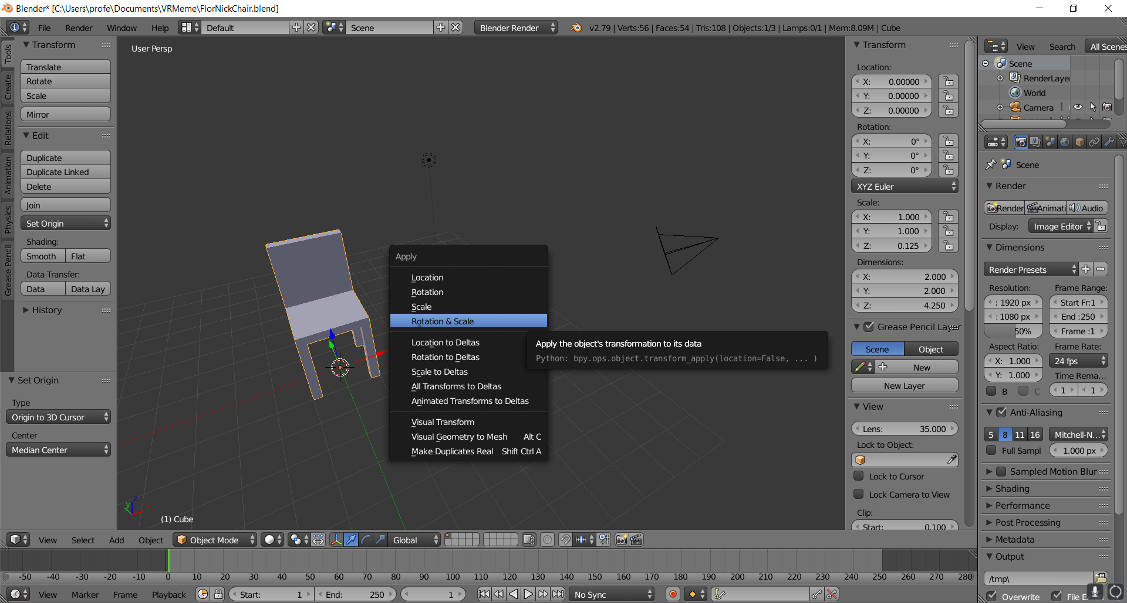
  - Click on Rotation and Scale (Note: Transform > Scale is now x:1, y:1, z:1):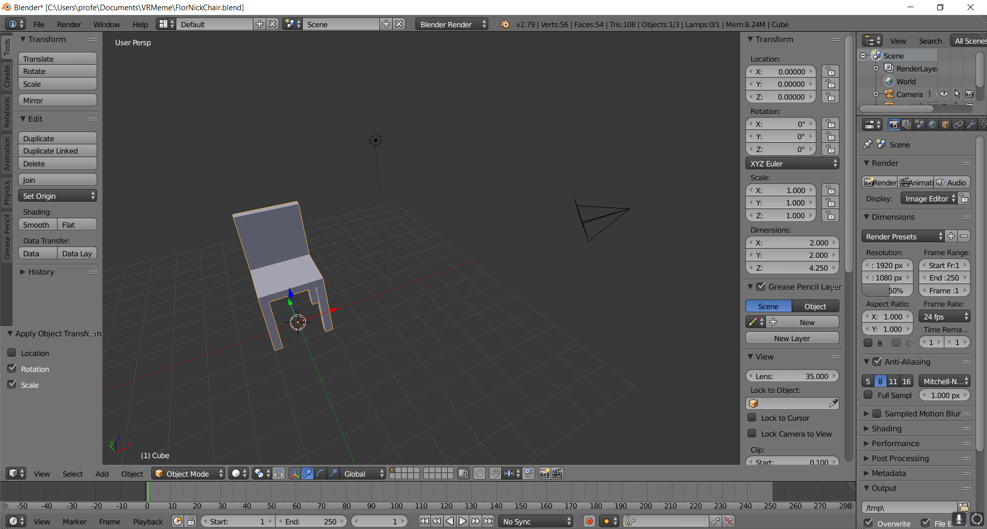
- Highlight File > Export > Babylon.js ver #.##
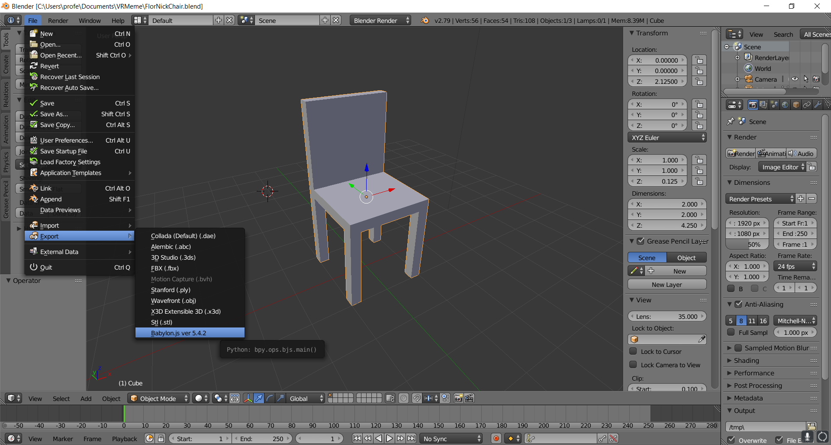
- Click on Babylon.js ver#.## (and browse to your VRMeme folder)
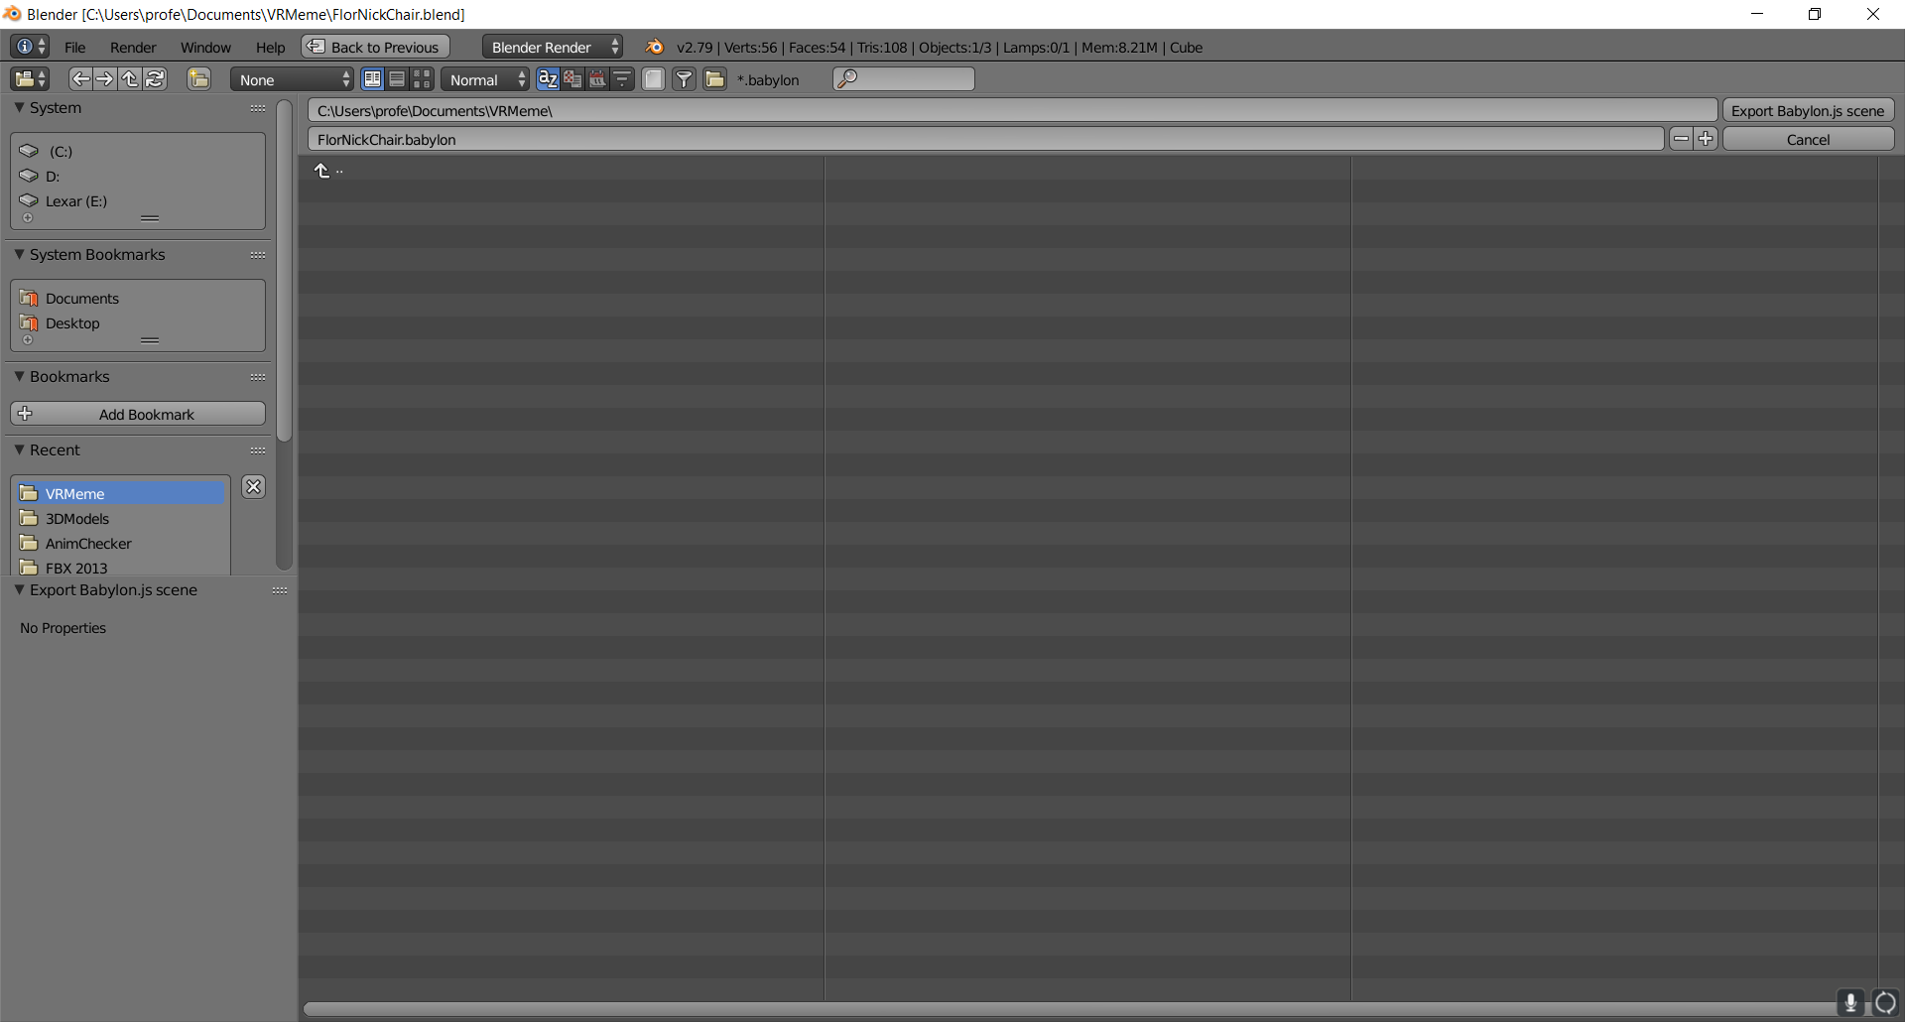
- Click the button Export Babylon.js scene
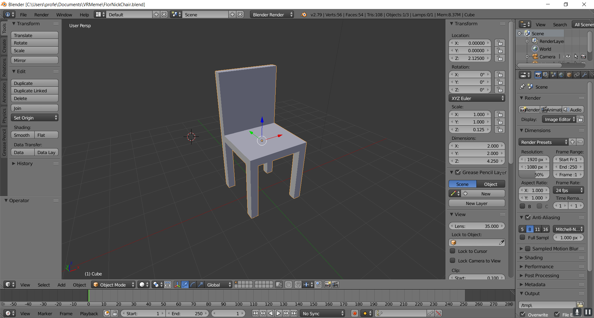

- Check if your model is in the VRMeme folder (filename.babylon, there’s also a .log file for errors):
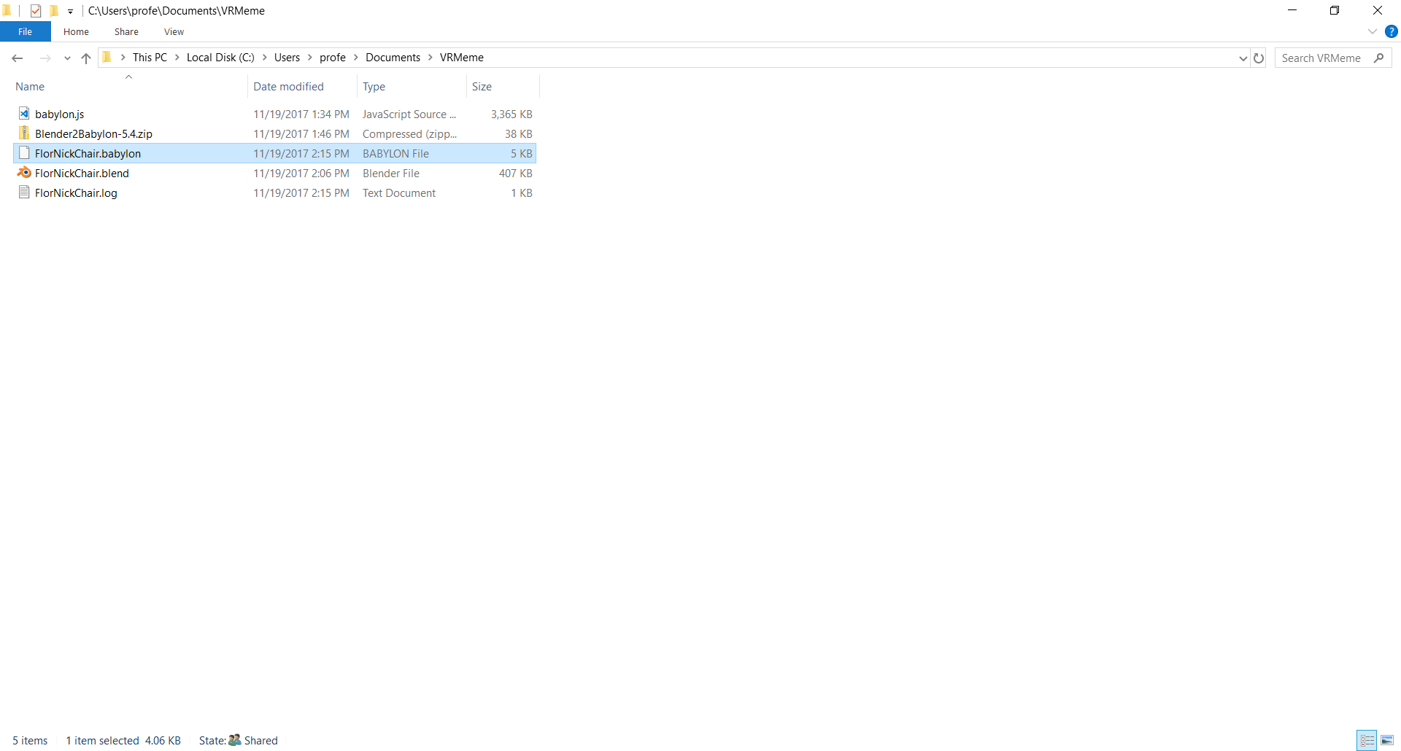

Congratulations, you’ve successfully exported your 3d model in Babylon format. Next, we’ll view this model in 3D in a web browser.

