Downloading Babylon.JS
Nick V. Flor (nickflor@unm.edu, @ProfessorF)

- Create a New Folder on your computer for your VR Meme. I called mind “VRMeme”
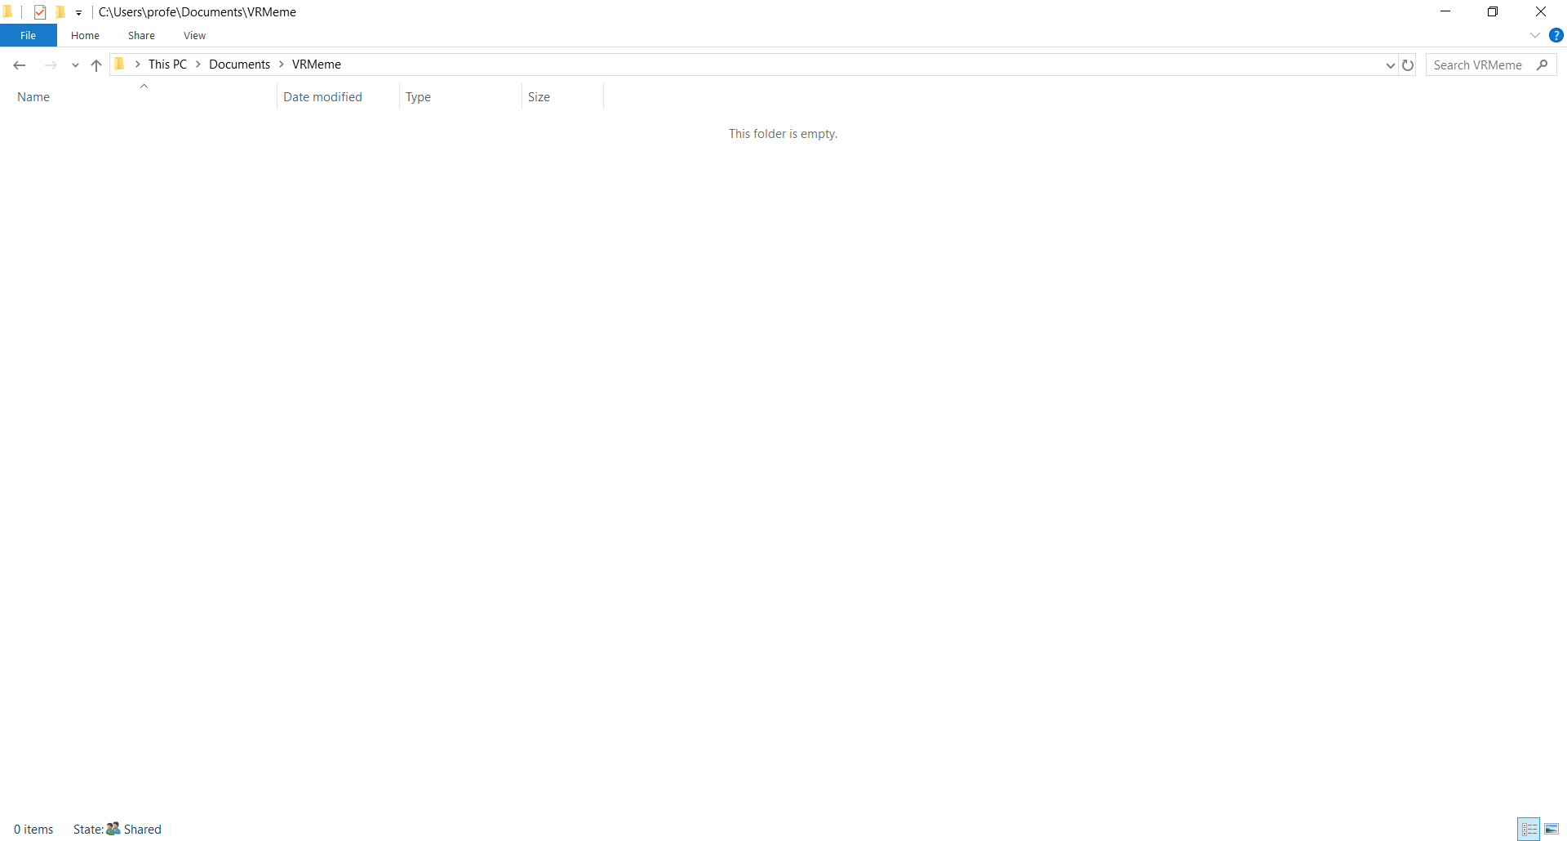
- Download Babylon.js
  - Run your favorite web browser and surf to BabylonJS.com:
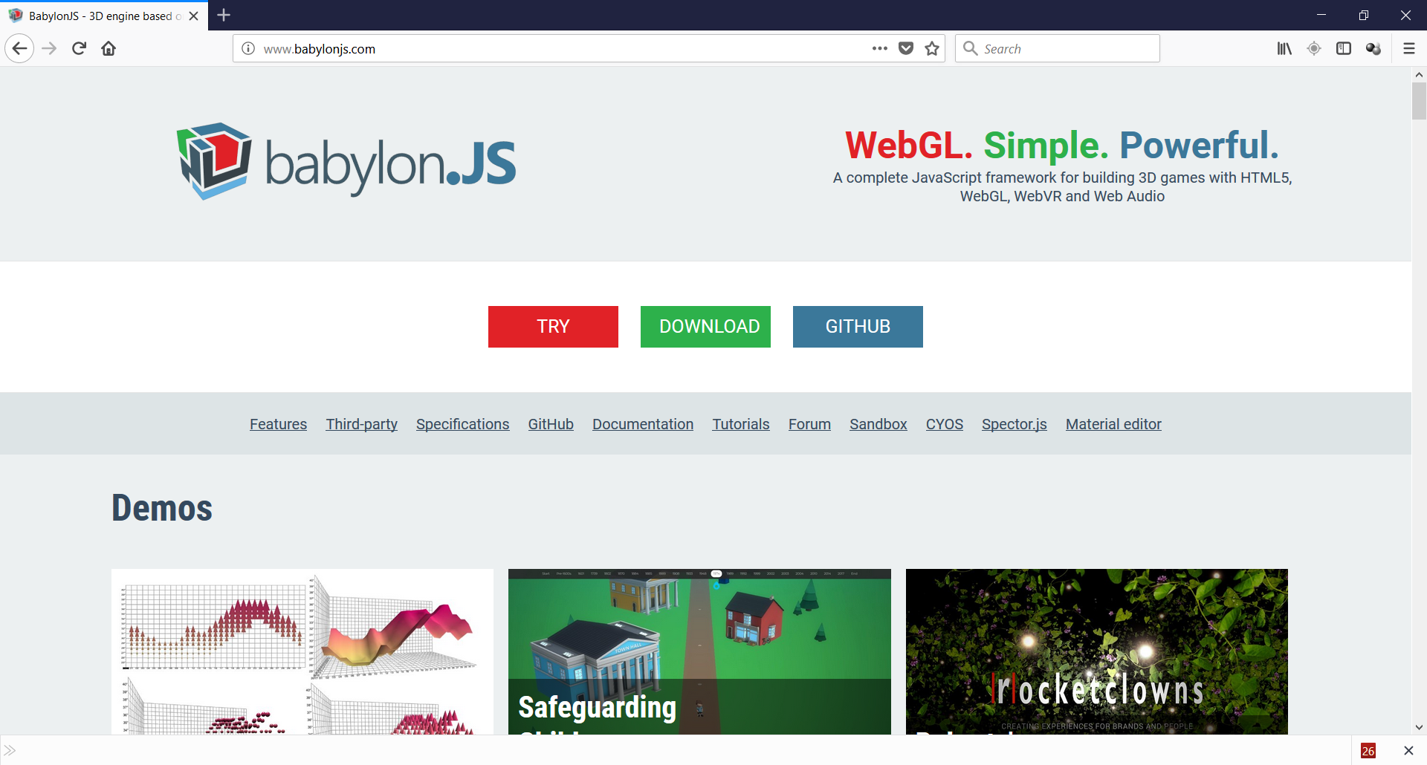
  - Click on the Download button:
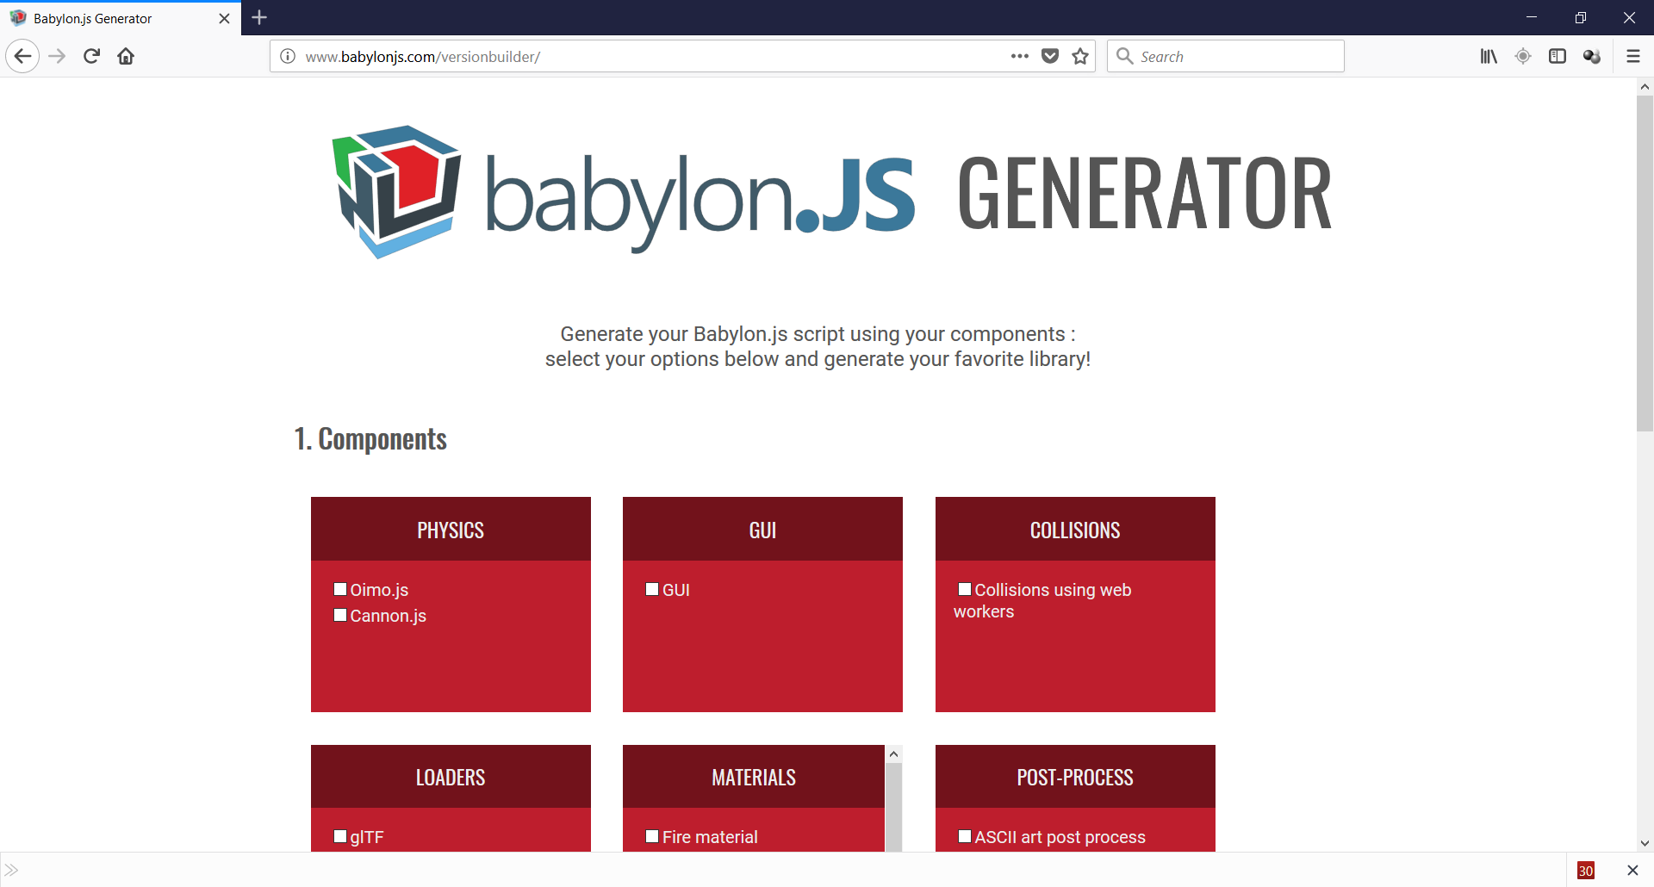
  - Scroll down and click on the Unminified radio button (also click on all materials and procedural textures). The Unminified version is slightly larger, but good for debugging. Later on, as you become more advanced, you will want to go back and install other components.
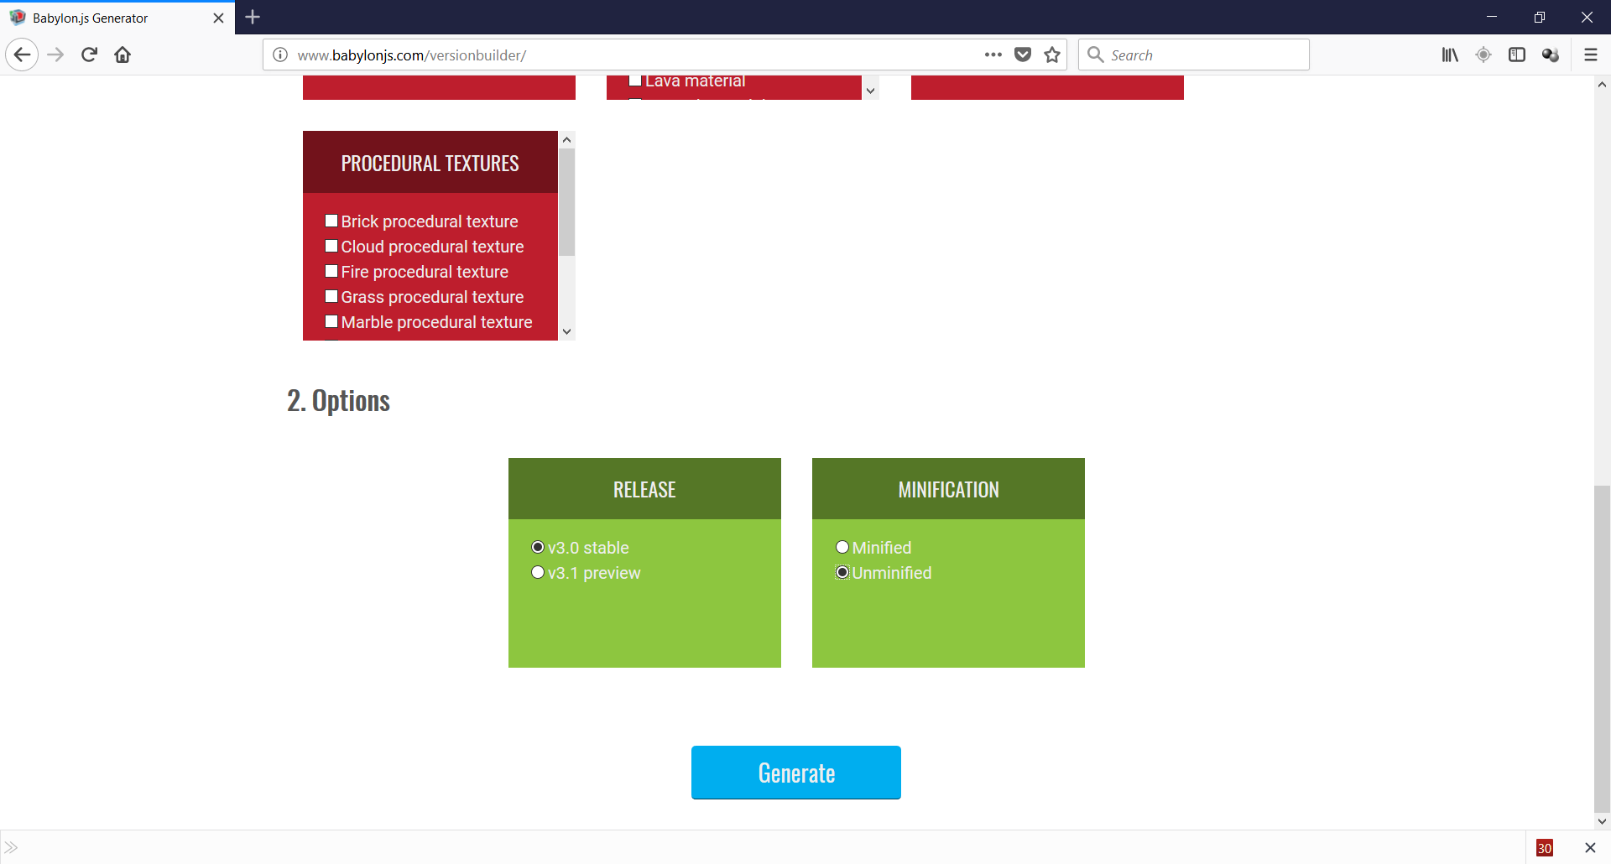
  - Click on the Generate button:
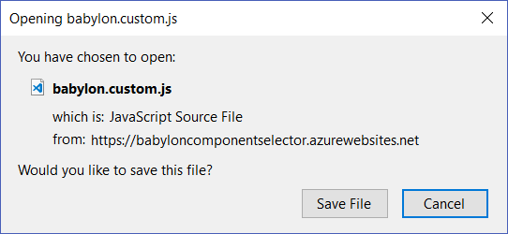
  - Click Save File then find your downloads folder (not shown) and move babylon.custom.js file from your downloads folder into VR Meme folder:
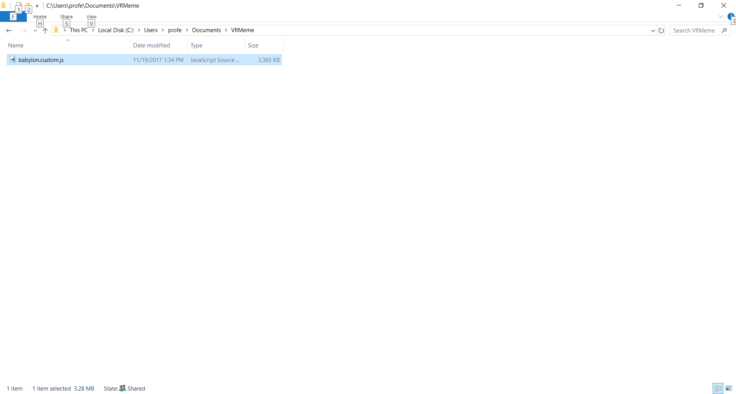
  - Rename this file babylon.js
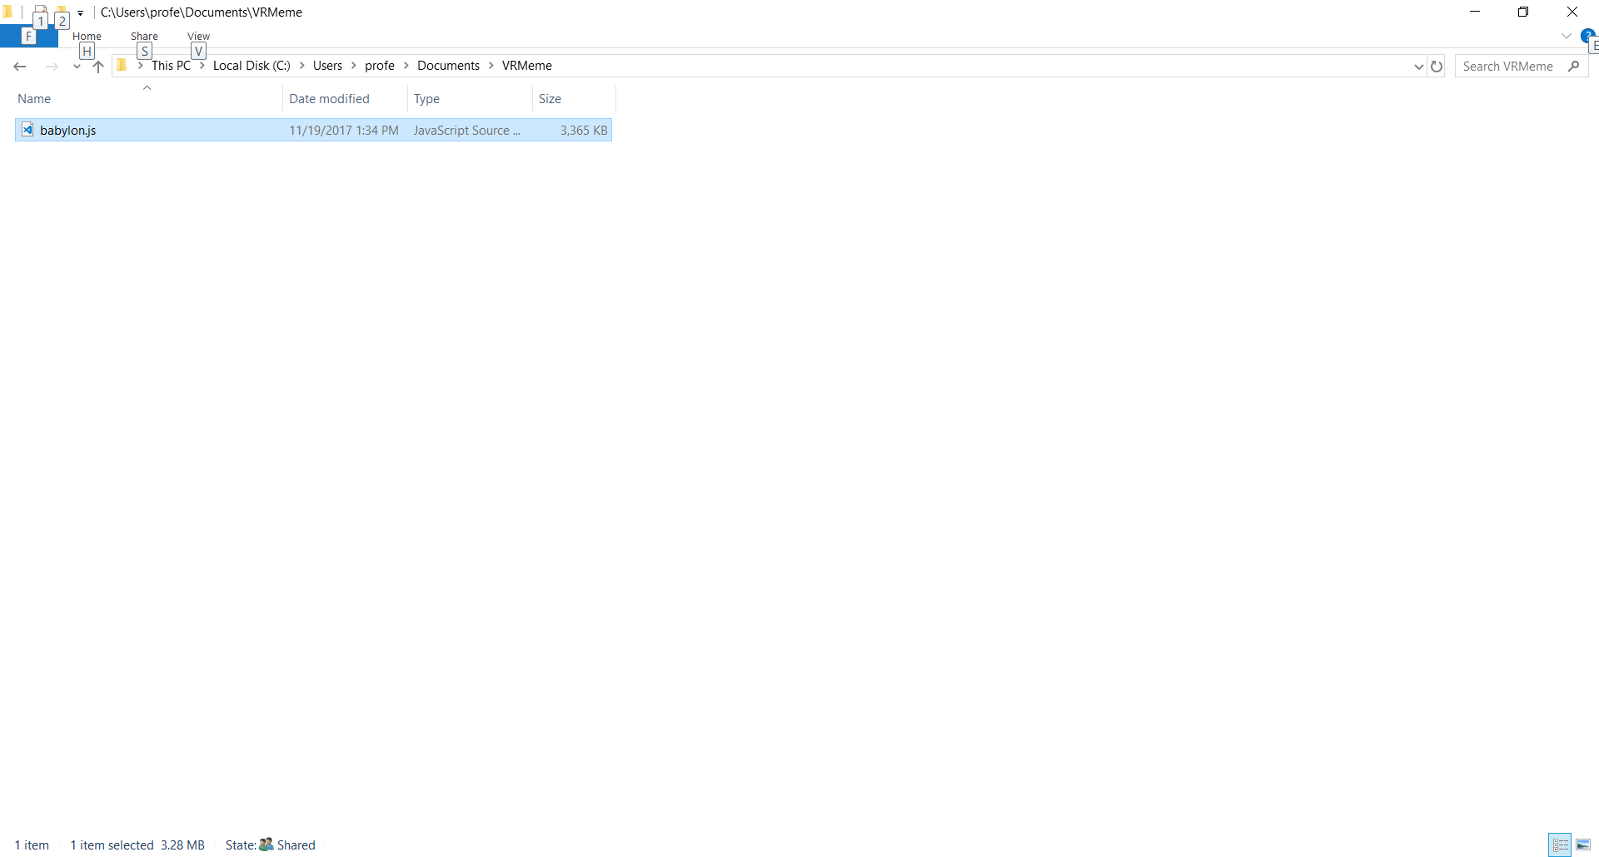

- (optional) Change the security permissions on babylon.js
  - Right-click on the Babylon.js and select properties in the pop-up menu:
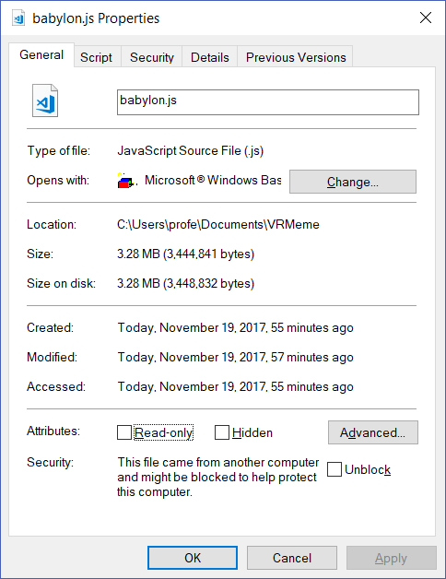
  - Check the Unblock box
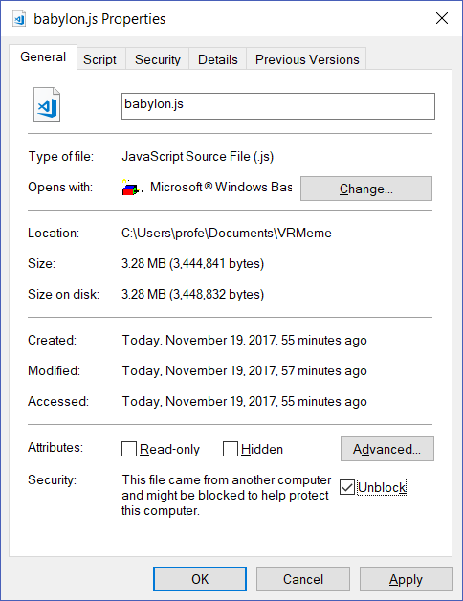

  - Click OK (You’ll return to the folder view)

You are done. Note: Every time you start a new project in a new folder, you must copy Babylon.js over to this new folder, or (better yet) download the latest version of Babylon.js from the website. You should periodically do this to make sure you always have the latest version.

