Downloading and Installing the Babylon.JS Blender Plug-In
Nick V. Flor (nickflor@unm.edu, @ProfessorF)

- Download the Babylon.JS Blender Plug-In
  - Open up your favorite web browser and surf to https://github.com/BabylonJS/Exporters/tree/master/Blender :
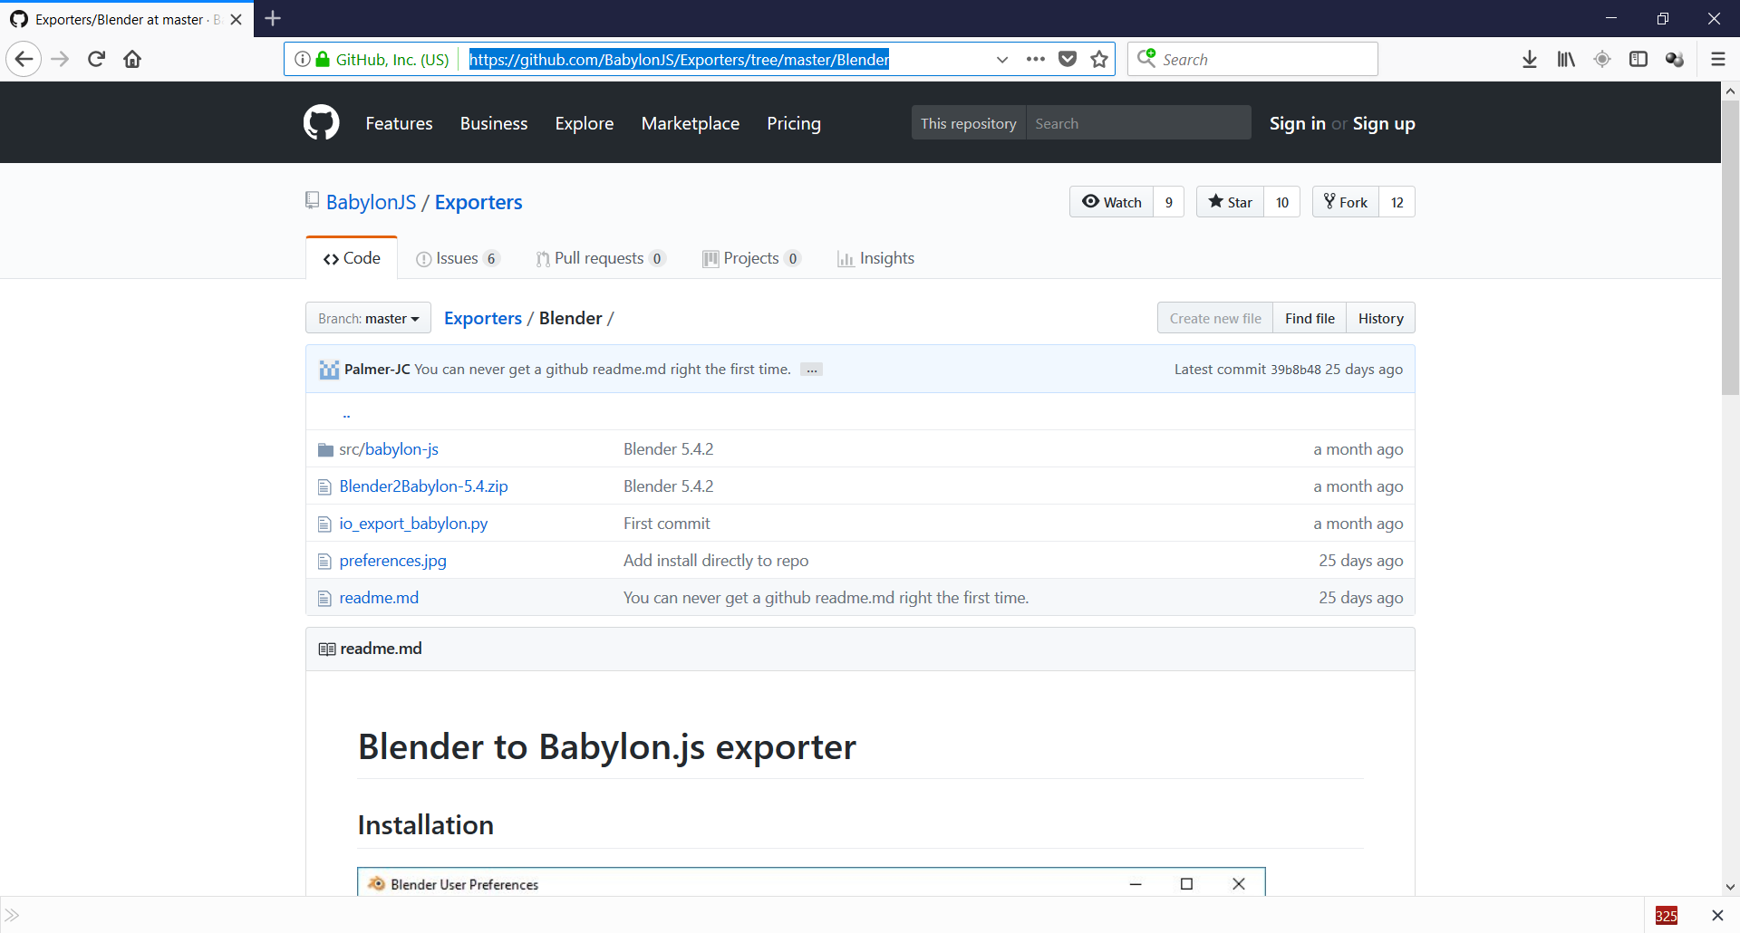
  - Click on the link to the latest Blender2Babylon zip (currently Blender2Babylon-5.4.zip):
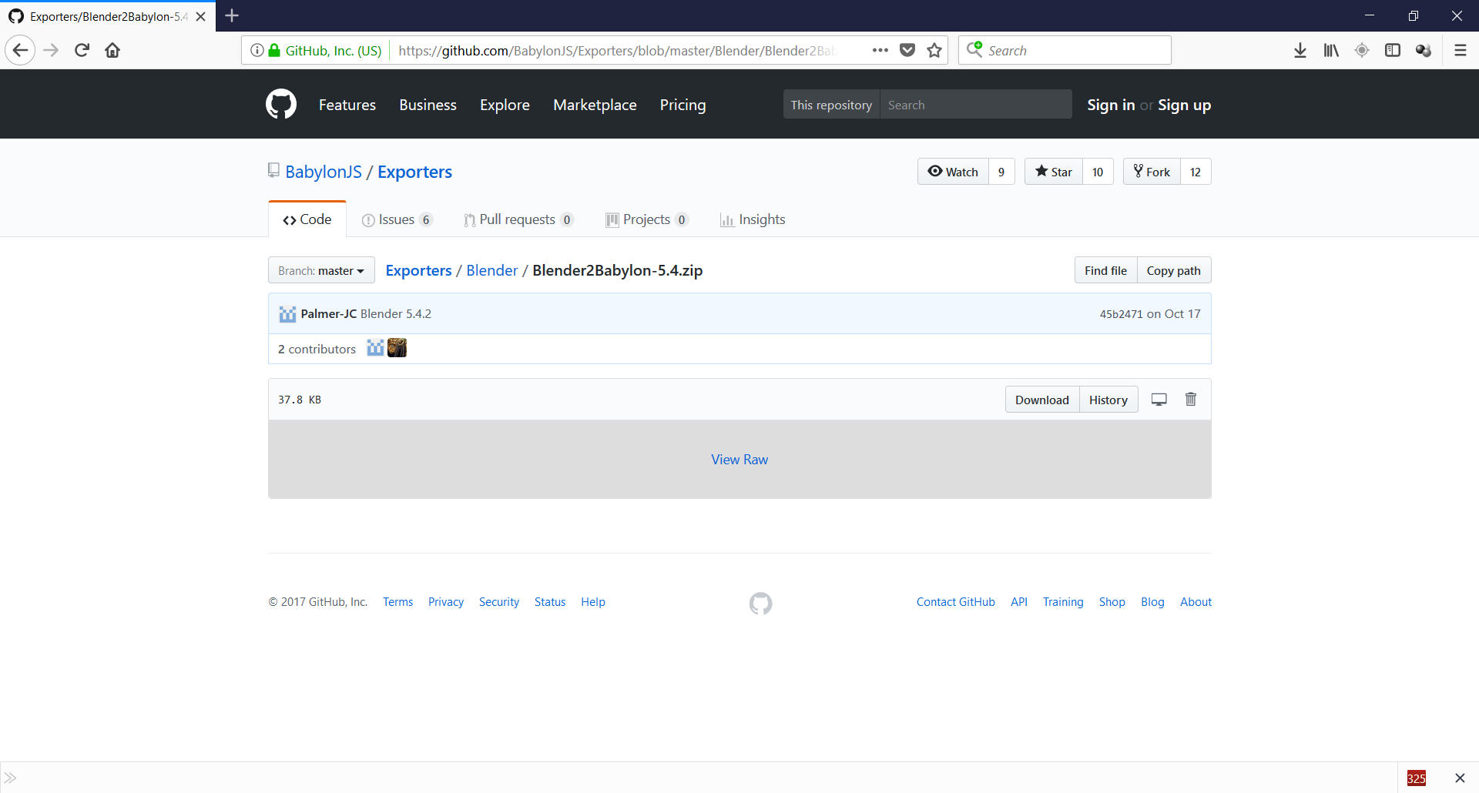
  - Click the Download button:
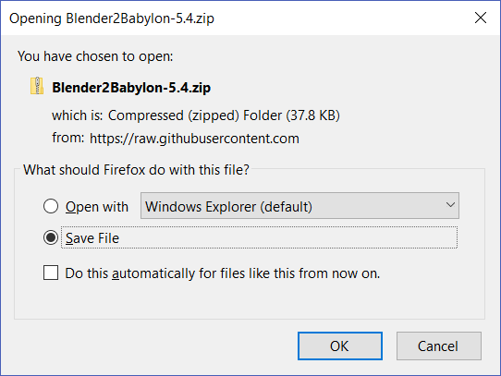
  - Click OK (You will just be shown 2b when it finishes)
- Find the zip file in your download folder and move it into your VR Meme (or whatever you called your development folder):
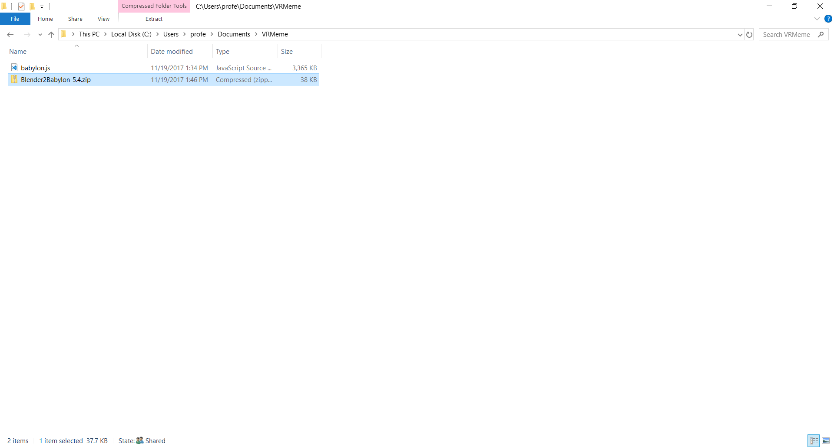
- Install the BabylonJS plug-in into Blender
  - Startup Blender
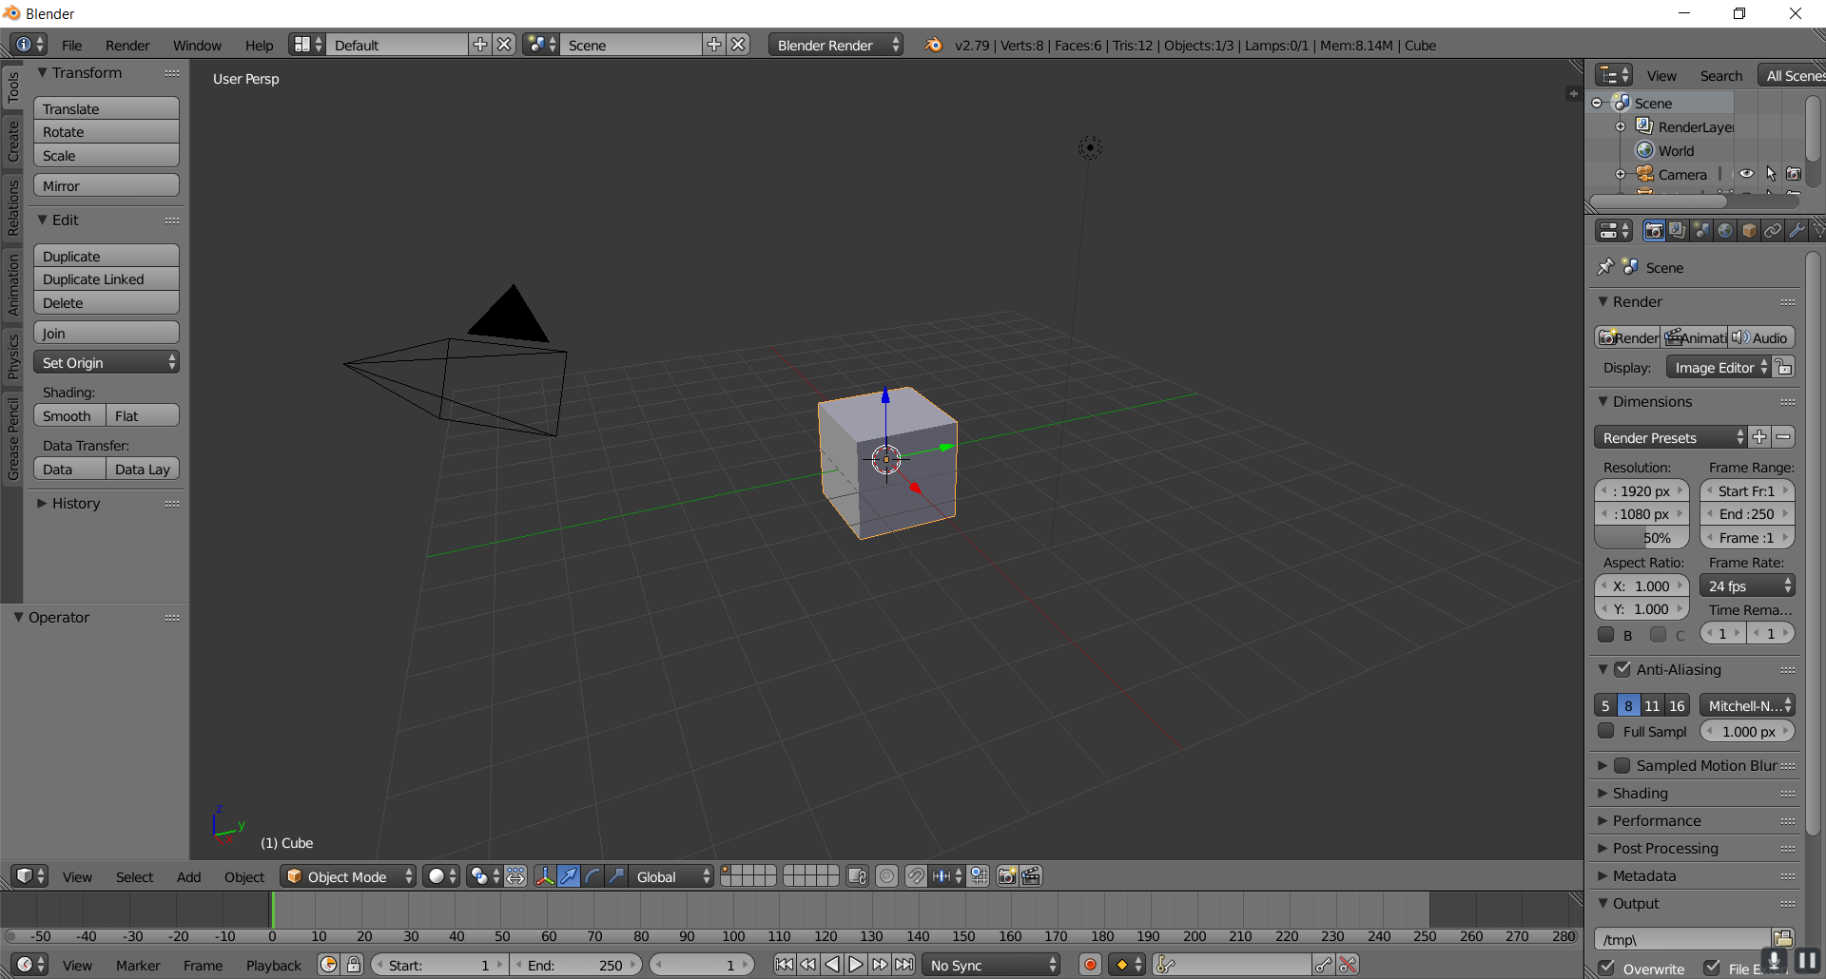
  - Click on File (menu) > User Preferences… (menu item):
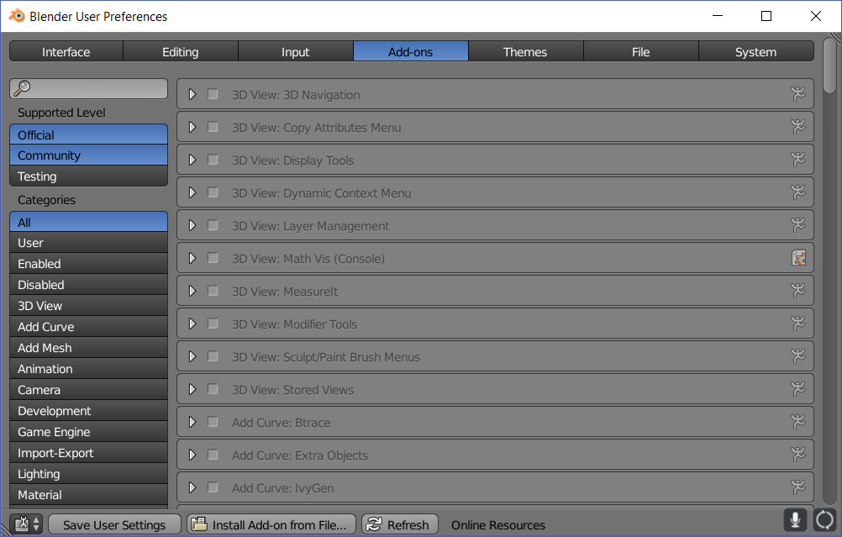
  - Click on the Install Add-on from File button, then browse to your VR Meme folder:
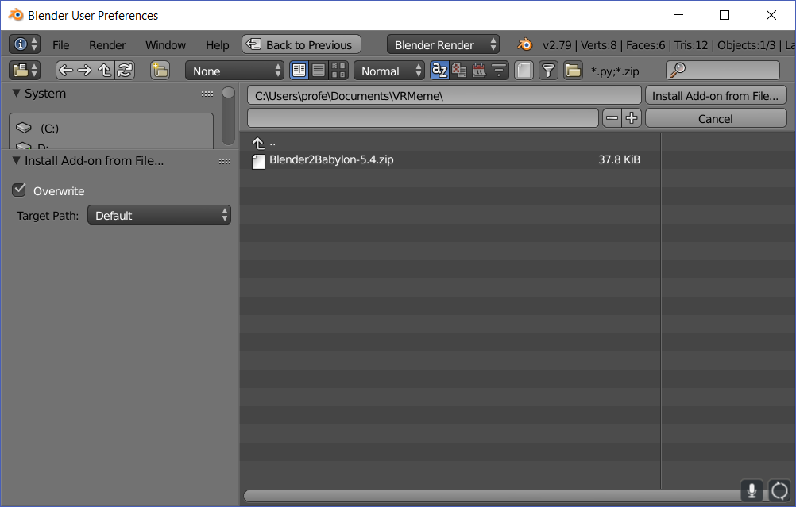
  - Select Blender2Babylon-5.4.zip (or whatever the latest version is you downloaded):
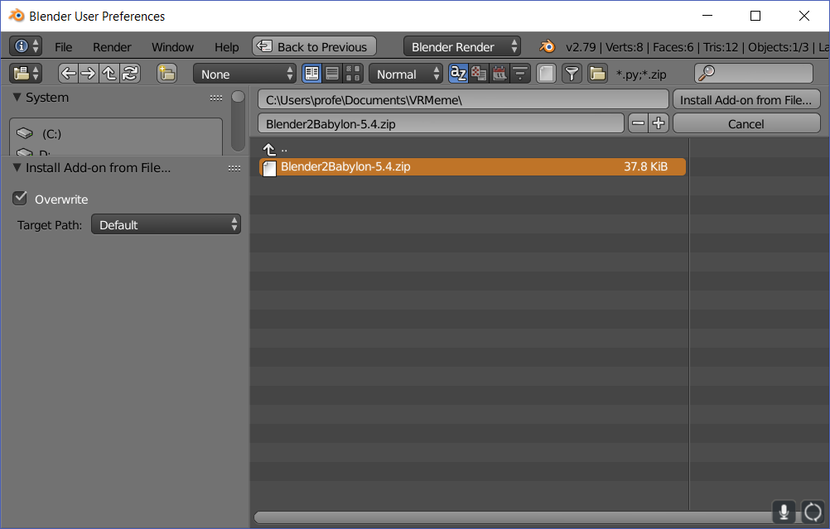
  - Click the Install Add-on from File… button:
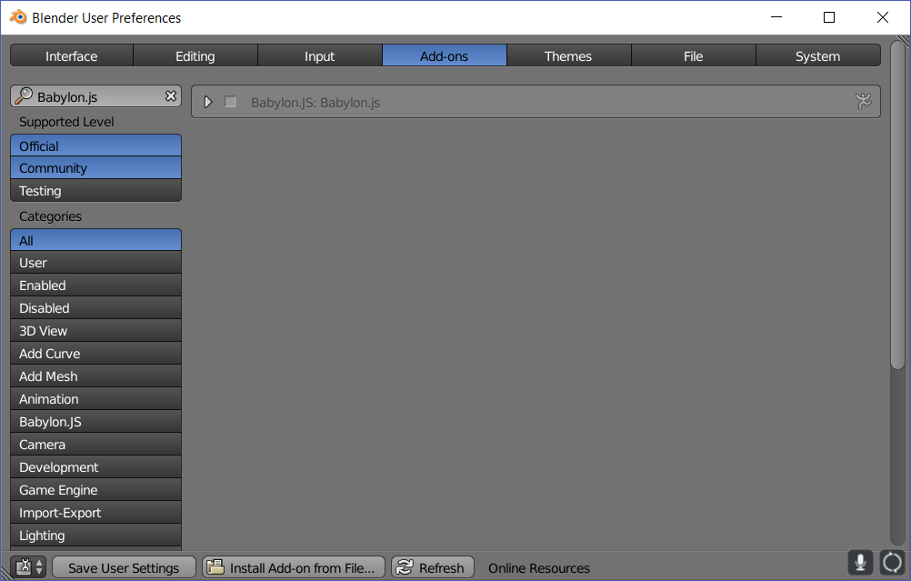
  - Enable the plug-in by clicking on the checkbox Babylon.JS:Babylon.js:
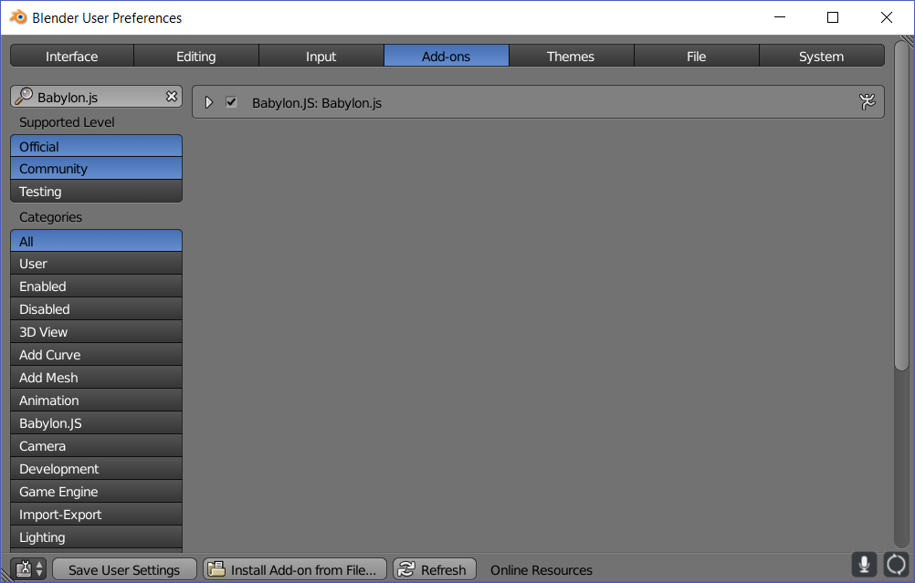
  - Click on the button Save User Settings (nothing will appear to happen), then exit out of this dialog box:
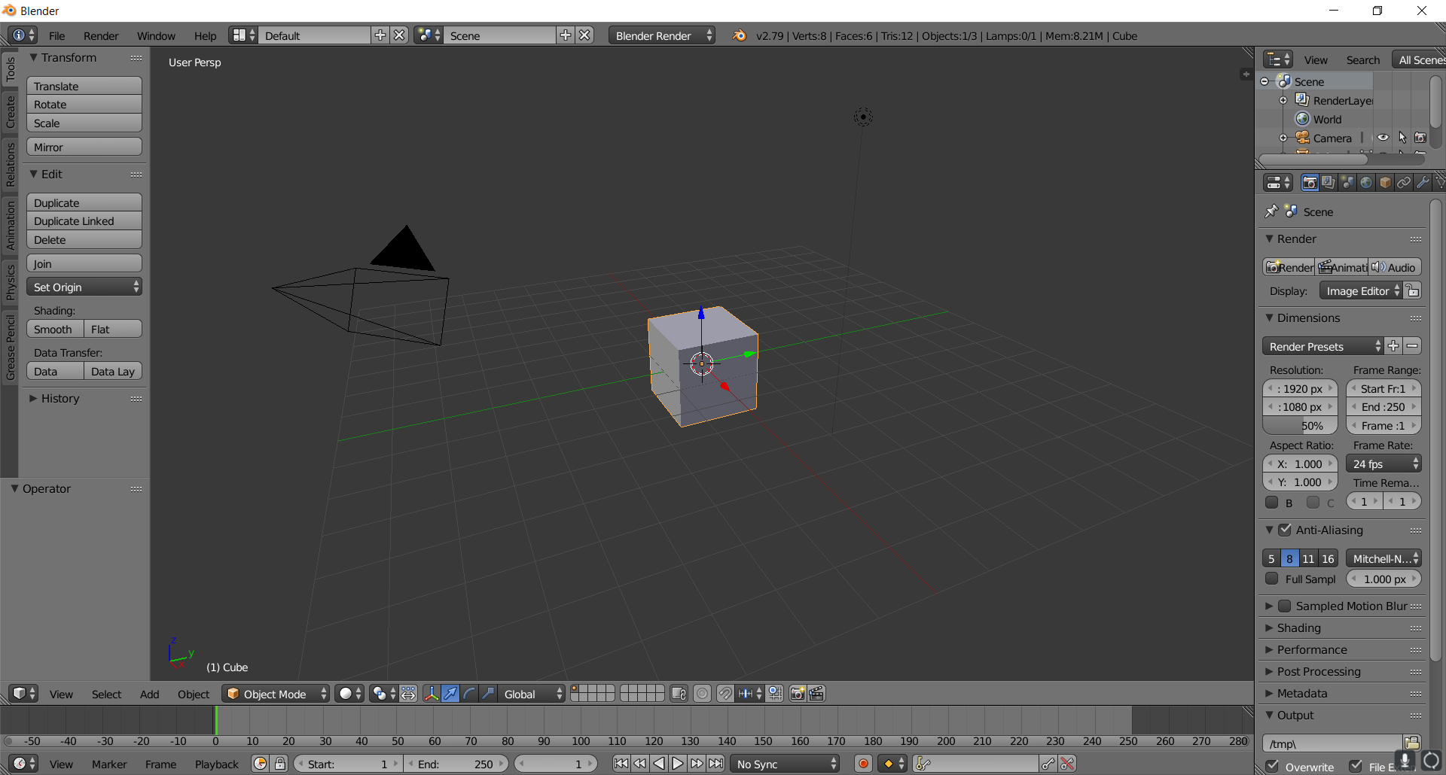
- Test if the plug-in installed correctly
  - Click File (Menu) > Export (Menu Item). You should see the option for Babylon.js ver #.##
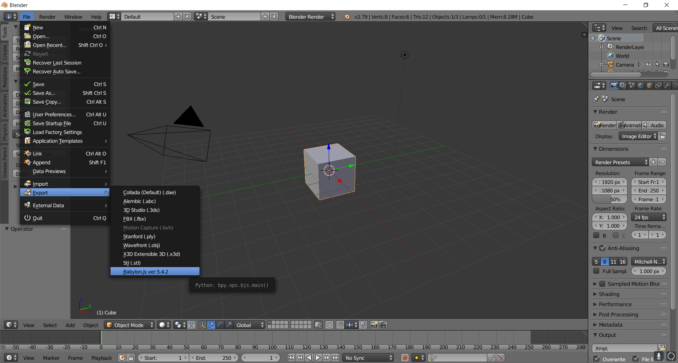

Congratulations, you’ve installed the plug-in successfully. Next we’ll export your chair as a Babylon.js file.

