Viewing in Babylon
Nick V. Flor (nickflor@unm.edu, @ProfessorF)

- Note: I’m assuming you’ve done all the tutorials up to converting your Blender 3D model to BablyonJS. I’m also assuming you have a folder named VRMeme (so, replace VRMeme with whatever your actual folder name is). So your VRMeme folder should look something like this:
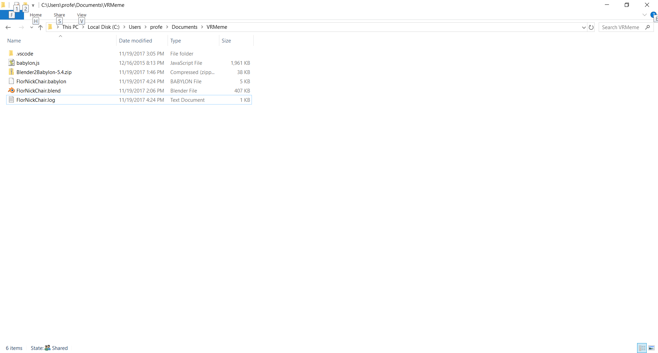

- Copy the following code into a text editor and save as view3d.html:
<!DOCTYPE html>
<html xmlns="http://www.w3.org/1999/xhtml">
<head>
<title>MGMT 190 VR Meme -- by ProfessorF (professorf@gmail.com)</title>
<script src="babylon.js"></script>
<script>
window.addEventListener("load", start);

var canvas, engine, scene, light0, origin, camera;

function start() {
//
// Create a canvas, the Babylon 3D engine, and a scene for objects
//
canvas = document.getElementById("cvRAVE");
engine = new BABYLON.Engine(canvas, true);
scene = new BABYLON.Scene(engine);
//
// Set to false for a VR Camera
//
if (true)
camera = new BABYLON.FreeCamera ("FreeCamera", new BABYLON.Vector3(0, 5, -15), scene);
else
camera = new BABYLON.VRDeviceOrientationFreeCamera("FreeCamera", new BABYLON.Vector3(0, 5, -15), scene);
//
// Create a light and a ground
//
light = new BABYLON.HemisphericLight("HemiLight", new BABYLON.Vector3(0, 1, 0), scene);
light.groundColor=new BABYLON.Color3(.5,.5,.5);

ground = BABYLON.Mesh.CreateGround("ground", 10000, 1000, 1, scene);
ground.material= new BABYLON.StandardMaterial("groundMat", scene);
ground.material.diffuseColor=new BABYLON.Color3(.15,.45,.15);

//
// Load the 3D model (Note: REPLACE FlorNickChair.babylon w/your file)
//
BABYLON.SceneLoader.ImportMesh("", "","FlorNickChair.babylon", scene, function (meshes, particles, skeletons) {});

//
// Attach camera since everything is loaded
//
scene.activeCamera.attachControl(canvas);
//
// Do Game Loop
//
engine.runRenderLoop(function () {
scene.render();
});
}
</script>
<style>
html, body {
width:100%;
height: 100%;
padding: 0;
margin: 0;
overflow: hidden;
}
#cvRAVE {
width:100%;height:100%;
}
</style>
</head>
<body>
<canvas id="cvRAVE" ></canvas>
</body>
</html>

- Verify your VRMeme folder looks as follows:
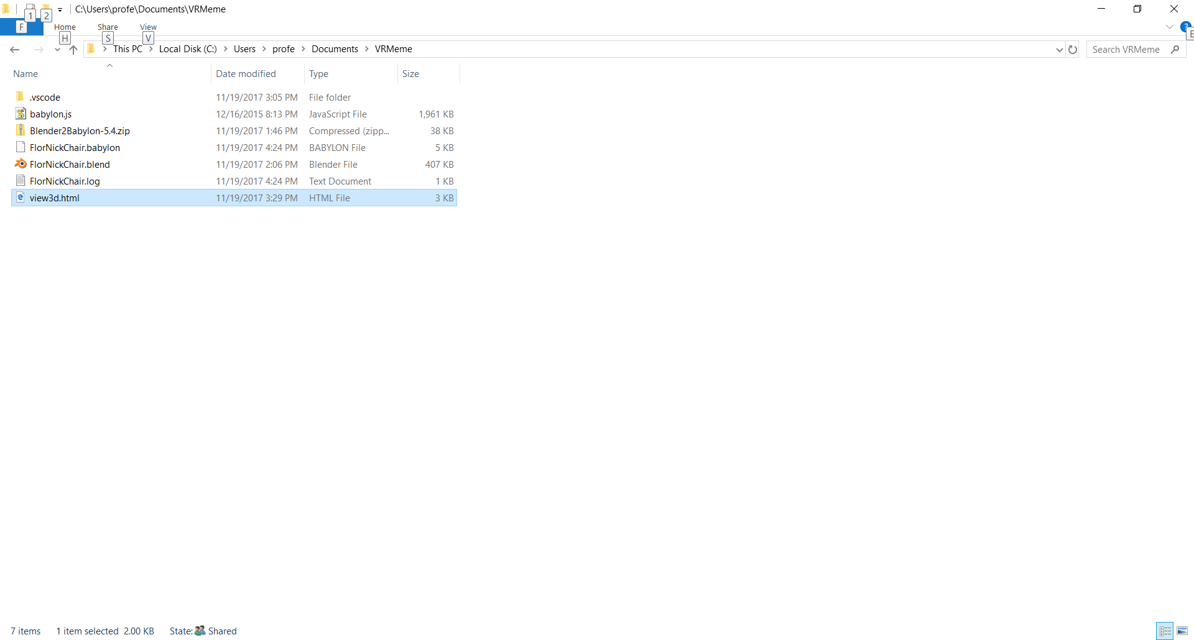
- Right-click over the view3d.html
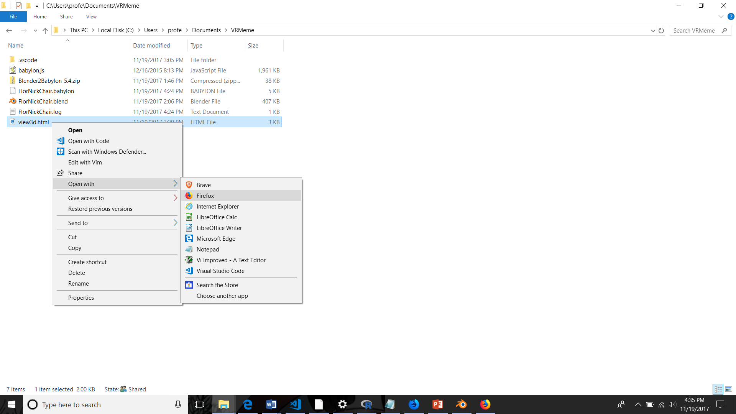
- Click on FireFox (it works best with FireFox, may not show up in other browsers)
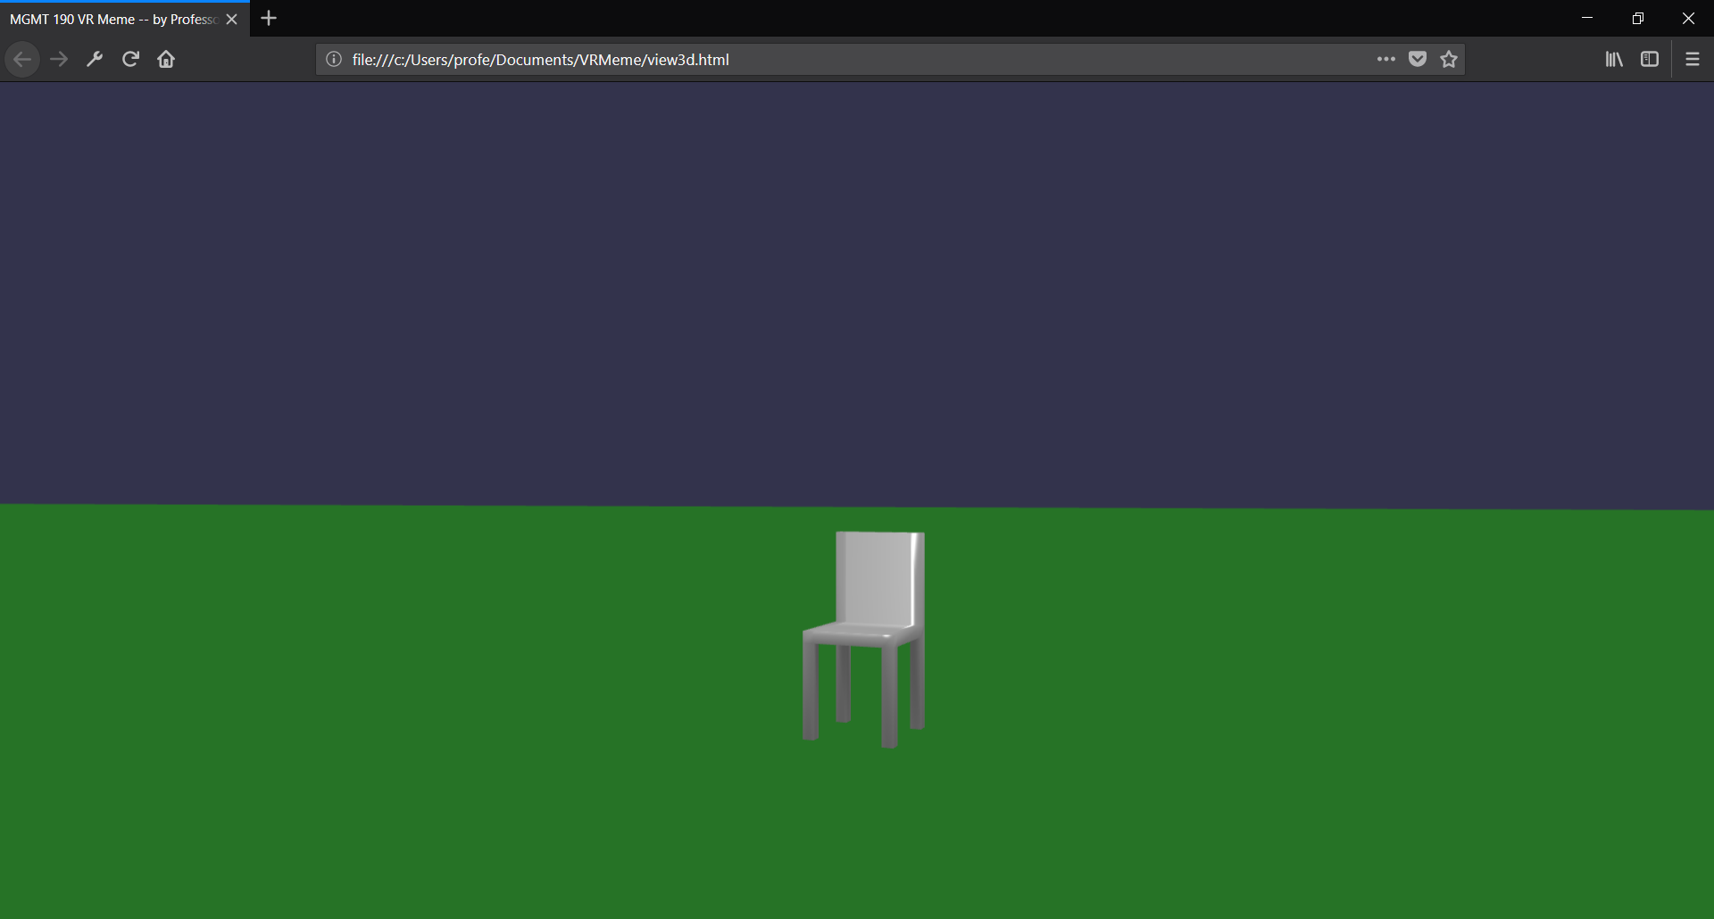
Congratulations, you’ve successfully exported your model into Babylon. Next, we’ll look at how to make the scene a VR scene (change the condition from true to false!).

