Creating a Chair in Blender
Nick V. Flor (nickflor@unm.edu, @ProfessorF)

- Start-up Blender (click through any start screens)
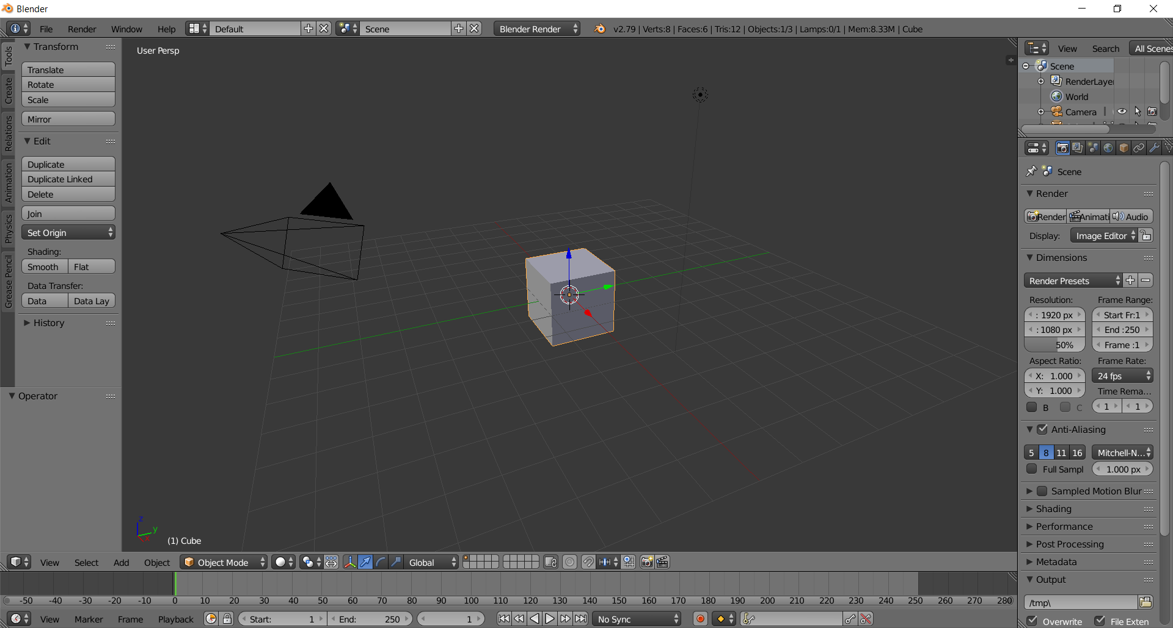

- Create the seat by flattening the box
  - Type N to bring up the information panel
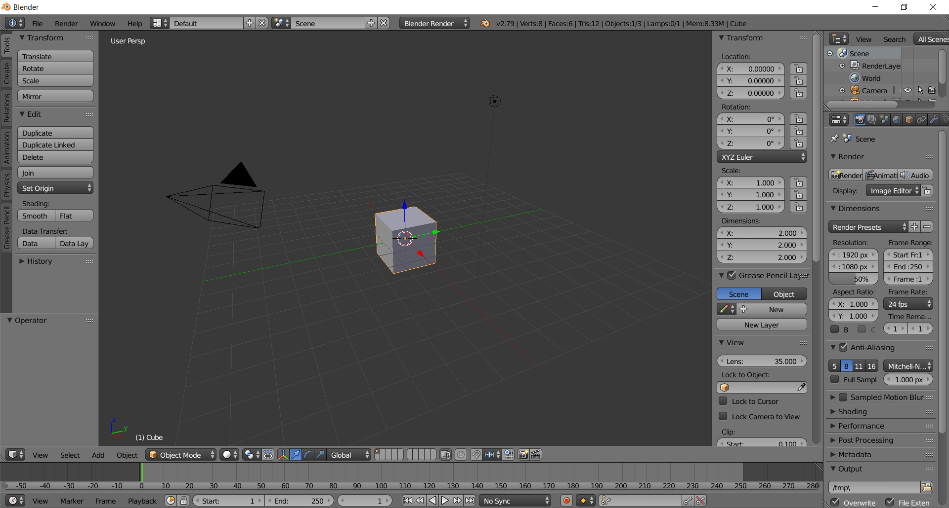

  - Type 0.25 in Transform > Dimensions > Z
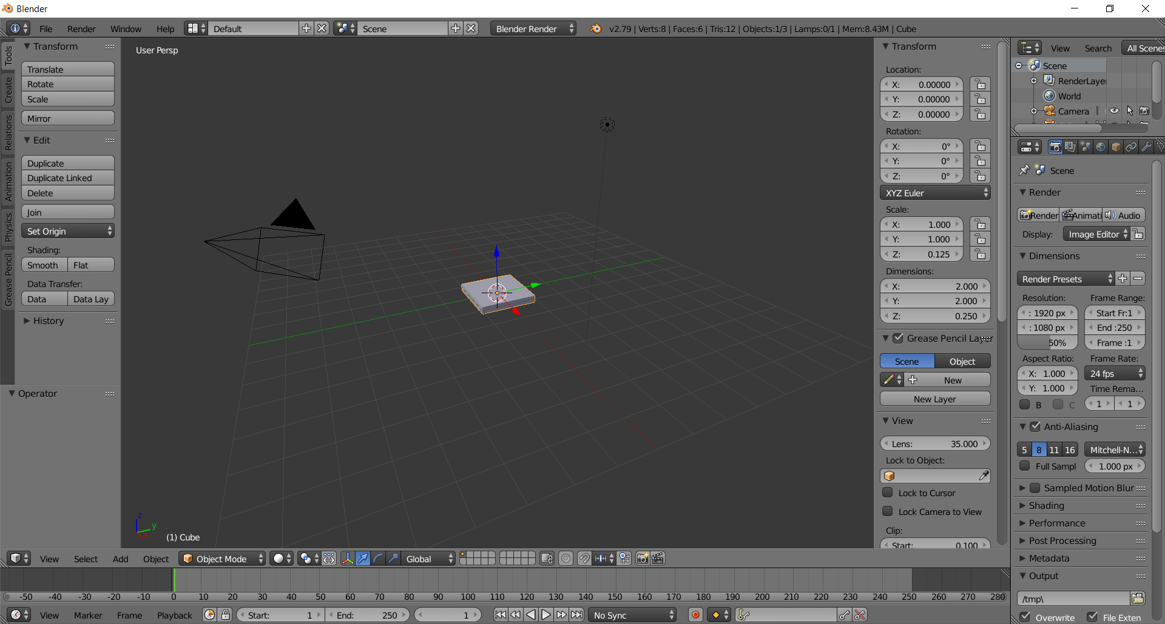

- Create the faces for the 4 legs Using Edge-Loops (helpful to zoom in with your mouse first)
  - Press the Tab key to go into Edit Mode
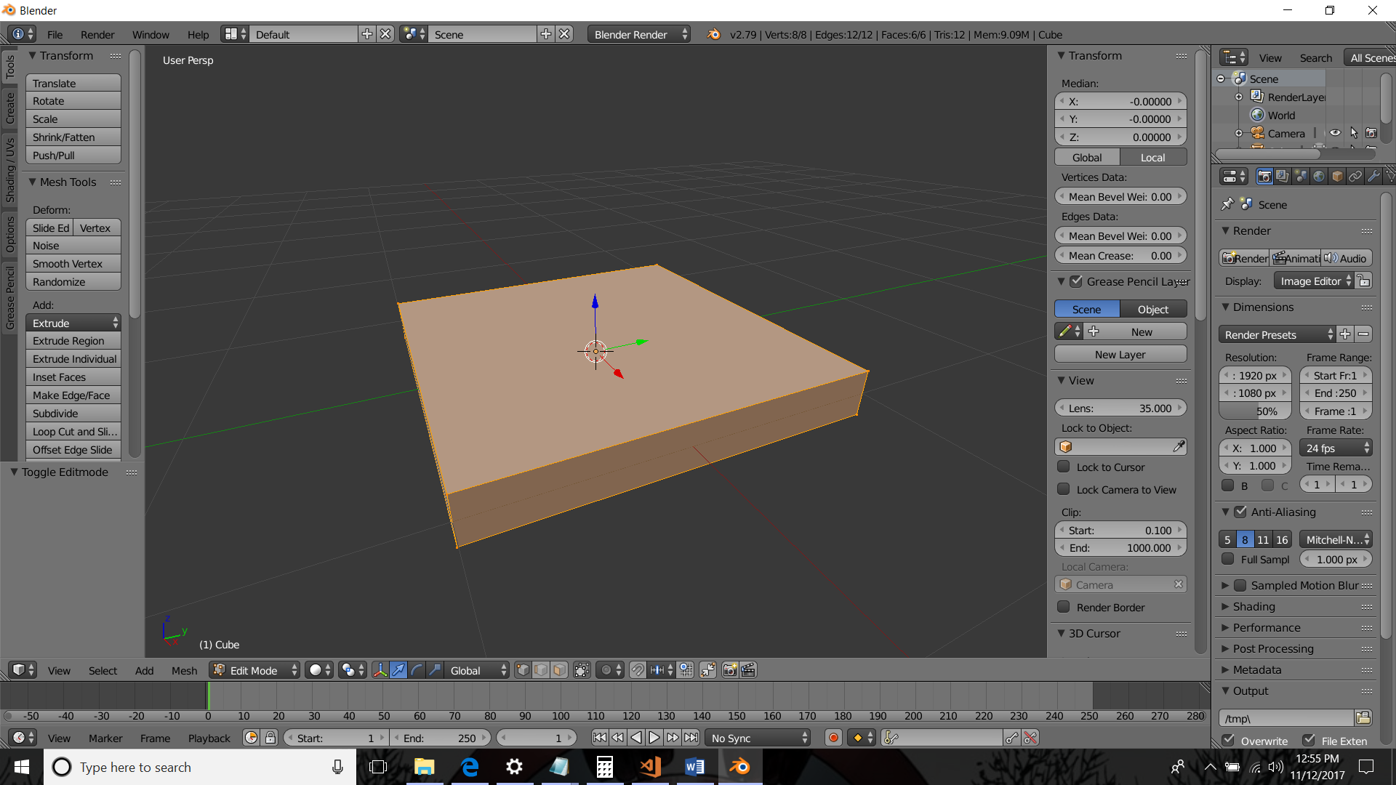
  - Add an edge loop by typing Ctrl-R (or click Loop-Cut and Slide in the left tool box panel) and hovering the mouse near an x-axis (red) edge
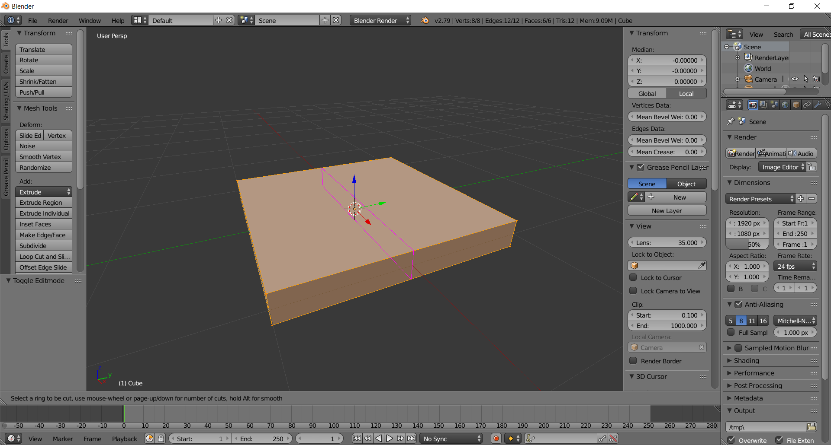

  - Left-click, or press the Enter key. This creates a slide-able edge loop. If you move your mouse it slides!
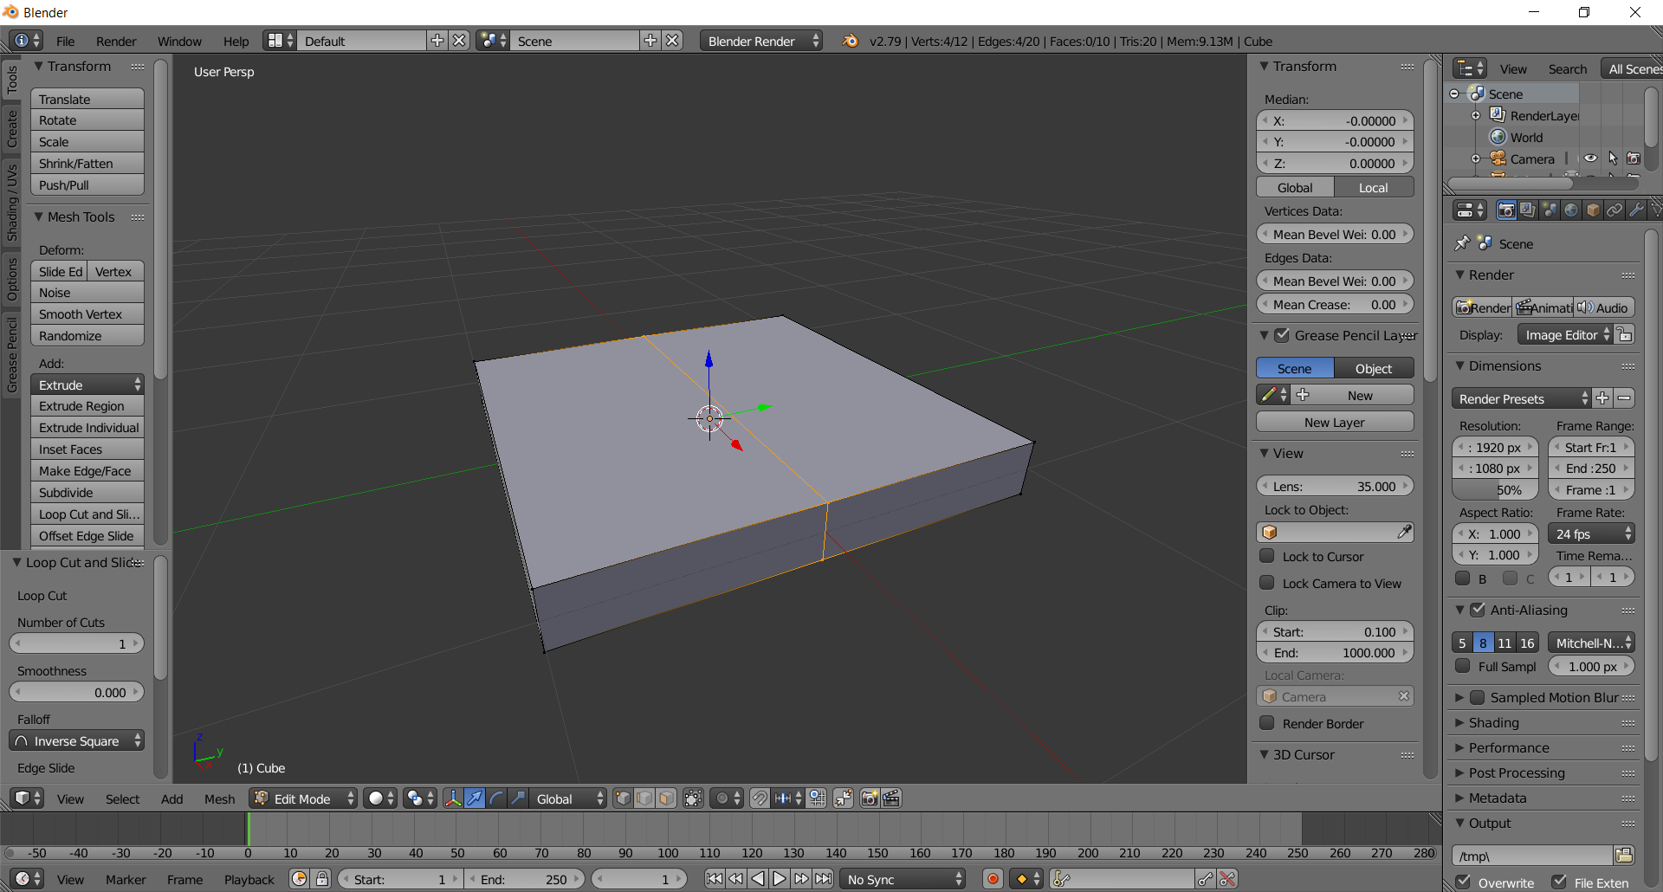

  - Hit the escape key to fix the edge-loop in the middle. Reason? We don’t want to eyeball the position of the edge-loop. We want to place it exactly, which we’ll do in the next step
(picture same as above)

  - Type -.75 in Transform > Median > Y, then press Enter. Note: the edge-loop jumps to a y-value of -0.750. Also note: red is the x-axis, green is the y-axis
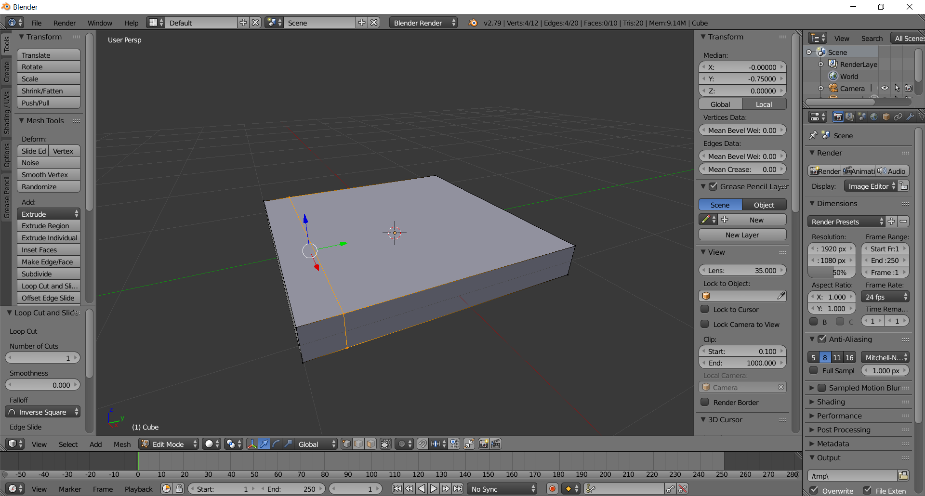
  - Add another edge loop by typing Ctrl-R (or click Loop-Cut and Slide in the left tool box panel), hovering the mouse near an x-axis (red) edge, clicking the left mouse button, and then pressing the ESC key. Note: this is the general sequence for creating an edge loop — Ctrl-R - Hover - Click - Esc
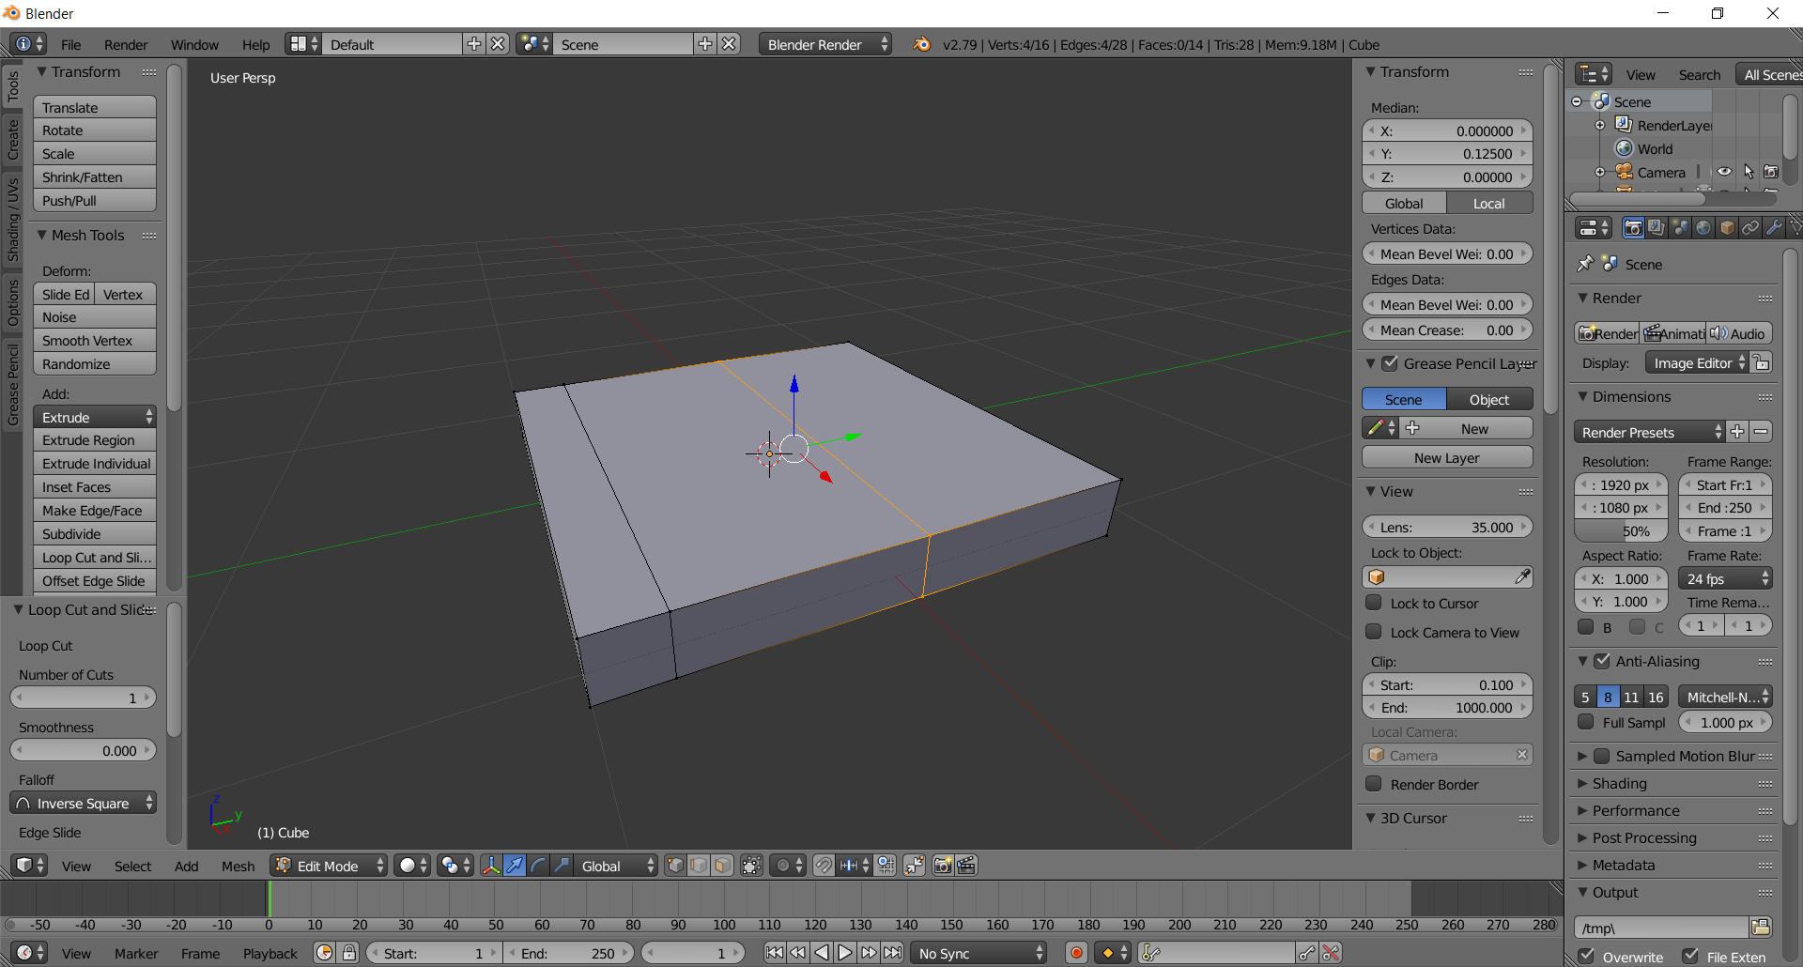
  - Type .75 in Transform > Median > Y, then press Enter. Note: the edge-loop jumps to a y-value of 0.750
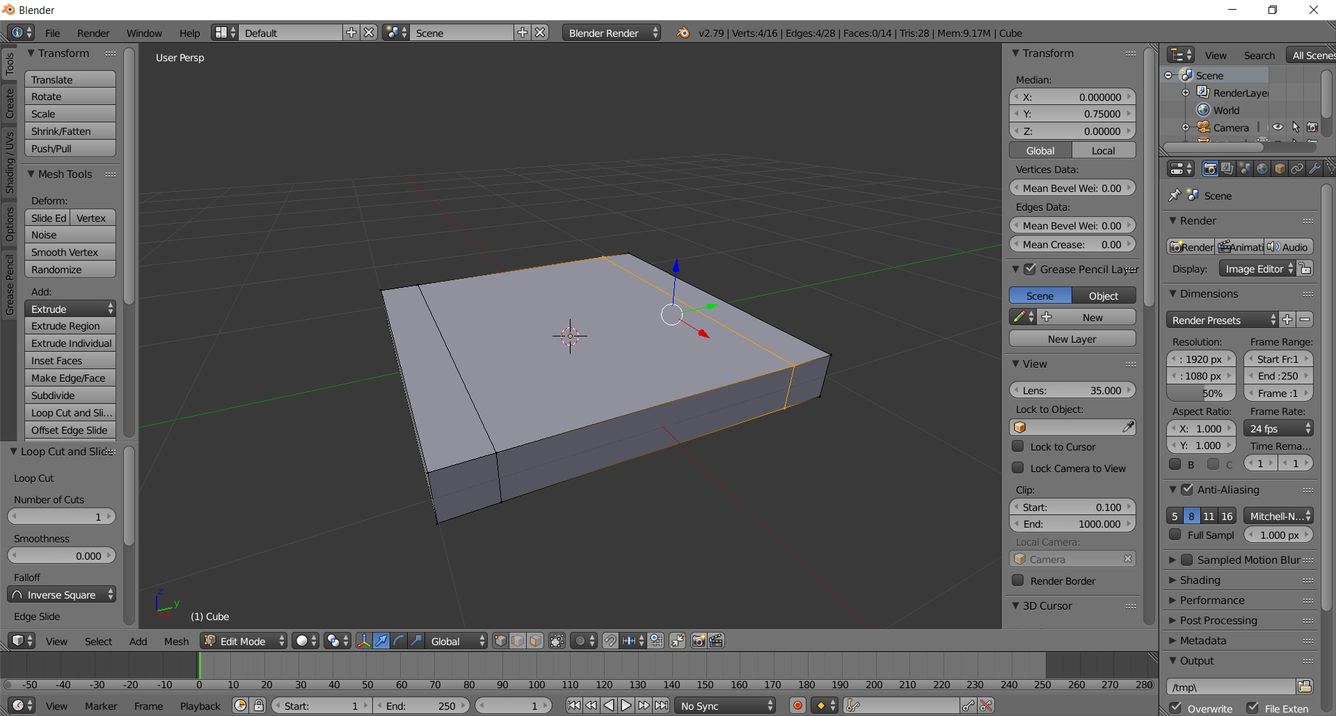
  - Add another edge loop, this time parallel to the y-axis, by typing Ctrl-R (or click Loop-Cut and Slide in the left tool box panel), hovering the mouse near an y-axis (green) edge, clicking the left mouse button, and then pressing the ESC key
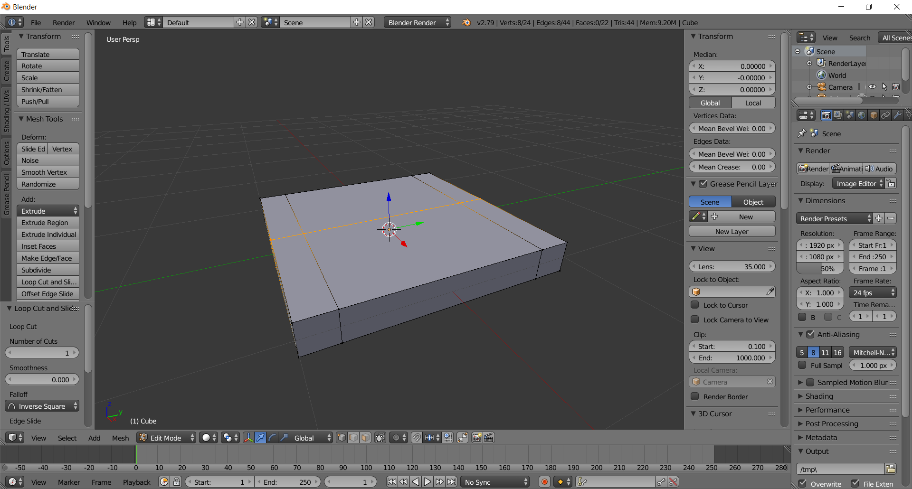
  - Type -.75 in Transform > Median > X, then press Enter. Note: the edge-loop jumps to an x-value of -0.750
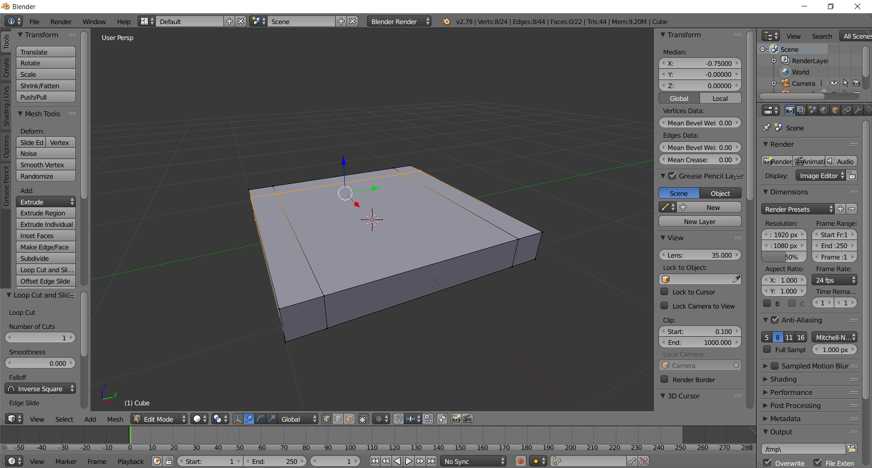
  - Add another edge loop parallel to the y-axis, by typing Ctrl-R, hovering the mouse near any y-axis (green) edge, clicking the left mouse button, and then pressing the ESC key
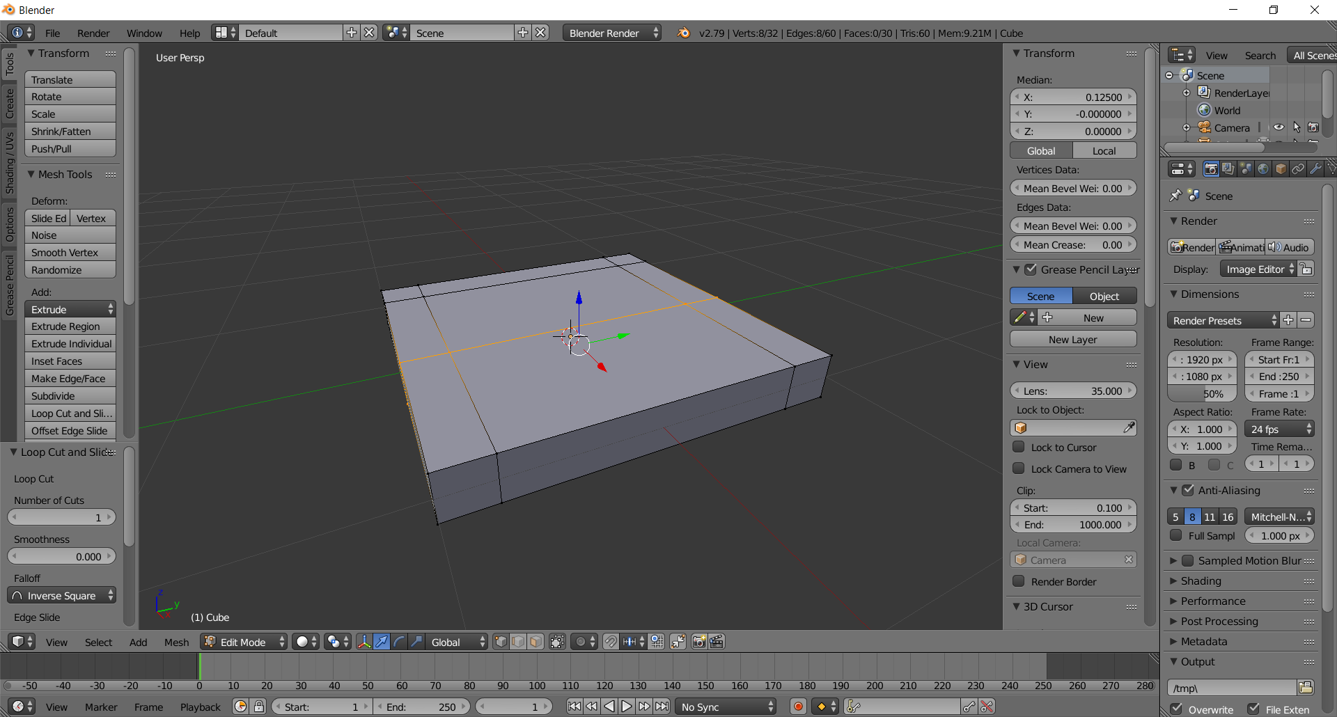
  - Type .75 in Transform > Median > X, then press Enter. Note: the edge-loop jumps to an x-value of 0.750
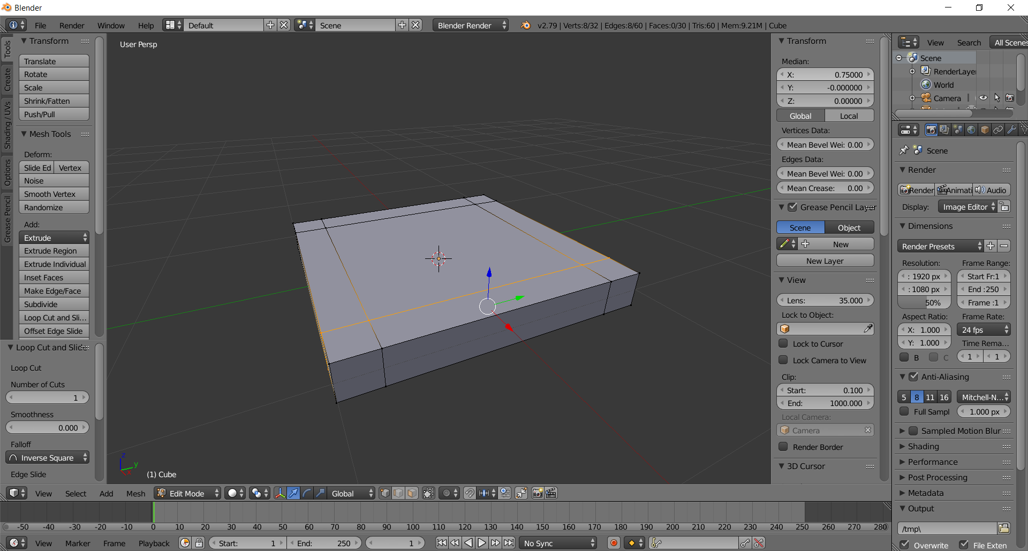

- Create the Legs via Extrusion
  - Rotate your view, so you can see underneath the seat, by holding middle-mouse button & moving mouse.
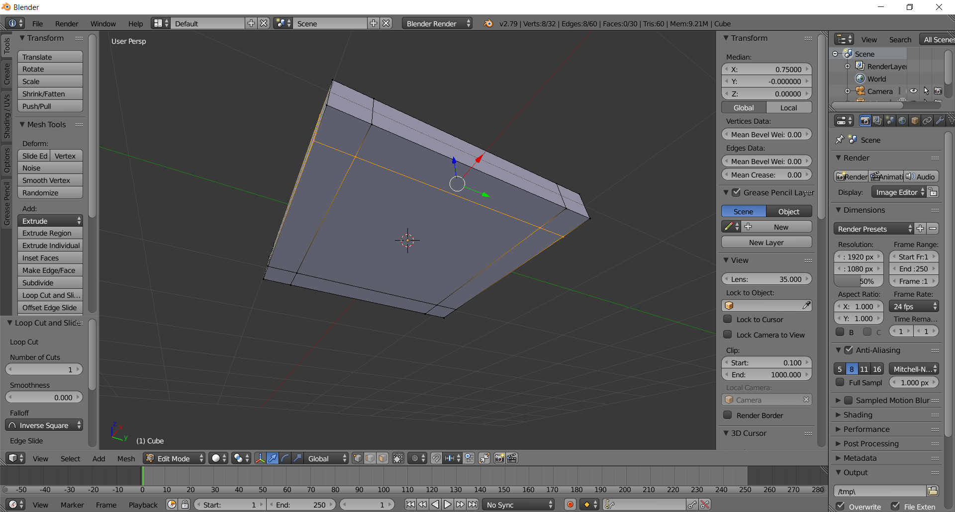

  - Switch to Face-Select Mode, by clicking on the face icon in the bottom tool shelf. You can also type Ctrl-Tab, then select Face in the pop-up menu.
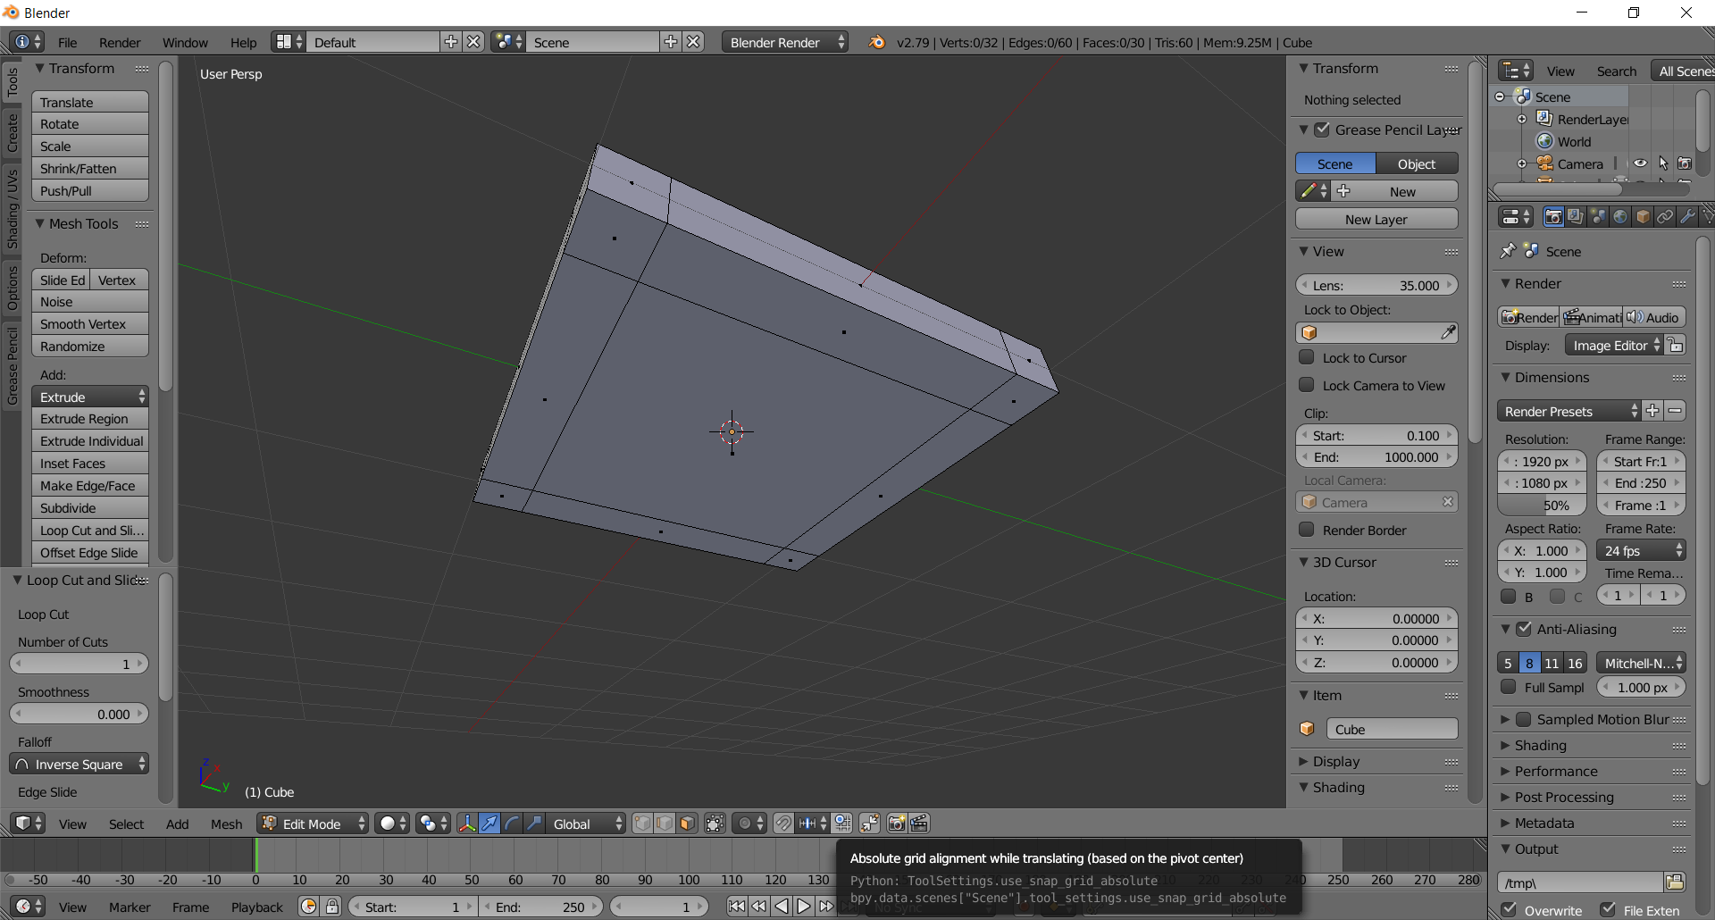

  - Right-Click (not Left-Click!) one of the corner (leg) faces. I clicked the furthest one away
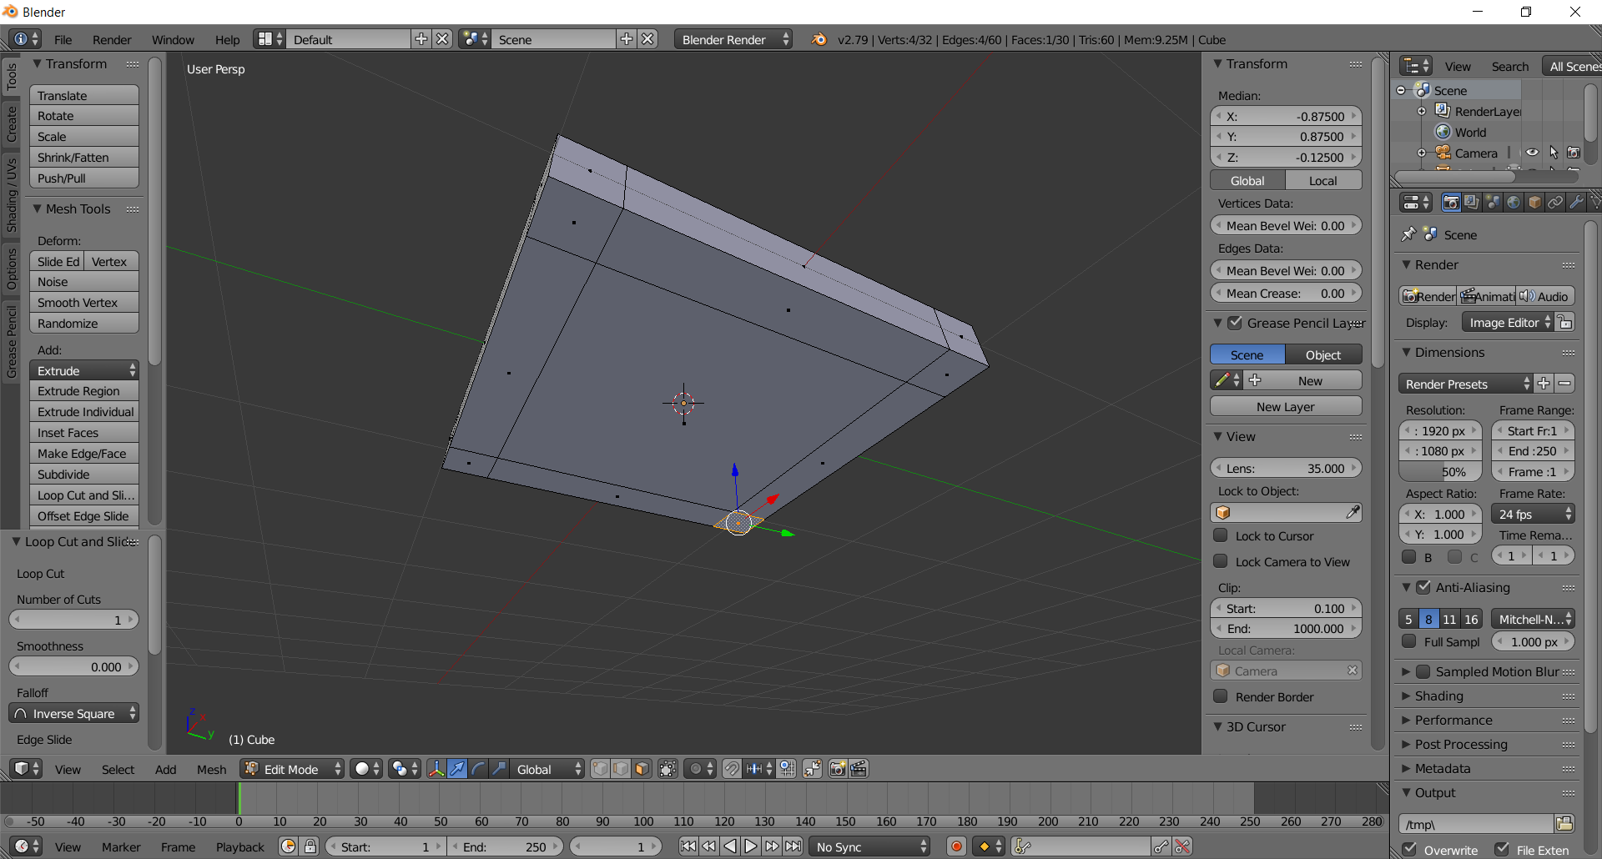
  - Click on the Extrude Region button in the left tool box (Keyboard shortcut: E). Note the blue line. This is the path of the extrusion, which is 90 degrees or normal to the face
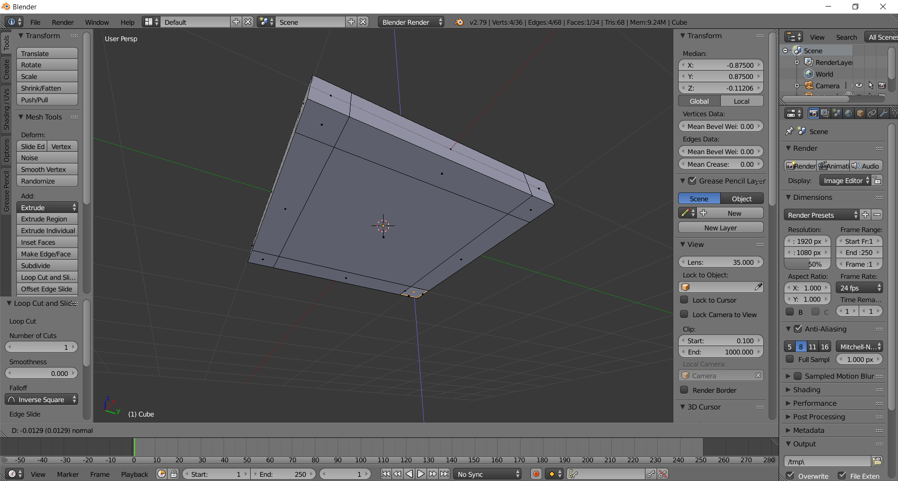
  - Slide your mouse back and forth near this blue line and note how this changes the length of the extrusion. But we don’t want to “eyeball” the extrusion, we want a precise length, so …
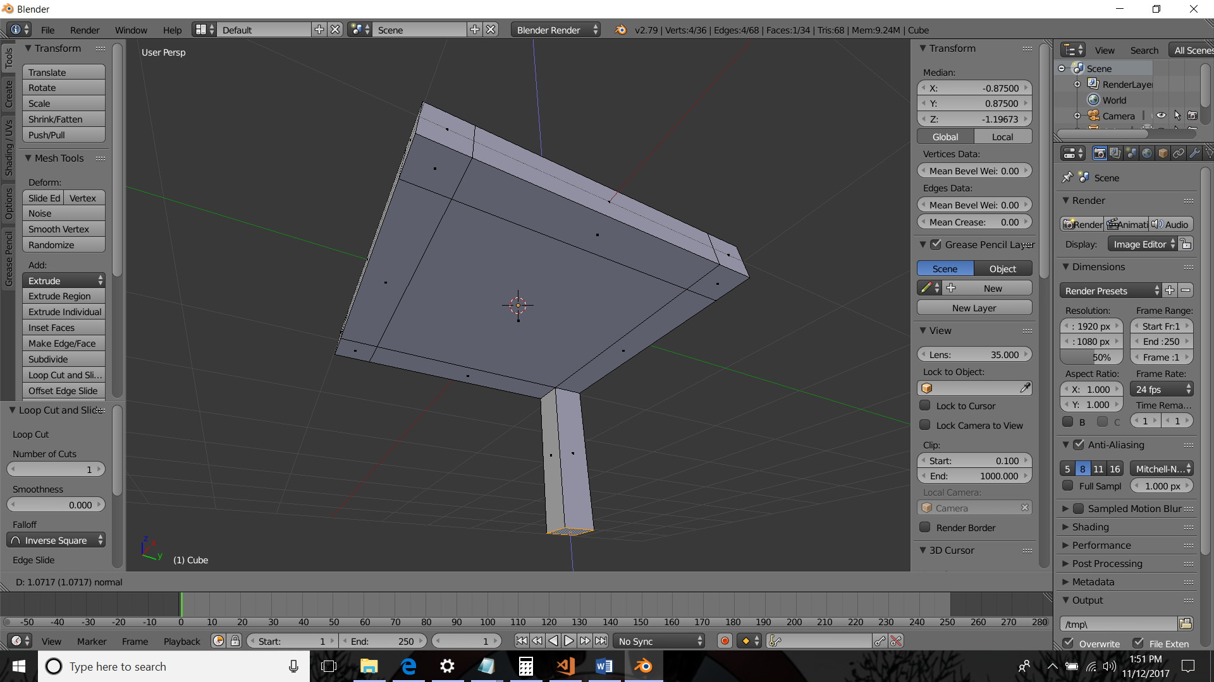\

  - Type 2 then press the Enter key (I zoomed back too using the mouse wheel so you could see)
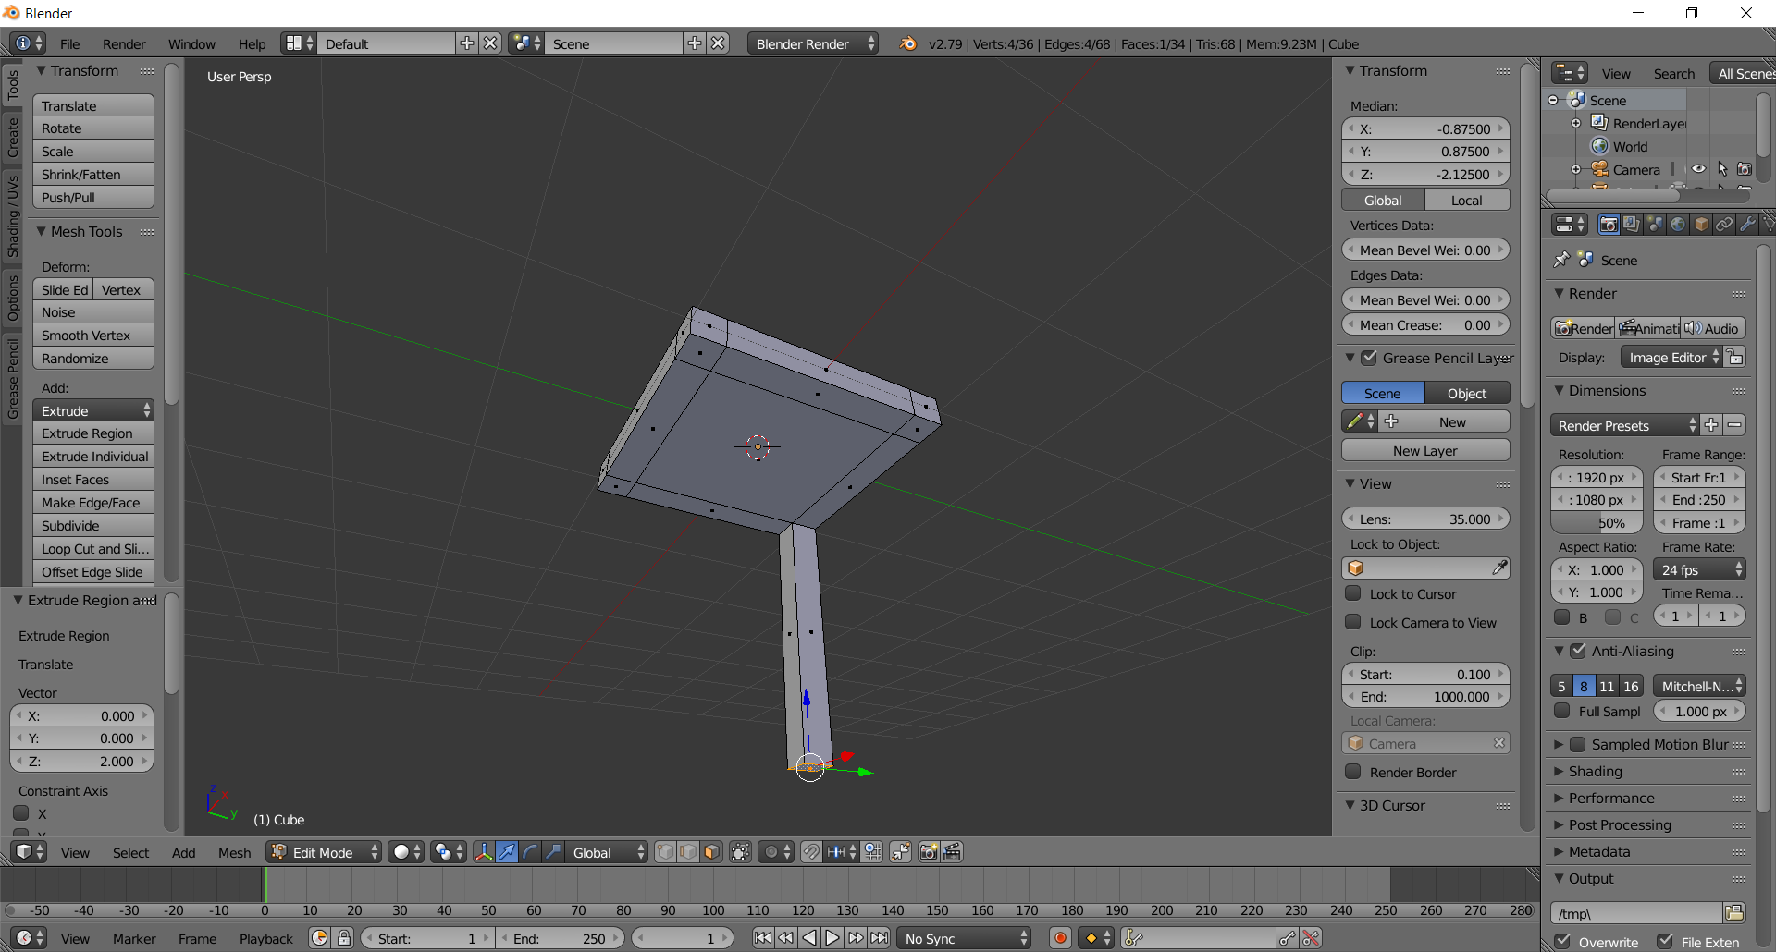
  - Right-Click another corner face
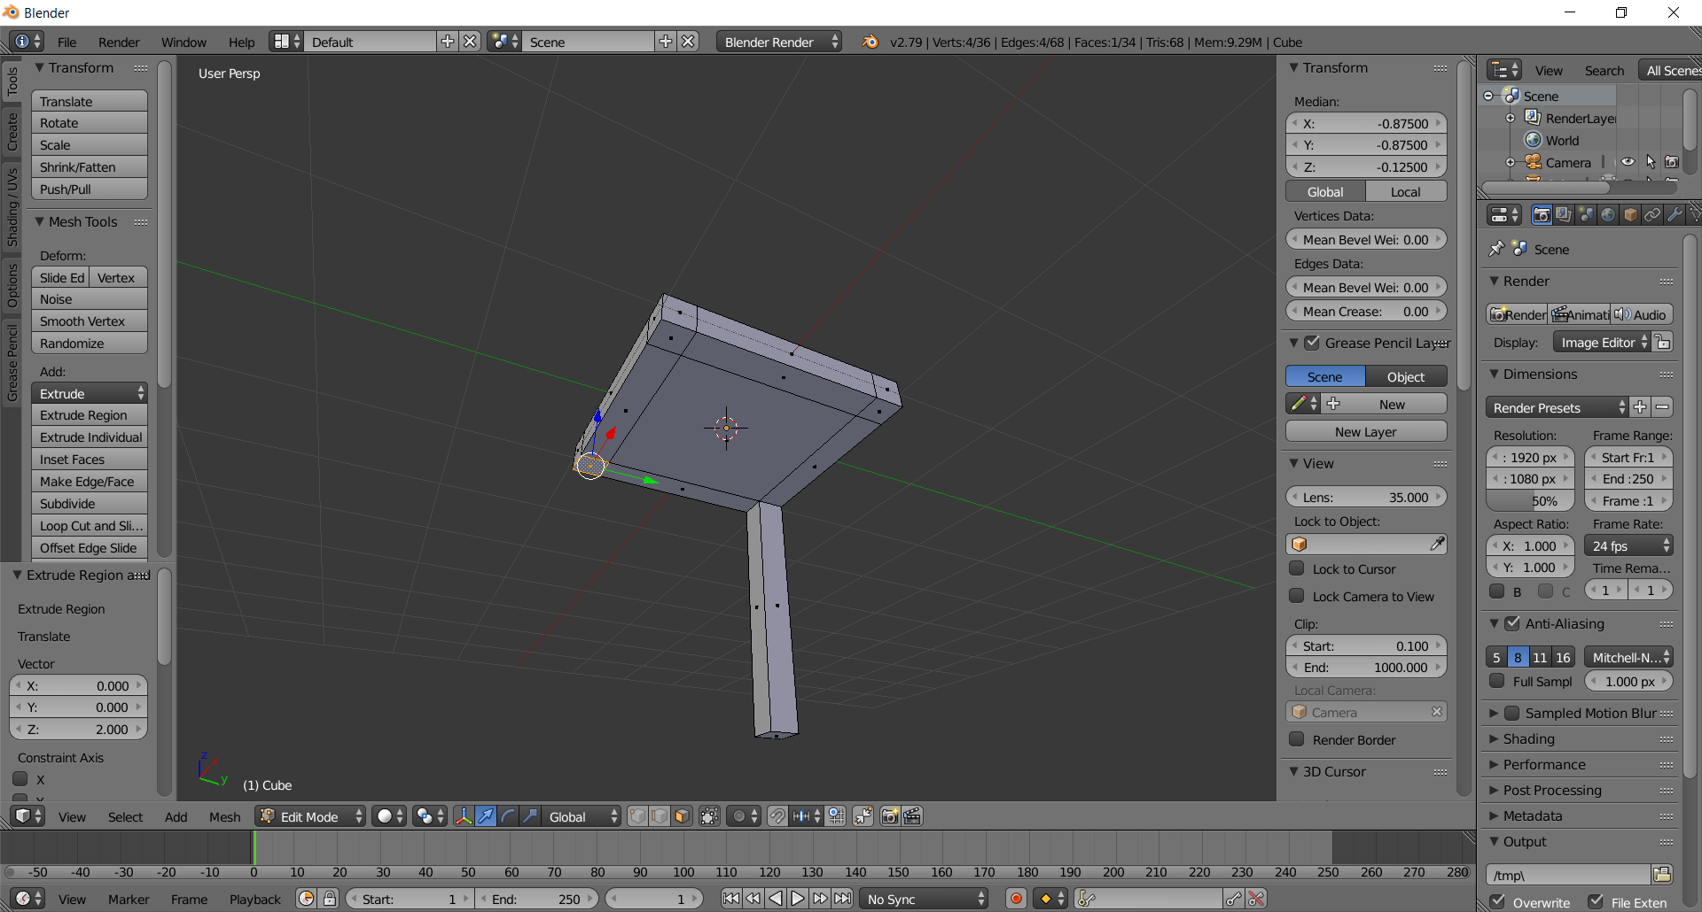
  - Extrude another leg using the same procedure. I do it quickly by typing E, then 2, then Enter. But the long way is: Click on the Extrude Region button in the left tool box, type E, type 2, type Enter.
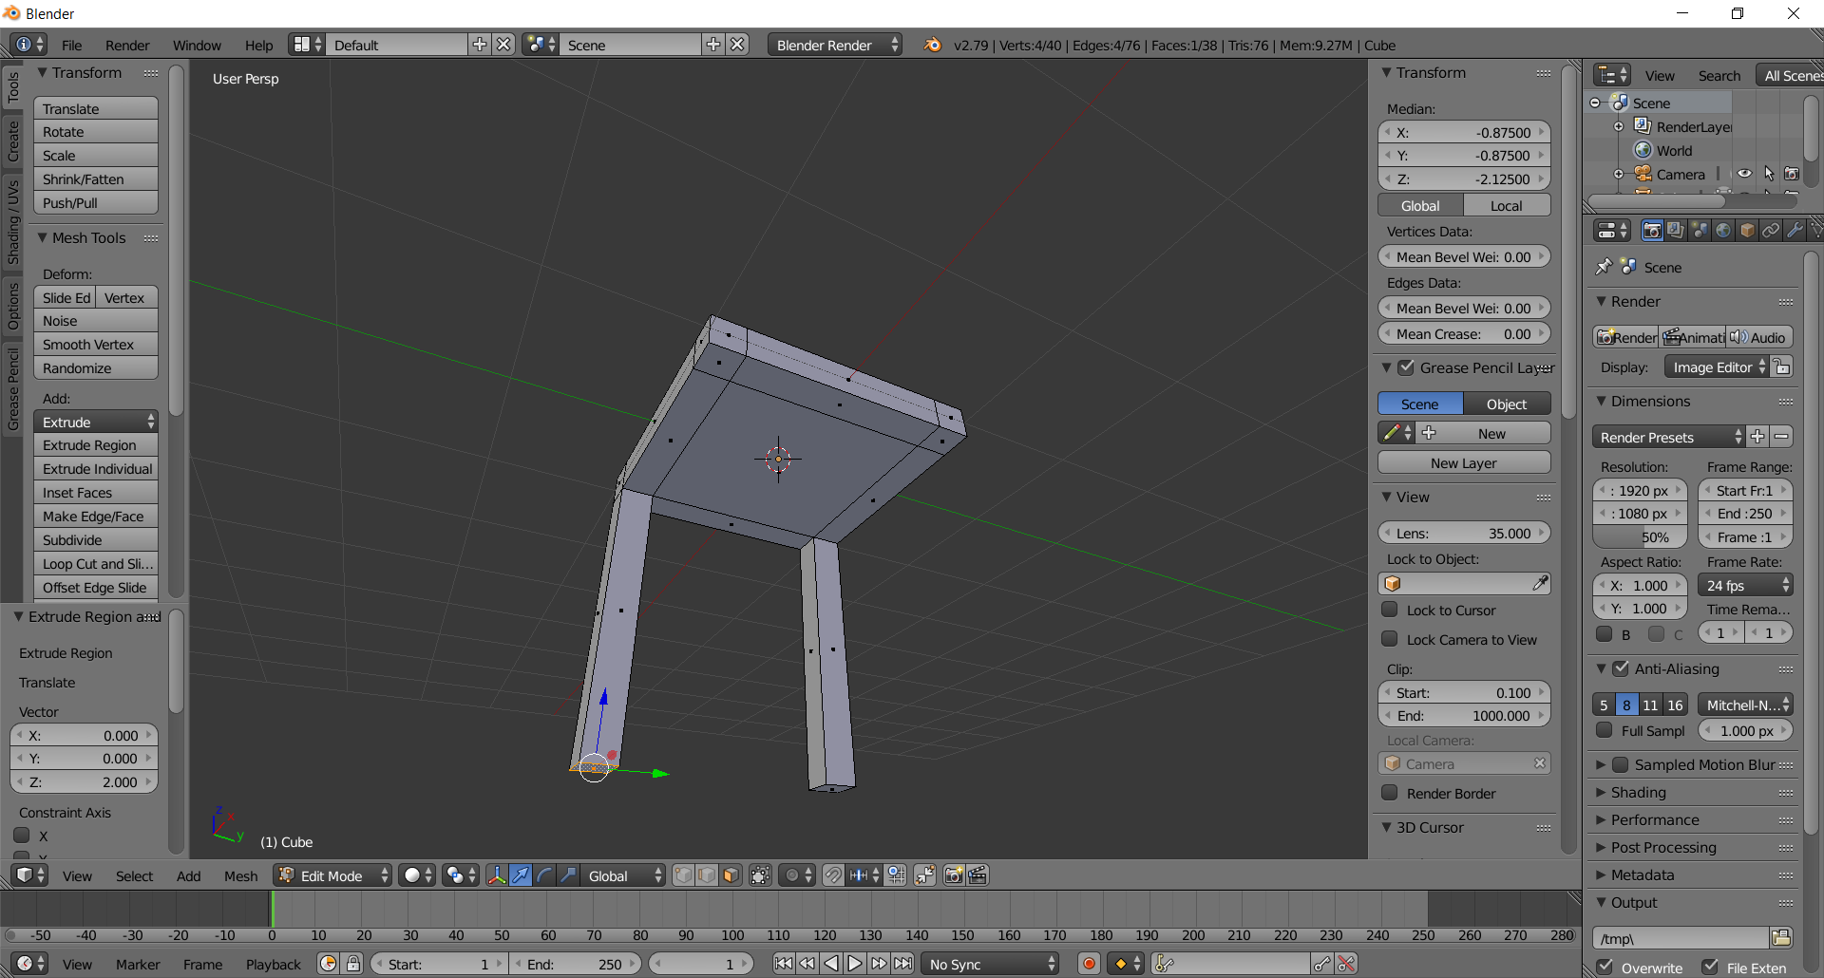
  - Right-Click on another corner face
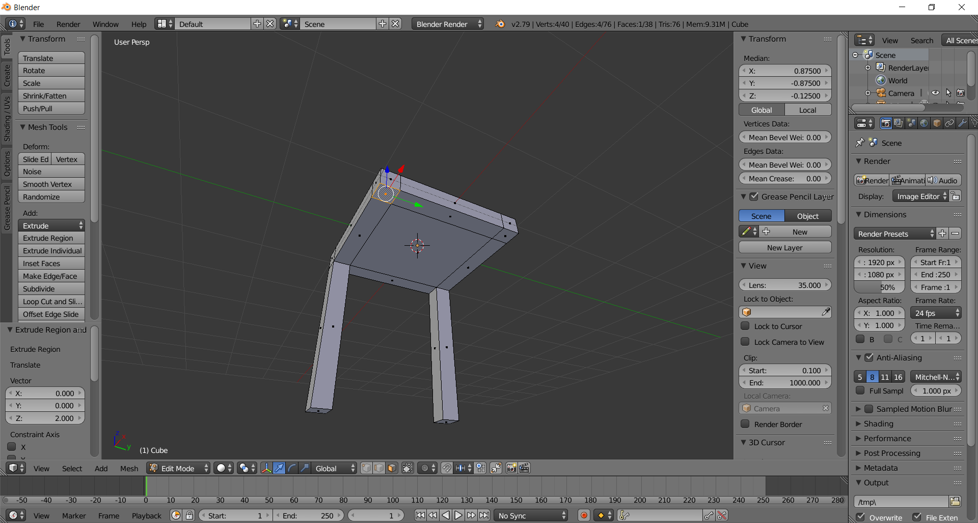
  - Extrude 2 units (Keyboard shortcut: E 2 Enter)
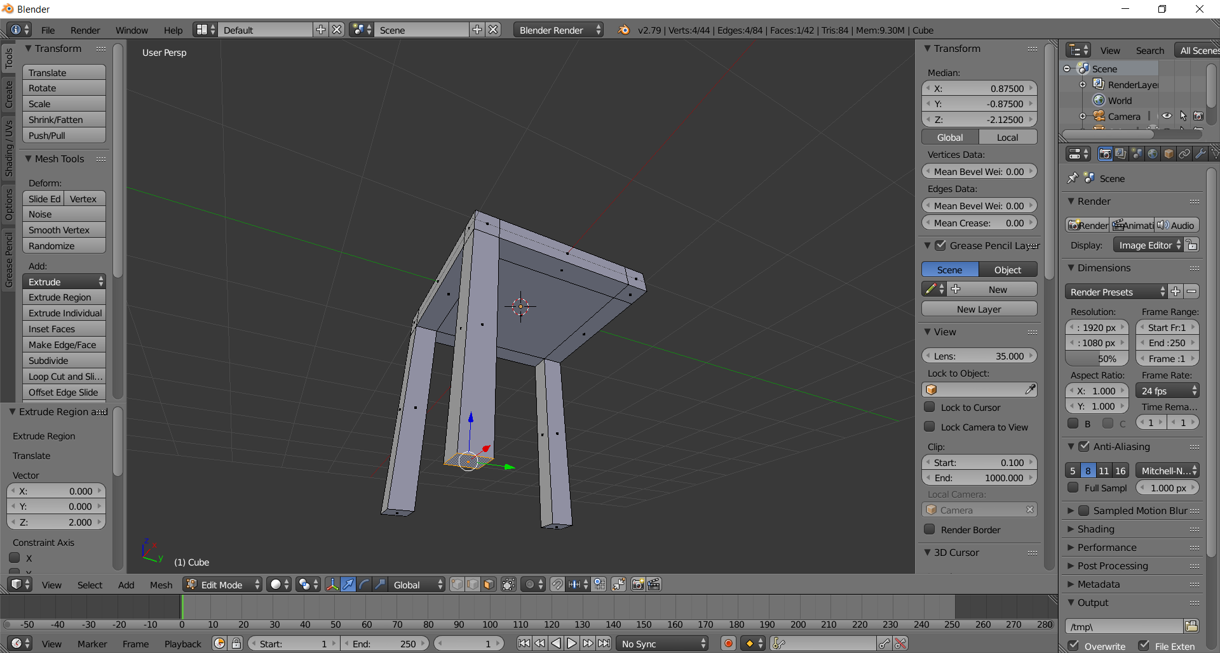
  - Right-Click the final corner face
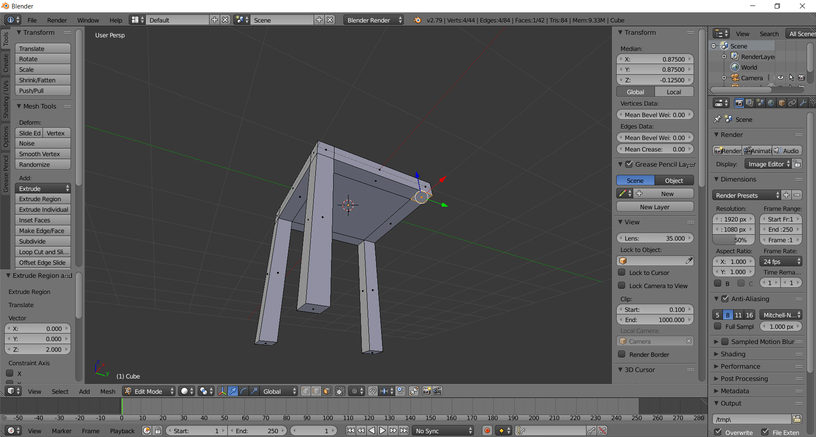

  - Extrude 2 units (Keyboard shortcut: E 2 Enter)
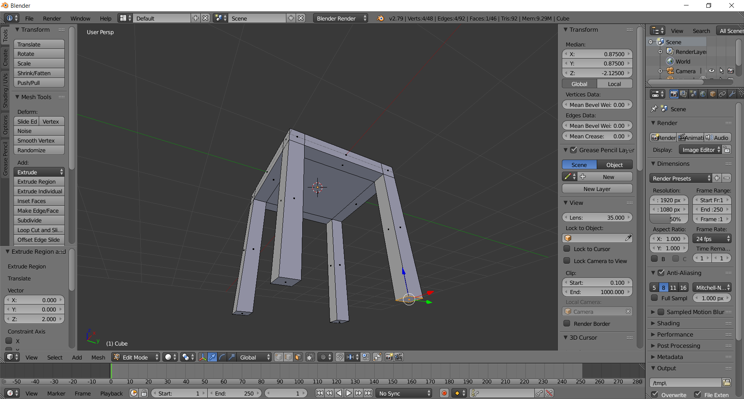

- Create the Seatback via Extrusion
  - Rotate your view (click and hold MMB, then move mouse) so you can see the seat top
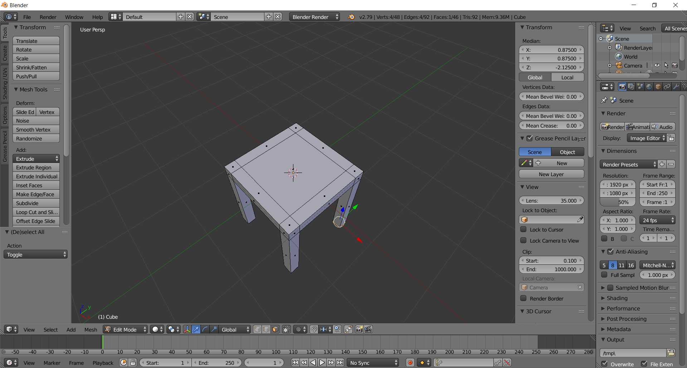

  - Right-Click one of the back faces
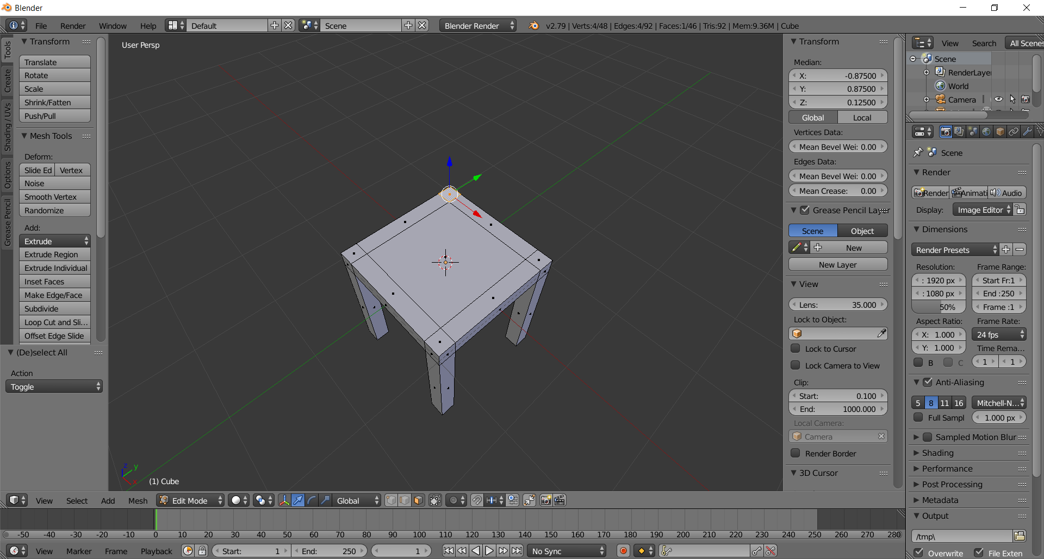
  - Hold the shift-key down and right-click the remaining faces
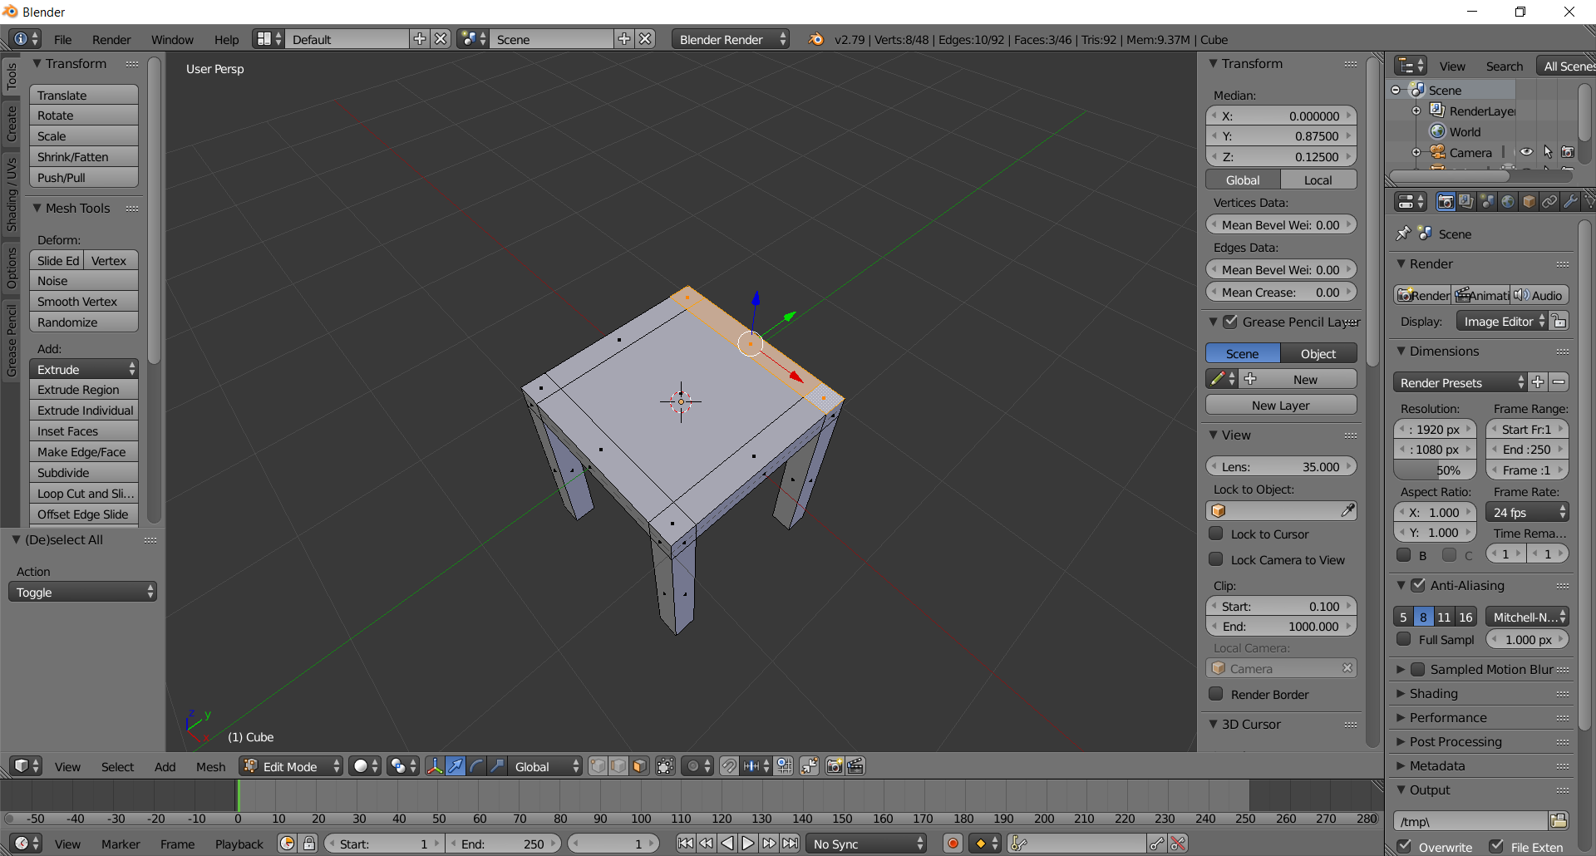

  - Extrude 2 units (Keyboard shortcut: E 2 Enter)
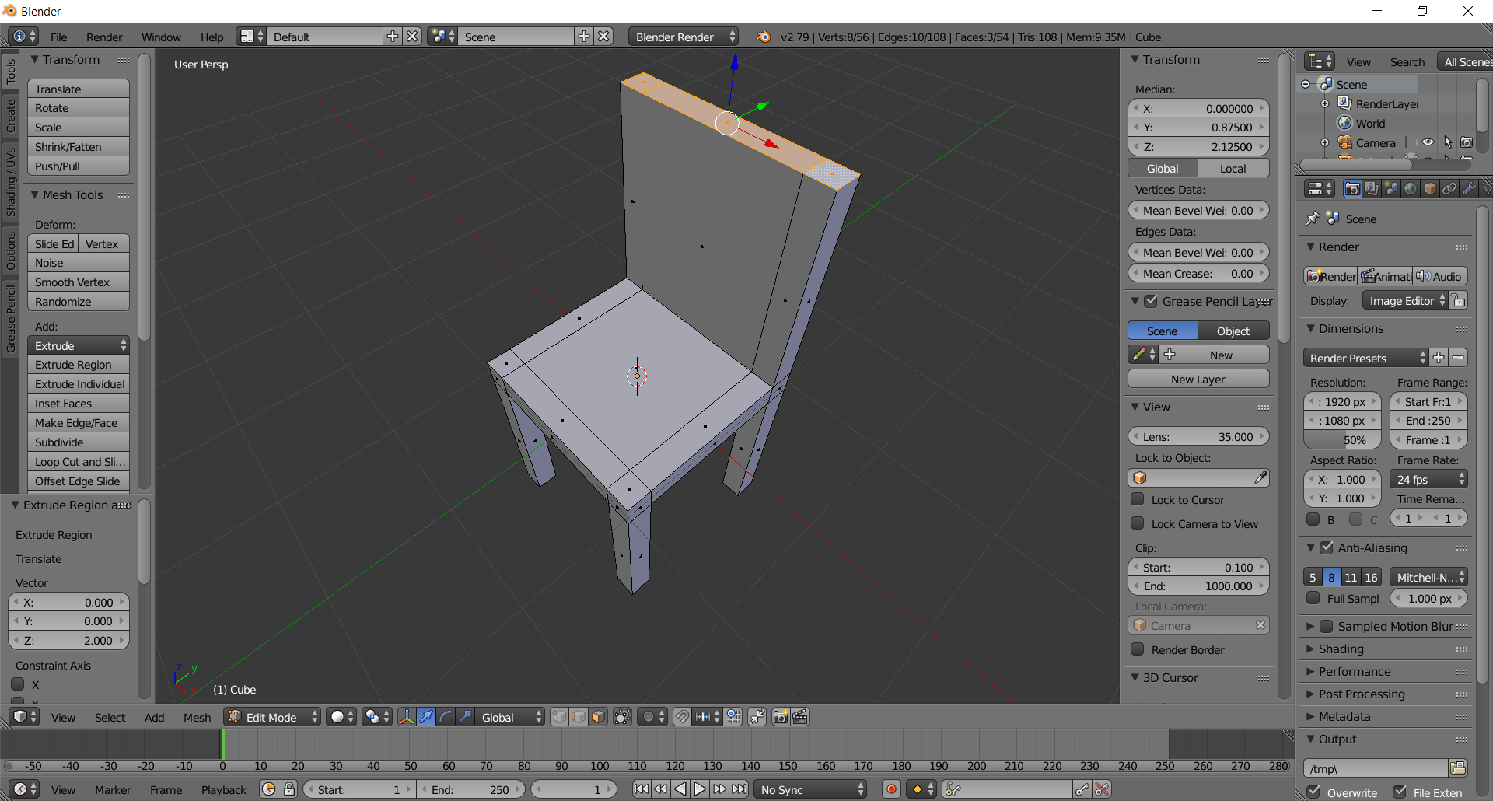

  - Rotate the seat to “eye-level” to see it better (hold middle-mouse button, move mouse)
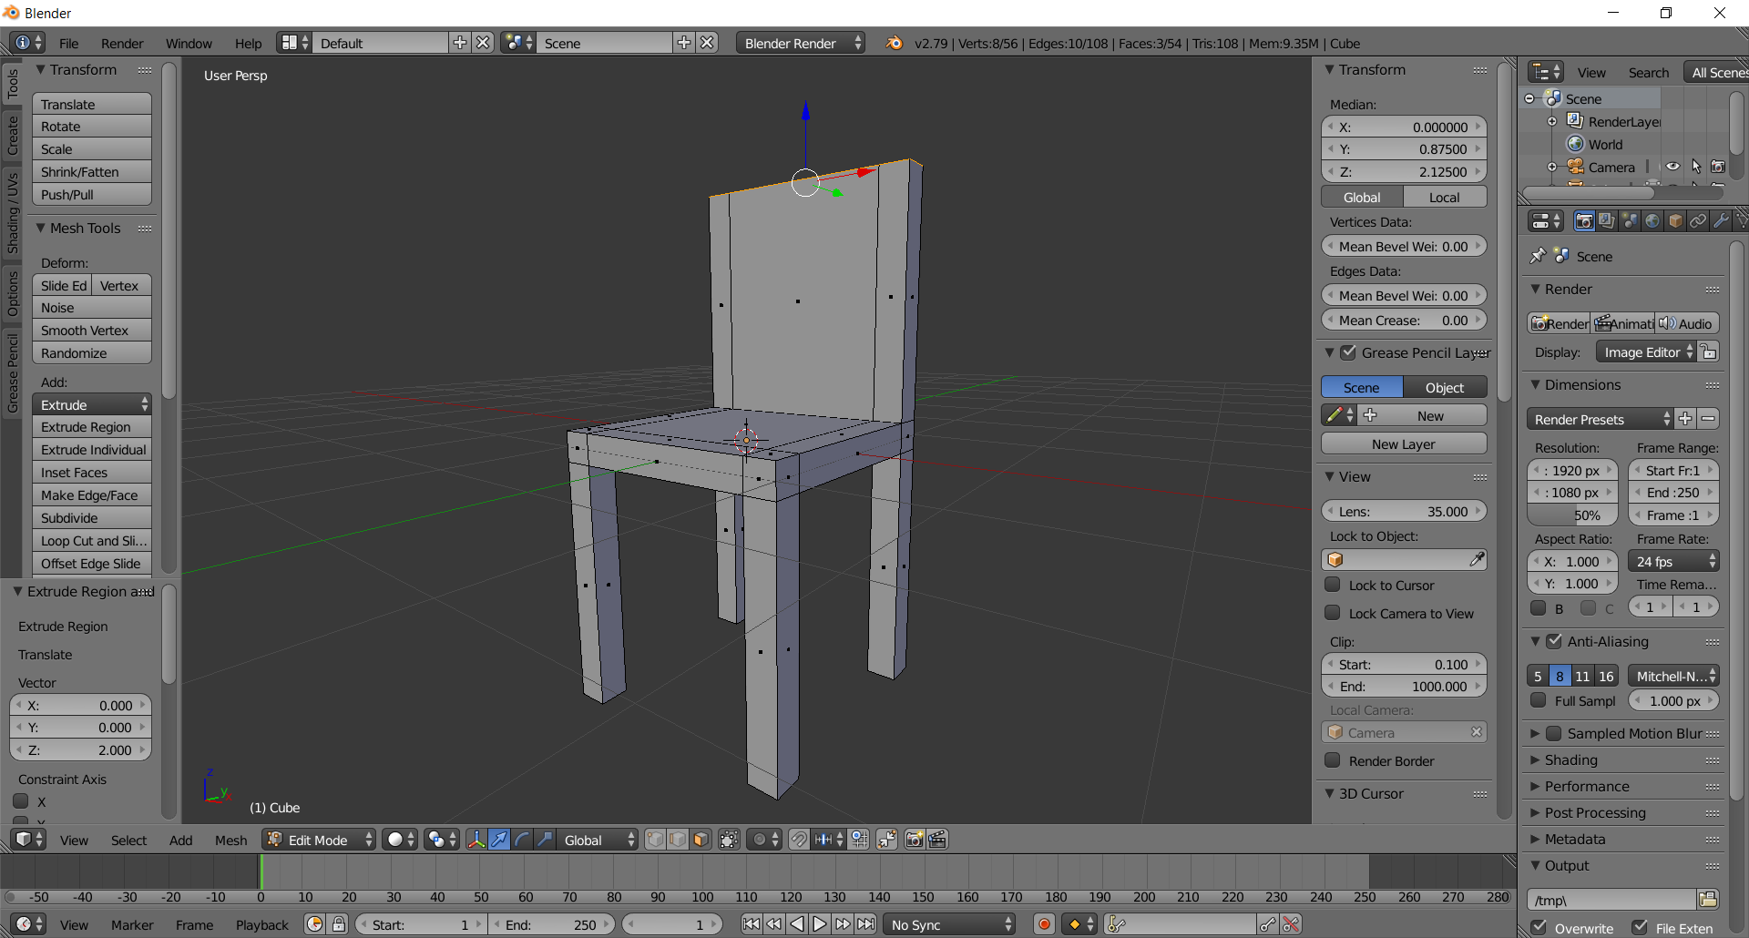
- Pop-up Seat so it’s on the Floor
  - Press the Tab key to get out of Edit Mode and into Object Mode
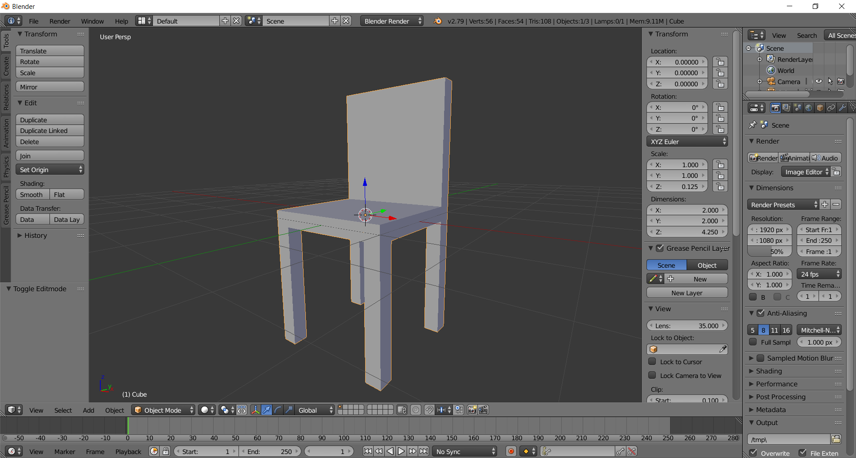
  - Type 2.125 into Transform > Z then press Enter. Why 2.125? The legs are 2 units long. The seat is .25 units high. Why not 2.25? Because note: the seat was centered at the origin, so only half of the seat (.125) was underground. The chair needed to be moved up by an amount equal to everything that was underground (All of the 2 unit legs+.125 of the seat)
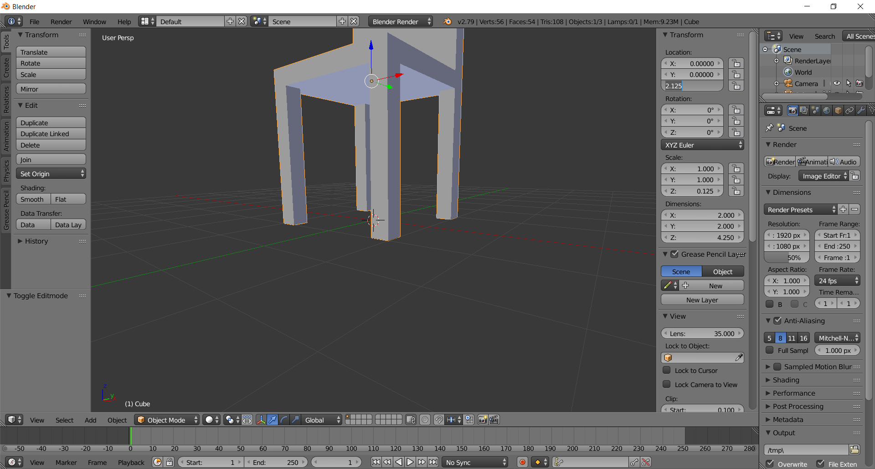
  - Zoom and fix the camera so you can see it better:
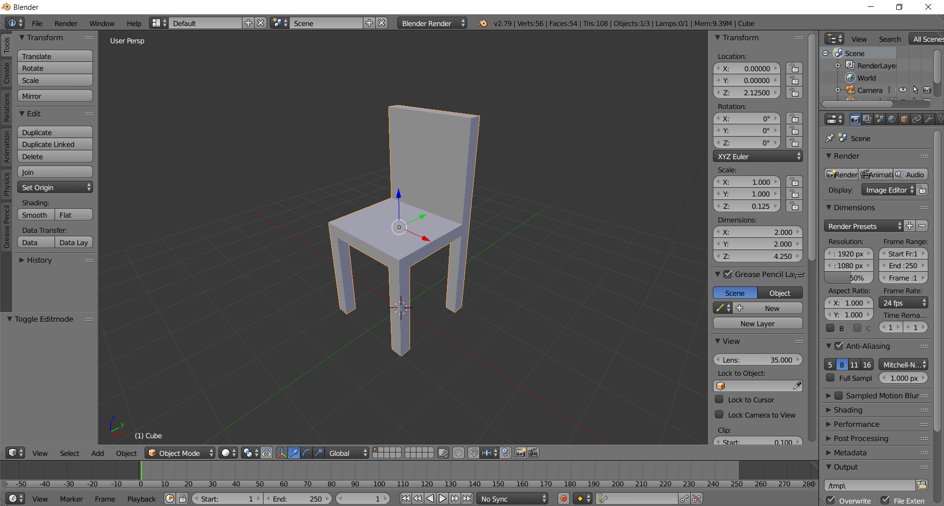

- Save your file via File > Save (choose folder) > LastNameFirstNameChair.blend > Save Blender File

