Blender Manikin Head
Nick V. Flor (nickflor@unm.edu, @ProfessorF)

- Startup Blender
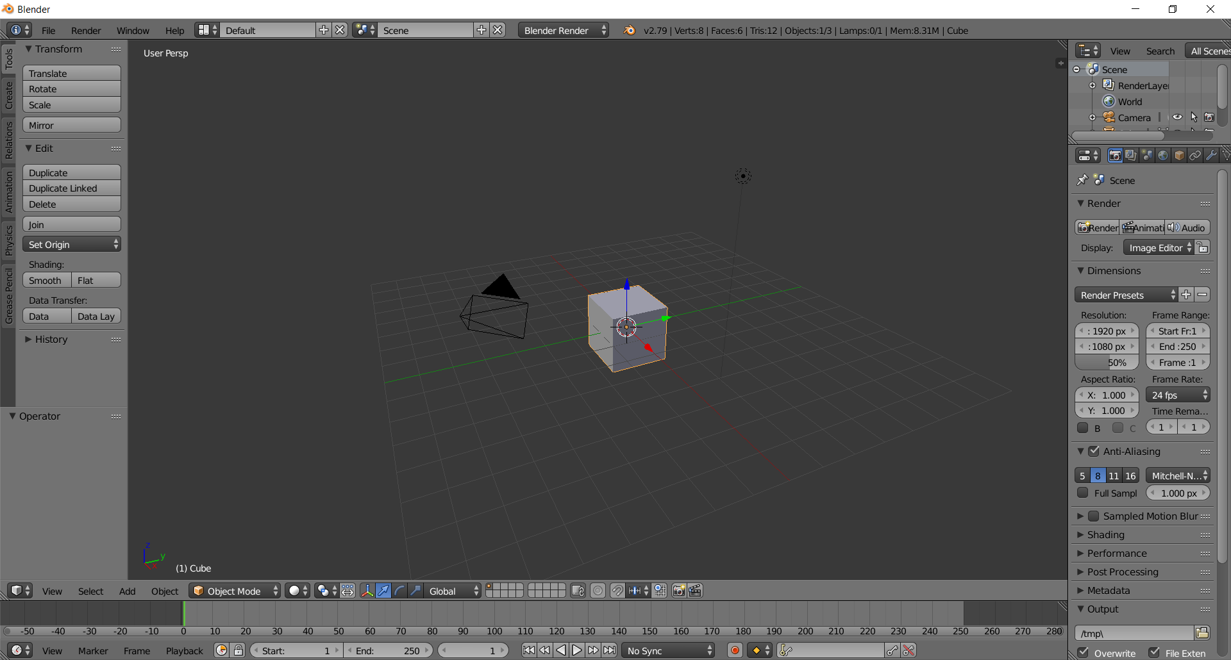

- Delete the box and add a sphere representing the head
  - Press the Delete Key, Click Delete on the Pop-up Menu
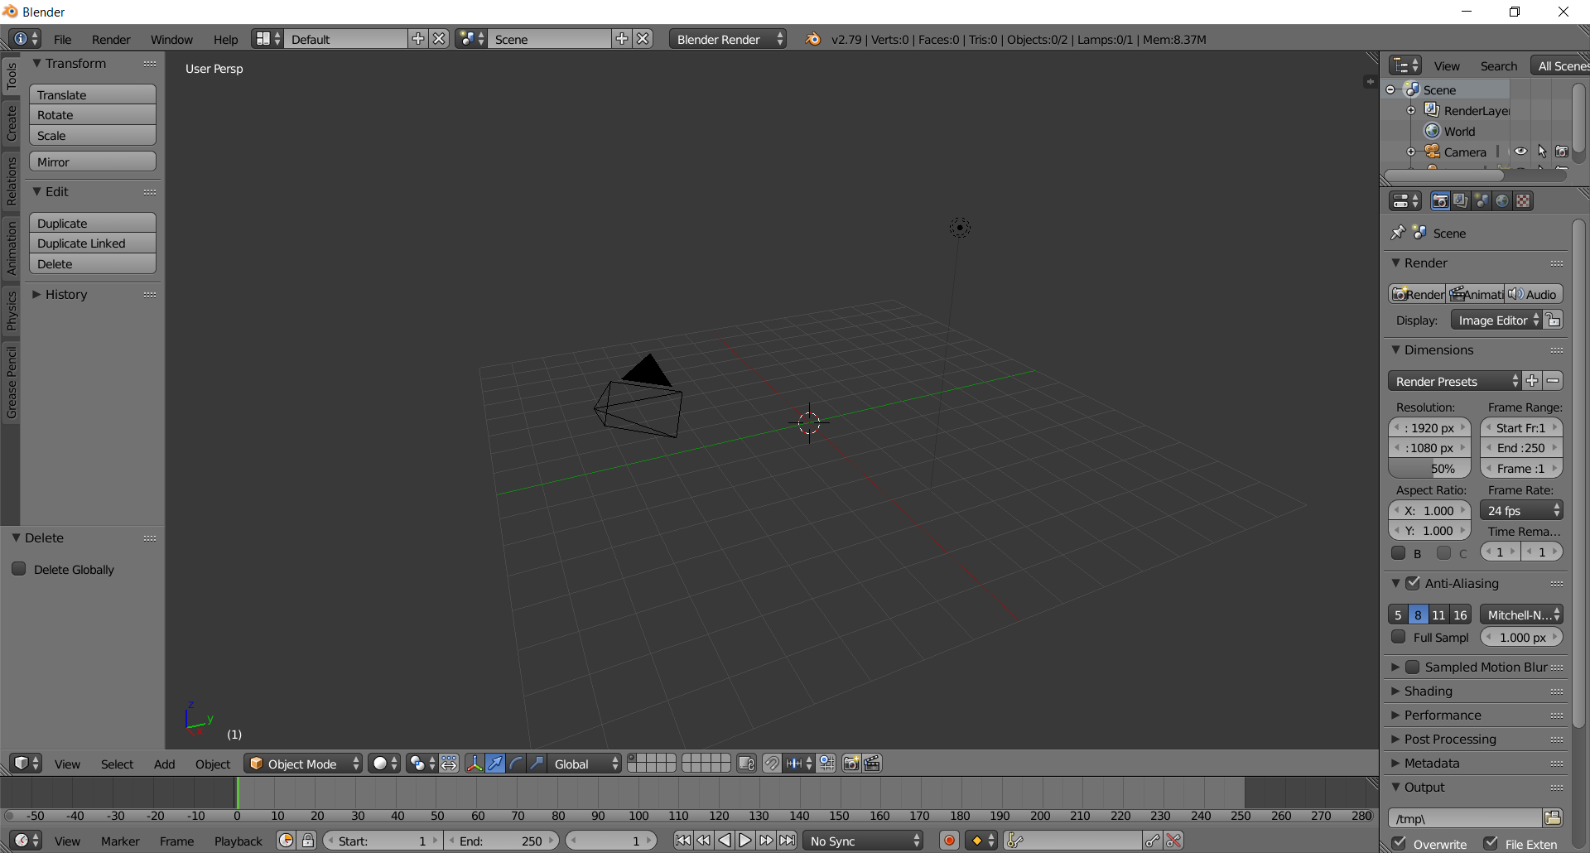

  - Add > Mesh > UV Sphere
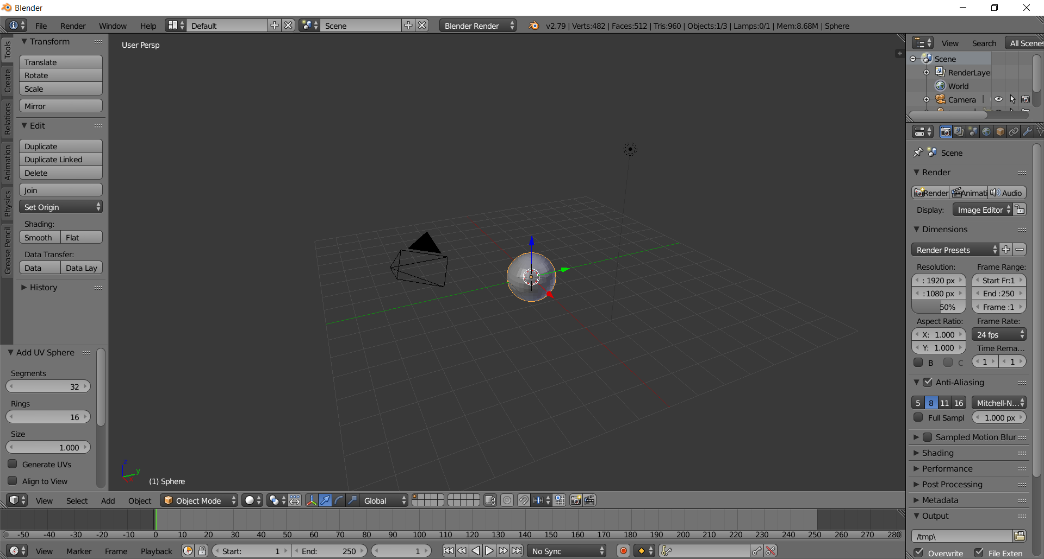

  - In the left panel, Add UV Sphere > Segments: 8; Rings: 4; Size: .5 (. to zoom in)
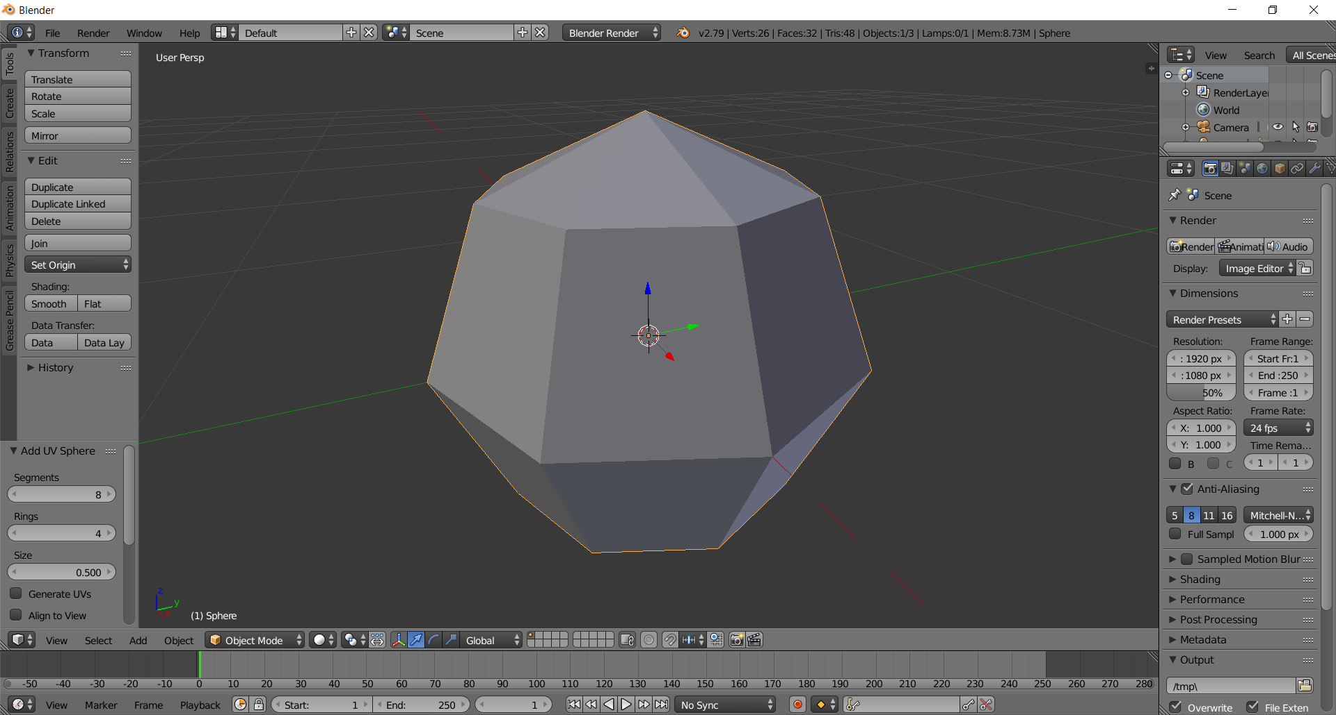

- Sculpt the head
  - Type N to bring up the information panel
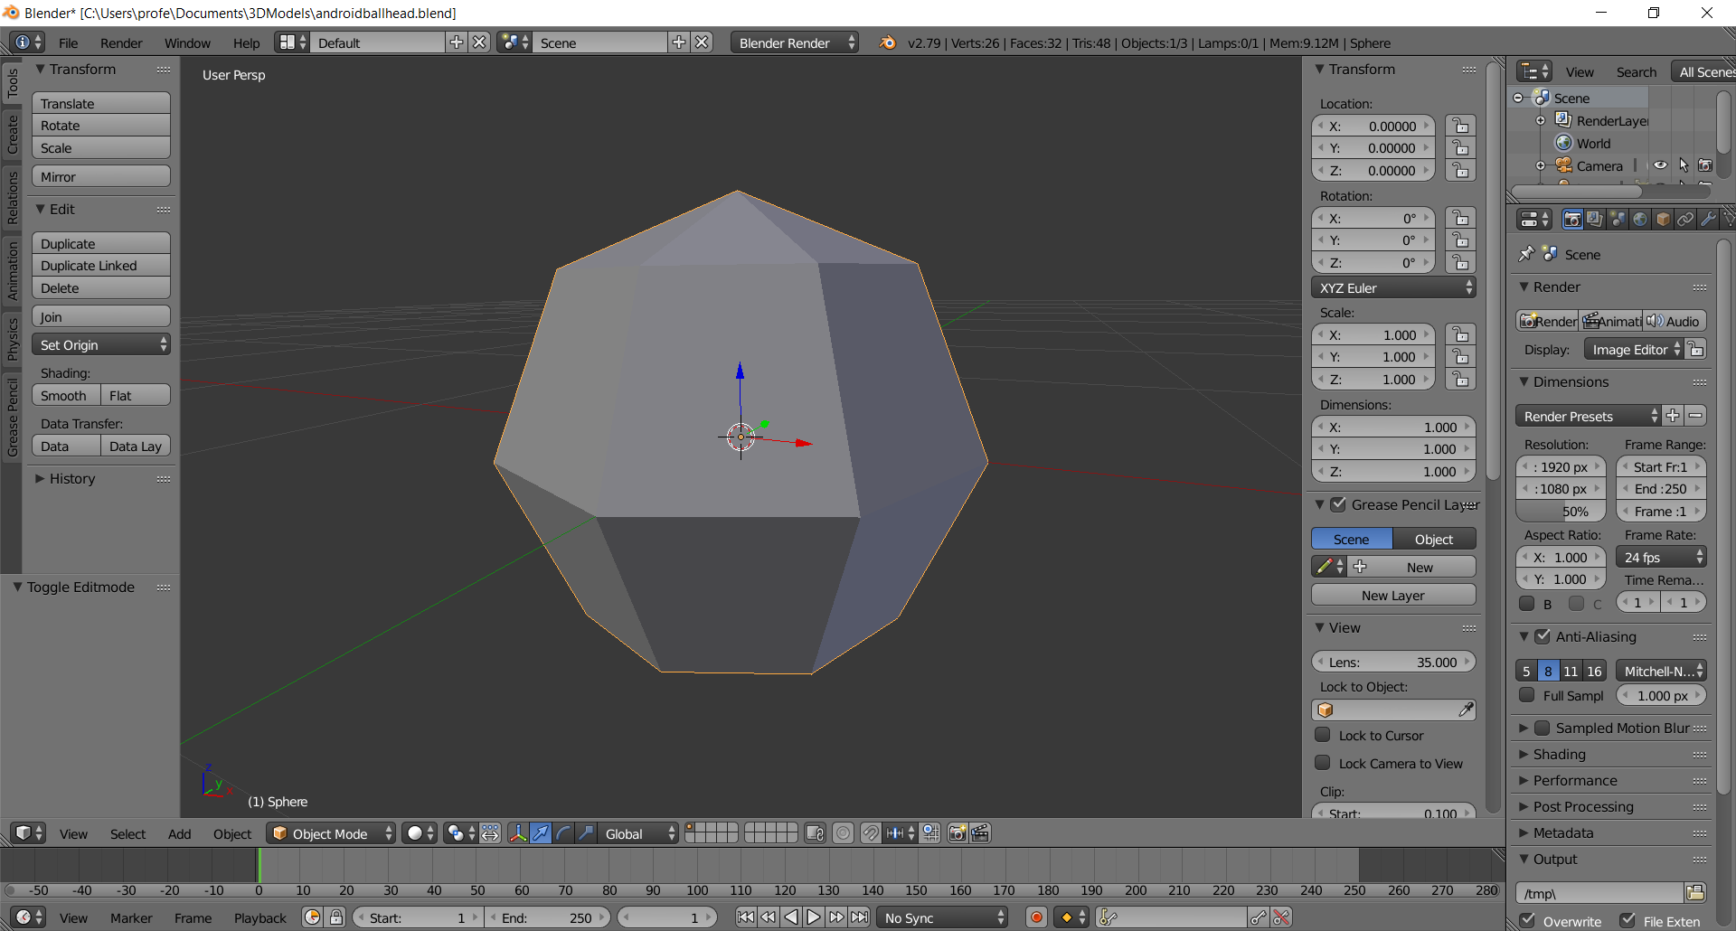
  - Press the TAB key to switch to edit more
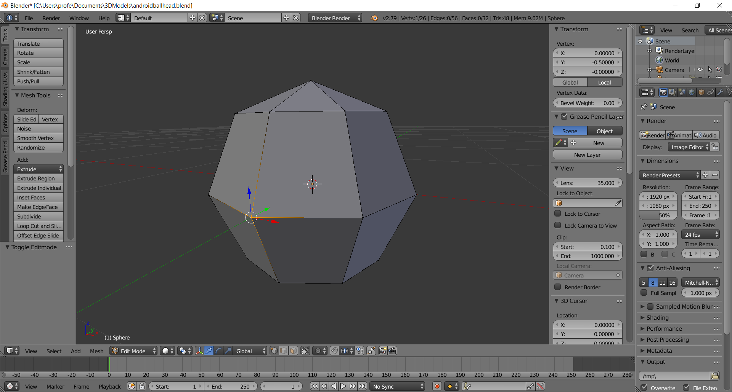
  - Switch to Vertex mode (CTRL-TAB, Click on Vertex) and select (Right-Click) the bottom face vertex
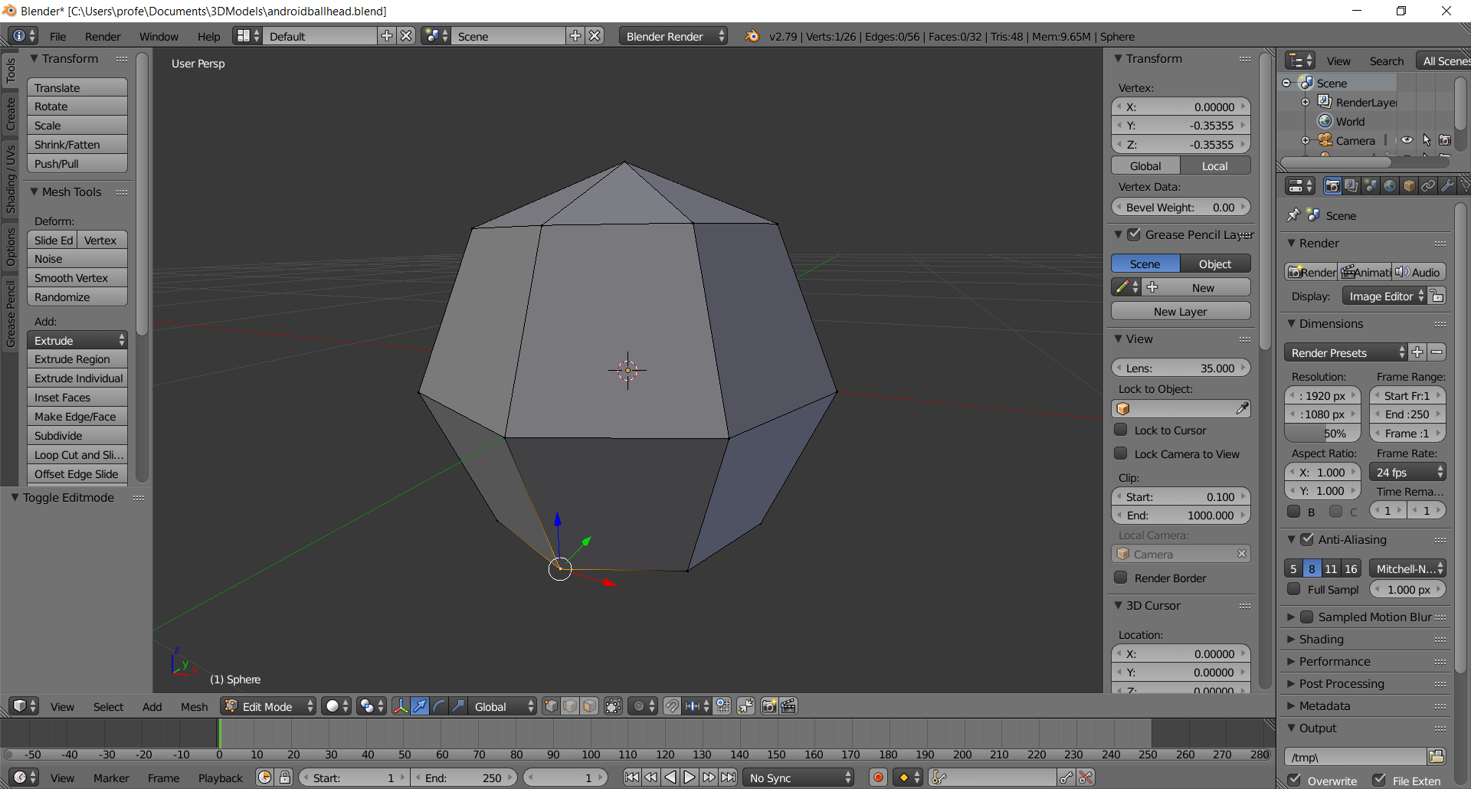
  - Type -.5 into Transform > Vertex > Y
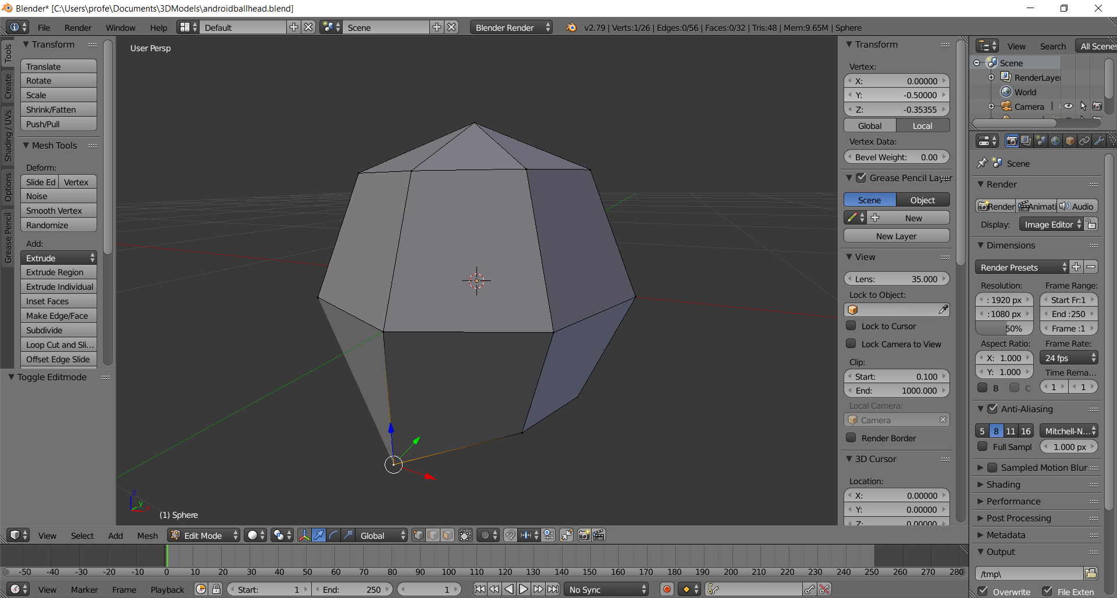
  - Select (Right-Click, Shift-Right-Click) the bottom two jaw vertices
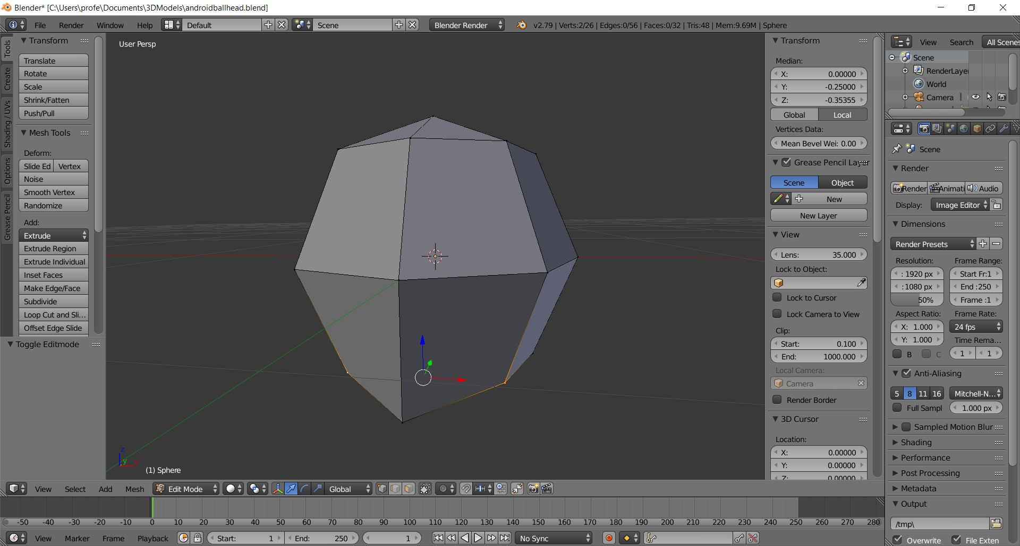
  - Enter -0.35355 into Transform > Median > Y
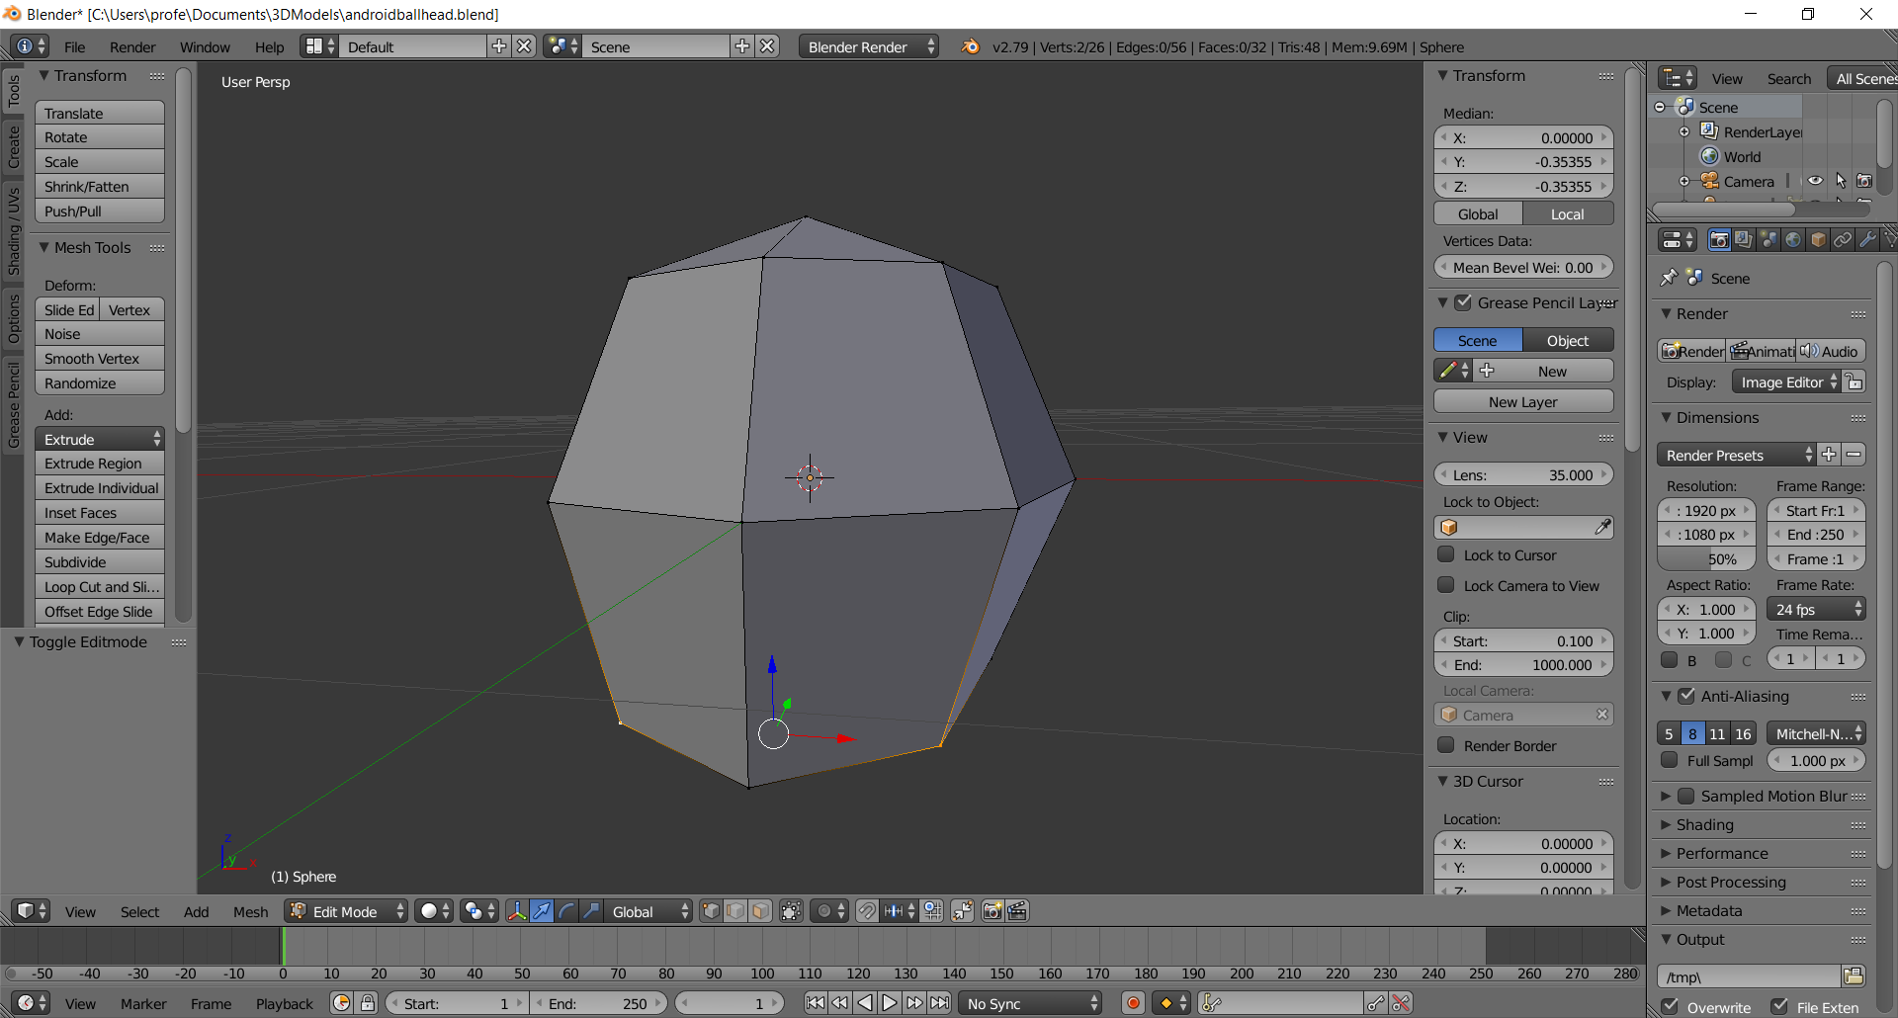
  - Shift-Select the chin-vertex:
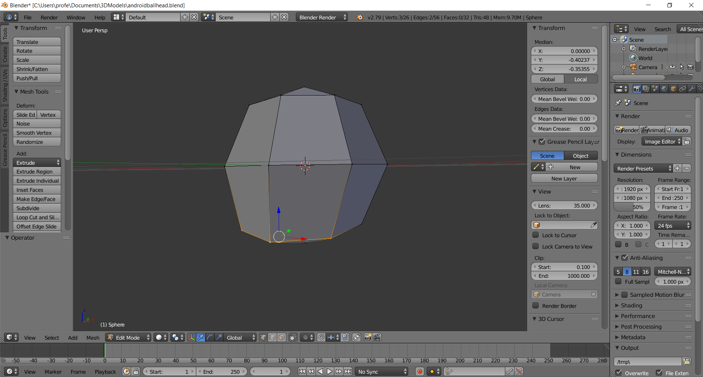
  - Enter -.5 in Transform > Median > Z
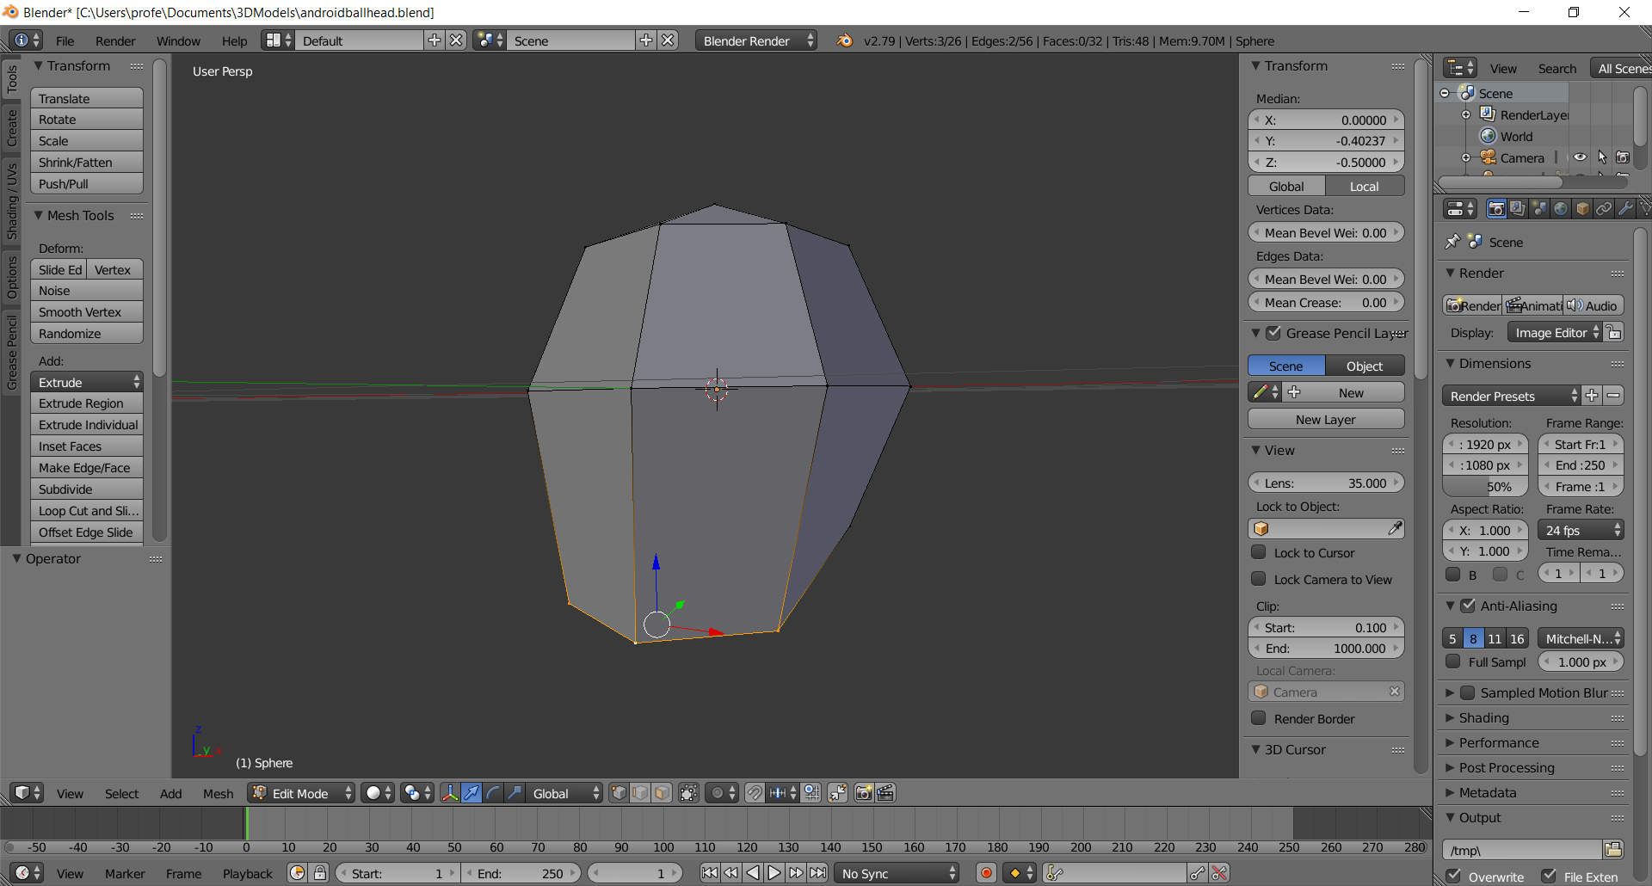
  - Tilt the head so you can see the bottom of the jaw
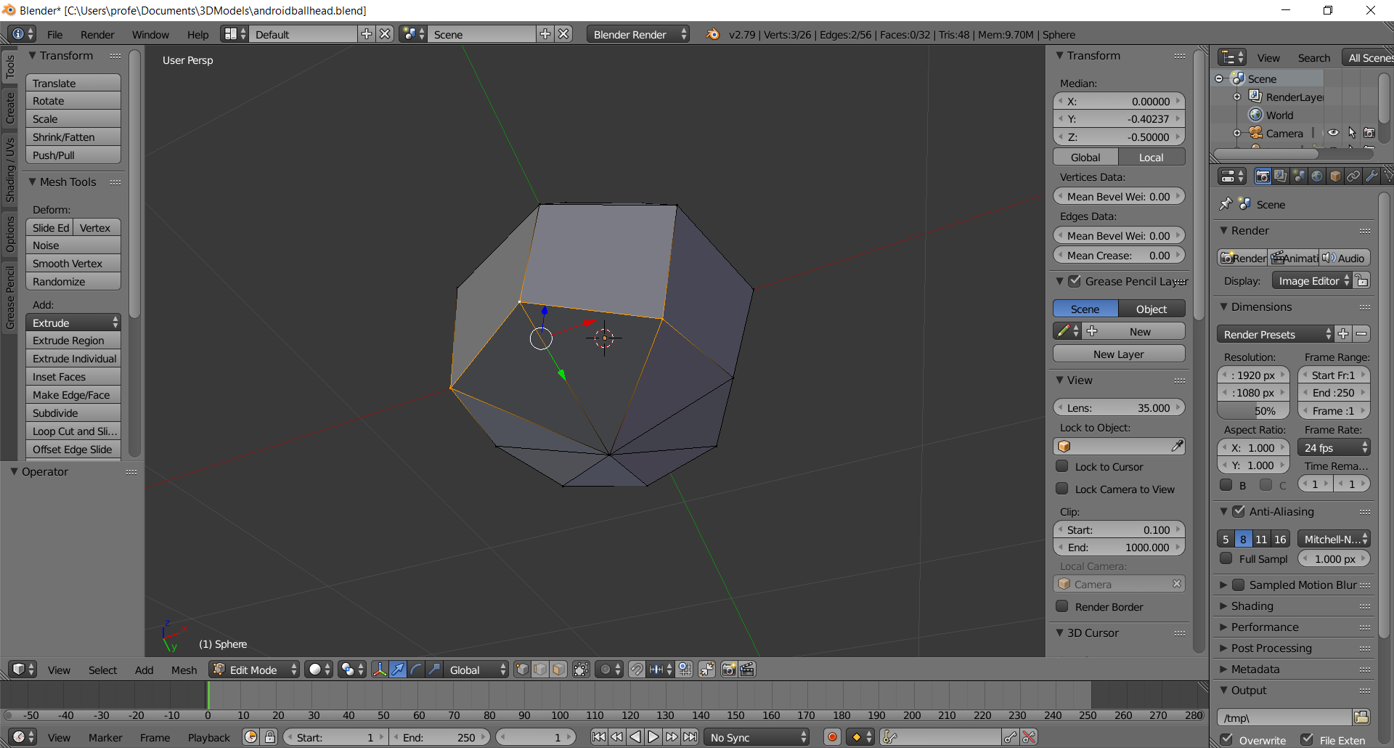
  - Switch to Edge mode (CTRL-TAB, click on Edge), then select & shift-select the two edges underneath the chin
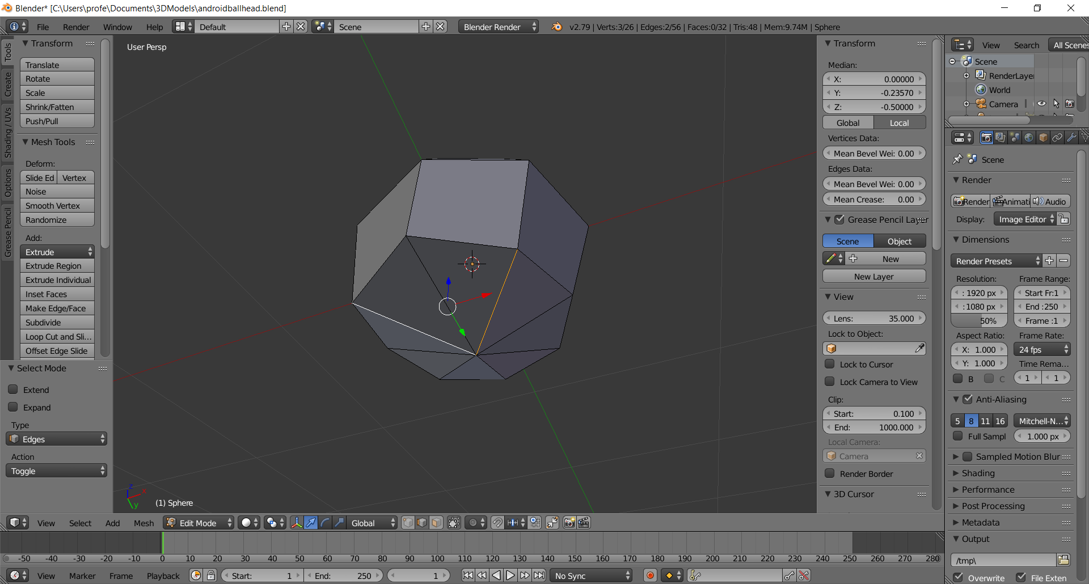
  - Press the Delete key then click Dissolve Edges in the pop-up
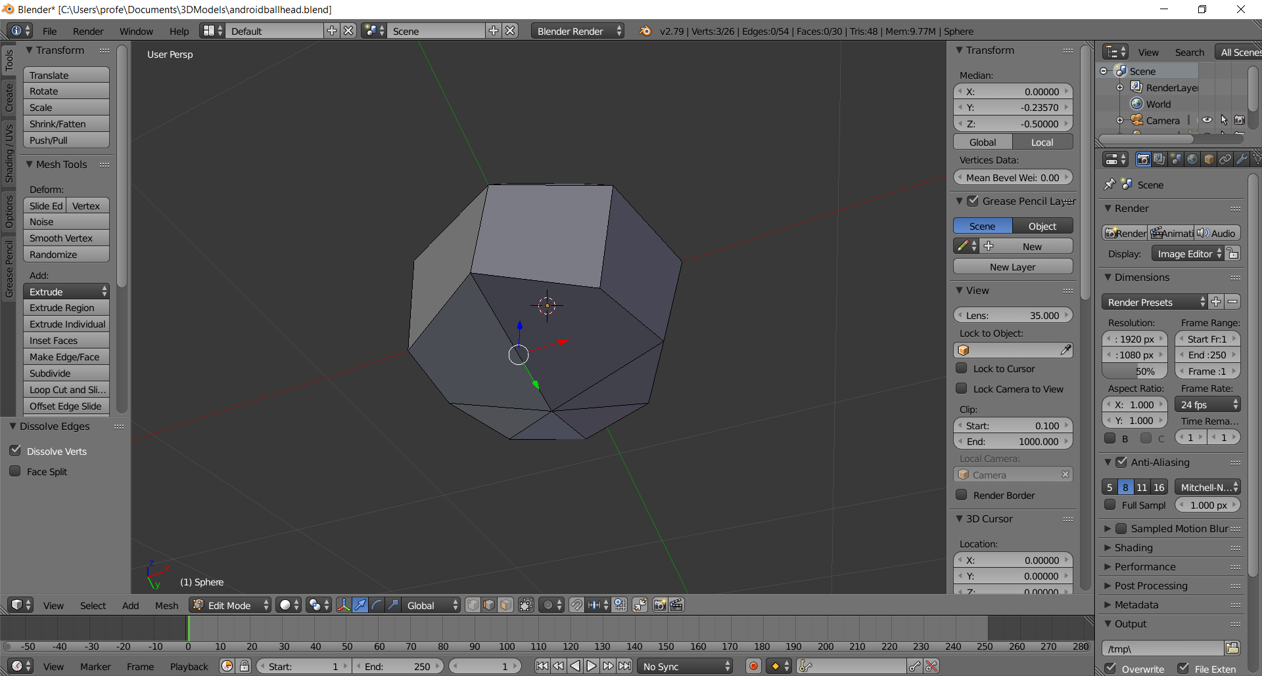
  - Select & Shift-Select the back edges
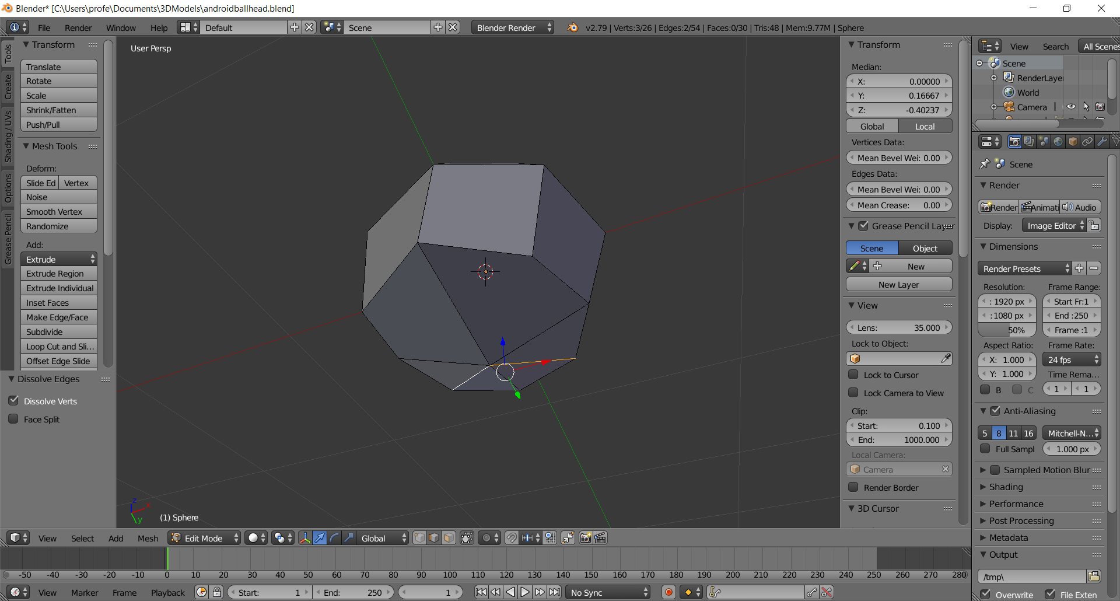
  - Press the Delete key then click Dissolve Edges in the pop-up. You should now have just 4 faces on the bottom of the head
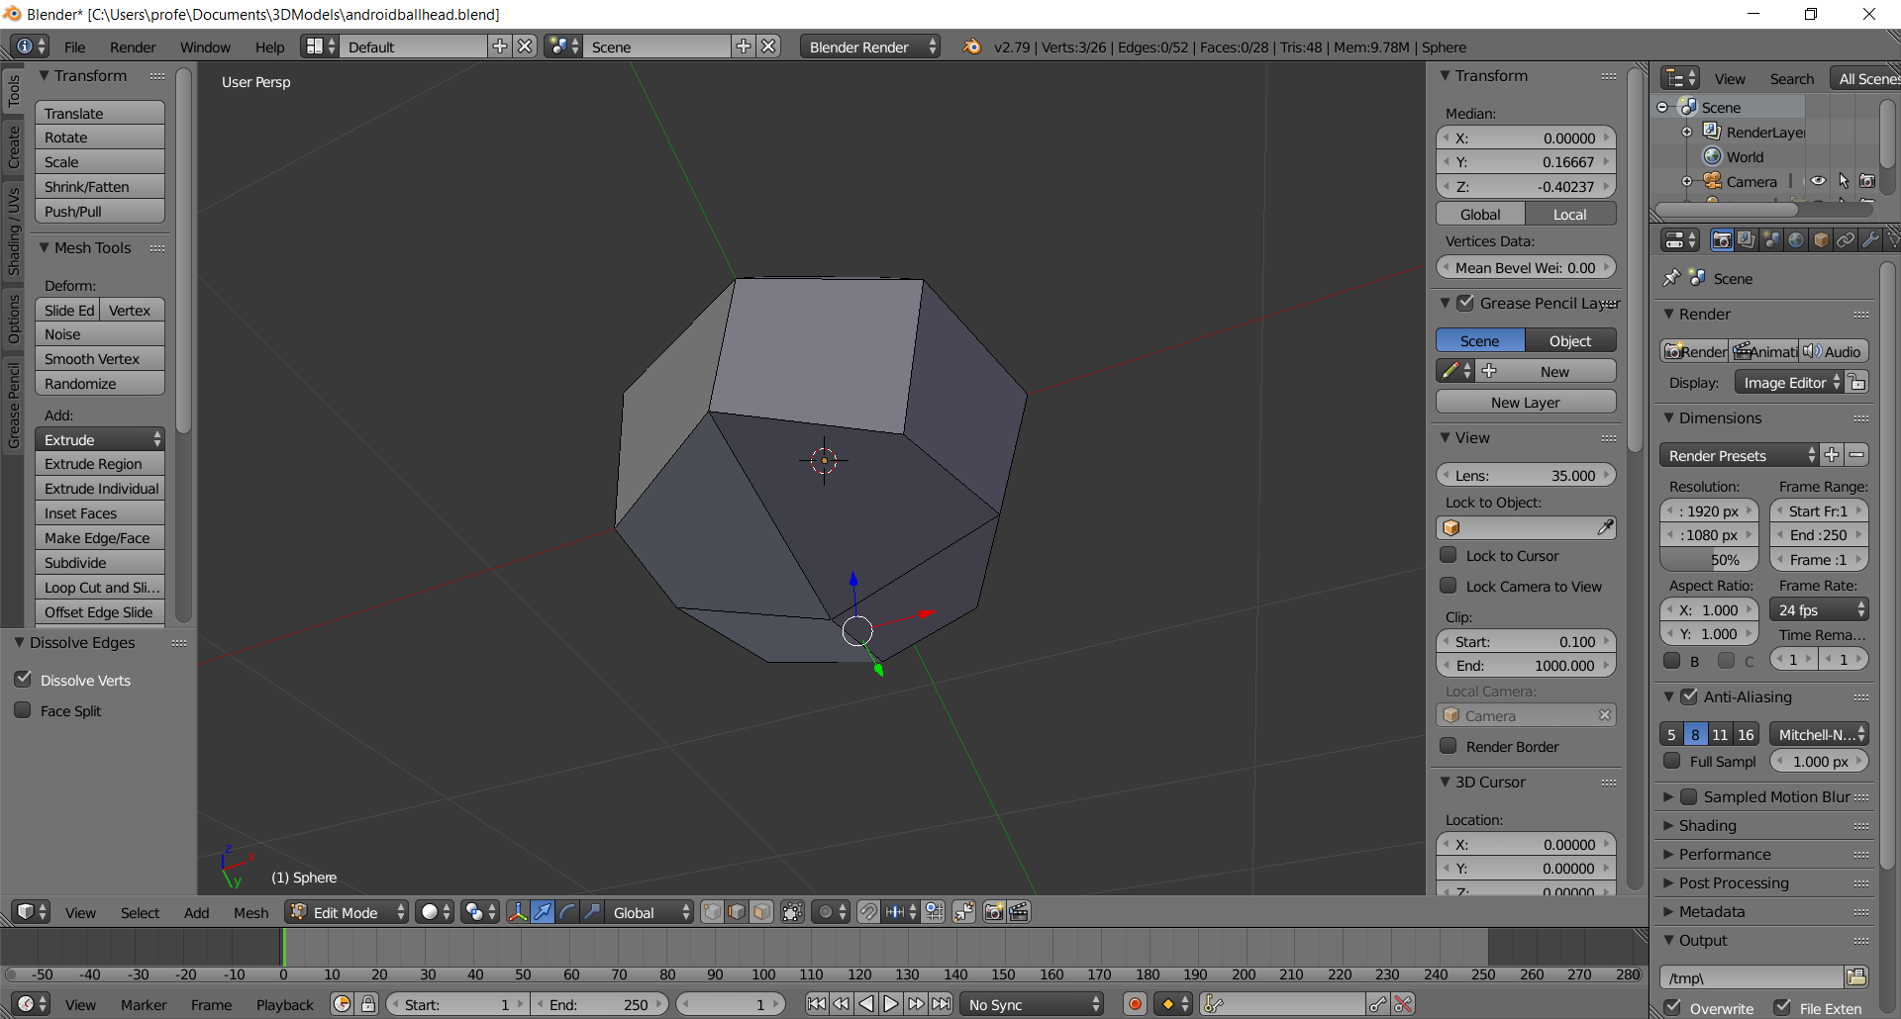
  - Rotate the head so you can see the top, then select & shift-select these 4 edges
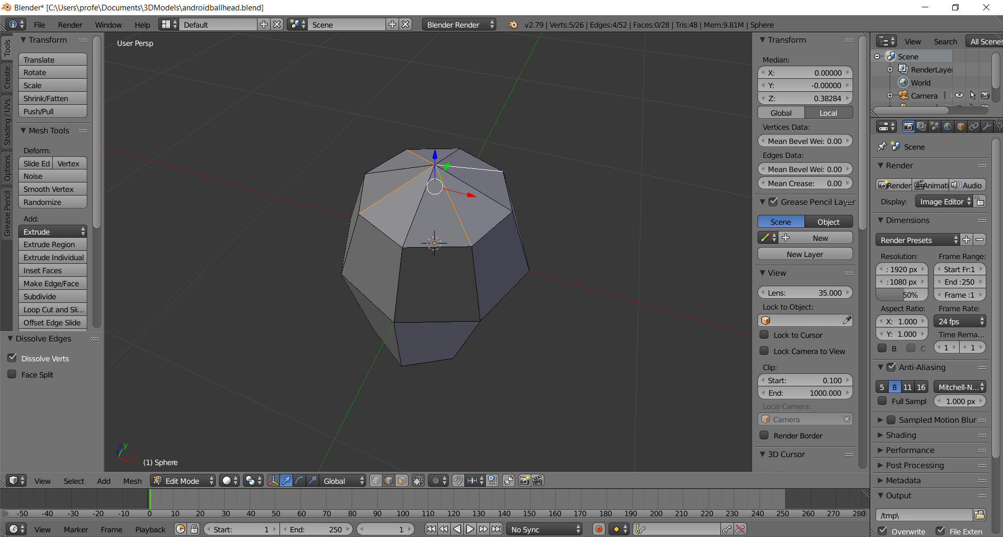
  - Press the Delete key then click Dissolve Edges in the pop-up. You should now have just 4 faces on the top of the head
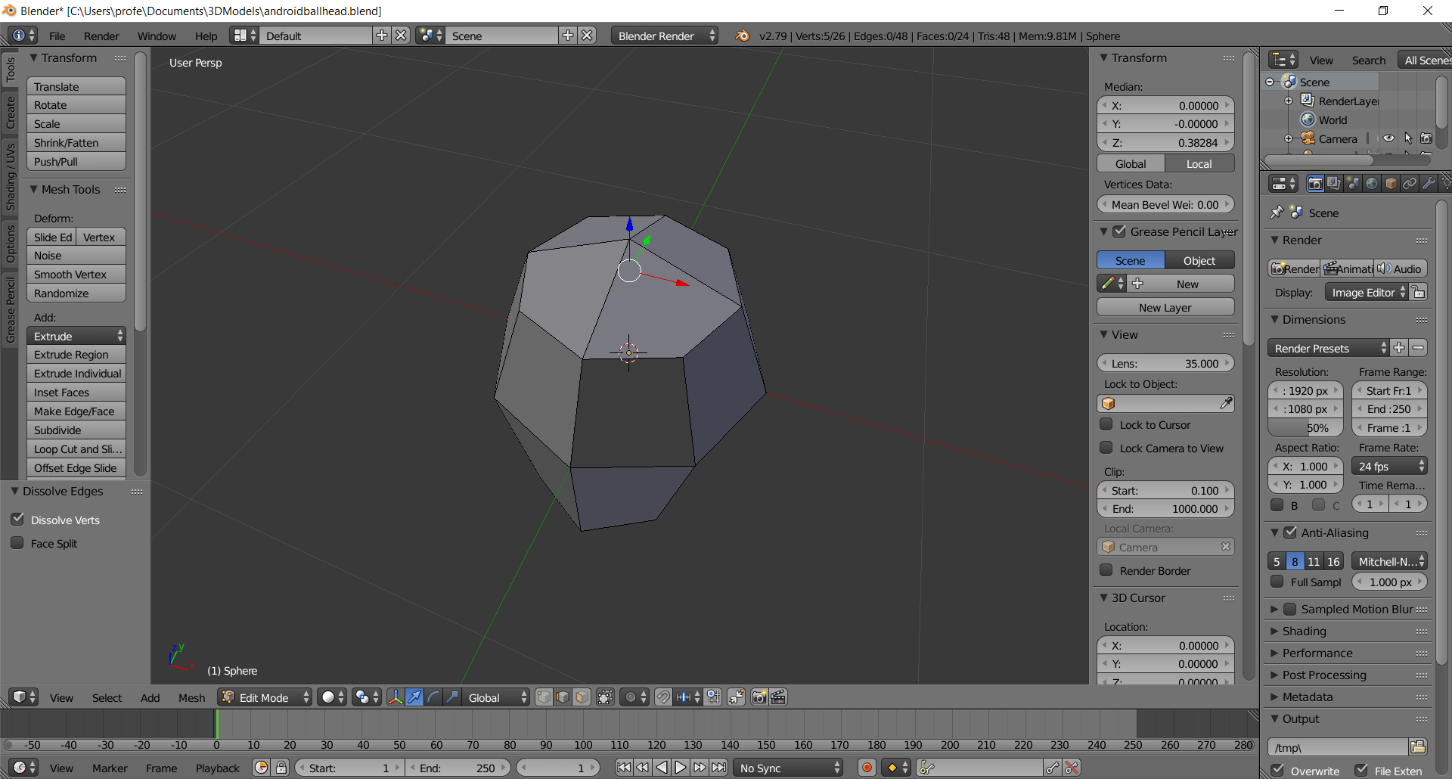

- Create the Neck
  - Rotate until you can see the bottom of the head
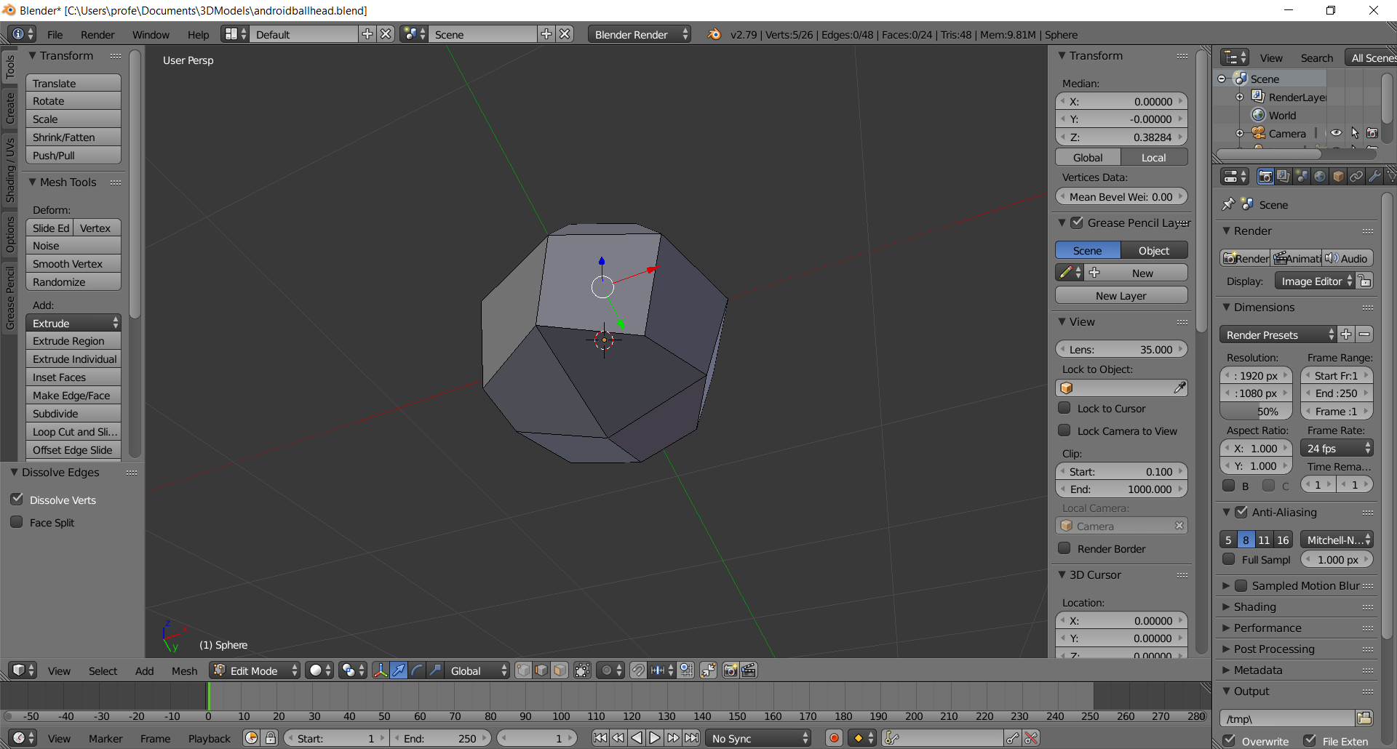
  - Switch to Face mode (CTRL-TAB, click on Face), the select, shift-select the back two neck faces
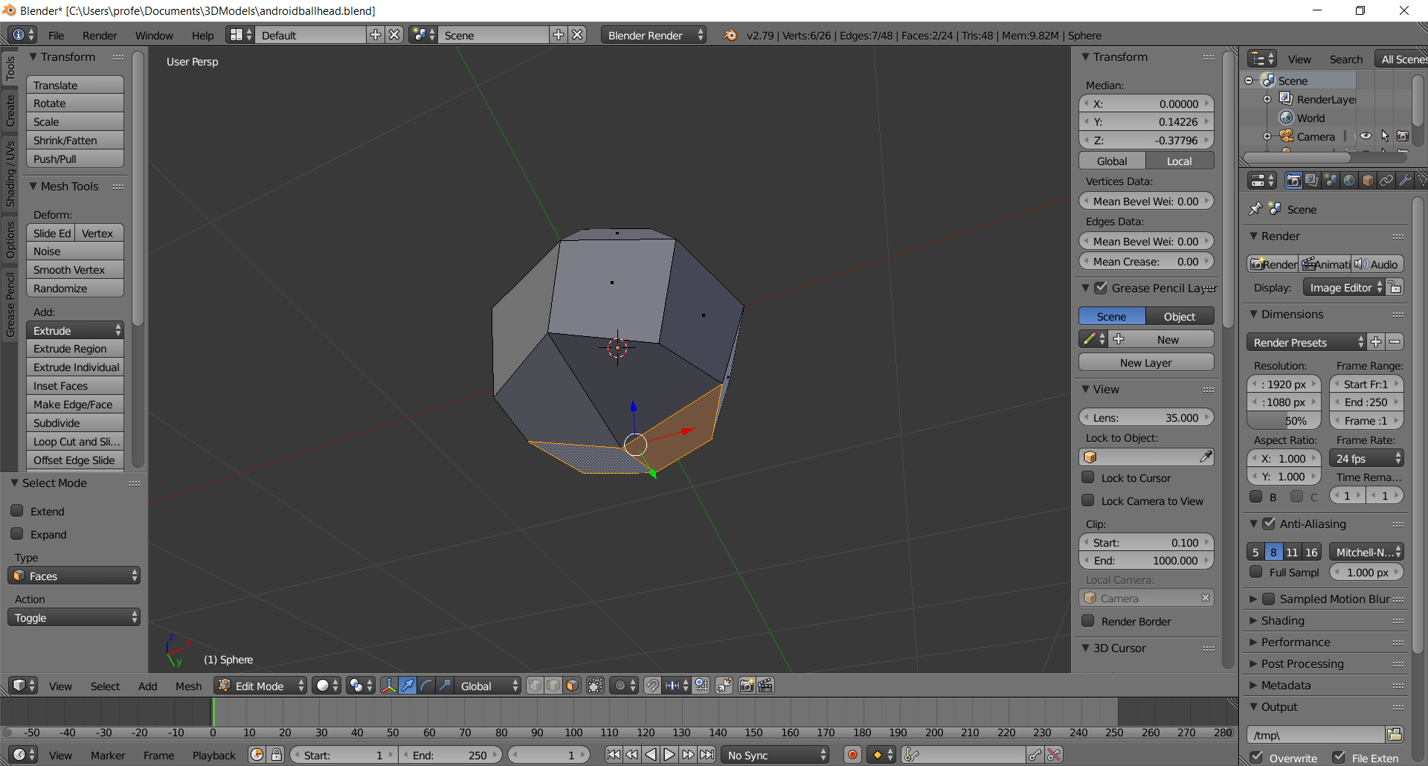
  - Extrude the neck down the Z-axis .25 units (type: E .25 Enter)
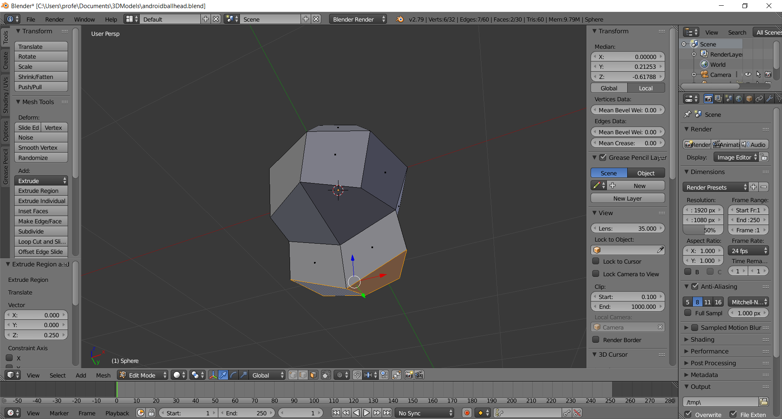

- Pop-up the Head
  - Switch to Object mode (press TAB), and rotate the head so you can see the ground grid. Note: the head is submerged into the ground
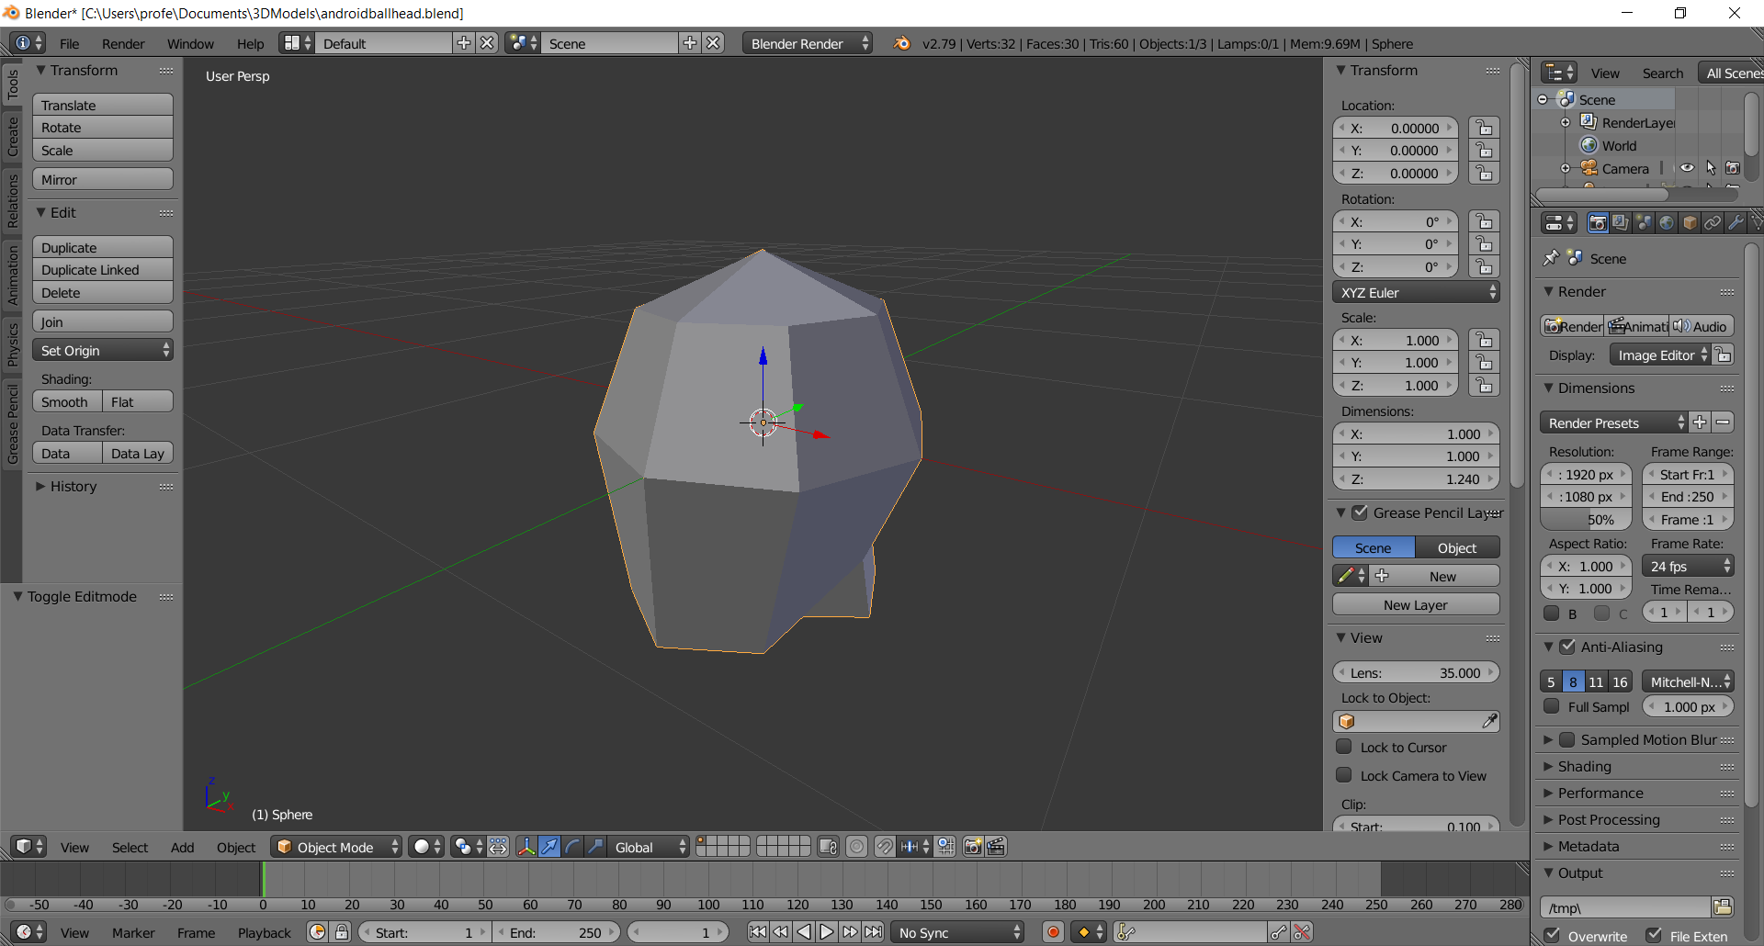
  - Enter .5 into the Transform > Location > Z. Note: the head is now above the ground plane, some of the neck is below, but that’s okay
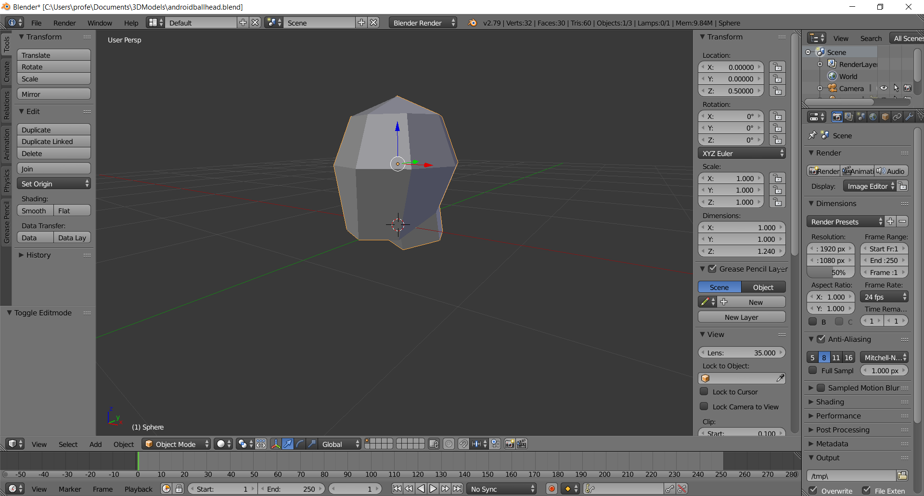
  - Save as LastNameFirstNameHead.blend

