How to Create a Fallout 4 Quest: Part 1— One-Time Setup
Nick V. Flor (nickflor@unm.edu)

Start up the GECK by running the Bethesda.Net Launcher  Note: I’m assuming:  - You have Fallout 4  - You’ve downloaded the GECK (inside the Bethesda.net Launcher)  - You’ve have signed up for an account on Bethesda and are logged in. | 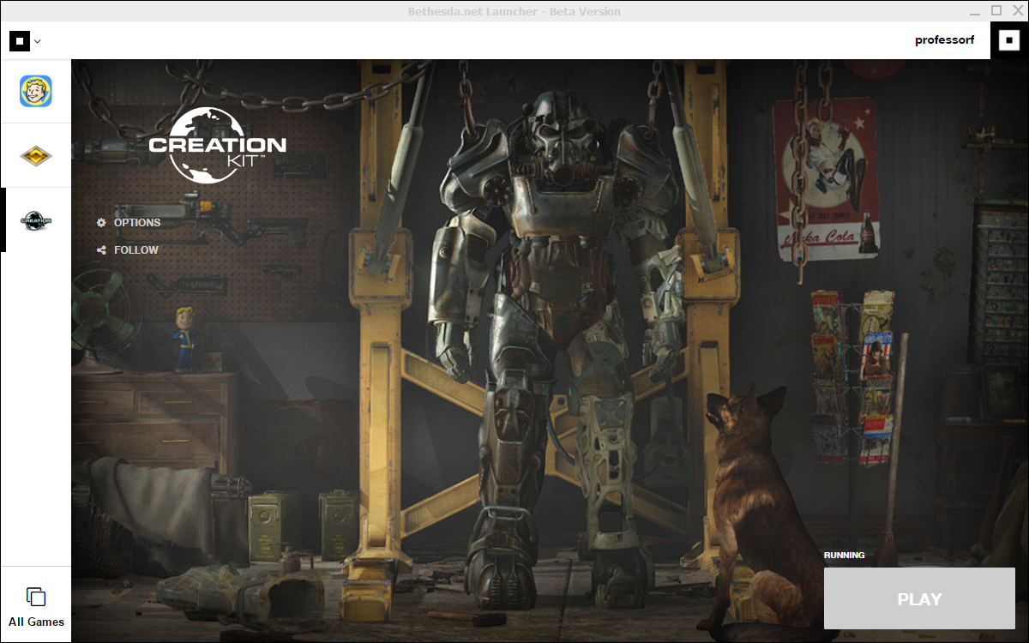
Click the Play button (lower right corner)  Click OK to any dialogs that pop up.  Three windows will appear:  - Object Window: Eventually will contain all the objects in the Fallout 4 world. Basically, everything you see in the game has an object that is referenced here  - Cell View: Specific “cells” in the world, like rooms and towns  - Render Window: Displays the current cell you’re editing | 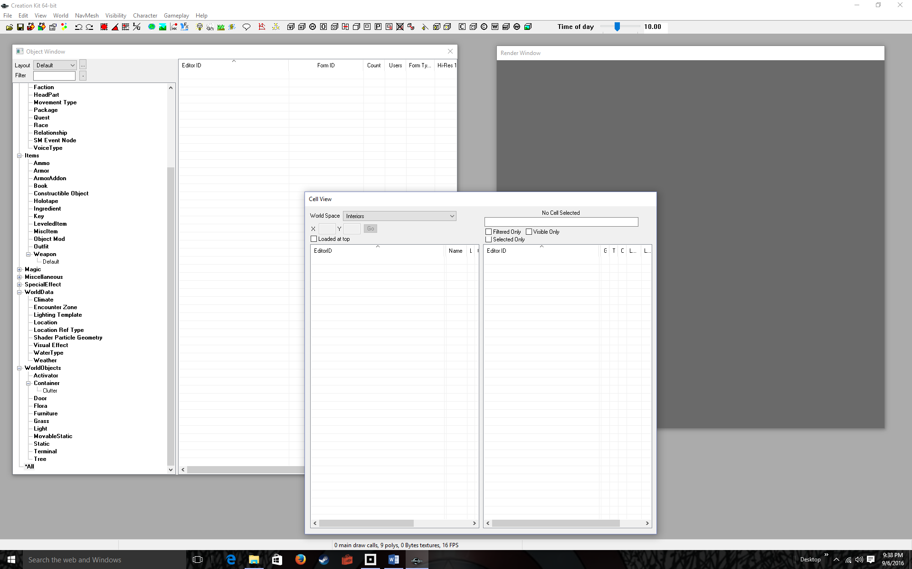
Menu-Select File > Data… | 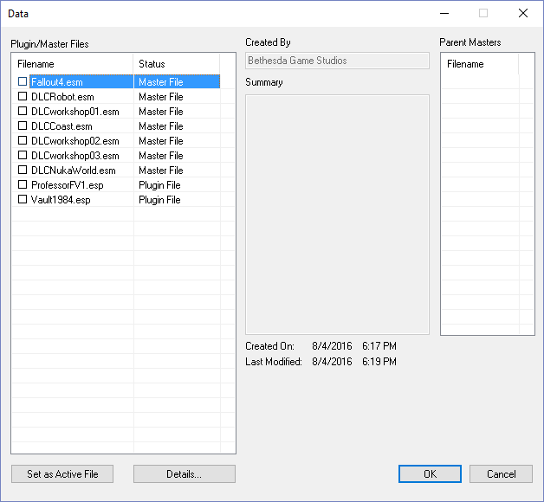
Double-click the Fallout4.esm | 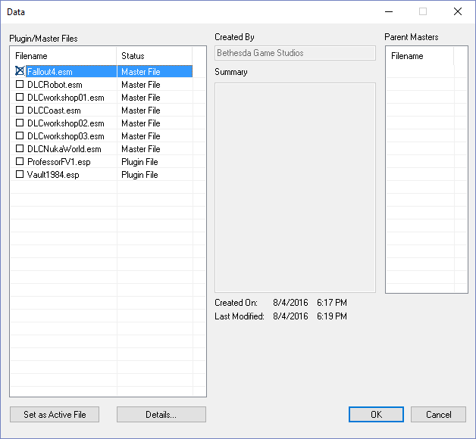
Click the OK button  Note that the Object Window and Cell View windows are populated with data representing the objects in the Fallout 4 world. There is also a warnings windows filled with warning messages. Ignore all of them. | 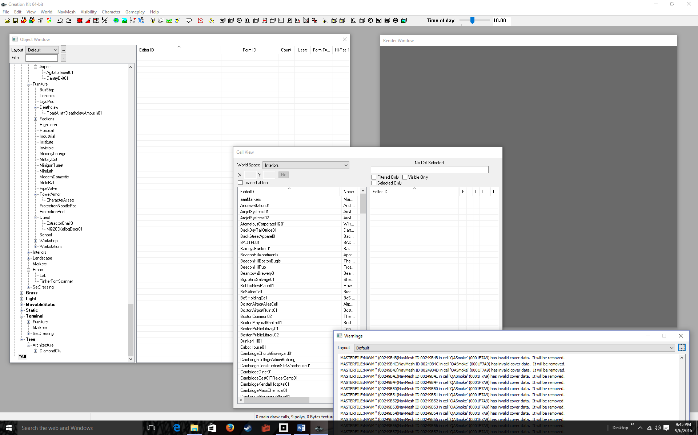
Double-Click on any item in the left list in the Cell View Window  This brings up the object in the Render Windows.  For example if you double-click on BeaconHillPub, you’ll see it appear in the Render Window  To navigate the Render Window:  - Mouse wheel zooms in and out  - Holding down the mouse wheel while dragging the mouse, pans  - Holding down the Shift-Key while dragging the mouse rotates  - If you click on an object in the render window, Shift-Key (mouse move) rotates around that object | 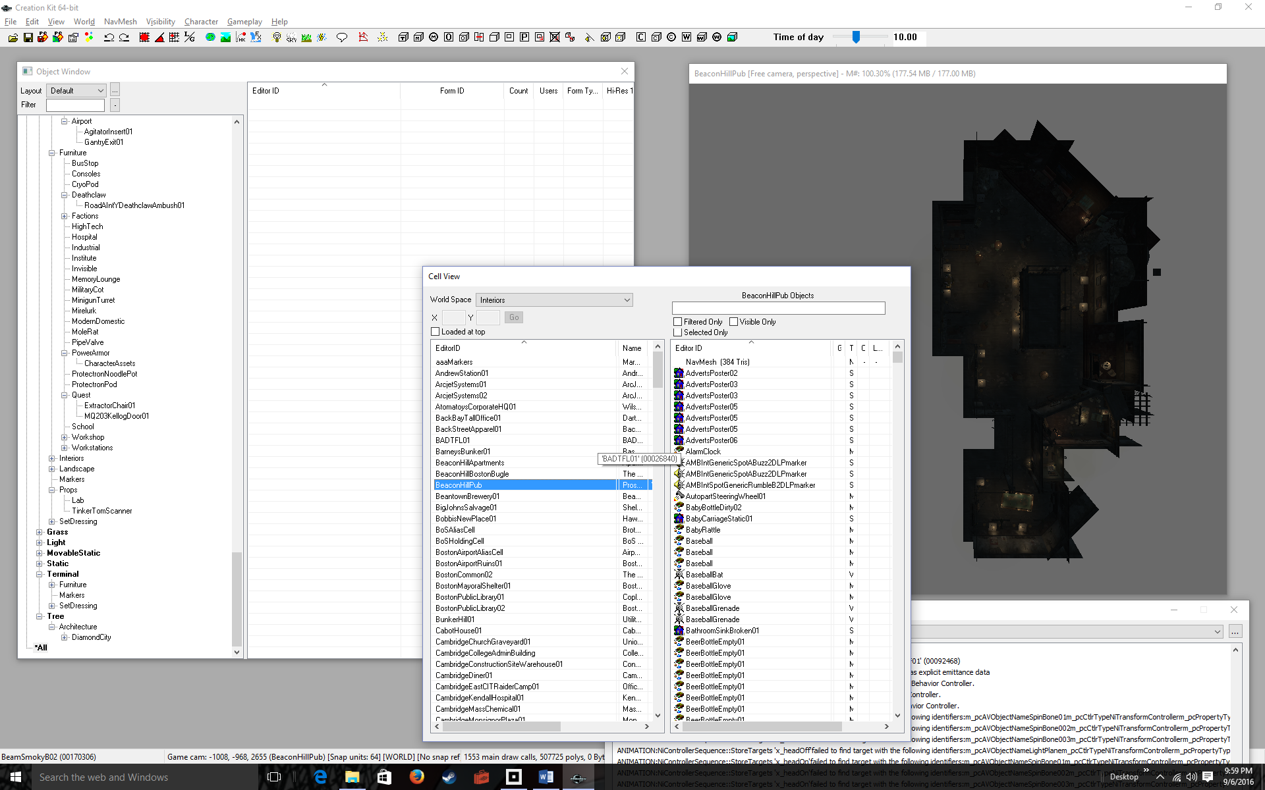
Menu-Select File > Save | 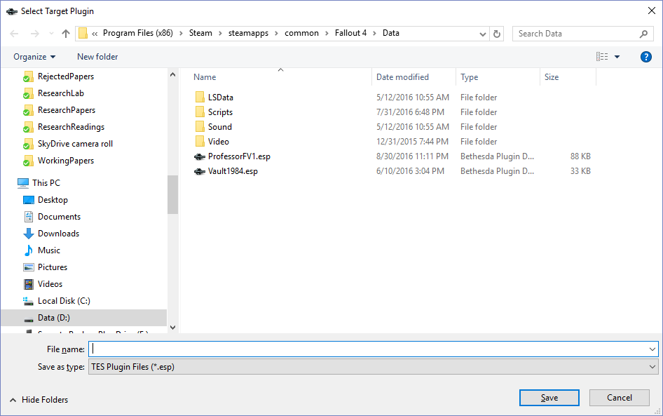
Type in a File name  I type ProfessorFTutorial, but you should choose something easy to remember like YournameTutorial. The filename doesn’t have to end in Tutorial, I just chose that because this is a tutorial! | 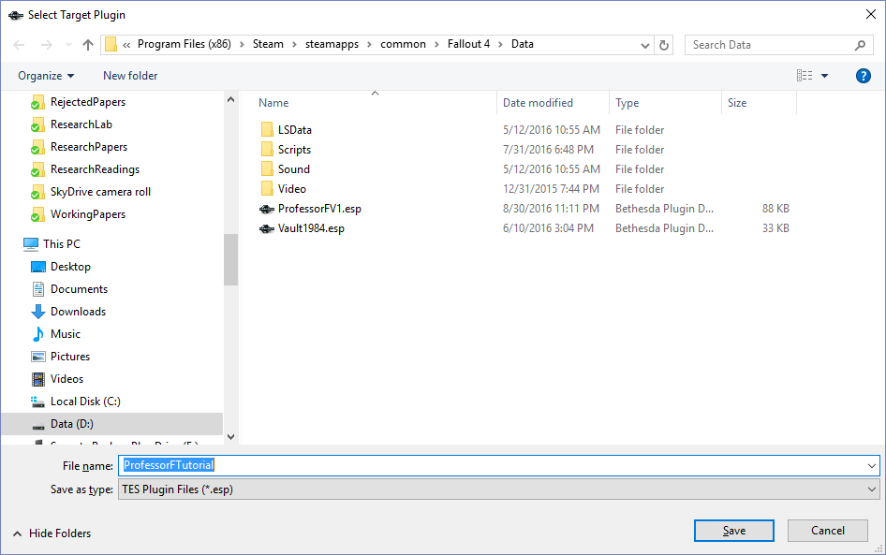
Click the Save button  Note that the title bar of your Window is whatever you named your file in the previous step.  You’re done creating your first mod! It doesn’t do anything interesting, it’s just a copy of Fallout 4.  But it’s the starting point.  Go to the next tutorial to load your mod into Fallout 4. | 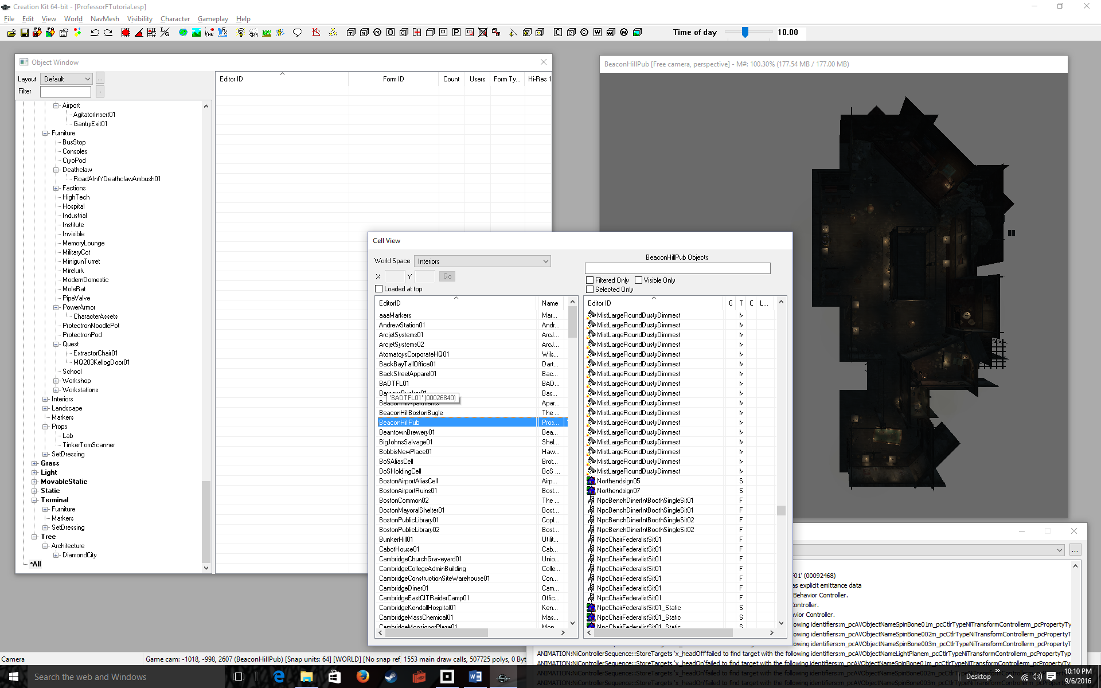
Enable Loose Files
Open\Create the file : <Documents>\My Games\Fallout 4\Fallout4Custom.ini
Populate the Fallout4Custom.ini file with the following:

[Archive]
bInvalidateOlderFiles=1
sResourceDataDirsFinal=

