How to Create a Fallout 4 Quest: Part 10— Quest Accept
Nick V. Flor (nickflor@unm.edu)

- Start up the GECK by running the Bethesda.Net Launcher,  - Open up your Mod (as in Tutorial 3) then  - Bring up your Quest  - Click on the Scenes tab  Yes I skipped a lot of steps, but by now you should know how to bring up your quest. | 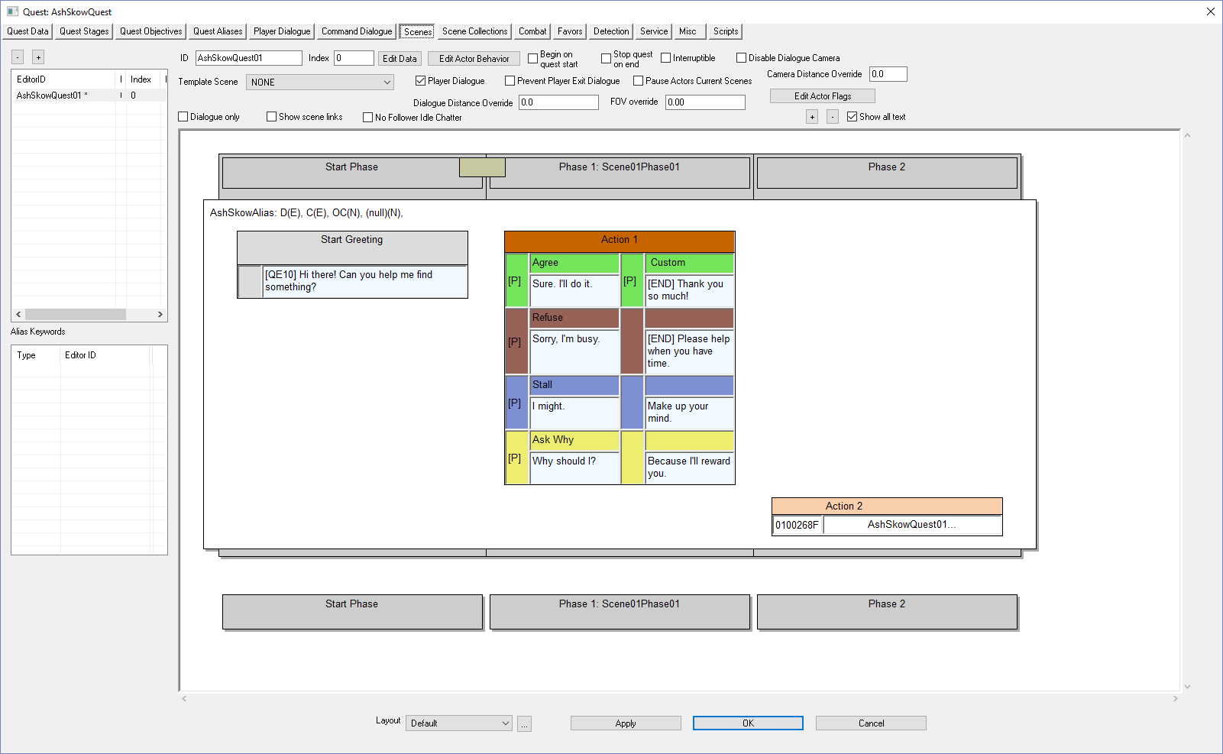
Double-Click the NPC Custom text corresponding to the Player agreeing  In our example this is: Thank you so much! | 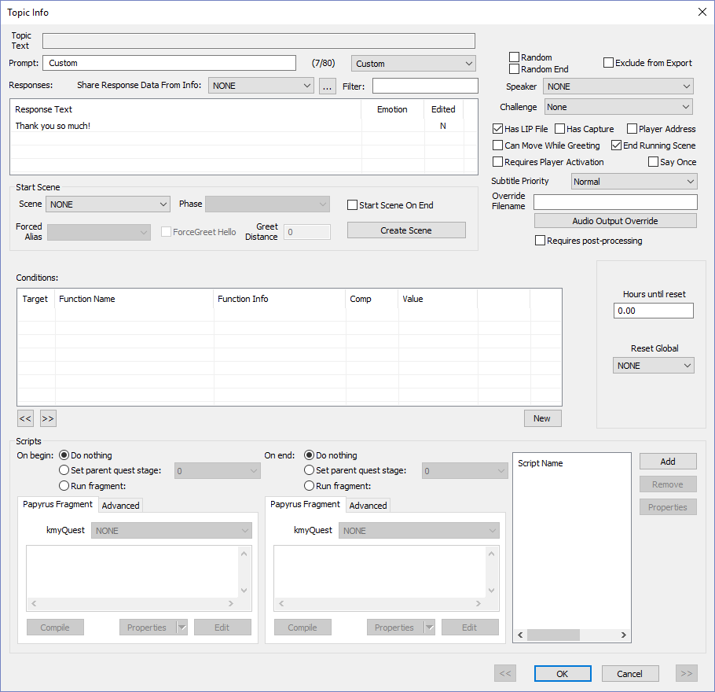
- Check the radio button Set parent quest stage  - Select the retrieve quest stage # (20) | 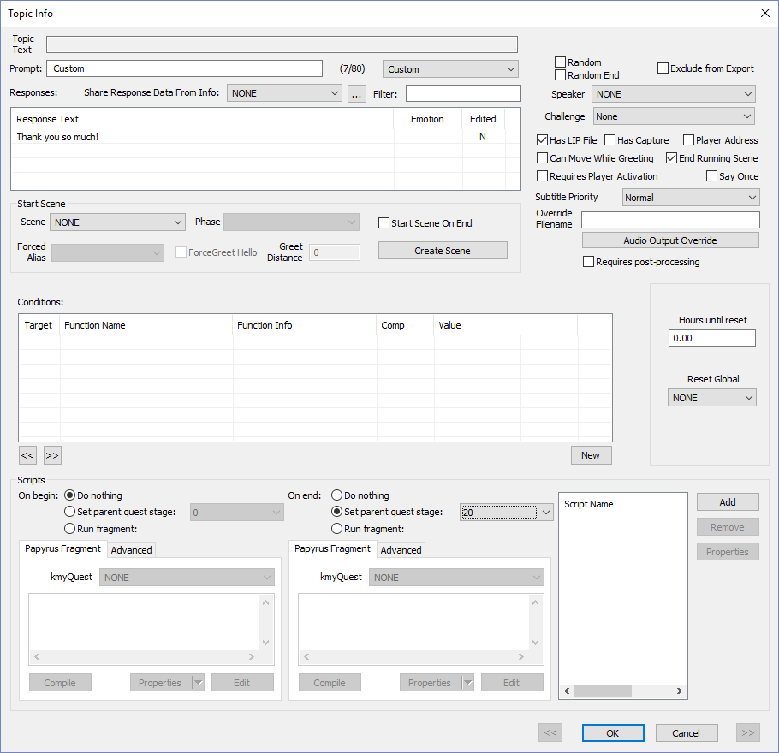
Click OK  Note in brackets near the NPC response is QE20, which means ending the dialog will set the quest stage to 20.  Now we have to add code to set the objective displayed to the accept objective (20).  Also note I purposely made Quest Stage #s and Quest Objective #s match. They don’t have to. The numbering is up to you. But it makes it easier to remember. | 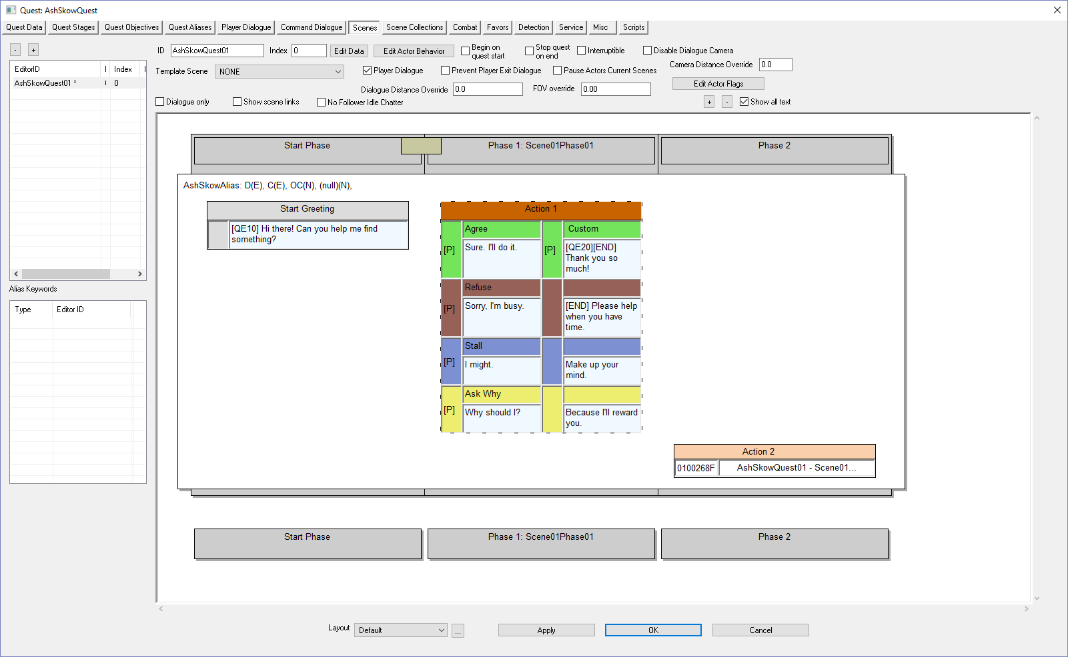
- Click the Quest Stages tab  - Click on the quest agreement index (20) | 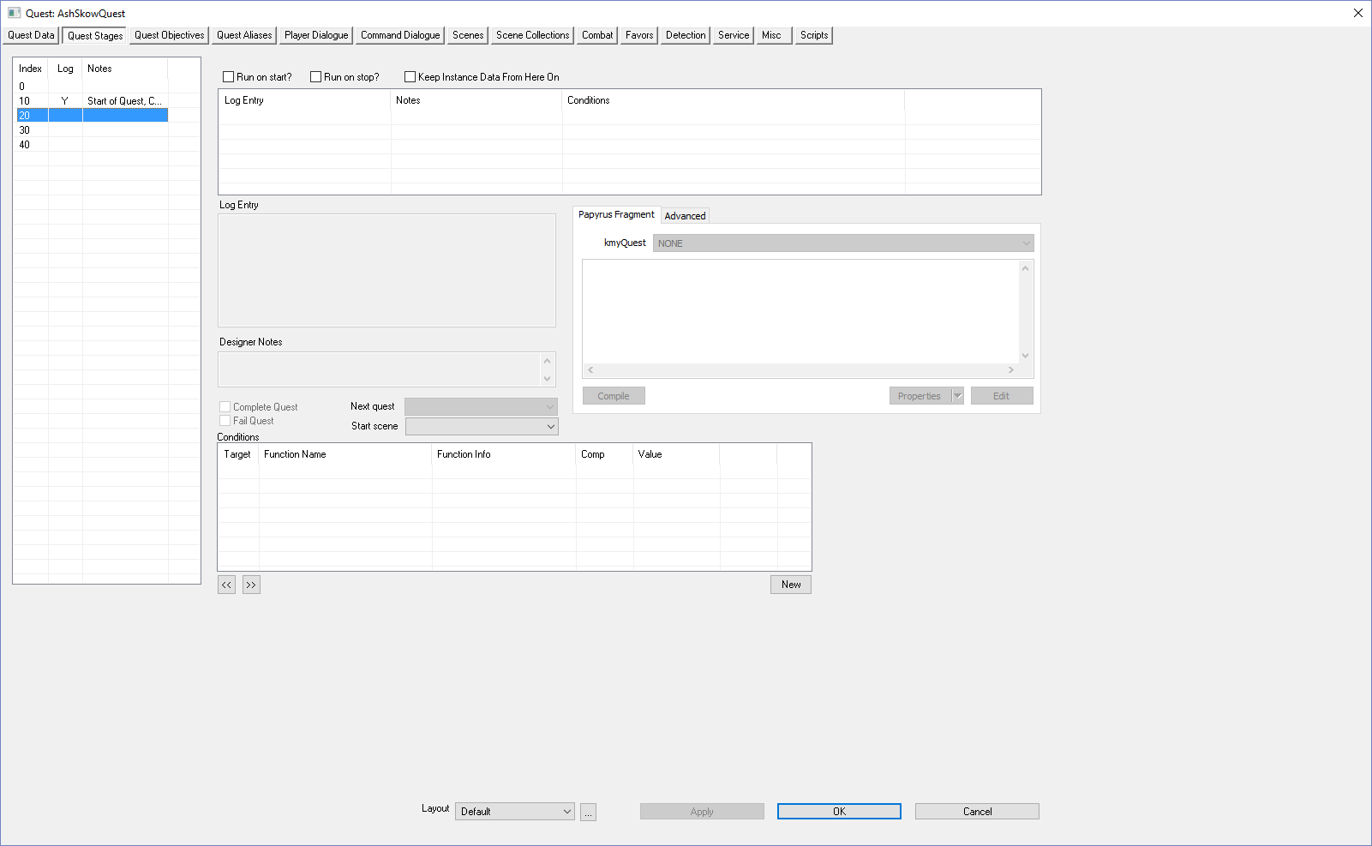
Right-Click over Log-Entry | 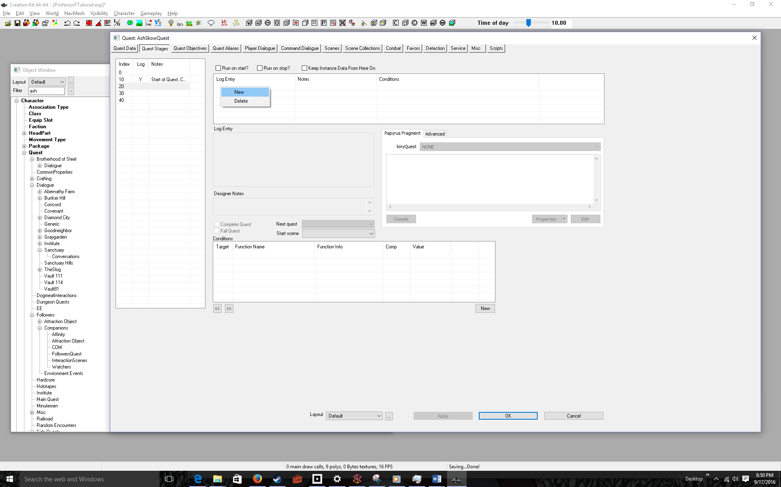
- Select New  - Add a Log Entry  - Add a Designer Note  - Add Code to Display the Accept Objective  - Click the Compile button  The Code:  SetObjectiveDisplayed(20)  Will display Retrieve Object for Ash to the player | 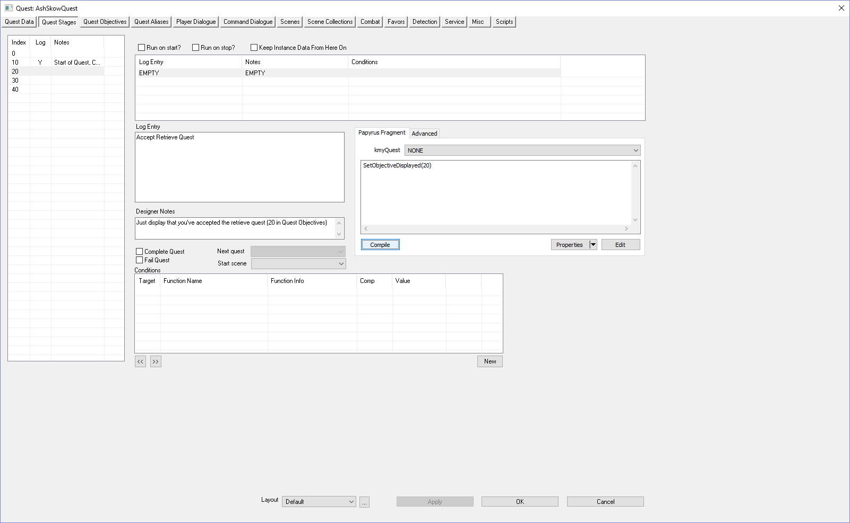
Click on the Quest Objectives tab  Note that Objective 20 has the Display Text Retrieve Object for Ash, which will be displayed once the user agrees to the quest. | 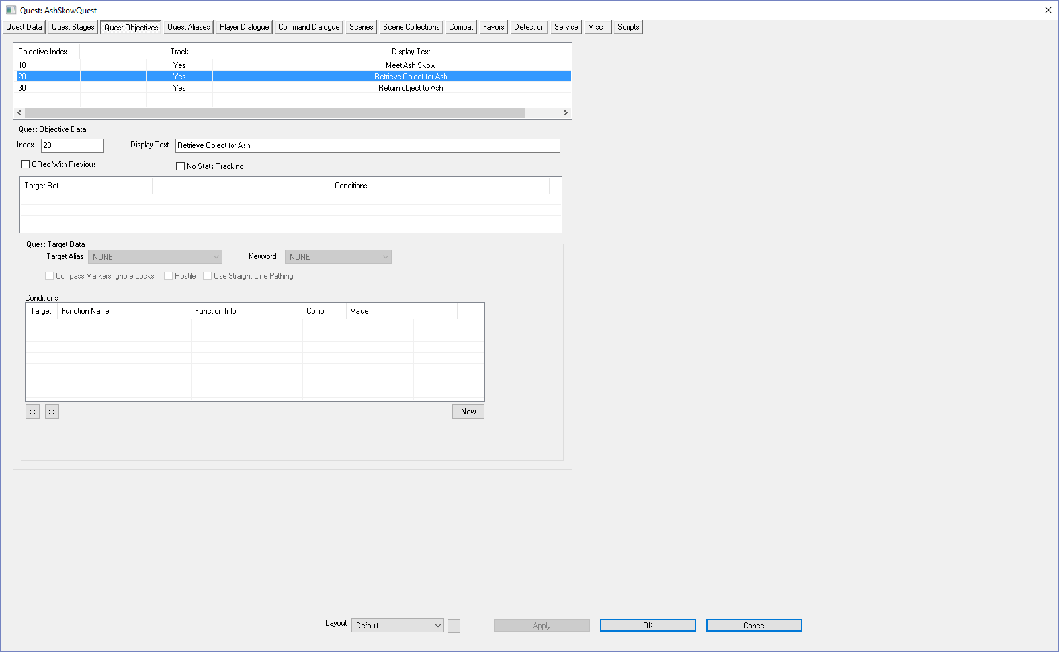
- Click the OK button  - File > Save | 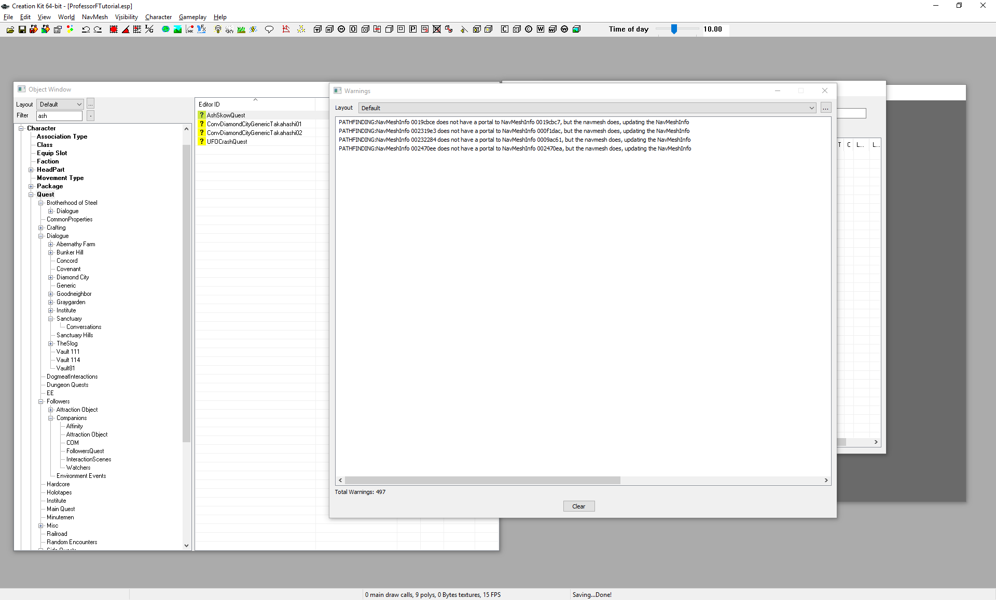
- Startup Fallout 4  - Talk to Ash  Since you quit out you’ll see all the Start Quest dialog. I “fast-forwarded” to the talk dialog. | 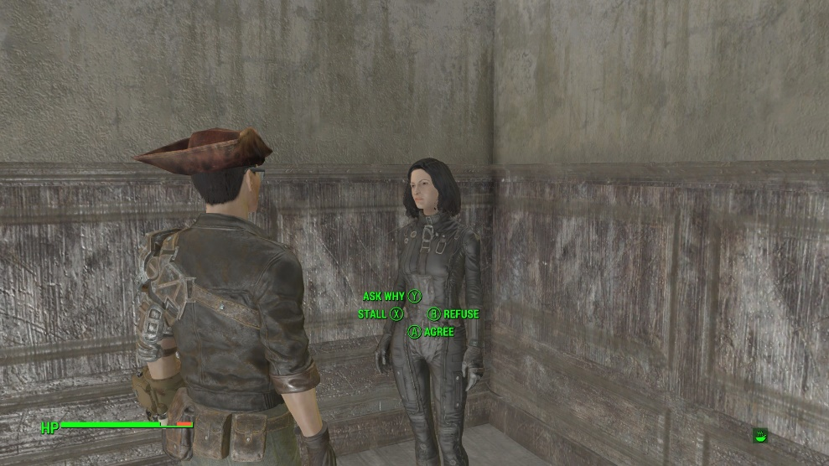
Agree and wait for the dialog to finish | 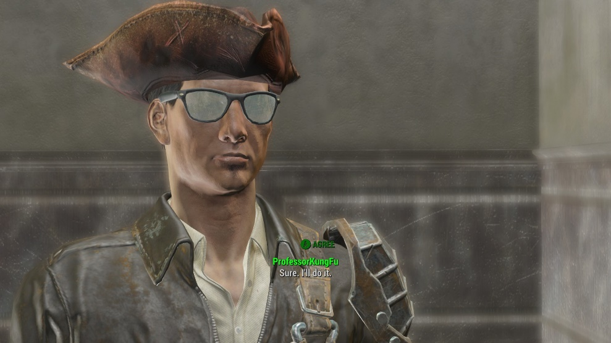
Wait | 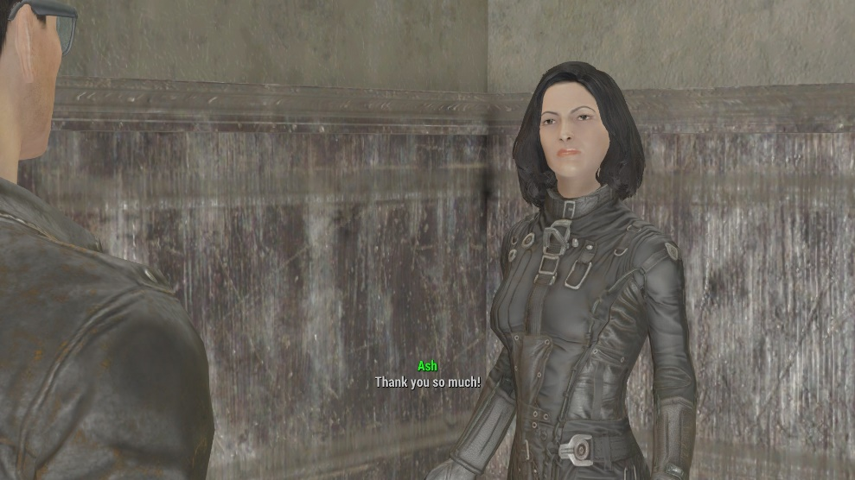
Wait  The game displays the message: Retrieve Object for Ash (Objective 20 text). And you’re ready to retrieve the object (Teddy bear). | 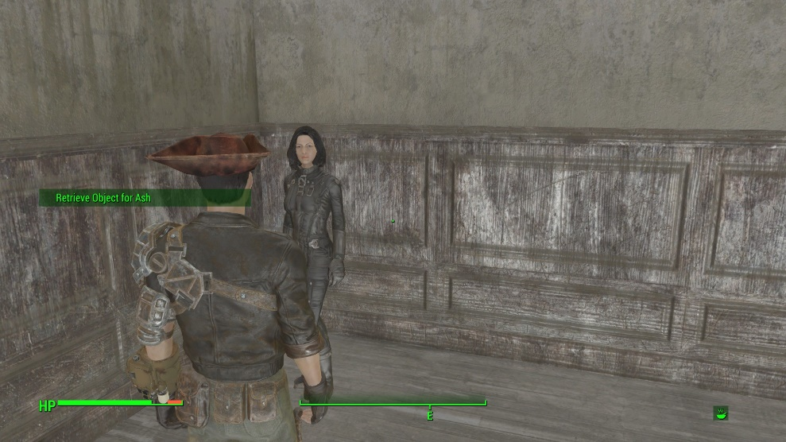

Don’t forget to quit out (Alt-F4) otherwise Fallout 4 will remember your quest and make it hard to debug.

