How to Create a Fallout 4 Quest: Part 11— Creating Dialog (Middle)
Nick V. Flor (nickflor@unm.edu)

Start up your Mod in the GECK  Open up your Quest  Select the Scenes tab  Note: This is only if the GECK isn’t running, and yes I skipped a lot of steps because we’re far into these tutorials!  Having accepted the quest, we need to add a scene to handle the dialog where the user runs into the NPC but DOES NOT have the object to be retrieved. | 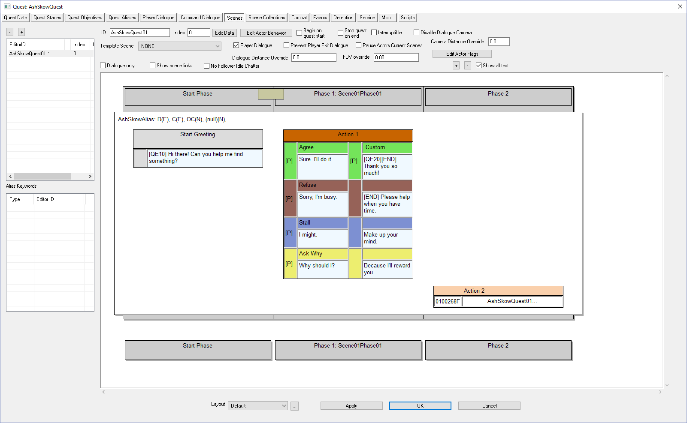
Right-Click over the EditorID panel | 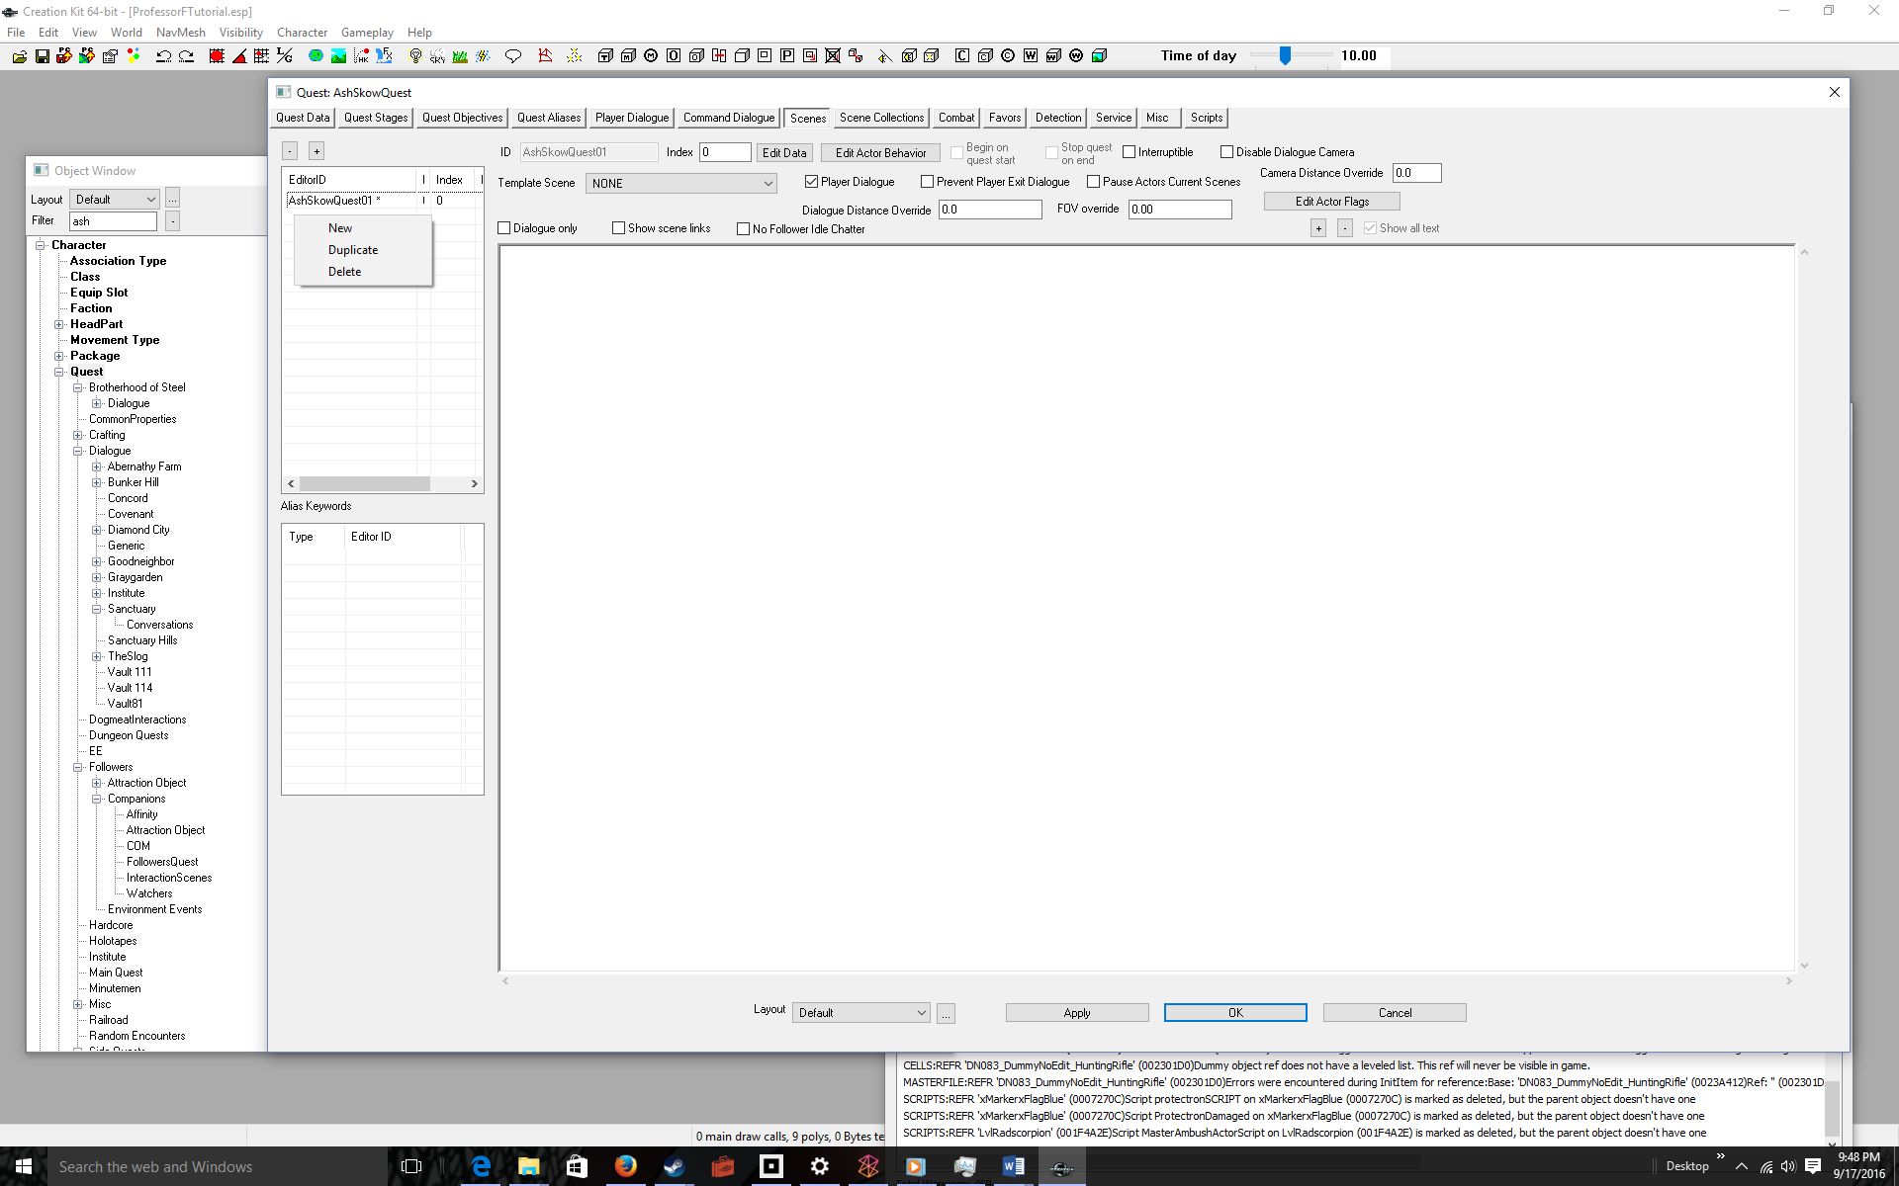
Select New  The quest ID is shown as a prefix. Don’t use that as a scene ID, do the next step | 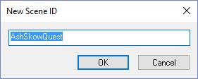
Append NN to the text  Where NN is the number of the scene. I used 02 because 01 was the greeting scene. | 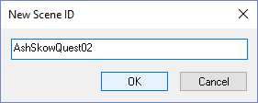
Click OK  Note the scene name appears in the EditorID. | 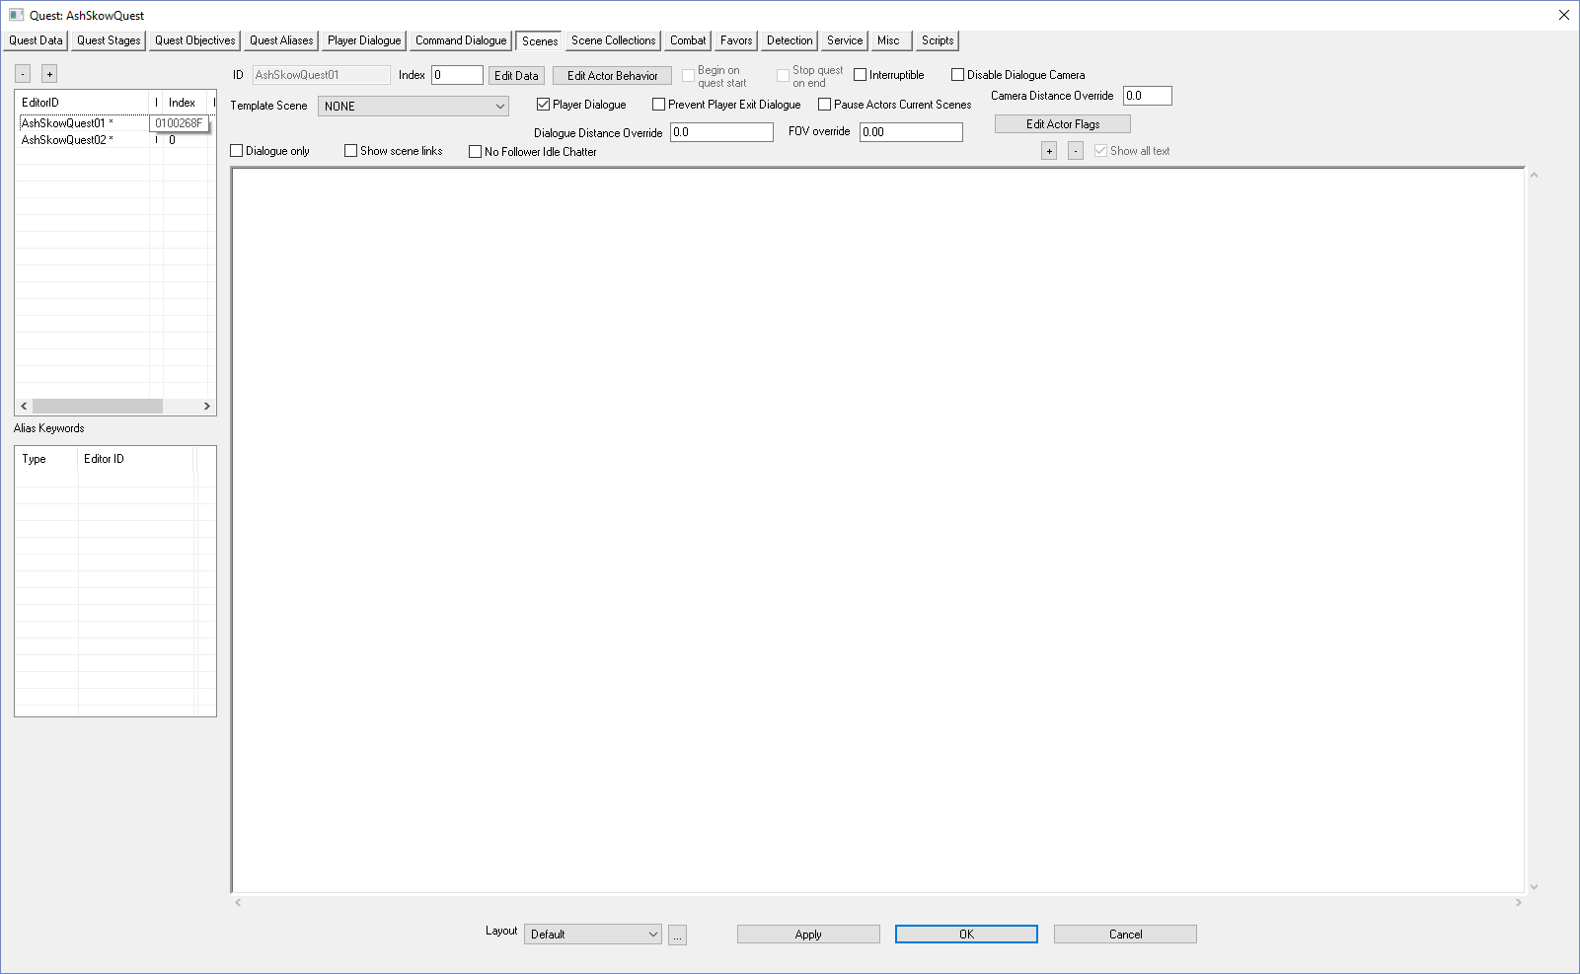
Click on the scene name  Note that the ID text box fills in with your scene name, AshSkowQuest02 | 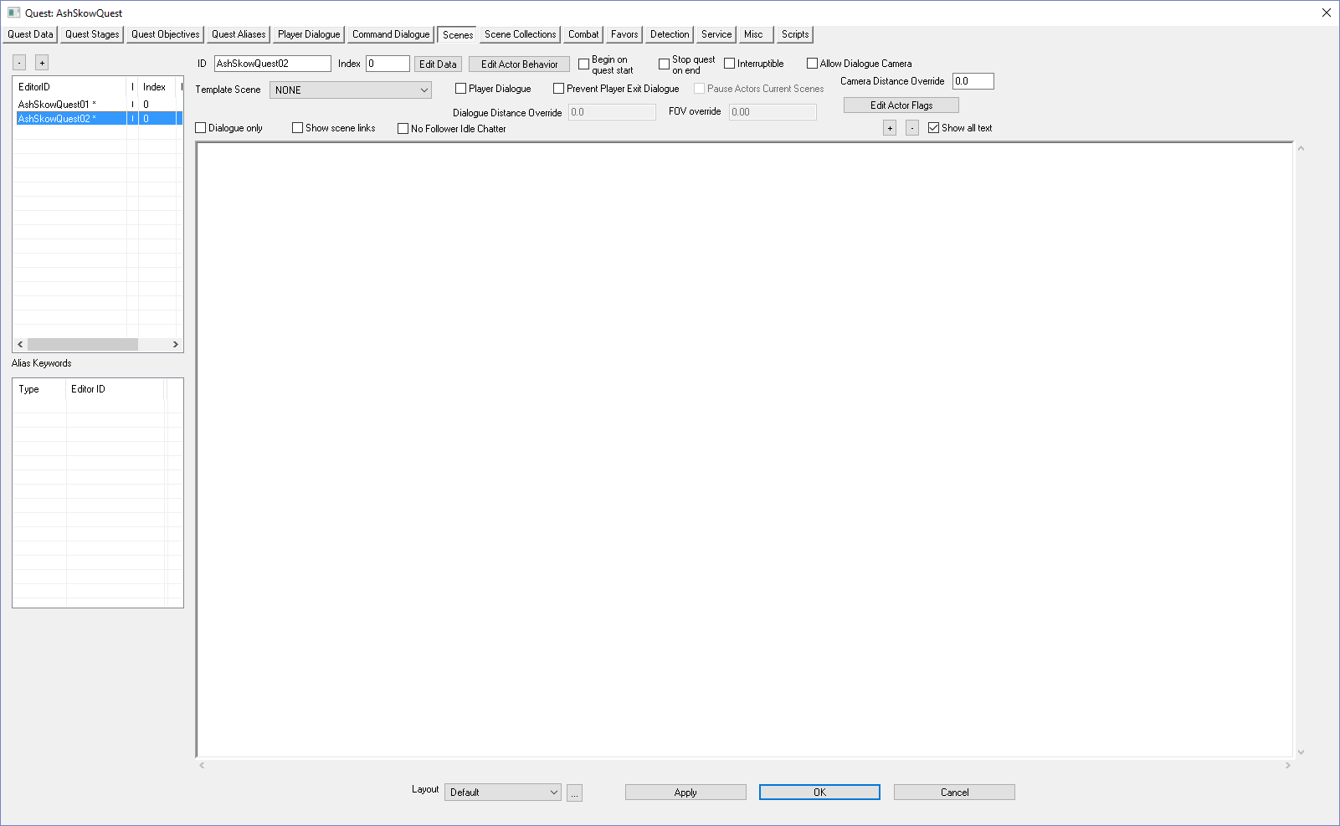
Click on the Player Dialogue checkbox | 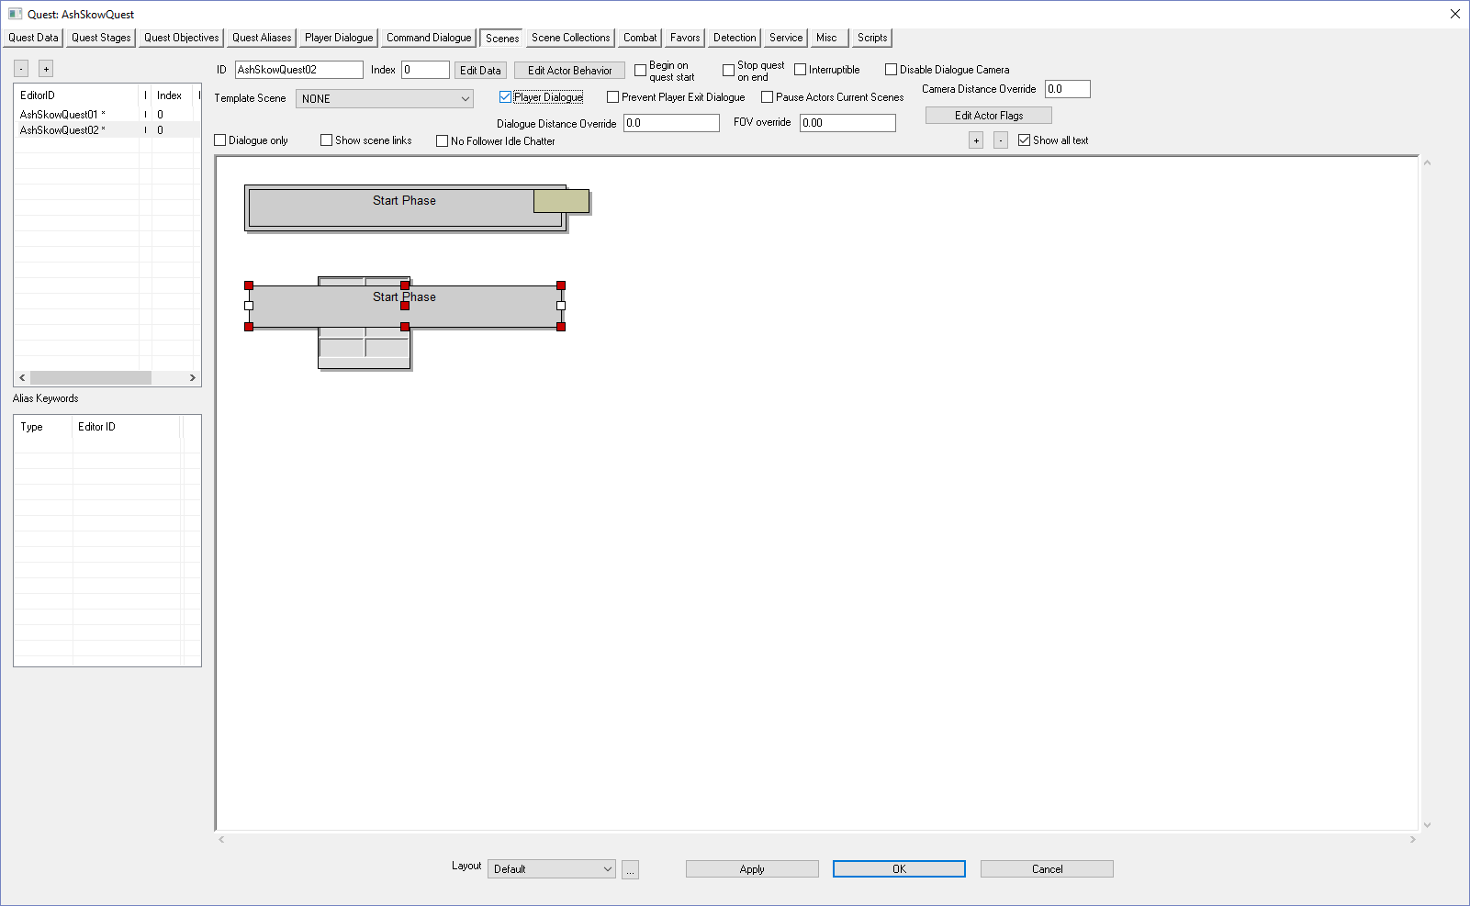
Right-click anywhere in the white area | 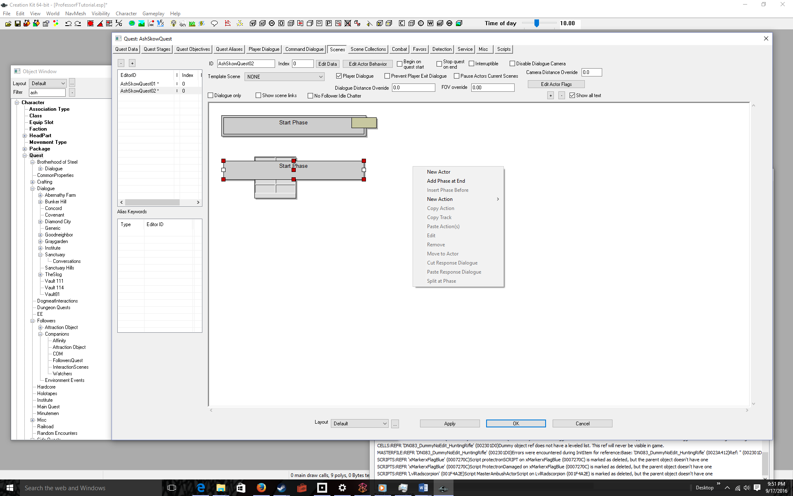
Select New Actor | 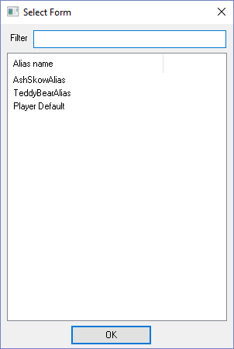
Click on your NPC alias (AshSkowAlias) then click the OK button | 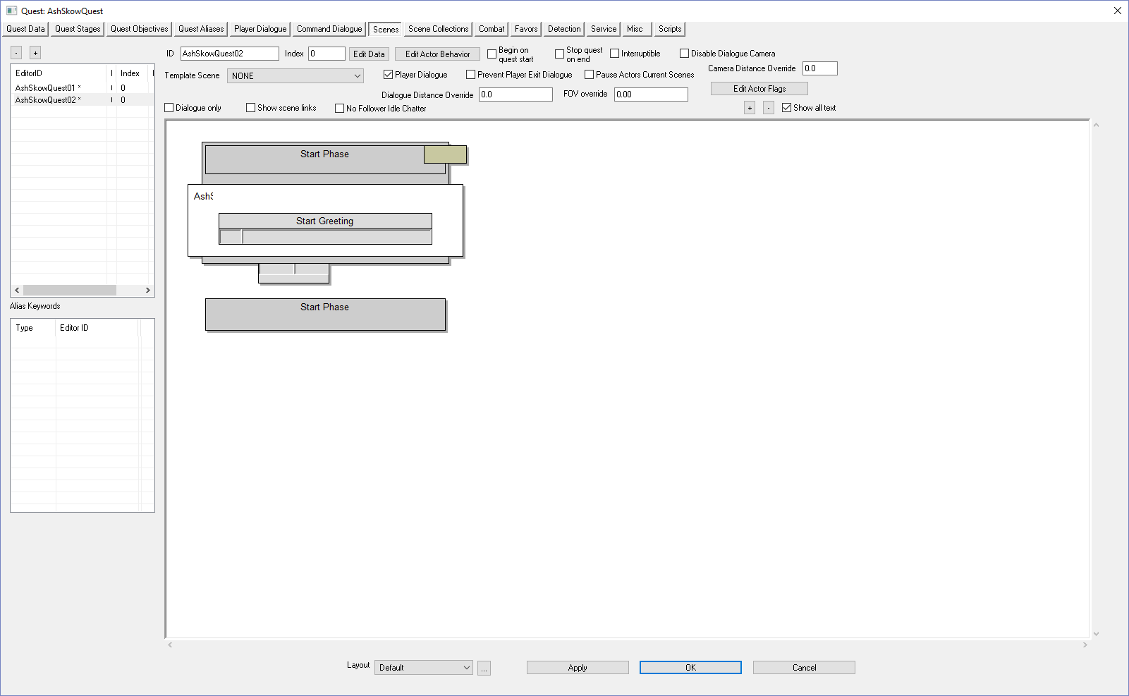
Double-click the empty gray box underneath Start Greeting  There are many inputs here, but the only one that matters is the Response Text. This is the greeting the player will see when prompted to talk to the NPC | 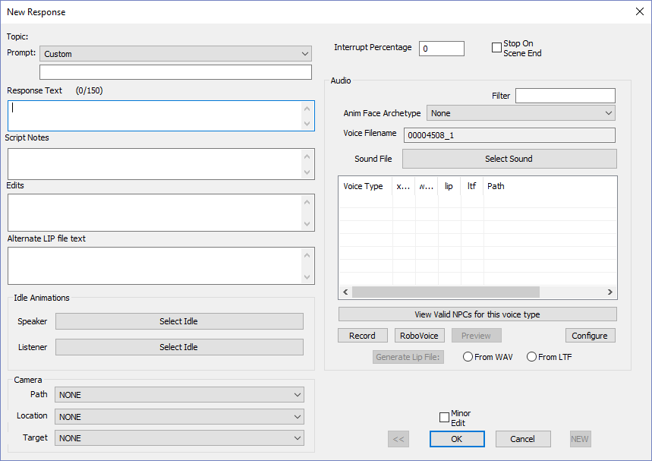
Type a greeting into the Response Text box  Since the player has agreed to the quest and is in the retrieve part of the quest (but hasn’t found the artifact yet) a good example is: “Have you found my artifact?”  Again, this is what the player will seen when prompted to talk to the character, or when the player goes in range | 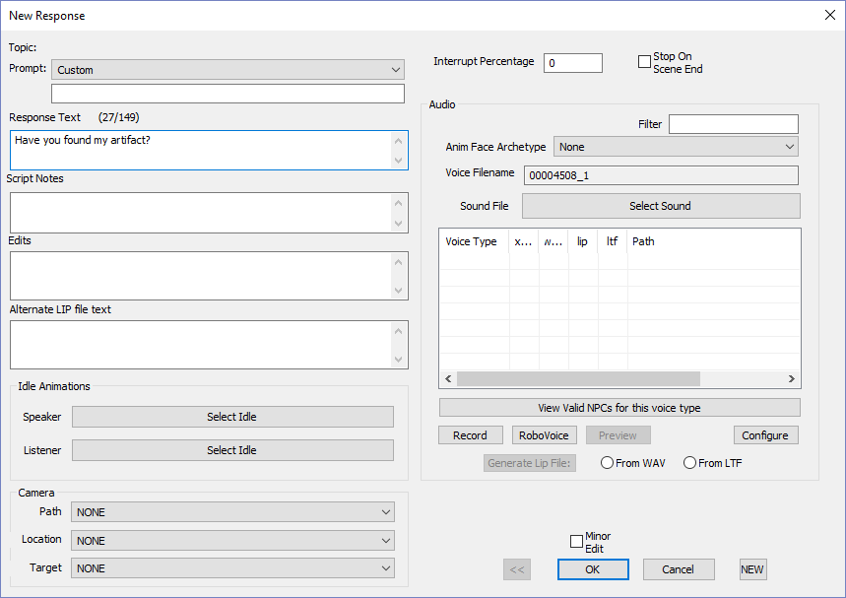
Click the OK button  Note the Response Text is filled with your greeting. This pop-up also allows you to change many options when we start scripting the quest—like when the greeting appears. But for now, we can ignore most of what’s in this box. | 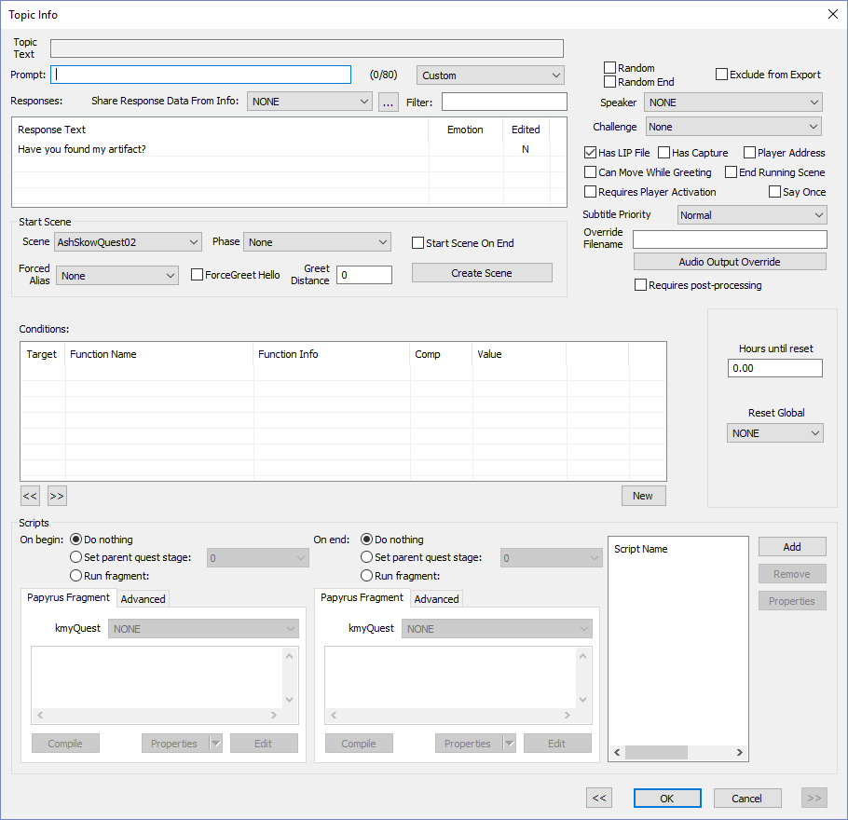
Click the OK button again  Yet another dialog box pops up allowing you to change options. Again, you don’t need to do anything at this point in your quest-scripting knowledge. | 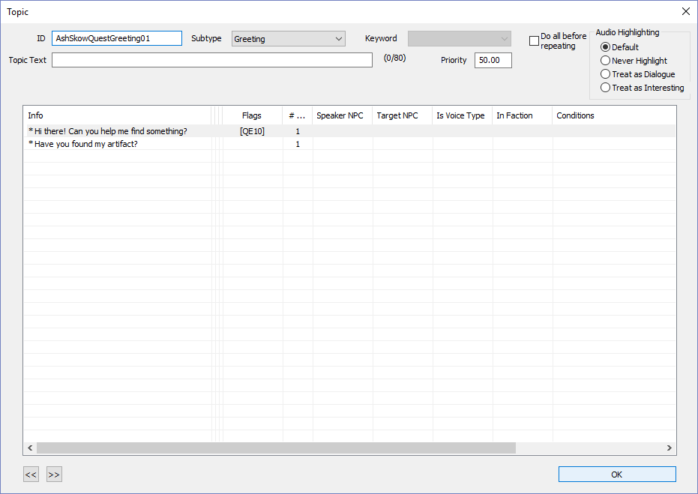
Click the OK button  Finally we’re back to the main scene window.  Remember: the Start Greeting is what the player will see when he or she first engages the NPC (usually by selecting the Talk option)  But we have a problem. How does Fallout 4, know which greeting to run? The answer is it will always run the Quest01 greeting unless you set conditions | 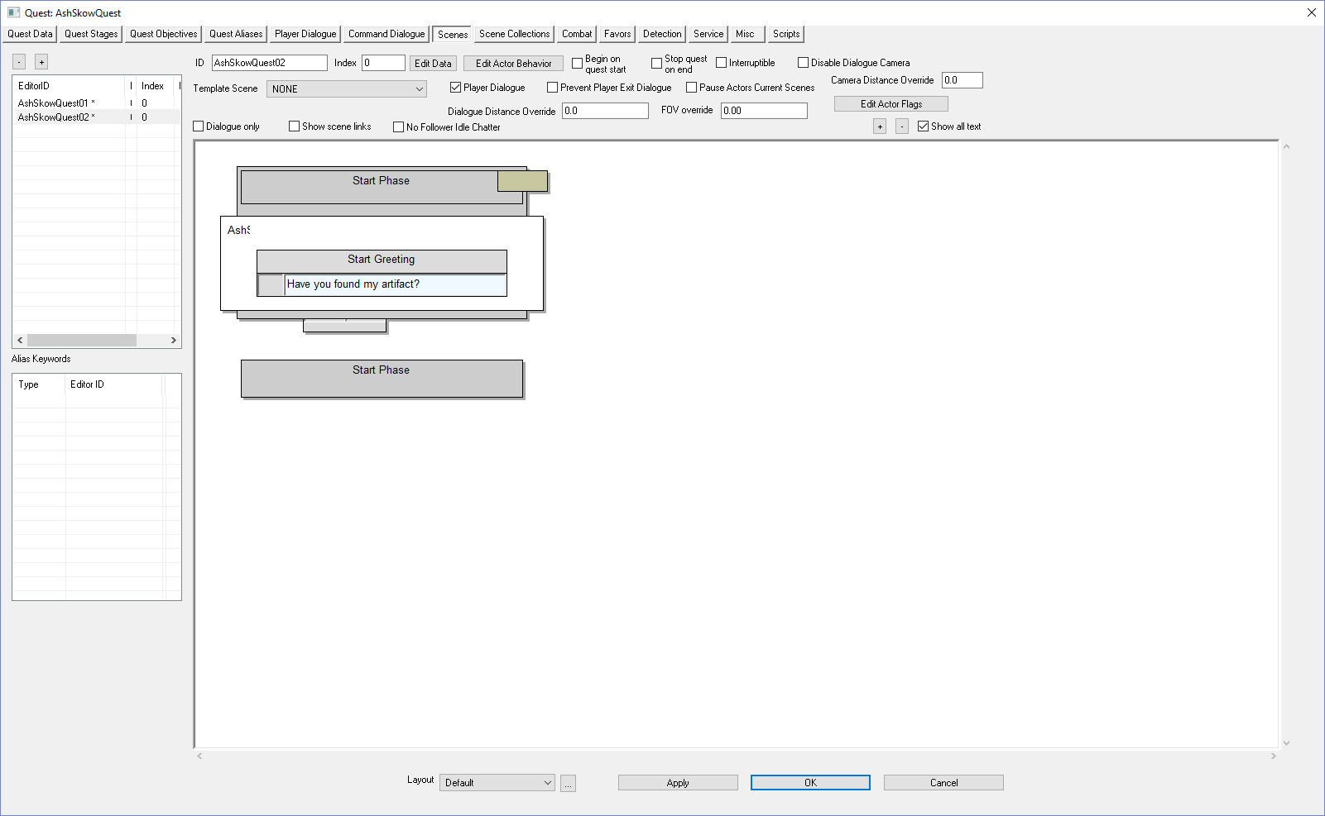
START: PROCEDURE FOR SETTING SCENE CONDITIONS  Click on the EditorID of the first scene  This is the general procedure for setting conditions on dialog. You start by clicking on a scene in the EditorID panel, in our case AshSkowQuest01 | 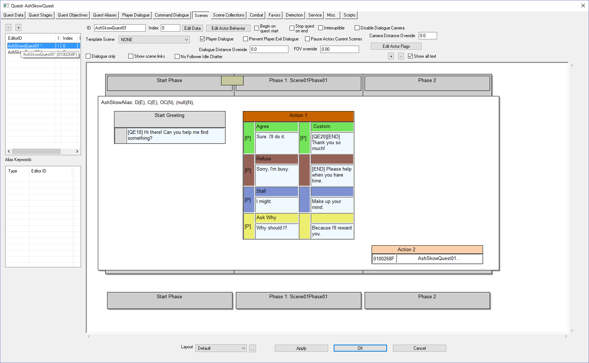
Double-Click the blue area of the Start Greeting  The Topic Info window is where you set conditions for displaying a scene | 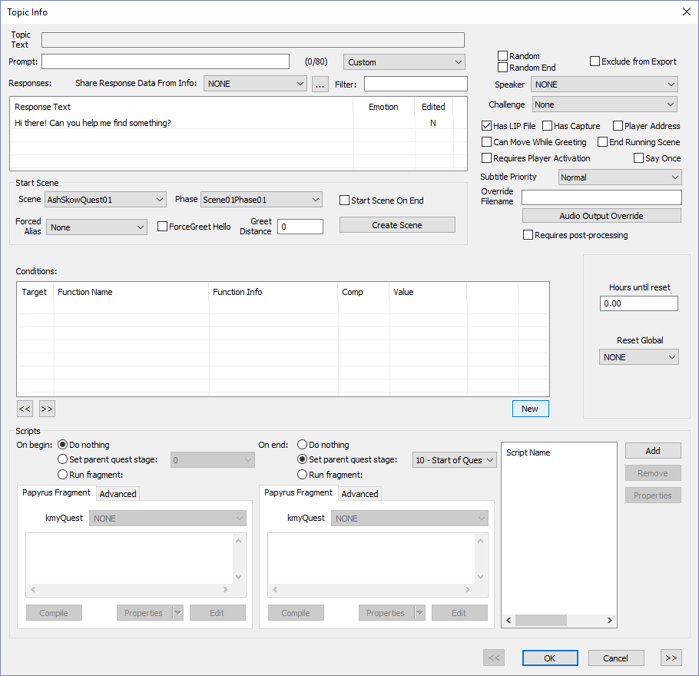
Click the New button to create a new condition | 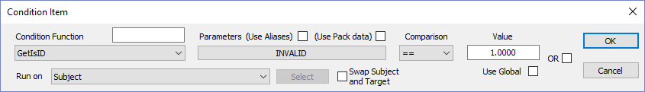
Select GetStage in the Condition Function drop-down  Pro-tip: Typing GetStage allows you to find the function faster. | 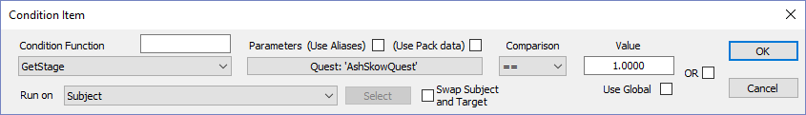
Set the Comparison drop-down to < and Value to Meet Quest Stage Index (20)  This will scene will run until the player agrees, in which case Quest Stage = 20 | 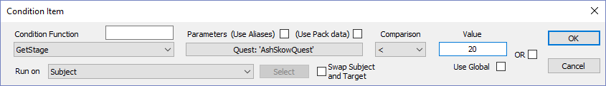
Click OK  To be safe, you want to add one more condition, and that is that the greeting is only said by Ash Skow. | 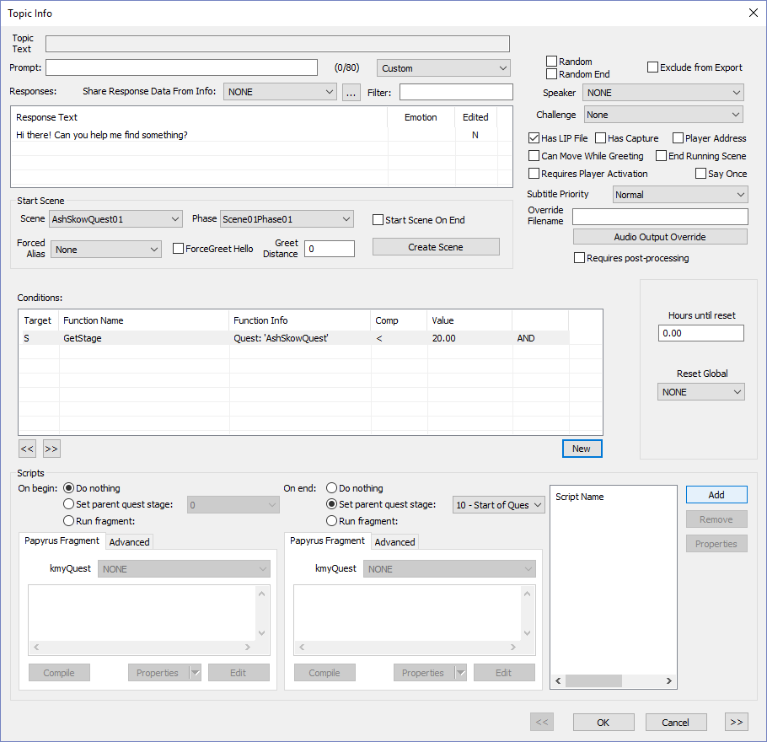
Click the New button to create a new condition
Click on INVALID | 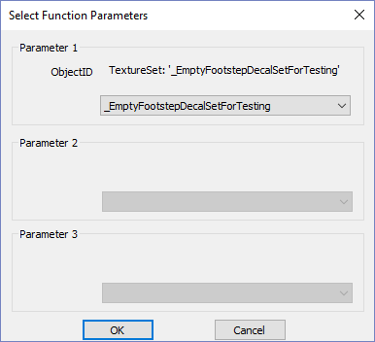
In the drop-down, select AshSkow  Pro-Tip: By typing AshSkow after clicking on the drop-down, you can more quickly find the NPC. | 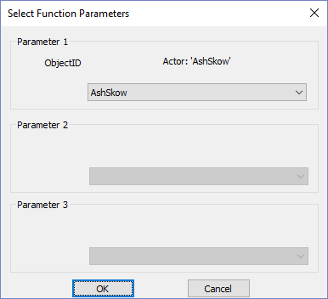
Click OK | 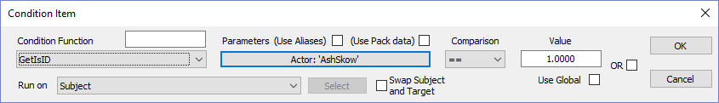
Click OK | 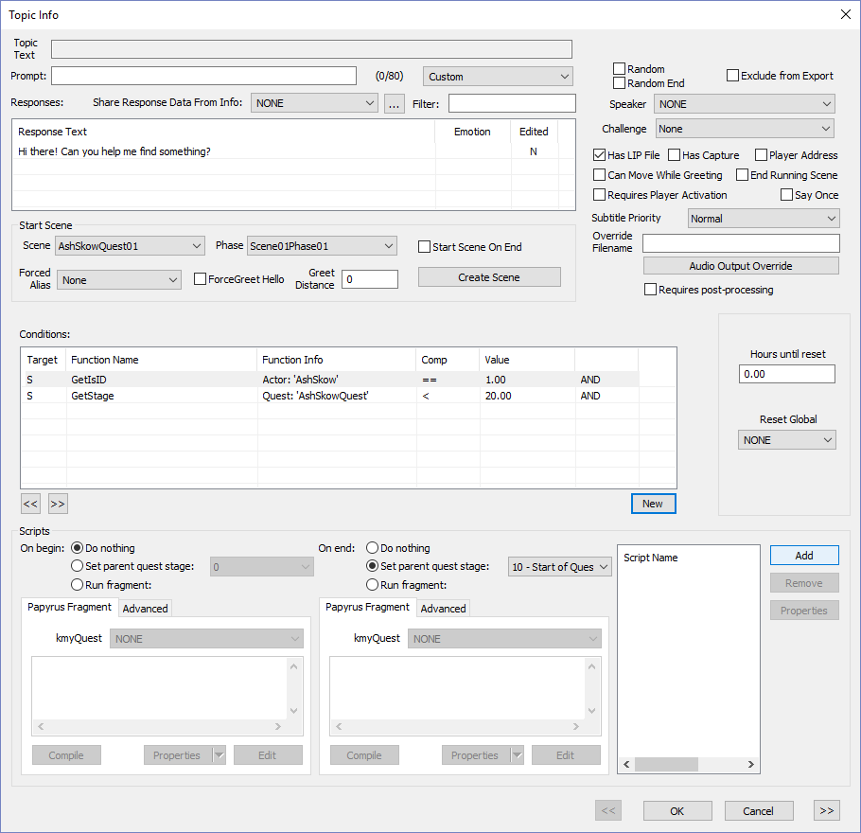
Click OK  END: PROCEDURE FOR SETTING SCENE CONDITIONS  Next we’ll set the conditions for scene 02 | 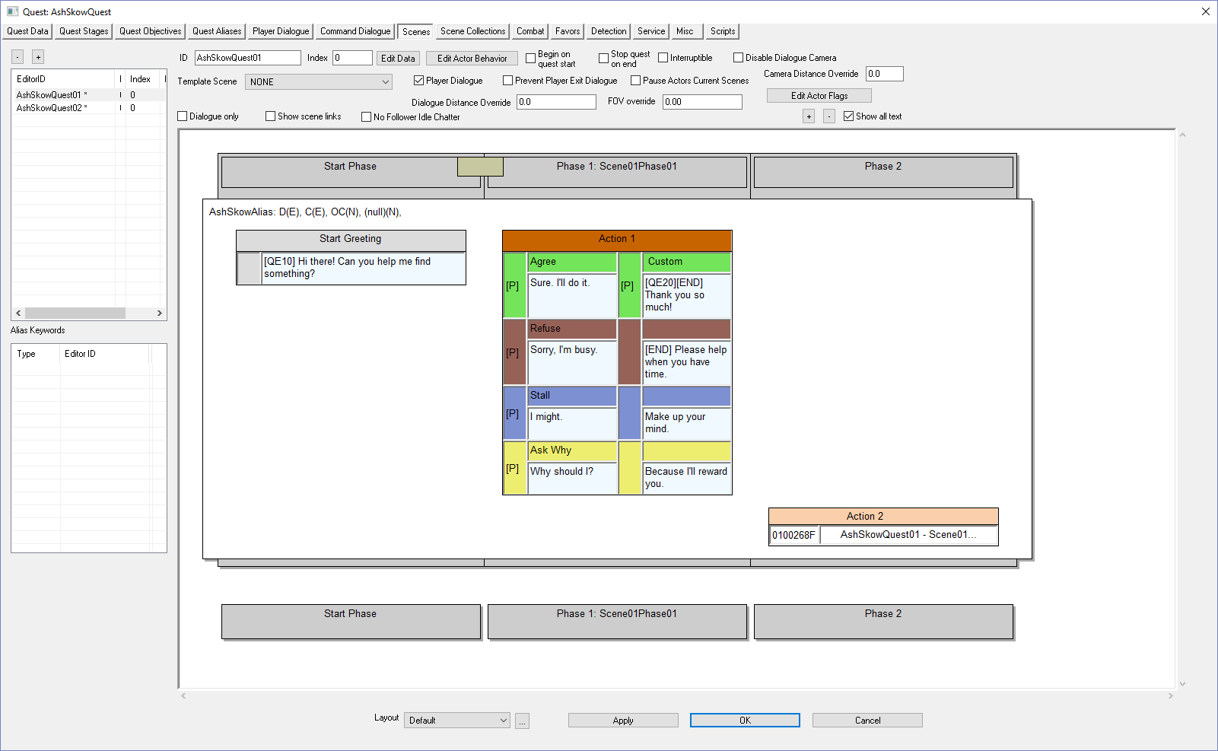
Click on the EditorID of the second scene  This is the general procedure for setting conditions on dialog. You start by clicking on a scene in the EditorID panel, in our case AshSkowQuest01 | 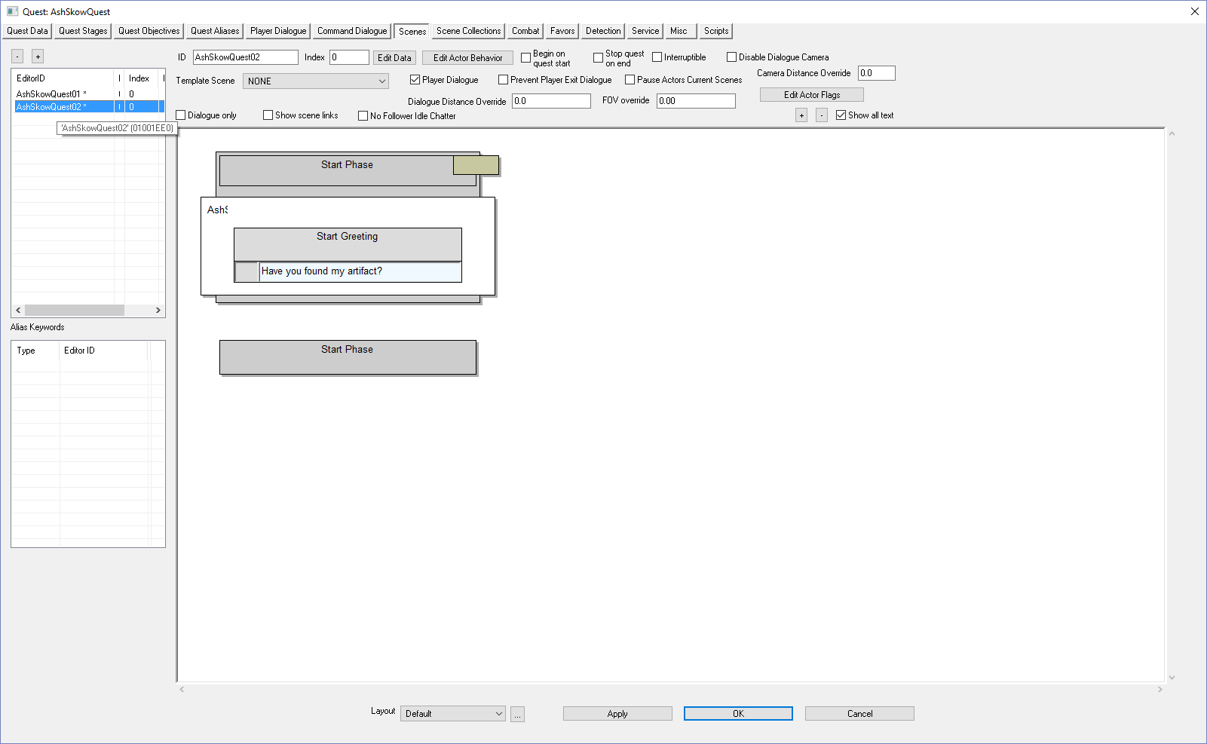
Double-Click the blue area of the Start Greeting  The Topic Info window is where you set conditions for displaying a scene | 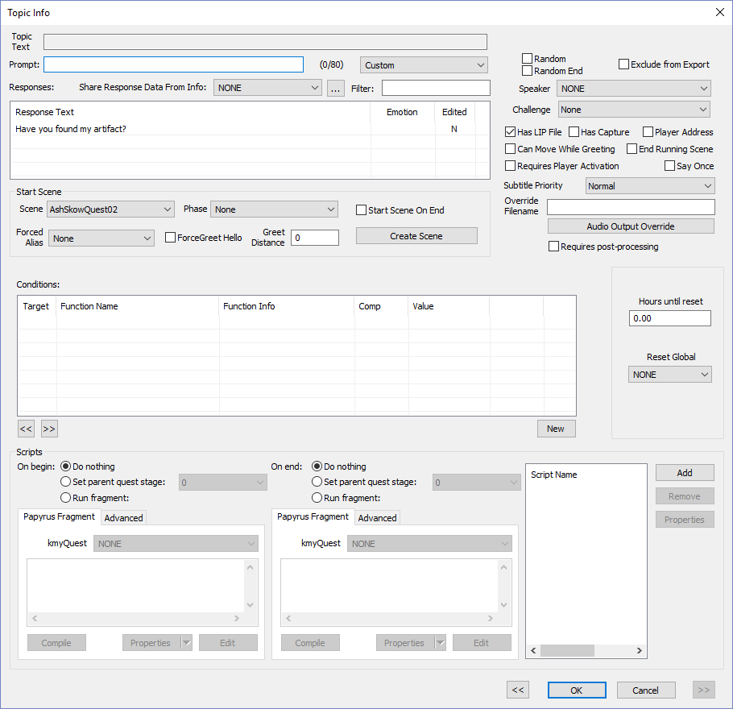
Click the New button to create a new condition
Select GetStage, <, and Found Artifacts Quest Stage Index (30)  This scene will run until the player finds the artifacts— Quest Stage 30 | 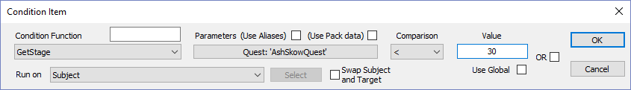
Click OK  Now let’s make sure only the NPC says this dialog, not our player. | 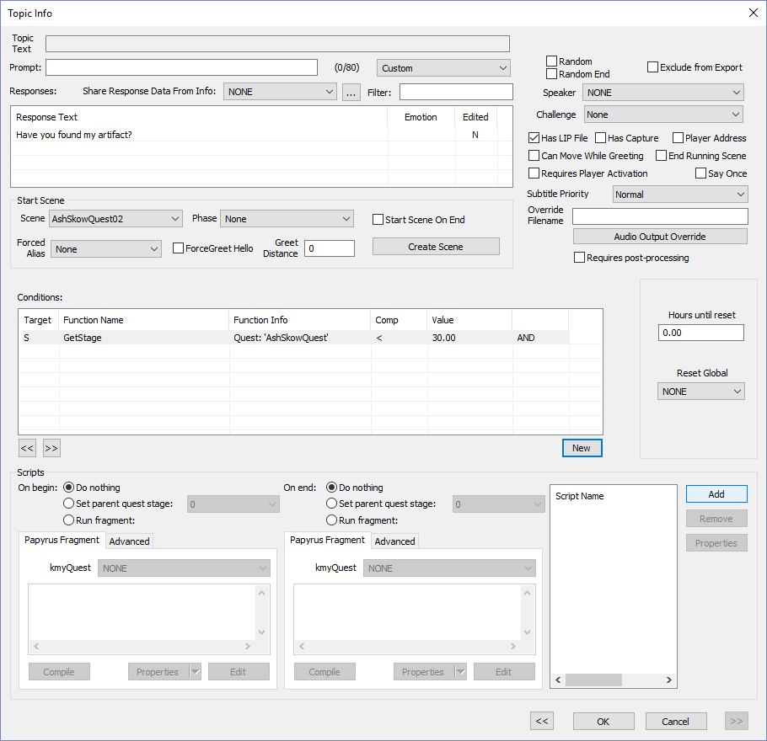
Click the New button to create a new condition
Click on INVALID
In the drop-down, select AshSkow

Pro-Tip: By typing AshSkow after clicking on the drop-down, you can more quickly find the NPC.
Click OK
Click OK | 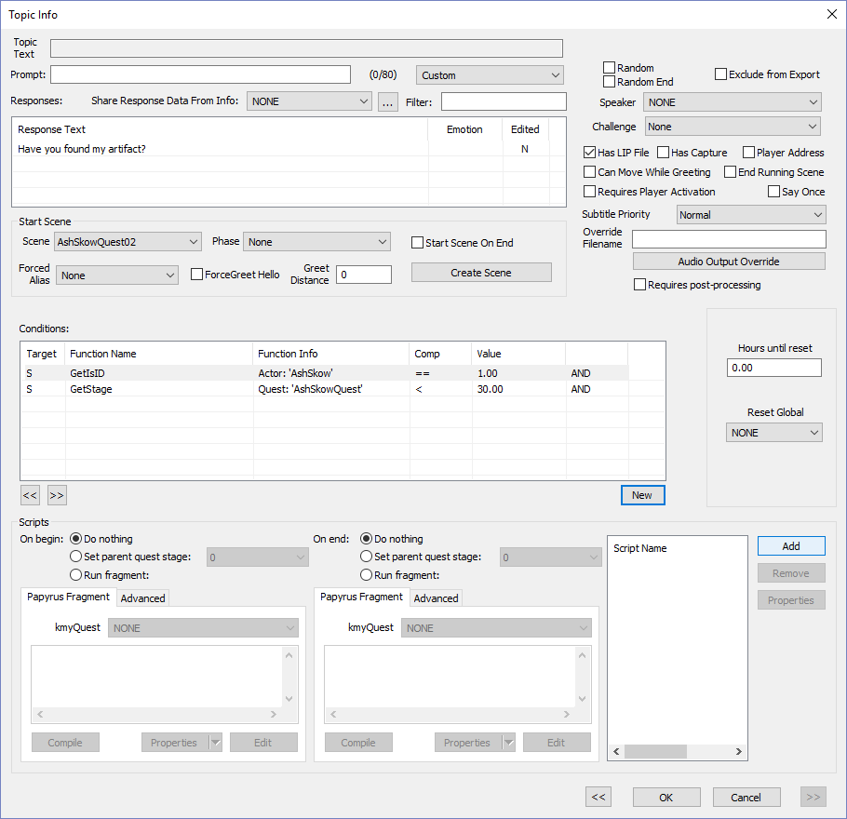
Click OK

Time to test if the dialog displays properly.
Click OK  Select File > Save | 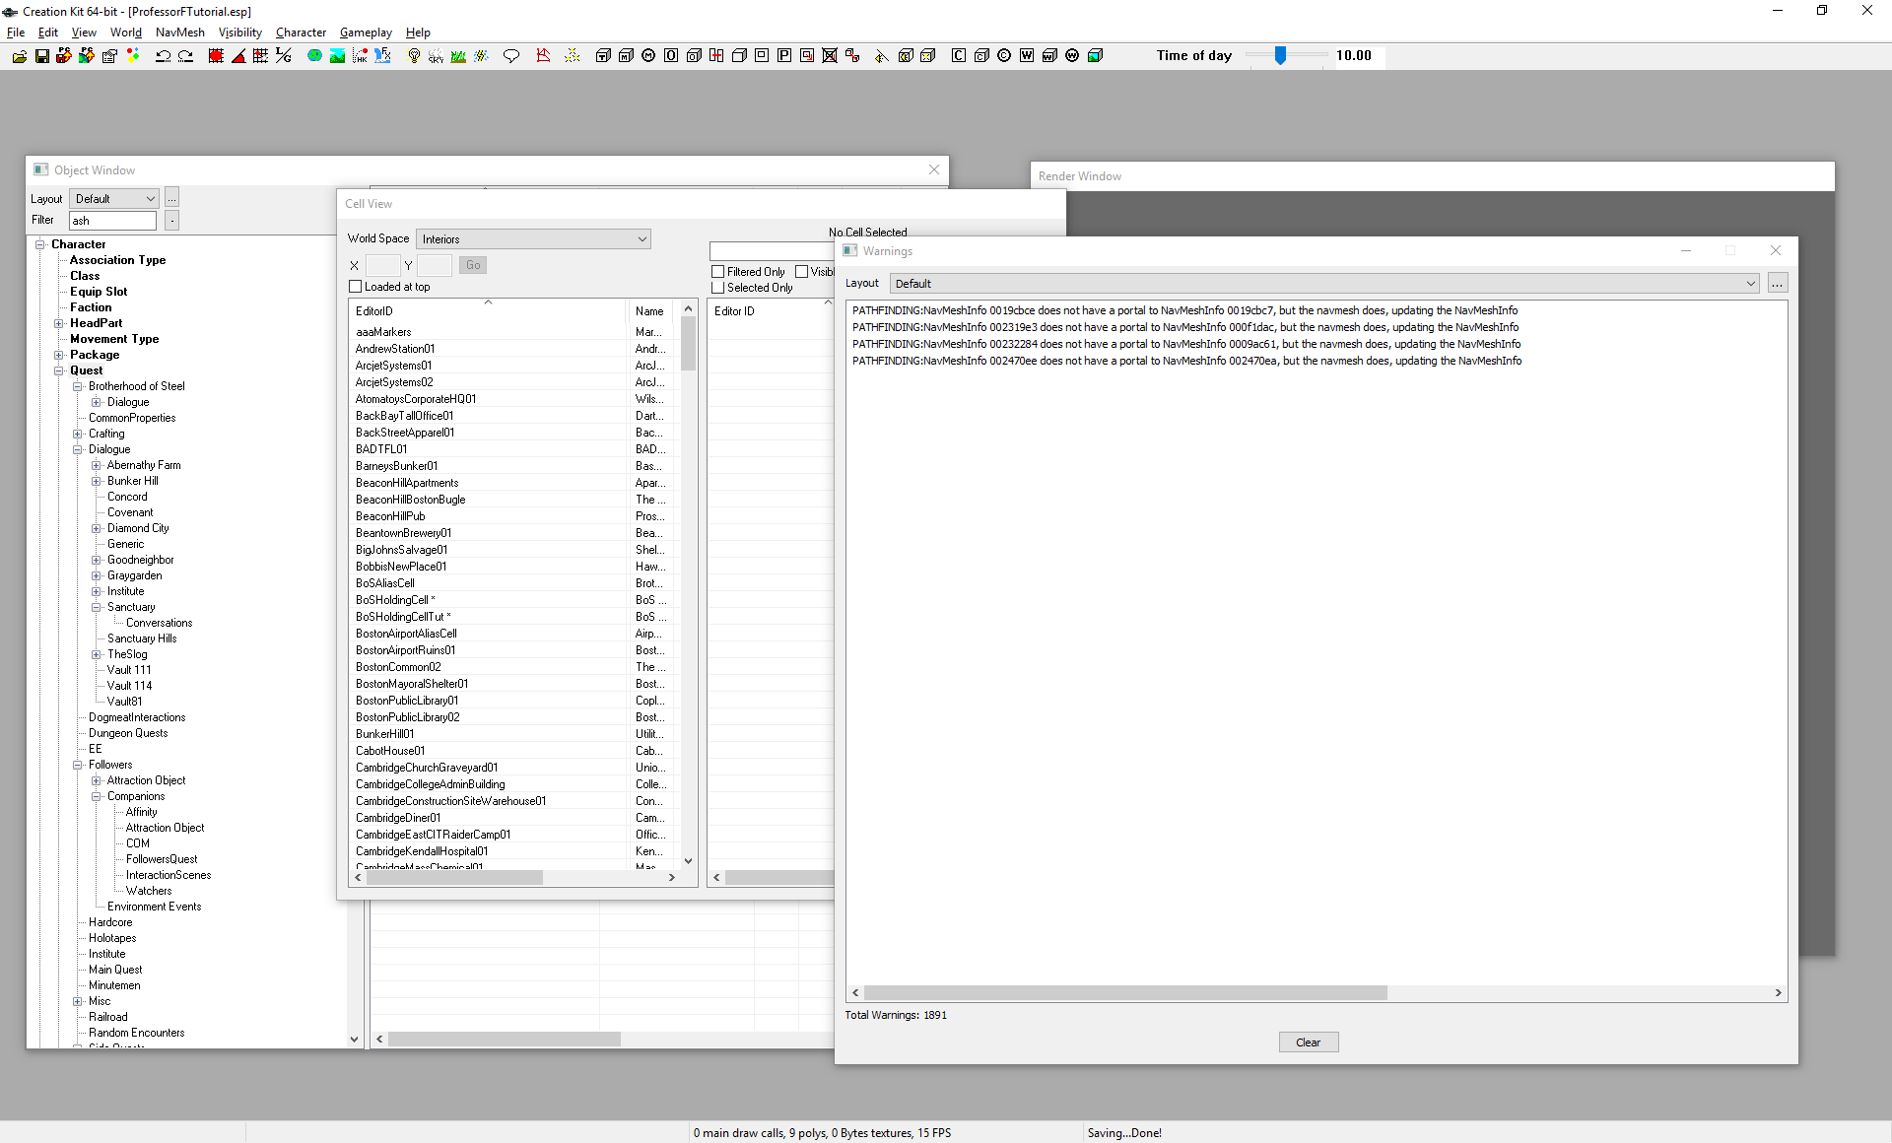
Run Fallout 4, Goto Ash and Agree to the quest  Yes, many steps not show, but you should know how to meet the NPC and advance through the quest | 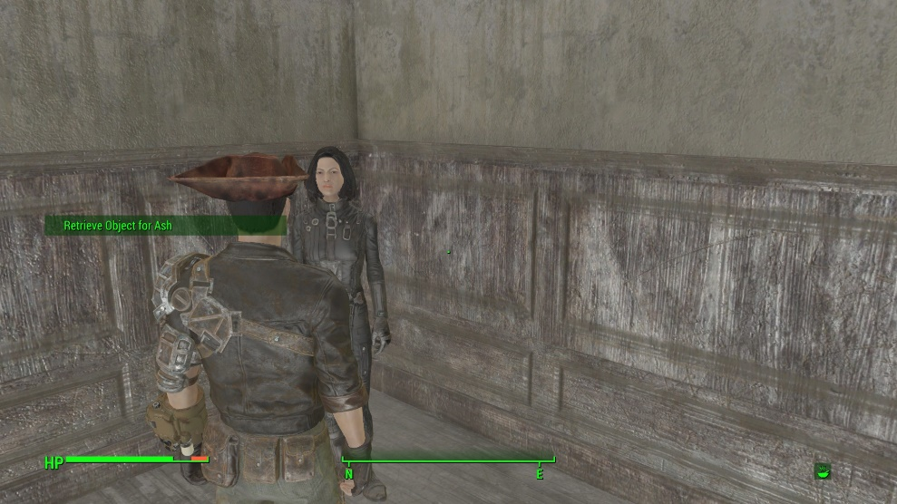
Test by walking away… | 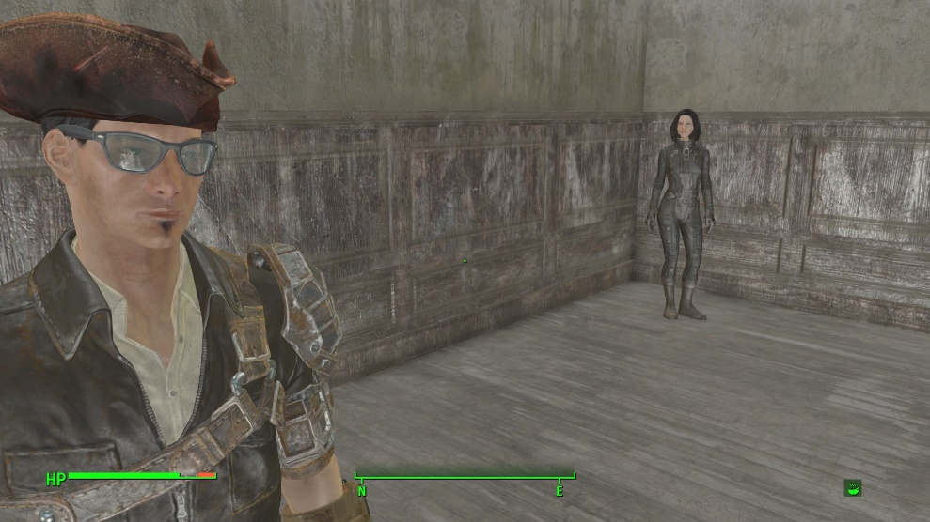
… Then get close again | 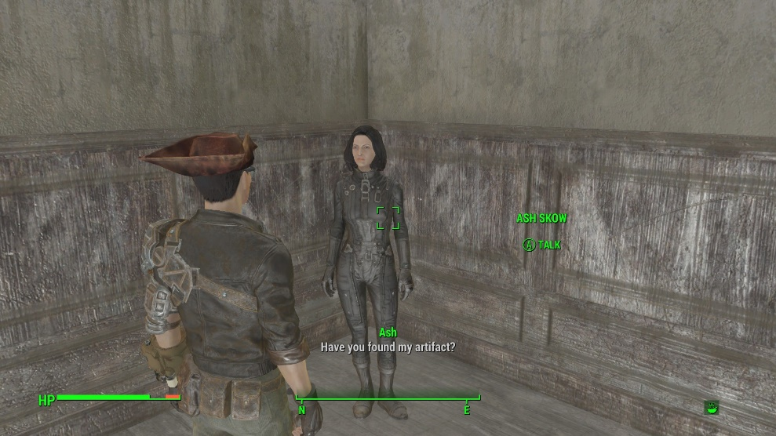

Don’t forget to quit out of the game! (ALT-F4 for the PC Master Race)

